**User Guid:**

1. **General description**

This app includes cloud computing trivia games, scoring points and viewing player rankings. It also includes an administrator where he can add and update questions.

To run the game, first run the last cell (“CSS”), and the click on run on the tool bar-> click run all

1. **The target audience**

People who are interested in learning and practicing cloud topics in a playful and fun way. Topics such as Python, Google Collab, cloud services, etc.

1. **User interface**

**Login as player:**

* 1. Login screen:

This is the first screen that the user sees. In this screen, the user logs in using a username and password.

* 1. Home Page screen
  2. The system's main screen is where the player can choose from the options: start a new game or view the ranking table.

Clicking on the question mark button on the upper left side of the screen will open an explanation window about the game:

* 1. 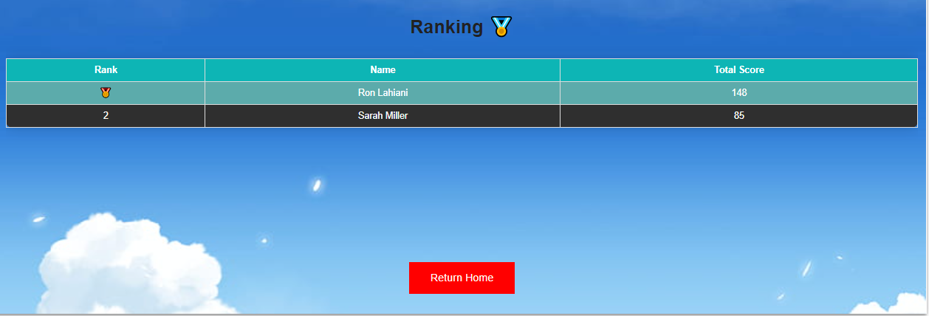Ranking screen:
  2. Game screen:
  3. 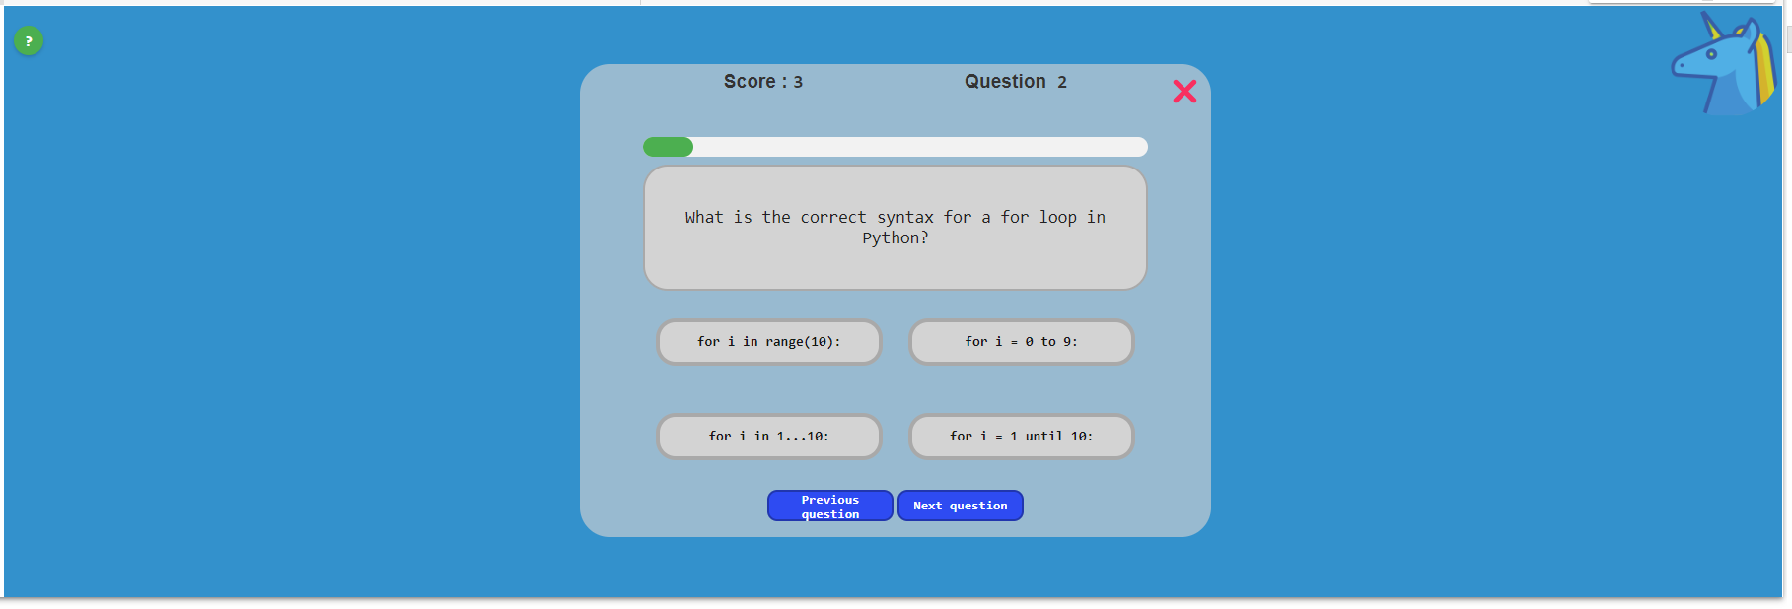 The game contains trivia questions where each question has 4 possible answers, and the user need to choose one of the answers. At every moment the player sees his total score and the number of the current question.

 By clicking on an incorrect answer, it will be marked in red, and the player will lose one point.

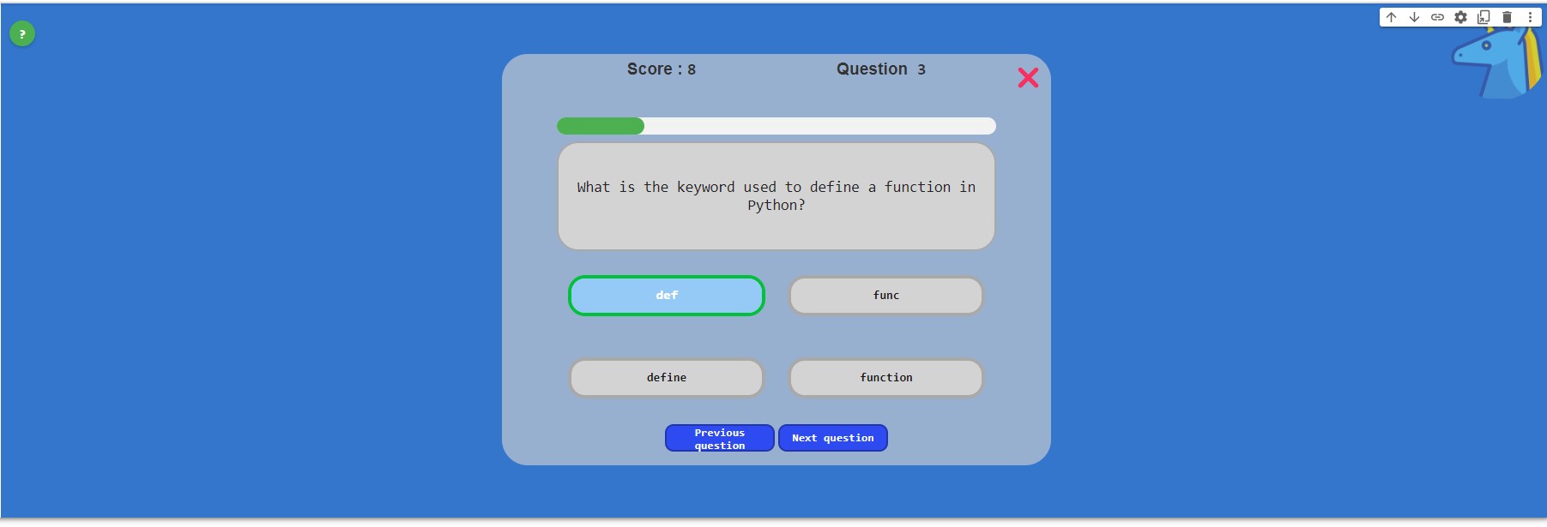 By clicking on a correct answer, it will be marked in green, a success sound will be heard.

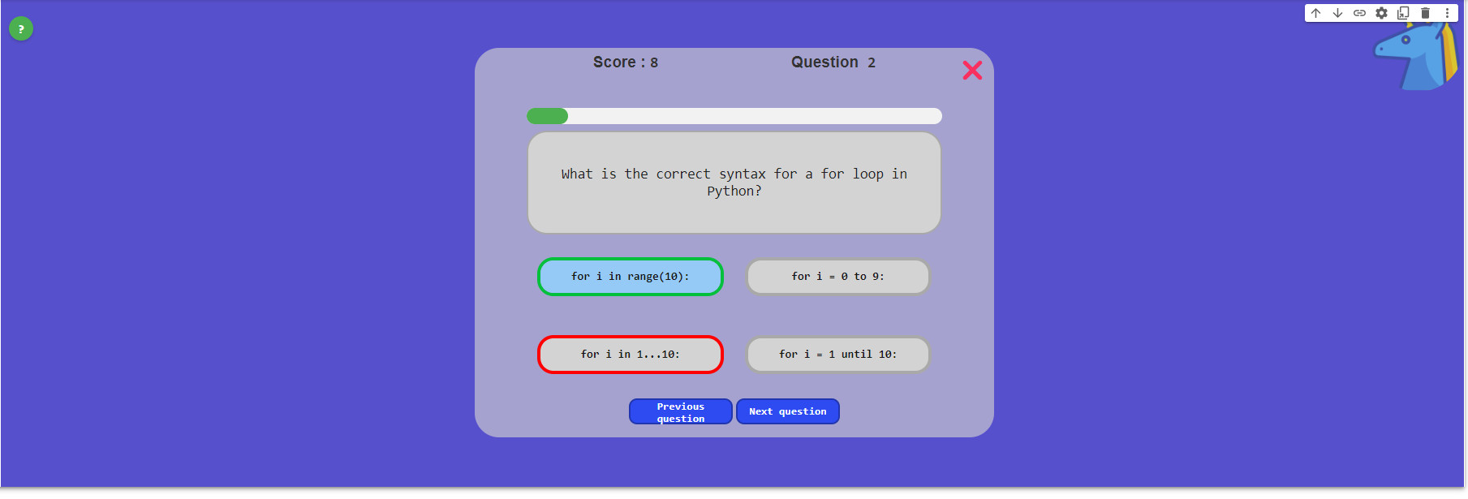By clicking on the previous question button, we will go to the previous question and the answer we answered will be marked. By clicking on the next question button, we will go to the next question even if we did not answer the current question, if we answered correctly, the score will be added.

By pressing the x button, we will go to the game summary screen

* 1. End game screen:

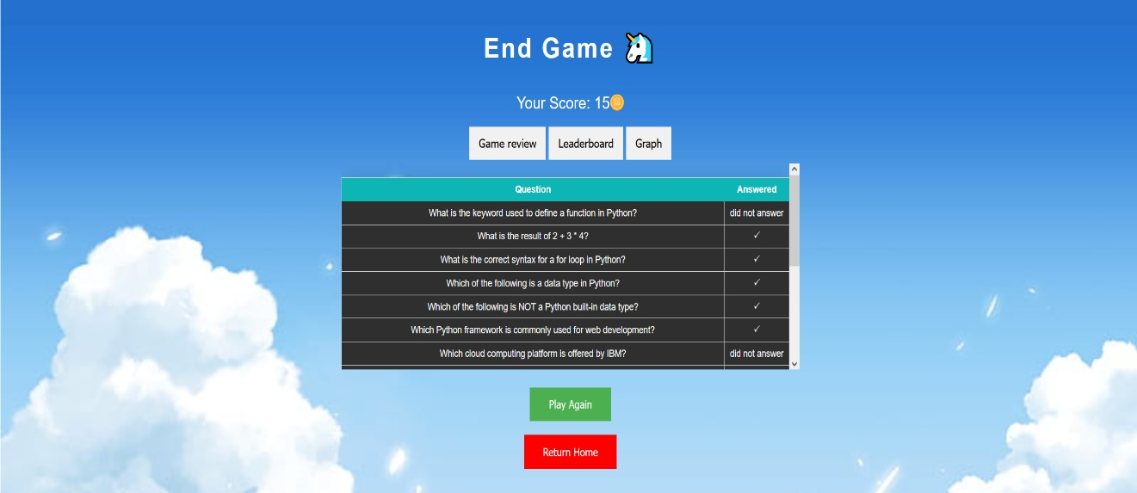In this screen, the user can see the summary of the game, a table listing all the questions and their status: are the answers correct? how many errors are there? did the user answer the question? The player's final score is also shown, and he can return to the main screen or play a new game.

* 1. Graph screen:

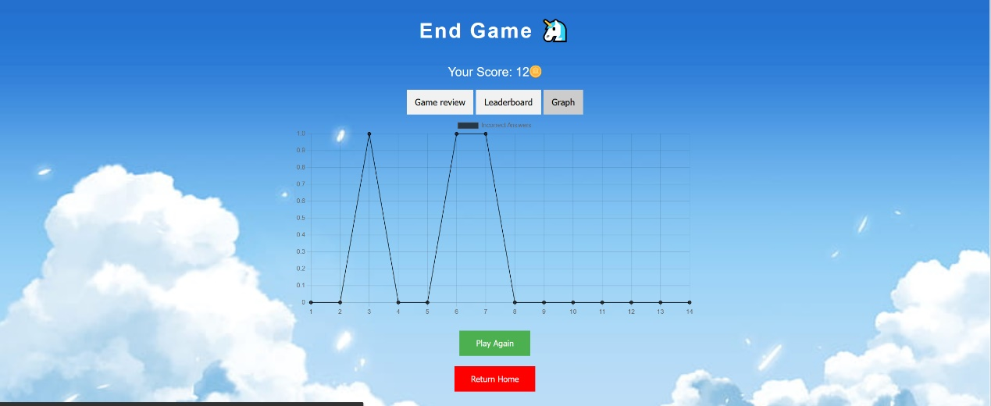On this screen, the player is shown a graph showing the number of mistakes he made in each question.

By clicking on the "Leadebored" button, we will go to the ranking screen (3.3)

**Login as manager:**

* 1. 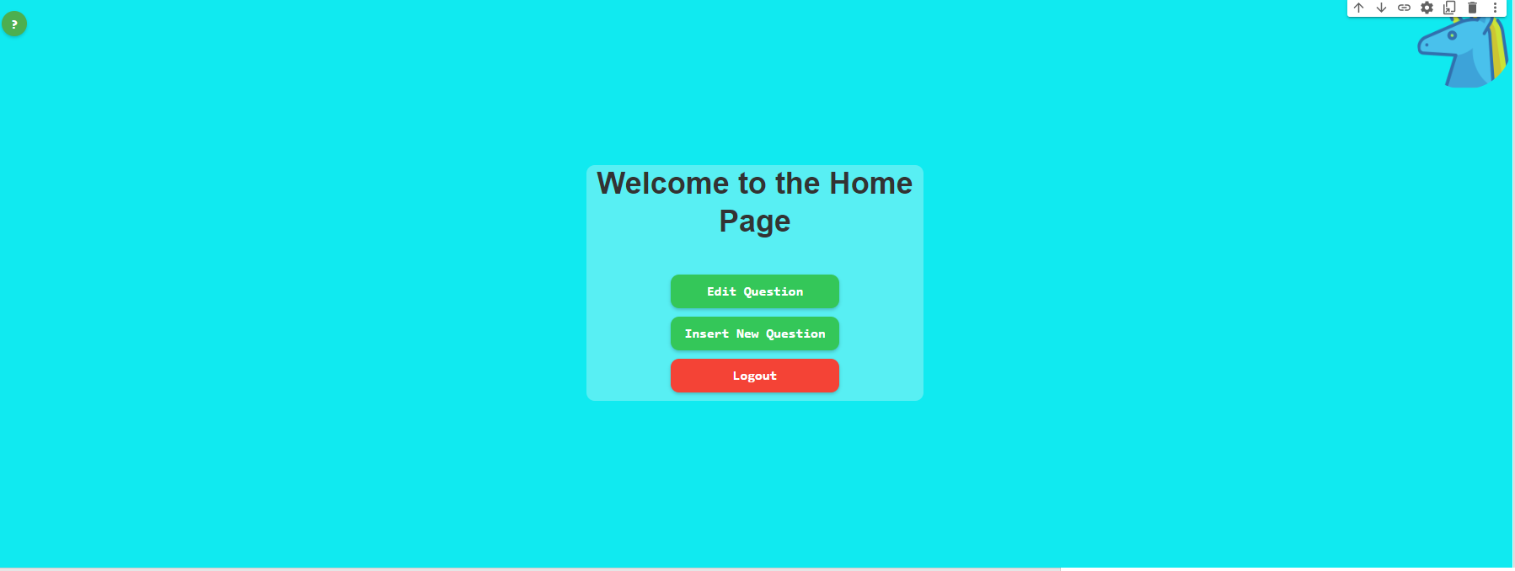Manager home page screen:
  2. This is the manager's main screen. On this screen there is a menu where all the manager's options are displayed: insert new question or edit question.
  3. Choose question screen:

By clicking the edit question button on the home page, we will go to the question selection screen. On this screen, the manager will select the question he wants to edit from the list of questions.

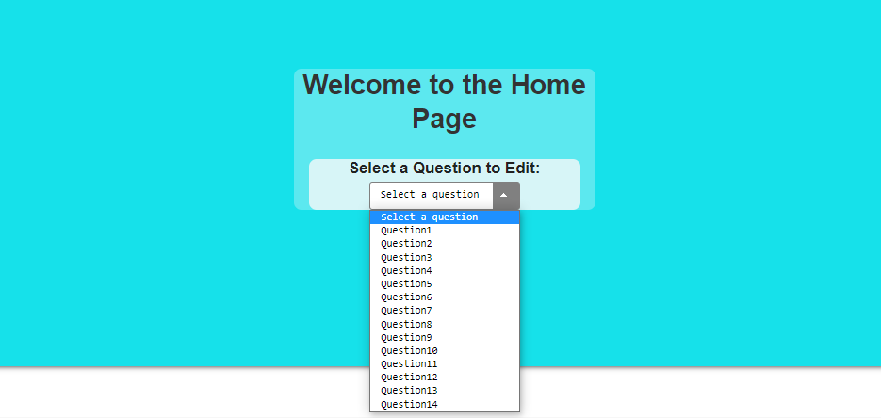

* 1. Edit question screen:

On this screen, the manager can view the content of the question and change its fields. On clicking the save button, the question will change, and the manager will automatically return to the main screen.

By clicking " Delete Question" button the question will be deleted, and the manager will automatically return to the main screen.

* 1. Insert new question screen:

In this screen, the manager will add a new question by filling all the fields. By clicking