Name: Netal Asawa

UID: 2019130003

TE Comps

Batch A

Experiment 03

**AIM:** To perform one way anova with sas platform

**Procedure:**

ANOVA stands for Analysis of Variance. In SAS it is done using PROC ANOVA. It performs analysis of data from a wide variety of experimental designs. In this process, a continuous response variable, known as a dependent variable, is measured under experimental conditions identified by classification variables, known as independent variables.

Consider the SASHELP.CARS dataset for one way anova test.

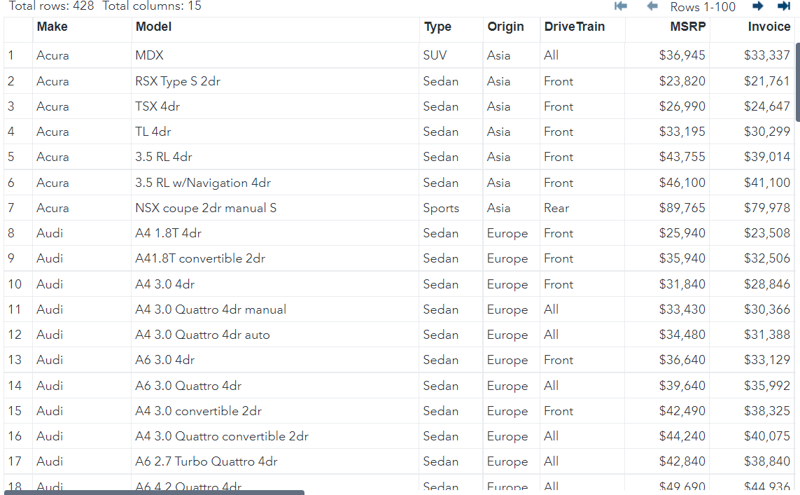

In the SASHELP.CARS dataset there is dependence between the variables car type and their horsepower. As the car type is a variable with categorical values, we take it as class variable and use both these variables in the MODEL.

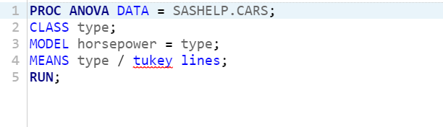  
When the above code is executed, we get the following result −

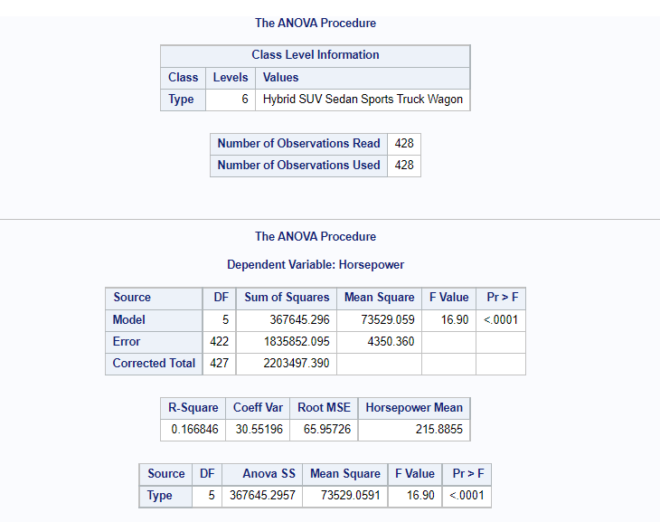

In the above result

The overall F-value is 16.90 and P-value is <.0001 So the P-value is less than 0.5 so it rejects null hypothesis

**Box plot**

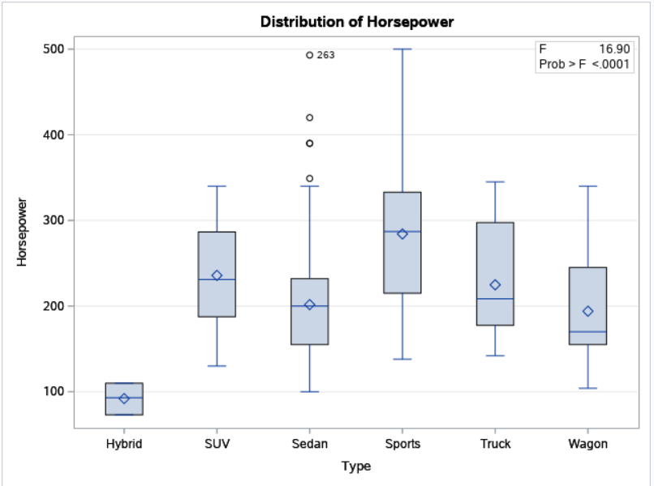

**Conclusion:**

In the one way anova basically compare the means of 2 different groups. From the above result of one way anova test is reveals that there is statiscally significant difference in their means.