I was asked to create a script which connecting remote SSH server anonymously and execute provided commands

First, the bash script updates and upgrades the system using the function "**inst**" which uses aptitude tool (commented as default due for time it takes. The user can uncomment it in source code)

Then, in the code I defined the functions will be used in script:

**Anon** – to check that the remote server and the local PC are not in same country. If yes- aborting the script and notify the user. If the remote server's IP is private, I am detecting it as security issue but user can select if to continue.

The script comparing remote server's location by IP (with WHOIS service) and comparing it to local pc's public IP's location (with curl – to get public IP of local pc's default gateway and WHOIS – to search the location by IP)

Then, the script tells the user what the country of both IP addresses is.

**VPS –** this function combining the provided details from user (which will be given later in script) and execute the command in local pc to connect remote server (using SSHPASS tool to take the remote server user's password and put it in the same line with the SSH command to connect remote server). All remote server's STDOUT (standard output) will be saved in a temp file named '**stdout.txt**' (which will be deleted at end of script)

Then, the script getting input from user which will be used as variables in the script:

Remote server's username (**server_uname**)

Remote server's ip (**server_ip)**

**\*Here the script using a while loop condition to check validity of IP address provided. If the IP address is not valid, user will be asked to enter a valid IP address\***

**\*Here the 'anon' function takes action to check if the provided IP is private. If no – it checking where the IP is located with WHOIS service\***

Remote server's password (**server_pass**) – the password is hidden to increase security

Remote command to execute (**command**)

\***Here the 'VPS' function takes action to establish the connection and execute the command on remote server\***

* The script notifies the user that the command was sent, and if there's an output it will be shown in 5 seconds
* The script clears the shell's screen to make the remote's output more readable
* The script deleting the '**stdout.txt**' file

To prove the script is working, I opened a server-side on kali linux in my network.

Then, from another VM (ubuntu OS), I am executing the script

For example- I will execute a nmap scan from kali (10.0.0.6) on the local PC (10.0.0.11)

We can see first the script installing the required tools (4- whois, curl, ssh, sshpass)

* Getting remote server's username
* Getting remote server's address
* The '**anon**' script acts
* User notified about connecting to private IP address (just in private remote IP addresses cases)
* User notified about his public IP address
* User notified about both IP's locations (just in public remote IP addresses cases)
* Getting remote server's password from user (hidden)
* Getting command to execute on remote server

The script presents the output from remote's server:

For more example, I used a free public ssh server for testing.

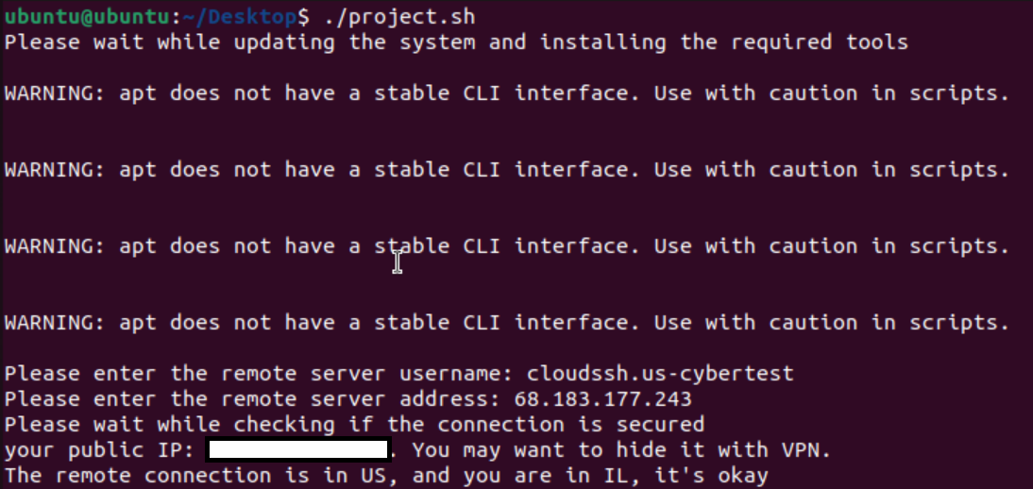

We can see the script alerted us about geographic locations of both IP addresses and did not alert about private remote IP address

**Script coping with errors**

In this example, we can see that if the user entered wrong details (such as wrong IP address or pass etc.) He will be alerted about something is wrong

In other example, we can see that if the user entered not valid IP address, he will be asked to enter it again:

Example of trying to connect to same country remote server:

