**UNIVERSIDAD DE BUENOS AIRES  
 FACULTAD DE INGENIERÍA  
 <75.12> ANÁLISIS NUMÉRICO**

|  |  |  |  |  |  |  |  |  |  |  |  |  |  |  |  |  |  |  |  |  |  |  |  |  |  |  |  |  |  |  |  |  |  |  |  |  |  |  |  |  |  |  |  |  |  |  |  |  |  |  |  |  |  |  |  |  |  |  |  |  |  |  |
| --- | --- | --- | --- | --- | --- | --- | --- | --- | --- | --- | --- | --- | --- | --- | --- | --- | --- | --- | --- | --- | --- | --- | --- | --- | --- | --- | --- | --- | --- | --- | --- | --- | --- | --- | --- | --- | --- | --- | --- | --- | --- | --- | --- | --- | --- | --- | --- | --- | --- | --- | --- | --- | --- | --- | --- | --- | --- | --- | --- | --- | --- | --- |
| **DATOS DEL TRABAJO PRÁCTICO** | | | | | | | | | | | | | | | | | | | | | | | | | | | | | | | | | | | | | | | | | | | | | | | | | | | | | | | | | | | | | | |
| 1 | | | | | | | 2 | | 0 | | | 1 | | 8 | | |  | | | | | | | | | | | | | | | | | | | | | | | | | | | | | | | | | | | | | | | | | | | | | |
| AÑO | | | | | | | | | |  | | | | | | | | | | | | | | | | | | | | | | | | | | | | | | | | | | | | | | | | | | | | | |
| 1° | | | | | | | | | |  | | | | | | | | | | | | | | | | | | | | | | | | | | | | | | | | | | | | | | | | | | | | | |
| TP NRO | | | | | | | CUAT | | | | | | | | | | TEMA | | | | | | | | | | | | | | | | | | | | | | | | | | | | | | | | | | | | | | | | | | | | | |
| **INTEGRANTES DEL GRUPO** | | | | | | | | | | | | | | | | | | | | | | | | | | | | | | | | | | | | | | | | | | | | | | | | | | | | | | | | | | | | | | |
| 8 | | | | | | | B | | r | | | a | | c | | | c | | e | | l | | a | | r | | g | | h | | e | | |  | | A | | | i | | l | | i | | n | |  | | Y | |  | | 9 | | 9 | | 3 | | 6 | | 6 | |
| APELLIDO Y NOMBRE | | | | | | | | | | | | | | | | | | | | | | | | | | | | | | | | | | | | | | | | | | | | | | PADRÓN | | | | | | | | | |
| J | | a | | | m | | i | | | l | | i | | s | |  | | N | | e | | t | | a | | | n | | e | | | l | |  | |  | |  | |  | |  | |  | | 9 | | 9 | | 0 | | 9 | | 3 | |
| GRUPO | | | | | | | APELLIDO Y NOMBRE | | | | | | | | | | | | | | | | | | | | | | | | | | | | | | | | | | | | | | | | | | | | | | PADRÓN | | | | | | | | | |
| **DATOS DE LA ENTREGA** | | | | | | | | | | | | | | | | | | | | | | | | | | | | | | | | | | | | | | | | | | | | | | | | | | | | | | | | | | | | | | |
|  |  |  | |  | | . | | T | | X | | | T | | |  | |  | | - | |  | |  | |  | |  | |  | |  | | |  | |  |  | |  | |  | |  | |  | |  | |  | |  | |  | |  | |  | |  | |  |
| ARCHIVO | | | | | | | | | | | | | | | | NRO CONTROL | | | | | | | | | | | | | | | | FECHA VENC | | | | | | | | | | | | | | | | FECHA ENTR | | | | | | | | | | | | | | |
| **CORRECCIONES** | | | | | | | | | | | | | | | | | | | | | | | | | | | | | | | | | | | | | | | | | | | | | | | | | | | | | | | | | | | | | | |
| FECHA | | | | | | | | | | | NOTA | | | | | | | | | | | | | OBSERVACIONES | | | | | | | | | | | | | | | | | | | | | | | | | | | | | | | | | | | | | | |
|  | | | | | | | | | | |  | | | | | | | | | | | | |  | | | | | | | | | | | | | | | | | | | | | | | | | | | | | | | | | | | | | | |
|  | | | | | | | | | | | | | | | | | | | | | | | | | | | | | | | | | | | | | | |
|  | | | | | | | | | | |  | | | | | | | | | | | | |  | | | | | | | | | | | | | | | | | | | | | | | | | | | | | | | | | | | | | | |
|  | | | | | | | | | | | | | | | | | | | | | | | | | | | | | | | | | | | | | | |
| DOCENTE | | | | | | | | | | | FIRMA | | | | | | | | | | | | |  | | | | | | | | | | | | | | | | | | | | | | | | | | | | | | | | | | | | | | |
|  | | | | | | | | | | |  | | | | | | | | | | | | |  | | | | | | | | | | | | | | | | | | | | | | | | | | | | | | | | | | | | | | |
|  | | | | | | | | | | | | | | | | | | | | | | | | | | | | | | | | | | | | | | |
|  | | | | | | | | | | |  | | | | | | | | | | | | | | | | | | | | | | | | | | | | | | | | | | | | | | |
|  | | | | | | | | | | | | | | | | | | | | | | | | | | | | | | | | | | | | | | |

**Desarrollo del trabajo práctico.**

1. ***Punto de equilibrio positivo, sin tener en cuenta el efecto de la gravedad.***

Sin efecto de gravedad la constante g es nula y nos queda la ecuación:

$f(y)=−2ky (1 −\frac{Lo}{\sqrt{y{}^{2}+a{}^{2}}}) = 0$

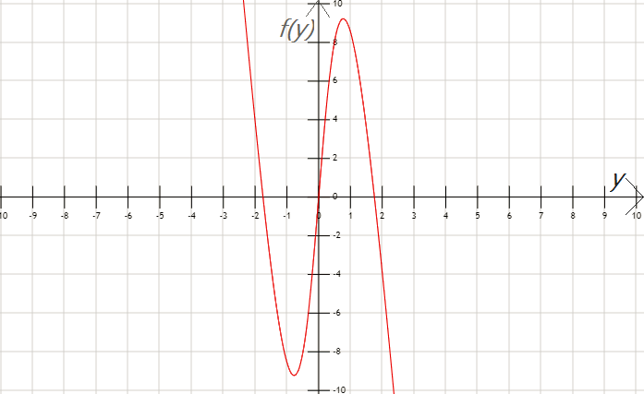

*gráfico f(y)*

|  |  |  |  |
| --- | --- | --- | --- |
| *Constante* | *Lo* | *k* | *a* |
| *Valor* | *2,02* | *10* | *1* |

Luego despejando *‘****y****’* obtenemos las raíces:

$y_{1}=0$, $y_{2,3}=±\sqrt{{L_{o}^{}}^{2}-1} ⇒ y_{2}=1,7532 , y_{3}=-1,7532$

Entonces el punto de equilibrio positivo es y = 1,7532

1. *Regula-Falsi*

Tablas de datos que resultan del algoritmo utilizado para este método:

|  |  |  |  |  |
| --- | --- | --- | --- | --- |
| k | $a_{k}$ | $b_{k}$ | $f(a_{k})$ | $f(b_{k})$ |
| 0 | 1 | 2 | 8.5671139 | -3.865141 |
| 1 | 1.68910375907 | 2 | 0.982278 | -3.865141 |
| 2 | 1.75210359838 | 2 | 0.045315 | -3.865141 |
| 3 | 1.75497631505 | 2 | 0.001970 | -3.865141 |
| 4 | 1.75510117367 | 2 | 8.546774e-05 | -3.865141 |
| 5 | 1.75510658887 | 2 | 3.706445e-06 | -3.865141 |
| 6 | 1.75510682370 | 2 | 1.607351e-07 | -3.865141 |
| 7 | 1.75510683389 | 2 | 6.970505e-09 | -3.865141 |
| 8 | 1.75510683433 | 2 | 3.022840e-10 | -3.865141 |
| 9 | 1.75510683435 | 2 | 1.310991e-11 | -3.865141 |

|  |  |  |  |  |  |
| --- | --- | --- | --- | --- | --- |
| k | $r_{k+1}$ | $Δr_{k+1}$ | $Δr/r$ | $λ$ | p |
| 0 | 1.689103759076 |  |  |  |  |
| 1 | 1.752103598381 | 6.299983930521e-02 | 3.595668621617e-02 |  |  |
| 2 | 1.754976315052 | 2.872716670955e-03 | 1.636897687070e-03 | 0.047599 | 1.015530 |
| 3 | 1.755101173678 | 1.248586260069e-04 | 7.114041508234e-05 | 0.043637 | 1.000683 |
| 4 | 1.755106588871 | 5.415192873670e-06 | 3.085392595530e-06 | 0.043382 | 1.000029 |
| 5 | 1.755106823709 | 2.348382885930e-07 | 1.338028463115e-07 | 0.043367 | 1.000001 |
| 6 | 1.755106833893 | 1.018408757325e-08 | 5.802545677894e-09 | 0.043366 | 0.999999 |
| 7 | 1.755106834335 | 4.416473853297e-10 | 2.516356136787e-10 | 0.043369 | 1.000003 |
| 8 | 1.755106834354 | 1.915245739780e-11 | 1.091241685287e-11 | 0.043328 | 1.000045 |
| 9 | 1.755106834355 | 8.304468224196e-13 | 4.731602693147e-13 |  |  |

1. *Punto Fijo*

Con la función que se pide en el enunciado: g(y) = y - f(y) el algoritmo resulta en *‘overflow’* lo que significa que no converge, esto se debe a que no cumple las condiciones del Teorema de punto fijo:

* No cumple con la primer condición del teorema (el valor de la función ‘*g*’ para todos los puntos del intervalo pertenecen a ese mismo intervalo):

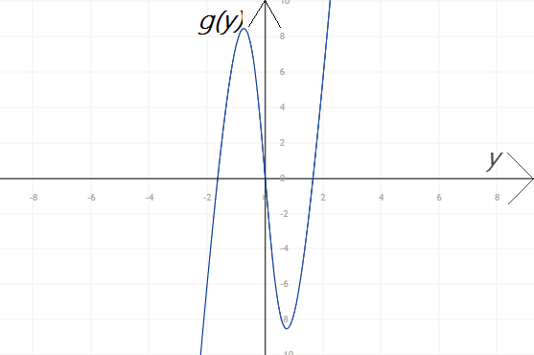

*gráfico: g(y) = y - f(y)*

* Tampoco se cumple con la segunda condición del teorema (el módulo de la derivada de la función ‘*g*’ es menor a 1 en todo el intervalo):

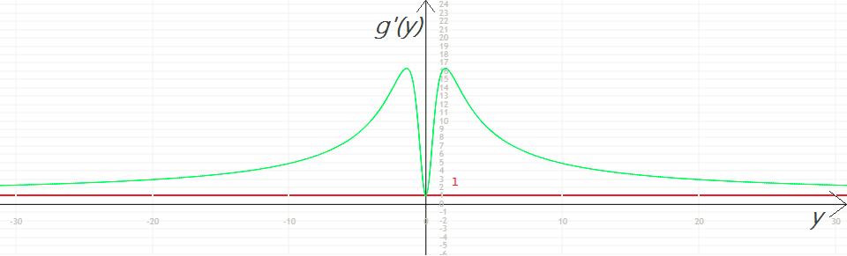

*gráfico: g’(y)*

1. *Newton-Rapson*

Tabla de datos que resultan del algoritmo utilizado para este método:

|  |  |  |  |  |  |
| --- | --- | --- | --- | --- | --- |
| k |  |  |  |  | p |
| 0 | 2.000000 |  |  |  |  |
| 1 | 1.764127 | 0.235873 | 0.133705 |  |  |
| 2 | 1.755124 | 0.009003 | 0.005129570 | 0.144976 | 1.923906 |
| 3 | 1.755107 | 1.681636e-5 | 9.581389e-6 | 0.205998 | 1.998489 |
| 4 | 1.755107 | 5.922995e-11 | 3.3747207e-11 |  |  |
| 5 | 1.755107 | 0.0 | 0.0 |  |  |

1. *Gráfico representativo del error relativo en todos los métodos empleados*

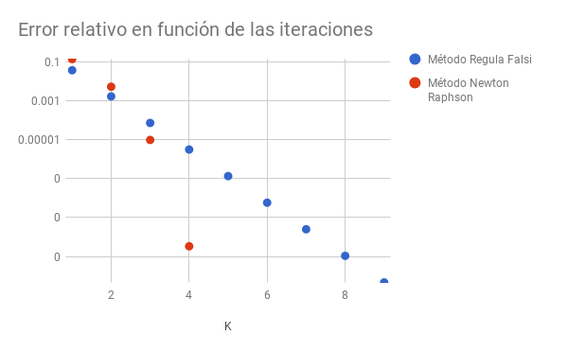

1. ***Todos los puntos de equilibrio del sistema, teniendo en cuenta el efecto de la gravedad.***

Teniendo en cuenta la gravedad nos queda la ecuación:

$f(y)=−2ky (1 −\frac{Lo}{\sqrt{y{}^{2}+a{}^{2}}}) -mg= 0$

Y sus raíces son las siguientes:

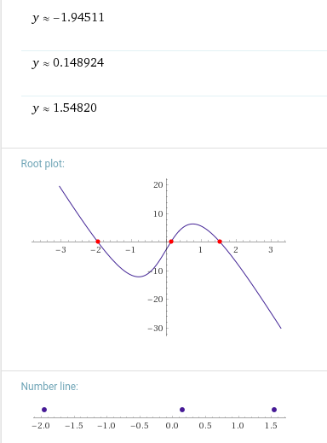

*gráfico de f(y)*

|  |  |  |  |  |  |
| --- | --- | --- | --- | --- | --- |
| *Constante* | *Lo* | *k* | *a* | *m* | *g* |
| *Valor* | *2,02* | *10* | *1* | *0,303* | *9,81* |

1. *Regula-Falsi*

Tablas de datos que resultan del algoritmo utilizado para este método:

*Primero busco el punto de equilibrio en el intervalo [1,2]*

|  |  |  |  |  |
| --- | --- | --- | --- | --- |
| k | $a_{k}$ | $b_{k}$ | $f(a_{k})$ | $f(b_{k})$ |
| 0 | 1 | 2 | 5.594684 | -6.837571 |
| 1 | 1.450014 | 2 | 1.285195 | -6.837571 |
| 2 | 1.537033 | 2 | 0.150678 | -6.837571 |
| 3 | 1.547016 | 2 | 0.015994 | -6.837571 |
| 4 | 1.548073 | 2 | 0.001679 | -6.837571 |
| 5 | 1.548184 | 2 | 0.000176 | -6.837571 |
| 6 | 1.548195 | 2 | 1.846E-5 | -6.837571 |
| 7 | 1.548196 | 2 | 1.936E-6 | -6.837571 |
| 8 | 1.548197 | 2 | 2.03E-7 | -6.837571 |
| 9 | 1.548197 | 2 | 2.128E-8 | -6.837571 |
| 10 | 1.548197 | 2 | 2.232E-9 | -6.837571 |
| 11 | 1.548197 | 2 | 2.340E-10 | -6.837571 |
| 12 | 1.548197 | 2 | 2.453E-11 | -6.837571 |

|  |  |  |  |  |  |
| --- | --- | --- | --- | --- | --- |
| k | $r_{k+1}$ | $Δr_{k+1}$ | $Δr/r$ | $λ$ | p |
| 0 | 1.450014 |  |  |  |  |
| 1 | 1.537033 | 0.0870196 | 0.0566153 |  |  |
| 2 | 1.547016 | 0.0099823 | 0.0064526 | 0.125540 | 1.036938 |
| 3 | 1.548073 | 0.0010571 | 0.0006828 | 0.107836 | 1.003941 |
| 4 | 1.548184 | 0.0001110 | 7.1668e-5 | 0.105261 | 1.000414 |
| 5 | 1.548195 | 1.1636e-5 | 7.5154e-6 | 0.104907 | 1.000043 |
| 6 | 1.548196 | 1.2200e-6 | 7.8803e-7 | 0.104860 | 1.000005 |
| 7 | 1.548197 | 1.2792e-7 | 8.2628e-8 | 0.104854 | 1.000000 |
| 8 | 1.548197 | 1.3413e-8 | 8.6638e-9 | 0.104853 | 0.999999 |
| 9 | 1.548197 | 1.4064e9 | 9.084e-10 | 0.104854 | 1.000000 |
| 10 | 1.548197 | 1.4747e-10 | 9.525e-11 | 0.104842 | 0.999994 |
| 11 | 1.548197 | 1.5463e-11 | 9.988e-12 | 0.105143 | 1.000121 |
| 12 | 1.548197 | 1.6209e-12 | 1.047e-12 |  |  |

*Luego busco el punto de equilibrio en el intervalo [0,1]*

|  |  |  |  |  |
| --- | --- | --- | --- | --- |
| k | $a_{k}$ | $b_{k}$ | $f(a_{k})$ | $f(b_{k})$ |
| 0 | 0 | 1 | -2.97243 | 5.5946839 |
| 1 | 0 | 0.346958 | -2.97243 | 3.3310842 |
| 2 | 0 | 0.163609 | -2.97243 | 0.2784571 |
| 3 | 0 | 0.149595 | -2.97243 | 0.0127892 |
| 4 | 0 | 0.148954 | -2.97243 | 5.5698e-4 |
| 5 | 0 | 0.148926 | -2.97243 | 2.4197e-5 |
| 6 | 0 | 0.148924 | -2.97243 | 1.0511e-6 |
| 7 | 0 | 0.148924 | -2.97243 | 4.5659e-8 |
| 8 | 0 | 0.148925 | -2.97243 | 1.9833-9 |
| 9 | 0 | 0.148924 | -2.97243 | 8.6155-11 |
| 10 | 0 | 0.148924 | -2.97243 | 3.7418-12 |

|  |  |  |  |  |  |
| --- | --- | --- | --- | --- | --- |
| k | $r_{k+1}$ | $Δr_{k+1}$ | $Δr/r$ | $λ$ | p |
| 0 | 0.346958 |  |  |  |  |
| 1 | 0.163609 | 0.1833496 | 1.1206602 |  |  |
| 2 | 0.149595 | 0.0140140 | 0.0936799 | 0.107261 | 1.199749 |
| 3 | 0.148954 | 6.4088e-4 | 4.3026e-3 | 0.0489426 | 1.015899 |
| 4 | 0.148926 | 2.7906-5 | 1.8738e-4 | 0.043778 | 1.000731 |
| 5 | 0.148924 | 1.2123-6 | 8.1406e-6 | 0.043457 | 1.000032 |
| 6 | 0.148924 | 5.2662-8 | 3.5362e-7 | 0.043440 | 1.000001 |
| 7 | 0.148924 | 2.2876-9 | 1.5360e-8 | 0.043439 | 1.000000 |
| 8 | 0.148924 | 9.937e-11 | 6.673e-10 | 0.043439 | 1.000001 |
| 9 | 0.148924 | 4.316e-12 | 2.898e-11 | 0.043466 | 1.000028 |
| 10 | 0.148924 | 1.875e-13 | 1.259e-12 |  |  |

*Y por último busco el punto de equilibrio en el intervalo [-2,0]*

|  |  |  |  |  |
| --- | --- | --- | --- | --- |
| k | $a_{k}$ | $b_{k}$ | $f(a_{k})$ | $f(b_{k})$ |
| 0 | -2 | 0 | 0.892711 | -2.97243 |
| 1 | -2 | -1.538070 | 0.892711 | -6.081584 |
| 2 | -2 | -1.940873 | 0.892711 | -0.068365 |
| 3 | -2 | -1.945079 | 0.892711 | -5.3047e-4 |
| 4 | -2 | -1.945112 | 0.892711 | -4.1023e-6 |
| 5 | -2 | -1.945112 | 0.892711 | -3.1724e-8 |
| 6 | -2 | -1.945112 | 0.892711 | -2.453e-10 |
| 7 | -2 | -1.945112 | 0.892711 | -1.899e-12 |

|  |  |  |  |  |  |
| --- | --- | --- | --- | --- | --- |
| k | $r_{k+1}$ | $Δr_{k+1}$ | $Δr/r$ | $λ$ | p |
| 0 | -1.538070 |  |  |  |  |
| 1 | -1.940873 | 0.402802 | 0.207536 |  |  |
| 2 | -1.945079 | 4.2059e-3 | 2.1624e-3 | 0.011079 | 1.065218 |
| 3 | -1.945112 | 3.2616e-5 | 1.6768e-5 | 0.007779 | 1.000567 |
| 4 | -1.945112 | 2.5223e-7 | 1.2967e-7 | 0.007733 | 1.000004 |
| 5 | -1.945112 | 1.9506e-9 | 1.0028e-9 | 0.007733 | 0.999999 |
| 6 | -1.945112 | 1.508e-11 | 7.755e-12 | 0.007693 | 0.999742 |
| 7 | -1.945112 | 1.1679e-13 | 6.0046e-14 |  |  |

1. *Punto Fijo*

Con la función que se pide en el enunciado: g(y) = y - f(y) el algoritmo resulta en *‘overflow’* lo que significa que nuevamente no converge, esto hace qué sea imposible hallar las raíces con esta función g(y).

Analizamos este resultado gráficamente y pudimos observar:

* La función g(y) cumple con la primer condición del teorema de punto fijo, es decir, el valor de la función en un intervalo, pertenecen a ese intervalo (I = [-4;-4]).

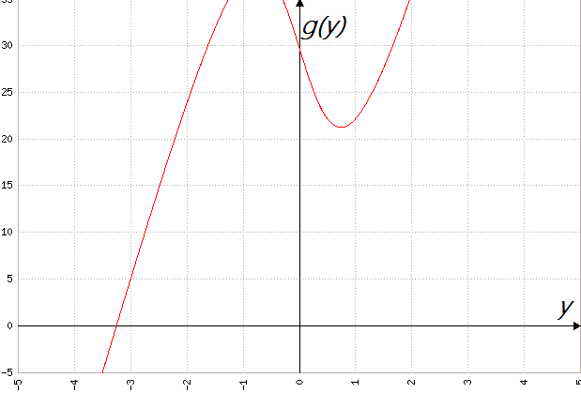

*gráfico g(y)*

* Luego observamos que la función g(y) no cumple con la segunda condición, ya que el valor de la derivada en módulo, en todo ese mismo intervalo, no es menor a uno.

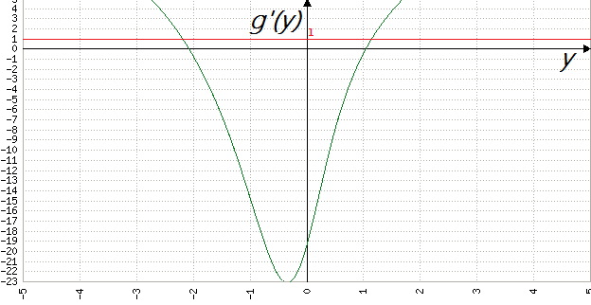

*gráfico g’(y)*

1. *Newton-Rapson*

Tabla de datos que resultan del algoritmo utilizado para este método:

*Busco el punto de equilibrio utilizando como semilla el [2]*

|  |  |  |  |  |  |
| --- | --- | --- | --- | --- | --- |
| k |  |  |  |  | p |
| 0 | 2.000000 |  |  |  |  |
| 1 | 1.582732 | 0.417268 | 0.263638 |  |  |
| 2 | 1.548563 | 0.034169 | 0.022065 | 0.166622 | 1.812764 |
| 3 | 1.548197 | 3.666e-4 | 2.364e-4 | 0.304907 | 1.991735 |
| 4 | 1.548197 | 4.362e-8 | 2.817e-8 | 0.305392 | 1.991936 |
| 5 | 1.548197 | 6.66e-16 | 4.30e-16 |  |  |

*Luego busco el punto de equilibrio utilizando como semilla el [0.5]*

|  |  |  |  |  |  |
| --- | --- | --- | --- | --- | --- |
| k |  |  |  |  | p |
| 0 | 0.5 |  |  |  |  |
| 1 | -0.071965 | 0.571964 | 7.947824 |  |  |
| 2 | 0.148713 | 0.220678 | 1.483919 | 13.01298 | 7.297588 |
| 3 | 0.148924 | 2.115e-4 | 0.001420 | 0.001586 | 1.333242 |
| 4 | 0.148924 | 2.001e-8 | 1.343e-7 | 0.414793 | 1.991138 |
| 5 | 0.148924 | 1.94e-16 | 1.30e-15 |  |  |

*Y por último busco el punto de equilibrio utilizando como semilla [-2]*

|  |  |  |  |  |  |
| --- | --- | --- | --- | --- | --- |
| k |  |  |  |  | p |
| 0 | -2 |  |  |  |  |
| 1 | -1.945522 | 0.054478 | 0.028002 |  |  |
| 2 | -1.945112 | 4.0979e-4 | 2.1068e-4 | 0.133625 | 1.988743 |
| 3 | -1.945112 | 2.4499e-8 | 1.2595e-8 | 0.069165 | 1.904314 |
| 4 | -1.945112 | 2.220e-16 | 1.141e-16 |  |  |

1. *Gráfico representativo del error relativo en función de las iteraciones*

*Para el punto de equilibrio [1.54820]:*

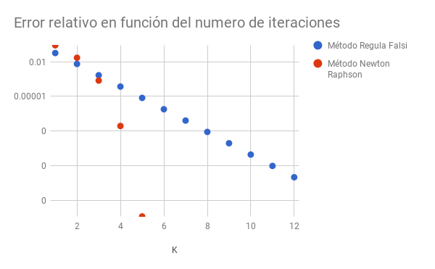

*Para el punto de equilibrio [0.14892]:*

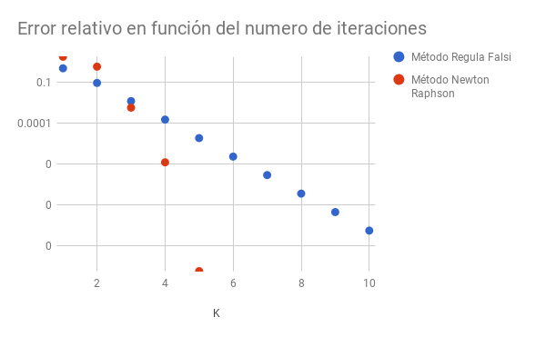

*Para el punto de equilibrio [1.54820]:*

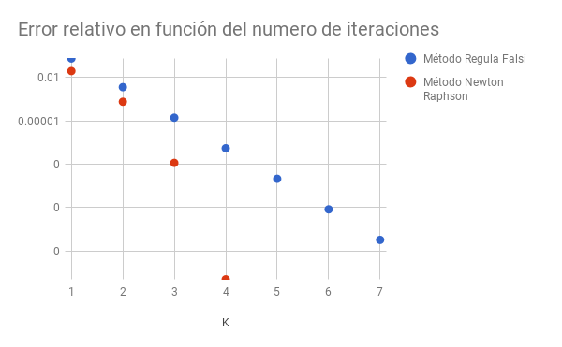

1. *Comparaciones entre punto* 1) *y* 2) *:*

*El comportamiento de los tres métodos fue el mismo en ambos casos, y esto se puede apreciar en los gráficos. El método Regula-Falsi siempre fue acercándose al resultado, lento pero seguro con orden uno. En cambio Newton-Raphson comenzaba las primeras iteraciones con un error mayor qué el Regula-Falsi, pero rápidamente lo corregía y terminaba en muchas menos iteraciones y un menor error. En estos casos no se pudo aplicar la fórmula de Punto Fijo qué g(y) qué ustedes nos proveyeron ya qué, como explicamos anteriormente y mostramos a partir de gráficos, está no converge y por éste motivo nunca llega a encontrar las raíces.*

1. ***Máximo intervalo de convergencia.***
2. ***Todos los puntos de equilibrio del sistema, con método Newton-Rapson en cada caso:***

|  |  |  |  |  |  |  |
| --- | --- | --- | --- | --- | --- | --- |
| *m* | *0* | $0.3*m_{0}$ | $0.6*m_{0}$ | $0.9*m_{0}$ | $1.2*m_{0}$ | $1.5*m_{0}$ |
| *raiz 1* |  |  |  |  |  |  |
| *raiz 2* |  |  |  |  |  |  |
| *raiz 3* |  |  |  |  |  |  |
| *raiz 4* |  |  |  |  |  |  |
| *raiz 5* |  |  |  |  |  |  |
| *raiz 6* |  |  |  |  |  |  |
| *raiz 7* |  |  |  |  |  |  |
| *raiz 8* |  |  |  |  |  |  |
| *raiz 9* |  |  |  |  |  |  |
| *raiz 10* |  |  |  |  |  |  |