Project 2 Report

# Problem 1:

For this problem I started with the base code and implemented the Matrix Multiplication program in the same way as the matrix vector multiplication program. The code where I multiplied the two matrixes is shown below.

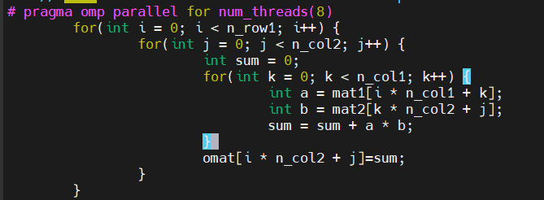

I ran first without parallelization and secondly with parallelization with the following results.

**Without Parallelization:**

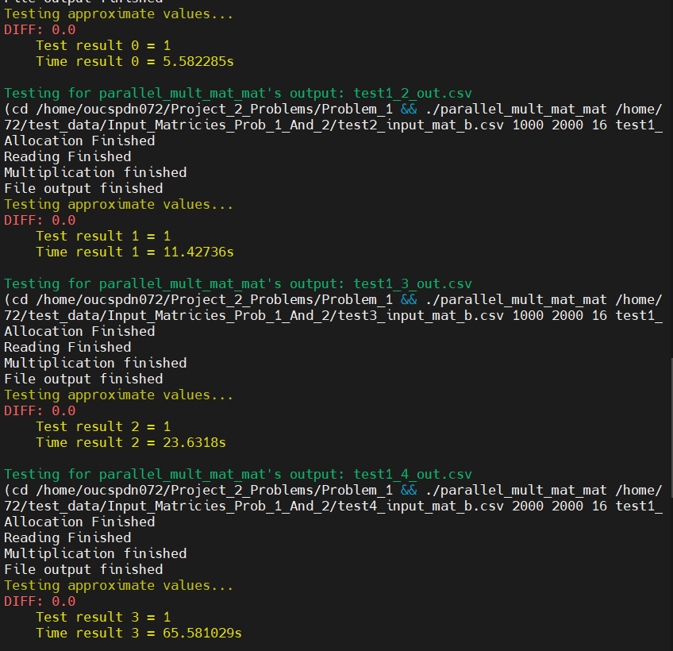

**With parallelization:**

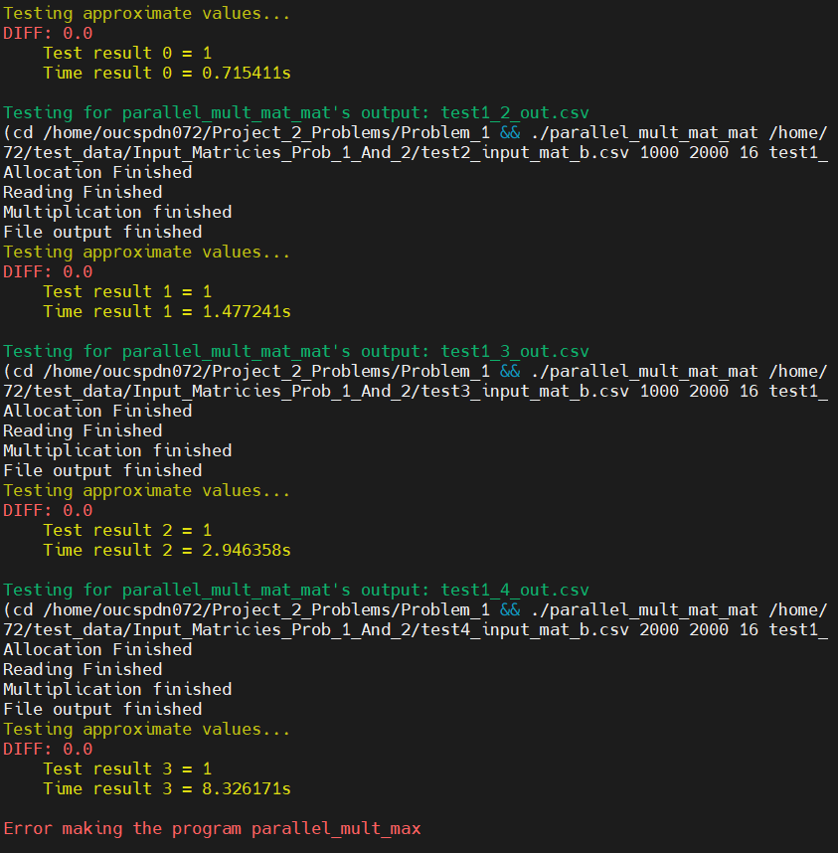

The two outputs shows that parallelization dramatically increases the execution time.

|  |  |  |  |  |
| --- | --- | --- | --- | --- |
| Runtime | Test 1 | Test 2 | Test 3 | Test 4 |
| p = 1 |  |  |  |  |
| p = 2 |  |  |  |  |
| p = 4 |  |  |  |  |
| p = 8 |  |  |  |  |

|  |  |  |  |  |
| --- | --- | --- | --- | --- |
| Speedup | Test 1 | Test 2 | Test 3 | Test 4 |
| p = 1 |  |  |  |  |
| p = 2 |  |  |  |  |
| p = 4 |  |  |  |  |
| p = 8 |  |  |  |  |

|  |  |  |  |  |
| --- | --- | --- | --- | --- |
| Efficiency | Test 1 | Test 2 | Test 3 | Test 4 |
| p = 1 |  |  |  |  |
| p = 2 |  |  |  |  |
| p = 4 |  |  |  |  |
| p = 8 |  |  |  |  |

# Problem 2a:

# Problem 2b:

# Problem 3:

# Problem 4: