NetGraphz2

Monitoring system interface
Contents
Monitoring system interface 1
Introduction 3
Structure 4
Application 5
Web front-end 5
Client JavaScript 6
Notifications server 7
Graph API 7
Tools 8
Icinga2 host configuration stubs generator 8
Icinga2 scripts and configurations 8
Installation 9
Unpacking 9
Preparation of prerequisites 9
Neo4j web shell 11
Neo4j shell configuration 11
Neo4j adding nodes and links 11
MongoDB 12
Linking Icinga2 12
Preconfiguration 13
Notifications server 13
Final steps 13
Configuration 14
Web front-end 14
Information section 15
MongoDB section 15
Neo4j section 15
MKLiveStatus section 16
Application section 16
JavaScript user interface 17
Communication section 18
Updater section 18
Renderer section 18
Layout 19
UI section 20
Node panel 20
Links in node panel 20
Tab stop 21
Notifications 21
Search 21
Notifications server 22
Icinga2 scripts HTTP API (RPC) settings 22
Neo4j NetGraphz settings 22
Server section 22
Neo4j Node and Relationship properties 23
Hosts 23
Links 23
Usage 24
Troubleshooting 25
Neo4j 25
MongoDB 27
Notifications server 29
Contacts 30

Introduction
NetGraphz2 — web-based interface for Icinga 2 monitoring system to provide visual graph-like overview of network, replacing static status map. It allow users interact with graph, see how nodes connected between. Such representation allows to find possible outages quickly, analyze weak points of network. Placing nodes in comfortable position using layout algorithm allows user to see clusters of nodes, which may represent connection points in real life.
Application goal is not to represent nodes on real geographical map. We believe that people remember connections much quicker than real world map. Evolution made a big gift for us humans giving us abstract associative memory abilities.
Program uses information from existing monitoring system (Icinga 2) using it's opened interface (MK LiveStatus). It stores graph separately from monitoring system configuration. It's not hardly connected to specific monitoring system.
Nodes and links are stored in graph database (neo4j) which allows application to do such actions as graph traversing really quick. It allows to easily automatically generate monitoring system configuration snippets starting from specific nodes using DFS.
Main web-interface is built on JavaScript. Rendering of graph performed by Cytoscape.js library which is leading library for graph draw and interaction. Additionally we use many other libraries under open license. Full list of used JavaScript libraries available at the document. At the same time structure of application own JS in pretty complex, but we don't use any sort of Bower, Require.js, AMD. We don't think that it's too much clever decision.
Structure of application is partial. There is no central daemon which handles all application life cycle. NetGraphz2 based on several components connected between using internal API. Messaging are passing between configured systems.
The main goal of our project is to provide people good, reliable, fast tool to find out problems in theirs difficult network. Visual interface is the primary priority of project. Without ability to see network from bird-eye view you can't make clever decision about future upgrade and development plan. When you have lack of maps, you don't know anything that might happen. We are here to solve this problem using well-tested, reliable technologies and solutions.
We want to TRY make your network management easy as possible!

NetAssist LLC
2015

Structure
Application solution consists of several applications liked by API. As it was said above, there is no central daemon which controls application life cycle. So, we don't use such way.
At the opposite we have several parts and utilities with own role:
- Web-site (PHP 5.6, Phalcon) — Used to deliver pages, summary information, graph with correct nodes location to end users. We use it as back-end for end users. Site is written following MVC pattern, repository pattern and many others. We believe that good and documented code is what we need there. (folder: web-phalcon)
  - Client JS — core of visualization. Used to show graph, navigate through, search through and many more. It receives nodes from web-site, builds graph for use. It uses Cytoscape.js to perform node rendering and interaction. (folder: web-phalcon/public/js)
- Notifications server (Node.js) – Receives notification from monitoring system (Icinga) using it's RESTful API and monitoring notifications scripts. Gets node identifier, information and forwards notifications to users though WebSocket or AJAX LongPoll, also forwards chat messages from users. (folder: notifications)
- Graph API (Node.js) – Small RESTful API to manage graph nodes and links (folder: api)
- Icinga2 configuration generator (python) – Utility to generate configuration, traversing graph from root node using DFS. (folder: icinga_config_generator)
- Icinga2 notifications scripts (Node.js) – scripts to forward notifications from Icinga 2 to the notifications server
- Icinga2 include configurations example – sample configurations files to set up interactions between notifications server and monitoring system.

Application

Web front-end
Web interface front-end located in web-phalcon folder. It consists of several parts and uses MVC pattern. We use Phalcon 2.0.3 framework to build page, so it should be installed in order to install NetGraphz2.
In the root folder of web-front end you may find such folders:
- app — contains Phalcon applications source files (Controllers, View, Models) and code to access MKLiveStatus service.
- public — contains files to be sent to the user browser including JavaScript user interface
Let's take a look on front-end role. It is just simple, it gives user information about host from graph database and connects existing nodes to monitoring system data. Front-end application works as visualization: client JS part role — visual interaction, server part — data combining.
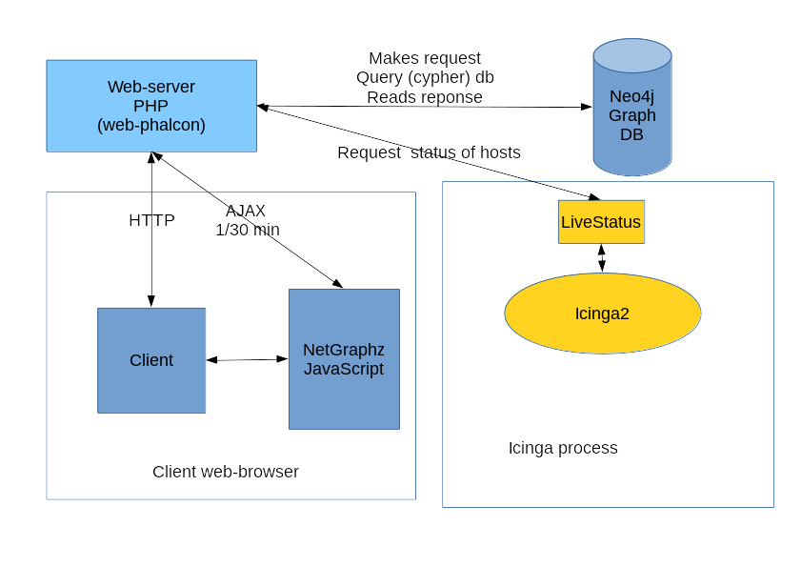Fig 1: Front-end site role
Front-end user configuration like node positions, user interface preferences, etc is stored in the MongoDB database. It gives the way to get and store such data in the fastest way.

Client JavaScript
One of the most important part is client JavaScript user interface. Uses Cytoscape.js, jQuery, jQuery UI, socket.io-client and few other 3-rd party libraries. All netgraphz JavaScript code located in web-phalcon/public/js/netgraphz folder It split into modules:
- communication.js – Server notifications handler
- core.js – Core definitions and constants
- eventbus.js – Event bus interface to implement publisher-subscriber pattern
- fetcher.js – Graph fetching functions
- graph_utils.js – Useful functions to work with graph states
- main.js – Provides application start-up sequence
- renderer.js – Interface for cytoscape.js renderer
- settings.js – Contains settings for client scripts
- store.js – In-memory storage for nodes, links and states
- tools.js – Basic tools like JS-object extend, deep extend, etc
- ui.js – User-interface functions and event-listeners
- ui.notifications.js – Notifications UI
- ui.panel.js – Node/link information panel UI functionality
- ui.search.js – Node search functionality (search field)
- ui.tabstop.js – TAB key problem navigation functionality
- updater.js – Automatic update of graph
Client JavaScript provides verbose error, information console output for browser. You can find out what's going wrong into browser developer console.
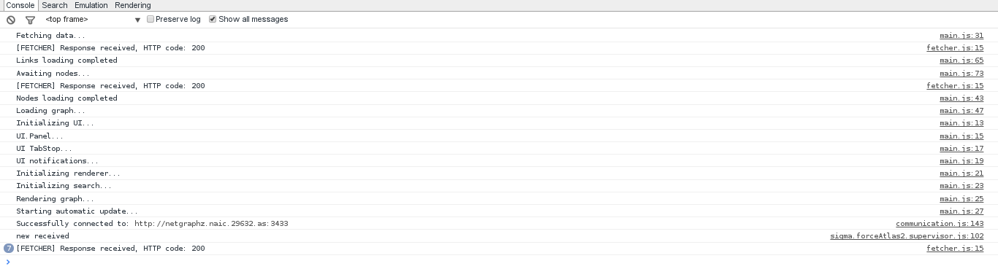Fig 2: JavaScript console output

Notifications server
Forwards notifications between connected users, located in notifications folder. Works on Node.js IO framework which is designed for such use cases. Uses netgraphz2 node.js database library located in node_netgraphz2 folder
Handles web-socket or long-poll connections on port 3433 by default by sending JSON objects to connected clients about current events. Also listens 3434 port by default for Icinga script calls.
Configuration of the server located in config.json file.
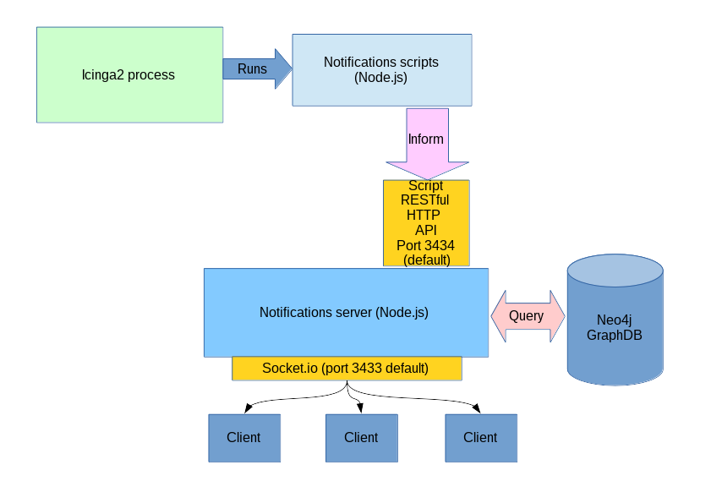Fig 3: Notifications server flowchart

Graph API
Still in development, will be published in api folder. Will use same JavaScript IO framework as run-time and same library as notifications server. Needed to update graph using RESTful API requests. Documentation about this application part will be published later…

Tools
Application also contains few additional tools for deployment purposes.

Icinga2 host configuration stubs generator
Can be used to create Icinga2 host configurations automatically starting from some root host using DFS. Located in icinga/config_generator directory, requires few additional Python modules to get started (look into installation section).
Configuration generation is long-time process: it might take 5 minutes to fully finish utility execution (depends from graph size).
Tool uses two files: host_template.cfg, dependency_template.tpl – host and host dependencies templates in order to generate configurations.
Tool configuration sample file can be found config.json file. Prints following help message when started with --help argument:
usage: generator [-h] [-v] config_file.json output_folder start_host

Icinga config generator from nodes graph database

positional arguments:
config_file.json Configuration JSON file path (see README and manual)
output_folder Output folder for config files
start_host Starting host for DFS graph scanning

optional arguments:
-h, --help show this help message and exit
-v, --version show program's version number and exit
It generates only host stubs using ip_address and icinga_name graph nodes properties! So, be careful and always backup old Icinga2 host configuration!

Icinga2 scripts and configurations
Located in icinga folder. Needed to connect Icinga2 hosts and services notifications mechanism to NetGraphz2 system. Configuration of scripts located in icinga/scripts/config.json file.
Additional required Icinga2 configurations provided in icinga/conf.d folder.
Script and configuration installation shown in installation section.

Installation
System installation is easy to do, but requires few manual steps

Unpacking
- Unpack distribution package into /opt/netgraphz2 directory on your server.
- Consider changing PATH variable value to make easier to manage NetGraphz2Graph configuration

Preparation of prerequisites
- Install Icinga 2 (https://www.icinga.org/download/), neo4j (http://neo4j.com/download/), node.js >= 0.10.29 (https://nodejs.org/download/), MongoDB (https://www.mongodb.org/) Python 2.7.5 with Python development files (https://www.python.org/downloads/), Icinga2 LiveStatus plugin service (included in disribution)
For Debian Jessie or later I recommend to install it from packages:
# wget -O - https://debian.neo4j.org/neotechnology.gpg.key | apt-key add -
# echo 'deb http://debian.neo4j.org/repo stable/' >/etc/apt/sources.list.d/neo4j.list
# echo 'deb http://http.debian.net/debian jessie-backports main' > /etc/apt/sources.list.d/backports.list
# wget -O - http://packages.icinga.org/icinga.key | apt-key add -
# echo 'deb http://packages.icinga.org/debian icinga-jessie main' > /etc/apt/sources.list.d/icinga.list
# echo 'deb-src http://packages.icinga.org/debian icinga-jessie main' >> /etc/apt/sources.list.d/icinga.list
# apt-get update
# apt-get install neo4j icinga2 mongodb python python-dev python-pip nodejs
- Install Python additional modules (needed to start toolkit). Run following command:
# pip install MySQL-python py2neo
- Install Apache2 HTTPd >= 2.6 web-server (http://httpd.apache.org/download.cgi).
Debian Jessie +:
# apt-get install apache2
- Install PHP 5.6 + FPM enabling JSON, Imagick, GD, memcached, rrd, Mcrypt extensions:
Debian Jessie +:
# apt-get install php5-dev php5 php5-fpm php5-mongo php5-json php5-mysql php5-imagick php5-intl php5-gd php5-memcache php5-memcached php5-rrd php-pear php5-mcrypt
- Enable Apache2 FastCGI proxy extension, enable path rewriting in web-server configuration (e.g mod_rewrite, mod_proxy_fcgi in Apache2).
# a2enmod rewrite
# a2enmod proxy_fcgi
- Install PHP Phalcon module (https://phalconphp.com/en/download), follow instruction on Phalcon developers site.
After buidling and installation of phalcon enable it as PHP module. For Debian Jessie+:
# echo 'extension=phalcon.so' > /etc/php5/mods-available/phalcon.ini
# php5enmod phalcon
- Install some PHP packages from PECL:
# pecl install SPL_Types
Enable SPL_Types module in PHP configuration (add extension=spl_types.so into php configuration)
Debian Jessie +:
# echo 'extension=spl_types.so' > /etc/php5/mods-available/spl_types.ini
# php5enmod spl_types
- Configure FPM:
Set listening TCP port to 9000 for pool (/etc/php5/fpm/pool.d/www.conf in Debian).
listen = 127.0.0.1:9000
and comment or delete line
listen = /var/run/php5-fpm.sock
Change automatic restart parameters (PHP sometimes falls down with SEGV) for daemon (/etc/php5/fpm/php-fpm.conf in Debian):
emergency_restart_threshold = 2
emergency_restart_interval = 5s
- Configure Apache2 site for NetGraphz2. Copy basic site definition (001-netgraphz2.conf) from apache2 subfolder of the installation directory to your apache2 site-available directory (/etc/apache2/sites-available).
Edit copied site definition file in the apache2 directory
Change ServerName, DocumentRoot, ServerAdmin, Directory section path and ProxyPassMatch to your actual values.
Enable NetGraphz2 site:
# a2ensite 001-netgraphz2
- Restart PHP FPM and web-server itself
Debian Jessie +:
#service apache2 restart
#service php5-fpm restart

Neo4j web shell
Once you have installed neo4j, you can enter neo4j web interface by following http://[your server address]:7474/ URL. Here you may change default access credentials and execute some Cypher queries.
We recommend to use neo4j shell which is more powerful and less fancy. You may find instructions how to enable it below.

Neo4j shell configuration
Before starting manipulating graph database we recommend to enable neo4j shell on localhost. In order to make shell works in Debian Jessie edit /etc/neo4j/neo4j.properties neo4j configuration file and uncomment following sections:
remote_shell_enabled=true
remote_shell_host=127.0.0.1
remote_shell_port=1337
Then, you should save modifications to file and restart neo4j service. In Debian you can use following command:
# service neo4j restart
Now you should be able to use neo4j-shell.
# neo4j-shell
Shell should start and print output like:
Welcome to the Neo4j Shell! Enter 'help' for a list of commands
NOTE: Remote Neo4j graph database service 'shell' at port 1337

neo4j-sh (?)$
Now you can quit from the shell: type quit and press Enter.

Neo4j adding nodes and links
To add nodes and links, you should use Cypher queries (API still in development, sorry). Information about Cypher query language is available from neo4j manual:
http://neo4j.com/docs/stable/cypher-introduction.html
http://neo4j.com/docs/stable/cypher-getting-started.html
http://neo4j.com/docs/stable/cypher-query-lang.html

Information about all visible attributes is available in “Neo4j Node and Relationship properties”.
To execute query, run neo4j-shell utility. Example queries to make node and links.
$ cypher
CREATE (n:NetAssistNode {name: 'naic.29632.as', ip_address: '205.162.49.41', icinga_name: 'netgraphz2 server'}) RETURN n;
$ cypher
MATCH (n:NetAssistNode), (m:NetAssistNode) WHERE n.name='sw-core-1g' AND m.name='netgraphz2 server' CREATE (n)-[r:LINKS_TO]->(m) RETURN r;
$ cypher
MATCH (n:NetAssistNode), (m:NetAssistNode) WHERE n.name='sw-core-1g' AND m.name='netgraphz2 server' CREATE (m)-[r:LINKS_TO]->(n) RETURN r;
This set of queries would create node with single attribute name (value 'netgraphz2 server') and link it to existing node with name 'sw-core-1g' (if such node exists).

MongoDB
To get NetGraphz2 user accounts working, you should install MongoDB database dump into your MongoDB server. To install working database dump run mongorestore command from mongo directory relative to the installation location. It will import installation database to database name 'netgraphz2'.
# cd mongo
# mongorestore
Access to the MongoDB is available though the mongo CLI application.

Linking Icinga2
- After installation of Icinga2 monitoring system, enable Icinga2 MKLiveStatus extension (https://github.com/Icinga/icinga2/blob/master/doc/15-livestatus.md). Place LiveStatus configuration file into /etc/icinga2/conf.d/livestatus.conf with following contents:
library "livestatus"
object LivestatusListener "livestatus-tcp" {
socket_type = "tcp"
bind_host = "127.0.0.1"
bind_port = "6558"
}
object LivestatusListener "livestatus-unix" {
socket_type = "unix"
socket_path = "/var/run/icinga2/cmd/livestatus"
}
The following configuration will assign listening address to 127.0.0.1 and listening port to 6558 (TCP) and unix socket to /var/run/icinga2/cmd/livestatus. It's possible to choose other ports if you configure web-application correctly.
- Configure Icinga2 scripts (/opt/netgraphz2/icinga_scripts/config.json). Default port of notifier API is set to be 3434 TCP.
- Link Icinga2 configuration directories:
# cd <Icinga2 configuration path> - mostly /etc/icinga2
# ln -s /opt/netgraphz2/icinga/scripts/ scripts.netgraphz2
# ln -s /opt/netgraphz2/icinga/conf.d/ netgraphz2.d
Edit icinga2.conf:
Add line:
include_recursive "netgraphz2.d"
- OPTIONAL: Generate Icinga2 configuration stubs from existing graph database using utility located in /netassist/netgraphz2/icinga/config_generator directory (look in “Icinga2 host configuration stubs generator” subsection)
- Add your hosts configuration into Icinga2 and restart Icinga2

Preconfiguration
Read configuration section of this manual to understand configuration variables meaning.
- Configure web interface (/opt/netgraphz2/web-phalcon/app/config/config.php).
- Configure notifications server (/opt/netgraphz2/notifications/config.json).
- Configure client JavaScript (/opt/netgraphz2/web-phalcon/public/js/netgraphz/settings.js). Don't forget to change notification server URL!

Notifications server
- If you using systemd startup system, you can use provided service definition located in systemd/netgraphz2.notifications.service file relative to your installation directory. First of all, edit it and change default path of /opt/netgraphz2 if you have another installation directory. Then, copy a service definition file to your /lib/systemd directory and execute following command:
# systemctl enable netgraphz2.notifications
Service will be installed in your system and enabled in autostart.
- Start notifier daemon #[nodejs or node] /opt/netgraphz2/app.js. If you use systemd and installed service following to the previous step, just execute:
# systemctl start netgraphz2.notifications

Final steps
- Open web-browser and enter NetGraphz2 web-site address, register you personal account.
- Sign into your account, wait simulation to finish and save preferred nodes positions
- Enjoy NetGraphz2

Configuration

Web front-end
Web front-end Phalcon-based application is configured by main configuration file located in /web-phalcon/app/config/config.php relative to your installation path. This Phalcon application configuration file, it uses PHP array syntax to specify configuration variable values. Most of server-side parameters like neo4j database connection, MongoDB connection, company information, Icinga2 LiveStatus connection address and port. Configuration variables names are case sensitive!
Configuration syntax look like:
<?php
...
return new \Phalcon\Config(array(
'information' => array(
'companyName' => 'My company',
'siteName' => 'NetGraphz2',
'icingaUrl' => '/icinga2-classicui',
'openSignUp' => true
),
...
?>
It consist of several section represented as PHP arrays. Syntax should be valid PHP,
Every option described below should be specified. Don't change some default values of 'application' configuration section unless you don't imagine how it may affect application stablity and performance

Information section
Section called 'information'. Here you can change company information and global page title. These parameters are not quit important for application functionality. The main possible usage is distringuishing different NetGraphz2 installations.
Variable name | Description | Type | Example (default)
companyName | Specifies company name shown on all pages of the web-application | string | 'NetAssist'
siteName | Name of site appended to the page title | string | 'Our NetGraphz'
icingaUrl | URL of Icinga2 web interface (link shown in the top menu) | string | 'http://example.com/icingaweb2'
openSignUp | Allow to signup by follow sign up link (true/false). | boolean | true

MongoDB section
Section called 'mongo'. Enter your MongoDB connection configuration here. This section is very short comparing to the rest of configuration.
Variable name | Description | Type | Example (default)
connectionString | PHP MongoDB driver connection string: host, port and additional network options. For more information and options follow MongoDB reference manual section here: https://docs.mongodb.org/manual/reference/connection-string/ .  Don't forget to specify connectTimeoutMS option to avoid page hungs if MongoDB goes down. | string | 'mongodb://localhost:27017/?connectTimeoutMS=1200'
database | Database to use | string | 'netgraphz2'
options | Additional MongoDB driver options. Reserved for future usage. Leave as empty PHP array. | php  array | array ()

Neo4j section
Section is called 'graph'. It's designed to enter your neo4j server paremeters.
Variable name | Description | Type | Example (default)
host | Neo4j database server host name | string | 'localhost'
port | Neo4j HTTP RESTful API port | integer | 7474
auth | Set's flag is HTTP Authentication required for Neo4j API | boolean | true
username | Neo4j HTTP Authentication username | string | 'neo4j'
password | Neo4j HTTP Authentication password | string | 'changed'
scheme | URL scheme to be used to access Neo4j API. Possible values are 'http' and 'https' for SSL encrypted connection (recommended for remote hosts) | string | 'http'

MKLiveStatus section
This section specifies MKLiveStatus parameters to communicate with Icinga2 proccess through the PHP stream socket API. It's called simply 'livestatus'. If this section is misconfigured, you'll get always grey nodes. Check out web-server log and PHP stderr output to find out connection problems (see «Troubleshooting» section). There is two possible ways to connect: unix sockets and TCP/IP socket.
Variable name | Description | Type | Example (default)
host | MKLiveStatus hostname | string | 'localhost'
port | MKLiveStatus TCP port (in case of TCP connection) | integer | 6558
keepAlive | Try to keep socket connection alive for future reusage and faster request processing like connection pool | boolean | false
authEnable | Sets if MKLiveStatus request 'auth' parameter used sent during each request. It's not implemented fine in any of MKLiveStatus implementation yet, so it's not used in practice yet. | boolean | false
authUser | MKLiveStatus authentication user parameter (optional). Leave empty if you not using auth parameters | string | ''
unixSocket | Use UNIX domain sockets to connect to the MKLiveStatus plugin. Using TCP/IP connection by default. | boolean | false
unixSocketPath | UNIX domain socket file path. Leave empty if you not using UNIX sockets (connect using TCP/IP connection). | string | '/var/run/icinga2/livestatus.sock'

Application section
Phalcon 'application' section provides mostly framework speicific configuration options. Some of them are quit important and should be changed to make application work properly.
Variable name | Description | Type | Example (default)
controllersDir  modelsDir  migrationsDir  viewsDir  pluginsDir  libraryDir  cacheDir  graphDir  ... | Phalcon application component directories. Don't changes these settings unless you are not an application developer. | string | APP_PATH . '/app/controllers/'  APP_PATH . '/app/models/'  APP_PATH . '/app/migrations/'  APP_PATH . '/app/views/'  APP_PATH . '/app/plugins/'  APP_PATH . '/app/library/'  APP_PATH . '/app/cache/'  APP_PATH . '/app/graph/'
baseUri | Base relative URL of web application. Default value is '/' consider application located in the root directory of web-site. | string | '/'
cryptSalt | Cryptographic salt for encryption algorithm. It has to be string of random characters 24 chars long. Def. value should be changed! | string | 'Thae4pijiexahfahYief3411'
rememberLifeTime | Cookie life time for 'remember me' login option in seconds | integer | 604800
failLoginWindowTime | Window time (t) in seconds for N unsuccessful login tries sequence before user account get blocked by application | integer | 300
failLoginBlockPermament | Sets if user gets permanently blocked after N unsuccessful login tries sequence in window time (t) | boolean | false
failLoginBlockTime | Sets temporary block time in seconds if user exceeds N unsuccesful login ties in window time (t). Works if failLoginBlockPermament set to be false. | integer | 600
failLoginWindowMaxCount | Specifies N - number of unsuccessful login before user get blocked by application | integer | 5

JavaScript user interface
JS user interface configuration located in /web-phalcon/public/js/netrgraphz/settings.js file relative to your installation path. It's JavaScript file, so configuration is done by modifying object values in JSON-way.
File should stay same valid JavaScript after modifications, otherwise NetGraphz will not work properly. If you break syntax, restore original file from NetGraphz2 distribution package.
File syntax look like:
var netgraphz = netgraphz || {};
netgraphz.settings = (function(){
return {
'communication': {
'remote_url': 'http://netgraphz.naic.29632.as:3433', //URL of notifications server
},
'updater': { //Updater settings
'updateInterval': 30000, //Interval to start fetching new nodes data (30 sec by default)
'partInterval': 1200, //Interval between parts
'partSize': 30 //Ammount of nodes to fetch by request, should be not too big and not too small
},
...
};
})();

Communication section
Settings for notification server connection. It used to have reverse communication WebSockets channel for notifications and status updates. Section name is 'communication'.
Variable name | Description | Type | Example (default)
remoteUrl | URL of NetGraphz2 Notifications WebSocket service | string | 'http://myhost:3433'

Updater section
Automatic background nodes status updater. It runs each Tupd, downloads new some part of node status information, waits Tpart time then downloads next part until it finish update.
Variable name | Description | Type | Example (default)
updateInterval | Interval between update batches (Tupd) in milliseconds. Update runs every Tupd time, if previous update iteaction took longer than Tupd, waiting time will be substracted from this interval. | integer | 30000
partInterval | Interval between parts (Tpart) in milliseconds | integer | 1200
partSize | Number of hosts in each update part | integer | 30

Renderer section
Graph renderer engine (Cytoscape.js) and Layout algrorithm parameters
Variable name | Description | Type | Example (default)
container_id | DOM Element ID of container to place graph | string | 'mynet'
layout_time | Layout (graph simulation) time in milliseconds | integer | 5500
initialRadius | Radius of initial positioning circuit to place nodes in px | integer | 400
doubleTapTime | Time to detect of double tap (double click) in milliseconds | integer | 400
animationTime | Nodes transition animation time in milliseconds | integer | 1000
zoomNodeLevel | Level to zoom in/out when node was double clicked | float | 1.75
autoResizeContainer | Automatically resize container dimensions when window resizes | boolean | True
state_palette | Sets default color palette for node states  '-1' — unknown state (unmonitored/not loaded)  0 — down state  1 — up state  2 — warning state | JS  object | {  '-1': "#8C8B76",  0: "#FC766D",  1: "#86D95D",  2: "#F0DE78"  }

Layout
Layout algorithm paramaters
Variable name | Description | Type | Example (default)
name | Layout algorith to be used. Currently we support only ported version ForceAtlas2 | string | 'forceAtlas2'
animate | Animate layout changes | boolean | true
refresh | Number of page refreshes between rendering | integer | 1
ungrabifyWhileSimulating | Disable node grabbing ablities when simulation is running | boolean | true
fit | Try to fit nodes into view port (container) | boolean | true
zoomNodeLevel | Level to zoom in/out when node was double clicked | float | 1.75
padding | Padding around simulational field in px | integer | 30
boundingBox | Constrain layout bounds  { x1, y1, x2, y2 } or { x1, y1, w, h } or null (undefined) | JS  object | undefined
useWebWorker | Use WebWorker to run simulation. You should use it, otherwise application will tun into laggy mess. | boolean | true
linLogMode | LinLog mode of layout algorithm (forceAtlas2) | boolean | false
outboundAttractionDistribution | Enable outbound attraction distribution for algorithm. It makes final result a little wider. | boolean | false
adjustSizes | Adjust simulation sizes to extend space between nodes | boolean | true
spreadAfterStop | Spread out nodes after layout finishes (to prevent jams) | boolean | true
edgeWeightInfluence | Coefficient of edge influence | float | 0
scalingRatio | Scaling ratio of simulation. Important parameter: it set's up physical dimensions scaling and affects on how far node clusters would be after simulation | float | 3.0
strongGravityMode | Turns on strong gravity (R^2) mode | boolean | false
gravity | Gravity coefficient | float | 0.95
slowDown | Slow down coefficient for equations of motion | float | 0.2
infinite | Infinite simulation, don't count on potential energies values | boolean | true

UI section
User interface configuration

Node panel
Node information panel UI configuration. Section 'node_panel'
Variable name | Description | Type | Example (default)
node_panel_id | Node panel DOM element identifier | string | 'node_panel'
node_panel_close_button_id | Node panel close button DOM element identifier | string | 'node_panel_close'
fadeTime | Time to fade out panel in milliseconds | integer | 400
holdTime | Time to hold panel in milliseconds | integer | 2400
links | Provides configuration for links in node panel (below) for each node. Look below for link configuration | JS array | [ {  'title': 'Icinga',  'url': '/cgi-bin/icinga2-classicui/extinfo.cgi?type=1&host={icinga_name}',  'type': 'link',  'newTab': true  }, … ]

Links in node panel
Format of link object
Variable name | Description | Type | Example (default)
title | Label of link | string | 'icinga'
url | URL of link (contains tags to replace). Each tag is covered by brackets { }.  Possible tags to replace:  {icinga_name}  {ip}  {name}  {model} | string | '/cgi-bin/icinga2-classicui/extinfo.cgi?type=1&host={icinga_name}'
type | Type of link ('link' or 'popup').  Link – acts as generic link  Popup – creates popup window when clicking (may be blocked by browser) | string | 'link'
newTab | Open link in new tab | boolean | true
popupSize | Size of popup window. JavaScript object. Contains 'width' and 'height' variables - integer size of popup in pixels. | JS object | {  'width': 300,  'height': 400  }
popupName | Name of popup. Contains tags to replace. | string | 'icinga - {icinga_name}'

Tab stop
Settings of tab navigation module. Responsible for TAB, SHIFT+TAB navigation. Section called 'tabStop'.
Variable name | Description | Type | Example (default)
enabled | Enable UI.TabStop module | boolean | true

Notifications
Settings of UI notifications. Section called 'notifications'.
Variable name | Description | Type | Example (default)
tryUseDesktop | Try to use HTML5 desktop notification API | boolean | true
showTime | Show time for Desktop notifications | integer | 900
sounds | JS object to specify sounds to be played during different raise of different types of notifications.  Notification types:  info – System information  warning – Node enters warning state (packet loss, etc)  error – Node goes or still down  ok – Node goes up  Key-value object ('key': 'value')  'key' – string – notification type  'value' – string – relative path of sound file | JS object | {  'info': '/sounds/KDE-Sys-App-Message.ogg',  'warning': '/sounds/KDE-Sys-Warning.ogg',  'error': '/sounds/KDE-Sys-App-Error.ogg',  'ok': '/sounds/KDE-Sys-App-Positive.ogg'  }
toastr | Specify toast notification extension parameters used when Desktop notifications not available.  http://codeseven.github.io/toastr/demo.html to get behavior you want | JS object | {  'closeButton': true,  'debug': false,  'newestOnTop': false,  'progressBar': false,  'positionClass': 'toast-bottom-left',  'preventDuplicates': false,  'onclick': null,  'hideDuration': 1000,  'timeOut': 5000,  'extendedTimeOut': 1000,  'showEasing': 'swing',  'hideEasing': 'linear',  'showMethod': 'fadeIn',  'hideMethod': 'fadeOut'  }

Search
Section called 'search'. It defines behavior of search field.
Variable name | Description | Type | Example (default)
enabled | Set's if search field is enabled | boolean | true
searchInputId | Search field DOM element identifier | string | 'node-name-search'

Notifications server
Notifications server configuration located in notifications/config.json file. Here you may change basic configuration of NetGraphz2 notifications server.
Variable name | Description | Type | Example (default)
host | Hostname that identifies server | string | 'localhost'

Icinga2 scripts HTTP API (RPC) settings
Section 'api'. Provides settings for HTTP server to handle Icinga2 event scripts.
Variable name | Description | Type | Example (default)
authEnabled | Enable authentication | boolean | true
authTokensPath | Path to the authentication tokens collection file | string | 'auth_tokens.json'
listenAll | Listen on all addresses (0.0.0.0) | boolean | false
port | Listen TCP port | integer | 3434
address | Listen address | string | '127.0.0.1'
icinga | Icinga2 event forward settings.  'broadcast_user' – Icinga user to resend it's notifications to all connected users | JS object | {  'broadcast_user': '_netgraphz2_notify_all'  }

Neo4j NetGraphz settings
Section called 'netgraphzdb'. Settings of graph database.
Variable name | Description | Type | Example (default)
port | Port of neo4j API | integer | 7474
useAuth | Use authentication for server | boolean | true
auth | Authentication data. JSON object with string properties login and password | JS object | {  'login': 'neo4j',  'password': 'neo4j'  }

Server section
Section called 'notificator'. It provides settings for WebSocket connection listener.
Variable name | Description | Type | Example (default)
port | TCP port to listen | integer | 3433

Neo4j Node and Relationship properties

Hosts
Use nodes with label NetAssistNode. Following properties supported:
- name [string] — node name
- db_sw_id [int] — database identifier (if imported)
- address [string] — physical location
- comment [string]
- model [string] — Device hardware model
- icinga_name [string] — links to the Icinga2 monitooring host name
- serial [string] — Serial number
- num_ports [int] — Number of ports (for switches, routers)
- ip_address [string] — IP address of Node (currently only IPv4)
- manage_vlan_id [int] — VLAN of management
- mac_address [string] — MAC address
- loc_id [int] — NetAssist internal
- net_id [int] — NetAssist internal

Links
Create relationship with type LINKS_TO. Following properties supported:
- db_sw_id [int] - database identifier of source node
- db_ref_sw_id [int] - database identifier of destination node
- speed [int] — link speed in mbps
- quality [int] — link quality for 0 to 1 [OPTIONAL]
- type [int] — link type (0-fiber, 1-copper, 2-radio, …) [OPTIONAL]
- port_id [int] — port number on source node
- ref_port_id [int] — port number on destination node
- comment [string]

Usage
Open main page, you'll see loading graph. After loading layout start, ForceAtlas2 simulation will automatically make clusters. You can manually control layout execution pressing «Layout start» and «Layout stop» buttons. If user zoomed to much, it can restore graph position to the center using «Reset zoom» button.
Graph navigation is performed by mouse. Zooming is done by scroll wheel. Each node can be dragged in to preferred position. Single click selects node, double click focuses node in the center of the view-port.
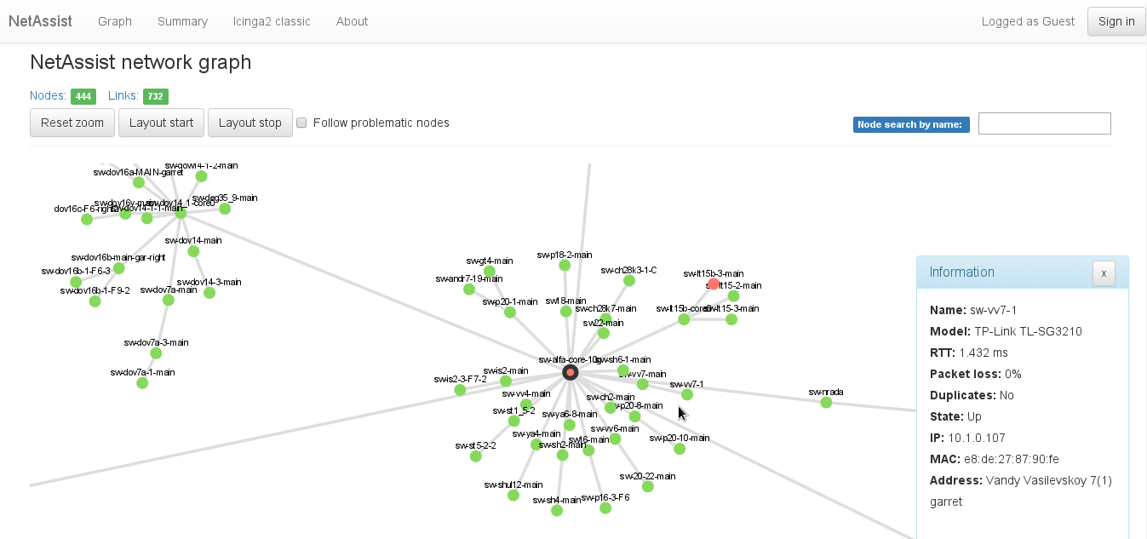Fig 4: NetGraphz2 user interface
Nodes status are shown in different colors: red — down, green — up, warning — problematic, gray — not monitored by Icinga2.
Node information panel raises automatically when node being hovered by cursor.
Navigation through problematic and down nodes done by [TAB] and [SHIFT]+[TAB] keys. Search through nodes names done by search field (top right, [/] key). Check box on top of the screen enable automatic following to the down nodes in real time.
It's possible to select multiple nodes at once: hold [SHIFT] key and click on nodes you want to choose. Rectangular selection is done by holding [CTRL] key and selecting screen region.

Troubleshooting
There are common errors may happened during application usage. NetGraphz2 relies on several components and theirs communications. If something breaks specific error rise up on the main page.

Neo4j
- No connection to the graph database.
Symptoms:
You get error message like specified below, usually, on the blank page. Web server return code HTTP error codes between 500-503. Error description, graph URL, script path depends from your instance configuration.
Error on Connection "default" with message "Error creating resource: [message] fopen(http://localhost:7474/db/data/transaction/commit): failed to open stream: Connection timed out [file] /opt/netgraphz2/web-phalcon/vendor/guzzlehttp/guzzle/src/Handler/StreamHandler.php [line] 282.
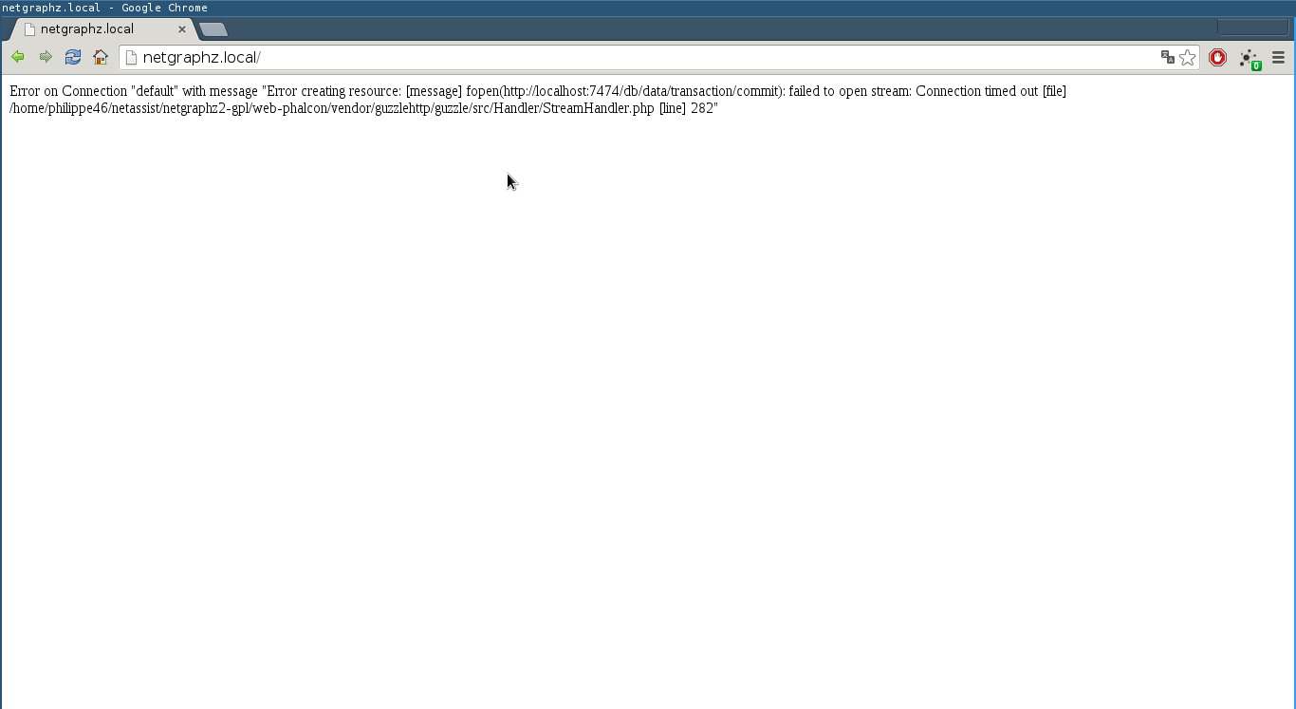Fig 5: Graph database connection error

Reason:
Web-site (web-phalcon) failed to get graph from graph database due to connection failure (timeout, refuse, etc). If you host graph database on separate host, it's possible caused by network communication error. In most cases the reason is not running or down Neo4j. Neo4j is stable application in most cases, but sometimes it may be killed or crashed because of low RAM available (Java takes a lot of RAM) if no swapping space enabled.
Possible solution:
Check communication to the remote or local neo4j database, check database URL in configuration file, check firewall and network routing topology. Check if neo4j process is running remotely or locally. If neo4j failed to start up or crashed, review error log.
Note:
Error may appear when server CPU load is very high or database is under heavy load. It happens because of HTTP client timeout. Wait for load to come down and try to reload the page.
- Neo4j authentication failure
Symptom:
Similar to the graph databases connection failure. Contains different error message like specified below. Usually appears on the blank page the same way as connection error.
Error on Connection "default" with message "Client error: 401"
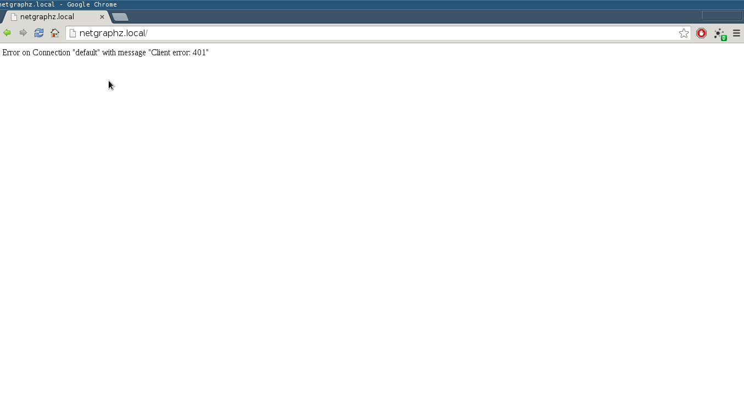Fig 6: Neo4j authentication failure
Reason:
Web-site (web-phalcon) failed to authenticate on neo4j database instance due to the incorrect login-password pair, specified in application (web-phalcon) configuration file.
Solution:
Change login and password from web-site configuration file (web-phalcon/app/config.php) or change neo4j user name and password. Try to reload page.

MongoDB
Some possible issues with MongoDB
- Cannot connect to MongoDB
Symptoms:
Error message during login, impossible to login due to error.
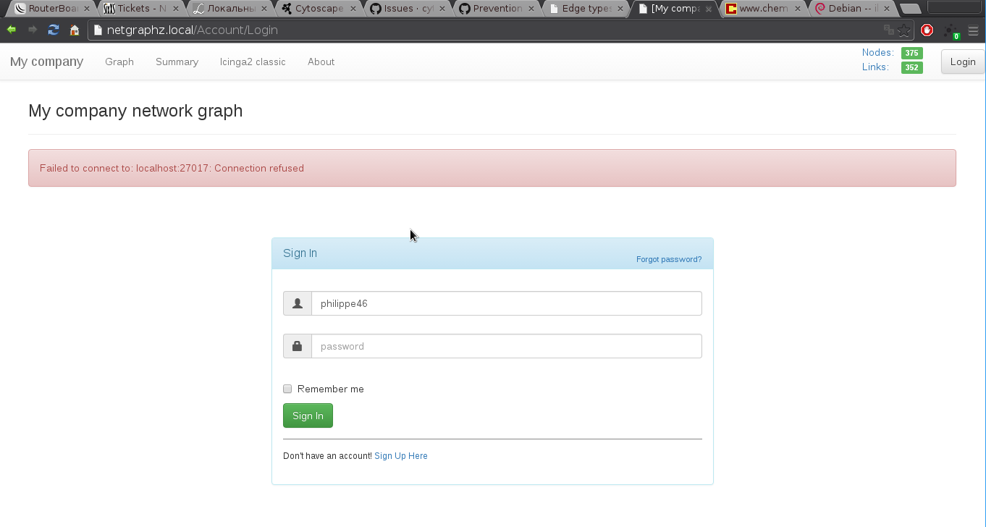Fig 7: Login failure
Error message when loading graph page (failed to load user parameters) for already logged user.
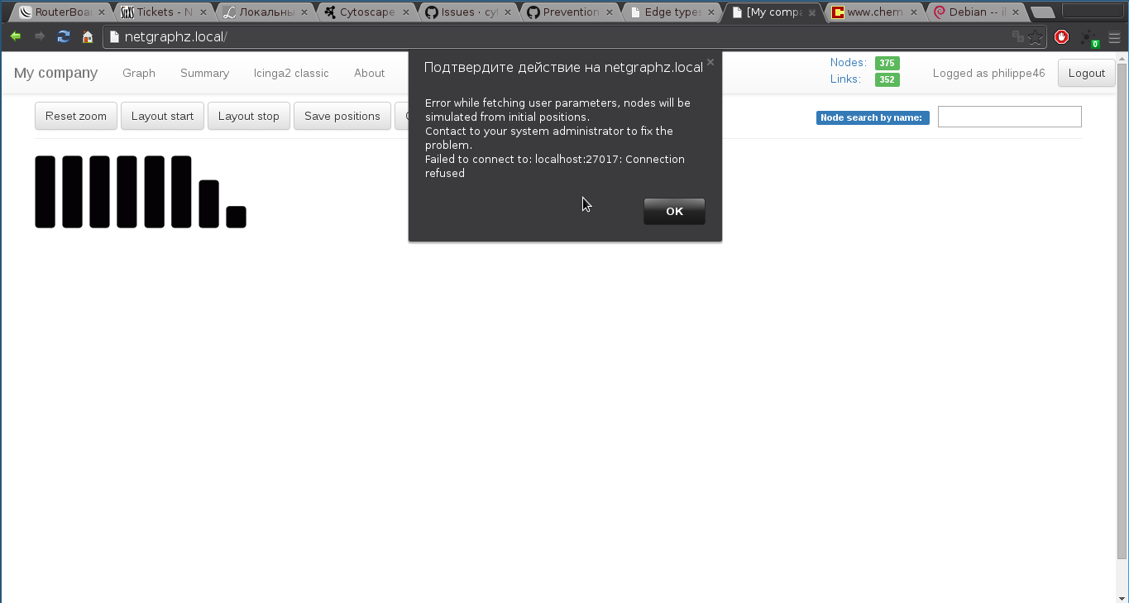Fig 8: Properties load failure

Error message when clicking on nodes positions save/clear buttons
Reason:
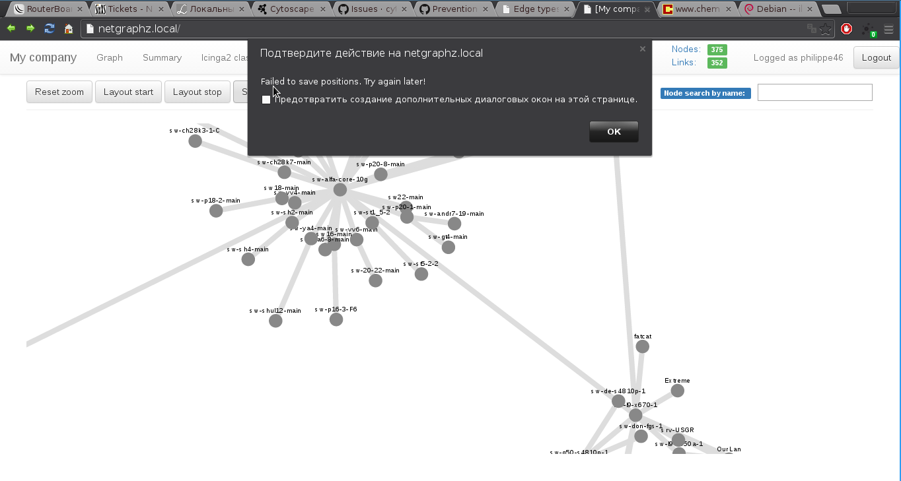Fig 9: Positions save failure
Web-site (web-phalcon) failed to access MongoDB database, error message shows error reason.
Solution:
Check if MongoDB is running, database created correctly. Change connection string in web-application configuration file. Try to reload page. If doesn't help, reinstall MongoDB database from installation dump.

Notifications server
- Failed to reach notifications serve
Symptoms:
Nodes changing it's state but no notifications received for a long time. Notifications server connection error messages from socket.io library present in JS console.
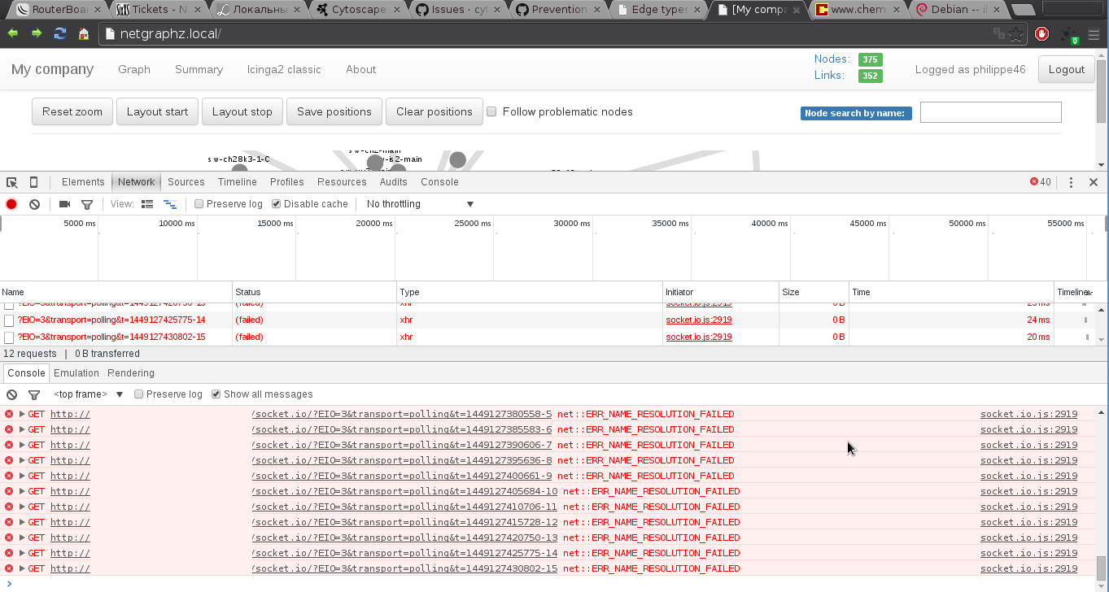Fig 10: Connection error
Reason:
Browser application failing to connect to notifications server. It might be network error, misconfiguration or problem on notification server side.
Solution:
Check notification server, JavaScript application configuration files. Check network connectivity issues: you must see valid HTTP response on notifications server port. Restart notifications server and try again.

Contacts

Company:
NetAssist LLC
Ukraine, Kyiv
str. Striletskaya 7/9 office 96
http://netassist.ua
Project leader:

Philippe Duke
NetAssist LLC
Email: philippe46@netassist.ua
philippe46@pulsepad.com.ua
philippe46.snproject@gmail.com
philippe46@henkuaile.cn
Site: http://henkuaile.cn
Jabber: philippe46@netassi.st
Facebook: http://facebook.com/philippe46.snproject

