## UAC端:

### 环境:

#### OS:

win10-64

#### IP:*192.168.101.104*,

#### sipp:

*SIPp v3.3-TLS, built Aug 15 2017, 09:49:09.*

#### 文件列表:

* uac_t1.xml
* uac_f.csv

### 操作

sipp -aa -i 192.168.101.104 -sf uac_t1.xml -inf uac_f.csv 192.168.101.8 -l 1 -m 1 -p 12346 -trace_msg -trace_screen -trace_err

## UAS端：

### 环境

#### OS:

Linux: *Linux slave 2.6.32-431.el6.x86_64 #1 SMP Fri Nov 22 03:15:09 UTC 2013 x86_64 x86_64 x86_64 GNU/Linux*

IP: 192.168.101.22

#### Sipp:

SIPp v3.3-TLS, built Aug 15 2017, 02:05:55.

#### IP:192.168.101.22

#### 文件列表

1. uas_t1.xml
2. uas_f.csv

### 操作

1. 注册:

sipp -i 192.168.101.22 -sf uas_t1.xml -inf uas_f.csv 192.168.101.8:5060 -l 10 -trace_msg -trace_screen -trace_err -p 12346 -m 10 –aa

1. 启动被叫端:

sipp -i 192.168.101.22 -sf uas_t1.xml -inf uas_f.csv 192.168.101.8:5060 -l 10 -trace_msg -trace_screen -trace_err -p 12346 -m 10 –aa

## sip server

### 环境:

#### OS:

Linux master 2.6.32-696.6.3.el6.x86_64 #1 SMP Wed Jul 12 14:17:22 UTC 2017 x86_64 x86_64 x86_64 GNU/Linux

#### SipServer:

FreeSWITCH Version 1.4.26+git~20160205T175853Z~ca9207aa32~64bit (git ca9207a 2016-02-05 17:58:53Z 64bit)

#### IP:192.168.101.22

## 测试

#### 设置

默认使用freeswitch的默认用户

1000-1003为uas端用户

1004-1007是uac端用户

呼叫接通后等待25秒

#### 流程:

先启动被叫注册->UAS端 ->UAC端

#### 测试结果图

* UAC:

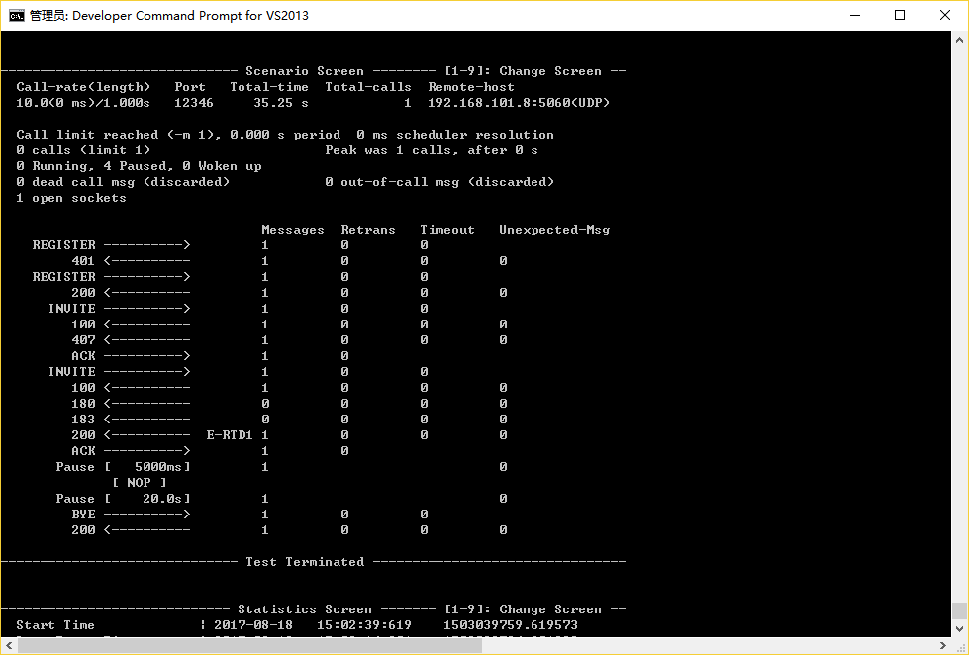

* 注册:

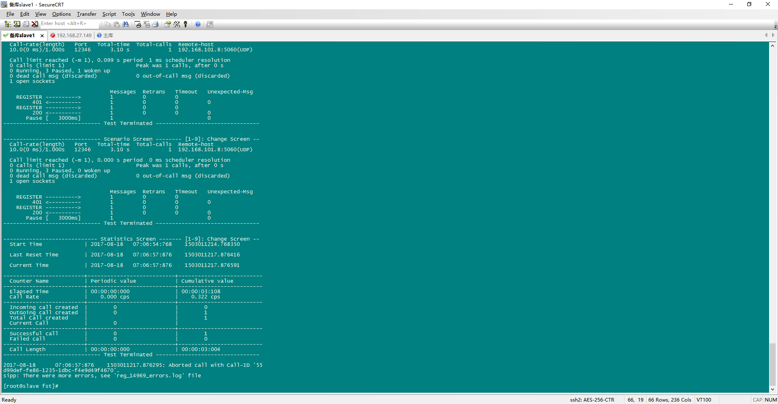

* UAS:

