## UAC端:

### 环境:

#### OS:

win10-64

#### IP:*192.168.27.1*

#### sipp:

*SIPp v3.3-TLS, built Aug 15 2017, 09:49:09.*

#### 文件列表:

* uac_t1.xml
* uac_f.csv

### 操作

sipp -aa -i 192.168.27.1 -sf uac_t3.xml -inf uac.csv 192.168.27.149:5060 -l 1 -m 1 -p 12346 -trace_msg -trace_screen -trace_err

sipp -aa -i 192.168.27.1 -sf uac_t1.xml -inf uac.csv 192.168.27.149:5060 -l 1 -m 1 -p 12346 -trace_msg -trace_screen -trace_err

## UAS端：

### 环境

#### OS:

Linux: *3.10.0-514.26.2.el7.x86_64 #1 SMP Tue Jul 4 15:04:05 UTC 2017 x86_64 x86_64 x86_64 GNU/Linux*

IP: 192.168.101.22

#### Sipp:

SIPp v3.3-TLS-PCAP, built Aug 15 2017, 05:09:40.

#### IP:192.168.27.129

#### 文件列表

1. uas_t1.xml
2. uas_f.csv

### 操作

1. 注册:

sipp -i 192.168.27.129 -sf reg.xml -inf uas.csv 192.168.27.149:5060 –l 3 -trace_msg -trace_screen -trace_err -p 12346 -m 3

1. 启动被叫端:

sipp -i 192.168.27.129 -sf uas.xml -inf uas.csv 192.168.27.149:5060 -l 100 -trace_msg -trace_screen -trace_err -p 12346 -m 100 –aa

## sip server

### 环境:

#### OS:

#### Linux 2.6.32-696.6.3.el6.x86_64 #1 SMP Wed Jul 12 14:17:22 UTC 2017 x86_64 x86_64 x86_64 GNU/Linux

#### SipServer:

Opensips 2.2.5

#### IP:192.168.27.149

## 测试

#### 设置

注册opensips的 1000 -2999用户

1000-1999为uac端用户

2000-2999是uas端用户

呼叫接通后等待25秒

#### 流程:

先启动被叫注册->UAS端 ->UAC端

#### 测试结果图

* UAC:
* 注册:
* UAS:

第一步:

用eyebeam启动注册用户1001,呼叫2000,UAS是sipp的

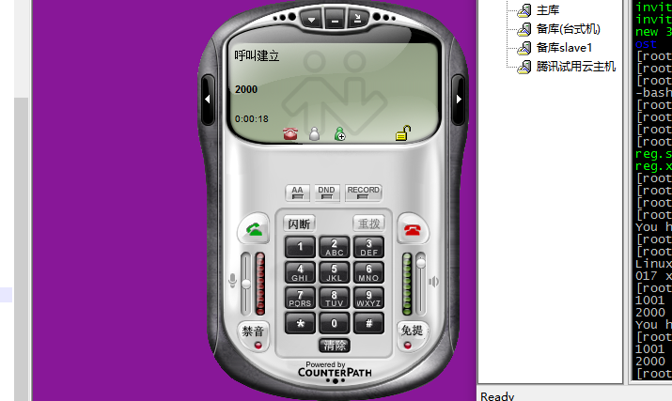

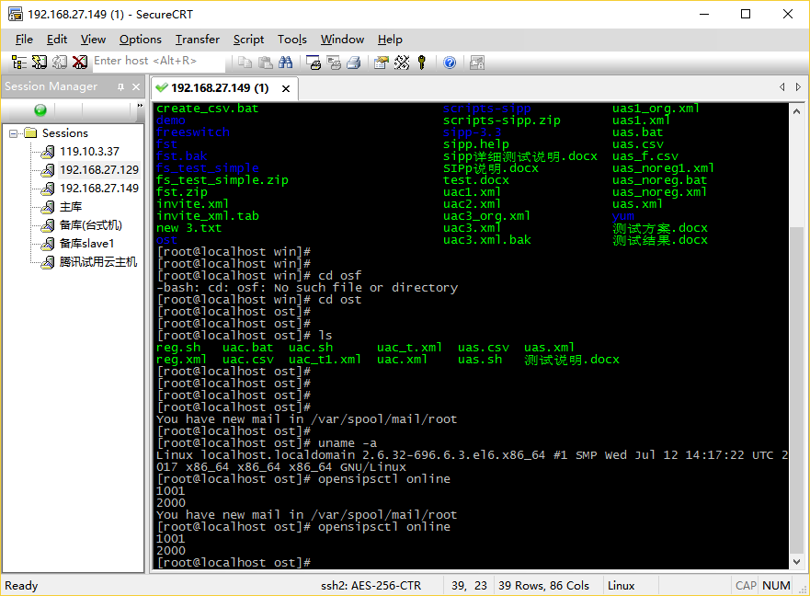

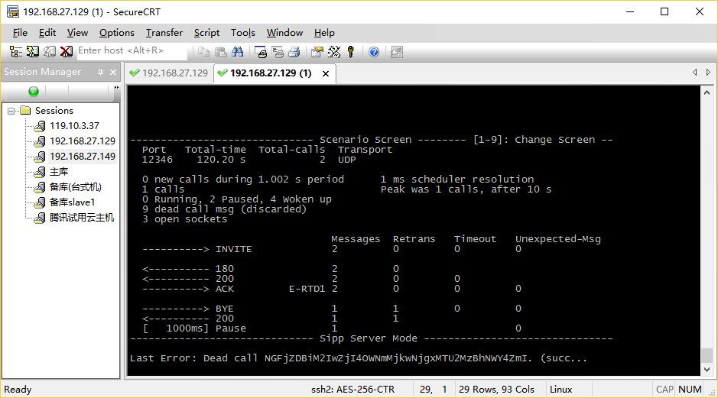

日志如下:

