测试结果

## 测试1

10万次呼叫

### 备库:UAC

IP:192.168.101.22

**sipp -sf uac3.xml -inf uac.csv -m 100000 -sn uac 192.168.101.8 -i 192.168.101.22 -aa -trace_err -s 2000 -r 100 -rp 1000**

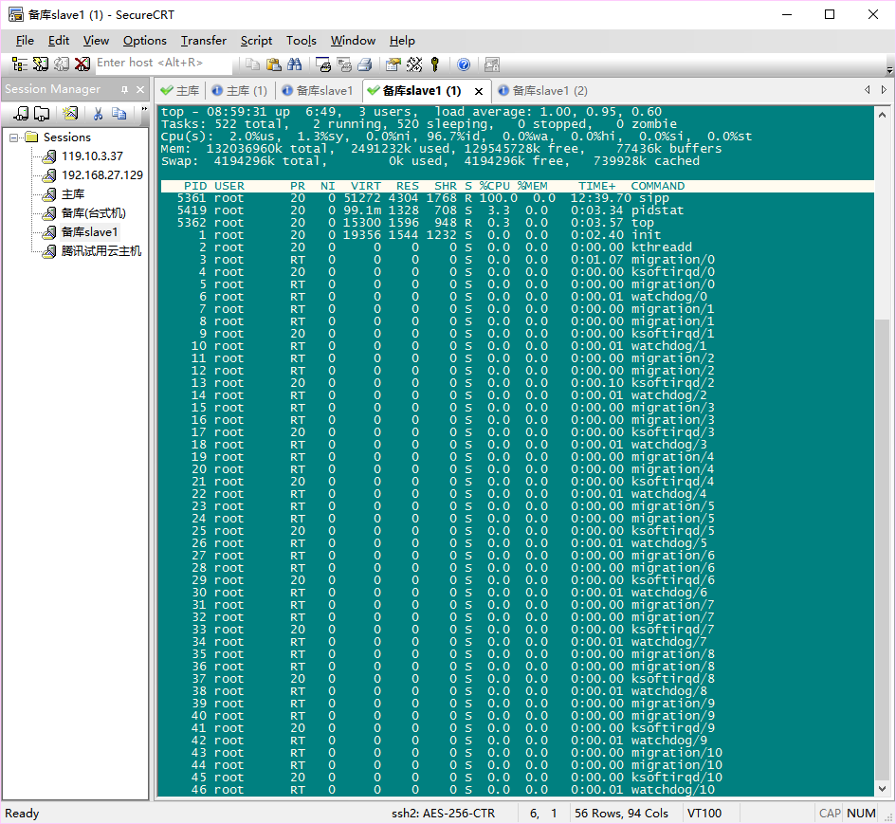

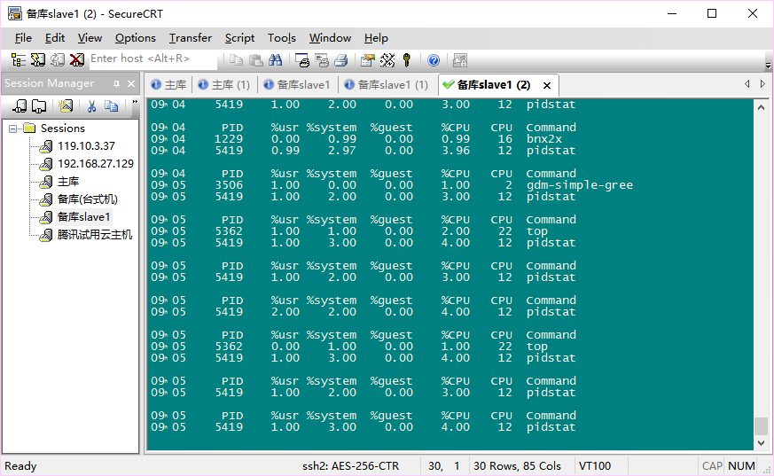

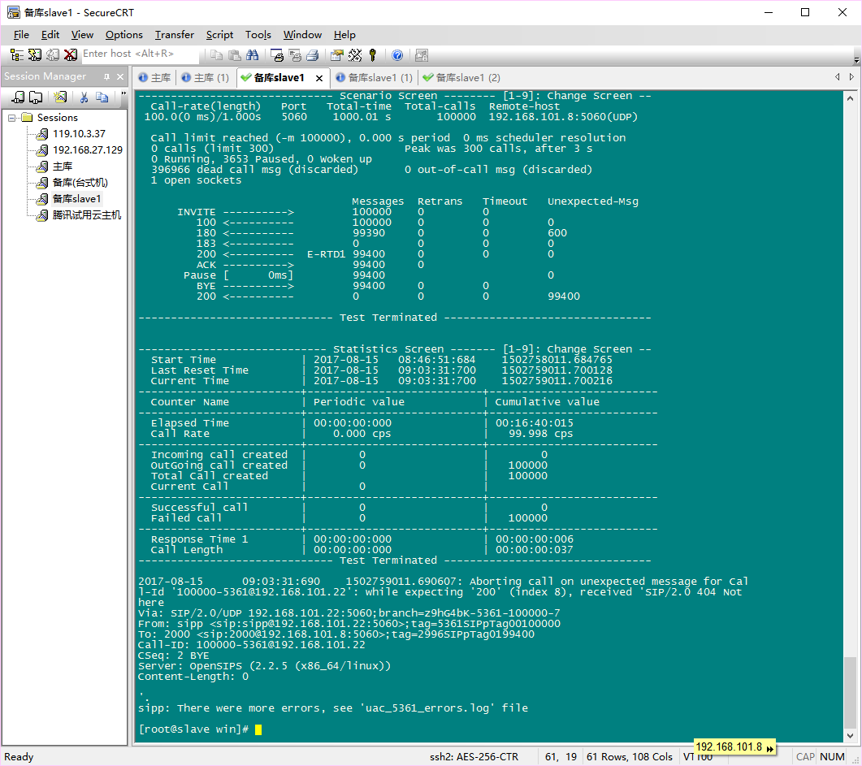

### 主库:opensips

IP:192.168.101.8

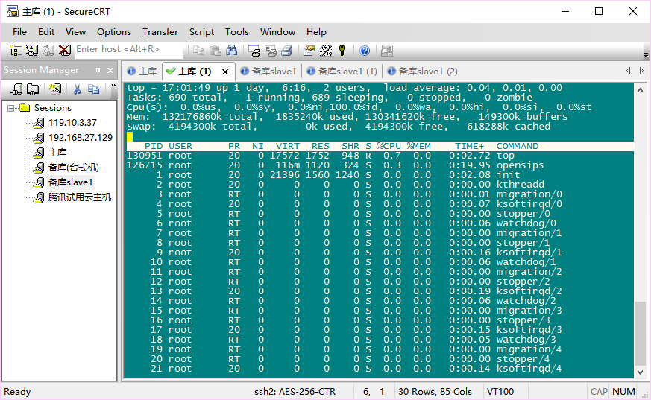

### 我的笔记本UAS

IP:192.168.101.104

测试命令:

**sipp -sf uas1.xml -inf uas.csv -m 100000000 -i 192.168.101.104 -sn uas 192.168.101.8**

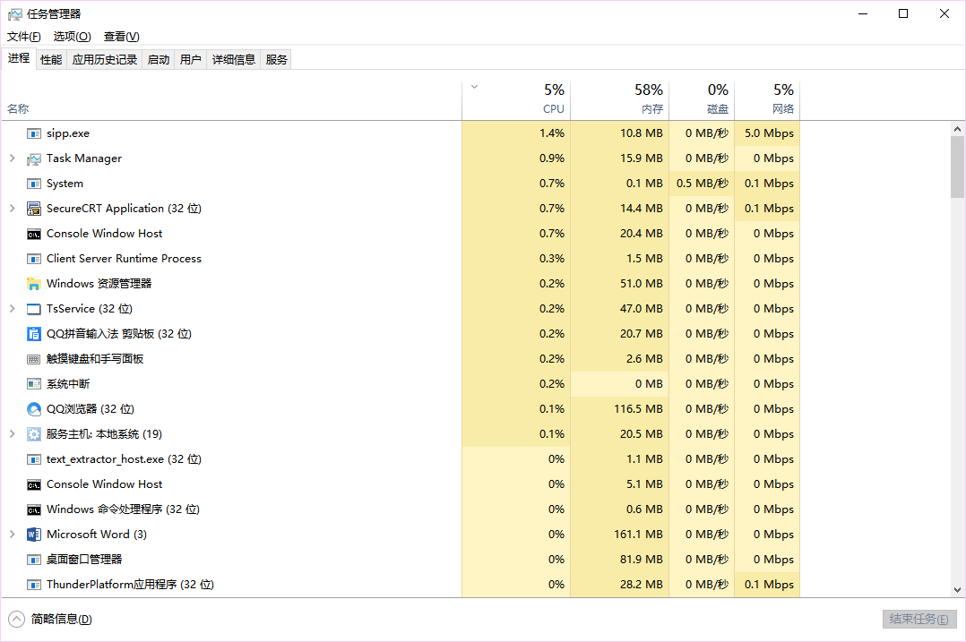

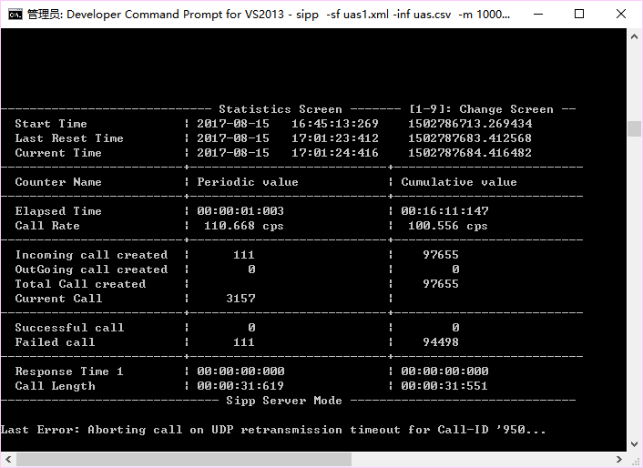

IP:192.168.101.8

Opensips 主库

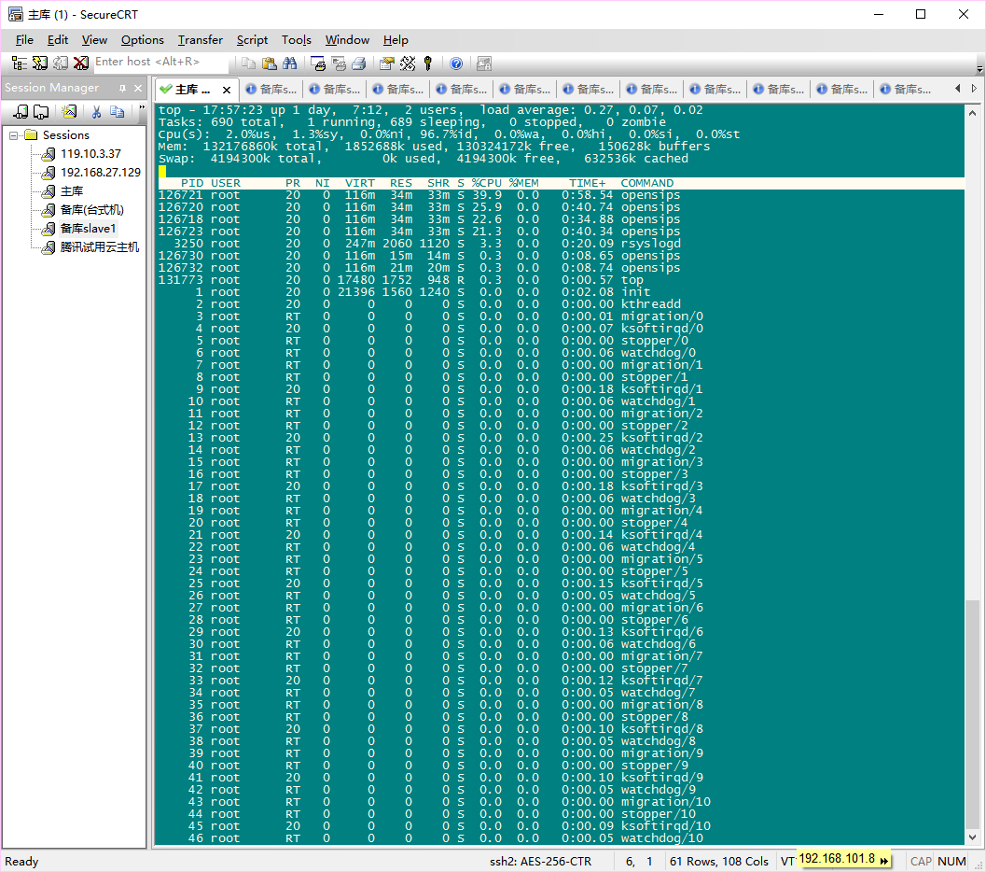

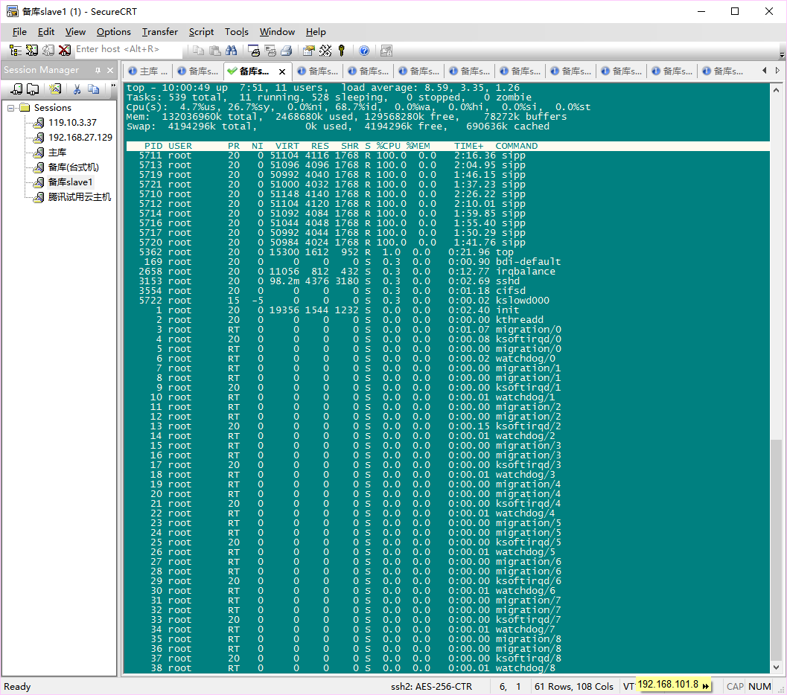

笔记本

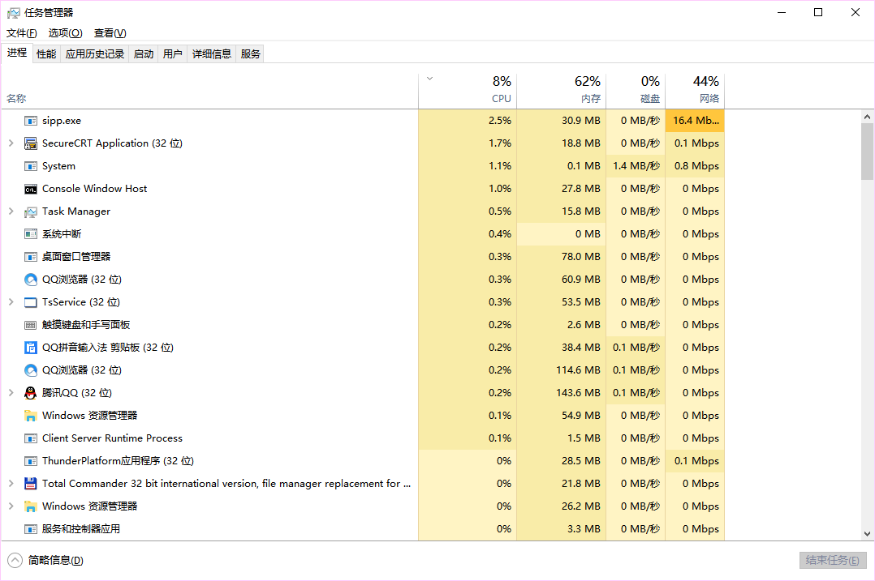

sipp -sf uas.xml -inf uas.csv -m 10000000 -i 192.168.101.104 -sn uas 192.168.101.8

## 测试2

### 备库:UAC

IP:192.168.101.22

**sipp -sf uac3.xml -inf uac.csv -m 100000 -sn uac 192.168.101.8 -i 192.168.101.22 -aa -trace_err -s 2000 -r 100 -rp 1000**

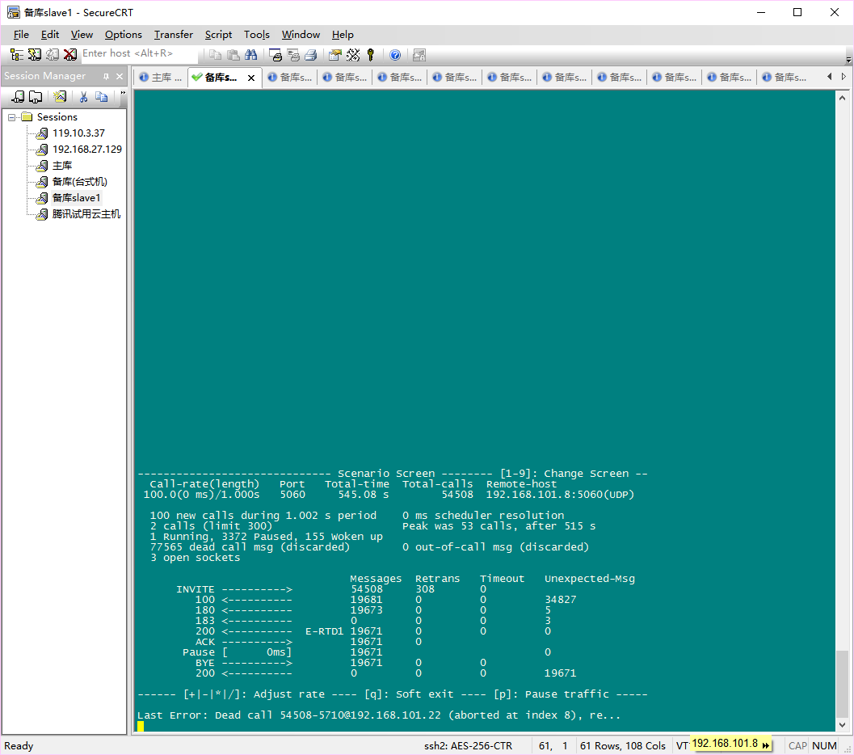

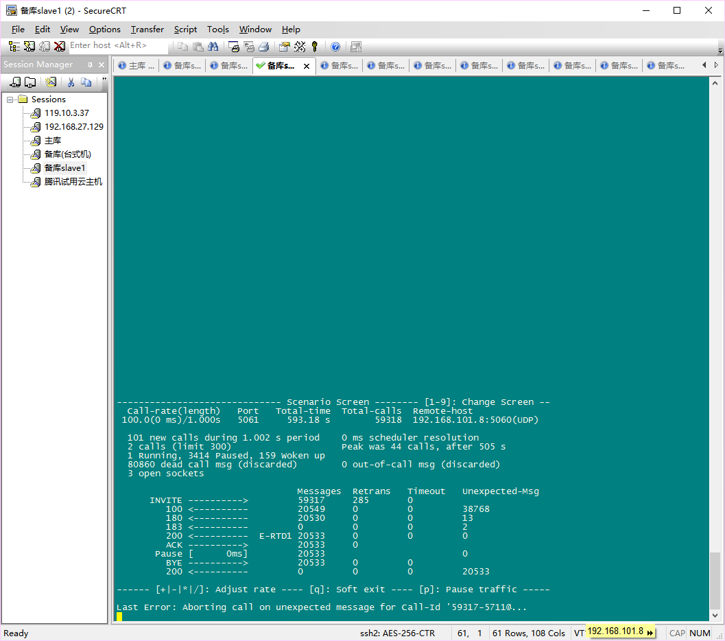

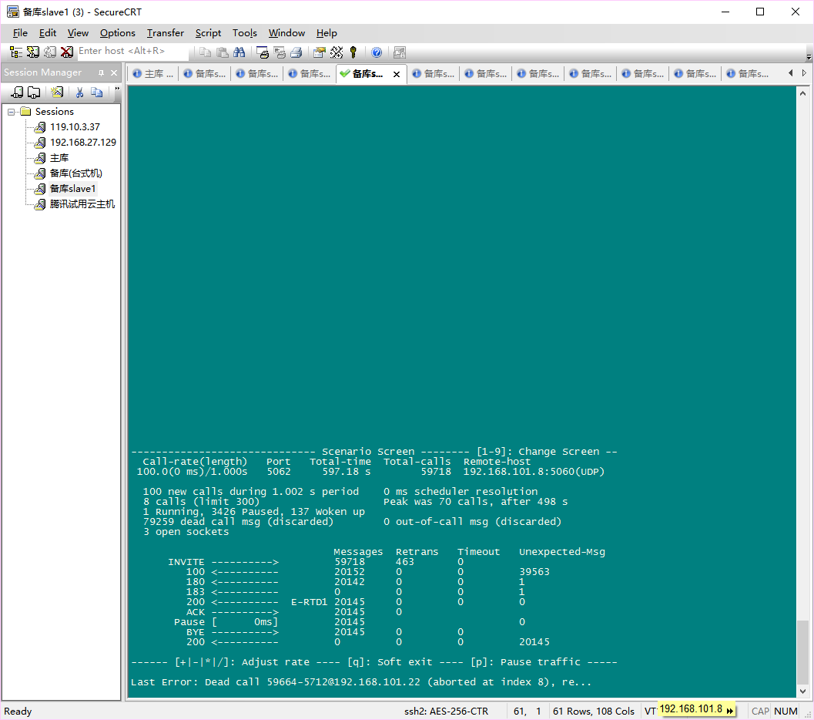

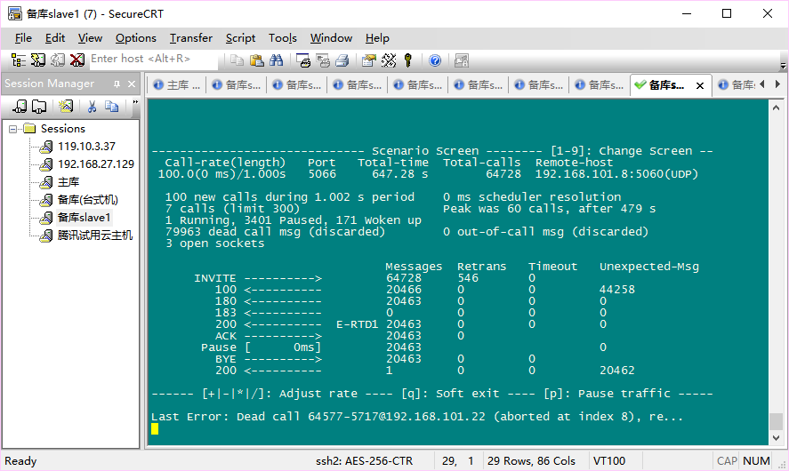



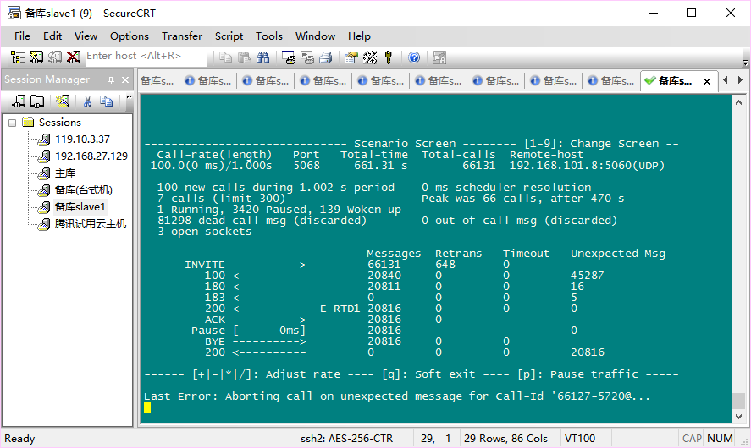

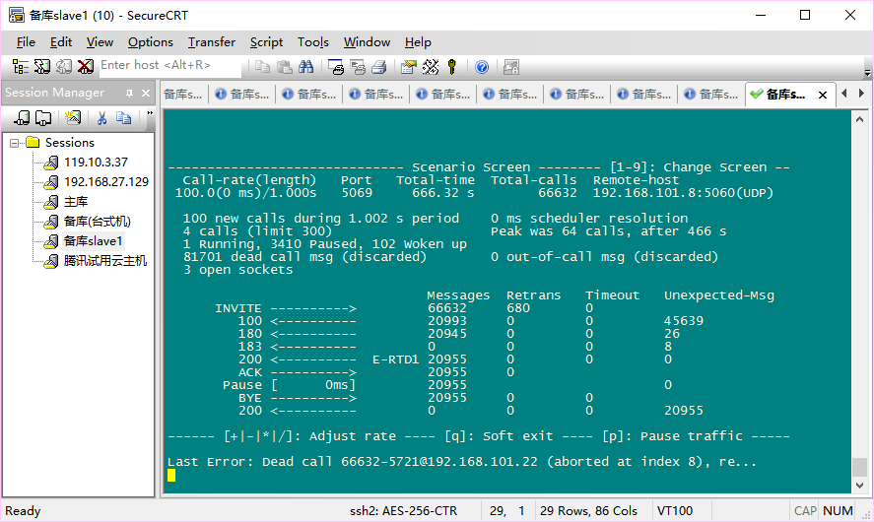

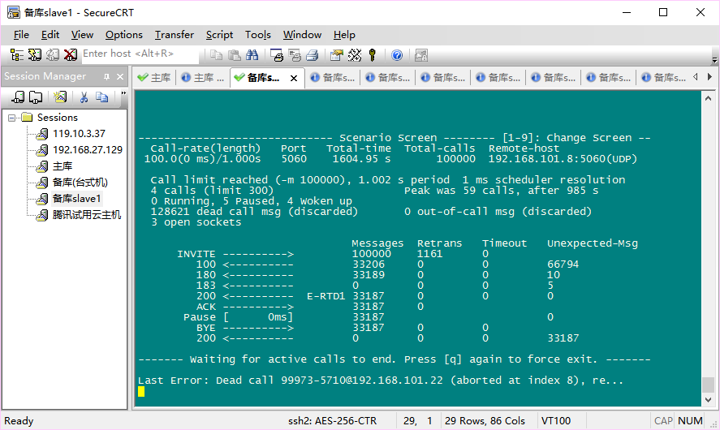







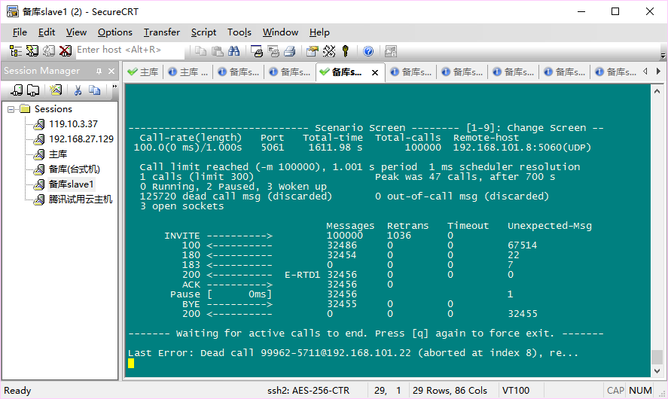



**大量出错,UAS收到32万次呼叫后停止**

### 主库:opensips

