Question 1: Write a C program to define 3 different threads with the following purposes where N is the input:
• Thread A: runs a loop and returns the sum of first N prime numbers
• Thread B & C: should run in parallel — one prints "Thread 1 running" every 2 seconds, the other prints "Thread 2 running" every 3 seconds, both for 100 seconds.

#include<stdio.h>
#include<stdlib.h>
#include<pthread.h>
#include<stdbool.h>
#include<unistd.h>

bool isprime(int n){
if(n<2){
return false;
}
for(int i=2;i*i<=n;i++){
if(n%i==0){
return false;
}
}
return true;
}

/*Thread A function*/
void* threadAsumofprimes(void* arg){
int n = *(int*)arg;
long long* sum = (long long*)malloc(sizeof(long long));
*sum = 0;
if(sum == NULL){
printf("memory hasnt been allocated");
pthread_exit(NULL);
}
int count = 0;
int current_num = 2;
while(count<n){
if(isprime(current_num)){
*sum += current_num;
count++;
}
current_num++;
}
return (void*)sum;
}

/*Thread B function*/

void* threadBfunctionrun(void *arg){
int totaltime = 100;
int interval = 2;
for(int i=0;i<totaltime;i=i+interval){
sleep(interval);
printf("Thread A is running\n");
}
return NULL;
}
/*THread C function*/
void* threadCfunction(void* arg){
int totaltime = 100;
int interval = 3;
for(int i=0;i<totaltime;i=i+interval){
sleep(interval);
printf("Thread B is running\n");
}
return NULL;
}

int main(){
pthread_t threadA;
pthread_t threadB;
pthread_t threadC;
printf("Till where do you want the sum of primes");
int n;
scanf("%d",&n);
/*Creation of Thread A*/
pthread_create(&threadA,NULL,threadAsumofprimes,&n);
/*Creation of Thread B*/
pthread_create(&threadB,NULL,threadBfunctionrun,NULL);
/*Creation of Thread C*/
pthread_create(&threadC,NULL,threadCfunction,NULL);

long long* result;

pthread_join(threadA,(void**)&result);
printf("THe result of thread A's function for the input %d is %lld",n,*result);

pthread_join(threadB,NULL);
pthread_join(threadC,NULL);

}

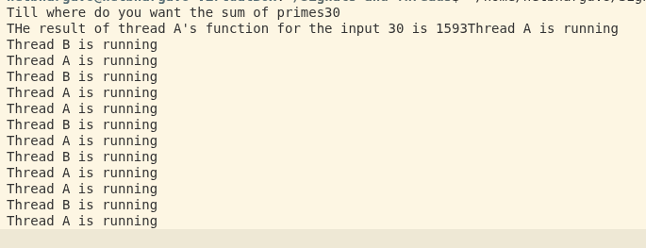

Question 2: In the above program:
• Add signal handling for SIGINT (etc) and prevent termination.
• Convert the above threads to individual functions and note down the time taken and the flow of execution.

#include <stdio.h>
#include <stdlib.h>
#include <pthread.h>
#include <stdbool.h>
#include <unistd.h>
#include <signal.h>
#include <time.h>

void handle_sigint(int sig) {
printf("\n>>> [SIGNAL] Caught Ctrl+C (SIGINT). Prevention active: Termination blocked! <<<\n\n");
}

bool isprime(int n){
if(n < 2) return false;
for(int i = 2; i * i <= n; i++){
if(n % i == 0) return false;
}
return true;
}

/* Core Logic Function (Can be run as a thread or a normal function) */
void* threadAsumofprimes(void* arg){
int n = *(int*)arg;
long long* sum = (long long*)malloc(sizeof(long long));
if(sum == NULL){
printf("Memory allocation failed\n");
pthread_exit(NULL);
}
*sum = 0;
int count = 0;
int current_num = 2;
while(count < n){
if(isprime(current_num)){
*sum += current_num;
count++;
}
current_num++;
}
return (void*)sum;
}

/* Function B (Simulates 10 seconds total duration for demo speed instead of 100s) */
void* threadBfunctionrun(void *arg){
int totaltime = 10; // Reduced from 100 to 10 for quick testing
int interval = 2;
for(int i = 0; i < totaltime; i = i + interval){
sleep(interval);
printf("Thread 1 (2s interval) running\n");
}
return NULL;
}

/* Function C */
void* threadCfunction(void* arg){
int totaltime = 10; // Reduced from 100 to 10 for quick testing
int interval = 3;
for(int i = 0; i < totaltime; i = i + interval){
sleep(interval);
printf("Thread 2 (3s interval) running\n");
}
return NULL;
}

int main(){
// Register the custom SIGINT handler
signal(SIGINT, handle_sigint);

pthread_t threadA, threadB, threadC;
int n = 30; // Pre-set target input for easy benchmarking
long long* result;
time_t start_time, end_time;

printf("===========================================\n");
printf("RUNNING TEST 1: THREADED (PARALLEL) EXECUTION\n");
printf("===========================================\n");
printf("(Try pressing Ctrl+C while this runs!)\n\n");
start_time = time(NULL);

/* Creation of Threads running in parallel */
pthread_create(&threadA, NULL, threadAsumofprimes, &n);
pthread_create(&threadB, NULL, threadBfunctionrun, NULL);
pthread_create(&threadC, NULL, threadCfunction, NULL);

/* Wait for parallel execution to finish */
pthread_join(threadA, (void**)&result);
if(result != NULL) {
printf("\n[Parallel] Sum of primes result: %lld\n", *result);
free(result);
}
pthread_join(threadB, NULL);
pthread_join(threadC, NULL);

end_time = time(NULL);
double parallel_time = difftime(end_time, start_time);
printf("--> Total Time taken with Threads: %.2f seconds\n\n", parallel_time);

printf("===========================================\n");
printf("RUNNING TEST 2: INDIVIDUAL FUNCTIONS (SEQUENTIAL)\n");
printf("===========================================\n");
start_time = time(NULL);

/* Running sequentially one after another as individual normal functions */
result = (long long*)threadAsumofprimes(&n);
if(result != NULL) {
printf("\n[Sequential] Sum of primes result: %lld\n", *result);
free(result);
}
printf("Starting Function B sequentially...\n");
threadBfunctionrun(NULL);
printf("Starting Function C sequentially...\n");
threadCfunction(NULL);

end_time = time(NULL);
double sequential_time = difftime(end_time, start_time);
printf("--> Total Time taken sequentially: %.2f seconds\n", sequential_time);
printf("===========================================\n");

return 0;
}

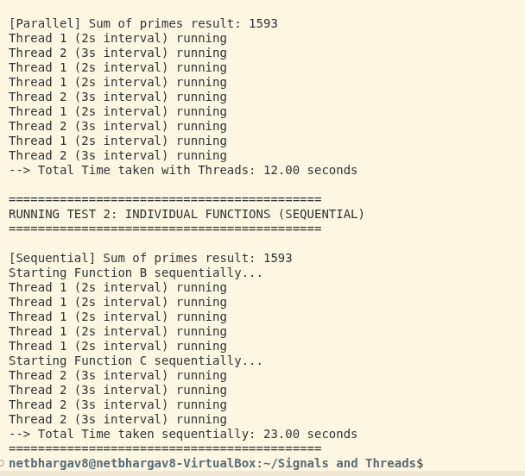

Question 3: Explain the terms
1. Child Process – fork()
- Definition: A system call that creates a brand-new, independent child process by duplicating the parent's address space.
- Return Value: It is called once but returns twice. It returns the child's PID to the parent process, and returns 0 inside the new child process.
- Execution: Both parent and child execute concurrently starting from the exact line immediately following the fork() call.

2. Handling Common Signals
- Concept: Signals are asynchronous kernel notifications sent to a running program.
- Common Signals:
  - SIGINT (Signal 2): Triggered by Ctrl + C. Default action is termination, but it can be safely caught/blocked via a custom signal handler.
  - SIGKILL (Signal 9): Forces immediate program termination. It cannot be caught, blocked, or ignored.
  - SIGSEGV (Signal 11): A Segmentation Fault, sent when a program tries to access restricted or illegal memory space.

3. Exploring Different Kernel Crashes
- Kernel Panic: A fatal internal error from which the OS kernel cannot safely recover (e.g., severe hardware failure or corrupted system files). The entire machine halts immediately to prevent data loss.
- Oops: A non-fatal kernel deviation. The OS prints an error log and kills the offending process, attempting to keep the rest of the system running.
- BSOD: Blue Screen of Death; the specific Windows operating system equivalent of a fatal kernel panic.

4. Time Complexity
- Definition: Measures how an algorithm's execution time scales asymptotically as the input size grows, denoted in Big-O notation.
- Application: In our lab code, the prime checker function runs in O(sqrt(N)) time due to trial division.
- Threads Impact: Spawning multiple threads lowers real-world wall-clock execution time by utilizing multiple CPU cores, but it does not change the core mathematical Big-O complexity of the underlying algorithm.

5. Locking Mechanisms – Mutex vs. Spinlock
- Mutex (Mutual Exclusion): A sleeping lock. If a thread finds the lock taken, it yields the CPU and goes to sleep. This is highly efficient for long waiting periods but incurs context-switch overhead.
- Spinlock: A busy-wait lock. The waiting thread stays awake and runs a continuous loop ("spins") checking the lock until it becomes free. This consumes 100% CPU on that core but is ideal for ultra-short critical sections because it avoids context-switching.

