Q1) Create a file and add executable permission to all users (user, group and others)
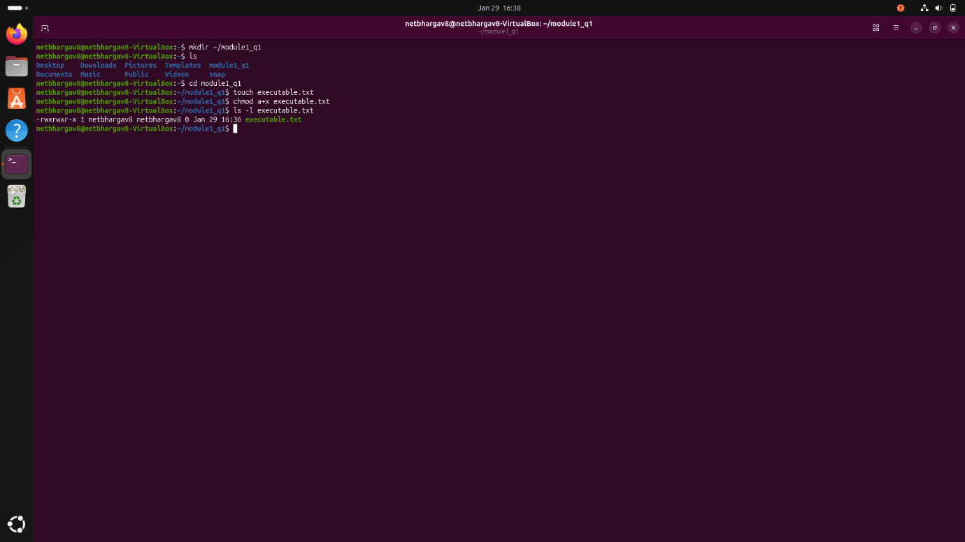
Explanation:
- Used touch executable.txt to initialize the file.
- Applied chmod a+x executable.txt to add execute permissions for all (user, group, and others).
- Ran ls -l to confirm the permission bits are now -rwxr-xr-x, indicating the file is successfully executable by everyone.

Q2) create a file and remove write permission for group user alone.
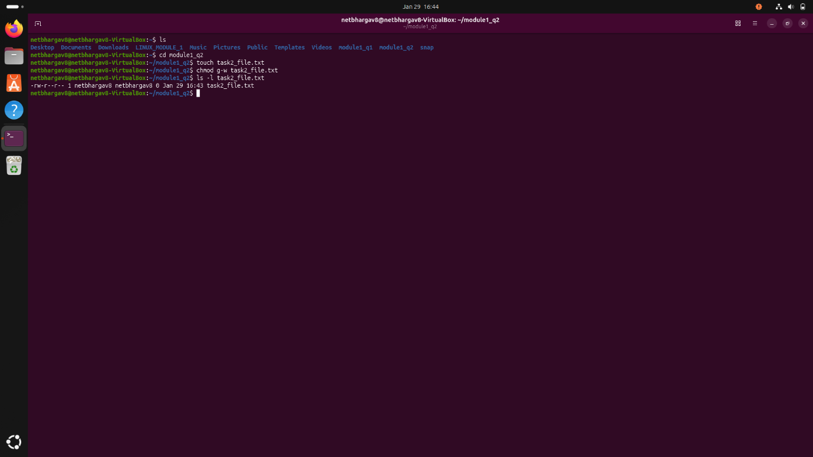
Explanation:
- Created a new file using touch task2_file.txt
- Applied the command chmod g-w task2_file.txt which removed the write permission for the group.
- Ran ls -l to verify. The output -rw-r--r-- shows that while the owner still has write access (w), the group section now only has read access (r--).

Q3) Create a file and add a softlink to the file in different directory (Eg : Create a file in dir1/dir2/file and create a softlink for file inside dir1)
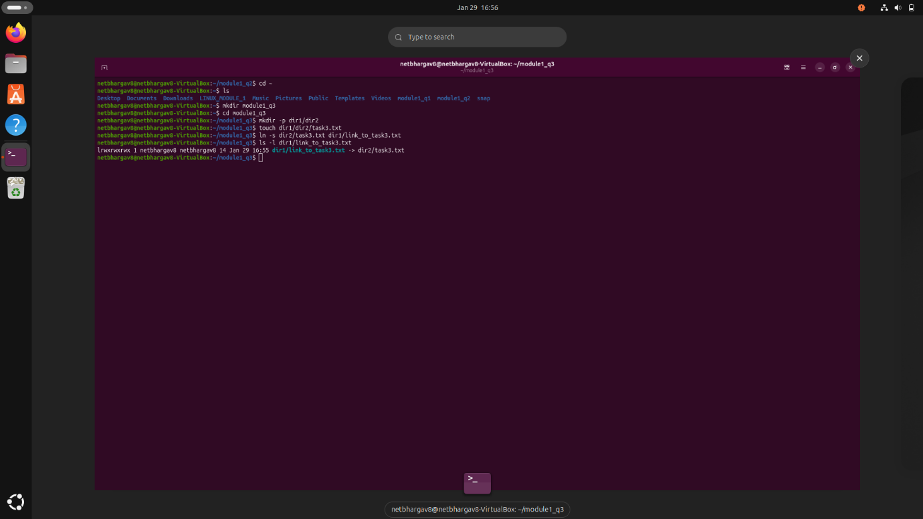
Explanation:
- Created a nested directory structure using mkdir -p dir1/dir2 and initialized a source file with touch dir1/dir2/task3.txt.
- Executed ln -s dir2/task3.txt dir1/link_to_task3.txt to create a symbolic link inside dir1 that points to the file in dir2.
- Ran ls -l dir1/link_to_task3.txt, which displays the link pointing to the original path (-> dir2/task3.txt) and shows an l at the start of the permission string, confirming it is a symbolic link.

Q4) Use ps command with options to display all active process running on the system

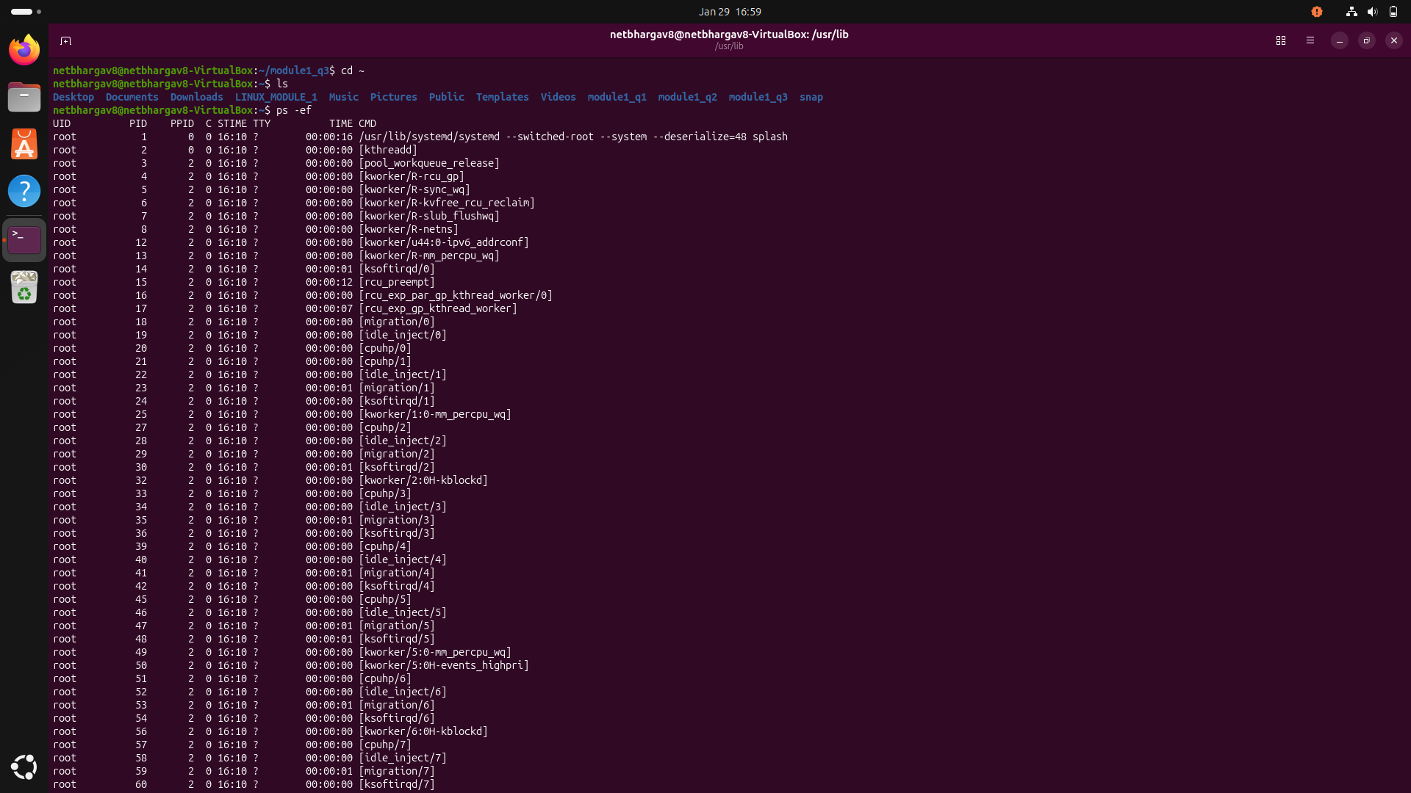
Explanation:
- I used the ps -ef command.
- The terminal displayed a complete list of active system tasks, such as systemd and various background workers.

Q5) Create 3 files in a dir1 and re-direct the output of list command with sorted by timestamp of the files to a file
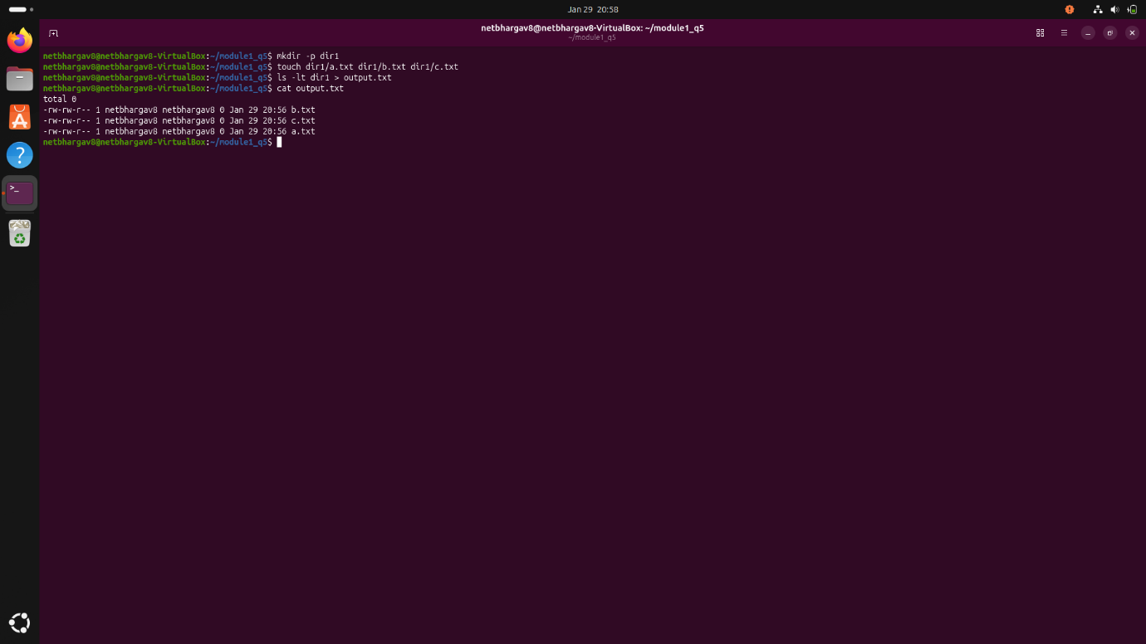
Explanation:
- I created a directory named dir1 and initialized three files (a.txt, b.txt, c.txt) inside it.
- I ran the command ls -lt dir1 > output.txt which lists the files in dir1 sorted by modification time (-lt) and saves that list into a file named output.txt
- Using cat output.txt, I confirmed the file contains the list of the three files correctly sorted by their timestamps

