QuickREx – regular expressions
QuickREx is a regular expressions plug-in. It offers the following features:
- Support for JDK- and Jakarta ORO-style regular expressions
- TAB-completion for entering regular expressions
- Live-evaluation of matches as you type
- Navigation through matches and groups
- Conversion of regular expressions to Java-Strings (backslash-escaping)
- ‘Grep’: Extract all matches from a text

Using QuickREx for testing Regular Expressions
Regular Expressions are powerful but can be confusing at times. I regularly found myself working with scrapbook-pages to test my regular expressions (or working late-night shifts to fix problems in production ☹ ). QuickREx was written to get around using scrapbook pages or working on the high-wire and to be able to play with regular expressions more easily.
QuickREx gives you a view in which you can enter test-texts and try regular expressions. The expressions are evaluated against the test-text on the fly, matches are highlighted and you can navigate between the matches. You can also navigate through groups within each match (if groups are defined in your regular expression).
QuickREx also offers TAB-completion for regular expressions and conversion of regular expressions to Java-Strings (including e.g. proper escaping of the ubiquitous backslash). All TAB-completion suggestions as well as the corresponding help-text pop-ups are customizable. They are defined in .xml-files distributed with the plug-in. These files can be changed to add additional hints, remove rarely used hints or change the descriptions.
QuickREx offers the three most widely used implementations of Regular Expressions in the Java-world:
- JDK Regular Expressions (available since 1.4)
- Jakarta ORO Perl-style Regular Expressions (ORO-Version 2.0.8, supports Perl 5.003 Regular Expressions)
- Jakarta ORO Awk-style Regular Expressions (ORO-Version 2.0.8)
For each of the implementations, you can set the available compiler-flags through QuickREx or use inline flag-switches with the regular expression.
Regular Expressions and Test-Texts can be persisted for later reference. Also, any file-contents can be loaded as test-text.

Using QuickREx for using Regular Expressions
Another feature I am missing from time to time when working on Wintel-boxes is the good old 'grep' command.
QuickREx also offers this feature: Load your test-text, enter or load the regular expression you want and press the 'Grep'-button. QuickREx opens a dialog containing only the matches separated by line-breaks.
This can be useful e.g. when you need to look at large log-files where you are only interested in lines starting like 'ERROR'. (Of course, you could have used Log4j and adjusted the log-level in the first place)

Features and Screenshots

Testing Regular Expressions with the QuickREx View
If the Plugin is installed, you should find a view offered under Window > Show View > Other... in the category QuickREx.
The view looks as displayed in the screenshot below.
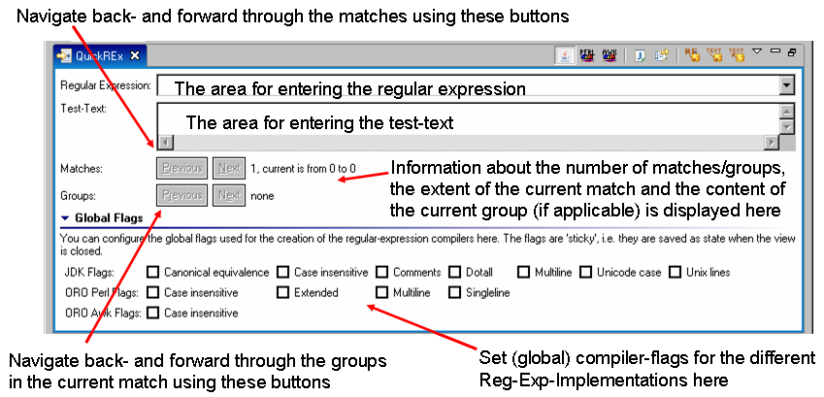

The cool-bar offers the functionality detailed in the following screen-shot:
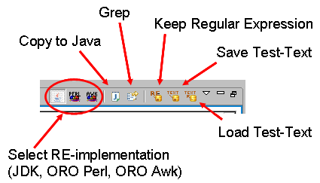
As you type text into the test-text area or a regular expression into the area for the regular expressions, the expression is constantly evaluated. The information on matches and groups is updated on the fly and matches are highlighted in the test-text.
Below is a screenshot of a situation where there are no groups but several matches. The match highlighted in green is the current one. All information on groups pertains to the current match.
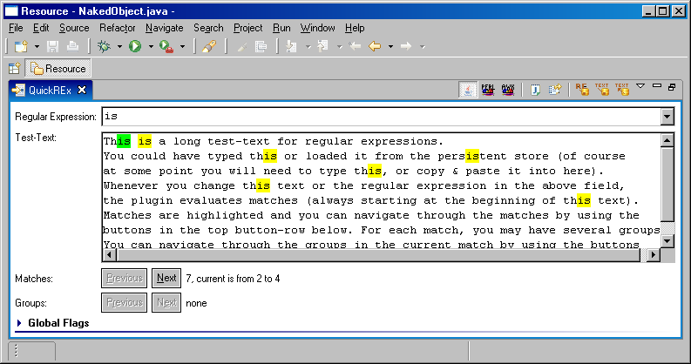
The information next to the buttons used to navigate between the matches is to be interpreted as "There are 7 matches altogether, the current match (highlighted in green) has a start-index of 2 and an end-index of 4". As you can see there are no groups in the current match. You can navigate between the matches using the 'Previous' and 'Next' buttons near the label 'Matches'. If there were groups in the current match, you could navigate through the groups using the 'Previous' and 'Next' buttons near the label 'Groups'.
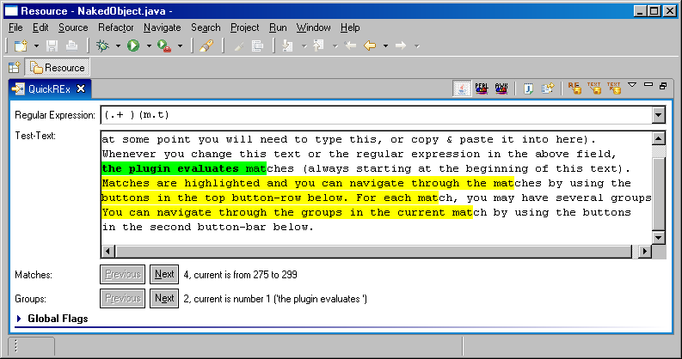
The above screenshot displays a case where there are groups in the current match. The current group is indicated by a bold font and the contents of the group are printed in the information-are next to the group-navigation buttons. The information there is to be interpreted as "There are 2 groups in the current match, the current group is the first one, containing 'the plugin evaluates '".

Selecting the Reg-Exp implementation
QuickREx offers the three most widely used implementations of Regular Expressions in the Java-world:
- JDK Regular Expressions (available since 1.4)
- Jakarta ORO Perl-style Regular Expressions (ORO-Version 2.0.8, supports Perl 5.003 Regular Expressions)
- Jakarta ORO Awk-style Regular Expressions (ORO-Version 2.0.8)
The default implementation is the JDK-one. To change the implementation, use the leftmost buttons in the view's coolbar (see screenshot above). The expression will immediately be re-evaluated. Also, the TAB-completion will adjust to offer the completions defined for the selected implementation.
Alternatively, you may use the view's drop-down menu and select the implementation of your choice (see figure).

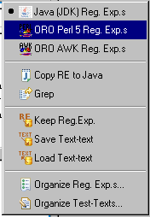

Setting global compiler-flags
You can set global compiler flags with any of the implementations QuickREx offers. This is done at the bottom of the view (see screenshot at the top of the page). To keep the view small, the "Global Flags"-section is folded away when the view is opened. To access it, click on the section-header.
The state of the flags is saved when you close the view or leave the Workbench. Note that there are different flags depending on the chosen implementation. Also note that the flags do behave slightly differently, depending on the implementation chosen. Check the tool-tip texts for the check-boxes to find details about the individual flags (see screenshot).

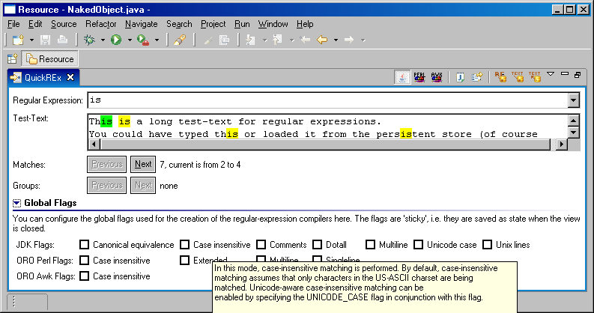

Using TAB-completion
As in several specialized editors within Eclipse, you can use TAB-completion for regular expressions in QuickREx. To get a list of proposals for completion of the current expression, hit 'Ctrl+Space' while editing in the area for regular expressions. An assistant will open as displayed in the below screenshot. Scrolling through the suggestions also updates the hint on the right side of the proposal. When you select a proposal, QuickREx will try to work out whether the already typed in characters should be part of an expression or not.
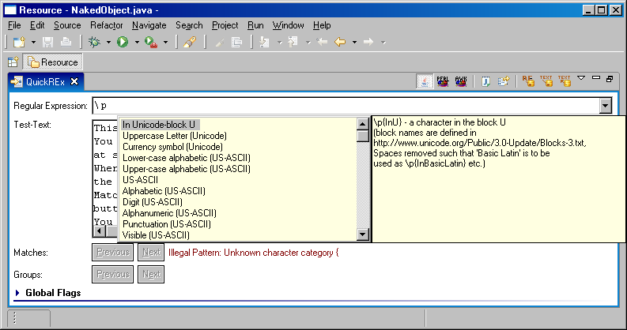
Note that due to the complexity of regular expressions, TAB-completion is not as accurate as it is e.g. in the Java-editor. Sometimes the proposed possibilities may result in illegal patterns. Generally, QuickREx tries to do a good job in guessing what you may want. To this end, the rules are roughly as follows:
- Offer all completions which are not definitely illegal. Thus for example, you will not be offered '+' ("Greedy match 1 or more times") at the beginning of the regular expression - but almost anything else.
- Try to guess the intentions of the user in cases where things are pretty clear. Offer things starting with the most likely ones. They are the exceptions, but there are cases where it is clear what the user is after. Thus, the input '\p{Lo' is very likely part of '\p{Lower}'. This will be the first offer.
- In case there are several potential completions even within the rules, offer the shortest ones first. Thus, if you start with '\' and ask for completion, you will be offered '\\', '\0', ... before \p{Lower}. If you keep typing and the next character typed is a 'p', you will notice how the order of proposals changes.

TAB-completion in QuickREx is fully customizable without changing a single line of code. Check out the Eclipse-Help or the online documentation for details.

Copying Regular Expressions to Java-code
Typically, regular expressions are full with backslashes and the like. To use them in code, you need to escape special characters. When the number of backslashes increases, this gets annoying. To simplify the task and to reduce the potential sources of errors, QuickREx offers the possibility of properly escaping the current regular expression and inserting them at the current curser position of (or replacing the current selection in) the last active editor window. To this end, simply place the cursor where you want the regular expression to go in the editor and press 'Copy to Java' in the coolbar or select it in the drop-down (see above).

Grep - extracting all matches from text
If you want to extract only the matches for a particular regular expression from the current test-text, simply press the button 'Grep' in the coolbar or select it in the drop-down (see above). A dialog as displayed below will open, holding all matches separated by line-feeds. You can copy the result from the dialog to the clipboard to use it anywhere else as usually.
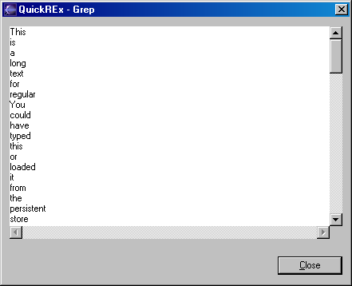

Saving, Loading and Organizing Regular Expressions and Test-Texts
You can save useful regular expressions and test-texts for later reference. All persisted data is held in the so-called plugin-content-area in Eclipse which is found as a folder with the plugin-id as name under the path (Workspace)/.metadata/.plugins. The QuickREx-plugin generates two .xml-files, regularExpressions.xml and testTexts.xml, which hold the persisted regular expressions and test-texts.
To keep the current regular expression for later reference, simply press the button 'Keep Regular Expression' in the cool-bar or select the entry from the drop-down menu (see above) with the regular expression entered into the reg.-exp.-field. This will add the current String to the list of regular expressions available in the regular-expression combo. Once the plugin is deactivated by the workbench, this list is persisted into the file mentioned above.
To load a previous regular expression, simply select it in the regular-expression combo list.
To delete saved regular expressions from the list, use the drop-down menu of the view (see above). This offers an action 'Organize Reg. Exp.s...'.
A dialog will open, displaying the list of currently saved regular expressions. Select the expression(s) to delete and press the 'Delete'-button in the dialog. When you are done, press 'Close'.
To keep the current test-text for later reference, press the button 'Save Test-Text' in the cool-bar or select the entry from the drop-down menu (see above). A dialog opens, displaying the current text and asking for a name. Enter a name and press 'OK'. If the name is already in use, a message will inform you about this fact when the name is entered. If you still press 'OK', the old text is overwritten with the current text.
To load a previous test-text or the contents of a file, press the button 'Load Test-Text' in the cool-bar or select the entry from the drop-down menu (see above). A dialog lets you select the name of the test-text to load or read the contents of a file on the file-system.
To load a previously saved text, select the name of the text to load from the list. The saved text is displayed in the dialog for reference (see below). Pressing 'OK' loads the selected text into the test-text field.
To load the contents of a file on the file-system, press 'Browse...' and find the file in the file-selection dialog. When closing the dialog with a file selected, the contents of the file are displayed in the field 'Text'. Pressing 'OK' closes the organize-dialog and loads the file-contents in to the test-text field. Note that the test-text-contents are no longer linked with the file-contents, i.e. changing any one will not change the other.
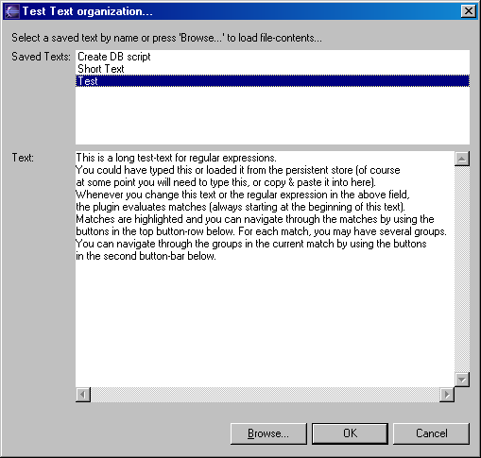
To delete saved test-texts, use the drop-down menu of the view (see above). This offers an action 'Organize Test-Texts...'.
A dialog similar to the one above will open, where the 'OK' button is replaced by a 'Delete' button and the 'Cancel' button is replaced by a 'Close' button. Select the name of the test-text to be deleted and click 'Delete'. A message informs you that the text has been deleted and the list is refreshed. To close the dialog, use the corresponding button.

