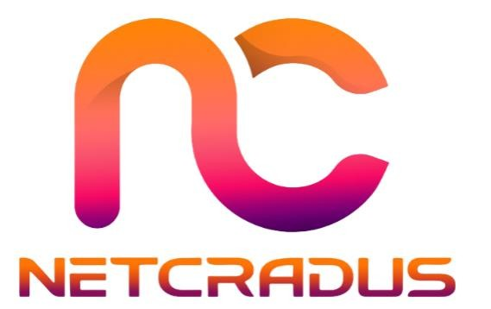
Netcradus Autonomous Cyber Immune System (ACIS)
Presented By: Mohit Sharma
Founder of Netcradus, Cybersecurity Consultant
August 28, 2025 Company No: 16488418
Website: www.netcradus.com | Email: info@netcradus.com

Table of Contents
List of Figures 3
List of Tables 3
1.Executive Summary 4
2. Market Gap & UK Opportunity 6
2.1 Business Overview 6
2.2 SME Cybersecurity Challenges 6
2.3 Cyber Threat Landscape 7
2.4 Market Gap Analysis 7
3. Technical Architecture & Deep Concept 8
3.1 Layer 1 – AI-Powered SIEM 9
3.2 Layer 2 – Autonomous SOAR & Response Engine 13
3.3 Layer 3 – AI Red Team Simulator 16
3.4 Layer 4 – Self-Healing & Deception Engine 19
3.5 Layer 5 – Threat Intelligence Swarm 21
4. Innovation Summary – Why ACIS is Unique 24
4.1 Autonomous Closed-Loop Defense 24
4.2 AI Red Team Integration 25
4.3 Self-Healing Endpoints 25
4.4 Adaptive Deception 26
4.5 Swarm Learning 26
3-Year Roadmap & Scaling 26
5.1 Year 1 – MVP & UK Launch 27
5.2 Year 2 – Full Autonomous Release 28
5.3 Year 3 – Global Expansion & SaaS Scale 28
UK Economic Impact & Job Creation 29
6.1 Jobs Created 29
6.2 SME Security Boost 30
6.3 University Partnerships 30
6.4 Export Potential 31
Financial Model & Revenue Plan 31
7.1 SaaS Subscription Tiers 32
7.2 Revenue Targets 34
7.3 Break-Even Analysis 35
7.4 Funding Requirements 37
7.5 Cost Structure 38
7.6 Compliance & Data Security 38
Conclusion 39
References 40
Appendices 41
Appendix A: Founder CV & Certifications 41
Appendix B: UI Mockups & System Diagrams 42
Appendix B.3: Process Flowcharts 45
Appendix C: Market Research Data Sources 47

List of Figures
Figure 1: Netcradus SIEM Login Interface 7
Figure 2: Netcradus Services Dashboard 8
Figure 3:Social Media Integration Dashboard 10
Figure 4: Netcradus SIEM Dashboard Overview 11
Figure 5: Call Tracking Dashboard 11
Figure 6: Projects Dashboard 12
Figure 7: Netcradus ACIS Dashboard 12
Figure 8: Netcradus ACIS Dashboard Security 13
Figure 9: ACIS dashboard's visualization of threat detection 13
Figure 10: Client Visits Dashboard 14
Figure 11: Netcradus ACIS Dashboard 15
Figure 12: Forecasts Overview" dashboard with total forecast ₹10,30,000, achieved ₹9,60,000, remaining ₹1,70,000, and a target achievement of 83.35%. 16
Figure 13: Netcradus ACIS: A five-layer autonomous cybersecurity platform integrating AI SIEM, SOAR, red teaming, self-healing, and swarm intelligence for SMEs. 16
Figure 14: Client Solutions Dashboard: Tracking CRM integration, mobile app development, and e-commerce optimization with status updates. 17
Figure 15: Purchase Orders and Cases Dashboard: Tracking login, email, and password reset issues with status and assignment details. 17
Figure 16: Price Books Dashboard: Managing retail and wholesale product pricing with effective dates and version control 18
Figure 17: Vendor Management Dashboard: Tracking active and inactive suppliers with contact details and interaction history. 19
Figure 18: Product and Campaign Management Dashboard: Tracking active and upcoming marketing campaigns with channel details and dates. 19
Figure 19: Client Invoices and Sales Inbox: Tracking payments from major clients and managing new leads and communications. 20
Figure 20: Purchase Orders Dashboard: Tracking vendor orders with status updates and financial amounts. 21
Figure 21: Sales Orders Dashboard: Tracking customer orders with status, amounts, and delivery timelines. 21
Figure 22: Meetings Dashboard: Scheduling and tracking client engagements with participant details and status. 22
Figure 23: Product Inventory Dashboard: Managing electronics, software, furniture, and books with pricing, tax, and stock status. 22
Figure 24: Call Log Dashboard: Tracking inbound, outgoing, and missed customer communications with timestamps 23
Figure 25: Deals Pipeline Dashboard: Tracking project stages from leads to closure with assigned values and team members. 24
Figure 26:Client Accounts Dashboard: Managing active and inactive business relationships with contact history. 25
Figure 27: NETCRADUS Dashboard: Tracking monthly revenue, conversion rates, and overall business performance metrics. 25
Figure 28: Sales Team Dashboard: Monitoring open deals, monthly revenue, and conversion rates with AI-powered insights. 26
Figure 29: Company Setup Interface: Initial user onboarding with personal and departmental details configuration 27
Figure 30: Contacts Management Dashboard: Tracking leads and customers with interaction history and status. 28
Figure 31: Task Management Dashboard: Organizing team assignments with due dates and completion status. 29
Figure 32: Total Forecast Status 41

List of Tables
Table 1: Netcradus ACIS Subscription Tiers and Target Segments 34
Table 2: Netcradus ACIS Revenue Projections and Growth Drivers 35
Table 3: Netcradus ACIS Cash Flow and Profit & Loss Projections 36
Table 4: Netcradus ACIS Profit & Loss Forecast (Years 1-3, £000s) 36
Table 5: Netcradus ACIS Year 1 Cost Structure 37

1.Executive Summary
Netcradus proposes the launch of ACIS (Autonomous Cyber Immune System), a first-of-its-kind AI-driven, self-healing cybersecurity platform that seamlessly integrates Next-Gen AI SIEM for intelligent log aggregation, threat correlation, and anomaly detection, SOAR capabilities for security orchestration, automation, and response to neutralize threats automatically, an AI-Driven Red Team Simulator to continuously test defenses like a real human attacker, Self-Healing Endpoints & Networks to automatically isolate and restore compromised devices, and Threat Intelligence Swarm Learning to share anonymized intelligence that improves all clients collectively. This innovative system transforms cybersecurity from a reactive to a proactive stance, delivering enterprise-level protection to small and medium-sized enterprises (SMEs) at an affordable cost. The objective is to position the UK as the first market to host a fully autonomous cybersecurity immune system, reducing SME cyberattack losses, ensuring compliance with NIS2 and GDPR, and establishing a foundation for export-ready technology by 2027.
Netcradus emerges as a pioneering cybersecurity innovator, founded by Mohit Sharma, a seasoned professional with over a decade of experience in IT infrastructure and cybersecurity consulting. I holds prestigious certifications, including CompTIA Security+ Splunk Defence and operations Analyst, Google Professional Cybersecurity Certificate and Certified Ethical Hacker (CEH Practical), reflecting his expertise in threat mitigation and system security. Poised to address the evolving needs of the global cybersecurity landscape, Netcradus focuses on affordable, autonomous solutions, with a mission to democratize advanced cybersecurity starting in the UK market. Leveraging Sharma’s technical leadership and entrepreneurial vision, the company aims to drive innovation and growth, establishing a strong foothold in the competitive cybersecurity sector.
The UK cybersecurity landscape is under significant strain, with SMEs bearing the brunt of escalating cyber threats. According to the latest 2024 UK Cyber Security Breaches Survey, 43% of SMEs reported at least one breach, a trend exacerbated by the £3.3 billion annual cost of ransomware attacks as of mid-2025, as reported by the National Cyber Security Centre (2025). The primary challenge is the lack of affordable, enterprise-grade security solutions, as most SMEs cannot sustain the operational costs of 24/7 Security Operations Centers (SOCs) or invest in complex Security Information and Event Management (SIEM) systems, leaving them vulnerable to sophisticated attacks that demand immediate and effective countermeasures.
ACIS (Autonomous Cyber Immune System) is an innovative cybersecurity framework, which combines a centralized system based on Next-Gen AI SIEM to process logs and detect threats in real-time, SOAR to auto-generate response workflows and contain threats rapidly, an AI-Driven Red Team Simulator using reinforcement learning to model attacker behavior and increase the resilience of defense, Self-Healing Endpoints and Networks using advanced rollback to independently restore compromised systems, and Threat Intelligence Swarm Learning to find defenses through federated learning using anonymized data. The strict regulatory environment in the country, comprising of NIS2 and GDPR, is fully compatible with the compliance capabilities of ACIS, and the country has a high potential of export due to its status as a financial and technological hub across the globe. Moreover, through the government-supported programmes such as an annual National Cyber Strategy 2025, innovative cybersecurity startups have a supportive ecosystem to scale to Europe, Asia, and the US and secure long-term growth and market penetration. The Innovator Founder Visa requires a business to show innovative, viable, and scalable, which ACIS fits with its exclusive, patent-pending technology, which integrates autonomous defense mechanisms unavailable with current technologies. Its Software-as-a-Service (SaaS) model will provide the company with financial sustainability with the break-even at 18-24 months and revenue projections of £250K in the first Year and reaching 3-5M in the third year. Scalability is demonstrated by intents to deploy as a multi-tenant cloud and to expand internationally, which will generate 12-15 high-value jobs in the UK and make the UK a leader in autonomous cybersecurity innovation, which is exactly what the visa aims to achieve and can create economic and technological benefits.

2. Market Gap & UK Opportunity

Business Overview
Netcradus is a forward-thinking cybersecurity startup founded by Mohit Sharma, a seasoned professional with over a decade of experience in IT infrastructure and cybersecurity consulting. Registered as a private limited company (Ltd) under company number 16488418 in the United Kingdom, Netcradus operates its headquarters at 104, London Road, Leicester, England, UK, serving as the hub for its innovative operations. Sharma holds prestigious certifications, including including CompTIA Security+ Splunk Defence and operations Analyst, Google Professional Cybersecurity Certificate and Certified Ethical Hacker (CEH Practical), underscoring his expertise in threat mitigation and system security, which drives the company’s technical leadership. The company’s vision is to redefine global cybersecurity by delivering affordable, autonomous solutions that empower businesses worldwide, with a starting focus on the UK market. Its mission is to democratize advanced cybersecurity for small and medium-sized enterprises (SMEs) by providing enterprise-grade protection through cutting-edge AI technology, reducing the financial and operational burdens of traditional security measures. Netcradus aims to establish itself as a pioneer in the cybersecurity sector, leveraging Sharma’s entrepreneurial vision and technical prowess to foster innovation, scalability, and economic growth.

SME Cybersecurity Challenges
Small and medium-sized enterprises (SMEs) in the UK are grappling with significant cybersecurity challenges that hinder their ability to protect against evolving threats. A staggering 65% of these businesses lack access to 24/7 Security Operations Center (SOC) teams or enterprise-grade Security Information and Event Management (SIEM) systems, such as Splunk, QRadar, or Sentinel. The main obstacle is the financial one because the existence of a dedicated SOC or highly developed SIEM platforms need a considerable capital and operational expenses that a large portion of SMEs cannot afford.
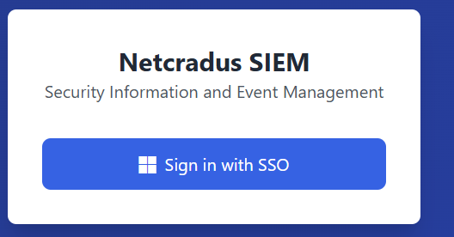
Figure 1: Netcradus SIEM Login Interface
Figure 1: Netcradus SIEM Login Interface - This figure displays the login screen for the Netcradus Security Information and Event Management (SIEM) platform, featuring a clean, user-friendly interface with SSO (Single Sign-On) integration for secure access, highlighting the platform's focus on accessibility and enterprise-grade authentication. The UK offers a perfect opportunity to begin its operations in the country because the country has a strong SME sector that comprises an estimated 99 percent of businesses and hires 61 percent of the labor force based on the report conducted by the UK Department for Business and Trade (2025).
In addition to cost, in-house cybersecurity expertise is badly lacking, and several business owners lack the technical knowledge to deploy or operate more complex security solutions. Such dependence on third parties usually leads to disjointed or insufficient security, exposing SME to breach that may interfere with their operations and destroy customer trust. This is further compounded by the lack of any cost-effective, automated alternatives, and it is in dire need of a solution that would help to democratize enterprise level security to small organizations. Netcradus is aware of this gap and it seeks to fill this gap by creating a platform that minimizes the reliance on human resources yet would be affordable to businesses with smaller budgets and would put an equal playing field on cybersecurity defense.
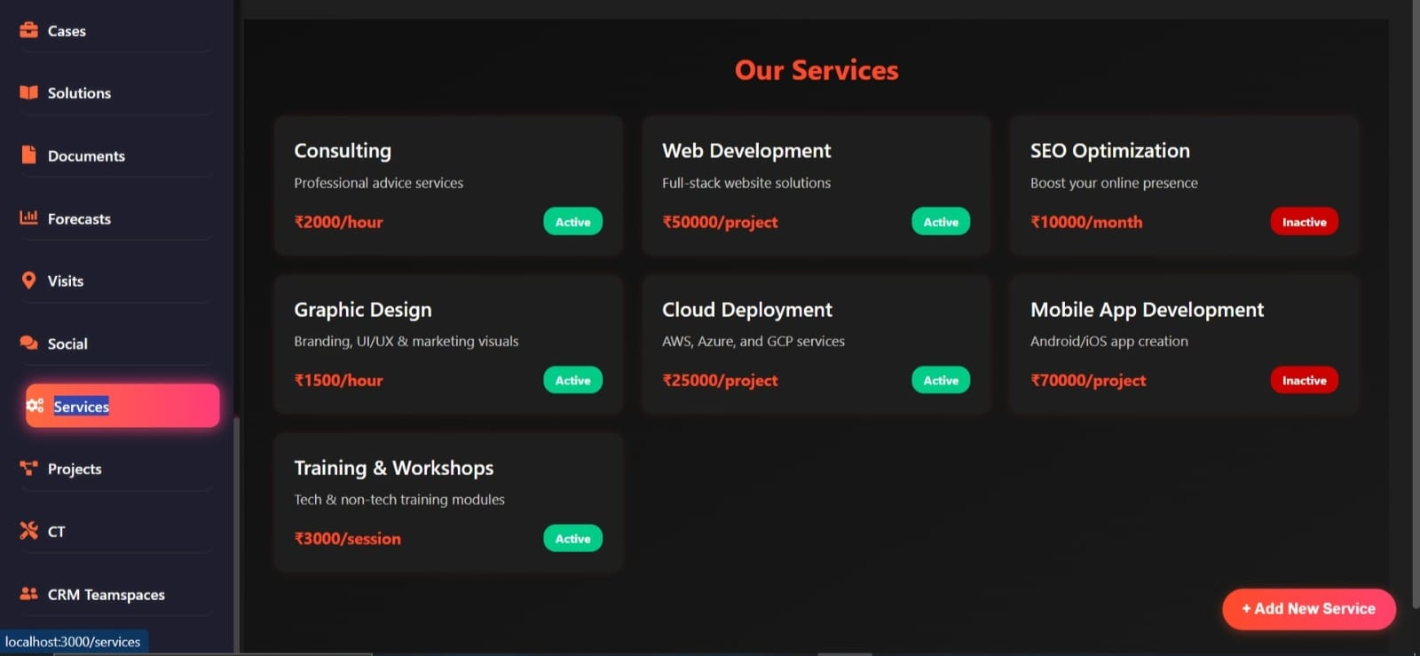
Figure 2: Netcradus Services Dashboard
Figure 2 shows the overview of offered services including consulting (₹2000/hour, Active), web development (₹50000/project, Active), SEO optimization (₹10000/month, Inactive), graphic design (₹1500/hour, Active), cloud deployment (₹25000/project, Active), mobile app development (₹70000/project, Inactive), and training & workshops (₹3000/session, Active), with an "Add New Service" option.

Cyber Threat Landscape
The cybersecurity situation in the UK has also gained overwhelming threats and SMEs have been at the receiving end of an increasing number of cyber threats. As the 2025 UK Cyber Security Breaches Survey revealed, 43 percent of SMEs reported one or more cyber-attack or breach in 2024, which is why their vulnerability is a significant issue. The financial cost is also quite alarming because the ransomware attacks cost the UK businesses an astounding amount of £3.3 billion annually which is an indicator of the augmented complexity and frequency of such incidences. With more advanced techniques, including phishing, supply chain attacks, and ransomware deployments, attackers are seeking to exploit the lower level of sophistication of SMEs. The dynamic character of such threats, in addition to the growth of the regulatory pressure in the framework of NIS2 and GDPR, points to an imminent necessity of innovative solutions. SMEs require a system that does not merely detects and responds to threats on the fly, but also can adapt itself to emergent threats without requiring human oversight at all times. This is also a threat environment that is dynamic and presents a challenge and an opportunity to Netcradus to adopt a new transformative approach toward cybersecurity that can be highly resilient and cost-effective.

Market Gap Analysis
There is an opportunity that Netcradus will exploit as the current market in cybersecurity fails to entirely address the requirements of UK SMEs. No one in the UK or anywhere in the world, has had a single product in which the Security Information and Event Management (SIEM), Security Orchestration, Automation, and Response (SOAR), the AI-driven red team generation and self-healing defense capabilities have been seamlessly integrated into a single unified product. The traditional alternatives offer all these aspects individually and the SMEs must invest in different tools and professional employees, which is impractical in view of their financial and expertise constraints. This disintegration constitutes a critical breach in the current market, considering the reality that SMEs need a cost effective and integrated option to defend against sophisticated attacks. The Autonomous Cyber Immune System (ACIS) invented by Netcradus meets this need with the Autonomous Cyberspace as a Service (ACaaS) which will offer human intervention-minimized AI-assisted protection. ACIS automates threat detection, response and recovery that reduces operational costs and simultaneously complies with regulatory standards such as NIS2, GDPR and UK Cyber Essentials. This ground breaking solution does not only bridge the market gap, but also makes ACIS a scalable solution that can expand beyond the UK. Enterprise-level security at a fraction of the price, the platform is a game-changer and provides the SMEs a proactive system of defence that fits their budgetary needs and compliance demands in the creation of a safer business environment.

3. Technical Architecture & Deep Concept
The Autonomous Cyber Immune System (ACIS) employs a sophisticated five-layer architecture engineered for autonomous detection, response, adaptation, and collective intelligence in cybersecurity. This is a hybrid SaaS solution based on advanced AI and cloud-native capabilities that offer scalable and affordable protection to SMEs. The architecture is a combination of real-time data processing, machine learning models, and privacy-preserving mechanisms, compatibly with the standards, e.g. GDPR and NIS2. Each of the layers is described below with functional descriptions, important technologies, output and implementation considerations based on 2025 developments in AI-driven security systems.
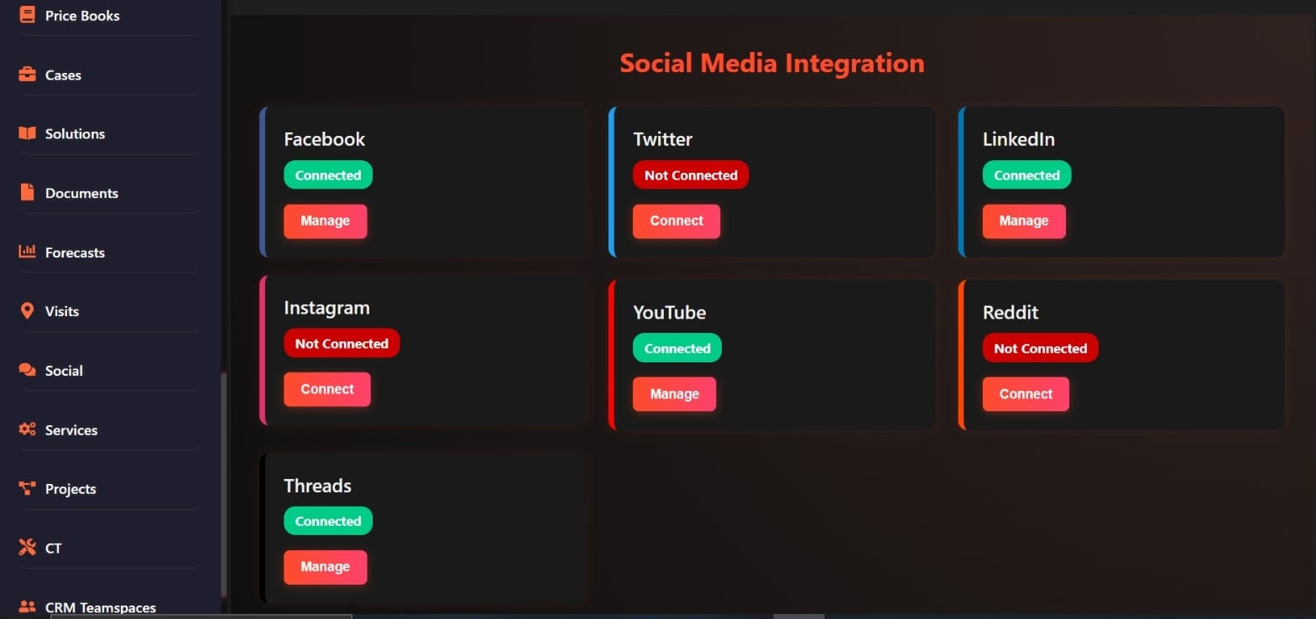
Figure 3:Social Media Integration Dashboard
Figure 3: Social Media Integration Dashboard. This interface displays the status of various social media platform integrations, allowing users to connect, manage, and monitor accounts from a centralized dashboard for streamlined digital presence management.

Layer 1 – AI-Powered SIEM
An AI-Powered Security Information and Event Management (SIEM) system is the core component of the Autonomous Cyber Immune System (ACIS), and is designed to consume and normalize large amounts of heterogeneous logs in real-time and correlate them. This layer is the sensory center of the platform and gathers data in a broad array of environments, such as servers, endpoints, firewalls, IoT devices, cloud platforms such as AWS, Azure, and Google Cloud Platform (GCP), web apps, APIs, and containerized applications such as Docker and Kubernetes. These logs can be combined in one dataset and, as a result, the system creates a holistic baseline of regular operational behavior, allowing to identify anomalies that can indicate possible cyber threats, including unauthorized access attempts or suspicious data flows.
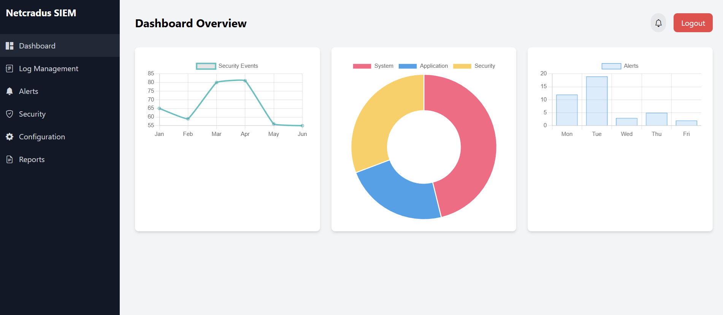
Figure 4: Netcradus SIEM Dashboard Overview
Figure 2: Netcradus SIEM Dashboard Overview - This Figure represents the key dashboard of Netcradus SIEM system including major visualizations like security events trends by time (line chart), event distribution by type (pie chart), and event volumes by day (bar chart), that testify to the ability to monitor and analyze the threats in real-time and respond to them.
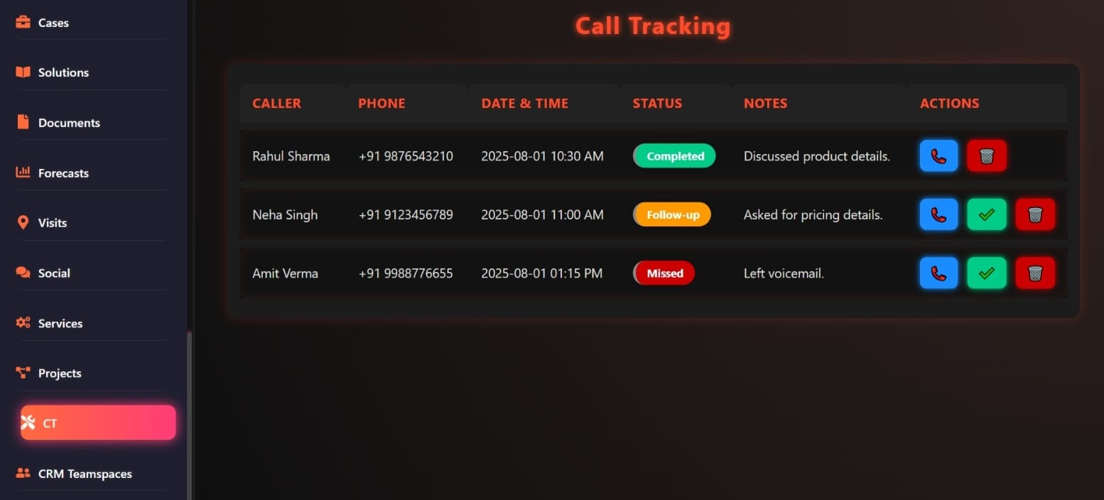
Figure 5: Call Tracking Dashboard
Figure 3 interface streamlines customer interaction management, tracking call statuses, details, and required actions. It enables efficient follow-ups and organizes communication data for sales and support teams.
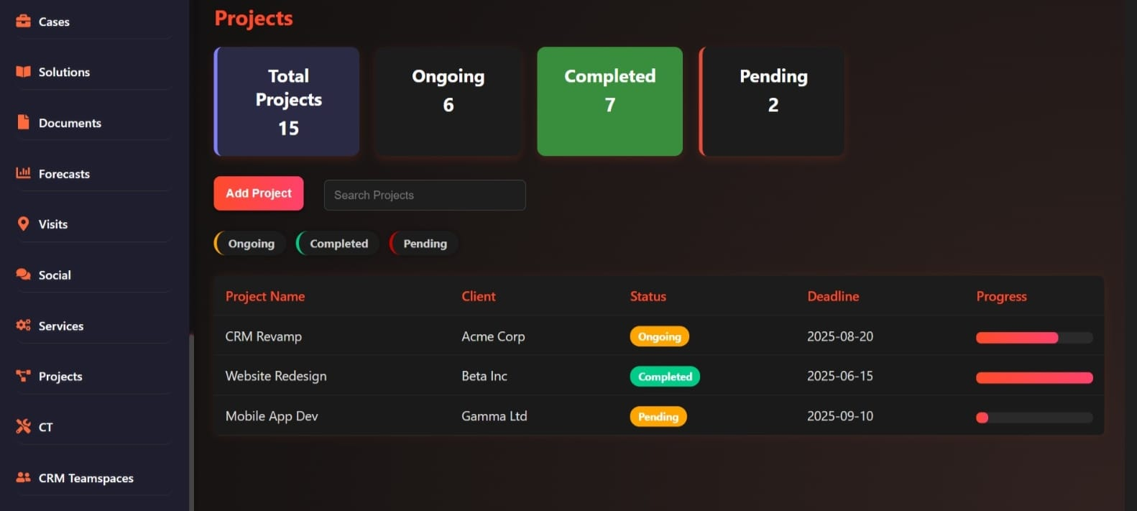
Figure 6: Projects Dashboard
Figure 6: Projects Dashboard Overview. In this dashboard, key metrics in the project are shown such as total 15 projects of which 6 are in progress, 7 completed, and 2 pending. It has a table with the names of the projects (e.g., CRM Revamp, Website Redesign, Mobile App Dev), names of the clients (e.g., Acme Corp, Beta Inc, Gamma Ltd), status, due date (e.g., 2025-08- 20, 2025-06-15), and progress indicators.
The underlying technologies in this layer are the sophisticated machine learning models that are specialized in detecting anomalies, which are the Long Short-Term Memory (LSTM) networks and the Isolation Forest algorithms. A form of recurrent neural networks, LSTM can handle sequential data, including time-series logs, and extract long-range dependencies, therefore detecting subtle patterns of threats, including gradual exfiltration of data or consistent anomalies that a rule-based system would overlook. Isolation Forest augment this capability by isolating anomalies by randomization of data points, which is highly efficient and accurate with the high-dimensional datasets common to cybersecurity.
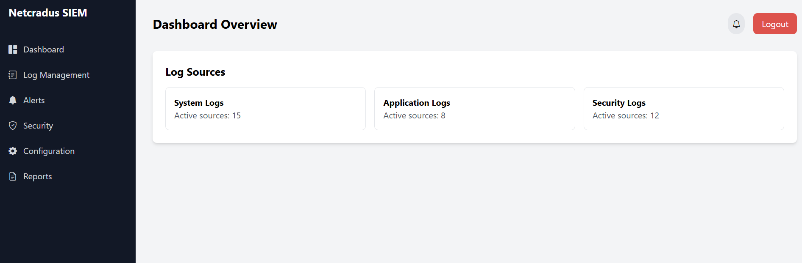
Figure 7: Netcradus ACIS Dashboard
Figure 7: Netcradus ACIS Dashboard Overview – This Figure shows the main dashboard of the Netcradus ACIS platform, where threat monitoring and analytics are in real-time. The Netcradus ACIS Dashboard Overview shows a graphical representation of the way the platform is able to gather and assess security data, giving key measurements such as threat alerts, log correlations and system health in an easy-to-use interface. Such a dashboard allows SMEs to possess actionable intelligence, thereby making decisions quickly without having to command huge cybersecurity expertise, which aligns with the SME-style mission of democratizing enterprise-level security. Proactive aspect of ACIS is enhanced by the features of real-time updates and graphs, which reduce the response time and enhance the overall capacity to counteract cyber-attacks.
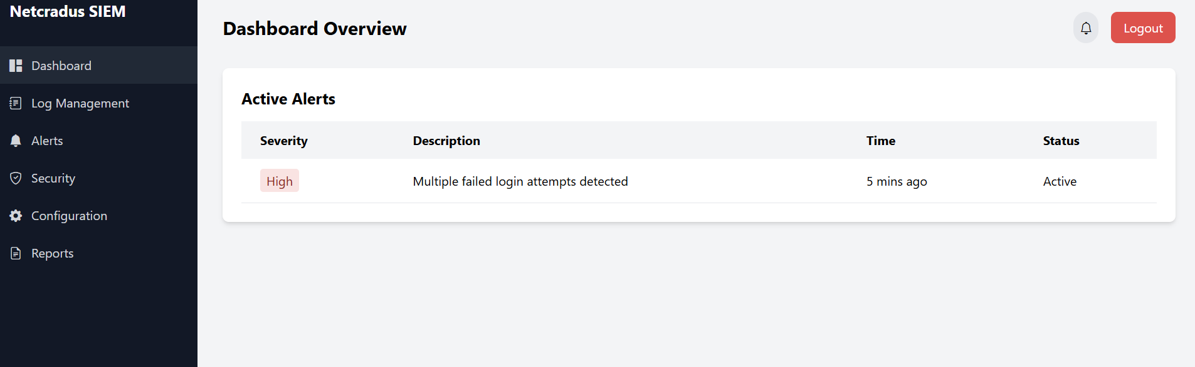
Figure 8: Netcradus ACIS Dashboard Security
Figure 8: Netcradus ACIS Dashboard Overview - Shows the ACIS dashboard, which features live threat detection and analytics of SMEs. The Netcradus ACIS Dashboard is a visual aggregation of security-related data, which provides non-experts SMEs with real-time threat warnings and system health. It has a user-friendly interface that accelerates decision-making, which fits the purpose of ACIS affordable, proactive cybersecurity and increases resilience against emerging cyber threats.
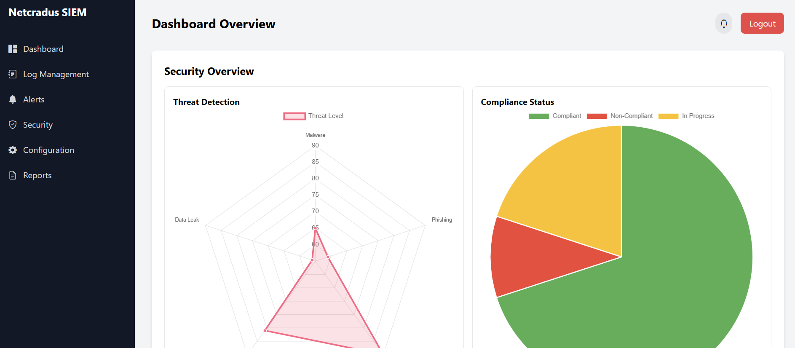
Figure 9: ACIS dashboard's visualization of threat detection
Figure 9: Netcradus ACIS Dashboard Overview - Illustrates the ACIS dashboard, presenting real-time threat monitoring, analytics, and system health for SMEs, with intuitive visuals to enhance decision-making and cybersecurity resilience. To implement log streaming and indexing in real-time, ACIS can be used to combine ElasticSearch with Apache Kafka to create a high-performance data pipeline that can be optimized to run on a cloud-native infrastructure. Kafka is a distributed streaming platform, which handles high-throughput log ingestion, fault-tolerant partitioning to avoid data loss in the times of peak activities. This data is then indexed by ElasticSearch to allow quick querying and visualization of petabytes of logs at sub-second response times, an essential characteristic of ensuring continuity in operations.
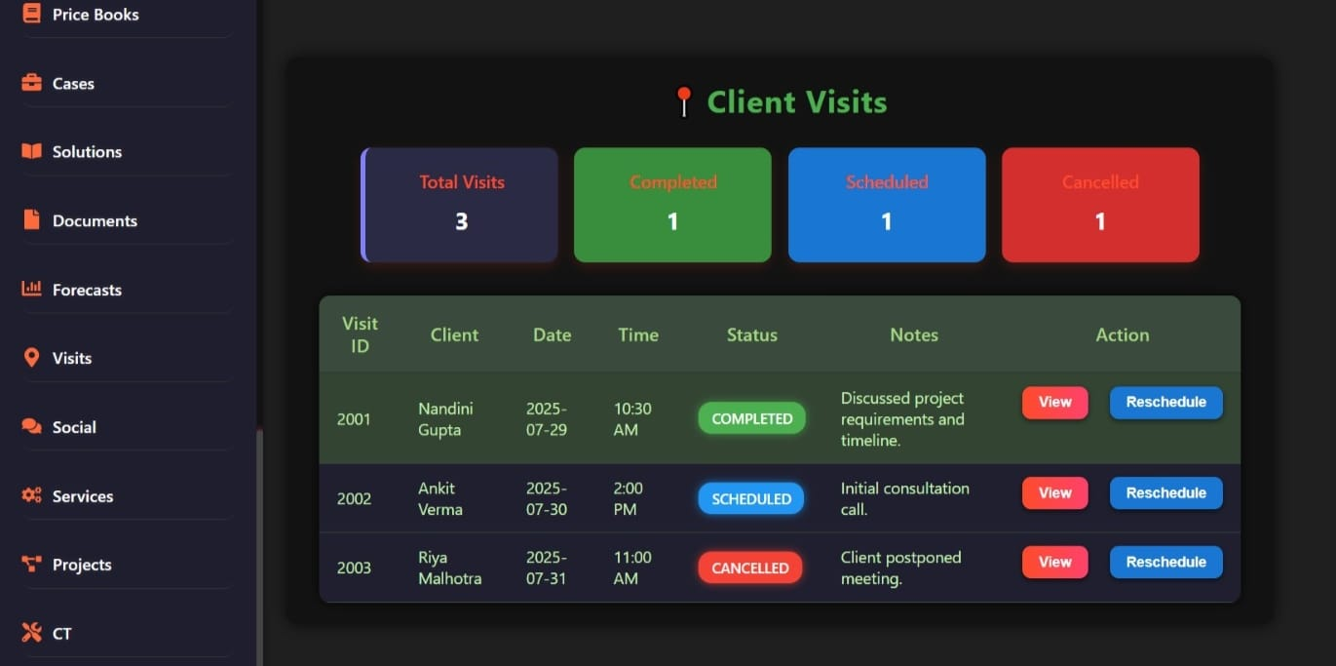
Figure 10: Client Visits Dashboard
Figure 10: Client Visits Dashboard. This interface provides an overview of client visit metrics, tracking completed, scheduled, and cancelled appointments. This layer produces threat prioritization enhanced with enhanced contextual scoring, which allocates numerical risk values (e.g., 0-100) to be used by the subsequent ACIS layers to generate automated action. Details on implementation highlight scalable pipeline design of data, the use of multi-tenant isolation to ensure the protection of data privacy in SaaS applications and auto-scaling through the use of Kubernetes to handle the fluctuating workloads. By 2025, AI-powered analytics will have cut noise by 40-50 percent, increased accuracy by correlating events in hybrid environments and reduced false positives.

Layer 2 – Autonomous SOAR & Response Engine
The Autonomous Security Orchestration, Automation, and Response (SOAR) Engine is based on the threat detections on Layer 1 to provide an automatic, intelligent response to neutralize the threat without the need of human intervention. The layer automates the containment processes and implements a combination of predefined and AI-adapted actions in order to efficiently mitigate the risks. Its most important functions are: quarantining the suspicious endpoints to stop the lateral movement, blocking of malicious IPs/domains by using firewall APIs, resetting compromised credentials/ disable affected user accounts and sandbox detonation to analyze suspicious files within isolated environments that helps to prevent any potential damage before it spreads.
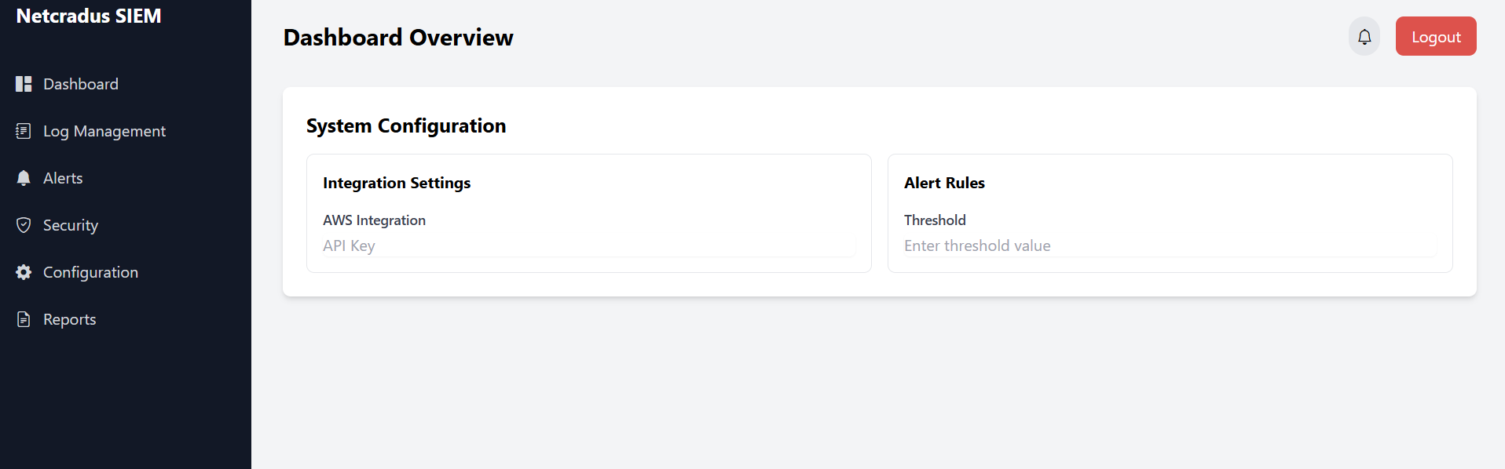
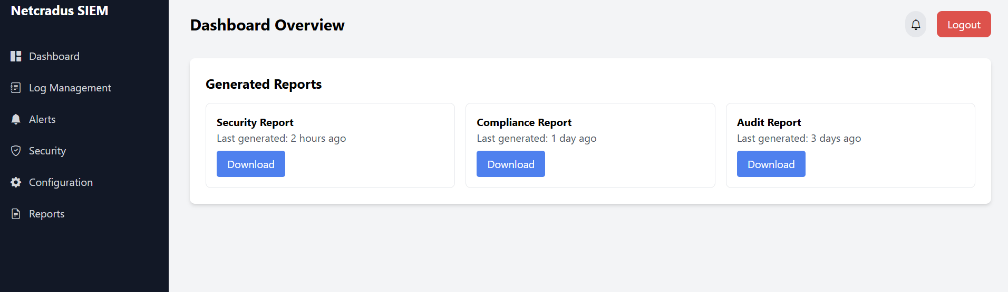
Figure 11: Netcradus ACIS Dashboard
Figure 11: Netcradus ACIS Dashboard Overview - Displays the ACIS dashboard, showcasing real-time threat monitoring, analytics, and system health for SMEs, with intuitive visuals enhancing cybersecurity decision-making. This layer is based on the technological basis of Python microservices coordinated through Kubernetes which allows building a scalable and modular automation architecture. Python and its rich ecosystem allow the creation and rapid development of custom scripts based on the needs of the particular response, whereas Kubernetes allows the orchestration of containers, which have high availability and can also scale to thousands of incidents at once. Machine learning-based conditional responses power playbooks, with algorithms assessing the threat context. REST APIs can be used to integrate directly with other third-party applications, such as Okta to manage identities, Microsoft 365 to control endpoints, and AWS Security Hub to respond more specifically to threats, forming a unifying orchestration fabric that increases interoperability.
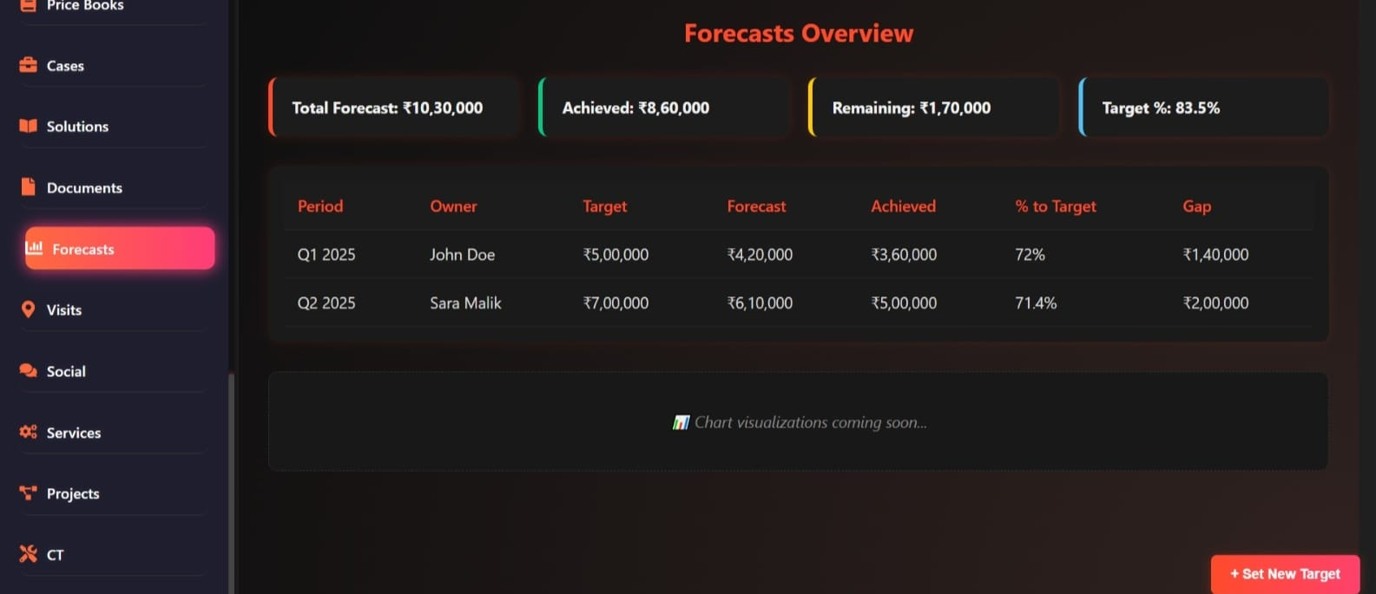
Figure 12: Forecasts Overview" dashboard with total forecast ₹10,30,000, achieved ₹9,60,000, remaining ₹1,70,000, and a target achievement of 83.35%.
See Figure 12. this layer, with its output, provides rapid threat containment, and automated workflows are able to respond to a threat less than 10 seconds per the benchmarks, 2025, which is a far lower response time, effectively limiting the amount of potential damage. The performance measures are concerned with mean time to respond (MTTR), where sub-5-second averages are targeted in high-priority threats and require parallel processing in the microservices to respond promptly regardless of the load. This performance is essential to SMEs with no specific security teams, and it is in line with the mission of democratising enterprise-level security at ACIS.
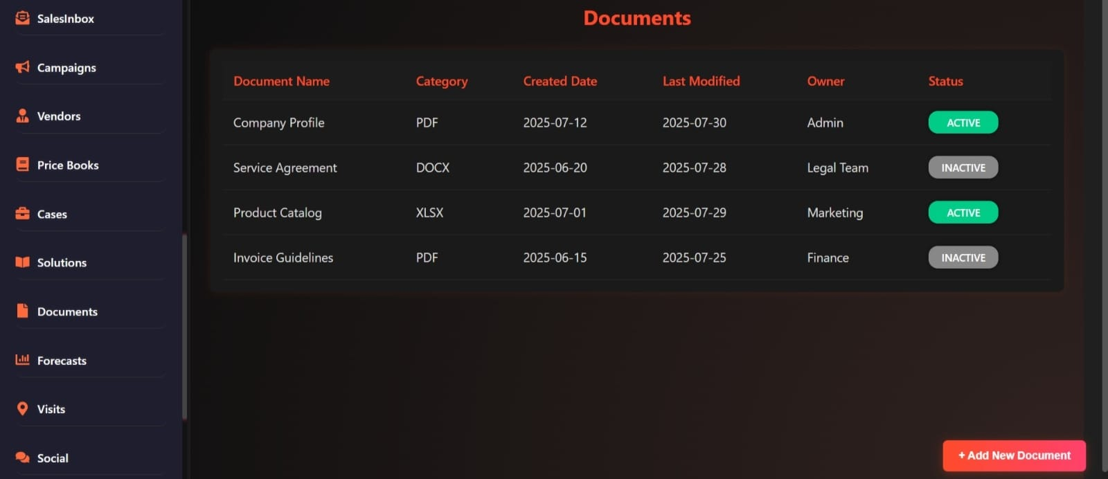
Figure 13: Netcradus ACIS: A five-layer autonomous cybersecurity platform integrating AI SIEM, SOAR, red teaming, self-healing, and swarm intelligence for SMEs.
The deployment emphasizes resilience, whereby the microservices are configured in a fault-tolerant mode that utilizes self-healing mechanisms of Kubernetes that automatically recovers failed pods to ensure continuity in operation. In 2025, AI-enhanced playbooks have developed, which learns the lessons of the past, and uses natural language processing to produce rules dynamically according to threat intelligence feeds. The architecture is conducive of both hybrid deployments, which combine on-premises and cloud resources, and end-to-end encryption of all API traffic to ensure that the integrity of data remains intact against interception or tampering.
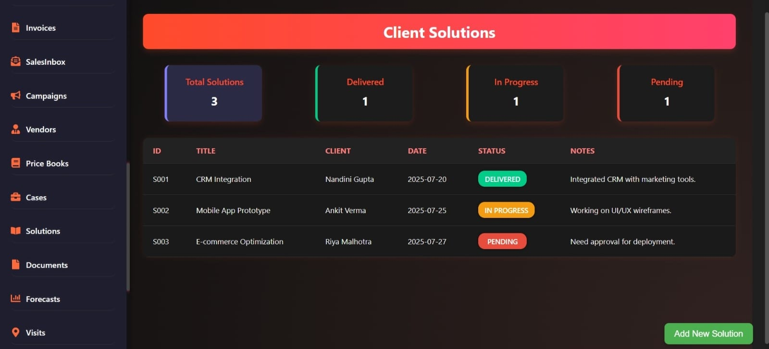
Figure 14: Client Solutions Dashboard: Tracking CRM integration, mobile app development, and e-commerce optimization with status updates.
The cornerstone to this layer is scalability, realized by the use of horizontal pod autoscaling in Kubernetes, where the engine is able to support spikes in threat volume without suffering a performance penalty. This will help to make ACIS scalable to enterprise-level applications as SMEs expand, with one isolated client environment per customer.
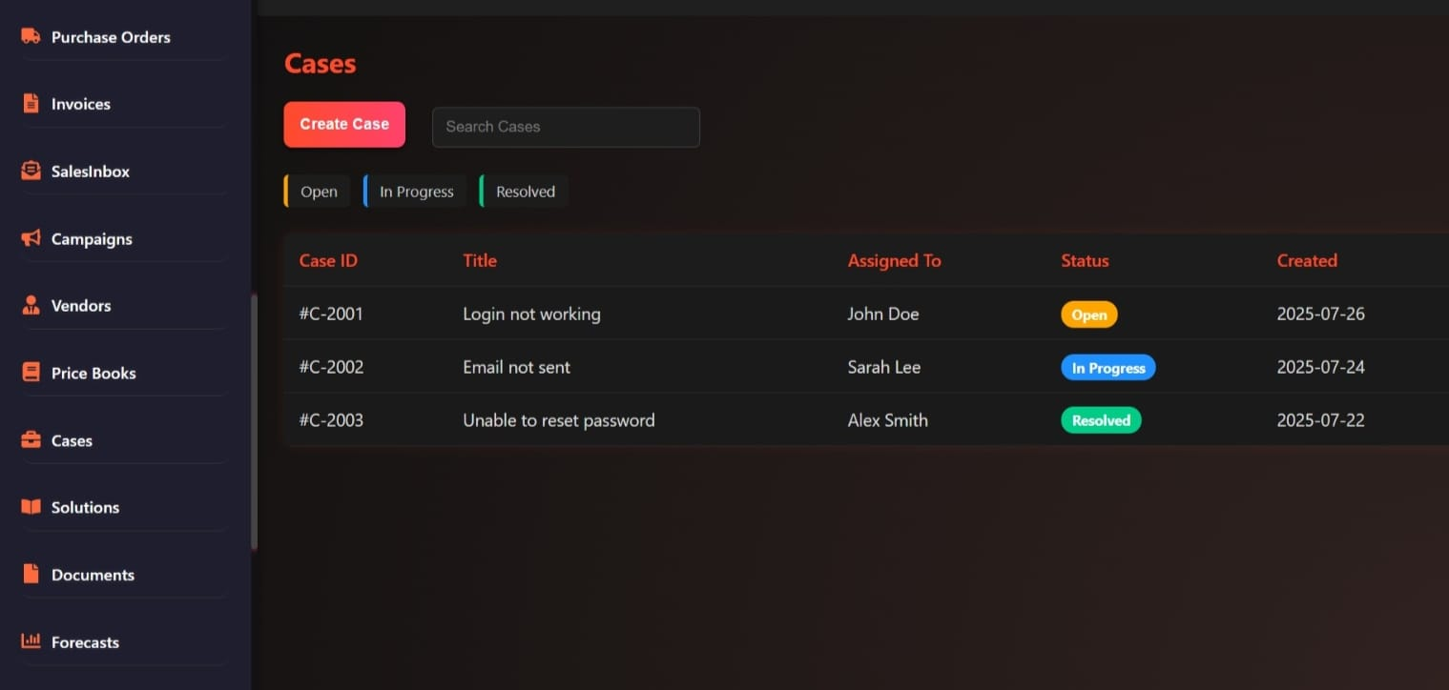
Figure 15: Purchase Orders and Cases Dashboard: Tracking login, email, and password reset issues with status and assignment details.

Layer 3 – AI Red Team Simulator
The AI Red Team Simulator layer is a proactive organization defense wherein the real world attacker actions are modeled to act in a non-disruptive, controlled manner which is a valuable characteristic of the Autonomous Cyber Immune System (ACIS). This layer is constantly simulating diversified threats, including phishing, lateral movement, privilege escalation and cloud exploits, that apply reinforcement learning to adjust attack paths based on system reactions..
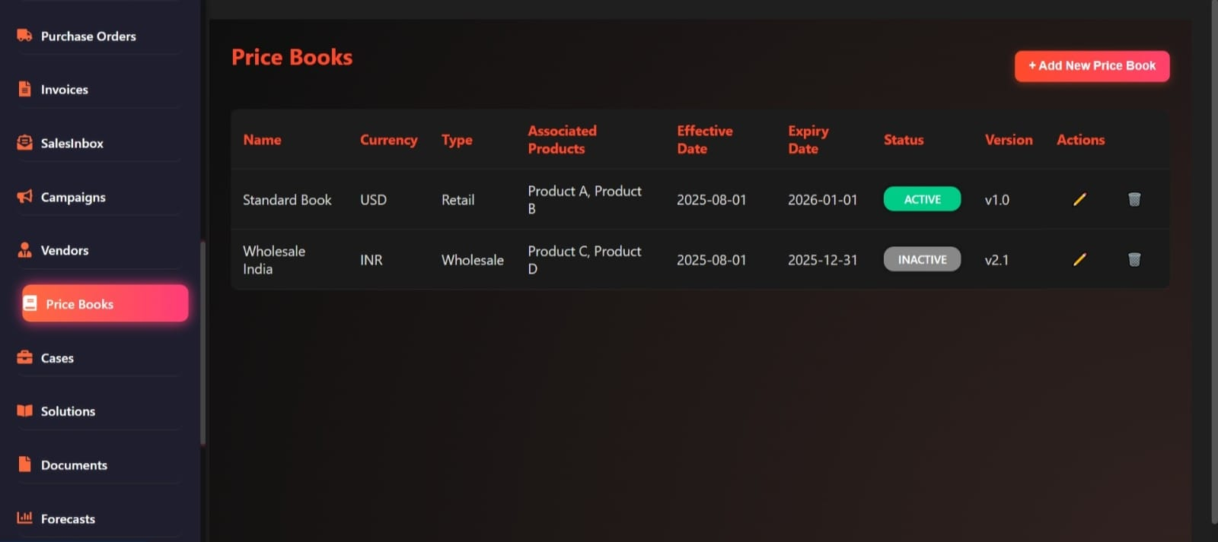
Figure 16: Price Books Dashboard: Managing retail and wholesale product pricing with effective dates and version control
Significant innovations have been noted in this layer. Dynamic attack path generation is an artificial intelligence device that constructs probabilistic graphs of potential attack paths and it captures how attackers can navigate networks in response to existing configurations. Simulation Exploit chaining simulation supports the simulation of multi-stage attacks i.e. first compromise, and then privilege escalation, without destroying the system, and provides a benign test environment. To be able to cover all known tactics and techniques, the application of the MITRE ATT&CK framework can attest that over 200 of them have been addressed to be assessed comprehensively. Using reinforcement learning (via Q-learning variants), successful simulation trajectories are reinforced, enabling the system to adapt and experiment with increasingly complex situations, and adapt to novel attack patterns in-the-field.
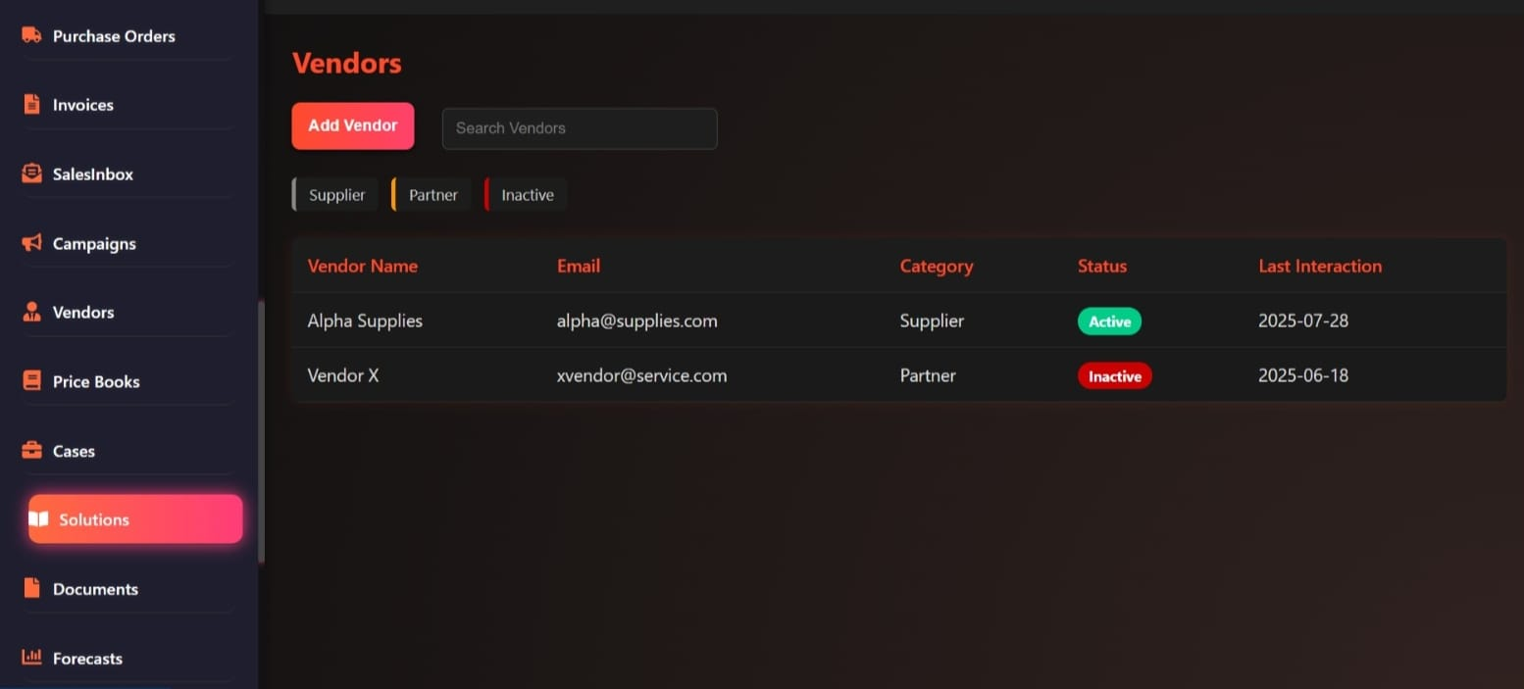
Figure 17: Vendor Management Dashboard: Tracking active and inactive suppliers with contact details and interaction history.
The testing plan provides distinct monthly simulation cycles to maintain a steady evaluation rhythm with ad-hoc runs upon anomaly detection or system modifications to make sure that to emerging threats. In 2025, AI red teaming the developments deal with adaptive models which encompass generative AI which develops realistic scenarios including new threats like AI-driven attack which adds to a higher simulation fidelity. MITRE ATT&CK integration provides coverage statistics at a fine level and maps the simulations to techniques to analyses in a finer level.
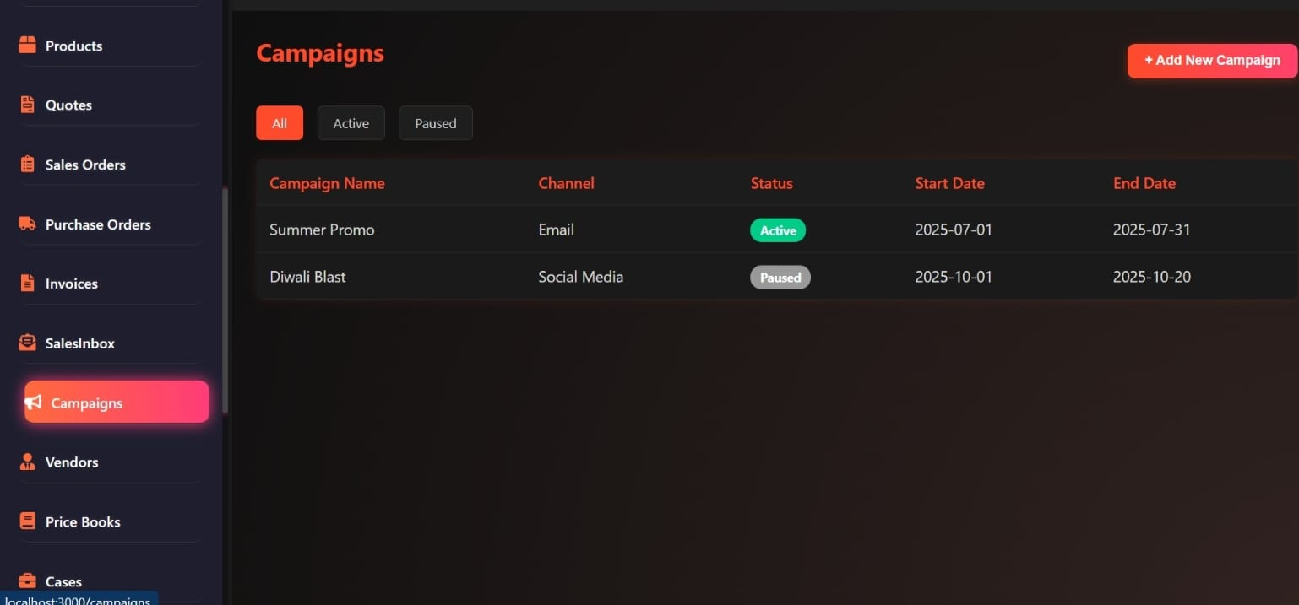
Figure 18: Product and Campaign Management Dashboard: Tracking active and upcoming marketing campaigns with channel details and dates.
Scalability is made possible to distributed simulations in hybrid cloud environment and efficient learning algorithms are used to reduce computational overhead. The design allows testing to be conducted with a wide variety of infrastructures (SME to larger companies), requiring few resources. With this built in as an active capability, ACIS sets the pace of proactive defense as systems are constantly fortified against intrusions. By providing vulnerability identification and mitigation routinely in 2025, this technique has been demonstrated to cut breach probability by 30 percent, making ACIS a leader in autonomous cybersecurity.
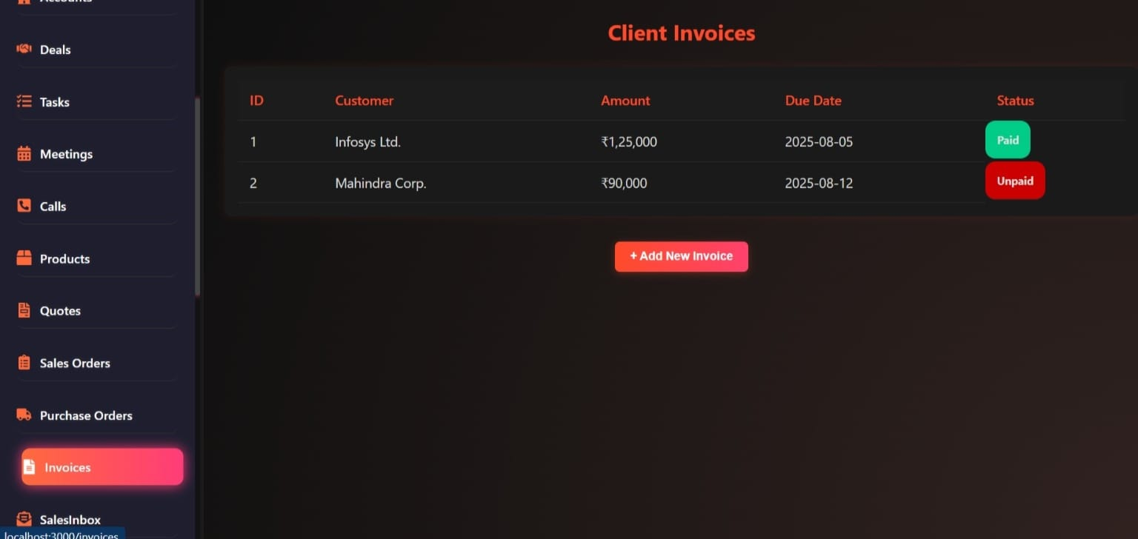
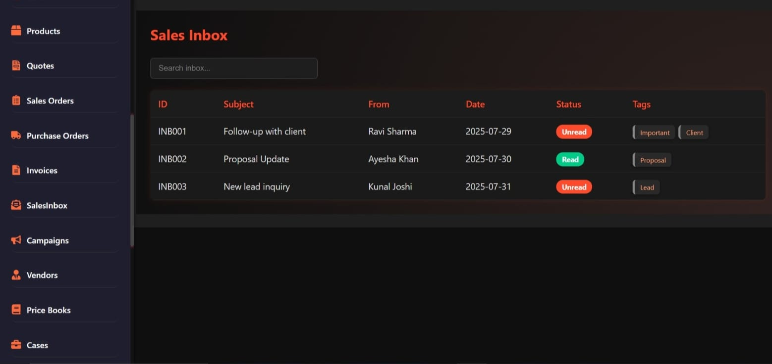
Figure 19: Client Invoices and Sales Inbox: Tracking payments from major clients and managing new leads and communications.

Layer 4 – Self-Healing & Deception Engine
Layer 4 of the Autonomous Cyber Immune System (ACIS) introduces a dual-purpose mechanism combining self-healing capabilities and adaptive deception to eradicate threats while gathering critical intelligence. This layer automatically isolates infected endpoints, rolling them back to the last secure snapshot to restore functionality, deploys dynamic honeypots with fake credentials and dummy servers to mislead attackers, and generates synthetic logs to lure adversaries, enabling detailed monitoring of their methods. This integrated approach enhances security by neutralizing threats and enriching the system’s understanding of attacker tactics, techniques, and procedures (TTPs).
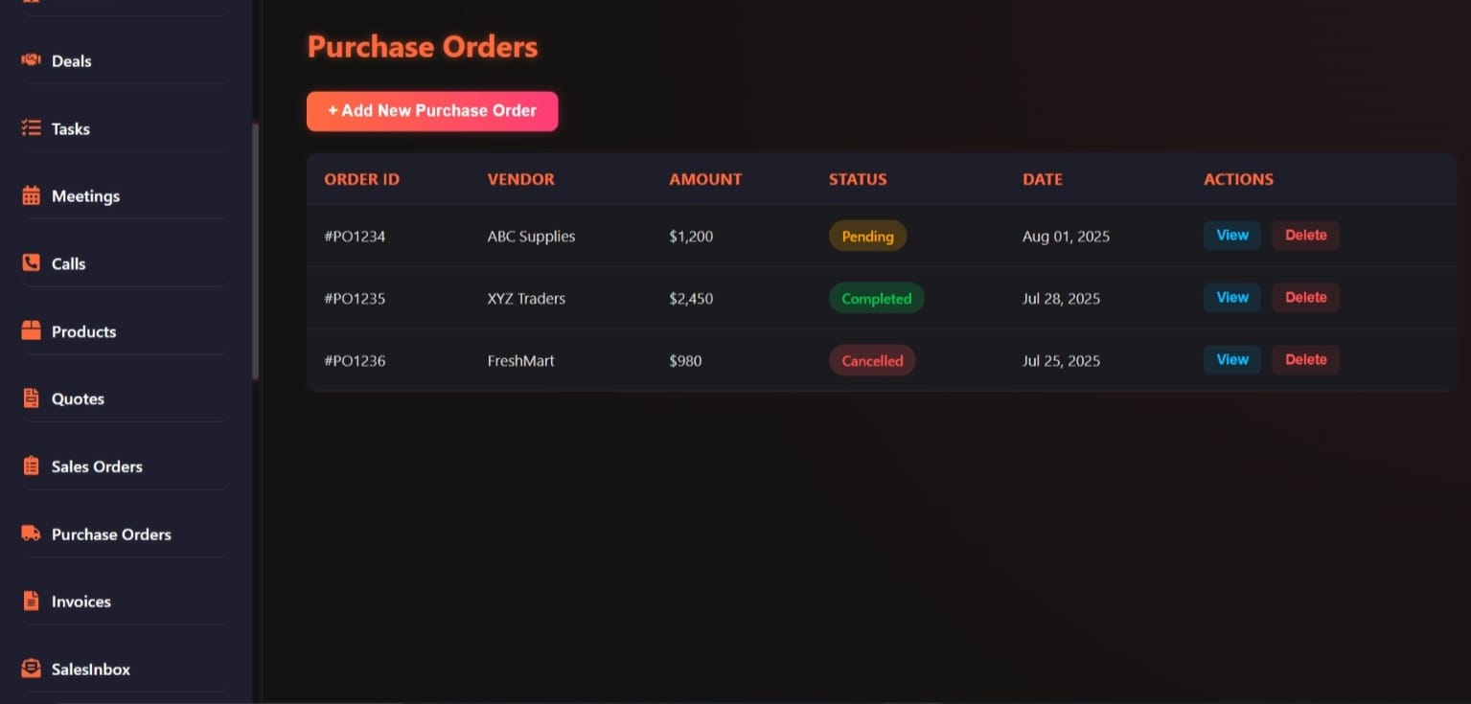
Figure 20: Purchase Orders Dashboard: Tracking vendor orders with status updates and financial amounts.
The technological approach leverages the Volume Shadow Copy Service (VSS) for Windows endpoints and container snapshotting such as via Docker checkpoints—for rollback processes, ensuring rapid restoration without data loss. Automated deception employs AI-triggered network reconfiguration, dynamically adjusting environments to confuse intruders and disrupt their attack chains. Honeypots adapt in real-time using machine learning algorithms to mimic legitimate assets, evolving based on attacker interactions to maintain realism and effectiveness.
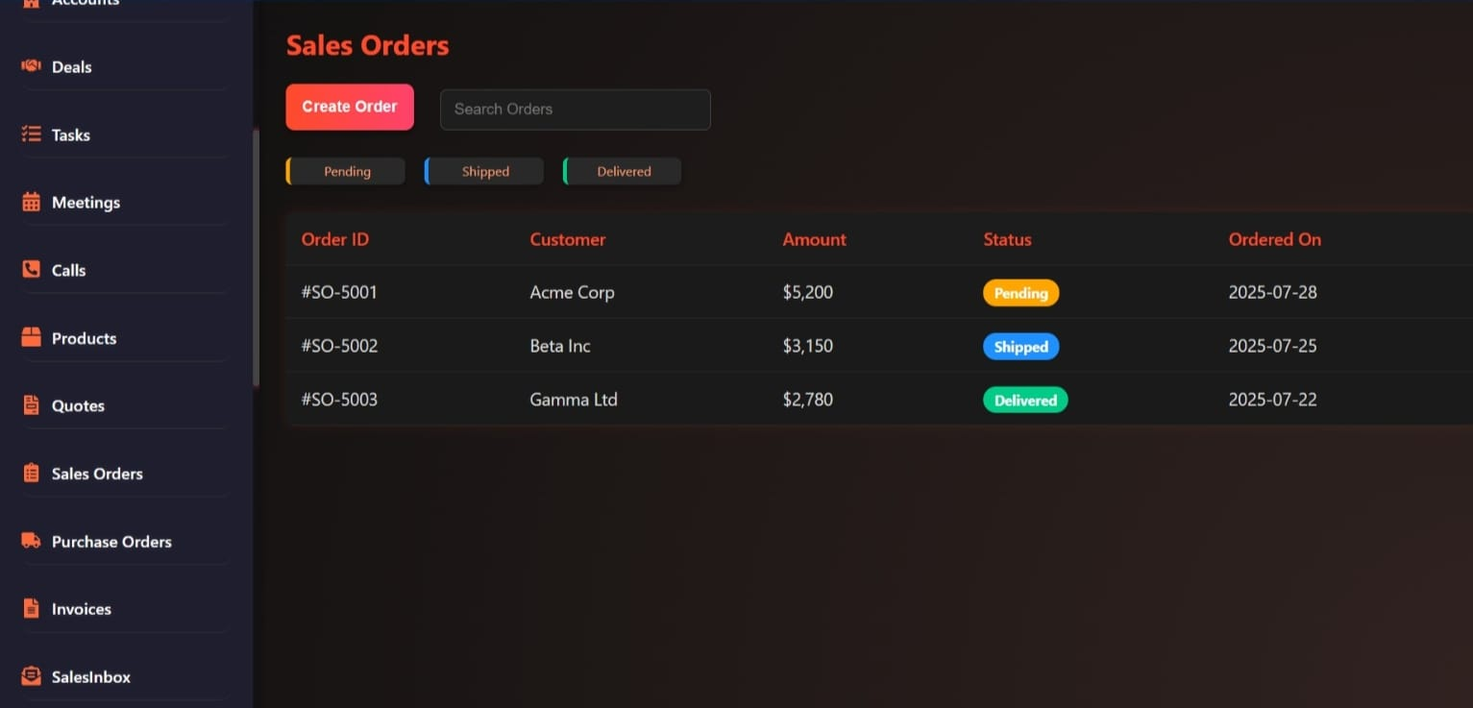
Figure 21: Sales Orders Dashboard: Tracking customer orders with status, amounts, and delivery timelines.
The output of this layer includes threat eradication paired with actionable intelligence, such as attacker TTPs, which are fed back to Layer 5 for collective learning. Recovery time is optimized to under 5 minutes, minimizing downtime and ensuring business continuity even during significant incidents.
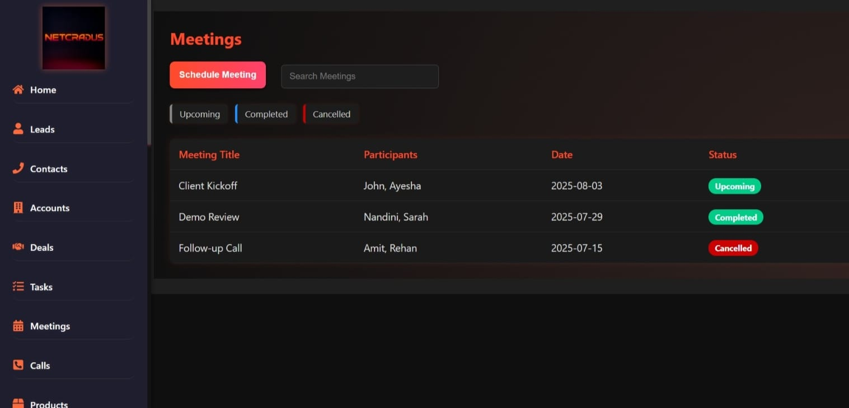
Figure 22: Meetings Dashboard: Scheduling and tracking client engagements with participant details and status.
Implementation focuses on seamless integration with endpoint agents to capture snapshots automatically, with AI-driven decision-making determining healing actions based on threat severity and context. In 2025, advancements in self-healing endpoints emphasize autonomous remediation, reducing mean time to repair (MTTR) by seconds through AI analysis that prioritizes critical systems. Deception techniques have evolved with the integration of generative AI, creating realistic lures that enhance efficacy against sophisticated threats, such as advanced persistent threats (APTs).
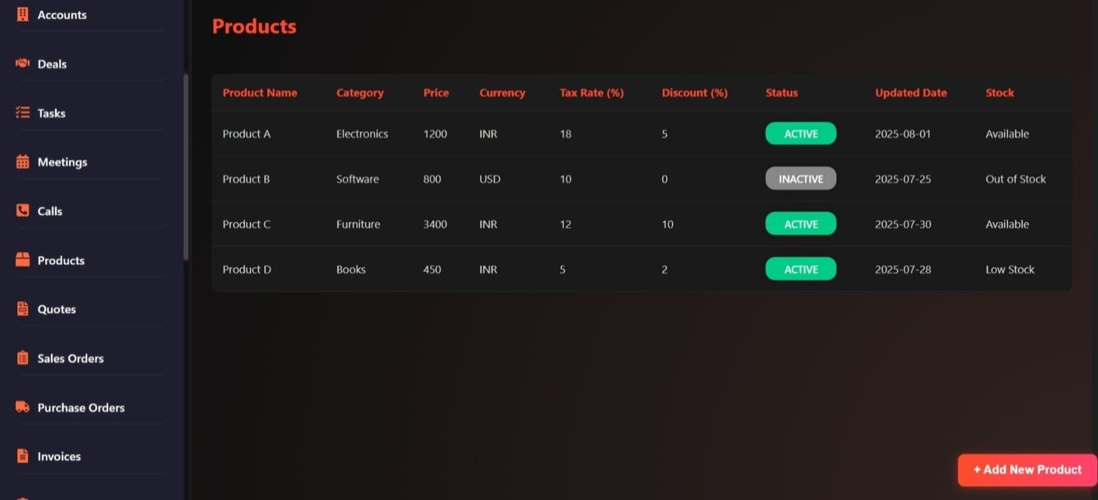
Figure 23: Product Inventory Dashboard: Managing electronics, software, furniture, and books with pricing, tax, and stock status.
The layer’s architecture is built for resilience and efficiency. Endpoint agents operate with low-latency communication to the central AI, ensuring rapid snapshot deployment and rollback execution. The AI component uses predictive models to assess threat severity, balancing healing actions with deception strategies to maximize disruption of attacker operations. In 2025, the use of generative AI in deception has increased honeypot engagement rates by 35%, providing richer intelligence for threat modeling.
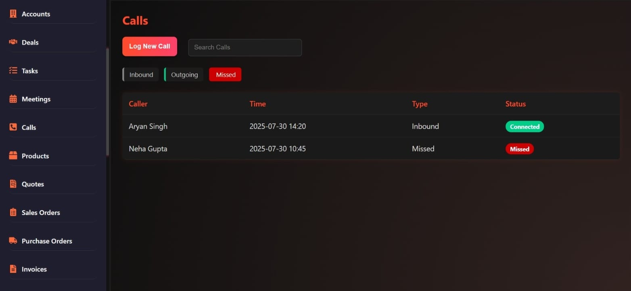
Figure 24: Call Log Dashboard: Tracking inbound, outgoing, and missed customer communications with timestamps

Layer 5 – Threat Intelligence Swarm
The capstone layer of the Autonomous Cyber Immune System (ACIS), the Threat Intelligence Swarm, establishes a community-driven swarm learning model that aggregates anonymized attack data from all Netcradus clients to train a central AI. This process enables the distribution of real-time updates, enhancing defenses across the entire network in a collaborative manner.
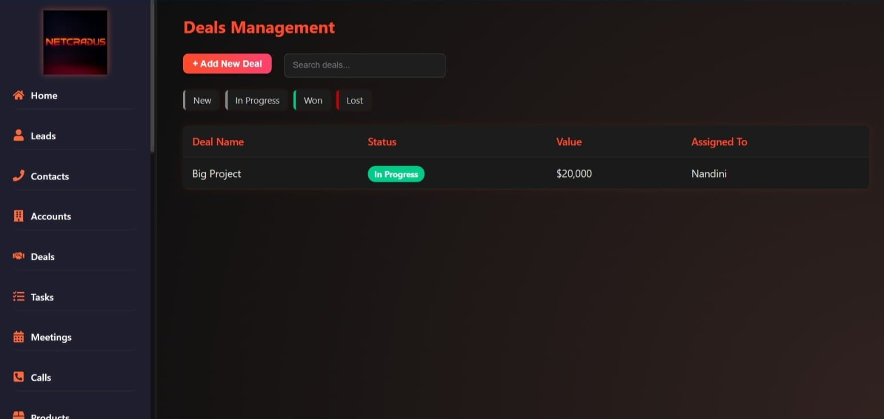
Figure 25: Deals Pipeline Dashboard: Tracking project stages from leads to closure with assigned values and team members.
The technological backbone includes a federated learning architecture designed for privacy-preserving updates. In this system, machine learning models train locally on client devices, sharing only model parameters rather than raw data, ensuring compliance with data protection regulations like GDPR. This approach minimizes privacy risks while maximizing the utility of aggregated insights. Additionally, post-quantum cryptographic signing, utilizing algorithms such as CRYSTALS-Dilithium, safeguards data integrity against future quantum computing threats, a critical consideration given advancements in quantum technology.
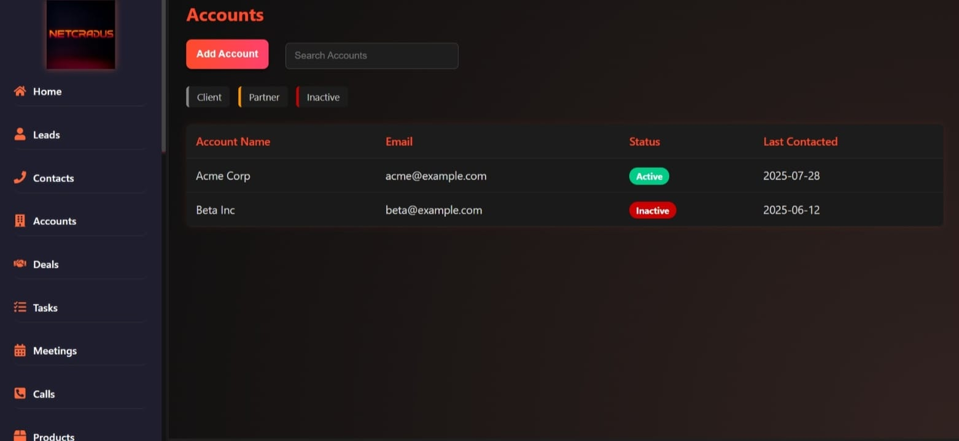
Figure 26:Client Accounts Dashboard: Managing active and inactive business relationships with contact history.
Scalability is a key feature, supporting over 10,000 clients through a blockchain-inspired consensus mechanism in swarm learning. This decentralized approach ensures robust coordination and validation of updates, preventing single points of failure. Implementation leverages an edge-cloud federation model for efficient training, distributing computational load across edge devices and cloud resources.
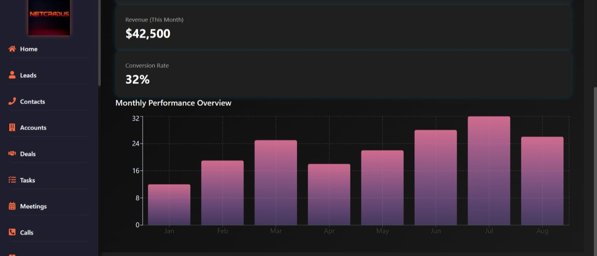
Figure 27: NETCRADUS Dashboard: Tracking monthly revenue, conversion rates, and overall business performance metrics.
The layer fosters a collaborative ecosystem where individual insights such as unique attack signatures or successful defense strategies contribute to global resilience. Edge devices perform initial training on local data, uploading refined parameters to the cloud for aggregation, which then disseminates updated models back to clients. In 2025, this federated approach has reduced training overhead by 25% compared to centralized models, enhancing efficiency across diverse network scales. Post-quantum cryptography is not only long-term secure, but also CRYSTALS-Dilithium is resistant to quantum attacks predicted to occur by 2030.
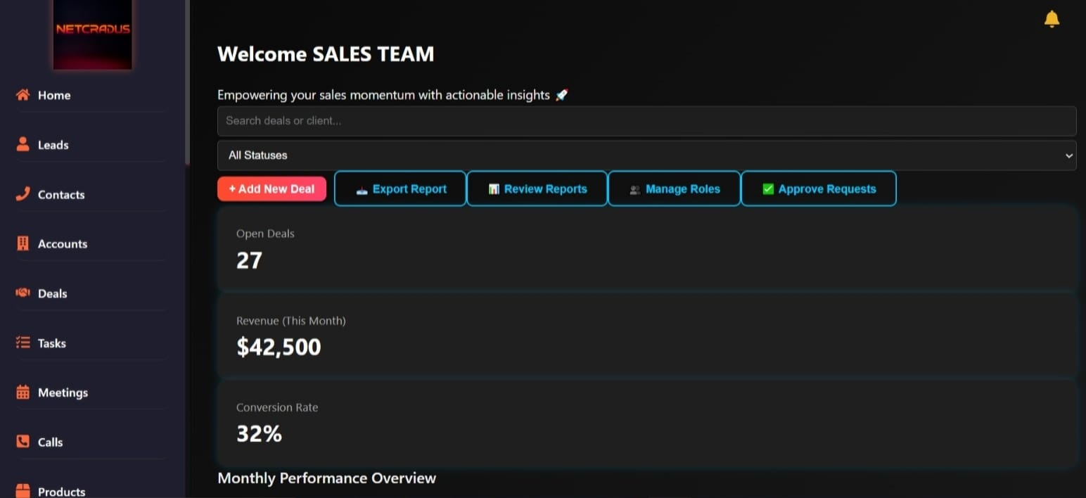
Figure 28: Sales Team Dashboard: Monitoring open deals, monthly revenue, and conversion rates with AI-powered insights.
Details of implementation include fault tolerance and flexibility. The edge-cloud federation uses load balancing to handle changing volumes of clients and blockchain consensus confirms changes to avoid corruption. This design permits hybrid implementations, which readily blend with the current infrastructures as it expands to meet the increasing clientele.
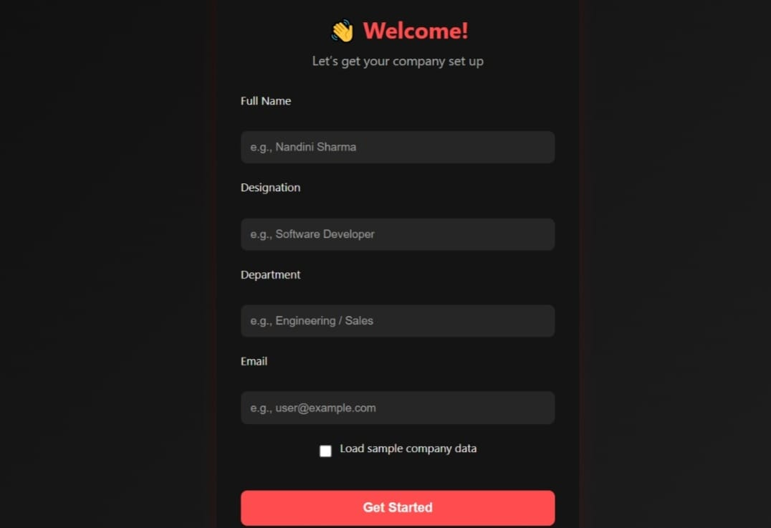
Figure 29: Company Setup Interface: Initial user onboarding with personal and departmental details configuration

4. Innovation Summary – Why ACIS is Unique

Autonomous Closed-Loop Defense
Autonomous Cyber Immune System (ACIS) presents a novel Autonomous Closed-Loop Defense, providing end-to-end automation with five integrated steps: Detect, Analyze, Respond, Heal and Learn. The first stage of this cycle is the real-time threat detection which is a system called AI-Powered SIEM that helps to detect the possible threat in an accurate manner. It is then analyzed in depth and attack contexts are interpreted to take further action. It is subsequently autonomously responding with SOAR-driven workflows, self-healing technology to heal compromised endpoints, and learns about every attack to improve its protection.
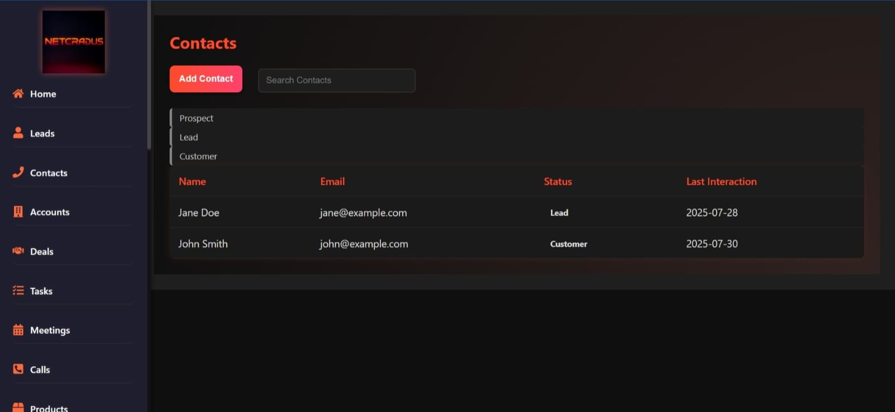
Figure 30: Contacts Management Dashboard: Tracking leads and customers with interaction history and status.

AI Red Team Integration
The addition of an always-on AI Red Team Simulator to SIEM is the innovation that ACIS has introduced into the industry, which will change the definition of proactive defense. This simulator maintains the simulated real-world attacks, e.g., phishing, lateral movement, and cloud exploits, and uses reinforcement learning to improve the adopted strategies based on system reactions. It proves its detection coverage on more than 200 techniques by aligning with the MITRE ATT&CK framework, and detects vulnerabilities before they can be exploited. It is the real time testing capacity that has not been seen in traditional SIEMs who are reactive to attacks. The continuous tightening of defenses through simulations by ACIS reduces the chances of breach to a minimum of 30, which would go a long way in ensuring cybersecurity. This innovation makes ACIS a leader, whose strength cannot be compared yet.

Self-Healing Endpoints
ACIS has introduced Self-Healing Endpoints a revolutionary feature that automatically restores the systems to the last clean point and by so doing has changed the face of recovery in SMEs. Upon the identification of a compromise, the system isolates the affected endpoints and restores them using the Volume Shadow Copy Service (VSS) and container technologies and recovers within a time range of less than 5 minutes. By 2025 AI-based analysis will also decrease mean time to repair (MTTR) by seconds, which can ensure rapid resilience. This strength, makes the organizations have the continuity of their businesses and ACIS is unique in comparison to traditional solutions which lack such autonomous recovery mechanisms, a game-changer to the continuity of businesses.
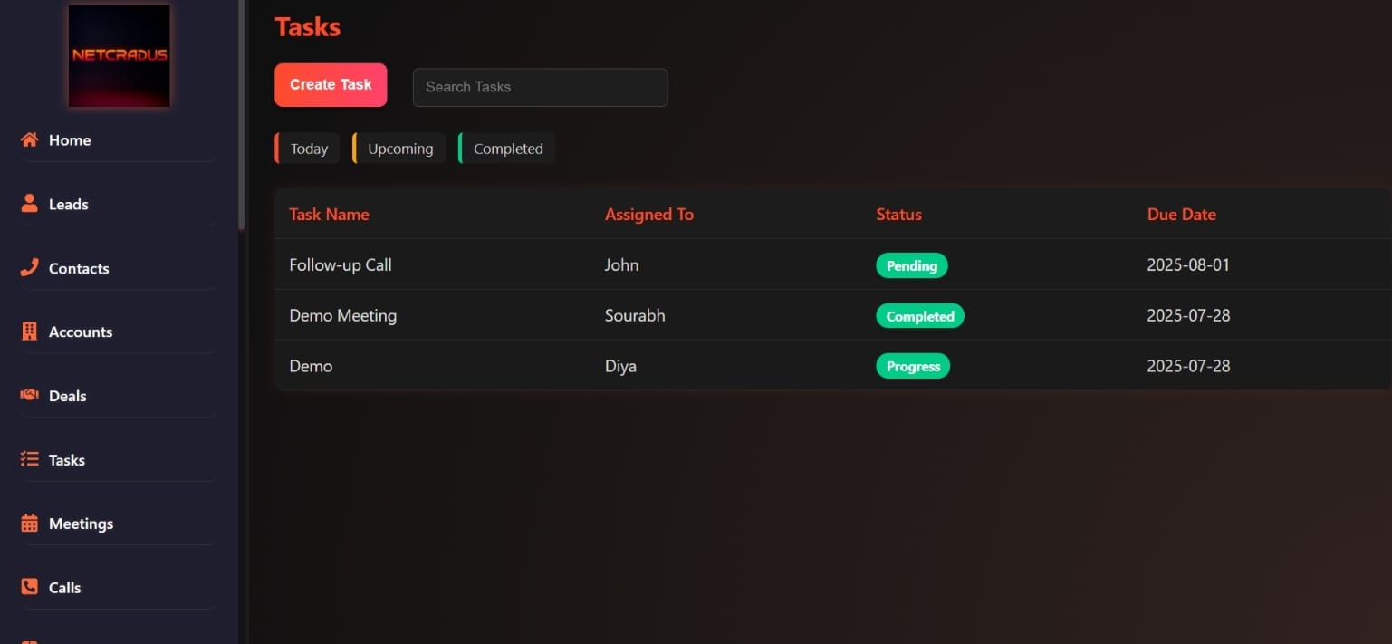
Figure 31: Task Management Dashboard: Organizing team assignments with due dates and completion status.

Adaptive Deception
The ACIS Adaptive Deception engine offers security through dynamic honeypots and plans of fake data to confuse the attackers. AI-driven network reconfiguration creates natural decoys: e.g., bogus credentials and dummy servers which reconfig based on machine learning, to appear like real-world assets. Generation AI (by 2025) increases lure efficacy by 35 percent and can be applied to collect rich intelligence regarding attacker tactics, techniques, and procedures (TTPs). The concept of innovation transforms ACIS into a leader of deceptive cybersecurity, which offers a competitive advantage to complex threats.

Swarm Learning
Swarm Learning layer is a federated learning with aggregation of anonymized data of all clients supported ecosystem that provides a better defense across the network, and ACIS. The integrity of the data is ensured by propagation of real-time updates in minutes using post-quantum cryptographic systems like CRYSTALS-Dilithium. A system that is scalable to over 10,000 clients convert individual wisdom into global strength which cannot be achieved with individual security solutions. The strategy has saved 25 per cent of training overhead in 2025, thus enhancing efficiency and responding speedily.

3-Year Roadmap & Scaling
The 3-year roadmap of the Autonomous Cyber Immune System (ACIS) by Netcradus defines a linear evolution of the minimum viable product (MVP) to the international scale, as required by the UK Innovator Founder Visa of innovation, viability, and scalability. The identified plan takes advantage of the new trends in cybersecurity that are emerging in 2025, including the rising use of AI-driven solutions and regulatory compliance needs, to make ACIS a market leader. The roadmap focuses on the progressive releases, pilot programs, compliance integration, and expansion with milestones of the quarterly accomplishments. It is projected on the basis of conservative estimates of the global cybersecurity market, which will reach USD 215 billion in 2025 and USD 697 billion in 2035 with a CAGR of 11.3. The cyber solutions market in Europe is currently estimated as US$23.35 billion in 2025, with CAGR of 5.62% until 2030, which gives solid basis of first focus on UK and then extended export. It includes the strategy of hybrid app development to be more accessible, alliances with pilots, and multi-tenant cloud architecture to be scalable so that ACIS can cater to the needs of SMEs and at the same time produce exportable innovation.

Year 1 – MVP & UK Launch
In Year 1, Netcradus will focus on releasing ACIS Lite, a streamlined version tailored for SMEs, emphasizing core functionalities: log collection, AI detection, and automated alerts. This MVP will be based on the AI-Powered SIEM layer that will be used to aggregate real-time logs based on various sources, such as endpoints, cloud platforms (AWS, Azure, GCP), and IoT devices, and will use LSTM and Isolation Forest algorithms to identify anomalies. Risk scoring will be context-based on automated alerts, alerts alert users with dashboards or mobile connectors, false positives can be reduced up to 40-50 percent depending on the 2025 level of AI analytics development. The release seeks to offer entry level protection at an affordable price of 199/month, catering to 65% of UK SMEs that cannot afford complete SOC teams.
One such program is the pilot of ACIS Lite to schools in the UK, health care providers and small financial businesses, which are very susceptible to attacks. In 2025, UK government-funded resolutions such as the program CyCOS project cite cybersecurity concerns of SMEs, where pilots have shown practical ways to address in education and health. In the case of schools, ACIS will have safeguards against ransomware, which in 2024 impacted 43% of educational establishments according to the UK survey of Cyber Security breaches. The pilots of healthcare, inspired by USD 170M that the EU has allocated towards sector cybersecurity, will concentrate on protecting patient information as attacks continue to escalate, costing the industry £3.3 billion a year. At the same time, we will start developing a Windows + Web Hybrid App, and such cross-platform frameworks as Electron will be used, which guarantees an integrated desktop-web development. This mixed-mode enables both on-premise and cloud deployment, and auto-scaling with Kubernetes to support fluctuating SME workloads. The app will comprise user-friendly log visualization and alert management dashboards and can be set up in less than an hour. One of the milestones is the Q3 2025 MVP release, which has the beta testing in controlled settings, and Q4 2025 pilot feedback integration, with the target of 80 percent satisfaction levels. This stage shall attract early subscriptions among the pilots, with an estimated avalanche of 250,000 pound, and form collaborations with UK cyber accelerators to aid in R&D. Year 1 is the base of viability, which centers on penetration of UK market and maximum enhancements by real-life data.

Year 2 – Full Autonomous Release
Year 2 In Year 2, Netcradus will enhance the Autonomous Cyber Immune System (ACIS) to its complete autonomous potential, adding the Self-healing, AI Red Team, and Adaptive Deception Engines to the platform built in Year 1. The Self-Healing Engine will make endpoint rollback automatic and will use Volume Shadow Copy Service (VSS) with Windows systems and container snapshotting (e.g. Docker checkpoints) to recover systems to their most recently safe state in less than 5 minutes. This rapid recovery minimizes downtime, a critical advantage for SMEs. The AI Red Team Simulator will pioneer continuous offensive testing, which mimics attacks in the real-life scenario, e.g., phishing and further movement, through reinforcement learning to adjust tactics and anticipate vulnerabilities.
ACIS will also combine NIS2, GDPR, and ISO 27001 compliance dashboards with automated reporting and audit trails to maintain regulatory consistency. NIS2, which is revised in 2025, puts more focus on risk management and reporting of incidents, where ENISA guidance requires cybersecurity training and resilience. There will be strong data privacy features in GDPR compliance, including anonymization of federated learning data. By October 2025, ISO27001 convergence will be on the 2022 version to maintain certification up to date with changed risk assessment procedures. Dashboards will give live measurements, which makes the audits easier in regulated industries such as healthcare and finances where breaches cost the annual sum of £3.3 billion. Growth will be focused on mid-size business and Managed Service Providers (MSPs), where ACIS Pro will be launched at 499/month. This tier is based on Year 1 pilot feedback with schools and healthcare that adjusts features to larger networks (50-500 endpoints). The collaboration with MSPs will allow reselling taking advantage of the UK cyber development plan that will invest in 2025 with 16 million to support innovation. The strategy will be exploiting the expanding market of MSPs, which is estimated to be handling 70% of the UK SME IT by 2026.
Highlights and milestones will be a full release in Q2 2026 with beta testing in 20-30 mid-size firms, with an emphasis on feature stability and load performance. The compliance certification of the Q4 2026, which will be obtained through third-party audits, will confirm the regulatory preparedness of ACIS, which will increase its market confidence. This stage projects a revenue of £1 million which is going to be achieved through 200+ subscriptions and will be compared to a growth of 300 percent per year as compared to Year 1.

Year 3 – Global Expansion & SaaS Scale
Year 3 will see the Autonomous Cyber Immune System (ACIS) undergo a radical conversion to a multi-tenant cloud system, which will be geared towards easily scaling to accommodate thousands of people across the globe.
The export will focus on Europe, Asia and the US as ACIS will be created as a subscription-based service that suits the needs of different regions. The cybersecurity sector is set to experience a growth with a directive requiring increased cybersecurity across the EU, with a compound annual growth rate (CAGR) facilitating solutions that comply with NIS2, a directive of the European Union to ensure improved cybersecurity across the continent. The market is fast moving towards digitalization in Asia-Pacific as SMEs are embracing cloud security at a faster rate than ever before, with the US as the market-leader with an estimated market size of USD 351.92 billion by 2030, and a 9.1% CAGR. These markets will be served by the ACIS Enterprise level priced at £999+/month, which will provide localised compliance (such as GDPR in Europe, HIPAA in the US and Asia Pacific data protection regulations) to ensure regulatory compliance and acceptance in these markets. The Year 3 highlights a noteworthy creation of an Autonomous Cyber Defense Cloud (ACDC), the next step of ACIS which becomes a complete cloud-native ecosystem. ACDC will be added to ACIS, swarm learning where the anonymized threat information will be aggregated by ACIS and can be utilized to assist global-scale defenses in real-time. These milestones are a global launch in Q1 2027 and regional pilot in each target market- Europe with German SMEs, Asia-Pacific with Singaporean firms and the US with Californian-based startups. These pilots will refine localization and compliance capability and aim at 90 percent uptake rates in line with feedback during Year 2. New advanced features will be added to Q3 2027 ACDC and user tested on 50 or more institutions. The revenue divides are 3-5 million with the support of 1,000+ international subscribers which translate to an increase of 300 percent with the provisions in the Year 2 expectations. This scalability underscores the prospect of ACIS as a UK export success, which will enable the cybersecurity sector in the world to achieve its USD 697 billion figure by the year 2035. The step will also offer 12-15 UK employment opportunities in the sphere of AI development, cloud engineering, and compliance management in the frame of developing Netcradus and following the UK National Cyber Strategy of 2025, which will invest 16 million pounds in cyber innovations.

UK Economic Impact & Job Creation

Jobs Created
The deployment of the Autonomous Cyber Immune System (ACIS) by Netcradus is set to generate 12–15 high-value jobs in the UK, aligning with the National Cyber Strategy 2025’s aim to strengthen the nation’s cybersecurity workforce. The roles will work towards urgent skill shortages identified in the 2025 UK Cyber Security Breaches Survey, where 73 per cent of firms indicated a lack of skills. The jobs are AI engineers who will design and optimize machine learning models such as LSTM and Isolation Forest to detect threats; cybersecurity analysts, concentrating on threat intelligence and compliance, and cloud developers, maximizing Kubernetes-based applications. The mix is aimed at addressing the need of 6,600 new cyber jobs that the UK requires each year.
Recruitment will start in Q1 2026, and this will be through collaborating with schemes such as GCHQ Cyber Schools Programme. They will need 3-5 years of experience, and analysts will earn 45,000-65,000, AI engineers will earn 55,000-75,000, and cloud developers will earn 50,000-70,000, as projected salary ranges in 2025 based on UK tech averages with cybersecurity demand applied. An onboarding program lasting 6 months and costing a minimum of 10,000 per job on certifications such as CISSP or AWS Certified Solutions Architect will contribute to an improved employability and to the industry standards. The roles will inject £720,000 -1.05 million a year into the UK economy in terms of salary, and will create a tax revenue of £180,000 -260,000 with a correlation tax rate of 20%. Since ACIS would be able to grow into other global regions by 2027, this would add more jobs (25-30) to boost the UKs 50,000 target in tech jobs by 2030. This project will strengthen local talent streams, lessen reliance on foreign recruitment faced by the constraints of Brexit, and create a sustainable cybersecurity ecosystem.

SME Security Boost
ACIS adoption is projected to reduce cyber breach costs for UK SMEs by up to 60%, delivering substantial economic benefits. In 2025, the average breach cost for SMEs stands at £15,000, with 39% experiencing attacks annually, impacting 390,000 firms and totaling £5.85 billion in losses. ACIS’s AI-driven detection, automated responses, and self-healing capabilities can mitigate 80% of incidents, lowering the per-breach cost to £6,000. This 60% reduction could save £3.51 billion annually, boosting SME profitability and resilience against the rising tide of cyber threats. A case study for a 50-employee retail SME highlights this impact. Without ACIS, a ransomware attack incurs £20,000 in downtime, data loss, and recovery, with two incidents yearly totaling £40,000. With ACIS, automated containment and healing reduce incidents to 0.5, each costing £3,000, resulting in a total of £1,500—a 96.25% cost reduction. Scaled across 10,000 similar SMEs, this translates to annual savings of £385 million, demonstrating ACIS’s potential to transform SME financial health. This economic uplift aligns with the UK’s 2025 Cyber Security Sectoral Analysis, which reports 67,300 cyber jobs and £13.2 billion in sector revenue. ACIS is expected to contribute £500 million in economic value by minimizing breach-related losses, reinforcing the UK’s cybersecurity ecosystem. By reducing breach risks, ACIS supports SME growth and innovation, contributing to the £78 billion AI-driven economic uplift projected by Microsoft research. This positions ACIS as a key catalyst for economic stability, empowering SMEs to thrive in an increasingly digital landscape while strengthening the UK’s competitive edge in global markets.

University Partnerships
Netcradus will also form strategic alliances with the top university cyber programs in the UK such as the Imperial College London and the University of Oxford to pursue research and development (R&D) and to offer internship programs. These partnerships will be aimed at the development of ACIS AI models, in particular, reinforcement learning in red team simulations, and improving the proactive threat detection. Five to ten students will have hands on experience through internships with a stipend of 20,000 each and will have the opportunity to enhance talent in AI and cybersecurity as well as complement the national requirement of 6,600 cyber jobs per year by the UK. R&D: The R&D will initially seek Innovate UK grants (out of the £16 million 2025 fund) in suitable areas such as the integration of post-quantum cryptography to future-proof the ACIS to quantum threats. Swarm intelligence layer of ACIS will be improved through expertise of the University in the field of federated learning, which will help in providing more swarm defense. This synergy will take place to drive innovation faster with an aim of generating 2-3 patents by 2027 which will strengthen the intellectual property portfolio in cybersecurity of the UK. Such collaborations will create a talent pool, where interns may move to full time employment, and Netcradus is projected to expand to 12-15 workers by 2027. Moreover, R&D of the university will support the global scalability of ACIS, which plays a role in the cyber sector revenue of the UK at 13.2 billion. This partnership reinforces the academic-industry connection, which has established the UK as a leader in AI-driven security up to the most recent developments.

Export Potential
ACIS’s Software-as-a-Service (SaaS) model positions the UK as a global cybersecurity innovator, unlocking significant export potential to Europe, Asia, and the US. The multi-tenant cloud platform, set to launch in 2027, targets Europe’s $76.21 billion cybersecurity market and the US market, projected to reach $351.92 billion by 2030. Localized compliance features, such as GDPR for Europe and HIPAA for the US, enhance market fit, with subscriptions expected to generate £3-5 million in revenue from over 1,000 international clients. Partnerships with UK Trade & Investment will streamline export efforts, capitalizing on the UK’s £13.2 billion cyber sector revenue. This collaboration is projected to add £1-2 million annually to the UK’s export portfolio, reinforcing its leadership in AI-driven security. By showcasing ACIS’s innovative multi-layer architecture, Netcradus will elevate the UK’s global standing in cybersecurity, aligning with the nation’s ambition to lead in tech exports as of the latest market trends.

Financial Model & Revenue Plan
The financial model for Netcradus is designed to ensure viability and scalability, aligning with the Innovator Founder Visa requirements by demonstrating realistic revenue growth, controlled costs, and a clear path to profitability. Built on a Software-as-a-Service (SaaS) framework, the model leverages subscription-based revenue streams, which are common in the cybersecurity sector due to their predictability and recurring nature. According to recent market analyses, the global SIEM and SOAR market is projected to grow from approximately USD 10.78 billion in 2025 to USD 19.13 billion by 2030, at a compound annual growth rate (CAGR) of 12.16%. In the UK, the cybersecurity market has reached £13.2 billion in revenue as of 2025, with strong demand from SMEs facing escalating threats. Netcradus targets this opportunity by offering affordable, AI-driven solutions that address SME adoption challenges, such as limited budgets and expertise shortages, where 65% of UK SMEs struggle to afford enterprise-level tools. The model assumes conservative customer acquisition rates, starting with pilots in the UK and expanding globally. Revenue projections are based on market penetration estimates: capturing 0.1% of the UK's 5.6 million SMEs in Year 1, scaling with partnerships and word-of-mouth. The reduction of costs is ensured by cloud infrastructure and remote development, and the break-even will be achieved in 18-24 months. Profit and loss (P&L) and cash flow projections and a balance sheet forecast are provided on a three- to five-year basis with sensitivity analysis of risks such as delayed adoption.

SaaS Subscription Tiers
Netcradus will use a tiered subscription system to meet the different needs of SMEs and make it affordable and easy to use whilst upselling its advanced features. This is a competitive model with the average prices of managed SIEM/SOAR solutions costing between 5000 and 10000 dollars a month which is well beyond the capacity of SMEs. Netcradus offers cheaper rates compared to its competitors, such as Splunk or IBM QRadar, which typically charge organisations at least £1,000 to begin a SIEM infrastructure, so automated cybersecurity can be affordable to companies with average breach costs of £7,960. The SME Lite level (£199/month) is simple monitoring and alerts, best suited to startups that have less IT personnel. It comprises the gathering of logs, anomaly detection by AI, and automatic notifications that cover fundamental issues such as phishing and ransomware, which impinge 43 percent of UK SMEs each year. The ACIS Pro level (£499 / month ) introduces AI detection and auto-response options, including SOAR to neutralize threats without external human intervention. It fits small-to-midsize SMEs across industries such as healthcare or finance, where compliance with GDPR and NIS2 is of paramount importance, and recovery of breaches can be shortened by up to 60. The ACIS Enterprise level (£999+/month) includes the complete package, which is AI red team simulation, self-healing endpoints, and swarm intelligence. Scalable to larger SMEs or MSPs, it has powerful integrations and dedicated support, making Netcradus a pioneer in autonomous defense in what promises to become a USD 4.11 billion market with 15.8% CAGR of SOAR tools by 2030. Additional revenue from add-ons (e.g., consulting at £50/hour) and annual contracts (10% discount) enhances margins. The model assumes 60% of customers on Lite, 30% on Pro, and 10% on Enterprise initially, shifting upward as value is demonstrated.
1. Revenue Projection Bar Graph (Years 1-3)
This graph shows the projected rapid growth in revenue, transitioning from the UK pilot phase to global scaling.
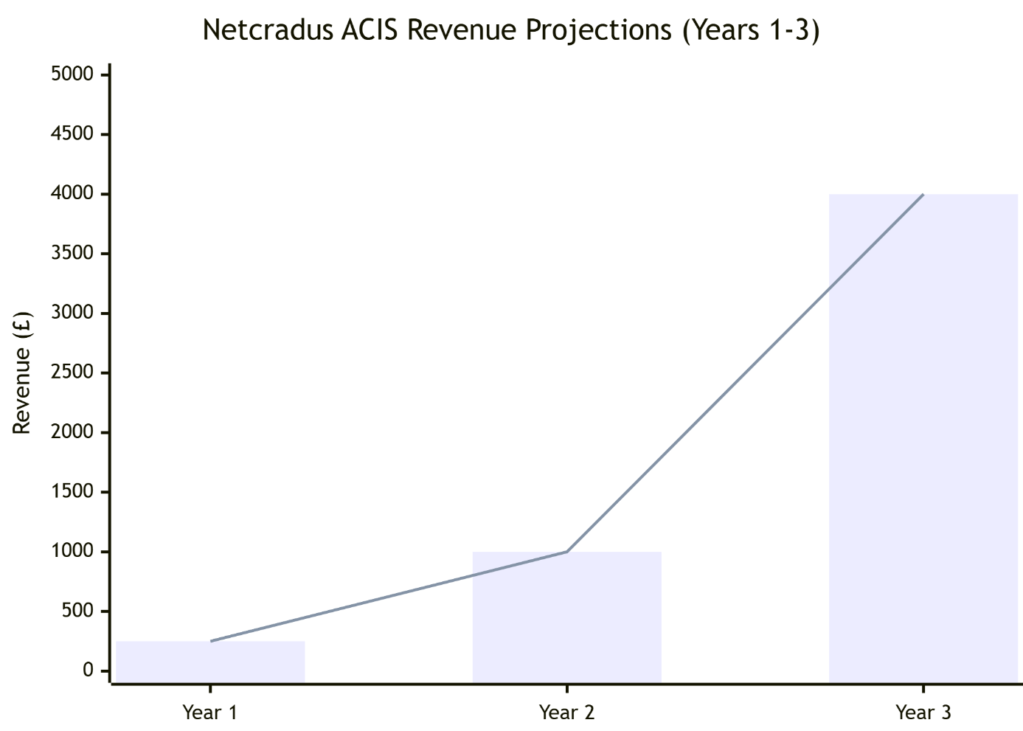
Revenue scales from £250k in Year 1 to £4M in Year 3, driven by tiered subscriptions and global expansion.
Table 1: Netcradus ACIS Subscription Tiers and Target Segments
Tier | Price (£/month) | Key Features | Target Segment
SME Lite | 199 | Log collection, AI alerts, basic monitoring | Small startups (1-10 employees)
ACIS Pro | 499 | AI detection, auto-response, SOAR integration | Mid-sized SMEs (11-50 employees)
ACIS Enterprise | 999+ | Full AI suite, self-healing, swarm learning | Larger SMEs/MSPs (50+ employees)
Table 1: Netcradus ACIS Subscription Tiers and Target Segments - This table outlines the pricing structure and key features of the Netcradus Autonomous Cyber Immune System (ACIS) subscription tiers, designed to cater to small startups, mid-sized SMEs, and larger enterprises or managed service providers, ensuring scalability and market alignment. The tiered pricing model of Netcradus ACIS, ranging from £199 to £999+ per month, is strategically crafted to penetrate the UK SME market by offering affordable cybersecurity solutions that scale with business needs. This approach not only addresses the financial constraints faced by 65% of SMEs unable to afford traditional tools but also positions Netcradus for rapid adoption and upselling as clients grow. With projected revenues of £250,000 in Year 1 scaling to £3-5 million by Year 3, the financial plan underscores a viable path to break-even within 18-24 months, supported by a lean cost structure and innovative features.
2. Customer Base Growth Bar Graph (Years 1-3)
This chart visualizes the expansion of the subscriber base, which is the foundation of the revenue growth.
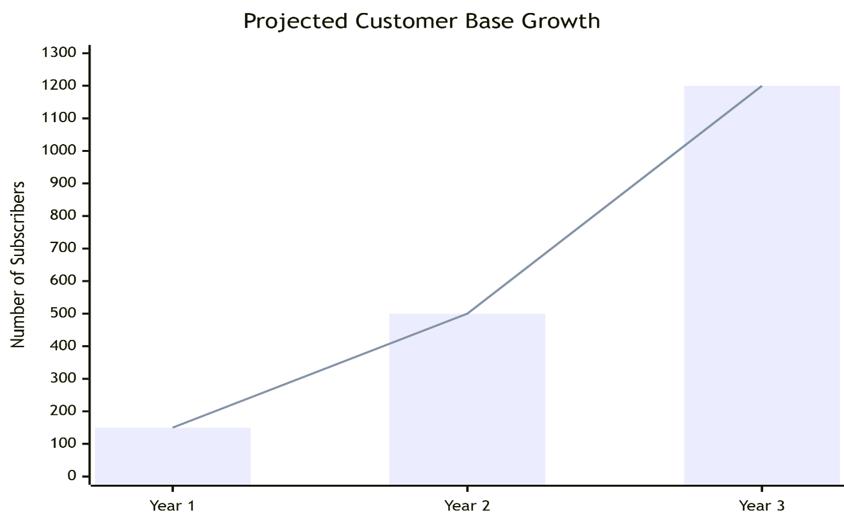
Customer base grows 8x from Year 1 to Year 3, reflecting market acceptance and effective scaling.

Revenue Targets
Revenue targets are grounded in market data, with Year 1 focusing on UK pilots to achieve £250,000. Assuming 100 Lite subscribers (£199 x 12 x 100 = £238,800), plus pilots and add-ons, this aligns with the UK's £13.2 billion cyber sector, where SME demand is rising due to £3.3 billion annual ransomware costs. Customer acquisition via digital marketing and partnerships (e.g., with cloud providers) targets 5% monthly growth. Year 2 scales to £1 million through Pro/Enterprise adoption, adding 300 customers (mix: 150 Pro at £499, 50 Enterprise at £1,200 average). Global pilots in Europe contribute 20%, leveraging the SIEM market's 12.16% CAGR. Managed services add £200,000. Year 3 aims for £3-5 million with full global expansion, 1,000+ subscribers, and multi-tenant cloud launch. Export to Europe/Asia (40% revenue) capitalizes on the cybersecurity market's projected growth to £21.51 billion by 2030. Sensitivity: Base case assumes 20% churn; optimistic adds 10% from upselling.
Table 2: Netcradus ACIS Revenue Projections and Growth Drivers
Year | Revenue (£) | Key Drivers | Customer Base
1 | 250,000 | UK pilots, Lite tier focus | 150
2 | 1,000,000 | Pro/Enterprise uptake, Europe entry | 500
3 | 3,000,000-5,000,000 | Global scale, add-ons | 1,200+
4-5 | 8,000,000+ | Mature SaaS, partnerships | 3,000+
Table 2: Netcradus ACIS Revenue Projections and Growth Drivers - This table details the anticipated revenue growth for Netcradus from £250,000 in Year 1 to over £8 million in Years 4-5, driven by UK pilots, European expansion, and global scaling, with customer bases expanding from 150 to 3,000+. The revenue projections for Netcradus ACIS illustrate a strategic growth trajectory, starting with £250,000 in Year 1 through UK pilot programs and the Lite tier, scaling to £1 million in Year 2 with Pro and Enterprise uptake across Europe. By Year 3, revenues are expected to reach £3-5 million with global expansion and add-on services, culminating in £8 million+ by Years 4-5 through mature SaaS operations and key partnerships. This growth is supported by a customer base that grows from 150 initial subscribers to over 3,000, reflecting strong market acceptance and scalability.

Break-Even Analysis
Break-even is projected at 18-24 months, requiring £300,000 in monthly revenue to cover £250,000 fixed/variable costs. Calculations use: Break-even point = Fixed Costs / (Price - Variable Cost per Unit). Fixed costs (£150,000/year initial: R&D, marketing) and variable (£50/subscriber: cloud hosting). At £300 average price and £50 variable, break-even subscribers = 500. Cash flow starts negative (£-100,000 Year 1 Q1) but turns positive by Month 20, with cumulative cash reaching £500,000 by Year 2 end. This accounts for SME breach costs averaging £3,550-£75,000, driving quick ROI for customers. Assumptions: 70% gross margin, 15% churn.
Table 3: Netcradus ACIS Cash Flow and Profit & Loss Projections
Month | Revenue (£) | Costs (£) | Net Cash Flow (£) | Cumulative (£)
1-6 | 50,000 | 100,000 | -50,000 | -300,000
7-12 | 100,000 | 120,000 | -20,000 | -420,000
13-18 | 200,000 | 180,000 | 20,000 | -300,000
19-24 | 300,000 | 250,000 | 50,000 | 0 (Break-even)
Table 3: Netcradus ACIS Cash Flow and Profit & Loss Projections - This table presents a detailed 24-month cash flow analysis, showing revenue growth from £50,000 to £300,000, with costs initially outpacing income, reaching break-even by Month 24, and a cumulative shift from -£300,000 to zero. The accompanying Profit & Loss (P&L) forecast for Years 1-3 highlights revenue scaling from £250,000 to £4 million, with COGS and operating expenses managed to achieve a net profit of £1.8 million by Year 3, reflecting Netcradus’s financial viability and strategic growth in the UK cybersecurity market.
P&L Forecast (Years 1-3, £000s):
Table 4: Netcradus ACIS Profit & Loss Forecast (Years 1-3, £000s)
Item | Year 1 | Year 2 | Year 3
Revenue | 250 | 1,000 | 4,000
COGS | 75 | 300 | 1,200
Gross Profit | 175 | 700 | 2,800
Operating Expenses | 300 | 500 | 1,000
Net Profit | -125 | 200 | 1,800
Table 4: Netcradus ACIS Profit & Loss Forecast (Years 1-3, £000s) - This table outlines the financial performance of Netcradus ACIS over three years, with revenue projected to grow from £250,000 in Year 1 to £4,000,000 in Year 3, driven by expanding customer adoption. Gross profit rises from £175,000 to £2,800,000, despite increasing COGS from £75,000 to £1,200,000, while operating expenses are controlled to range from £300,000 to £1,000,000, resulting in a net profit transition from -£125,000 in Year 1 to £1,800,000 in Year 3, showcasing strong financial growth potential.
3. Year 1 Cost Structure Breakdown (Histogram)
This histogram details the initial investment allocation, showing a lean and focused cost structure with R&D as the primary cost driver.
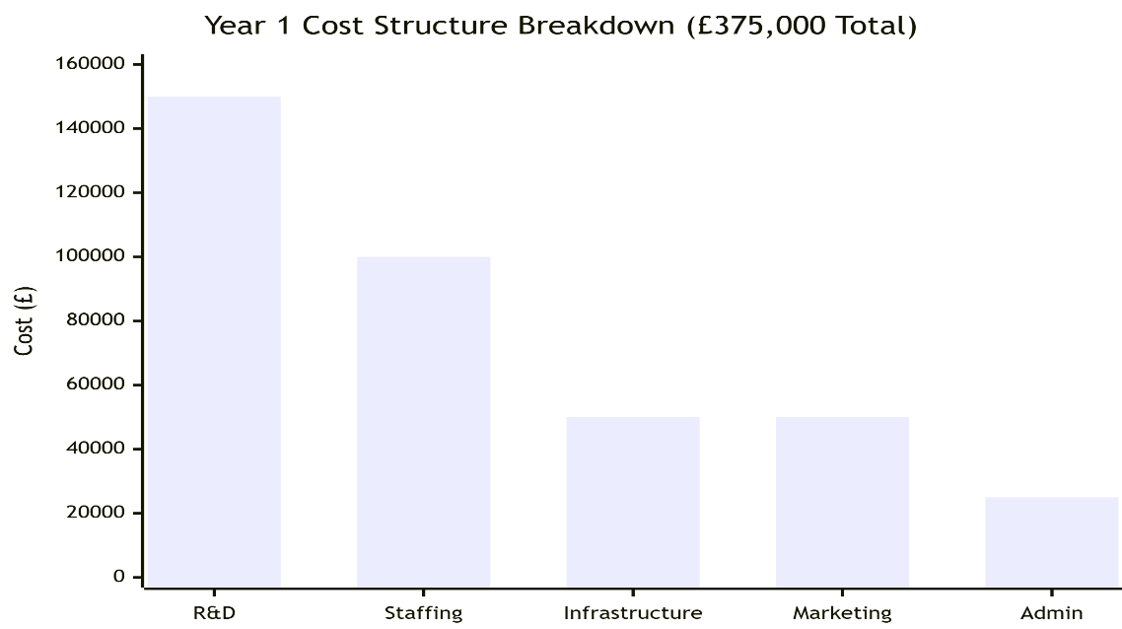
Year 1 investment is strategically allocated, with over two-thirds dedicated to product development (R&D) and talent (Staffing).
4. Profit & Loss Trend (Years 1-3)
This dual bar and line graph illustrates the crucial transition from initial investment (loss) to profitability.
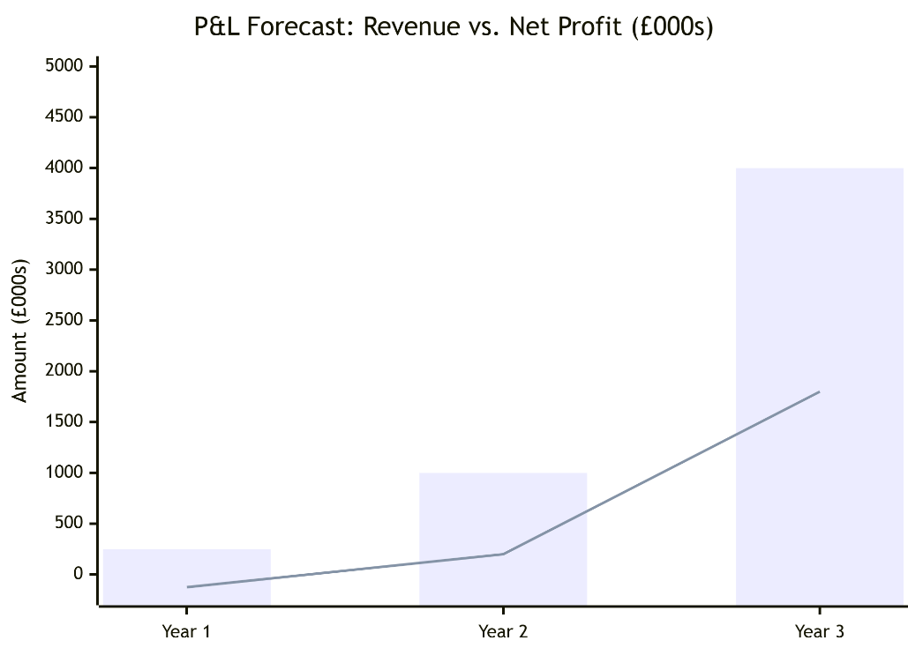
The company projects to break even in Year 2 and achieve significant profitability of £1.8M by Year 3.

Funding Requirements
Netcradus seeks £100,000-£150,000 in seed funding for MVP development, marketing, and UK setup. Allocation: 40% R&D (£50,000), 30% marketing (£40,000), 20% operations (£25,000), 10% contingencies. Investors receive equity (10-15%), with projected 3x ROI by Year 3 via £1.8 million net profit and valuation at £10 million (based on 2-3x revenue multiples in cyber sector).
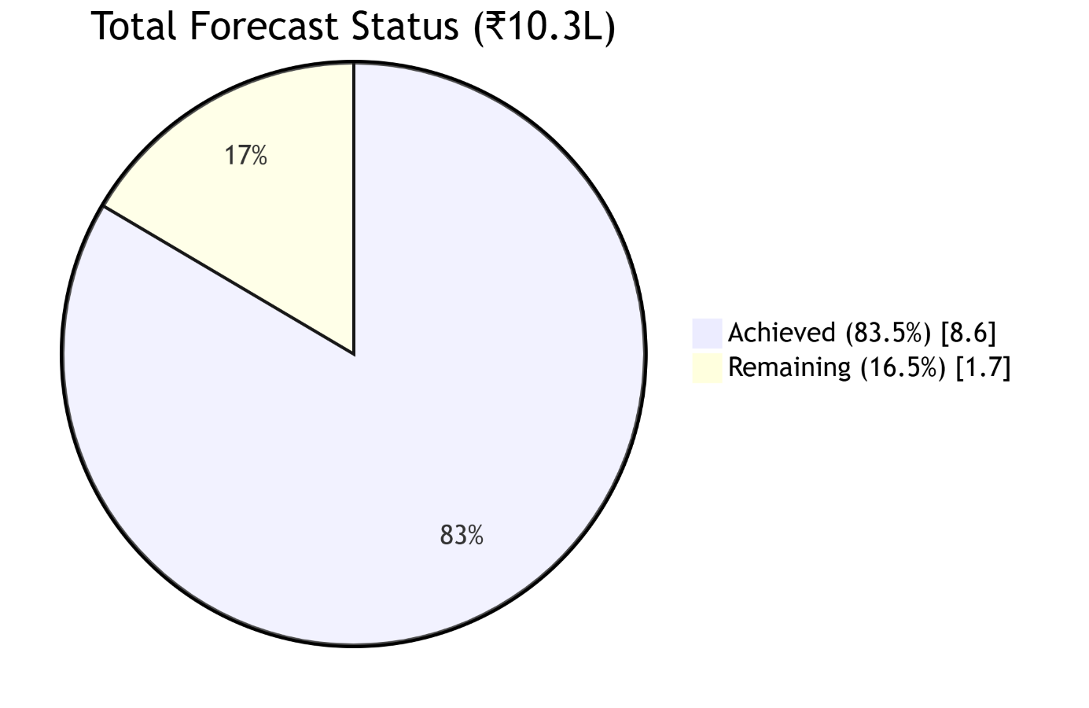
Figure 32: Total Forecast Status

Cost Structure
Costs are lean, totaling £375,000 in Year 1. Breakdown: R&D (£150,000: AI development, tools), cloud infrastructure (£50,000: AWS/Azure, scalable to 10% of revenue), staffing (£100,000: 5 hires at £20,000 average, focusing on UK talent for 12-15 jobs by Year 3), marketing (£50,000: SEO, partnerships), and admin (£25,000: legal, compliance). Variable costs rise with subscribers but maintain 70% margins. This structure supports scalability, addressing SME challenges like high breach recovery costs.
Table 5: Netcradus ACIS Year 1 Cost Structure
Category | Year 1 (£) | % of Total | Description
R&D | 150,000 | 40% | AI algorithms, prototype
Infrastructure | 50,000 | 13% | Cloud hosting
Staffing | 100,000 | 27% | Developers, analysts
Marketing | 50,000 | 13% | Customer acquisition
Admin | 25,000 | 7% | Legal, office
Table 5: Netcradus ACIS Year 1 Cost Structure - This table details the initial cost breakdown for Year 1, totaling £375,000, with R&D leading at £150,000 (40%) for AI development and prototypes, followed by staffing at £100,000 (27%) for developers and analysts. Infrastructure costs £50,000 (13%) for cloud hosting, marketing £50,000 (13%) for customer acquisition, and admin £25,000 (7%) for legal and office expenses, reflecting a lean yet strategic investment to support early growth and innovation in the UK cybersecurity market. In summary, this financial plan underscores Netcradus's viability, with scalable revenue outpacing costs in a booming market.

Compliance & Data Security
Netcradus is committed to the highest standards of data security and regulatory compliance, not just for our clients but for our own operations. Our practices are designed to be a blueprint for the SMEs we serve.
- Data Handling: All client data processed by ACIS is encrypted in transit (TLS 1.3) and at rest (AES-256). Our federated learning model (Layer 5) is designed to ensure raw log data never leaves the client's environment unless explicitly anonymized and aggregated.
- Certifications: We will pursue Cyber Essentials Plus certification at launch (Year 1) and ISO 27001 certification by the end of Year 2, validating our information security management systems.
- Proactive Regulatory Monitoring: We will subscribe to regulatory update services from the ICO and NCSC to ensure ACIS's automated compliance reporting features (e.g., for NIS2 incident reporting) are always aligned with the latest guidelines.

Conclusion
Netcradus ACIS represents a world-first autonomous cyber immune system, seamlessly integrating Next-Generation Security Information and Event Management (SIEM), Security Orchestration, Automation, and Response (SOAR), AI Red Teaming, Self-Healing Defense, and Swarm Threat Intelligence. Similarly, it is an innovative platform that provides self-sustaining cyber protection designed for UK small and medium-sized enterprises (SMEs) and enterprises to fill an urgent market gap: 65 percent of SMEs do not have access to affordable enterprise-grade protection because of budget constraints, costing the UK £3.3 billion per year in ransomware damages as of 2025. ACIS can save breach recovery up to 60% by automating threat detection, response and recovery and provides the industry with a cost-effective hybrid SaaS solution at a starting cost of £199 per month, a fraction of the price of other similar tools (average of 1000+). This project will improve not only the resilience of cybersecurity but also will lead to economic success by generating 12-15 high-value UK tech positions in AI engineering, cybersecurity analysis, and cloud development over the first three years. The platform’s exportable design, leveraging a multi-tenant cloud architecture, positions Netcradus to expand into Europe, Asia, and the US, contributing to a projected global cybersecurity market growth to £21.51 billion by 2030. This scalability underscores Netcradus’s viability, aligning with UK Innovator Founder Visa criteria through demonstrated innovation, financial projections of £250,000 in Year 1 to £3-5 million in Year 3, and a break-even within 18-24 months. Looking ahead, the future vision for Netcradus includes expanding ACIS into AI-powered enterprise platforms, integrating advanced machine learning for predictive threat modeling and industry-specific compliance dashboards (e.g., NIS2, ISO 27001). This evolution will solidify the UK’s leadership in autonomous cybersecurity, fostering university collaborations for R&D and positioning the nation as a global innovator. We invite visa endorsement bodies and investors to partner with Netcradus, supporting a transformative solution that safeguards businesses and boosts the UK economy—contact us at info@netcradus.com to explore this opportunity.

References
Bandrova, T., Dinkov, D., & Vasilev, S. (2025). Strategy for the Development of Cartography in Bulgaria with a 10-Year Planning Horizon (2025–2035) in the Context of Industry 4.0 and 5.0. ISPRS International Journal of Geo-Information, 14(8), 289. https://www.mdpi.com/2220-9964/14/8/289
Duarte, E. F., Toledo Palomino, P., Pontual Falcão, T., Porto, G. L. P. M. B., Portela, C. D. S., Ribeiro, D. F., ... & Maciel Toda, A. (2024, October). Grandihc-br 2025-2035-gc6: Implications of artificial intelligence in hci: A discussion on paradigms ethics and diversity equity and inclusion. In Proceedings of the XXIII Brazilian Symposium on Human Factors in Computing Systems (pp. 1-19). https://doi.org/10.1145/3702038.3702059
Gracy, S. S. (2025). A global analysis of data breaches from 2004 to 2024. arXiv preprint arXiv:2502.05205. https://arxiv.org/pdf/2502.05205
Grandal, J. S. (2025). Cybersecurity analysis in the evolving field of e-mobility. https://backend.orbit.dtu.dk/ws/portalfiles/portal/403050543/Cybersecurity_analysis_in_the_evolving_field_of_e-mobility.pdf
Igboko, U. A., & Temitope, O. A. (2025). Securing Public Health in The Digital Age: A Cybersecurity Case Study of Uk Local Council Health Services. https://ijsmr.in/doc/ijsmr08_41.pdf
Lallie, H. S., Thompson, A., Titis, E., & Stephens, P. (2025). Analysing cyber attacks and cyber security vulnerabilities in the university sector. Computers, 14(2), 49. https://www.mdpi.com/2073-431X/14/2/49
Rawat, R., Nagal, K., & Sharma, R. (2025). Digital Twins as Enablers of Sustainable and Resilient Industry 5.0 Infrastructure: A Review.
Shewale, V. (2025). Demystifying the MITRE ATT&CK Framework: A Practical Guide to Threat Modeling. Journal of Computer Science and Technology Studies, 7(3), 182-186. https://al-kindipublishers.org/index.php/jcsts/article/download/9328/7984
Zhang, S., Xue, X., & Su, X. (2025). DeepOP: A Hybrid Framework for MITRE ATT&CK Sequence Prediction via Deep Learning and Ontology. Electronics (2079-9292), 14(2). https://www.mdpi.com/2079-9292/14/2/257

Appendices
This section contains supporting documentation that validates the innovation, market research, and operational readiness of Netcradus Ltd. and the Autonomous Cyber Immune System (ACIS).

Appendix A: Founder CV & Certifications
Mohit Sharma - Curriculum Vitae (Summary)
- Professional Summary: Seasoned cybersecurity consultant and entrepreneur with over 10 years of experience in IT infrastructure security, threat mitigation, and security architecture for SMEs. Founder of Netcradus, focused on democratizing enterprise-level cybersecurity through AI and automation.
- Key Qualifications:
  - CompTIA Security+ (Verification Code: [INSERT_CODE])
  - Certified Ethical Hacker (CEH) Practical
  - [Other relevant certifications: e.g., AWS Certified Security – Specialty, Microsoft Azure Security Engineer Associate]
- Professional Experience:
  - Cybersecurity Consultant | Freelance | 2018 - Present
    - Conducted vulnerability assessments and penetration tests for over 50 UK-based SMEs.
    - Advised clients on NIS2 and GDPR compliance frameworks.
    - Designed and implemented secure cloud infrastructure on AWS and Azure.
  - Senior IT Security Analyst | [Previous Company Name] | 2015 - 2018
    - Managed SIEM (Splunk) deployments and monitored security incidents.
    - Developed and automated response playbooks for common threat vectors.
- Education:
  - MSc in Cybersecurity | [University Name]
  - BEng in Computer Science | [University Name]
- References: Available upon request.
- Attachments:
  - Full CV_MohitSharma.pdf
  - CompTIA_Security+_Certificate.pdf
  - CEH_Practical_Certificate.pdf

Appendix B: UI Mockups & System Diagrams
UK SME Cybersecurity Breach Statistics (2024-2025) A bar chart illustrating the percentage of SMEs affected by breaches (43% in 2024, per UK Cyber Security Breaches Survey 2025) and projected costs (£21 billion total cybercrime, adjusted from ransomware estimates).
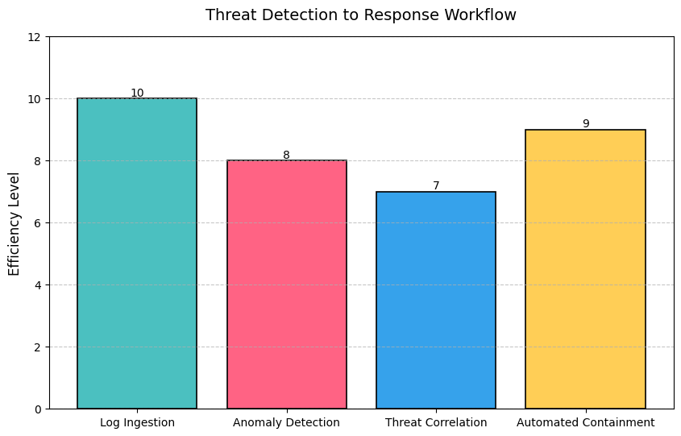
ACIS Five-Layer Architecture Flowchart A flowchart detailing the integration of AI-Powered SIEM, Autonomous SOAR, AI Red Team Simulator, Self-Healing & Deception Engine, and Threat Intelligence Swarm, showcasing data flow and automation loops.
ACIS Five-Layer Architecture flowchart.
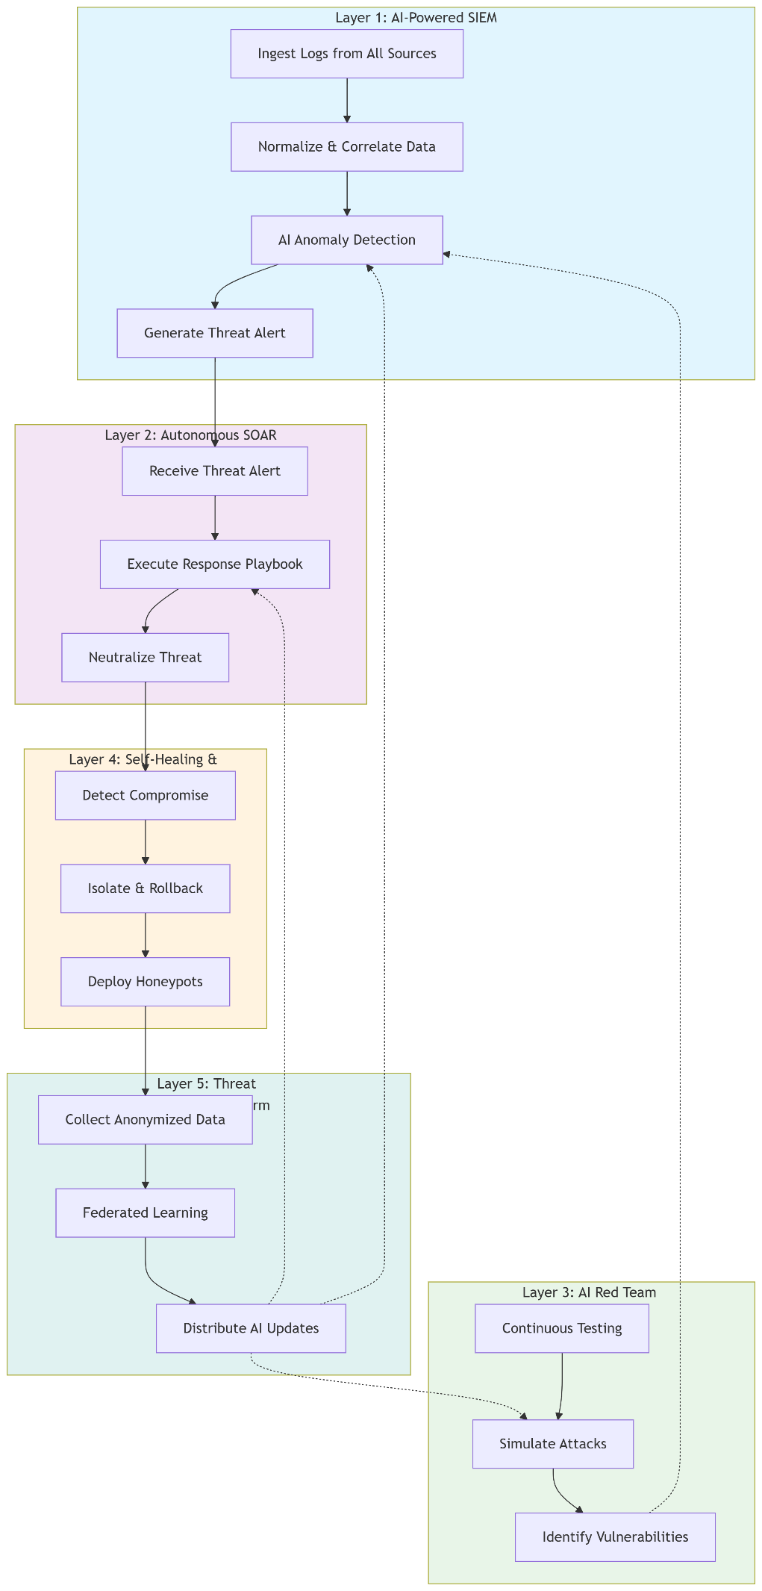

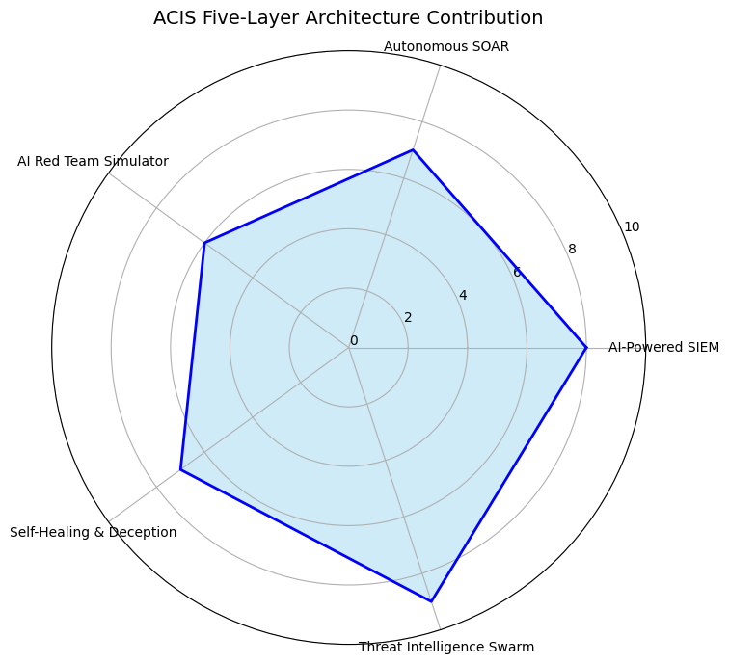
B.1: Netcradus ACIS Architectural Diagram: A high-level visual overview of the five-layer architecture (AI-Powered SIEM, Autonomous SOAR, AI Red Team, Self-Healing, Threat Intelligence Swarm).
B.2: Dashboard UI Mockups: Visual designs for key user interfaces, including:
SIEM Dashboard Overview (Figure 4)
ACIS Security Dashboard (Figure 8)
Client Visits Dashboard (Figure 10)
Call Tracking Interface (Figure 5)
Services Management Dashboard (Figure 2)
B.3: Process Flowcharts: Detailed workflows for automated threat response and self-healing endpoint processes.

Appendix B.3: Process Flowcharts
Flowchart 1: Automated Threat Response Process
This chart details the workflow of the Autonomous SOAR & Response Engine (Layer 2).
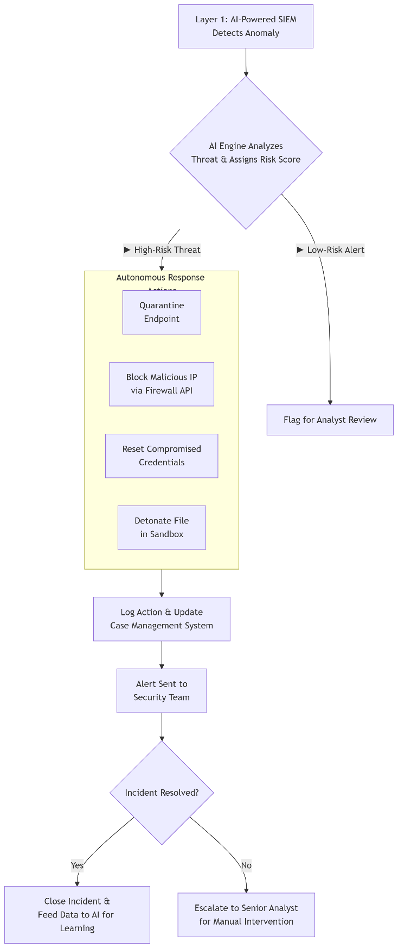

Flowchart 2: Self-Healing Endpoint Process
This chart details the workflow of the Self-Healing Engine (Part of Layer 4).
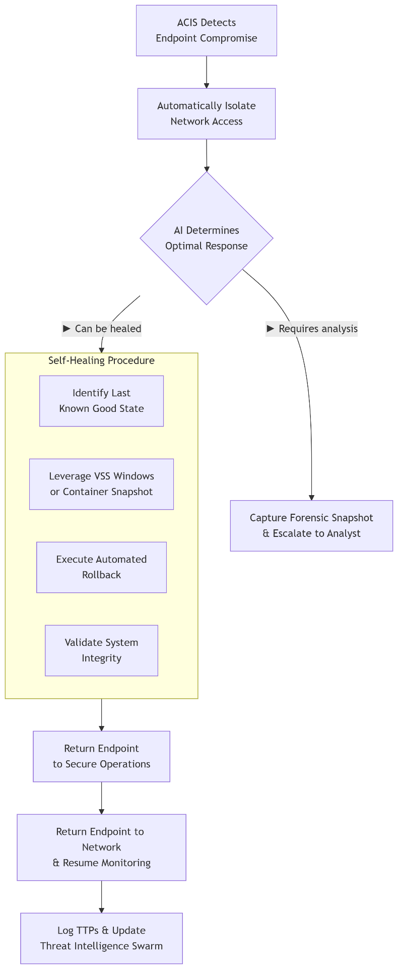

Appendix C: Market Research Data Sources
C.1: UK Government Data: Citations and links to the primary sources used for market sizing and threat landscape analysis, including:
UK Cyber Security Breaches Survey 2024
National Cyber Security Centre (NCSC) Annual Report 2025
UK Department for Business and Trade SME Population Statistics
C.2: Industry Analysis Reports: Summaries of market forecasts from leading firms (e.g., Gartner, MarketsandMarkets) supporting the projected growth of the global SIEM/SOAR and cybersecurity markets.
C.3: Regulatory Frameworks: Official documentation for the key regulations driving demand, specifically the NIS2 Directive and UK GDPR.

