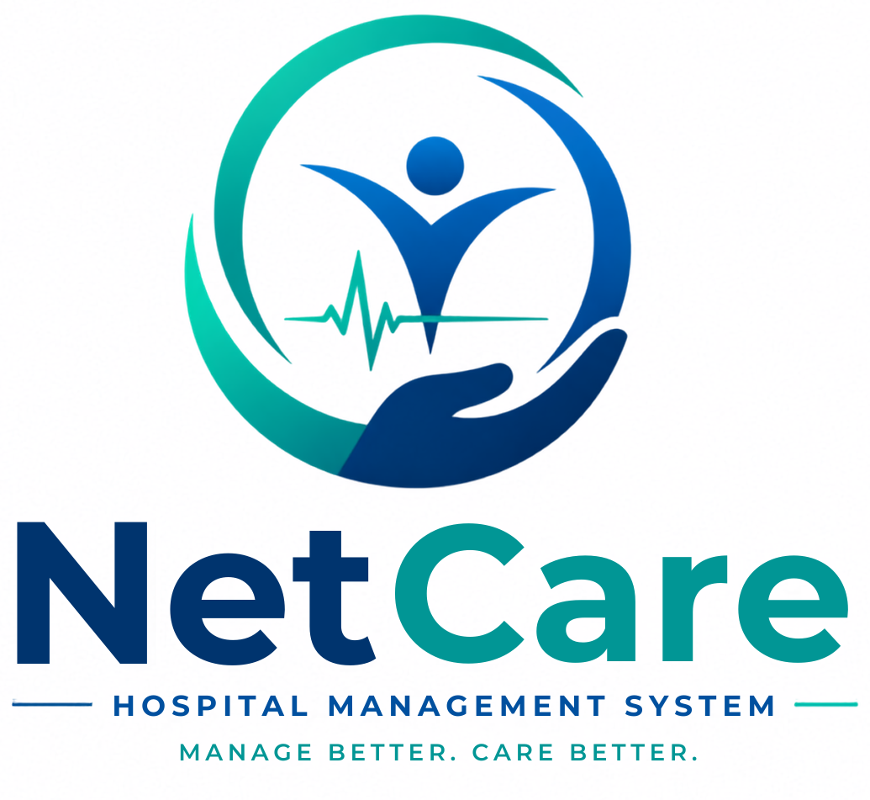
Marketing Playbook
How to get more hospitals onto Netcare — and later, patients onto netcare.co.in
Written for: the founder, who is now running marketing and sales · Prepared 2026-10-08 · Internal working document

1. How to use this document
This is the working plan for the next 90 days of marketing. It is built around one idea: hospital owners buy when they trust you, have seen it work, and can try it without risk — so every tactic below either builds trust, shows the product, or lowers the risk of trying.
Companion files in this folder: the pitch deck (.pptx), the brochure (.pdf), the 90-second explainer video (.mp4), the Sales Kit (scripts, templates, objections, demo, pilot checklist), the Pricing & Offer Proposal, and the Video Scripts. The marketplace design lives in docs/PUBLIC_MARKETPLACE_PLAN.md.
Honesty rule for all marketing. Every claim must be true today. The public booking marketplace is not built yet — always say 'coming soon'. Do not publish statistics, testimonials or uptime numbers you do not have. Section 5 lists what not to claim.

2. Positioning

One line
Netcare runs your whole hospital — appointments, records, IPD, pharmacy, lab, maternity and billing — on your own hospital address, live in a day.

The 30-second version
Most small and mid-size hospitals run on paper, Excel and two or three disconnected tools. Money leaks between billing, pharmacy and lab; licence renewals get missed; and patients cannot find you online. Netcare puts everything on one record, prices and bills from the server so nothing slips, tracks your licences, and — soon — sends you new patients from netcare.co.in. We set it up for you in a day.

What you are really competing with
Alternative | Why owners choose it | How Netcare answers (truthfully)
Paper registers + Excel | Free, familiar, no training | Show the leakage: a dispensed medicine that never reached a bill. Offer a free pilot with data import so switching is not a project.
Cheap local HMS (desktop / one-off licence) | Low price, a salesperson who visits | Web-based, updates continuously, no server to maintain, own subdomain, maternity depth, licence tracking. Do not criticise them by name.
Large HIS vendors | Brand, long feature lists | Too heavy and costly for 10–50 beds. Netcare is built for exactly this size and set up in a day.
Doing nothing | Switching is scary | Make the first step tiny: a 15-minute demo, then a no-card pilot.

3. Who to sell to first
Do not market to 'all hospitals'. Pick one segment in one city and win it. Word of mouth between owners in one town is your cheapest channel — but only if they all know each other.

Ideal first customer (ICP)
- Size: roughly 10–50 beds, or a busy single-specialty clinic (maternity, dental, eye, diagnostic).
- Decision maker: the owner-doctor — one person who can say yes in a meeting.
- Pain signal: still on paper or Excel, or unhappy with a desktop HMS; runs a pharmacy and lab in-house; wants more patients.
- City: the one where you can visit in person twice a week. Suggested: your home city (decision pending — see §12).

Segment scoring (fill in as you meet people)
Criterion | Weight | Score 1–5 | Notes
Owner is the doctor | 3
Currently paper / Excel | 3
Has in-house pharmacy or lab | 2
Maternity or child health | 2
Within 30 min of you | 2
Knows another hospital owner you can reach | 2

Start with whoever scores highest. Maternity homes are Netcare's strongest fit because the product goes deeper there (pregnancy, ANC, linked baby records, growth, immunizations) than most alternatives.

4. Messaging

Five pillars, each tied to something that exists today
Pillar | Message | Proof you can show live
1. Live in a day | We set up your subdomain, doctors, fees and branding; you start booking appointments the same day. | Onboarding wizard; hospital gets own subdomain and first admin account in one flow.
2. Stop revenue leakage | Every service ends up on a bill; the browser can never decide what a visit costs. | Fee schedule by visit type; dispense-and-bill in pharmacy; consultation / pharmacy / lab summaries; invoices generated on the server.
3. Honest stock | Stock moves with real orders; expired or short stock is never dispensed. | Medicine and injectable ledgers, low-stock report, dispensing refusal on short or expired stock.
4. Paperwork under control | Licences, consent and audit — tracked, not remembered. | Licence-expiry report, itemised withdrawable consent, minor/guardian consent, audit log.
5. Your data, your rules | Each hospital sees only its own data; you decide what each role can see. | Custom roles with own/all scopes; permissions checked live; tenant-isolation tests run before releases.

Words that work with owners — and words to avoid
Say | Avoid
'Your own hospital address' | 'Multi-tenant SaaS'
'Stop paying for things you gave away' | 'RBAC', 'scoped permissions'
'We set it up and import your data' | 'Self-serve onboarding'
'Never miss a licence renewal' | 'Compliance suite'
'See real open slots, soon on netcare.co.in' | 'Marketplace', 'aggregator' (sounds like a threat to their own brand)

5. What not to claim
- The patient marketplace is live. It is not. Say 'coming soon' and 'founding hospitals shape it'.
- Savings or growth numbers ('saves 30% time', '40% more patients'). You have no data yet. Collect it from the pilots, then publish it with permission.
- 'Certified' / 'fully compliant'. The consent features are designed around the DPDP Act, telemedicine guidelines and IT/SPDI rules, but are not a legal certification. Say 'designed around', and let their counsel verify.
- Uptime or 'never goes down'. Netcare is web-based and needs internet. Be straightforward about that (see Sales Kit objection #6).
- Offline mode, native mobile app, Hindi interface, WhatsApp automation — none are verified in the product today.
- Named testimonials or hospital logos before you have written permission.
- 'Best doctor', rankings, or paid placement on any doctor listing — medical-council advertising rules restrict doctors; keep any listing factual.

6. Channels — where the hospitals are
Channel | What to do | Weekly target | Effort / cost
1. Walk-in visits (highest conversion) | Visit hospitals in your chosen city with a tablet, the brochure and a 15-min demo. Ask for the owner, not reception. | 8–10 visits | High effort, near-zero cost
2. Doctor associations | Local IMA chapter, FOGSI chapter (maternity), dental / eye associations: offer a 20-minute talk 'Stopping revenue leakage in a small hospital'. | 1 contact / week | Medium effort, builds trust
3. Referrals | Every pilot hospital gets asked at week 3: 'Which two colleagues should see this?' Reward: a free month for each hospital that goes live. | Ask every pilot | Low cost
4. WhatsApp | Send the 90-sec video and the brochure with a personal note (templates in Sales Kit). One-to-one, never bulk. | 20 personal messages | Low
5. Channel partners | Local IT shops, billing consultants, medical-equipment dealers who already visit hospitals. Offer a referral commission on paid conversions. | 2 conversations / week | Medium; pay only on results
6. Local search & content | A simple 'Netcare for Hospitals' page, Google Business Profile, 2 short articles ('How to track licence expiry', 'Billing leaks in a small pharmacy'). Slow but compounding. | 1 post / week | Low, slow
7. Events | Local medical conferences and CME days — a stall is often cheaper than ads and puts you in front of owners. | 1 per month | Medium

Skip for now: paid Google/Facebook ads aimed at hospitals (expensive per lead at this stage), bulk SMS/WhatsApp blasts (DLT/consent rules and poor trust), cold email to generic addresses.

7. The 90-day plan
When | Goal | Actions | Done when
Weeks 1–2: Get ready | A demo that never embarrasses you | Create a demo hospital through the onboarding wizard with realistic sample doctors, patients, fees, stock. Rehearse the 15-min demo. Fix the readiness items in §10. Fill the contact placeholders in the deck, brochure and video. | You can run the demo twice in a row with no surprises
Weeks 3–6: Pilots | 3–5 pilot hospitals live | Start walk-ins and associations. Sign pilots (free, [30] days). Set each one up yourself, import data, train staff, stay on call in week 1. Weekly 15-min check-in call. | 3 hospitals booking real appointments
Weeks 7–10: Proof | Evidence you can publish | Measure: appointments booked, bills raised, stock alerts, time-to-first-appointment. Get written permission for a case study and a quote. Ask for referrals. | 2 case studies + 2 referrals
Weeks 11–13: Convert | First paying customers | Convert pilots to paid using the Pricing & Offer Proposal. Launch the referral and partner programme. Start the marketplace waitlist page (see §11). | ≥ [2] paying hospitals

8. First four weeks of content
Week | Piece | Channel | Source
1 | 90-second explainer video | WhatsApp (1-to-1), LinkedIn, website | Netcare-Explainer-90s.mp4
2 | Post: 'Where small hospitals lose money' (3 examples: unbilled dispensing, unbilled lab, expired stock) | LinkedIn, WhatsApp groups | Pillar 2–3
3 | One-page brochure + demo-booking message | WhatsApp, leave-behind at visits | Netcare-Brochure.pdf
4 | Post: 'The licence calendar every hospital should keep' with Netcare's expiry tracking as the tool | LinkedIn, association newsletter | Pillar 4

After the first pilots: weekly 'what we learned' posts with permission; a before/after case study; a short talk for the association.

9. Metrics — what to track every week
Stage | Definition | Starter target (hypothesis — adjust after 4 weeks)
Contacts | Owners you spoke to (visit, call, WhatsApp reply) | 30 / week
Demos | Completed 15-min demos | 8 / week
Pilots started | Hospital set up and used by staff | 1 / week (weeks 3–6)
Activated | Pilot with ≥ 10 real appointments booked in week 1 | ≥ 70% of pilots
Converted | Pilot → paid | ≥ 40% of activated pilots
Referrals | New contacts introduced by a customer | 2 per pilot
Time to first appointment | Signup → first real booking | ≤ 1 day

Keep it in one spreadsheet: one row per hospital — name, owner, city, beds, source, date of each stage, objections heard, next step. Review every Friday: where do people drop off, and why?

10. Readiness checklist — fix before you push hard
One failed onboarding at an early hospital costs more than ten sales gain. Based on the project docs (no frontend tests; production builds currently ignore type errors), treat these as priorities:
Item | Why it matters | Status
Production monitoring and error alerts | You must hear about a problem before the hospital does | [ ]
Daily database backups, and a tested restore | Hospitals hold patient records | [ ]
A staging environment / demo hospital with sample data | You never demo on real data | [ ]
GST-correct invoices checked by an accountant | The owner's accountant will check this first | [ ]
A support phone / WhatsApp number that someone answers | Small hospitals buy support, not software | [ ]
Privacy policy and terms pages on netcare.co.in | Required before collecting any lead or patient data | [ ]
Data export process (what the owner gets if they leave) | Promised in the pilot offer; confirm you can deliver it | [ ]
Data import process (patients, stock) from Excel | Promised in the pilot offer; confirm the method and who runs it | [ ]
Onboarding rehearsal: signup → first appointment in one day | This is the headline claim; time it | [ ]

11. The patient side: netcare.co.in marketplace
When the marketplace is built, marketing it is a different job: supply first, demand second. An empty directory is worse than no directory.
- Launch city by city. Open public booking only in a city with enough listed hospitals to make search useful (suggest at least [10] hospitals across several specialties).
- Everywhere else, show a waitlist ('Coming to your area — tell us where'). Every signup is also a sales signal for where to sell the HMS next.
- Founding-hospital programme: early hospitals get listed first, help shape the product, and keep control (opt-in, choose doctors, daily limits, pause any time).
- Show hospitals the return: a dashboard number 'bookings from Netcare this month' is the best renewal argument.
- Patient acquisition (once supply exists): local search, Google Business Profiles for listed hospitals, community posts, and the hospitals themselves telling their own patients 'book on our Netcare page'. Do not buy ads to a directory that is not ready.
- Keep listings factual (name, qualification, registration number, department). No rankings or paid placement without legal review.
Full design, risks, and open decisions are in docs/PUBLIC_MARKETPLACE_PLAN.md.

12. Compliance cautions for marketing
- Doctor advertising: NMC and medical-council rules restrict advertising by doctors. Keep claims about doctors factual; get legal review before any ranking, 'top doctor' or paid placement.
- Patient testimonials / patient images: do not use them. Use hospital-owner and doctor testimonials with written permission.
- Lead data: the owners' names, phones and notes you collect are personal data under the DPDP Act 2023 — keep a short privacy notice, collect only what you need, delete on request.
- WhatsApp and SMS: message individuals who have shown interest; do not bulk-send. Promotional SMS in India needs DLT registration and consent.
- No guarantees of savings, patient numbers or compliance outcomes.
- This is practical guidance, not legal advice — have counsel review the final public pages.

13. Assumptions and decisions you need to make
# | Decision / assumption | Recommendation
1 | First city and segment | Your home city; maternity or multi-specialty nursing homes of 10–50 beds
2 | Pilot length and terms | [30] days, free, no card; confirm before printing
3 | Who does data import, and how | You, by script/Excel template for the first customers
4 | What the owner gets on exit | Full export of their data in a standard format; decide format
5 | Pricing | See Pricing & Offer Proposal — validate with 5 owners first
6 | Support hours and channel | Phone + WhatsApp, defined hours, written on the brochure
7 | Founding-hospital benefits | Priority listing, free marketplace listing for [12] months — confirm before promising
8 | Referral reward | One free month per hospital that goes live

