依赖库library_fdddf_diff使用文档说明

1. 背景
library_fdddf_diff是一个文本对比的低代码平台依赖库，支持对两个输入文本进行对比，并对差异的行进行高亮标记。
示例效果如下：
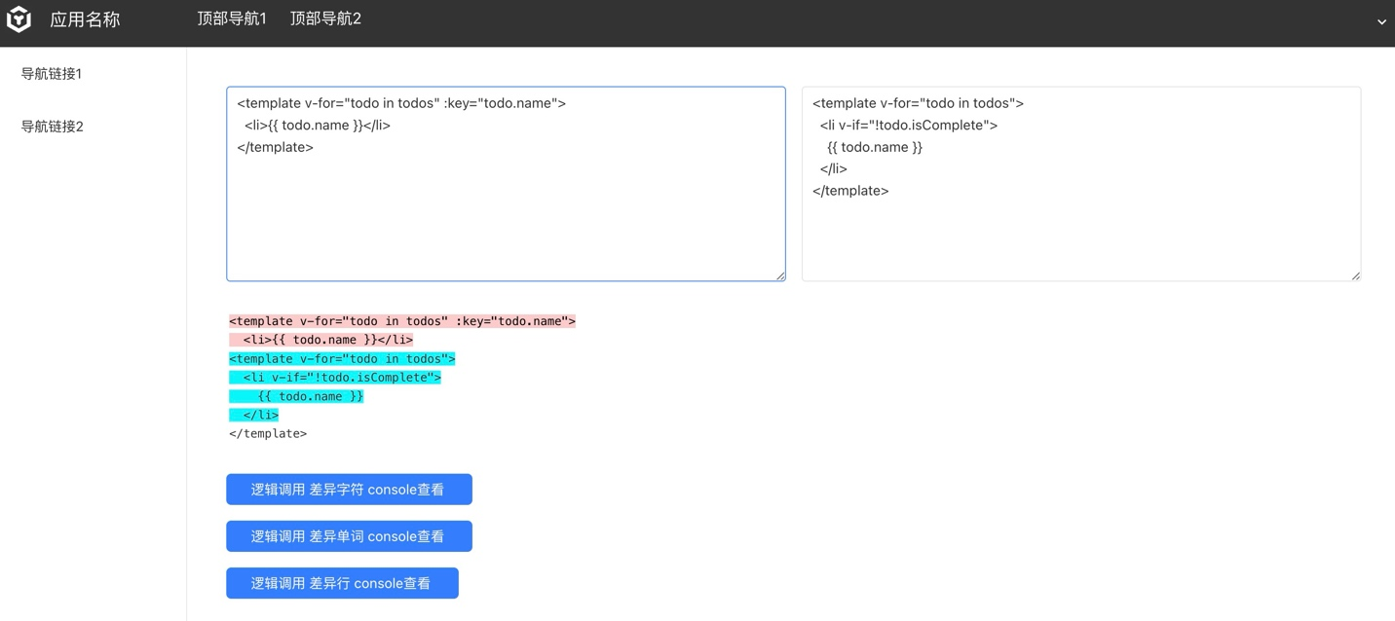

2. 依赖库方法
以下逻辑以如下文本说明：

左侧文本 | 右侧文本
How are you  are you here?  Thanks | how are you  are you ok?

返回变更的对象结构
[{ value: string, added: bool, removed: bool, count: number }]

- value: 通常作为单个字符串添加、删除或常用的文本
- added: true 表示该行是添加的行，false 表示该行是删除的行， 实际返回值为字符串 1或0
- removed: true 表示该行是删除的行，false 表示该行是添加的行， 实际返回值为字符串 1或0
- count: 更改对象中的值由多少个标记（例如，不同字符的字符，不同行的行）组成

getDiffLines
返回行级对比结果
- 入参：String one, String other
- 出参：List<Map<String, String>>
调用此逻辑返回值如：
[
{
"value" : "How are you
are you here?
Thanks",
"added" : "0",
"removed" : "1",
"count" : "3"
},
{
"value" : "how are you
are you ok?",
"added" : "1",
"removed" : "0",
"count" : "2"
}
]
示例中以行为准块状对比。

getDiffChars
返回字符级对比结果
- 入参：String one, String other
- 出参：List<Map<String, String>>
调用此逻辑返回值如：
[
{
"value" : "H",
"added" : "0",
"removed" : "1",
"count" : "1"
},
{
"value" : "h",
"added" : "1",
"removed" : "0",
"count" : "1"
},
{
"value" : "ow are you
are you ",
"added" : "0",
"removed" : "0",
"count" : "19"
},
{
"value" : "here",
"added" : "0",
"removed" : "1",
"count" : "4"
},
{
"value" : "ok",
"added" : "1",
"removed" : "0",
"count" : "2"
},
{
"value" : "?
",
"added" : "0",
"removed" : "0",
"count" : "2"
},
{
"value" : "Thanks
",
"added" : "0",
"removed" : "1",
"count" : "7"
}
]
示例中以字符为块对比，如How变更为how， 此时返回结果中包含如下对象
{
"value" : "H",
"added" : "0",
"removed" : "1",
"count" : "1"
},
{
"value" : "h",
"added" : "1",
"removed" : "0",
"count" : "1"
},

getDiffWords
返回单词级对比结果
- 入参：String one, String other
- 出参：List<Map<String, String>>
调用此逻辑返回值如：
[
{
"value" : "How",
"added" : "0",
"removed" : "1",
"count" : "1"
},
{
"value" : "how",
"added" : "1",
"removed" : "0",
"count" : "1"
},
{
"value" : " are you
are you ",
"added" : "0",
"removed" : "0",
"count" : "4"
},
{
"value" : "here",
"added" : "0",
"removed" : "1",
"count" : "1"
},
{
"value" : "ok",
"added" : "1",
"removed" : "0",
"count" : "1"
},
{
"value" : "?
",
"added" : "0",
"removed" : "0",
"count" : "1"
},
{
"value" : "Thanks
",
"added" : "0",
"removed" : "1",
"count" : "1"
}
]

示例中以单词为块对比，如How变为how,包含以下对象：
{
"value" : "How",
"added" : "0",
"removed" : "1",
"count" : "1"
},
{
"value" : "how",
"added" : "1",
"removed" : "0",
"count" : "1"
},

3. 示例

3.1 引入依赖库
在依赖库管理导入library_fdddf_diff依赖库
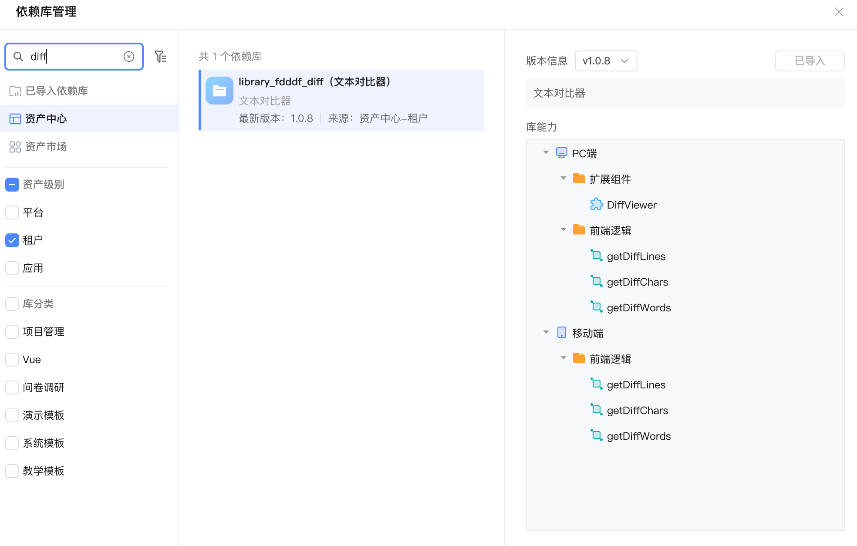

3.2 页面使用依赖库示例

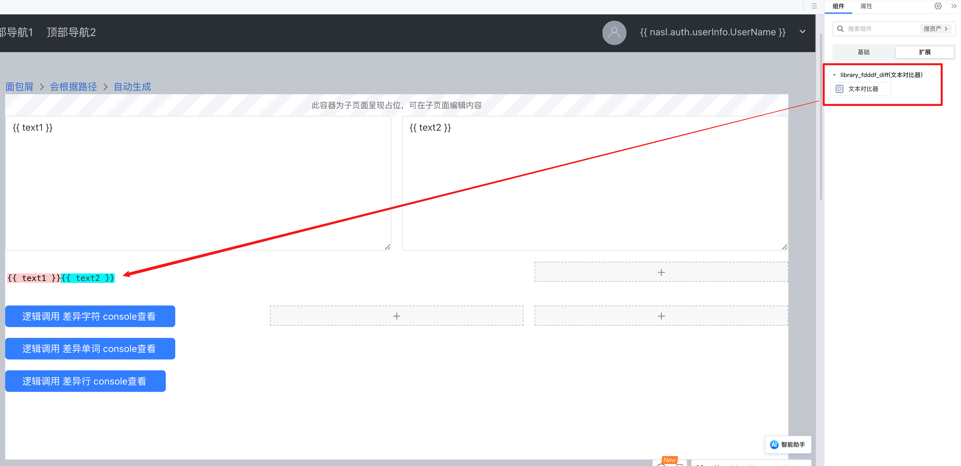

页面中创建和绑定两个文本框，用来输入需要对比的文本；
拖入依赖库组件 “文本对比器”

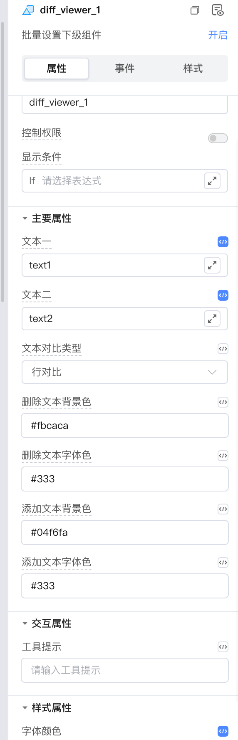
选择文本对比类型为行对比；
修改需要自定义的颜色 ，如修改添加文本背景色为#04f6fa;
预览即可。

逻辑调用示例：

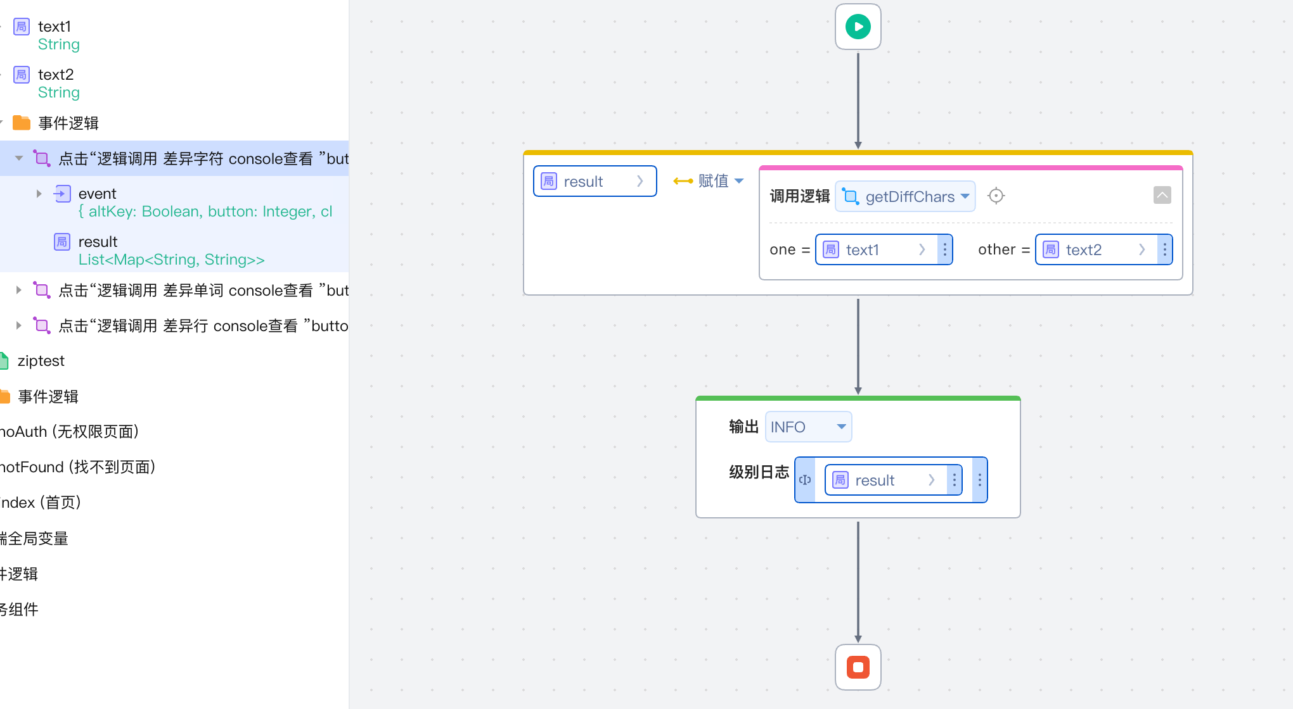
调用依赖库逻辑getDiffChars可获取返回结果。
结果参数意义可参考 https://github.com/kpdecker/jsdiff?tab=readme-ov-file#change-objects

