依赖库library_fdddf_diff使用文档说明

## 1. 背景

library_fdddf_diff是一个文本对比的低代码平台依赖库，支持对两个输入文本进行对比，并对差异的行进行高亮标记。

示例效果如下：

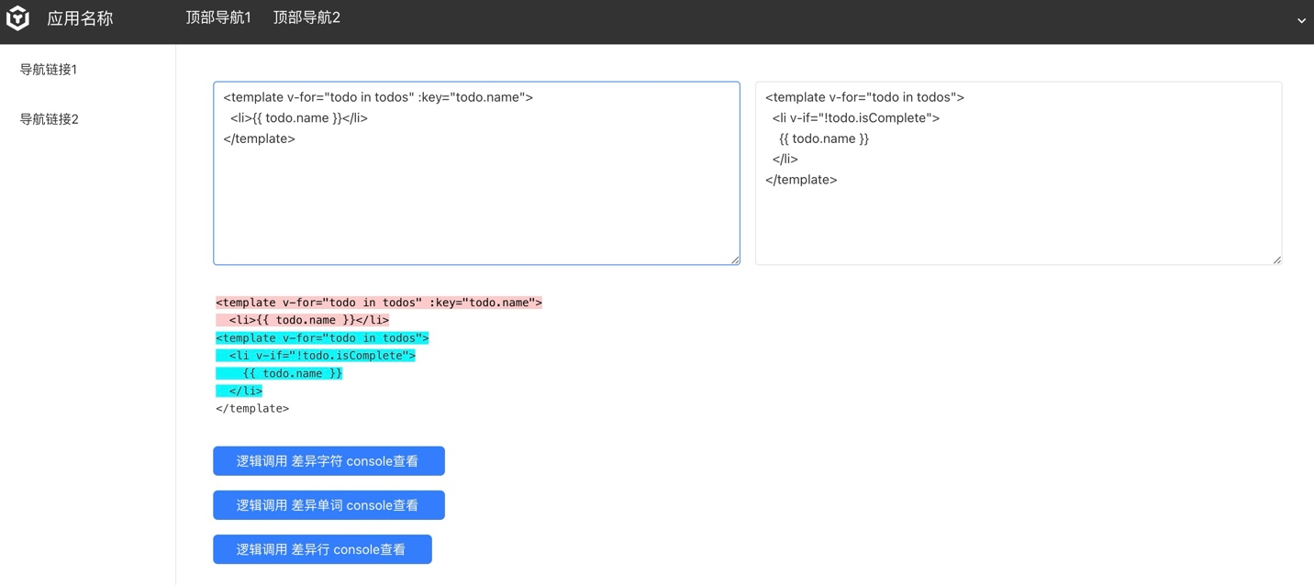

## 2. 依赖库方法

以下逻辑以如下文本说明：

|  |  |
| --- | --- |
| 左侧文本 | 右侧文本 |
| How are you  are you here?  Thanks | how are you  are you ok? |

返回变更的对象结构

|  |
| --- |
| [{ value: string, added: bool, removed: bool, count: number }] |

* value: 通常作为单个字符串添加、删除或常用的文本
* added: true 表示该行是添加的行，false 表示该行是删除的行， 实际返回值为字符串 1或0
* removed: true 表示该行是删除的行，false 表示该行是添加的行， 实际返回值为字符串 1或0
* count: 更改对象中的值由多少个标记（例如，不同字符的字符，不同行的行）组成

### getDiffLines

返回行级对比结果

* 入参：String one, String other
* 出参：List<Map<String, String>>

调用此逻辑返回值如：

|  |
| --- |
| [  {  "value" : "How are you  are you here?  Thanks",  "added" : "0",  "removed" : "1",  "count" : "3"  },  {  "value" : "how are you  are you ok?",  "added" : "1",  "removed" : "0",  "count" : "2"  }  ] |

示例中以行为准块状对比。

### getDiffChars

返回字符级对比结果

* 入参：String one, String other
* 出参：List<Map<String, String>>

调用此逻辑返回值如：

|  |
| --- |
| [  {  "value" : "H",  "added" : "0",  "removed" : "1",  "count" : "1"  },  {  "value" : "h",  "added" : "1",  "removed" : "0",  "count" : "1"  },  {  "value" : "ow are you  are you ",  "added" : "0",  "removed" : "0",  "count" : "19"  },  {  "value" : "here",  "added" : "0",  "removed" : "1",  "count" : "4"  },  {  "value" : "ok",  "added" : "1",  "removed" : "0",  "count" : "2"  },  {  "value" : "?  ",  "added" : "0",  "removed" : "0",  "count" : "2"  },  {  "value" : "Thanks  ",  "added" : "0",  "removed" : "1",  "count" : "7"  }  ] |

示例中以字符为块对比，如How变更为how， 此时返回结果中包含如下对象

|  |
| --- |
| {  "value" : "H",  "added" : "0",  "removed" : "1",  "count" : "1"  },  {  "value" : "h",  "added" : "1",  "removed" : "0",  "count" : "1"  }, |

### getDiffWords

返回单词级对比结果

* 入参：String one, String other
* 出参：List<Map<String, String>>

调用此逻辑返回值如：

|  |
| --- |
| [  {  "value" : "How",  "added" : "0",  "removed" : "1",  "count" : "1"  },  {  "value" : "how",  "added" : "1",  "removed" : "0",  "count" : "1"  },  {  "value" : " are you  are you ",  "added" : "0",  "removed" : "0",  "count" : "4"  },  {  "value" : "here",  "added" : "0",  "removed" : "1",  "count" : "1"  },  {  "value" : "ok",  "added" : "1",  "removed" : "0",  "count" : "1"  },  {  "value" : "?  ",  "added" : "0",  "removed" : "0",  "count" : "1"  },  {  "value" : "Thanks  ",  "added" : "0",  "removed" : "1",  "count" : "1"  }  ] |

示例中以单词为块对比，如How变为how,包含以下对象：

|  |
| --- |
| {  "value" : "How",  "added" : "0",  "removed" : "1",  "count" : "1"  },  {  "value" : "how",  "added" : "1",  "removed" : "0",  "count" : "1"  }, |

## 3. 示例

### 3.1 引入依赖库

在依赖库管理导入library_fdddf_diff依赖库

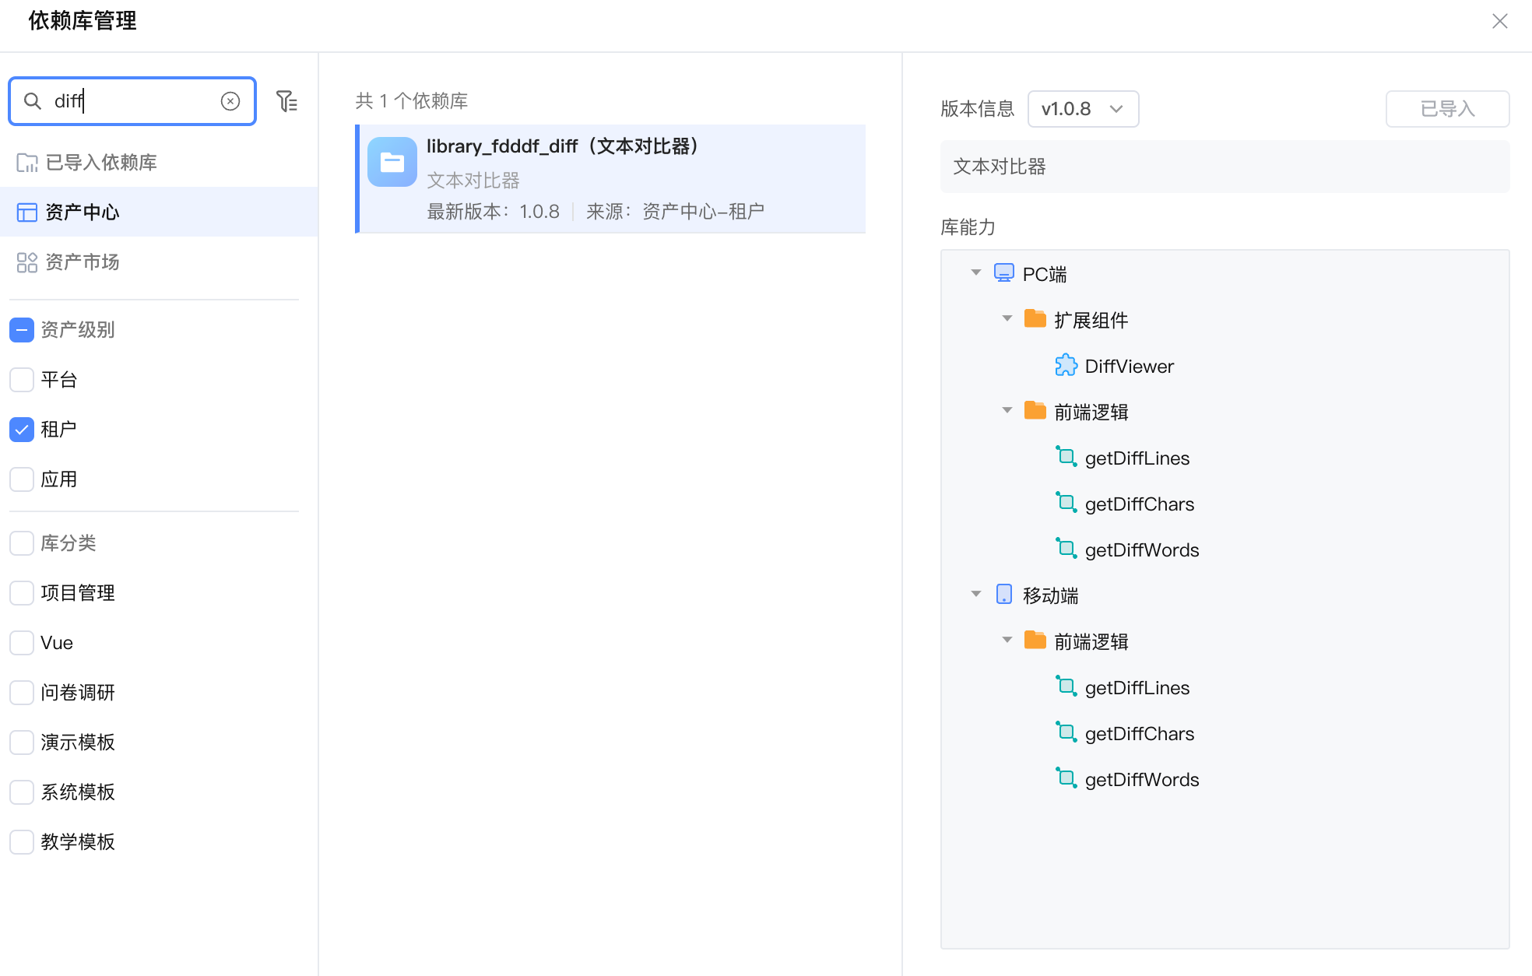

### 3.2 页面使用依赖库示例

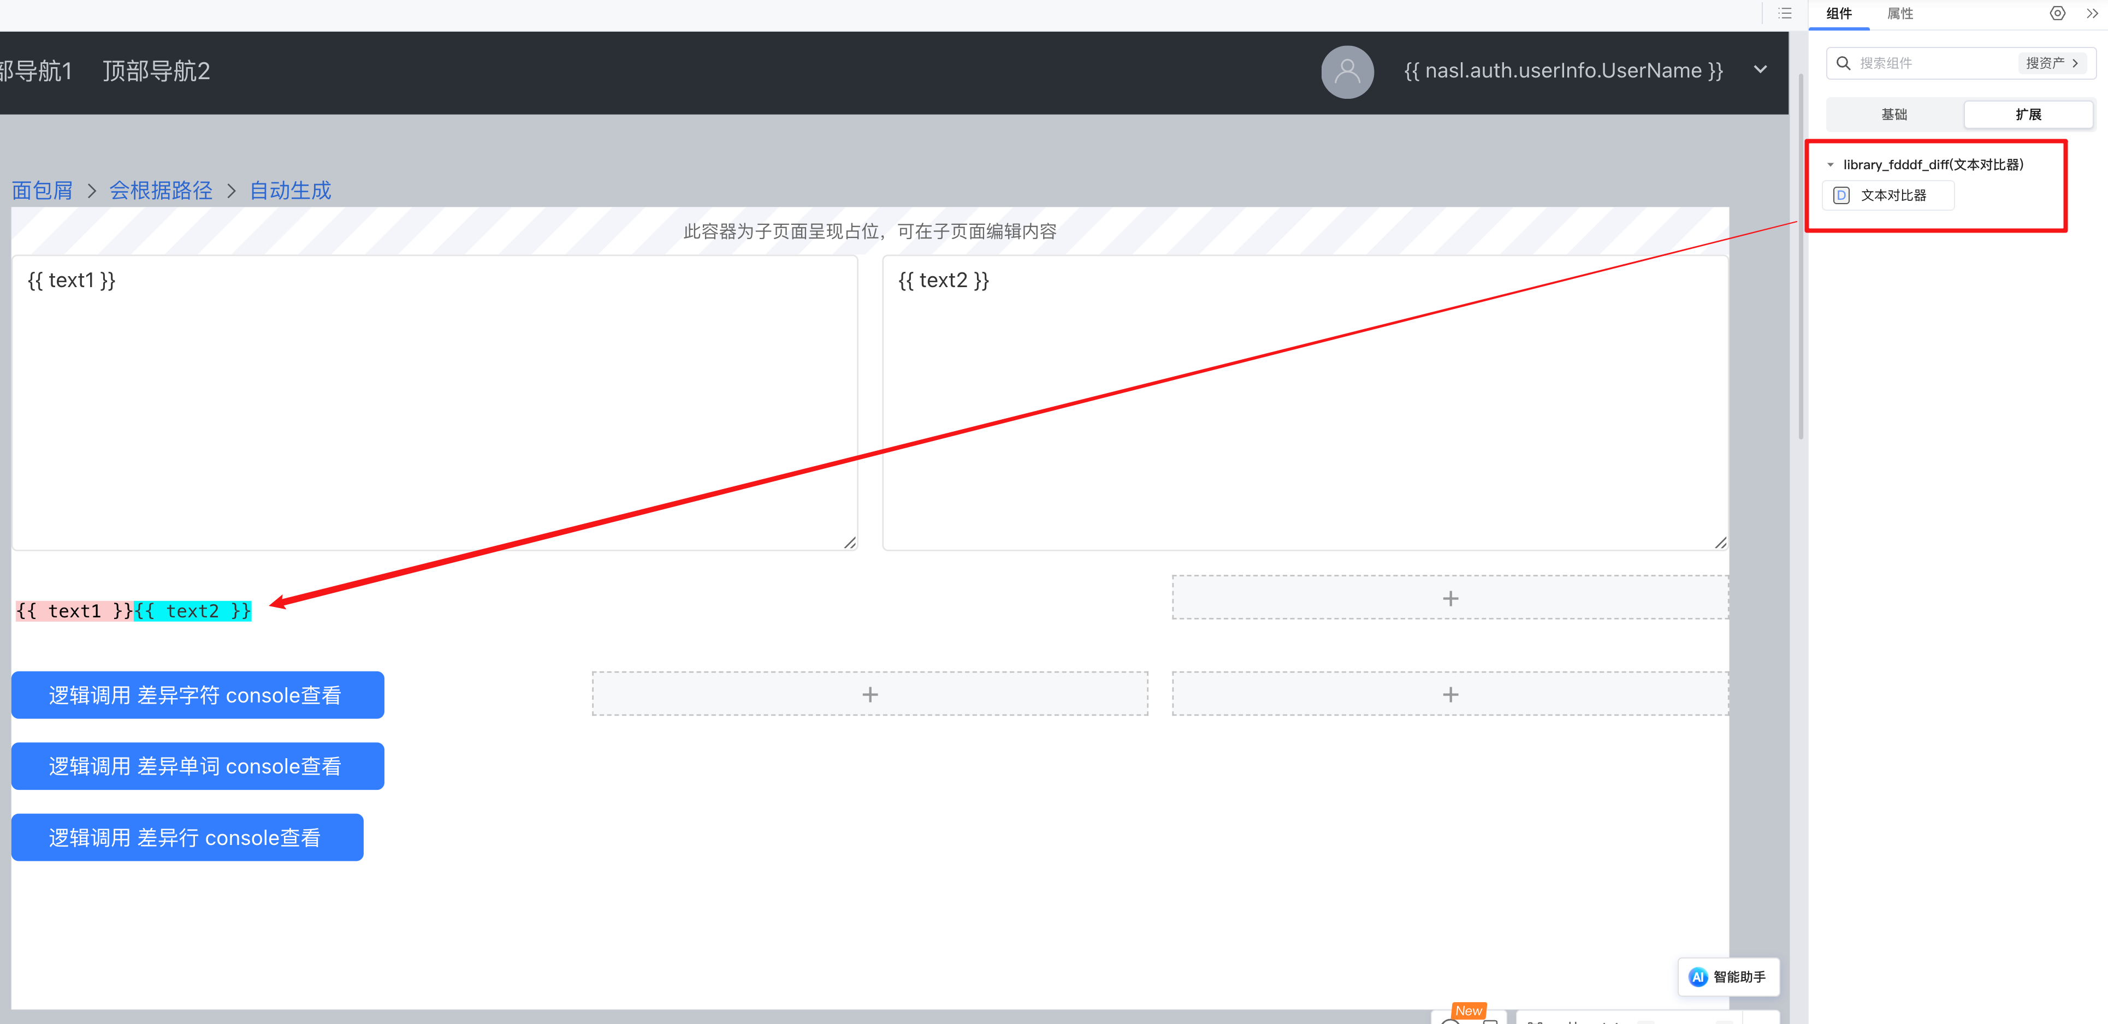

页面中创建和绑定两个文本框，用来输入需要对比的文本；

拖入依赖库组件 “文本对比器”

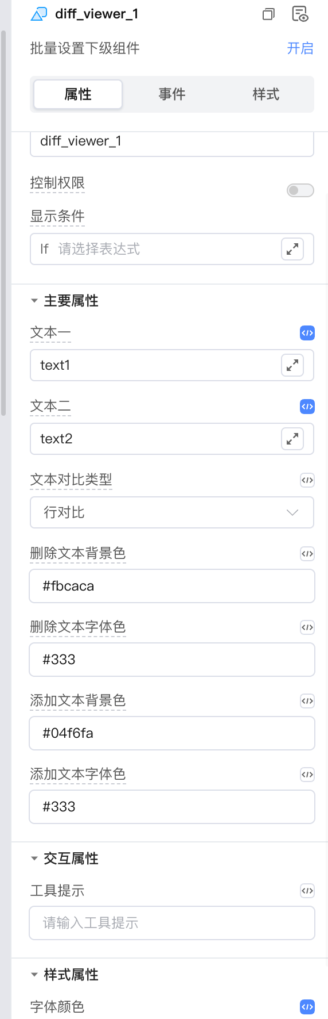

选择文本对比类型为行对比；

修改需要自定义的颜色 ，如修改添加文本背景色为#04f6fa;

预览即可。

逻辑调用示例：

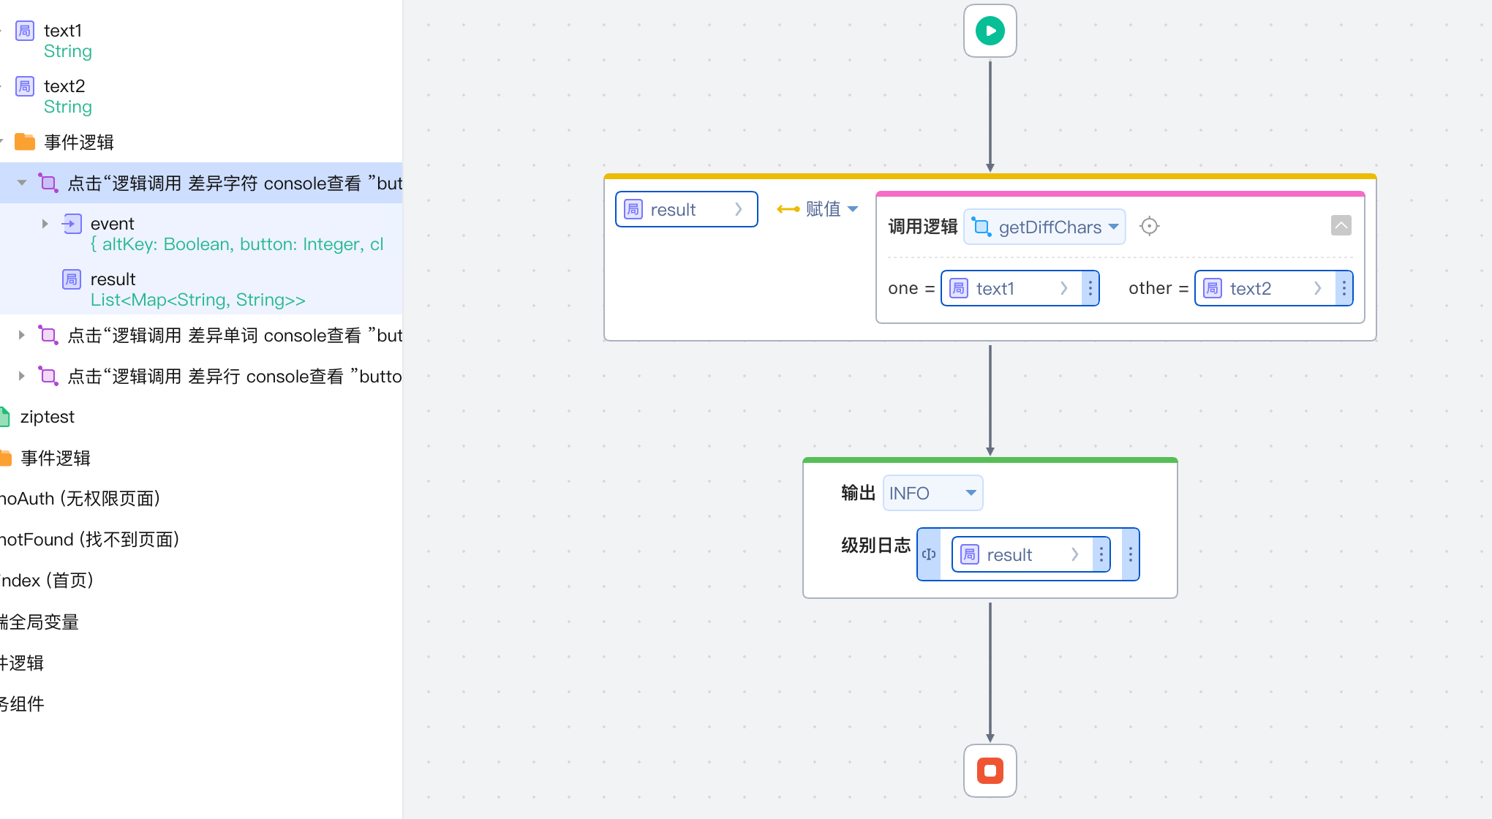

调用依赖库逻辑getDiffChars可获取返回结果。

结果参数意义可参考 <https://github.com/kpdecker/jsdiff?tab=readme-ov-file#change-objects>