Before
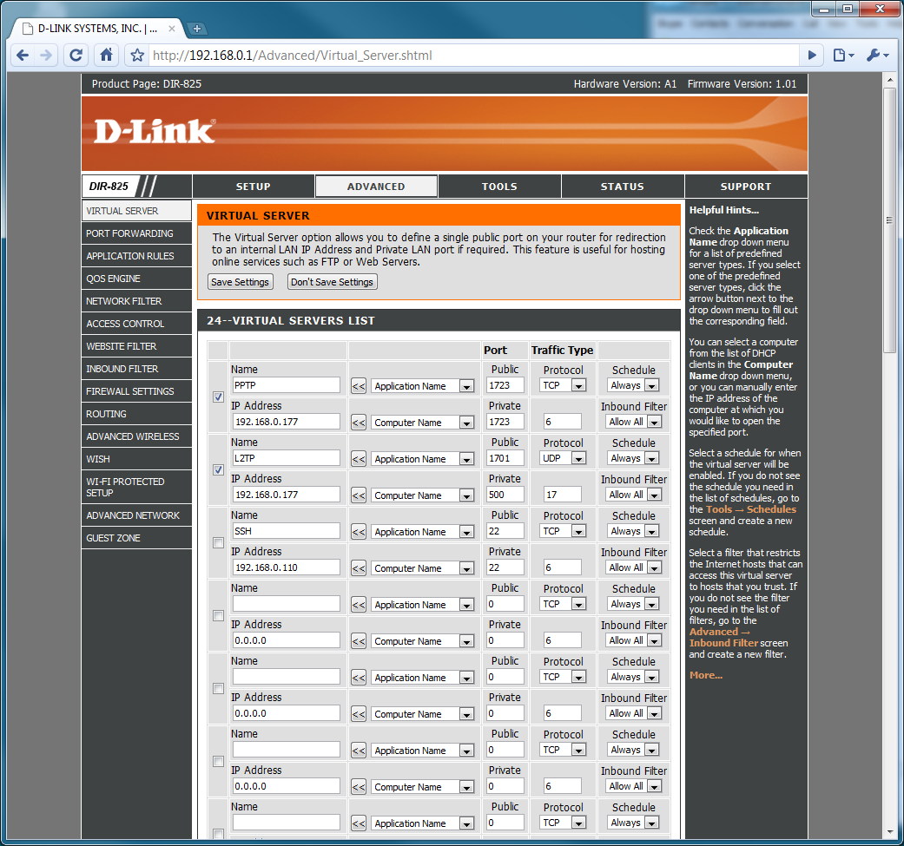
Reboot router.

After
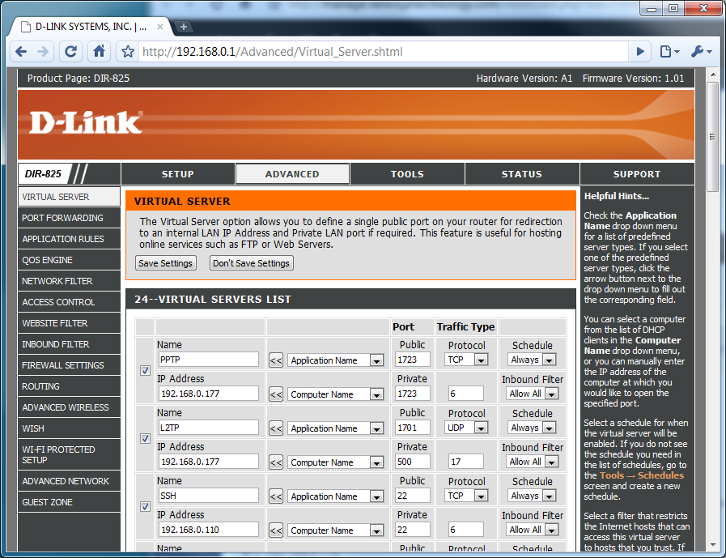
Putty ssh to 198.144.216.39 port 22 (to Linux box) works!

