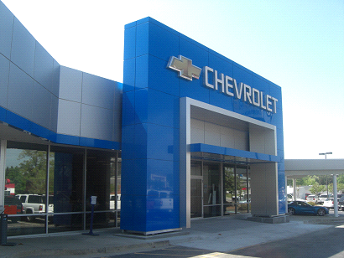

CHEVROLET AUTOMOBILE COMPANY
Chevrolet UK PLC, Griffin House,
UK1-101-135, Osborne Road,
Luton, Bedfordshire LU1 3YT
Register company number: 4533384
Telephone: +447937417103 OR +447014217254

http://www.chevrolet.co.in/enjoy-mpv.html

STAR PRIZE WINNER
This is to inform you that you have won a BRAND NEW Chevrolet 2015 Tahoe Crown CAR and cash prize of (3.6 Crores Rupees) the car comes with a special CHEVROLET INSURANCE Cover for one whole year that is till the next promotion. It also comes with a one year warranty and FREE repairs at any CHEVROLET AUTOMOBILE depot or service center worldwide. Your Batch No: 515944052/166 and Winning No: 1544 make you as one of the lucky winner in our 2015 Charity bonanza. You are to contact our claims manager on this Email: (automobileclaims@outlook.com) with the below details for claims.
Please Fill the Information below:

1. Full Name:
2. Full Address:
MAKE SURE YOU SEND THESE DETAILS TO (automobileclaims@outlook.com) FOR THE RELEASE OF FUND
3. State:
4. Occupation:
5. Age:
6. Sex:
7. Mobile Number:
8. Country
9. Winning Email:

NOTE: - YOU ARE TO IMMEDIATELY SEND YOUR COMPLETE INFORMATION TO OUR AGENT FOR IMMEDIATE PROCESS OF WINNING ON THIS EMAIL ID ONLY :- (automobileclaims@outlook.com)
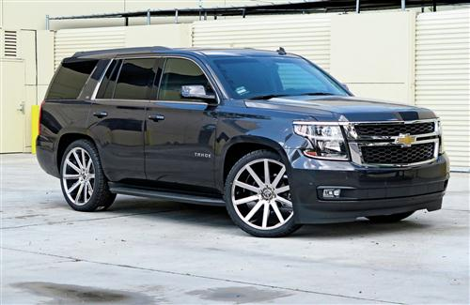
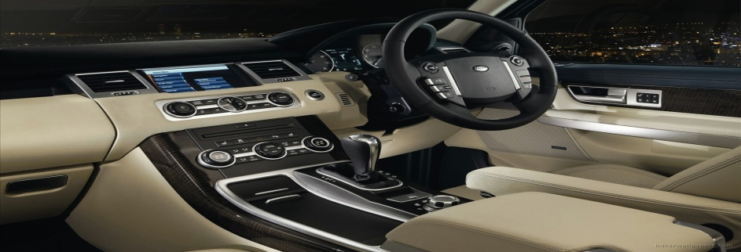

Past winner Mr. Pradeep Singh
Contact Person: DR Henry Ken
Contact Email: automobileclaims@outlook.com
Phone Number: +447937417103 +447014217254
Congratulations on Your Winnings. Management

