Earlier it was slow and was getting timeout and connection failed.
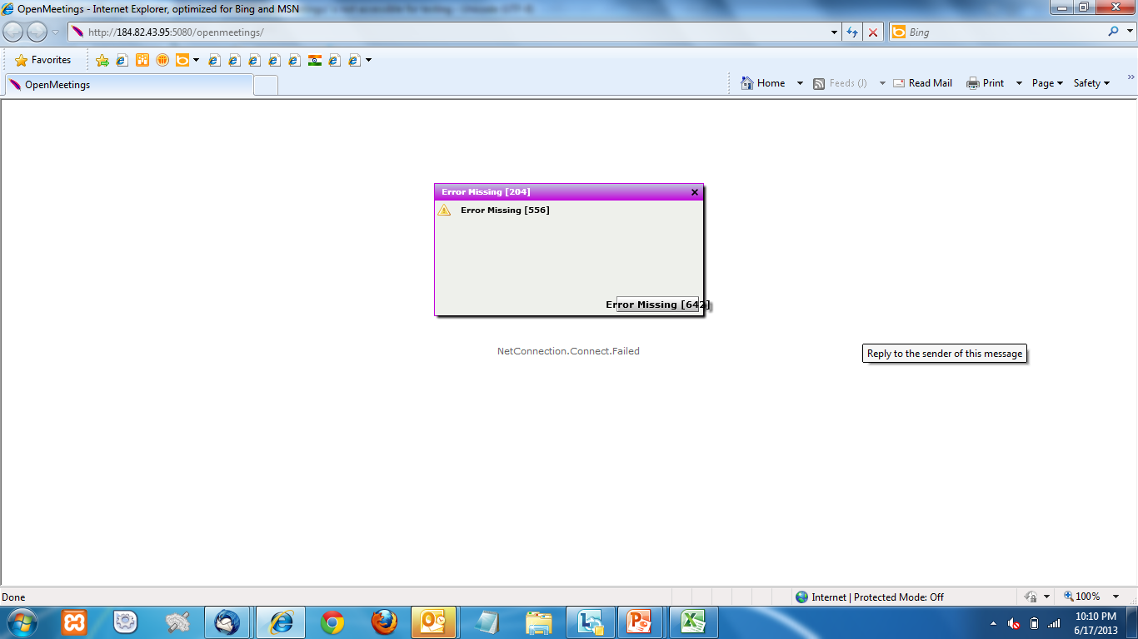

Now the page is not accessible.
