Subject: CII 12th Mutual Fund Summit 2016: Mumbai

Dear Friend,

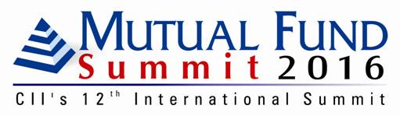

This is to inform you that CII’s 12th edition of Mutual Fund Summit is now being rescheduled to a later date in July 2016.

The Summit is supported by ‘McKinsey & Company’ as the Knowledge Partner for the Summit.

You may please release 5 July from your dairy as communicated to your earlier as the Summit date and allow us sometime to help you with the confirmed Summit dates shortly.

For further information, you can direct a query to Ms Sana Bagwan on +91 22 24931790
Ext. 408 / +91 22 6661 1691 or email her on sana.bagwan@cii.in

Kind regards,
Raghavendra
*************************************
Raghavendra Pandey

Head – Major Conferences
Confederation of Indian Industry (WR)
105 Kakad Chambers, 132 Dr A B Road
Worli, Mumbai - 400018
Phone : +91 22 24931790 ext. 409
Fax : +91 22 24939463 / 24945831
Email: : raghavendra.pandey@cii.in
Website: http://mutualfundsummit.com/
www.cii.in

**********************************

