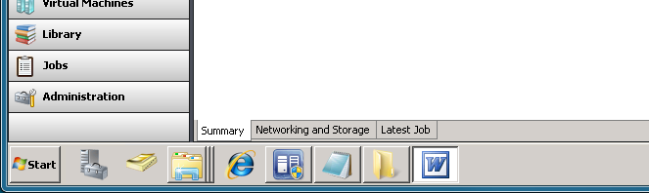
What is this blue and yellow symbal?

