Test – 01

- Q1) Write a Python function `is_prime(n)` to check if a number is prime. Use an AI coding tool to generate and justify a set of test cases before implementation. Pass all generated test cases.
Prompt: Write a Python function is_prime or not checking the input given by user
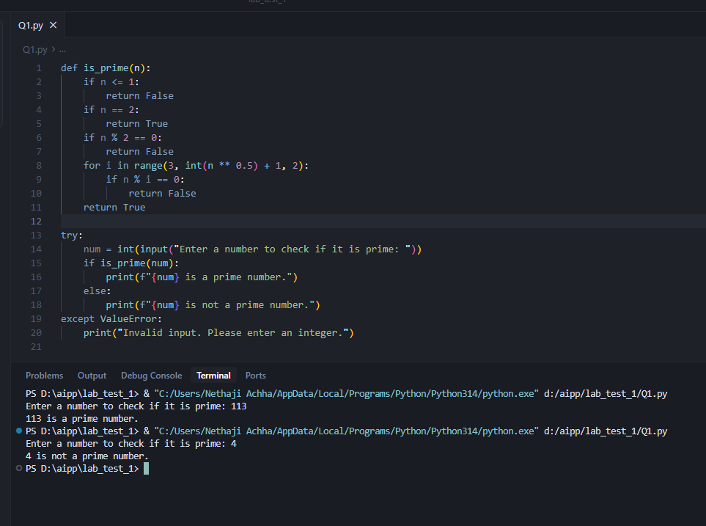
- Develop a Python class `Rectangle` with methods for area and perimeter. Use an AI assistant for auto-generating docstrings and inline comments. Compare them with your manual documentation.
Prompt: Develop a Python class Rectangle with methods for area and perimeter. Use an AI assistant for auto-generating docstrings and inline comments. Compare them with your manual documentation. My checking the inputs of length and breadth given by the user.
