Introduction to HTML
HTML → HyperText Markup Language
It is the structure of any website.
Like the skeleton of the body, HTML gives the basic layout.
🔹 Why HTML is used?
- To display text, images, links, buttons, forms
- To structure content into headings, paragraphs, sections
- To create the layout of a website
Basic HTML Code Structure
<!DOCTYPE html>
<html>
<head>
<title>My First Website</title>
</head>
<body>
<h1>Hello World!</h1>
</body>
</html>
META TAGS
Meta tags are used inside the <head> section of an HTML page.
They give information about the webpage to the browser & search engines.
They are not visible on the website.
- Meta – Author
<meta name="author" content="Nethaji">
- Meta – Description
<meta name="description" content="This is a demo website to learn HTML basics.">
- Favicon / Link Icon (image/x-icon)
<link rel="icon" type="image/x-icon" href="favicon.ico">
Text Basics:
- Headings (h1 to h6):
Headings are used to show titles and important text.
<h1>Main Heading</h1>
Note: Only one <h1> is recommended per page (SEO purpose).
- Paragraph (<p>):
Used to show normal text/paragraphs.
<p>This is a paragraph in HTML.</p>
- Horizontal Line (<hr>):
Creates a line (divider) across the page.
- Line Break (<br>):
Moves text to the next line (like pressing Enter once).
- Strong (<strong>):
Used to make text bold AND important.
HTML Entities:
Used to display special characters that HTML normally treats as code.
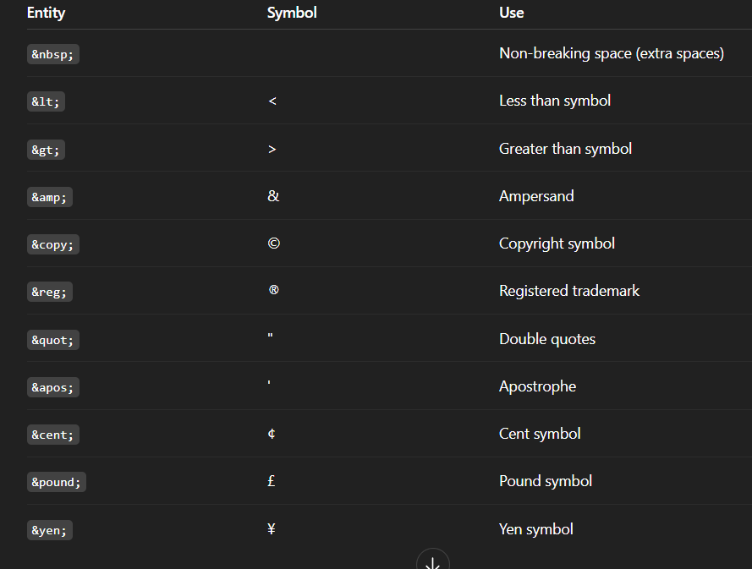

- <abbr> – Abbreviation Tag
Used to show the full form when the user hovers.
Syntax
<abbr title="HyperText Markup Language">HTML</abbr>

- <address> – Contact Information Tag
Displays address or contact details in italics by default.
Syntax
<address>
Written by Nethaji.<br>
Visit me at: <br>
Hyderabad, India<br>
</address>

LISTS IN HTML
Lists help display items in order or without order.
- Ordered List (<ol>)
Items come in numbers (1, 2, 3…).
Syntax
<ol>
<li>HTML</li>
<li>CSS</li>
<li>JavaScript</li>
</ol>

- Unordered List (<ul>)
Items come in bullet points.
Syntax
<ul>
<li>Milk</li>
<li>Bread</li>
<li>Butter</li>
</ul>
- Description List (<dl>)
Used for definitions like in dictionaries.
Syntax
<dl>
<dt>HTML</dt> <!-- Term -->
<dd>A markup language for web pages.</dd> <!-- Description -->
<dt>CSS</dt>
<dd>Used for styling web pages.</dd>
</dl>
dt = term
dd = description

LINKS IN HTML
The <a> tag is called anchor tag, used for opening links.
Basic format:
<a href="URL">Text</a>

- Absolute URL (Full Link)
Used to open external websites.
<a href="https://google.com">Go to Google</a>
📌 Starts with http / https
📌 Opens other websites

- Relative URL
Used to open pages inside the same project folder.
Example project:
index.html
about.html
Link:
<a href="about.html">About Page</a>
📌 Does NOT contain https
📌 Used inside your own website folder

- Internal Page Jump (Same Page Navigation)
Use id + #link.
Step 1: Give a section an id
<section id="contact">
<h2>Contact Us</h2>
</section>
Step 2: Link to it
<a href="#contact">Go to Contact Section</a>
📌 Browser scrolls to that section.

- <nav> – Navigation Menu
Used to create menus.
<nav>
<a href="index.html">Home</a>
<a href="about.html">About</a>
<a href="#contact">Contact</a>
</nav>
📌 SEO + structure improvement
📌 Used for top navigation bars

- Download Link
<a href="files/resume.pdf" download>Download My Resume</a>
📌 Browser downloads file instead of opening it.

- Email Link (mailto)
<a href="mailto:test@example.com">Send Email</a>
Opens user’s email app to send a mail.

- Phone Link (tel)
<a href="tel:+919876543210">Call Me</a>
📌 Used in mobile websites.

- Open Link in New Tab (target="_blank")
<a href="https://youtube.com" target="_blank">Open YouTube</a>
📌 Very commonly used
📌 Opens link in another tab

IMAGES IN HTML
Basic Image Tag
<img src="pic.jpg" alt="Description">

- Width & Height
<img src="car.jpg" width="300" height="200">
📌 Width/height can be in pixels or %
📌 If you set only width → height auto adjusts

- Title Attribute (Tooltip on hover)
<img src="dog.jpg" title="This is a dog">

- Loading Attribute (Performance)
<img src="pic.jpg" loading="lazy">
📌 lazy → loads only when image appears on screen
📌 improves website speed

- <figure> + <figcaption>
Used when image needs a description under it.
<figure>
<img src="sunset.jpg" width="300">
<figcaption>Beautiful Sunset View</figcaption>
</figure>
📌 Best for:
- Blogs
- Photo galleries
- Articles
- Educational content

📌 Full Images Example
<figure>
<img src="mountain.jpg" width="400" loading="lazy" title="Mountain">
<figcaption>Snow Mountain in Winter</figcaption>
</figure>
SEMANTIC TAGS
Semantic = gives meaning to the browser & search engines.
Helps with SEO, screen readers, page structure.

1. <header>
Used at the top of the page or section.
<header>
<h1>My Website</h1>
</header>

2. <main>
Contains the main content of the webpage.
<main>
<p>Important content goes here.</p>
</main>

3. <footer>
Used at the bottom of a page.
<footer>
© 2025 My Website
</footer>

4. <nav> with aria-labelledby
Used for navigation menus.
<h2 id="menu-title">Main Menu</h2>

<nav aria-labelledby="menu-title">
<a href="#">Home</a>
<a href="#">About</a>
</nav>
📌 aria-labelledby helps blind users understand the purpose of the nav.

5. <article>
Used for standalone content like:
- Blog posts
- News articles
- Forum posts
<article>
<h2>Blog Title</h2>
<p>This is a blog article.</p>
</article>

6. <aside>
Side content (sidebar, ads, extra info).
<aside>
<p>Related Articles</p>
</aside>

7. <details> + <summary>
Expandable/collapsible content.
<details>
<summary>Click to read more</summary>
<p>This is hidden content.</p>
</details>
📌 Good for FAQs.

8. <time> with datetime
Used to show dates or times.
<time datetime="2025-12-09">Dec 09, 2025</time>
📌 Helps browsers understand exact date format.

NON-SEMANTIC TAGS
They do NOT have meaning
Used only for layout & styling.

1. <div>
Block container.
<div>
<p>This is a division block.</p>
</div>

2. <span>
Inline container.
<p>This is <span style="color:red;">red text</span>.</p>
📌 Used to style part of a sentence.

TABLES IN HTML

1. <table>
Starts a table.
2. <tr> — Table Row
Holds table cells.
3. <th> — Table Header Cell
Bold + centered by default.
4. <td> — Table Data Cell
Normal data.

Example:
<table border="1">
<tr>
<th>Name</th>
<th>Age</th>
</tr>
<tr>
<td>Ram</td>
<td>22</td>
</tr>
</table>

Rowspan & Colspan
Merge columns
<td colspan="2">Two Columns Merged</td>
Merge rows
<td rowspan="3">Three Rows Merged</td>

<caption>
Title of the table (appears above table).
<table>
<caption>Student Details</caption>
</table>

<thead>, <tbody>, <tfoot>
Better structure + SEO + styling.
<table border="1">
<caption>Marks Table</caption>

<thead>
<tr>
<th>Subject</th>
<th>Marks</th>
</tr>
</thead>

<tbody>
<tr>
<td>Math</td>
<td>90</td>
</tr>
<tr>
<td>Science</td>
<td>85</td>
</tr>
</tbody>

<tfoot>
<tr>
<td>Total</td>
<td>175</td>
</tr>
</tfoot>
</table>

scope Attribute
Helps screen readers understand table headers.
For column headers:
<th scope="col">Name</th>
<th scope="col">Age</th>
For row headers:
<th scope="row">Marks</th>

FORMS IN HTML
Forms are used to collect user input such as name, email, password, etc.
Basic structure:
<form action="submit.php" method="POST">
<!-- form elements -->
</form>

✅ 1. <form> Tag
✔ action
Where the form data is sent.
<form action="submit.php">
✔ method
How data is sent:
- GET → visible in URL
- POST → hidden, more secure
<form method="POST">
Full example:
<form action="submit.php" method="POST">
</form>

✅ 2. <label>
Text describing an input field.
<label for="name">Enter Name:</label>
<input id="name">
📌 for must match input’s id.

✅ 3. <input> Tag (Most Used Tag)
Important Attributes
Attribute | Meaning
type | kind of input
name | name used in backend
id | used for label + JS
placeholder | hint text
autocomplete | on/off
required | must fill
autofocus | cursor starts here
pattern | regex validation
min / max | limit numbers
step | number steps
value | default value

🎯 Common Input Types
✔ Text Input
<input type="text" name="username" placeholder="Enter name">
✔ Password
<input type="password" name="pass">
✔ Tel (Phone)
<input type="tel" name="phone">
✔ Number
<input type="number" min="1" max="10" step="1">
✔ Radio Button (Choose ONE)
<input type="radio" name="gender" value="male"> Male
<input type="radio" name="gender" value="female"> Female
📌 Same name = only one can be selected.
✔ Checkbox (Choose MANY)
<input type="checkbox" name="skill" value="python"> Python
<input type="checkbox" name="skill" value="java"> Java
✔ Submit Button
<input type="submit" value="Submit Form">

🎯 Input Attributes Example
<input type="text"
name="fullname"
id="fullname"
placeholder="Enter full name"
required
autofocus
autocomplete="off">

📘 4. <select> + <option> (Dropdown List)
<select name="city">
<option value="hyd">Hyderabad</option>
<option value="blr" selected>Bangalore</option>
<option value="chennai">Chennai</option>
</select>
📌 selected → default selected option.

✔ <optgroup> (Group Options)
<select>
<optgroup label="South India">
<option>Hyderabad</option>
<option>Chennai</option>
</optgroup>

<optgroup label="North India">
<option>Delhi</option>
<option>Mumbai</option>
</optgroup>
</select>
📌 label gives group title.

📘 5. <datalist> (Auto-Suggestions)
<input list="browsers">
<datalist id="browsers">
<option value="Chrome">
<option value="Firefox">
<option value="Edge">
</datalist>
📌 User sees suggestions but can type freely.

📘 6. <fieldset> + <legend>
Used to group form elements.
<fieldset>
<legend>Personal Info</legend>

<label>Name</label>
<input type="text">
</fieldset>

📘 7. <textarea>
Used for multi-line input (comments, messages).
<textarea cols="30" rows="5" placeholder="Enter message"></textarea>
📌 Attributes:
- cols → width
- rows → height
(Note: You wrote "area" but the attribute is rows.)

📘 8. <button> Tag
✔ Submit Button
<button type="submit">Submit</button>
✔ Reset Button
<button type="reset">Clear Form</button>
✔ Normal Button
<button type="button">Click Me</button>

