IOT BASED NOISE MONITORING SYSTEM

A Project report submitted in partial fulfilment of the requirements for the degree of B.E in Computer Science Engineering

By

J.NETHAJI (513221104017)

Under the supervision of Professor & HOD Department of Computer Science And Engineering

NOISE POLLUTION MONITORING

PHASE 1: PROBLEM DEFENITION AND DESIGN THINKING

* PROBLEM STATEMENT
* DESIGN THINKING APPROACH

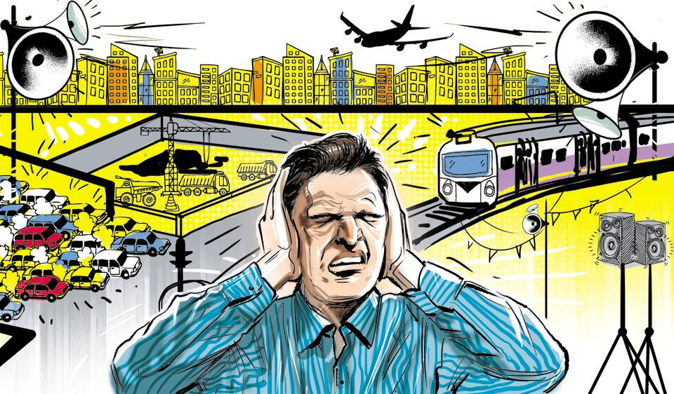 PROBLEM STATEMENT:

Noise pollution impacts millions of people on a daily basis. The most common health problem it causes is Noise Induced Hearing Loss (NIHL). Exposure to loud noise can also cause high blood pressure, heart disease, sleep disturbances, and stress.

Noise pollution is caused by extremely loud sounds and is very discomforting and painful for the ears. It may also cause health problems like hypertension, lack of sleep, anxiety And many more

Inform the public, especially persons affected by environmental noise, as well as policy and decision makers, of the dangers of noise pollution.

Support enforcement of noise pollution legislation and monitor the effectiveness of control measures.

DESIGN THINKING APPROACH:

Design thinking was used to discuss the topic of Noise pollution. An image and audio was sent as a pre-cap and children were asked to see it before the session. The children were guided through various stages of design thinking i.e., empathize, define, ideate, prototype and test. The children were encouraged to talk and share their feelings in the empathize stage. In the define stage, the children were made to understand what the problem is, by questioning them and building on their responses.  In the ideate stage the children came up with various solutions to curb noise pollution. The fourth stage was the most exciting as children had to create their prototype to reduce noise pollution. Students experienced harsh and soothing sounds and learnt to differentiate between them.To reinforce the same,shakers with rice and pebbles were made. The children came up with creative solutions like use of ear plugs, lowering the volume, planting more trees,no honking and no loudspeakers. They depicted the soothing sound and harsh sounds using clay and through drawing. The session livened up with children’s creativity , enthusiasm and eagerness to share their ideas.

The session ended with a video showcasing various means to reduce noise pollution.