

Cardiff Metropolitan University
Cardiff School of Technology
BSc Software Engineering

SmartShiksha
A Centralized Educational App and Website for Government Schools in Sri Lanka
Submitted in
September
2025
By
G.L.D. Himaya Senarathne

Cardiff ID – ST20284358
ICBT ID - KG/BSCSD/14/32

This dissertation is submitted in partial fulfillment of the requirements for the degree of
Bachelor of Science in Software Engineering (BSc SE)

DECLARATION

This work is being submitted in partial fulfillment of the requirements for the degree of Bachelor of Science in Software Engineering (BSc SE) and has not previously been accepted in substance for any degree and is not being concurrently submitted in candidature for any degree.

Signed – Himaya (himayadasuni@gmail.com)
Date - 06.09.2025

SUPERVISOR’S DECLARATION STATEMENT

Student Name – G.L.D. Himaya Senarathne
Supervisor’s Name – Mrs. Chathuri Wathsala Kulathunga

I acknowledge that the above-named student has regularly attended the meeting, and actively engaged in the dissertation supervision process.

Signed - ……………………………………………. (Supervisor) Date - …………………......

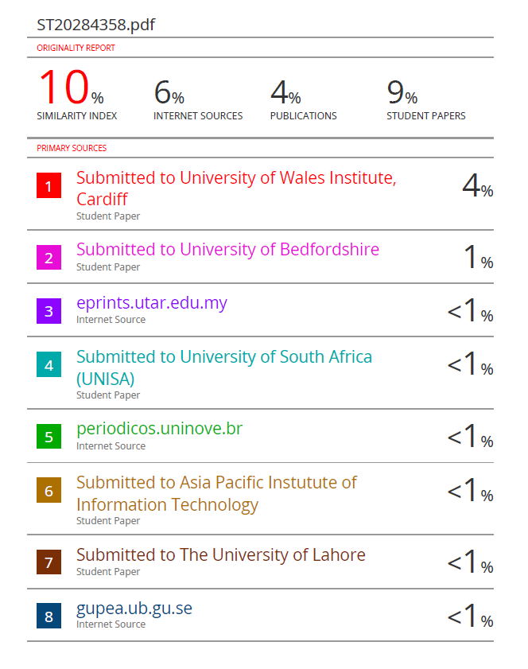

Acknowledgment
First and foremost, I, the student of Higher Diploma in Computing & Software Engineering (Batch 14), would like to thank Mrs. Chathuri Kulathunga and Dr. Thilani Gunawardane for teaching us so much about Development Project and for their encouragement, support, and patience.
Additionally, I would like to thank our colleagues and senior students for their generous assistance in making the project a success.
I also want to thank the ICBT management for providing me with this chance to demonstrate my abilities during my project and for supporting me throughout our academic careers.
Finally, I want to express our gratitude to the parents for offering me moral support and a welcoming environment during my journey.

Executive Summary
The education sector in Sri Lanka faces persistent challenges in communication and stakeholder engagement, particularly within government schools serving Grades 6–11. Parents often lack timely access to academic updates, teachers face administrative burdens in sharing information, and students experience reduced support due to fragmented systems. To address these issues, this project introduces SmartShiksha, a centralized educational mobile and web application designed to strengthen collaboration between parents, teachers, and students.
The system provides key functionalities such as attendance tracking, homework management, academic performance monitoring, and digital notices within a single platform. It leverages predictive analytics, using Logistic Regression to forecast student performance, thereby supporting early intervention strategies for at-risk learners. The Agile methodology was adopted in the development process, enabling iterative improvements and user-driven customization.
Future enhancements include cross-platform support using frameworks like Flutter or React Native, Sinhala–English bilingual functionality, offline-first access for rural communities, and integration with Ministry of Education systems. These additions will broaden inclusivity, strengthen scalability, and align the platform with national-level educational policies.
SmartShiksha demonstrates the potential of combining digital technologies and analytics to transform school communication systems. By bridging gaps between stakeholders, the platform enhances accountability, improves decision-making, and supports equitable access to quality education across Sri Lanka.

Abstract
This thesis presents SmartShiksha, a centralized educational mobile and web application designed to enhance communication and collaboration among parents, teachers, and students in Sri Lankan government schools (Grades 6–11). The project addresses key challenges in the education sector, including limited parental engagement, fragmented communication channels, and barriers caused by digital literacy gaps. The system integrates essential features such as homework updates, attendance tracking, notices, and performance monitoring within a single platform, thereby streamlining information flow between stakeholders.
The development process follows the Agile methodology, ensuring iterative improvements based on user feedback. The application is built using Android (Java) for initial deployment, with future scalability planned through cross-platform support. Predictive analytics models, including Logistic Regression, are incorporated to analyze student performance outcomes, offering early identification of at-risk learners. Furthermore, proposed enhancements such as bilingual support, offline functionality, and integration with Ministry of Education databases aim to increase inclusivity and alignment with national education policies.
By combining communication, analytics, and accessibility features, SmartShiksha contributes to bridging the digital divide in Sri Lankan schools and supports informed decision-making for both parents and educators. The findings highlight the potential of digital and analytical tools to strengthen accountability, improve student outcomes, and advance equitable access to education across the island.

Abbreviation
Abbreviation | Full Form
ICT | Information and Communication Technology
ANN | Artificial Neural Network
DNN | Deep Neural Network
O/L | Ordinary Level (Sri Lankan National Examination)
API | Application Programming Interface
ERD | Entity Relationship Diagram
UI | User Interface
SE | Software Engineering
AI | Artificial Intelligence
ML | Machine Learning
TDD | Test-Driven Development
GDPR | General Data Protection Regulation
DBMS | Database Management System
SQL | Structured Query Language
HTML | HyperText Markup Language
CSS | Cascading Style Sheets
PHP | Hypertext Preprocessor
VS Code | Visual Studio Code
LSTM | Long Short-Term Memory (Neural Network)
FAQ | Frequently Asked Questions

Contents
1. Introduction 11
1.1. Background Study 12
1.2. Problem Statement 13
1.3. Objectives 14
1.4. Solutions 15
2. Literature Review 16
3. Planning 19
3.1. Feasibility Report 19
3.1.1. Technical Feasibility 19
3.1.2. Economic Feasibility 20
3.1.3. Operational Feasibility 20
3.1.4. Legal Feasibility 21
3.1.5. Ethical Considerations 21
3.1.6. Market Viability 21
3.2. Risk Assessment 22
3.3. SWOT Analysis 24
3.4. PESTEL Analysis 25
3.4.1. Political 25
3.4.2. Economic 25
3.4.3. Social 25
3.4.4. Technological 25
3.4.5. Environmental 25
3.4.6. Legal 26
3.5. Life Cycle Model 26
3.5.1. Requirement Gathering and Analysis 26
3.5.2. Design and Prototyping 26
3.5.3. Development 27
3.5.4. Testing 27
3.5.5. Deployment 27
3.5.6. Maintenance and Feedback 27
3.5.7. Reason for Selecting Agile Model 28
3.6. Time plan 28
4. Requirement Gathering and Analysis 29
4.1. Requirement Gathering Technique Used 29
4.1.1. Questionnaire 29
4.1.2. Interview 30
4.1.3. Summary of Questionnaire and Interview Findings 30
4.2. Functional and Non-Functional Requirements 31
4.2.1. Functional Requirements 31
4.2.2. Non-Functional Requirements 32
5. System Design 33
5.1. ER Diagram 33
5.2. Use Case Diagram 34
5.3. Sequence diagram 37
5.4. Class Diagram 40
5.5. Site Maps 41
5.6. Wireframe Diagram 42
5.6.1. Application 42
5.6.2. Website 47
6. Implementation 49
6.1. Technology Stack 49
6.2. Nature of the Dataset 51
6.3. Model Comparison 51
6.4. The Result 53
6.5. Design Patterns 54
6.5.1. Website Interfaces 54
6.5.2. Application Interfaces 58
7. Testing and Validation 66
7.1. Test Plan 66
Test Plan ID and Title 66
Introduction and Objective 66
Scope of Testing 67
Test Objectives and Approach 67
Test Schedule and Milestones 68
Test Environment Setup 68
Resources and Responsibilities 68
Test Deliverables 69
Entry and Exit Criteria 69
Risks and Mitigation Strategies 69
7.2. Test Cases 70
7.5.1. Login 70
7.5.2. Student Management 71
7.5.3. Teacher Management 72
7.5.4. Feedback 73
7.5.5. Notice Board & Events 74
7.5.6. Payments & Fees 75
8. Conclusion 76
9. Future Enhancements 77
10. Lessons Learned 78
11. Gantt Chart 80
12. References 80
13. User Manual 83
14. Appendix 90
14.1. Google Form 90
11.2. Codes 94
11.3. Database 124
11.4. Supervisory Log sheet 125

Table of Figures
Figure 1 Timeline 29
Figure 2 ER Diagram 33
Figure 3 Use Case 35
Figure 4 Teacher Sequence 38
Figure 5 Student Sequence 38
Figure 6 Parent Sequence 39
Figure 7 Principal Sequence 39
Figure 8 Admin Sequence 40
Figure 9 Class Diagram 41
Figure 10 App Sitemap 42
Figure 11 Website Sitemap 42
Figure 12 Application Wireframe 47
Figure 13 Website Wireframes 50
Figure 14 ANN Classification Report 52
Figure 15 DNN Classification Report 52
Figure 16 Logistic Regression Classification Report 53
Figure 17 Model train 54
Figure 18 Home Page 55
Figure 19 About Us 55
Figure 20 Features 56
Figure 21 Interfaces 56
Figure 22 FAQ 57
Figure 23 Benefits 57
Figure 24 Marks Calculator 58
Figure 25 Predictor 58
Figure 26 Login Figure 27 Teacher Dashboard 59
Figure 28 Profile Figure 29 Manage Students 59
Figure 30 Manage Attendance Figure 31 Manage Homework 60
Figure 32 Manage Events Figure 33 Send Feedback 60
Figure 34 Generate Report Figure 35 Enter marks 61
Figure 36 Parent Dashboard Figure 37 Assign Child 61
Figure 38 Attendance Figure 39 Marks 62
Figure 40Payment Gateway Figure 41 Feedbacks 62
Figure 42 Student Report Figure 43 Homework 63
Figure 44 Teacher Details Figure 45 Payment History 63
Figure 46 Student Dashboard Figure 47 Chatbot 64
Figure 48 Principal Dashboard Figure 49 Manage Student 64
Figure 50 Manage Teacher Figure 51 Manage Classes 65
Figure 52 View Fees Figure 53 School Details 65
Figure 54 Admin Dashboard Figure 55 Search Payments 66
Figure 56 Manage Payments Figure 57 Receipt 66
Figure 58 Forget Password 67
Figure 59 Java Files 95
Figure 60 XML 101

List of Tables
Table 1 Risk Assessment 24
Table 2 SWOT 24
Table 3 Time plan 29
Table 4 Testing 68
Table 5 Test Case 1 70
Table 6 Test Cases 2 71
Table 7 Test Case 3 72
Table 8 Test Case 4 73
Table 9 Test Case 5 74
Table 10 Test Case 6 75

Introduction
Education is a fundamental driver of social and economic development, providing individuals with the knowledge, skills, and values necessary to participate effectively in society. Globally, governments recognize education as a cornerstone for national progress, with effective schooling systems playing a central role in shaping human capital and reducing inequalities (World Bank, 2018). In developing nations, particularly in South Asia, education is not only a means of personal advancement but also a critical tool for social cohesion and economic competitiveness (UNESCO, 2020).
The Sri Lankan education system has long been regarded as one of the most successful in the region, offering free primary, secondary, and tertiary education to its citizens since 1945. Despite significant progress, the system faces contemporary challenges, including resource disparities between urban and rural schools, unequal access to technology, and limited channels of effective communication among stakeholders in the learning process. These issues hinder the ability of students, teachers, and parents to maximize educational opportunities and outcomes.
In the 21st century, digital transformation has reshaped the way education is delivered and managed worldwide. ICT has been increasingly integrated into school systems to enhance teaching, streamline administrative processes, and improve engagement between stakeholders (Selwyn,2016). ICT adoption in education is not merely a technological shift but also a pedagogical change, enabling collaborative learning, real-time feedback, and improved access to resources. However, in many developing countries, challenges such as infrastructure gaps, lack of digital literacy, and resistance to change continue to limit its full potential.
Sri Lanka, while making strides in ICT integration through initiatives such as the “Smart Classroom” program and school census digitalization, still faces barriers in ensuring consistent implementation across government schools. Effective communication among parents, teachers, and students remains a key component of educational success, as research highlights that strong stakeholder collaboration positively influences student learning, attendance, and motivation. Thus, addressing communication gaps within the education sector is vital to advancing national goals of equity, quality, and inclusivity.

1.1. Background Study

Education has undergone a paradigm shift in recent decades, moving from traditional teacher-centered models to more dynamic, interactive, and technology-enabled approaches. Globally, education is recognized not only as a means of individual empowerment but also as a catalyst for sustainable socio-economic growth (UNESCO,2020). The expansion of technology in education has transformed both the content and delivery of teaching and learning, making it more accessible, flexible, and collaborative.
The role of ICT in education has been widely acknowledged in policy and research. ICT is not merely a tool for digitalizing existing processes but a driver for innovation in pedagogy, administration, and communication (Selwyn,2016). Studies have shown that ICT integration improves teaching efficiency, enhances student engagement, and facilitates stronger school-home collaboration. However, disparities in infrastructure, affordability, and training have resulted in a persistent “digital divide,” particularly in developing regions (OECD, 2019).
In South Asia, education systems face unique challenges such as high student–teacher ratios, unequal resource allocation, and varying levels of parental involvement. Research indicates that strong communication between schools and families is positively associated with improved student learning outcomes, reduced absenteeism, and greater accountability. Effective two-way communication fosters mutual understanding and collaboration, ensuring that parents and educators work together to support student development (Goodall et al., 2014).
Sri Lanka has made substantial progress in education, achieving high literacy rates compared to its regional counterparts (Little, 2010). Free access to primary, secondary, and higher education since 1945 has contributed to these achievements. Nevertheless, the system continues to grapple with inequalities between urban and rural schools, teacher shortages in specialized subjects, and limitations in adopting modern pedagogical practices (Aturupane,2013). Although the government has invested in digital education initiatives such as e-thaksalawa and Smart Classroom programs, many schools struggle with inadequate ICT infrastructure, low bandwidth connectivity, and limited teacher training (MOHE, 2022).
Another critical dimension in the Sri Lankan context is the role of parents in supporting students’ education. Studies suggest that parental engagement is a predictor of academic performance, particularly when parents are consistently informed and involved in school-related activities. However, in many government schools, traditional methods of communication, such as letters or notices, remain dominant, leading to delays and inefficiencies. Furthermore, in rural areas, geographic and socio-economic barriers hinder effective interaction between parents, teachers, and students.
Thus, the global and national educational landscape reflects the increasing importance of ICT and communication strategies to bridge gaps among stakeholders in the schooling process. By addressing these systemic and contextual challenges, countries like Sri Lanka can move closer to achieving equitable, inclusive, and high-quality education for all.

1.2. Problem Statement
Despite advancements in education and technology, Sri Lankan schools still face persistent communication challenges among parents, teachers, and students. Research highlights that clear and timely communication is essential for improving student performance, accountability, and collaboration. However, lack of a centralized platform has led to fragmented communication through letters, calls, or social media, causing inefficiencies. Moreover, paper-based and informal methods often result in delayed, lost, or inaccessible information, limiting the benefits of ICT. Teachers also struggle with inconsistent student progress updates due to large class sizes and administrative burdens, leaving parents informed only during exams or occasional meetings. Busy schedules further cause parents to miss meetings, reducing involvement despite its proven link to better academic outcomes. Finally, students face a lack of structured systems to track performance, relying instead on verbal updates or notice boards, which hinder accountability and timely improvement. Collectively, these issues highlight the urgent need for effective communication strategies to strengthen parent-teacher-student collaboration in Sri Lankan schools (Harris, 2015).

1.3. Objectives

- To Build a Centralized Application
Currently, there is no centralized platform that connects parents, teachers, and students in Sri Lankan schools. Communication is fragmented across paper notices, phone calls, and informal digital tools such as WhatsApp, which are neither standardized nor monitored. Research indicates that a lack of structured communication platforms reduces accountability and weakens stakeholder collaboration (Epstein, 2011). Developing a centralized digital solution is therefore essential to streamline communication, improve efficiency, and ensure inclusivity.
- To Achieve High User Satisfaction
Adoption of educational technology is often hindered if platforms are not designed with user-friendliness and accessibility in mind. Teachers, parents, and students may resist using new systems if they are too complex, resource-intensive, or fail to meet their needs. Ensuring high user satisfaction is therefore critical for long-term sustainability and acceptance. Studies confirm that usability and user experience significantly influence the success of ICT integration in education.
- To Support Education Goals and Enhance Transparency
Strong communication and accountability mechanisms are directly linked to improved learning outcomes and institutional trust. In Sri Lanka, gaps in parental engagement and inconsistent reporting of student performance undermine these goals. Supporting national education objectives and enhancing transparency requires platforms that allow stakeholders to access timely, accurate, and relevant information, fostering trust and collaboration within the school community (Jeynes,2012).
- To Complete Development and Testing in 10 Weeks
One of the challenges in implementing ICT solutions in education is the delay in development and deployment due to limited resources and bureaucratic processes. A focused and structured timeframe is necessary to ensure that interventions are not only designed but also tested and validated in real-world school environments. Completing development and testing within 10 weeks reflects both the urgency of addressing communication gaps and the feasibility of rapid digital solutions in education systems.

1.4. Solutions

- Unified Communication
A key solution is establishing real-time interaction between parents, teachers, and students to reduce delays and miscommunication. Research shows that effective two-way communication is strongly associated with improved student learning outcomes, increased parental involvement, and greater accountability. Digital communication platforms enable instant sharing of information, reducing reliance on outdated paper-based methods (Selwyn,2016). Unified communication systems also ensure that information is accessible to all stakeholders simultaneously, minimizing the risk of miscommunication and delays.
- Academic Monitoring
Another solution is implementing structured academic monitoring tools that track performance, attendance, and term progress through visual reports. Visual data representation supports early detection of academic issues and helps parents and teachers make informed decisions. Studies highlight that data-driven monitoring improves teaching practices and student outcomes by providing transparency and clarity in performance trends. By digitizing attendance and grades, schools can provide timely and accurate academic updates, fostering accountability among students.
- Behavior Feedback
Introducing structured behavior feedback mechanisms between home and school can strengthen the partnership in supporting student development. Evidence suggests that behavioral monitoring and parent–teacher collaboration reduce disciplinary problems and encourage positive behavior in students. Providing systematic feedback also ensures that parents are consistently informed, enabling them to reinforce positive behavior or address issues promptly (Jeynes,2012). This structured approach moves away from irregular reporting and promotes ongoing communication regarding student well-being.
- Online Services
The introduction of online services such as payments and school updates can streamline administrative processes and enhance stakeholder convenience. Research shows that digitized services reduce administrative burdens, increase efficiency, and provide parents and students with timely access to critical school information (OECD, 2019). Online services also align with broader trends in e-governance and digital education, ensuring that schools keep pace with global educational transformation. By centralizing these services, schools can promote transparency, reduce delays, and foster trust among stakeholders.

Literature Review
The integration of ICT in education has emerged as a transformative force in the past two decades, reshaping teaching, learning, and administrative processes. ICT is increasingly recognized as a critical driver for improving access to education, enhancing learning outcomes, and fostering effective communication among stakeholders. Selwyn (2016) emphasizes that ICT adoption in education represents not just a technological shift but also a cultural and pedagogical transformation, fundamentally altering how teachers, parents, and students interact. The growing emphasis on ICT in schools aligns with international frameworks, including UNESCO’s Education 2030 Agenda, which highlights technology as a key enabler for inclusive, equitable, and quality education (UNESCO, 2020).
In developing countries such as Sri Lanka, integrating ICT into education presents both opportunities and challenges. While urban schools have seen improvements in digital infrastructure and technology-based learning, rural schools continue to face significant resource gaps, limiting equitable access to digital tools. Aturupane (2013) notes that despite high literacy rates, Sri Lankan schools struggle with uneven distribution of resources, including trained personnel, internet connectivity, and digital learning materials. These disparities impact the ability of teachers and parents to communicate effectively, monitor student progress, and implement timely interventions. Consequently, ICT-enabled communication platforms could play a vital role in addressing these inequities by providing structured, centralized channels for all stakeholders.
Parental involvement is widely acknowledged as a critical determinant of student success. Epstein (2011) proposed a comprehensive framework emphasizing school-family partnerships as essential for fostering academic achievement, reducing absenteeism, and supporting social development. Consistent with this, Goodall and Montgomery (2014) highlight that effective digital communication can move parental engagement beyond occasional meetings and fragmented updates, enabling continuous collaboration. Research by Jeynes (2012) demonstrates through meta-analytic evidence that parental involvement, especially when systematic and structured, positively affects student academic performance, particularly in high-stakes examinations. However, many Sri Lankan schools continue to rely on paper-based notices, informal phone calls, and unregulated social media groups, which impede transparency, increase the likelihood of miscommunication, and limit parental engagement.
ICT integration extends beyond communication to monitoring academic and behavioral outcomes. Anderson (2010) emphasizes that the use of visual reporting tools such as dashboards and performance charts allows teachers, students, and parents to gain a holistic understanding of academic progress. Such tools can help identify at-risk students early, facilitate timely intervention, and support evidence-based decision-making. , reduces administrative workload, and provides stakeholders with real-time insights into student performance. In this way, ICT not only supports academic monitoring but also strengthens transparency and trust between schools and families.
Machine learning and predictive analytics have become increasingly important in the education sector, enabling proactive identification of students who may be at risk of underperforming. Romero and Ventura (2020) discuss the role of educational data mining, illustrating that predictive models can analyze historical student data such as grades, attendance, and participation to forecast future outcomes, including the likelihood of passing standardized examinations. This aligns with global trends in learning analytics, where predictive models inform personalized interventions, optimize resource allocation, and reduce dropout rates. Al-Barrak and Al-Razgan (2016) demonstrate that machine learning algorithms, including decision trees, support vector machines, and ensemble methods, achieve high accuracy in predicting student performance. These approaches are particularly relevant in the Sri Lankan context, where national examinations, such as the O/L exams, serve as critical academic milestones influencing future educational pathways. By leveraging historical student data, predictive systems can provide actionable insights, allowing teachers and parents to implement targeted support for students at risk of failing.
Integrating ICT and predictive analytics offers several synergistic benefits. Centralized communication platforms equipped with machine learning functionalities enable real-time data sharing, academic tracking, behavioral monitoring, and predictive insights. Such integration addresses multiple challenges simultaneously: it reduces communication delays, increases parental involvement, supports student accountability, and facilitates proactive academic interventions. (Wijesinghe, 2017).
Despite the demonstrated potential of ICT and predictive analytics, several challenges remain. The Ministry of Education Sri Lanka (2022) identifies uneven ICT infrastructure, limited teacher training, and resistance to adopting new technologies as major barriers. Rural schools, in particular, face connectivity issues, lack of devices, and limited technical support, which restrict the scalability of digital solutions. Selwyn (2016) warns that without adequate support, technology can inadvertently exacerbate educational inequalities. Similarly, Kotsiantis et al. (2010) note that while predictive models are promising, their accuracy depends on the availability and quality of historical data, highlighting the need for robust data collection and management systems in schools.
Existing literature, therefore, underscores a clear research gap. While studies have examined ICT integration, parental engagement, and predictive analytics separately, few have explored their combined potential in a Sri Lankan school context. There is limited evidence on how a centralized communication system, enriched with machine learning capabilities, can simultaneously enhance communication, academic monitoring, behavioral feedback, and predictive insights. This gap highlights the need for a holistic approach that aligns with the educational goals of Sri Lanka, ensuring transparency, inclusivity, and evidence-based decision-making.
In conclusion, the literature indicates that integrating ICT with structured communication and machine learning has the potential to transform educational experiences in Sri Lankan schools. By enabling academic monitoring, behavioral feedback and predictive analytics, schools can enhance parental engagement, support student learning, and improve academic outcomes. This literature review provides a strong foundation for exploring centralized digital solutions tailored to the Sri Lankan context, addressing both systemic challenges and emerging opportunities in educational technology.

Research Gap
Although global studies highlight the role of educational technologies, parental engagement, and predictive analytics in improving learning outcomes, research in the Sri Lankan school context remains limited. Existing systems are often fragmented, focusing either on communication or academic monitoring, but not both. Moreover, while machine learning has been applied to predict student performance in higher education, there is little evidence of its use in secondary education in developing countries such as Sri Lanka, particularly for predicting O/L examination outcomes. Finally, language and digital literacy challenges are often overlooked. These gaps highlight the need for a centralized, context-specific, and predictive school communication system tailored to the Sri Lankan educational environment (Romero et al., 2020).

Planning

3.1. Feasibility Report

Technical Feasibility
The project is technically feasible as it uses widely adopted and well-documented technologies that ensure scalability, reliability, and ease of maintenance. The mobile application will be developed using Java, a language recognized for its portability, strong developer community, and suitability for Android-based solutions, while the database will be managed through MariaDB, which provides high performance, data integrity, and compatibility with MySQL. The web platform will be built using HTML and CSS to deliver responsive and user-friendly interfaces, supported by PHP and MySQL for dynamic content management and robust server-side processing. With the rapid increase in smartphone penetration and internet usage in Sri Lanka, particularly among students, teachers, and parents, the system will be accessible to its intended users. Moreover, the chosen technologies have strong vendor support and large developer communities, which ensures long-term maintainability, adaptability, and sustainability of the system as it evolves (Livingstone et al., 2016).

Economic Feasibility
The system is designed to be cost-effective and sustainable by leveraging Android Studio for mobile app development and Visual Studio Code for web development, both of which are free, open-source, and widely supported platforms. By prioritizing these tools along with open-source frameworks and technologies, licensing costs are minimized while ensuring access to large developer communities for long-term support. Hosting and database management requirements can be efficiently handled using MariaDB/MySQL on affordable shared hosting providers or through scalable cloud-based services, reducing upfront infrastructure investment while allowing flexibility for future expansion. This approach ensures the system can scale seamlessly as the user base grows, maintaining financial efficiency over time. Moreover, the implementation of the system is expected to cut recurring costs linked to printed circulars, manual record-keeping, and fragmented communication within schools. Digitized communication enhances efficiency and lowers administrative overheads, while fostering greater transparency and engagement, which in turn contribute to improved educational outcomes and long-term socioeconomic benefits. Therefore, the project demonstrates strong economic viability.

Operational Feasibility
For any system to succeed, it must be easy to adopt and integrate into existing workflows. The proposed platform will follow user-centered design principles, ensuring that teachers, parents, students, principals, and administrators can interact with the system with minimal training. This is particularly important in the Sri Lankan context, where digital literacy levels vary across regions. The system provides role-specific functions: teachers can manage attendance, homework, marks, events, and feedback; parents can monitor their child’s academic progress, payments, and teacher communications; students can track homework, attendance, and results; principals can oversee school-wide operations, including classes, fees, and staff; while administrators can manage fees and financial records. Intuitive navigation, help bots for all user types, and simplified reporting tools will encourage consistent adoption. By automating processes such as attendance monitoring, payment management, academic reporting, and teacher-parent interaction, the solution is expected to greatly enhance the efficiency of school operations, ensuring its operational feasibility.

Legal Feasibility
The project aligns with Sri Lanka’s national educational strategies, including the Ministry of Education’s digital learning and ICT integration initiatives. Compliance with data privacy regulations will be ensured by implementing strong authentication mechanisms, encryption for sensitive information, and restricted access protocols. Additionally, the system adheres to intellectual property regulations by using open-source frameworks under appropriate licenses, while ensuring that all content generated is owned by the respective schools. Legal safeguards will be prioritized to protect student information, a critical aspect in digital education systems (MOHE, 2020).

Ethical Considerations
Ethical considerations play a crucial role in implementing education technologies. Protecting student privacy is paramount, as sensitive academic and behavioral data will be stored in digital platforms. Ensuring confidentiality through encryption and access control will reduce risks of unauthorized exposure. Transparency in data usage and explicit consent from parents and schools will be integrated into the system. Equity is another ethical priority. By providing a bilingual interface and ensuring accessibility even on low-end smartphones, the platform promotes inclusivity, bridging digital divides across socioeconomic backgrounds (Perera et al., 2012). Moreover, the system will avoid bias in predictive analytics by relying on transparent algorithms and continuous monitoring, thereby supporting fairness and accountability in decision-making.

Market Viability
The Sri Lankan education sector offers a strong market for the proposed system, driven by growing government and private investments in digital transformation after COVID-19 disruptions. Most schools still depend on WhatsApp groups, paper notices, or scattered digital tools, leaving a gap for a centralized solution. The proposed platform addresses this need by integrating communication and monitoring, aligning with cultural values of parental involvement. In the long run, it can cut costs, enhance transparency, and improve student outcomes, ensuring sustainability.

3.2. Risk Assessment
Category | Risk | Impact | Mitigation Method
Operational Risks | Lack of digital literacy among parents and teachers | High | Structured training, user manuals, and early stakeholder involvement
 | Resistance to adopting new technologies | Medium | Awareness programs, user-friendly design, and demonstrating long-term benefits
 | Insufficient training for users | High | Workshops, training sessions, and help bot support
 | Limited access to smartphones or stable internet in rural areas | High | Offline-first features, lightweight app design, and school-provided access points
Financial Risks | Initial development costs may exceed budget | Medium | Phased development approach and budget monitoring
 | Ongoing server expenses and maintenance could be higher than expected | Medium | Use of affordable cloud services and scalable infrastructure
 | Unforeseen technical challenges leading to extra costs (Anderson, 2010) | High | Risk buffer allocation and partnerships with technical providers
 | Inconsistent funding affecting updates and scalability | High | Government support, donor funding, and subscription-based services
Legal & Ethical Risks | Non-compliance with Sri Lanka’s Personal Data Protection Act No. 9 of 2022 | High | Ensure compliance with national law and alignment with GDPR standards
 | Legal penalties and loss of trust due to data mishandling | High | Transparent privacy policies, encryption, and strict access control
 | Misuse of predictive analytics (e.g., unfairly labelling students) | Medium | Ethical use guidelines, anonymisation, and fairness checks
 | Risk of stigmatization and bias | Medium | Promote transparency, informed consent, and provide data control options to users
User Adoption Risks | Low engagement if the platform is not user-friendly | High | User-centered design, feedback-driven improvements, and simplified navigation
 | Reversion to informal communication if platform is too complex | Medium | Regular usability testing, responsive support, and continuous feature refinement
 | Lack of timely updates discouraging continued use | Medium | Scheduled updates, bug fixes, and efficient technical support
 | ICT platforms succeed only when perceived as relevant, easy to use, and aligned with routines | High | Continuous stakeholder engagement, communication of benefits, and system integration into school tasks
Table 1 Risk Assessment

3.3. SWOT Analysis

Strengths | Weaknesses | Opportunities | Threats
Provides a centralized platform for parents, teachers, and students, improving communication efficiency. | Limited digital literacy among parents and some teachers may hinder adoption (Romero et al., 2020). | Growing government support for digital education reforms in Sri Lanka. | Cybersecurity risks such as data breaches or misuse of sensitive student information.
Real-time communication reduces delays compared to paper-based methods. | Dependence on stable internet connectivity, which may not be available in rural areas. | Integration of machine learning for predictive analytics in student performance can enhance decision-making. | Resistance to change from teachers and parents who prefer traditional communication.
Supports academic and behavioral monitoring, fostering transparency in student progress | Risk of low user engagement if the platform is not user-friendly or updated regularly. | Collaboration with NGOs and EdTech companies can ensure scalability and funding support. | Market competition from other educational apps that offer similar services.
Table 2 SWOT

3.4. PESTEL Analysis

3.4.1. Political
The Sri Lankan government has shown increasing commitment to digital transformation in education, as highlighted in national policy frameworks promoting ICT integration into schools. Initiatives such as the National Education Reforms 2020–2025 aim to improve digital inclusivity, which creates a favorable environment for technology-driven solutions. However, political instability and frequent changes in education policies can create uncertainty in the sustainability of digital initiatives.

3.4.2. Economic
Sri Lanka’s economy has faced challenges, particularly following the COVID-19 pandemic and the 2022 economic crisis, which led to reduced government spending on education. Nevertheless, increasing mobile penetration and declining internet data costs present significant opportunities for digital educational platforms. Investments in EdTech are growing regionally, suggesting strong long-term economic potential despite short-term fiscal challenges (UNESCO, 2021).

3.4.3. Social
Socially, there is growing recognition of the importance of parental engagement in student success, with studies showing that structured communication improves academic performance. However, disparities remain between urban and rural schools, with rural families often lacking exposure to digital platforms (Perera, 2019).

3.4.4. Technological
Rapid technological advancements, including the adoption of cloud computing, mobile applications, and machine learning, are reshaping education delivery. In Sri Lanka, smartphone usage has increased significantly, with over 50% of households having internet access. However, unequal access to stable internet connections in rural areas still poses a barrier. The growing use of AI in education also opens opportunities for predictive analytics in student performance monitoring (Williamson, 2017).

3.4.5. Environmental
Although digital platforms reduce reliance on paper-based communication, thereby supporting sustainability goals, the environmental cost of increased electronic device usage and e-waste management remains a concern. Sri Lanka’s environmental regulations encourage green ICT practices, aligning with global trends toward sustainable digitalization (Fernando, 2020).

3.4.6. Legal
The implementation of Sri Lanka’s Personal Data Protection Act (No. 9 of 2022) highlights the growing importance of safeguarding student and parent data in digital platforms. Educational applications must ensure compliance with privacy and data protection laws, particularly concerning minors. Intellectual property rights, software licensing, and cybersecurity regulations also shape the legal environment for digital solutions in education (Laudon et al., 2020).

3.5. Life Cycle Model
The Agile Software Development Life Cycle was adopted for this project due to its flexibility, iterative nature, and ability to adapt to changing requirements. Unlike traditional linear models such as the Waterfall approach, Agile promotes collaboration, incremental delivery, and continuous improvement, making it suitable for dynamic projects in the education technology domain (Beck et al., 2001). The main phases followed are outlined below.

3.5.1. Requirement Gathering and Analysis
In Agile, requirement gathering is conducted iteratively, focusing on prioritizing features according to stakeholder needs. Rather than finalizing all requirements at the beginning, requirements are revisited and refined throughout the project. This ensures alignment with user expectations and provides flexibility for changes during development (Highsmith, 2009). Interviews and questionnaires were used to gather requirements from stakeholders including teachers, parents, and students, ensuring that the system addressed real-world needs.

3.5.2. Design and Prototyping
Agile emphasizes the creation of prototypes and wireframes to provide stakeholders with early visibility of the product design. Instead of producing exhaustive design documents, lightweight design artifacts were created, which evolved iteratively through feedback. This approach allowed stakeholders to validate the usability and structure of the system before development progressed further (Cohn, 2010).

3.5.3. Development
The development process was carried out in short iterative cycles (sprints), where functional components of the system were built and delivered incrementally. Each sprint focused on implementing a subset of features, such as attendance tracking or report generation, followed by stakeholder feedback. This iterative approach helped identify issues early, ensured continuous progress, and aligned development with stakeholder priorities.

3.5.4. Testing
Testing in Agile is integrated into each sprint, rather than being confined to the end of the development cycle. Functional testing, usability testing, and performance checks were conducted continuously to validate the quality of each feature. Test-driven development (TDD) principles were also applied, ensuring that every feature was verified against predefined acceptance criteria. This iterative testing minimized the risk of defects and improved overall system reliability.

3.5.5. Deployment
In Agile, deployment is incremental, enabling users to access working software at the end of each sprint. For this project, features were deployed progressively to ensure early usability and to gather real-world feedback. This approach contrasts with traditional models where deployment only occurs at the end of the entire project, reducing the risk of project failure (Balijepally et al., 2012).

3.5.6. Maintenance and Feedback
Agile highlights the importance of continuous improvement. Post-deployment, maintenance tasks such as bug fixes, system updates, and feature enhancements are carried out in new iterations. Feedback loops with stakeholders ensure that the system evolves according to their changing needs, keeping the platform relevant and sustainable in the long.
Overall, the Agile model provided flexibility, stakeholder involvement, and iterative delivery, which are particularly vital for education technology systems where user needs vary widely. Its adaptability ensured that the system could be refined continuously based on feedback from parents, teachers, and students, increasing both usability and effectiveness.

3.5.7. Reason for Selecting Agile Model
The Agile methodology was selected for this project over traditional models such as the Waterfall or Spiral because it offers greater flexibility, adaptability, and responsiveness to change, which are crucial for developing an educational platform that must continuously evolve to meet user needs. Unlike Waterfall, which follows a rigid sequential process and delays user feedback until later stages, Agile supports iterative development, enabling early delivery of functional modules and continuous stakeholder involvement throughout the lifecycle. This approach is particularly valuable in the Sri Lankan school context, where teachers, parents, and students may provide varying feedback during implementation, requiring timely adjustments to features. Furthermore, Agile reduces risks by delivering incremental improvements, enhancing user satisfaction, and ensuring the system remains relevant and usable in dynamic educational settings (Highsmith, 2002).

3.6. Time plan

Phase | Timeline | Key Activities
Requirement Gathering | 11 Jul 2025 – 18 Jul 2025 | Stakeholder inputs gathered, user stories defined, and project scope approved.
Design Phase | 19 Jul 2025 – 28 Jul 2025 | Information Architecture (IA), Entity Relationship Diagram (ERD), and UI wireframes finalized.
Development Phase | 29 Jul 2025 – 15 Aug 2025 | Core modules developed, APIs integrated, unit testing conducted, and major functionality implemented.
Testing Phase | 16 Aug 2025 – 30 Aug 2025 | Functional, integration, and usability testing performed; bugs identified and fixed.
Finalization Phase | 31 Aug 2025 – 07 Sep 2025 | Documentation finalized, deployment readiness ensured, and project submitted.
Table 3 Time plan
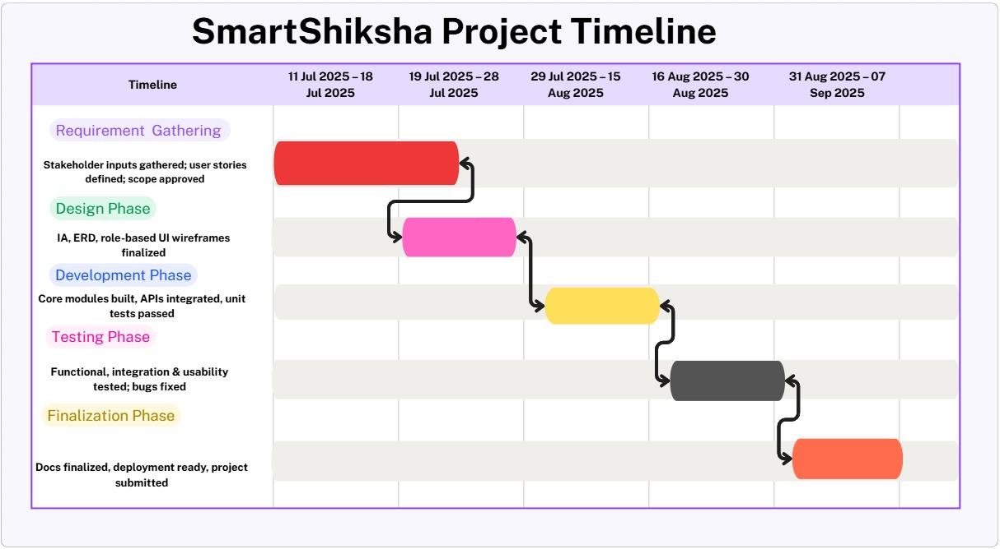
Figure 1 Timeline

Requirement Gathering and Analysis
Requirement gathering is a critical stage in the software development process, as it ensures that the needs of stakeholders are fully understood before design and development commence. The objective is to collect both functional requirements (what the system should do) and non-functional requirements (usability, performance, security) to guide the project in meeting user expectations. Effective requirement gathering minimizes the risk of costly rework and ensures stakeholder alignment. Two key techniques were employed in this project: questionnaires and interviews. These methods were selected to gain both quantitative insights from a larger group of users and qualitative insights from in-depth discussions with stakeholders.

4.1. Requirement Gathering Technique Used

Questionnaire
A questionnaire was designed and distributed among parents, teachers, and students to understand their challenges with existing school communication methods and their expectations for a digital platform. Questionnaires are effective for collecting structured data from a larger population within a short period of time. The questionnaire included closed-ended questions (e.g., multiple choice, Likert scales) to measure satisfaction levels with current communication methods, as well as open-ended questions to allow respondents to express additional needs and suggestions (Brace, 2018).
Key focus areas included
- Current methods of communication.
- Frequency of miscommunication or delays.
- Preferences for mobile applications or web platforms.
- Importance of academic monitoring features.

Interview
Interviews were conducted with a selected group of teachers, parents, and school administrators to gather in-depth insights into communication challenges and system expectations. Interviews provide flexibility and allow clarification of responses, making them suitable for understanding user concerns and motivations. Semi-structured interviews were used, combining pre-prepared questions with the freedom to explore emerging themes. (Myers et al., 2007).
Sample interview questions included
- What are the biggest communication challenges you face in your school?
- How do delays or missing information affect parents and students?
- What features would you consider most useful in a centralized system?
- What difficulties do you experience with parent-teacher meetings?

Summary of Questionnaire and Interview Findings
- Lack of a Centralized Platform – Most participants reported that communication in schools is fragmented, relying on paper-based notices, informal WhatsApp groups, or phone calls, often leading to delays or missed updates.
- Need for Academic Monitoring – Parents and teachers highlighted the importance of structured access to student performance, attendance records, and behavioral updates.
- Parent Involvement Limitations – Many parents admitted missing meetings due to work commitments, which limited their knowledge of their child’s progress.
- Student Engagement – Students expressed interest in having access to timetables, term results, and updates in one place, improving their ability to track progress.
Overall, the requirement gathering confirmed that stakeholders strongly support the development of a centralized, user-friendly, system that integrates academic and behavioral monitoring.

4.2. Functional and Non-Functional Requirements

Functional Requirements
- User Registration and Authentication
Parents, teachers, and students should be able to register and log in securely.
Multi-role access must be implemented (parent, teacher, student).
- Unified Communication
Enable real-time messaging between teachers, parents, and students.
Support notifications for urgent updates.
- Academic Monitoring
Provide access to student performance records, attendance, and progress reports.
Allow teachers to upload grades and generate term reports.
- Behaviour Feedback
Teachers should be able to provide structured feedback on student behaviour.
Parents should receive timely notifications of behavioural updates.
- Online Services
Provide digital access to timetables, payments, and event registration.
Enable parents to view circulars, notices, and school policies (Sommerville, 2016).
- Machine Learning Module
Predict student academic performance based on past results and attendance.
Provide insights into the likelihood of passing the O/L examination.

Non-Functional Requirements
- Usability
The system must have an intuitive interface suitable for all user groups.
- Performance
The system should support at least 500 concurrent users without performance degradation.
Notifications and updates must be delivered in real-time.
- Security
Ensure secure authentication (e.g., password encryption, two-factor authentication).
Compliance with data protection standards to safeguard student information.
- Scalability
The platform should be able to accommodate future growth (e.g., multiple schools).
Cloud-based deployment for flexible resource allocation.
- Reliability and Availability
The system should achieve 99.5% uptime to ensure accessibility during school hours.
Regular backups must be maintained to prevent data loss (Wiegers et al., 2013).
- Maintainability
The system should allow easy updates, bug fixes, and feature extensions.
Modular design to ensure minimal downtime during upgrades.
- Ethical and Legal Compliance
Adherence to Sri Lankan data privacy regulations in handling student records.
Ensure ethical use of machine learning predictions, avoiding bias and misuse of data.

System Design

5.1. ER Diagram

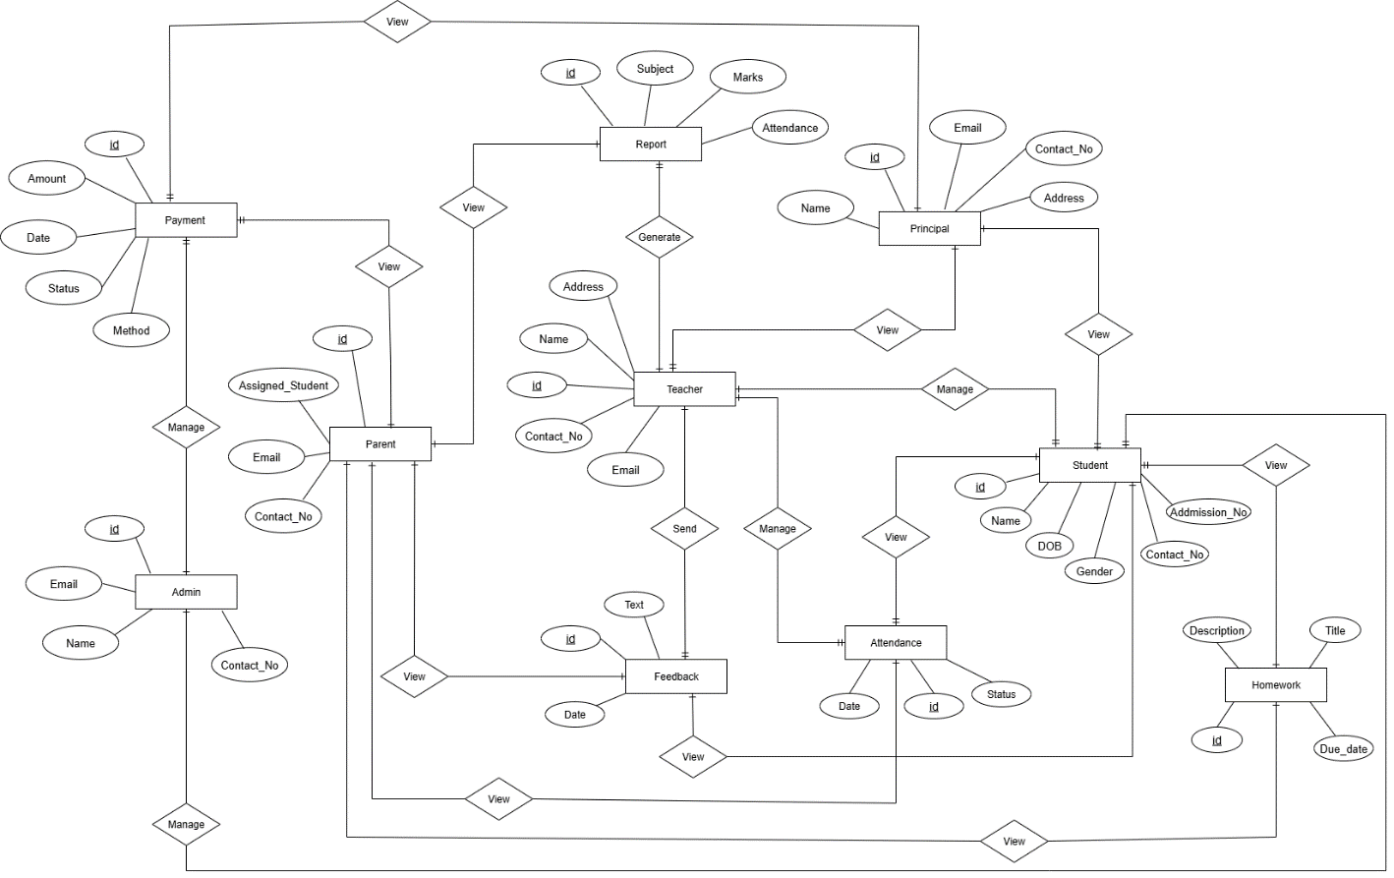
Figure 2 ER Diagram

This ER diagram represents the database structure for the SmartShiksha system, showing the relationships between key entities in a school management environment. The main entities include Student, Parent, Teacher, Principal, Admin, Report, Feedback, Payment, and Homework, each linked with relevant attributes such as ID, name, email, contact number, and date. Relationships like “Manages,” “Assigned_Student,” “Sends,” “Generates,” and “Views” define the interactions among these entities. For example, teachers generate reports, provide feedback, and manage student records; parents are assigned students and can make payments; principals and admins oversee system operations. Reports track subjects, marks, and attendance, while homework entities store assignments and deadlines. Overall, the ER diagram demonstrates a comprehensive structure that integrates academic, administrative, financial, and communication processes within a centralized educational system.

Use Case Diagram
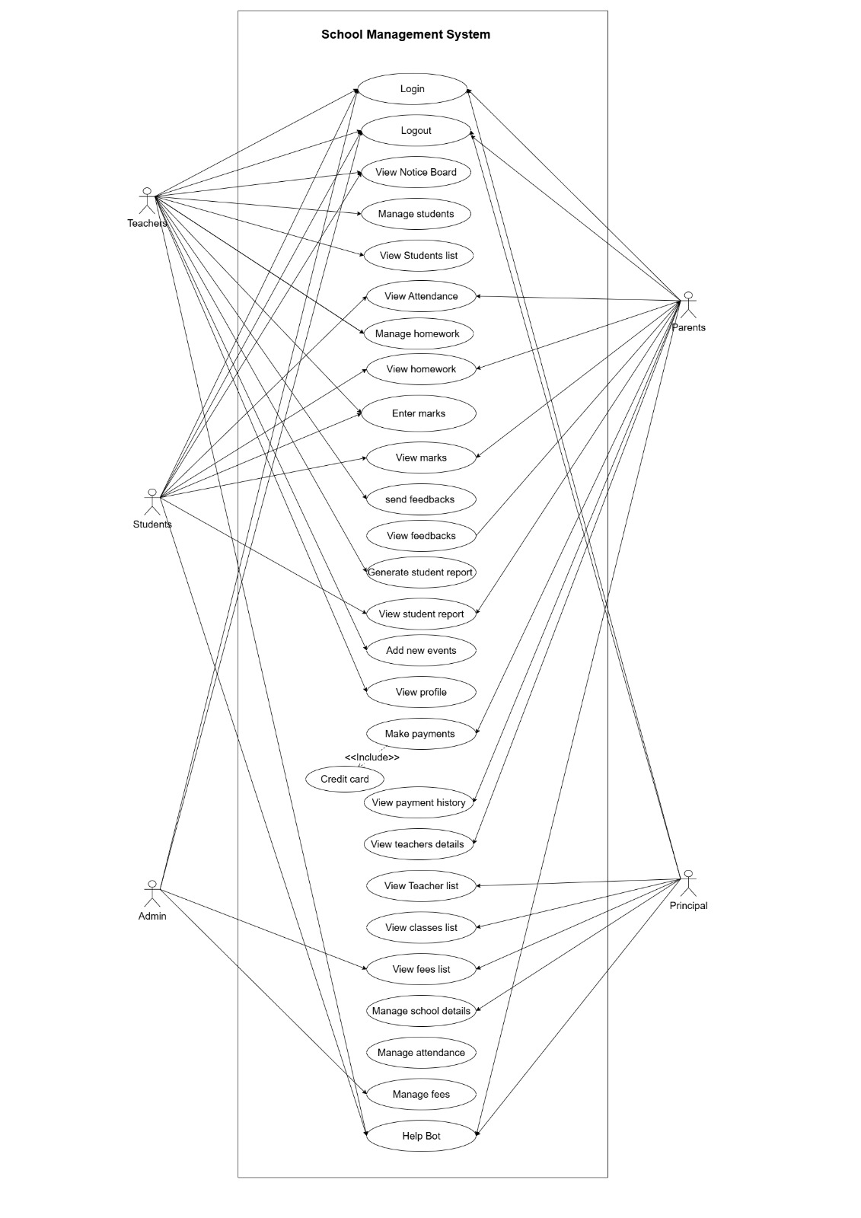
Figure 3 Use Case
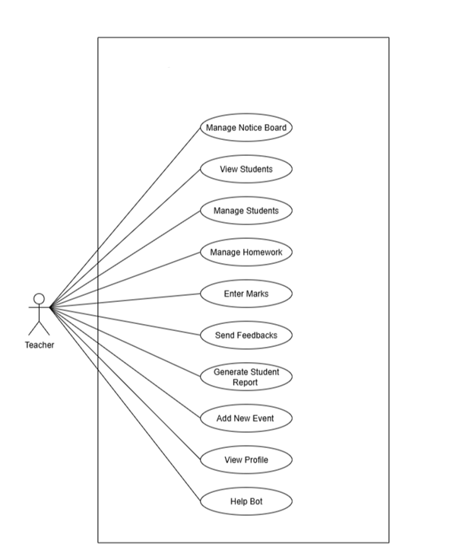
Student Management System

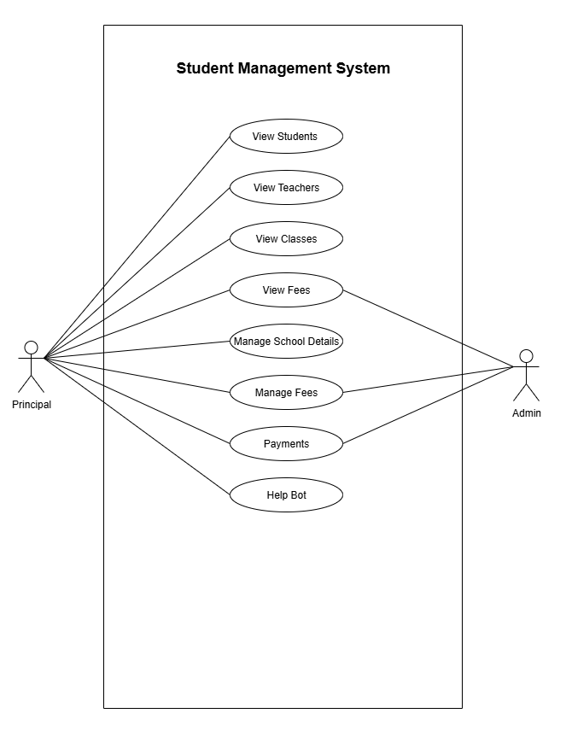

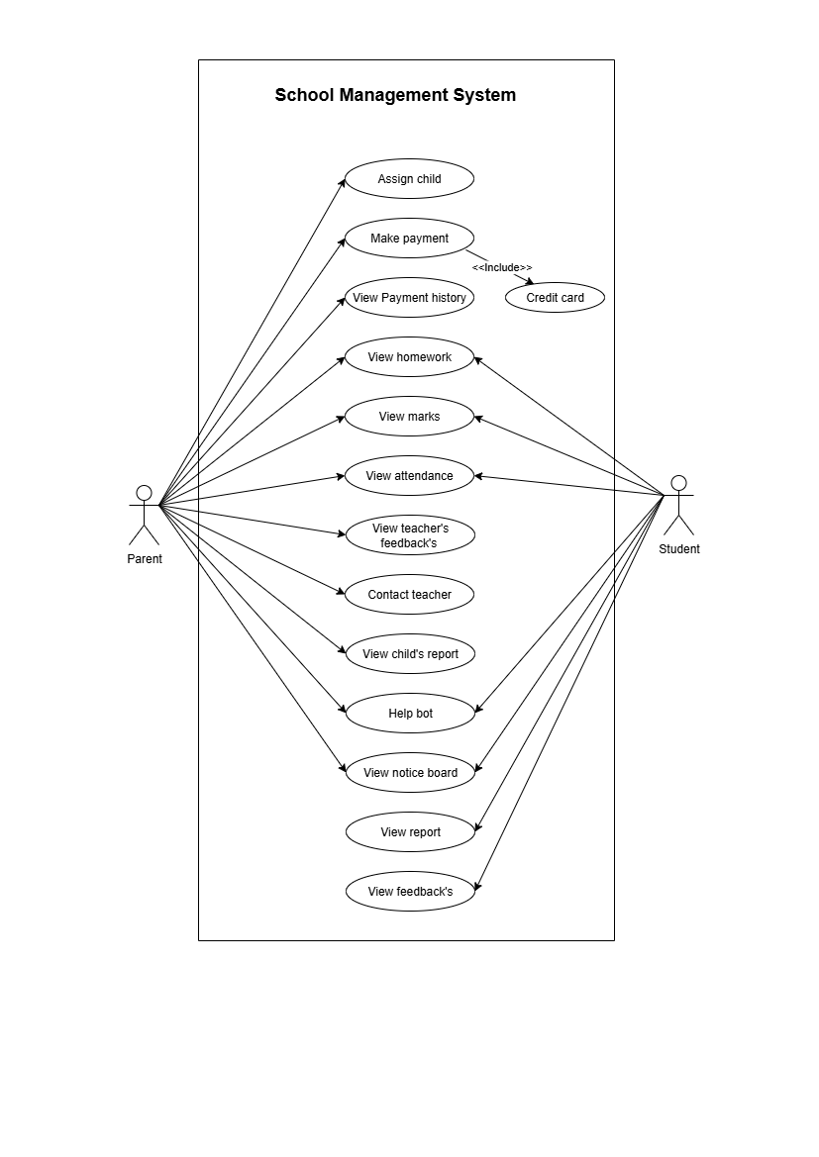
This use case diagram illustrates the functionality of the School Management System by highlighting the interactions between different user roles Teachers, Parents, Students, Admin, and Principals and the system. Core use cases include login/logout, viewing notice boards, managing students, recording attendance, handling homework, entering and viewing marks, generating reports, sending and receiving feedback, and managing events. Additional administrative functions such as managing fees, school details, teacher and class lists, and payment handling are shown for the Admin and Principal roles. Parents can view student progress, feedback, and payment history, while students can access profiles, homework, and reports. A Help Bot provides support across the system. Overall, the diagram demonstrates how various stakeholders interact with the system’s centralized features to streamline academic, administrative, and communication processes.

Sequence diagram

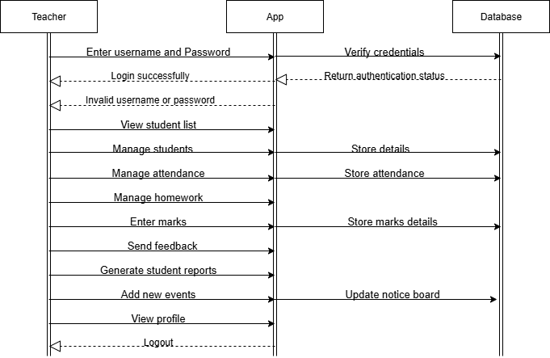
Figure 4 Teacher Sequence

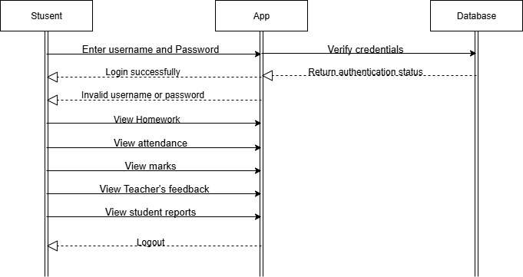
Figure 5 Student Sequence
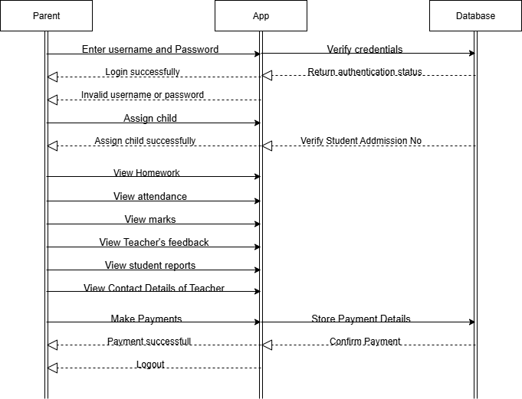
Figure 6 Parent Sequence

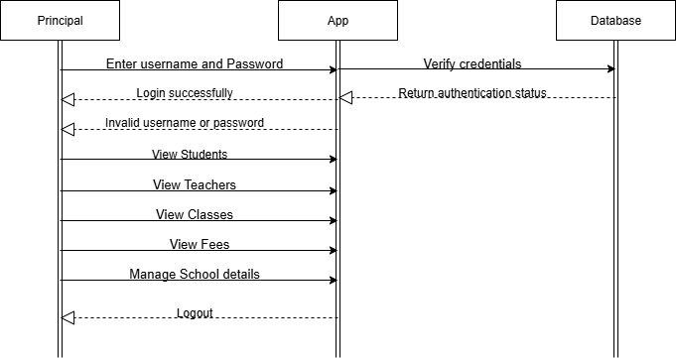
Figure 7 Principal Sequence

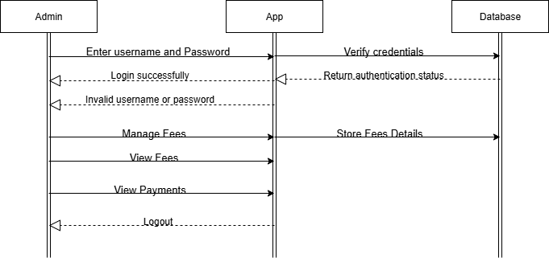
Figure 8 Admin Sequence

These sequence diagrams illustrate the step-by-step interactions between different user roles (Teacher, Parent, Student, Principal, and Admin), the application, and the database within the School Management System. Each diagram begins with the user logging in, where credentials are verified by the system before granting access. Teachers can manage students, attendance, homework, marks, reports, and events, while parents can view their child’s performance, feedback, and make payments. Students primarily access homework, attendance, marks, and reports, whereas principals oversee broader operations such as viewing teachers, classes, and managing school details. Admins handle financial processes like managing fees and viewing payments. Across all roles, the app communicates with the database to store, update, and retrieve information, ensuring secure, real-time management of school activities.

Class Diagram
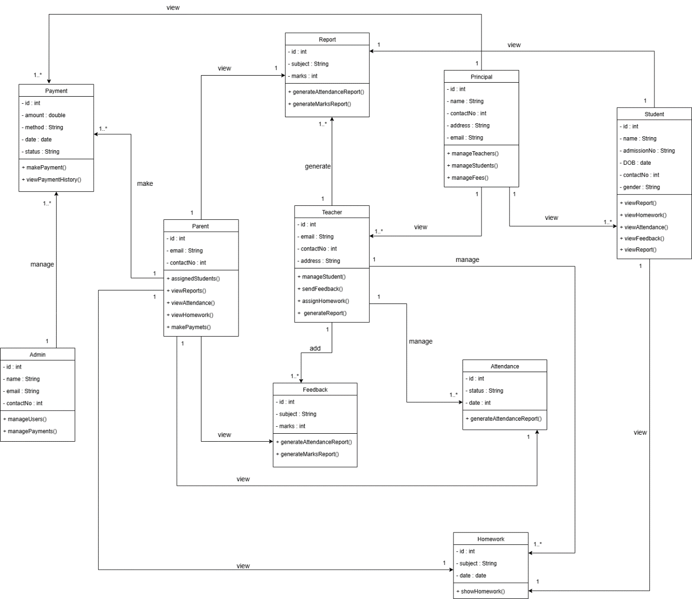
Figure 9 Class Diagram
This class diagram represents the structural design of the School Management System, showing the main classes, their attributes, methods, and relationships. Core classes include Student, Teacher, Parent, Principal, Admin, Report, Feedback, Attendance, Homework, and Payment. Each class has defined attributes such as IDs, names, emails, and contact details, along with methods to perform specific actions like generateReport(), manageStudent(), makePayment(), and viewFeedback(). Relationships among classes demonstrate how entities interact—for example, teachers manage students, attendance, and homework; parents view reports and make payments; principals oversee teachers and fees; and admins handle system-wide functions such as managing payments. The diagram emphasizes object-oriented principles by linking academic, administrative, and financial processes, ensuring modularity, reusability, and efficient system management.

Site Maps
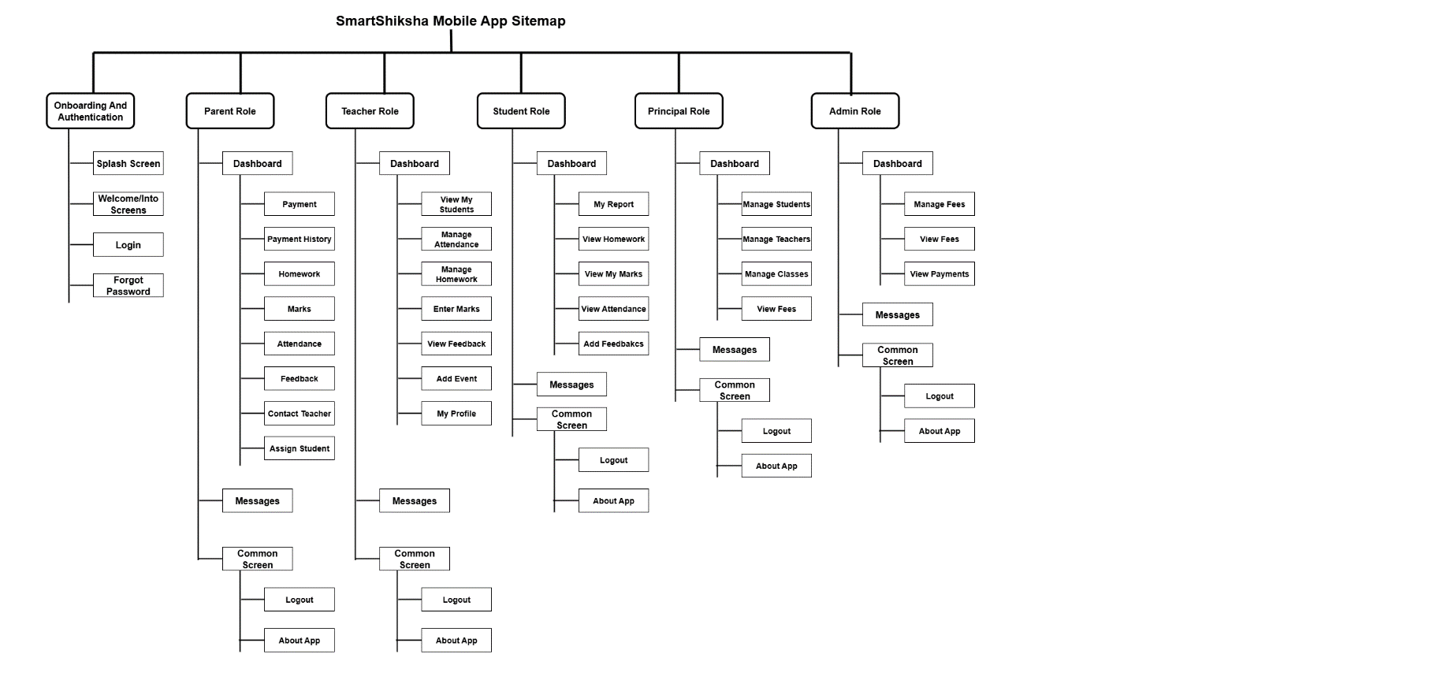
Figure 10 App Sitemap
The diagram represents the SmartShiksha Mobile App Sitemap, outlining the navigation flow for different user roles including Parent, Teacher, Student, Principal, and Admin. Each role has a dedicated dashboard with role-specific functions such as managing students, viewing reports, handling payments, monitoring attendance, and sending feedback. Common features like messaging, logout, and app information are accessible across roles, while onboarding functions such as login, registration, and password recovery are shared for all users.
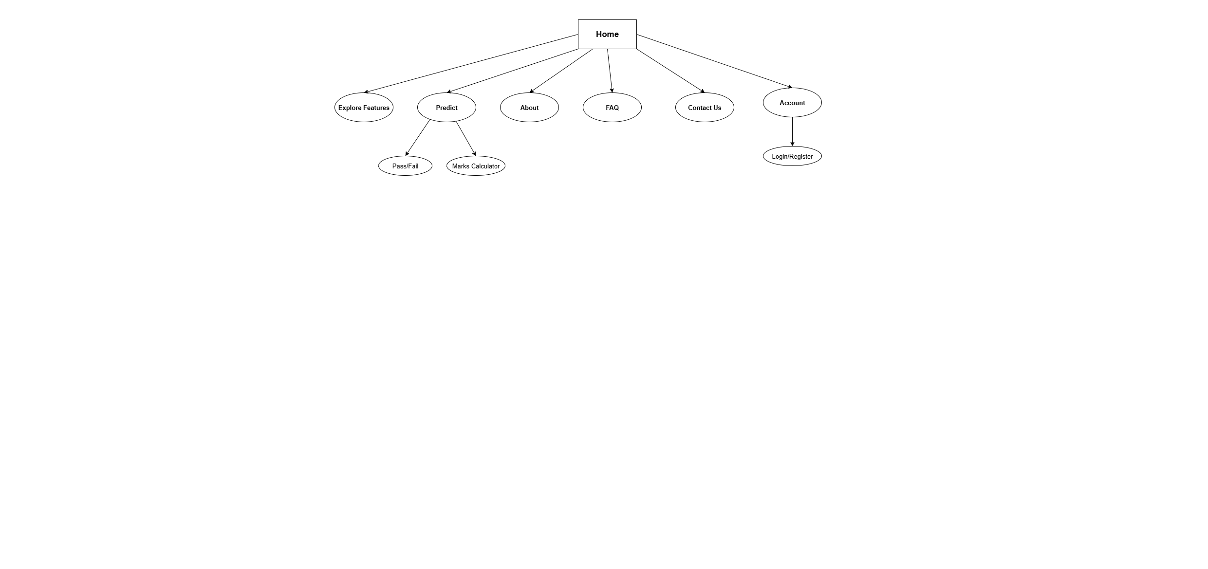
Figure 11 Website Sitemap
This diagram illustrates the Website Sitemap, which is simpler and more user-focused. From the Home page, users can explore features, access the predictive tools (Pass/Fail prediction and Marks Calculator), view information through About and FAQ pages, contact the system administrators, or manage their accounts via login/registration. This structure ensures intuitive navigation, enabling users to quickly access both informational content and interactive features.

Wireframe Diagram

5.6.1. Application

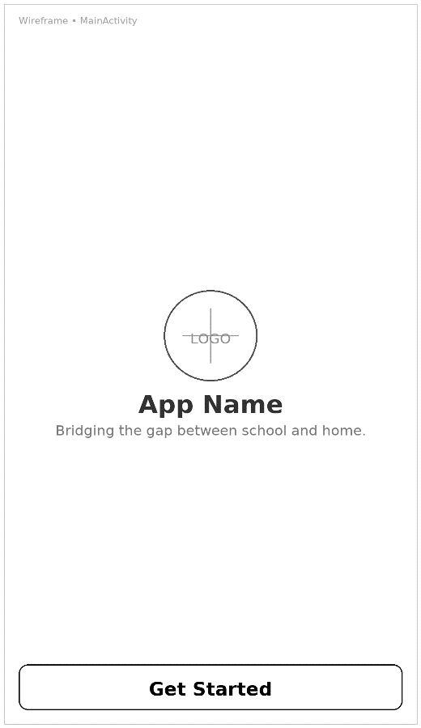
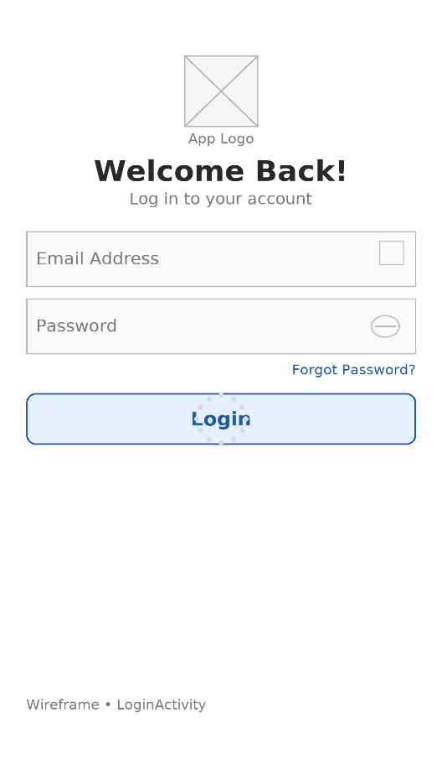
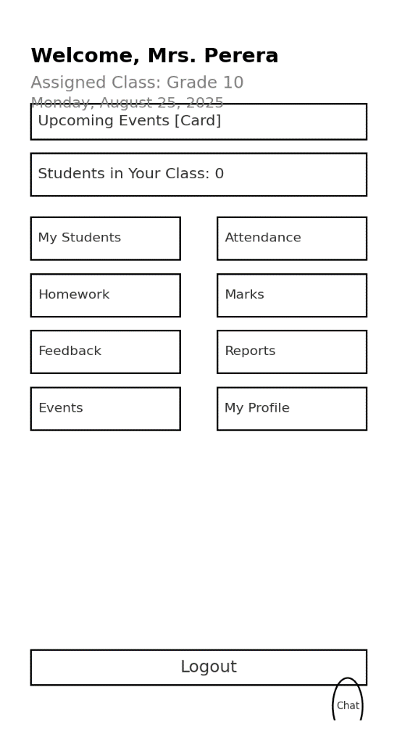
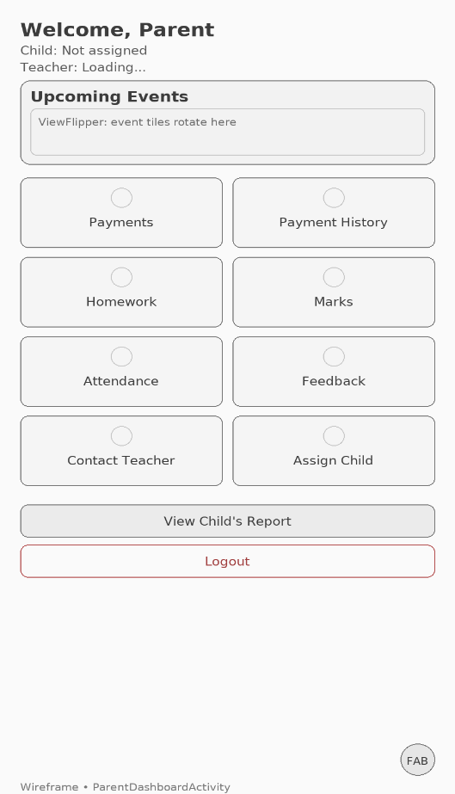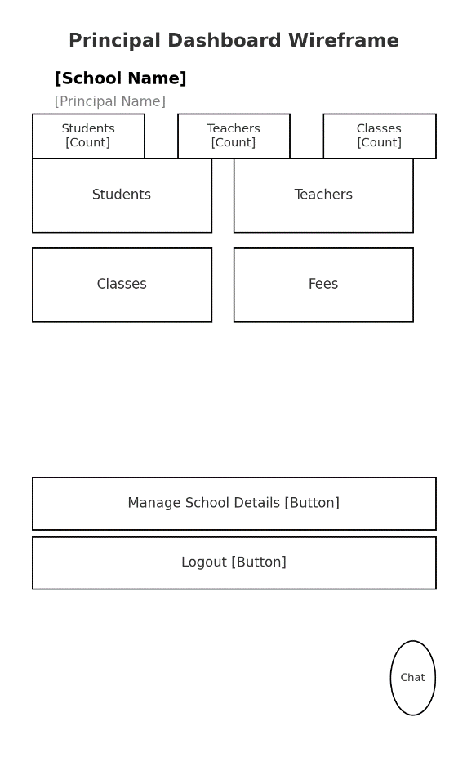

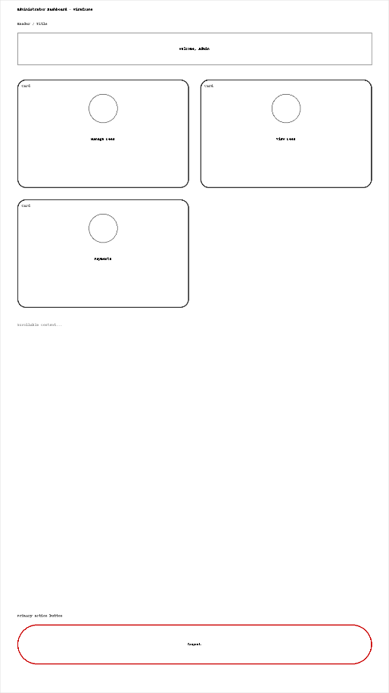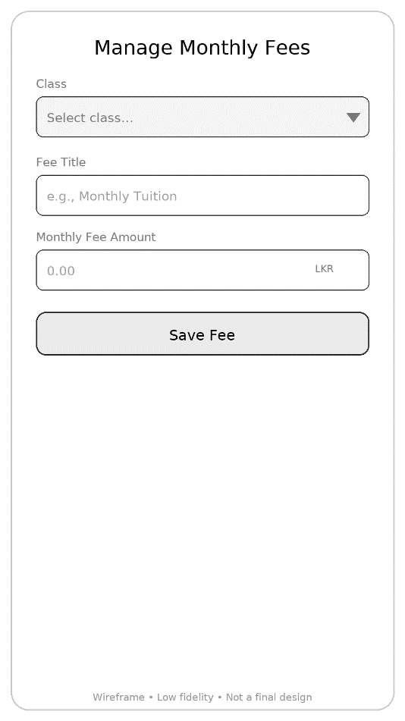
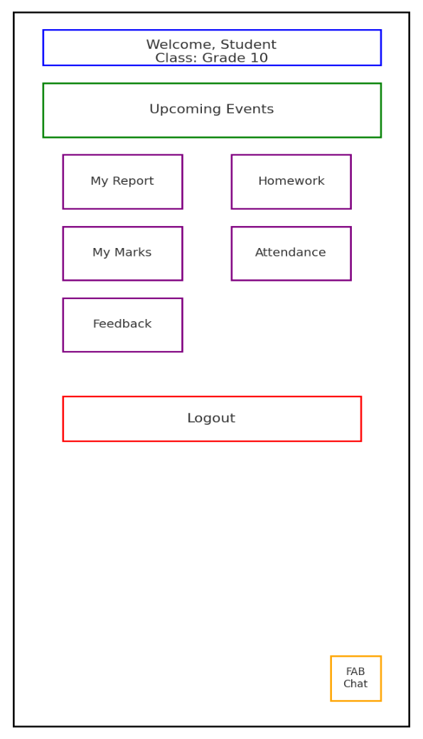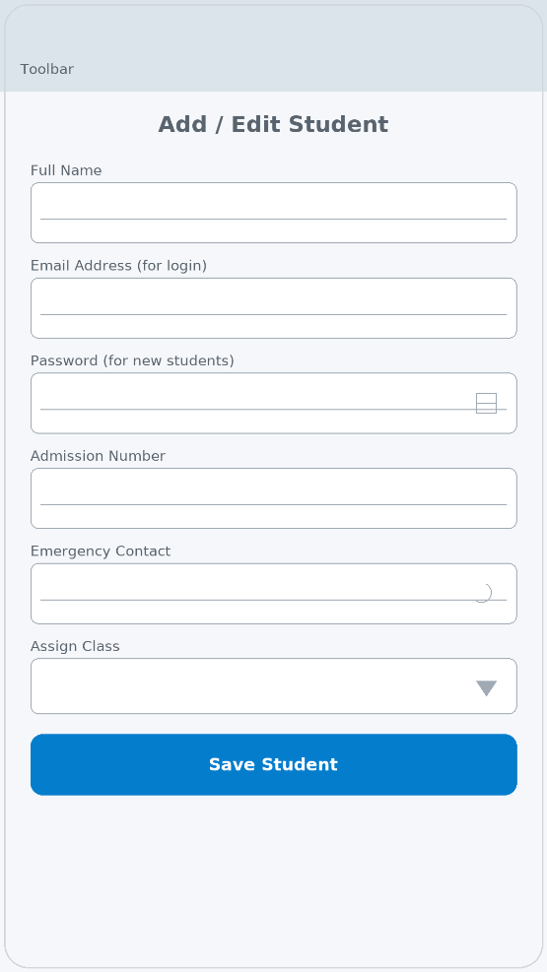
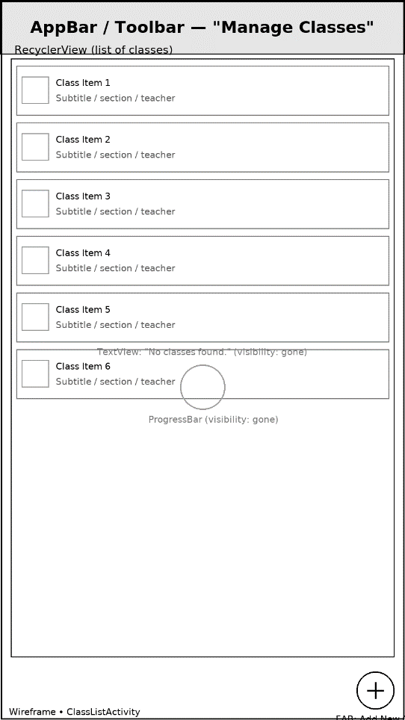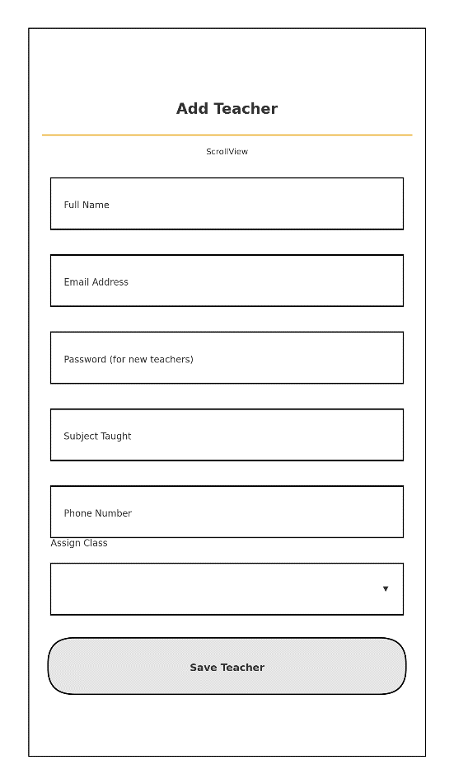

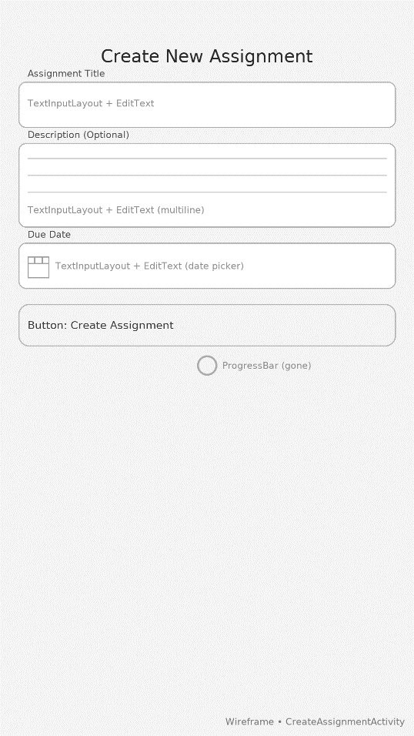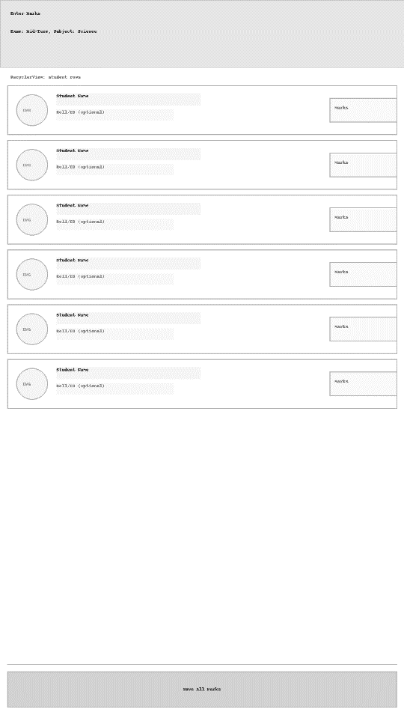
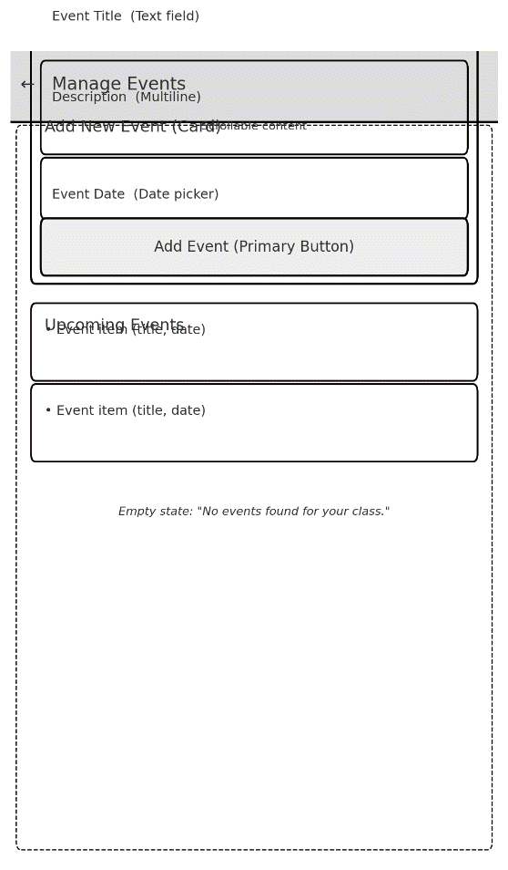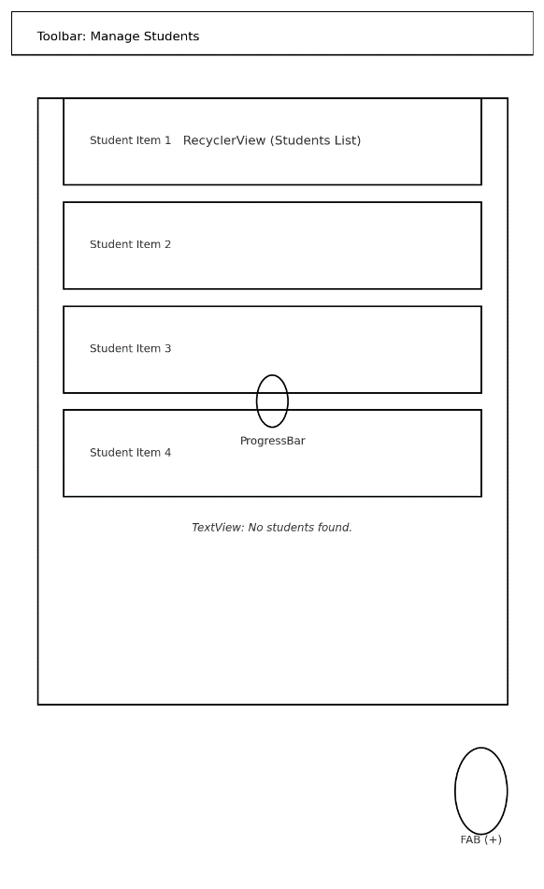
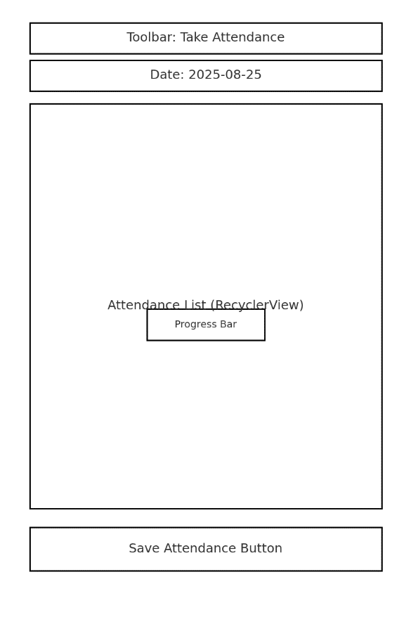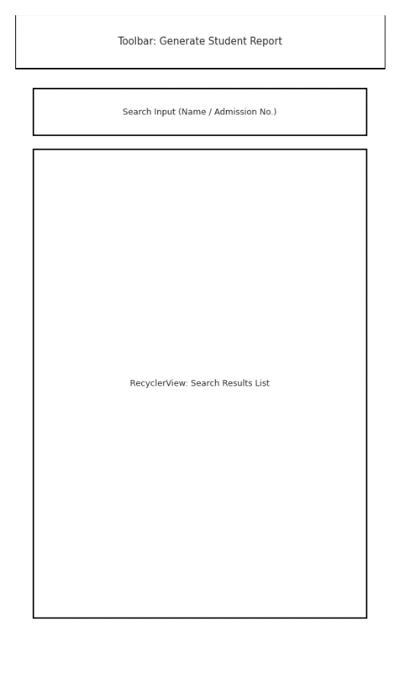
Figure 12 Application Wireframe

5.6.2. Website
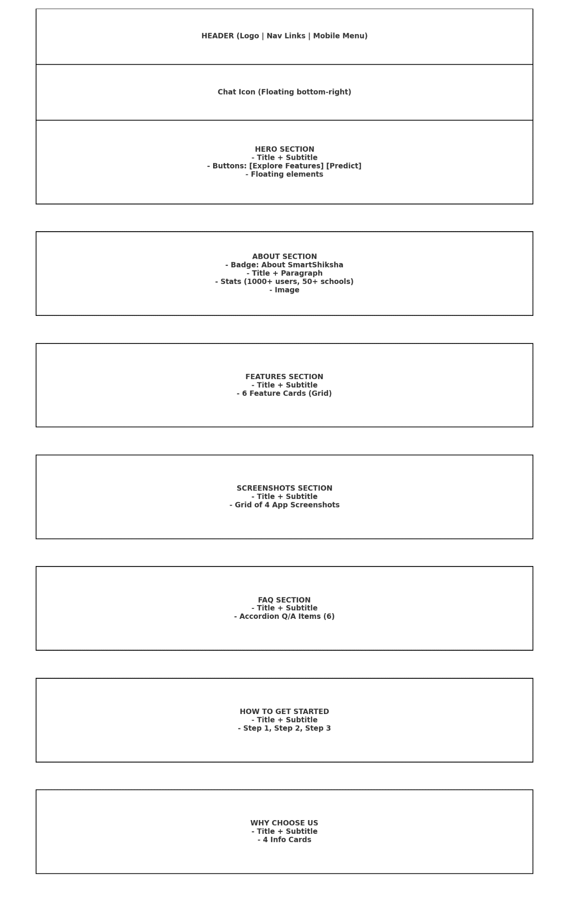
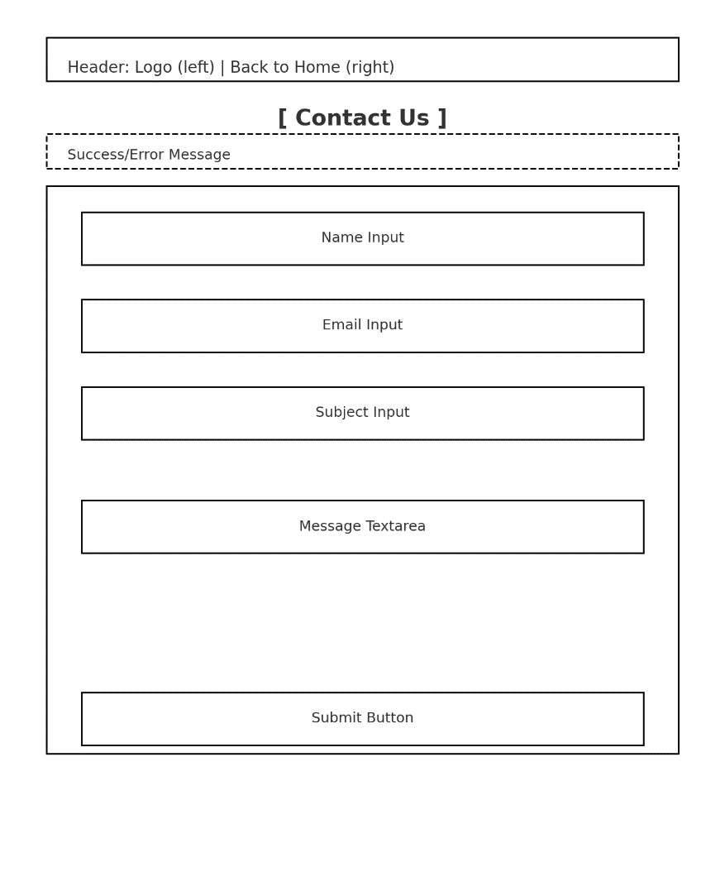


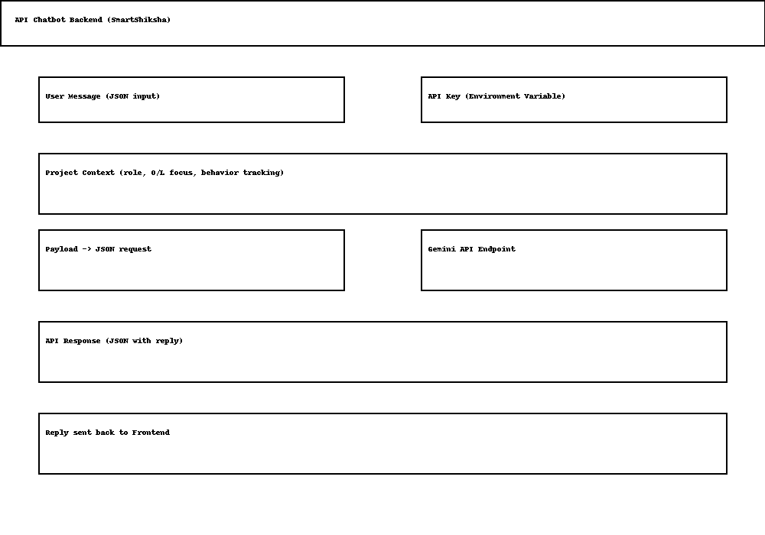
Figure 13 Website Wireframes

Implementation

6.1. Technology Stack

The proposed system utilizes a combination of modern technologies to deliver a scalable, efficient, and user-friendly solution. Each component of the technology stack has been carefully selected to meet the requirements of both mobile and web platforms, while also supporting integration with intelligent services such as chatbots.
Mobile Application
The mobile application is developed using Java, one of the most widely adopted programming languages for Android development. Java offers portability, object-oriented design, and strong community support, making it a reliable choice for building robust mobile solutions. Its compatibility with the Android SDK enables seamless development and integration with backend services. The database system implemented is MariaDB (MySQL compatible), as shown in the project’s configuration. MariaDB is an open-source relational database management system (RDBMS) known for its performance, scalability, and security features. Since it is fully compatible with MySQL, it supports SQL-based queries, making it easier to manage relational data for user accounts, student records, and application data (Widenius et al., 2019).
Website
The website is designed using HTML and CSS for structuring and styling content, ensuring a responsive and accessible front-end interface. HTML provides the backbone for web page content, while CSS enhances usability and visual presentation.
For server-side processing, PHP is used as the backend scripting language. PHP is widely recognized for its simplicity, dynamic content generation, and strong integration with relational databases such as MySQL. The backend enables features such as data handling, form processing, and communication with the database.
MySQL, paired with PHP, provides efficient data management for the website. It ensures reliable data storage and retrieval for user profiles, course details, and student records (DuBois, 2013).
Chatbot Integration
The system incorporates a chatbot powered by the Gemini API, which is part of Google’s generative AI ecosystem. Unlike traditional rule-based chatbots, Gemini offers advanced natural language understanding (NLU) and reasoning capabilities, enabling it to generate human-like responses and handle complex queries. By leveraging the Gemini API, the chatbot can process student, teacher, and parent inquiries in real time, enhancing accessibility and engagement across platforms. Gemini’s multimodal abilities also allow future extensions, such as integrating text, images, and contextual data into the conversation flow. The use of Gemini ensures that the chatbot goes beyond simple question answer tasks. It can support personalized guidance, learning recommendations, and administrative help, which makes it a valuable tool within the educational ecosystem. Moreover, its cloud-based deployment offers scalability and secure integration with the existing application stack (Google DeepMind, 2023).

6.2. Nature of the Dataset
The dataset used for model training and evaluation consisted of 2,392 student records with 15 attributes covering demographic, behavioral, and academic factors. These included age, gender, parental education, study time, absences, extracurricular activities, tutoring, parental support, and volunteering, along with academic outcomes such as GPA and GradeClass. The dataset is structured, tabular, and balanced, making it suitable for classification tasks such as predicting student performance and pass/fail outcomes. Similar student performance datasets have been widely employed in educational data mining studies due to their capacity to capture both academic and non-academic influences on outcomes.

6.3. Model Comparison
In order to identify the most suitable predictive model for forecasting student performance and the likelihood of passing or failing the O/L examination, three machine learning models were trained and evaluated: Artificial Neural Network (ANN), Deep Neural Network (DNN), and Logistic Regression. Each model was assessed based on its classification accuracy, precision, recall, and F1-score.
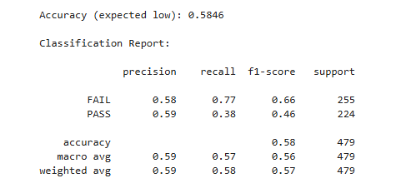
Figure 14 ANN Classification Report
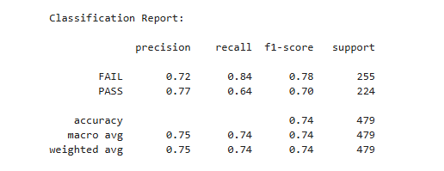
Figure 15 DNN Classification Report
The ANN model achieved an overall accuracy of 58.46%, with relatively higher recall for the FAIL class (0.77) but poor recall for the PASS class (0.38). This indicates that while the ANN was somewhat effective in identifying failing students, it struggled to correctly classify those likely to pass, leading to a bias in predictions. Similarly, the DNN model produced an identical accuracy of 58.46% with nearly the same classification report. Although deeper neural networks generally improve learning by capturing more complex relationships (LeCun et al., 2015), the relatively small dataset size and lack of extensive hyperparameter tuning limited the effectiveness of both ANN and DNN.
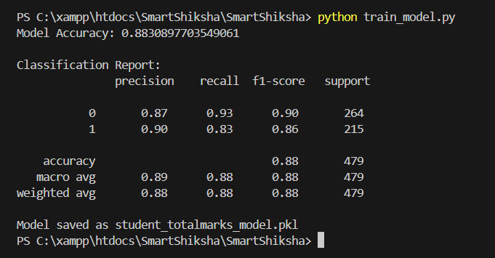
Figure 16 Logistic Regression Classification Report

In contrast, Logistic Regression significantly outperformed both ANN and DNN, achieving an accuracy of 88.3%. It demonstrated strong balance across both classes, with a precision of 0.90 and recall of 0.83 for the PASS category and 0.87 precision with 0.93 recall for the FAIL category. These results confirm that Logistic Regression effectively distinguishes between students who are likely to pass or fail, while minimizing false classifications. This aligns with previous studies, which highlight those simpler models like Logistic Regression can outperform deep learning approaches when applied to structured, tabular educational datasets with limited size (Shahiri et al., 2015).
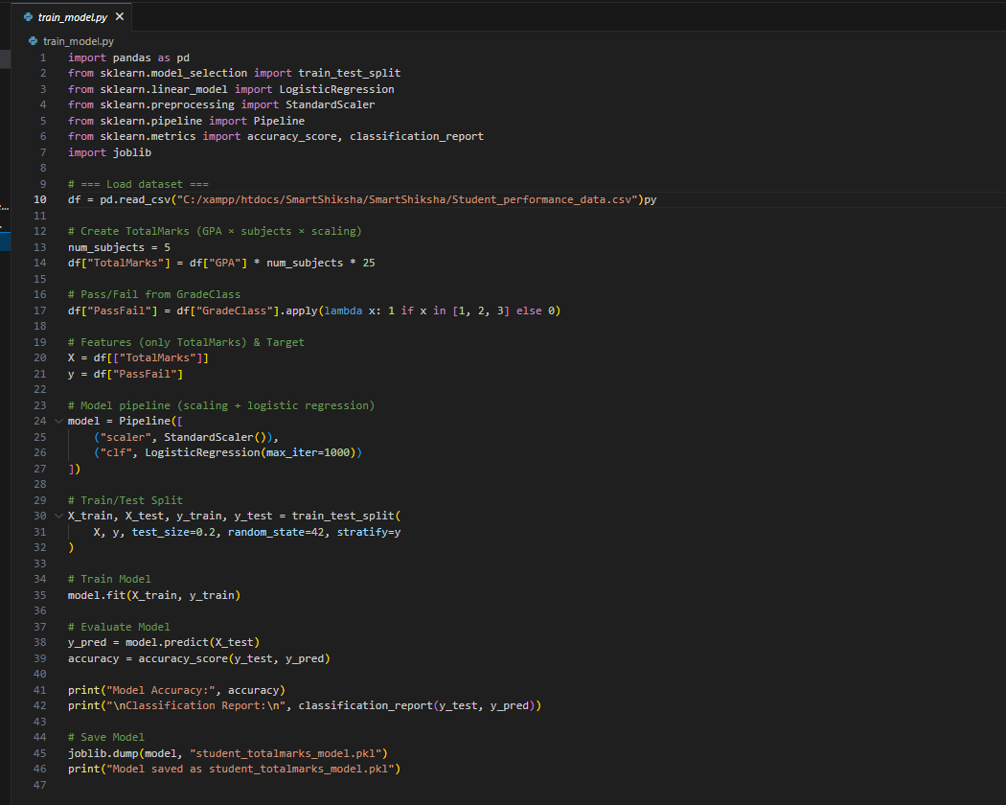
Figure 17 Model train

6.4. The Result
The results revealed that Logistic Regression outperformed ANN and DNN, achieving an accuracy of 88.3% with balanced precision and recall across both pass and fail categories. In contrast, ANN and DNN achieved only 58.46% accuracy, with both models showing bias toward predicting the failing category. This performance difference can be attributed to the dataset size and structure, where simpler models such as Logistic Regression are often more effective (Rajeswari et al., 2020).
Therefore, Logistic Regression was selected as the optimal model for predicting student academic performance. Its strengths include high accuracy, computational efficiency, and interpretability, making it well-suited for deployment in educational environments where decision transparency is critical.

6.5. Design Patterns

Website Interfaces

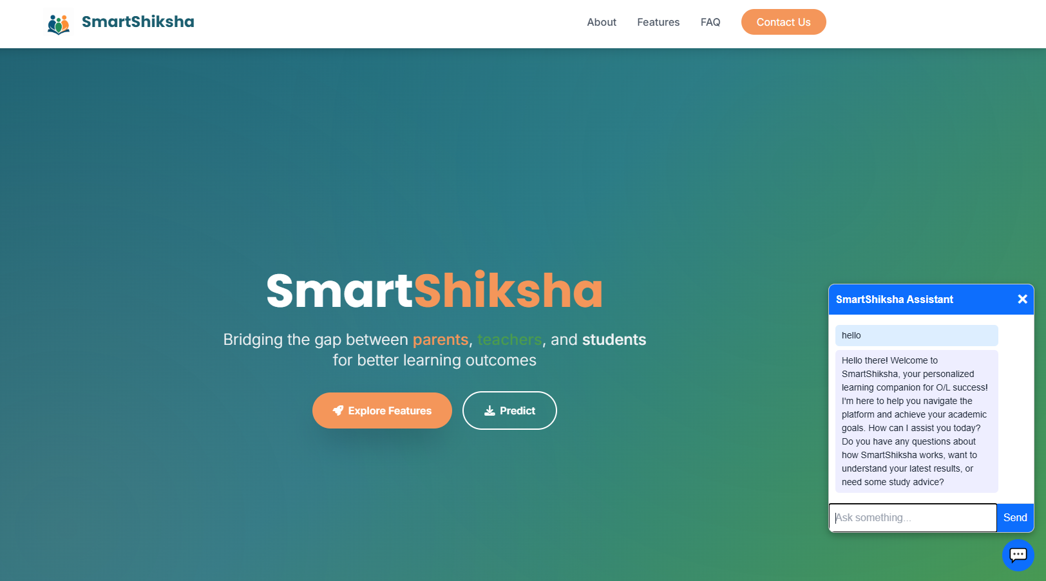
Figure 18 Home Page

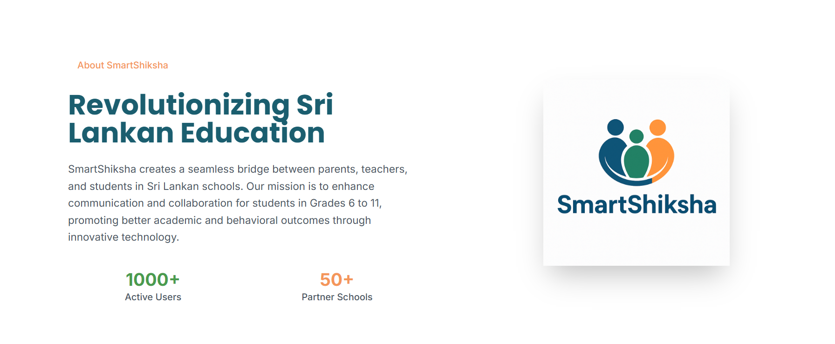
Figure 19 About Us

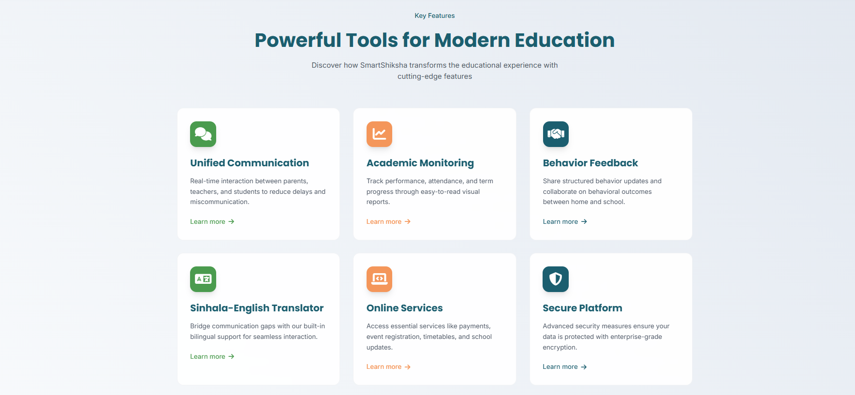
Figure 20 Features

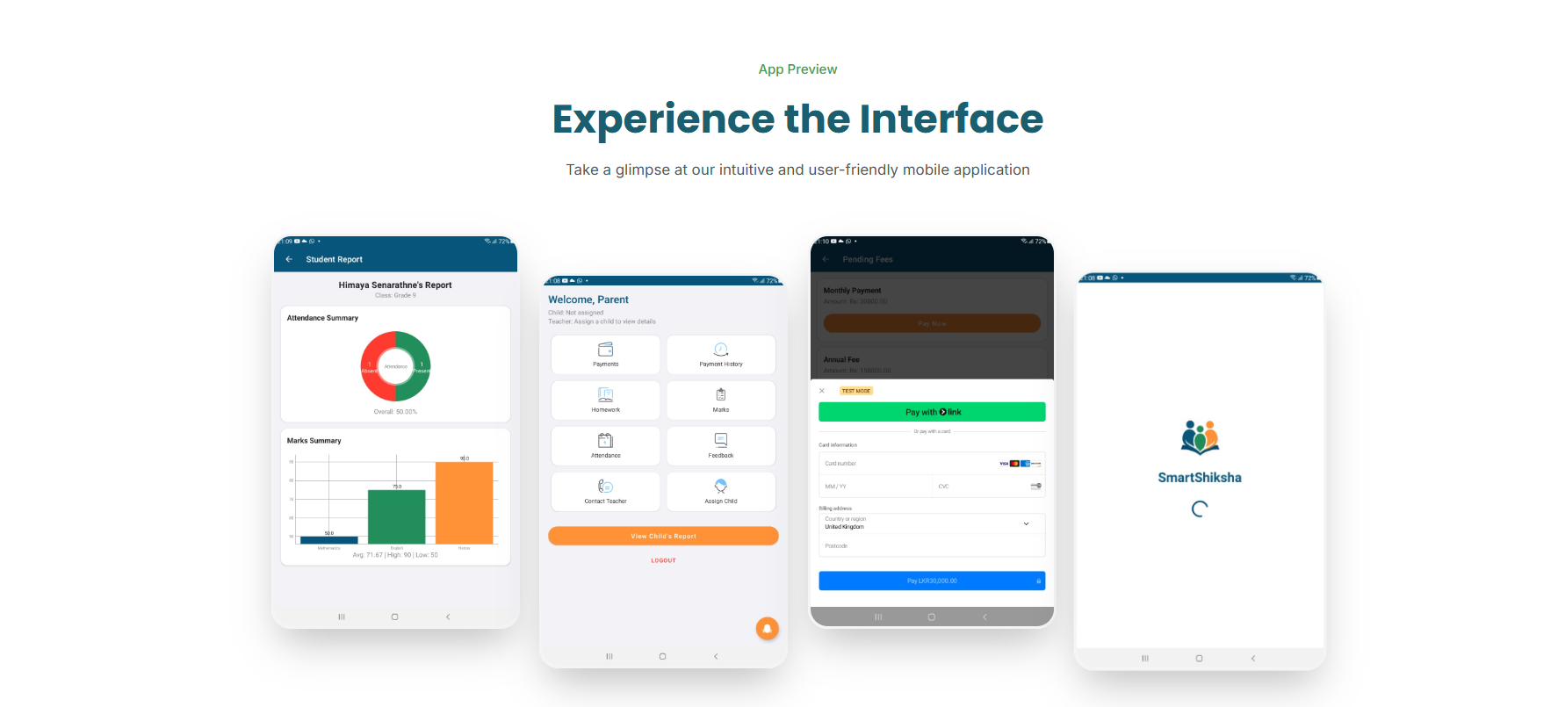
Figure 21 Interfaces

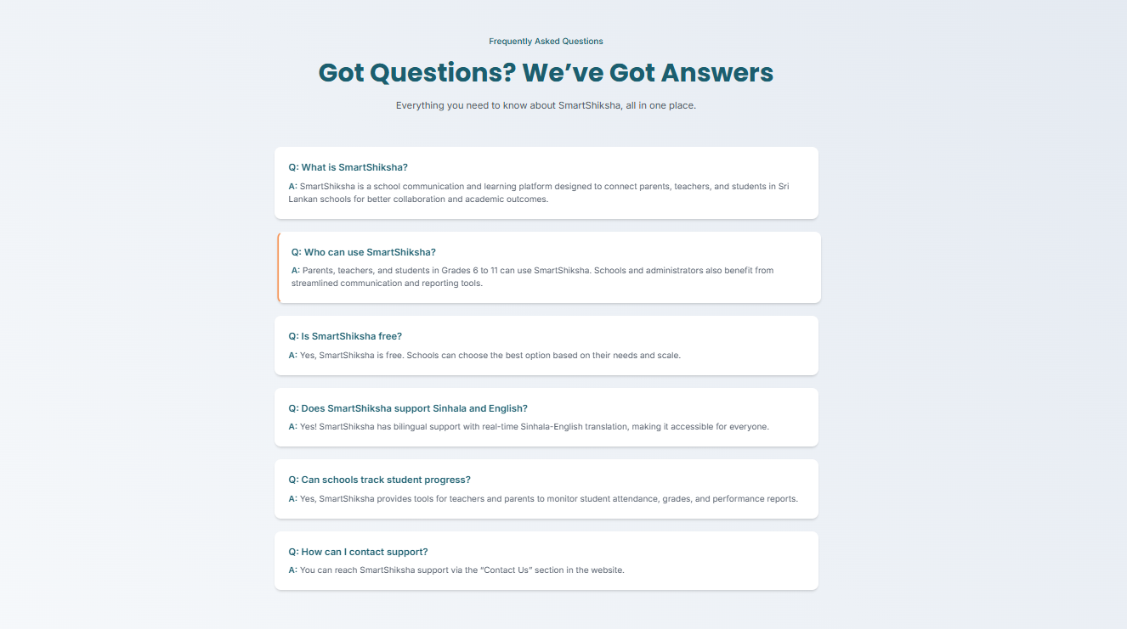
Figure 22 FAQ
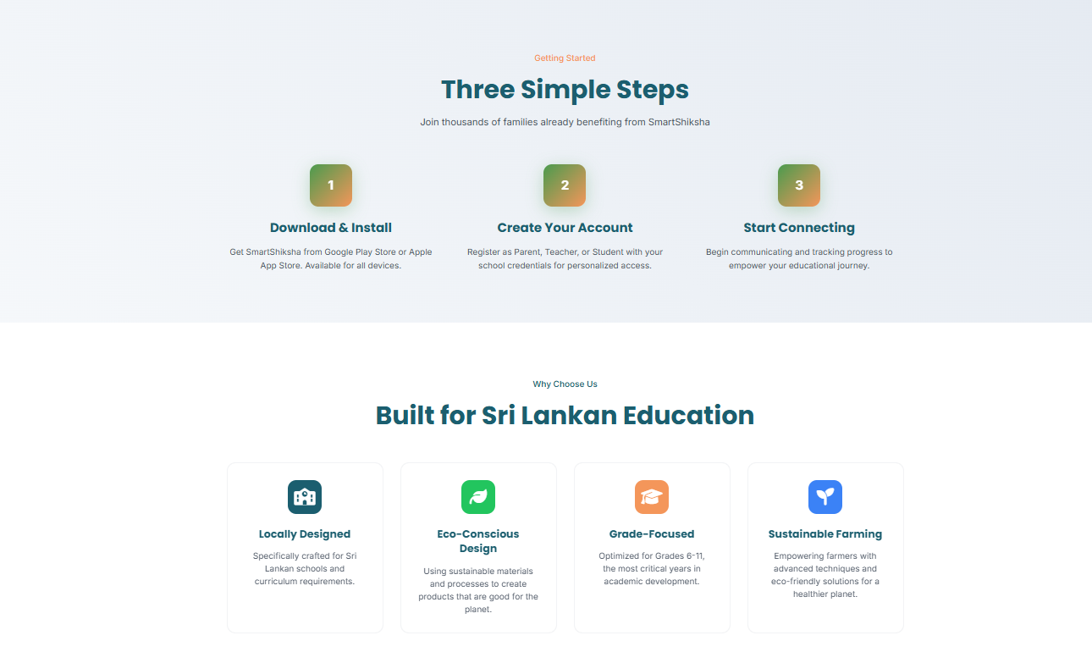
Figure 23 Benefits
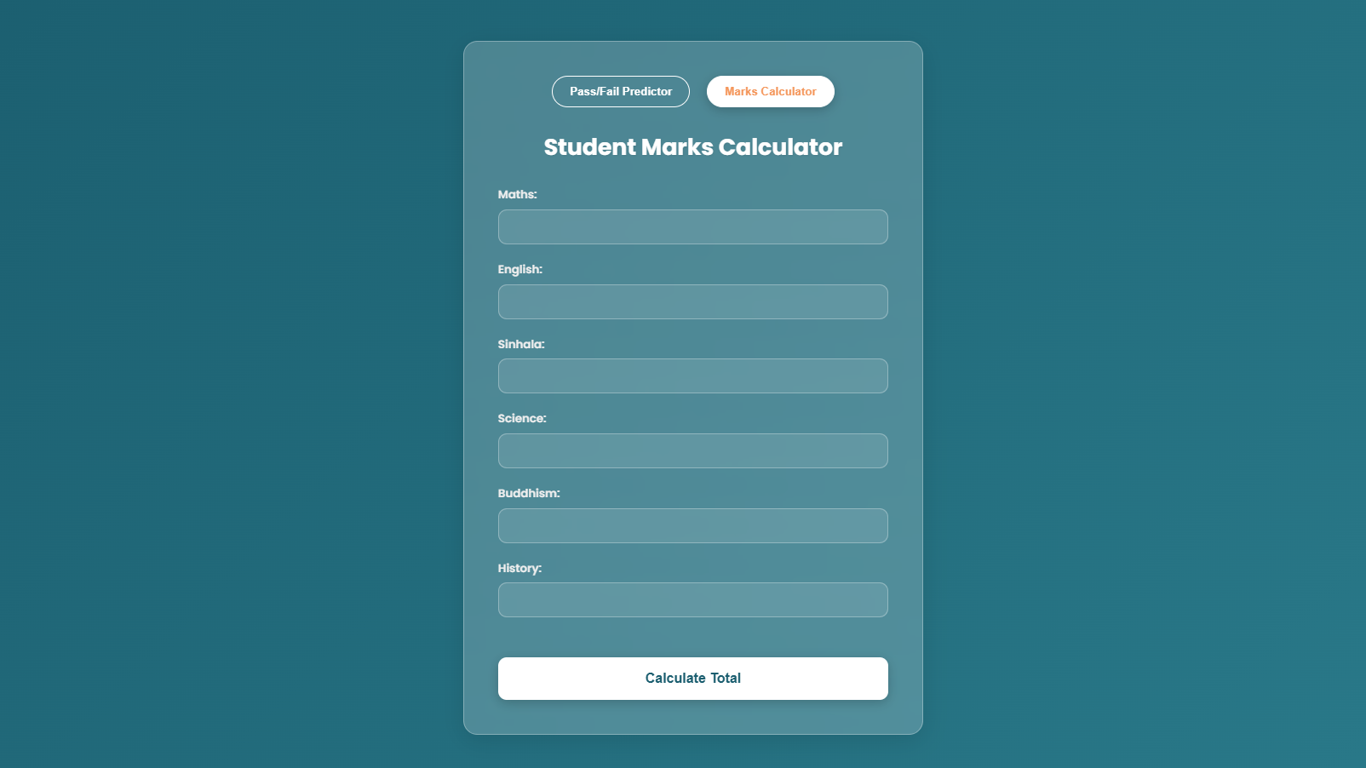
Figure 24 Marks Calculator
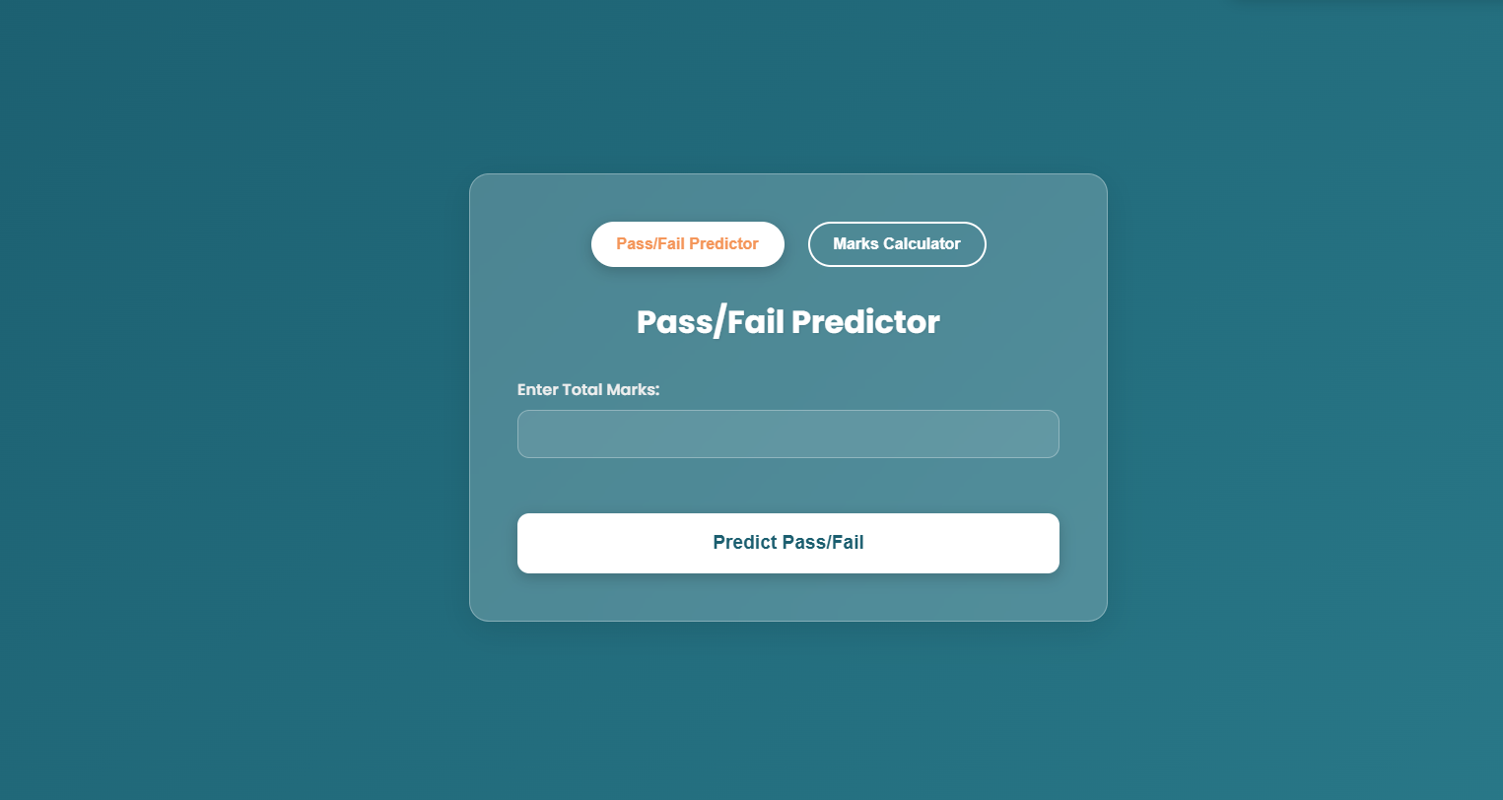
Figure 25 Predictor

Application Interfaces
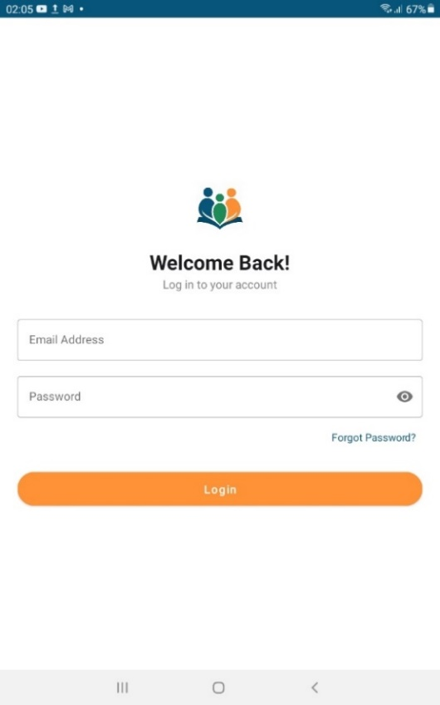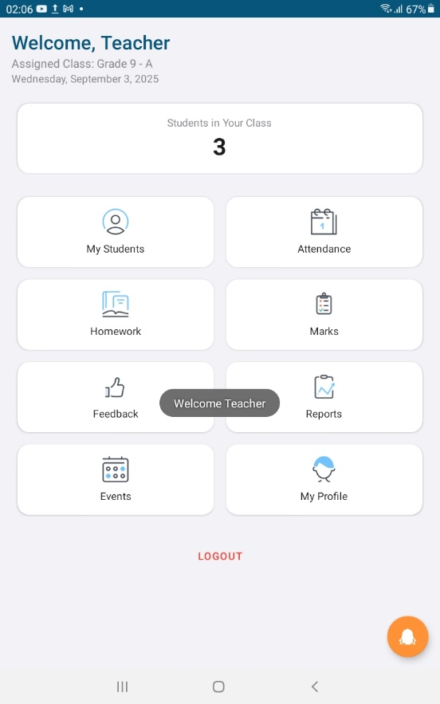
Figure 26 Login Figure 27 Teacher Dashboard
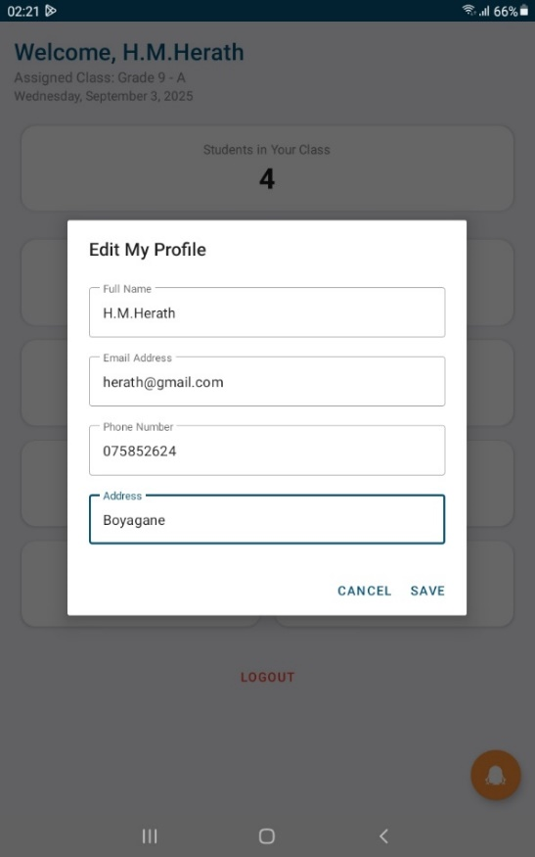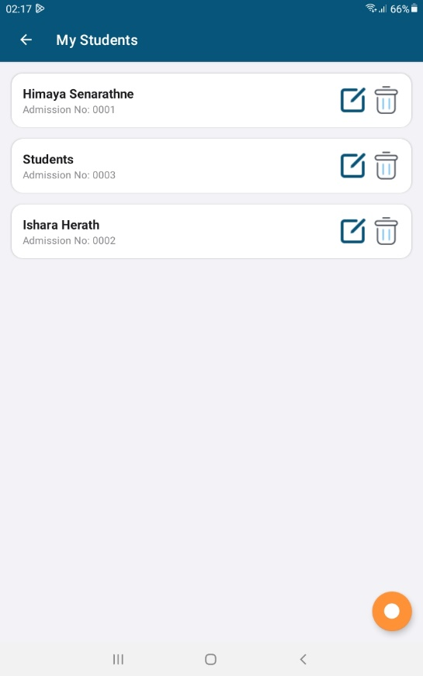
Figure 28 Profile Figure 29 Manage Students
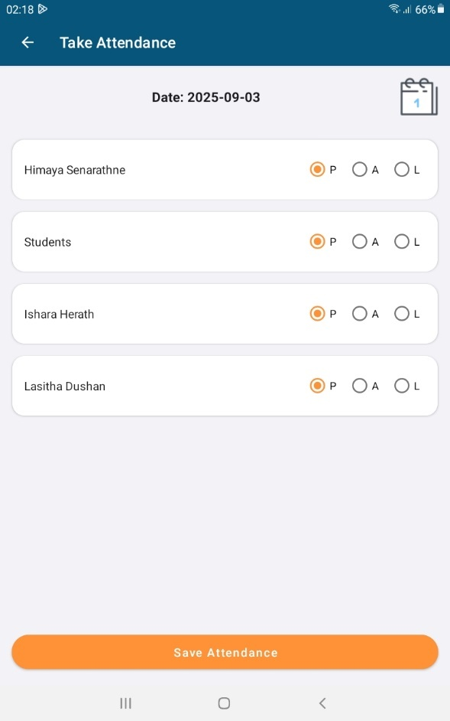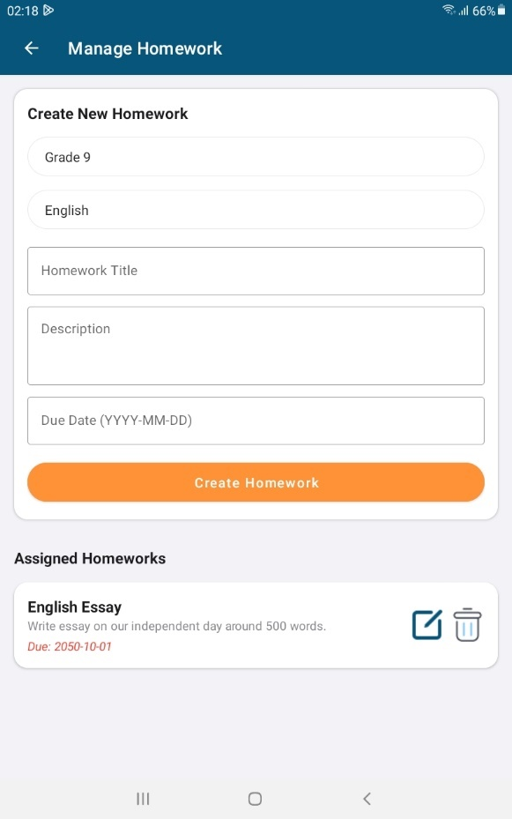
Figure 30 Manage Attendance Figure 31 Manage Homework

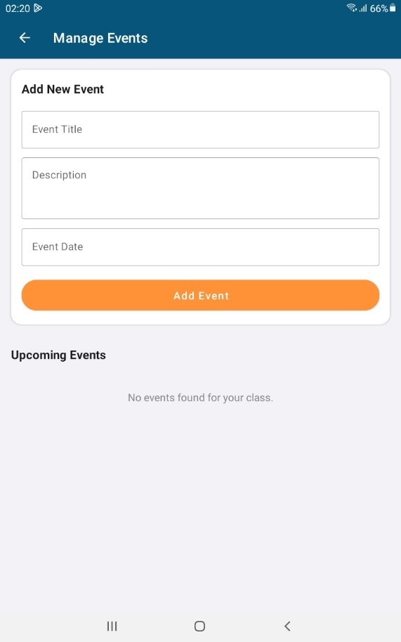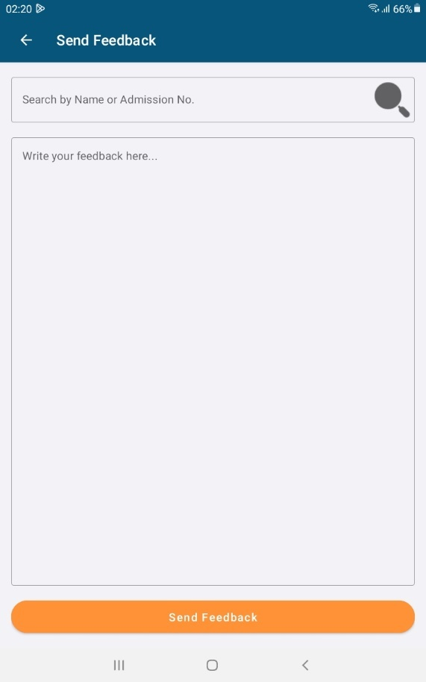
Figure 32 Manage Events Figure 33 Send Feedback

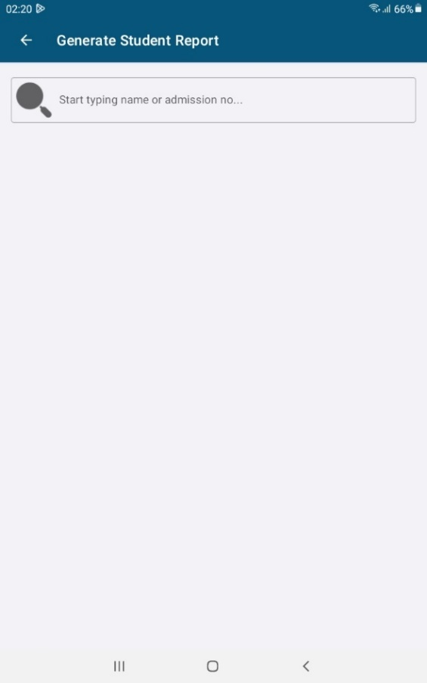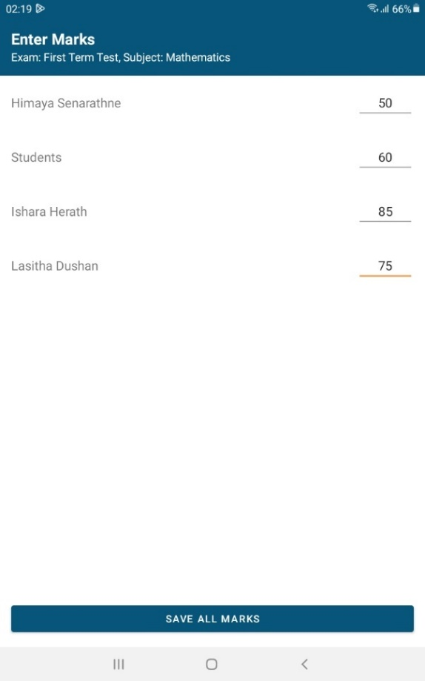
Figure 34 Generate Report Figure 35 Enter marks
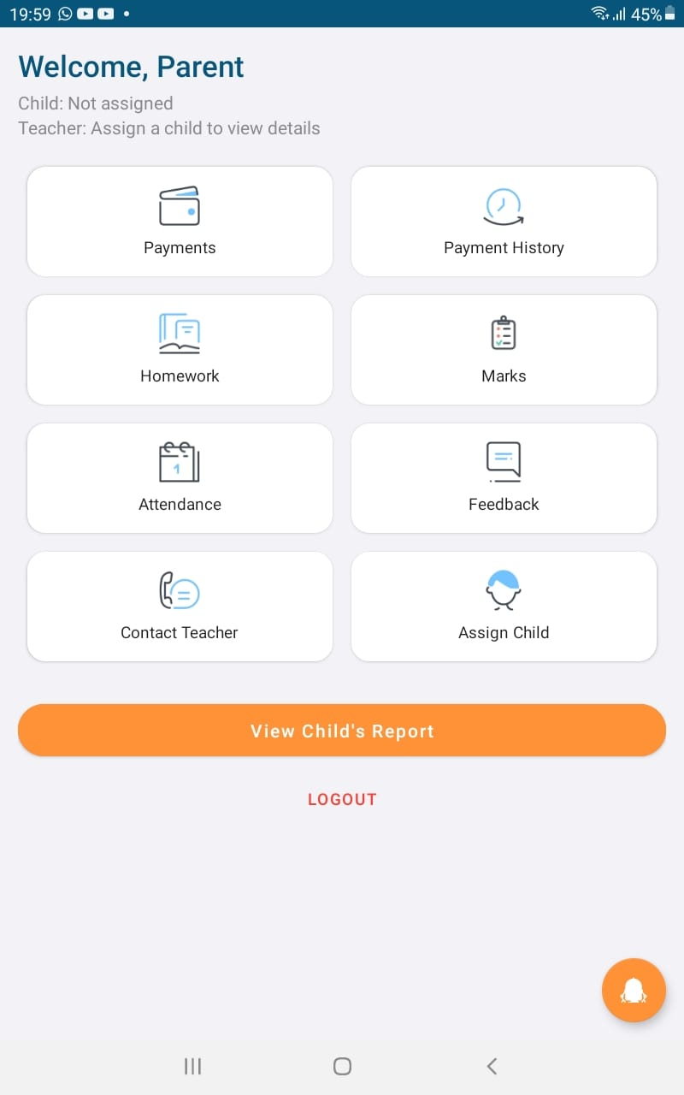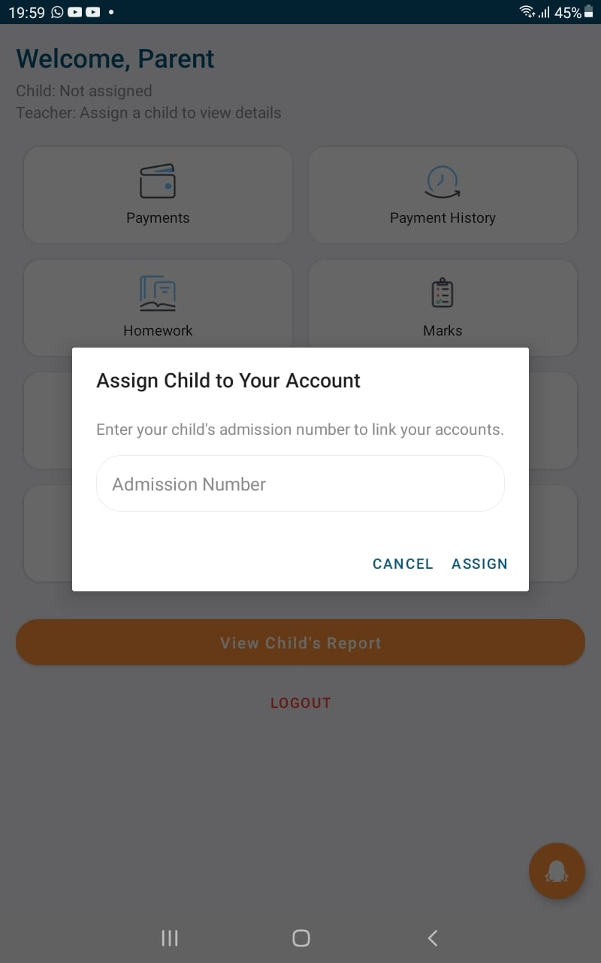
Figure 36 Parent Dashboard Figure 37 Assign Child
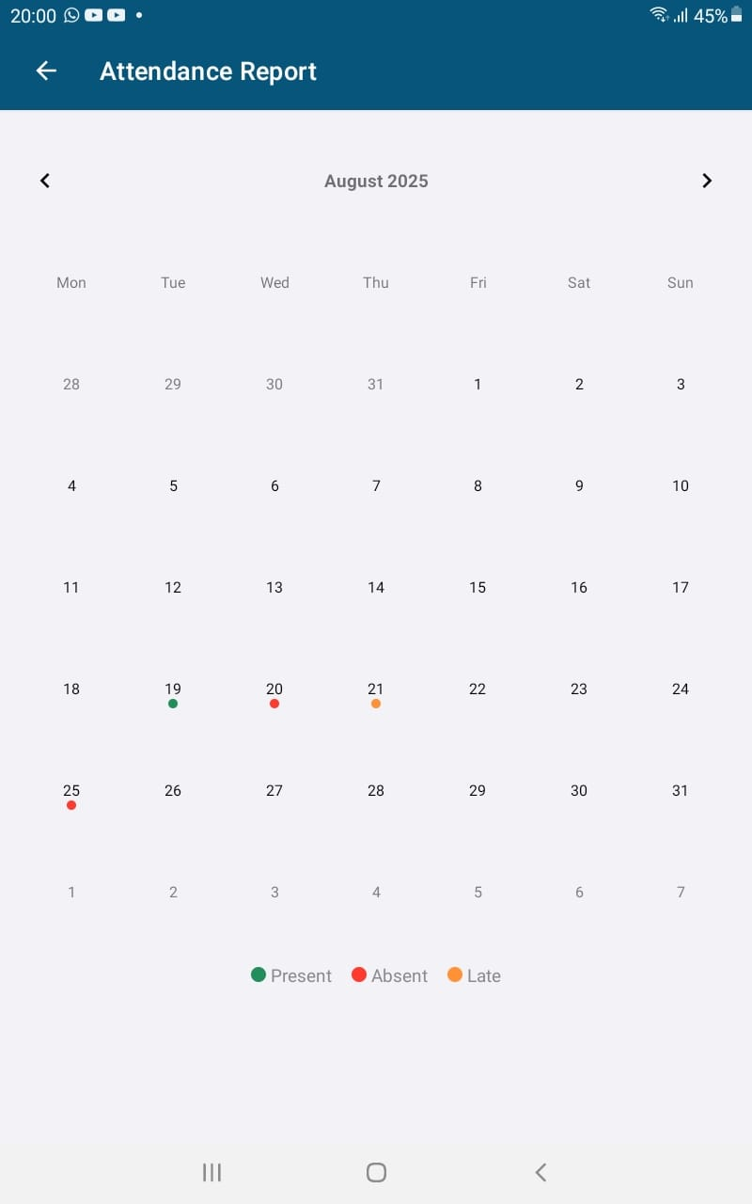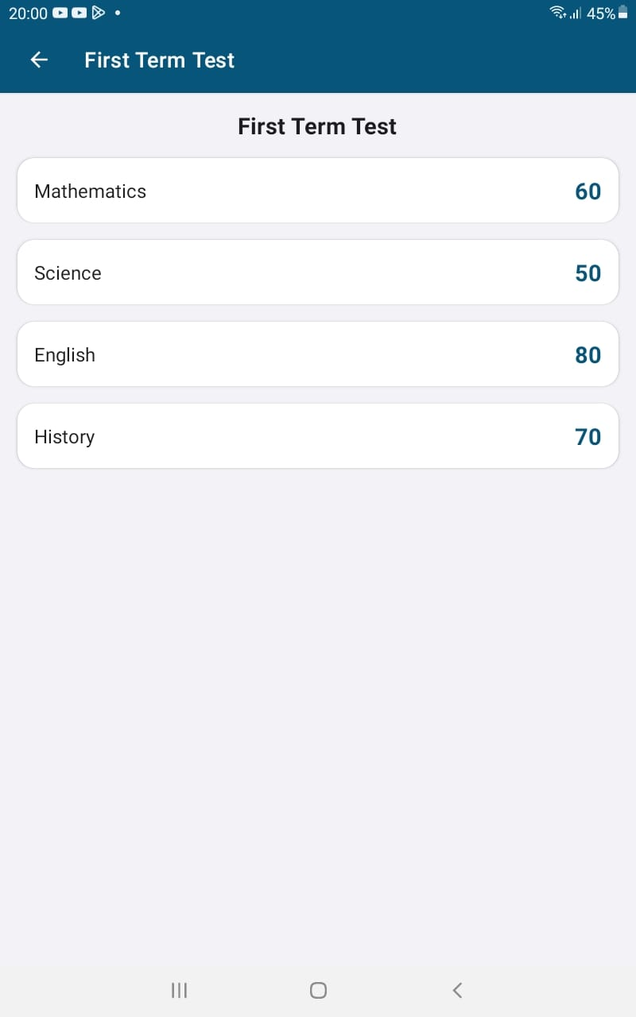
Figure 38 Attendance Figure 39 Marks
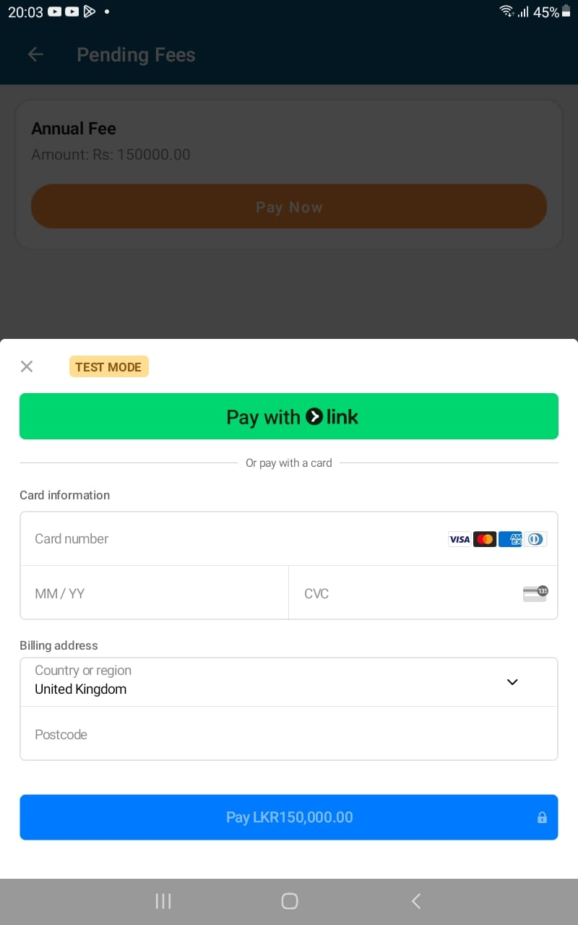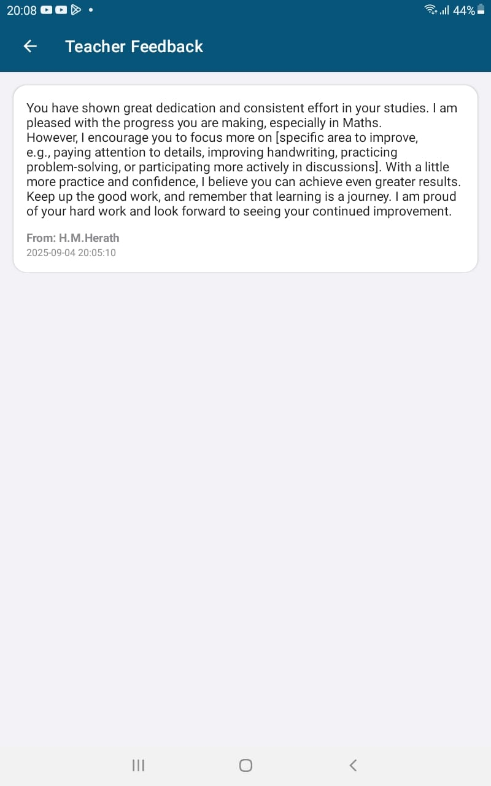
Figure 40Payment Gateway Figure 41 Feedbacks
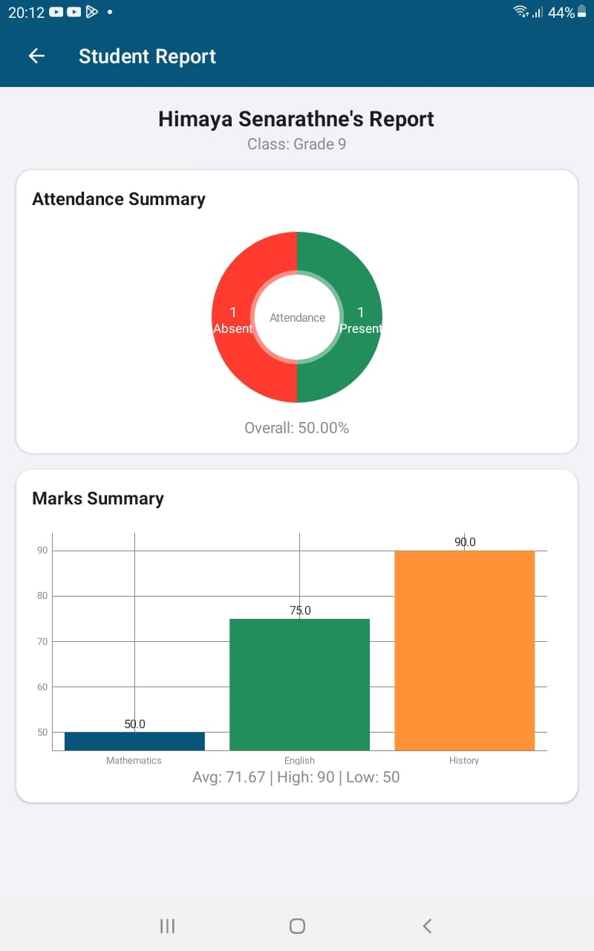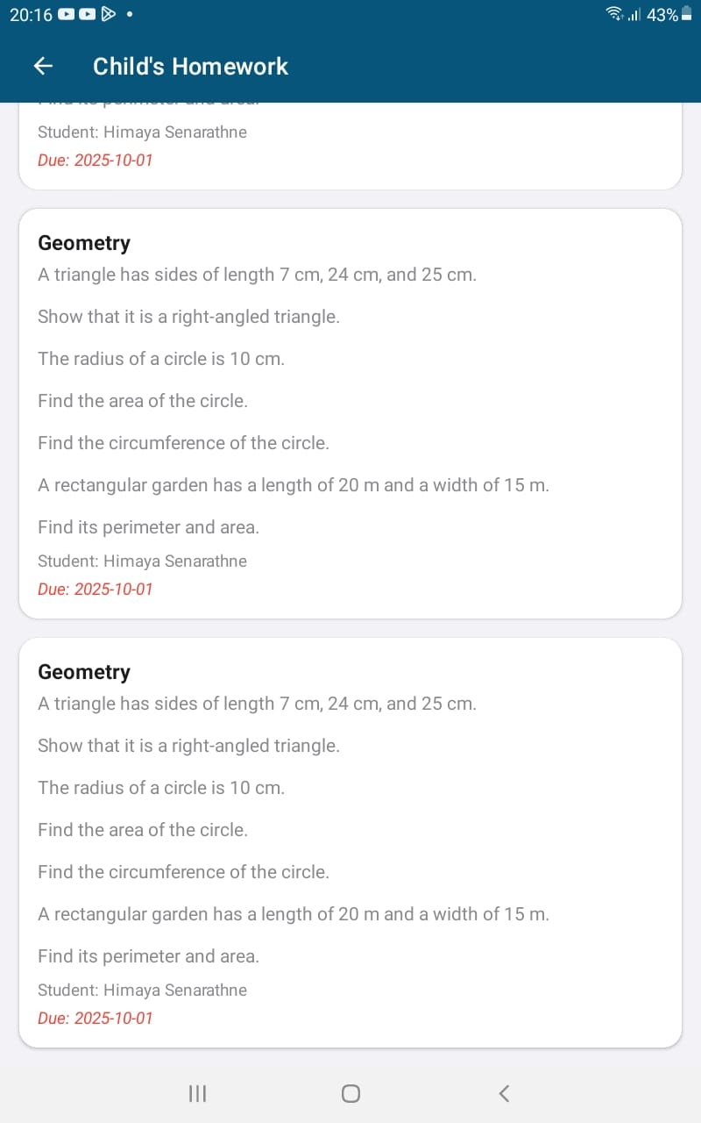
Figure 42 Student Report Figure 43 Homework
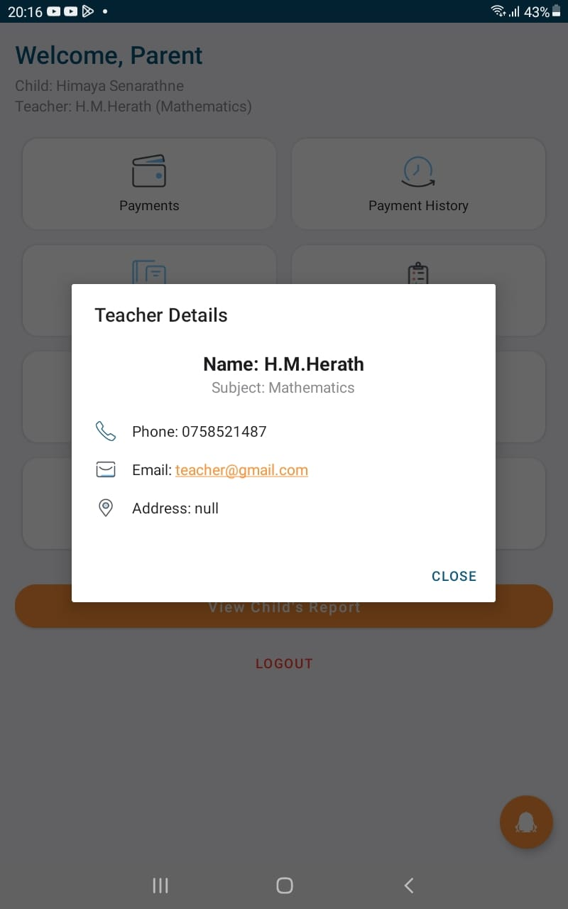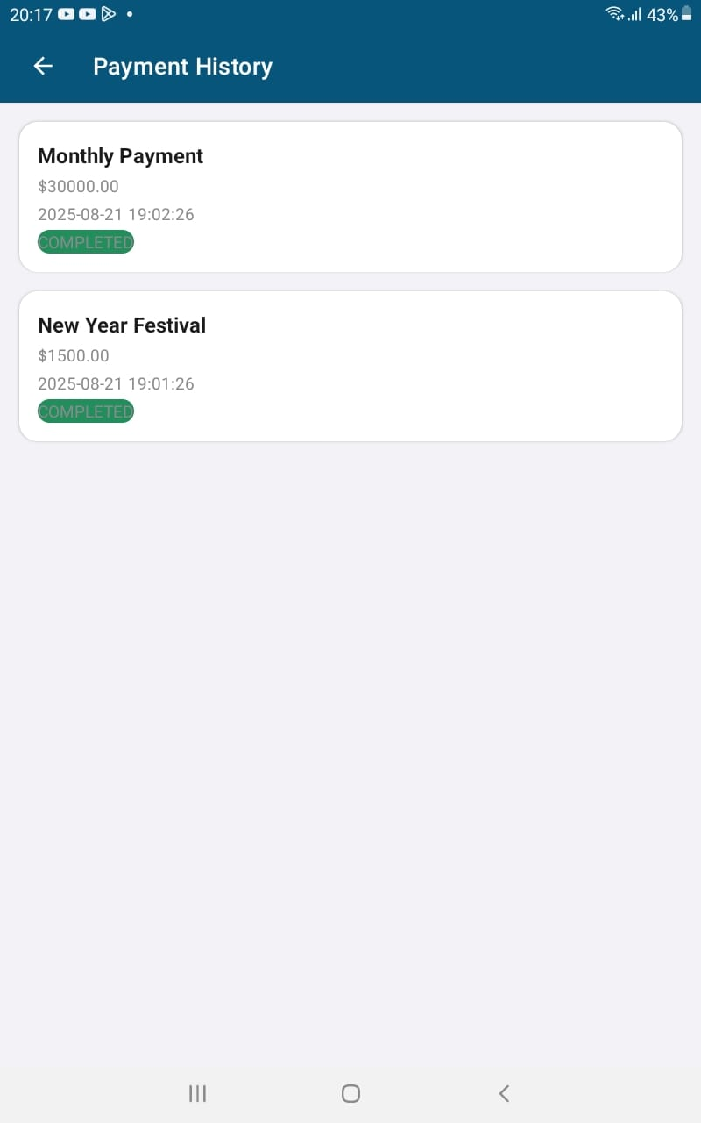
Figure 44 Teacher Details Figure 45 Payment History
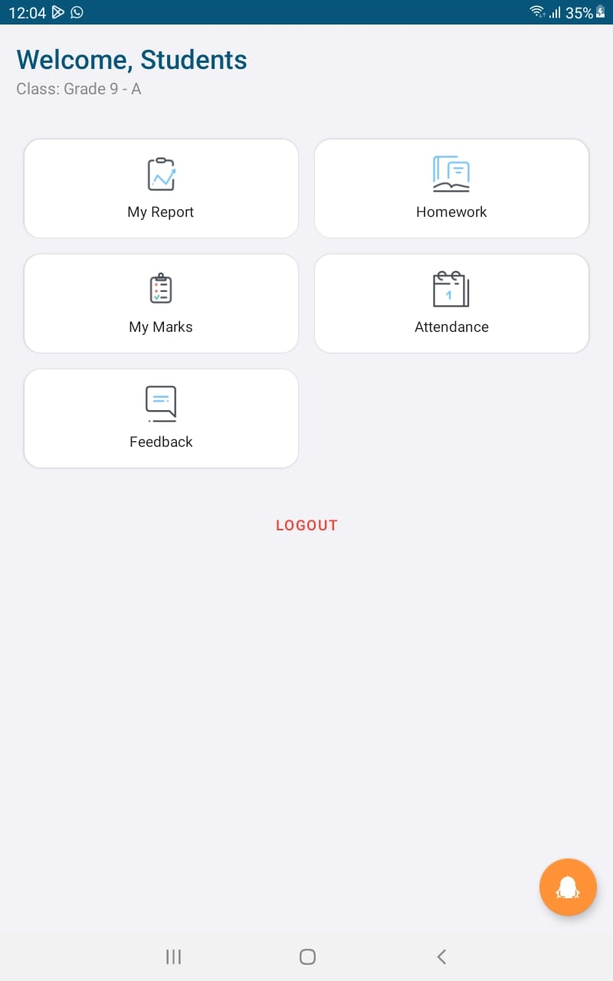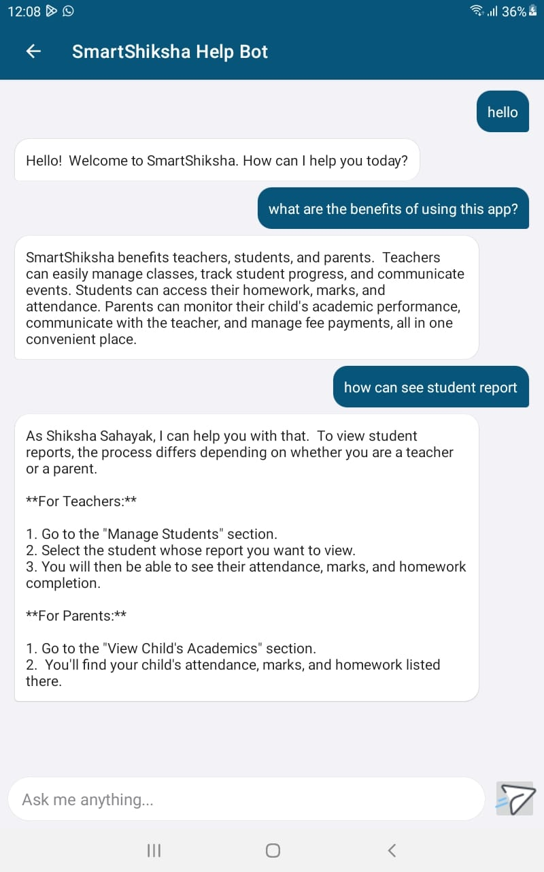
Figure 46 Student Dashboard Figure 47 Chatbot
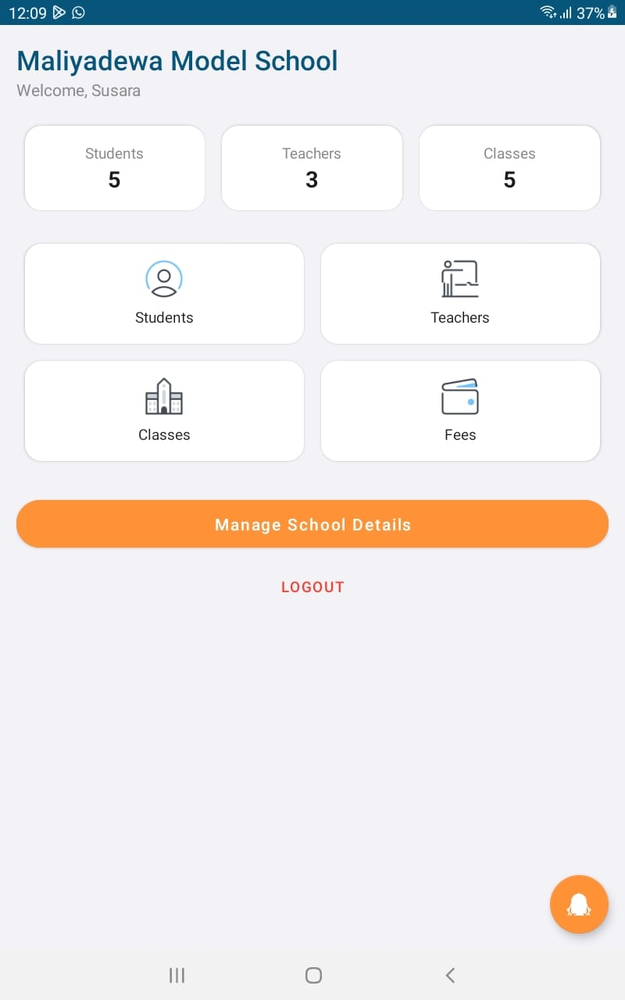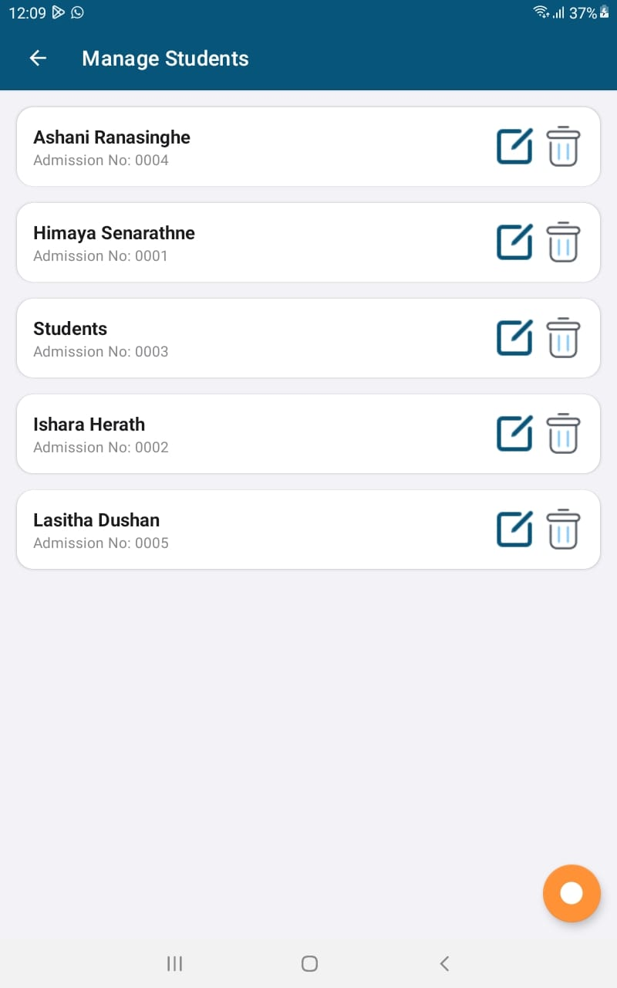
Figure 48 Principal Dashboard Figure 49 Manage Student
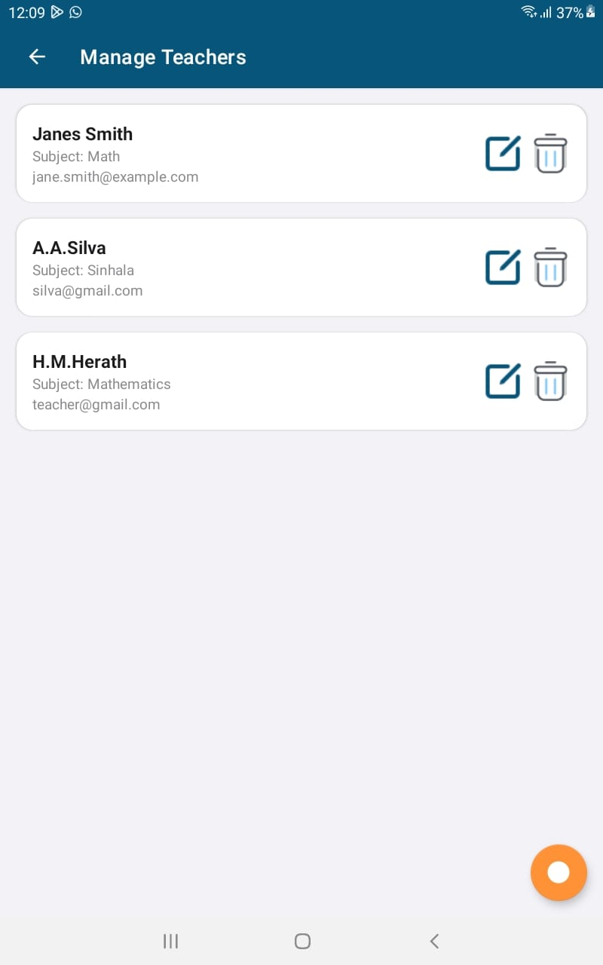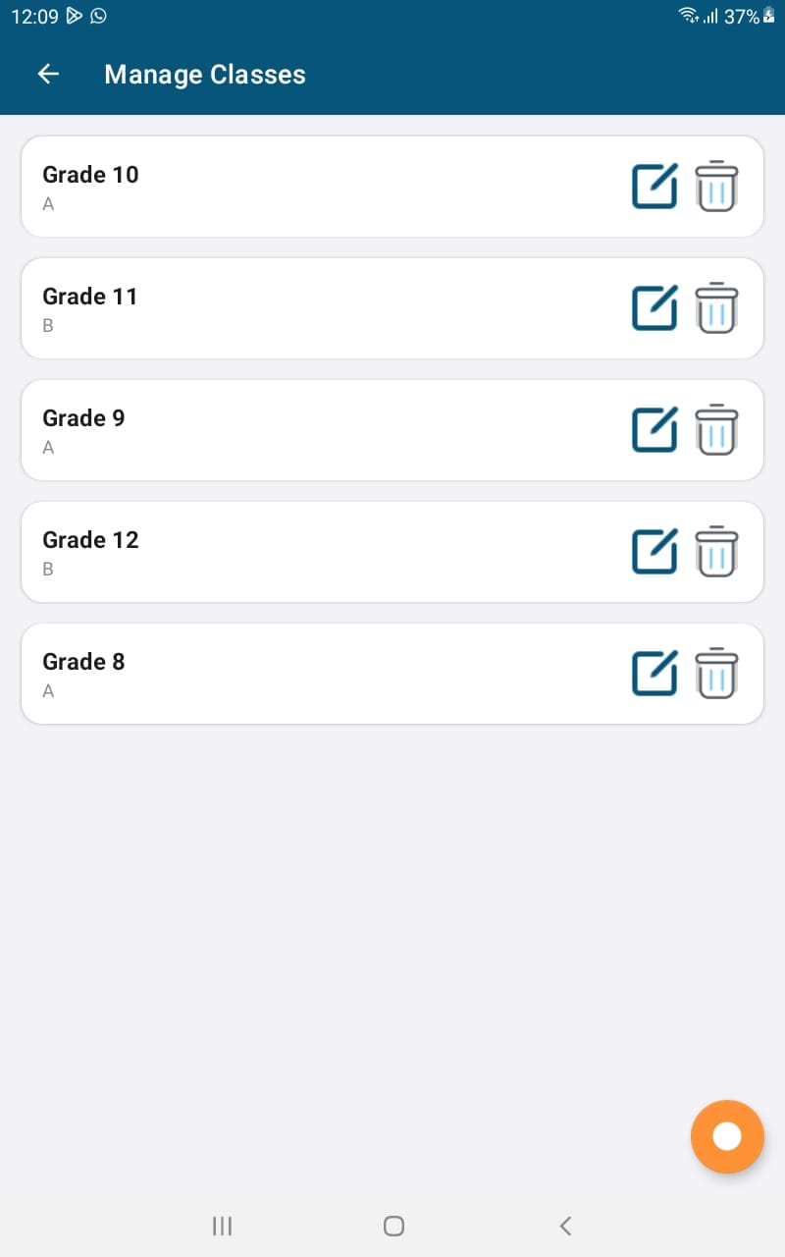
Figure 50 Manage Teacher Figure 51 Manage Classes

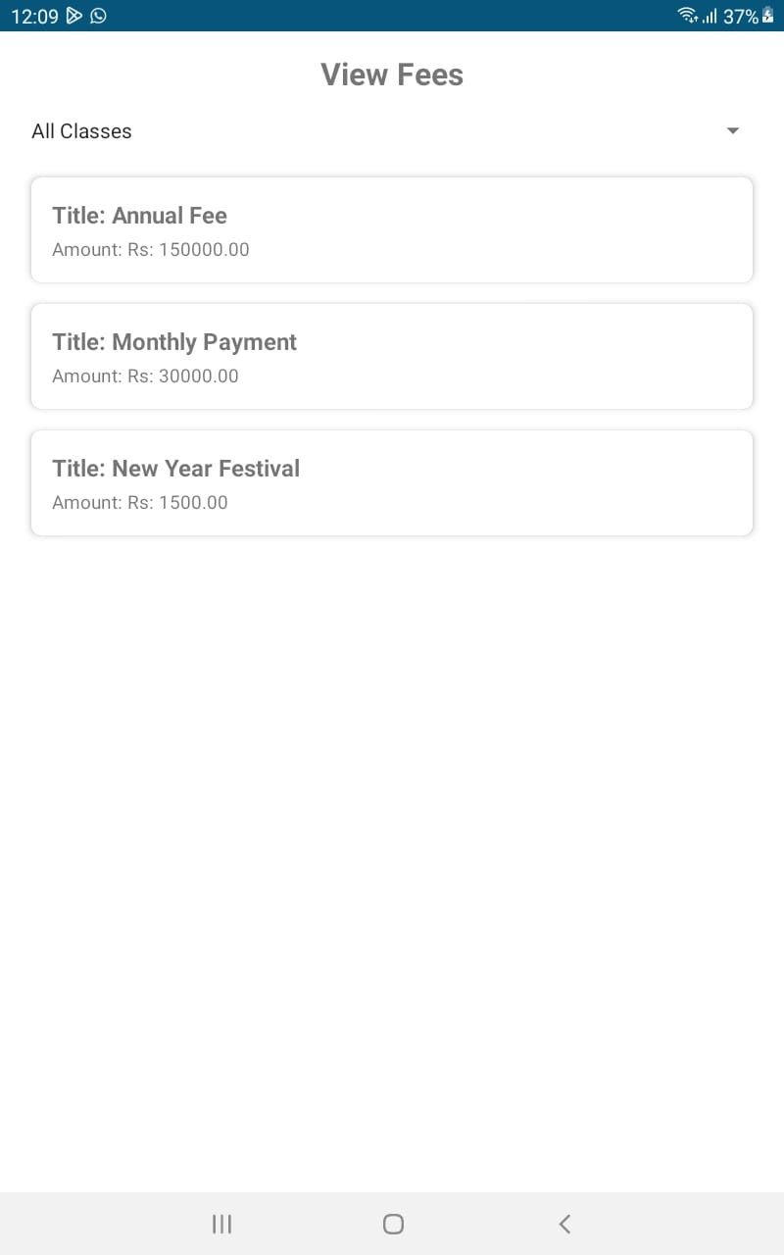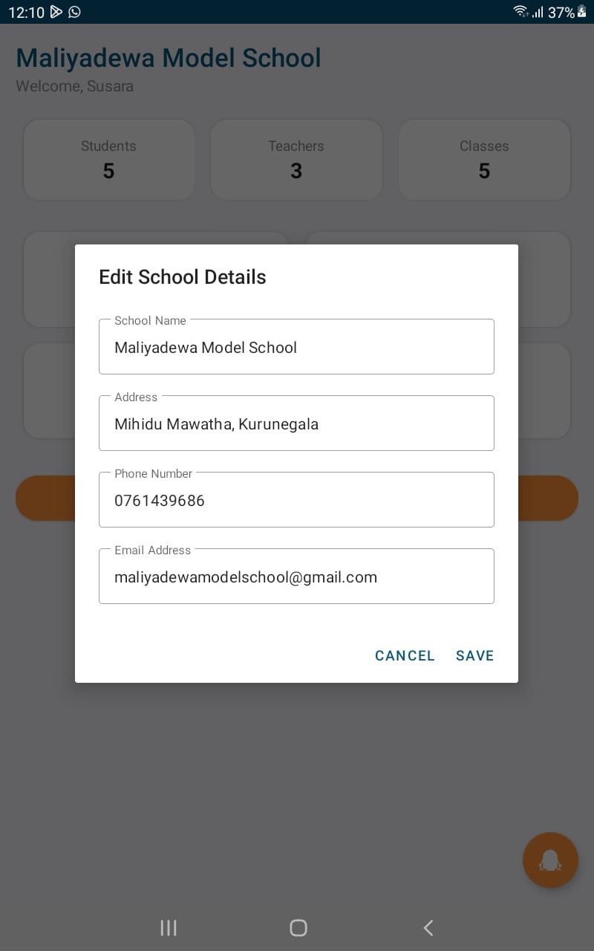
Figure 52 View Fees Figure 53 School Details
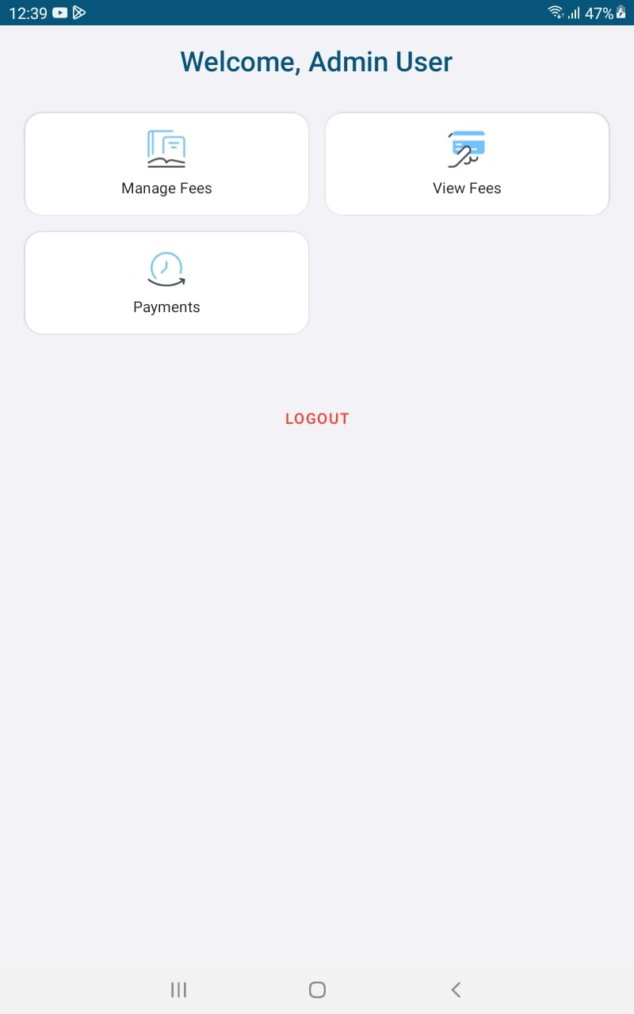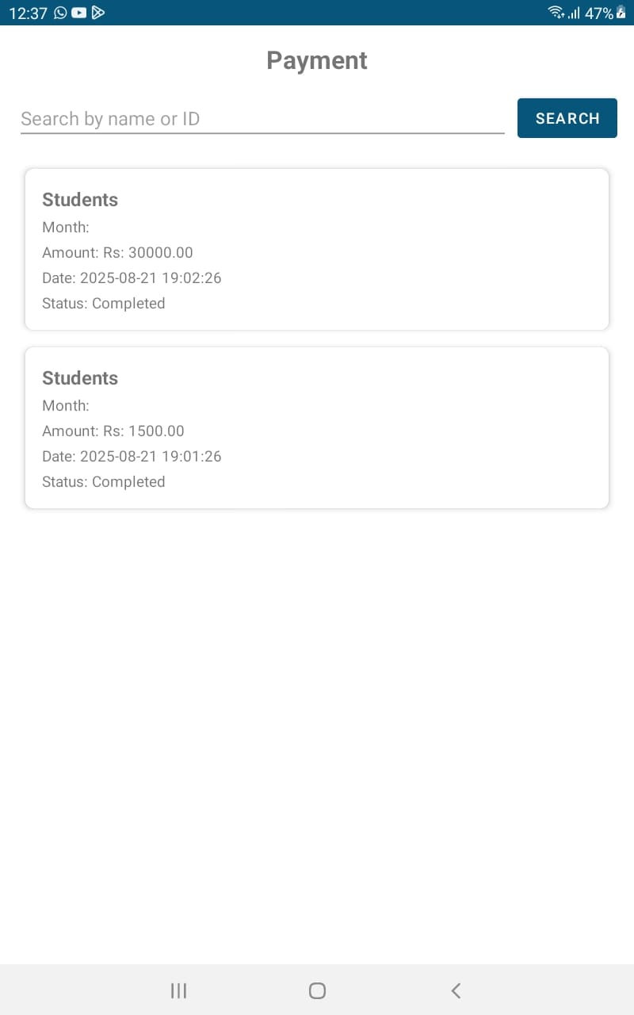
Figure 54 Admin Dashboard Figure 55 Search Payments
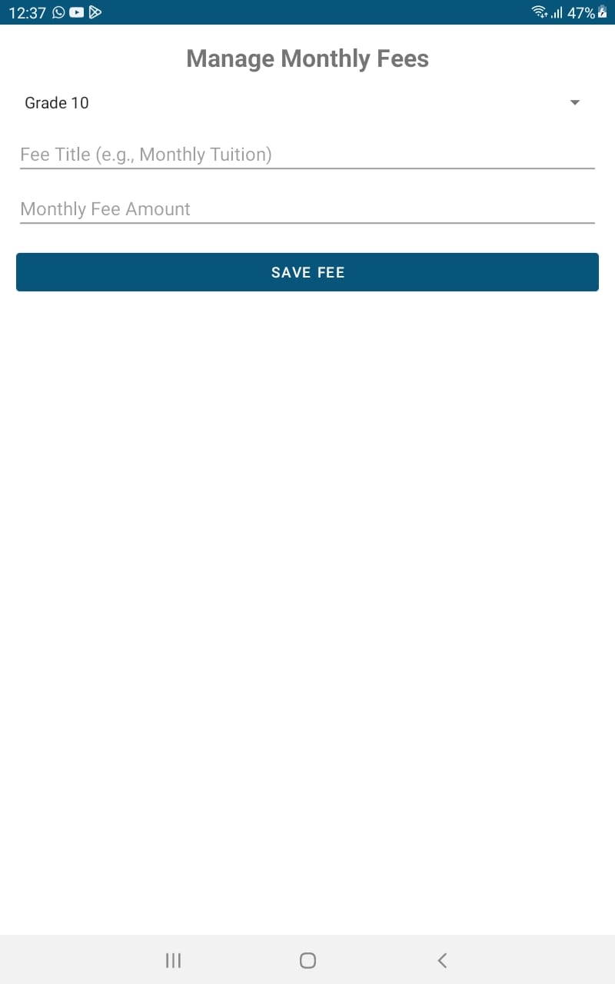
Figure 56 Manage Payments Figure 57 Receipt
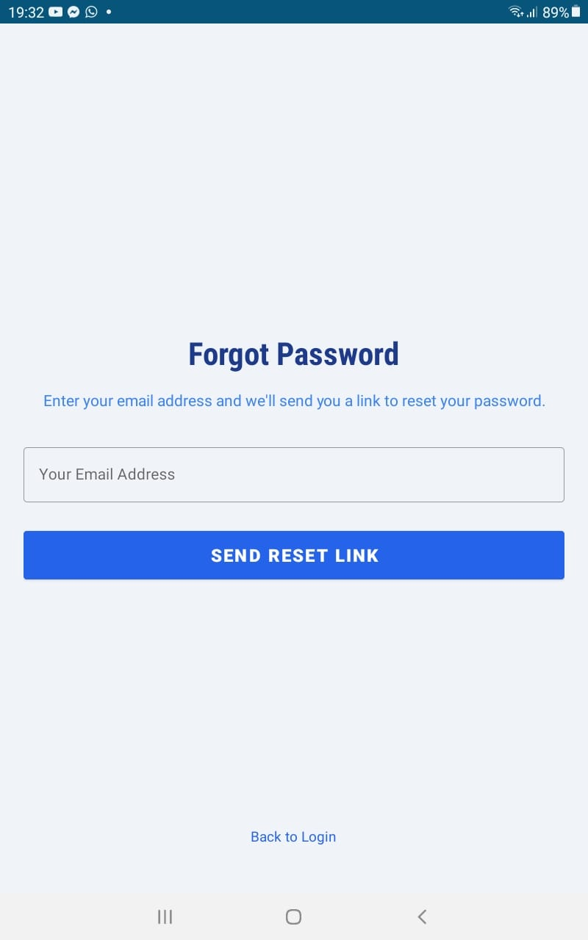
Figure 58 Forget Password

Testing and Validation

7.1. Test Plan

Test Plan ID and Title
TP-SS-01: SmartShiksha Application and Web Platform Test Plan

Introduction and Objective
The purpose of this test plan is to outline the testing strategy for the SmartShiksha parent-teacher-student communication application and website. The primary objective is to ensure that all functional and non-functional requirements are validated against specifications, guaranteeing a secure, user-friendly, and reliable platform. Testing aims to identify defects early, verify system stability, and confirm that the application meets performance, usability, and operational expectations.

Scope of Testing
In Scope
- Mobile application (Android Studio – Java) core features such as attendance, homework management, feedback, reports, and payments.
- Web platform (HTML, CSS, PHP, MariaDB) functionalities including teacher, parent, student, principal, and admin roles.
- Database integrity, including data consistency across 18 structured tables.
- Chatbot functionality for automated support.
- Security testing for user authentication and data privacy.
Out of Scope
- Cross-platform development for iOS.
- Third-party payment gateway integration testing beyond sandbox environments.
- Network-level load balancing and advanced penetration testing.

Test Objectives and Approach
The primary testing goals are
- Verify functional accuracy of teacher, parent, student, principal, and admin workflows.
- Validate database operations such as student record creation, fee management, and report generation.
- Ensure chatbot responses are accurate, timely, and context-appropriate.
- Confirm usability and accessibility of the platform across devices.
- Test operational resilience under normal and high loads.
Approach
- Manual Testing: Functional verification of user stories, exploratory testing, and UI validation.
- Automated Testing: Regression and database queries validation through automated scripts.
- Risk-Based Testing: Prioritize high-risk modules such as payments, attendance, and marks entry.

Test Schedule and Milestones
Phase | Start Date | End Date | Milestones/Deliverables
Test Planning | Week 1 | Week 2 | Test Plan approval
Test Case Development | Week 2 | Week 3 | Test cases reviewed and finalized
Test Environment Setup | Week 3 | Week 4 | Database and application configured
Test Execution | Week 4 | Week 7 | Functional and non-functional testing
Bug Triage and Fixes | Week 5 | Week 8 | Defect resolution and re-testing
Test Closure | Week 9 | Week 10 | Test summary report, sign-off
Table 4 Testing

Test Environment Setup
- Hardware: Windows 10/11 PCs with minimum 8GB RAM, Android smartphones with Android 10 and above.
- Software: Android Studio (for app testing), VS Code (web testing), XAMPP with PHP 8.x, MariaDB (phpMyAdmin), Selenium for automation.
- Configurations: Localhost setup with shared hosting for database and cloud sync testing.
- Tools: Jira for bug tracking, GitHub for version control, JUnit and PHPUnit for automated testing.

Resources and Responsibilities
- Test Manager: Oversees planning, execution, and reporting.
- QA Engineers: Execute manual and automated test cases, log defects, and validate fixes.
- Developers: Resolve reported defects and provide technical support for debugging.
- Project Lead: Ensures resources, timelines, and milestones are met.

Test Deliverables
- Approved test plan
- Test cases and test scripts
- Test execution logs
- Defect reports (Jira)
- Test summary report at closure

Entry and Exit Criteria
Entry Criteria
- Development completed for designated module.
- Test environment fully configured and stable.
- Test cases reviewed and approved.
Exit Criteria
- At least 95% of planned test cases executed successfully.
- All critical and high-severity defects resolved.
- Test summary report reviewed and signed off.

Risks and Mitigation Strategies
- Risk: Delay in bug fixes due to resource limitations.
Mitigation: Allocate buffer time and ensure developer availability during execution.
- Risk: Variations in user digital literacy affecting usability testing.
Mitigation: Include representative testers from different backgrounds.
- Risk: Data corruption during database testing.
Mitigation: Maintain backup and rollback mechanisms for MariaDB.
- Risk: Compatibility issues on lower-end devices.
Mitigation: Perform cross-device testing on a range of Android smartphones.

7.2. Test Cases

Test ID | Test Steps | Test Data | Expected Result | Actual Result
L001 | Enter valid username & password | Username: student@gmail.com, Password: 123 | “Welcome Student”; redirect to Dashboard; session created | Pass
L002 | Enter invalid username | Username: wrongUser, Password: xyz | Login failed: “User not found” | Pass
L003 | Enter incorrect password | Username: admin1, Password: wrongPass | Login failed: “Incorrect password” | Pass
L004 | Leave fields blank | Username: (empty), Password: (empty) | Error: “Please enter both email & password” | Pass

Login

Table 5 Test Case 1

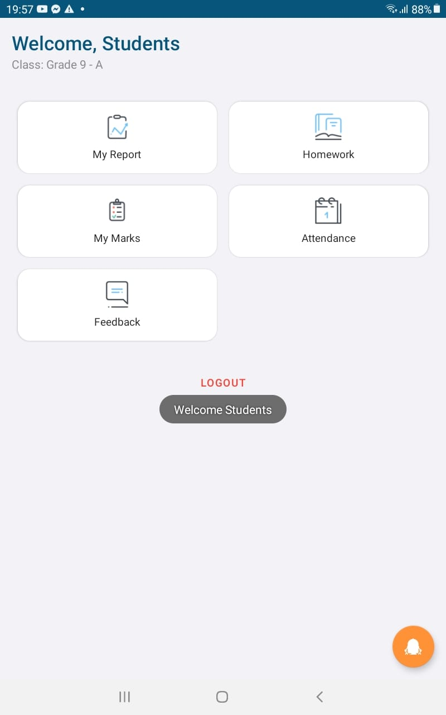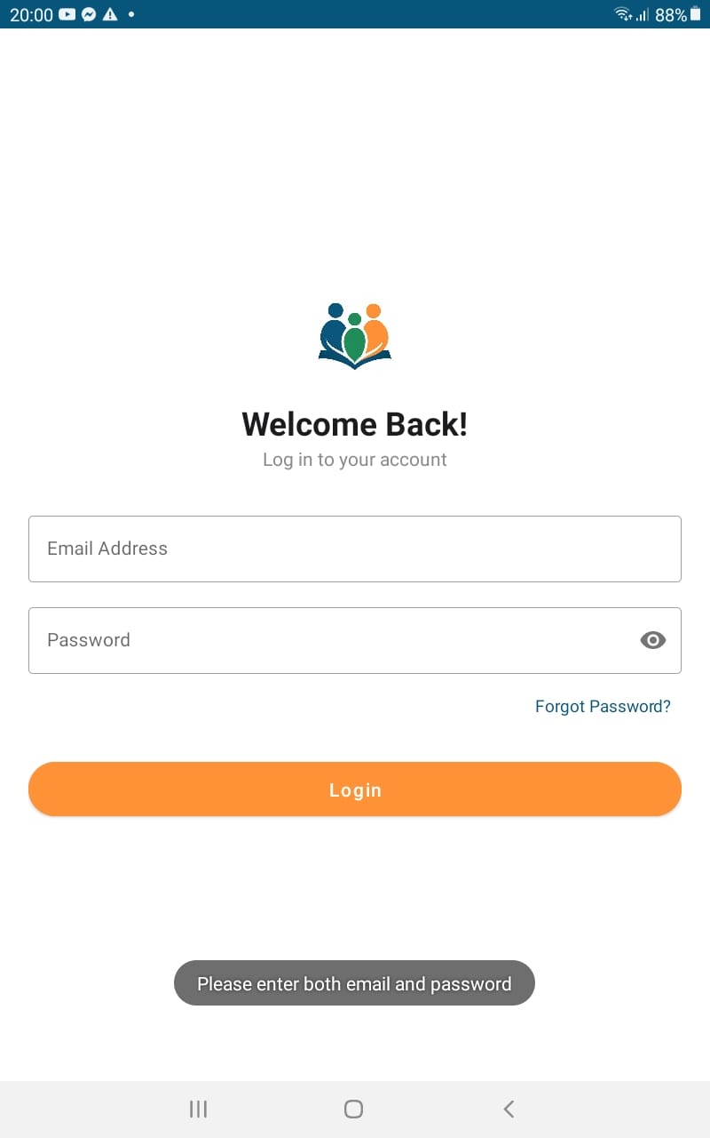

Student Management
Test ID | Test Steps | Test Data | Expected Result | Actual Result
SM01 | Add new student | Name: Ruwan, Grade: 7, Email: ruwan@gmail.com | “Student successfully added”, visible in list | Pass
SM02 | Add with existing email | Email: ruwan@gmail.com (already used) | Error: “Email already registered” | Pass
SM03 | Edit student details | Update phone/address for ID S304 | Details updated successfully | Pass
SM04 | View student profile | ID S304 | Profile shows demographics, attendance, marks | Pass
SM05 | Delete student | ID S304 | Student deleted; related records handled per rules (soft delete or cascade) | Pass
Table 6 Test Cases 2
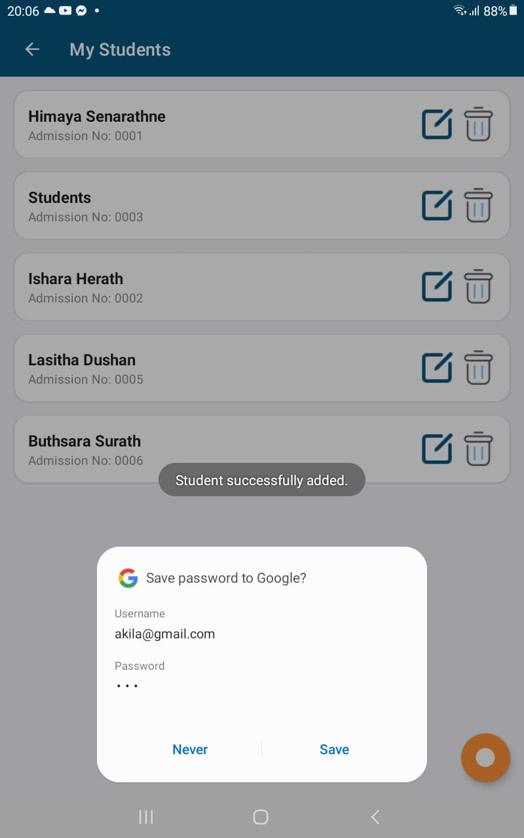

Teacher Management

Test ID | Test Steps | Test Data | Expected Result | Actual Result
TM01 | Add new teacher | Name: Shalani, Subject: Maths, Email: shalanai@gmail.com | “Teacher successfully added”, visible in list | Pass
TM02 | Duplicate email | Email: shalani@mail.com | Error: “Email already registered” | Pass
TM03 | Assign class/subject | Teacher T120 → Grade 7 / Maths | Assignment saved; appears in timetable | Pass
TM4 | Edit teacher profile | Update qualification/phone | Details updated successfully | Pass

Table 7 Test Case 3

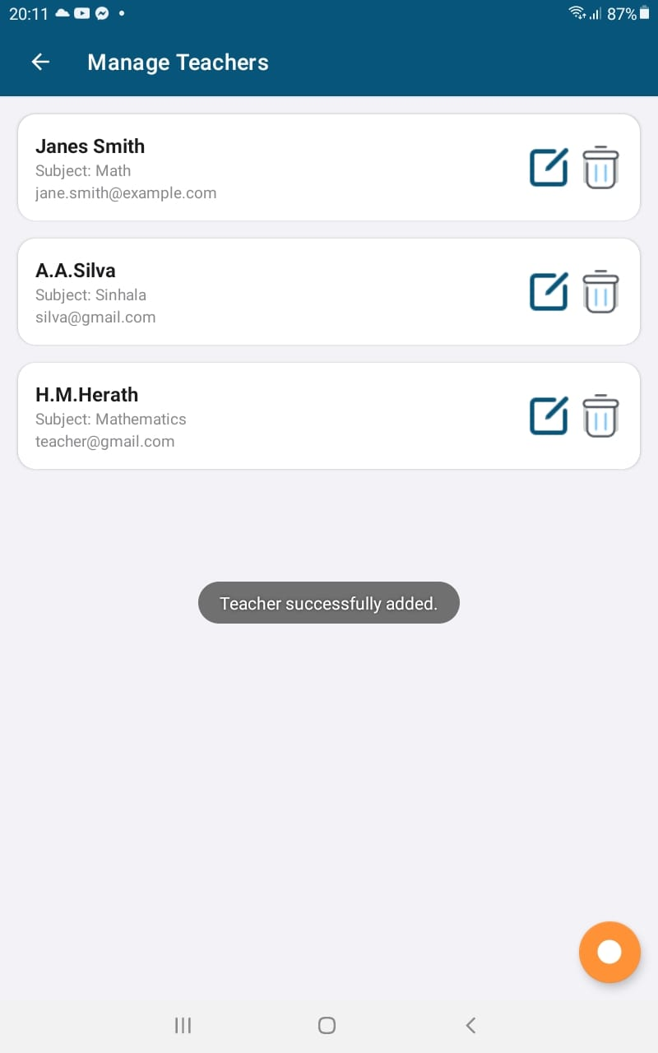

Feedback

Test ID | Test Steps | Test Data | Expected Result | Actual Result
FB01 | Submit feedback | Name Nimal, Email nimal@mail.com, Message “Great portal” | “Feedback sent successfully “ | Pass
FB02 | Invalid email | nimal@mail | Error: “Enter a valid email” | Pass
FB03 | Empty message | (empty) | Error: “Message cannot be empty” | Pass
FB04 | Admin reply | Feedback ID F120 | Reply stored/sent; status → Replied | Pass
Table 8 Test Case 4

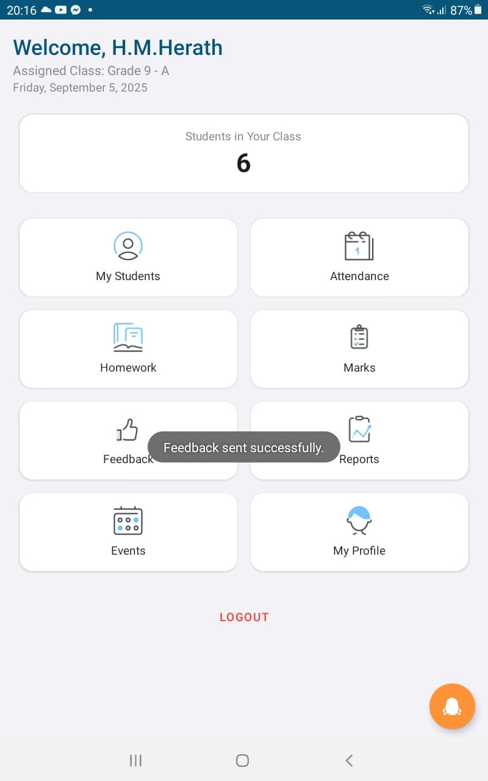

Notice Board & Events

Test ID | Test Steps | Test Data | Expected Result | Actual Result
NE01 | Post a notice (admin) | Title “PTM on Friday”, Expiry +7d | “Event added successfully” , shows on dashboard | Pass
NE02 | Edit/expire notice | Change expiry to past | Notice hidden after expiry | Pass
NE03 | Add event | “Science Fair”, Date 2025-10-01, Venue “Hall A” | Event created; appears in calendar/list | Pass
NE04 | Event registration (if enabled) | Student S304 clicks Register | Registration saved; capacity decremented | Pass
Table 9 Test Case 5

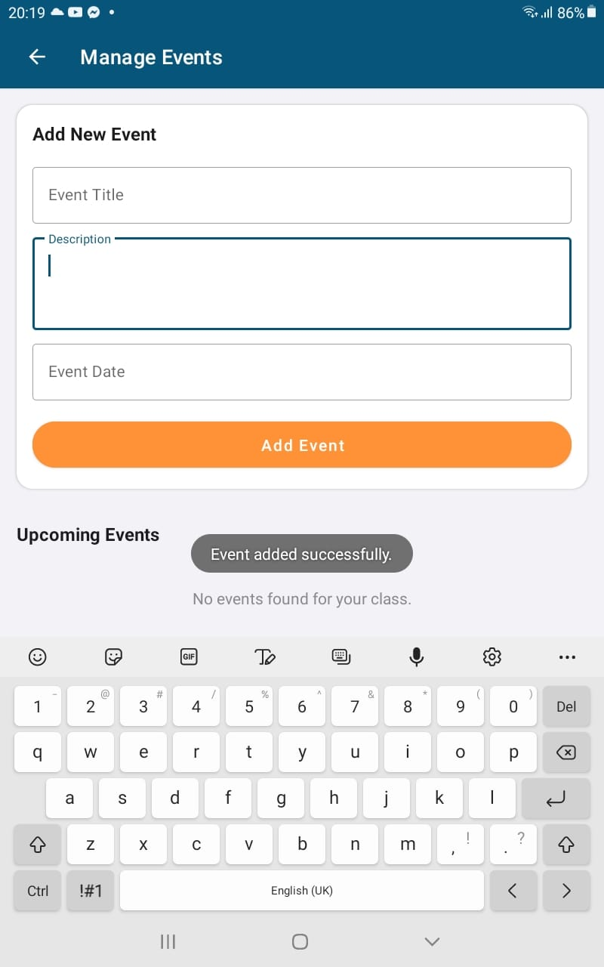

Payments & Fees
Test ID | Test Steps | Test Data | Expected Result | Actual Result
PF01 | Parent is logged in, child assigned and Successful payment with valid card | Grade 7, Term 2, Tuition 15000  4111 1111 1111 1111 | Payment processed successfully, | Pass
PF02 | Invalid card number | 1234 5678 9101 1121 | Payment fails, error message “Your Card Number is Invalid” displayed | Pass
PF03 | Insufficient balance | LKR 15,000 (greater than available balance, e.g., only LKR 10,000 is in the account). | Payment declined; error message displayed | Pass
PF04 | View payment history | Shows all payments done under this parent ID | Correct transaction records (date, amount, method) displayed | Pass
Table 10 Test Case 6
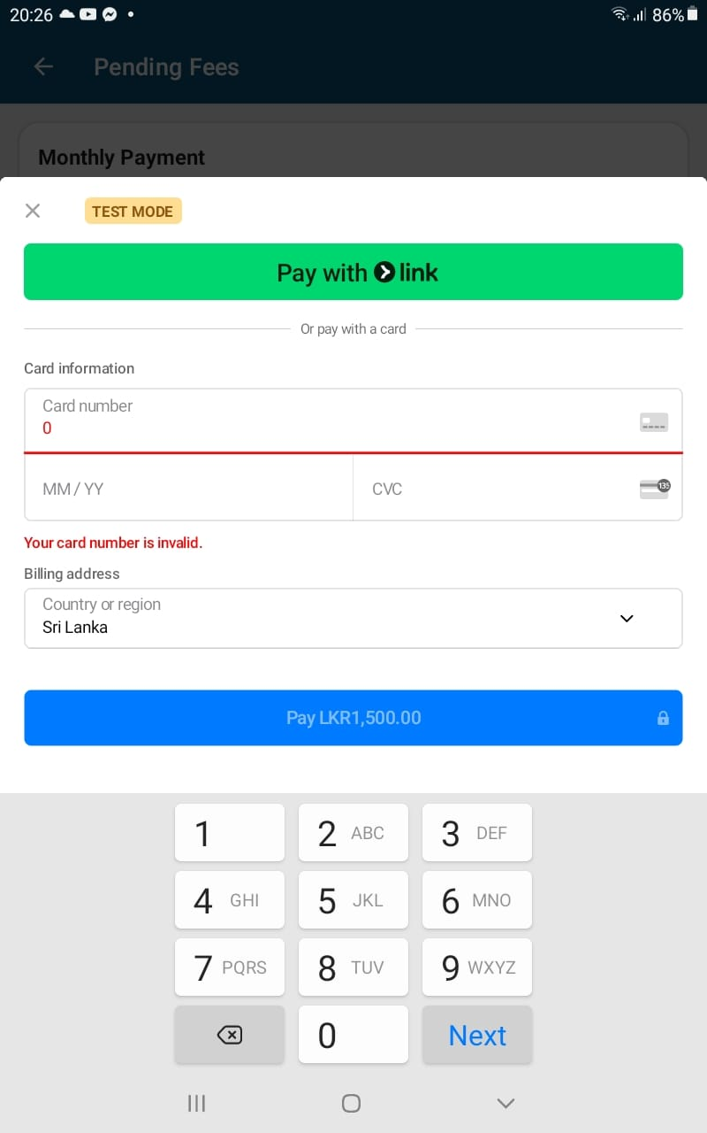

Conclusion
This study set out to explore the use of digital platforms and predictive analytics in enhancing communication and performance monitoring within the Sri Lankan school system. The research identified several critical challenges in existing practices, including fragmented communication, reliance on manual reporting, and limited access to real-time updates for parents, teachers, and students. These issues highlight the necessity for centralized digital solutions that can bridge communication gaps and foster stronger school–home partnerships.
The system proposed in this research integrates both a mobile application and a web platform, leveraging Java (via Android Studio), HTML, CSS, PHP, and MariaDB for data management. The inclusion of a chatbot further enhances user engagement by providing real-time assistance and reducing dependency on manual support. The technological stack selected is cost-effective, scalable, and aligned with global best practices for educational technologies.
From a predictive analytics perspective, multiple machine learning models were evaluated ANN, DNN, and Logistic Regression. Logistic Regression achieved the highest accuracy, significantly outperforming ANN and DNN. This finding supports existing research that demonstrates the reliability of logistic regression in handling structured educational datasets where interpretability and precision are essential. The adoption of Logistic Regression thus ensures that student performance predictions, such as the likelihood of passing the O/L examination, are both accurate and actionable (Widenius et al.,2019).
The feasibility study confirmed that the system is technically, economically, and operationally viable. Ethical considerations, including data privacy and responsible use of student performance data, were also addressed, aligning with international standards of educational data governance. Moreover, the market viability of such a solution is reinforced by the increasing smartphone penetration and internet accessibility in Sri Lanka.
In conclusion, the research demonstrates that a centralized, technologically driven platform can transform communication, monitoring, and predictive capabilities within Sri Lankan schools. By streamlining academic and behavioral reporting, enabling real-time interactions, and incorporating predictive analytics, the system has the potential to enhance transparency, accountability, and overall student success. Future work may explore expanding the model with larger datasets, applying advanced deep learning approaches, and integrating multilingual support to ensure inclusivity across diverse educational communities (Shahiri et al.2015).

9. Future Enhancements
- Mobile Cross-Platform Support
The current app is built for Android, which is widely used in Sri Lanka. However, iOS support is lacking, especially for urban users. A future step would be to adopt cross-platform frameworks like Flutter or React Native, allowing the app to run on both Android and iOS. This will expand coverage and ensure inclusivity across user groups (Ankrah et al., 2020).
- Language Translator
Language remains a key barrier to technology adoption in Sri Lanka. While the current system primarily supports English, many parents and even some teachers in rural areas are more comfortable with Sinhala as the medium of communication. A future enhancement would be to embed a built-in language translator to allow seamless switching between English and Sinhala. This would ensure inclusivity for diverse user groups, strengthen parental engagement, and improve communication between schools and families.
- Notifications via Email and Push Alerts
At present, the system provides in-app updates for activities such as homework, attendance, and notices. However, these updates are only visible when the user actively opens the app. By integrating email notifications and push alerts, schools could ensure that parents and students receive real-time updates, even when they are not logged in. These notifications could cover important events such as fee payment deadlines, examination reminders, emergency closures, or new homework.
- Advanced Predictive Analytics
The system currently employs Logistic Regression as the main predictive model. While this provides valuable insights, the model can be enhanced further through the use of advanced deep learning techniques such as LSTM networks, which are well-suited for sequential and time-series data. This would help teachers identify at-risk students earlier and support better decision-making.
- Integration with Government Education Systems
Another potential future direction is the integration of the application with centralized government education systems, such as databases maintained by the Ministry of Education. This would enable schools to synchronize exam schedules, curriculum updates, and reporting requirements directly within the app, reducing manual input by teachers and ensuring national-level standardization. E-governance initiatives in Sri Lanka face challenges in education due to fragmented systems. This integration would reduce manual work for teachers and align school operations with national standards (Fernando et al.,2019).
- Offline Functionality
Internet access in Sri Lanka is still uneven, especially in rural areas. To address this digital divide, the system can be enhanced with offline-first functionality, where critical features such as homework, notices, and attendance are available offline and synchronize automatically when connectivity is restored. Offline-first design approaches are crucial for educational technologies in developing regions, as they ensure reliability even in low-connectivity environments. This enhancement would make the system more inclusive and usable across the entire country.

10. Lessons Learned

- Importance of User-Centered Design
One of the key lessons learned is the significance of designing applications around the actual needs of users, including parents, teachers, and students. Without considering ease of use and digital literacy levels, even the most technically advanced systems risk rejection. A user-centered design process ensures higher adoption and satisfaction rates, especially in educational contexts where stakeholders have varied technological skills (Norman, 2013).
- Effective Communication Enhances Adoption
The project highlighted that clear and transparent communication between developers, schools, and users is crucial for aligning requirements and expectations. Misunderstandings during the requirement gathering stage can lead to unnecessary redesigns or user dissatisfaction later. Early and consistent engagement with stakeholders improves trust and usability.
- Technology Selection Shapes Long-Term Sustainability
Choosing appropriate technologies such as Android Studio for mobile development, PHP/MySQL for web backend, and a structured database has long-term consequences for system performance, maintainability, and scalability. The lesson learned is that technology selection should balance performance, community support, and future adaptability rather than focusing solely on short-term convenience (Pressman et al., 2019).
- Data Quality is Critical for Machine Learning Accuracy
During the machine learning model evaluation, it became clear that the quality and preparation of data significantly affect model accuracy. Logistic Regression outperformed ANN and DNN due to cleaner handling of structured data. This emphasizes that high-quality input data is often more important than selecting complex models (Provost et al., 2013).
- Testing Must Be Iterative and Comprehensive
The project reinforced that testing cannot be treated as a one-time task but must be iterative and thorough across functionality, usability, and performance. Inadequate testing leads to vulnerabilities or usability issues post-deployment. Establishing structured test plans and milestones greatly improves reliability and reduces post-release costs.
- Cultural and Contextual Factors Influence Adoption
The project revealed that cultural and contextual aspects such as language preferences, digital literacy levels, and regional access to devices play a crucial role in the adoption of educational technology. Ignoring these factors risks alienating certain user groups. Hence, incorporating context-specific features such as Sinhala-language support or offline functionality can improve inclusivity.
- Scalability and Flexibility are Essential for Growth
A significant lesson learned is that educational technologies must be designed with scalability and flexibility in mind. As the user base grows, the system should handle increased traffic, more data, and additional features without requiring complete. Future-proofing the architecture from the start saves resources in the long term.
- Stakeholder Engagement Drives Project Success
Finally, it became evident that the success of educational systems relies not just on technical robustness but also on strong stakeholder engagement, including continuous feedback loops between developers, teachers, and parents. As Bryson, Crosby et al., (2014) argue, collaborative stakeholder involvement fosters ownership, sustainability, and real-world impact.

11. Gantt Chart



12. References
Aturupane, H. (2013) Transforming school education in Sri Lanka: From cut stones to diamonds. Washington, DC: World Bank.
Epstein, J.L. (2011) School, family, and community partnerships: Preparing educators and improving schools. 2nd edn. Boulder, CO: Westview Press.
Little, A.W. (2010) Access to basic education in Sri Lanka: Politics, policies and progress. CREATE Pathways to Access Research Monograph No. 29. Brighton: University of Sussex.
Ministry of Education Sri Lanka (2022) Annual school census report 2022. Colombo: Ministry of Education.
Selwyn, N. (2016) Education and technology: Key issues and debates. 2nd edn. London: Bloomsbury Publishing.
UNESCO (2020) Global education monitoring report 2020: Inclusion and education – All means all. Paris: UNESCO.
UNESCO (2021) Digital learning in developing countries: The future of education. Paris: UNESCO.
World Bank (2018) World development report 2018: Learning to realize education’s promise. Washington, DC: World Bank.
Goodall, J. and Montgomery, C. (2014) ‘Parental involvement to parental engagement: A continuum’, Educational Review, 66(4), pp. 399–410.
Harris, J. (2015) Integrating technology in education: Key issues and strategies. London: Routledge.
Jeynes, W.H. (2012) ‘A meta-analysis of the efficacy of different types of parental involvement programs for urban students’, Urban Education, 47(4), pp. 706–742.
Little, A.W. (2010) Access to basic education in Sri Lanka: Politics, policies and progress. CREATE Pathways to Access Research Monograph No. 29. Brighton: University of Sussex.
OECD (2019) OECD skills outlook 2019: Thriving in a digital world. Paris: OECD Publishing.
Selwyn, N. (2016) Education and technology: Key issues and debates. 2nd edn. London: Bloomsbury Publishing.
Al-Barrak, M.A. and Al-Razgan, M. (2016) ‘Predicting students’ performance through classification: A case study’, Journal of Theoretical and Applied Information Technology, 93(2), pp. 335–344.
Kotsiantis, S., Pierrakeas, C. and Pintelas, P. (2010) ‘Predicting students’ performance in distance learning using machine learning techniques’, Applied Artificial Intelligence, 18(5), pp. 411–426.
Romero, C. and Ventura, S. (2020) ‘Educational data mining and learning analytics: An updated survey’, Wiley Interdisciplinary Reviews: Data Mining and Knowledge Discovery, 10(3), pp. 1–21.
Marston, S., Li, Z., Bandyopadhyay, S., Zhang, J. and Ghalsasi, A. (2011) ‘Cloud computing — The business perspective’, Decision Support Systems, 51(1), pp. 176–189.
Laudon, K.C. and Laudon, J.P. (2020) Management information systems: Managing the digital firm. 16th edn. Harlow: Pearson.
Williamson, B. (2017) Big data in education: The digital future of learning, policy and practice. London: SAGE.
Romero, C. and Ventura, S. (2020) ‘Educational data mining and learning analytics: An updated survey’, Wiley Interdisciplinary Reviews: Data Mining and Knowledge Discovery, 10(3), pp. 1–21.
Government of Sri Lanka (2022) Personal Data Protection Act No. 9 of 2022. Colombo: Government of Sri Lanka.
Wijesinghe, R. (2017) ‘Educational inequality in rural Sri Lanka: A sociological perspective’, Sri Lanka Journal of Social Sciences, 40(2), pp. 45–58.
Livingstone, S. and Sefton-Green, J. (2016) The class: Living and learning in the digital age. New York: NYU Press.
Perera, L. and Gunawardena, C. (2012) ‘Cultural diversity and ICT integration in Sri Lanka’, International Journal of Education and Development using ICT, 8(1), pp. 55–67.
Anderson, J. (2010) ICT transforming education: A regional guide. Bangkok: UNESCO.
Fernando, R. (2020) ‘Green ICT practices in Sri Lanka: Opportunities and challenges’, Journal of Environmental Management and Sustainability, 5(2), pp. 23–34.
Sommerville, I. (2016) Software engineering. 10th edn. Harlow: Pearson.
Preece, J., Rogers, Y. and Sharp, H. (2015) Interaction design: Beyond human-computer interaction. 4th edn. Hoboken: Wiley.
Beck, K., Beedle, M., van Bennekum, A., Cockburn, A., Cunningham, W., Fowler, M., Grenning, J., Highsmith, J., Hunt, A., Jeffries, R., Kern, J., Marick, B., Martin, R.C., Mellor, S., Schwaber, K., Sutherland, J. and Thomas, D. (2001) Manifesto for Agile Software Development.
Pressman, R.S. and Maxim, B.R. (2020) Software engineering: A practitioner’s approach. 9th edn. New York: McGraw-Hill.
Chung, L., Nixon, B.A., Yu, E. and Mylopoulos, J. (2012) Non-functional requirements in software engineering. Berlin: Springer Science & Business Media.
Wiegers, K.E. and Beatty, J. (2013) Software requirements. 3rd edn. Redmond: Microsoft Press.
Widenius, M., Axmark, D. and Arno, K. (2019) MariaDB and MySQL: Commonalities and Differences. Open-Source Database Foundation.
DuBois, P. (2013) MySQL Cookbook. 3rd edn. Sebastopol, CA: O’Reilly Media.
Google DeepMind (2023) Introducing Gemini: our largest and most capable AI model. Available at: https://deepmind.google/technologies/gemini
Goodfellow, I., Bengio, Y. and Courville, A. (2016) Deep Learning. Cambridge, MA: MIT Press.
LeCun, Y., Bengio, Y. and Hinton, G. (2015) ‘Deep learning’, Nature, 521(7553), pp. 436–444.
Widenius, M., Axmark, D. and Arno, K. (2019) MariaDB and MySQL: The Complete Guide. 2nd edn. Birmingham: Packt Publishing.
Shahiri, A.M., Husain, W. and Rashid, N.A. (2015) ‘A review on predicting student’s performance using data mining techniques’, Procedia Computer Science, 72, pp. 414–422.
Ankrah, E. and Osei-Bryson, K. (2020) ‘Cross-platform mobile application development: Benefits and challenges’, Journal of Information Technology Research, 13(1), pp. 21–35.
Fernando, M. and Samaranayake, P. (2019) ‘E-governance in Sri Lanka: Opportunities and challenges in the education sector’, Sri Lanka Journal of Social Sciences, 42(2), pp. 87–95.
Norman, D. (2013) The Design of Everyday Things. Revised and expanded edn. New York: Basic Books.
Pressman, R. and Maxim, B. (2019) Software Engineering: A Practitioner’s Approach. 9th edn. New York: McGraw-Hill Education.
Provost, F. and Fawcett, T. (2013) Data Science for Business: What You Need to Know about Data Mining and Data-Analytic Thinking. Sebastopol: O’Reilly Media.

13. User Manual
Payments – Make school fee or other payments online.
Payment History – View records of past transactions.
Homework – Check your child’s assigned homework.
Marks – View exam and test results.
Attendance – Track your child’s daily attendance records.
Feedback – Send feedback or concerns to the school.
Contact Teacher – Directly message or call your child’s teacher.
Assign Child – Link a child’s profile to your parent account.
View Child’s Report – Open a detailed academic and activity report.
Logout – Securely exit your account.


Pending Fees Section – Shows the type of fee (e.g., Annual Fee) and the amount due.
Pay Now Button – Starts the payment process for the selected fee.
Pay with Link Button – Option to complete payment through a secure payment gateway (Link).
Card Information Fields – Enter your card details:
- Card Number – 16-digit card number.
- MM/YY – Expiry date of the card.
- CVC – 3-digit (Visa/MasterCard) or 4-digit (Amex) security code.
Billing Address Section – Select country/region and enter postcode.
Pay Button – Confirms and processes the payment (shows the amount in LKR).




My Report – View a summary of your academic performance and progress.
Homework – Access homework assigned by teachers.
My Marks – Check exam and test results for each subject.
Attendance – Track your attendance records (present/absent days).
Feedback – Send feedback or requests to teachers or school admins.
Logout – Securely exit your account.


Student Report Guidance – Provides steps based on user type:
- For Teachers
Go to Manage Students.
Select the student.
View attendance, marks, and homework completion.
- For Parents:
Go to View Child’s Academics.
Check attendance, marks, and homework details.
Chat Input Box – Allows users to type questions and get instant automated responses.
Welcome Message – Greets users and offers assistance with common queries.


Students Card – Displays the total number of registered students.
Teachers Card – Shows the total number of teachers in the school.
Classes Card – Indicates the total number of active classes.
Students Button – Opens student management (view, add, or update student details).
Teachers Button – Opens teacher management (view, add, or update teacher details).
Classes Button – Manage class details, assignments, and schedules.
Fees Button – View and manage school fee structures and payments.
Manage School Details Button – Allows updating overall school information and settings.
Logout Button – Securely exit the admin account.


Student List – Displays all registered students with their names and admission numbers.
Edit Icon – Allows the admin to update student details (e.g., name, class, admission info).
Delete Icon – Permanently removes a student’s record from the system.
Add Button (Orange) – Add a new student to the database.


Class List – Displays all available grades and their sections (e.g., Grade 10 – A, Grade 11 – B).
Edit Icon – Allows the admin to update class details (e.g., section name, teacher assignment).
Delete Icon – Permanently removes a class from the system.
Add Button (Orange) – Add a new class to the school database.


Fee List – Displays all active fees with their titles and amounts (e.g., Annual Fee, Monthly Payment, New Year Festival).
Title Field – Shows the name of the fee (purpose or category).
Amount Field – Displays the amount to be paid in rupees (LKR).
Dropdown (All Classes) – Allows filtering fees by specific classes or viewing all at once.


School Name Field – Enter or update the official name of the school.
Address Field – Provide or edit the school’s physical address.
Phone Number Field – Add or update the school’s contact number.
Email Address Field – Enter the official school email for communication.
Cancel Button – Discards changes and returns to the previous screen.
Save Button – Confirms and updates the school details in the system.


Manage Fees – Create, update, or delete different fee categories (e.g., annual, monthly, event-based).
View Fees – See all existing fees with their titles and amounts for reference.
Payments – Track and review payments made by parents or students.
Logout – Securely exit the admin account.


Search Bar – Allows searching for payments by student name or ID.
Search Button – Executes the search to quickly find specific payment records.
Payment Records – Displayed in card format, showing details such as:
- Student – Name or group (e.g., Students).
- Month – The billing month for the payment.
- Amount – Total fee paid (in LKR).
- Date & Time – Exact timestamp of payment.
- Status – Indicates whether payment is Completed or Pending.


Class Dropdown (e.g., Grade 10) – Select the class for which the monthly fee will be set.
Fee Title Field – Enter the title of the fee (e.g., Monthly Tuition, Lab Fee).
Monthly Fee Amount Field – Input the amount to be charged each month.
Save Fee Button – Confirms and saves the fee details into the system.

Teacher Name & Subject – Displays the teacher’s full name and the subject they teach (e.g., H.M. Herath – Mathematics).
Phone Number – Shows the teacher’s contact number for direct communication.
Email Address – Provides the teacher’s official email for queries or feedback.
Address – Displays the teacher’s registered address (if available).
Close Button – Closes the popup and returns to the parent dashboard.



14. Appendix

14.1. Google Form
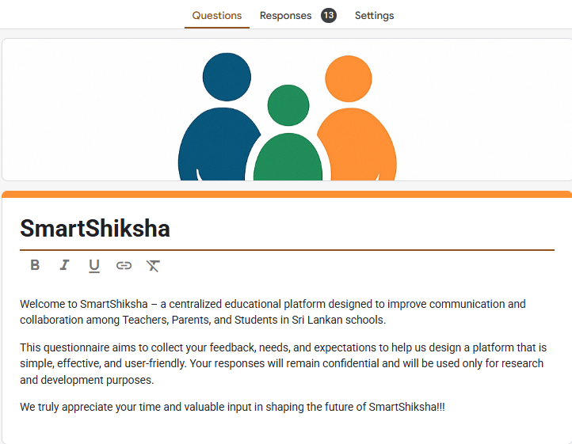
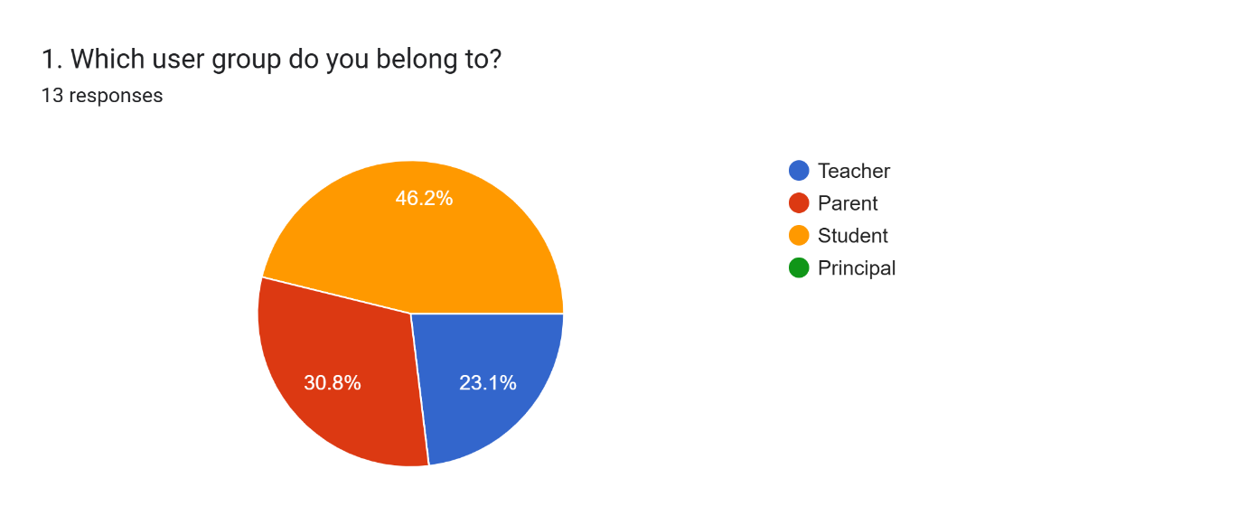
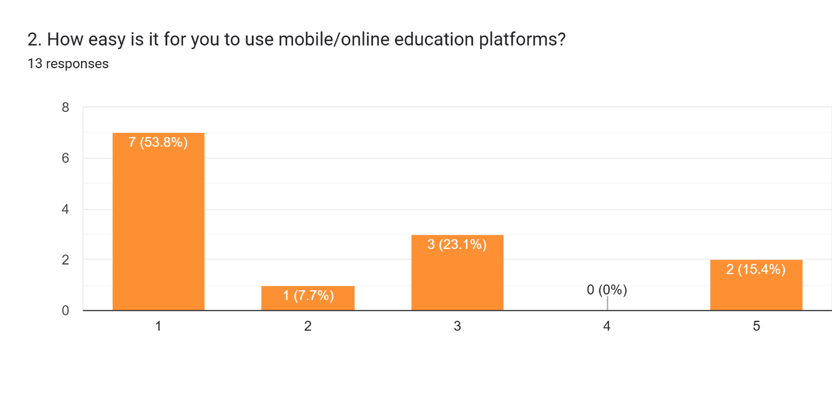
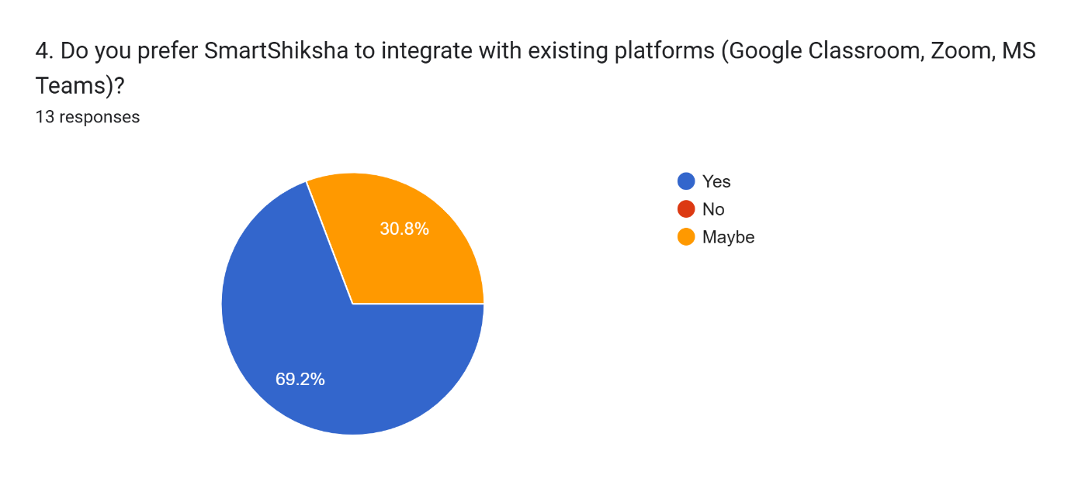
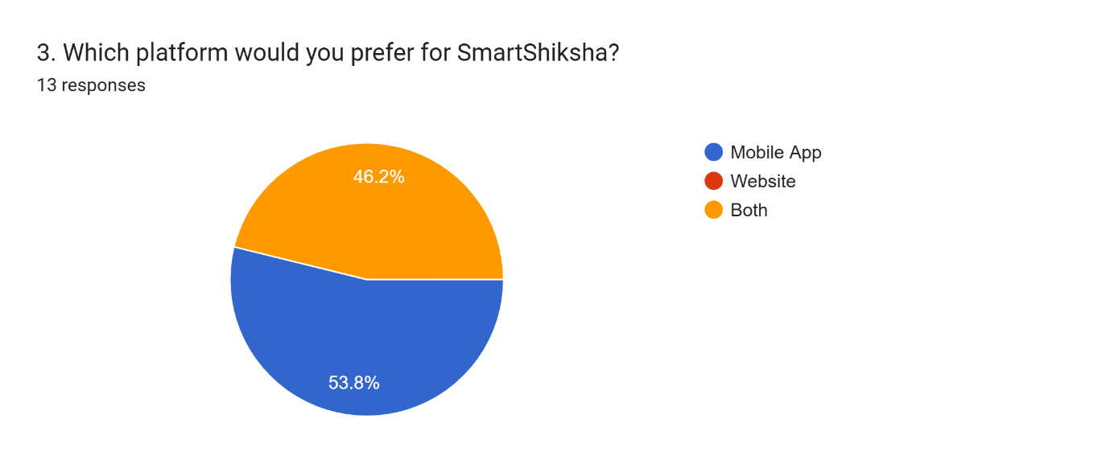
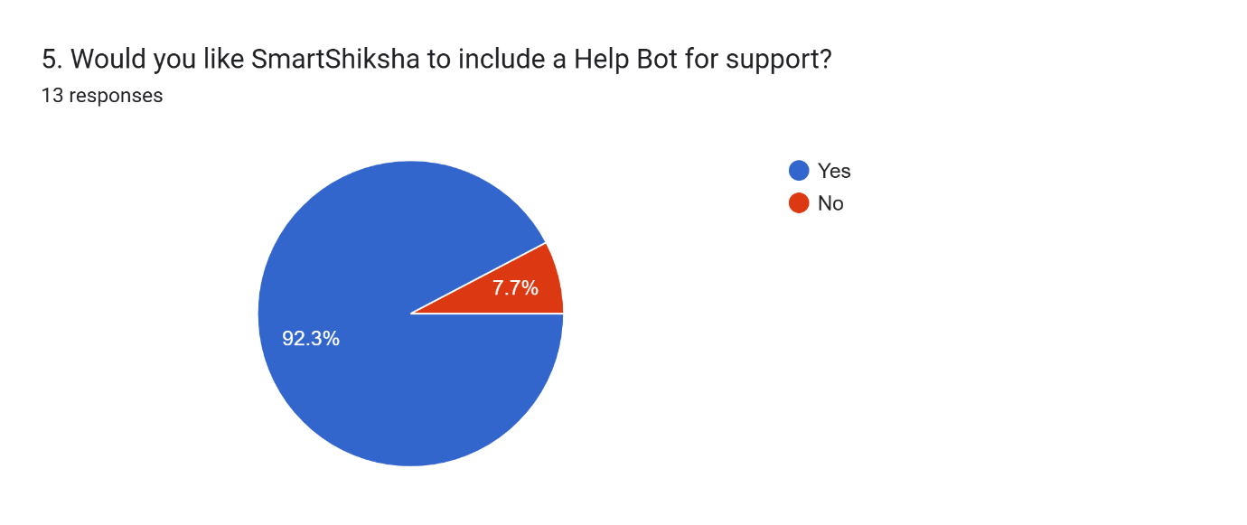
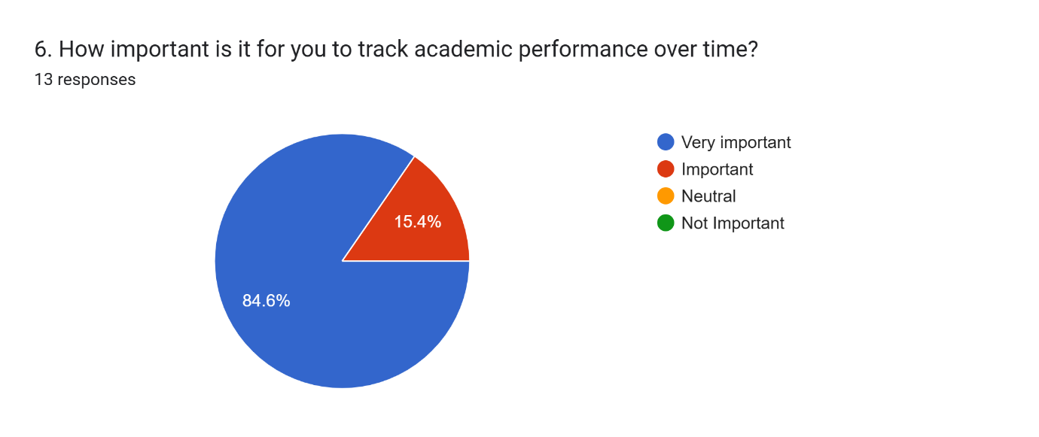
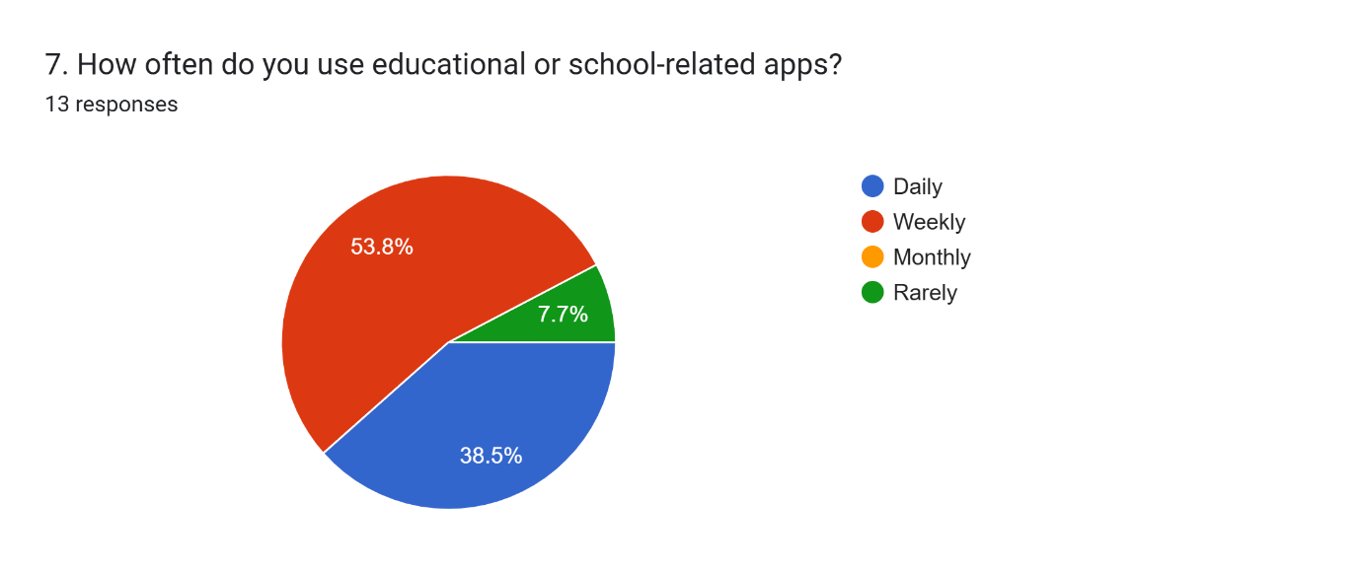
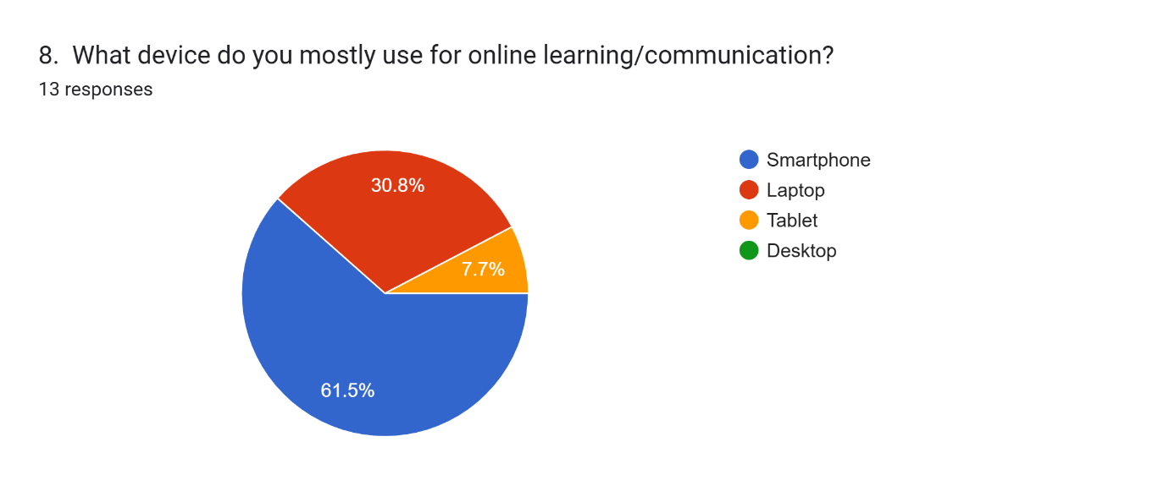
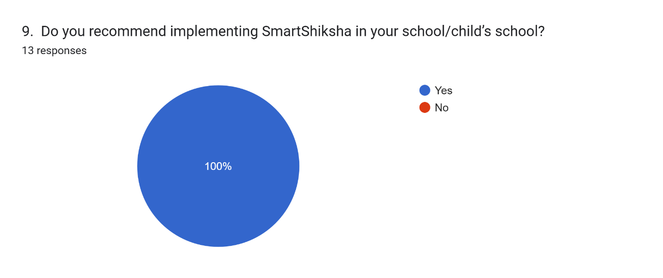
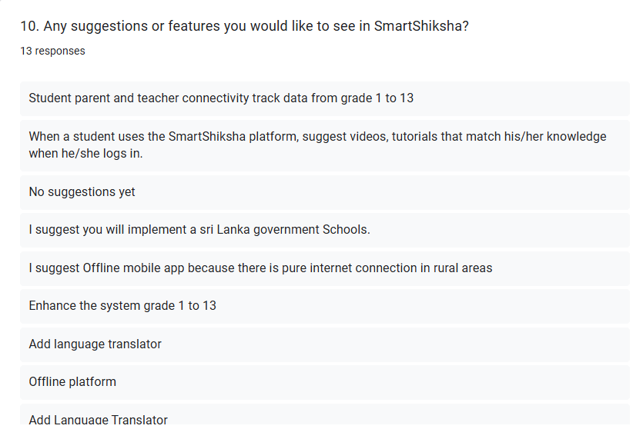

11.2. Codes
Application
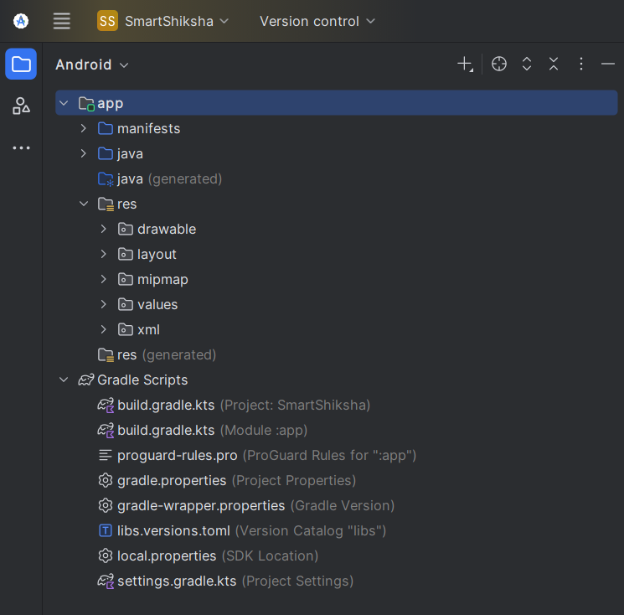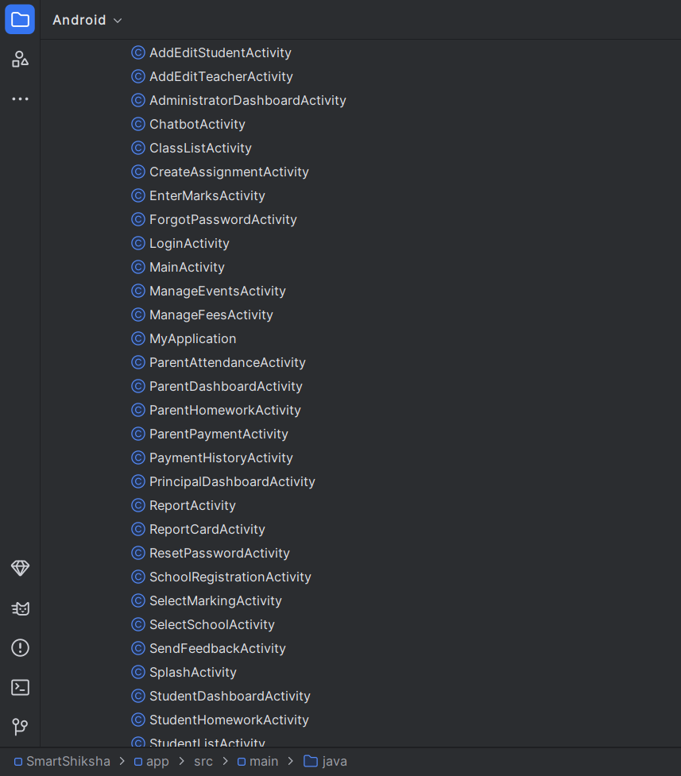
Figure 59 Java Files
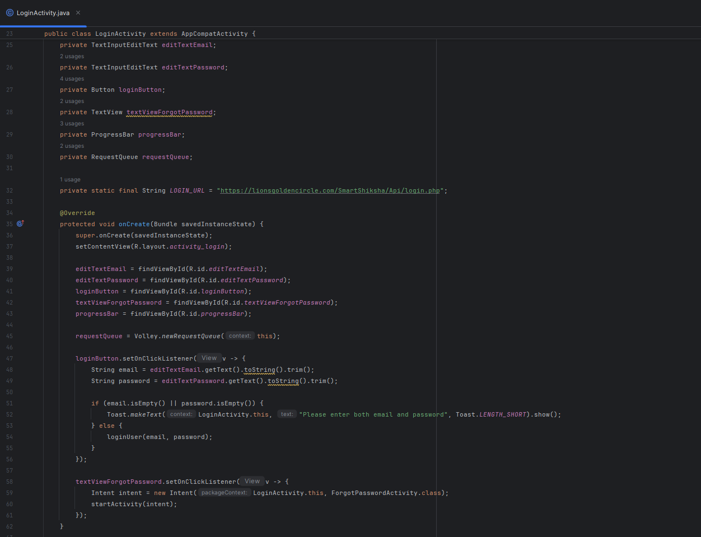
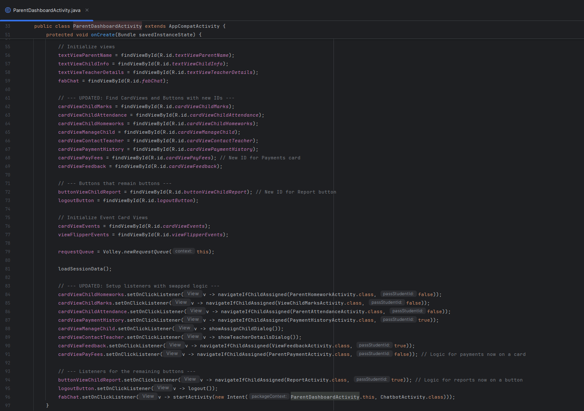
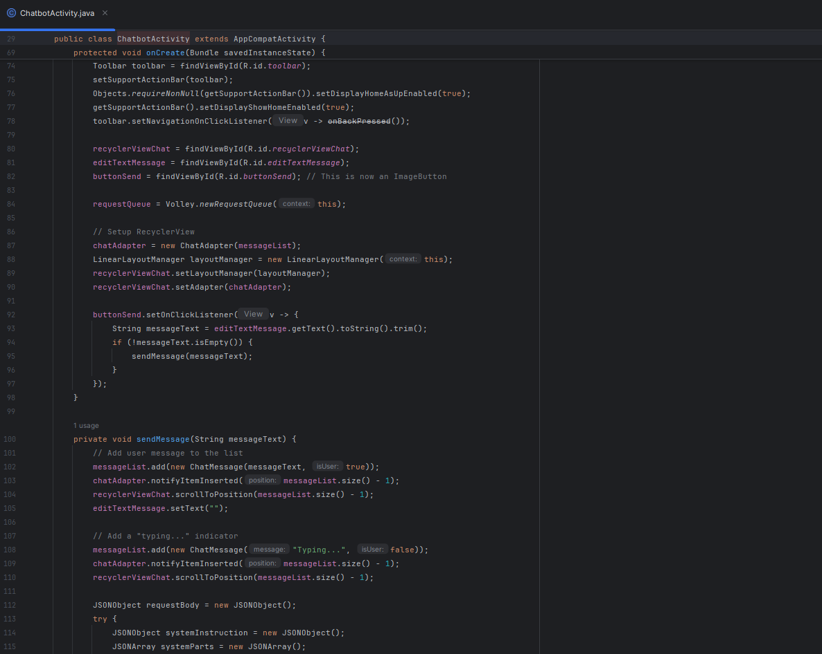
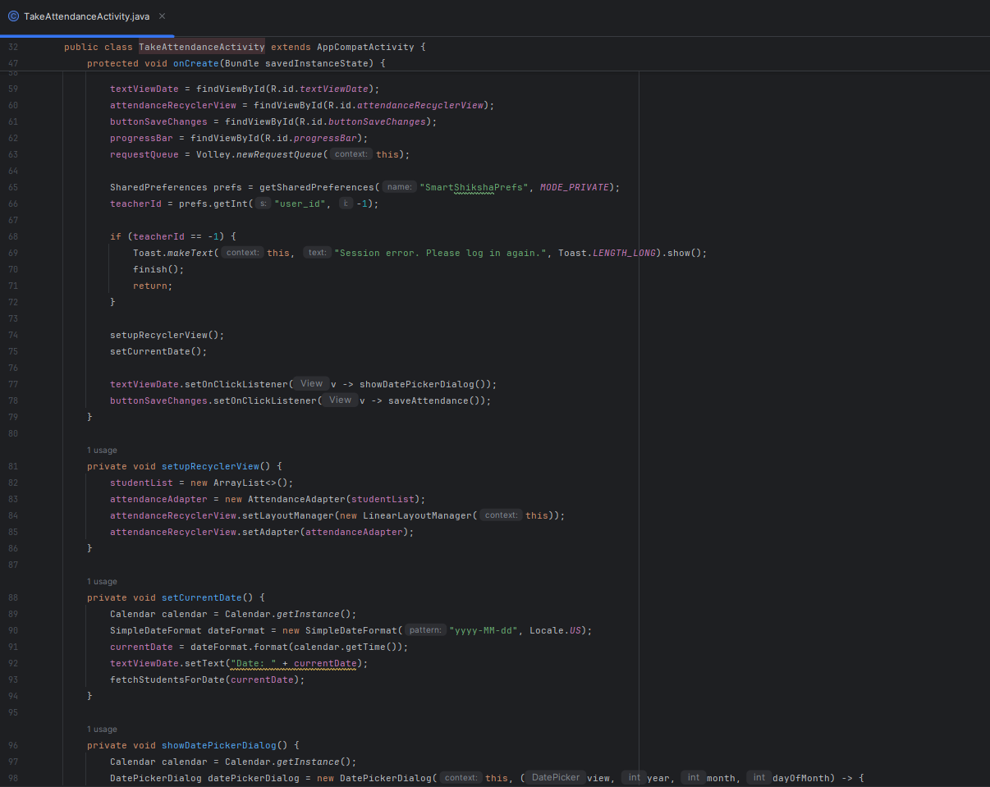
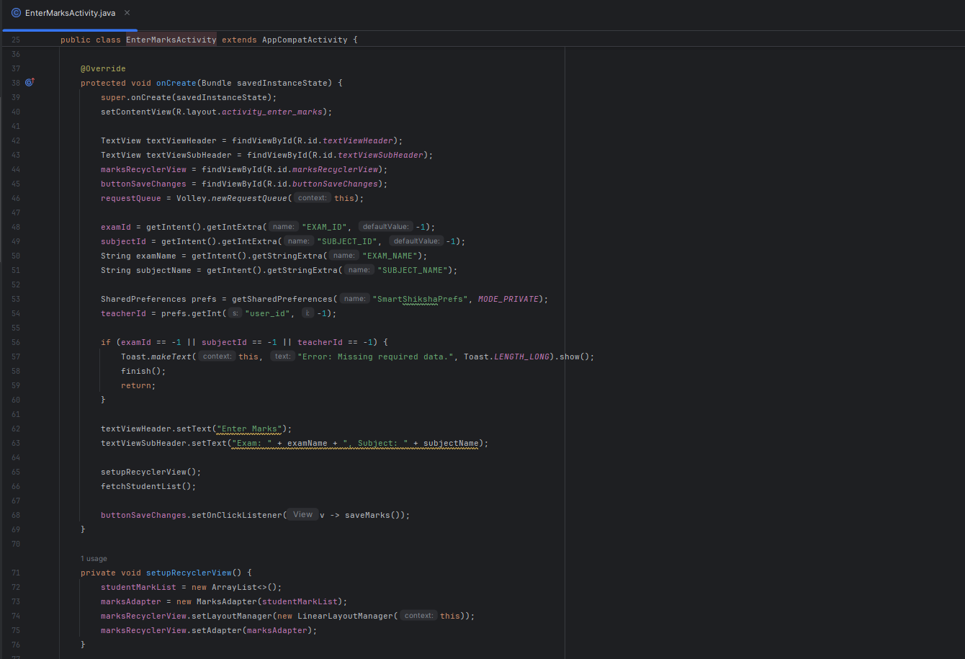
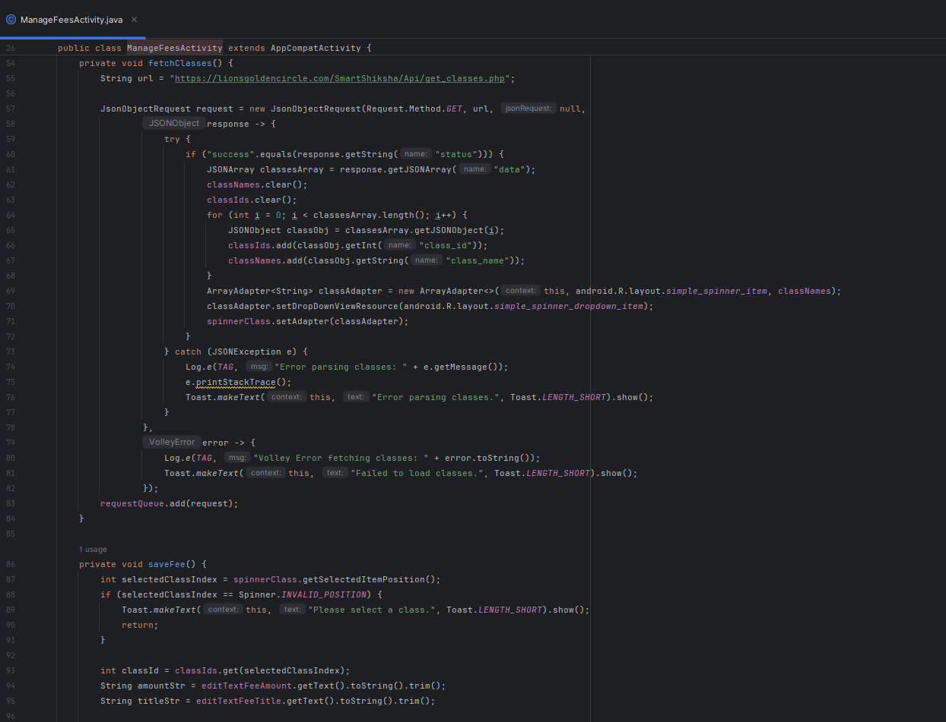
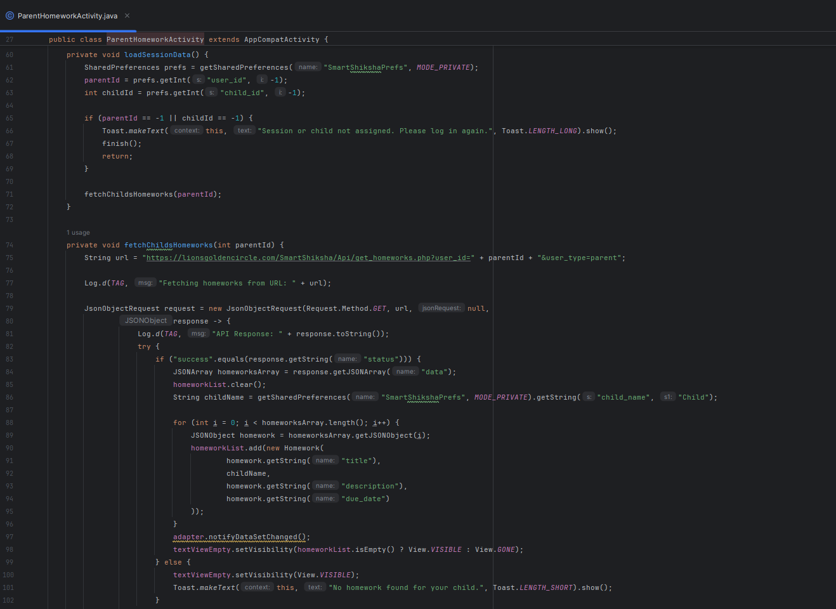
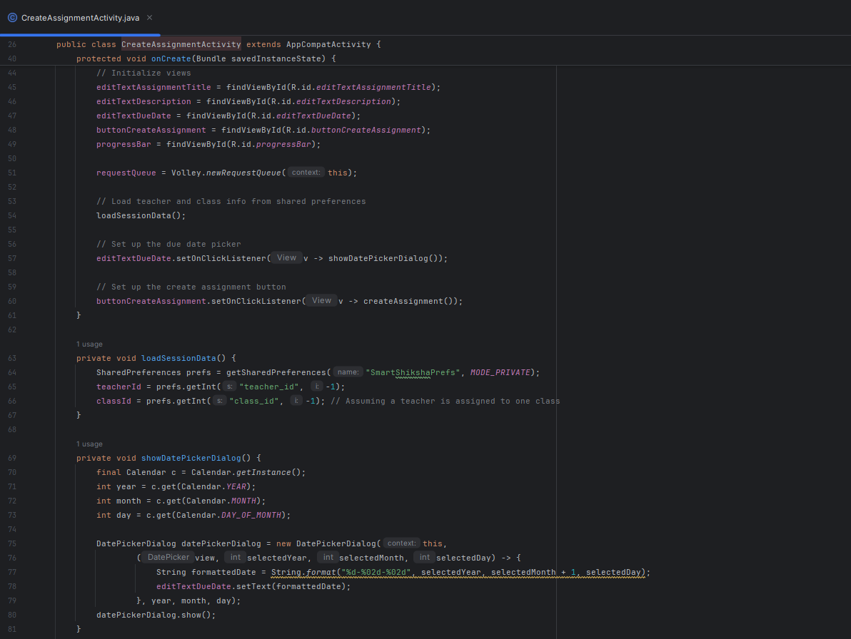
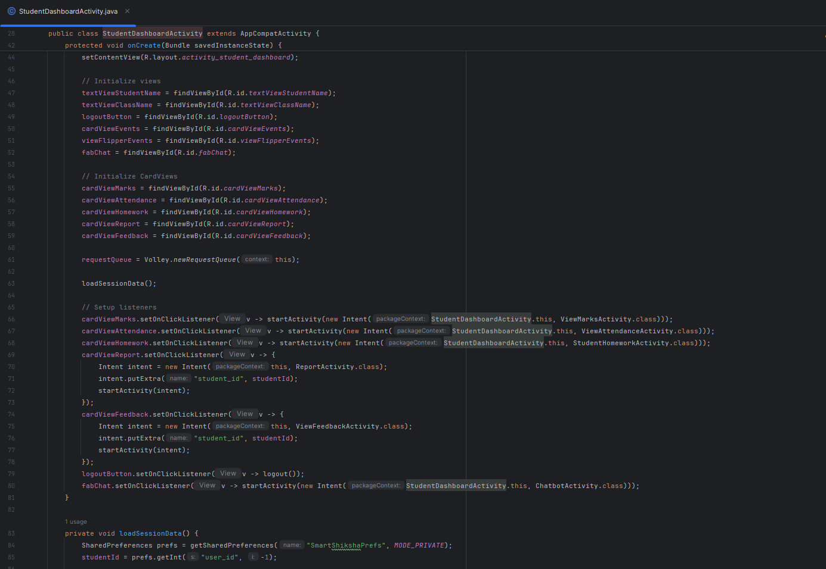
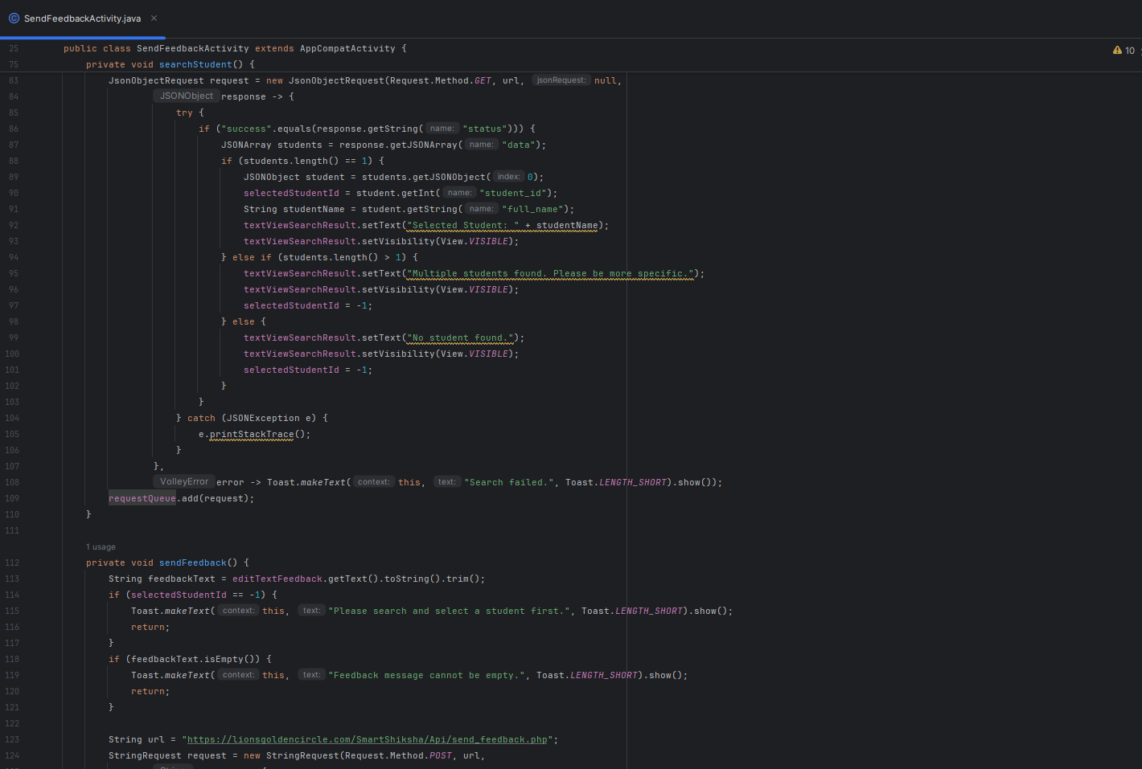
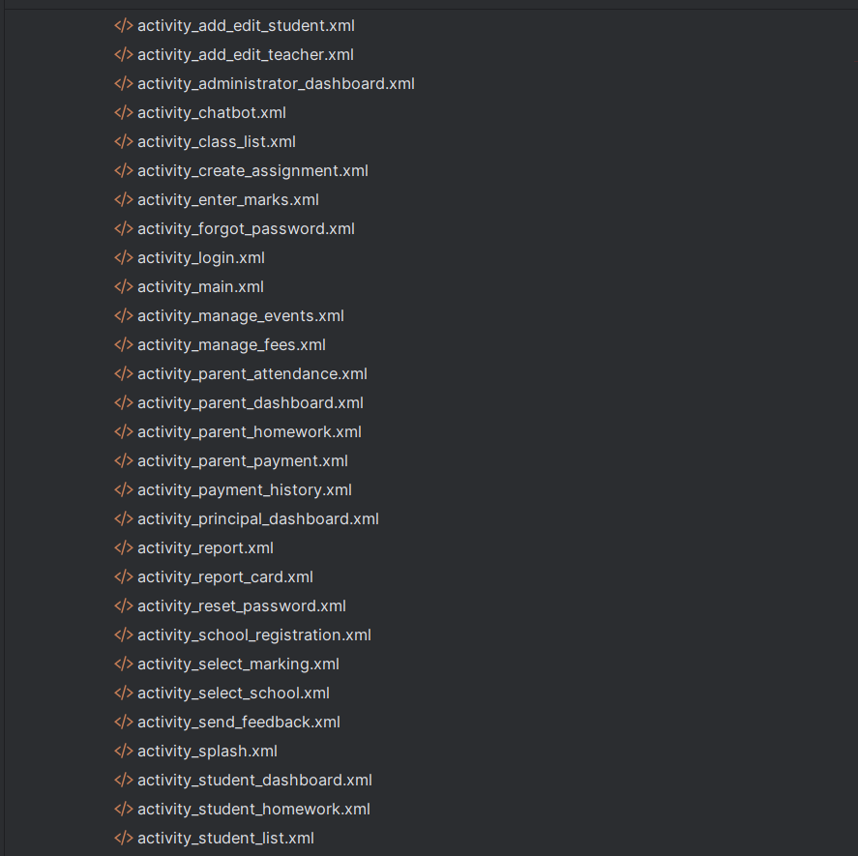
Figure 60 XML
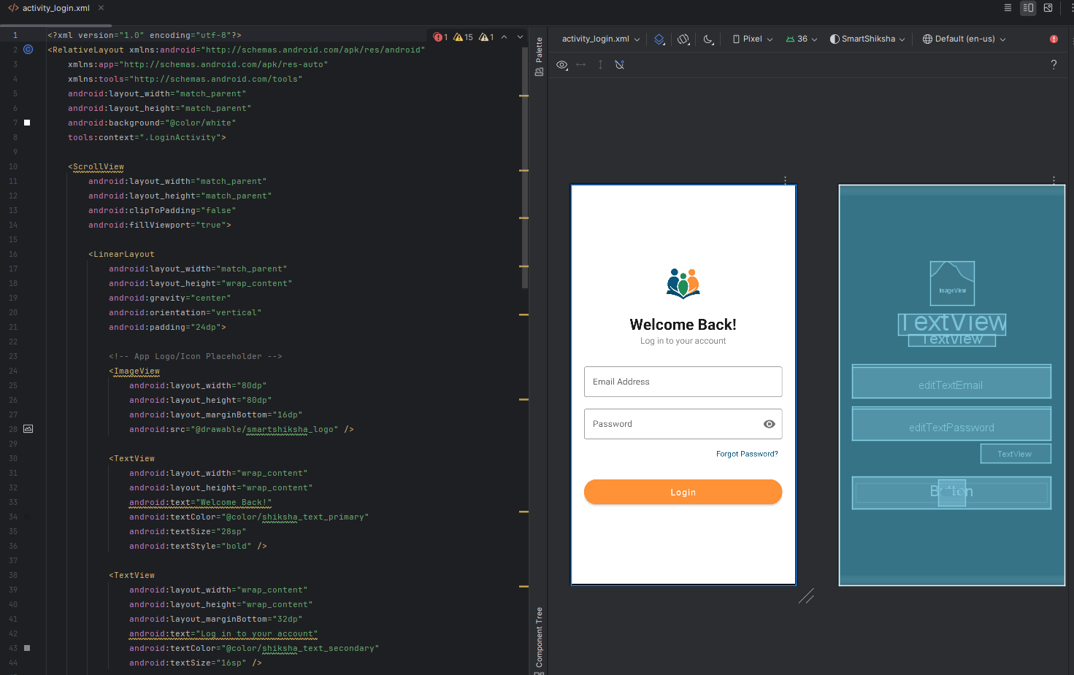
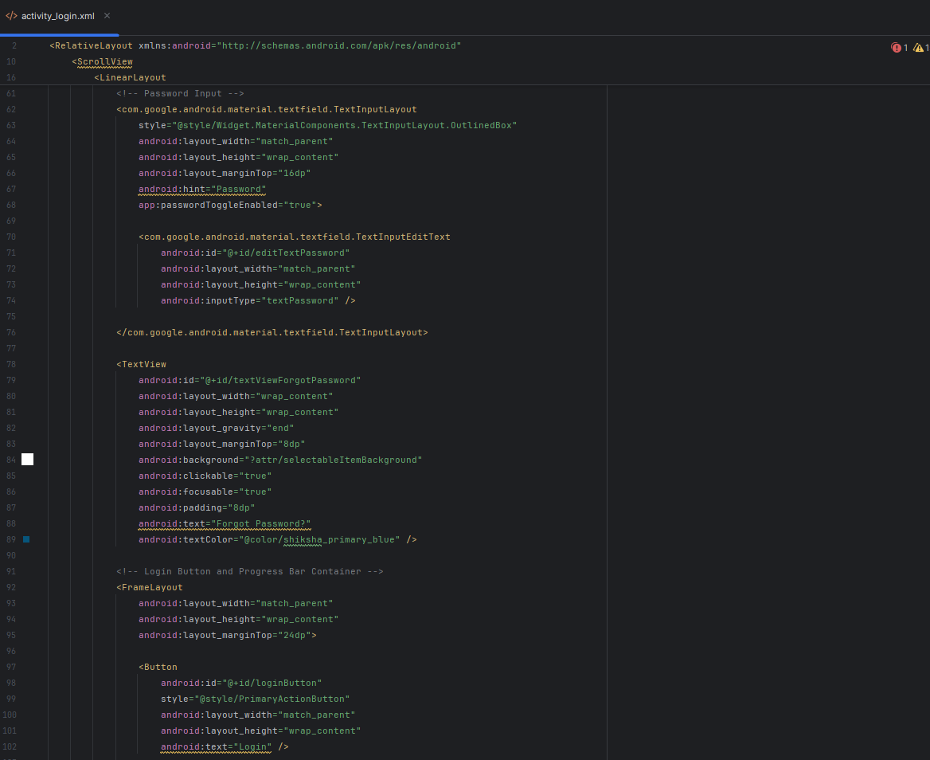
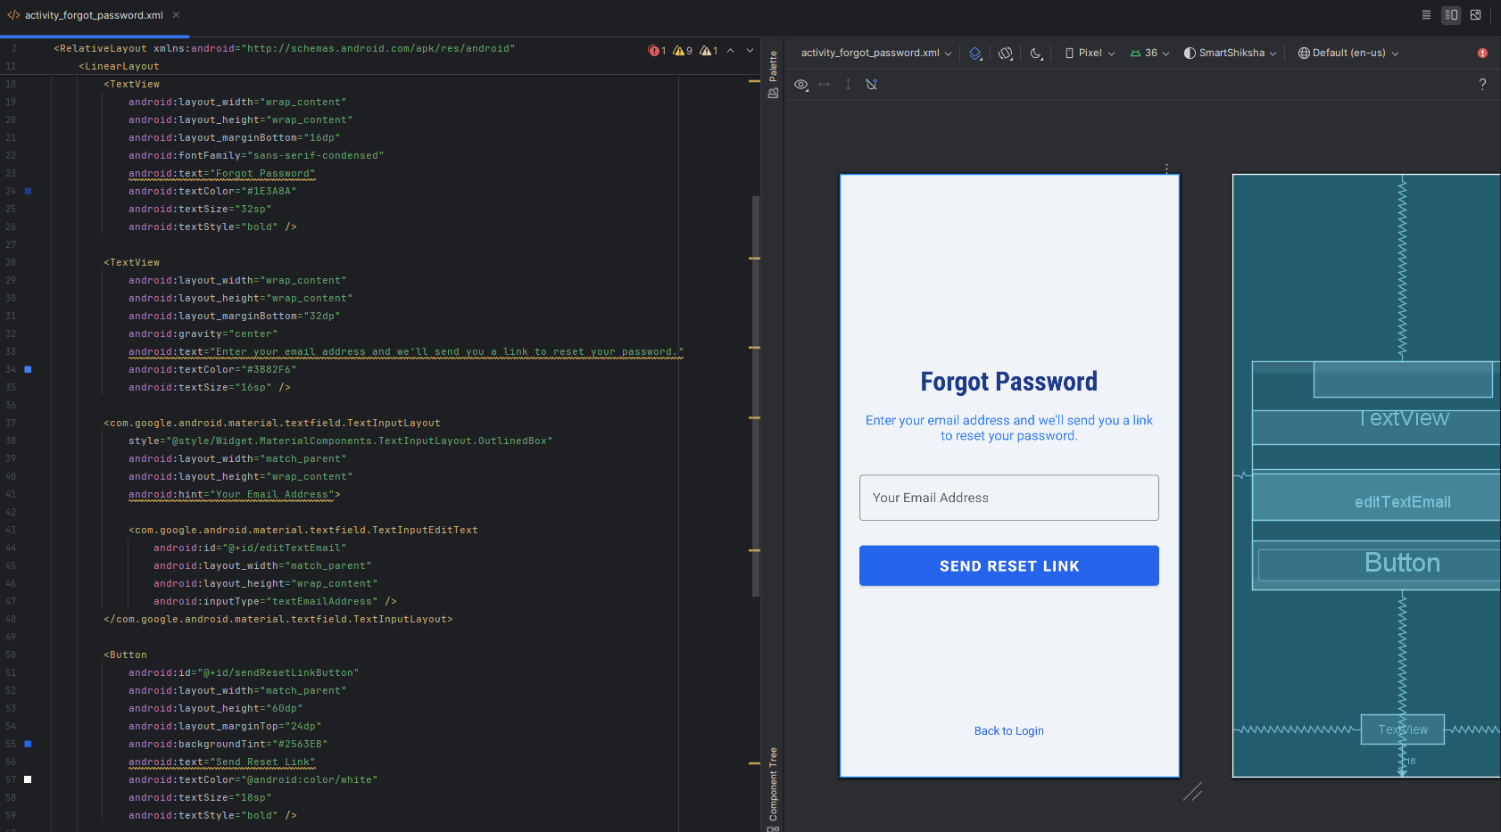

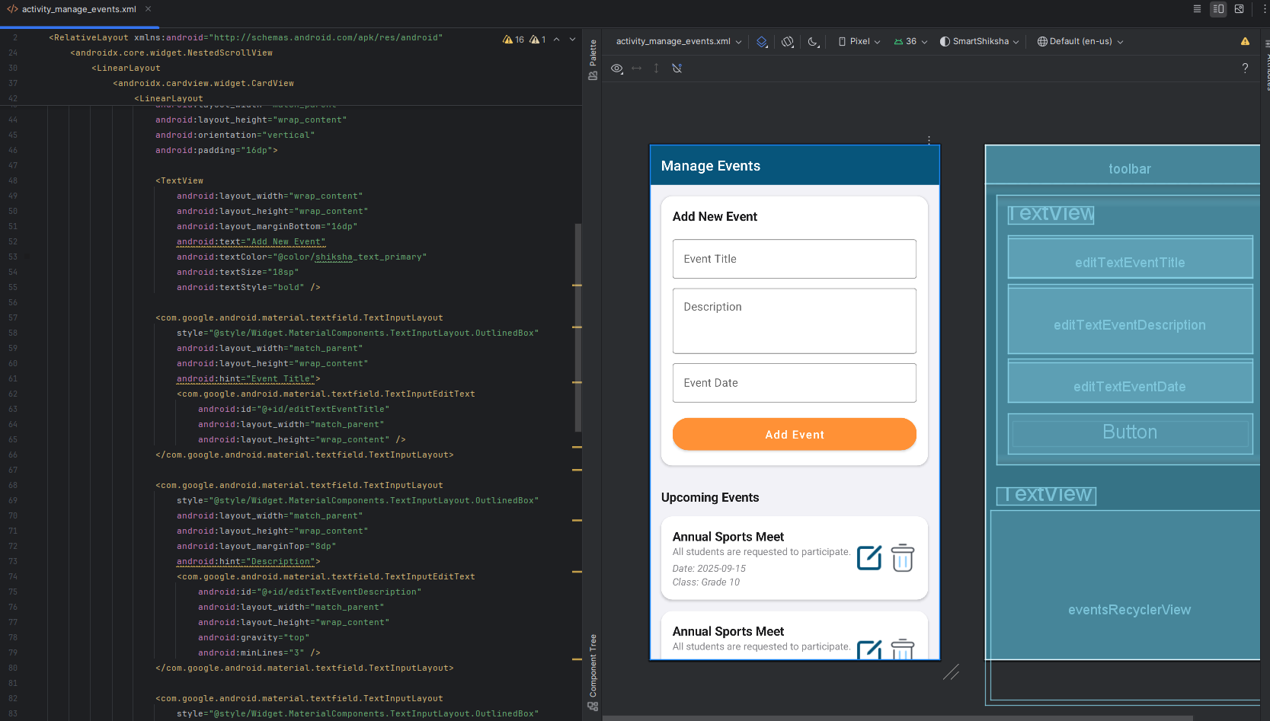
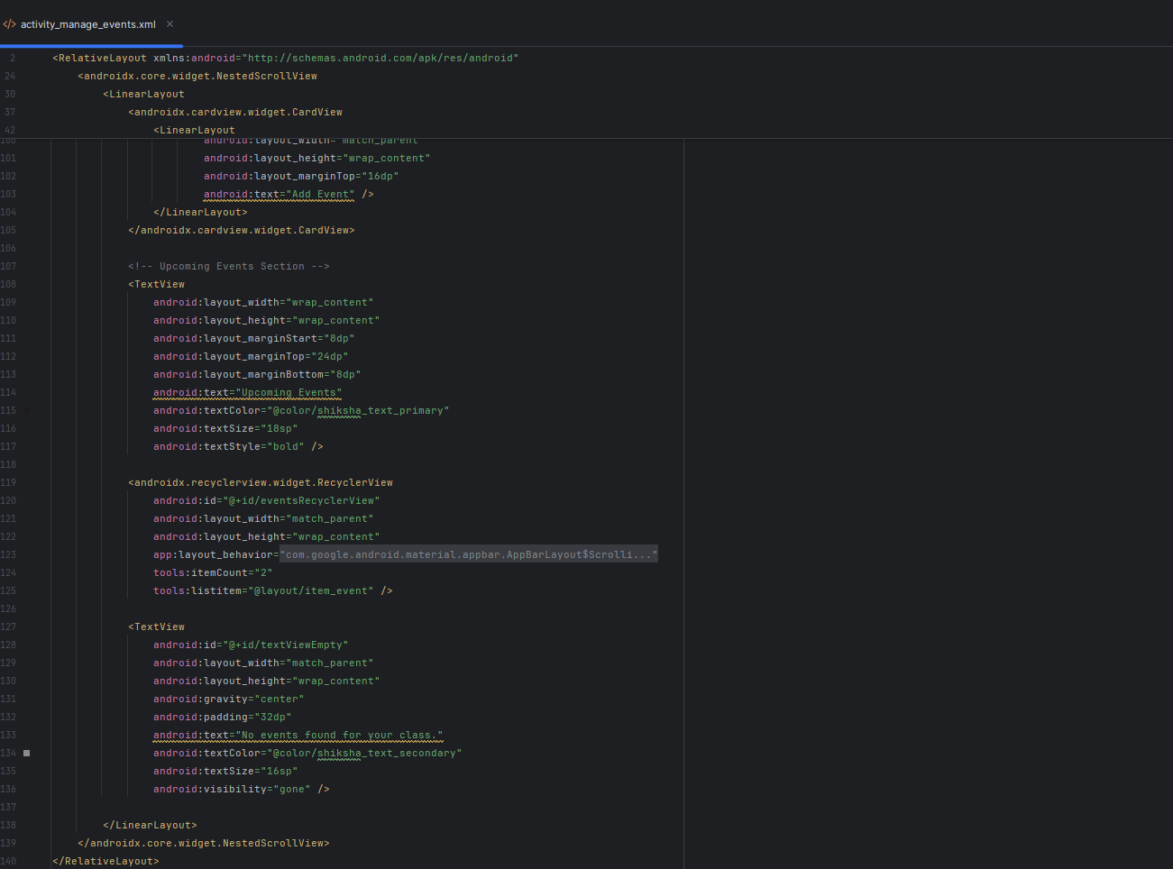

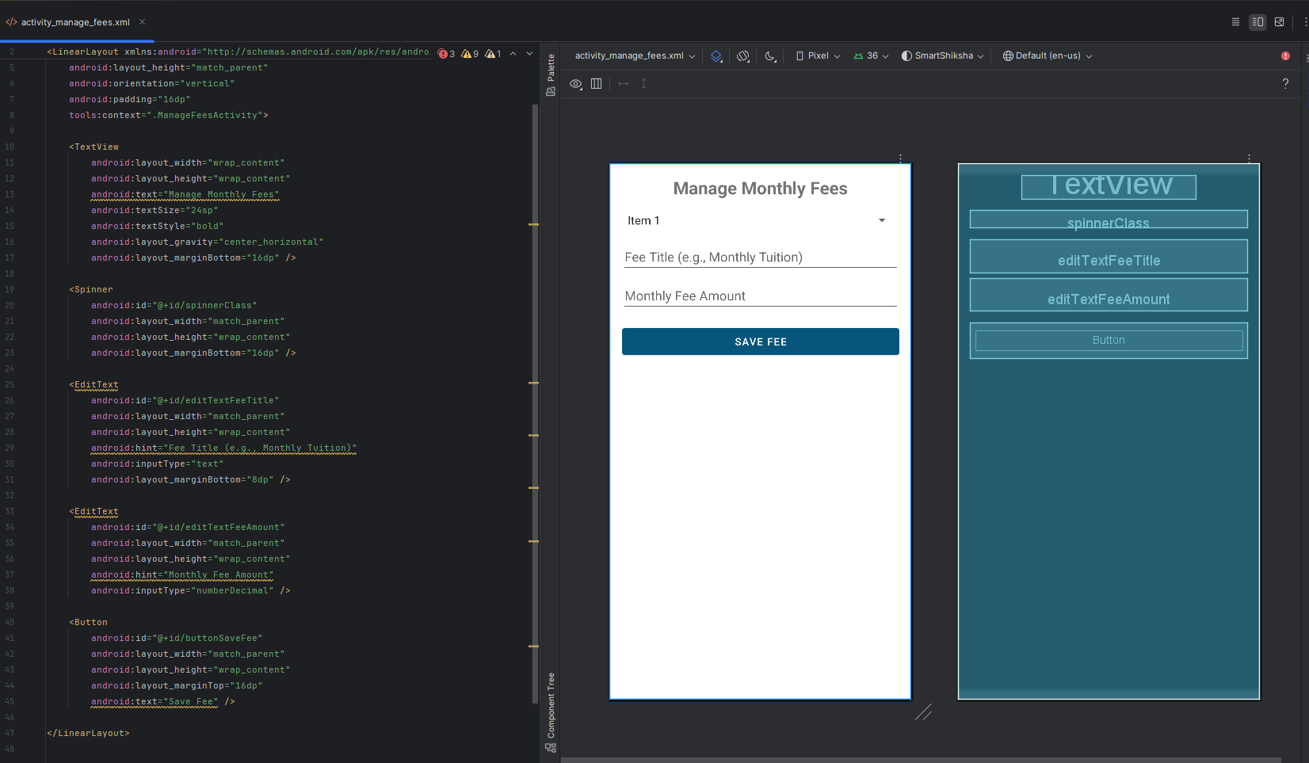
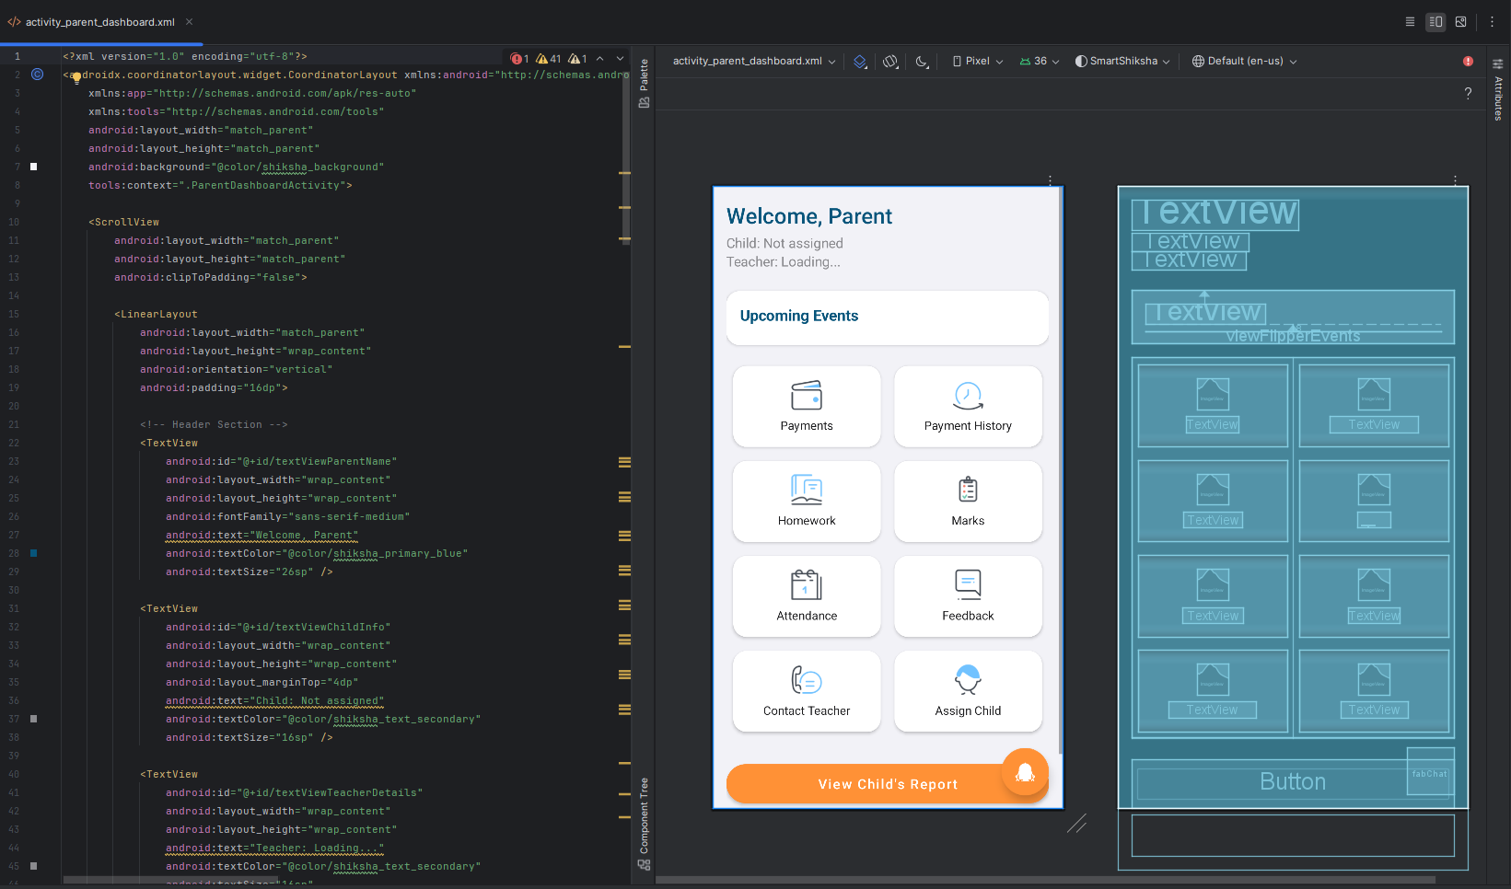

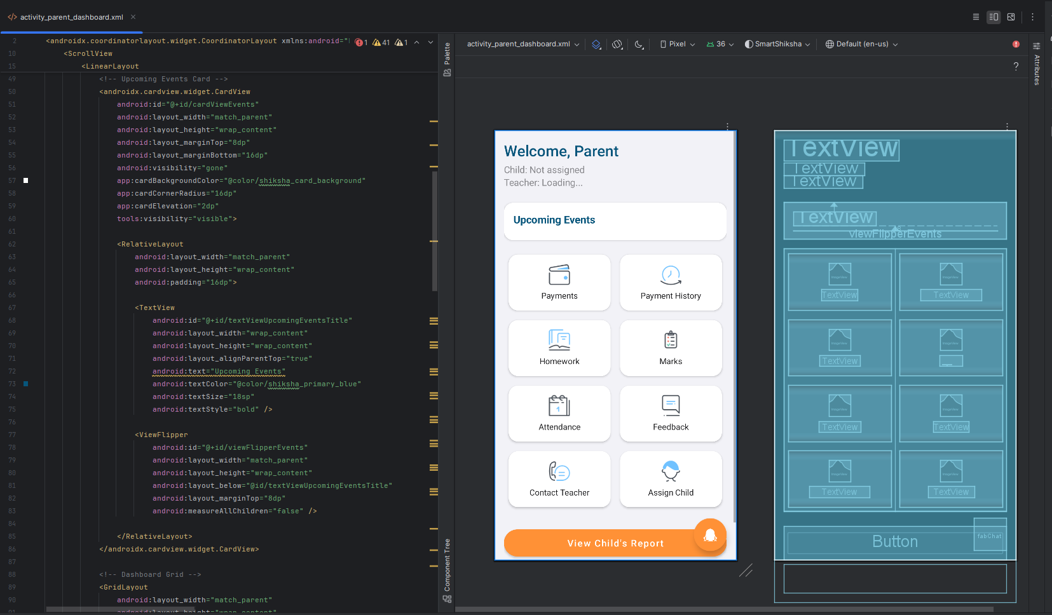
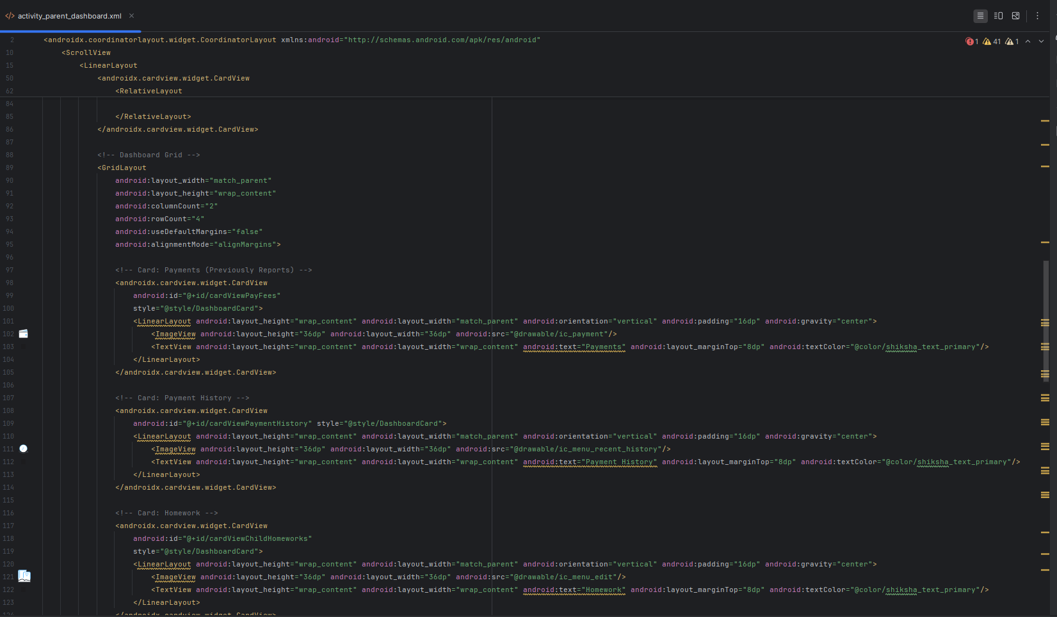

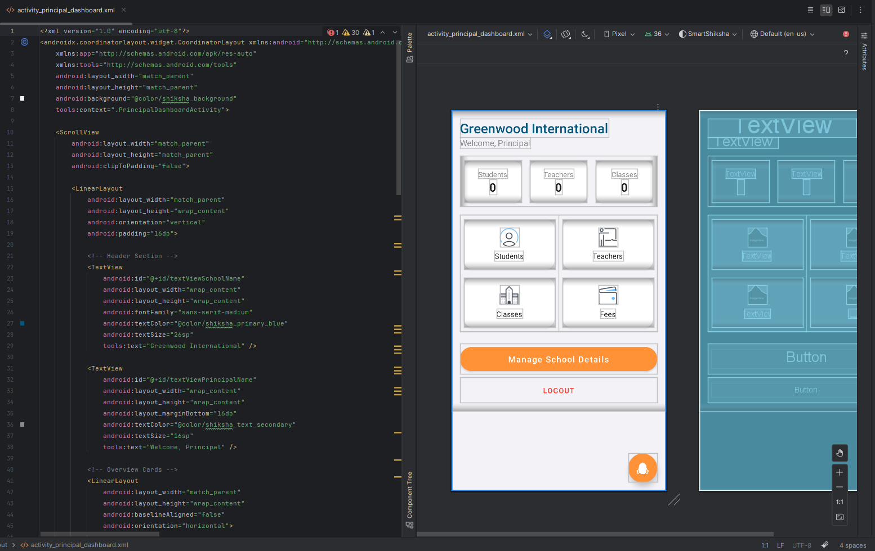
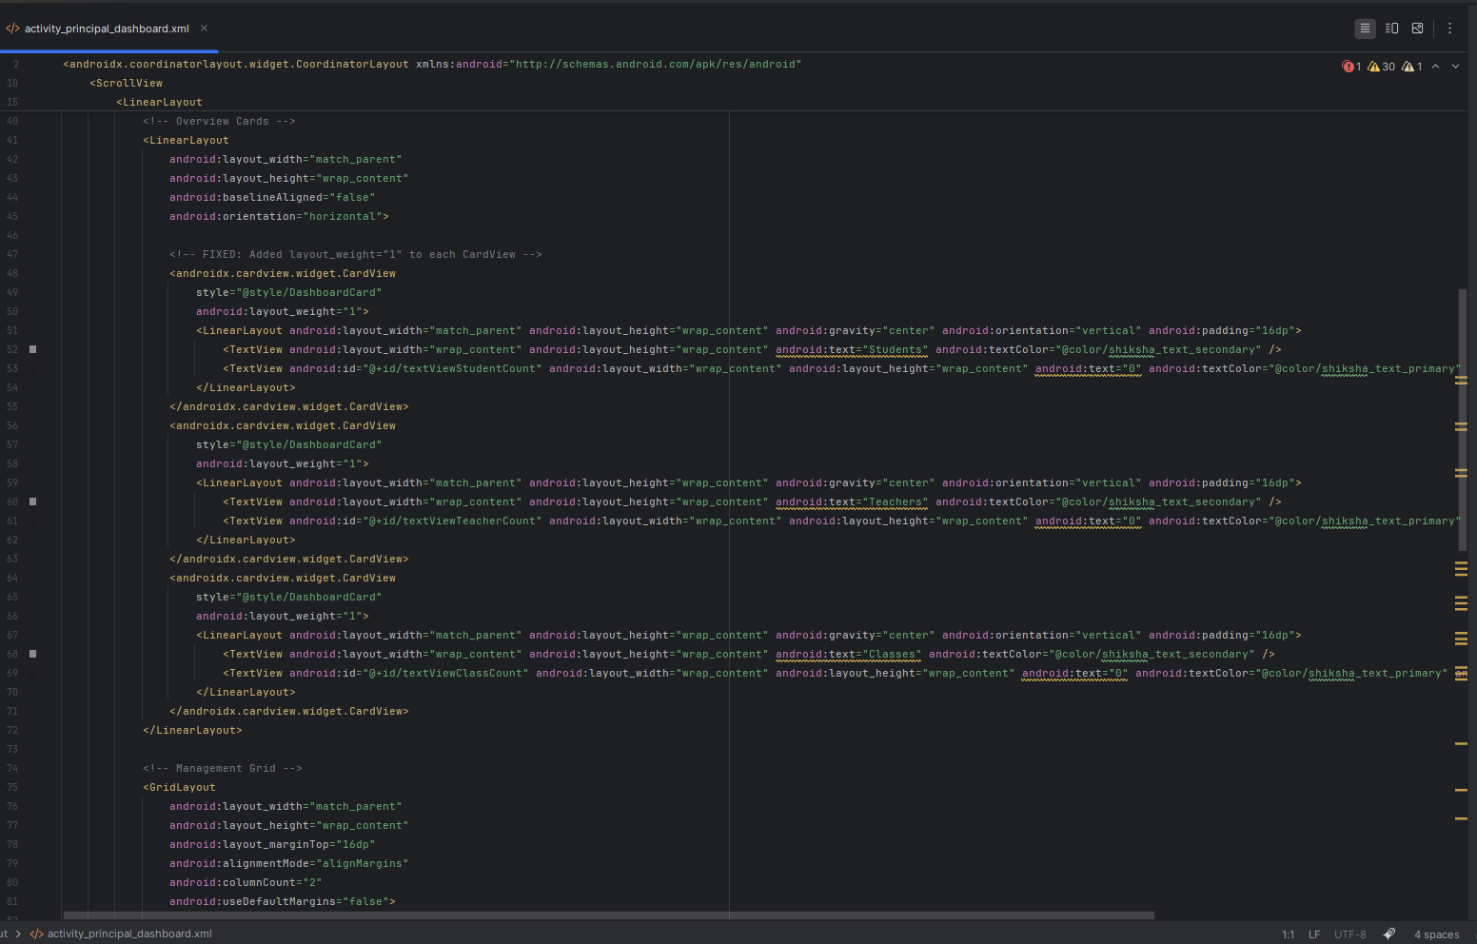

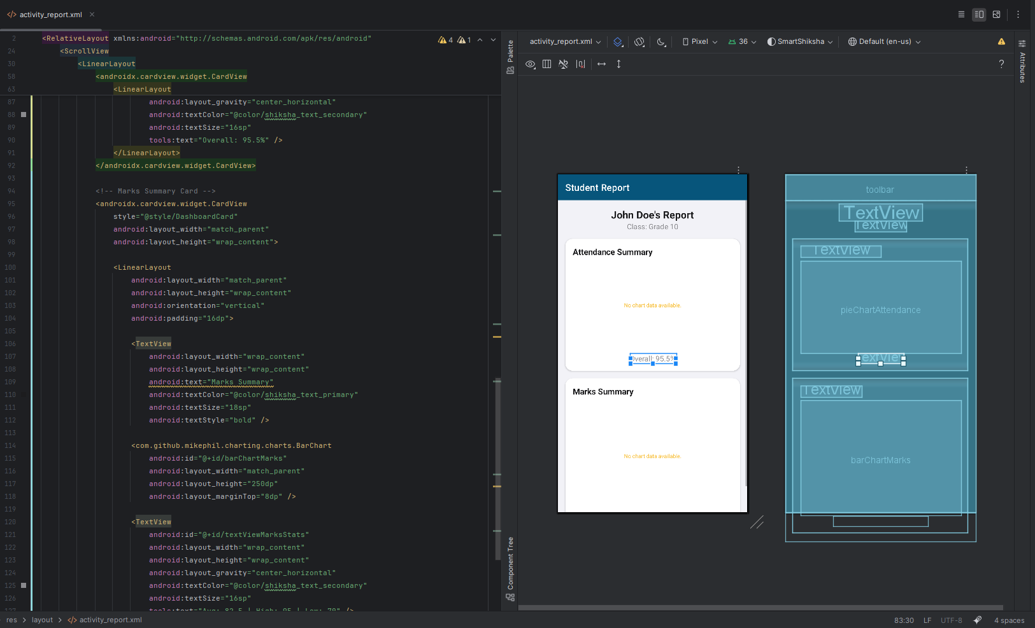
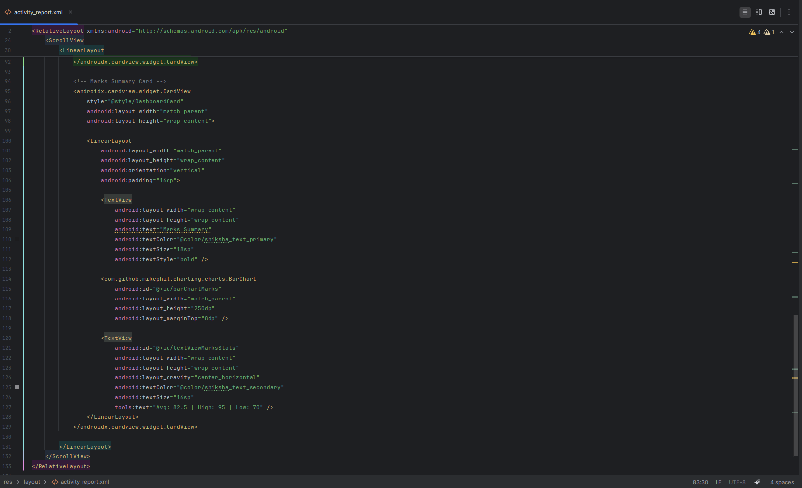

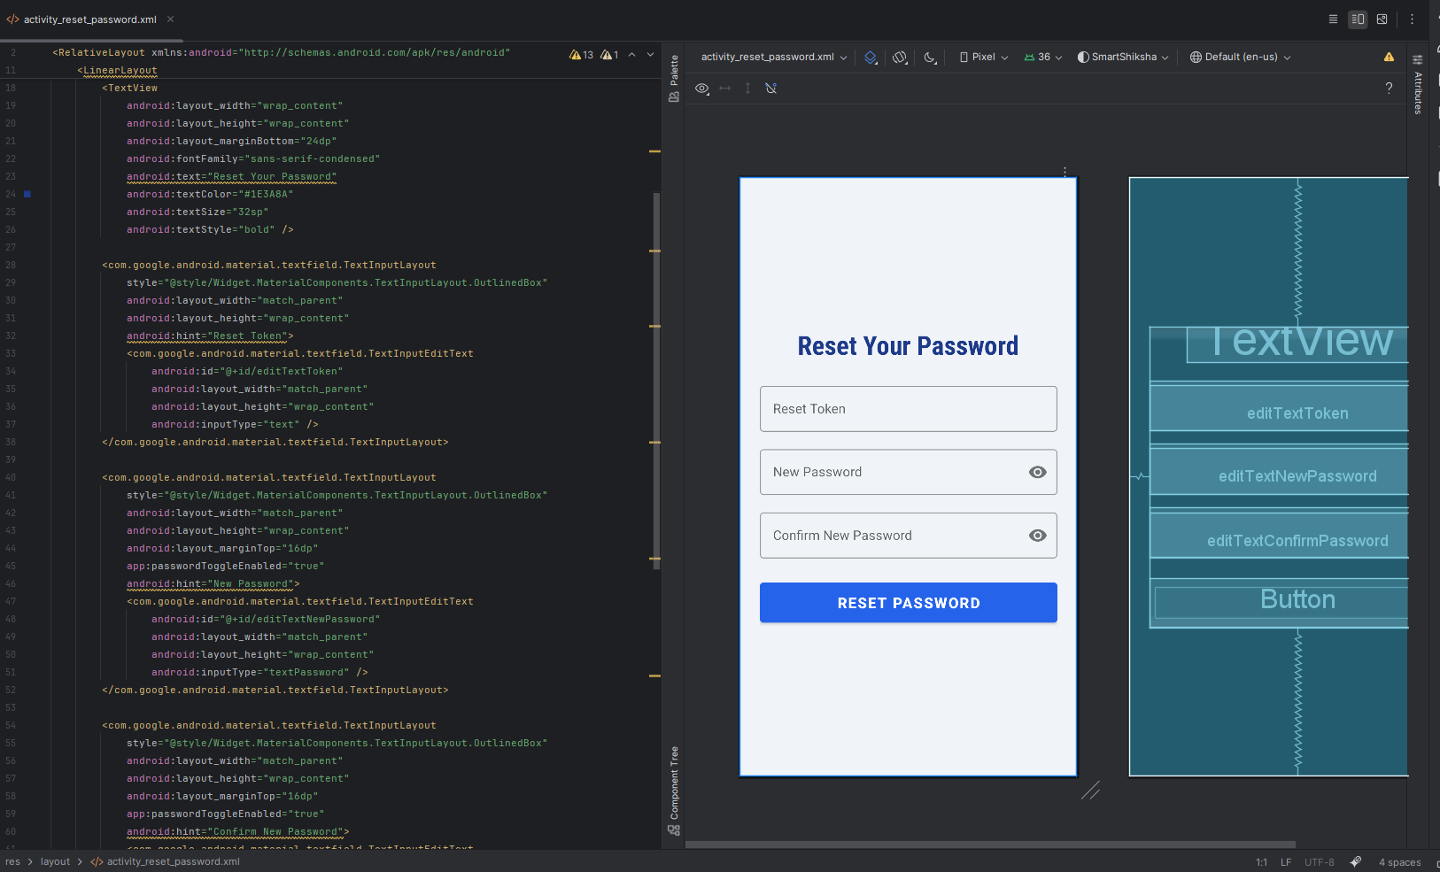
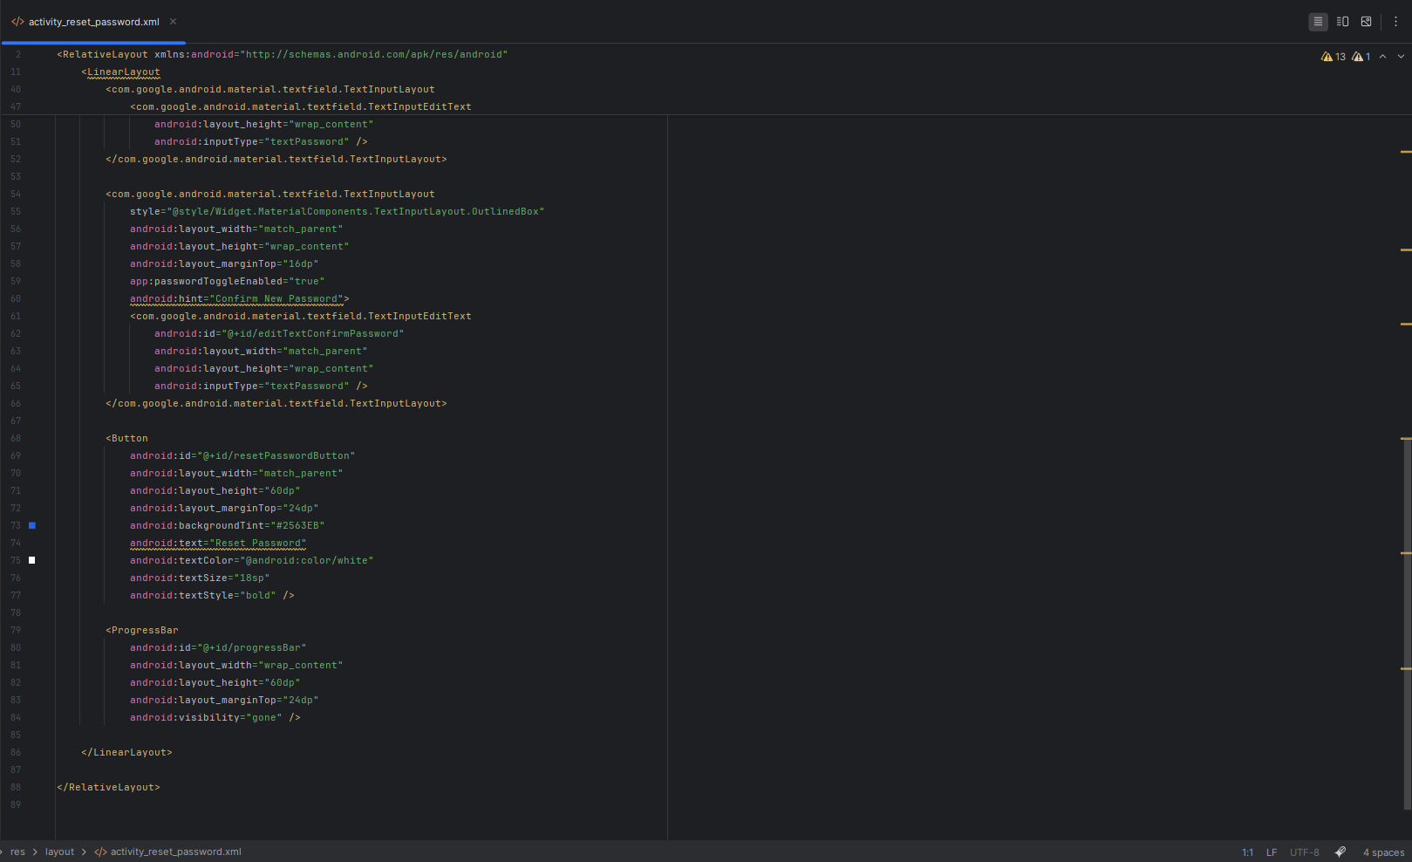

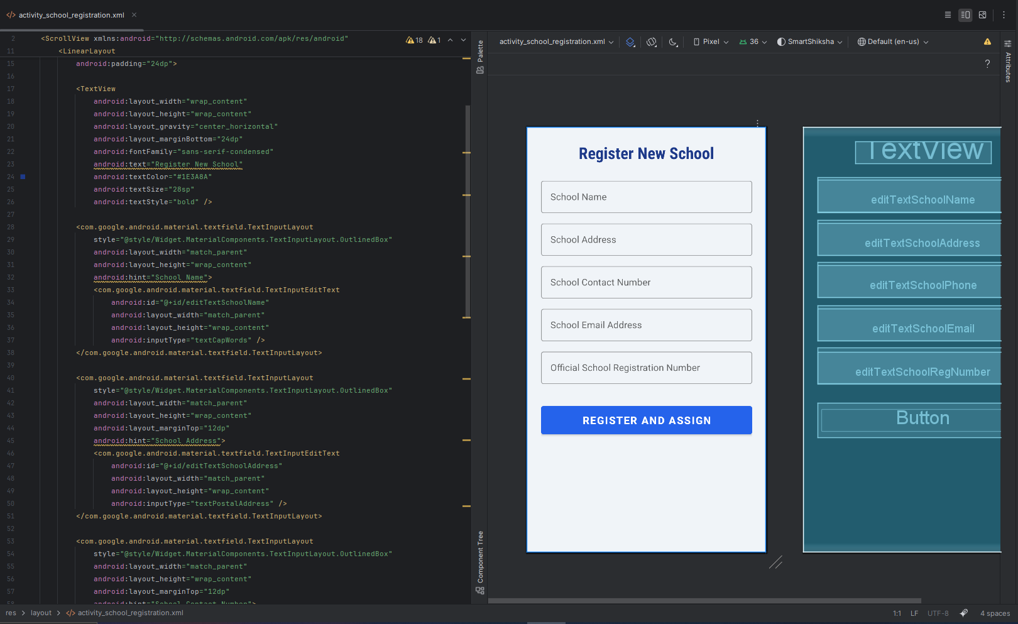
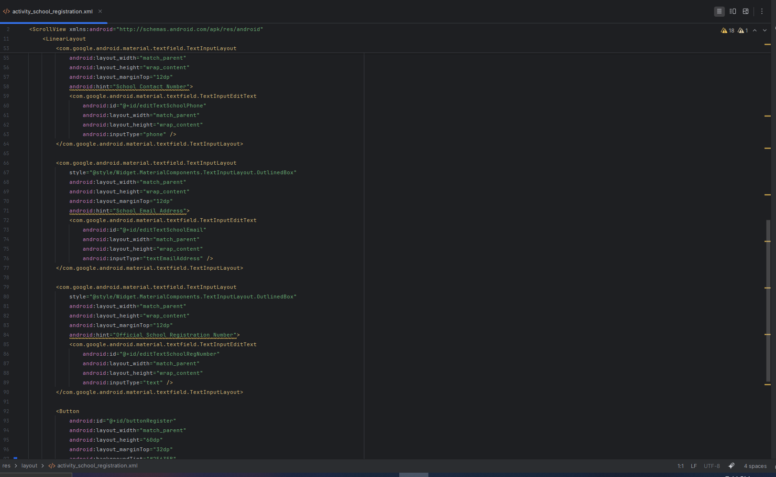

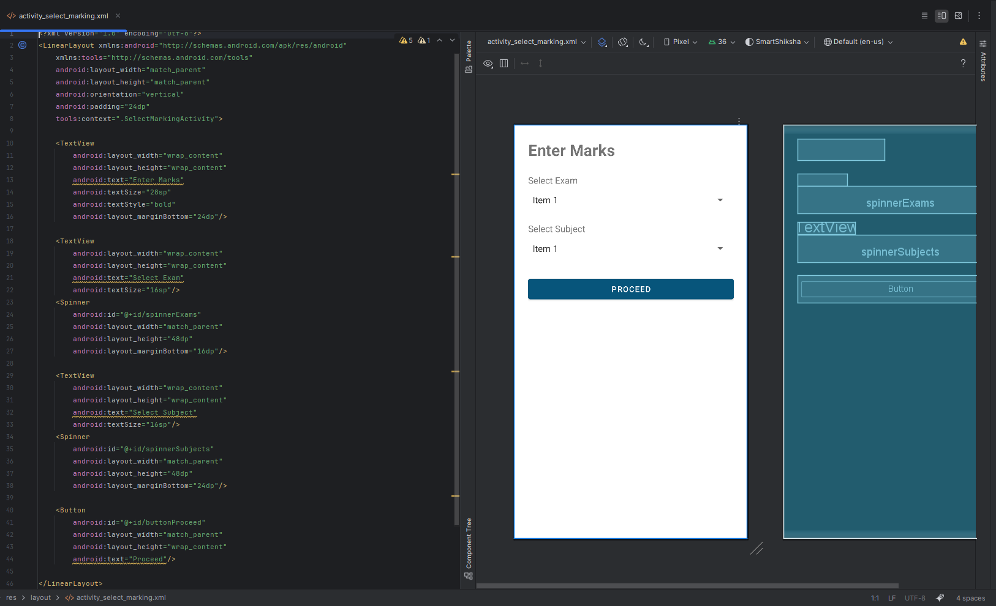
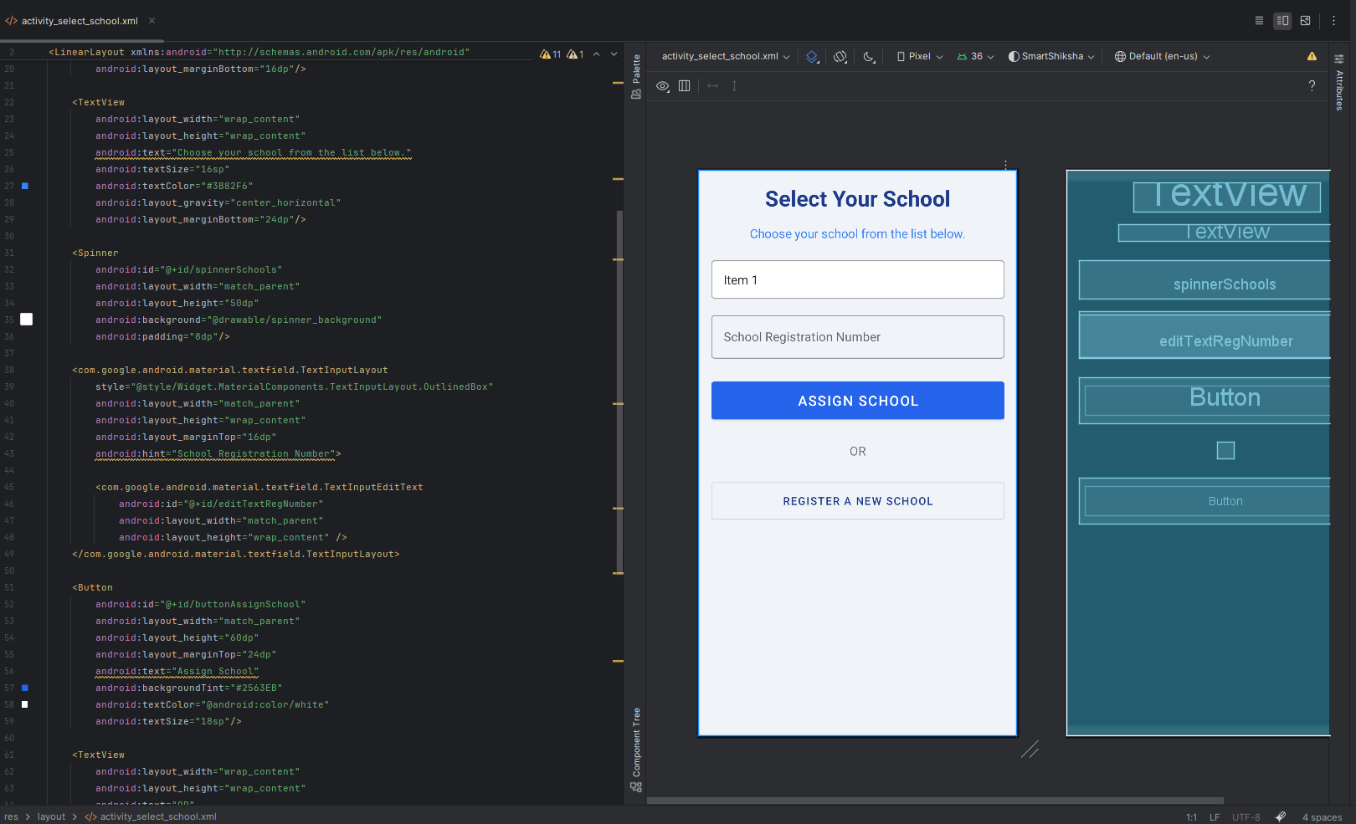

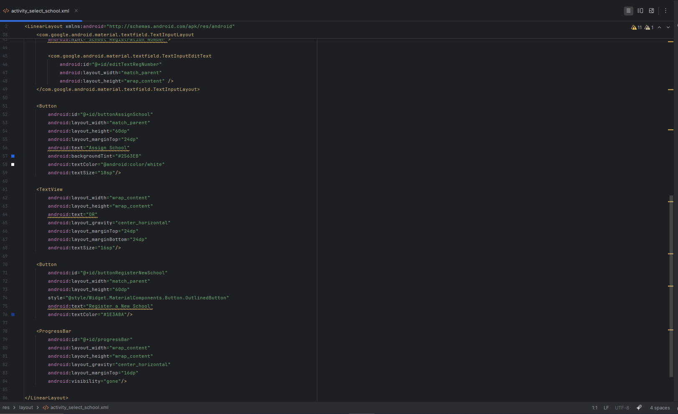
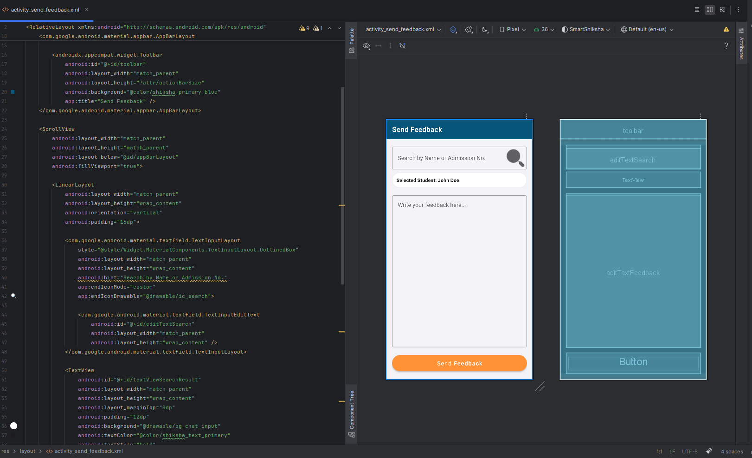

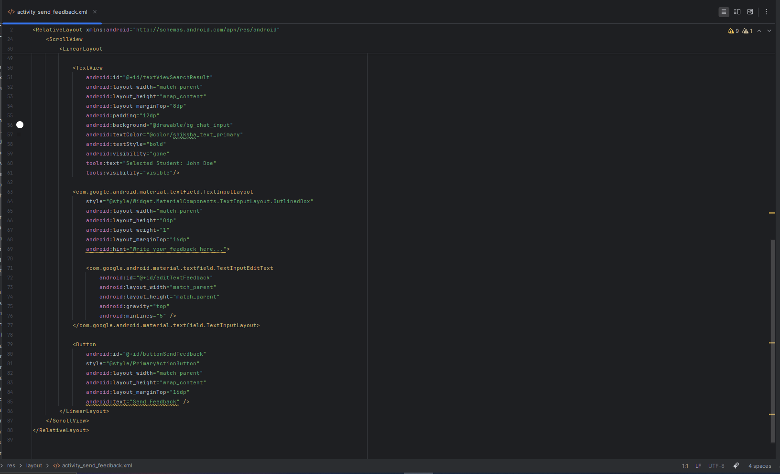
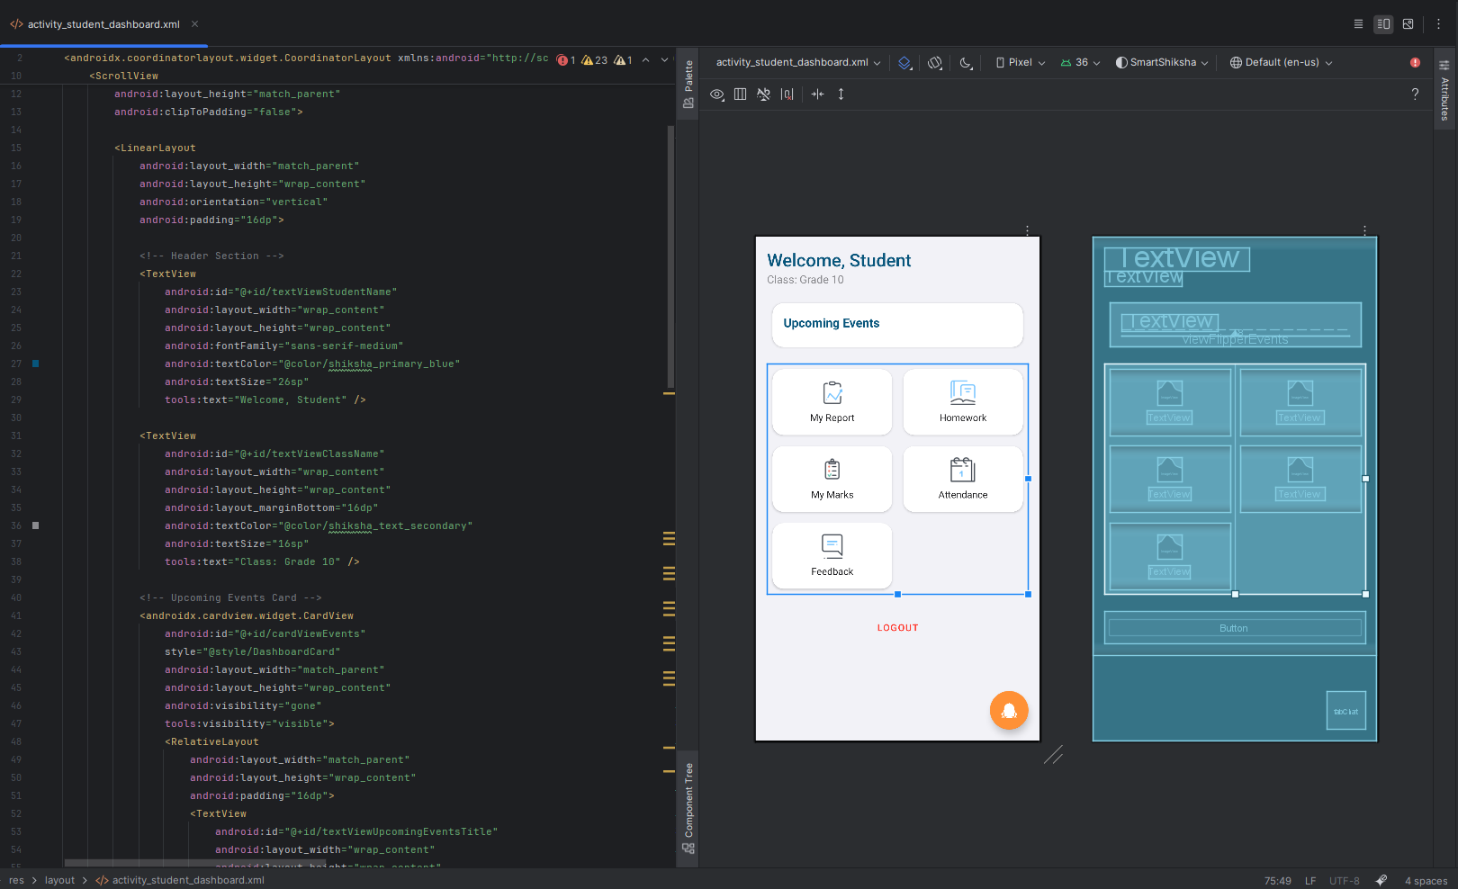

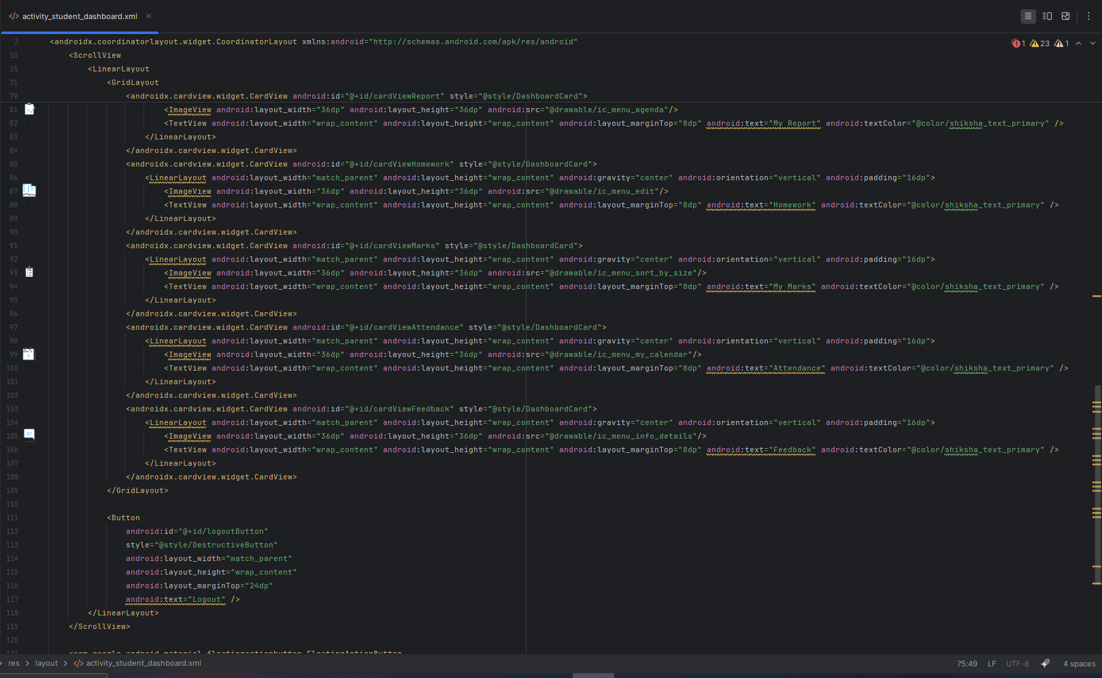
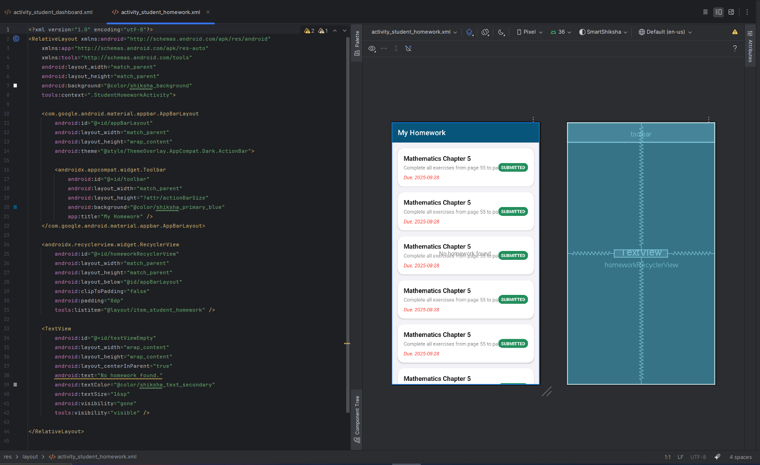

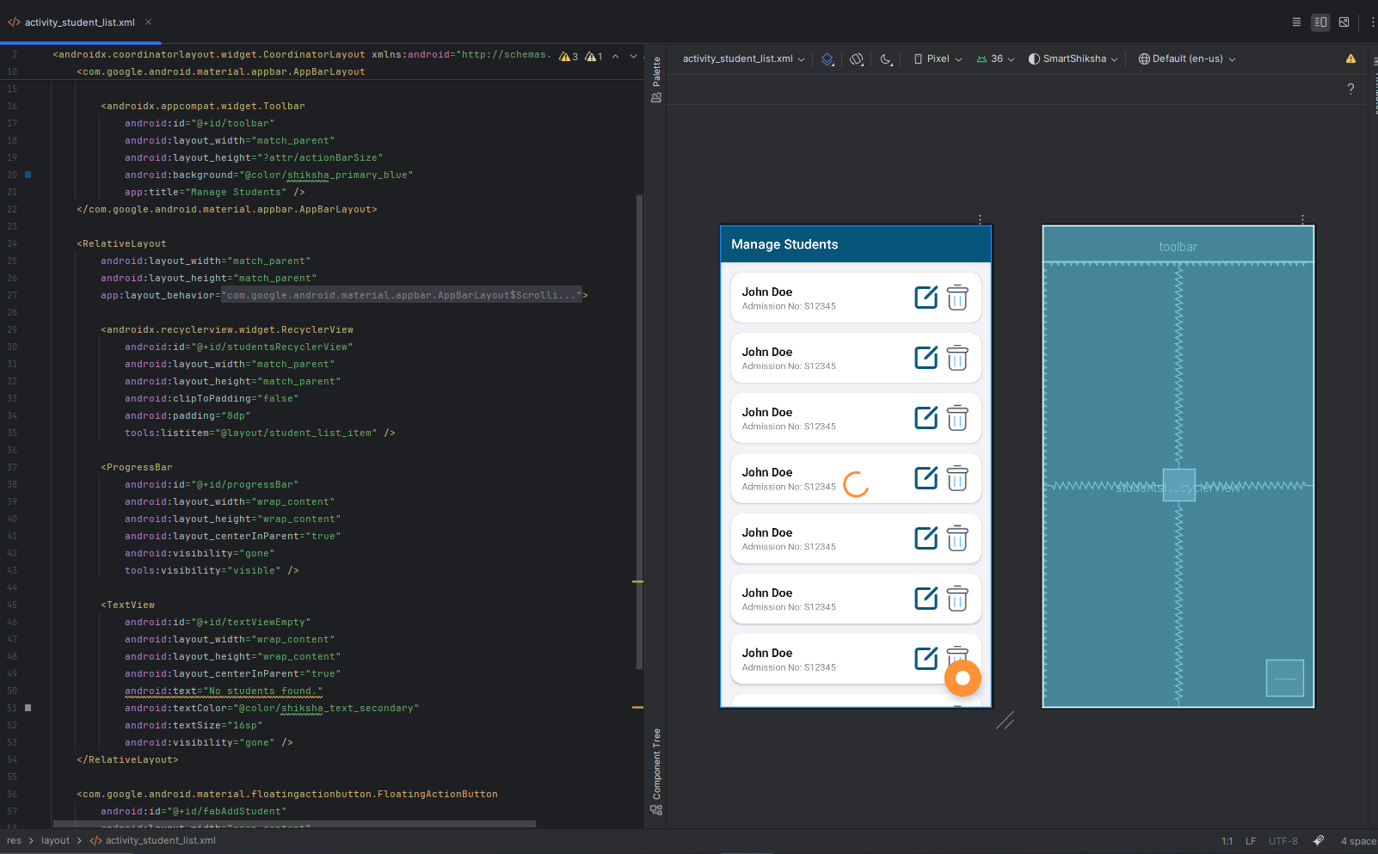
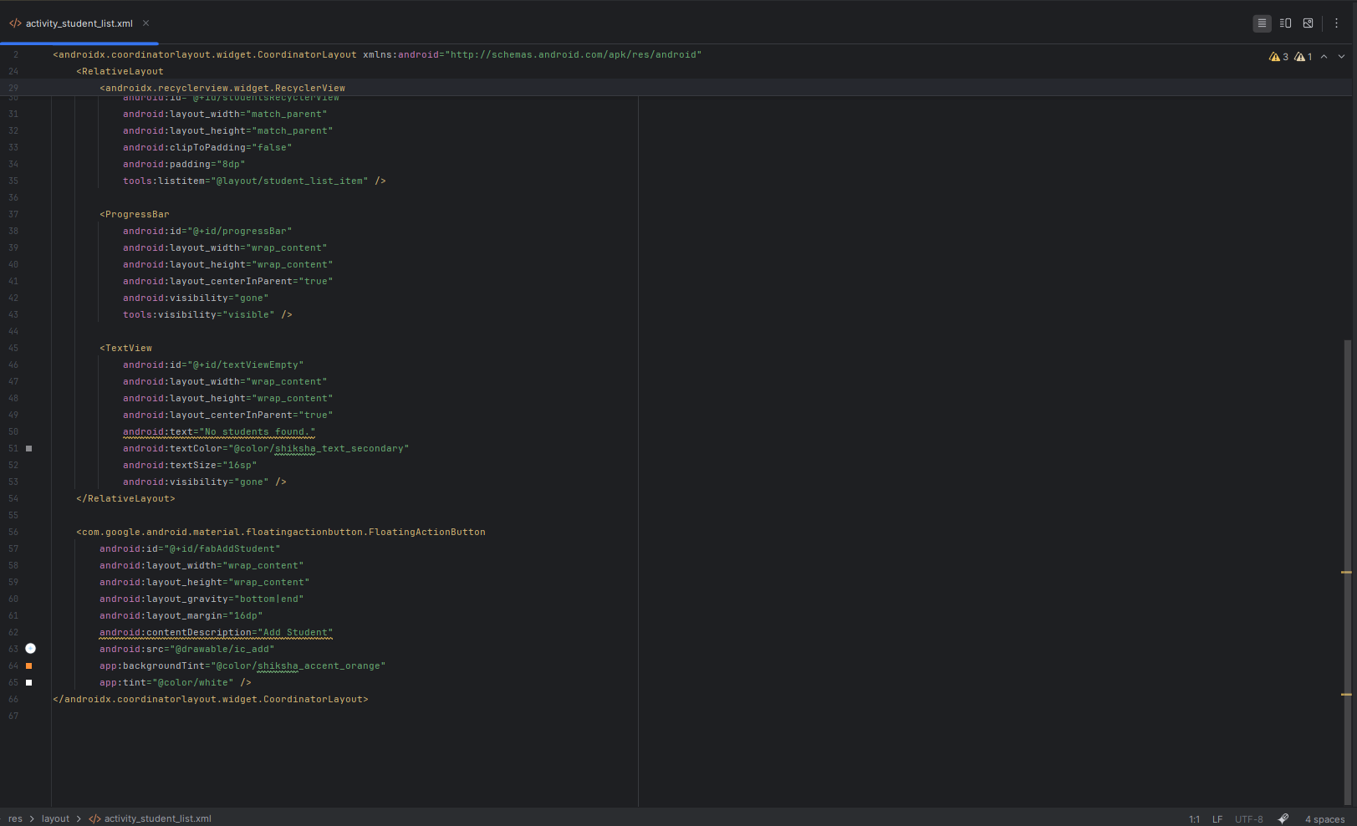

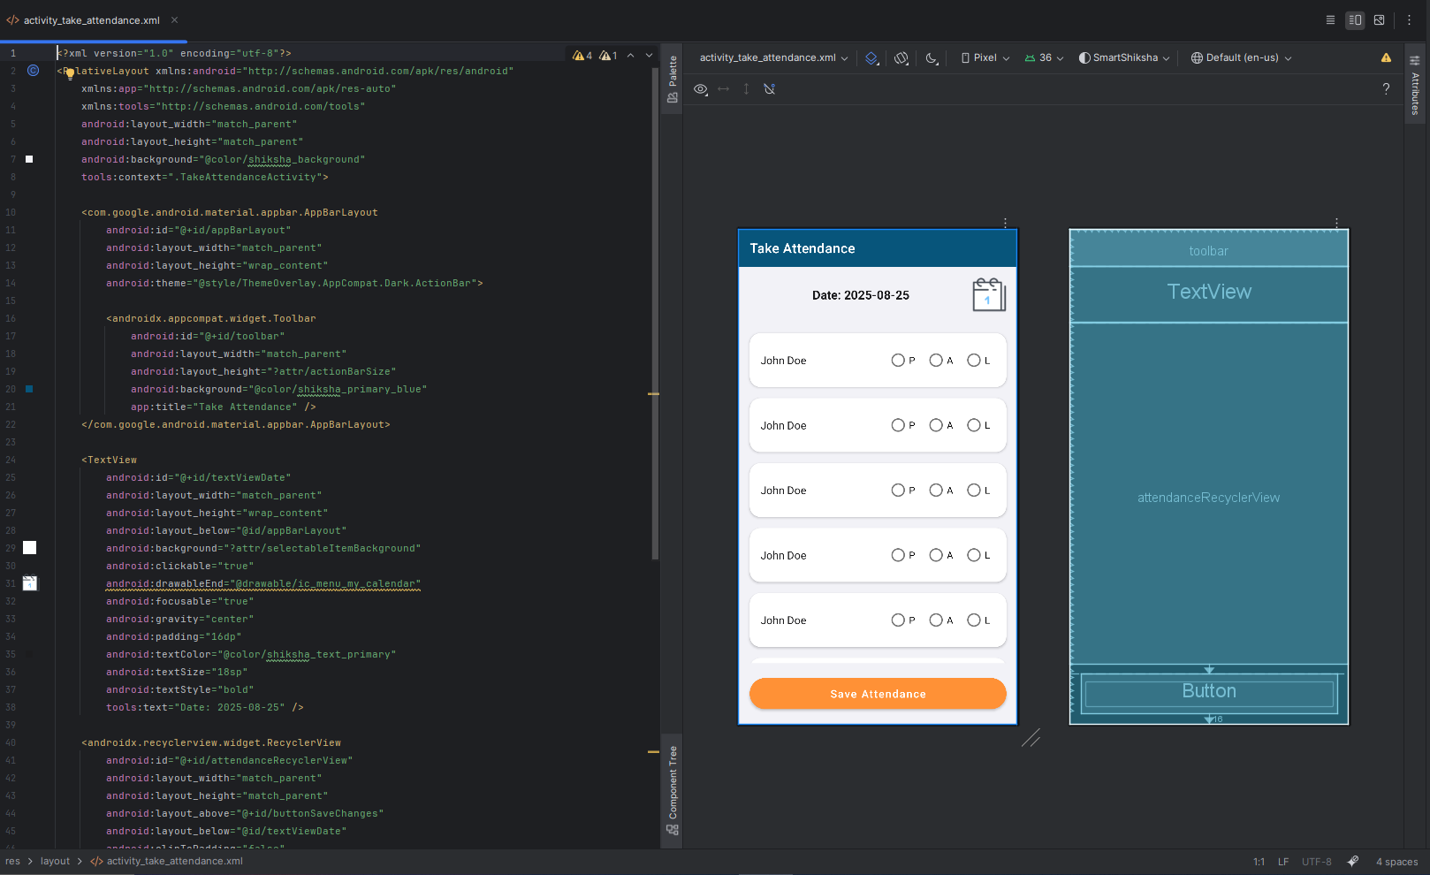
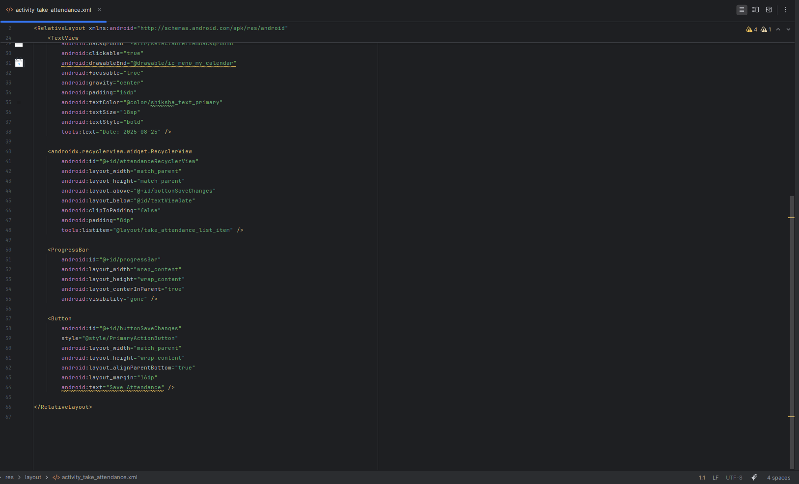

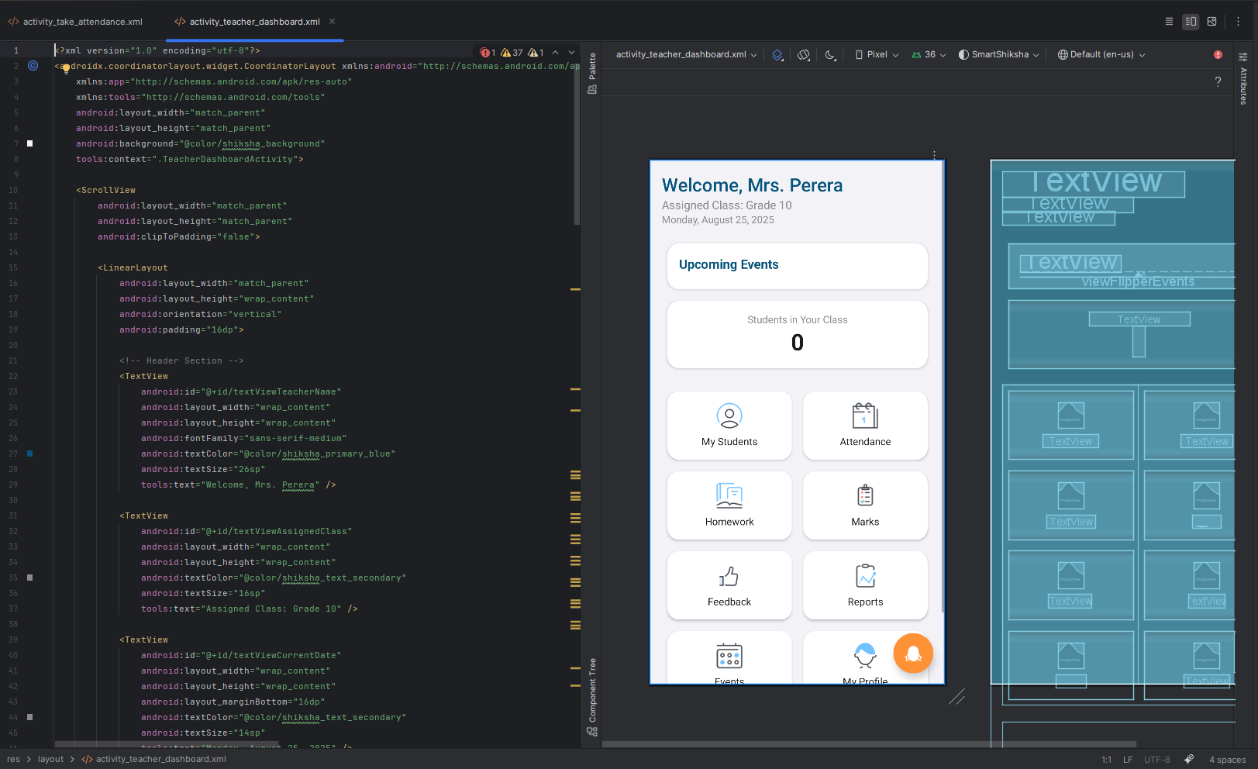
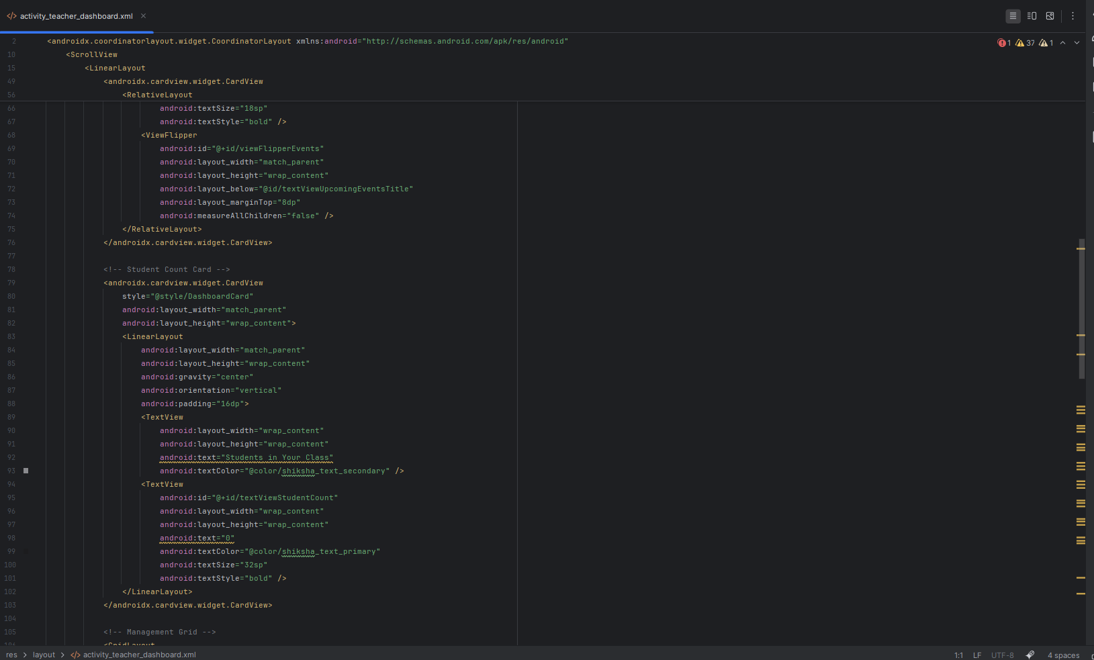

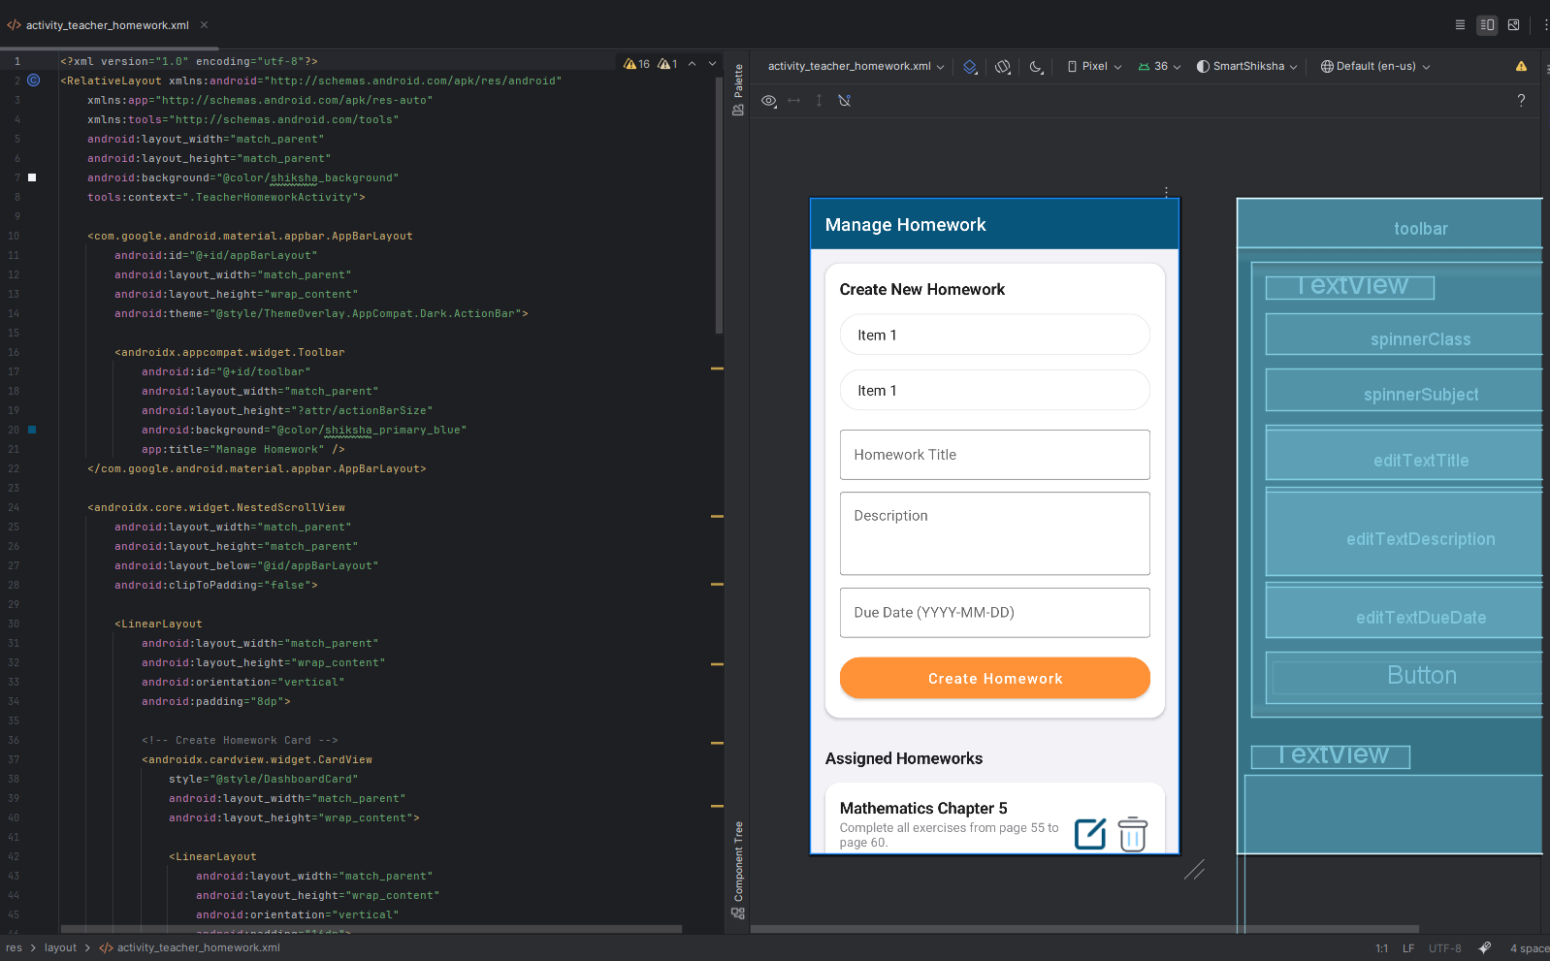
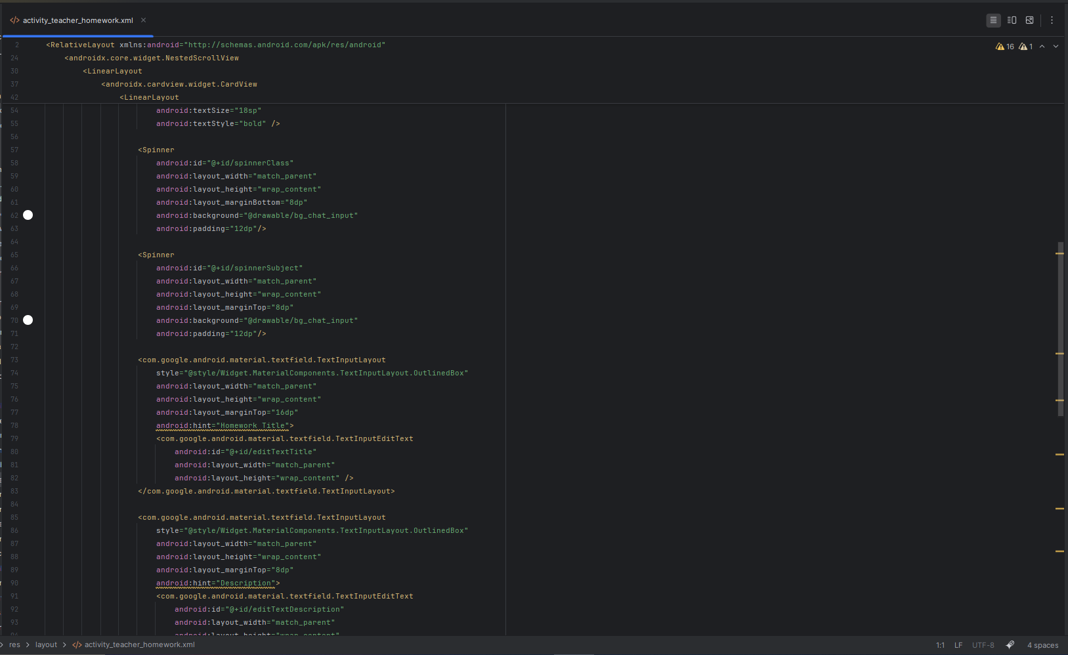

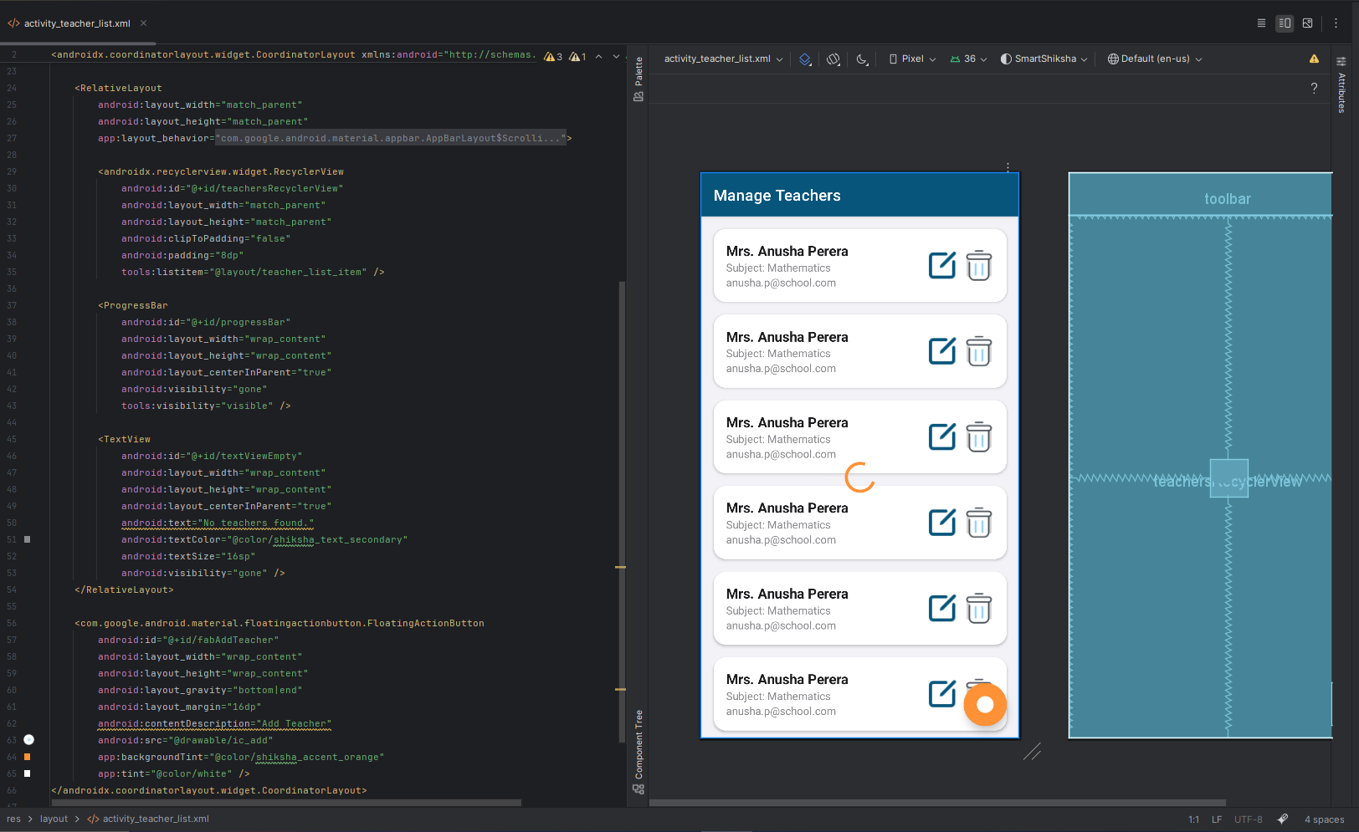
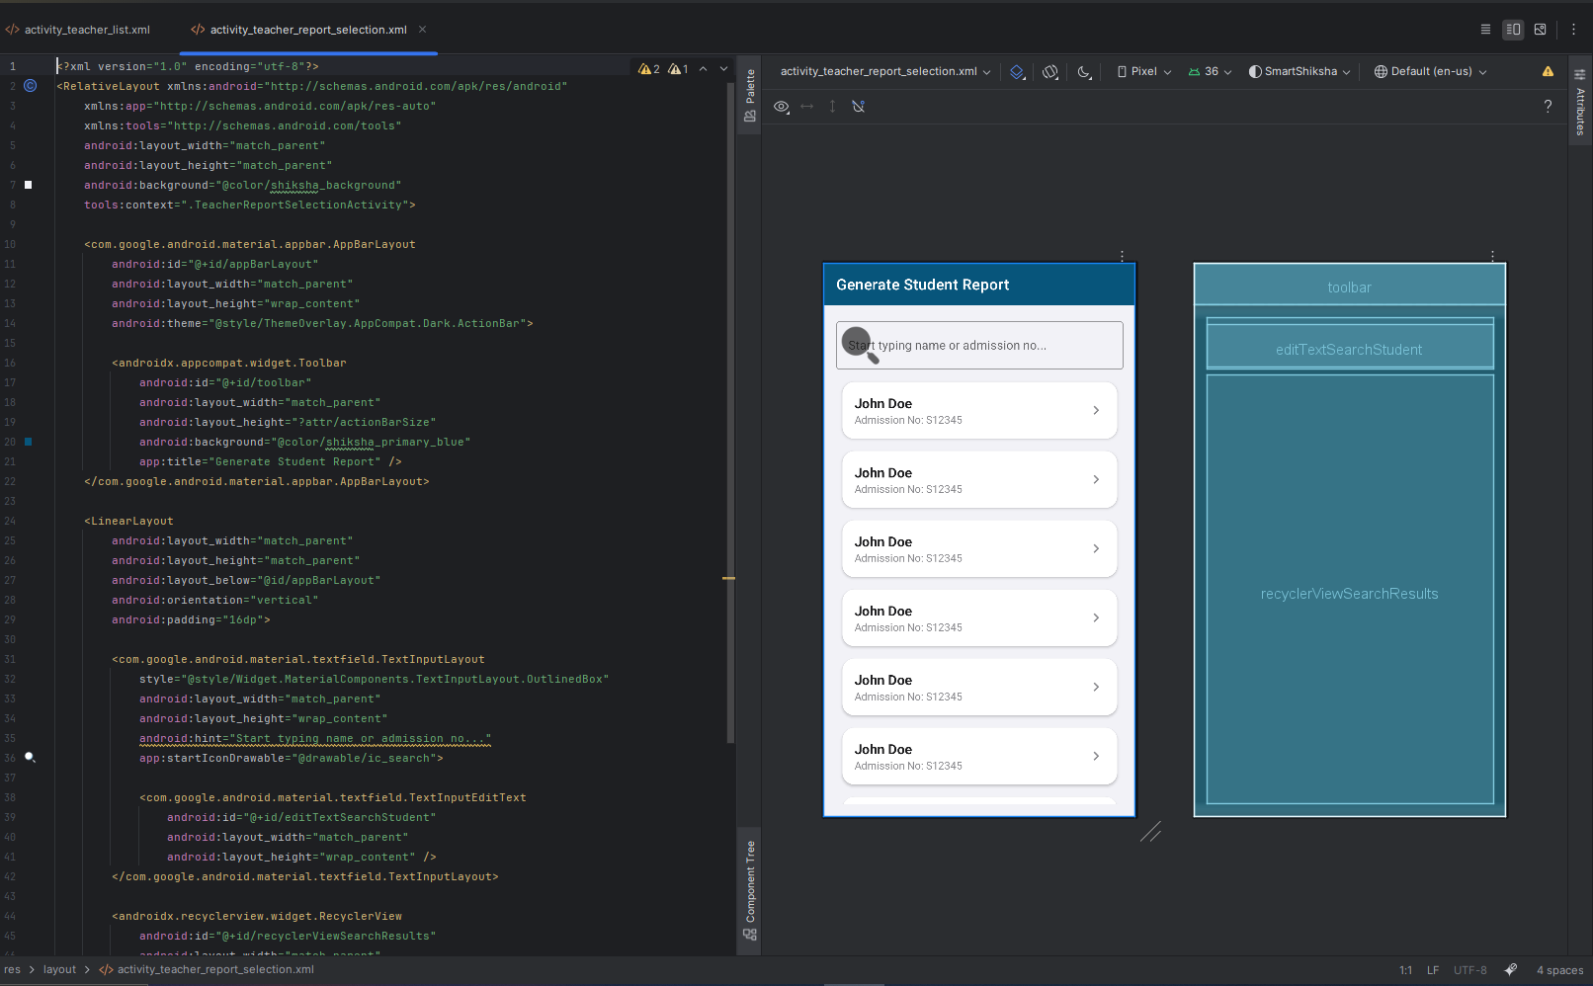

Website
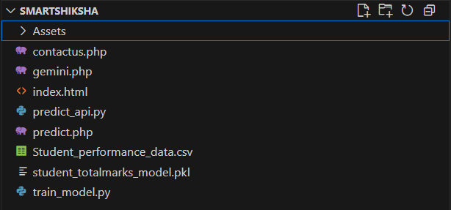

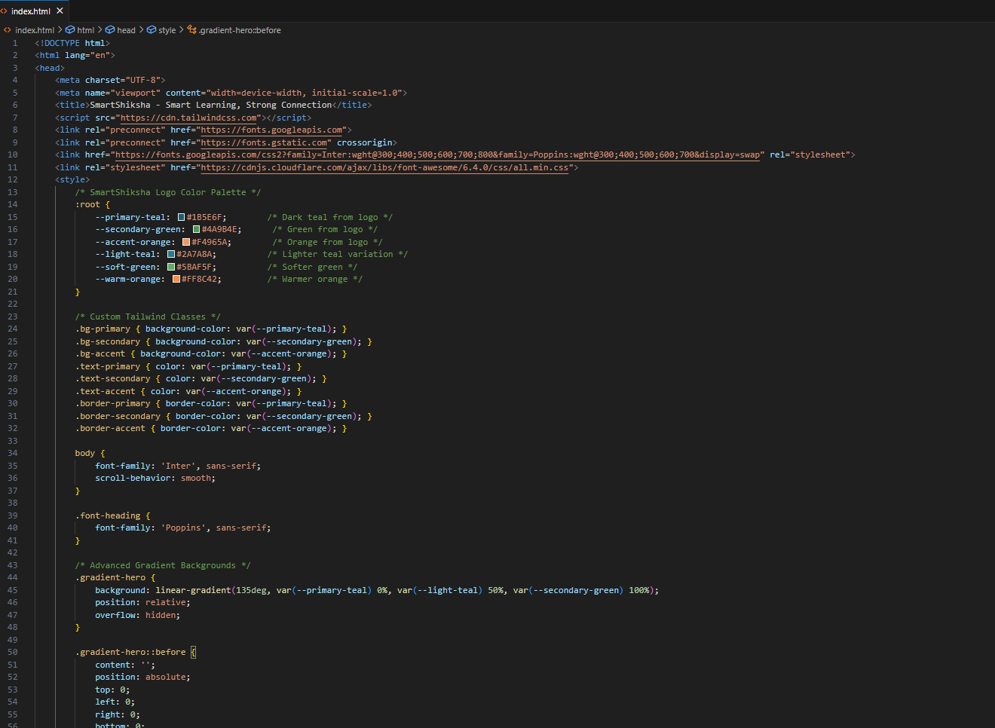
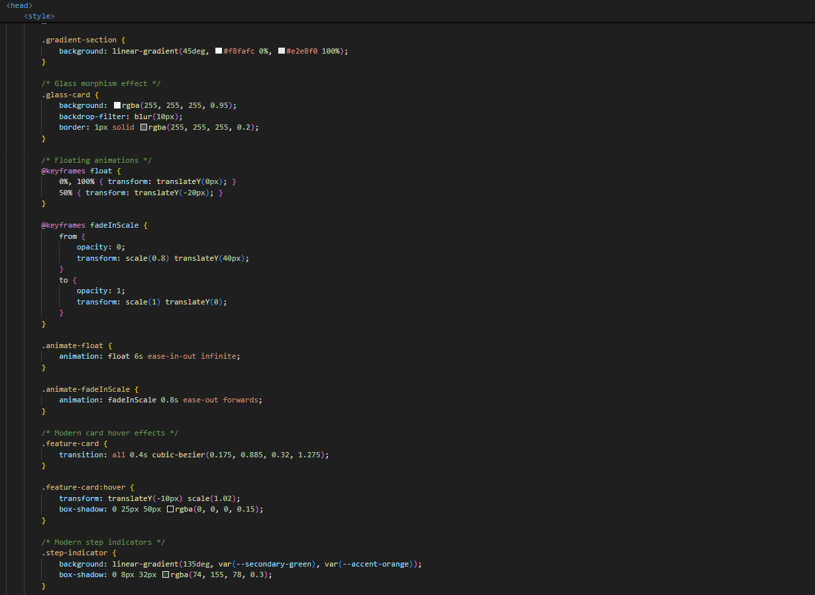
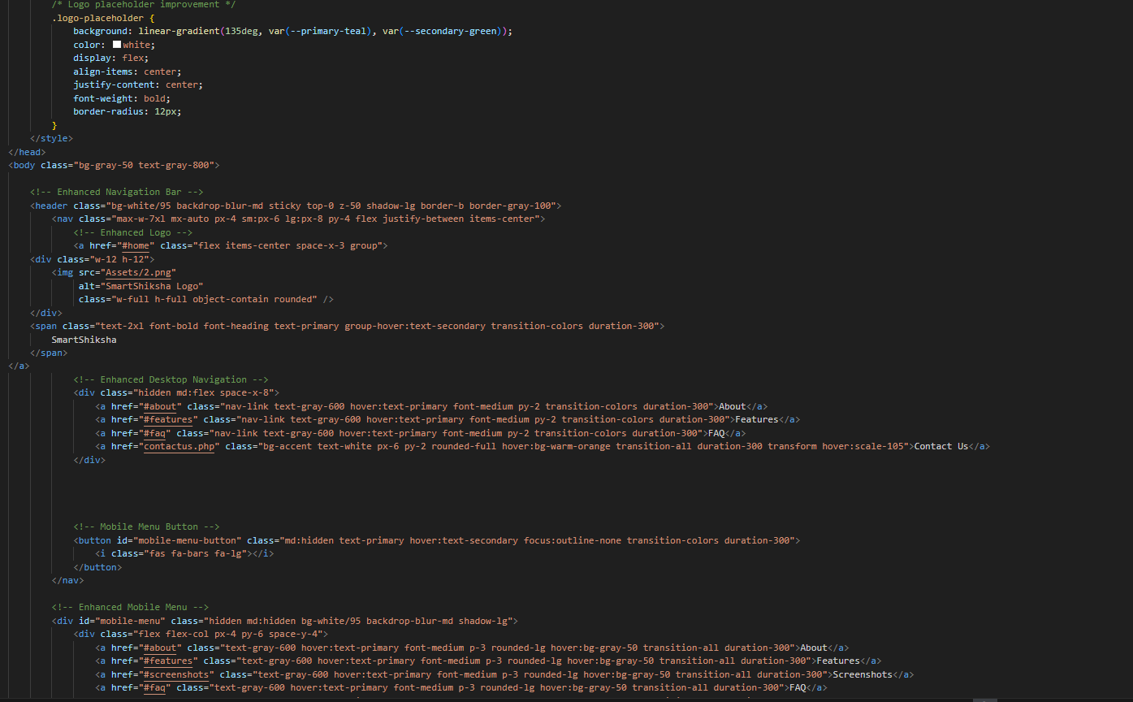

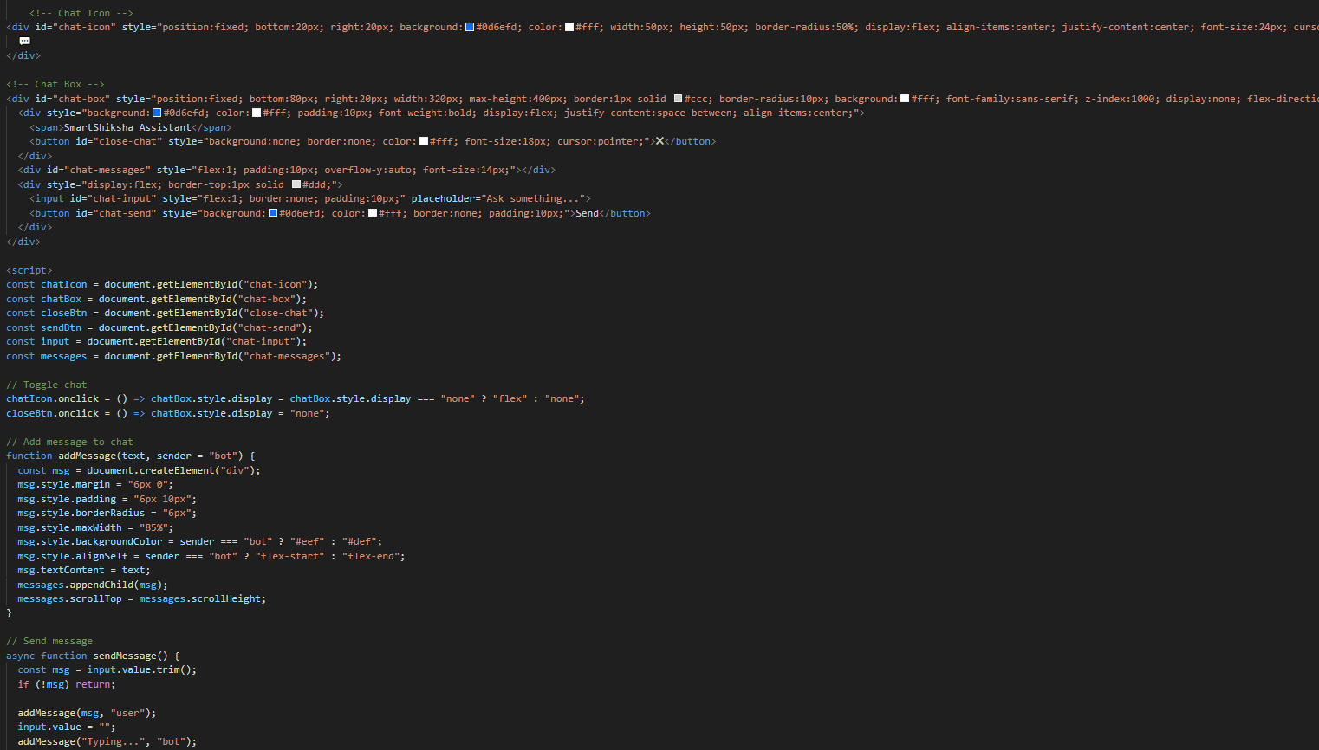
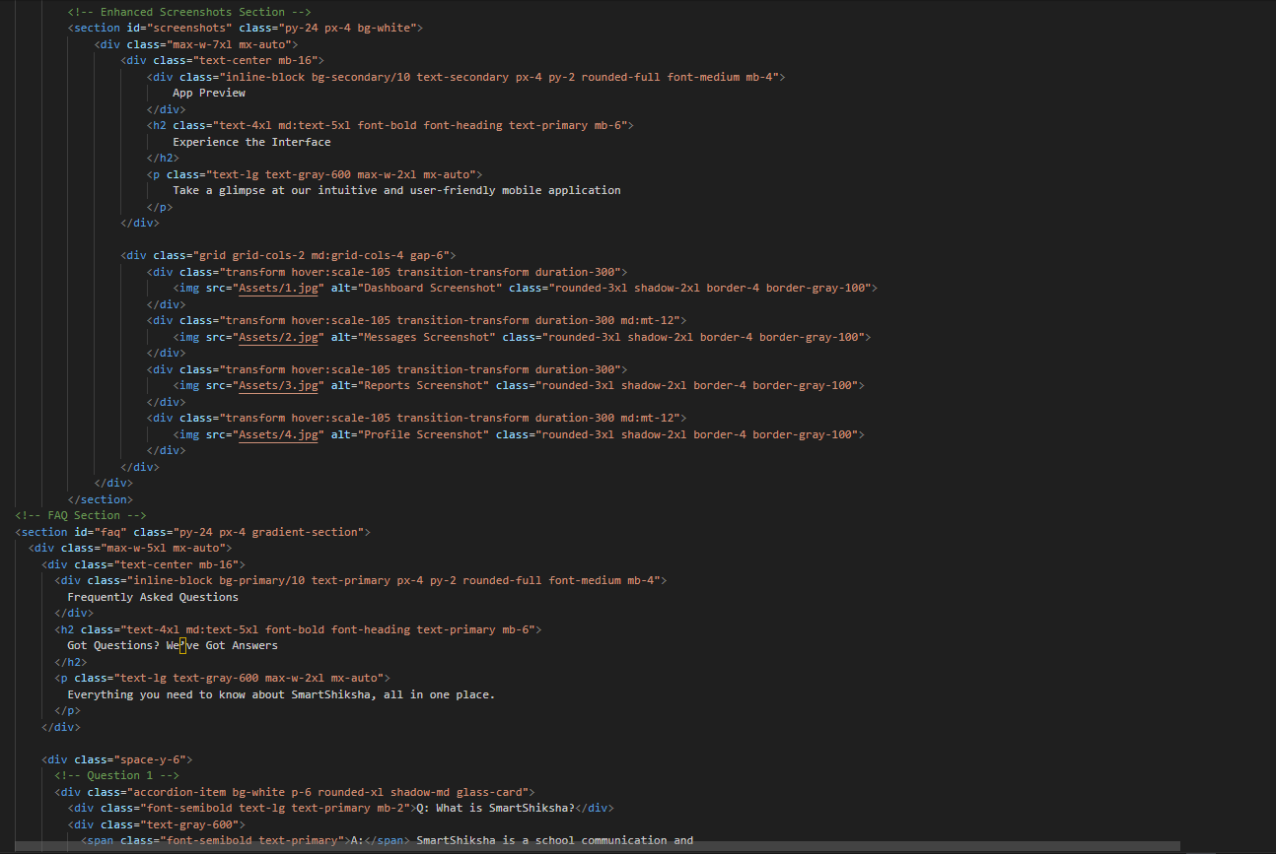

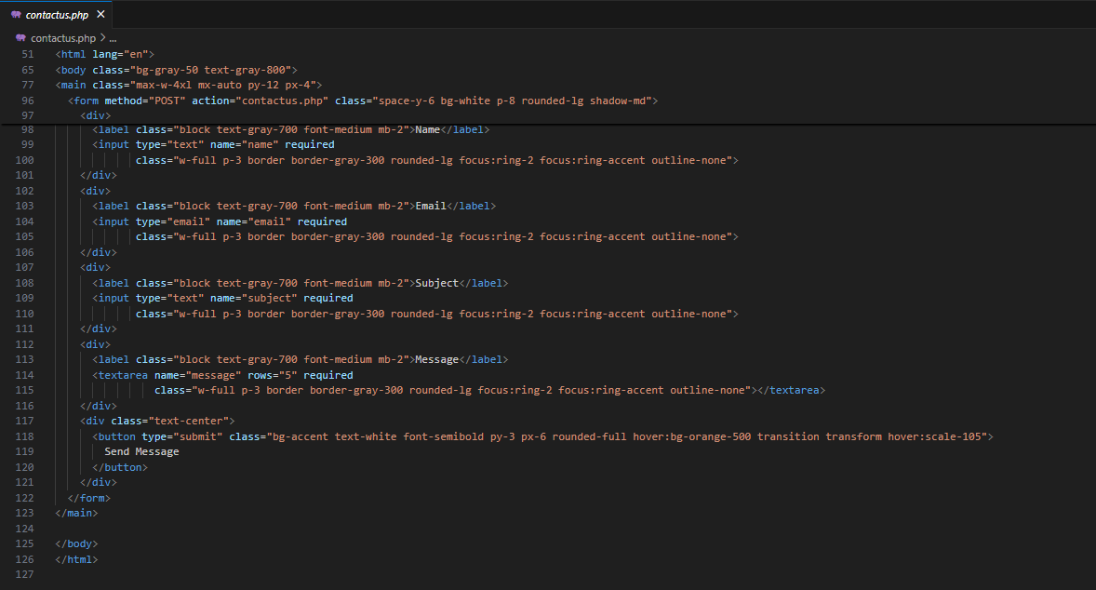

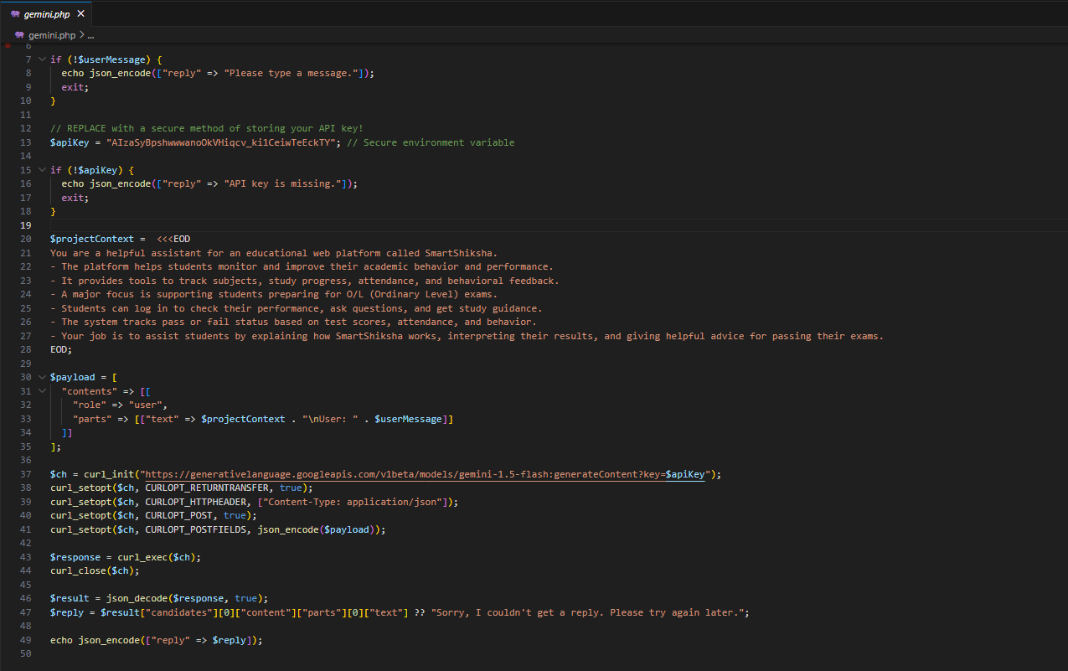

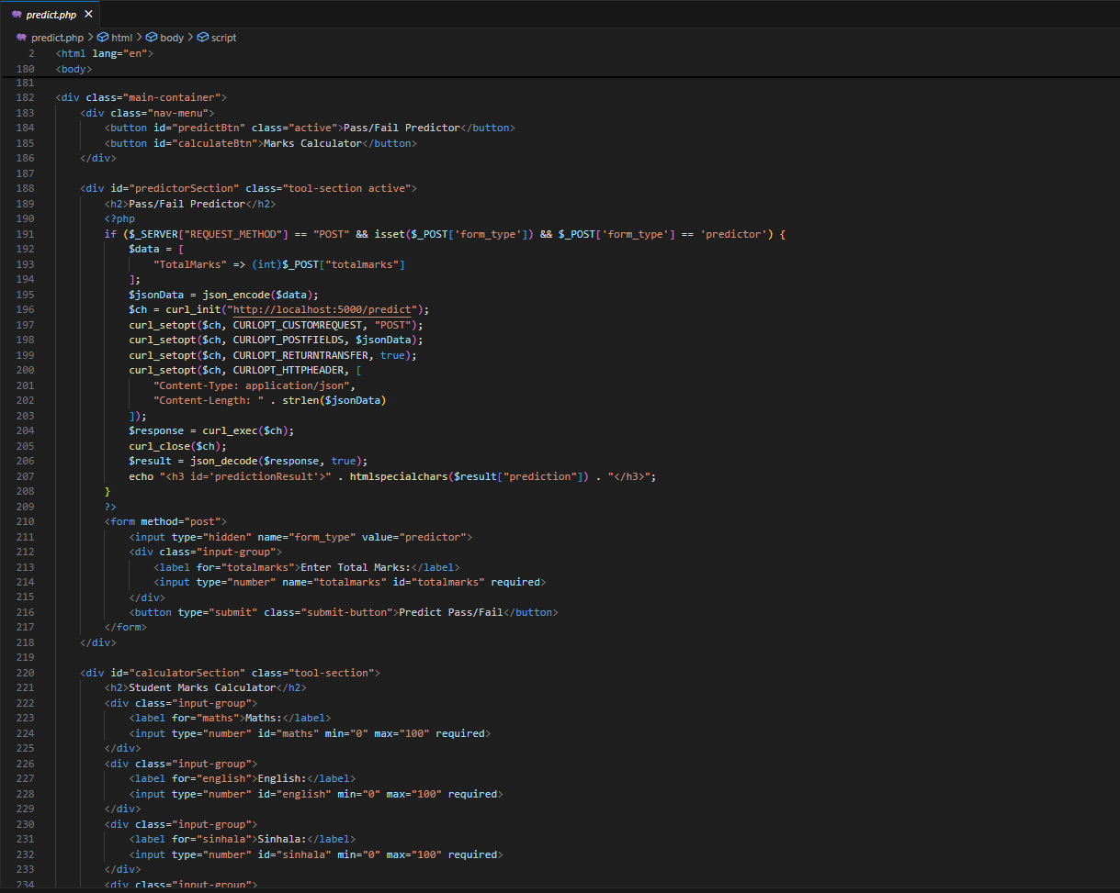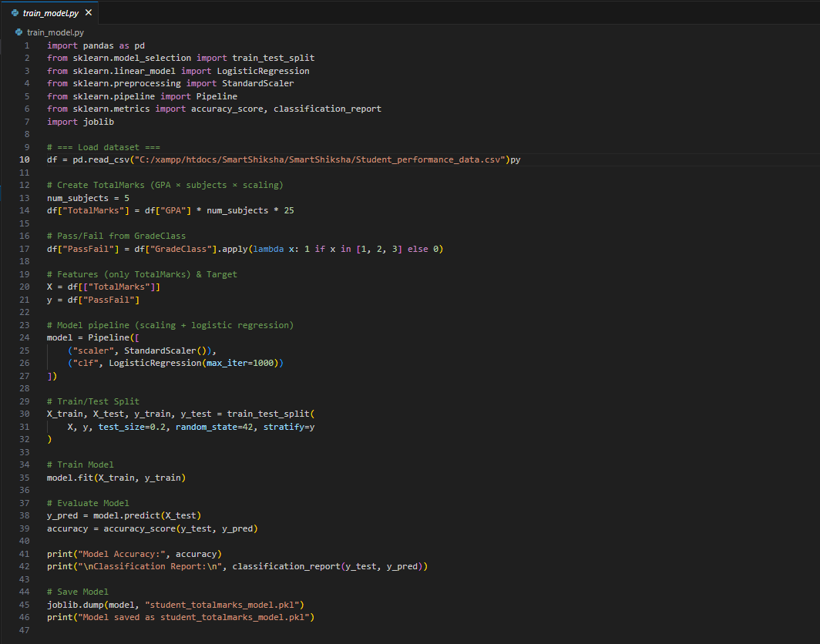

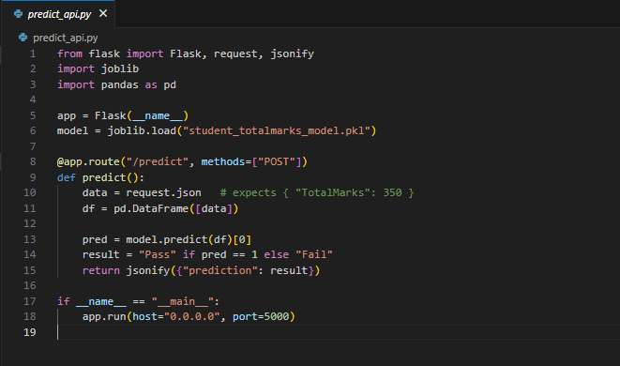

11.3. Database
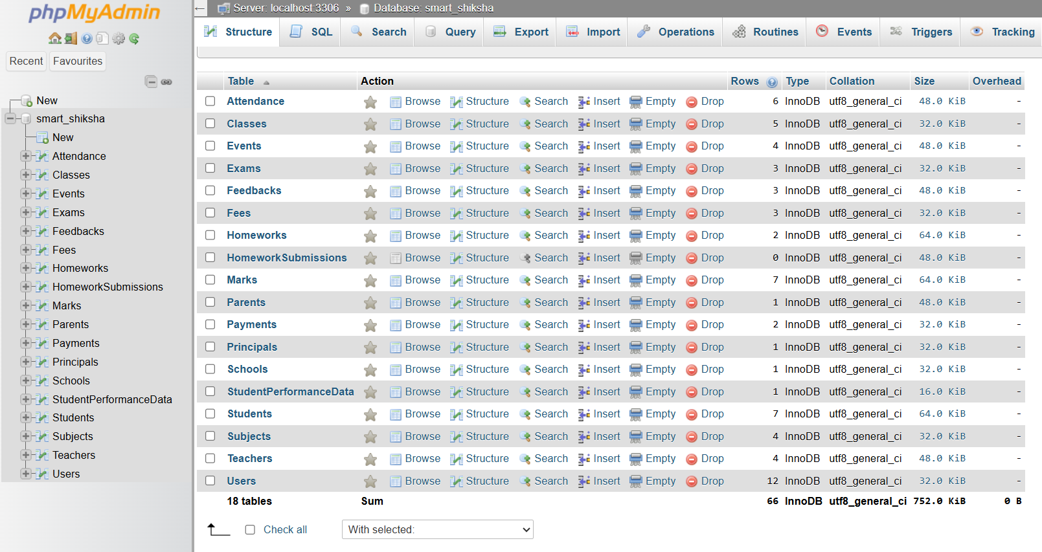
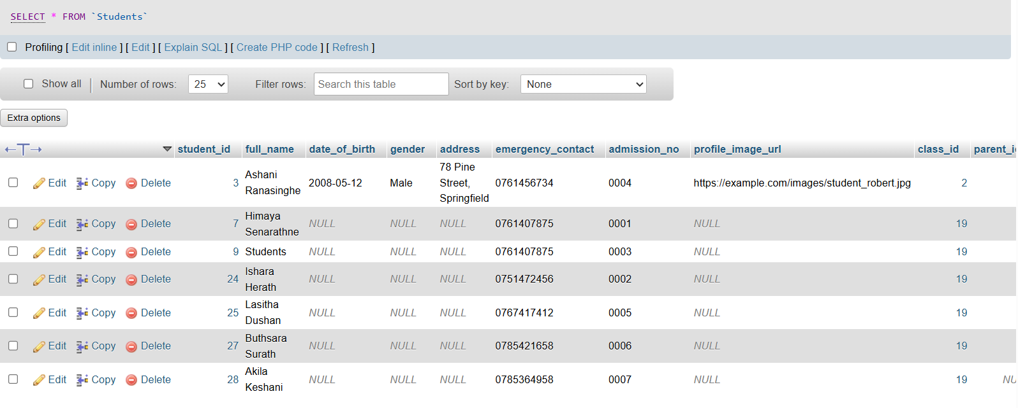
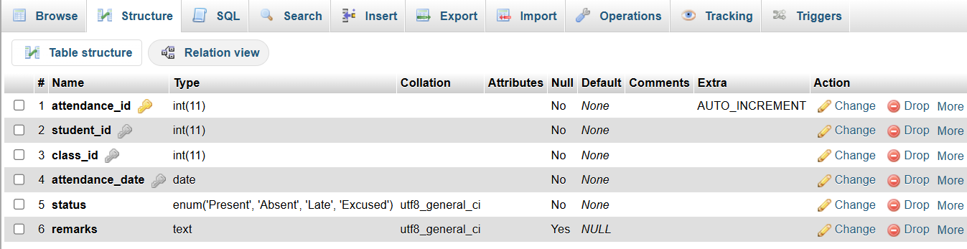
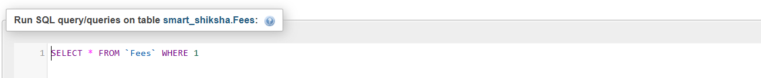

11.4. Supervisory Log sheet

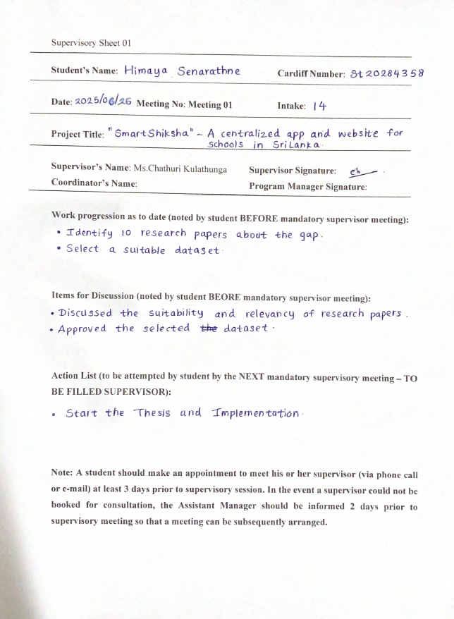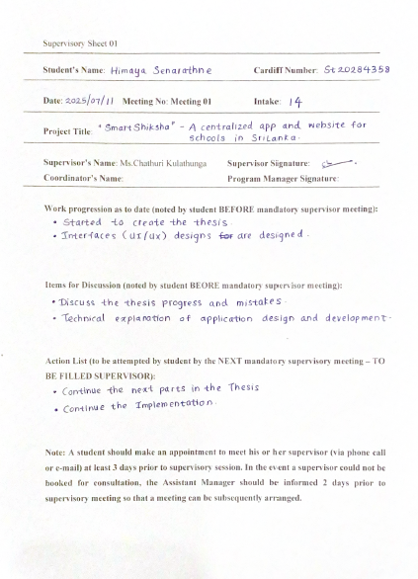

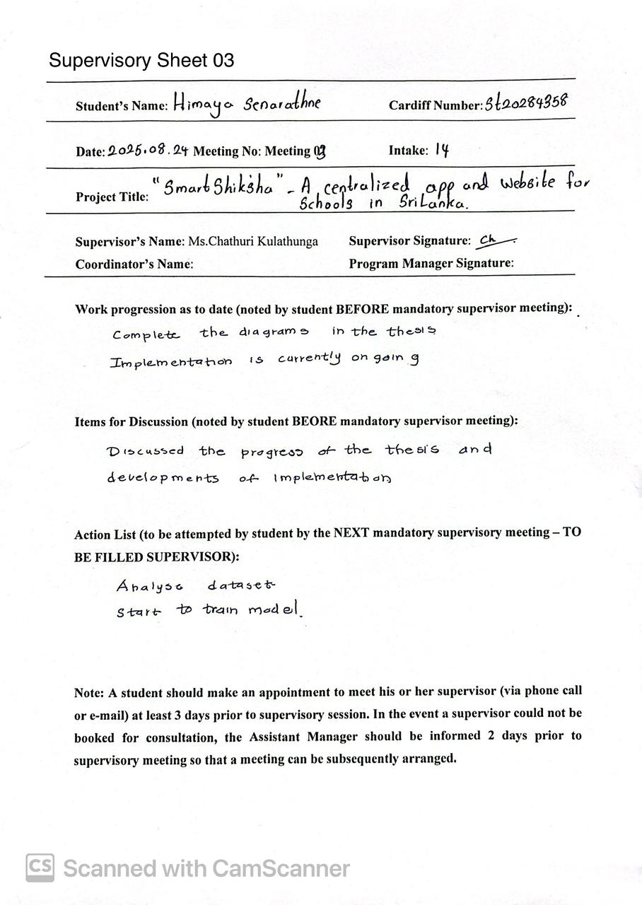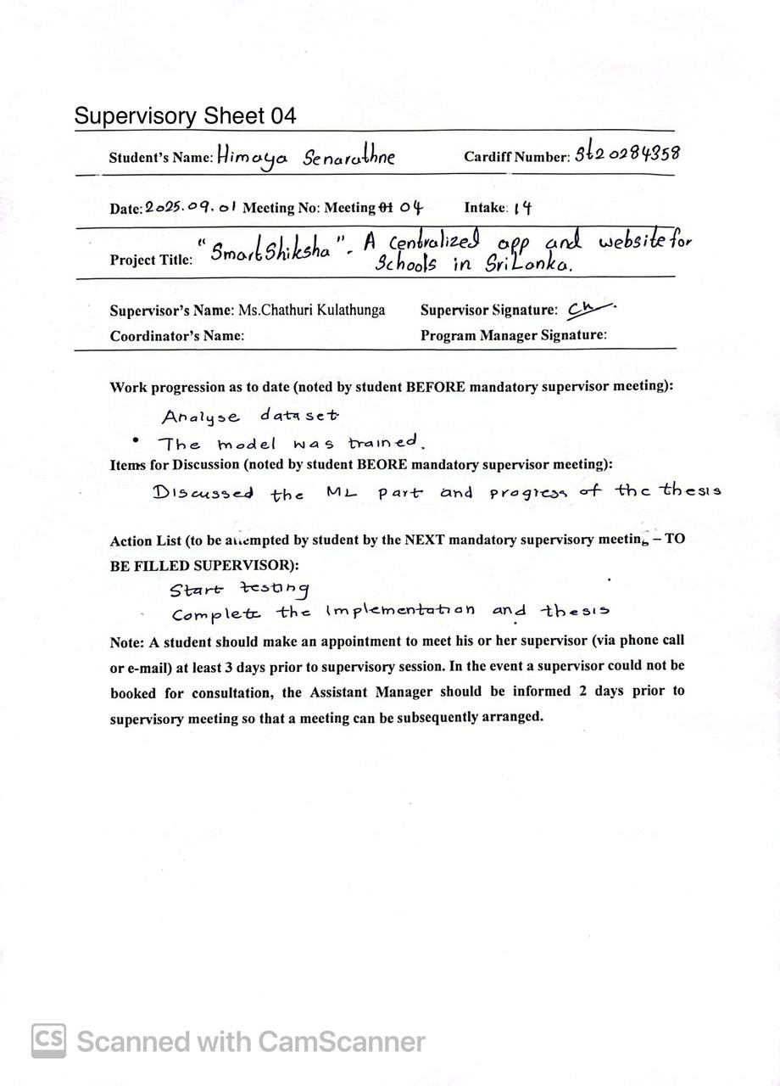

GitHub Link
- SamrtShikha Mobile Application.
https://github.com/DHimayaa/SmartShiksha.git
- SmartShiksha Website
https://github.com/DHimayaa/SmartShiksha-Website.git

