Mintfy
Firestore Schema Design
Collection structure, indexing strategy and multi-currency income handling for Kavindu Silva's finance app
Module | SE3092 Platform Based Development, Assignment 01 (Year 3, Semester 2, 2026)
Project | Mintfy (package: com.mintfy.app)
Firebase project | mintfy-56844 · Cloud Firestore (default) database · asia-south1 (Mumbai)
Related documents | Mintfy Software Requirements Specification (Final, 20 October 2026)  firestore.rules, firestore.indexes.json and firestore-tests/rules.test.js in the repository
Document status | Final
Date | 20 October 2026
Team members | W.P.S.T. Weerawardhana (IT23596870)  Tharuka HMND (IT23689176)  A.A.R.A.I. Perera (IT23746350)

1. Introduction

1.1 Purpose
This document specifies the Cloud Firestore data model for Mintfy and the reasons behind it. Section 4.2 of the assignment brief asks for a Firestore schema with justification for collection structure, indexing strategy and multi-currency income handling. Sections 2, 5 and 4 answer those three points in that order. The schema is derived from the Mintfy SRS: every collection, field, index and security rule below traces to a requirement there, and through it to Kavindu Silva's scenario. The document forms the Firestore chapter of the Technical Design Document and is the reference the Android data layer is built against.

1.2 Scope
Covered: the Firestore collections and fields, the security rules that enforce them, the composite indexes, the queries the screens will run, and how the rules were verified on the emulator and on the live project. Firebase Authentication appears only as the source of the user identity (uid).
Not covered: the Room database that caches this data on the device, the repositories and ViewModels that read it, and the screens. These belong to the MVVM architecture chapter. Section 7 describes only the points where they meet Firestore.

1.3 Design goals
Six goals shaped every decision in this document. Each comes from a specific failure in Kavindu's scenario.
ID | Goal | Why it matters for Kavindu | SRS
G-01 | Each user sees only their own data | Kavindu records his salary, freelance clients and crypto losses. None of it may be visible to another account. | FR-A3, NFR-04
G-02 | Money is exact | Totals of LKR 132,500 salaries and LKR 850 coffees must add up to the cent every time. Floating-point values cannot guarantee that. | NFR-05
G-03 | Received and expected income are never mixed | His estimate of LKR 160,000 to 210,000 is unreliable because it mixes money he has with money he hopes for. | FR-B6, FR-B7, FR-E6
G-04 | Past months never change | AdSense is converted at the transfer-day rate. If last month's income moved with today's rate, he would stop trusting the app. | FR-B5, A-02
G-05 | Works offline | Cash purchases happen in shops and cafés, often with poor signal. Recording an expense must never wait for the network. | FR-G1 to FR-G3, NFR-03
G-06 | Built around the screens' questions | Firestore only answers queries it has indexes for, so the dashboard, history and goal queries were listed first and the structure was chosen to serve them. | FR-F1 to FR-F6, NFR-02

1.4 Firebase project configuration
Setting | Value | Reason
Project | mintfy-56844 on the free Spark plan | Everything Mintfy needs fits in the free tier. No Cloud Functions are used (see D-09).
Android app | com.mintfy.app | Must match the applicationId. google-services.json is kept out of the repository.
Authentication | Email/Password provider enabled | FR-A1 and constraint C-07. Google Sign-In is FR-A4 (Later). Email enumeration protection stays on, so a wrong password and an unknown email return the same error and the sign-in screen shows one plain-language message (FR-H4).
Firestore database | (default), Standard edition, production mode | Production mode denies all access until rules are deployed. Test mode would have left the database open to anyone.
Location | asia-south1 (Mumbai) | The closest region to Colombo, which keeps sync latency low (NFR-02). The location cannot be changed later.
SDK | Firebase BoM 35.0.2: firebase-auth, firebase-firestore; kotlinx-coroutines-play-services | The BoM keeps the Firebase libraries on one tested set of versions. await() lets repositories call Firebase from coroutines (C-06).
Configuration as code | firestore.rules, firestore.indexes.json, firebase.json | Kept in the repository and deployed with the Firebase CLI, so the submitted rules and indexes are exactly what runs on the live project.

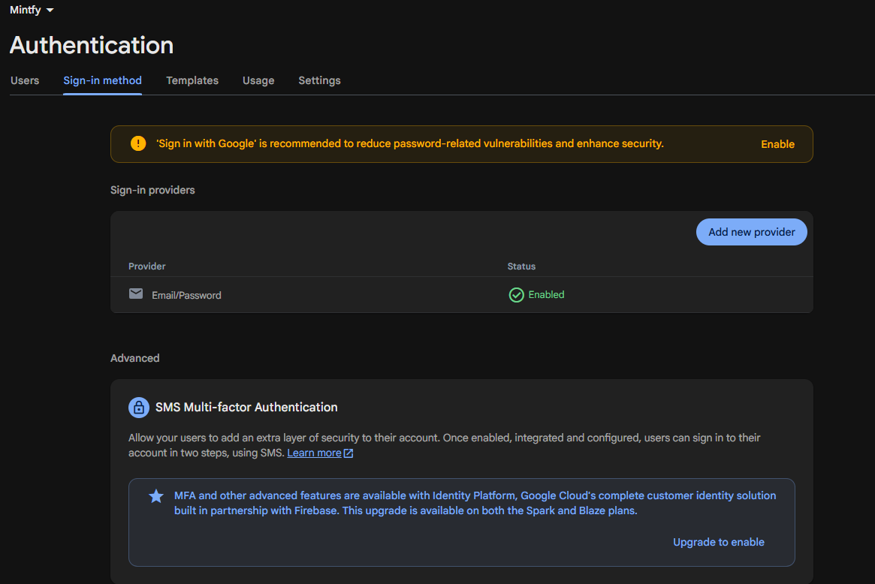
Figure 1.1: Firebase Authentication on project mintfy-56844 with the Email/Password provider enabled.

2. Collection Structure

2.1 Entities derived from the SRS
Each functional area of the SRS names the things Kavindu creates or records. Those things become the collections.
Entity | What it stores | Kavindu example | SRS
User profile | Email, base currency and the income estimate range | Estimate LKR 160,000 to 210,000 | FR-A1, FR-B8
Income source | A named origin of money and its type | "Startup salary" (SALARY), "Tech blog AdSense" (ADSENSE) | FR-B1, FR-B3
Income entry | One amount received, or one freelance amount still owed | LKR 132,500 salary; USD 52.30 AdSense; LKR 45,000 invoice | FR-B2 to FR-B9
Expense | One spending transaction | LKR 850 coffee paid in cash | FR-C1 to FR-C5
Category | A spending label with its committed or discretionary type | Rent (COMMITTED), Food & Coffee (DISCRETIONARY) | FR-D1, FR-D2, FR-D4
Payment method | How an expense was paid | Cash, Bank card, Secondary account | FR-C2
Recurring expense | A cost that repeats | Rent LKR 34,000 monthly; the gym | FR-C6
Savings goal | Target, deadline and amount already saved | MacBook Pro M4, LKR 490,000, LKR 11,200 saved | FR-E1

2.2 Collection tree
Every collection is a subcollection of the signed-in user's profile document, so every document path begins with users/{uid}, where uid is the Firebase Authentication user ID.
users/{uid} profile document
|-- incomeSources/{sourceId} salary, freelance, AdSense, crypto, other
|-- incomeEntries/{entryId} receipts and freelance invoices
|-- expenses/{expenseId}
|-- categories/{categoryId} committed or discretionary
|-- paymentMethods/{methodId} cash, card, named accounts
|-- recurringExpenses/{recurringId}
`-- goals/{goalId}

2.3 Schema diagram
Figure 2.1 on the next page shows every collection with its fields, types and the key rule for each field. It is printed on a landscape page so the field names stay readable.
How to read the diagram
- A line labelled subcollection means the collection is stored inside users/{uid}.
- A line labelled with a field name, such as categoryId, is a reference by document ID. Firestore has no joins; the app resolves references on the device.
- Crow's-foot ends show "many". For example, each expense has exactly one category and one payment method, and may come from one recurring item or none.
- Totals, the remaining goal amount and the on-track status are calculated, never stored (section 2.5).
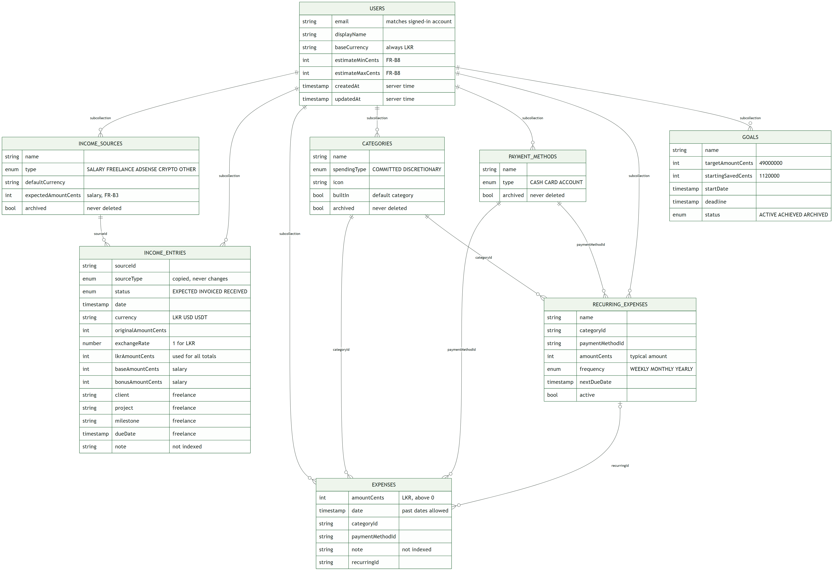
Figure 2.1: Mintfy Firestore schema. All collections are subcollections of users/{uid}.

2.4 Design decisions
Each decision below records the alternative the team considered and why it was rejected.
ID | Decision | Reason | Alternative rejected
D-01 | All data is nested under users/{uid}. | One ownership check in the rules protects every document (FR-A3). Every query is automatically limited to one user, so no query can forget a userId filter. Firestore rules are not filters: a query that could return another user's documents is rejected outright. | Top-level collections with a userId field on each document.
D-02 | Receipts and freelance invoices share one incomeEntries collection, separated by status. | Monthly income is one query: status RECEIVED in the month (FR-B6). Paying an invoice is a status update on the same document, so the demo step "mark it received and show it move into income" is a single write. | Separate receipts and invoices collections (paying would be a delete plus a create). Entries nested under each source (monthly totals would need collection-group queries).
D-03 | Income and expenses are separate collections. | The two records have different fields (currency, rate and status against category and payment method), so each gets a simple, exact validation rule. | One transactions collection with a type field and branching rules.
D-04 | Categories and payment methods are documents referenced by ID. | FR-D4 lets Kavindu rename a category or change its type. One document changes and every expense follows. | The category name stored as text on each expense.
D-05 | spendingType is not copied onto expenses. | The UC-10 demo step changes a category's type and expects the donut to change for past spending too. A copy would mean rewriting every past expense. Kavindu has about a dozen categories, so the app reads the type on the device. | Copying spendingType onto each expense.
D-06 | sourceType is copied onto each income entry. | Q3 (unpaid freelance) and Q4 (crypto year-to-date) filter by type. The rules forbid changing a source's type, so the copy can never go stale. | Looking up the source for every entry before filtering.
D-07 | Reference data is archived, never deleted. Transactions can be deleted. | Old expenses keep their category and payment method labels. Expenses and income entries can still be deleted, as FR-C5 requires. | Deleting a category and leaving expenses that point to nothing.
D-08 | Document IDs are generated on the device. | The Firestore SDK creates an ID with no network connection, and Room uses the same ID as its primary key. Offline creation works (FR-G1) and a retried write cannot create a duplicate. Default categories and payment methods use fixed IDs such as default_rent, so seeding them twice is harmless. | Server-assigned IDs, which need a round trip before the record exists.
D-09 | Monthly totals are calculated, not stored. | At about five expenses a day, a month is roughly 150 documents, which the device sums instantly. Stored totals would need Cloud Functions (Blaze plan) to stay correct, and Firestore's server-side sum() works neither offline nor with real-time listeners (FR-F5, NFR-03). | A monthlySummaries collection updated on every write.
D-10 | The last-used category and payment method (FR-C3) stay on the device. | They are a convenience for the add-expense form. Storing them in Firestore would add a cloud write to every expense. | Fields on the user profile.

2.5 Values that are derived, never stored
These values change whenever an entry is added, edited or deleted, or simply as time passes. Calculating them from stored entries keeps them correct without any extra writes.
Value | How it is calculated | SRS
Monthly received income | Sum of lkrAmountCents of RECEIVED entries dated in the month (Asia/Colombo time) | FR-B6, FR-F1
Monthly expenses | Sum of amountCents of expenses dated in the month | FR-F1
Monthly savings | Received income minus expenses for the month | FR-E3, A-01
Committed and discretionary split | Monthly expenses grouped by their category's spendingType | FR-F2
Unpaid freelance total | Sum of lkrAmountCents of FREELANCE entries with status EXPECTED or INVOICED | FR-B7
Crypto net year-to-date | Sum of the signed lkrAmountCents of CRYPTO entries since 1 January | FR-B9
Amount saved toward the goal | startingSavedCents plus monthly savings since the goal's startDate | FR-E3
Required monthly saving | (target minus saved) divided by months left. At the start: LKR 478,800 / 12 = LKR 39,900 | FR-E2, FR-E5
On track or behind | On track when this month's savings are at least the required monthly saving | FR-E4

3. Collection Reference

3.1 Conventions
Convention | Rule | Reason
Money | Whole cents as a 64-bit integer (Kotlin Long). LKR 34,000.00 is stored as 3400000. | NFR-05. Integer arithmetic is exact; in floating point, 0.1 + 0.2 is not 0.3.
Enumerations | Uppercase strings, for example DISCRETIONARY | Readable in the console. Firestore maps Kotlin enum classes to these names.
Dates | Firestore Timestamp. Month boundaries are calculated in Asia/Colombo time. | A coffee bought at 23:30 on the 31st belongs to that month.
createdAt, updatedAt | Written with FieldValue.serverTimestamp(). The rules require both to equal the server's request time on create; on update createdAt cannot change. | One trusted clock orders every change, which gives last-write-wins (A-03).
Optional fields | May be absent or null | Kotlin data classes write null for empty optional properties.
Field names | Exactly as listed. The rules reject unknown fields. | A typo fails at the first write instead of silently storing bad data.

In the field tables, Req. marks a required field. Every collection also has the required createdAt and updatedAt timestamps described above.

3.2 users/{uid}
One document per user, created at registration. Its ID is the Firebase Authentication uid. It cannot be deleted.
Field | Type | Req. | Example | Notes and rules | SRS
email | string | ✔ | kavindu@example.com | Must equal the signed-in account's email | FR-A1
displayName | string |  | Kavindu | Up to 60 characters
baseCurrency | string | ✔ | LKR | Always LKR; all totals are shown in LKR | NFR-05
estimateMinCents | int |  | 16000000 | LKR 160,000; must not exceed the maximum | FR-B8
estimateMaxCents | int |  | 21000000 | LKR 210,000 | FR-B8

3.3 users/{uid}/incomeSources/{sourceId}
One document per source Kavindu earns from. Sources are archived, never deleted (D-07).
Field | Type | Req. | Example | Notes and rules | SRS
name | string | ✔ | Startup salary | 1 to 60 characters | FR-B1
type | enum | ✔ | SALARY | SALARY, FREELANCE, ADSENSE, CRYPTO or OTHER. Cannot change after creation | FR-B1
defaultCurrency | string | ✔ | USD | Pre-selects the currency on the add-income form | FR-B5
expectedAmountCents | int |  | 12000000 | Expected salary (LKR 120,000), compared with each receipt | FR-B3
archived | bool | ✔ | false | Hides the source from new entries

3.4 users/{uid}/incomeEntries/{entryId}
One document per amount received, or per freelance amount still owed. Section 4 explains the currency fields.
Field | Type | Req. | Example | Notes and rules | SRS
sourceId | string | ✔ | src_salary | ID of the income source | FR-B2
sourceType | enum | ✔ | SALARY | Copied from the source; cannot change (D-06) | FR-B7, FR-B9
status | enum | ✔ | RECEIVED | EXPECTED, INVOICED or RECEIVED. Only FREELANCE and OTHER may be unpaid | FR-B4, FR-B6, FR-E6
date | timestamp | ✔ | 25 Oct 2026 | Date received; for an unpaid entry, the date payment is expected | FR-B2
currency | string | ✔ | USD | Currency actually paid in: LKR, USD or USDT | FR-B5
originalAmountCents | int | ✔ | 5230 | Amount in that currency (USD 52.30). Negative only for crypto | FR-B5, FR-B9
exchangeRate | number | ✔ | 298.75 | LKR per unit, entered by the user. Exactly 1 for LKR | FR-B5, A-02
lkrAmountCents | int | ✔ | 1554000 | LKR actually credited (LKR 15,540.00). Every total uses this field | FR-B5, FR-B6
baseAmountCents | int |  | 12000000 | Salary base. With the bonus, must add up to the amount | FR-B3
bonusAmountCents | int |  | 1250000 | Salary bonus (LKR 12,500) | FR-B3
client | string |  | Lanka Bites | Freelance client, up to 80 characters | FR-B4
project | string |  | WordPress site | Freelance project | FR-B4
milestone | string |  | Milestone 2 | Freelance milestone | FR-B4
dueDate | timestamp |  | 5 Nov 2026 | Invoice due date | FR-B4
note | string |  | September payout | Up to 200 characters; not indexed

Entries can be deleted (FR-C5).

3.5 users/{uid}/expenses/{expenseId}
Field | Type | Req. | Example | Notes and rules | SRS
amountCents | int | ✔ | 85000 | LKR 850.00. Must be above zero | FR-C1, FR-H3
date | timestamp | ✔ | 20 Oct 2026 | Any past date is allowed, for backfilling | FR-C1, FR-C4
categoryId | string | ✔ | default_food_coffee | The spending type comes from the category (D-05) | FR-C1, FR-D2
paymentMethodId | string | ✔ | default_cash | Cash, card or a named account | FR-C2
note | string |  | Coffee with team | Up to 200 characters; not indexed | FR-C1
recurringId | string |  | rec_rent | Set when the expense was created from a recurring item | FR-C6

Expenses are always in LKR: Kavindu spends in Sri Lanka, so an expense has no currency fields. The amount is what was actually paid that time, which is how a committed cost such as utilities can differ each month (FR-D3). Expenses can be edited and deleted (FR-C5).

3.6 users/{uid}/categories/{categoryId}
Field | Type | Req. | Example | Notes and rules | SRS
name | string | ✔ | Food & Coffee | 1 to 40 characters | FR-D1
spendingType | enum | ✔ | DISCRETIONARY | COMMITTED or DISCRETIONARY | FR-D2
icon | string |  | coffee | Icon key used by the UI
builtIn | bool | ✔ | true | true for the defaults created at first sign-in. Cannot change | FR-D1
archived | bool | ✔ | false | Categories are archived, never deleted | FR-D4

The flag is named builtIn rather than isDefault because Firestore's Kotlin mapper drops the "is" prefix from Boolean properties. A field called isDefault would be stored as default and fail the rules.
Default categories (FR-D1)
Created in one batch at first sign-in with fixed IDs, so Kavindu can record his first expense with no setup.
ID | Name | Spending type | Why, for Kavindu
default_rent | Rent | COMMITTED | LKR 34,000 every month
default_utilities | Utilities | COMMITTED | Fluctuates, but cannot be skipped
default_subscriptions | Subscriptions | COMMITTED | The two services he meant to cancel
default_gym | Gym & Health | COMMITTED | Auto-debited from the secondary account
default_groceries | Groceries | COMMITTED | Basic living cost
default_food_coffee | Food & Coffee | DISCRETIONARY | Part of the LKR 24,000 coffee and dining month
default_dining | Dining & Delivery | DISCRETIONARY | UberEats orders
default_transport | Transport | DISCRETIONARY | PickMe rides, which his bank mislabelled (E-13)
default_entertainment | Entertainment | DISCRETIONARY | Optional leisure spending
default_shopping | Shopping | DISCRETIONARY | Impulse purchases
default_other | Other | DISCRETIONARY | Anything else

These defaults are a team decision. Transport is discretionary because most of Kavindu's trips are PickMe rides he could replace. FR-D4 lets him change any type.

3.7 users/{uid}/paymentMethods/{methodId}
Field | Type | Req. | Example | Notes and rules | SRS
name | string | ✔ | Secondary account | 1 to 40 characters | FR-C2
type | enum | ✔ | ACCOUNT | CASH, CARD or ACCOUNT | FR-C2
archived | bool | ✔ | false | Payment methods are archived, never deleted

Seeded with default_cash (Cash), default_card (Bank card) and default_secondary (Secondary account). Cash and the secondary account are exactly the channels his bank's summary never saw (E-13).

3.8 users/{uid}/recurringExpenses/{recurringId}
Field | Type | Req. | Example | Notes and rules | SRS
name | string | ✔ | Rent | 1 to 60 characters | FR-C6
categoryId | string | ✔ | default_rent | Category for the expenses it creates | FR-C6
paymentMethodId | string | ✔ | default_card | Payment method for the expenses it creates | FR-C6
amountCents | int | ✔ | 3400000 | Typical amount. The expense created each period may differ | FR-C6, FR-D3
frequency | enum | ✔ | MONTHLY | WEEKLY, MONTHLY or YEARLY | FR-C6
nextDueDate | timestamp | ✔ | 1 Nov 2026 | Orders the recurring list | FR-C6
active | bool | ✔ | true | Inactive items stay for history | FR-C6

3.9 users/{uid}/goals/{goalId}
Field | Type | Req. | Example | Notes and rules | SRS
name | string | ✔ | MacBook Pro M4 | 1 to 60 characters | FR-E1
targetAmountCents | int | ✔ | 49000000 | LKR 490,000. Must be above zero | FR-E1
startingSavedCents | int | ✔ | 1120000 | LKR 11,200 already saved | FR-E1
startDate | timestamp | ✔ | 20 Oct 2026 | Start of the saving period | FR-E2
deadline | timestamp | ✔ | 20 Oct 2027 | Must be after startDate | FR-E1
status | enum | ✔ | ACTIVE | ACTIVE, ACHIEVED or ARCHIVED | FR-E1

The remaining amount, the required monthly saving and the on-track status are not fields. Section 2.5 shows how they are derived.

4. Multi-Currency Income Handling
Kavindu is paid in LKR (salary, freelance), in USD (AdSense) and in USDT (crypto). His Play Store app failed partly because it supported only one currency (E-11). This section explains how Mintfy records every currency while still producing one reliable monthly figure in LKR.

4.1 The rule
Every income entry stores four values together, at the moment the money arrives. Every total in Mintfy adds up lkrAmountCents and nothing else.
Field | Answers the question
originalAmountCents | How much was paid, in the payer's currency?
currency | Which currency was it?
exchangeRate | At what rate was it converted on the transfer day?
lkrAmountCents | How many rupees actually arrived in his account?

4.2 Kavindu's four sources
The column headings are the fields from section 4.1, in the same order.
Source | What happens | Currency | Original amount (cents) | Rate | LKR amount (cents) | Status
Salary | Base LKR 120,000 plus bonus LKR 12,500 arrive on the 25th | LKR | 13250000 | 1 | 13250000 | RECEIVED
AdSense | USD 52.30 at 298.75 is LKR 15,624.63; the bank credits LKR 15,540.00 | USD | 5230 | 298.75 | 1554000 | RECEIVED
Freelance | LKR 45,000 milestone invoiced to Lanka Bites | LKR | 4500000 | 1 | 4500000 | INVOICED
Crypto | Q3 loss of 60 USDT, realised at 300 | USDT | -6000 | 300 | -1800000 | RECEIVED

- Salary also stores baseAmountCents 12000000 and bonusAmountCents 1250000. The app compares the receipt with the source's expectedAmountCents and shows the LKR 12,500 difference (FR-B3), so he no longer has to read his payslip.
- AdSense keeps both the converted value and what was credited. The LKR 84.63 gap is bank fees, and it is visible only because both values are stored.
- Freelance counts nowhere until it is marked RECEIVED, when its date becomes the payment date (FR-B6, FR-E6). Until then it appears in the unpaid invoices total (FR-B7).
- Crypto results are realised gains and losses, entered as signed amounts. The year-to-date net is their sum (FR-B9). Holdings and live prices are out of scope (O-02).

4.3 Why the LKR value is stored instead of recalculated
- Exchange rates change daily. Converting when a screen opens would change last month's income every time (G-04).
- There is no live rate feed (A-02). The rate that matters is the one his bank applied on the transfer day.
- What the bank credits can differ from amount × rate because of fees. Only the stored LKR value matches his bank statement.
- Keeping the original amount and the rate makes every figure auditable, for example "USD 52.30 at 298.75" (NFR-05).

4.4 Rounding and the exchange rate
The exchange rate is the only decimal field in the schema. It is stored for the record and is never used to recalculate stored money. When Kavindu enters an amount and a rate, the app proposes lkrAmountCents as originalAmountCents × exchangeRate rounded half-up to the cent, once, at entry time. He can overwrite it with the amount his bank actually credited. From then on, totals add integers only, so they are exact.

4.5 How the security rules protect this
- The currency must be a code of 3 to 5 capital letters: LKR, USD, USDT.
- An LKR entry must have an exchangeRate of exactly 1, and lkrAmountCents equal to originalAmountCents.
- Only CRYPTO entries may be negative, and both of their amounts must have the same sign.
- If both base and bonus are given, they must add up to originalAmountCents.
- Only FREELANCE or OTHER entries may be EXPECTED or INVOICED. Salary, AdSense and crypto are recorded only when received.

4.6 Income status lifecycle
EXPECTED ──► INVOICED ──► RECEIVED
(agreed) (invoice sent) (money arrived: counts as income and savings)
A freelance milestone starts as EXPECTED when it is agreed, becomes INVOICED when Kavindu sends the invoice, and becomes RECEIVED when the money arrives. Only RECEIVED entries count as income or savings. The dashboard shows the EXPECTED and INVOICED total separately, which keeps the kind of invoice he twice forgot to follow up (E-02) in view.

5. Indexing Strategy

5.1 How Firestore uses indexes
Firestore creates a single-field index for every field automatically. That covers any query that filters or sorts on one field, such as all expenses in a date range. A query that combines an equality or "in" filter on one field with a range or sort on another needs a composite index, which must be declared. Without it, the query fails with FAILED_PRECONDITION. Mintfy's indexes were therefore derived from the list of queries its screens run, not added after errors appeared.

5.2 Query catalogue
ViewModel names follow the SRS traceability matrix (section 9) and are provisional until the architecture is final.
ID | Screen (ViewModel) | Query | Index | SRS
Q1 | Dashboard (DashboardViewModel) | expenses where date ≥ start of month and date < start of next month | Automatic | FR-F1 to FR-F3, FR-F5
Q2 | Dashboard (DashboardViewModel) | incomeEntries where status == RECEIVED and date in the month | I-1 | FR-B6, FR-F1, FR-F6
Q3 | Dashboard (DashboardViewModel) | incomeEntries where status in [EXPECTED, INVOICED], ordered by date | I-1 | FR-B7, FR-E6
Q4 | Income (IncomeViewModel) | incomeEntries where sourceType == CRYPTO and date ≥ 1 January | I-2 | FR-B9
Q5 | History (HistoryViewModel) | expenses where date in range, newest first | Automatic | FR-C7
Q6 | History (HistoryViewModel) | expenses where categoryId == X and date in range, newest first | I-4 | FR-C7
Q7 | Income (IncomeViewModel) | incomeEntries where sourceId == X, newest first | I-3 | FR-B1
Q8 | Recurring (RecurringViewModel) | recurringExpenses where active == true, ordered by nextDueDate | I-5 | FR-C6
Q9 | Goal (GoalViewModel) | goals where status == ACTIVE | Automatic | FR-E1, FR-F4
Q10 | Add expense (ExpenseViewModel) | categories and paymentMethods where archived == false, sorted on the device | Automatic | FR-C3, FR-D1

5.3 Composite indexes
ID | Collection | Fields (↑ ascending, ↓ descending) | Serves
I-1 | incomeEntries | status ↑, date ↑ | Q2, Q3
I-2 | incomeEntries | sourceType ↑, date ↑ | Q4
I-3 | incomeEntries | sourceId ↑, date ↓ | Q7
I-4 | expenses | categoryId ↑, date ↓ | Q6
I-5 | recurringExpenses | active ↑, nextDueDate ↑ | Q8

Q2 and Q3 share I-1 because both read the date in ascending order, so one index serves two dashboard queries. All five use query scope "Collection", which applies the index inside each user's folder. Firestore adds the document ID (__name__) to every index as a tiebreaker, which is why the console lists it as a third field.
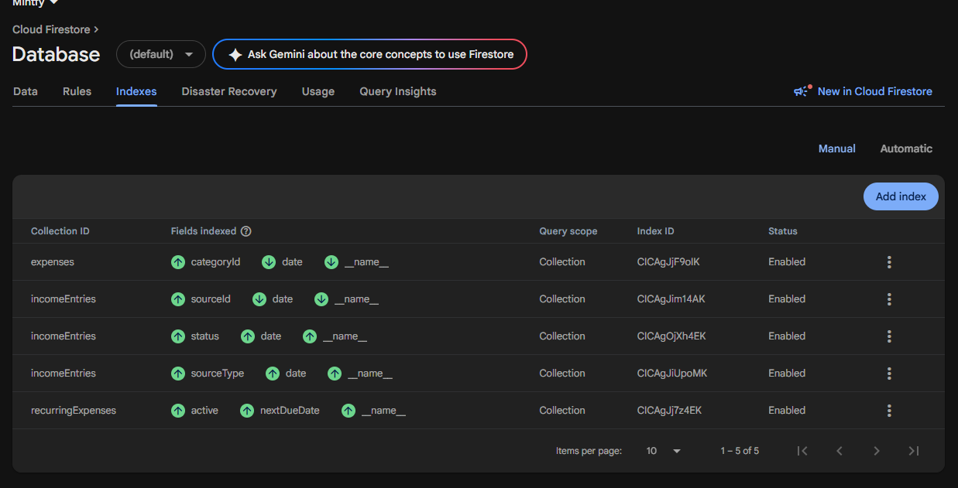
Figure 5.1: The five composite indexes deployed to mintfy-56844, all with status Enabled.

5.4 Index exemptions
The note field on expenses and incomeEntries is free text that no query filters or sorts on. Its single-field indexes are disabled in firestore.indexes.json (fieldOverrides). This saves index storage and write cost on every expense Kavindu records, which matters for an app he is meant to use several times a day.

5.5 No stored totals
There are no aggregate indexes or summary documents. Monthly totals are calculated on the device from the Q1 and Q2 results (D-09), which keeps them correct offline and lets them update with the real-time listeners.

6. Security Rules

6.1 Approach
The full rules are in firestore.rules in the repository root and are deployed to the live project. They follow five principles:
- Deny by default. Only the paths listed in the rules are reachable; any other path is denied.
- Ownership. Every path is under users/{uid}, and every rule first checks that request.auth.uid equals uid.
- Shape. A write must contain every required field and nothing outside the fields listed in section 3.
- Values. Types, enumerations, integer money and the currency rules of section 4.5 are checked on the server, so even a modified app cannot store invalid data.
- History. createdAt and updatedAt come from the server clock, createdAt can never change, and a source's type, an entry's sourceType and a category's builtIn flag are fixed after creation.

6.2 Rules by collection
Collection | Read | Create and update | Delete | Key validation | SRS
users/{uid} | Owner | Owner, valid profile | Never | Email matches the account; base currency LKR; estimate min ≤ max | FR-A1, FR-B8
incomeSources | Owner | Owner; type cannot change | Never (archive) | One of five types; integer expected salary | FR-B1, FR-B3
incomeEntries | Owner | Owner; sourceType cannot change | Owner | Currency rules (4.5); status rule; integer amounts | FR-B3 to FR-B9, FR-E6
expenses | Owner | Owner, valid expense | Owner | Integer amount above zero; date, category and payment method required | FR-C1 to FR-C5, FR-H3
categories | Owner | Owner; builtIn cannot change | Never (archive) | COMMITTED or DISCRETIONARY | FR-D1, FR-D2, FR-D4
paymentMethods | Owner | Owner, valid method | Never (archive) | CASH, CARD or ACCOUNT | FR-C2
recurringExpenses | Owner | Owner, valid item | Owner | Amount above zero; WEEKLY, MONTHLY or YEARLY | FR-C6
goals | Owner | Owner, valid goal | Owner | Target above zero; deadline after start | FR-E1
Any other path | Denied | Denied | Denied |  | NFR-04

6.3 Key excerpts
Ownership, shape and integer money
function isOwner(uid) {
return request.auth != null && request.auth.uid == uid;
}
// Has every required field and nothing outside required + optional.
function hasShape(required, optional) {
return incoming().keys().hasAll(required)
&& incoming().keys().hasOnly(required.concat(optional));
}
function isPositiveCents(v) { return v is int && v > 0; } // NFR-05
Multi-currency and received income (inside incomeEntries)
// FR-B5: an LKR receipt has no conversion
&& (d.currency != 'LKR'
|| (d.exchangeRate == 1 && d.lkrAmountCents == d.originalAmountCents))
// FR-E6: only freelance or other income can be waiting for payment
&& (d.status == 'RECEIVED' || d.sourceType in ['FREELANCE', 'OTHER'])
Server timestamps
function isNewTimestamps() {
return incoming().createdAt == request.time && incoming().updatedAt == request.time;
}
function isUpdatedTimestamps() {
return incoming().createdAt == resource.data.createdAt
&& incoming().updatedAt == request.time;
}

6.4 What the Android data layer must follow
- Use the field names in section 3 exactly. Unknown fields are rejected.
- Hold money as Long, never Double. A value such as 850.5 is rejected.
- On create, write both createdAt and updatedAt as FieldValue.serverTimestamp(). On update, leave createdAt unchanged and write updatedAt as FieldValue.serverTimestamp().
- Keep the document ID out of the stored fields (for example with @get:Exclude on an id property).
- Avoid Boolean properties that start with "is" (see builtIn in section 3.6).

7. Real-time Listeners and Offline Sync
This section records the planned data flow between Firestore and the device. The repositories and ViewModels themselves are described in the architecture chapter.

7.1 Real-time listeners
Screen | Listener | What it gives Kavindu | SRS
Dashboard | Q1 and Q2 for the current month; Q3 for unpaid invoices | A saved expense appears in the totals and the donut within a second, with no refresh | FR-F5, NFR-02
Dashboard goal card and Goal | Q9, combined with Q1 and Q2 | The on-track status changes as soon as income or spending changes | FR-E4, FR-F4
Income, History, Recurring | Q4, Q5 to Q7 and Q8 while the screen is open | Edits made on another device appear without reopening the screen | FR-C7, FR-G3

Listeners are registered in the repositories and exposed to ViewModels as Kotlin Flows. Each listener is removed when the ViewModel's scope ends, so no screen keeps reading in the background.

7.2 Offline use and sync
- Firestore's own offline cache is on by default on Android. Writes made offline are queued and sent automatically when the connection returns (FR-G3).
- Room holds the copy the screens read first (FR-G2). Listener snapshots are written into Room.
- Device-generated IDs (D-08) mean a record created offline has its final ID immediately.
- A Firestore write completes only when the server confirms it, so the UI never waits on it. The entry is saved locally and appears at once (NFR-03).
- If the same record is changed on two devices, the last write wins (A-03), ordered by the server timestamps.
- Snapshot metadata (hasPendingWrites) tells the app which entries are not yet synced, which drives the offline indicator (FR-G5).

8. Example Documents
Kavindu's data as it is stored in Firestore. Timestamps are shown as dates for readability; in Firestore they are Timestamp values, and createdAt and updatedAt are omitted.
Profile: users/{uid}
{
"email": "kavindu@example.com",
"displayName": "Kavindu",
"baseCurrency": "LKR",
"estimateMinCents": 16000000,
"estimateMaxCents": 21000000
}
AdSense receipt in USD: users/{uid}/incomeEntries/{entryId}
{
"sourceId": "src_adsense",
"sourceType": "ADSENSE",
"status": "RECEIVED",
"date": "2026-10-03",
"currency": "USD",
"originalAmountCents": 5230,
"exchangeRate": 298.75,
"lkrAmountCents": 1554000,
"note": "September AdSense payout"
}
Freelance invoice not yet paid: users/{uid}/incomeEntries/{entryId}
{
"sourceId": "src_freelance",
"sourceType": "FREELANCE",
"status": "INVOICED",
"date": "2026-11-05",
"currency": "LKR",
"originalAmountCents": 4500000,
"exchangeRate": 1,
"lkrAmountCents": 4500000,
"client": "Lanka Bites",
"project": "WordPress site",
"milestone": "Milestone 2",
"dueDate": "2026-11-05"
}
Coffee paid in cash: users/{uid}/expenses/{expenseId}
{
"amountCents": 85000,
"date": "2026-10-20",
"categoryId": "default_food_coffee",
"paymentMethodId": "default_cash",
"note": "Coffee with team"
}
MacBook goal: users/{uid}/goals/{goalId}
{
"name": "MacBook Pro M4",
"targetAmountCents": 49000000,
"startingSavedCents": 1120000,
"startDate": "2026-10-20",
"deadline": "2027-10-20",
"status": "ACTIVE"
}

9. Verification

9.1 Automated security rules tests
The rules are tested by 29 automated tests in firestore-tests/rules.test.js, run against the local Firestore emulator. The tests use the demo project ID demo-mintfy, which cannot reach the live database. Every "rejected" test changes exactly one field of a document that is accepted in its own test, so each rejection is caused by the rule under test and nothing else. The tests use Kavindu's figures throughout.
firebase emulators:exec --only firestore --project demo-mintfy "npm --prefix firestore-tests test"
Group | Tests | What is shown | SRS
Ownership | 5 | Another user and signed-out users are blocked; unknown collections are denied | FR-A3, NFR-04
Expenses | 8 | Decimal and zero amounts and unknown fields are rejected; createdAt cannot be faked or changed; edit and delete work | NFR-05, FR-H3, FR-C5
Income entries | 8 | Salary base and bonus must add up; a USD AdSense receipt keeps amount, rate and LKR value; an LKR entry with rate 2 is rejected; freelance can be INVOICED but salary cannot; a crypto loss can be negative but a salary cannot | FR-B3 to FR-B9, FR-E6
Categories | 3 | A valid default is accepted; spending type MAYBE is rejected; categories cannot be deleted | FR-D1, FR-D2
Savings goal | 2 | The MacBook goal is accepted; a deadline before the start date is rejected | FR-E1
Profile | 3 | Own email accepted; someone else's email rejected; estimate min greater than max rejected | FR-A1, FR-B8

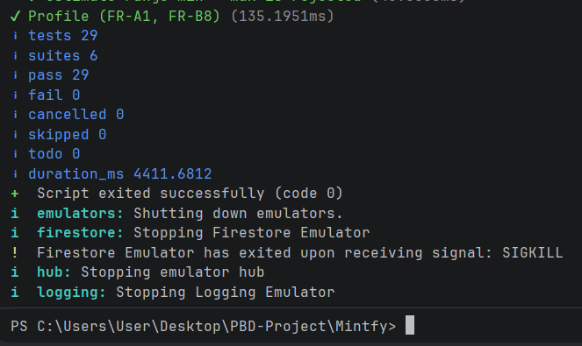
Figure 9.1: Security rules test run on the Firestore emulator: 29 tests, 29 passed, 0 failed.

9.2 Rules Playground on the live project
The same rules were checked on the deployed project mintfy-56844 with the console's Rules Playground, using a get request on an expense document.
Figure | Path | Signed in as | Expected | Result
9.2 | /users/abc/expenses/e1 | abc (password provider) | Allowed | Allowed
9.3 | /users/abc/expenses/e1 | xyz (password provider) | Denied | Denied
9.4 | /users/abc/expenses/e1 | Not signed in | Denied | Denied
9.5 | /hack/x | abc (password provider) | Denied | Denied

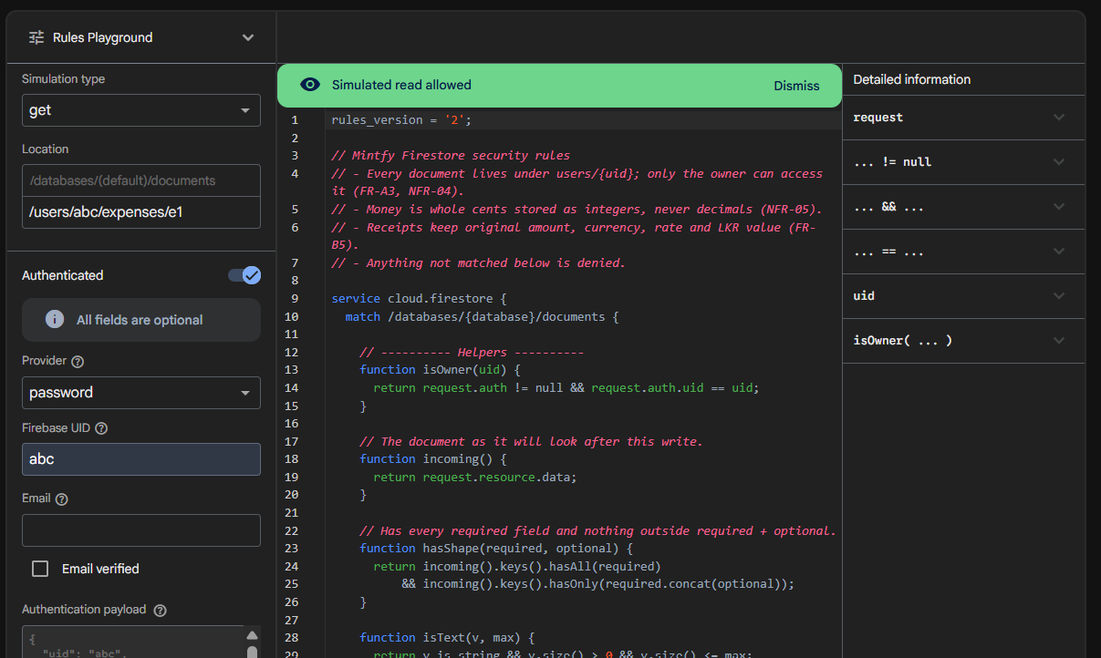
Figure 9.2: The owner (uid abc) reading their own expense is allowed.
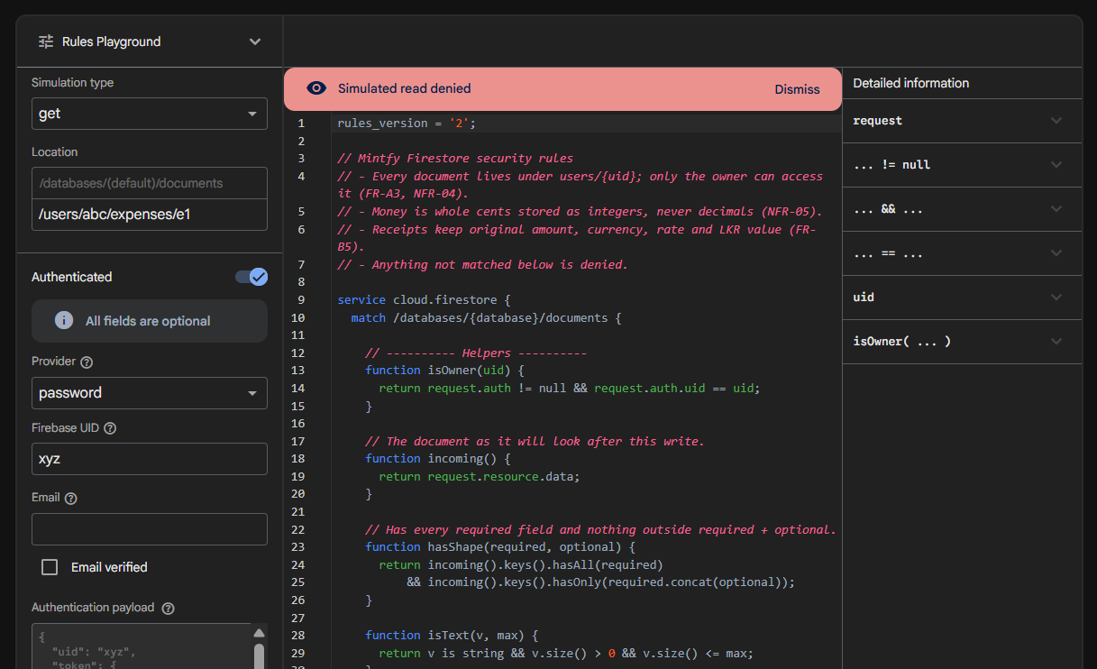
Figure 9.3: Another user (uid xyz) reading the same expense is denied.
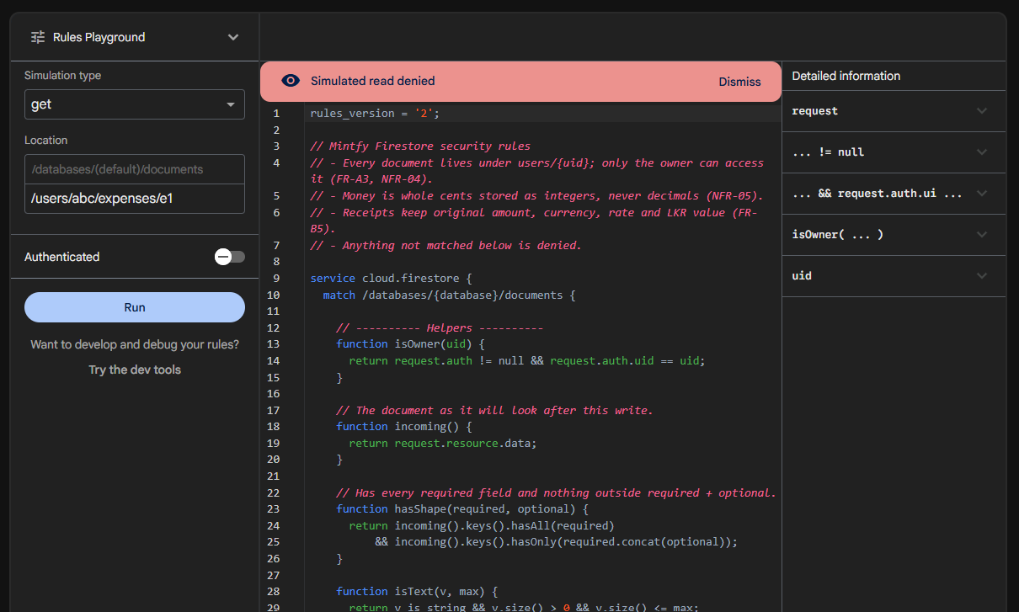
Figure 9.4: A signed-out request is denied.
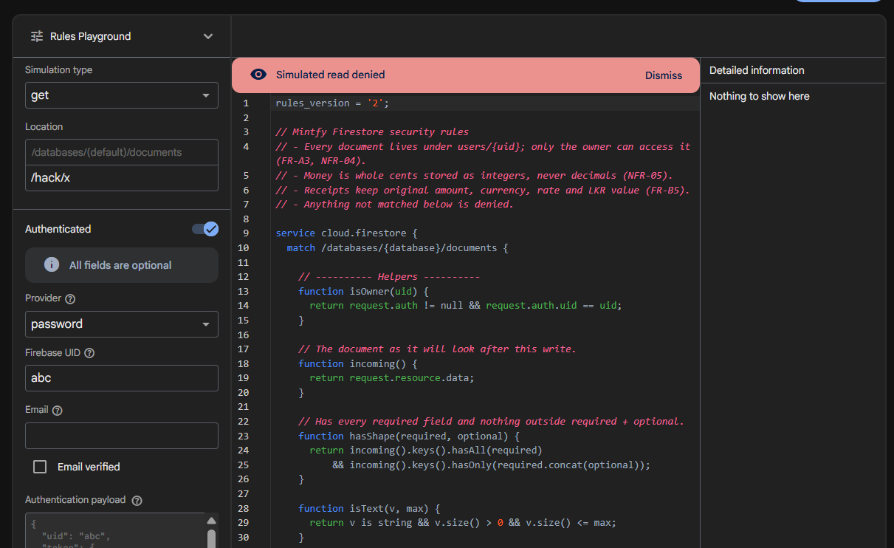
Figure 9.5: A path outside users/{uid} is denied, even for a signed-in user.

10. Traceability
Each SRS requirement that touches the data model, traced to the schema element that supports it, the rule or index that enforces it, and the evidence that it works. Rows marked "Schema review" are enforced by the rules but not yet covered by a dedicated test; they will be exercised by the app's own tests and the live demo.
SRS | Schema element | Enforced by | Verified by
FR-A1 | users/{uid}.email | Rule: email matches the signed-in account | Test: someone else's email rejected
FR-A3, NFR-04 | All data under users/{uid} (D-01) | isOwner() on every path; deny by default | Ownership tests (5); Figures 9.2 to 9.5
FR-B1 | incomeSources.type | Rule: five types; cannot change | Schema review
FR-B3 | baseAmountCents, bonusAmountCents, expectedAmountCents | Rule: base + bonus = amount | Tests: salary accepted; mismatch rejected
FR-B4 | client, project, milestone, dueDate, status | Rule: FREELANCE may be INVOICED | Test: freelance invoice accepted
FR-B5 | currency, originalAmountCents, exchangeRate, lkrAmountCents | Rule: LKR needs rate 1 and equal amounts | Tests: USD AdSense accepted; LKR at rate 2 rejected
FR-B6, FR-E6 | status; Q2 with index I-1 | Rule: only FREELANCE or OTHER can be unpaid | Test: salary cannot be INVOICED
FR-B7 | Q3 with index I-1 | Index I-1 (Enabled) | Figure 5.1
FR-B8 | estimateMinCents, estimateMaxCents | Rule: min ≤ max | Test: min greater than max rejected
FR-B9 | Signed lkrAmountCents; Q4 with index I-2 | Rule: only CRYPTO negative, same sign | Tests: crypto loss accepted; negative salary rejected
FR-C1, FR-C2, FR-H3, NFR-05 | expenses fields; integer cents; paymentMethods | Rule: integer amount above zero; required fields; CASH, CARD or ACCOUNT | Tests: decimal and zero amounts rejected
FR-C5 | Deletable expenses and entries; fixed createdAt | Rules: owner delete; createdAt unchanged | Tests: edit keeps createdAt; delete allowed
FR-C6, FR-C7 | recurringExpenses with Q8; history queries Q5 and Q6 | Rule: frequency values; indexes I-4 and I-5 | Figure 5.1
FR-D1, FR-D2, FR-D4 | categories.spendingType and builtIn; fixed default IDs; referenced by ID (D-04, D-05) | Rule: two types; no delete; builtIn cannot change | Tests: MAYBE rejected; delete rejected
FR-E1 to FR-E5 | goals fields; derived values (2.5) | Rule: deadline after start | Tests: goal accepted; early deadline rejected
FR-F5 | Q1, Q2 listeners (7.1) | Real-time listeners | Planned: UC-06 demo step
FR-G1 to FR-G4 | Device-generated IDs (D-08); server timestamps | Rule: createdAt and updatedAt = request.time | Test: client-chosen createdAt rejected

