CW25201 COMPUTER ORGANIZATION AND ARCHITECTURE
UNIT 1
- Computer Architecture
Computer architecture refers to the features of a computer system that are visible to the programmer and directly influence program execution. It specifies the functional behavior of the system.
Examples of architectural attributes:
- Instruction Set Architecture (ISA)
- Number of bits used to represent data (8-bit, 16-bit, 32-bit, 64-bit)
- Data types (integer, floating point, character)
- Memory addressing techniques
- Input/Output (I/O) mechanisms
- Registers available to programmers
- Computer Organization
Computer organization refers to the internal hardware implementation that realizes the architectural specifications. These details are generally transparent to the programmer.
Examples of organizational attributes:
- Control signals
- ALU design
- Memory technology (SRAM, DRAM, Cache)
- Bus structure
- Interfaces between CPU and peripherals
- Pipeline implementation
- Cache organization
Computer Architecture | Computer Organization
Refers to the attributes of a computer system that are visible to the programmer. | Refers to the internal implementation of the computer system that realizes the architecture.
It defines what the computer does. | It defines how the computer does it.
It directly affects the logical execution of a program. | It deals with the operational units and their interconnections.
Mainly concerned with the programmer's view of the system. | Mainly concerned with the hardware designer's view of the system.
Changes in architecture usually require changes in software. | Changes in organization usually do not affect software.

Structure and Function of a Computer
A computer is a complex system made up of millions of electronic components. To understand it easily, it is viewed as a hierarchical system, where a large system is divided into smaller subsystems.
At every level, a computer is described using two concepts:

Structure
- Structure refers to how the components of a computer are connected or organized.
- It describes the relationship between different hardware units.
Example:
- CPU connected to memory through buses.
- Memory connected to I/O devices.

Function
- Function refers to what each component does.
- It describes the operation performed by each component.
Example:
- CPU processes data.
- Memory stores data.
- Input devices accept data.
- Output devices display results.
A computer can be studied in two ways:
- Bottom-Up: Start from electronic components and build upwards.
- Top-Down: Start from the whole computer and divide it into smaller parts.
The Top-Down Approach is preferred because it is easier to understand.

Basic Functions of a Computer
A computer performs only four fundamental functions.
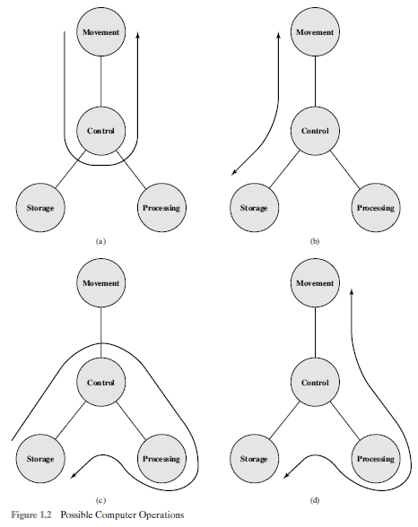
Figure 1.2 depicts the four possible types of operations.
The computer can function as a data movement device (Figure 1.2a), simply transferring data from one peripheral or communications line to another. It can also function as a data storage device (Figure 1.2b), with data transferred from the external environment to computer storage (read) and vice versa (write). The final two diagrams show operations involving data processing, on data either in storage (Figure 1.2c) or en route between storage and the external environment (Figure 1.2d).

(i) Data Processing
- The computer performs arithmetic and logical operations on data.
- It converts raw data into useful information.
Examples
- Addition
- Subtraction
- Multiplication
- Sorting
- Searching
Responsible Unit: CPU (ALU)

(ii) Data Storage
A computer stores data for future use.
There are two types of storage:

Short-Term Storage
- Temporary storage during processing.
- Provided by registers and main memory (RAM).

Long-Term Storage
- Permanent storage.
- Provided by hard disks, SSDs, CDs, etc.
Example
Saving a Word document on the hard disk.

(iii) Data Movement
The computer transfers data between itself and other devices.
There are two types:

Input/Output (I/O)
- Data moves between the computer and directly connected devices.
Examples
- Keyboard
- Mouse
- Printer
- Monitor

Data Communication
- Data moves between computers over long distances through networks.
Examples
- Internet
- Email
- Cloud storage

(iv) Control
The Control Unit (CU) controls all computer operations.
Its responsibilities include:
- Fetching instructions
- Decoding instructions
- Executing instructions
- Coordinating CPU, memory, and I/O devices
The Control Unit ensures that every component works in the correct sequence.

The Control Unit coordinates all the other functions.

Function | Purpose | Example
Data Processing | Performs arithmetic and logical operations | Calculating marks
Data Storage | Stores data temporarily or permanently | Saving a file
Data Movement | Transfers data between computer and devices | Printing a document
Control | Coordinates all computer operations | Executing program instructions

Structure of a Computer System
The structure of a computer system refers to the way its hardware components are organized and interconnected to perform data processing and communication efficiently.
A computer interacts with the external environment through peripheral devices (such as keyboard, mouse, printer, monitor) and communication lines (such as network or Internet connections).

Top-Level Structure of a Computer
The computer consists of four main structural components:
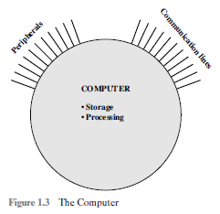

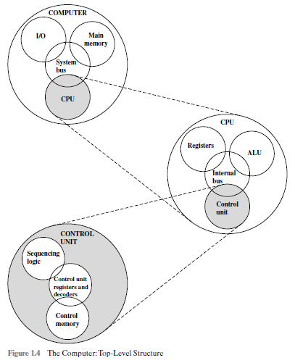

External Devices:
Keyboard, Mouse, Monitor, Printer, Storage, Network

Four Main Structural Components

1. Central Processing Unit (CPU)
The CPU is the brain of the computer. It controls all operations and performs arithmetic and logical calculations.

Functions
- Executes program instructions.
- Controls all hardware components.
- Performs arithmetic and logical operations.
- Coordinates data movement between memory and I/O devices.

2. Main Memory
Main memory stores:
- Programs (instructions)
- Input data
- Intermediate results
- Final results

Functions
- Temporarily stores data and instructions.
- Provides fast access to the CPU.
- Usually implemented using RAM.

3. Input/Output (I/O)
The I/O subsystem transfers data between the computer and the external environment.

Input Devices
- Keyboard
- Mouse
- Scanner
- Microphone

Output Devices
- Monitor
- Printer
- Speakers

Functions
- Accepts input.
- Displays or prints output.
- Enables communication with external devices.

4. System Interconnection (System Bus)
The system bus is the communication pathway that connects the CPU, memory, and I/O devices.

Types of Buses
- Data Bus – Transfers data.
- Address Bus – Carries memory addresses.
- Control Bus – Transfers control signals.

Function
- Enables communication among all computer components.
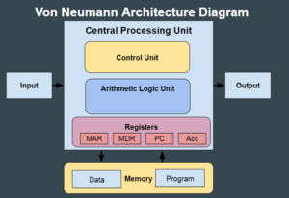

Internal Structure of the CPU
The CPU itself consists of four major components:
Control Unit

ALU
Registers

Internal CPU Bus

Components of the CPU

1. Control Unit (CU)
Function
- Controls and coordinates all CPU operations.
- Fetches instructions from memory.
- Decodes instructions.
- Generates control signals.
- Manages data flow among the CPU, memory, and I/O devices.

2. Arithmetic Logic Unit (ALU)
Function
Performs arithmetic and logical operations.

Arithmetic Operations
- Addition
- Subtraction
- Multiplication
- Division

Logical Operations
- AND
- OR
- NOT
- XOR
- Comparisons (<, >, =)

3. Registers
Definition
Registers are small, high-speed storage locations inside the CPU.

Common Registers
- Program Counter (PC)
- Instruction Register (IR)
- Memory Address Register (MAR)
- Memory Data Register (MDR)
- Accumulator (AC)

Functions
- Store instructions.
- Store addresses.
- Store intermediate results.
- Speed up CPU operations.

4. CPU Interconnection (Internal Bus)
The internal CPU bus connects:
- Control Unit
- ALU
- Registers
It enables fast communication between these components.

Microprogrammed Control Unit
Some computers implement the Control Unit using microprogramming.

Components
- Control Memory – Stores microinstructions.
- Sequencing Logic – Determines the execution order of microinstructions.
- Control Registers and Decoders – Decode microinstructions and generate control signals.

Advantages
- Easier to modify and update the instruction set.
- Simpler implementation of complex instructions.

Multi-Core Computer Structure
A multi-core computer is a computer system in which two or more independent processing cores are integrated onto a single processor chip. Each core can independently fetch, decode, and execute instructions, enabling the computer to execute multiple tasks simultaneously.
It improves performance, throughput, and energy efficiency by exploiting parallel processing rather than continuously increasing the clock frequency.

Multi-Core Computer Structure

Main Memory

System Interconnect

Shared Cache (L3)

CORE 1
L1 cache
ALU
Registers
CU

CORE 2
L1 cache
ALU
Registers
CU

CORE 3
L1 cache
ALU
Registers
CU

\

Components of a Multi-Core Processor

1. Processing Cores
Each core is an independent CPU containing:
- Control Unit (CU) – Fetches, decodes, and controls instruction execution.
- Arithmetic Logic Unit (ALU) – Performs arithmetic and logical operations.
- Registers – High-speed storage for operands and intermediate results.
- L1 Cache – Private cache for frequently accessed instructions and data.
Each core can execute a different process or thread simultaneously.

2. Cache Memory
Multi-core processors use a hierarchy of cache memories:

L1 Cache
- Private to each core.
- Fastest cache.
- Stores frequently used instructions and data.

L2 Cache
- May be private to each core or shared between a small number of cores.
- Larger than L1 but slightly slower.

L3 Cache
- Shared among all cores.
- Reduces accesses to main memory.
- Facilitates communication and data sharing between cores.

3. Main Memory
- Shared by all processor cores.
- Stores programs and data.
- Accessed through the memory controller and system interconnect.

4. System Interconnection
The system interconnection (such as a bus, ring, mesh, or crossbar) enables communication between:
- Processor cores
- Shared cache
- Main memory
- Input/Output devices
Modern processors use high-speed interconnects to reduce communication delays.

Working of a Multi-Core Computer
- The operating system divides a program into multiple threads.
- Different threads are assigned to different processor cores.
- Each core executes its assigned thread independently.
- Shared cache and main memory allow cores to exchange data when necessary.
- The operating system synchronizes the threads and combines the results.

Advantages
- Higher processing speed.
- Improved multitasking.
- Better parallel execution of applications.
- Lower power consumption compared to increasing clock frequency.
- Improved system responsiveness.
- Increased overall throughput.

Disadvantages
- Increased hardware complexity.
- Software must support multithreading to fully utilize multiple cores.
- Cache coherence and synchronization issues.
- Higher processor design cost.

Applications
- High-performance computing (HPC)
- Artificial Intelligence and Machine Learning
- Multimedia processing
- Scientific simulations
- Database servers
- Cloud computing
- Gaming
- Video editing and rendering

Single-Core vs. Multi-Core Processors
Feature | Single-Core Processor | Multi-Core Processor
Number of cores | 1 | 2 or more
Multitasking | Limited | Excellent
Parallel processing | No | Yes
Performance | Lower | Higher
Power efficiency | Lower for equivalent performance | Higher
Heat generation | Higher at high clock speeds | Lower for comparable workloads
Throughput | Lower | Higher

Computer Components
According to John von Neumann's architecture, a computer consists of four major components that work together to execute programs:
- Central Processing Unit (CPU)
- Main Memory
- Input/Output (I/O) Modules
- System Interconnection (System Bus)
The stored-program concept states that both data and program instructions are stored in the same read–write memory.

Von Neumann Architecture
The von Neumann architecture is based on three key concepts:
- Data and instructions are stored together in the same read–write memory.
- Memory is organized into addressable locations, regardless of whether they contain instructions or data.
- Instructions are executed sequentially, unless altered by a branch or jump instruction.
The process of connecting the various components in the desired configuration as a form of programming

(a) Hardware Programming (Hardwired Program)
Data ─────► Hardware Logic ─────► Results
- The hardware is specially designed for one task.
- Changing the program requires changing the hardware.

(b) Software Programming (Stored Program)
Instructions
│
▼
Instruction Interpreter
│
Control Signals
│
General Purpose ALU
│
Data
│
Results
- A general-purpose processor executes different programs by reading instructions from memory.
- Only the software changes; the hardware remains the same.

1. Central Processing Unit (CPU)
The CPU is the brain of the computer. It interprets program instructions, performs arithmetic and logical operations, and controls all system activities.

Components

a) Control Unit (CU)
- Fetches instructions from memory.
- Decodes instructions.
- Generates control signals.
- Coordinates CPU, memory, and I/O operations.

b) Arithmetic Logic Unit (ALU)
Performs:
- Addition
- Subtraction
- Multiplication
- Division
- AND
- OR
- NOT
- Comparison operations

c) Registers
High-speed storage locations inside the CPU.
Important registers include:
- Program Counter (PC) – Holds the address of the next instruction.
- Instruction Register (IR) – Stores the current instruction.
- Memory Address Register (MAR) – Holds the memory address for read/write operations.
- Memory Buffer Register (MBR/MDR) – Temporarily holds data transferred to or from memory.
- Accumulator (AC) – Stores intermediate arithmetic and logical results.
- I/O Address Register (IOAR) – Holds the address of an I/O device.
- I/O Buffer Register (IOBR) – Temporarily stores data exchanged with I/O devices.

2. Main Memory
Main memory stores:
- Program instructions
- Input data
- Intermediate results
- Final results

Characteristics
- Read/write memory
- Shared by CPU and I/O modules
- Organized as sequential memory locations
- Each location has a unique address

3. Input/Output (I/O) Module
The I/O module transfers data between the computer and external devices.

Functions
- Accepts input from input devices.
- Sends output to output devices.
- Buffers data during transfer.
- Controls communication with peripherals.

Examples
Input Devices
- Keyboard
- Mouse
- Scanner
Output Devices
- Monitor
- Printer
- Speakers

4. System Interconnection (System Bus)
The system bus connects:
- CPU
- Memory
- I/O modules

Types of Buses
- Data Bus – Transfers data.
- Address Bus – Carries memory and I/O addresses.
- Control Bus – Carries control signals.

CPU Interaction with Memory
The CPU communicates with memory using:

Memory Address Register (MAR)
- Stores the address of the memory location to be accessed.

Memory Buffer Register (MBR)
- Stores data being transferred between CPU and memory.
CPU
│
│ Address
▼
MAR
│
▼
Main Memory
▲
│ Data
MBR
│
▼
CPU

CPU Interaction with I/O
The CPU communicates with I/O devices using:

I/O Address Register (IOAR)
- Specifies the I/O device.

I/O Buffer Register (IOBR)
- Holds data transferred between CPU and I/O devices.
CPU
│
│ Device Address
▼
IOAR
│
▼
I/O Module
▲
│ Data
IOBR
│
▼
CPU

Functions of Each Component
Component | Function
CPU | Executes instructions and controls operations
ALU | Performs arithmetic and logical operations
Control Unit | Controls instruction execution
Registers | Temporary high-speed storage
Main Memory | Stores instructions and data
I/O Module | Transfers data between computer and external devices
System Bus | Connects CPU, memory, and I/O

Working of the Computer
- Input data and program instructions enter through the I/O module.
- Instructions and data are stored in main memory.
- The CPU fetches instructions using the Program Counter (PC) and MAR.
- Instructions are stored in the Instruction Register (IR).
- The Control Unit decodes the instruction.
- The ALU performs arithmetic or logical operations if required.
- Results are stored back in memory or sent to an output device through the I/O module.

Advantages of the Von Neumann Architecture
- Simple and cost-effective design.
- Stores both instructions and data in the same memory.
- Easy to program.
- Flexible because software can be changed without modifying hardware.

Limitations
- Suffers from the Von Neumann bottleneck, where the CPU and memory share the same communication path, limiting data transfer speed.

Classes of Computing Applications and Their Characteristics
Computers are used in different applications based on user needs. Although they use the same basic hardware technology, they differ in performance, cost, reliability, and purpose.
There are three major classes of computing applications:
- Desktop Computers
- Servers
- Embedded Computers

1. Desktop Computer
A desktop computer is a personal computer designed for use by a single user. It provides good performance at a low cost.

Characteristics
- Used by one person at a time.
- Low cost.
- Executes general-purpose software.
- Easy to upgrade.
- Includes monitor, keyboard, mouse, and CPU.

Applications
- Office work
- Internet browsing
- Programming
- Education
- Gaming
- Multimedia editing

Examples
- Dell Desktop
- HP Desktop
- Lenovo ThinkCentre

2. Server
A server is a powerful computer that provides services or resources to multiple users over a network.

Characteristics
- Supports many users simultaneously.
- High processing power.
- Large memory and storage.
- High reliability and availability.
- Expandable hardware.
- Connected through networks.

Applications
- Web hosting
- Database management
- Email services
- Cloud computing
- File sharing

Types of Servers
- File Server
- Web Server
- Database Server
- Mail Server
- Application Server

Examples
- Google data centers
- Banking servers
- University servers

3. Supercomputers (High-End Servers)
A supercomputer is the fastest and most powerful type of server, designed to solve extremely complex scientific and engineering problems.

Characteristics
- Thousands of processors
- Terabytes of RAM
- Petabytes of storage
- Extremely high speed
- Costs millions of dollars

Applications
- Weather forecasting
- Climate modeling
- Oil and gas exploration
- Space research
- Artificial Intelligence
- Protein structure analysis

4. Embedded Computer
An embedded computer is a computer built inside another device to perform one specific task or a set of related tasks.

Characteristics
- Dedicated to a specific application.
- Small size.
- Low power consumption.
- Integrated with hardware.
- Users often do not realize they are using a computer.

Applications
- Cars
- Smartphones
- Smart TVs
- Washing machines
- Microwave ovens
- Digital cameras
- Medical equipment
- Airplanes

Examples
- Car engine control unit (ECU)
- Smartwatch processor
- ATM controller
- Traffic signal controller

Comparison of Computing Classes
Feature | Desktop Computer | Server | Embedded Computer
Users | Single user | Multiple users | Usually no direct user
Purpose | General-purpose computing | Network services and heavy workloads | Specific dedicated task
Performance | Moderate | High | Varies depending on application
Cost | Low | Medium to Very High | Low to Moderate
Storage | Moderate | Very Large | Small to Moderate
Reliability | Moderate | Very High | High
Examples | PC, Laptop | Web Server, Database Server | Car ECU, Smart TV, Mobile Phone

From a High-Level Language to the Language of Hardware
A computer understands only machine language (binary). Since binary is difficult for humans, programming languages and translation programs are used to communicate with the computer.

Translation Process
High-Level Language
│
(Compiler)
▼
Assembly Language
│
(Assembler)
▼
Machine Language (Binary)
│
▼
Computer Hardware (CPU)

Binary Language (Machine Language)
A computer understands only 0s and 1s, called binary digits (bits).
- Bit = Binary Digit
- Two possible values:
  - 0 (OFF)
  - 1 (ON)
Example:
1000110010100000
This binary code represents an instruction for the processor.

Characteristics
- Lowest-level language.
- Directly understood by hardware.
- Difficult for humans to read and write.
- Fastest to execute.

Instructions
An instruction is a command given to the computer to perform an operation.
Examples:
- Add two numbers
- Subtract numbers
- Store data
- Load data
- Compare values
Instructions are stored as binary numbers in memory.

Assembly Language
Assembly language is a symbolic representation of machine language.
Instead of writing:
1000110010100000
A programmer writes:
ADD A, B
This is easier to understand.

Characteristics
- Uses mnemonic codes (ADD, SUB, MOV, LOAD).
- Machine-dependent.
- Easier than binary.
- One assembly instruction usually corresponds to one machine instruction.

Assembler
An assembler is a program that converts assembly language into machine language.

Example
Assembly Program
ADD A, B
↓
Assembler
↓
Machine Code
1000110010100000

Function
- Converts mnemonics into binary instructions.
- Produces executable machine code.

High-Level Programming Language
A high-level language is a programming language that is easy for humans to read, write, and understand.
Examples:
- C
- C++
- Java
- Python
- Visual Basic
Example in C:
sum = A + B;

Characteristics
- English-like syntax.
- Easier to learn.
- Machine-independent (portable).
- Supports complex programming.

Compiler
A compiler is a software program that translates a high-level language into assembly language or directly into machine language.
Example:
High-Level Program
A = B + C;
↓
Compiler
↓
Assembly Program
ADD B, C
STORE A
↓
Assembler
↓
Machine Code
101100010010...

Complete Translation Flow

Step 1 – High-Level Language
A = B + C;
↓

Step 2 – Compiler
Converts it to Assembly Language.
ADD B,C
STORE A
↓

Step 3 – Assembler
Converts assembly language into binary.
1010110010001010
↓

Step 4 – CPU
Executes the binary instruction.

Advantages of High-Level Languages

(i) Easy to Understand
Uses English words and mathematical expressions.
Example
total = a + b;
instead of
1010101010011010

(ii) Higher Programmer Productivity
- Fewer lines of code
- Faster program development
- Easier debugging
- Easier maintenance

(iii) Portability
The same program can run on different computers after recompilation.
Example
A C program can be compiled for:
- Windows
- Linux
- macOS
without changing the source code significantly.

(iv) Easier Maintenance
Programs are easier to modify and update.

(v) Supports Different Applications
Different languages are designed for different purposes.
Language | Application
C | System programming
C++ | Object-oriented programming
Java | Cross-platform applications
Python | AI, Data Science, Automation
Fortran | Scientific computing
COBOL | Business applications
Lisp | Artificial Intelligence

Difference Between Languages
Feature | Machine Language | Assembly Language | High-Level Language
Representation | Binary (0s and 1s) | Mnemonics | English-like statements
Human Readability | Very difficult | Moderate | Easy
Translation Required | No | Assembler | Compiler
Machine Dependency | Yes | Yes | Mostly portable
Programming Speed | Slow | Faster | Fastest
Example | 10101010 | ADD A,B | A = B + C;

Hardware–Software Interface
The hardware–software interface is the set of rules and mechanisms that enable software to interact with hardware. The most important part of this interface is the Instruction Set Architecture (ISA).
The hardware–software interface is the connection between computer hardware and software that enables programs to communicate with and control the hardware. It is mainly defined by the Instruction Set Architecture (ISA).
Components of the Hardware–Software Interface
- Instruction Set Architecture (ISA)
  - Defines the machine instructions understood by the CPU.
  - Includes:
    - Instruction formats
    - Data types
    - Registers
    - Addressing modes
    - Memory organization
  - Examples: ARM, x86, RISC-V.
- Operating System (OS)
  - Acts as an intermediary between applications and hardware.
  - Manages CPU, memory, files, and I/O devices.
- Device Drivers
  - Software programs that allow the operating system to communicate with specific hardware devices such as printers, keyboards, and network cards.
- System Calls
  - Provide services from the operating system to application programs, such as file access, memory allocation, and device communication.

Block Diagram

Application Software

Operating System

Hardware–Software
Interface (ISA)

|

Hardware
CPU • Memory • I/O

Working of the Hardware–Software Interface
- The user runs an application program.
- The application requests services from the operating system.
- The operating system converts these requests into machine instructions defined by the ISA.
- The CPU fetches, decodes, and executes the instructions.
- The hardware performs the required operation and returns the result to the software.
Example
Suppose you save a document.
- The application sends a save request.
- The operating system processes the request.
- The device driver communicates with the storage device.
- The CPU executes the required machine instructions.
- The hard disk or SSD stores the file.
Importance of the Hardware–Software Interface
- Enables communication between software and hardware.
- Provides compatibility between programs and processors.
- Allows hardware upgrades without changing application software (if the ISA remains the same).
- Simplifies software development by hiding hardware details.
- Improves portability of software across systems with the same ISA.
Hardware vs. Software
Hardware | Software
Physical components of a computer | Programs and instructions
CPU, memory, keyboard, monitor | Operating system, compiler, browser
Performs operations | Controls and manages hardware
Can wear out physically | Can be updated or modified

Operations and Operands of Computer Hardware
Operations and operands are the fundamental parts of every machine instruction executed by the CPU.
Operation
An operation (opcode) specifies what action the CPU should perform on the data.
Examples of operations include:
- Addition
- Subtraction
- Multiplication
- Division
- AND, OR, XOR, NOT
- Data transfer (LOAD, STORE, MOVE)
- Comparison
- Branching (Jump)
- Shift and Rotate
Example
ADD R1, R2, R3
Operation: ADD
Meaning:
R1 = R2 + R3

Operand
An operand is the data or the location of data on which the operation is performed.
Operands can be:
- Register
- Memory location
- Immediate (constant) value
Example
ADD R1, R2, R3
Operation:
ADD
Operands:
R2
R3
Destination: R1

General Instruction Format
Opcode | Operand1 | Operand2 | Operand3
Example:
SUB R5, R1, R2
Meaning
R5 = R1 − R2
Here
- Opcode = SUB
- Source Operand 1 = R1
- Source Operand 2 = R2
- Destination Operand = R5

Types of Operations
1. Arithmetic Operations
Used for mathematical calculations.
Examples
ADD
SUB
MUL
DIV
INC
DEC
Example
ADD R1,R2,R3
Result
R1 = R2 + R3

2. Logical Operations
Operate on bits.
Examples
AND
OR
XOR
NOT
Example
AND R1,R2,R3
Result
R1 = R2 AND R3

3. Data Transfer Operations
Move data between registers and memory.
Examples
LOAD
STORE
MOV
Example
LOAD R1,1000
Meaning
R1 ← Memory[1000]
Example
STORE R1,1000
Meaning
Memory[1000] ← R1

4. Shift Operations
Move /Rotate bits left or right.
Examples
SHL :Example SHL R1 Before shift 00110101 After shift 01101010
SHR Example SHR R1 Before shift 00110101 After shift 00011010
ROL Example ROL R1 Before shift 10110101 After shift 01101011
ROR Example ROR R1 Before shift 00110101 After shift 10011010

5. Compare Operations
Used before branching.
Example
CMP R1,R2
The CPU compares R1 and R2 and updates status flags (Zero, Carry, Sign, Overflow).

6. Branch Operations
Change program execution.
Examples
JMP
BEQ
BNE
CALL
RET
Example
START:
MOV R1, #10
MOV R2, #10

CMP R1, R2
BEQ EQUAL

MOV R3, #0
JMP END

EQUAL:
CALL ADDITION
JMP END

ADDITION:
ADD R1, R2
RET

END:

Types of Operands
1. Register Operand
Data stored in CPU registers.
Example
ADD R1,R2,R3
Operands are R2 and R3.
Advantages
- Fastest access
- No memory access required

2. Memory Operand
Data stored in main memory.
Example
LOAD R1,500
Operand = Memory location 500.
Advantages
- Large storage
Disadvantages
- Slower than registers

3. Immediate Operand
The value is part of the instruction itself.
Example
ADD R1,R1,#10
Meaning
R1 = R1 + 10
Immediate value = 10.

Example Instruction Execution
Instruction
ADD R1,R2,R3
Suppose
R2 = 25
R3 = 15
Execution
R1 = 25 + 15
Result
R1 = 40

Hardware Components Involved
Instruction
│
▼
Instruction Register (IR)
│
▼
Control Unit (decodes opcode)
│
▼
ALU performs operation
│
▼
Registers/Memory store result
Execution Steps
- Fetch the instruction from memory.
- Decode the opcode.
- Fetch the operands.
- Execute the operation in the ALU.
- Store the result in a register or memory.

Example: Memory Operation
Instruction
LOAD R1,2000
Memory
Address Value
2000 75
Execution
R1 ← Memory[2000]
Result
R1 = 75

Operation Type | Purpose | Example
Arithmetic | Mathematical calculations | ADD, SUB, MUL
Logical | Bit manipulation | AND, OR, XOR, NOT
Data Transfer | Move data | LOAD, STORE, MOV
Shift | Shift bits | SHL, SHR
Compare | Compare operands | CMP
Branch | Change execution flow | JMP, BEQ, BNE

Operand Type | Description | Example
Register | Data in CPU registers | R1, R2
Memory | Data in main memory | Memory[1000]
Immediate | Constant value in instruction | #10

Instruction Set Architectures (ISA)
An Instruction Set Architecture (ISA) is the interface between computer hardware and software. It defines the set of instructions that a processor understands and the rules for using those instructions.
In simple words:
ISA tells the software programmer what the processor can do and how to communicate with the hardware.
The ISA is different from the internal implementation of the processor. Two processors may have different internal designs but implement the same ISA and therefore run the same machine-code programs.
Examples of ISA
- x86 / x86-64 – Used mainly in desktop computers, laptops, and servers.
- ARM – Widely used in smartphones, tablets, embedded systems, and many modern computers.
- RISC-V – An open-standard RISC instruction set.
- MIPS – A classic RISC architecture used mainly in education and embedded systems.
- SPARC – A RISC architecture.

Hardware–Software Interface
ISA acts as a bridge between software and hardware.
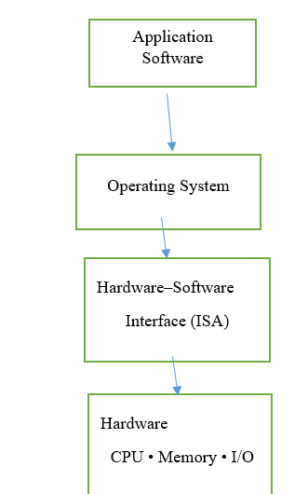

For example, when a program performs an addition:
ADD R1, R2, R3
The ISA defines:
- What ADD means.
- Which registers can be used.
- How the instruction is encoded in binary.
- How the processor obtains the operands.
- Where the result is stored.

Components of an ISA
An ISA specifies several aspects of a computer system.
1 Instruction Set
The ISA defines the operations that the processor can perform.
Arithmetic Operations
ADD
SUB
MUL
DIV
Logical Operations
AND
OR
XOR
NOT
Data Transfer Operations
LOAD
STORE
MOVE
Shift and Rotate Operations
SHL
SHR
ROL
ROR
Control Transfer Operations
JMP
BEQ
BNE
CALL
RET

2 Data Types
ISA specifies the types of data that the processor can handle.
Examples:
- Integer
- Character
- Boolean
- Floating-point
- Single precision
- Double precision
For example, a 64-bit ISA may support 64-bit integer operations and 32-bit or 64-bit floating-point operations.

3 Registers
Registers are small, high-speed storage locations inside the processor.
ISA specifies the number and type of registers available to programs.
Common types include:
General-Purpose Registers
Used to store data and intermediate results.
R0, R1, R2, R3, ...
Program Counter (PC)
Contains the address of the next instruction to be executed.
Instruction Register (IR)
Holds the current instruction being executed.
Stack Pointer (SP)
Points to the top of the stack.
Status/Flag Register
Stores condition information such as:
- Zero flag
- Carry flag
- Sign/Negative flag
- Overflow flag

4. Instruction Formats
An instruction consists of an opcode and one or more operands.
General format:
Opcode | Operand | Operand | Operand
Example
ADD R1, R2, R3
Here:
- ADD → Opcode
- R2 → Source operand
- R3 → Source operand
- R1 → Destination
Operation:
R1 ← R2 + R3
The actual machine instruction is represented in binary inside the processor.

5. Addressing Modes
An addressing mode specifies how an instruction identifies its operand.
5.1 Immediate Addressing
The operand is directly included in the instruction.
MOV R1, #10
Meaning:
R1 ← 10

5.2 Register Addressing
The operand is stored in a register.
ADD R1, R2, R3
The operands are in registers.

5.3 Direct Addressing
The instruction contains the memory address of the operand.
LOAD R1, 1000
Meaning:
R1 ← Memory[1000]

5.4 Indirect Addressing
A register contains the address of the operand.
LOAD R1, (R2)
Meaning:
R1 ← Memory[address stored in R2]

5.5 Indexed Addressing
The effective address is calculated using a base address and an index.
Effective Address = Base Address + Index
This is useful for accessing arrays.

6. Memory Organization
ISA defines how the processor interacts with memory.
It specifies:
- Address size
- Addressable memory
- Memory access operations
- Memory alignment
- Byte ordering
Byte Ordering
Two common methods are:
Little Endian
- Least significant byte stored at the lowest address.
Big Endian
- Most significant byte stored at the lowest address.

7. Input/Output and Interrupts
An ISA also defines mechanisms for communicating with I/O devices and handling exceptional events.
Examples:
- Keyboard input
- Disk operations
- Network communication
- Timer interrupts
- Hardware exceptions
The processor may use:
- Memory-mapped I/O
- I/O instructions
- Interrupt mechanisms

CISC and RISC Architectures
CISC and RISC are two major Instruction Set Architecture (ISA) design approaches used in computer processors.
- CISC → Complex Instruction Set Computer
- RISC → Reduced Instruction Set Computer
Both architectures provide a hardware–software interface, but they differ in the number, complexity, format, and execution of instructions.

1. CISC Architecture
CISC (Complex Instruction Set Computer) is a processor architecture that provides a large set of complex instructions. A single instruction can perform several low-level operations, such as loading data from memory, performing an arithmetic operation, and storing the result.
CISC architecture uses a large and powerful instruction set with many addressing modes, allowing complex operations to be performed using fewer instructions.
Examples:
- Intel x86
- x86-64 bit
- Motorola 68000

Basic CISC Architecture

Main Memory
|
| Instructions / Data
▼
Instruction
Fetch Unit
|
▼
Complex
Instruction
Decoder
|
▼
Microprogrammed
Control Unit
|
| |
▼ ▼
Registers ALU
| |
|
▼
Memory
Characteristics of CISC
1. Large Instruction Set
CISC processors provide a large number of instructions.
Instructions may perform:
- Arithmetic operations
- Logical operations
- Data movement
- Memory operations
- Control operations
For example:
ADD A, B
Depending on the CISC instruction set, a single instruction may perform multiple operations involving memory operands.

2. Complex Instructions
A single instruction can perform multiple low-level operations.
For example:
LOAD data, PERFORM arithmetic, STORE result
These operations may be represented by a single complex machine instruction.
This reduces the number of instructions needed in a program.

3. Variable-Length Instructions
CISC instructions may have different lengths.
For example:
Instruction 1 → 1 byte
Instruction 2 → 3 bytes
Instruction 3 → 6 bytes
The exact instruction length depends on the operation and operands.
Advantage
Variable-length instructions can improve code density, reducing the amount of memory required for a program.
Disadvantage
Instruction decoding becomes more complicated.

4. Large Number of Addressing Modes
CISC processors generally support many addressing modes.
Examples:
- Immediate addressing
- Register addressing
- Direct addressing
- Indirect addressing
- Indexed addressing
- Base addressing
- Relative addressing
This gives programmers flexibility in accessing data.
5. Memory-to-Memory Operations
CISC architectures may allow operations directly between memory locations.
For example:
Memory[A] + Memory[B] → Memory[C]
This can reduce the number of instructions required.

6. Microprogrammed Control Unit
Traditional CISC processors often use a microprogrammed control unit.
A complex machine instruction is broken into a sequence of smaller internal operations called micro-operations.
This makes the control unit flexible but can introduce additional complexity and latency.

7. Fewer Instructions per Program
Since one instruction can perform multiple operations, a CISC program may require fewer instructions.
For example:
CISC:
Instruction 1 → Load + Add + Store
Instead of:
RISC:
Instruction 1 → Load
Instruction 2 → Load
Instruction 3 → Add
Instruction 4 → Store

Advantages of CISC
1. Smaller Program Size
Complex instructions reduce the total number of instructions required.
2. Better Code Density
Programs occupy less memory.
3. Fewer Instructions
A complex operation can be performed with a single instruction.
4. Rich Addressing Modes
Programmers have many options for accessing operands.
5. Backward Compatibility
CISC architectures such as x86 have maintained compatibility with a large body of existing software.

Disadvantages of CISC
1. Complex Hardware
The processor needs complicated circuitry to support a large instruction set.
2. Complex Instruction Decoding
Variable-length instructions are more difficult to decode.
3. Difficult Pipelining
Different instruction lengths and execution times make pipeline design more complicated.
4. Higher Hardware Complexity
The control unit and instruction decoder are more complex.
5. Variable Execution Time
Different instructions may require different numbers of clock cycles.

2. RISC Architecture
RISC (Reduced Instruction Set Computer) is a processor architecture that uses a small set of simple and highly optimized instructions.
RISC architecture uses simple instructions, fixed-length instruction formats, a large register set, and a load/store architecture to achieve fast and efficient instruction execution.
Examples:
- ARM
- RISC-V
- MIPS
- SPARC

Basic RISC Architecture

Main Memory
|
|
▼

Instruction Fetch
|
▼
Instruction Decode
|
▼

Register File
R0 R1 R2 ... Rn
|
▼
ALU

|
▼
Load / Store
|
▼

Main Memory

Characteristics of RISC
1. Small Instruction Set
RISC uses a relatively small set of simple instructions.
Examples:
ADD,SUB,AND,OR,LOAD,STORE
Each instruction performs a simple operation.

2. Simple Instructions
RISC instructions generally perform one basic operation.
For example:
ADD R1, R2, R3
performs:
R1 = R2 + R3
The instruction does not directly perform complex memory operations.

3. Fixed-Length Instructions
RISC instructions generally have a fixed size.
For example:
32-bit instruction
Most instructions have the same length.
Advantages
- Simple instruction decoding
- Faster instruction fetching
- Efficient pipelining
- Predictable instruction boundaries

4. Load/Store Architecture
This is one of the most important features of RISC.
Only LOAD and STORE instructions access memory.
Arithmetic and logical operations operate on registers.
Example:
LOAD R1, A
LOAD R2, B
ADD R3, R1, R2
STORE R3, C
Execution:
Memory A ──LOAD──> R1
Memory B ──LOAD──> R2
│
▼
R1 + R2
│
▼
R3
│
STORE
│
▼
Memory C
This is called a Load/Store architecture.

5. Large Number of Registers
RISC processors typically provide a large number of general-purpose registers.
For example:
R0, R1, R2, R3, ... R31
Registers are much faster to access than main memory.
Therefore, keeping frequently used data in registers improves performance.

6. Few Addressing Modes
RISC uses a small number of simple addressing modes.
Common examples:
- Register
- Immediate
- Base + Offset
This reduces the complexity of the instruction decoder.

7. Efficient Pipelining
RISC instructions are simple and generally have similar formats, making them suitable for pipelining.
A typical pipeline may contain:
IF → ID → EX → MEM → WB
Where:
- IF = Instruction Fetch
- ID = Instruction Decode
- EX = Execute
- MEM = Memory Access
- WB = Write Back
Example:
Instruction 1: IF → ID → EX → MEM → WB
Instruction 2: IF → ID → EX → MEM → WB
Instruction 3: IF → ID → EX → MEM → WB
Several instructions can be processed simultaneously at different pipeline stages.

8. Hardwired Control
RISC processors traditionally use a hardwired control unit.
The control signals are generated directly by hardware logic.
Advantages
- Fast control signal generation
- Lower instruction decoding overhead
- Suitable for high-speed execution

9. Faster Instruction Execution
Because RISC instructions are simple and optimized, they can often be executed efficiently with a high instruction throughput.
But not every RISC instruction necessarily takes exactly one clock cycle in every modern processor. Modern RISC processors may use multiple pipeline stages, caches, out-of-order execution, and other advanced techniques.

Advantages of RISC
1. Simple Hardware
The processor design is simpler because the instruction set is less complex.
2. Efficient Pipelining
Fixed instruction formats make pipelining easier.
3. Fast Execution
Simple instructions allow high instruction throughput.
4. Low Power Consumption
The simpler instruction processing can contribute to lower power consumption, especially in mobile and embedded systems.
5. Compiler Optimization
The simple instruction set makes it easier for compilers to optimize instruction sequences.
6. Large Register Set
More registers reduce frequent memory access.

Disadvantages of RISC
1. Larger Program Size
Complex tasks may require several simple instructions.
2. More Memory Usage
More instructions can increase the size of the program.
3. More Instructions Required
A single complex operation may require multiple instructions.
4. Greater Dependence on Compiler
The compiler must efficiently arrange instructions and make good use of registers.

RISC Example
Suppose to calculate:
C = A + B
A RISC processor might use:
LOAD R1, A
LOAD R2, B
ADD R3, R1, R2
STORE R3, C
The operations are:
1. Load A into R1
2. Load B into R2
3. Add R1 and R2
4. Store the result in C

CISC Example
A CISC architecture may provide an instruction capable of performing a more complex memory-based operation in fewer instructions.
Conceptually:
ADD A, B
This could represent an operation that:
1. Reads A from memory
2. Reads B from memory
3. Performs addition
4. Stores the result
The exact behavior depends on the particular CISC ISA.
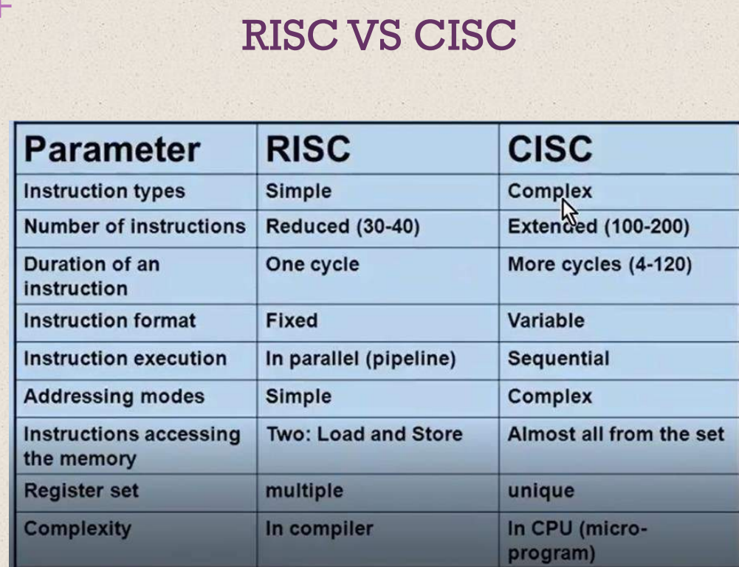

Comparison: RISC vs CISC
Feature | RISC | CISC
Full Form | Reduced Instruction Set Computer | Complex Instruction Set Computer
Instruction Set | Small and simple | Large and complex
Instruction Format | Usually fixed | Often variable
Instruction Length | Usually fixed | Usually variable
Addressing Modes | Few | Many
Memory Operations | Load/Store | May operate directly on memory
Registers | Large register set | Traditionally fewer, though modern designs vary
Control Unit | Traditionally hardwired | Traditionally microprogrammed
Instruction Decoding | Simple | Complex
Pipelining | Easier | More difficult traditionally
Program Size | Usually larger | Usually smaller
Code Density | Lower traditionally | Higher traditionally
Hardware Complexity | Lower | Higher
Compiler Role | More important | Relatively less dependent on complex instruction selection
Examples | ARM, RISC-V, MIPS | x86, x86-64

RISC and CISC primarily describe the design philosophy and ISA characteristics, not necessarily the complete internal implementation of a modern processor.

Performance Metrics and Benchmarks

Basic Measures of Computer Performance are,

- Clock Speed / Clock Rate
- Instruction Execution Rate
- CPI — Cycles Per Instruction
- MIPS — Millions of Instructions Per Second
- MFLOPS — Millions of Floating-Point Operations Per Second
- Execution Time
- Arithmetic, Geometric, and Harmonic Means
- Benchmarks and SPEC

1.Clock Speed or Clock Rate
The operations performed by a processor are controlled by a system clock.
Examples of processor operations include:
- Fetching an instruction
- Decoding an instruction
- Loading data
- Storing data
- Performing arithmetic operations
- Performing logical operations
The clock generates regular pulses that synchronize these operations.
Clock rate
The clock rate is the number of clock cycles generated per second.
It is measured in Hertz (Hz).
Common units are:
- 1 MHz = (10^6) cycles/second
- 1 GHz = (10^9) cycles/second
Thus, a 1-GHz processor receives one billion clock pulses per second.
The relationship between clock rate and cycle time is:
(t) clock cycle time=1/(f) = 1/clock frequency
Therefore, a 1-GHz processor has a clock cycle time of 1 nanosecond.

Why Clock Speed Alone Is Not Enough
A higher clock speed does not always mean better overall performance.
Different instructions such as load, store, branch, and arithmetic instructions may require different numbers of cycles.
Also, with pipelining, several instructions may be executing simultaneously.
Therefore:
Simply comparing the clock speeds of two processors does not provide a complete comparison of their performance.
For example:
- Processor A: 4 GHz, average CPI = 4
- Processor B: 3 GHz, average CPI = 1
Processor B may execute a program faster despite having a lower clock rate.

2. Instruction Execution Rate
The instruction count ((I_c)) as the number of machine instructions actually executed by a program until completion or during a specified time interval.
Instruction count means the number of instructions executed, not simply the number of instructions present in the object code.
The same program can execute different numbers of instructions depending on its input and execution path.

3. CPI — Cycles Per Instruction
It represents the average number of clock cycles required to execute one instruction.
Different instructions may require different numbers of cycles.
For example:
Instruction Type | CPI
Arithmetic | 1
Load/Store | 2
Branch | 4
Memory access with cache miss | 8
Therefore, the overall CPI depends on the instruction mix of the program.
The formula is:
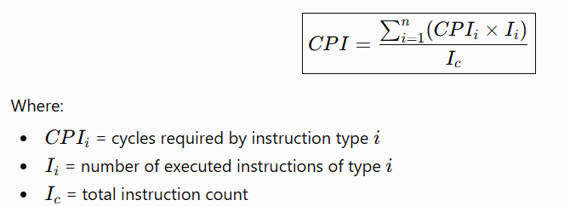

Average CPI is determined by how many instructions of each type are executed and how many cycles each type requires.

4.Processor Execution Time
The processor time required to execute a program is:

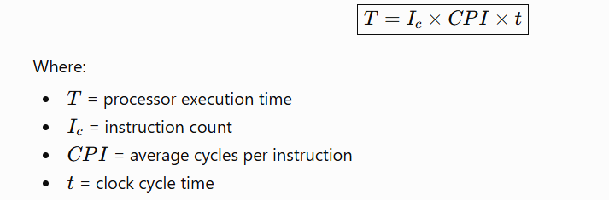
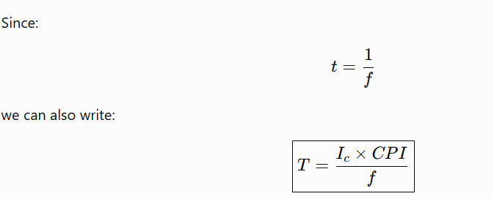

This equation shows that processor performance depends on three major factors:
- Number of instructions executed
- Average number of cycles per instruction
- Clock cycle time
The Refined Processor Performance Equation
Refines the execution-time equation by considering memory operations.
The equation becomes:
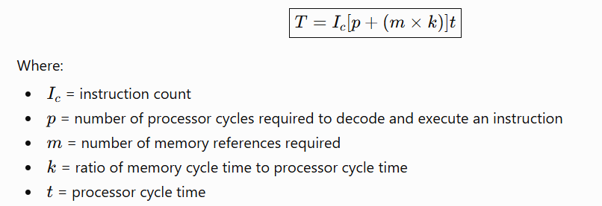
A processor may be very fast, but if it frequently waits for slow memory accesses, overall performance may be reduced.

Five Important Performance Factors
The five factors in the refined performance equation are,

These are affected by four major system attributes:
1. Instruction Set Architecture
Affects:
- Instruction count ((I_c))
- Processor cycles ((p))
2. Compiler Technology
Affects:
- Instruction count
- Processor cycles
- Memory references
3. Processor Implementation
Affects:
- Instruction count
- Processor cycles
4. Cache and Memory Hierarchy
Affects:
- Memory references
- Memory cycle ratio
The relationship given in the chapter can be summarized as:
Performance Factor | ISA | Compiler | Processor | Cache & Memory
(I_c) — Instruction count | ✓ | ✓ | — | —
(p) — Processor cycles | ✓ | ✓ | ✓ | —
(m) — Memory references | — | ✓ | — | ✓
(k) — Memory/processor cycle ratio | — | — | — | ✓
(t) — Processor cycle time | — | — | ✓ | —

5. MIPS Rate
A common measure of processor performance is the instruction execution rate, expressed as:
MIPS — Millions of Instructions Per Second
The formula is:
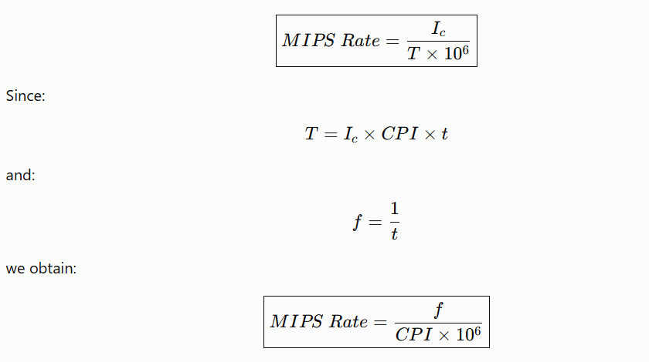Therefore:
- Higher clock rate → potentially higher MIPS
- Lower CPI → potentially higher MIPS
But MIPS is not always a valid measure for comparing different architectures, because different architectures may perform different amounts of work with one instruction.

Example of MIPS Calculation from the File
The file provides a
- Clock rate = 400 MHz
- Instruction count = 2 million
Instruction Type | CPI | Instruction Mix
Arithmetic and logic | 1 | 60%
Load/store with cache hit | 2 | 18%
Branch | 4 | 12%
Memory reference with cache miss | 8 | 10%
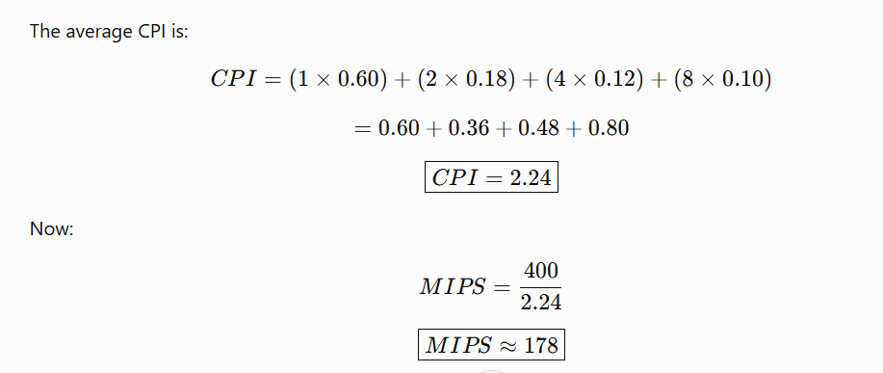The processor's performance is approximately 178 MIPS for this workload.

6. MFLOPS (Millions of Floating-Point Operations Per Second)Rate
Floating-point operations are common in:
- Scientific applications
- Engineering applications
- Games
- Numerical simulations
- Graphics
The formula is:
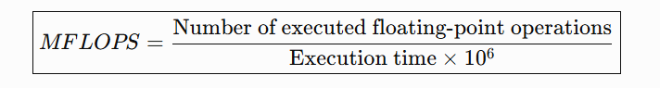

MFLOPS is useful when evaluating systems that perform large numbers of floating-point calculations.

MIPS and MFLOPS are inadequate as universal measures for comparing processor performance.
The main reason is that different processors may use different instruction sets.
Consider:
A=B+C
A CISC processor might execute this using one instruction:
ADD mem(B), mem(C), mem(A)
A RISC processor might use several instructions:
LOAD mem(B), reg(1)
LOAD mem(C), reg(2)
ADD reg(1), reg(2), reg(3)
STORE reg(3), mem(A)
Thus:
- CISC → 1 instruction
- RISC → 4 instructions
Suppose both complete the original high-level operation in approximately the same amount of time.
Then:
- CISC = 1 MIPS
- RISC = 4 MIPS
If we compare only MIPS, it incorrectly appears that RISC is four times faster.
But both systems performed the same high-level task in approximately the same time.
Therefore:
MIPS cannot be reliably used to compare processors with different instruction set architectures.
This is one of the main reasons why benchmarks are used.

Calculating the Mean in Performance Analysis
When several benchmark programs are used, we often need to combine their results into a single value.
The three common means are:
- Arithmetic Mean (AM)
- Geometric Mean (GM)
- Harmonic Mean (HM)

1 Arithmetic Mean
Formula:
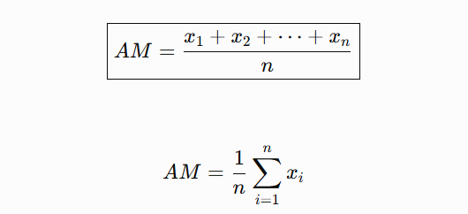
The arithmetic mean is appropriate when the sum of all measurements is meaningful.
It is particularly useful for execution time.
Example
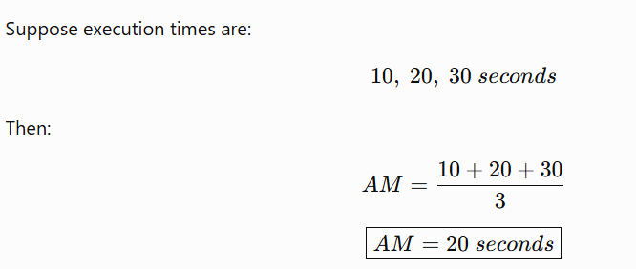
It states that for a time-based variable such as execution time, the arithmetic mean has the useful property that it is directly proportional to total time.

2. Harmonic Mean
Formula:
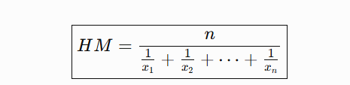
The harmonic mean is particularly appropriate for rates.
Examples:
- MIPS
- MFLOPS
- Program execution rate
- Throughput
If several programs are executed, the total execution time is more meaningful than the sum of their individual rates.
The harmonic mean provides a result that is inversely proportional to the total execution time, which is the desired property when averaging rates.

3. Geometric Mean
Formula:
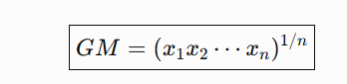
The geometric mean is particularly useful when working with normalized performance ratios.
An important property is:
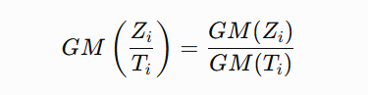
The geometric mean gives equal weight to percentage changes in the values. It is also useful for benchmark analysis because it provides consistent results when comparing relative performance after normalization.

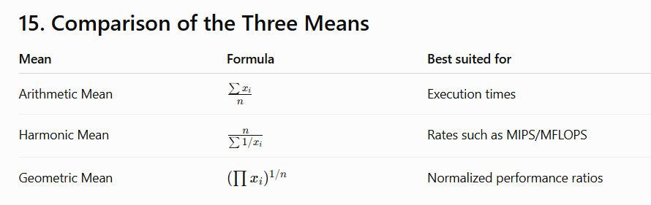
The mathematical relationship:
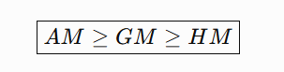
Equality occurs only when all values are equal.

SPEC uses the geometric mean for its benchmark results.
The reasons include:
1. Consistency
The geometric mean gives consistent relative results regardless of which system is selected as the reference.
2. Less Bias from Outliers
The geometric mean is less affected by extreme values than the arithmetic or harmonic mean in the context discussed.
3. Suitable for Normalized Ratios
Benchmark results are usually normalized against a reference system. The geometric mean works well with these normalized ratios.
Therefore:
SPEC uses the geometric mean to combine normalized benchmark performance results into an overall score.

Benchmark
A benchmark is a program used to evaluate the performance of a computer system.
The basic idea is:
The same set of benchmark programs can be executed on different computers, and their execution times can be compared.
Benchmarks are useful for:
- Customers deciding which computer system to purchase
- Vendors designing new systems
- Researchers comparing architectures
- System designers evaluating improvements
Benchmark-based evaluation became increasingly important because the performance of one processor on one program may not predict its performance on a very different application.

Characteristics of a Good Benchmark
According to the uploaded file, a good benchmark should have four important characteristics.
1. Written in a High-Level Language
This makes the benchmark portable across different machines.
Examples:
- C
- C++
- Fortran
2. Representative
The benchmark should represent a particular programming domain or application area.
Examples:
- Systems programming
- Numerical programming
- Commercial programming
3. Easily Measured
The performance should be easy to measure accurately.
4. Widely Distributed
The benchmark should be widely available so that different organizations can use it for comparison.
These four characteristics are important because they make benchmark results more useful and reliable.

Benchmark Suite
A benchmark suite is a collection of programs designed to evaluate a computer system.
A benchmark suite:
- Contains multiple programs
- Is generally written in high-level languages
- Represents a particular application or system programming area
- Provides a broader performance evaluation than a single benchmark
For example, a processor that performs well in scientific computing may not perform equally well in commercial applications.
Therefore, using multiple benchmarks gives a more complete picture of performance.

SPEC
SPEC stands for:
Standard Performance Evaluation Corporation
It is an industry consortium that develops and maintains standardized benchmark suites.
SPEC benchmarks are widely used for:
- Computer performance comparison
- Research
- Processor evaluation
- System design
The benchmark suites cover different application areas.

21. SPEC CPU2006
SPEC CPU2006 as an important benchmark suite for processor-intensive applications.
It is suitable for applications that spend most of their execution time doing computation rather than I/O.
The suite contains:
- 12 integer benchmarks
- 17 floating-point benchmarks
- More than 3 million lines of code
The benchmarks are based on real-life applications, rather than artificial loops or synthetic benchmarks, making the results more realistic.

Examples of SPEC Integer Benchmarks
Some integer benchmark application areas listed in the file include:
Benchmark Area | Application
Programming Language | Perl interpreter
Compression | bzip2
Compiler | GCC
Combinatorial Optimization | Vehicle scheduling
Artificial Intelligence | Go game
Gene Search | Protein sequence analysis
Artificial Intelligence | Chess
Quantum Computing | Quantum computer simulation
Video Compression | H.264/AVC
Discrete Event Simulation | Ethernet network simulation
Path Finding | 2D map path finding
XML Processing | XML transformation
These applications represent a variety of computational workloads.

Examples of SPEC Floating-Point Benchmarks
The floating-point benchmark suite includes application areas such as:
- Fluid dynamics
- Quantum chemistry
- Physics
- Computational fluid dynamics
- Molecular dynamics
- General relativity
- Finite element analysis
- Linear programming
- Image ray tracing
- Structural mechanics
- Computational electromagnetics
- Weather forecasting
- Speech recognition
These benchmarks are useful for evaluating processors in scientific and engineering workloads.

Important SPEC Terms
1 Benchmark
A program written in a high-lev el language that can be compiled and executed on a computer.
2 System Under Test — SUT
The computer system whose performance is being evaluated.
3 Reference Machine
A standard system used by SPEC to establish baseline performance.
Each benchmark is executed on the reference machine to determine its reference time.
4 Reference Time
The execution time of a benchmark program on the reference machine.
5 Base Metric
A standard metric with strict compilation guidelines.
The purpose is to maintain comparability between systems.
6 Peak Metric
Allows greater compiler optimization.
For example, different compiler options may be used, and feedback-directed optimization may be permitted.
7 Speed Metric
Measures the time required to execute a benchmark.
It is used to compare a computer's ability to complete single tasks.
8 Rate Metric
Measures how many tasks a computer can complete in a given amount of time.
It is also called:
- Throughput
- Capacity
- Rate measure
The rate metric is particularly useful for systems with multiple processors because simultaneous tasks can be executed.

Speed Metric vs Rate Metric

Speed Metric | Rate Metric
Measures completion time of a task | Measures number of tasks completed per unit time
Focuses on single-task performance | Focuses on throughput
One task is evaluated | Multiple simultaneous tasks may be executed
Useful for single processor performance | Useful for multiprocessor/multicore systems
Example
Suppose a system completes one program in 10 seconds.
This evaluates speed.
If a multicore system runs four copies of a program simultaneously and completes all four in 10 seconds, its rate performance reflects its ability to handle multiple tasks.

SPEC Benchmark Evaluation Process
It is a three-step procedure for evaluating a system using SPEC CPU benchmarks.
Step 1: Run Each Benchmark Three Times
Each program is:
- Compiled
- Executed three times
- Execution time measured for each run
- Median execution time selected
Median is used ,Because execution time can vary due to factors such as:
- Disk access variations
- Operating system activity
- OS kernel execution
The median reduces the effect of these variations.

Step 2: Calculate the Runtime Ratio
For each benchmark:
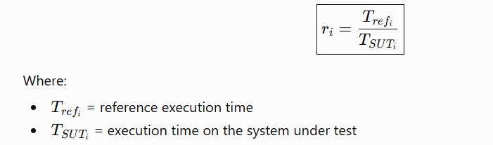
A higher ratio means better performance because the system under test completed the program in less time.
Example from the file
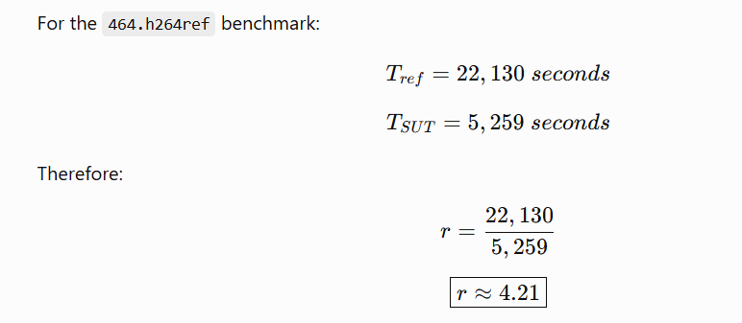
So the system under test is approximately 4.21 times as fast as the reference system for that benchmark.

Step 3: Calculate the Geometric Mean
For 12 integer benchmarks:
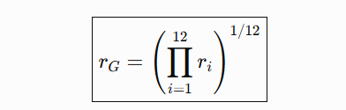
This gives the overall benchmark performance score.
The flow is:
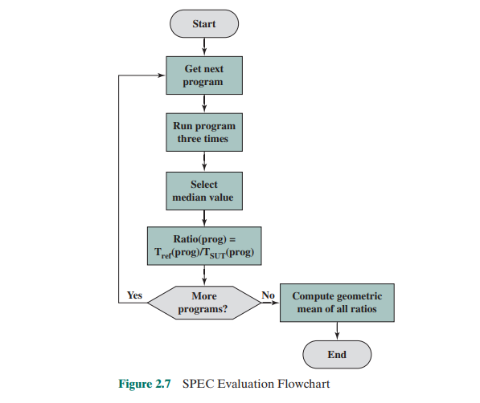

SPEC CPU Metrics
four metrics for integer benchmarks,:
1. SPECint2006
Geometric mean of 12 normalized ratios using peak tuning.
2. SPECint_base2006
Geometric mean of 12 normalized ratios using base tuning.
3. SPECint_rate2006
Geometric mean of 12 normalized throughput ratios using peak tuning.
4. SPECint_rate_base2006
Geometric mean of 12 normalized throughput ratios using base tuning.

Rate Metric Calculation
For a multicore or multiprocessor system, the rate metric considers multiple copies of the benchmark running simultaneously.
The formula is:
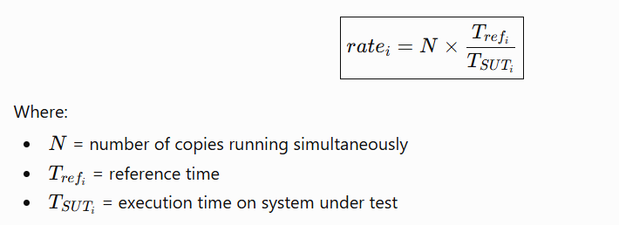
Usually, (N) may correspond to the number of processors or simultaneous threads.
The final rate score is calculated using the geometric mean of the individual rate values.
Complete Relationship Between Performance Metrics and Benchmarks
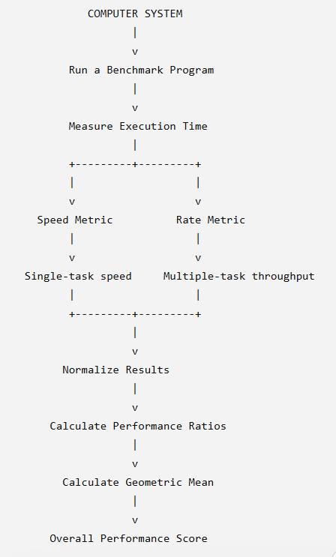

Performance Metrics vs Benchmarks
Performance Metrics | Benchmarks
Numerical measures of performance | Programs used to evaluate performance
Examples: Clock rate, CPI, MIPS, MFLOPS | Examples: SPEC CPU benchmarks
Describe how performance is measured | Provide workloads for measurement
May focus on processor characteristics | Attempt to represent real applications
Can be calculated from execution data | Generate the execution data
Used to quantify performance | Used to compare systems under common workloads

Addressing Modes
It refers to the method used by an instruction to specify where its operand is located or how the effective address (EA) of the operand is calculated.
The address field in an instruction is usually relatively small, but the processor needs to access a large range of memory locations. Addressing modes provide different ways to overcome this limitation. Each mode involves a trade-off between address range, flexibility, number of memory references, and complexity of address calculation.

Important Notations
- A = Contents of an address field in the instruction
- R = Contents of an address field that refers to a register
- EA = Effective Address, the actual address of the operand
- (X) = Contents of memory location X or register X
The seven basic addressing modes discussed are:
- Immediate Addressing
- Direct Addressing
- Indirect Addressing
- Register Addressing
- Register Indirect Addressing
- Displacement Addressing
- Stack Addressing

1.Immediate Addressing
In immediate addressing, the operand value itself is present inside the instruction.
Formula
Operand=A
Here, A is the actual operand, not an address.
Example
MOV R1, #25
Here:
- 25 is directly available in the instruction.
- The processor does not need to access memory to obtain the operand.
Advantages
- Very simple
- Fast
- No additional memory reference is required to obtain the operand
- Useful for constants
- Useful for initializing variables
Disadvantage
The size of the operand is limited by the number of bits available in the instruction's address/operand field.
For example, if only 8 bits are available, only a limited range of constants can be represented.

2.Direct Addressing
In direct addressing, the address field of the instruction directly contains the effective address of the operand.
Formula
EA=A
The processor uses A as the memory address.
Example
LOAD R1, 5000
Assume location 5000 contains the required operand.
Then:
EA=5000
The processor accesses memory location 5000.
Advantages
- Very simple
- Easy to implement
- Requires only one memory reference to access the operand
- No special address calculation is required
Disadvantage
The address field is limited in size.
Therefore, the available address space is limited.
3. Indirect Addressing
In indirect addressing, the address field does not directly contain the address of the operand.
Instead, it contains the address of a memory location that contains the effective address.
Formula
EA=(A)
The notation (A) means:
Contents of memory location A.
Example
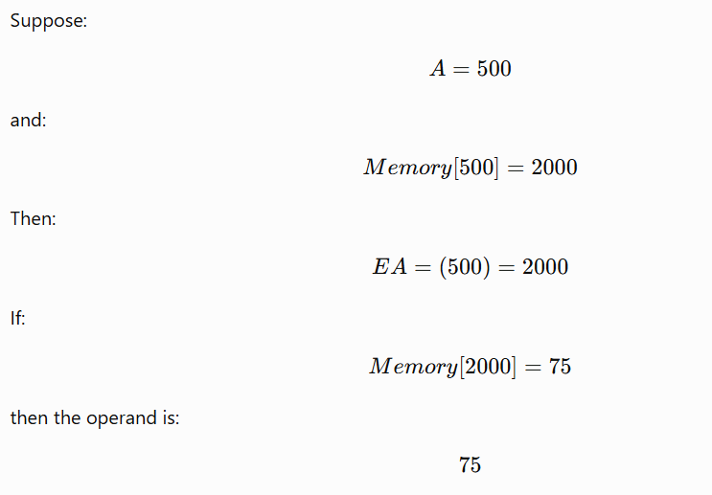
Advantages
- Provides a much larger address space
- The address field can point to a full-word memory address
Disadvantages
- Requires two memory references:
  - First to obtain the effective address
  - Second to obtain the operand
- Therefore, it is slower than direct addressing
4. Register Addressing
In register addressing, the address field refers to a processor register rather than a memory location.
Formula
EA=R
The operand is contained directly in the specified register.
Example
ADD R1, R2
If the instruction refers to register R2, the processor obtains the operand directly from R2.
If the register address field contains the value 5, it refers to:
R5
The operand is the content of R5.
Advantages
- Very fast
- No memory reference is required to obtain the operand
- Small address field is sufficient
- Register access is much faster than main memory access
Disadvantage
The number of registers is limited.
For example, a 4-bit register field can identify:
2^4=16 registers.
5. Register Indirect Addressing
Register indirect addressing is similar to indirect addressing, but the address field refers to a register instead of a memory location.
Formula
EA=(R)
The register contains the effective address of the operand.
Example
Suppose:
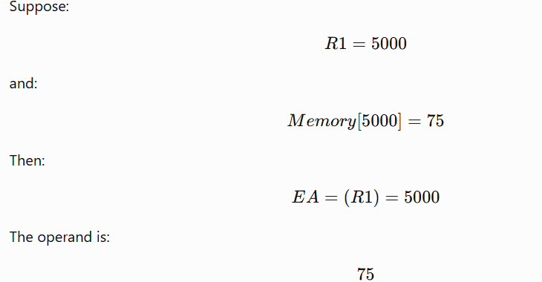
Advantages
- Large address space
- Address field only needs to specify a register
- More flexible than direct addressing
- Uses one less memory reference than ordinary indirect addressing
Disadvantage
An additional memory reference is needed to access the operand.
6. Displacement Addressing
Displacement addressing is a powerful addressing mode that combines features of direct addressing and register indirect addressing.
Formula
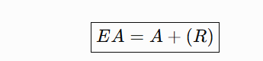
Where:
- A = address/displacement field in the instruction
- R = contents of the specified register
The processor adds these two values to obtain the effective address.
Example
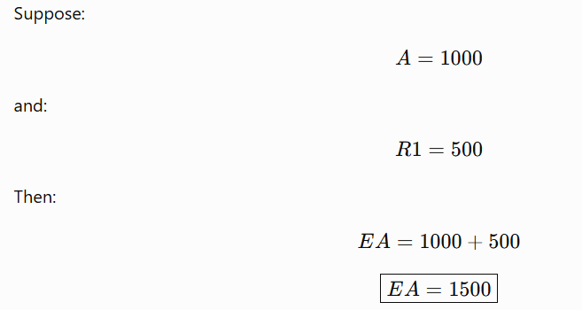
The operand is obtained from memory location 1500.
Displacement addressing requires two address fields, at least one of which is explicit. The register may be explicitly specified or implicitly determined by the instruction.
There are three major forms:
- Relative addressing
- Base-register addressing
- Indexing

7. Relative Addressing
Relative addressing is also called PC-relative addressing.
Here, the Program Counter (PC) is used as the implicit register.
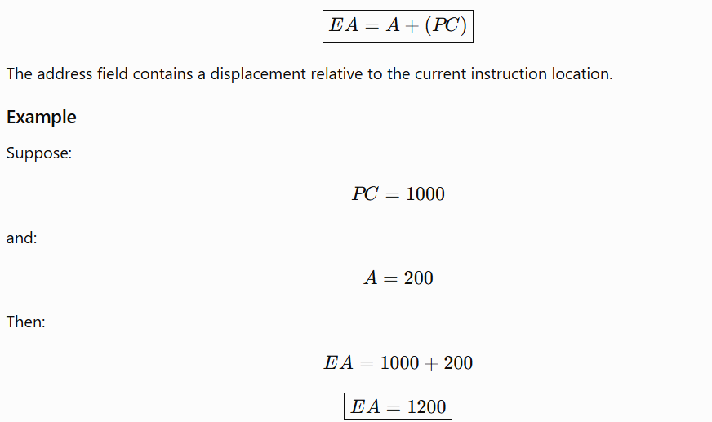Advantages
- Saves instruction address bits
- Useful when the target is located close to the current instruction
- Makes use of the principle of locality
- Useful for branch instructions
8. Base-Register Addressing
In base-register addressing, a register contains the starting address or base address, and the instruction contains a displacement.
Formula:
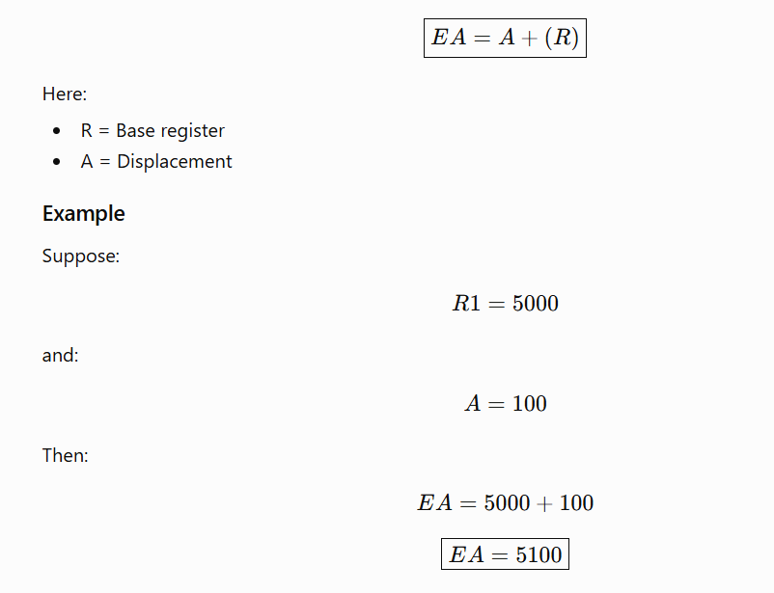Uses
Base-register addressing is useful for:
- Segmentation
- Accessing blocks of data
- Relocatable programs
- Accessing memory relative to a base address
8. Indexing
In index addressing, the address field contains a memory address and the register contains a displacement.
Formula
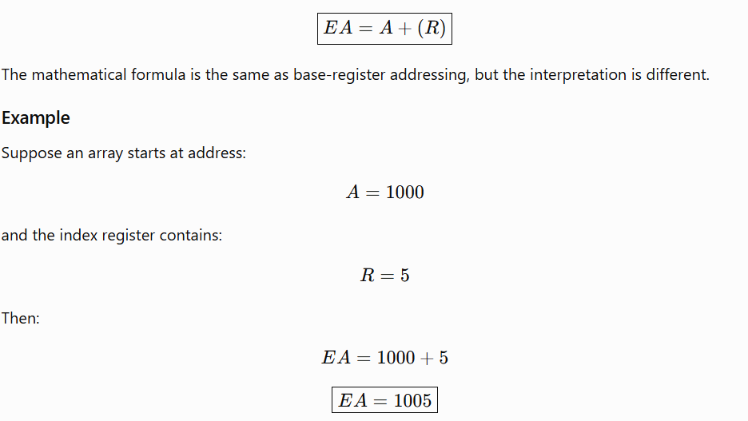This is useful for accessing elements of an array or list.
Example
Suppose an array is stored as:
A[0] → Address 1000
A[1] → Address 1001
A[2] → Address 1002
A[3] → Address 1003
...
The index register can be changed:
R = 0 → Access A[0]
R = 1 → Access A[1]
R = 2 → Access A[2]
R = 3 → Access A[3]
Thus, indexing is particularly useful for iterative operations and arrays.

12. Autoindexing
Autoindexing is a modification of indexing in which the index register is automatically incremented or decremented after accessing an operand.
Formula
EA=A+(R)
(R)=(R)+1
For incrementing:
Before:
R = 0
Access:
EA = A + R
After:
R = R + 1
This is useful when processing consecutive elements of an array or list.
For example:
First iteration → A + 0
Second iteration → A + 1
Third iteration → A + 2
Fourth iteration → A + 3
The autoindexing is useful because index registers frequently need to be incremented or decremented after each reference.

13. Postindexing
In postindexing, indirect addressing is performed first, and then indexing is performed.
Formula
{EA=(A)+(R)}
The memory location specified by A is first accessed to obtain an address. Then the register value is added.
Use
Postindexing is useful for accessing one of several blocks of data having a fixed format.
Example in a process control block, where A points to a variable pointer and the index register provides a displacement within the block.

14. Preindexing
In preindexing, indexing is performed before indirect addressing.
Formula
{EA=(A+(R))}
The resulting address points to another memory location containing the final effective address.
Use
Preindexing is useful for constructing a multiway branch table.
For example, depending on a condition, a program can select one of several addresses from a table.

15. Stack Addressing
A stack is a linear data structure that follows the:
LIFO Last In First Out principle.
The stack has a top and a stack pointer (SP).
The stack pointer identifies the top of the stack or the relevant stack location.
Formula
{EA=Top of Stack}
The instruction does not need to explicitly specify an operand address.
Example
Suppose the stack contains:
Top
↓
30
20
10
An operation such as:
ADD
may implicitly take the top two operands from the stack.
Advantages
- No explicit memory address is required in the instruction
- Simple instruction format
- Useful for arithmetic expressions
- Useful for procedure calls and returns
Disadvantage
- Limited applicability
- Operations are restricted to the top of the stack
- Accessing arbitrary elements is less convenient
Stack addressing as a form of implied addressing, because the instruction implicitly operates on the top of the stack.

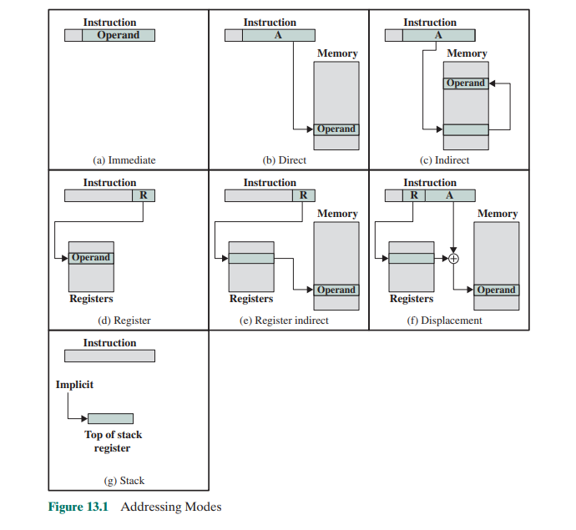
Comparison of All Addressing Modes
 |  |  |  |  | Addressing Mode | Effective Address / Operand | Main Advantage | Main Disadvantage
 |  |  |  |  | Immediate | Operand = A | No memory reference for operand | Limited operand size
 |  |  |  |  | Direct | EA = A | Simple | Limited address space
 |  |  |  |  | Indirect | EA = (A) | Large address space | Multiple memory references
 |  |  |  |  | Register | EA = R | Fast; no memory reference | Limited number of registers
 |  |  |  |  | Register Indirect | EA = (R) | Large address space | Extra memory reference
 |  |  |  |  | Displacement | EA = A + (R) | Flexible | More complex
 |  |  |  |  | Stack | EA = Top of Stack | No explicit address needed | Limited applicability

