



Nielsen Norman Group

Heuristic Evaluation

Group 06 - Snapchat



# Visibility of System Status







# Match Between System and the Real World

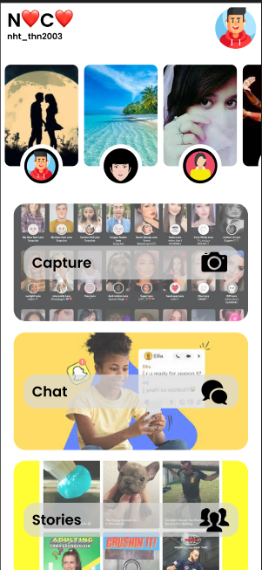



# User Control and Freedom

# 

# 

# 





# Consistency and Standards







# Error Prevention









# Recognition Rather Than Recall











# Flexibility and Efficiency of Use







# 

# Aesthetic and Minimalist Design

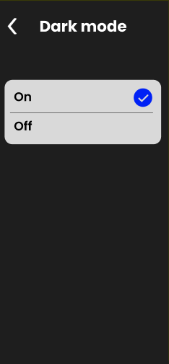





# Help Users Recognize, Diagnose, and Recover from Errors

# 

# 

# Help and Documentation

