AI for Developers - January 2026
Individual Project Assignment
Sudent Name: Aneta Petrova Spasova
Project Name: Netita Properties

Overview
Netita Properties is a responsive real estate web application that helps users explore a curated property dataset and, most importantly, generate AI-driven investment insights from public imoti.net listings.
AI Property Intelligence is the project's core feature: the user pastes an imoti.net listing URL and receives a structured insight report, not a copy of the listing.
The insight report summarizes key numeric indicators such as price per mÂ², context against local district metrics, affordability and risk signals, and an overall investment score to support faster, more informed decisions.
To respect content ownership and privacy, the system does not store or republish raw HTML, descriptions, or images from external listings; it extracts only minimal numeric fields in-memory and returns computed insights.
Users can browse and search for properties from the dataset (hero search and listings), open a detailed property view, and optionally enrich that view with AI insights when an imoti.net URL is provided.
An Admin panel supports creating, editing, and deleting properties for the dataset, enabling quick content updates during demos and local testing.
The project also includes lightweight analytics (counts, averages, price per mÂ²) and integrates with a local dataset API, with an offline fallback mode for admin usage when the backend is unavailable.

Choose Your Own Project Topic
Netita Properties is a responsive real estate website built using vanilla HTML5, CSS3, and JavaScript. The system includes a local Node.js/Express server that serves static pages, exposes a JSON API for the bundled property dataset, and optionally provides AI-powered insights for imoti.net listings.
System Requirements:
- Responsive UI for desktop, tablet, and mobile
- Local Node/Express backend serving API endpoints for property CRUD and optional AI analysis
- Admin panel with property add/edit/delete functionality
- Property search/filter via hero section
- Analytics module computing counts, averages, and price per mÂ²
- Optional AI module for analyzing external listing URLs and generating investment insights

System Architecture - Modules
This project is organized into the following modules, each with a clear purpose and well-defined interactions:
- Frontend: Responsive UI pages (home, listings, property details, contact) that render property cards, navigation, and the hero search flow so users can browse and discover properties quickly.
Copilot support: Copilot helped refine the page-level structure and user flows, and suggested clearer separation of responsibilities between rendering, navigation, and data loading.
- Property Data Layer: A unified data source for property records and media references, supporting both initial seed data and persisted updates so the UI always works with consistent fields.
Copilot support: Copilot helped normalize the dataset fields, identify edge cases (missing images/values), and keep the data model consistent across pages and admin actions.
- Backend API: Local HTTP API that serves the static site and exposes endpoints for reading and managing properties, plus a dedicated endpoint for AI insights.
Copilot support: Copilot helped shape the route responsibilities, request/response contracts, and defensive validation so the API remains predictable for the frontend.
- Admin Panel Module: An admin-facing interface for creating, editing, and deleting properties, enabling quick content updates for demos and local testing; it also supports offline editing behavior when the API is unavailable.
Copilot support: Copilot helped streamline CRUD interactions and confirm practical UX behaviors (form state, validation feedback, and safe defaults) without overcomplicating the interface.
- Analytics Engine: Computes high-level market indicators (counts, averages, and price per m2) that can be used for summaries and comparisons, including segmentation by property type and local context metrics.
Copilot support: Copilot helped verify calculation logic, select meaningful aggregates, and ensure analytics stay in sync when properties are added or updated.
- AI Property Intelligence: The core capability: users provide a public imoti.net listing URL and receive an insights-only JSON report with numeric signals (for example price per mÂ², relative positioning vs. district metrics, and an overall investment score) to support decision-making.
Copilot support: Copilot helped design the insight output structure, focus extraction on minimal numeric fields, and enforce the constraints that external listing content is not stored or republished.

Development Process per Module
1. Frontend (UI Layer)
- Approach & reasoning - Build a static multi-page UI (HTML/CSS/vanilla JS) with API-first data loading and an offline fallback, keeping code modular and avoiding frameworks to match the project architecture.
- Step-by-step workflow - Implement the UI pages and page scripts and wire them to the properties API.
  - Build/maintain pages: index.html, listings.html, property-details.html, contact.html, admin.html
  - Styling via design system + page overrides: css/style.css and css/pages.css
  - Page scripts: js/main.js, js/listings.js, js/property-details.js, js/contact.js (+ js/dropdown.js where used)
- Testing strategy - Manual browser validation of navigation, responsive layout, listings filters/sort/pagination, and both details modes (?id= and ?imotiUrl=). Validate offline fallback by loading without the server.
- AI tool choice - GitHub Copilot (VS Code), because it accelerates vanilla JS/UI scaffolding while staying consistent with the repos no-framework conventions.
- Key prompts/interactions
  - Load properties from /api/properties with a safe fallback to data/properties.js if the API is unavailable.
  - Sync listings filter state into the URL without page reload; keep mobile sidebar accessible (focus trap + Escape).
2. Backend API
- Approach & reasoning - Use a small Express server to serve the static site and expose a JSON API with file-based persistence (no DB) to keep the backend lightweight and easy to run locally.
- Step-by-step workflow - Add API routes, validation, and JSON persistence with atomic writes.
  - Implement routes in server/server.js (GET/POST/PATCH/DELETE for /api/properties; analytics; AI analyze)
  - Implement store and validation in server/data/propertiesStore.js (seed from data/properties.js, normalize inputs, atomic writes)
- Testing strategy - Run npm run dev and validate endpoints with the smoke test (npm run smoke) and manual CRUD calls; confirm persistence in server/data/properties.json.
- AI tool choice - GitHub Copilot (VS Code), because it speeds up Express route scaffolding and keeps handlers thin while moving logic into services/util/store modules.
- Key prompts/interactions
  - Create JSON-file persistence with seed-on-first-run and atomic writes.
  - Implement CRUD routes with consistent error JSON responses and input validation.
3. Admin Panel Module
- Approach & reasoning - Provide a minimal CRUD UI for properties with an optional Basic Auth gate (enabled only when env vars are set) and an offline mode (localStorage) for demos when the server is unavailable.
- Step-by-step workflow - Build the admin UI, wire it to the API, and add authenticated image uploads.
  - Admin UI logic in js/admin.js (online CRUD + offline localStorage fallback)
  - Protect admin and write endpoints in server/server.js when ADMIN_USER and ADMIN_PASS are set
  - Upload endpoint: POST /api/uploads/images (stored in assets/images/uploads)
- Testing strategy - Verify create/edit/delete persists when online; verify uploads succeed and file paths render; verify offline mode stores updates in localStorage; verify auth prompts when env vars are enabled.
- AI tool choice - GitHub Copilot (VS Code), because it’s effective for vanilla JS form state + fetch wiring and for keeping the feature set minimal.
- Key prompts/interactions
  - Implement an admin CRUD UI that falls back to localStorage when the API is unavailable.
  - Add a secure image upload endpoint restricted to image mime types/extensions with size limits.
4. Analytics Engine
- Approach & reasoning - Compute analytics from existing structured property data (no extra storage), expose it via an API endpoint, and reuse the same aggregates in the admin UI.
- Step-by-step workflow - Implement analytics computation and expose it through the backend.
  - Analytics util: server/util/propertiesAnalytics.js
  - Endpoint: GET /api/analytics/properties in server/server.js
- Testing strategy - Call the endpoint and verify generatedAt + analytics payload. Create/update/delete properties and confirm aggregates change accordingly (also visible in Admin).
- AI tool choice - GitHub Copilot (VS Code), because it helps generate correct aggregation logic and keep it isolated in a utility module.
- Key prompts/interactions
  - Compute counts/averages/medians grouped by listing type and return a stable JSON shape.
6. AI Property Intelligence
- Approach & reasoning - Build an insights-only pipeline for imoti.net URLs: validate input strictly, fetch HTML, extract minimal numeric/enum fields in-memory, compute insights, and return computed JSON only (no raw HTML or listing content is stored or republished).
- Step-by-step workflow - Implement validate fetch extract compute respond, keeping business logic in services/util.
  - Endpoint: POST /api/imoti/analyze in server/server.js
  - Service orchestration: server/services/imotiAnalyzeService.js
  - URL validation: server/util/validateImotiUrl.js
  - Minimal extraction: server/util/extractImoti.js
  - Insights computation: server/util/priceAnalysis.js, server/util/investmentScore.js, server/util/areaInsights.js, server/util/metrics.js
- Testing strategy - Use npm run smoke with IMOTI_TEST_URL (or manual POST) and confirm the response includes only price_analysis, investment_score, and area_insights; confirm failures return safe error JSON with no HTML or stack traces.
- AI tool choice - GitHub Copilot (VS Code), because it accelerates building a modular, constraint-driven pipeline while keeping sensitive-data rules explicit in code.
- Key prompts/interactions
  - Implement POST /api/imoti/analyze that returns insights only; do not store or return raw HTML, descriptions, or images.
  - Reject imoti homepage/search URLs; require a single-ad details URL and https.

Smoke tests:
PS C:\Users\anine\PROJECTS\Netita Properties> powershell -NoProfile -Command "Invoke-RestMethod -Uri http://localhost:5175/api/analytics/properties | ConvertTo-Json -Depth 6"
{
"generatedAt": "2026-02-13T09:20:36.648Z",
"analytics": {
"count": 20,
"avgPrice": 469000,
"medianPrice": 457500,
"avgSqft": 2217.5,
"avgPricePerSqft": 216.38466456031065
}
}
Invoke-RestMethod http://localhost:5173/api/properties: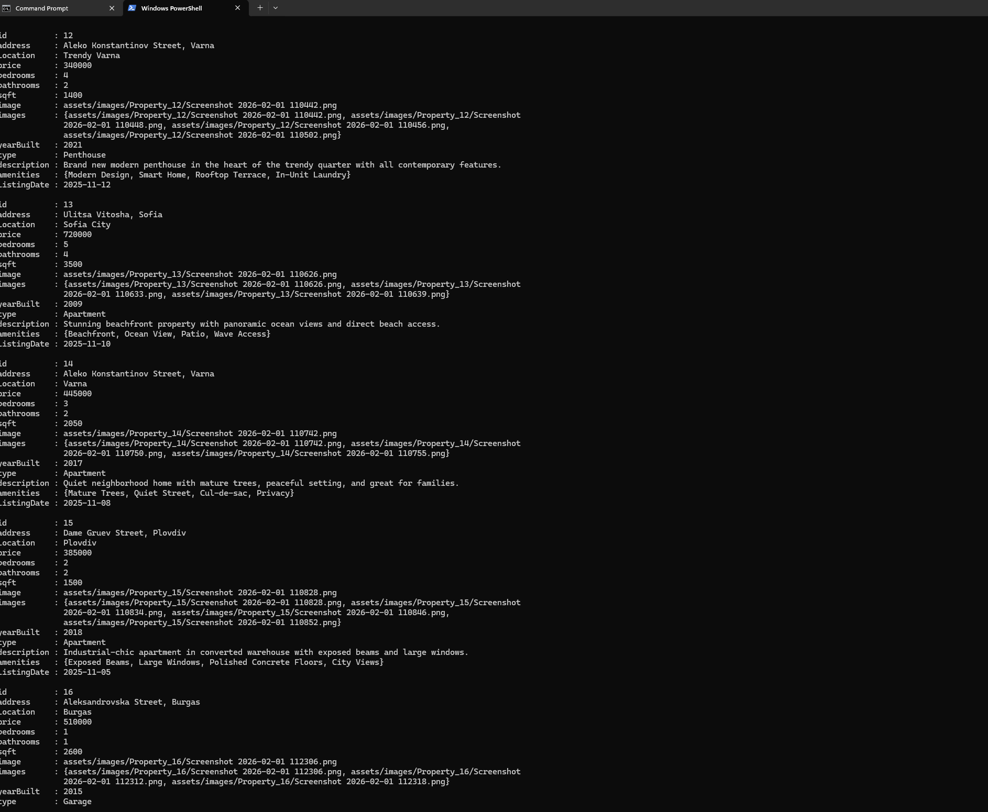
Invoke-RestMethod http://localhost:5173/api/properties/1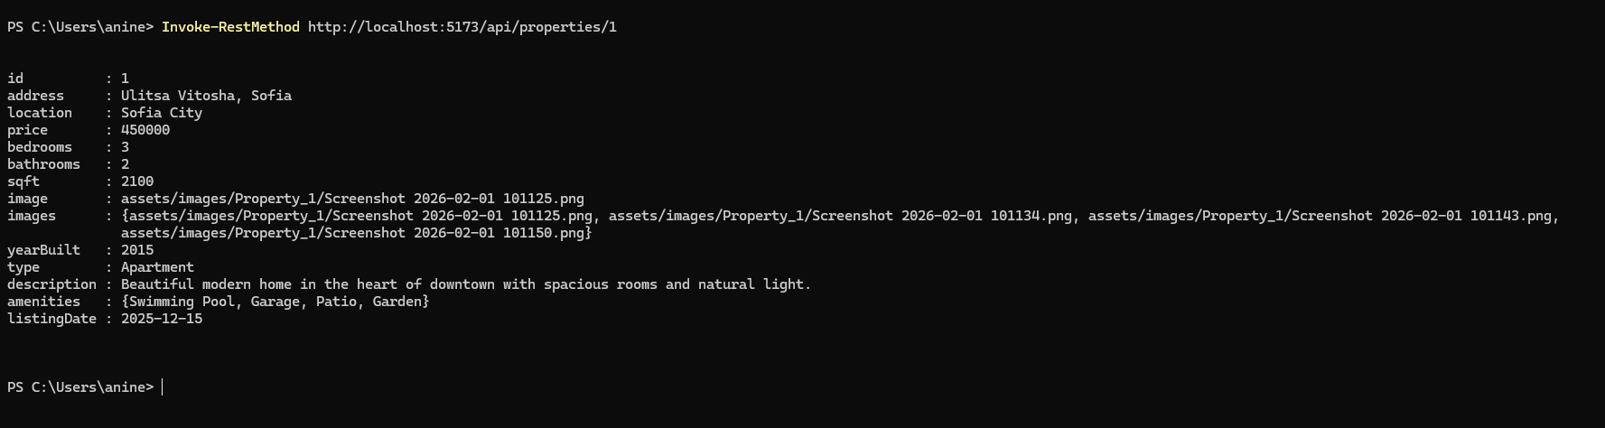

Challenges & Tool Comparison
- Biggest Challenges:
  - Designing a fully modular vanilla JS architecture without frameworks
  - Ensuring responsive CSS grids and hero interactions work across devices
  - Generating AI analysis without storing sensitive listing data
- Most Helpful Tool: GitHub Copilot â€” accelerated code scaffolding and module consistency
- Improvements for Future Work:
  - Add database integration for persistent data
  - Implement full authentication/authorization for Admin
  - Expand AI module to suggest similar properties

Working System Evidence
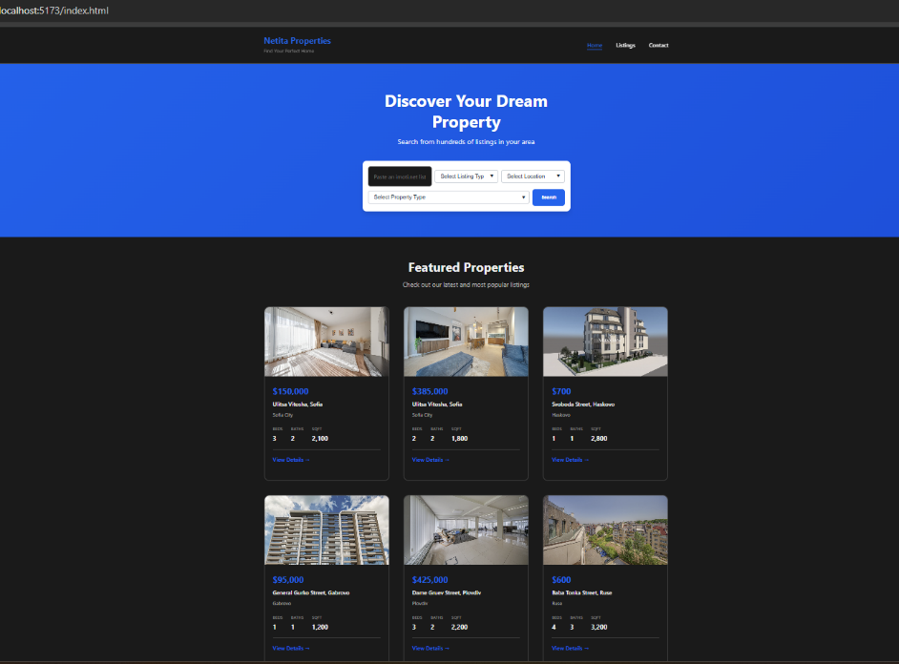
- Home Page with Featured Properties & Hero Search

- AI Property Intelligence age with Featured Properties
  - local: http://localhost:5173/property-details.html?id=3&ai=1:

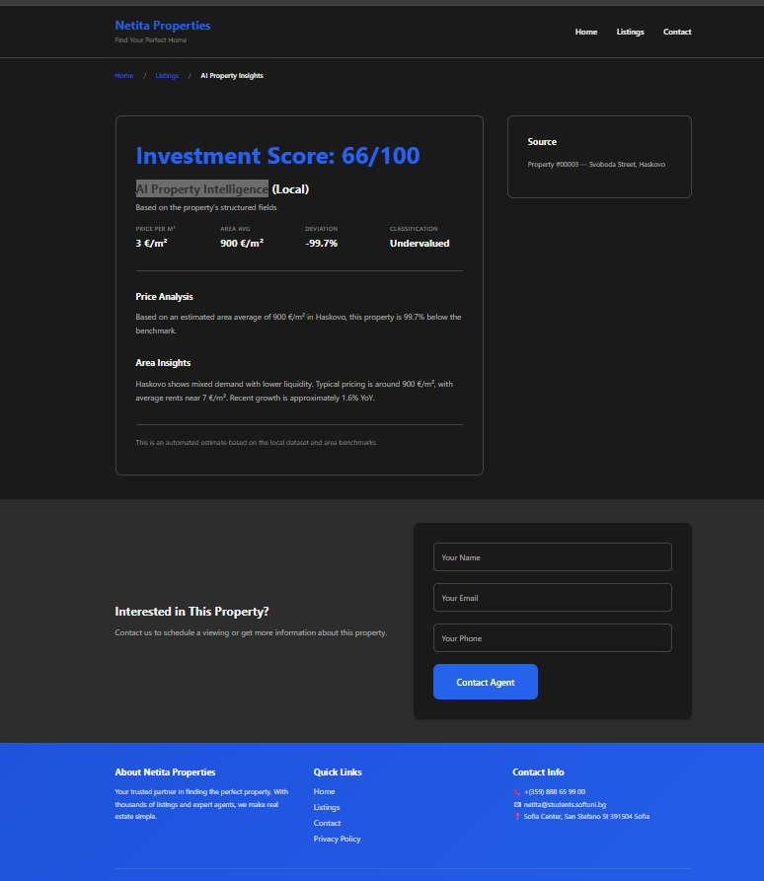

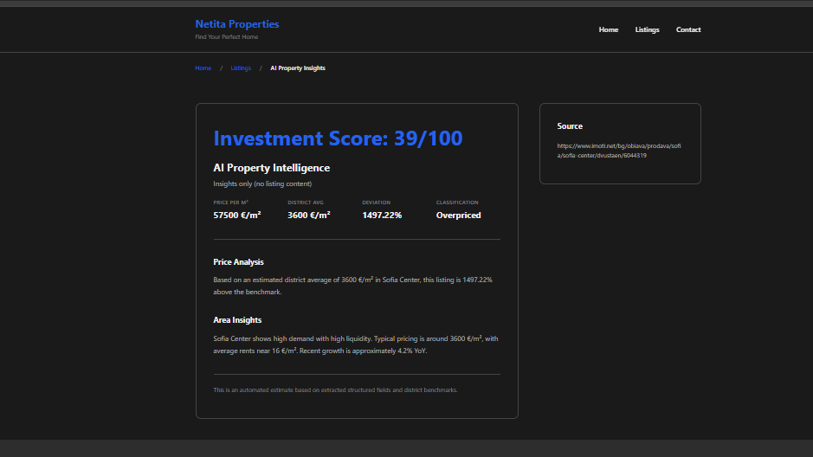
  - https://www.imoti.net/bg/obiava/prodava/sofia/sofia-center/dvustaen/6044319:

- Admin Panel with Property CRUD and Analytics
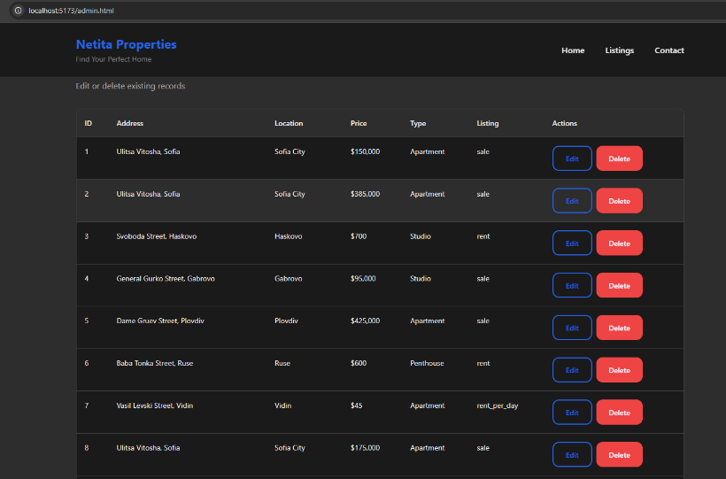
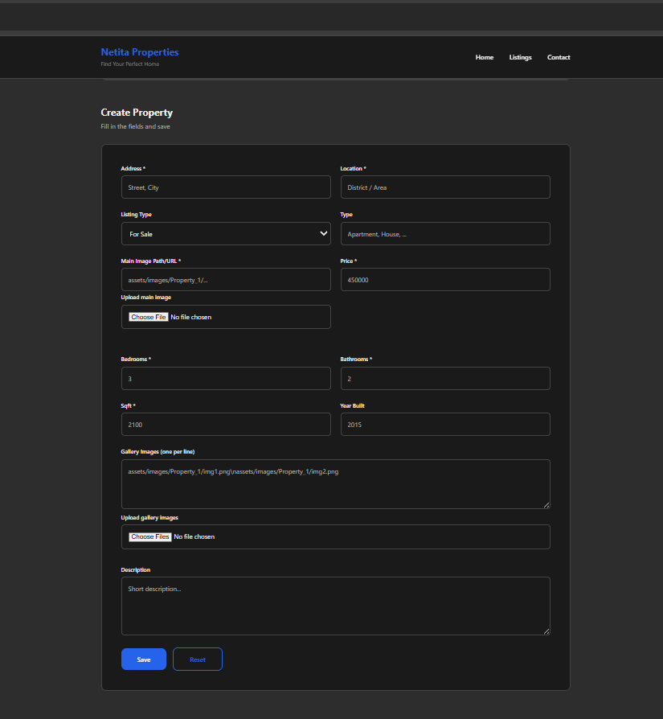
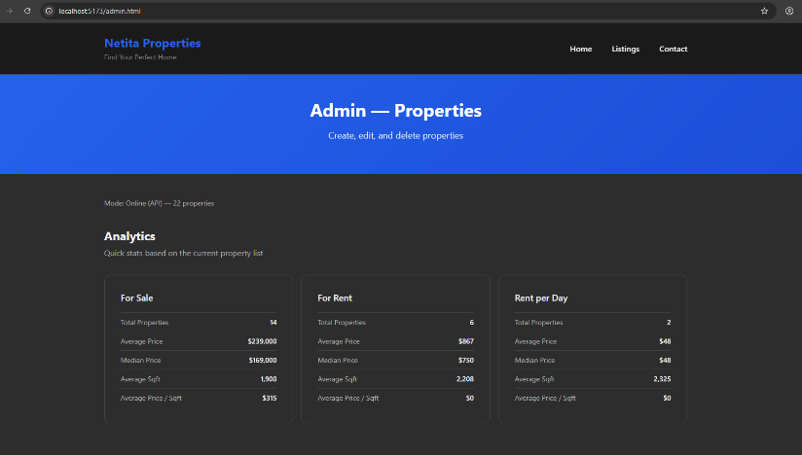

- Generated using Explain-Code-Netita.prompt.md:
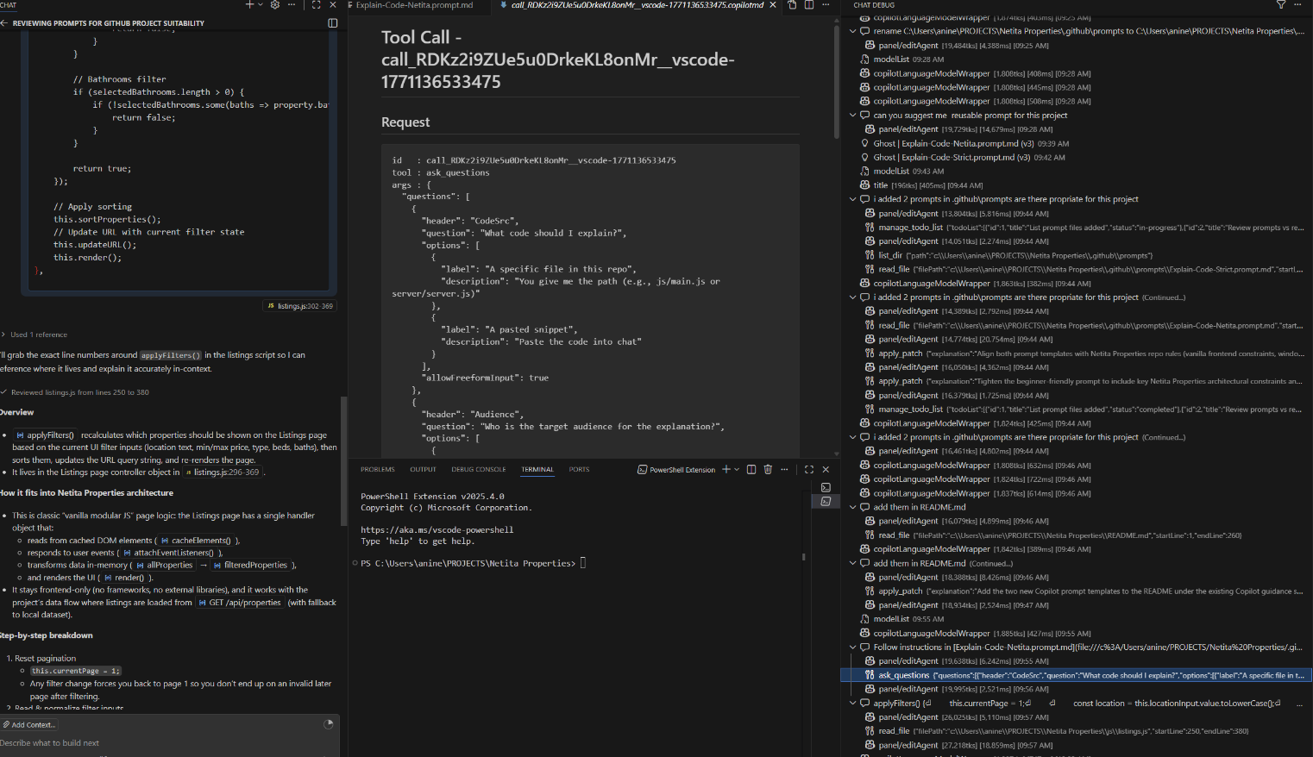
  - applyFilters() (lines 296â€“369 in listings.js) filters and sorts properties based on user inputs (location, price, type, beds, baths), updates the URL, and re-renders the Listings page. Runs frontend-only in vanilla JS modular style.

- Apply instruction to .js files using js.instructions.md:
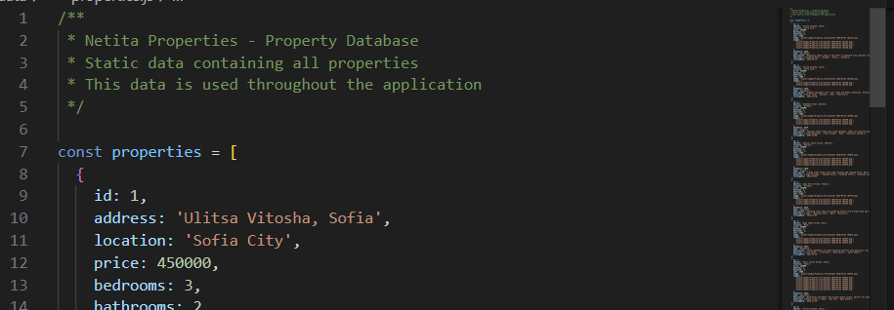

Repository
GitHub Repository : https://github.com/netitasoftuni/Netita-Properties

