**ADagent**

**Advertising Agency System**

User Guide

Aug 31, 2010

**ADagent**

**Advertising Agency System**

Welcome to ADagent!

This system is for Advertising Agency.

This user guide will introduce you to our service

and help you get smooth operations.

**Contents**

1. Introduction
2. Installation
3. User Types
4. System Administrator
   1. User View
      1. Logging in
      2. Creating user accounts
      3. Reference / Deleting orders
      4. Editing orders
   2. Fees View
      1. Setting Fees
5. User
   1. Logging in
   2. Creating new orders

**1. Introduction**

ADagent is a stand alone application which enable you to manage advertising project easily. You can easily refer to records of advertisement orders and overcome discrepancies in your project.

**2. Installation**

Expanding the submitted zip file, the below files will appear.

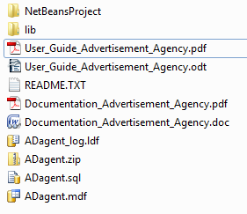

* 1. **Attaching the database file into SQL Server**

1. Lunch up Microsoft SQL Server 2005 and log in user with permission of administration.

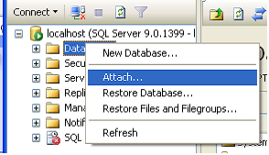

1. Click add and Select the file of “ADagent.mdf”
   1. **Set up the connection settings in application**
2. Open ADagent.zip file with WinZip.

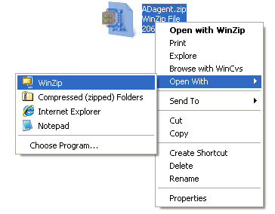

1. Open persistence.xml file with Notepad.

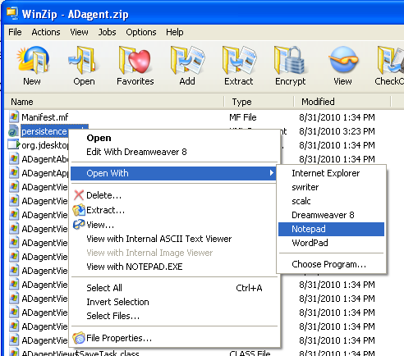

1. Modify user name and password of Microsoft SQL Server 2005.

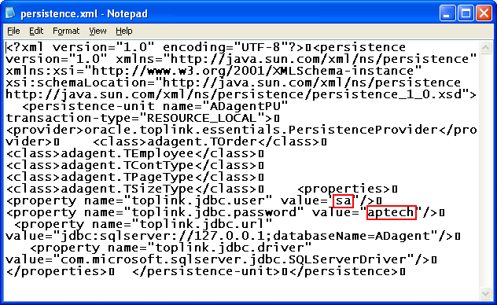

1. Save the file.
2. Change the file name from Adagent.zip to Adagent.jar.

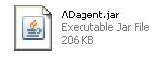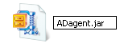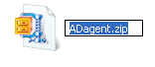

**3. User Types**

ADagent has two types of users:

* System Administrator
* User

**System Administrator**

The System Administrator can use all function within the software, as well as manage the following:

* Creating, editing and deleting User accounts
* Editing and deleting orders
* Editing the price of advertisements by setting the parameters of content type, size type and page type.

**User**

The user is limited to the following:

* Creating orders for customers
* Calculating total charge for advertisements automatically based on the parameter provided by the System Administer.
* Reference records of customer orders.

**4. System Administrator**

**4.1 User View**

**4.1.1 Logging in**

To login to Advertising Agency System as System Administrator

1. Launch Advertising Agency System by double click

Adagent.jar file.

1. select **File** > **Login**
2. Login dialog will be displayed.
3. Enter 'admin' as User name and '123' as Password.
4. Click **Login** to open Administrator Start page.

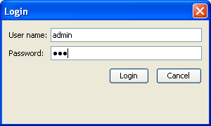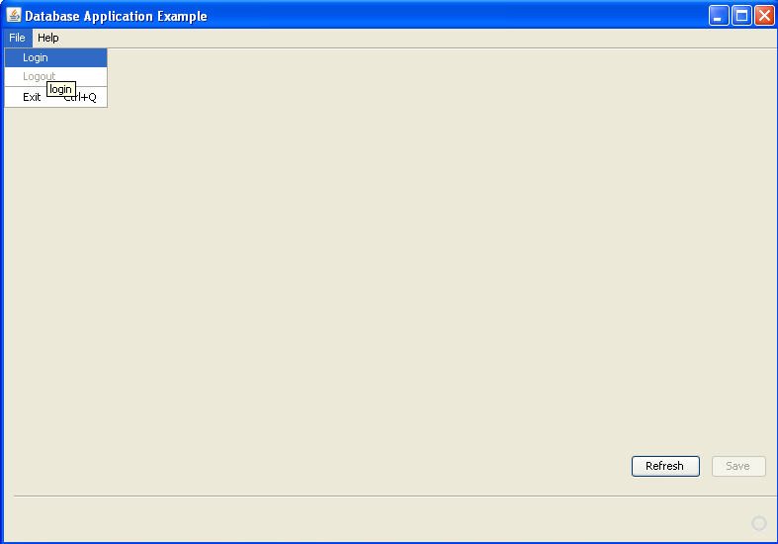

**Incorrect Login Procedure**

If you any reason an unrecognised combination of User name and password is used during login, the system will return an error message.

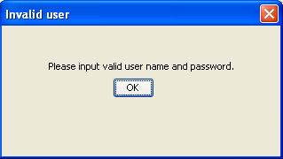

**4.1.2 Creating User accounts**

Having logged in successfully as a System Administrator you are now shown a new view called "User View".

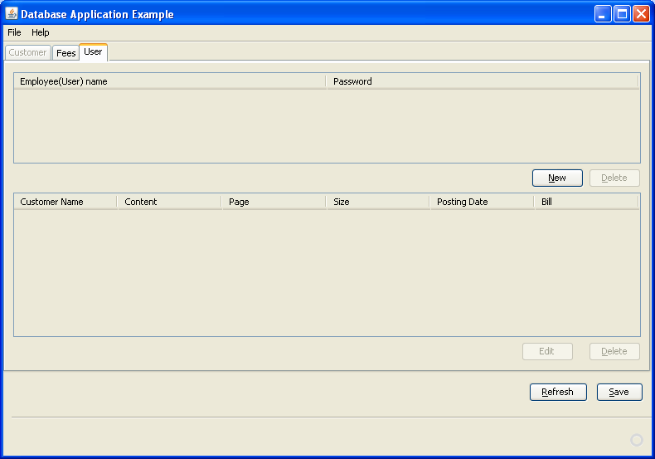

1. Click **New** to create new user account.
2. Enter Employee Name and Password on new created row.

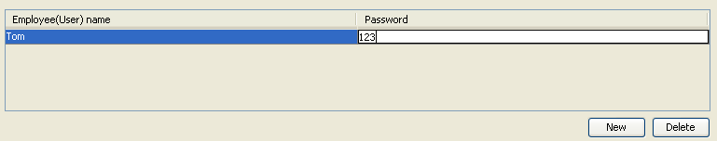

1. Click **Save**.

Note: Data is not populated into the database unless you click **Save** thus if you want the initial data, click **Refresh**.

**4.1.3 Reference / Deleting orders**

The System Administrator can refer to order data* for each employee by selecting a employee on Employee list table.

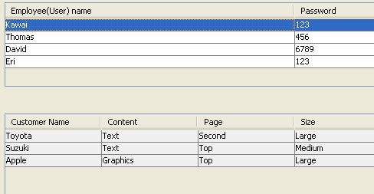

And you can also delete a selected order by clicking **Delete**.

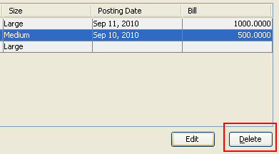

* Please refer to 5.2 Creating new Orders

**4.1.4 Editing orders**

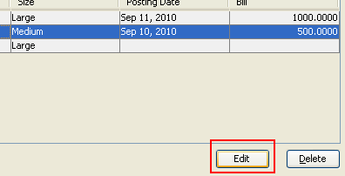The System Administrator can edit a selected order by clicking **Edit**. Once you click **Edit**, Edit dialog will be displayed.

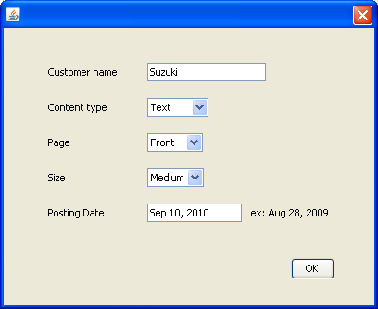

**4.2 Fees View**

**4.2.1 Setting Fees**

1. Select **Fees** tab to desplay Fees View

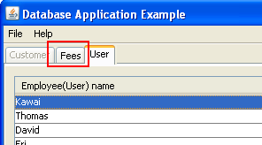

1. Set the parameters of content type, size type and page type.

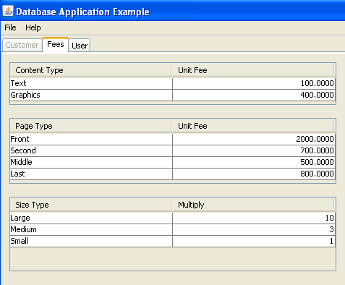

**5. User**

**5.1 Logging in ( User )**

To login to Advertising Agency System as user

1. Launch Advertising Agency System by double click

Adagent.jar file.

1. Select **File** > **Login**
2. Login dialog will be displayed
3. Enter User name and Password
4. Click **Login** to open User Start page.

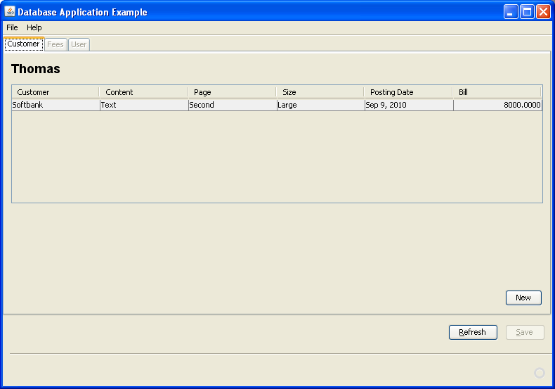

**5.2 Creating New Orders**

Having logged in successfully as a user you are now shown a new menu called "Customer View".

1. Click **New** to create new order.
2. Edit dialog will be displayed.

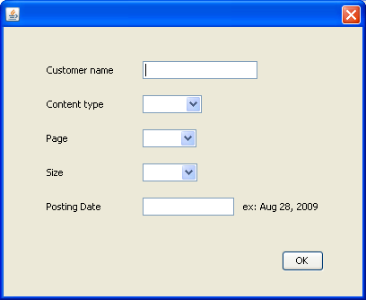

1. Enter the information.
2. Click **Save** to calculate the bill.
3. You can confirm the order detail and the bill on Customer table.
4. If Click **Save** to populate data into the database.