Certificate // Create the certificate of completion as like from the eProject Guide// Refer Page no 8 of eProject Guide

[Index]

1. Problem Definition 3
2. Customer Requirement Specification (CRS) 4
Client: 4
Business/Project Objective: 4
Input/Output: 4
Hardware Requirements: 4
Operating System: 4
Software Requirement: 4
3. Use Case 5
4. Data Flow Diagram (DFD) 8
5. Entry Relationship (ER) Diagram 10
6. Database Design/Structure 11
7. Flowchart 14
8. GUI Standards Documents 17
9. Interface Design Documents 18
10. Task Sheet 19
11. Final Checklist 20

Problem Definition

After reading the project specifications, the developer states the scope of the project very briefly. This is referred to as the problem definition.

  - How will a customer purchase products through online?
  - How to fetch and handle orders?
  - How can the payment process be made clear?
  - How to create an employee profile?
  - How can the details be maintained using the database?

Customer Requirement Specification (CRS)

Client:
Arts (a retail dealer of various products)

Business/Project Objective:
Create an application named Online Shopping Cart using .NET Technologies

Input/Output:
  - Inputs for the Web-based application
  - Outputs from the Web-based application

Hardware Requirements:
  - A minimum computer system that will help you access all the tools in the courses in a Pentium 166 or better

Operating System:
  - Windows 2000 Server (or higher if possible)

Software Requirement:
  - .Net
  - Dreamweaver 8
  - SQL Server 2005
  - Internet Explorer 7

Use Case

Figure 3.1-3.3 shows the use case of the application.

User
Register
Log in
Buy Products
Edit his/her Account
Cancel Products
View
Products
View
FAQs & Feedbacks
Log off
Create FAQs & Feedback
View his/her Order

Fig 3.1: Use Case of User

Log in
View Details of Orders
Edit his/her Password
Update Details of Orders
View
Products
View
FAQs & Feedbacks
Log off
View Orders
Edit Orders
Employee

Fig 3.2: Use Case of Employee

Employee
Log in
Update Admins & Employees
Create Admins & Employees
View Admins & Employees
View
Products
View
FAQs & Feedbacks
Log off
Edit Products
Dealer
(Admin)

Fig 3.3: Use Case of Dealer (Admin)

Data Flow Diagram (DFD)

Fig 4.1-4.2 shows DFD of the application.

1
Stationary
Shopping
Website

Customer
Selecting and
Purchasing Products
Invoice Details

Fig 4.1: DFD LEVEL 0 - Online Shopping Cart for Arts

Invoice
Confirmation
Credit Card Info
Submit
Retrieve Details of Selected Product
Display list of
available Products
2
Log on
1
Registration
4
Display Products Details
Register
Customer Info
Log in
User ID &
Password

Customer
User ID &
Password
Log on
Products
Details
Retrieve list of
available Products
Select Product
Display
Products Details
3
Display Products List
5
Purchase
Products
User Details
Customer Info
Register
Buy
6
Invoicing

Fig 4.2: DFD LEVEL 1 - Online Shopping Process

Entry Relationship (ER) Diagram

The E-R Diagram in the database is given in Figure 5.1.

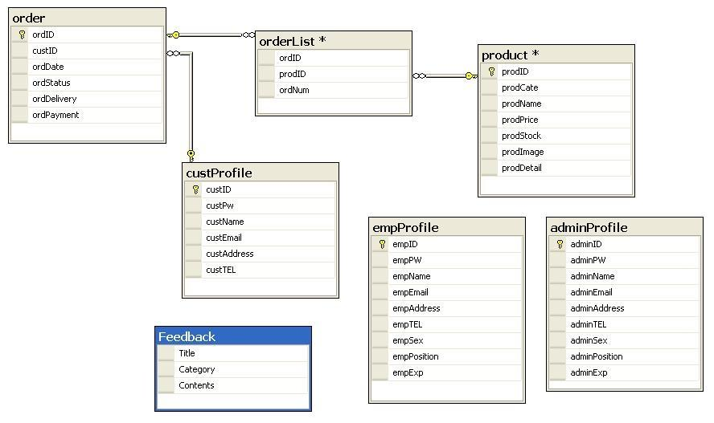

Fig 5.1: ERD-Online Shopping Cart

Database Design/Structure

The table structure in the database is given in Figure 6.1-6.7.

Table : adminProfile
Column  Name | Data Type | Max Digits | Key | Null | Description
adminID | nvarchar | 15 | PK | NO | -
adminPW | nvarchar | 30 | - | NO | -
adminName | nvarchar | 30 | - | NO | -
adminEmail | nvarchar | 50 | - | NO | -
adminAddress | nvarchar | 50 | - | NO | -
adminTEL | nvarchar | 15 | - | NO | -
adminSex | nvarchar | 6 | - | NO | -
adminPosition | nvarchar | 20 | - | NO | -
adminExp | nvarchar | 9 | - | NO | -

Fig 6.1: Administrator Profile table

Table : custProfile
Column  Name | Data Type | Max Digits | Key | Null | Description
custID | nvarchar | 15 | PK | NO | -
custPw | nvarchar | 30 | - | NO | -
custName | nvarchar | 30 | - | NO | -
custEmail | nvarchar | 50 | - | NO | -
custAddress | nvarchar | 50 | - | NO | -
custTEL | nvarchar | 15 | - | NO | -

Fig 6.2: Customer Profile table

Table : empProfile
Column Name | Data Type | Max Digits | Key | Null | Description
empID | nvarchar | 15 | PK | NO | -
empPW | nvarchar | 30 | - | NO | -
empName | nvarchar | 30 | - | NO | -
empEmail | nvarchar | 50 | - | NO | -
empAddress | nvarchar | 50 | - | NO | -
empTEL | nvarchar | 15 | - | NO | -
empSex | nvarchar | 6 | - | NO | -
empPosition | nvarchar | 20 | - | NO | -
empExp | nvarchar | 9 | - | NO | -

Fig 6.3: Employee Profile table

Table : Feedback
Column Name | Data Type | Max Digits | Key | Null | Description
Title | nvarchar | 20 | - | NO | -
Category | nvarchar | 15 | - | NO | -
Contents | nvarchar | 500 | - | NO | -

Fig 6.4: Feedback table

Table : product
Column Name | Data Type | Max Digits | Key | Null | Description
prodID | nvarchar | 7 | PK | NO | -
prodCate | varchar | 15 | - | NO | -
prodName | varchar | 30 | - | NO | -
prodPrice | money | - | - | NO | -
prodStock | int | - | - | NO | -
prodImage | image | - | - | NO | -
prodDetail | nvarchar | 200 | - | NO | -

Fig 6.5: Products table

Table : order
Column  Name | Data  Type | Max Digits | Key | Null | Description
ordID |  |  | PK | NO | -
custID |  |  | - | NO | FK to custProfile table
ordData |  |  | - | NO | -
ordStatus |  |  | - | NO | -
ordDelivery |  |  | - | NO | -
ordPayment |  |  | - | NO | -

Fig 6.6: Order table

Table : orderList
Column Name | Data  Type | Max Digits | Key | Null | Description
ordID |  |  | - | NO | FK to order table
prodID |  |  | - | NO | FK to product table
ordNum |  |  | - | NO | -

Fig 6.7: OrderList table

Flowchart

Fig 7.1-7.3 shows the flowchart for the application.

Input UserID and Password
Input data is correct and existing in the database

NO
Start
End
YES
Display
Log in Page
Display
Success Page
Display
Error Message
Fig 9.1: Flow Chart for Login

Input User details
YES
Start
End
NO
Display
Register Page
Display
Success Page
Display
Error Message
Input data exists in the database

Save details in the database
Fig 9.2: Flow Chart for Registration

Select Products
YES
Start
End
NO
Display
Products List Page
Display
Success Page
Display
Error Message
Input data is valid

Display
Products Details
Input required data

Fig 9.3: Flow Chart for Shopping

GUI Standards Documents

Property | Value
Document theme and color scheme | LightSkyBlue
Form-Background Color | Transparent
Title-Font Size | Medium
Title-Font Color | Navy
Title-Font Style | Bold-True
Title-Alignment | Lefts
Background color of Controls on the form | LightGoldenrodYellow
Foreground color of Controls on the form | Red
Control Caption-Font Size | Small
Control Caption-Font Color | Black
Control Caption-Font Style | Bold-False
Control caption and controls-Alignment | Centers
Command button-Alignment | Center

Interface Design Documents

Document Name | Description | Controls on the Document
AboutUs | Explanation about an online shopping site named Arts. | Label, Button, LinkButton, Image, Panel
AdminMain | Top page that only Admin can manage. | Label, TextBox, Button LinkButton, Image, Table
ChangePW | Employees can change their password from this page. | Label, TextBox, Button, LinkButton
ContactUs | Arts existent information | Label, Button, LinkButton, Image
CreateProdProf | Only Admin can create details of products in this page. | Label, TextBox, Button, LinkButton, RadioButton, DropDownList
EmpMain | Employees can check orders in this page. | Label, TextBox, Button, LinkButton, Image, Table
Fail | The page to show the task is invalid. | Label, Button, LinkButton
Feedback | Customers can send their feedback to Arts from this page. | Label, TextBox, Button, LinkButton, DropDownList
Login | Input page for customers to enter Arts site. | Label, TextBox, Button, LinkButton
Main | Top page that all controls start from this page. | Label, TextBox, Button, LinkButton, Image, Table
prodDetail | Explanation about product details which is selected. | Label, TextBox, Button, LinkButton, Image, DropDownList
SignUp | Input page for the first visitor to create his/her account. | Label, TextBox, Button, LinkButton
Success | The page to show the task had been done successfully. | Label, Button, LinkButton
CreateEmpProf | Only Admin can create profiles of Admin and Employees in this page. | Label, TextBox, Button, LinkButton, RadioButton, DropDownList
EmpFirstPage | Top page for employees. | Label, TextBox, Button, LinkButton

Task Sheet

Project Ref. No.: |  | Activity Plan  Prepared By: | Date of Preparation of Activity Plan:
Sr.  No. | Task | Activity Plan  Prepared By: | Actual Start  Date | Actual  Days | Team Member Names | Status
1 | Programming |  | 9th Jan 2009 | 7 |  | Completed
2 | Test |  | 14th Jan 2009 | 2 |  | Completed
3 | Create Documentations |  | 9th Jan 2009 | 7 |  | Completed

Final Checklist

- Checklist of Validation
No. | Option | Validated
01 | Are all variables initialized with proper default values? | YES
02 | Are the functions functioning according to their requirements? | YES
02 | - Can the dealer alone manage the details of the products, employees and check the details of the orders, stock details, feedbacks and FAQ’s from the customers? | YES
02 | - Can the employee change his/her password, and check and update the details of the orders and the delivery reports, no more than that? | YES
02 | - Can the customer check the details of the order that he/she has placed? | YES
02 | - Can the registered customers alone manage his/her account, orders placed by them and check the details of the products? | YES
02 | - Can the non registered customers only check or fetch the details of the products and register with the site? | YES
02 | - Can the customer only cancel the order provided that the product is not dispatched from the dealer’s premises? | YES
03 | Is the output being displayed in the correct format? | YES
04 | Is the output correct or accurate? | YES
05 | Does the application’s functionality satisfy the user requirements? | YES
05 | - Are the details of the products, employees, orders, delivery/dispatching details and that of the customers maintained using the help of the database? | YES
05 | - Are there separate login for Admin, Employees and for the customer? | YES

- Submission Checklist
No. | Option | Yes | No | NA | Comments
01 | Are the displayed messages devoid of spelling mistakes? | YES
02 | Are the functions declared properly? | YES
03 | Have all the functions being tested? | YES
04 | Do the functions return correct values? | YES
05 | Have the files been integrated correctly? | YES

