This is to certify that

Mr. Kawai
Ms. Sato

Has successfully Designed & Developed
ASKME Mobile site

Submitted by: Masanori Kawai, Eri Sato

Date of Issue:08/JULY/2010

Authorized Signature:______________

[Index]

1. Customer Requirement Specification (CRS) 3
Hardware Requirements: 3
Operating System: 3
Software Requirement: 3
2. Installation into the server machine 4
2.1 Attaching the database file into SQL Server 4
2.2 Creating the Database Source Network 5
2.3 Assignment of Web files 6
3. Using our web application’s 7

1. Customer Requirement Specification (CRS)

Hardware Requirements:
  - A minimum computer system that will help you access all the tools in the courses in a Pentium 166 or better

Operating System:
  - Windows XP with IIS (or higher if possible)

Software Requirement:
  - SQL Server 2005
  - Internet Information Server with ASP

2. Installation into the server machine

2.1 Attaching the database file into SQL Server

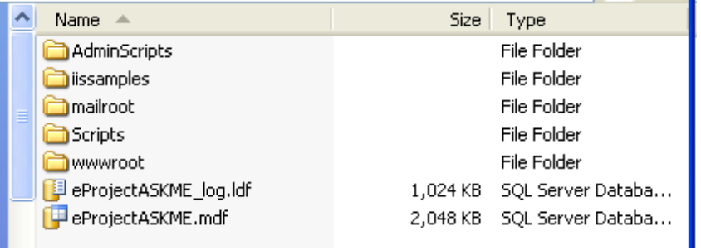
- Copy eProjectASKME.mdf and eProjectASKME_log.ldf into “C:\Inetpub\”
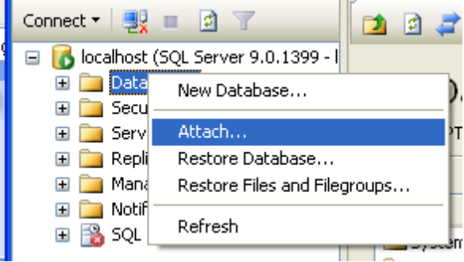
- Lunch up Microsoft SQL Server 2005 and log in user with permission of administration.
- Click add and Select the file of “eProjectASKME.mdf”
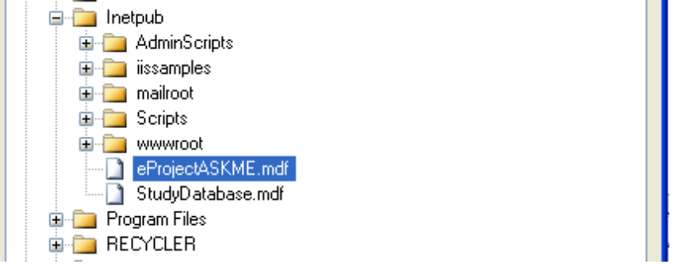

2.2 Creating the Database Source Network

- Lunch up “Control panel->Administrative tools->ODBC” and select the “System DSN” and click “add” Button.
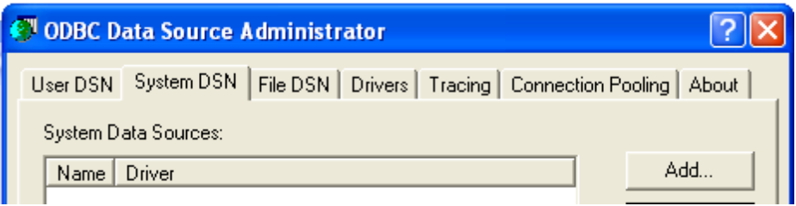
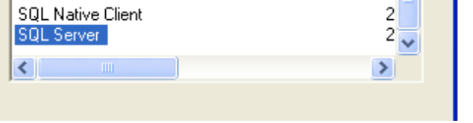
- Select “SQL Server”
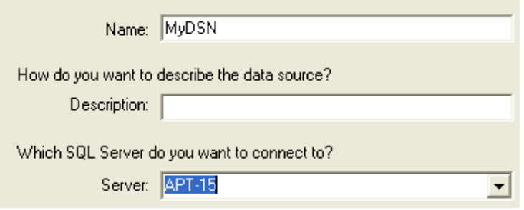
- Input “My DSN” in the “Name” and Select “Server” as your machine(This document uses APT-15)

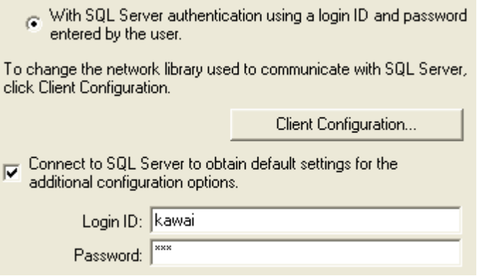
- Select “With SQL Authentification...” and input “User” and “Password”(This document uses “kawai”(user) and “123”(password)
- Select “eProjectASKME” as the default database.
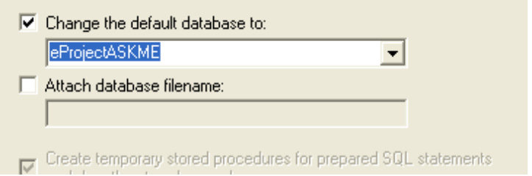

- Next step is default and click Finish.
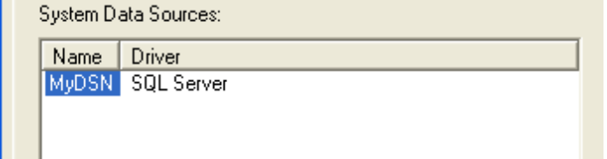

2.3 Assignment of Web files

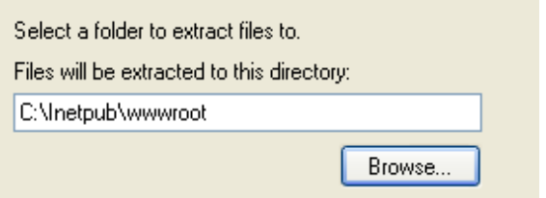
- Extract all the files from ASKME.zip into “C:\Inetpu\wwwroot”
.
- Open the “C:\Inetpu\wwwroot\ASKME\Connections\MyConn.asp” with TextEditor(eg. Notepad etc.)
- At the bottom line, Please change uid and password(eg.uid=kawai, password=123)
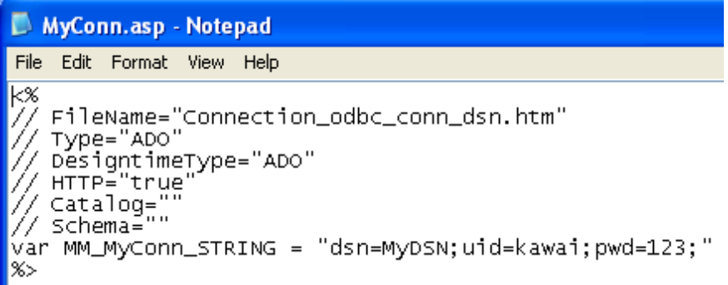

3. Using our web application’s
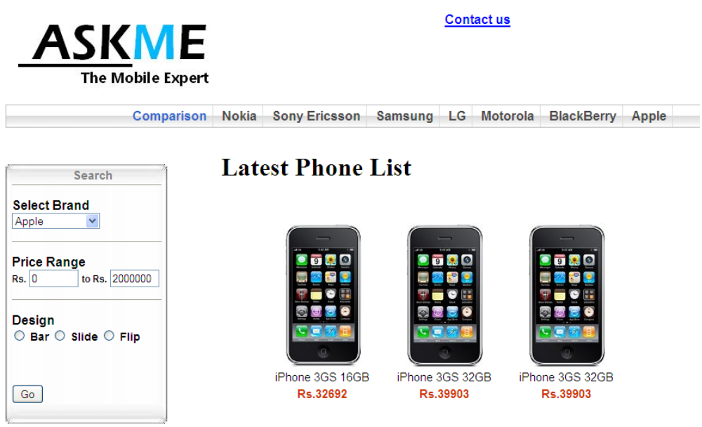
- Please access the top page(http://(server address)/ASKME/Frameset.html

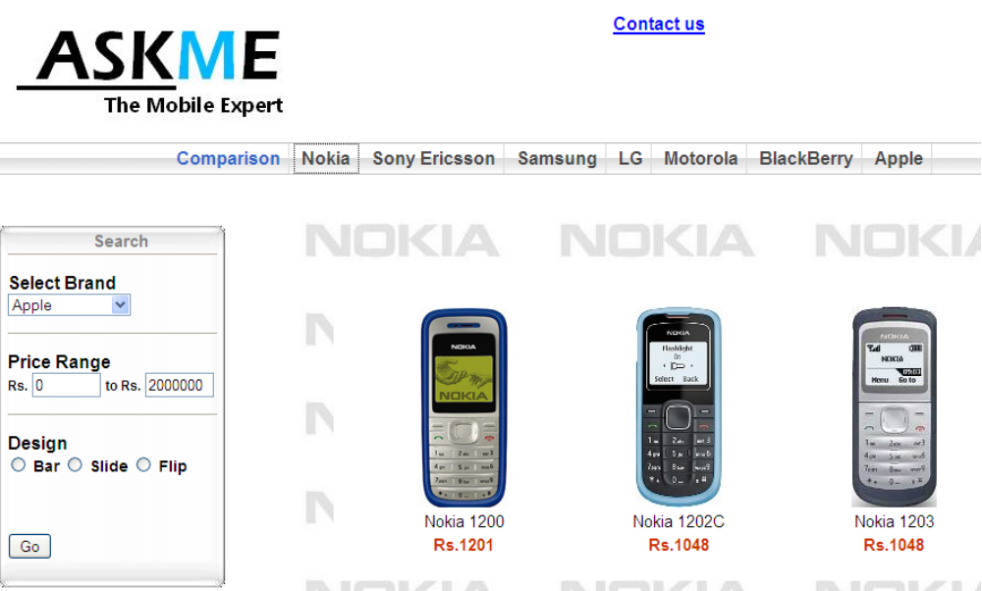
- Please click a Brand menu, if you want to check the specific phone of the brand.
- If you want to check the details, Please click the image and the model name.
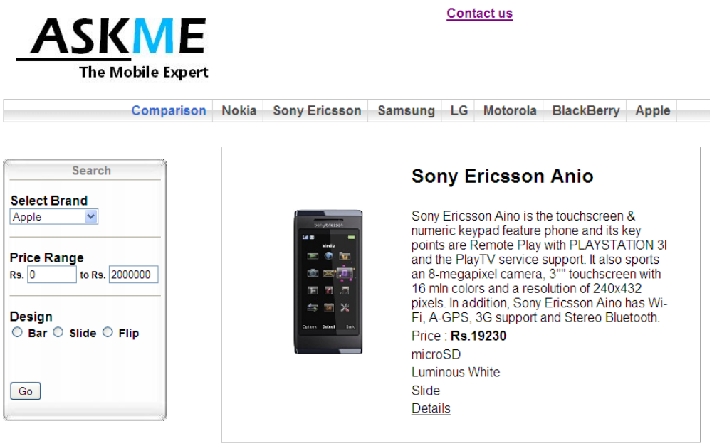
- If you need to compare 5 phones with the same brand and 2 phones with different brand. Please click “Comparison” menu.
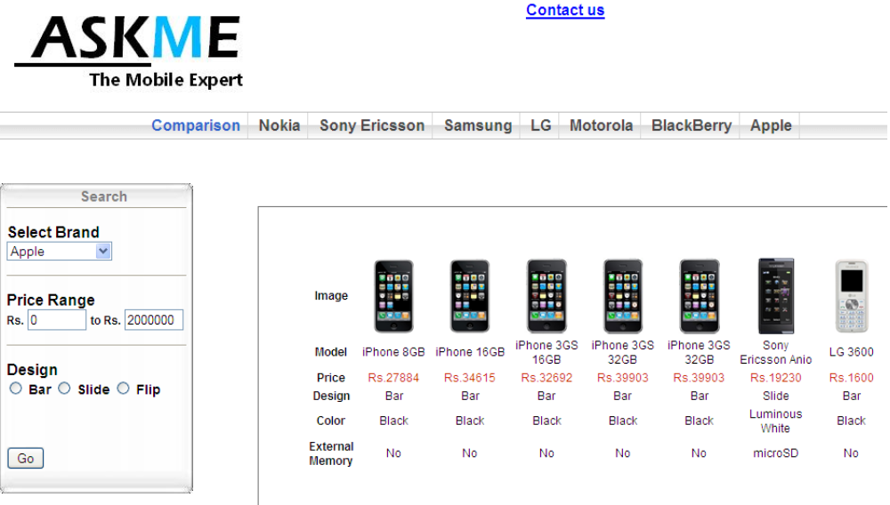
- If you have any questions, Please click “Contact Us”. This page shows the our companies information.
