SRC
Travel management
Online Booking Bus

User Guide

January 12, 2011

This is to certify that

Mr. Kawai
Ms. Sato

Has successfully Designed & Developed
TARS Delivery System online application

Submitted by: Masanori Kawai, Eri Sato

Date of Issue: 12/January/2011

Authorized Signature:______________

SRC
Travel System
Online Booking Bus

Welcome to SRC Travel System!
This system is for Online Booking Bus.
This user guide will introduce you to our service
and help you get smooth operations.

Contents

- Introduction
- Installation
- User Types
- User
- Employee
- Administrator

Introduction

SRC Travel System is an online application which enables you to manage booking easily. You can easily refer to records of orders and overcome discrepancies in your project.

Installation

Expanding the submitted zip file, the below files will appear.

Attaching the database file into SQL Server
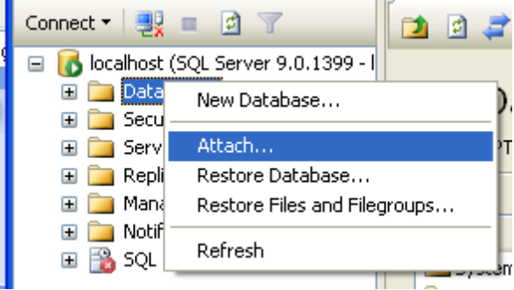
- Lunch up Microsoft SQL Server 2005 and Attach the database file.
- Please change two connectionStrings to match your database server settings under below
<add name="y510.SRC.dbo" connectionString="Data Source=Y510;Initial Catalog=SRC;User ID=kawai;pwd=123" /> <add name="SRCConnection" connectionString="Data Source=Y510;Initial Catalog=SRC;User ID=kawai;pwd=123" providerName="System.Data.SqlClient" />

User Types

TARS Delivery System has three types of users:

- User
- Employee
- Administrator

Employee

The user is limited to the following:
- Creating booking for customers
- Calculating total bus ticket fees automatically based on the parameter provided by the System Administer.
- Reference records of booking list.

Administrator

The Administrator can use all function within the software, as well as manage the following:
- Creating, editing and deleting Employee accounts
- Editing and deleting City List
- Creating , editing ,and deleting Bus List.

Employee

Logging in

Please Enter Employee Name and Password to login in SRC Travel System as Employee.

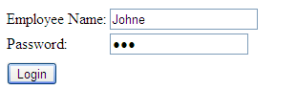
You can see the window as below.
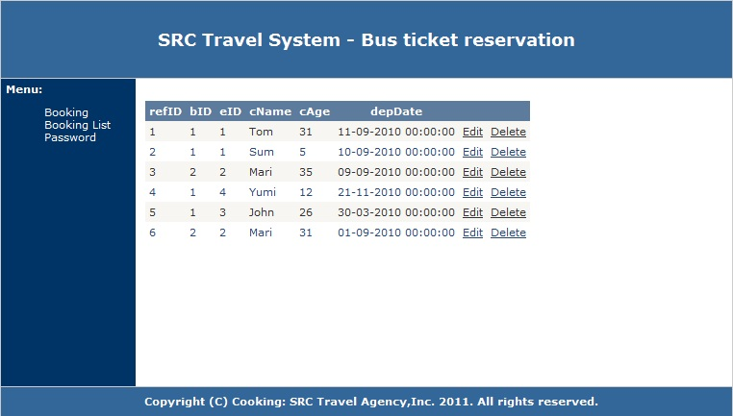

Click “Booking” link to start to create new Booking.
This screen allow you to search Buses
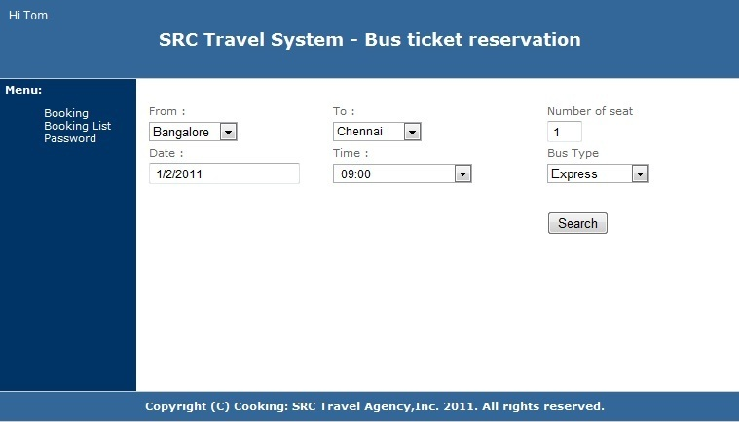

Once the search is success, you click the bus name.
Type a customer name and the person’s name.
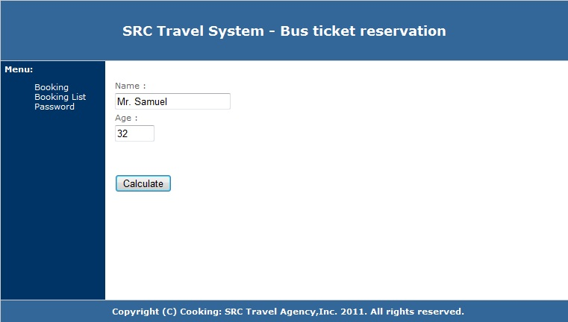

Click “calculation” button to get the amount of total fees.
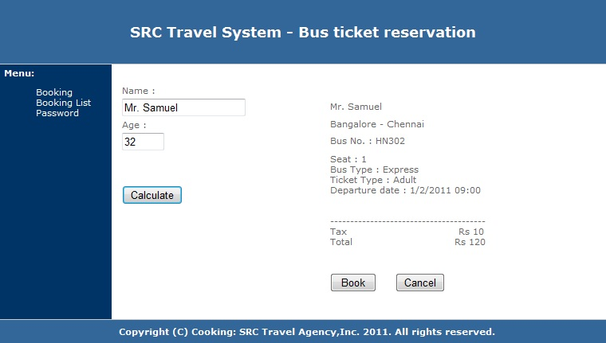

If you want to book it, Click “Book” Button.

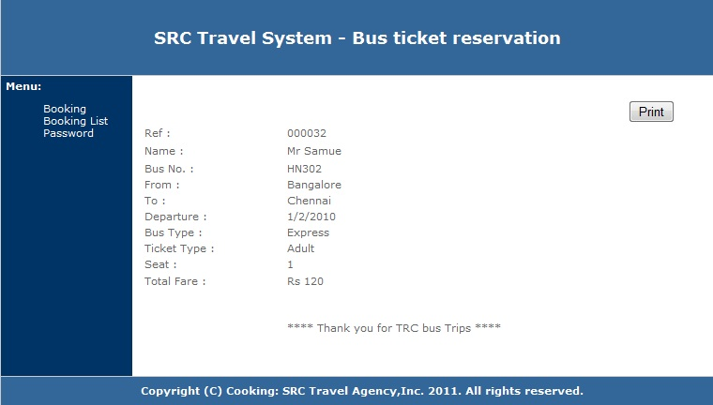
If you need to print out the booking information, Please click “Print” Button.

Employee can change their own password.
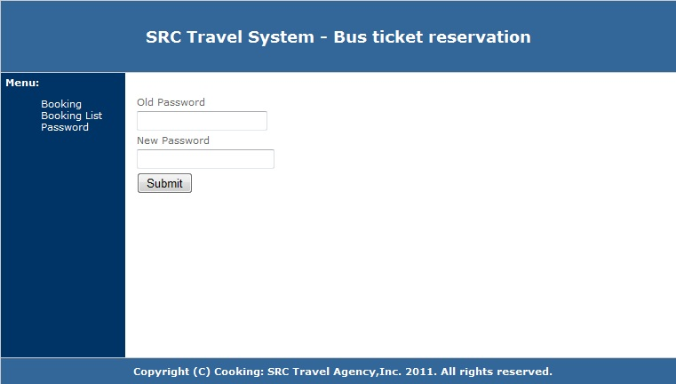

Administrator

Logging in

To login to SRC Travel System as Employee, select Employee on the left side window. Now you can see the login window on the right side. Enter Administrator (admin) and Password (123).
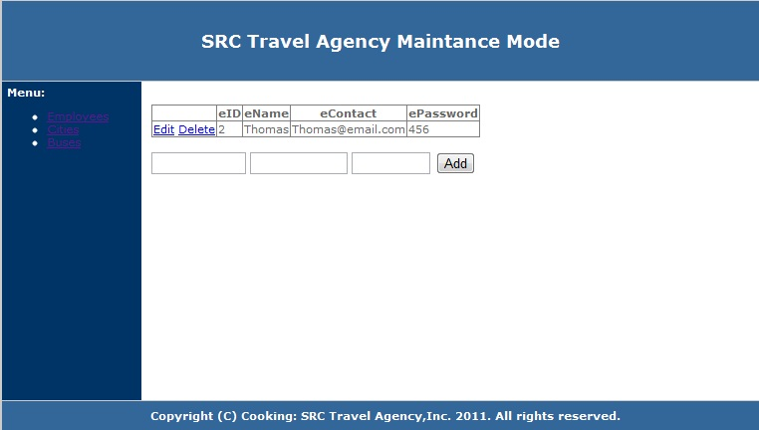
Employee List

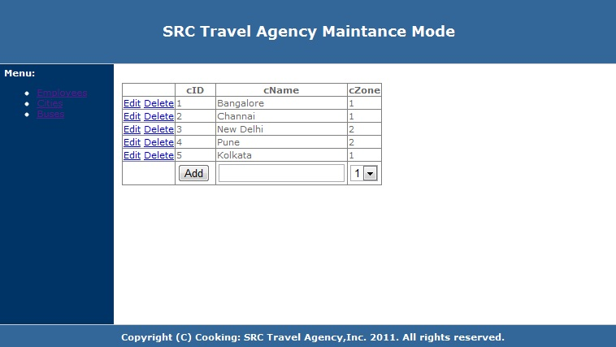
City List

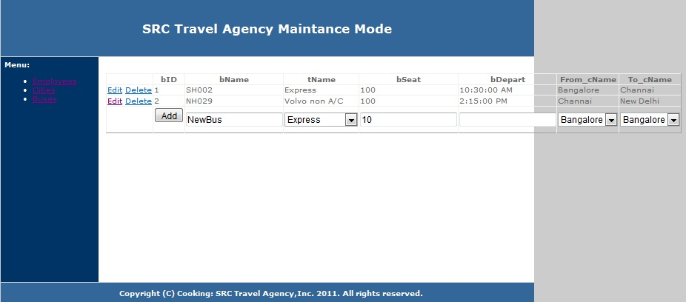
Bus List

