CVS Health | Information Security
Server Internet Egress: Proxy vs Firewall
Executive summary — based on server and Citrix traffic
September 2026 – Network Security Engineering

Key finding
Half of server internet traffic (50%) leaves directly through the firewalls; about a third (34%) goes through a proxy. Aetna sends the most through proxies (41%, mostly Zscaler). CVS (60%) and Retail (68%) mostly go direct.
Figures are based on server and Citrix traffic only (Tanium, 15 days, 27,979 servers). End-user desktop and retail store traffic is not included.

Proxy vs firewall by segment
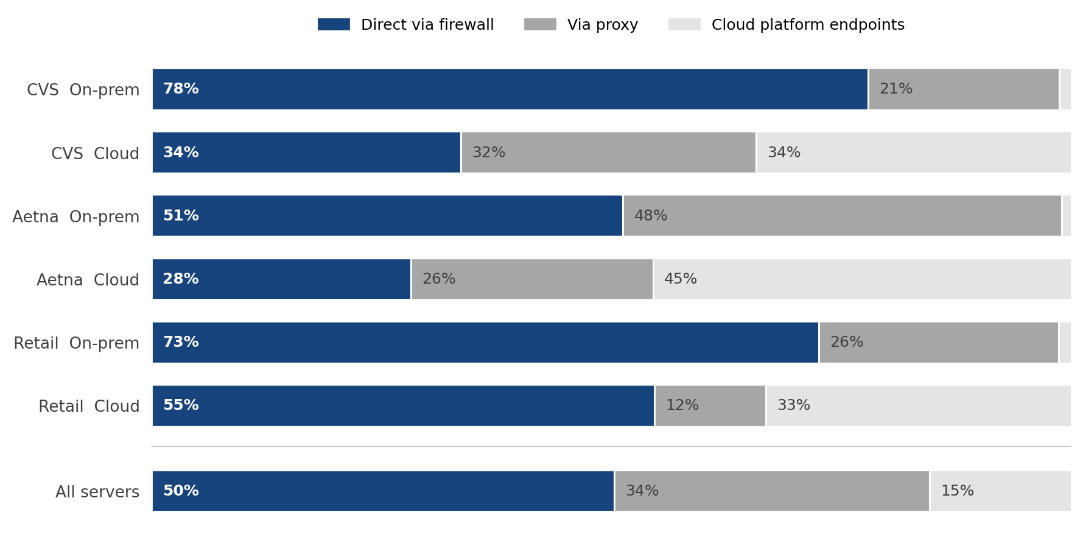
Share of internet connections from server and Citrix hosts. Cloud platform endpoints = Azure service endpoints reached through Azure, not the enterprise proxies or firewalls.

What it means
- CVS and Retail direct traffic is overstated. On-prem CVS web traffic is redirected to the Skyhigh proxies by the firewall (WCCP), so part of the 78% (CVS) and 73% (Retail) on-prem direct share is actually proxied.
- Aetna direct traffic is real firewall egress. It is traffic that bypasses the Aetna PAC proxies; Aetna's proxied traffic is mostly Zscaler.
- Cloud servers use the cloud platform itself. 34–46% of cloud-hosted traffic goes to Azure service endpoints, outside the enterprise proxies and firewalls.
- Retail means retail-owned applications. 903 servers whose application belongs only to Retail Front Store, Retail Pharmacy or IT Retail — not store traffic.

Scope
Segment | Servers | Internet connections | Direct via firewall | Via proxy | Cloud platform
CVS | 11,753 | 12.5M | 60% | 25% | 15%
Aetna | 9,888 | 13.7M | 44% | 41% | 16%
Retail | 903 | 0.8M | 68% | 22% | 10%
CVS/Aetna shared address space | 3,424 | 2.1M | 52% | 43% | 5%
Not yet in IPAM | 2,011 | 1.3M | 11% | 48% | 41%
Total | 27,979 | 30.4M | 50% | 34% | 15%

Scope: server and Citrix hosts only (Tanium agent traffic), 15-day export, counted in connections, not bytes. Internal destinations and CVS NAT addresses are excluded. User desktop, VPN and retail store traffic are not included.
Prepared by: Network Security Engineering | Data source: Tanium traffic (server_internet_egress_report_v20260928) | September 2026

