PCI Traffic Processing — Current State Assessment
Companion to: PCI Cardholder Data Environment — Operational Security Model (Draft v1)
CVS Health — Network Security Engineering | September 2026

1. Purpose and Method
This assessment documents what is actually configured today across the PCI-relevant enforcement points at Shea, Vegas, Middletown/Windsor, and Rhode Island (Woonsocket/Cumberland), based on direct inspection of Panorama-managed device-group rules and individual firewall running-configs (Panorama exports and Palo Alto device exports, both dated 8/31/2026). Findings below are sourced from the actual configuration files, not inferred from documentation or prior audit narrative — where a claim could not be directly verified in the configs reviewed, it is marked as such rather than assumed.

2. Confirmed Traffic Flow — Shea
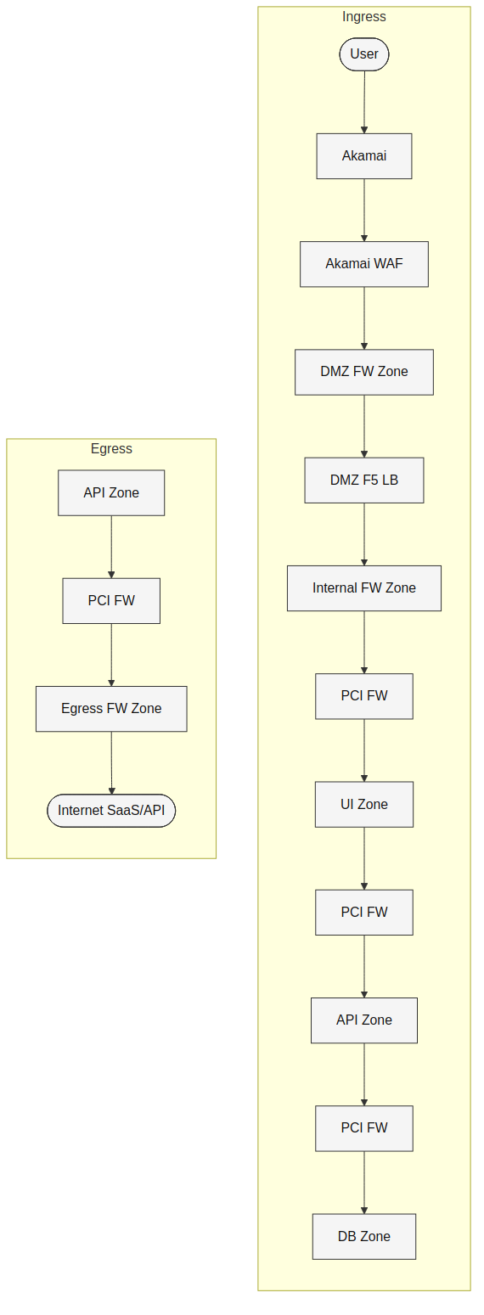
Verified against PAZSHDC-SEC-PAN-PROD-01 (Panorama, Shea device group) and PAZSHDC-SEC-EXXT-NET-PA-01 (the physical device). Confirmed zones on the physical device: Outside (ae1/16, internet-facing), Inside (ae1/15), DMZ-PDE (ae1/18), Semafone_DMZ (ae1/19.3264 — dedicated PCI-scope-reduction zone for call-center DTMF masking).
The local rulebase on this device is empty — all security policy is Panorama-managed. Confirmed rules crossing DMZ-PDE: inbound_61 (Outside→any, Bladelogic-Servers→PCI-Servers), DMZ-PDE_access_in_1608/1609 (DMZ-PDE→any, PCI_1A_Servers→Symantec_VIP_Gateways/2FA_Gateway_Servers). Confirmed egress rules (DMZ-PDE→Outside): 4 explicit host/application-scoped rules; one destination range (23.192.0.0/11, 2.16.0.0/13, 23.0.0.0/12, 23.32.0.0/11, 95.100.0.0/15, 184.24.0.0/13) matches Akamai's published IP ranges, directly confirming this is the Akamai connectivity path.

2.1 Enforcement finding
Every PCI-adjacent rule found on this device — ingress and egress — is bound to the profile-setting group Alert-All-SPG. Direct inspection of this group's component profiles confirms:
Component profile | Confirmed action
Alert-All-Vuln (vulnerability protection) | alert — all severities (critical/high/medium/low/informational), all CVEs, all hosts
Alert-All-AS (anti-spyware) | alert — all severities, including botnet-domain detection specifically
Vulnerability_Best_Practice_SP (used elsewhere on this device, e.g. SPG-PPOM-All) | alert on every rule, including Server_Critical / Server_High / Client_Critical / Client_High — despite the "Best Practice" name
This is a confirmed finding from the configuration itself, not a repeated assumption from prior audit narrative. Whether this reflects a documented, time-bound tuning window or a permanent unmanaged state was not determinable from this point-in-time config export and requires confirmation from the device/policy owner.

3. Site Firewall Topologies
The logical ingress/egress model is implemented differently at each site. None of the device sets reviewed contain a zone literally named "PCI," "UI," "API," or "DB" — tier segmentation, where present, is enforced via address-object groups within existing zones (e.g., PCI-Servers, PCI_1A_Servers inside the DMZ-PDE zone at Shea) rather than dedicated zone names.
At-a-glance summary (detail for each site follows in 3.1–3.3):
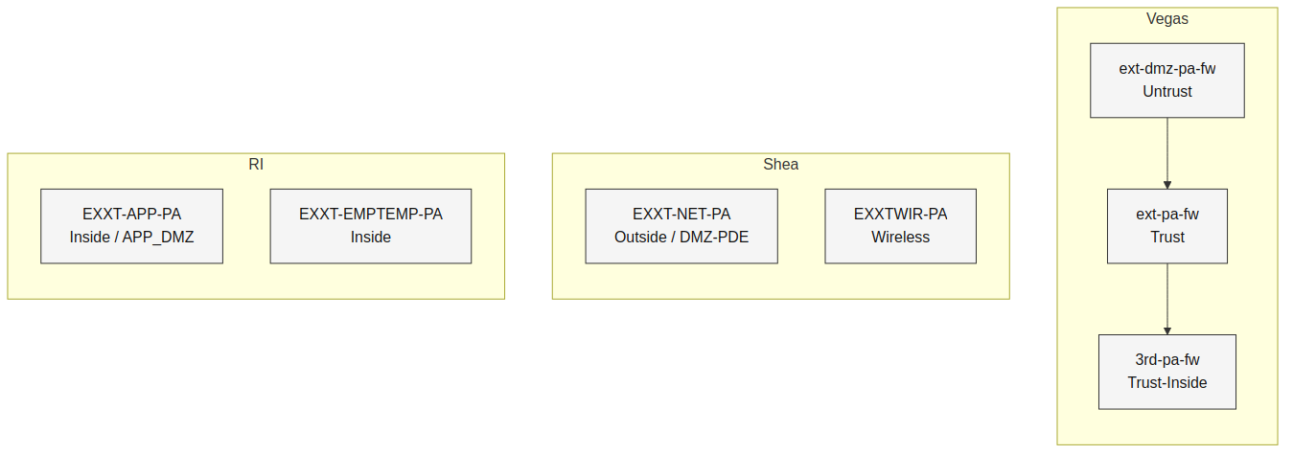

3.1 Vegas
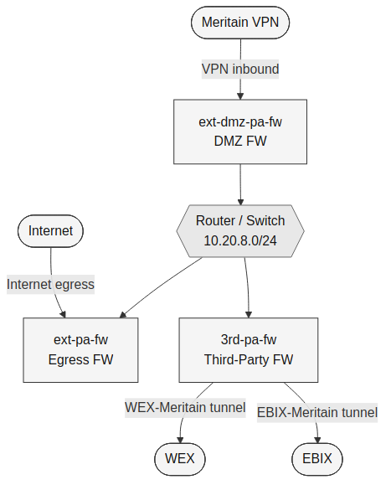
Three distinct devices, not a combined pair: ext-dmz-pa-fw (Untrust, 152.145.172.0/24) → router/switch interconnect (10.20.8.0/24, each device on its own /29) → ext-pa-fw (its own separate Untrust at 152.145.168.0/24 plus Trust) → 3rd-pa-fw (Trust-Inside, plus dedicated per-partner tunnel zones).
Third-party connectivity is centralized here: 3rd-pa-fw hosts named tunnel zones WEX-Meritain and EBIX-Meritain. Both are confirmed crypto-map-equivalent, not generic route-based VPN — each tunnel's IPsec configuration specifies explicit proxy-ID pairs (WEX: local 152.145.182.10/32 ↔ remote 208.64.199.216/29; EBIX: local 152.145.182.11/32 ↔ remote 10.7.12.0/26 and 10.7.8.0/24) rather than relying on dynamic routing over the tunnel interface. Traffic selection is scoped to these exact pairs regardless of the underlying PAN-OS tunnel-interface implementation.

3.2 Middletown and Windsor
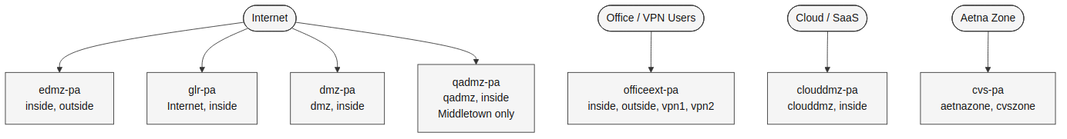
Identical device-for-device structure at both sites: dmz-pa, edmz-pa, cvs-pa, officeext-pa, clouddmz-pa, glr-pa (Middletown adds qadmz-pa). Notably, cvs-pa has zones aetnazone and cvszone — a dedicated, confirmed CVS/Aetna boundary firewall at each site, directly relevant to the CVS/Aetna IP-collision problem documented elsewhere (see cisco-sna-deployment).
No third-party (3rd-pa equivalent) device found at either site. officeext-pa's vpn1/vpn2 zones are on physical Ethernet interfaces, not tunnel interfaces, and use generic (not partner-named) labels — structurally different from Vegas's named per-partner tunnel model. This is consistent with, but does not by itself prove, third-party traffic being centralized through the Vegas hub rather than terminated locally; confirming what actually traverses vpn1/vpn2 would require the Panorama-side rules for this device, which were not reviewed.

3.3 Rhode Island (Woonsocket / Cumberland)
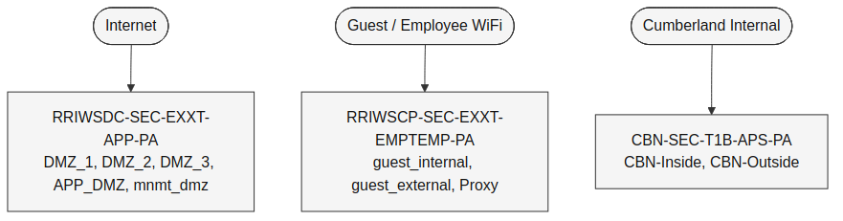
Three device roles: RRIWSDC-SEC-EXXT-APP-PA (DMZ_1/DMZ_2/DMZ_3, APP_DMZ, mnmt_dmz — the richest DMZ segmentation of any site reviewed), RRIWSCP-SEC-EXXT-EMPTEMP-PA (guest_internal, guest_external, and a self-hosted Proxy zone on a loopback interface), and CBN-SEC-T1B-APS-PA (Cumberland-specific, with its own CBN-Inside/CBN-Outside pair and TACACS+/ISE authentication-profile integration). No third-party device found here either.

4. Summary of Confirmed Gaps Against the Target Model
Target model requirement | Current state (confirmed) | Status
Egress FW threat-prevention profile enforces (block/sinkhole) on the PCI-to-intermediary channel | Alert-All-SPG confirmed alert-only on all Shea PCI-adjacent rules, ingress and egress, including the verified Akamai-destination rule | Gap
PCI FW enforces explicit UI/API/DB tier boundaries | No UI/API/DB zone found in any reviewed device; tiering (if implemented) is not visible as zone-level segmentation in this device set | Unconfirmed
DMZ FW / Internal FW perform admission control only (no inspection expected) | Confirmed at Shea, Vegas, Middletown/Windsor, RI — consistent with target model | Meets model
Third-party connectivity centralized at Vegas, proxy-ID/crypto-map scoped | Confirmed at Vegas (WEX-Meritain, EBIX-Meritain); absent elsewhere as expected | Meets model
DNS egress restriction for PCI workloads | Not reviewed in this assessment | Unconfirmed

5. Recommended Next Steps
- Confirm with the Alert-All-SPG policy owner whether the alert-only state on Shea's PCI-adjacent rules reflects a documented, time-bound tuning window or an unmanaged permanent state; if the latter, remediate to enforcing action on critical/high vulnerability severity and botnet-domain detection at minimum.
- Confirm the PCI transaction model (browser-redirect vs. server-side pass-through) before authorizing SSL decrypt on any PCI egress rule, per the Operational Model Section 4.
- Locate and verify the actual PCI FW device(s) enforcing UI/API/DB tier segmentation — not identified by zone name in this device set.
- Confirm what traffic actually traverses officeext-pa's vpn1/vpn2 zones at Middletown/Windsor to validate the no-local-third-party-traffic assumption.
- Repeat this same rule/profile-enforcement verification at Vegas, Middletown/Windsor, and RI's PCI-adjacent devices — this assessment's enforcement finding (Section 2.1) is confirmed only for Shea.

