NodeVault: A Peer-to-Peer Decentralized Community-Based Network for Encrypted and Distributed Data Storage
1. Project Overview
NodeVault is a peer-to-peer decentralized storage network where users with extra storage on their mobile devices can participate by storing encrypted and fragmented data from other users. The goal is to create a secure, resilient, and fault-tolerant network where data is distributed across multiple nodes, ensuring high redundancy and protection against data loss.
Core Objectives
- Secure and encrypted data storage
- Data fragmentation and distribution across multiple nodes
- High redundancy to prevent data loss
- Automatic redistribution when nodes leave the network
- Peer-to-peer architecture with direct communication
- Zero-knowledge encryption to ensure data privacy

2. Requirement Analysis
2.1. Functional Requirements
- User Registration and Authentication
  - Users can register and authenticate using email.
  - Secure login with 2FA support.
- Storage Contribution
  - Users can allocate storage to the network.
  - Option to modify allocated storage dynamically.
- Data Upload and Retrieval
  - Data is encrypted, fragmented, and distributed.
  - Efficient data retrieval from multiple nodes.
- Redundancy and Auto-Recovery
  - Data stored in multiple nodes (~10 devices).
  - If a node is lost, data is automatically redistributed.
- Data Integrity and Verification
  - Regular integrity checks using cryptographic hashing.
  - Proof of Storage and Proof of Replication.
- Privacy and Security
  - Zero-knowledge encryption ensures data privacy.
  - No node can decrypt the stored data.
- Peer-to-Peer Communication
  - Nodes discover each other and exchange data.
  - Secure, encrypted data transmission.
2.2. Non-Functional Requirements
- Performance: Fast upload/download speed.
- Scalability: Support for thousands of nodes.
- Fault Tolerance: Resilient to node failures.
- Security: End-to-end encryption, secure key exchange.
- Battery Efficiency: Optimized for mobile battery usage.

3. Technical Architecture
3.1. High-Level Layers
Layer | Purpose | Tech Stack
Frontend Layer | User interface for upload, retrieval, and account settings | React (Next.js), TypeScript
Backend Layer | Handles authentication, data routing, and monitoring | Node.js, Express.js
Storage Layer | Handles fragmentation, encryption, and redundancy | libp2p, SQLite (for metadata)
Communication Layer | Peer-to-peer communication and data exchange | libp2p, WebRTC
Security Layer | Encryption, key exchange, and integrity checks | AES-256, ECC, SHA-256

3.2. Detailed Tech Stack
Frontend
- React (Next.js) – UI framework
- Tailwind CSS – Styling
- TypeScript – Strong typing
Backend
- Node.js – Server runtime
- Express.js – API framework
- gRPC – Structured data exchange
Storage and Encryption
- libp2p – P2P networking
- SQLite – Metadata storage
- AES-256 – Symmetric encryption
- ChaCha20 – Fast encryption on mobile
- SHA-256 – Integrity checks
Key Exchange and Authentication
- Elliptic Curve Cryptography (ECC) – Secure key exchange
- Diffie-Hellman – Key generation
Networking and Communication
- WebRTC – Real-time peer communication
- libp2p – Peer discovery and data exchange

4. Flow Diagram
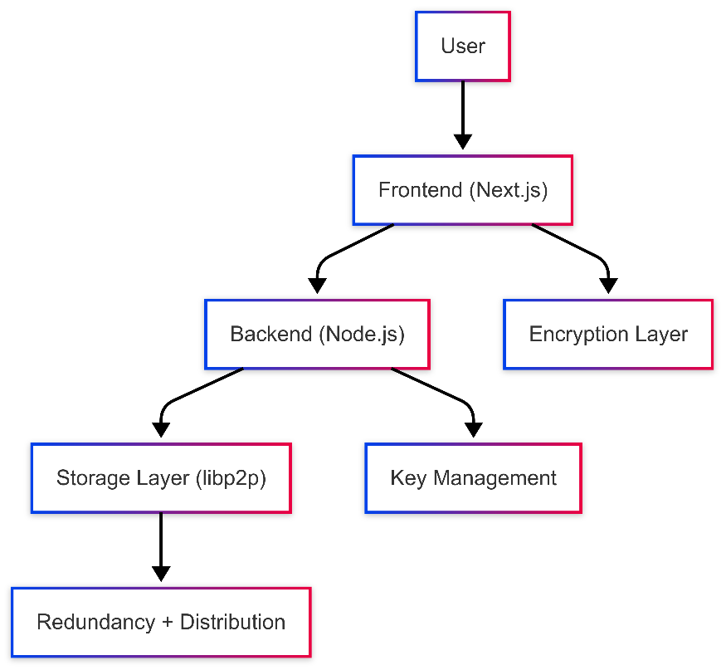

5. System Flow
5.1. Data Upload
- User uploads file.
- File is encrypted using AES-256.
- Encrypted data is fragmented into shards.
- Fragments are distributed to available nodes using libp2p.
- Metadata (hashes) are stored in SQLite.
5.2. Data Retrieval
- User requests file.
- Metadata is retrieved from SQLite.
- Nodes holding fragments are discovered using libp2p.
- Fragments are fetched and reassembled.
- File is decrypted using AES-256.
5.3. Node Loss and Redistribution
- Regular integrity checks.
- If a node drops out, libp2p signals loss.
- Data is redistributed to other nodes.

6. Challenges and Solutions
Challenge | Solution
Node Failure | Redundancy across 10+ nodes + auto-redistribution
Encryption Overhead | Use ChaCha20 for fast mobile encryption
Data Integrity | SHA-256 and Merkle Tree for integrity checks
High Latency | Optimize libp2p routing + direct WebRTC connection
Battery Drain | Optimize sync frequency and reduce active connections

7. Next Steps
- Build libp2p-based communication layer.
- Implement AES-256 encryption and fragmentation.
- Create Node.js backend for data routing and verification.
- Develop Next.js frontend for data upload and retrieval.
- Test network stability and redundancy.

✅ Goal
To create a decentralized, secure, and scalable data storage network where data is fragmented, encrypted, and stored across a resilient community-based system.

