PRIKAZ NASLOVA I CSS GDJE JE DEFINIRAN FONT
<h1 data-v-04b753c2="" data-v-1665e7ec="" class="h1 dark" style="text-align: center;">MARQ® LUXURY SMARTWATCHES</h1>

.h1[data-v-04b753c2] {
font-family: Superscripts-Oswald, Oswald, Roboto Condensed, Roboto, Noto Sans TC, Noto Sans SC, Noto Sans JP, Noto Sans KR, Prompt, sans-serif;
font-weight: 400;
letter-spacing: .05rem;
line-height: 1.25;
font-size: 2rem;
margin: 1rem 0;
}
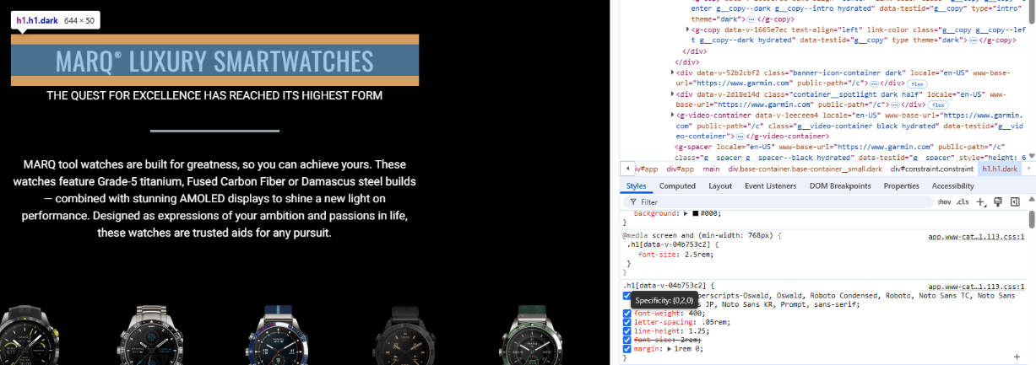

PRIKAZ GUMBA I CSS GDJE JE DEFINIRANA BOJA
<g-button data-v-13b75077="" id="js__cta__buy" data-testid="add-to-cart-button" class="app__product__cta__button g__button__host g__button__host--large hydrated" theme="candy-blue" size="large"><!----><a class="g__button g__button--contained g__button--contained--large g__button--contained--candy-blue" href="https://buy.garmin.com/en-US/cart/addToCart?partNumQty=010-03393-30:1">Add To Cart</a></g-button>
.g__button--contained--candy-blue {
color: #000;
background: #6dcff6;
border-color: #6dcff6;
}

