Contents

[Easy PlayFab Integration 2](#_Toc514160856)

[Setting the Package up 2](#_Toc514160857)

[PlayFab Setup Instructions 2](#_Toc514160858)

[Put PlayFab ID to the script 6](#_Toc514160859)

[FB Setup Instructions 6](#_Toc514160860)

[Brief Description 7](#_Toc514160861)

[Deprecated Features: 8](#_Toc514160862)

[Run Demo 8](#_Toc514160863)

[Script Reference 9](#_Toc514160864)

[Namespace 9](#_Toc514160865)

[Classes Overview 9](#_Toc514160866)

[EasyPlayFabIntegration: 9](#_Toc514160867)

[UILeaderboardItem: 10](#_Toc514160868)

[Support information 10](#_Toc514160869)

# Easy PlayFab Integration

Thanks allot for purchasing this asset. You can contact at info.curioassets@gmail.com in order to get any help regrading this asset. Also please include your Invoice number in your email subject for fast response.

# Setting the Package up

* Please download and import latest version of Official Facebook SDK for Unity3D

<https://developers.facebook.com/docs/unity>

* Download PlayFab SDK from: <https://api.playfab.com/sdks/unity>
* Create your Facebook App on developer portal [https://developers.facebook.com](https://developers.facebook.com/)  mark it as game.

# PlayFab Setup Instructions

Create a New PlayFab account or login with existing one at <https://developer.playfab.com/>

Create a new studio if you don’t have one already

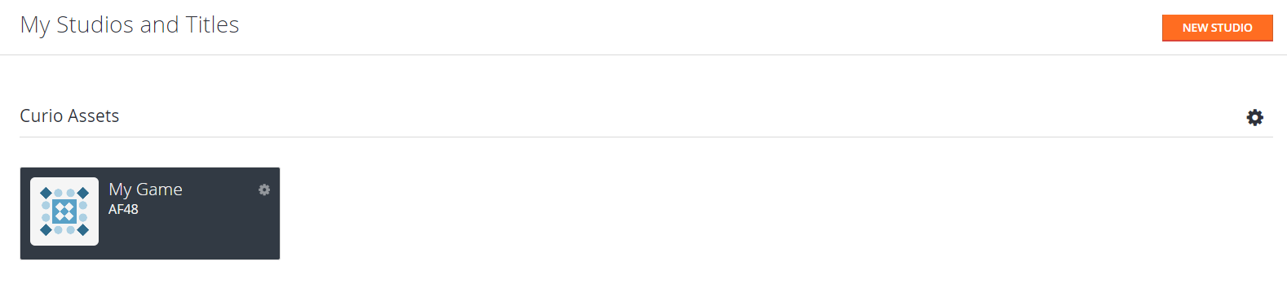

Create a new game by clicking on “New title”

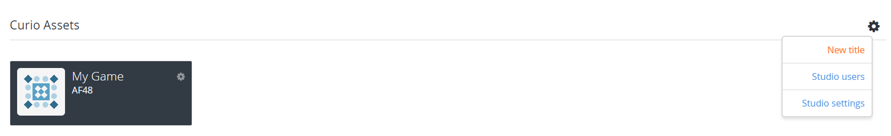

Fill all the information and then hit “CREATE TITLE”

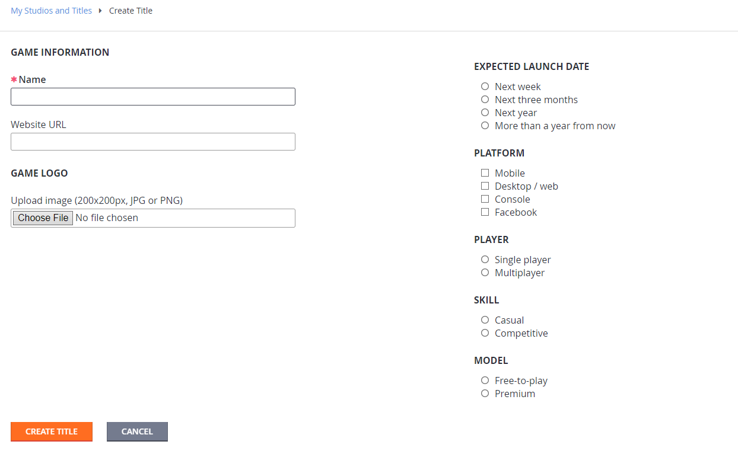

\_\_\_\_\_\_\_\_\_\_\_\_\_\_\_\_\_\_\_\_\_\_\_\_\_\_\_\_\_\_\_\_\_\_\_\_\_\_\_\_\_\_\_\_\_\_\_\_\_\_\_\_\_\_\_\_\_\_\_\_\_\_\_\_\_\_\_\_\_\_\_\_\_\_\_\_\_\_\_\_

\_\_\_\_\_\_\_\_\_\_\_\_\_\_\_\_\_\_\_\_\_\_\_\_\_\_\_\_\_\_\_\_\_\_\_\_\_\_\_\_\_\_\_\_\_\_\_\_\_\_\_\_\_\_\_\_\_\_\_\_\_\_\_\_\_\_\_\_\_\_\_\_\_\_\_\_\_\_\_\_

A dashboard will be open with all statistics and settings

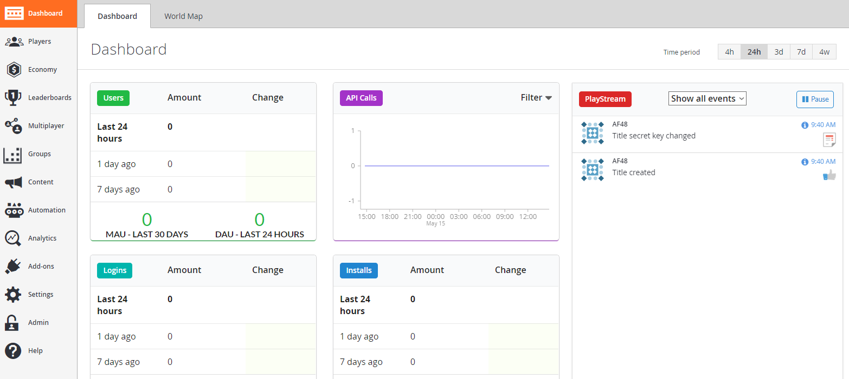

Now create a new leaderboard with name mentioned in the EasyPlayFabManager.cs file or replace with your given name to the same file.



Fill in details of your new leaderboard

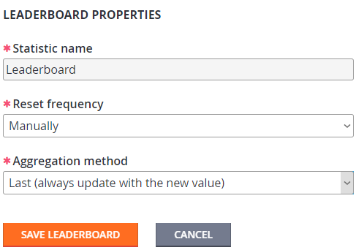

* Click settings and “Allow non-unique player display names”

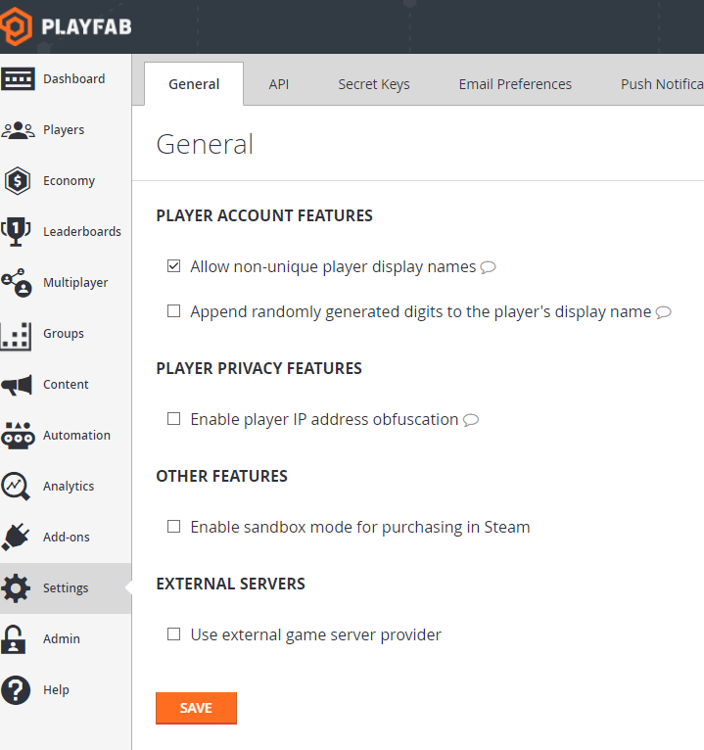

Now Click API and check “Allow client to post player statistics” and scroll down to save the settings.

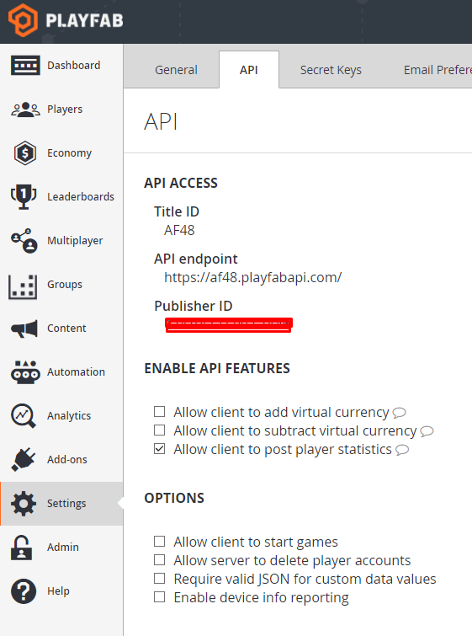

Now click “[Client Profile Options](https://developer.playfab.com/en-us/AF48/settings/profile-view-constraints)” and check display name and avatar URL. Don’t forget to hit save button



## Put PlayFab ID to the script

* If you want to manually set your PlayFab GameID this is the right time to do. Go to the PlayFabIntegrationManager.cs script by replacing the current PLAYFAB\_GAMEID Constant.

C:\Users\GS\AppData\Local\Microsoft\Windows\INetCache\Content.Word\Screenshot_4.png

* Other Wise you can download PlayFab Editor extension to setup your ID.

You can view ever more details here: <https://api.playfab.com/docs/getting-started/unity-getting-started>

# FB Setup Instructions

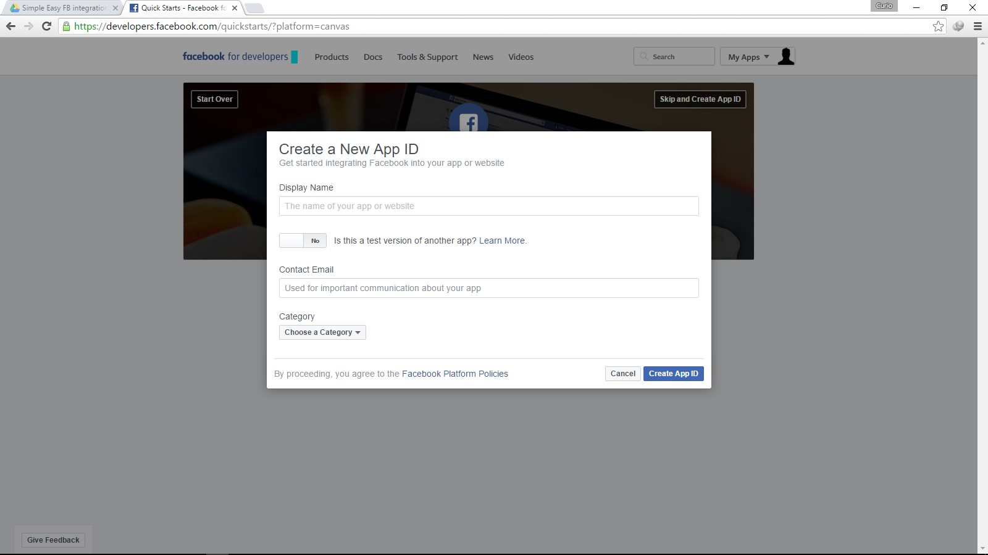

From the Facebook menu bar in the Unity Editor select Edit Settings and Fill in the details of AppName and AppId from the Facebook Developer Console.

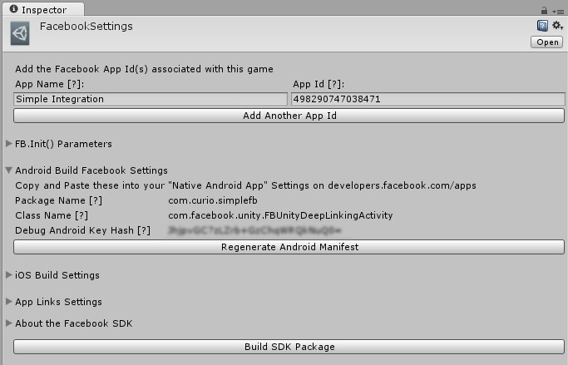

No more customized UI for inviting friends is available, So you won’t need to add support for Canvas platform.

If you are running Unity on macOS (Previously OSX) then you don’t need to perform any special steps.

If you are Using Microsoft Windows as your Operating System then you will need to install OpenSSL and put its path in Environmental Variables (Ideally system). Your Java and Android SDK should also be present in the path. This step is only required for google android platform.

If you have configured everything correctly then you can copy Package name, class name and Debug Android Key hash from Unity editor and paste it in the Android settings of your Facebook developer dashboard.

# Brief Description

Facebook integration is the most popular social integration for games and apps now a days. Every game developer wants to add Fb Social features to expand game download and play as well as interactivity.

Facebook has enormous social interaction features. Curio Asset’s Facebook plugin makes it simple and easy for you to integrate social features in your game. This asset created a customized UI for leaderboard.

### Deprecated Features:

This asset is with custom Invite dialogs like in Candy Crush or other King Games.

The invite button takes the chosen users and then send them invite through native

Facebook dialog. If you have enabled Friction less Request you’ll see the native Facebook dialogues only once. As mentioned earlier the invite\_able friends feature needs canvas implementation of your game. Also leaderboard is game only feature so don’t forget that your Facebook App should be categorized as game. Our Asset uses publish\_actions and user friends’ permissions for leaderboard and invite feature to work.

This package uses the Latest Unity UI features and hence is fully customizable. You can create a UI that totally matches with the UI of your game. The package is fully supported on iOS, Android and WebGL games made in Unity.

The namespace is named as CurioAssets to avoid name mangling issues with your existing code.

Support and frequent updates for every new version of Facebook SDK is ensured so you’ll always be able to use the latest Facebook SDK features.

# Run Demo

For running demo, Open Example Directory located in EasyPlayFabIntegration and select the Scene named “Demo”, Hit play and test the package features. In Editor Upon starting or hitting Login button asks for Facebook User Access Token, you can

follow the link to get it and then paste in the field shown.

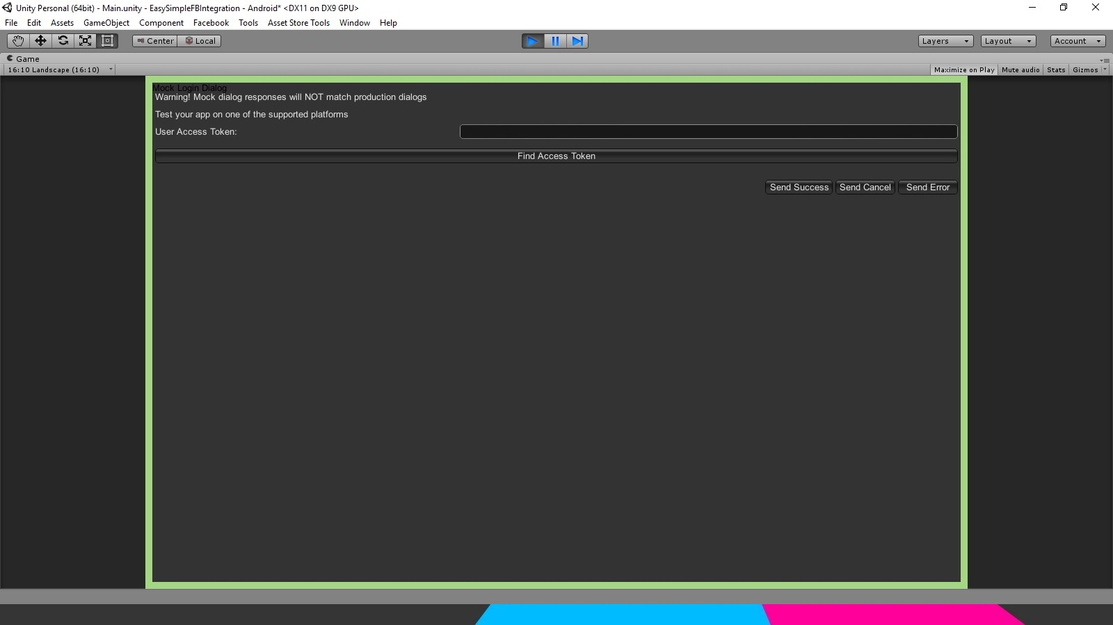

For Testing on android, iOS device you’ll need to add this main scene in the build settings of your Unity project. Facebook SDK for Unity 5 i.e Version 7 and above requires Android API Layer 15 (Code Name Ice Cream Sandwich 4.0.3). iOS 7 is also Still Supported.

# Script Reference

## Namespace

Name of the namespace is CurioAssets

## Classes Overview

EasyPlayFabIntegration: This is the main master script. It is responsible for loading leaderboard, invite data. Also through this script you can post score to test how it’s working.

Moreover this script also helps you in sharing your score progress or anything to the Facebook by showing default Facebook Dialog. This class is a singleton class so you can easily call it from anywhere in your project. You just need to call

EasyPlayFabIntegration.Instance and any method will be accessible for your use. The use is simplest and easiest.

Deprecated Features: For now, I am creating upto 250 Facebook friends to invite. This is particularly useful if you want more friends. As In Facebook There are maximum of 5000 friends for a user so you can easily show up to 5000 friends. As the package comes will full source code, you can avoid deleting and instantiation gameObjects and can simply show and hide. There are various methods like

PostScore(), ShareStory(), Load and Refresh Leaderboard and Invite Dialogues.

Also There are fields for demo scenes like showing and hiding buttons and UI depending on the Facebook login and logout status.

UILeaderboardItem: This class stores and shows values of Facebook Leaderboard data and loads them into the UI. It has fields like Name, Score and Picture fields, which gets filled when the data is parsed back from the returned JSON response of Facebook.

# Support information

I have tried to add as many comments and information as I can. If you still find something ambiguous or want more elaboration in terms of code, logic or functionality then you are always welcome to contact me. Also we do create all of these assets by investing allot of time and effort. If you like this asset, I would request to kindly take a minute and leave a review on the asset store page at <http://u3d.as/vTR>

Facebook Page: [fb.com/curioasset](https://www.facebook.com/CurioAssets)

Twitter: twitter.com/curiologix  
Support Email: info.curioassets@gmail.com