Five most common UA destination airports

The top 5 destinations from NYC on United Airlines are Chicago-O’Hare (ORD), Houston-Bush (IAH), San Francisco (SFO), Los Angeles (LAX), and Denver (DEN).

Airport | ORD | IAH | SFO | LAX | DEN
Flights | 6984 | 6924 | 6819 | 5823 | 3796

Interestingly, Denver holds the fifth-highest position, but, the number of flights from position 4 (LAX) to Denver drops at a more significant margin than what was observed from positions 1-4.

Average gain per airport
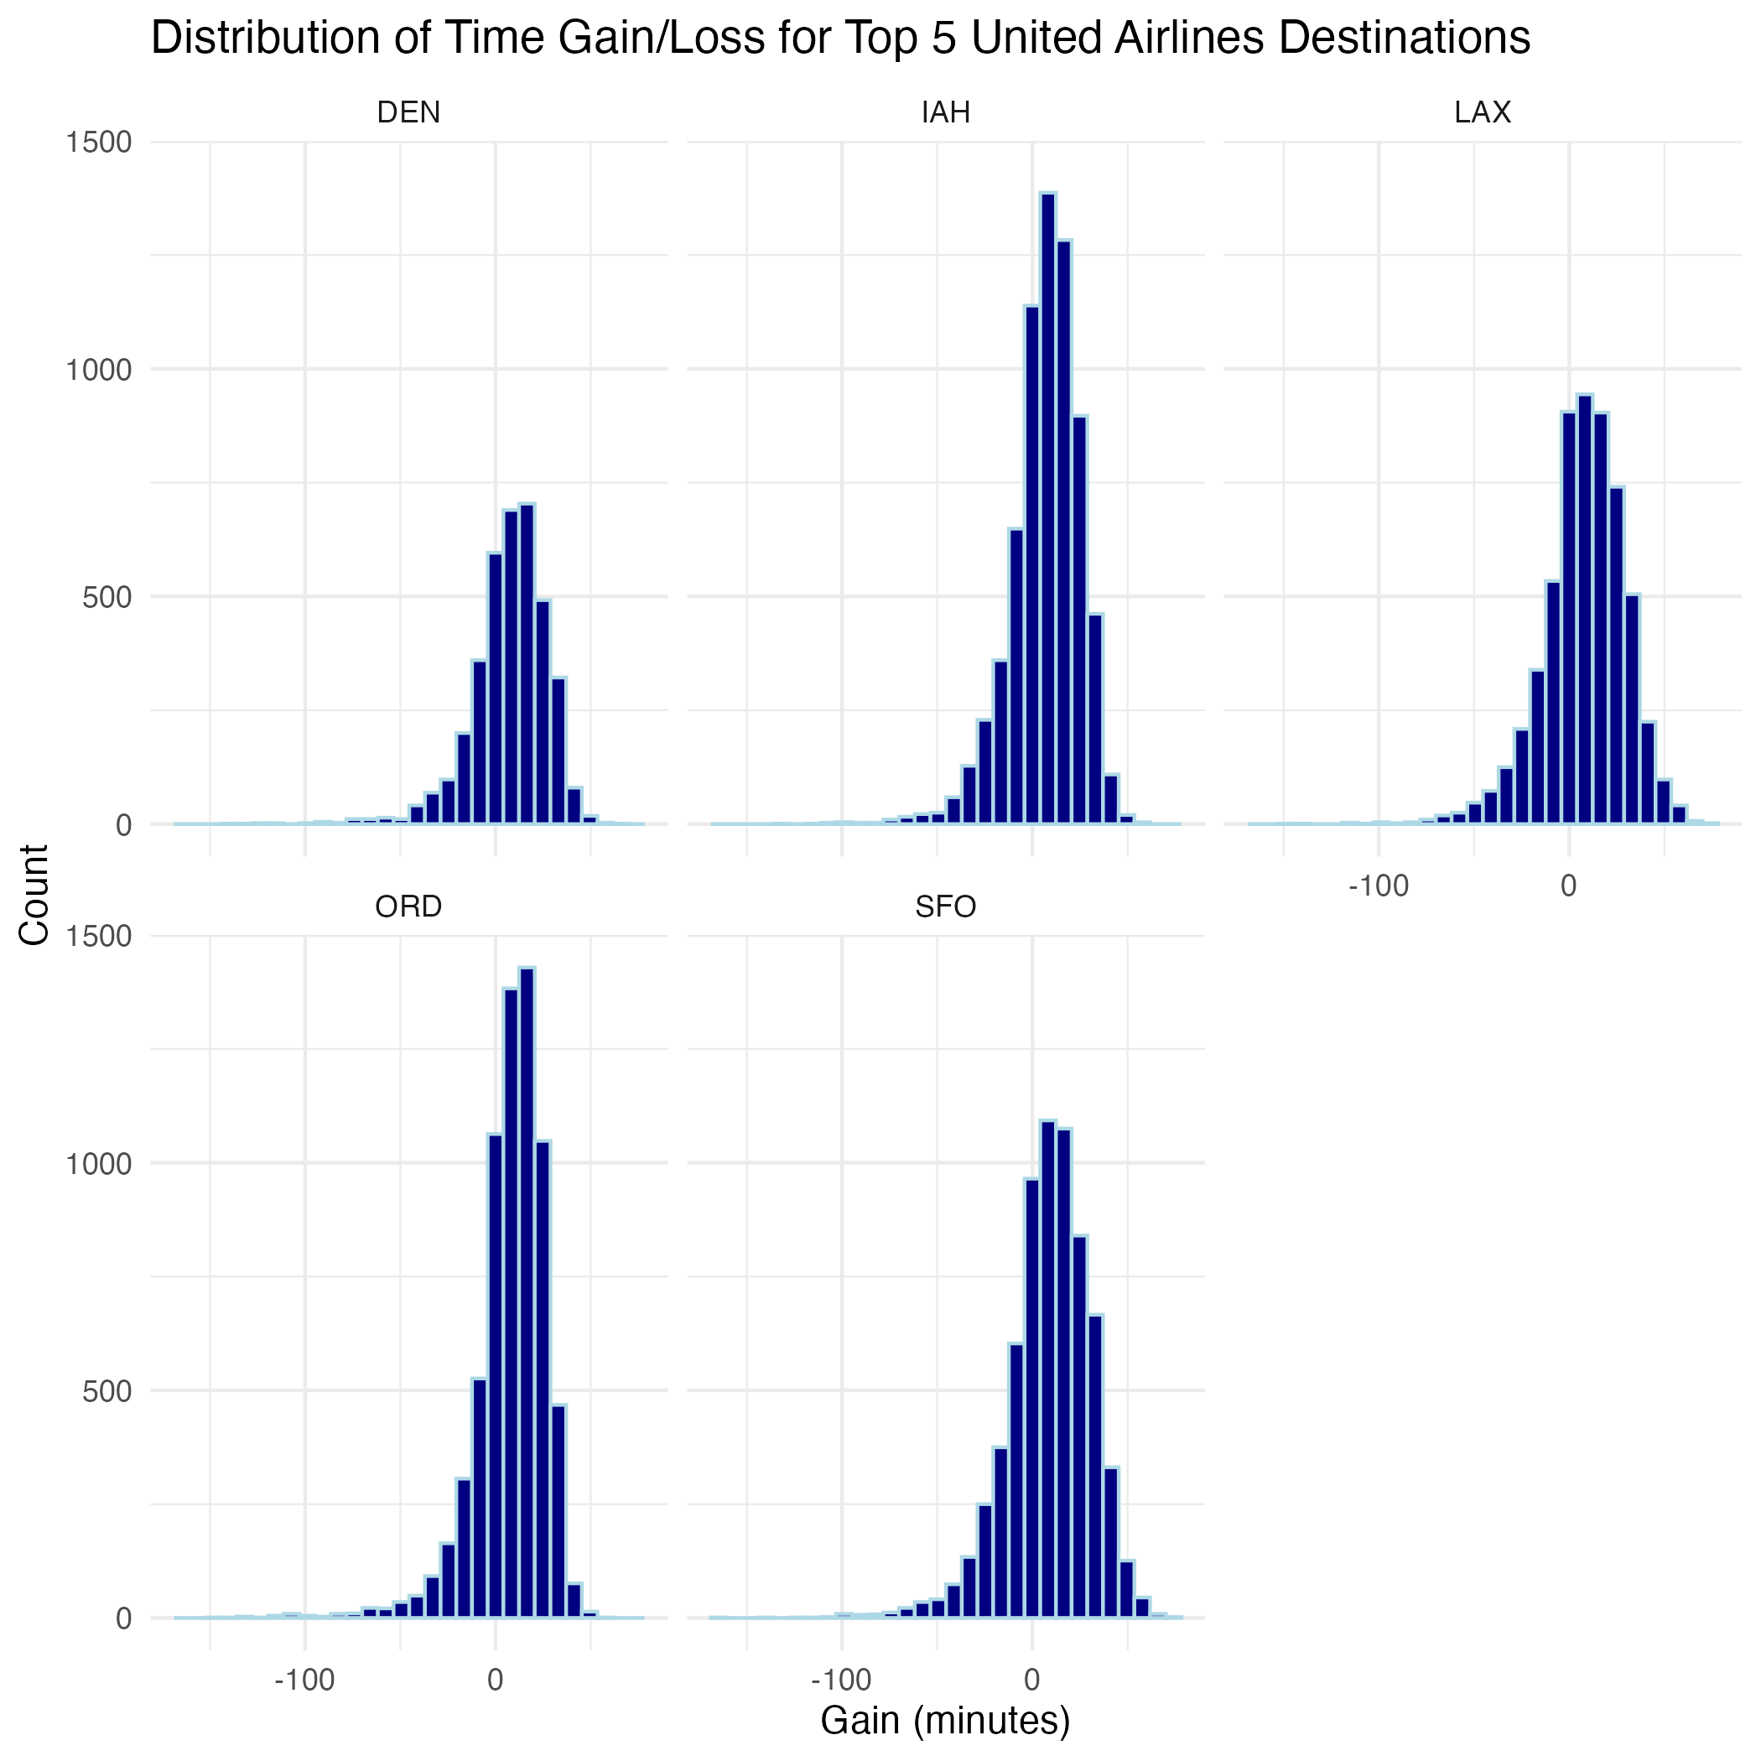
All five destinations show distributions centered just below zero, meaning United flights typically lose a little time on average. DEN and SFO have tighter, more compact shapes, suggesting more consistent performance. IAH and LAX show slightly wider spreads, with more flights losing larger chunks of time. ORD has the most pronounced left tail, indicating the biggest time losses overall. Across all five airports, the average gain is negative, so none of these routes routinely make up time in the air.

