Gain relative to the duration of the flight

The gain per hour is calculated by dividing the total gain(departure delay-arrival delay) by the duration(airtime) in hours of each flight.

Gain Per Hour for flights that departed late versus that departed on-time

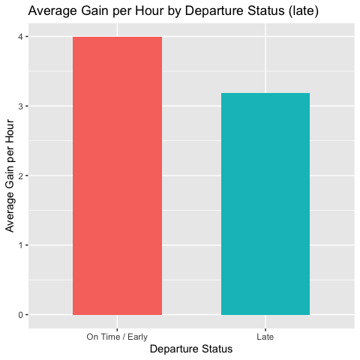

Summary table for average gain per hour for flights that departed late.
late | count | mean_gph* | median_gph* | sd_gph* | min_gph* | max_gph*
FALSE | 30657 | 3.99 | 3.33 | 7.74 | -106.23 | 56.47
TRUE | 27125 | 3.18 | 3.01 | 9.24 | -138.95 | 68.82
*gph(gain per hour)

The results indicate a clear difference in average time recovery between flights that departed on time and those that departed late. Flights that departed on time or early achieved a higher mean gain per hour (3.99 minutes) compared with flights that departed late (3.18 minutes). Although both groups show substantial variability as reflected in their relatively large standard deviations, the consistent difference in mean values suggests that late-departing flights generally recover less lost time during flight.
Late-departing flights show a wider spread between their minimum and maximum gain values, which means they are less consistent in how much time they can make up. Overall, the results suggest that even though flights try to recover time while in the air, starting late limits how much time they can realistically regain. This is likely because of factors such as air-traffic control rules, crowded routes, or other operational constraints that prevent pilots from speeding up as much as they might want to.
To compare the difference in gain per hour between the late and early/on time departure status, we conducted statistical tests. The result of the test is shown below:
Description | Results
p-value | < 0.05
Confidence interval | (0.666,0.946)
Mean-late | 3.99
Mean-on time/early | 3.18

The 95% confidence interval for the true difference in mean gain per hour between on-time departures and late departures is (0.666, 0.946). Because this interval does not include zero, it provides strong evidence of a statistically significant difference between the two groups.
There is a significant difference in average gain per hour between flights that depart on time and those that depart late. The positive mean difference, combined with a confidence interval entirely above zero, indicates that on-time flights consistently gain more time per hour than late departures. This suggests that departing late limits a flight’s ability to recover time during the journey.
Gain Per Hour for flights that departed very late versus that departed on-time

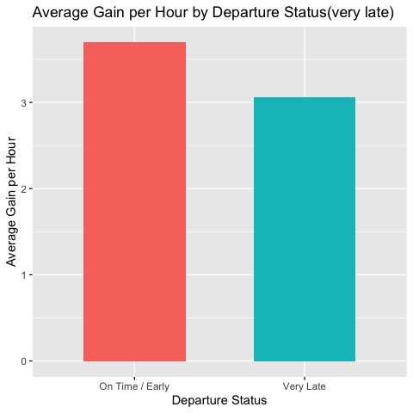

Summary table for average gain per hour for flights that departed very late.
very_late | count | mean_gph | median_gph | sd_gph | min_gph | max_gph
FALSE | 50232 | 3.69 | 3.18 | 8.06 | -118.33 | 68.82
TRUE | 7550 | 3.06 | 3.33 | 10.89 | -138.95 | 60.00
*gph(gain per hour)

The average gain per hour is lower for flights that departed very late compared to those that departed on time or early. On-time flights gained an average of 3.69 minutes per hour, whereas very late flights gained only 3.06 minutes per hour. Although both groups show substantial variability, the difference in their mean values suggests that flights departing very late have reduced ability to make up time during flight.
The larger standard deviation and wider range among very late departures indicate higher inconsistency in how much time they can recover. This suggests that once a flight is significantly delayed at departure, operational constraints such as air-traffic control limits, congestion, or routing restrictions likely limit the extent of time recovery available in the air.

To compare the difference in gain per hour between the very late and early/on time departure status, we conducted statistical tests. The result of the test is shown below:
Description | Results
p-value | < 0.05
Confidence interval | (0.375,0.886)
Mean-very late | 3.69
Mean-on time/early | 3.06

The 95% confidence interval for the true difference in mean gain per hour between on-time departures and very late departures is (0.375,0.886). Because this interval does not include zero, it provides strong evidence of a statistically significant difference between the two groups.
There is a significant difference in average gain per hour between flights that depart on time and those that depart very late. The positive mean difference, combined with a confidence interval entirely above zero, indicates that on-time flights consistently gain more time per hour than very late departures. This suggests that departing very late limits a flight’s ability to recover time during the journey.

Average gain per hour for longer flights versus shorter flights

Flights with an airtime less than or equal to the median airtime of the dataset were categorized as Short, whereas those exceeding the median were labeled Long.

Flight Length | Count
Long | 28736
Short | 29046

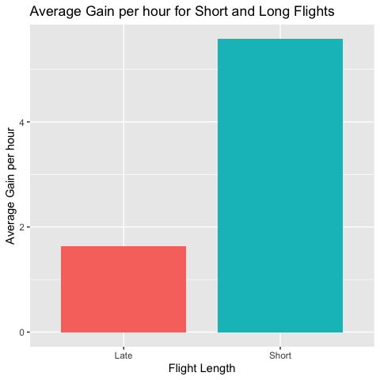

The graph shows that the average gain per hour is very high for short flights compared to that of long flights. To compare the difference between these two groups, we conducted statistical tests. The results of the tests is shown as below:

Description | Results
p-value | < 0.05
Confidence interval | (-0.408, -0.3811)
Mean-short | 5.57
Mean-long | 1.63

The test result was highly significant providing strong evidence that the mean gain per hour differs between short and long groups.
The estimated mean gain per hour for Short flights was 5.57 minutes, whereas Long flights gained only 1.63 minutes on average. The 95% confidence interval for the true difference in means (Long – Short) ranged from –4.08 to –3.81, which does not include zero. This confirms a statistically significant and meaningful difference between the groups.
Short flights make up significantly more time per hour than long flights. Because gain per hour measures how much delay a flight recovers relative to its air time, these results suggest that shorter routes provide greater opportunity for time recovery, while longer flights recover considerably less time relative to flight duration. This may reflect operational limitations on longer routes, such as air-traffic constraints or reduced flexibility to accelerate over long distances.

