3GPP TR 22.858 V18.2.0 (2021-12)

Technical Report

3rd Generation Partnership Project;

Technical Specification Group Services and System Aspects;

Study of enhancements for residential 5G;

Stage 1

(Release 18)



The present document has been developed within the 3rd Generation Partnership Project (3GPP TM) and may be further elaborated for the purposes of 3GPP.  
The present document has not been subject to any approval process by the 3GPPOrganizational Partners and shall not be implemented.  
This Report is provided for future development work within 3GPPonly. The Organizational Partners accept no liability for any use of this Specification.  
Specifications and Reports for implementation of the 3GPP TM system should be obtained via the 3GPP Organizational Partners' Publications Offices.

Keywords

<keyword[, keyword]>

***3GPP***

Postal address

3GPP support office address

650 Route des Lucioles - Sophia Antipolis

Valbonne - FRANCE

Tel.: +33 4 92 94 42 00 Fax: +33 4 93 65 47 16

Internet

http://www.3gpp.org

***Copyright Notification***

No part may be reproduced except as authorized by written permission.  
The copyright and the foregoing restriction extend to reproduction in all media.

© 2021, 3GPP Organizational Partners (ARIB, ATIS, CCSA, ETSI, TSDSI, TTA, TTC).

All rights reserved.

UMTS™ is a Trade Mark of ETSI registered for the benefit of its members

3GPP™ is a Trade Mark of ETSI registered for the benefit of its Members and of the 3GPP Organizational Partners  
LTE™ is a Trade Mark of ETSI registered for the benefit of its Members and of the 3GPP Organizational Partners

GSM® and the GSM logo are registered and owned by the GSM Association

Contents

Foreword 7

1 Scope 8

2 References 8

3 Definitions and abbreviations 9

3.1 Definitions 9

3.2 Abbreviations 9

4 Overview 9

5 Use cases 11

5.1 Use case QoS for small indoor base station connectivity 11

5.1.1 Description 11

5.1.2 Pre-conditions 11

5.1.3 Service Flows 11

5.1.4 Post-conditions 12

5.1.5 Existing features partly or fully covering the use case functionality 12

5.1.6 Potential New Requirements needed to support the use case 12

5.2 Use case visitor access to small indoor base station 12

5.2.1 Description 12

5.2.2 Pre-conditions 13

5.2.3 Service Flows 13

5.2.4 Post-conditions 13

5.2.5 Existing features partly or fully covering the use case functionality 13

5.2.6 Potential New Requirements needed to support the use case 14

5.3 Use case of QoS maintenance from outdoor to indoor 14

5.3.1 Description 14

5.3.2 Pre-conditions 14

5.3.3 Service Flows 15

5.3.4 Post-conditions 15

5.3.5 Existing features partly or fully covering the use case functionality 15

5.3.6 Potential New Requirements needed to support the use case 15

5.4 Use case on efficient routing between UE and non-3GPP device 15

5.4.1 Description 15

5.4.2 Pre-Conditions 16

5.4.3 Service Flows 16

5.4.4 Post-Conditions 16

5.4.5 Existing features partly or fully covering the use case functionality 16

5.4.6 Potential New Requirements needed to support the use case 16

5.5 Use Case on efficient routing for UE-to-UE communications via residential gateway 17

5.5.1 Description 17

5.5.2 Pre-Conditions 17

5.5.3 Service Flows 17

5.5.4 Post-Conditions 18

5.5.5 Existing features partly or fully covering the use case functionality 18

5.5.6 Potential New Requirements needed to support the use case 18

5.6 Use case on E2E QoS monitoring 18

5.6.1 Description 18

5.6.2 Pre-Conditions 19

5.6.3 Service Flows 19

5.6.4 Post-Conditions 19

5.6.5 Existing features partly or fully covering the use case functionality 19

5.6.6 Potential New Requirements needed to support the use case 20

5.7 Provisioning evolved residential gateways and Premises Radio Access Stations 20

5.7.1 Description 20

5.7.2 Pre-conditions 20

5.7.3 Service Flows 20

5.7.4 Post-conditions 20

5.7.5 Existing features partly or fully covering the use case functionality 20

5.7.6 Potential New Requirements needed to support the use case 20

5.8 Use case on 5G LAN scalability 21

5.8.1 Description 21

5.8.2 Pre-conditions 21

5.8.3 Service Flows 21

5.8.4 Post-conditions 21

5.8.5 Existing features partly or fully covering the use case functionality 22

5.8.6 Potential New Requirements needed to support the use case 22

5.9 Use case on indoor LAN to 5G LAN connectivity 22

5.9.1 Description 22

5.9.2 Pre-conditions 22

5.9.3 Service Flows 22

5.9.4 Post-conditions 22

5.9.5 Existing features partly or fully covering the use case functionality 23

5.9.6 Potential New Requirements needed to support the use case 23

5.10 Use case: seamless path switch from a UE-to-UE direct communication to an indirect communication via an evolved residential gateway 23

5.10.1 Description 23

5.10.2 Pre-conditions 23

5.10.3 Service Flows 23

5.10.4 Post-conditions 24

5.10.5 Existing features partly or fully covering the use case functionality 24

5.10.6 Potential New Requirements needed to support the use case 24

5.11 Use case: seamless switching from a service hosting environment to an application server via an evolved residential gateway 25

5.11.1 Description 25

5.11.2 Pre-conditions 25

5.11.3 Service Flows 25

5.11.4 Post-conditions 26

5.11.5 Existing features partly or fully covering the use case functionality 26

5.11.6 Potential New Requirements needed to support the use case 26

5.12 Use case: local control of connectivity of UEs in a CPN 27

5.12.1 Description 27

5.12.2 Pre-conditions 28

5.12.3 Service Flows 28

5.12.4 Post-conditions 29

5.12.5 Existing features partly or fully covering the use case functionality 29

5.12.6 Potential New Requirements needed to support the use case 29

5.13 Use case on IP Traffic offload 29

5.13.1 Description 29

5.13.2 Pre-Conditions 30

5.13.3 Service Flows 30

5.13.4 Post-Conditions 30

5.13.5 Existing features partly or fully covering the use case functionality 30

5.13.6 Potential New Requirements needed to support the use case 31

5.14 Use case on PRAS sharing 31

5.14.1 Description 31

5.14.2 Pre-Conditions 31

5.14.3 Service Flows 31

5.14.4 Post-Conditions 32

5.14.5 Existing features partly or fully covering the use case functionality 32

5.14.6 Potential New Requirements needed to support the use case 32

5.15 Use case multicast service access control for legacy device(s) behind an eRG 32

5.15.1 Description 32

5.15.2 Pre-conditions 32

5.15.3 Service Flows 33

5.15.4 Post-conditions 33

5.15.5 Existing features partly or fully covering the use case functionality 33

5.15.6 Potential New Requirements needed to support the use case 33

5.16 Use case on the connection of 5G LAN with fixed IP VPN 33

5.16.1 Description 33

5.16.2 Pre-conditions 34

5.16.3 Service Flows 34

5.16.4 Post-conditions 34

5.16.5 Existing features partly or fully covering the use case functionality 34

5.16.6 Potential New Requirements needed to support the use case 35

5.17 Use case on loss of connectivity between eRG or PRAS and 5GC 35

5.17.1 Description 35

5.17.2 Pre-conditions 35

5.17.3 Service Flows 35

5.17.4 Post-conditions 35

5.17.5 Existing features partly or fully covering the use case functionality 36

5.17.6 Potential New Requirements needed to support the use case 36

5.18 Control of Customer Premises Network by Authorised Administrator 36

5.18.1 Description 36

5.18.2 Pre-conditions 37

5.18.3 Service Flows 37

5.18.4 Post-conditions 37

5.18.5 Existing features partly or fully covering the use case functionality 37

5.18.6 Potential New Requirements needed to support the use case 38

5.19 Use case: eRG supporting Multiple connectivity 38

5.19.1 Description 38

5.19.2 Pre-conditions 38

5.19.3 Service Flows 39

5.19.4 Post-conditions 39

5.19.5 Existing features partly or fully covering the use case functionality 40

5.19.6 Potential New Requirements needed to support the use case 40

5.20 Providing 5G Multicast-Broadcast Services (5MBS) for devices through eRG. 40

5.20.1 Description 40

5.20.2 Pre-conditions 40

5.20.3 Service Flows 40

5.20.4 Post-conditions 41

5.20.5 Existing features partly or fully covering the use case functionality 41

5.20.6 Potential New Requirements needed to support the use case 41

5.21 Identification, Authentication, and Authorization for Premises Radio Access Stations 42

5.21.1 Description 42

5.21.2 Pre-conditions 42

5.21.3 Service Flows 42

5.21.4 Post-conditions 42

5.21.5 Existing features partly or fully covering the use case functionality 43

5.21.6 Potential New Requirements needed to support the use case 43

5.22 Use Case for supporting external services behind eRG in CPN 43

5.22.1 Description 43

5.22.2 Pre-conditions 43

5.22.3 Service Flows 44

5.22.4 Post-conditions 44

5.22.5 Existing features partly or fully covering the use case functionality 44

5.22.6 Potential Requirements 44

6 Traffic Scenarios 45

6.1 Traffic Scenario: inHome 45

6.1.1 Description 45

6.1.2 Assumptions 45

6.1.3 Potential Functional Requirements 46

6.1.4 Potential Key Performance Requirements 46

7 Consolidated requirements 47

7.1 Introduction 47

7.2 General 48

7.3 Gateway 48

7.4 Service Discovery 48

7.5 Application Servers 49

7.6 Identification, Privacy, and security 50

7.7 Direct Communications 51

7.8 Connectivity - QoS - charging 51

7.9 Provisioning 52

7.10 Premises Radio Access Station 52

7.11 5G-LAN 53

7.12 Broadcast Multicast 53

8 Conclusions and recommendations 53

Annex A: Resident networks overview 54

A.1 Introduction 54

A.2 Customer Premises Network overview 54

A.3 Customer Premises Network entities 54

A.3.1 evolved Residential Gateway (eRG) 54

A.3.2 Premises Radio Access System (PRAS) 54

A.3.3 Customer Premises Network (CPN) 55

A.3.4 User Equipment (UE) 55

A.3.3 Non-3GPP device 55

Annex B: Change history 55

# Foreword

This Technical Report has been produced by the 3rd Generation Partnership Project (3GPP).

The contents of the present document are subject to continuing work within the TSG and may change following formal TSG approval. Should the TSG modify the contents of the present document, it will be re-released by the TSG with an identifying change of release date and an increase in version number as follows:

Version x.y.z

where:

x the first digit:

1 presented to TSG for information;

2 presented to TSG for approval;

3 or greater indicates TSG approved document under change control.

y the second digit is incremented for all changes of substance, i.e. technical enhancements, corrections, updates, etc.

z the third digit is incremented when editorial only changes have been incorporated in the document.

# 1 Scope

The present document examines use cases and traffic scenarios in residential environments (e.g. homes and small offices) and identifies related new potential functional requirements and potential key performance requirements in the following three areas:

- Enhancements for wireline wireless convergence,

- Enhancements for fixed LAN - 5GLAN integration, and

- Enhancements for indoor small base stations

# 2 References

The following documents contain provisions which, through reference in this text, constitute provisions of the present document.

- References are either specific (identified by date of publication, edition number, version number, etc.) or non‑specific.

- For a specific reference, subsequent revisions do not apply.

- For a non-specific reference, the latest version applies. In the case of a reference to a 3GPP document (including a GSM document), a non-specific reference implicitly refers to the latest version of that document *in the same Release as the present document*.

[1] 3GPP TR 21.905: "Vocabulary for 3GPP Specifications".

[2] 3GPP TS 22.261: " Service requirements for the 5G system; Stage 1".

[3] 3GPP TS 22.220: "Service requirements for Home Node B (HNB) and Home eNode B (HeNB)".

[4] 3GPP TS 23.501: "System architecture for the 5G System (5GS)".

[5] 3GPP TS 22.278: "Service requirements for the Evolved Packet System (EPS)".

[6] 3GPP TS 23.287: "Architecture enhancements for 5G System (5GS) to support Vehicle-to-Everything (V2X) services".

[7] 3GPP TS 23.316: "Wireless and wireline convergence access support for the 5G System (5GS) "

[8] 3GPP TS 22.146: "Multimedia Broadcast/Multicast Service (MBMS); Stage 1".

[9] 3GPP TS 22.246: "Multimedia Broadcast/Multicast Service (MBMS) user services; Stage 1".

[10] 3GPP TR 22.904: "Study on user centric identifiers and authentication".

[11] 3GPP TS 22.101: "Service aspects; Service principles".

[12] 3GPP TS 22.346: "Isolated Evolved Universal Terrestrial Radio Access Network (E-UTRAN) operation for public safety; Stage 1".

[13] 3GPP TS 38.331: "NR; Radio Resource Control (RRC); Protocol specification".

# 3 Definitions and abbreviations

## 3.1 Definitions

For the purposes of the present document, the terms and definitions given in 3GPP TR 21.905 [1] and the following apply. A term defined in the present document takes precedence over the definition of the same term, if any, in 3GPP TR 21.905 [1].

**Authorised Administrator:** a user or other entity authorised to partially configure and manage a network node in a CPN (e.g. a PRAS, or eRG).

**Customer Premises Network:** a network located within a premises (e.g. a residence, office or shop), which is owned, installed and/or (at least partially) configured by the customer of a public network operator.

**Evolved Residential Gateway:** a gateway between the public operator network (fixed/mobile/cable) and a customer premises network within a residence, office or shop.

**Hybrid access:** access consisting of multiple different access types combined, such as fixed wireless access and wireline access

**Non-3GPP device:** a non-3GPP device is a device that uses non-3GPP access technology and does not have 3GPP credentials

**Premises Radio Access Station:** a base station installed at a customer premises network primarily for use within a residence, office or shop.

## 3.2 Abbreviations

For the purposes of the present document, the abbreviations given in 3GPP TR 21.905 [1] and the following apply. An abbreviation defined in the present document takes precedence over the definition of the same abbreviation, if any, in 3GPP TR 21.905 [1].

CPN Customer Premises Network

eRG Evolved Residential Gateway

PRAS Premises Radio Access Station

# 4 Overview

Many operators around the world both have mobile network and fixed network operations. Operators provide triple-play, combining mobile communication, fixed telephony and broadband Internet, or even quad-play, adding TV, to customers in the consumer / residential market. In this market, operators can distinguish themselves by providing an optimal integration between the different services. Following the trend of wireline/wireless convergence, operators are integrating their fixed and mobile networks into a single core network with fixed and mobile access networks.

Even for single play mobile network operators optimising 5G residential services is relevant. One of the main benefits that 5G brings to consumers is that it will provide higher bitrates. These higher bitrates will enable or improve eMBB services such as mobile TV, AR/VR, or mobile gaming. Remarkably, to a large extend such 'mobile' services are used by users that are not on the move. Generally hourly patterns for mobile data traffic show that the highest mobile data usage is in the evening, when people are enjoying mobile data services whilst at home.

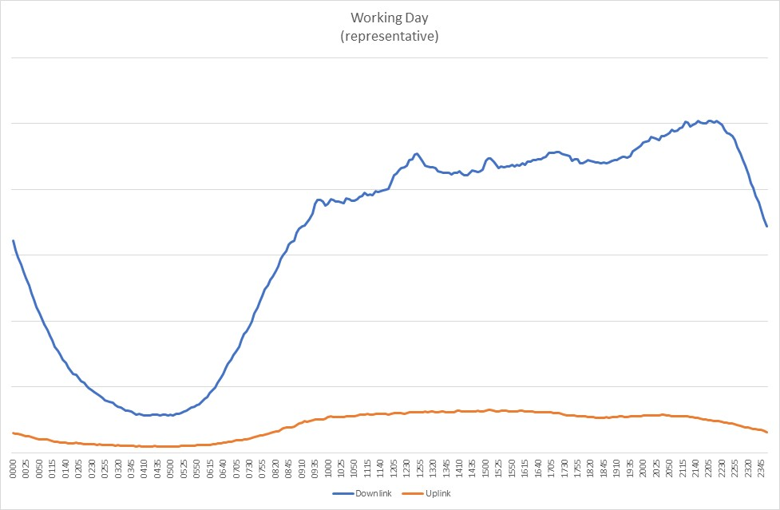

Figure 4-1: example daily pattern of cellular usage (source KPN)

The pattern of cellular data usage implies that residential environments are very important in 5G usage. The residential environment is where a large portion of 5G traffic will be handled. And the residential environment is not the easiest environment to provide network coverage. With video/TV services and AR/VR gaming, residential users demand high bitrates and with a concentration of media traffic can easily require significant capacities. High bitrates and high capacity are best provided with mmwave frequencies. However, at mmwave frequencies it will be difficult to provide outside-to-inside coverage with operator base stations. Also with indoor base stations, it will not be easy to provide sufficient indoor coverage. Scenarios with a PRAS in every room (e.g. integrated in the light fixture in the centre of the ceiling) may be needed to provide really good in-home coverage. This also requires upgrades to fixed access, residential gateways and in-home cabling. At the same time, it is virtually impossible for an operator to install and manage their own radio access infrastructure in a residential environment. Where in a large office, the operator can provide and manage indoor coverage, in a residential environment the installation of radio equipment, cabling will likely be left to the homeowner (Authorised Administrator).

Currently fixed broadband services work on a different premise than mobile services. With mobile services, each individual device is known and identifiable in the mobile network. That implies that services can be provided to individual devices. With fixed broadband services, the operator provides Internet access to a residential gateway. Behind that residential gateway is usually a LAN, but individual devices on that LAN are not known or identifiable in the core network. For an integrated fixed broadband / mobile residential 5G offering, it would be beneficial if devices behind an eRG can also be known and identified in the core network.

The trend towards Wireline / Wireless Convergence is already recognised in 3GPP. In collaboration with the BroadBand Forum (BBF), architecture solutions have been specified where a single 5G core network is used to also control fixed broadband access. Also, solutions like 5G LAN and UE relaying have been specified with residential use cases (partly) in mind. Nevertheless, there are still areas where improvements for residential use are needed/useful to achieve the vision of a residential 5G without boundaries between fixed broadband and mobile.

# 5 Use cases

## 5.1 Use case QoS for small indoor base station connectivity

### 5.1.1 Description

In many cases, residential indoor coverage will require the deployment of indoor base stations or access points. Especially for multimedia services like UHD TV, or AR/VR gaming high bitrates are needed. This in turn requires the use of higher frequency bands (e.g. 3.5 GHz or 26/28 GHz for NR or 5 GHz, 6 GHz or 60 GHz for WiFi based radio access). At these frequencies, outdoor to indoor coverage from an outdoor PLMN is challenging. Also indoor penetration throughout a house is problematic, requiring multiple Premises Radio Access Stations (PRASs).

For 5G services that require specific QoS (e.g. guaranteed bitrate, latency) or e.g. that rely on edge applications, it is important that the 5G network can differentiate the related service data flows in order to treat them accordingly. This also applies in case a PRAS is connected via an evolved Residential Gateway (eRG) and an indoor infrastructure. In the Wireline Wireless Convergence work between 3GPP and BBF, the eRG is seen as an UE. That way the eRG can request QoS for the fixed access network. Also on the radio interface between the UE and the PRAS, QoS control can work as normal. An issue however is how QoS is provided on the backhaul between the PRAS and the eRG and in the eRG. It is not guaranteed that this backhaul has sufficient QoS. Also prioritization of specific service data flows may be needed to provide the expected QoS. Finally, the eRG may have to request specific QoS for the fixed access network for specific service data flows.

Note: in the use case, we generally refer to PRAS, but the similar requirements apply for e.g. a WiFi6 access point that is connected to the 5G core (non-3GPP access) via an eRG.

### 5.1.2 Pre-conditions

The following pre-conditions and assumptions apply to this use case:

- A PRAS is deployed inside a residential home.

- The PRAS provides access to the 5G system (e.g not local IP access)

- UEs using the PRAS have individual subscriptions to access the 5G system.

- The Premises Radio Access Stations (PRAS) is connected to an eRG

- The eRG is connected to the same 5G system (and has a subscription to the same 5G system) as the PRAS.

### 5.1.3 Service Flows

Teenagers Oliver and Scott are avid gamers. They get together in the games room in the basement of Scott's house and discuss the new game that has become available that day. Scott decides to download the new game on his laptop. The size of that game is over 100 Gbyte so even on 5G it will take a while. Good thing that Scott's parents had PRASs installed in the house. 5G coverage would otherwise have been dismal in the basement and downloading would have taken forever.

While the game is downloading, Oliver and Scott decide to play their favorite multi-user AR/VR game. Each put on a VR headset, get a controller and start gaming. The AR/VR game they play is cloud based with rendering in an edge node. This way they can play the game wherever they want and still have optimal quality of experience. The low latency ensures they have no 'lag' when they move their head or when they try to shoot each other in the game. Good thing also that the 5G system makes sure that the AR/VR game is prioritized over downloading the game. That the download takes a bit more time is not a big issue, but without the usual settings for frames per second and resolution or with additional lag because of the download the game would be 'unplayable'.

### 5.1.4 Post-conditions

The game consoles have set up a 5G connection to the Premises Radio Access Stations (PRAS). They have requested the same session with the same QoS, DNN, Slice, et cetera as they would have done with an outdoor base station.

The eRG ensures that prioritization within the eRG and Customer Premises Network takes requested QoS into account. This e.g. implies that the AR/VR game gets priority over the downloading of the game.

The eRG also ensures that the 5G core network can differentiate the service data flows for the AR/VR games from general Internet access, to ensure that specific handling of these service data flows (e.g. routing to an edge node) is possible.

### 5.1.5 Existing features partly or fully covering the use case functionality

3GPP TS 22.220 "Service requirements for Home Node B (HNB) and Home eNode B (HeNB)" [3] specifies requirements for indoor base stations in a 3G (HNB) or 4G (HeNB) context. It is not very clearly specified whether these requirements also apply for 5G. Requirements are included to request resources from the IP backhaul in the fixed broadband access. Note that 3GPP TS 22.220 [3] does not assume WWC convergence. There are no requirements for the provision of QoS within the Customer Premises Network itself.

3GPP TS 22.261 [2], clause 6.26.2.1 mentions indoor small base stations connected in the context of 5GLAN: "The 5G system shall enable the network operator to provide the same 5G LAN-type service to any 5G UE, regardless of whether it is connected via public base stations, indoor small base stations connected via fixed access, or via relay UEs connected to either of these two types of base stations."

3GPP TS 22.261 [2], clause 6.3.2.4 discusses fixed broadband access. It does not really use WWC terminology (e.g. 5G-RG), but either assumes a residential gateway that functions as a relay UE, or a residential gateway that integrates an indoor base station. There is no mentioning of a base station that is connected to the residential gateway. 3GPP TS 23.316 [7] is the architecture specification for Wireline Wireless Convergence.

### 5.1.6 Potential New Requirements needed to support the use case

[PR. 5.1.6-001] The 5G system shall enable the network operator to provide any 5G services to any 5G UE via a Premises Radio Access Station (PRAS) connected via an evolved Residential Gateway (eRG).

NOTE1: The eRG may be connected via fixed access, via 5G Fixed Wireless Access, or hybrid access.

NOTE2: The PRAS may also be co-located with the eRG

[PR. 5.1.6-002] The 5G system shall enable the evolved Residential Gateway (eRG) to provide backhaul with the required QoS for the services provided via a Premises Radio Access Station (PRAS)connected via the eRG.

NOTE3: Backhaul for the PRAS includes the Customer Premises Network between PRAS and eRG and the (fixed) access network between the eRG and the 5G core network.

## 5.2 Use case visitor access to small indoor base station

### 5.2.1 Description

In many cases, residential indoor coverage will require the deployment of Premises Radio Access Stations (PRASs). The assumption is that these PRASs are installed by the home owner (Authorised Administrator). Nevertheless, it is quite possible that these PRASs can also be used by visitors to the home.

Visitor access is only possible with a few security provisions. Communication for the visitor has to be protected against eavesdropping or manipulation in the residential in-home network and/or evolved residential gateway. These elements are not under control of the operator and cannot be sufficiently trusted.

From the other hand, the homeowner needs to be shielded from the visitor. One aspect is that the homeowner may not want to be charged for traffic, services, and applications initiated by the visitor. Another aspect is that the homeowner may not want the visitor to access his private devices in the home (e.g., working PCs, security cameras, etc.) via PRAS and evolved residential gateway. For example, when the visitor’s UE is connecting to the eRG, may receive unintended broadcast communication/data from the homeowner’s devices, which are also connecting to the eRG. Also for lawful intercept, traffic originating from a visitor should be identifiable as such.

In existing customer premises networks, generally internal credentials are used (e.g. WiFi username/password). Using 3GPP credentials to access a CPN will be an improvement of security and will relieve the home owner of having to manage (and remember) CPN internal credentials.

### 5.2.2 Pre-conditions

The following pre-conditions and assumptions apply to this use case:

- A PRAS is deployed inside a residential home.

- The PRAS provides access to the 5G system (e.g. not local IP access)

- UEs using the PRAS have individual subscriptions to access the 5G system, these subscriptions may be with different operators.

- The PRAS is connected to an eRG

- The eRG is connected to the same 5G system (and has a subscription to the same 5G system) as the PRAS.

### 5.2.3 Service Flows

Doctor Joe is a general practitioner (GP) that works from a practice next to his home in a small village. Every day patients visit his practice for all kinds of consultations.

Because of the local radio conditions (small village) and the construction of his home (concrete walls), there is very poor outdoor-to-indoor coverage in his practice. Doctor Joe has therefore installed Premises Radio Access Stations (PRASs) in his practice, both for himself and for waiting patients.

Doctor Joe is happy that 3GPP credentials can be used for communication within the CPN. He no longer has to manage and configure username/password combinations for his devices and security is improved; he no longer needs the sticky note with the WiFi password he had on his computer.

Doctor Joe does not mind that patients are using the PRAS that he has paid for. However, Doctor Joe does not want to pay for traffic, services, or applications that his patients may initiate via his PRAS and fixed access. Doctor Joe also does not want that these patients are able to access his PC or control the lights/cameras via his PRAS and eRG. Furthermore, he does not want to get in trouble when patients e.g. download illegal content via his fixed access. Therefore, Doctor Joe prefers that communication from/for his patients is identified as such.

Patient Mary is waiting in the waiting room. She wants to communicate in private with her mother. Even though she is using a PRAS installed by Doctor Joe, she can trust that her communication remains private.

### 5.2.4 Post-conditions

Communication for each patient is identified and billed separately from the traffic from Doctor Joe and other patients.

Communication for patients cannot be eavesdropped or manipulated.

### 5.2.5 Existing features partly or fully covering the use case functionality

3GPP TS 22.220 "Service requirements for Home Node B (HNB) and Home eNode B (HeNB)" [3] specifies requirements for indoor base stations in a 3G (HNB) or 4G (HeNB) context. It is not very clearly specified whether these requirements also apply for 5G. 3GPP TS 22.220 [3] also includes requirements on security and privacy.

3GPP TS 22.261 [2], clause 6.26.2.1 mentions indoor small base stations in the context of 5GLAN: "The 5G system shall enable the network operator to provide the same 5G LAN-type service to any 5G UE, regardless of whether it is connected via public base stations, indoor small base stations connected via fixed access, or via relay UEs connected to either of these two types of base stations."

3GPP TS 22.261 [2], clause 6.3.2.4 discusses fixed broadband access and the use of a home base station. It mentions: "The 5G system shall support use of a home base station that supports multiple access types (e.g. 5G RAT, WLAN access, fixed broadband access)."

### 5.2.6 Potential New Requirements needed to support the use case

[PR. 5.2.6-001] The 5G system shall enable the network operator to provide any 5G services via a Premises Radio Access Station (PRAS) to any 5G UE with a valid subscription to the HPLMN associated with the PRAS.

[PR. 5.2.6-002] The 5G system shall enable the network operator to provide any 5G services via a Premises Radio Access Station (PRAS) to any 5G UE with a valid subscription to any VPLMN that has a roaming agreement with the HPLMN.

NOTE: Whether 5G UEs from VPLMNs in the same country as the HPLMN can use the PRAS is subject to regulatory policy on national roaming.

[PR. 5.2.6-003] The 5G system shall ensure the use of a Premises Radio Access Station (PRAS) does not compromise the security of any PLMN or broadband access network.

[PR. 5.2.6-004] The 5G system shall ensure the use of a Premises Radio Access Station (PRAS) does not compromise the security of the UE. The PRAS (and its associated backhaul connectivity) shall provide a level of security equivalent to regular 5G base stations.

[PR. 5.2.6-005] The 5G system shall enable the network operator associated with the Premises Radio Access Station (PRAS) to control the security policy of the PRAS.

[PR. 5.2.6-006] The 5G system shall ensure the Premises Radio Access Station (PRAS) does not compromise user privacy for UEs that are using the PRAS, including communication confidentiality, location privacy and identity protection.

[PR. 5.2.6-007] The 5G system shall be able to generate charging information that can differentiate between UEs connected to the Premises Radio Access Station (PRAS) and between backhaul for the PRAS and other data traffic over the same access.

[PR. 5.2.6-008] The 5G system shall provide a mechanism to prevent or allow a (guest) UE to discover and/or use the services provided by the devices on the CPN.

[PR. 5.2.6-009a] The 5G system shall support authentication of a UE with 3GPP credentials for communication with entities (UEs, devices) in a CPN.

NOTE: To support this functionality the CPN needs to be connected with the 5G core network.

[PR. 5.2.6-009] The 5G system shall ensure that communications associated with individual UEs in a CPN be identifiable (e.g., subscriber identifier) in the 5G network.

## 5.3 Use case of QoS maintenance from outdoor to indoor

### 5.3.1 Description

UEs can get all way QoS support from the 5G system when accessing the network with 3GPP RATs outdoors. However, due to the issue of 5G outside-to-inside coverage, UEs will probably access to 5GC through an evolved residential gateway (eRG) when moving from outdoor to indoor. If the all way QoS control can still be guaranteed at this moment, especially when high bandwidth or low latency consuming service is ongoing (e.g. video gaming), users might have a better service experience.

### 5.3.2 Pre-conditions

Tom has a mobile phone which is registered to MNO1. Tom loves to play video game at his leisure time. He even made a specific QoS setting with MNO1 to guarantee the high quality of the gaming service.

There is a eRG at Tom’s house. The eRG also subscribes to the same MNO as Tom’s mobile phone. Devices in Tom’s house can automatically be connected to the eRG via non-3GPP (R)ATs (e.g. WIFI).

### 5.3.3 Service Flows

1. Tom is on his way home by bus. It is so boring, so he starts playing video game on his mobile phone.

2. An hour later Tom arrives home. The video game is so exciting and fierce, so Tom is still obsessed with it. He keeps playing game when he enters the house.

3. Once Tom enters the house, his mobile phone is automatically connected to the eRG. So that his mobile phone can still access to the network.

4. The eRG identifies Tom’s mobile phone.

5. The eRG is informed of the relevant QoS characteristics of Tom’s mobile phone at this moment.

6. The 5G network and the eRG provide corresponding QoS control for Tom’s mobile phone.

### 5.3.4 Post-conditions

Even if Tom moves from outdoor to indoor while playing UHD video game, the quality of the video game he’s playing can be well maintained. Tom can still have a wonderful service experience.

### 5.3.5 Existing features partly or fully covering the use case functionality

3GPP TS 22.261 [2], clause 6.7.2 mentions the support of harmonised QoS framework to multiple accesses :"The 5G system shall be able to support a harmonised QoS and policy framework applicable to multiple accesses. "

3GPP TS 22.261 [2], clause 6.26.2.8 mentions QoS requirement between remote UE and relay UE: "The 5G network shall be able to provide a remote UE using 5G LAN-type service with same level of service as if the remote UE would be using a direct network connection (i.e. provide required QoS for the Ethernet packets transferred between remote UE and relay UE if they are using 3GPP access)."

3GPP TS 22.261 [2], clause 8.5 mentions different identifier association: "The HPLMN shall be able to associate a temporary identifier to a UE’s subscriber identity."But it doesn’t specify whether other entity (e.g., evolved residential gateway) can also perform the identity association.

### 5.3.6 Potential New Requirements needed to support the use case

[PR. 5.3.6-002] The 5G system shall be able to indicate to the evolved residential gateway that a specific UE connected to it either via 3GPP RAT or non-3GPP (R)AT needs specific QoS and what the required QoS characteristics are.

[PR 5.3.6-003] The 5G system shall minimize service disruption for a UE that is moving between CPN access and operator provided mobile access.

NOTE: CPN access can imply access via a PRAS or can imply access directly via an eRG. Operator provided mobile access implies access via an operator owned base station.

## 5.4 Use case on efficient routing between UE and non-3GPP device

### 5.4.1 Description

This use case assumes that Premises Radio Access Stations were already deployed in individual rooms behind the Evolved Residential Gateway, to provide better cellular coverage at home. This use case is to enable efficient routing for the communications between UE and non-3GPP device via the Evolved Residential Gateway.

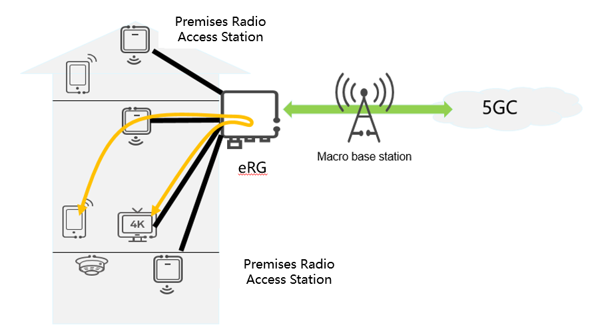

Figure 5.4.1-1: efficient routing between UE and non-3GPP device

### 5.4.2 Pre-Conditions

The following pre-conditions and assumptions apply to this use case:

- Multiple Premises Radio Access Stations were deployed in individual rooms insuide a residential home

- The Premises Radio Access Station provides cellular access to UEs

- The Premises Radio Access Station is connected to an Evolved Residential Gateway via wireline or wireless link

In particular, a Premises Radio Access Station is deployed in the living room.

There is a smart TV in the living room, which is a non-3GPP device, connecting to the Evolved Residential Gateway via wireline.

### 5.4.3 Service Flows

Alice is sitting in the living room. Her smartphone is connecting to the Premises Radio Access Station.

Alice finds an interesting video in her smartphone and want to project to the smart TV in the living room.

The request sent from the smartphone reaches the Evolved Residential Gateway via the Premises Radio Access Station and then routed by the residential gateway to the smart TV via the wireline.

### 5.4.4 Post-Conditions

Alice could enjoy the video on her smart TV.

### 5.4.5 Existing features partly or fully covering the use case functionality

3GPP TS 22.220 "Service requirements for Home Node B (HNB) and Home eNode B (HeNB)" [3] specifies the requirements for local IP Access for 3G and 4G.

3GPP TS 22.261 [2] specifies the requirements for routing efficiency, e.g., private communication for 5G LAN-type service, however, the efficient routing on Evolved Residential Gateway is not covered yet.

### 5.4.6 Potential New Requirements needed to support the use case

[PR. 5.4.6-001] Subject to regulatory requirements and operator policy, the 5G system shall support an efficient data path through an Evolved Residential Gateway for intra-CPN data traffic to or from a UE.

NOTE: For services an operator deploys in the 5G network (i.e. not in the CPN), local data routed via eRG does not apply.

## 5.5 Use Case on efficient routing for UE-to-UE communications via residential gateway

### 5.5.1 Description

This use case assumes that multiple Premises Radio Access Stations were already deployed in individual rooms behind an Evolved Residential Gateway, in order to provide better coverage at home. This use case is to enable efficient routing for the communications between two UEs via the Evolved Residential Gateway.

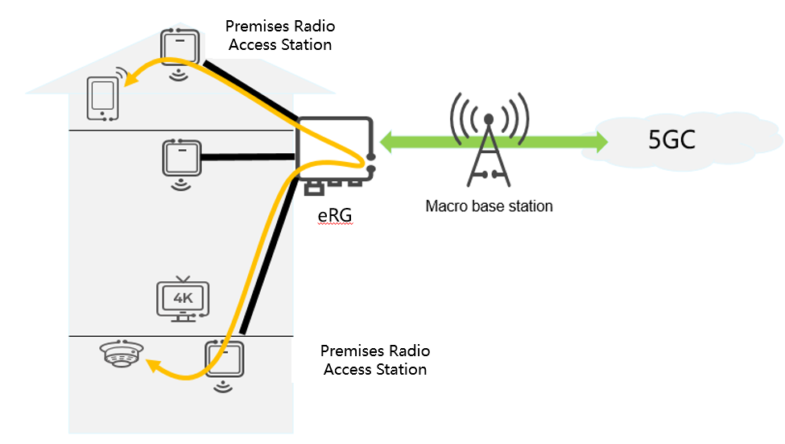

Figure 5.5.1-1: efficient routing for UE-to-UE communications via residential gateway

### 5.5.2 Pre-Conditions

The following pre-conditions and assumptions apply to this use case:

- Multiple Premises Radio Access Stations were deployed in individual rooms inside a residential home.

- The Premises Radio Access Station provides cellular access to UEs

- The Premises Radio Access Station is connected to an Evolved Residential Gateway via wireline or wireless link

- The Evolved Residential Gateway is connected to the same 5G system (and has a subscription to the same 5G system) as the Premises Radio Access Station belongs to.

In particular, one Premises Radio Access Station is deployed at the attic and another one is deployed at the basement. The connections between the Premises Radio Access Stations and the Evolved Residential Gateway could have multiple options, e.g., fiber, WiFi, or 3GPP licensed spectrum.

A security sensor is deployed at the basement which is capable of detecting smoke or fire. The sensor having a SIM is a 3GPP-capable UE which is connecting to the Premises Radio Access Station in the basement.

### 5.5.3 Service Flows

Alice is working alone at home, staying in her office in the attic. Her smartphone is connecting to the Premises Radio Access Station deployed in the attic.

Suddenly there is a fire in the basement.

The security sensor detects the fire and smoke, and then immediately sends an alarm to Alice’s smartphone.

The alarm message first reaches the Evolved Residential Gateway via the Premises Radio Access Station in the basement, and then routed by the Evolved Residential Gateway to Alice smartphone via the Premises Radio Access Station in the attic.

### 5.5.4 Post-Conditions

Alice reads the alarm message from her smartphone. After double-check the situations in the basement, Alice makes the call to the fire policy.

### 5.5.5 Existing features partly or fully covering the use case functionality

The 5G system shall support on-demand establishment of UE to UE, multicast, and broadcast private communication between members UEs of the same 5G LAN-VN. Multiple types of data communication shall be supported, at least IP and Ethernet.

3GPP TS 22.261 [2] specifies the requirement to support E2E QoS for a service, however, the existing requirement only consider QoS in the access networks, backhaul, core network and network to network interconnect. The QoS between UE, PRAS and eRG is not covered yet.

3GPP TS 22.261 [2] specifies the requirements for routing efficiency within the 5GC, e.g., private communication for 5G LAN-type service. However, the efficient routing on eRG is not covered yet.

### 5.5.6 Potential New Requirements needed to support the use case

[PR. 5.5.6-001] The 5G system shall be able to provide QoS control for the communication path between a UE and an Evolved Residential Gateway via a Premises Radio Access Station.

[PR. 5.5.6-002] Subject to regulatory requirements and operator policy, the 5G system shall support an efficient data path through an Evolved Residential Gateway for intra-CPN data traffic to or from a UE. routing efficiency for data traffic between two UEs through an Evolved Residential Gateway.

NOTE: For services an operator deploys in the 5G network (i.e. not in the CPN), local data routed via eRG does not apply.eway.

[PR. 5.5.6-003] The 5G system shall support a mechanism to minimize the security impact on any PLMN or broadband access network when using an Evolved Residential Gateway.

[PR. 5.5.6-004] The 5G system shall support a mechanism to minimize the security impact on the UE when using an Evolved Residential Gateway.

[PR. 5.5.6-005] The 5G system shall enable the network operator associated with an Evolved Residential Gateway to control the security policy of an Evolved Residential Gateway.

[PR 5.5.6-006] The 5G system shall ensure an Evolved Residential Gateway does not compromise user privacy for UEs that are using the Evolved Residential Gateway, including communication confidentiality, location privacy and identity protection.

[PR. 5.5.6-007] The 5G system shall support QoS control for intra-CPN data traffic between two UEs through an Evolved Residential Gateway.

## 5.6 Use case on E2E QoS monitoring

### 5.6.1 Description

This use case assumes that multiple PRASs were already deployed in individual rooms behind an eRG, in order to provide better cellular coverage at home. This use case is to enable E2E QoS monitoring for the whole communication path, i.e., from/to a UE to/from the 5GC via a PRAS and an eRG.

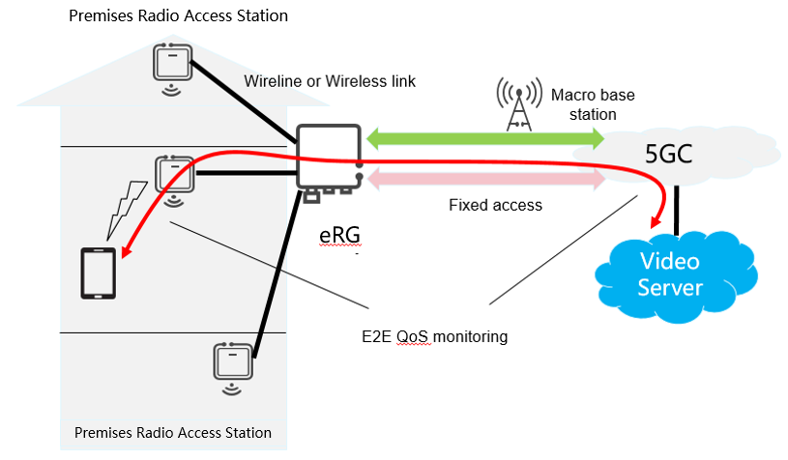

Figure 5.6.1-1. E2E QoS monitoring

### 5.6.2 Pre-Conditions

The following pre-conditions and assumptions apply to this use case:

* Multiple Premises Radio Access Stations were deployed in individual rooms inside a residential home.
* The Premises Radio Access Station provides cellular access to UEs

- The Premises Radio Access Station is connected to an Evolved Residential Gateway via wireline or wireless link

- The Premises Radio Access Station is connected to the same 5G system (and has a subscription to the same 5G system) as the Premises Radio Access Station belongs to.

In particular, a Premises Radio Access Station is deployed in the living room.

### 5.6.3 Service Flows

Alice sits in the living room and her smartphone connects to the Premises Radio Access Station.

Alice is watching an interesting video on her smartphone. The smartphone downloads the video content in real time from the video application server in the cloud.

After a while, the download speed becomes slow and the video is stuck.

Alice makes a call to the network operator and reports the downgrade of the network performance.

The network operator checks the E2E QoS status and identifies there is heavy interference on the Premises Radio Access Station. The network operator reconfigures the Premises Radio Access Station and recovers the E2E QoS.

### 5.6.4 Post-Conditions

The download speed recovers normal and Alice could continue enjoy the video.

### 5.6.5 Existing features partly or fully covering the use case functionality

3GPP TS 22.261 [2] Section 6.23.2 "QoS monitoring".

The 5G system shall be able to provide information that identifies the type and the location of a communication error for the Premises Radio Access Station (e.g. the ID of this Premises Radio Access Station).

### 5.6.6 Potential New Requirements needed to support the use case

[PR. 5.6.6-001] The 5G system shall provide a mechanism for supporting real time E2E QoS monitoring for the data traffic path (i.e., from/to a UE to/from the 5GC via a Premises Radio Access Station and a Evolved Residential Gateway).

## 5.7 Provisioning evolved residential gateways and Premises Radio Access Stations

### 5.7.1 Description

The use case illustrates how an evolved residential gateway or a Premises Radio Access Station can be connected and automatically provisioned to the operator's 5G network.

### 5.7.2 Pre-conditions

Ali has a home connectivity service subscription and a 5G subscription on his mobile phone with Network Operator Vanilla.

Ali purchased an evolved residential gateway and one (or more) Premises Radio Access Stations, which were not provided by the operator.

NOTE: it is assumed the evolved residential gateway is a fixed wireless access (FWA) gateway

Ali is at home and has his mobile phone nearby.

### 5.7.3 Service Flows

1. Ali switches both the evolved residential gateway and Premises Radio Access Station on for the first time.

2. Ali logs on to his account on Vanilla's portal to add both devices to his Vanilla account and to enable the devices in his home.

3. Vanilla's 5G core network provisions both the evolved residential gateway and Premises Radio Access Station. Once this process is complete, both the evolved residential gateway and Premises Radio Access Station are successfully connected to Vanilla's core network and are now fully operational.

4. Ali can now connect his TV to the Premises Radio Access Station in order to stream a movie.

### 5.7.4 Post-conditions

The evolved residential gateway and Premises Radio Access Station have been provisioned automatically with minimum user interaction.

### 5.7.5 Existing features partly or fully covering the use case functionality

There are existing features that support remote provisioning, such as via support of (un-)trusted non-3GPP access 3GPP TS 23.501 [4]. Remote provisioning of H(e)NBs is defined in 3GPP TS 22.220 [3], which includes verification and configuration of H(e)NB identity, initial OA&M provisioning.

### 5.7.6 Potential New Requirements needed to support the use case

[PR 5.7.6-001] The 5G system shall provide mechanisms for the network operator or an Authorised Administrator (e.g. a homeowner) to trigger remote provisioning of evolved residential gateways and for the network operator to perform remote provisioning of eRGs, which includes verification and configuration of evolved residential gateway identity and initial OA&M provisioning.

[PR 5.7.6-002] The 5G system shall provide mechanisms for the network operator or an Authorised Administrator (e.g. a homeowner) to trigger remote provisioning of Premises Radio Access Stations and for the network operator to perform remote provisioning of PRASs, which includes verification and configuration of Premises Radio Access Station identity and initial OA&M provisioning.

## 5.8 Use case on 5G LAN scalability

### 5.8.1 Description

5G houses will aim to connect a diverse quantity of devices ranging from multimedia entertainment, laptops, tables to security cameras. This use case presents a house where all the devices are 5G devices. These devices belong to different 5GL LAN-VNs deployed at the house.

1. Basis 5G LAN-VN: for the TV, tablet, phones, other multimedia and entertainment devices.

2. Work 5G LAN-VN.

3. House security 5G-LAN VN: including security cameras and other security systems.

4. Home control/automation 5G LAN-VN.

Different family members have access to the different 5G LAN-VN. While all the family members have access to the basis and home control 5G LAN-VN, only the mom has access to the work 5G LAN-VN who connect her to her office. Dad and mom are the only ones with access to both house security 5G LAN-VN.

Nevertheless, these devices may have different owners or users. The owner of the 5GLAN may decide that different users have access to different devices in a configurable way.

### 5.8.2 Pre-conditions

The following pre-conditions and assumptions apply to this use case:

- All devices at the house are 5G devices.

- A premises radio access station is deployed inside a residential home.

- The premises radio access station provides access to the 5G system (e.g not local IP access)

- UEs using the premises radio access station have individual subscriptions to access the 5G system.

- The premises radio access station is connected to a evolved Residential Gateway (eRG)

- The eRG is connected to the same 5G system (and has a subscription to the same 5G system) as the premises radio access station belongs to.

Multiple premises radio access stations are deployed in the home and connected to the evolved residential gateway.

### 5.8.3 Service Flows

Teenagers Oliver and Scott are avid gamers. They get together in the games room in the basement of Scott's house. While they are playing, they heard weird noises from the outside. Scott access to the home control 5G-LAN VN to switch on the lights and check inside. Scott cannot the security cameras and alarm system and he calls his father to check that everything is ok in the different entrances of the house and the garden.

After checking that everything is ok Scott’s father decides to Scott is old enough, so he picks up his phone and he configures the system so Scottt has now access and can access the security cameras.

### 5.8.4 Post-conditions

Scottt has now access and can access the security cameras.

### 5.8.5 Existing features partly or fully covering the use case functionality

A 5G system shall support 5G LAN-VNs with member UEs numbering between a few to tens of thousands.

3GPP TS 23.501 [4] clause 5.29.2 contains a statement: "The 5G VN Group management can be configured by a network administrator or can be managed dynamically by AF". Not sure if "network administrator" implies a PLMN administrator or an authorized user for the specific 5GLAN VN-Group. Dynamic management by AF, seems to require additional functionality as a user cannot directly access an AF.

### 5.8.6 Potential New Requirements needed to support the use case

[PR. 5.8.6-001] The 5G system shall be able to support large amounts of small 5G LAN-VNs targeting residential deployments.

NOTE: Targeting residential requirements translate into millions of 5GLAN-VN per operator per country. These 5G LAN-VNs may contain between 10-50 devices per LAN

[PR. 5.8.6-002] The 5G system shall support authorized 3rd parties to authorize/deauthorize UEs to be able to access a 5G LAN-VN.

## 5.9 Use case on indoor LAN to 5G LAN connectivity

### 5.9.1 Description

5G LAN-VNs aim to provide 5G UEs with similar functionalities to Local Area Networks (LANs) and VPN’s but improved with 5G capabilities (e.g. high performance, long distance access, mobility and security). Nevertheless, not every home device will be 5G devices. The use of evolved Residential Gateways that can interact between 5G-LAN VNs and in-home LAN networks, can allow interaction between devices belonging to both deployments.

### 5.9.2 Pre-conditions

The following pre-conditions and assumptions apply to this use case:

- There is a 5G LAN with 5G UEs.

- The home also comprises a in-home LAN with non-3GPP devices.

- There is an evolved Residential Gateway (eRG) that connects the in-home LAN with the public network

### 5.9.3 Service Flows

Tom updated his house during the last years into a fully smart house. The lights, kitchen facilities like the coffee machine and his multimedia entertainment system are connected to an in-home LAN deployed at the house.

Tom decides to update the fixed broadband access to his house with a new evolved Residential Gateway (eRG).

NOTE: Tom’s operator has deployed Wireline-Wireless Convergence, which implies that the eRG is preceived as a UE by a 5G Core Network common for wireline and wireless access.

Tom also decides to get a subscription to 5G LAN services. All his mobile devices (e.g. mobile phone, tablet, laptop) are added to the 5G LAN. However, he cannot yet get access to the devices on the in-home LAN from his mobile devices.

Tom now includes his eRG into his 5G-LAN VN. The eRG now allows his mobile devices on the 5G-LAN to connect to the devices on his in-home LAN.

### 5.9.4 Post-conditions

Tom can access devices on the LAN network of the house now with his 5G-phone.

### 5.9.5 Existing features partly or fully covering the use case functionality

None.

### 5.9.6 Potential New Requirements needed to support the use case

[PR. 5.9.6-001] The 5G system shall support the use of an evolved Residential Gateway to connect 5G devices from the 5G LAN VN it belongs to with non-3GPP devices on an in-home LAN.

## 5.10 Use case: seamless path switch from a UE-to-UE direct communication to an indirect communication via an evolved residential gateway

### 5.10.1 Description

This use case is depicted in Figure 5.10.1-1. It shows the scenario where two UEs have been in direct communication via a first path (Path #1) using 3GPP technology, but as the two UEs move apart from each other, they have to switch seamlessly to an indirect communication via one of the paths (Path #2, or Path #3) using 3GPP technology.

NOTE: The figure is not intended to capture all potential paths that might exist.



Figure 5.10.1-1. Seamless switching from a direct UE-to-UE path to an indirect path going through an evolved residential gateway.

### 5.10.2 Pre-conditions

Multiple Premises Radio Access Stations (PRASs) are deployed in the home (building) for serving different floors or rooms and interconnected via the eRG. The eRG is connected to the 5G-CN and the PRASs are connected to the 5G-CN via the eRG. UEs that are connected to PRASs can enjoy services offered by a Service Hosting Environment in the 3GPP network, and/or an Application Server (AS) via the eRG.

### 5.10.3 Service Flows

We consider a scenario where two UEs, UE1 and UE2, are connected via a 3GPP direct communication path (Path #1 in this example). Both UEs are assumed to be in proximity of one another (e.g. on the same floor) while enjoying their service via the direct link. An event occurs that triggers the move of UE1 away from UE2. While the UE1 moves away from UE2, it is the expectation of both UEs to continue their service seamlessly with the same QoS albeit through an indirect communication path via the network. Below we present the service flows:

1. UE1 (e.g. smartphone or tablet) and UE2 (e.g. laptop) are both on the same floor (Floor 2 in this example) in the home and connected to each other via 3GPP direct communication path (Path #1 in this example). UE1 is receiving a direct service from UE2. This service has a specific QoS (e.g. latency sensitive).

2. UE1 moves to another floor (Floor 1 in this example) whilst maintaining its service with UE2 with the same specific QoS.

3. As the direct communication path (Path #1) between UE1 and UE2 degrades because the two UEs move apart, UE1 connects automatically to PRAS 2 while UE2 connects automatically to PRAS 1.

4. The UE1-UE2 service is maintained with the same QoS through the indirect communication path (Path #2 in this example).

### 5.10.4 Post-conditions

The UE1-UE2 service is continued through indirect communication path going via the evolved residential gateway with the same QoS as through the original direct communication path.

### 5.10.5 Existing features partly or fully covering the use case functionality

3GPP TS 22.261 [2] clause 6.2.3 Service continuity: Requirements

The 5G system shall support service continuity for a remote UE, when the remote UE changes from a direct network connection to an indirect network connection and vice-versa.

3GPP TS 22.261 [2] clause 6.7.2: Priority, QoS, and policy control: Requirements

The 5G system shall be able to support E2E (e.g. UE to UE) QoS for a service.

NOTE: E2E QoS needs to consider QoS in the access networks, backhaul, core network, and network to network interconnect.

The 5G system shall be able to support QoS for applications in a Service Hosting Environment.

3GPP TS 22.261 [2] clause 7.6.1 AR/VR: Gaming and Training Data Exchanging

This use case is characterized by the exchange of the gaming or training service data between two 5G AR/VR devices.

3GPP TS 22.278 [5]: clause 7A.1 includes requirements on managing the switch from a direct communication path to an indirect communication path. These requirements are addressed in 3GPP TS 23.287 [6].

3GPP TS 22.261 [2] clause 6.23.2 includes requirements for QoS Monitoring which are addressed in 3GPP TS 23.501 [4] clause 5.33.3 QoS Monitoring to Assist URLLC Service.

### 5.10.6 Potential New Requirements needed to support the use case

[PR 5.10.6-001] The 5G system shall be able to minimize disruption to the user when a UE switches from a direct communication path between the UEs to an indirect communication path going through the eRG and there is connectivity to the 5G system.

[PR 5.10.6-002] The 5G system shall support real time E2E QoS monitoring and control for any data traffic path (i.e. from/to a UE to/from the 5GC and to/from another UE) via a PRAS and an eRG when there is connectivity to the 5G system.

NOTE 1: Related requirements on QoS are also outlined in clause 5.1 and clause 5.7.

NOTE 2: The above requirements may result in no new stage 2/3 work unless it is shown there is impact from introducing the PRAS/eRG in the path.

## 5.11 Use case: seamless switching from a service hosting environment to an application server via an evolved residential gateway

### 5.11.1 Description

This use case describes a scenario of service continuity for a UE consuming a low latency service provided by a service hosting environment. The low latency service (e.g. gaming) is maintained with the same QoS settings as the UE moves from the service hosting environment to an Application Server (AS) connected to an evolved Residential Gateway (eRG). While the AS can be a standalone platform, it can also be an on-site extension of an in-network Service Hosting Environment, e.g. an edge computing platform. In this case, the operator of the AS (e.g., a MEC server operator), can influence discovering/authorizing/orchestrating a residential application/service on the AS. The AS can be under the control of a 5G network operator, a customer or a third party. The service hosting environment and AS are served by the same 3GPP 5G core network (5G-CN).

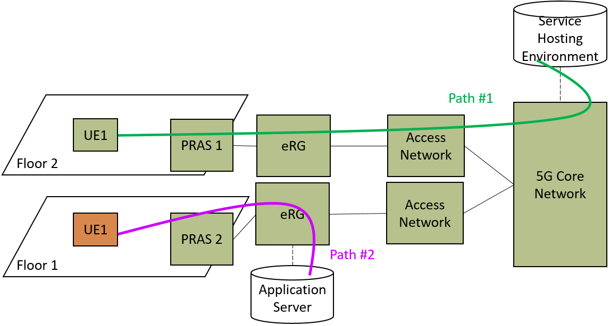

Figure 5.11.1-1. Seamless switching to an Application Server via an evolved residential gateway.

NOTE: The figure is not intended to capture all potential paths that might exist

### 5.11.2 Pre-conditions

A service hosting environment is attached to the 3GPP 5G-CN. An AS connects to the same 3GPP 5G-CN via an eRG. An indoor base station is deployed in the residential environment and is connected to the 3GPP 5G-CN via the eRG. The AS can be either in the MNO domain (i.e. a trusted application) or external to the MNO domain (i.e. an authorized third-party application).

### 5.11.3 Service Flows

We consider a scenario where a given UE, UE1, is receiving a service from a service hosting environment via a Premises Radio Access Station (PRAS 1) connected to the 3GPP 5G-CN. While the UE is enjoying its service, an event occurs that triggers the move of UE1 to an AS (e.g. UE1 arrives home). This AS is connected to the same 5G-CN via an eRG. As this event occurs, it is the expectation of UE1 to continue its service seamlessly with the same QoS albeit through the eRG in the AS. Below we present the service flows:

1. UE consumes a low latency service (e.g. gaming) provided by a service hosting environment through the 3GPP 5G-CN (Path #1). This low latency service has a specific QoS.

2. UE moves to an AS connected to the same 5G-CN via an eRG. The UE connects automatically to the PRAS 2 which in turn is connected to the eRG.

3. The UE continues to receive its service seamlessly and with the same QoS through the eRG in the AS.

### 5.11.4 Post-conditions

The UE service is continued seamlessly through the eRG in the AS and with the same QoS as it was in the service hosting environment. For the purpose of demonstrating the path switch, Path #2 in Figure 5.11.1-1 is an example the 5G System can choose to ensure seamless switching.

### 5.11.5 Existing features partly or fully covering the use case functionality

3GPP TS 22.261 [2] clause 6.5.2 Efficient user plane: Requirements

Based on operator policy, application needs, or both, the 5G system shall support an efficient user plane path, modifying the path as needed when the UE moves or application changes location, between a UE in an active communication and:

- an application in a Service Hosting Environment; or

- an application server located outside the operator’s network.

The 5G network shall maintain user experience (e.g. QoS, QoE) when a UE in an active communication moves from a location served by a Service Hosting Environment to:

- another location served by a different Service Hosting Environment; or

- another location served by an application server located outside the operator’s network, and vice versa.

The 5G network shall maintain user experience (e.g. QoS, QoE) when an application for a UE moves as follows:

- within a Service Hosting Environment; or

- from a Service Hosting Environment to another Service Hosting Environment; or

- from a Service Hosting Environment to an application server located place outside the operator’s network, and vice versa.

The 5G network shall support configurations of the Service Hosting Environment in the network (e.g. access network, core network), that provide application access close to the UE's point of attachment to the access network.

The 5G system shall support mechanisms to enable a UE to access the closest Service Hosting Environment for a specific hosted application or service.

The 5G network shall enable instantiation of applications for a UE in a Service Hosting Environment close to the UE’s point of attachment to the access network.

3GPP TS 22.261 [2] clause 6.7.2: Priority, QoS, and policy control: Requirements

The 5G system shall be able to support E2E (e.g. UE to UE) QoS for a service.

NOTE: E2E QoS needs to consider QoS in the access networks, backhaul, core network, and network to network interconnect.

The 5G system shall be able to support QoS for applications in a Service Hosting Environment.

### 5.11.6 Potential New Requirements needed to support the use case

[PR 5.11.6-001] The 5G system shall be able to provide support for an eRG to interconnect with an Application Server.

[PR 5.11.6-002] The 5G system shall be able to maintain QoS for a UE, when it is moving between a Service Hosting Environment and an Application Server in the CPN that is connected to an eRG.

## 5.12 Use case: local control of connectivity of UEs in a CPN

### 5.12.1 Description

In many residential scenarios, indoor coverage will require deployment of multiple PRASs or WLAN Access Points (APs). It is expected that both 3GPP RATs and non-3GPP RATs (e.g. WLAN) offer wireless connectivity allowing UEs to connect to local or external IP networks via the eRG, thus, as users move through the home, switching of connectivity between different PRASs or APs is required to maintain service quality.

For certain services requiring low latency and high throughput such as playing an interactive game on a VR/AR headset UE, there is a need to connect to a dedicated device within the CPN, for example a gaming console or a set-top-box.

The gaming console will provide the necessary service experience such as reactiveness when computing and rendering a new AR/VR scene displayed on the VR/AR headset (UE #1). In this use case, the gaming console can either be a 3GPP device, a non-3GPP device or support both RATs (3GPP and non-3GPP). The gaming console is part of the CPN.

The VR/AR headset (UE #1) will connect to the gaming console via one of the points of access (PRAS or AP) connected to the eRG.

To guarantee the required bandwidth and latency to the participants in the game, an authorized user e.g. the homeowner (Authorised Administrator) can initially, or dynamically via e.g. the gaming console or the eRG, reserve temporary access or capacity to particular UEs accessing particular PRASs and APs in the CPN during the game. Other UEs that generally are provided access to these PRASs and APs in the CPN, will during the game have a restricted or no access to certain PRASs and APs.

As a player moves around in the home, there will be a need to handover the VR/AR headset (UE #1) connection from one PRAS or AP to another. Although the VR/AR headset (UE #1) can connect simultaneously to an AP and to a PRAS, the VR/AR headset (UE #1) is not able to take educated decisions on its own with regards to capabilities of alternative accesses in the home, e.g. if a candidate handover access is overloaded. However, a centralized application can distribute accesses with respect to relevant applicative parameters like VR/AR headset, the position and the direction of the UE and buffer level. Besides, the centralized application can know the building map and where (e.g. location) the different players are and where they can be expected to move as the game progress.

The game application can also know the overall context for all players and can compute the best path for each UE for connecting to a particular point of access (PRAS or AP). This application can predict and adapt access to each 3GPP RAT or non-3GPP RAT for providing the best global service experience applied to each individual player at each time. The application can also learn from individual service experience resulting from past decisions applied to input parameters to improve access decisions.

To optimise the gaming experience, the gaming console can control which particular VR/AR headset (UE #1 or UE #2) connects to a particular point of access (PRAS #1 or PRAS #2 or AP #1 or AP #2) to reach the application. For example, the gaming console can disable a VR/AR headset (UE #1) to connect PRAS (PRAS #2) in order to force this VR/AR headset (UE #1) to connect to PRAS (PRAS #1).

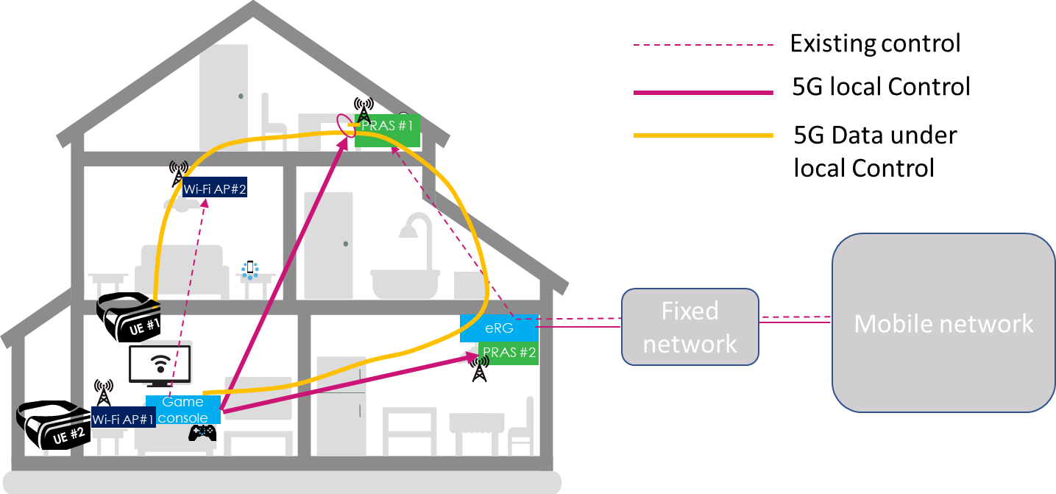

Figure 5.12.1-1. Local control of PRASs for UE #1 to access CPN device

### 5.12.2 Pre-conditions

John and his game player friend Paul wear a 5G-enabled VR/AR headset (UE #1, UE #2). They love to play their favourite immersive game taking place throughout the whole house. The following pre-conditions and assumptions apply to this use case.

* John, as the authorized user, has appropriately configured the devices in his house for the game.
* Multiple PRASs (PRAS #1, PRAS #2) (3GPP RAT) are deployed in John’s home, connected to the eRG.The home is equipped with several WLAN APs (AP #1, AP #2) (non-3GPP RAT), connected to the eRG.
* Game players use VR/AR headsets (UE #1, UE #2) that require low latency and high throughput.
* There is a gaming console in the home providing the expected gaming service experience such as reactiveness when computing and rendering a new AR/VR scene to be display on a VR/AR headset (UE #1, UE #2).
* Game players VR/AR headsets (UE #1, UE #2) can communicate with the gaming console over either of the 3GPP or non-3GPP RATs and the eRG.
* The gaming console contains a map of the house.
* The game play application knows the user locations.

### 5.12.3 Service Flows

The service flow for this use case is as follows:

1. John reserves temporary access or capacity for the relevant devices for the duration of the game;
2. John launches the multi-player augmented reality game from the residential gaming console indicating multi-RAT connectivity;
3. the gaming console communicates with the PRASs and APs to allow to control of the connectivity from the small base station to the gaming console;
4. John and Paul start playing the game from the living-room and power their VR/AR headset (UE #1 and UE #2);
5. each VR/AR headset (UE #1, UE #2) initially connects the gaming console from a suitable PRAS or AP;
6. the gaming console updates the game play each time a player moves indoor and forces the AR/VR headset (UE #1, UE #2) to connect to a particular point of access (PRAS #1 or PRAS #2 or AP #1 or AP #2); and
7. when Paul moves, the gaming console communicates with the PRASs (enable UE #1 on PRAS #1, disable UE #1 on PRAS #2) to force the VR/AR headset (UE #1) to connect to PRAS #1 to reach the gaming console.

### 5.12.4 Post-conditions

John and his friends can move throughout the home, from room to room on all floors, experiencing no latency when their VR/AR headset displays an augmented reality scene.

### 5.12.5 Existing features partly or fully covering the use case functionality

3GPP TS 22.261 [2] clause 6.3.2.1: The 5G system shall be able to support mobility between the supported access networks (e.g. NG-RAN, WLAN, fixed broadband access network, 5G satellite access network).

3GPP TS 22.261 [2] clause 6.3.2.4: The 5G system shall support use of a home base station that supports multiple access types (e.g. 5G RAT, WLAN access, fixed broadband access).

3GPP TS 22.261 [2] clause 6.7.2: A 5G system with multiple access technologies shall be able to select the combination of access technologies to serve a UE on the basis of the targeted priority, pre-emption, QoS parameters and access technology availability.

3GPP TS 22.220 [3] clause 5.5.3: It shall be possible to support service continuity, including handover, between a H(e)NB cell and other cells and between H(e)NB cells. This includes H(e)NB cells in residential and enterprise environment.

3GPP TS 22.220 [3] clause 5.7.2: A H(e)NB subsystem shall be able to support Local IP Access in order to provide access for IP capable UEs connected via a H(e)NB subsystem (i.e. using H(e)NB radio access) to other IP capable entities in the same residential/enterprise IP network.

NOTE: 3GPP TS 22.220 [3] is referred, and it is not clear whether these requirements also apply to 5G.

### 5.12.6 Potential New Requirements needed to support the use case

[PR. 5.12.6-001] The 5G system shall provide means to enable/disable a UE to connect to a Customer Premises Network device via a particular Premises Radio Access Station.

NOTE: Enabling/disabling a UE to a particular PRAS in the CPN does not prevent the UE to connect to other PRASs in the CPN.

[PR. 5.12.6-002] The 5G system shall provide means for an authorized user to prioritize access for a certain UE in a PRAS and CPN, within the limits given by the operator policy.

[PR. 5.12.6-003] The 5G system shall minimize service disruption when a CPN communication path changes between two PRASes.

## 5.13 Use case on IP Traffic offload

### 5.13.1 Description

This use case assumes that one or more Premises Radio Access Stations (PRASs) were deployed in home. The IP traffic via the PRAS can be offloaded towards an external IP network at eRG directly, without going through 5GC, which is depicted in Figure 5.13.1-1. The external IP network can be enterprise private network, or internet.



Figure 5.13.1-1 IP traffic offload by eRG

### 5.13.2 Pre-Conditions

The following pre-conditions and assumptions apply to this use case:

- One or more PRAS were deployed in a residential home.

- The PRAS provides cellular access to UEs.

- The PRAS is connected to an eRG via wireline or wireless link.

- The eRG can support an external IP connectivity.

### 5.13.3 Service Flows

Jim installed a PRAS in his house to improve the quality of experience.

Some friends will come to Jim’s house and play online games with extremely low latency together. Jim’s game experience perhaps declined due to the excessive core network pressure.

The specific IP traffic can be offloaded to the external IP network automatically at eRG when the QoS is detected not meet the requirement in PRAS or eRG.

Jim can configure which types of service are prioritized to be offloaded in the systematic backstage of PRAS or eRG, and the systematic back-stage provides an approach to configure the PRAS or eRG.

### 5.13.4 Post-Conditions

Jim and his friend can enjoy the online game in a forever good user experience.

### 5.13.5 Existing features partly or fully covering the use case functionality

3GPP TS 22.101 "Service principles" [11] specifies the requirements for Selected IP Traffic Offload (SIPTO) for PS Domain only.

3GPP TS 22.220 "Service requirements for Home Node B (HNB) and Home eNode B (HeNB) " [3] specifies the requirements for Selected IP Traffic Offload (SIPTO) at Local Network.

3GPP TS 23.501 "System architecture for the 5G System (5GS) stage 2" [4] specifies the concept of "UL CL" (Uplink classifier) and BP (Branching Point). UL CL is a functionality supported by an UPF that aims at diverting (locally) some traffic matching traffic filters provided by the SMF, and BP provides forwarding of UL traffic towards the different PDU Session Anchors and merge of DL traffic to the UE i.e. merging the traffic from the different PDU Session Anchors on the link towards the UE.

### 5.13.6 Potential New Requirements needed to support the use case

[PR. 5.13.6-001] The 5G system shall be able to support IP traffic offload in CPN.

NOTE: The priority of offload can be from default configuration, network or user.

## 5.14 Use case on PRAS sharing

### 5.14.1 Description

This use case assumes that one or more Premises Radio Access Stations (PRASs) were already deployed in home. The mobile phones of family members or the visitors, which have different subscriptions to operators, need access to the 5GC via the deployed PRAS(s).



Figure 5.14.1-1 PRAS sharing

### 5.14.2 Pre-Conditions

The following pre-conditions and assumptions apply to this use case:

- One or more PRAS were deployed in a residential home.

- The PRAS provides cellular access to UEs.

- The PRAS is connected to an eRG via wireline or wireless link.

- The mobile phones of family members or the visitor have individual subscriptions to the 5G system, and these subscriptions may be different operators.

Jim has a home connectivity service subscription and a 5G subscription on his mobile phone with Network Operator MNO1 and his wife, Alice, has a 5G subscription with MNO2.

### 5.14.3 Service Flows

Jim’s smart phone is connecting to the PRAS and Jim can enjoy the internet service via MNO1’s core network.

Alice has no roaming subscription with MNO1, so she only accesses the internet service via MNO2’s core network.

Jim can enter the systematic backstage of PRAS to manage the MNOs that policy allowed access. He adds the MNO2 to the PRAS system, and the provisioning for PRAS and eRG can be completed automatically.

### 5.14.4 Post-Conditions

Alice could enjoy the internet service on her mobile phone via PRAS with MNO2’s core network.

### 5.14.5 Existing features partly or fully covering the use case functionality

3GPP TS 22.101 "Service principles" [11] specifies the requirements for RAN sharing enhancements.

### 5.14.6 Potential New Requirements needed to support the use case

[PR. 5.14.6-001] The 5G system shall be able to support PRAS sharing between multiple PLMNs.

## 5.15 Use case multicast service access control for legacy device(s) behind an eRG

### 5.15.1 Description

Multicast service access control is performed at 5GC, which is a mechanism to judge whether an UE is allowed to join a multicast group and receive the corresponding multicast service. When a UE requests to obtain multicast services, it sends an IGMP/MLD Join message to 5GC. When receiving the IGMP/MLD Join message, 5GC checks whether the UE is allowed to join the requested multicast group based on multicast service access control information. If the UE is allowed to join the requested multicast group, 5GC will transmit the corresponding multicast service to the UE. Otherwise, the UE is not allowed to receive the requested multicast service.

IPTV service, a kind of multicast service, is defined as multimedia services such as television/video/ audio/text/graphics/data delivered over IP-based networks managed to support the required level of QoS/QoE, security, interactivity and reliability. Set Top Box (STB) is a legacy device used to obtain IPTV service via an eRG, which is connected to 5GC as shown in Figure 5.x.1-1. Currently, the IPTV network access control granularity is RG level, which means that all STBs behind a RG will share the same access right. If network can perform a more granular multicast service access control when multiple devices connect to an eRG, users might have a better service experience.

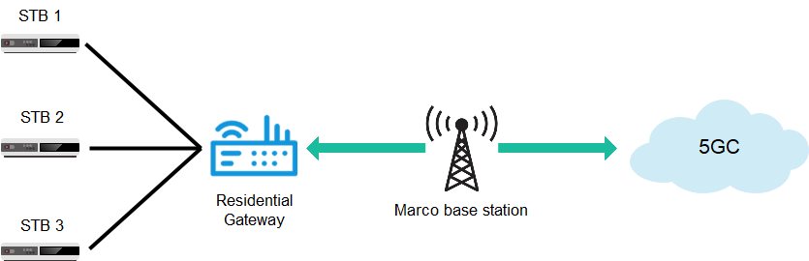

Figure 5.15.1-1: STB obtaining IPTV services via residential gateway

### 5.15.2 Pre-conditions

Mary would like to subscribe to IPTV service which is provided by IPTV network operated by IPTV operators. She needs to buy an eRG and a STB that are placed at home. The eRG is used to connect to the 5GC, while the STB is a legacy device used to obtain IPTV service via the eRG.

Mary has two children, who are Jack and David. Jack is a 5-year-old boy, while David is a 14-year-old teenager. Both of them have their own bedrooms.

### 5.15.3 Service Flows

Mary desires to place one STB in each bedroom so that she and her sons can enjoy IPTV services in their own bedrooms simultaneously. Moreover, she hopes that the STB in each bedroom can obtain different IPTV service according to their hobbies. Therefore, she bought another two STBs which are going to be placed in her sons’ bedrooms.

For the STB placed in Jack’s bedroom, Mary prefer to subscribe some cartoon IPTV channels because Jack loves watching cartoon. For the STB placed in David’s bedroom, Mary prefer to subscribe some movie IPTV channels because David is a big fan of movie. As for Mary, she prefers to subscribe to news IPTV channels. Additionally, Mary wishes to restrict both Jack and David from watching IPTV channels with violent content.

Mary requests the customised IPTV network access control for her user account to IPTV network operator.

IPTV network operator updates the IPTV service access control information to 5GC according to the request from Mary so that 5GC can perform different IPTV service access control for each of the STB.

### 5.15.4 Post-conditions

Mary, Jack and David can enjoy their favourite IPTV channels simultaneously. Moreover, Mary does not need to worry that her sons are exposed to violent content.

### 5.15.5 Existing features partly or fully covering the use case functionality

3GPP TS 23.316 [7] clause 4.9.1 and clause 7.7.1 mention that:

- The support of IPTV services at 5GC: "The SMF controls the support of IPTV by the UPF acting as PSA using PDR, FAR, QER, URR";

- In the case of IPTV network access control based on the DHCP procedure, 5G-RG may be configured to retrieve via DHCP the IP address that it will use to access IPTV services.

- When the SMF receives the Uplink DHCP message, the SMF may be configured to insert the IPTV access control information as received in subscription data from UDM to the uplink DHCP message.

In Release 16 5WWC, the existing feature of multicast service access control is UE/RG level granularity. Therefore, 5GC does not support to perform different multicast service access control for legacy devices behind a RG.

### 5.15.6 Potential New Requirements needed to support the use case

[PR. 5.15.6-001] The 5G system shall support multicast service access control based on eRG subscription that enables eRG to forward authorized multicast services to multiple non-3GPP devices behind the eRG.

NOTE: The multicast services that each of multiple non-3GPP devices is allowed to access may be different.

## 5.16 Use case on the connection of 5G LAN with fixed IP VPN

### 5.16.1 Description

This use case intends to make use of the 5G capabilities (e.g., high performance, long-distance access, mobility and security) to build a secure connection between the 5G LAN and the fixed IP VPN. For example, when people are working from home, they probably need to access the enterprise’s intranet by using the devices connecting to the home 5G LAN. The connection of 5G LAN with fixed IP VPN aims to enable the devices within the 5G LAN to access the intranet through the fixed IP VPN.

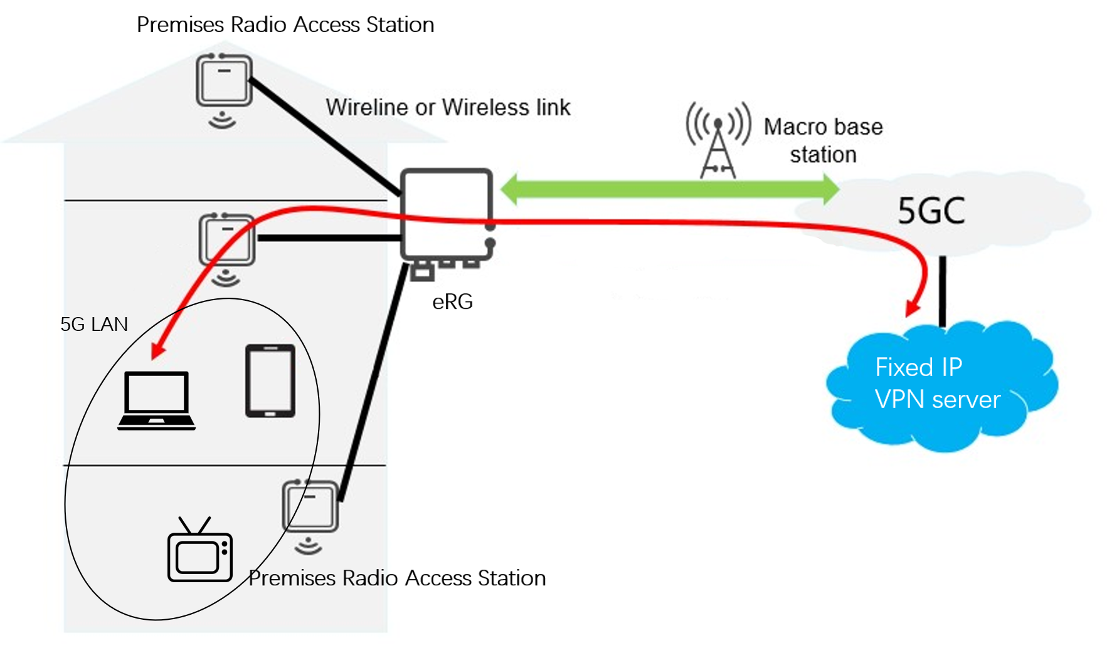

Figure 5.16.1-1: connection of 5G LAN with the fixed IP VPN

### 5.16.2 Pre-conditions

The following pre-conditions and assumptions apply to this use case:

- There are multiple 5G UEs within a 5G LAN-VN at home.

- There is a fixed IP VPN server deployed by the enterprise for intranet connection.

### 5.16.3 Service Flows

1. John works for company Tree and John is working from home.

2. John has a subscription to the 5G LAN services. John adds all the available devices (e.g., mobile phone, laptop, tablet, printer) in his house to the 5G LAN-VN.

3. John needs to access up-to-date data from his company’s intranet and has an e-meeting with his colleagues.

4. John uses his laptop to build a connection to Tree’s intranet through the fixed IP VPN.

5. John can access the intranet through the VPN server and he can also access the devices within the 5G LAN.

6. John sends a request to the VPN server for authorization for his mobile phone and tablet as trusted devices for intranet access through his laptop.

### 5.16.4 Post-conditions

While having the e-meeting with the colleagues using his phone, John can access the up-to-date data using his mobile phone or laptop or any other authorised devices connected to the home 5G LAN. John can also exchange files or data within the home 5G LAN.

### 5.16.5 Existing features partly or fully covering the use case functionality

The 5G system supports the interconnection of a UE with a fixed IP VPN.

3GPP TS 22.261 [2] Section 6.26.2.2 "5G LAN-virtual network (5G LAN-VN) "

There are existing features that support the on-demand establishment of UE to UE, multicast, and broadcast private communication between members UEs of the same 5G LAN-VN. Multiple types of data communication shall be supported, at least IP and Ethernet.

A 5G system shall support 5G LAN-VNs with member UEs numbering between a few to tens of thousands.

### 5.16.6 Potential New Requirements needed to support the use case

[PR. 5.16.6-001] The 5G system shall support interconnection of a 5G LAN-Virtual Network (5G LAN-VN) with a fixed IP VPN.

Editor’s Note: This requirement may need to be further studied.

## 5.17 Use case on loss of connectivity between eRG or PRAS and 5GC

### 5.17.1 Description

When a UE under a PRAS coverage, whose communication path remains within the home, is either:

- using an application server on e.g. an eRG or a compute and storage resource in the home; or

- communicating with another UE or non-3GPP device within the home, as described in clauses 5.4 and 5.5.

The use case considers what happens if the eRG or PRAS loses its connectivity with the 5GC.

### 5.17.2 Pre-conditions

- The user is using a client application on her UE.

- The UE is connected via a PRAS to an application server available on the eRG.

### 5.17.3 Service Flows

The connectivity between the eRG and the 5GC is lost, which is detected by the eRG.

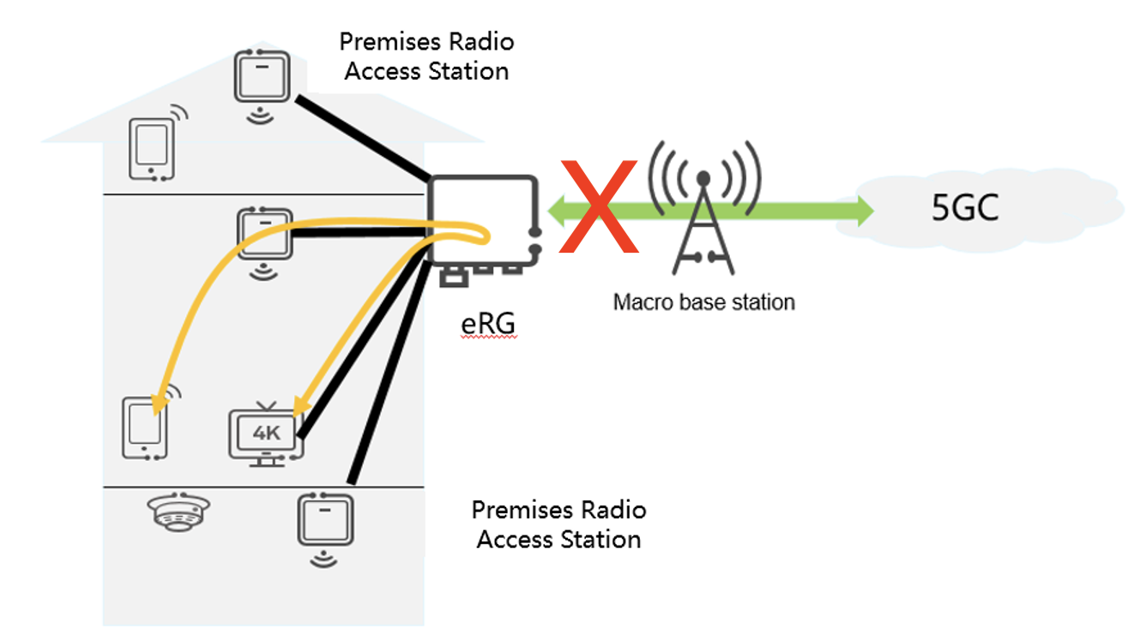

Figure 5.17.1-1: Loss of connectivity between eRG and 5GC

### 5.17.4 Post-conditions

The user experiences no interruption with her application, as it is using an application server on the eRG. However, she can no longer use her UE for communications via 5GC.

### 5.17.5 Existing features partly or fully covering the use case functionality

There are existing features and requirements that cover a similar scenario to the case where the connectivity between eRG or PRAS and the 5GC is lost.

From a Home (e)Node B perspective, a requirement in 3GPP TS 22.220 [3] clause 5.2 states:

*If the connection between H(e)NB and the rest of the operator network is out of service, then it shall be possible within an operator’s defined time period for the H(e)NB to deactivate the air-interface.*

From an Isolated E-UTRAN operation for public safety (IOPS) perspective, 3GPP TS 22.346 [12] supports the scenario with no backhaul with a *Fully Isolated E-UTRAN operation using local routing of UE-UE data traffic.*

From 3GPP TS 22.346 [12] clause 5.3.2:

*An eNB supporting Isolated E-UTRAN operation shall be able to detect a loss of backhaul connection and shall be able to initiate Isolated E-UTRAN operation.*

This feature is intended to be used for public safety purposes with public safety UEs.

Rel-16 IAB as defined in 3GPP TS 38.331 [13] can provide coverage even if connection to parent node is lost, as there are no mechanisms to disable IAB nodes from continuing to transmit if the connection to the parent node is lost. The latest agreement from RAN2#109bis is that IAB-DU behaviour after RLF declaration is left up to implementation. IAB-DU should be able to send RLF notification when RLF recovery fails.

For the detection of loss of connection between the CPN and the wider 5G network (core network), it is expected that this is based on the normal operation of the entities in the CPN that rely on co-ordination with the 5G network. Therefore, a new requirement is not needed to cover this case.

For the case where eRG is routing local communications within the CPN, if the connection between the CPN and the wider 5G network (core network) is lost, this requirement is covered within BBF specifications.

### 5.17.6 Potential New Requirements needed to support the use case

[PR. 5.17.6-001] void

[PR. 5.17.6-002] void

[PR. 5.17.6-003] When the CPN has lost connectivity with the 5G network, the 5G system shall provide an operator-controlled mechanism to enable:

- in the default configuration, or under certain conditions configured by the operator, the PRAS radio interface shall be deactivated; and

- under certain other conditions configured by the operator, the CPN shall continue existing intra-CPN communication, as long as no interaction with the 5G network is needed (e.g. refreshing security keys).

NOTE 1: The requirement above relates to intra-CPN operations and subject to operator policy and control, under certain situations.

NOTE 2: Setting up new intra-CPN communication sessions without CPN connection to the 5G network is only possible with non-3GPP provided credentials

## 5.18 Control of Customer Premises Network by Authorised Administrator

### 5.18.1 Description

The Customer Premises Network (CPN), including the eRG and PRAS, is at least owned, configured and managed by the customer of a public network operator. This implies that the public network operator is at least not fully in control of the configuration and management of the eRG, PRAS and CPN.

Some aspects of the eRG and PRAS can be under control of the public network operator. For example if the PRAS uses licensed frequencies the radio configuration will be under control of the PLMN. Another example could be network settings in the eRG for the interface to the 5G core network.

Other settings are configured / managed by the 'customer of the public network operator'. It is proposed to specify more clearly how this configuration and management by the 'customer of the public network operator' works. We are proposing to define the role of an Authorized Administrator. The Authorized Administrator may be authorized to configure / manage a specific node (e.g. a specific PRAS, eRG), or may be authorized to configure / manage a specific customer premises network (including one or more eRGs and/or PRASs).

### 5.18.2 Pre-conditions

None

### 5.18.3 Service Flows

Joe is installing a new Customer Premises Network in his home.

First thing, Joe installs is the eRG, in this case a wireline eRG. He has obtained the eRG from the operator and now connects it to the fixed access line.

The fixed operator has arranged that various setting in the eRG are automatically configured (e.g. using TR-069 management).

The eRG also enables Joe to configure a username / password combination that Joe can use for configuration / management of settings that are not under operator control from any device within the CPN. With this username / password, Joe is now Authorized Administrator for the eRG.

The public network operator also provides a service where Joe as Authorized Administrator can manage his eRG via a webpage (Ut interface) provided by the operator. Great aspect of this webpage is that the operator provides help with configuration. Joe is not exactly a network expert. Additionally, Joe can also manage his PRAS via a local webpage, on which some default configuration (e.g. password for the visitor accessing network via the PRAS) can be configured.

Joe now connects more devices (e.g. media server, home controller, printer, etc) to the eRG. Within the Customer Premises Network, devices can automatically discover what services other devices may provide (e.g. printer) using existing service discovery mechanisms (UPnP, zero config). Joe wants some of these services to be available also to devices that are connected to the PLMN. As Authorized Administrator of his 5GLAN service Joe can add his eRG to his 5GLAN VN group. Joe now configures which of the services from the devices on the CPN should be exposed to UEs on the PLMN. A specific service that Joe configures to be available for UEs on his 5GLAN is the configuration of his eRG.

Now Joe connects a PRAS to the eRG. Joe has obtained credentials for the PRAS from the PLMN. During installation the PRAS connects to the PLMN to obtain the settings under control of the operator (e.g. radio settings).

Joe can also log on to the PRAS using credentials (e.g. username / password) that were supplied with the PRAS. Using these credentials, Joe can configure settings of the PRAS via devices on the CPN. An example is that Joe can set whether visitor access network via his PRAS is allowed (allowing all or no visitors, or allowing specific visitors only). Joe can also use a webpage provided by his PLMN to configure his PRAS.

### 5.18.4 Post-conditions

Joe is Authorised Administrator of his Customer Premises Network, including PRAS and eRG. Joe can configure and manage the devices and services on his CPN from anywhere in the CPN and also from UEs that are connected to his 5GLAN VN Group.

### 5.18.5 Existing features partly or fully covering the use case functionality

Configuring nodes such as an eRG or PRAS is widely supported functionality.

Service discovery within a Customer Premises Network (e.g. UPnP, zero config, or proprietary protocols) is existing functionality.

Management of fixed eRG settings by an operator are specified by BBF in TR-069.

### 5.18.6 Potential New Requirements needed to support the use case

[PR 5.18.6-001] The 5G system shall enable configuration and management of an eRG by both the operator of the public (mobile) network the eRG is connected to and, within the boundaries defined by the operator, by an Authorised Administrator.

[PR 5.18.6-002] The 5G System shall support PRAS that use licensed spectrum, use unlicensed spectrum, or can use both unlicensed and licensed spectrum.

[PR 5.18.6-003] The 5G system shall enable configuration and management of a PRAS by a PLMN and, within the boundaries defined by the operator, by an Authorised Administrator. Specifically the PLMN shall be able to configure:

- radio settings pertaining to licensed spectrum shall be configured by the PLMN that owns the spectrum.

Specifically the Authorised Administrator shall be able to configure:

- Whether visitor access network via the PRAS is allowed (allowing all or no visitors, or allowing specific visitors only)

## 5.19 Use case: eRG supporting Multiple connectivity

### 5.19.1 Description

This use case is depicted in Figure 5.19.1-1. It shows the scenario where an eRG can support both wireline connection and 5G NR wireless connection simultaneously.



Figure 5.19.1-1: eRG supporting both wireline connection and 5G wireless connectivity

### 5.19.2 Pre-conditions

Lily moved into her new home and got IPTV service combined with internet. The IPTV providers offers 2 eRG solutions, just cable or cable with wireless. Cable provides an order magnitude higher speed but Lily has heard sometimes lot of people use the internet in the evenings and it crashes so she chooses for the one with cable access and the additional wireless capability as the wireless service can both compliment the cable and either can act as a backup in case one fails. The IPTV provider also supports the download of a media server onto the eRG to enable localized access to popular contents that Lily and her family watches often but at different times. The contents have an expiration for when it will be removed from the media server, but Lisa has the option to extend the expiration. The media server also supports streaming live high definition pay-per-view events and is able to utilize both wireless and cable accesses to meet the required QoS. Lily also has a home security alarm system. She is able to configure the eRG so the security alarm system can use the cable access as the primary access and the wireless access as the backup access. In addition, she also has IoT devices such as cameras, window and door sensors, humidity and temperature sensors, etc. Some of the IoT devices do not have subscription for cellular access and the wireless operator can configure the eRG to block traffic from those devices from being routed onto the cellular access.

Lily’s friend Lisa owns a small business and also employs an eRG that supports both cable and wireless access connectivity. The eRG not only provides communication path redundancy for the business but also network management services for the devices behind the eRG. Lisa is able to configure the eRG so that the security system uses the cable access as the primary access and the wireless access as the backup access. In addition, Lisa has requested from the wireless operator a firewall function that runs on the eRG to provide network security for the business. Both Lisa and the wireless operator are able to configure the firewall for different aspects of the firewall operations. Lisa is able to configure firewall rules while the wireless operator is able to configure and manage the orchestration and update of the firewall software in the eRG.

### 5.19.3 Service Flows

Home eRG:

1. Lily was watching TV at home, wherein the eRG used wireline connection for service.

2. there was an accident in the building, the wireline was destroyed or partially destroyed. There is a lot of commotion outside with people complaining they have no service.

3. eRG detects that the wireline was out of service or the data rate of wireline connection become very low.

4. eRG turns on the wireless work mode and optional may provide an indication on TV screen that now cable works in multiple connection mode.

5. The IPTV provider automatically downloads popular content Lily and her family watches to the media server when new content becomes available.

6. Lily and her family watch the contents at different times without any service interruption.

7. Lilly’s husband and son like to watch professional wrestling and enjoy the live stream of pay-per-view events in high definition.

Business eRG:

1. The wireline network experiences a temporary failure where no connectivity is available for the eRG.

2. The security system sends a normal communication to the cloud server to the eRG.

3. The eRG detects the wireline access is not available and forwards the security system communication to the wireless access.

4. The firewall function monitors all traffic entering the eRG through the wireless and wireline accesses.

5. Lisa is unable to perform a download from a certain site that she knows is trustworthy and discovers the firewall function is blocking the download. Lisa configures the firewall to allow the download for this one instance only and the downloads proceeds.

6. Meanwhile, a security patch for the firewall software is available and the wireless operator informs Lisa of its availability.

7. Lisa schedules the update for a time when the business is close to minimize interruptions.

### 5.19.4 Post-conditions

Lily could continue to watch TV while the people in the same building lose IPTV service combined with internet.

Lily’s husband and son enjoys live stream of professional wrestling without interruption since the media server is able to use both wireless and cable accesses.

The eRG is configured to not send unauthorize traffic onto the cellular access.

Lisa is able to protect her business network by configuring rules for the firewall while leaving the maintenance of the firewall software to the wireless operator.

### 5.19.5 Existing features partly or fully covering the use case functionality

3GPP TS 22.261 [2] clause 6.3.2.4 Fixed broadband access

The 5G system shall support use of a relay UE that supports multiple access types (e.g. 5G RAT, WLAN access, fixed broadband access).

NOTE 1: This is for a UE that uses indirect connection to communicate with the network. It does not cover an eRG that uses direct network connections.

The 5G system shall support use of a home base station that supports multiple access types (e.g. 5G RAT, WLAN access, fixed broadband access).

NOTE 2: It is unclear whether concurrent access is allowed. It is also unclear if this is applicable to an eRG.

3GPP TS 23.316 [7] may include support for the hybrid access by RG.

### 5.19.6 Potential New Requirements needed to support the use case

[PR 5.19.6-001] The 5G system shall support use of an eRG that is connected to the 5G Core Network over 5G fixed wireless access, fixed broadband access or hybrid access.

NOTE: When related to 5G-RG [PR 5.19.6-001] is fullfilled and [PR 5.19.6-002] does not apply.

[PR 5.19.6-002] The 5G system shall support a mechanism for the network operator to provide policies to the eRG on which transport (e.g. wireless, cable, etc.) is best suited for different services.

## 5.20 Providing 5G Multicast-Broadcast Services (5MBS) for devices through eRG.

### 5.20.1 Description

Broadcast/Multicast services in 5GC (5MBS) are available, potentially limited by a given service area.

A user can receive such a service either outdoor or at home.

The MNO wants to keep the benefits of multicast/broadcast distribution for in-home access. When at home, the user device (Smartphone, TV set, STB, PC, tablet…) can receive the service through the eRG. The device may be a 3GPP UE connected via a PRAS or the CPN access (e.g. Wi-Fi), or a non-3GPP device connected via the CPN access.

### 5.20.2 Pre-conditions

To enable this use case, following pre-conditions should be met:

1. The eRG is 5G multicast/broadcast capable.
2. The user is at home.
3. The user device is able to connect to the eRG.

### 5.20.3 Service Flows

a) The device connects to the eRG.

b) The eRG discovers the available 5G multicast/broadcast services (if not yet discovered).

c) The user selects one of the available 5G multicast/broadcast services.

d) The eRG connects to the 5GC to be provisioned with the selected broadcast/multicast service.

e) The eRG serves the received broadcast/multicast content to the device through the Customer Premise Network.

### 5.20.4 Post-conditions

The user is able to consume the selected broadcast/multicast service at home through the connection to the eRG.

### 5.20.5 Existing features partly or fully covering the use case functionality

Features described in 3GPP TS 22.146 [8] are all relevant for devices behind the residential gateway. However, this specific configuration is not explicitly considered, with the exception of clause 4.2.1:

- 3b) As an alternative, the Home Environment can join the user to the selected multicast group on behalf of the user, that has previously subscribed to this multicast group.

Related aspects for this use case from 3GPP TS 22.261 [2]:

Clause 6.3 Multiple access technologies:

- For optimization and resource efficiency, the 5G system will select the most appropriate 3GPP or non-3GPP access technology for a service,

- Based on operator policy, the 5G system shall enable the UE to select, manage, and efficiently provision services over the 3GPP or non-3GPP access.

- The 5G system shall be able to efficiently support connectivity using fixed broadband access.

- The 5G system shall support use of a relay UE that supports multiple access types (e.g. 5G RAT, WLAN access, fixed broadband access).

- The 5G system shall support use of a home base station that supports multiple access types (e.g. 5G RAT, WLAN access, fixed broadband access).

Clause 6.9 Connectivity models:

- The UE (remote UE) can connect to the network directly (direct network connection), connect using another UE as a relay UE (indirect network connection), or connect using both direct and indirect connections. Relay UEs can be used in many different scenarios and verticals (inHome, SmartFarming, SmartFactories, Public Safety and others). In these cases, the use of relays UEs can be used to improve the energy efficiency and coverage of the system.

Related aspects for this use case from 3GPP TS 22.246 [9]:

- The user should be able to receive MBMS user services via generic IP access systems.

5.20.6 Potential New Requirements needed to support the use case

[PR.5.20.6-001] The 5G system shall provide means to deliver 5G multicast/broadcast services to an eRG.

[PR.5.20.6-002] Under operator control, an eRG shall be able to receive multicast/broadcast services from its access network.

NOTE: The access network can be wireless or wireline.

[PR.5.20.6-003] Under operator control, an eRG, shall be able to efficiently deliver 5G multicast/broadcast services to authorized UEs and non-3GPP devices in the CPN.

## 5.21 Identification, Authentication, and Authorization for Premises Radio Access Stations

### 5.21.1 Description

To ensure providing the secure connectivity for UEs connected to 5G network via Premises Radio Access Stations (PRAS) behind eRG, this use case illustrates the need to have 5G system support for identification, authentication, and authorization of a PRAS which is not provided by the operators and has not previously been provided with credentials.

The use case is to ensure that there is 3GPP mechanism to protect the weak-link between these (assuming untrusted) PRAS(es) not provided by the operators and the eRG.

### 5.21.2 Pre-conditions

Alicia purchased a promotion deal from her smartphone’s operator Wallowa to upgrade her home network with a bundle package including one eRG and one PRAS-A. When receiving both devices, Alicia installed the eRG and PRAS-A in the second floor and connected both via wireline. Alicia powered on both devices. Both devices register to the 5G network and are provisioned with configuration of operation settings and authorizations from the 5G network. Both eRG and the PRAS-A are up and running well to provide 5G coverage in Alicia’s home.

Later, Alicia found there were still some coverage holes in the corner of the first floor so she decided to purchase one PRAS-B which is not provided by the operator and has not previously provided with credentials which thus considered as untrusted devices for the operator’s network.

When returning home, Alicia logs on to her account on Operator Wallowa's portal to upgrade the eRG subscription for allowing connecting this PRAS-B and then add this PRAS-B by configuring the device settings manually or via scanning QR code of the PRAS-B and associating it to the trusted 3GPP device, eRG, which it will be connected with tethering connection. Alicia may e.g. use an application on her smartphone to assist in selecting the correct eRG to connect to and/or to set up the initial connection between the PRAS and the eRG, to avoid the PRAS to connect to the neighbor’s eRG and to make it easier to perform the initial setup.

Alicia installed the PRAS-B in the first floor and connected the PRAS-B to 5G network via operator’s eRG.

### 5.21.3 Service Flows

1. Alicia turns on the PRAS-B and connects the PRAS-B to the eRG. The PRAS-B connects to 5G network via the eRG. The 5G system detects that PRAS-B has not previously been provided with credentials and then provision a credential to the PRAS-B which may be based on eRG subscription or PRAS subscription if available. Operator Wallowa’s 5G network identifies, authenticates, and authorizes the PRAS-B based on the credentials provided to the PRAS.

2. The 5G network provisions configurations, e.g. PRAS operation authorization, operator’s settings, etc., to the PRAS via eRG.

3. When the PRAS-B completes installation, it reconnects to Operator Wallowa's 5G network via eRG based on provisioned PRAS-B configuration.

4. The Operator Wallowa’s 5G network can identify PRAS-B, authenticate its identity, and authorize the PRAS-B operation based on the provisioned credentials and configuration of the PRAS-B.

5. Once this process is complete, the PRAS-B is successfully authenticated, authorized, configured, and connected to Operator Wallowa’s network via eRG and are now fully operational.

### 5.21.4 Post-conditions

The 5G network ensures that the E2E connection from the 5G core network to the UE connected to the operator’s PRAS-A and the PRAS-B behind eRG are secure because both PRAS(es) connected via operator’s eRG are authenticated, authorized, and managed by the operator.

Alicia can now connect her UEs to both PRAS(es). She is happy that she can speak to the phone when walking around the house with good 5G service coverage.

### 5.21.5 Existing features partly or fully covering the use case functionality

The following service requirement in 3GPP TS 22.101 [11] clause 26a provide the principle for user centric identifiers and authentication and authorization by the 3GPP system:

*The 3GPP System shall support operators to act as User Identity provider and to authenticate users for accessing operator and non-operator deployed (i.e. external non-3GPP) services.*

In the 3GPP TS 22.101 [11] clause 26a, the 5G network operator can act as an identity provider for Users, e.g. an individual human user, using a UE with a certain subscription, or an application running on or connecting to a UE, or a device ("thing") behind a gateway UE. These Users are associated to the 3GPP devices (UE or gateway UE) which are 5G subscribers of the operator’s network. The 5G network can identify and authenticate a User Identity based on the authenticated 3GPP device that is associated to the user. In the context of CPN, the 5G network can also enable support for identifying and authenticating an PRAS which is not provided by the operator and does not have 3GPP credentials based on the authenticated 3GPP device (eRG) that provides tethering connection.

### 5.21.6 Potential New Requirements needed to support the use case

[PR 5.21.6-001] The 5G system shall provide support for a network operator to authenticate a PRAS.

[PR 5.21.6-002] The 5G system shall provide support for a network operator to authorize a PRAS for its use in a CPN.

[PR 5.21.6-003] The 5G system shall support a secure mechanism for a network operator to provision a PRAS with an associated subscription and authentication credentials, and to identify a PRAS (e.g. for management purposes or to provide backhaul connectivity to the PRAS).

Editor’s Note: This requirement is FFS.

[PR 5.21.6-004] The 5G system shall provide mechanisms for the network operator to provision an authenticated PRAS with operation settings, e.g. carrier frequencies.

## 5.22 Use Case for supporting external services behind eRG in CPN

### 5.22.1 Description

According to 3GPP TS 22.101 [11] clause 26a, the 3GPP system can support an operator to act as identity provider and enable auto-log-in and single-sign-on to operator and non-operator services. This use case is extended from the use case 5.2, Identity provisioning to external services, in 3GPP TR 22.904 [10] which considers the applications are hosted in the cloud.

In support of external services provided behind an eRG in CPN, this use case describes the enhancement of functionalities and provides the potential service requirements in addition to those described in [11].

### 5.22.2 Pre-conditions

Dora is a subscriber of network operator Cannon-Beach where she has a user account and subscriptions for her UE and the eRG in the CPN. Based on the subscriptions for the eRG, operator Cannon-Beach enables a strong user authentication mechanism at the 5G system to ensure that the users accessing to the eRG in the CPN are authenticated and authorized.

Dora installs a local cloud with the application platform on a device connected to the eRG in the CPN in her home. The local cloud provides storage services for files, video, and photo album, etc. Dora configures applications/services information and registers to these applications with her user account of the network operator Cannon-Beach for the local cloud storage services hosted on the device behind the eRG in the CPN, by which each application/service is associated to a User Identity and corresponding User Profiles.

When enabling these applications/services in her user account, these services/applications can use strong user authentication from the 5G system to the applications running on the device behind the eRG in the CPN. As such, auto-log-in and single-sign-on is enabled for the applications.

### 5.22.3 Service Flows

Step1: Dora logged in her user account using her UE and her User Identity has been authenticated over the 5G system using a strong authentication mechanism for the connection to the eRG.

Step2: Dora opens a book on the bookshelf application hosted by the local cloud on the device behind the eRG for which the bookshelf application has been configured to require strong user authentication by the 5G system.

Step3: The bookshelf application accepts her request to access without further needs for Dora to provide additional credentials for the application. Since her UE has been authenticated by the 5G system and she has already been authenticated for the connection to the eRG, there is a high level of confidence regarding her identity. This level of confidence is increased based on Dora’s location and the elapse time from the last authentication of her identity.

Step4: In the meantime, the application client of photo album on her UE automatically synchronize her photos to the photo album application on the local cloud in the CPN. Since Dora also enabled the strong user authentication by the 5G system for this photo album application, her UE can automatically sign in and upload the photos to the photo album application on the local cloud.

Step5: The 5G system may request her strong re-authentication so as to ensure that she is still the actual authorized user behind the UE, which is achieved by having Dora re-authenticated by operator Cannon-Beach, e.g. over the biotech sensors (e.g. for face, fingerprint, voice) of the UE.

### 5.22.4 Post-conditions

Because of operator’s supports for non-operator services on the local cloud in the CPN and the support of strong user authentication by the 5G system, Dora is worries free to install more applications hosted by the local cloud on the devices connected to the eRG in the CPN in her home.

### 5.22.5 Existing features partly or fully covering the use case functionality

The following service requirement in 3GPP TS 22.101 [11] clause 26a provide the principle for user centric identifiers and authentication and authorization by the 3GPP system:

*The 3GPP System shall support operators to act as User Identity provider and to authenticate users for accessing operator and non-operator deployed (i.e. external non-3GPP) services.*

26a.2.1 User Identifiers and user authentication

*The 3GPP system shall be able to assess the level of confidence in the User Identity by taking into account information regarding the used mechanism for obtaining that User Identity (e.g. algorithms, key-length, time since last authentication), information from the network (e.g. UE or device in use, access technology, location).*

26a.2.5 Privacy requirements

*The 3GPP system shall protect the privacy of the user by transferring to a service only User Identity information that is necessary to provide the service and for which the user has consented to when registering for the service.*

The use case considers that the external services are provided as a local cloud application platform behind an eRG in CPN and proposes to enable 5G system support for identity provisioning to external services behind eRG in CPN.

### 5.22.6 Potential Requirements

[PR 5.22.6-001] The 5G system should support "User Identity" requirements (as defined in 3GPP TS 22.101 [11] clause 26.a) for a user (human) using a CPN authorized UE to access external non-3GPP applications/services hosted in a CPN (behind a eRG).

[PR 5.22.6-002] The 5G system shall support to allow a CPN authorized UE or non-3GPP device accessing to a CPN based on successful User Identity authentication.

# 6 Traffic Scenarios

## 6.1 Traffic Scenario: inHome

### 6.1.1 Description

Many houses suffer from problems of coverage due to the number of floors and other obstacles (i.e. walls, doors, columns, furniture). Outdoor-to-indoor coverage may be an issue at 3.5 GHz and will certainly be difficult at mmwave frequencies. Providing coverage with indoor solutions may be the answer; Premises Radio Access Stations (PRASs) can be connected via fixed access. 3GPP together with BBF has provided Wireline Wireless Convergence architecture solutions where fixed access is considered part of the 5G System.

Most houses have only one entry network point where the evolved Residential Gateway (eRG) will be installed. Connectivity to the eRG may be fixed access, 5G Fixed Wireless Access, or a hybrid of both.

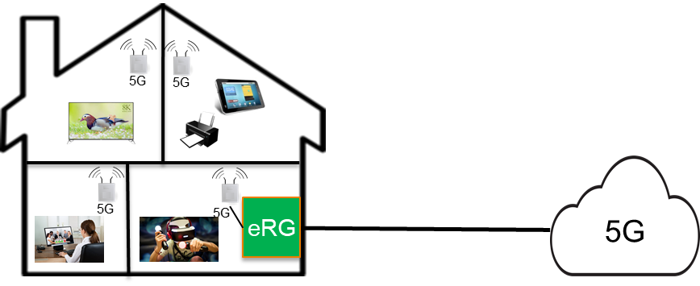

Figure 6.1.1-1 – InHome Scenario

Providing connectivity throughout the house from a single PRAS will not be feasible. Concrete floors and walls, will require multiple PRASs to be deployed in the house. That way it can be guaranteed that even in the attic, cellular and garage, there is sufficient coverage. At mmwave frequencies, even a PRAS per room (living room, kitchen, bed rooms, attic) may be required as higher frequencies will be blocked significantly by walls, et cetera.

### 6.1.2 Assumptions

Let’s consider a fairly large house with dimensions 10m x 10m and 3 floors. The owners of the house are a family of four; mother, father and two teen age children.

The traffic scenario for in the house is mainly determined by multimedia application usages. Most other services (e.g. mobile telephony) will not significantly contribute to the traffic load.

We assume the house has two UHD TVs, two VR headsets for gaming, and two office settings for working from home (for e.g. multimedia conferencing). Not all devices will be used at the same time. On the other hand, visitors may also bring/use devices. Assumption is that one UHD TV, two VR headsets for gaming and two office settings are used simultaneously, each at the maximum user experienced data rates of 1 Gbit/s DL and 500 Mbit/s UL. This results in an overall capacity for the house of 5 Gbit/s DL (UHD TV is DL only) and 2 Gbits/s UL.

The assumption is that different Premises Radio Access Stations (PRASs) are deployed around the house. Not all devices will use the same PRAS. Maximum per PRAS data rates are assumed to be half of that per house.

### 6.1.3 Potential Functional Requirements

None

### 6.1.4 Potential Key Performance Requirements

Values for max data rate and area capacity per home are based on values in 3GPP TS 22.261 [2] for InHome scenario and indoor hotspot. The area capacity per base station is calculated based on two base stations per home (10m x 10m with 3 floors).

Table 6.1.4-1 – Potential key performance requirements for InHome scenario

|  |  |  |  |  |  |  |  |  |
| --- | --- | --- | --- | --- | --- | --- | --- | --- |
| Scenario | Max. data rate (DL) | Max. data rate (UL) | End-to-end latency | Area traffic capacity  (DL)  (note 1) | Area traffic capacity  (UL)  (note 1) | Area traffic capacity  (DL)  (note 2) | Area traffic capacity  (UL)  (note 2) | Area |
| InHome Scenario | 1 Gbit/s | 500 Mbit/s | 10 ms | 5 Gbit/s/ home | 2 Gbit/s /home | 2.5 Gbit/s/ PRAS | 1 Gbit/s/ PRAS | 10mx10m – 3 floors |
| NOTE 1: Area traffic capacity is determined by high bandwidth consuming devices (e.g. ultra HD TVs, VR headsets, …) assuming a family of 4 members (one UHD TV with DL only and 4 high bandwidth consuming devices with UL and DL used simultaneously).  NOTE 2: Multiple Premises Radio Access Stations (PRASs) are assumed (e.g. one per room), maximum traffic per PRAS assumed to be half of the overall traffic per house. | | | | | | | | |

# 7 Consolidated requirements

## 7.1 Introduction

This section provides Consolidated Potential Requirements for consideration to include in the normative specifications. The CPRs have been grouped into different functional categories, each category contains a table that lists the original PR.

## 7.2 General

Table 7.2-1 – RESIDENT General Consolidated Requirements

| CPR ## | Original Potential Requirement No. | Consolidated Consolidated Potential Requirement |  | Comment |
| --- | --- | --- | --- | --- |
| CPR 7.2-1 |  | Subject to local regulations, the 5G system shall support regulatory requirements for emergency calls, PWS and eCall for UEs connected to a CPN. |  |  |

## 7.3 Gateway

Table 7.3-1 – RESIDENT Gateway Consolidated Requirements

| CPR # | Original Potential Requirement No. | Consolidated Potential Requirement | Original PR # | Comment |
| --- | --- | --- | --- | --- |
|  |  |  |  | Descriptive text will cover that an eRG is evolved from a 5G-RG |
| CPR 7.3-1 | PR 5.13.6-001 | The 5G system shall be able to support IP traffic offload within the CPN.  NOTE: The priority of offload can be from default configuration, network or user. | PR 5.13.6-001 |  |
|  | PR 5.19.6-001 |  | PR 5.19.6-001 | Descriptive text will cover that an eRG can be connected to a 5G Core Network over wireless access, fixed broadband access or hybrid access |
| CPR 7.3-2 | PR. 5.17.6-003 | When the CPN has lost connectivity with the 5G network, the 5G system shall provide an operator-controlled mechanism to enable:  - in the default configuration, or under certain conditions configured by the operator, the PRAS radio interface shall be deactivated; and  - under certain other conditions configured by the operator, the CPN shall continue existing intra-CPN communication, as long as no interaction with the 5G network is needed (e.g. refreshing security keys).  NOTE 1: The requirement above relates to intra-CPN operations and subject to operator policy and control, under certain situations.  NOTE 2: Setting up new intra-CPN communication sessions without CPN connection to the 5G network is only possible with non-3GPP provided credentials | PR. 5.17.6-003 |  |

## 7.4 Service Discovery

Table 7.4-1– RESIDENT Service Discovery Consolidated Requirements

|  |  |  |  |  |
| --- | --- | --- | --- | --- |
| **CPR #** | **Original Potential Requirement No.** | **Consolidated Potential Requirement** | **Original PR #** | **Comment** |
| CPR 7.4-1 | PR 5.2.6-008 | The 5G system shall enable a UE in a CPN to discover other UEs or non-3GPP devices within the same CPN | PR 5.2.6-008 |  |
| CPR 7.4-2 | PR 5.2.6-008 | The 5G system shall efficiently support service discovery mechanisms where UEs in a CPN can discover, subject to access rights:  - availability and reachability of other entities (e.g. other UEs or non-3GPP devices) on the CPN  - capabilities of other entities on the CPN (e.g. eRG, relay UE) and/or;  - services provided by other entities on the CPN (e.g. the entity is a printer). | PR 5.2.6-008 | Consolidated Potential Requirement from TR22.859 |

## 7.5 Application Servers

Table 7.5-1 – RESIDENT Application Servers Consolidated Requirements

| CPR # | Original Potential Requirement No. | Consolidated Potential Requirement | Original PR # | Comment |
| --- | --- | --- | --- | --- |
| CPR 7.5-1 | PR 5.11.6-001 | The 5G system shall support applications on an Application Server connected to the Customer Premises Network. | PR 5.11.6-001 |  |
| CPR 7.5-2 | PR 5.11.6-002 | *Based on operator policy, application needs, or both, the 5G system shall support an efficient user plane path, modifying the path as needed when the UE moves or application changes location, between a UE in an active communication and:*  *- an application in a Service Hosting Environment; or*  *- an application server located outside the operator’s network;* or  - an application server located in a customer premises network. | PR 5.11.6-002 | The text in italics is part of an existing requirement in 22.261 [2], the last bullet is proposed to be added. |
| CPR 7.5-3 | PR 5.11.6-002 | *The 5G network shall maintain user experience (e.g. QoS, QoE) when a UE in an active communication moves from a location served by a Service Hosting Environment to:*  *- another location served by a different Service Hosting Environment;* or  - another location served by an application server located in a customer premises network,  *and vice versa.* | PR 5.11.6-002 | The text in italics is part of an existing requirement in 22.261 [2], the last bullet is proposed to be added. |
| CPR 7.5-4 | PR 5.11.6-002 | *The 5G network shall maintain user experience (e.g. QoS, QoE) when an application for a UE moves as follows:*  *- within a Service Hosting Environment; or*  *- from a Service Hosting Environment to another Service Hosting Environment; or*  *- from a Service Hosting Environment to an application server located place outside the operator’s network;* or  - from a Service Hosting Environment to an application server located in a customer premises network,  *and vice versa* | PR 5.11.6-002 | The text in italics is part of an existing requirement in 22.261 [2], the last bullet is proposed to be added. |

## 7.6 Identification, Privacy, and security

Table 7.6-1 – RESIDENT Identification, Privacy, and security Consolidated Requirements

| CPR # | Original Potential Requirement No. | Consolidated Potential Requirement | Original PR # | Comment |
| --- | --- | --- | --- | --- |
|  | PR 5.22.6-001  PR 5.22.6-002 |  | PR 5.22.6-001 PR 5.22.6-002 | Support of UIA (as defined in 22.101.clause 26a [11]) is treated in descriptive text. |
| CPR 7.6-1 | PR 5.5.6-006 | The 5G system shall provide user privacy protection for UEs that are using the Evolved Residential Gateway, including communication confidentiality, location privacy and identity protection.  NOTE: Privacy protection should not block differentiated routing and QoS at the eRG for different destinations and services for the UE(s). | PR 5.5.6-006 |  |
| CPR 7.6-2 | PR 5.2.6-006 | The 5G system shall provide user privacy for UEs that are using the PRAS, including communication confidentiality, location privacy and identity protection.  NOTE: Privacy protection should not block differentiated routing, QoS, and services for the UE(s). | PR 5.2.6-006 |  |
| CPR 7.6-3 | PR 5.5.6-003  PR 5.5.6-004 | The 5G system shall support a mechanism to minimize the security risk of communications using an eRG. | PR 5.5.6-003  PR 5.5.6-004 |  |
| CPR 7.6-4 | PR 5.5.6-005 | The 5G system shall enable the network operator associated with an Evolved Residential Gateway to control the security policy of an Evolved Residential Gateway. | PR 5.5.6-005 |  |
| CPR 7.6-5 | PR 5.2.6-003  PR 5.2.6-004 | The 5G system shall support a mechanism to minimize the security risk of communications via a PRAS. | PR 5.2.6-003  PR 5.2.6-004 |  |
| CPR 7.6-6 | PR 5.2.6-004 | The PRAS (and its associated backhaul connectivity) shall provide a level of security equivalent to regular 5G base stations. | PR 5.2.6-004 |  |
| CPR 7.6-7 | PR 5.2.6-005 | The 5G system shall enable the network operator associated with the Premises Radio Access Station (PRAS) to control the security policy of the PRAS. | PR 5.2.6-005 |  |
| CPR 7.6-8 | PR 5.2.6-009a | The 5G system shall support authentication of a UE with 3GPP credentials for communication with entities (UEs, devices) in a CPN.  NOTE: To support this functionality the CPN needs to be connected with the 5G core network. | PR 5.2.6-009a |  |
| CPR 7.6-9 | PR 5.21.6-001 | The 5G system shall provide support for a network operator to authenticate a PRAS. | PR 5.21.6-001 |  |
| CPR 7.6-10 | PR 5.21.6-002 | The 5G system shall provide support for a network operator to authorize a PRAS for its use in a CPN. | PR 5.21.6-002 |  |

## 7.7 Direct Communications

Table 7.7-1 – RESIDENT Direct Communications Consolidated Requirements

| CPR # | Original Potential Requirement No. | Consolidated Potential Requirement | Original PR # | Comment |
| --- | --- | --- | --- | --- |
|  | PR 5.10.6-001 |  | PR 5.10.6-001 | Support of direct communication and path switching is covered in descriptive text |

## 7.8 Connectivity - QoS - charging

Table 7.8-1 – RESIDENT Connectivity, QoS and Charging Consolidated Requirements

| CPR # | Original Potential Requirement No. | Consolidated Potential Requirement | Original PR # | Comment |
| --- | --- | --- | --- | --- |
| CPR 7.8-1 | PR 5.5.6-002  PR 5.4.6-001 | Subject to regulatory requirements and operator policy, the 5G system shall support an efficient data path through an Evolved Residential Gateway for intra-CPN data traffic to or from a UE.  NOTE: For services an operator deploys in the 5G network (i.e. not in the CPN), local data routed via eRG does not apply. | PR 5.5.6-002  PR 5.4.6-001 |  |
| CPR 7.8-2 | PR 5.6.6-001  PR 5.1.6-002  PR 5.5.6-001  PR 5.3.6-002  PR 5.10.6-002  PR 5.5.6-007 | The 5G system shall support real time E2E QoS monitoring and control for any intra-CPN data traffic to or from a UE (i.e. via eRG or via PRAS and eRG) | PR 5.6.6-001  PR 5.1.6-002  PR 5.5.6-001  PR 5.3.6-002  PR 5.10.6-002  PR 5.5.6-007 |  |
| CPR 7.8-3 | PR 5.6.6-001  PR 5.1.6-002  PR 5.5.6-001  PR 5.3.6-002  PR 5.10.6-002 | The 5G system shall support real time E2E QoS monitoring and control for any data traffic between a UE within a CPN and the 5G network (i.e. via eRG or via PRAS and eRG) | PR 5.6.6-001  PR 5.1.6-002  PR 5.5.6-001  PR 5.3.6-002  PR 5.10.6-002 |  |
| CPR 7.8-5 | PR 5.2.6-007  PR 5.2.6-009 | The 5G system shall support charging data collection and LI for data traffic to/from individual UEs in a CPN (i.e. UEs behind the eRG and/or PRAS). | PR 5.2.6-007  PR 5.2.6-009 |  |
| CPR 7.8-6 | PR 5.2.6-007 | The 5G system shall be able to generate charging data that can differentiate between backhaul for the PRAS and other data traffic over the same access. | PR 5.2.6-007 |  |
| CPR 7.8-7 | PR 5.3.6-003 | The 5G system shall minimize service disruption for a UE that is moving between CPN access and operator provided mobile access.  NOTE: CPN access can imply access via a PRAS or can imply access directly via an eRG. Operator provided mobile access implies access via an operator owned base station. | PR 5.3.6-003 |  |

## 7.9 Provisioning

Table 7.9-1 – RESIDENT Provisioning Consolidated Requirements

| CPR # | Original Potential Requirement No. | Consolidated Potential Requirement | Original PR # | Comment |
| --- | --- | --- | --- | --- |
| CPR 7.9-1 | PR 5.18.6-001  PR 5.19.6-002  PR 5.7.6-001 | The 5G system shall support a mechanism for the network operator to provision an eRG with:  - policies on which transport (e.g. wireless, cable, etc.) is best suited for different negotiated QoS levels.  - authentication credentials  - identification,  - initial OA&M information, and  - associated subscription | PR 5.18.6-001  PR 5.19.6-002  PR 5.7.6-001 |  |
| CPR 7.9-2 | PR 5.18.6-003  PR 5.12.6-002  PR 5.21.6-004  PR 5.7.6-001  PR 5.21.6-003 | The 5G system shall enable the network operator to configure a PRAS with:  - radio settings pertaining to licensed spectrum,  - authentication credentials,  - identification,  - initial OA&M information, and  - associated subscription. | PR 5.18.6-003  PR 5.12.6-002  PR 5.21.6-004  PR 5.7.6-001  PR 5.21.6-003 |  |
| CPR 7.9-3 | PR 5.18.6-003 | Subject to operator policy, the 5G system shall enable the Authorised Administrator to provision a PRAS with UE access considerations (allowing all UEs, or allowing specific UEs only) | PR 5.18.6-003 |  |
| CPR 7.9-4 | PR 5.7.6-001 | The 5G system shall provide a mechanism for the Authorised Administrator to trigger initial provisioning of an eRG. | PR 5.7.6-001 |  |
| CPR 7.9-5 | PR 5.7.6-002 | The 5G system shall provide a mechanism for the Authorised Administrator to trigger initial provisioning of a PRAS. | PR 5.7.6-002 |  |

## 7.10 Premises Radio Access Station

Table 7.10-1 – RESIDENT Premises Radio Access Station Consolidated Requirements

| CPR # | Original Potential Requirement No. | Consolidated Potential Requirement | Original PR # | Comment |
| --- | --- | --- | --- | --- |
| CPR 7.10-1 | PR 5.1.6-001  PR 5.2.6-001  PR 5.2.6-001  PR 5.2.6-002 | The 5G system shall enable the network operator to provide any 5G services to any UE via a Premises Radio Access Station (PRAS) connected via an evolved Residential Gateway (eRG).  NOTE1: Whether the PRAS can be used by UEs from other PLMNs in the same country as the PLMN associated with the PRAS is subject to regulatory policy on national roaming. | PR 5.1.6-001  PR 5.2.6-001  PR 5.2.6-001  PR 5.2.6-002 |  |
| CPR 7.10-2 | PR 5.12.6-001 | The 5G system shall provide means to control which UEs can connect to a PRAS. | PR 5.12.6-001 |  |
| CPR 7.10-3 | PR 5.12.6-003 | The 5G system shall minimize service disruption when a CPN communication path changes between two PRASes. | PR 5.12.6-003 |  |
| CPR 7.10-4 | PR 5.14.6-001 | The 5G system shall be able to support PRAS sharing between multiple PLMNs. | PR 5.14.6-001 |  |
|  | PR 5.18.6-002 |  | PR 5.18.6-002 | Operation in Licensed and Unlicensed bands will be treated in descriptive text. |

## 7.11 5G-LAN

Table 7.11-1 – RESIDENT 5G-LAN Consolidated Requirements

| CPR # | Original Potential Requirement No. | Consolidated Potential Requirement | Original PR # | Comment |
| --- | --- | --- | --- | --- |
| CPR 7.11-1 | PR 5.8.6-001 | The 5G system shall be able to support large numbers of small 5G LAN-VNs.  NOTE: Targeting residential deployments translate into millions of 5GLAN-VN per operator per country. These 5G LAN-VNs may contain between 10-50 devices per LAN | PR 5.8.6-001 |  |
| CPR 7.11-2 | PR 5.8.6-002 | The 5G system shall support a mechanism to enable authorized 3rd parties to authorize/deauthorize UEs to access a 5G LAN-VN. | PR 5.8.6-002 |  |
| CPR 7.11-3 | PR 5.9.6-001 | The 5G system shall support the use of an evolved Residential Gateway to connect 5G devices from the 5G LAN VN it belongs to with non-3GPP devices on an in-home LAN. | PR 5.9.6-001 |  |
|  | PR 5.16.6-001 |  | PR 5.16.6-001 | No consensus to include this requirement in consolidated requirements |

## 7.12 Broadcast Multicast

Table 7.12-1 – RESIDENT Broadcast Multicast Consolidated Requirements

| CPR # | Original Potential Requirement No. | Consolidated Potential Requirement | Original PR # | Comment |
| --- | --- | --- | --- | --- |
| CPR 7.12-1 | PR.5.20.6-001  PR.5.20.6-002  PR.5.20.6-003  PR. 5.15.6-001 | Under operator control, an eRG, shall be able to efficiently deliver 5G multicast/broadcast services to authorized UEs and non-3GPP devices in the CPN.  NOTE: The multicast service(s) that each of the authorized UEs and/or non-3GPP devices is allowed to receive may be different. | PR.5.20.6-001  PR.5.20.6-002  PR.5.20.6-003  PR. 5.15.6-001 |  |

# 8 Conclusions and recommendations

This Technical Report analyses a number of use cases related to the use of 5G in a residential setting. It is argued that providing an excellent 5G experience in an in-home setting is very important as in-home is where many 5G users will spend a large amount of time, especially when using highly demanding services such as UHD-TV, AR/VR or mobile gaming. Based on the different use cases, requirements have been generated on topics such as Premises Radio Access System, evolved Residential Gateway, service discovery, provisioning, et cetera.

There are also some requirements related to 5G-LAN, where the existing 5G-LAN requirements already in [2] are being expanded.

The resulting potential requirements have been consolidated in clause 7 of the TR. The content of clause 7 should be considered as the basis of normative Release 18 requirements to support 5G for residential use cases.

Annex A: Resident networks overview

## A.1 Introduction

The following provides an overview of the entities defined in this Technical Report and their relations.

## A.2 Customer Premises Network overview

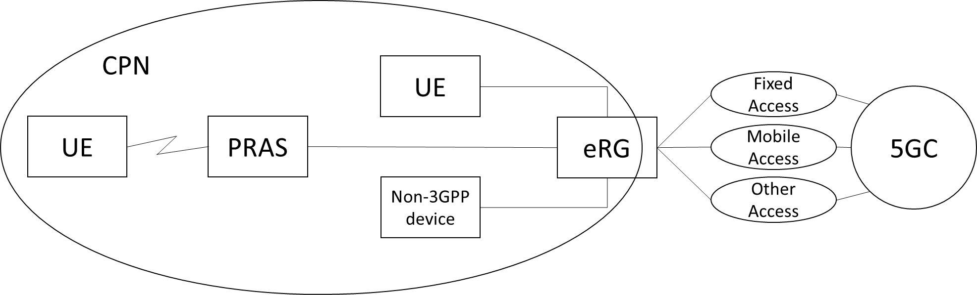

Figure A.2-1: Customer Premises Network connected to 5GC

The Resident networks overview contains the following entities.

- evolved Residential Gateway (eRG).

- Premises Radio Access System (PRAS).

- Customer Premises Network (CPN)

- User Equipment (UE).

- Non-3GPP Device.

## A.3 Customer Premises Network entities

### A.3.1 evolved Residential Gateway (eRG)

The evolved Residential Gateway is defined in clause 3.1.

The eRG is connected to the 5GC via e.g. fixed, mobile, or hybrid access following specifications for Wireline-Wireless Convergence [7]

Connectivity between the eRG and the UE, non-3GPP Device, or PRAS can use any suitable non-3GPP technology (e.g. Ethernet, optical, WiFi).

NOTE: the eRG does not provide PRAS functionality (i.e. there is no NR Uu access between the eRG and a UE). Ofcourse it is possible to implement an eRG and PRAS in a single box.

### A.3.2 Premises Radio Access System (PRAS)

The Premises Radio Access System is defined in clause 3.1.

A PRAS can use licensed spectrum, but also can use unlicensed spectrum.

Connectivity between the PRAS and the UE can use NR radio access (Uu) or non-3GPP radio access.

The PRAS only provides non-3GPP radio access to UEs with 3GPP credentials that are checked by the 5GC (similar to other non-3GPP access to the 5GC). The PRAS is not e.g. a WiFi AP that provides non-3GPP access to devices with non-3GPP credentials that are checked by the WiFi AP itself.

The PRAS is part of the Customer Premises Network and therefore connected to the eRG.

The PRAS may also provide E-UTRA radio access.

### A.3.3 Customer Premises Network (CPN)

The Customer Premises Network is defined in clause 3.1.

### A.3.4 User Equipment (UE)

The User Equipment is defined in [1].

### A.3.3 Non-3GPP device

The Non-3GPP device is defined in clause 3.1.

Annex B: Change history

|  |  |  |  |  |  |  |  |
| --- | --- | --- | --- | --- | --- | --- | --- |
| **Change history** | | | | | | | |
| **Date** | **Meeting** | **TDoc** | **CR** | **Rev** | **Cat** | **Subject/Comment** | **New version** |
| 2021-03 | SA#91e | SP-210209 |  |  |  | Presentation to SA for information  MCC Clean-up | 1.0.0 |
| 2021-05 | SA1#94e | S1-211307 |  |  |  | Output version of SA1#94e | 1.1.0 |
| 2021-06 | SA#92e | SP-210512 |  |  |  | Raised to v.2.0.0 by MCC for approval | 2.0.0 |
| 2021-06 | SA#92e | SP-210512 |  |  |  | Raised to v.18.0.0 by MCC following approval | 18.0.0 |
| 2021-06 | SA#92e | SP-210512 |  |  |  | Corrected logo (5G->5GA) | 18.0.1 |
| 2021-09 | SA#93e | SP-211099 | 0001 | 1 | C | FS_Resident: Clarification of Loss of 5GC connectivity requirements | 18.1.0 |
| 2021-09 | SA#93e | SP-211099 | 0002 | 1 | B | Update Use Case 5.21 for PRAS | 18.1.0 |
| 2021-09 | SA#93e | SP-211099 | 0003 | 1 | C | Clause5.5 routing via residential IP network | 18.1.0 |
| 2021-09 | SA#93e | SP-211099 | 0005 | 1 | C | Alignment and clarification of PR5.4.6-001 | 18.1.0 |
| 2021-09 | SA#93e | SP-211099 | 0006 | 1 | C | Consolidation of Resident requirements | 18.1.0 |
| 2021-09 | SA#93e | SP-211099 | 0007 | 1 | C | Hybrid access in definitions | 18.1.0 |
| 2021-09 | SA#93e | SP-211099 | 0008 | 1 | D | Consistent usage of definition Authorised Administrator | 18.1.0 |
| 2021-09 | SA#93e | SP-211099 | 0009 |  | C | Change residential network to CPN | 18.1.0 |
| 2021-09 | SA#93e | SP-211099 | 0010 |  | D | Editorial changes to TR | 18.1.0 |
| 2021-09 | SA#93e | SP-211099 | 0011 | 1 | D | Remove Editor s Note on requirements E2E QoS Monitoring. | 18.1.0 |
| 2021-09 | SA#93e | SP-211099 | 0012 |  | D | Remote Editor's Notes on requirements consolidation | 18.1.0 |
| 2021-09 | SA#93e | SP-211099 | 0013 |  | D | Removing editor's note on rephrasing requirements | 18.1.0 |
| 2021-09 | SA#93e | SP-211099 | 0014 | 1 | D | Remove Editor s Notes on requirement 5G LAN with fixed IP VPN | 18.1.0 |
| 2021-09 | SA#93e | SP-211099 | 0015 |  | C | Remove Editor’s Notes in 5.18 on requirements Control by Authorised Adminstrator | 18.1.0 |
| 2021-09 | SA#93e | SP-211099 | 0016 |  | D | Remove Editor’s Note in 5.22 on requirements external services behind eRG in CPN | 18.1.0 |
| 2021-09 | SA#93e | SP-211099 | 0017 | 1 | B | Update of use case 5.2 use of 3GPP credentials | 18.1.0 |
| 2021-09 | SA#93e | SP-211099 | 0018 | 1 | B | Update use case 5.3 on service continuity between CPN and public network | 18.1.0 |
| 2021-09 | SA#93e | SP-211099 | 0020 | 1 | F | FS_Resident Correction of clause 5.10 | 18.1.0 |
| 2021-09 | SA#93e | SP-211099 | 0021 | 1 | F | FS_Resident Correction of clause 5.11.1 | 18.1.0 |
| 2021-09 | SA#93e | SP-211099 | 0024 | 1 | B | Clarification of PRAS configuration | 18.1.0 |
| 2021-09 | SA#93e | SP-211099 | 0025 | 1 | B | Clarification of QoS between two UEs | 18.1.0 |
| 2021-12 | SP-94 | SP-211496 | 0027 |  | D | Resident consolidated requirements table update | 18.2.0 |