3GPP TR 22.878 V18.2.0 (2021-12)

Technical Report

3rd Generation Partnership Project;

Technical Specification Group Services and System Aspects;

Feasibility Study on 5G Timing Resiliency System

(Release 18)



The present document has been developed within the 3rd Generation Partnership Project (3GPP TM) and may be further elaborated for the purposes of 3GPP.  
The present document has not been subject to any approval process by the 3GPPOrganizational Partners and shall not be implemented.  
This Report is provided for future development work within 3GPPonly. The Organizational Partners accept no liability for any use of this Specification.  
Specifications and Reports for implementation of the 3GPP TM system should be obtained via the 3GPP Organizational Partners' Publications Offices.

Keywords

5G, Time, Resiliency

***3GPP***

Postal address

3GPP support office address

650 Route des Lucioles - Sophia Antipolis

Valbonne - FRANCE

Tel.: +33 4 92 94 42 00 Fax: +33 4 93 65 47 16

Internet

http://www.3gpp.org

***Copyright Notification***

No part may be reproduced except as authorized by written permission.  
The copyright and the foregoing restriction extend to reproduction in all media.

© 2021, 3GPP Organizational Partners (ARIB, ATIS, CCSA, ETSI, TSDSI, TTA, TTC).

All rights reserved.

UMTS™ is a Trade Mark of ETSI registered for the benefit of its members

3GPP™ is a Trade Mark of ETSI registered for the benefit of its Members and of the 3GPP Organizational Partners  
LTE™ is a Trade Mark of ETSI registered for the benefit of its Members and of the 3GPP Organizational Partners

GSM® and the GSM logo are registered and owned by the GSM Association

Contents

Foreword 5

1 Scope 6

2 References 6

3 Definitions, symbols and abbreviations 7

3.1 Definitions 7

3.2 Abbreviations 7

4 Overview 7

4.1 Applicability of 5G timing resiliency service in the smart grid sector 7

4.1.1 General 7

4.1.2 Timing Accuracy 8

4.1.3 Timing Resiliency 9

4.2 Applicability of 5G timing resiliency service in the financial sector 12

5 Use cases 13

5.1 Use case on resilient 5G system time synchronization 13

5.1.1 Description 13

5.1.2 Pre-conditions 14

5.1.3 Service flows 14

5.1.4 Post-condition 14

5.1.5 Existing feature partly or fully covering use case functionality 14

5.1.6 Potential new requirements 14

5.2 Use case on 5G timing resiliency for smart grids 14

5.2.1 Description 14

5.2.2 Pre-conditions 14

5.2.3 Service flows 15

5.2.4 Post-conditions 15

5.2.5 Existing feature partly or fully covering use case functionality 15

5.2.6 Potential new requirements and KPIs 15

5.2.6.1 Potential Requirements 15

5.2.6.2 Potential KPIs 16

5.3 Use case on 5G secure clock signals to devices and application servers 16

5.3.1 Use case description 16

5.3.2 Pre-conditions 16

5.3.3 Service flows 17

5.3.4 Post-conditions 17

5.3.5 Existing feature partly or fully covering use case functionality 17

5.3.6 Potential new requirements 17

5.4 Use Case on 5G timing resiliency for financial sector 17

5.4.1 Description 17

5.4.2 Pre-conditions 18

5.4.3 Service flows 19

5.4.4 Post-conditions 19

5.4.5 Existing feature partly or fully covering use case functionality 19

5.4.6 Potential new requirements and KPIs 20

5.4.6.1 Potential Requirements 20

5.4.6.2 Potential KPIs 20

6 Considerations 20

6.1 Potential security considerations 20

6.2 Potential charging considerations 21

7 Consolidated potential requirements and KPIs 21

7.1 Consolidated potential requirements 21

7.1.1 General 21

7.1.2 Monitoring and Reporting 22

7.1.3 Service Exposure 22

7.1.4 (void) 22

7.2 Consolidated potential KPIs 22

8 Conclusion and recommendations 23

Annex A: Change history 24

# Foreword

This Technical Report has been produced by the 3rd Generation Partnership Project (3GPP).

The contents of the present document are subject to continuing work within the TSG and may change following formal TSG approval. Should the TSG modify the contents of the present document, it will be re-released by the TSG with an identifying change of release date and an increase in version number as follows:

Version x.y.z

where:

x the first digit:

1 presented to TSG for information;

2 presented to TSG for approval;

3 or greater indicates TSG approved document under change control.

y the second digit is incremented for all changes of substance, i.e. technical enhancements, corrections, updates, etc.

z the third digit is incremented when editorial only changes have been incorporated in the document.

# 1 Scope

The present document identifies additional potential requirements on the 5G system to support time-synchronization services in public and vertical domains, including both the ability to improve resiliency of timing services involving technologies supported by 5G and the ability to the ability to act as a backup for GNSS timing services.

The use cases address:

1. the use of 5G system in concert with other timing technologies as a resilient timing source for end-users in complement/back-up/alternate to GNSS, and
2. enhancement to the 5G system to enable time synchronization resiliency if GNSS or other timing services are compromised.

# 2 References

The following documents contain provisions which, through reference in this text, constitute provisions of the present document.

- References are either specific (identified by date of publication, edition number, version number, etc.) or non‑specific.

- For a specific reference, subsequent revisions do not apply.

- For a non-specific reference, the latest version applies. In the case of a reference to a 3GPP document (including a GSM document), a non-specific reference implicitly refers to the latest version of that document *in the same Release as the present document*.

[1] 3GPP TR 21.905: "Vocabulary for 3GPP Specifications".

[2] National Institute of Standards and Technology (NIST), "Timing Challenges in the Smart Grid", January 2017.

[3] 61850-9-3-2016 - IEC/IEEE International Standard - Communication networks and systems for power utility automation – Part 9-3: Precision time protocol profile for power utility automation.

[4] IEEE 1588-2019, IEEE Standard for a Precision Clock Synchronization Protocol for Networked Measurement and Control Systems.

[5] Used with permission from ABB Distribution Solutions.

[6] 3GPP TS 22.104: "Service requirements for cyber-physical control applications in vertical domains".

[7] 3GPP TS 38.305: "NG Radio Access Network (NG-RAN); Stage 2 functional specification of User Equipment (UE) positioning in NG-RAN"

[8] ATIS-0900005: "Technical Report on GPS Vulnerability", https://access.atis.org/apps/group_public/download.php/36304/ATIS-0900005.pdf

[9] 3GPP TR 22.867: "Study on 5G Smart Energy and Infrastructure"

[10] NPL: "Time Traceability for the Finance Sector, Fact Sheet", version 2.0.

[11] BIPM Time Department, <https://www.bipm.org/en/bipm/tai/>

[12] Markets in Financial Instruments (MiFID II) - Directive 2014/65/EU  
<https://ec.europa.eu/info/law/markets-financial-instruments-mifid-ii-directive-2014-65-eu_en>

[13] Regulatory Technical Standard 25. Level of accuracy of business clocks  
<https://ec.europa.eu/finance/securities/docs/isd/mifid/rts/160607-rts-25_en.pdf>

[14] Annex to Regulatory Technical Standard 25, <https://ec.europa.eu/finance/securities/docs/isd/mifid/rts/160607-rts-25-annex_en.pdf>

[15] ESMA: “Guidelines on transaction reporting, order record keeping and clock synchronisation under MiFID II”, https://www.esma.europa.eu/sites/default/files/library/2016-1452_guidelines_mifid_ii_transaction_reporting.pdf

# 3 Definitions, symbols and abbreviations

## 3.1 Definitions

For the purposes of the present document, the terms and definitions given in 3GPP TR 21.905 [1] and the following apply. A term defined in the present document takes precedence over the definition of the same term, if any, in 3GPP TR 21.905 [1].

**holdover:** A clock A, previously synchronized/syntonized to another clock B (normally a primary reference or a Master Clock) but whose frequency is determined in part using data acquired while it was synchronized/syntonized to B, is said to be in holdover or in the holdover mode as long as it is within its accuracy requirements.

NOTE: holdover is defined in [4]

**Holdover time:** the time period that is available to repair the first priority timing source when it is lost (e.g., when the primary GNSS reference is lost). During this period the synchronization accuracy requirement should be guaranteed, e.g., by means of defining multiple synchronization references.

## 3.2 Abbreviations

For the purposes of the present document, the abbreviations given in 3GPP TR 21.905 [1] and the following apply. An abbreviation defined in the present document takes precedence over the definition of the same abbreviation, if any, in 3GPP TR 21.905 [1].

BIPM International Bureau of Weights and Measures

CAT Consolidated Audit Trail

DS-TT Device-side TSN translator

ESMA European Securities and Markets Authority

MiFID II Markets in Financial Instruments Directive II

MiFIR Markets in Financial Instruments Regulation

NMS National Market Systems

NTP Network Time Protocol

RTS 25 Regulatory Technical Standard 25

SCADA Supervisory control and data acquisition

SNTP Simple Network Time Protocol

TBS Terrestrial Beacon System

UTC Coordinated Universal Time

# 4 Overview

## 4.1 Applicability of 5G timing resiliency service in the smart grid sector

### 4.1.1 General

Power grids are critical to the world economy as most other critical infrastructure including communications depend on them. Electric utilities are transitioning towards smart power grids to enhance efficiency and reliability, with real-time measurements and control between smart devices in the field with centralized data facilities running intelligent analytics.

The timing solutions for Smart Grid must address a significant list of concerns. Time synchronization is in general considered a key security vulnerability of Smart Grids, and an area of direct relevance to timing resiliency systems and the 5G System is ensuring timing integrity, e.g., providing solutions to the increasing prevalence of satellite signal loss, jamming, and the potential for spoofing [2]. Power utility companies do not want to be dependent only on satellite-based time synchronization due to several factors:

1. Interference: Either caused intentionally or by environment (e.g. solar flares).
2. Governmental decision: Public time synchronization service can be disabled or weakened remotely; GPS selective availability as an example.
3. Maintenance: Changing the faulty GPS antenna may take some time.
4. Other: Long downtime time when updating or fixing satellite systems; Galileo downtime of 100h as an example. As a comparison, 24h holdover time has been specified for power systems.

Although there are a large range of applications possible in Smart Grids in need of timing resiliency, the focus here is mainly on power sub-stations where robust time synchronization is needed for e.g., synchro phasor applications. Those are relevant for 5G System-based timing resiliency solutions and simultaneously represent the most demanding application in terms of required time synchronization performance. However, other applications are also mentioned and captured.

### 4.1.2 Timing Accuracy

Precise timing is key to operating the smart power grid. One area relates to controlling the frequency (50Hz/60Hz), while another area relates to providing events with timestamped measurement values, with required accuracies down to a few hundred nanoseconds [2]. Correct timing is a key enabler for communication and orchestration of technologies for accurate and optimal wide area monitoring, protection and control in the power industry [2].

In a typical smart grid architecture, centralized monitoring systems have visibility to events occurring in a distributed hierarchy of substations and distribution systems. Having very accurate timing across the endpoints allows the monitoring systems to readily detect faults, identify the source and extent of impact, and take corrective action in a manner affecting the smallest possible portion of the grid. For such event reporting, a 1ms timing accuracy is sufficient.

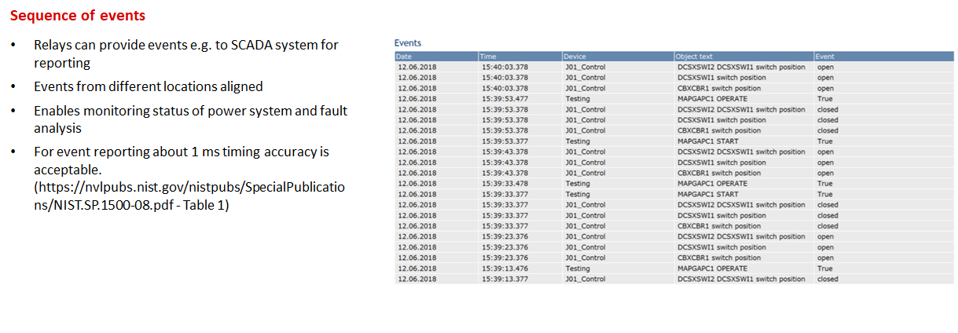

Figure 4.1.2-1: Time stamped events [5]

Timing accuracy is also needed for power system measurements for fault detection in the current phase. Recordings of the phase may be triggered at various points when a fault is detected. Running analysis on multiple time-aligned recordings can provide a clear picture of the extent of impact. For reliable analysis, 1 ms timing accuracy is typically needed across all recordings and is today limited mostly by SNTP time sync methods typically in use.

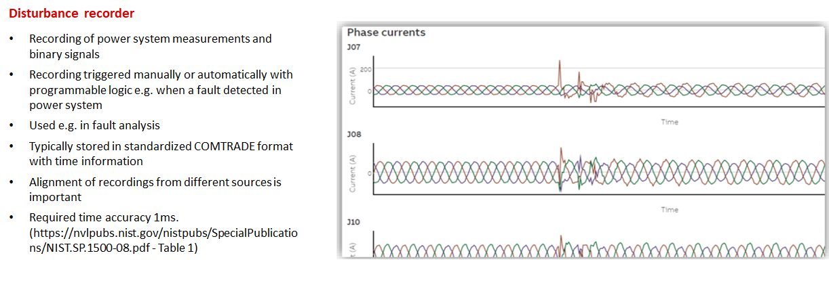

Figure 4.1.2-2: Current disturbance recoding [5]

Monitoring the power system frequency also requires timing accuracy for fault detection and resolution. In this case, accuracy between 1 µs to 10 µs is needed to provide accurate correlation of frequency.

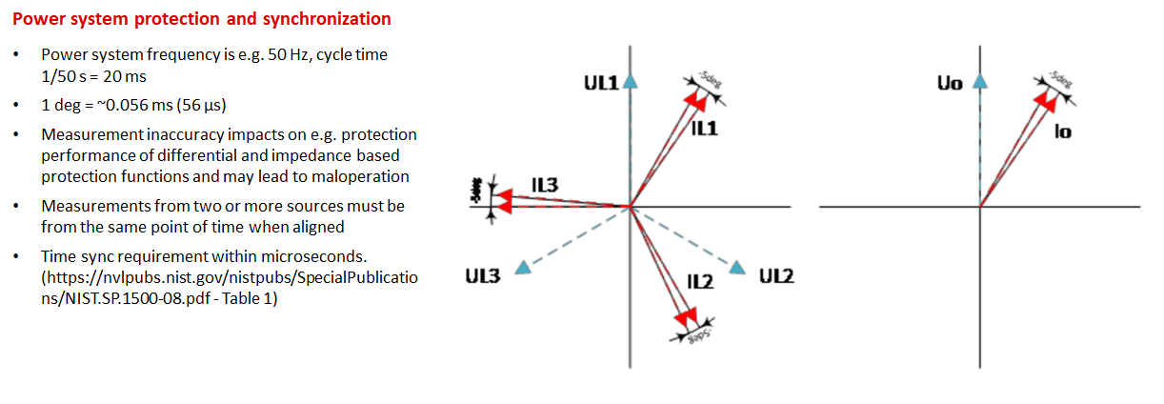

Figure 4.1.2-3: Frequency synchronization [5]

Finally, the accuracy needed depends on the timing role of the component within the power sub-system. E.g., a PTP sync device within the sub-network generally needs to fulfil the application requirements as discussed above (e.g., down to 1s accuracy requirement) whereas a component that is a PTP Grand Master needs to be accurate to a 250 ns requirement [3], specifically, 250 ns are assumed in (section 7.2 [3]) in order to distribute synchronization over a chain of up to 15 transparent clocks while meeting the requirement of 1 µs at the end-device.

### 4.1.3 Timing Resiliency

A simple overview of a power sub-station is provided in Figure 4.1.3-1. In a typical deployment today, the sub-station achieves time synchronization by means of a grandmaster clock that uses the IEEE 1588 Precision Time Protocol (PTP) [4] protocol to synchronize elements inside the power sub-station via an Ethernet connection. The grandmaster clock often uses a GNSS receiver to achieve time synchronization information. To access the GNSS signal, an external GNSS antenna is typically required. The figure shows how time and communication redundancy can be achieved within substation by means defined in IEC 61850-9-3-2016 [3]. However, since the time source (GNSS) illustrated is a single point of failure (e.g. whenever satellite(s) are not available or there is interference), 5G is a candidate resiliency solution.

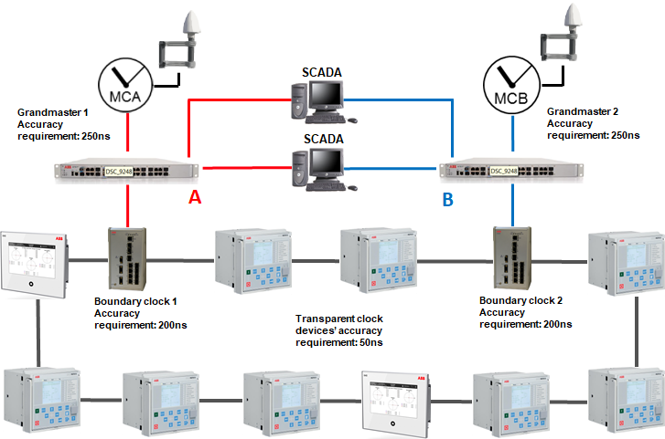

Figure 4.1.3-1: Example power sub-system setup leveraging 2x GNSS based clock grandmasters [5]

The GNSS receiver elements of the clock grandmaster installed in power-subsystems have some desirable characteristics including intrinsic multi-layer jamming and spoofing detection capabilities, e.g., autonomous disruption detection and intelligent protection and control. The timing accuracy requirement of the GNSS receiver is <250 ns according to the grandmaster requirements listed in [4]. This allows sufficient budget for synchronization distribution errors within the power sub-station versus the E2E requirements of the Smart Grid operation (e.g., where every PTP sync device needs to be synchronized to a <1 s accuracy).

Many power sub-systems already have cellular 4G coverage. A 5G System-based timing solution offers multiple potential enhancements, including:

1. As a resiliency solution to the GNSS received timing solution if GNSS fails or is compromised, e.g., integrated as alternative radio in each grandmaster clock or as an alternative grandmaster clock with 5G capability in the power sub-system.
2. As an alternative to GNSS use, e.g., integrated with PTP grandmaster clock avoiding installation of external GNSS antenna and receiver at the power sub-station.

These alternatives are illustrated in Figure 4.1.3-2. In both cases, time synchronization may be provided from the 5G System to 5G sync modem by either C-Plane method (e.g., via System Information Broadcast or unicast RRC messaging) or using PTP method according to the power sub-system configuration requirements.

The latter requires also some actions from the 5G System in case time source is lost is missing, e.g., similar to IEC 61850-9-3, clockClass should be dropped when the 5G System is in holdover state. Further, PPS output has significant use-cases and is commonly used today and can be desired property of 5G sync modem.

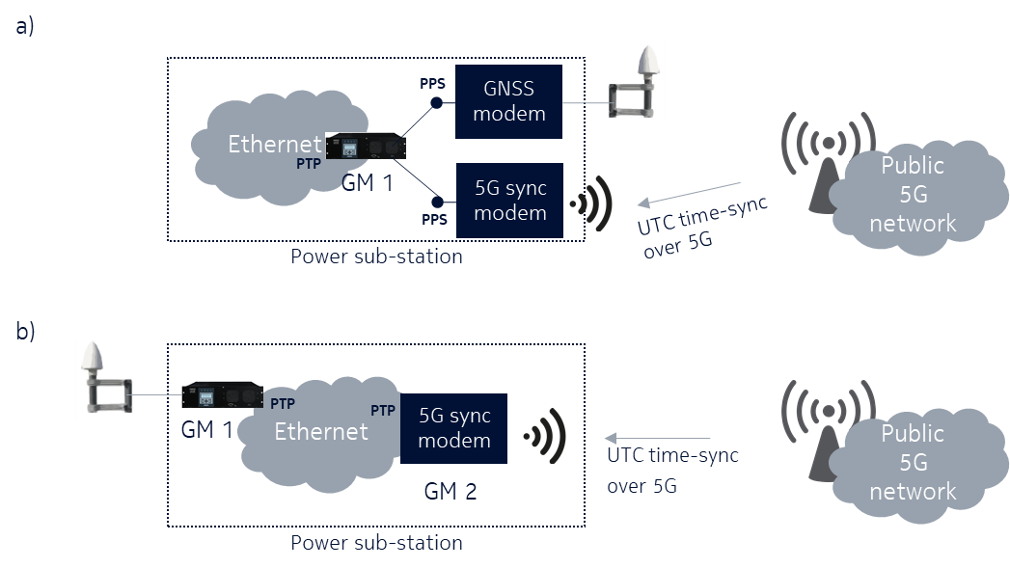

Figure 4.1.3-2: 5G integration into system – resilience and alternative mode

Another key requirement is holdover capability, the ability to continue providing accurate timing service in the event of loss of an external source (e.g., GNSS), for the 5G System. For option (a) in Figure 4.1.3-2 a 24 h holdover capability is automatically supported as this is the case for today’s distributed solution where GM1 and GNSS is always one and the same device. 5G modem functionality could be either integrated into the same device as a chip or as an input using option (a) type external modem, e.g., for this case, no specific holdover capability is required from the 5G System. With option (b), holdover capability is mainly determined by the 5G network. Here it is desirable that the 5G sync modem has a holdover capability of at least 5 s to comply with [3] and that the 5G network can support up to 24 h of holdover capability. However, as option (a) can be a solution when 24 h holdover capability is strictly needed for the power utility, this requirement could be more scalable, e.g., allow for wider range of performance of 5G networks and 5G sync modems with exploiting also hold-over capability (stability) of GM1.

High level requirements to the 5G System to support these alternatives are highlighted in Table 4.1.3-1

Table 4.1.3-1 High level requirements for 5G timing resiliency in smart grid

|  |  |
| --- | --- |
| **Area** | **Requirement** |
| Time Domain | UTC, delivered from network to end-point device in power sub-station. An absolute time difference to GPS/GNSS is acceptable (can be preconfigured) as long as 5G end device provides PPS output which can be used for measuring the difference. |
| Deployment | Wide area support is needed to reach power sub-systems, e.g., should support full coverage requirements. Mobility is low, e.g., power sub-systems are static structures.  Public Network [5]:   * Minimum density 5 devices per km2 * Maximum density 100 devices per km2   Private Network [5]:   * Up to 1000 devices per km2 |
| Mobility | None, synchronization devices are static and vehicles connect to grid in a static location when in need of time synchronization. |
| Synchronization accuracy (examples) | <250-1000 ns for synchro phasor use-cases, e.g., to supplement/replace existing GNSS receiver based solutions 1:1.  <1-10 s for Power system protection and synchronization  <1 ms for Event reporting use-cases, Disturbance recording use-cases |
| Holdover capability | Up to 24h for 5G network, e.g., the 5G network needs to maintain its ability to synchronize power sub-systems even after general loss or failure of UTC time source.  >5 s for 5G sync modem [3] |
| Services provided by 5G System | Time resilience service provides 5G clock properties, e.g., clockClass, accuracy, etc to reflect the possible selection of clock source e.g., during GNSS unavailability.  When acting as a backup or replacement time source, the 5G System provides secure timing service to UEs and application servers. |

## 4.2 Applicability of 5G timing resiliency service in the financial sector

For financial markets, the ability to verify continuously when events take place, i.e., time traceability, is fundamental to enable regulatory oversight and analyse the order in which trades are placed (e.g. accurate time stamps are used to settle disagreements and to prevent fraud). Market participants may execute orders on stocks in seconds or microseconds depending on the type of trading activity (e.g., high-frequency algorithmic, voice trading systems, human intervention, concluding negotiated transactions, etc). Financial markets are distributed systems; therefore, a common regulated timekeeping system can only be done if every market participant at each end point of the system involved in the transaction maintains an accurate clock.

There are several means to access UTC time such as using an atomic clock, NTP servers, GNSS signal, or UTC(k) delivery over fiber, where UTC(k) is a realisation of UTC maintained by the contributing institute (e.g., NPL, NIST) identified by k. The 5G system can be operate in collaboration with or as backup to other timing solutions used already by financial markets to comply with financial directives for timekeeping. As illustrated in Figure 4.2-1, the 5G system can be integrated as another time source within the clock distribution infrastructure of the financial customer.

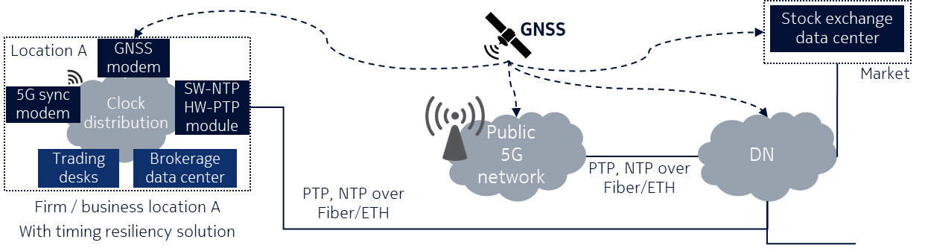

Figure 4.2-1 Example of time resilience use case for financial markets

Financial regulations for time source and time dissemination require the market participants must provide traceability back to UTC. This requires the time information sent to financial exchanges should be measured and verified at every link in the chain, i.e. from UTC generated at the BIPM (global ‘paper’ time scale [11]) up to the timestamping engine within the financial customer domain. Depending on the time source and distribution method the financial customer has, the traceability to UTC to comply with the regulations is achieved in different ways. For example (for more information see [10]):

1. If GNSS satellite signals are used, these signals alone do not readily provide traceability to UTC, but users can demonstrate traceability by obtaining GNSS monitoring bulletins from one of the regional UTC(k) timing centres. In this case, the end user will use these bulletins in addition to perform calibration and monitoring of the GNSS receiver equipment to demonstrate traceability to UTC.
2. If services for time delivery over fibers are used (e.g., as delivered by a national metrology institutes), the UTC is disseminated over managed fiber links. The traceability to UTC is maintained using PTP to distribute the time and continuously monitoring and audit the provision point to ensure the agreed level of accuracy defined in the service SLA. Note: this option may not be generally available.

The 5G system could follow similar approaches when applied in this use case (Figure 4.2-2 illustrates the two approaches):

a) The 5G system provides traceability to UTC up to the DS-TT: In this approach, the 5G system needs to continuously monitor and audit each link within the time distribution chain within the 5G system domain. The UTC traceability is certified up to the provision point at the DS-TT. Therefore, monitoring, calibration, and certification functionalities are required at the DS-TT. Two alternatives can be considered:

1. The 5G system supports these new functionalities including the required mechanisms in the standard.

2. Proprietary solutions are used in collaboration with the 5G system. For example, a client for the service of time delivery over fiber is installed within the DS-TT to combine NPL service and 5G wireless time distribution to provide traceability to UTC.

b) The 5G system does not provide traceability to UTC: Similar to GNSS signal delivery described before, the 5G system is not responsible of monitoring, calibrating or documenting evidence for traceability to UTC, the financial customer is taking care of these functionalities.

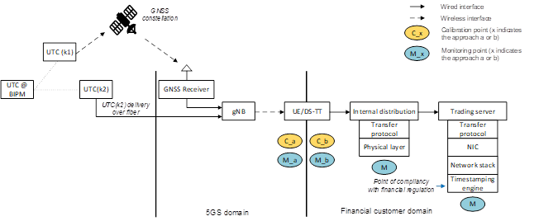

Figure 4.2-2 UTC(k) time distribution with 5G system indicating the traceability chain (modified from source [10])

# 5 Use cases

## 5.1 Use case on resilient 5G system time synchronization

### 5.1.1 Description

Many 5G systems rely on reference precision timing signals for network synchronization in order to operate. Today, 5G networks generally rely on GNSS for accurate reference time and frequency. This dependency has resulted in vulnerabilities for these systems in the event of GNSS jamming/interference, data or measurement spoofing of GNSS signals, environmental conditions and/or anomalies.

This use case describes how 5G systems may maintain time synchronization in the event of a loss or degradation of GNSS reference timing.

### 5.1.2 Pre-conditions

The 5G system receives GNSS precision timing signals for network synchronization.

### 5.1.3 Service flows

1. The 5G system maintains time synchronization from a single GNSS timing source.
2. A GNSS service degradation or outage takes place.
3. The 5G system detects primary GNSS reference timing signals are no longer viable.
4. The 5G system receives accurate timing signals from an independent timing source, e.g. Terrestrial Beacon System [7] [8], which can offer a timing alternative to GNSS.

### 5.1.4 Post-condition

The 5G system maintains accurate time synchronization during GNSS reference time service degradation.

### 5.1.5 Existing feature partly or fully covering use case functionality

Since Release 15, RAT-independent positioning technologies that leverage precision timing signals have been enabled in 5G systems, e.g. TBS/MBS [7]. Similar to GNSS, these technologies support positioning, navigation and timing (PNT) applications, while also being able to operate independently from GNSS. The timing features of these technologies may be leveraged to maintain reliable 5G time synchronization in the event of a degradation or loss of GNSS timing signals.

### 5.1.6 Potential new requirements

[PR 5.1.6-1] The 5G system shall be able to receive accurate timing signals from one or more independent timing source(s), which can offer a timing alternative to GNSS, e.g. TBS/MBS [7] [8]], Sync over Fiber [7].

[PR 5.1.6-2] The 5G system shall be able to detect when GNSS reference timing signals are no longer viable for network time synchronization.

[PR 5.1.6-3] The 5G system shall be able to maintain accurate time synchronization as appropriate for the supported applications in the event of degradation or loss of GNSS timing signals.

[PR 5.1.6-4] The 5G system shall be able to collect charging information based on the timing source (e.g., the source in use, start and stop of source usage).

## 5.2 Use case on 5G timing resiliency for smart grids

### 5.2.1 Description

The focus for this use-case description is power sub-stations where robust time synchronization is needed for e.g., synchro phasor and other Smart Grid applications.1

### 5.2.2 Pre-conditions

Power sub-systems use wireless means to achieve time synchronization, as is the case today leveraging GNSS receiver capabilities. In today’s power sub-system, the timing resiliency is based on e.g., having multiple grandmasters leveraging multiple GNSS receivers. In this use case the 5G system is used as a supplement to, e.g., integrated as alternative radio in the grandmaster clock or as an alternative grandmaster clock with 5G capability in the power sub-system, or alternative to the GNSS, e.g., integrated with PTP grandmaster clock avoiding installation of external GNSS antenna and receiver at the power sub-station.

In this use case, the smart grid is subscribed to and authorized to use the 5G timing resiliency service to ensure reliable timing signals are always available. The 5G timing resiliency service monitors the accuracy and availability of timing signals from a designated timing source and is able to provide an alternate source (e.g., 5G holdover capacity, atomic clock) in case of failure in the primary source. An SLA may be in place to establish the primary and any alternate timing sources that can be used.

### 5.2.3 Service flows

This section should also describe how the timing resiliency is enhanced when the 5G system is used in conjunction with the GNSS, how the system is notified of a failure of GNSS, how the 5G system picks up the slack to keep the system running smoothly in the absence of GNSS. The UEs are preconfigured to enable the provision of time synchronization service from the 5G system. In addition to the initial pre-configuration the UEs may have, additional information may be used for dynamically configuring the management of the 5G system time synchronization network within the smart grid system.

The configuration of the smart grid system includes timing service from GNSS with resiliency support provided by the 5G system. Based on the 5G time resilience requirements, the time distribution method used, and type of time synchronization device connected to the UE (e.g., DS-TT), the 5G system may configure different network entities (i.e., gNBs, UEs/DS-TTs, UPFs/NW-TTs) and the behaviour when an issue is detected (e.g., notification towards the UE or application, back-up configuration).

The 5G system detects that the GNSS is experiencing a problem (e.g., loss of satellite access, detection of inconsistent timing information).

The 5G system communicates the loss of GNSS to UEs or applications subscribed to the timing resilience service. Additionally, the 5G system may indicate the UEs should use the timing service provided by the 5G system until further notice instead of GNSS signal. The 5G system is configured to provide an accurate timing service for a specified holdover time. Depending on the detected problem and the impacted area, the 5G system may reconfigure its own network to ensure the distribution of an accurate timing service to the UEs.

The 5G system provides timing information to the UEs using a secure mechanism.

The UEs are able to verify the integrity and accuracy of the timing information provided by the 5G system

The 5G system continues to monitor for a return to service by the GNSS. When the GNSS service recovery is detected, the 5G system informs the UEs or application subscribed to the resilience timing service that they can again receive GNSS timing information.

### 5.2.4 Post-conditions

The Smart Grid can use 5G system as a resiliency backup to their GNSS receiver based (or wired) time synchronization systems to improve availability and reliability of the time synchronization. Alternatively, existing GNSS receiver-based solutions may be replaced with a 5G system-based solution where it improves efficiency and/or reliability.

### 5.2.5 Existing feature partly or fully covering use case functionality

Many 5G system features specified in Rel-16 and expected in Rel-17 will be required for the use-case:

1. Time synchronization to UTC leveraging 5G system C-Plane and/or U-Plane
2. Support for IEEE 1588 PTP
3. Propagation delay compensation, to ensure that time synchronization can be conducted accurately across wide area deployments needed for power sub-station support
4. Exposure framework supports time synchronization based on the needs of the service

### 5.2.6 Potential new requirements and KPIs

#### 5.2.6.1 Potential Requirements

[PR 5.2.6.1-1] The 5G system shall monitor for timing source failure.

[PR 5.2.6.1-2] The 5G system shall be able to indicate to devices (e.g., UEs, applications) that they need to use an alternate time source (e.g., use 5G system with internal holdover capability or an alternate source, e.g. atomic clock, Sync over Fiber, TBS), taking into account the holdover capability of the devices.

[PR 5.2.6.1-3] The 5G system shall support a holdover capability (e.g., maintaining required accuracy to UTC) of up to 24h.

[PR 5.2.6.1-4] The 5G system shall be able to detect when a timing source fails or is restored for network time synchronization.

[PR 5.2.6.1-5] The 5G system shall be able to collect charging information per UE for use of a timing resiliency service (e.g., start/stop time and source used by a UE, timing service used by UE, holdover capability of the service).

[PR 5.2.6.1-6] The 5G system shall be able to collect charging information on 5G system timing resiliency service (e.g., service KPIs, holdover capability, number of UEs using the service).

#### 5.2.6.2 Potential KPIs

Table 5.2.6.2-1: Timing resiliency service performance requirements for 5G System

|  |  |  |  |  |  |  |
| --- | --- | --- | --- | --- | --- | --- |
| **Use-case** | **Holdover Time** | **Sync Target** | **Sync accuracy** | **Service area** | **Mobility** | **Remarks** |
| Power grid (5G network) | Up to 24 hour | UTC (note 1) | <250ns-1000ns [3], [9] (note2) | < 20 km2 | low | When 5G System provides direct PTP Grandmaster capability to sub-stations |
| Power grid (time synchronization device) | >5 s | UTC (note 1) | <250ns-1000ns [3], [9] (note2) | < 20 km2 | Low | When 5G sync modem is integrated into PTP grandmaster solution (with 24h holdover capability) at sub-stations) |
| Note 1: A different synchronization target is acceptable as long as the offset is preconfigured when an alternatively sourced time differs from GNSS. In this case, a 5G end device shall provide PPS output which can be used for measuring the difference.  Note 2: Use case [New] in [9] illustrates the different accuracy measurements based on different configurations needed to support the underlying requirements from IEC [3]. The range is between 250 ns and 1000 ns. The actual requirement depends on the specific deployment. | | | | | | |

## 5.3 Use case on 5G secure clock signals to devices and application servers

### 5.3.1 Use case description

This use case describes the need for secure clock signals to be made available to devices and application servers in a reliable manner by a 5G timing resiliency service. The clock signals may be used for timing synchronization in a variety of applications, such as highly sensitive industrial IoT applications, Power grid, commercial banking and stock trading platforms. All these application domains are highly time sensitive and provide critical infrastructure. As such, these domains may be subject to attacks by spoofing the clock source. To prevent such attacks, in all these scenarios, the clock signals can be accepted only if they are authenticated to be genuine without any manipulation by an external source. Hence it is essential that there is a means to verify the authenticity and integrity of these clock signals.

### 5.3.2 Pre-conditions

Devices and application servers connecting to a 5G system providing a 5G timing resiliency service are expected to go through the 5G authentication process. As part of 5G authentication, the subscription records for these devices are verified and they are authorized for service. During this process, the devices also learn to generate the application specific keys. Hence when these devices invoke the 5G timing resiliency service, and receive the clock signals, it is possible to verify the authenticity of the clock server as well as verify the integrity of the clock signals.

### 5.3.3 Service flows

The 5G timing resiliency service needs to support multiple granularity and accuracy KPIs based on what these clock signals provided by the 5G system are used for. For example, there can be premium service with high accuracy and redundancy, whereas ordinary service may be just time of the day up to minutes. Hence the clock signals need to be made available based on the service subscription.

Table 5.3.3-1: Clock granularity examples

|  |  |  |
| --- | --- | --- |
| **Timing Service type** | **Application** | **Clock Granularity** |
| Premium timing service | Industrial controls | Highly accurate with nano second, microsecond granularity with redundancy |
| Commercial timing service | Commercial banking applications | Medium granularity up to seconds. |
| Regular timing service | Regular Time of the day | Medium granularity up to seconds. |
| Dedicated timing service | Clock signals with application specific format and frequency | Dedicated granularity and frequency |

### 5.3.4 Post-conditions

The UEs connected to 5G system are mutually authenticated and authorized for the 5G timing resiliency service. The UEs such as industrial precision robots requiring clock signals have a subscription for timing service. The 5G system is able verify the identity of the UE and authorize it for a timing service with the precise granularity needed. The UE, after completing the authentication and authorization, is able to invoke the timing service either through a specific API or a messaging interface. The UE is able to authenticate the clock server (source of clock signal) as genuine or not. If the UE finds that the clock server is failing the authentication verification, the UE does not accept the timing signals. The UE is also able to verify the integrity of clock signals received. If the integrity check fails, the UE doesn’t accept the signals.

Similarly, an application server also is able to connect to the 5G system. To receive required clock signals provided by the 5G system, the application server may be connected to the 5G system either over a wireless link or a wireline interface.

### 5.3.5 Existing feature partly or fully covering use case functionality

Currently TS 22.104 [6] has requirements on timing which provide the base for additional requirements for a timing service.

### 5.3.6 Potential new requirements

[PR 5. 3.6-1] The 5G system shall support a mechanism to verify authorization of a 3rd party application server to use a 5G timing resiliency service.

[PR 5.3.6-2] The 5G system shall support a mechanism to provide timing service to UEs and application servers with specific KPIs (e.g., accuracy, interval, coverage area).

[PR 5.3.6-3] The 5G system shall support a mechanism for a 3rd party application server to request a timing service with specific KPIs (e.g., accuracy, interval, coverage area).

## 5.4 Use Case on 5G timing resiliency for financial sector

### 5.4.1 Description

The focus for this use-case description is financial sector. Markets and market participants are highly interconnected, absolutely accurate time stamping is essential to determine exactly who made what trade, and precisely when. Market participants may execute orders on stocks in seconds or microseconds depending on the type of trading activity (e.g. high-frequency algorithmic, voice trading systems, human intervention, concluding negotiated transactions, etc). Without a reliable common reference time to provide synchronized time stamps, transactions across locations and stock exchanges are impossible to audit or to detect wrongdoing. To achieve a more regulated timekeeping system, the European Securities and Markets Authority (ESMA) has issued new rules in support of the MiFID II (Markets in Financial Instruments Directive II) regulations [12]. The Regulatory Technical Standard (RTS) 25 is a part of the standards developed by ESMA in the context of MiFID II. RTS 25 defines standards for clock synchronization [13]. Similar to MiFID II, U.S. Securities and Exchange Commission (SEC) introduced Rule 613 and the Consolidated Audit Trail (CAT) to accurately track all activity throughout the U.S. markets in National Market Systems (NMS) securities. Rule 613 requires electronic trading business clocks to be accurate to the National Institute of Standards and Technology (NIST) clocks (i.e. 50 ms for automated orders, 1s for manual orders). MiFID II generally has the strictest requirements when it comes to time stamping (i.e. ≤100µs for high frequency algorithmic trading, ≤1s for voice trading, human intervention, or concluded negotiated transactions, and ≤1ms for other type of trading activities), and is of relevance also to foreign regions as foreign regimes need to have regulations of comparable quality in order for companies in that regime to transact with European entities.

To ensure MiFID II compliance, market participants must have the ability to demonstrate where the timestamp is applied and that it remains consistent, it is not enough just having an accurate time source. Satellite signals or systems that provide direct traceability to the UTC time issued and maintained by a timing centre listed in the BIPM Annual Report on Time Activities are considered as acceptable as time sources. However, if satellite signals are used, the ESMA states the users should be aware of the relevant risks with those signals and must mitigate them [15]. In addition to document and monitor their timing network architecture, market participants also need to consider impacts MiFID II compliance brings in their system such as the security and integrity of the reports collected (e.g. access management that ensures only a certain group of nodes can access the data, authentication to protect the data, data integrity to maintain the consistency and accuracy of the data).

### 5.4.2 Pre-conditions

MiFID II and MiFIR regulation requirements mandate firms and venues to time stamp events accurately to UTC and to an appropriate level. Particularly, article 4 of RTS 25 [13] also states:

*Operators of trading venues and their members or participants shall establish a system of traceability to UTC. They shall be able to demonstrate traceability to UTC by documenting the system design, functioning and specifications. They shall be able to identify the exact point at which a timestamp is applied and demonstrate that the point within the system where the timestamp is applied remains consistent. Reviews of the compliance with this Regulation of the traceability system shall be conducted at least once a year.*

In this use case, both the time synchronization at the end devices (to enable the time stamp accuracy required) and how the time synchronization is distributed to these devices (to enable UTC traceability) are crucial to comply with MiFID II regulation. The market participant is subscribed to and authorized to use the 5G timing resilience service to receive accurate absolute time, directly traceable to UTC, resilient and worldwide available. The 5G timing distribution and resilience service ensures time traceability through either real-time monitoring (e.g., the continuous comparisons of the clock to ensure the device is working properly) or offline (e.g. calibration of the equipment) handling of the following:

1. A continuous chain of comparisons with known uncertainties.
2. Time equipment calibration.
3. Continuous monitoring to demonstrate compliance and correct functioning.
4. Calibration evidence and monitoring results to be archived.

For UTC traceability, each link involved in the time dissemination chain from the reference time scale UTC up to the point of provision must be documented, as illustrated in Figure 5.4.2-1. An SLA will be in place to establish the time synchronization accuracy and traceability requirement to UTC.

The time synchronization accuracy provided by the 5G System domain at the output of the 5G Device will be a suitable portion of the target requirement applicable at the application layer of the Financial customer domain, as an example in order to meet 100 µs, the 5G System domain could provide at least 10 µs accuracy.

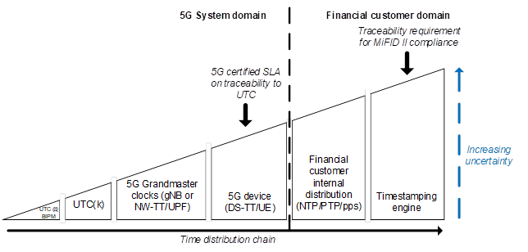

Figure 5.4.2-1: UTC time distribution chain to the financial customer

### 5.4.3 Service flows

1. The 5G system and the market participant establish an SLA for the 5G timing resilience including UTC traceability and required accuracy of the time distribution service.

2. The 5G system provides UTC timing information to the UEs using the 5G timing resilience service.

3. The 5G system maintains time synchronization to UTC time scale at the UE, monitors the time distribution and ensures UTC traceability.

4. The 5G system provides UTC traceability evidence to subscribed applications.

### 5.4.4 Post-conditions

The financial sector can use 5G system as a solution to access UTC and comply with MiFID II requirements. The 5G system can be used in collaboration with or as backup to other timing solutions used already by financial markets such as atomic clocks, NTP servers, GNSS, UTC(k) delivery over fiber (e.g. NPLTime or similar services).

### 5.4.5 Existing feature partly or fully covering use case functionality

Many 5G system features specified in Rel-16 and expected in Rel-17 will be required for the use-case:

1. Time synchronization of UE to UTC leveraging 5G system C-Plane and/or U-Plane
2. Time distribution from device to local data network using Ethernet, PPS, etc
3. Support for IEEE 1588 PTP
4. Propagation delay compensation
5. Exposure framework supports time synchronization based on the needs of the service

### 5.4.6 Potential new requirements and KPIs

#### 5.4.6.1 Potential Requirements

[PR 5.4.6.1-1] The 5G system shall support a mechanism to determine the time uncertainty of the 5G time synchronization.

[PR 5.4.6.1-2] The 5G system shall support mechanisms to monitor different time sources and adopt the most appropriate.

[PR 5.4.6.1-3] The 5G system shall support a mechanism to report time resiliency information (e.g., divergence from UTC, time uncertainty) to 3rd party applications.

[PR 5.4.6.1-4] The 5G system shall be able to collect charging information per application, including 3rd party application (e.g., timing resiliency service KPIs, holdover capability, number of UEs using the service, timing source).

[PR 5.4.6.1-5] The 5G system shall support a mechanism to monitor and verify authenticity of the timing source, where supported by the time source.

[PR 5.4.6.1-6] The 5G system should verify the availability of the external time sources.

#### 5.4.6.2 Potential KPIs

Table 5.4.6.2-1: Level of accuracy for members or participants of a trading venue [13, 14]

|  |  |  |
| --- | --- | --- |
| **Type of trading activity** | **Maximum divergence from UTC** | **Granularity of the timestamp (note 1)** |
| Activity using high frequency algorithmic trading technique | 100µs | ≤1µs |
| Activity on voice trading systems | 1s | ≤1s |
| Activity on request for quote systems where the response requires human intervention or where the system does not allow algorithmic trading | 1s | ≤1s |
| Activity of concluding negotiated transactions | 1s | ≤1s |
| Any other trading activity | 1ms | ≤1ms |
| Note 1: Only relevant for the case where the time synchronization service assists in configuring the required granularity for the timestamp (for direct use), otherwise it will be configured separately as part of the financial transaction timestamp process. | | |

# 6 Considerations

## 6.1 Potential security considerations

[CPR 6.1-1] The 5G system shall support a mechanism to verify authorization of a 3rd party application to use 5G timing resiliency.

[CPR 6.1-2] The 5G system shall support a mechanism to monitor and verify authenticity of the timing source, where supported by the time source.

[CPR 6.1-3] The 5G system should verify the availability of the external time sources.

## 6.2 Potential charging considerations

[CPR 6.2-1] The 5G system shall be able to collect charging information based on the timing source (e.g., the source in use, start and stop of source usage).

[CPR 6.2-2] The 5G system shall be able to collect charging information per UE for use of a timing source (e.g., start/stop time and source used by a UE, timing source used by UE, holdover capability).

[CPR 6.2-3] The 5G system shall be able to collect charging information on 5G system timing resiliency (e.g., resiliency KPIs, holdover capability, number of UEs using a certain timing source).

[CPR 6.2-4] The 5G system shall be able to collect charging information per application, including 3rd party application (e.g., timing resiliency KPIs, holdover capability, number of UEs using a certain timing source).

# 7 Consolidated potential requirements and KPIs

## 7.1 Consolidated potential requirements

### 7.1.1 General

Table 7.1.1-1 – General Consolidated Requirements

| CPR # | Consolidated Potential Requirement | Original PR # | Comment |
| --- | --- | --- | --- |
| CPR 7.1.1-1 | The 5G system shall be able to receive accurate timing signals from one or more independent timing source(s), which can offer a timing alternative to GNSS, e.g. TBS/MBS [7] [8]], Sync over Fiber [7]. | [PR 5.1.6-1] |  |
| CPR 7.1.1-2 | The 5G system shall be able to maintain accurate time synchronization as appropriate for the supported applications in the event of degradation or loss of GNSS timing signals. | [PR 5.1.6-3] |  |

### 7.1.2 Monitoring and Reporting

Table 7.1.2-1 – Monitoring and Reporting Consolidated Requirements

| CPR # | Consolidated Potential Requirement | Original PR # | Comment |
| --- | --- | --- | --- |
| CPR 7.1.2-1 | The 5G system shall monitor for timing source failure. | [PR 5.2.6.1-1] |  |
| CPR 7.1.2-2 | The 5G system shall be able to detect when reference timing signals (e.g., from GNSS or other timing source) are no longer viable for network time synchronization. | [PR 5.1.6-2] |  |
| CPR 7.1.2-3 | The 5G system shall support a mechanism to determine the time uncertainty of the 5G time synchronization. | [PR 5.4.6.1-1] |  |
| CPR 7.1.2-4 | The 5G system shall be able to indicate to devices (e.g., UEs, applications) that they need to use an alternate time source (e.g., to 5G system internal holdover capability, atomic clock, Sync over Fiber, TBS, GNSS), taking into account the holdover capability of the devices. | [PR 5.2.6.1-2] |  |
| CPR 7.1.2-5 | The 5G system shall be able to detect when a timing source fails or is restored for network time synchronization. | [PR 5.2.6.1-4] |  |
| CPR 7.1.2-6 | The 5G system shall support mechanisms to monitor different time sources and adopt the most appropriate. | [PR 5.4.6.1-2] |  |
| CPR 7.1.2-7 | The 5G system shall support a mechanism to report timing resiliency information (e.g., divergence from UTC, time uncertainty) to 3rd party applications. | [PR 5.4.6.1-3] |  |

### 7.1.3 Service Exposure

Table 7.1.3-1 – Service Exposure Consolidated Requirements

| CPR # | Consolidated Potential Requirement | Original PR # | Comment |
| --- | --- | --- | --- |
| CPR 7.1.3-1 | The 5G system shall support a mechanism for a 3rd party application to request resilient timing with specific KPIs (e.g., accuracy, interval, coverage area). | [PR 5.3.6-3] |  |

### 7.1.4 (void)

## 7.2 Consolidated potential KPIs

The 5G system shall be able to support a holdover capability with timing resiliency performance requirements defined in table 7.2-1.

Table 7.2-1: Timing resiliency performance requirements for 5G System

|  |  |  |  |  |  |  |
| --- | --- | --- | --- | --- | --- | --- |
| **Use-case** | **Holdover Time (note 3)** | **Sync Target** | **Sync accuracy** | **Service area** | **Mobility** | **Remarks** |
| Power grid (5G network) | Up to 24 hour | UTC (note 1) | <250ns-1000ns [3], [9] (note2) | < 20 km2 | low | When 5G System provides direct PTP Grandmaster capability to sub-stations |
| Power grid (time synchronization device) | >5 s | UTC (note 1) | <250ns-1000ns [3], [9] (note2) | < 20 km2 | Low | When 5G sync modem is integrated into PTP grandmaster solution (with 24h holdover capability) at sub-stations) |
| Note 1: A different synchronization target is acceptable as long as the offset is preconfigured when an alternatively sourced time differs from GNSS. In this case, a 5G end device shall provide PPS output which can be used for measuring the difference.  Note 2: Use case [New] in [9] illustrates the different accuracy measurements based on different configurations needed to support the underlying requirements from IEC [3]. The range is between 250 ns and 1000 ns. The actual requirement depends on the specific deployment.  Note 3: This requirement will vary based on deployment options. | | | | | | |

Table 7.2-2: Level of accuracy for members or participants of a trading venue [13, 14]

|  |  |  |
| --- | --- | --- |
| **Type of trading activity** | **Maximum divergence from UTC** | **Granularity of the timestamp (note 1)** |
| Activity using high frequency algorithmic trading technique | 100µs | ≤1µs |
| Activity on voice trading systems | 1s | ≤1s |
| Activity on request for quote systems where the response requires human intervention or where the system does not allow algorithmic trading | 1s | ≤1s |
| Activity of concluding negotiated transactions | 1s | ≤1s |
| Any other trading activity | 1ms | ≤1ms |
| Note 1: Only relevant for the case where the time synchronization assists in configuring the required granularity for the timestamp (for direct use), otherwise it will be configured separately as part of the financial transaction timestamp process. | | |

# 8 Conclusion and recommendations

The study has analysed a number of use cases supporting 5G timing resiliency for various vertical uses. The use cases demonstrate the anticipated enhancements in the 5G system in order to

1. use the 5G system in concert with other timing technologies as a resilient timing source in complement/back-up/alternate to GNSS, and
2. to enable time synchronization resiliency is available if GNSS or other timing sources are compromised.

The resulting considerations on security and charging have been consolidated in clause 6 and the potential requirements and KPIs have been consolidated in clause 7 of the TR. The content of clauses 6 and 7 should be considered as the basis of normative Rel-18 requirements to support 5G timing resiliency.

Annex A:  
Change history

|  |  |  |  |  |  |  |  |
| --- | --- | --- | --- | --- | --- | --- | --- |
| **Change history** | | | | | | | |
| **Date** | **Meeting** | **TDoc** | **CR** | **Rev** | **Cat** | **Subject/Comment** | **New version** |
| 2020-08/09 | SA1#91e |  |  |  |  | Agreements in SA1#91e: S1-203080, S1-203331, S1-203332, S1-203334, S1-203335, S1-203411.  And rapporteur’s clean up. | 0.1.0 |
| 2020-11/19 | SA1#92e |  |  |  |  | Agreements in SA1#92e: S1-204319, S1-204415, S1-204416.  And rapporteur’s clean up. | 0.2.0 |
| 2021-03/06 | SA1#93e |  |  |  |  | Agreements in SA1#93e: S1-210043, S1-210431, S1-210432, S1-210433, S1-210434, S1-210435  And rapporteur’s clean up. | 0.3.0 |
| 2021-03 | SA#91e | SP-210204 |  |  |  | Presented for one-step approval to SA.  MCC clean-up | 1.0.0 |
| 2021-03 | SA#91e | SP-210204 |  |  |  | Raised to v.18.0.0 following SA one-step approval | 18.0.0 |
| 2021-06 | SA#92e | SP-210509 | 0001 |  | D | Update of inclusive language | 18.1.0 |
| 2021-06 | SA#92e | SP-210509 | 0002 | 1 | F | 0 Corrections of holdover related aspects | 18.1.0 |
| 2021-12 | SP-94 | SP-211496 | 0003 |  | D | Update CPR tables | 18.2.0 |