3GPP TS 26.131 V18.0.0 (2022-12)

Technical Specification

3rd Generation Partnership Project;

Technical Specification Group Services and System Aspects;

Terminal acoustic characteristics for telephony;

Requirements

(Release 18)



The present document has been developed within the 3rd Generation Partnership Project (3GPP TM) and may be further elaborated for the purposes of 3GPP.  
The present document has not been subject to any approval process by the 3GPPOrganizational Partners and shall not be implemented.  
This Specification is provided for future development work within 3GPPonly. The Organizational Partners accept no liability for any use of this Specification.  
Specifications and reports for implementation of the 3GPP TM system should be obtained via the 3GPP Organizational Partners' Publications Offices.

Keywords

UMTS, terminal, telephony, acoustic, LTE

***3GPP***

Postal address

3GPP support office address

650 Route des Lucioles - Sophia Antipolis

Valbonne - FRANCE

Tel.: +33 4 92 94 42 00 Fax: +33 4 93 65 47 16

Internet

http://www.3gpp.org

***Copyright Notification***

No part may be reproduced except as authorized by written permission.  
The copyright and the foregoing restriction extend to reproduction in all media.

© 2022, 3GPP Organizational Partners (ARIB, ATIS, CCSA, ETSI, TSDSI, TTA, TTC).

All rights reserved.

UMTS™ is a Trade Mark of ETSI registered for the benefit of its members

3GPP™ is a Trade Mark of ETSI registered for the benefit of its Members and of the 3GPP Organizational Partners  
LTE™ is a Trade Mark of ETSI registered for the benefit of its Members and of the 3GPP Organizational Partners

GSM® and the GSM logo are registered and owned by the GSM Association

Contents

Foreword 8

Introduction 8

1 Scope 9

2 References 9

3 Definitions, symbols and abbreviations 10

3.1 Definitions 10

3.2 Abbreviations 10

4 Interface definition 11

4.1 General 11

4.2 Air interfaces 11

4.3 Acoustical interfaces 11

4.4 Electrical interfaces 12

5 Narrowband telephony transmission performance 12

5.1 Applicability 12

5.2 Overall loss/loudness ratings 12

5.2.1 General 12

5.2.2 Connections with handset UE 13

5.2.2a Connections with handset UE in the presence of background noise 13

5.2.3 Connections with desktop hands-free UE 13

5.2.4 Connections with hand-held hands-free UE 13

5.2.5 Connections with headset UE 14

5.2.5a Connections with headset UE in the presence of background noise 14

5.2.6 Connections with electrical interface UE 14

5.2.6.1 Analogue connection 14

5.2.6.2 Digital connection 14

5.3 Idle channel noise (handset, headset UE, , and electrical interface UE) 15

5.3.1 Sending (handset and headset UE) 15

5.3.2 Receiving (handset and headset UE) 15

5.3.3 Sending (electrical interface UE) 15

5.3.4 Receiving (electrical interface UE) 15

5.4 Sensitivity/frequency characteristics 16

5.4.1 Handset and headset UE sending 16

5.4.2 Handset and headset UE receiving 17

5.4.3 Desktop hands-free UE sending 17

5.4.4 Desktop hands-free UE receiving 18

5.4.5 Hand-held hands-free UE sending 19

5.4.6 Hand-held hands-free UE receiving 20

5.5 Sidetone characteristics (handset, headset, and analogue electrical interface UE) 23

5.5.1 Sidetone loss 23

5.5.2 Sidetone delay 23

5.6 Stability loss 23

5.7 Echo Control 24

5.7.1 General 24

5.7.2 Acoustic echo control in desktop hands-free UE 24

5.7.3 Acoustic echo control in hand-held hands-free UE 24

5.7.4 Acoustic echo control in a handset UE 24

5.7.5 Acoustic echo control in a headset UE 25

5.7.6 Echo control in an electrical interface UE 25

5.8 Distortion 25

5.8.1 Sending distortion (excluding electrical interface UE) 25

5.8.2 Receiving (excluding electrical interface UE) 26

5.8.3 Sending distortion (electrical interface UE) 26

5.8.4 Receiving distortion (electrical interface UE) 27

5.9 Void 28

5.10 Information on other parameters (not normative) 28

5.11 Sending performance in the presence of ambient noise 28

5.11.1 General 28

5.11.2 Connections with handset UE 28

5.11.3 Connections with Handheld hands-free UE 29

5.11.4 Connections with electrical interface UE 29

5.12 Delay 29

5.12.0 UE delay definition 29

5.12.0.1 Acoustic interfaces 29

5.12.0.2 Electrical interfaces 30

5.12.1 Handset UE 30

5.12.2 Headset UE 31

5.12.2.1 Wired headset 31

5.12.2.2 Wireless headset 32

5.12.3 Electrical interface UE 32

5.13 Echo control characteristics 33

5.13.1 Handset 34

5.13.2 Headset 34

5.13.3 Handheld hands-free 34

5.13.4 Desktop hands-free 35

5.13.5 Electrical interface 35

5.14 Clock accuracy 35

5.15 Jitter buffer management behaviour 35

6 Wideband telephony transmission performance 35

6.1 Applicability 35

6.2 Overall loss/loudness ratings 35

6.2.1 General 35

6.2.2 Connections with handset UE 36

6.2.2a Connections with handset UE in the presence of background noise 36

6.2.3 Connections with desktop hands-free UE 36

6.2.4 Connections with hand-held hands-free UE 36

6.2.5 Connections with headset UE 37

6.2.5a Connections with headset UE in the presence of background noise 37

6.2.6 Connections with electrical interface UE 37

6.2.6.1 Analogue connection 37

6.2.6.2 Digital connection 37

6.3 Idle channel noise (handset, headset UE, and electrical interface UE) 38

6.3.1 Sending (handset and headset UE) 38

6.3.2 Receiving (handset and headset UE) 38

6.3.3 Sending (electrical interface UE) 38

6.3.4 Receiving (electrical interface UE) 38

6.4 Sensitivity/frequency characteristics 39

6.4.1 Handset and headset UE sending 39

6.4.2 Handset and headset UE receiving 40

6.4.3 Desktop hands-free UE sending 40

6.4.4 Desktop hands-free UE receiving 41

6.4.5 Hand-held hands-free UE sending 43

6.4.6 Hand-held hands-free UE receiving 43

6.5 Sidetone characteristics (handset, headset, and analogue electrical interface UE) 47

6.5.1 Sidetone loss 47

6.5.2 Sidetone delay 47

6.6 Stability loss 48

6.7 Echo control 48

6.7.1 General 48

6.7.2 Acoustic echo control in desktop and vehicle-mounted hands-free UE 48

6.7.3 Acoustic echo control in hand-held hands-free UE 48

6.7.4 Acoustic echo control in a handset UE 49

6.7.5 Acoustic echo control in a headset UE 49

6.7.6 Echo control in an electrical interface UE 49

6.8 Distortion 50

6.8.1 Sending distortion (excluding electrical interface UE) 50

6.8.2 Receiving (excluding electrical interface UE) 50

6.8.3 Sending distortion (electrical interface UE) 51

6.8.4 Receiving distortion (electrical interface UE) 52

6.9 Void 53

6.10 Sending performance in the presence of ambient noise 53

6.10.1 General 53

6.10.2 Connections with handset UE 53

6.10.3 Connections with Handheld hands-free UE 53

6.10.4 Connections with electrical interface UE 53

6.11 Delay 54

6.11.0 UE delay definition 54

6.11.0.1 Acoustic interfaces 54

6.11.0.2 Electrical interfaces 54

6.11.1 Handset UE 54

6.11.2 Headset UE 55

6.11.2.1 Wired headset 55

6.11.2.2 Wireless headset 56

6.11.3 Electrical interface UE 57

6.12 Echo control characteristics 58

6.12.1 Handset 59

6.12.2 Headset 59

6.12.3 Handheld hands-free 59

6.12.4 Desktop hands-free 59

6.12.5 Electrical interface 59

6.13 Clock accuracy 60

6.14 Jitter buffer management behaviour 60

7 Super-wideband telephony transmission performance 60

7.1 Applicability 60

7.2 Overall loss/loudness ratings 60

7.2.1 General 60

7.2.2 Connections with handset UE 61

7.2.2a Connections with handset UE in the presence of background noise 61

7.2.3 Connections with desktop hands-free UE 61

7.2.4 Connections with hand-held hands-free UE 61

7.2.5 Connections with headset UE 62

7.2.5a Connections with headset UE in the presence of background noise 62

7.2.6 Connections with electrical interface UE 62

7.2.6.1 Analogue connection 62

7.2.6.2 Digital connection 62

7.3 Idle channel noise (handset, headset UE, and electrical interface UE) 63

7.3.1 Sending (handset and headset UE) 63

7.3.2 Receiving (handset and headset UE) 63

7.3.3 Sending (electrical interface UE) 63

7.3.4 Receiving (electrical interface UE) 63

7.4 Sensitivity/frequency characteristics 64

7.4.0 General 64

7.4.1 Handset and headset UE sending 64

7.4.2 Handset and headset UE receiving 65

7.4.2.1 Handset UE receiving 65

7.4.2.2 Headset UE receiving 66

7.4.3 Desktop hands-free UE sending 67

7.4.4 Desktop hands-free UE receiving 68

7.4.5 Hand-held hands-free UE sending 68

7.4.6 Hand-held hands-free UE receiving 69

7.4.7 Electrical interface UE sending 70

7.4.8 Electrical interface UE receiving 71

7.5 Sidetone characteristics (handset, headset, and analogue electrical interface UE) 72

7.5.1 Sidetone loss 72

7.5.2 Sidetone delay 73

7.6 Stability loss 73

7.7 Echo control 73

7.7.1 General 73

7.7.2 Acoustic echo control in desktop hands-free UE 73

7.7.3 Acoustic echo control in hand-held hands-free UE 74

7.7.4 Acoustic echo control in a handset UE 74

7.7.5 Acoustic echo control in a headset UE 74

7.7.6 Echo control in an electrical interface UE 74

7.8 Distortion 75

7.8.1 Sending distortion (excluding electrical interface UE) 75

7.8.2 Receiving (excluding electrical interface UE) 75

7.8.3 Sending distortion (electrical interface UE) 76

7.8.4 Receiving distortion (electrical interface UE) 77

7.9 Void 78

7.10 Sending performance in the presence of ambient noise 78

7.10.1 General 78

7.10.2 Connections with handset UE 78

7.10.3 Connections with Handheld hands-free UE 78

7.10.4 Connections with electrical interface UE 78

7.11 Delay 79

7.11.0 UE delay definition 79

7.11.0.1 Acoustic interfaces 79

7.11.0.2 Electrical interfaces 79

7.11.1 Handset UE 79

7.11.2 Headset UE 81

7.11.2.1 Wired headset 81

7.11.2.2 Wireless headset 82

7.11.3 Electrical interface UE 83

7.12 Echo control characteristics 84

7.12.1 Handset 85

7.12.2 Headset 85

7.12.3 Handheld hands-free 85

7.12.4 Desktop hands-free 86

7.12.5 Electrical interface 86

7.13 Clock accuracy 86

7.14 Jitter buffer management behaviour 86

8 Fullband telephony transmission performance 86

8.1 Applicability 86

8.2 Overall loss/loudness ratings 86

8.2.1 General 86

8.2.2 Connections with handset UE 86

8.2.2a Connections with handset UE in the presence of background noise 87

8.2.3 Connections with desktop hands-free UE 87

8.2.4 Connections with hand-held hands-free UE 87

8.2.5 Connections with headset UE 87

8.2.5a Connections with headset UE in the presence of background noise 87

8.2.6 Connections with electrical interface UE 87

8.3 Idle channel noise (handset, headset UE, and electrical interface UE) 87

8.3.1 Sending (handset and headset UE) 87

8.3.2 Receiving (handset and headset UE) 87

8.3.3 Sending (electrical interface UE) 87

8.3.4 Receiving (electrical interface UE) 88

8.4 Sensitivity/frequency characteristics 88

8.4.0 General 88

8.4.1 Handset and headset UE sending 88

8.4.2 Handset and headset UE receiving 88

8.4.2.1 Handset UE receiving 88

8.4.2.2 Headset UE receiving 88

8.4.3 Desktop hands-free UE sending 88

8.4.4 Desktop hands-free UE receiving 88

8.4.5 Hand-held hands-free UE sending 88

8.4.6 Hand-held hands-free UE receiving 88

8.4.7 Electrical interface UE sending 89

8.4.8 Electrical interface UE receiving 89

8.5 Sidetone characteristics (handset, headset, and analogue electrical interface UE) 89

8.5.1 Sidetone loss 89

8.5.2 Sidetone delay 89

8.6 Stability loss 89

8.7 Echo control 89

8.7.1 General 89

8.7.2 Acoustic echo control in desktop hands-free UE 89

8.7.3 Acoustic echo control in hand-held hands-free UE 89

8.7.4 Acoustic echo control in a handset UE 90

8.7.5 Acoustic echo control in a headset UE 90

8.7.6 Echo control in an electrical interface UE 90

8.8 Distortion 90

8.8.1 Sending distortion (excluding electrical interface UE) 90

8.8.2 Receiving (excluding electrical interface UE) 90

8.8.3 Sending distortion (electrical interface UE) 90

8.8.4 Receiving distortion (electrical interface UE) 90

8.9 Void 90

8.10 Sending performance in the presence of ambient noise 90

8.10.1 General 90

8.10.2 Connections with handset UE 91

8.10.3 Connections with Handheld hands-free UE 91

8.10.4 Connections with electrical interface UE 91

8.11 Delay 91

8.11.0 UE delay definition 91

8.11.0.1 Acoustic interfaces 91

8.11.0.2 Electrical interfaces 91

8.11.1 Handset UE 91

8.11.2 Headset UE 92

8.11.2.1 Wired headset 92

8.11.2.2 Wireless headset 93

8.11.3 Electrical interface UE 93

8.12 Echo control characteristics 94

8.12.1 Handset 94

8.12.2 Headset 94

8.12.3 Handheld hands-free 94

8.12.4 Desktop hands-free 95

8.12.5 Electrical interface 95

8.13 Clock accuracy 95

8.14 Jitter buffer management behaviour 95

Annex A (informative): Change history 96

# Foreword

This Technical Specification has been produced by the 3rd Generation Partnership Project (3GPP).

The contents of the present document are subject to continuing work within the TSG and may change following formal TSG approval. Should the TSG modify the contents of the present document, it will be re-released by the TSG with an identifying change of release date and an increase in version number as follows:

Version x.y.z

where:

x the first digit:

1 presented to TSG for information;

2 presented to TSG for approval;

3 or greater indicates TSG approved document under change control.

y the second digit is incremented for all changes of substance, i.e. technical enhancements, corrections, updates, etc.

z the third digit is incremented when editorial only changes have been incorporated in the document.

# Introduction

The present document specifies minimum performance requirements for the electro-acoustic characteristics of 3G, LTE, NR and WLAN terminals when used to provide narrowband, wideband, super-wideband or fullband telephony.

The objective for narrowband services is to reach a quality as close as possible to ITU-T standards for PSTN circuits. However, due to technical and economic factors, there cannot be full compliance with the general characteristics of international telephone connections and circuits recommended by the ITU-T.

The performance requirements are specified in the main body of the text; the test methods and considerations are described in TS 26.132.

# 1 Scope

The present document is applicable to any terminal capable of supporting narrowband, wideband, super-wideband or fullband telephony, either as a stand-alone service or as the telephony component of a multimedia service. The present document specifies minimum performance requirements for the electro-acoustic characteristics of 3G, LTE, NR and WLAN terminals when used to provide narrowband, wideband, super-wideband or fullband telephony.

The set of minimum performance requirements enables a guaranteed level of speech quality while taking possible physical limits of the terminal design into account. Some performance objectives are also defined, if such design limits can be overcome. Care must be taken in applying performance objectives in isolation, not to degrade overall end-user speech quality.

# 2 References

The following documents contain provisions which, through reference in this text, constitute provisions of the present document.

- References are either specific (identified by date of publication, edition number, version number, etc.) or non‑specific.

- For a specific reference, subsequent revisions do not apply.

- For a non-specific reference, the latest version applies. In the case of a reference to a 3GPP document (including a GSM document), a non-specific reference implicitly refers to the latest version of that document *in the same Release as the present document*.

[1] 3GPP TS 26.132: "Speech and video telephony terminal acoustic test specification".

[2] ITU-T Recommendation B.12 (1988): "Use of the decibel and the neper in telecommunications"

[3] ITU-T Recommendation G.103 (1998): "Hypothetical reference connections".

[4] ITU-T Recommendation G.111 (1993): "Loudness ratings (LRs) in an international connection".

[5] ITU-T Recommendation G.121 (1993): "Loudness ratings (LRs) of national systems".

[6] ITU-T Recommendation G.122 (1993): "Influence of national systems on stability and talker echo in international connections".

[7] Void

[8] ITU-T Recommendation P.11 (1993): "Effect of transmission impairments".

[9] ITU-T Recommendation P.380 (2003): "Electro-acoustic measurements on headsets".

[10] ITU-T Recommendation P.50 (1993): "Artificial voices".

[11] ITU-T Recommendation P.79 (11/07) with Annex G (2001): "Calculation of loudness ratings for telephone sets".

[12] ITU-T Recommendation G.223 (11/88): "Assumptions for the calculation of noise on hypothetical reference circuits for telephony".

[13] ITU-T Recommendation P.340 (05/00): "Transmission characteristics and speech quality parameters of hands-free terminals".

[14] ITU-T Recommendation P.501 (01/12): "Test signals for use in telephonometry".

[15] ITU-T Recommendation P.502 (05/00): "Objective test methods for speech communication systems using complex test signals".

[16] 3GPP TS 06.77 (R99): "Minimum Performance Requirements for Noise Suppresser Application to the AMR Speech Encoder".

[17] 3GPP TS 26.114: "IP Multimedia Subsystem (IMS); Multimedia Telephony; Media handling and interaction ".

[18] 3GPP TS 23.203: "Policy and charging control architecture".

[19] 3GPP TS 23.402: "Architecture enhancements for non-3GPP accesses".

[20] 3GPP TS 24.302: "Access to the 3GPP Evolved Packet Core (EPC) via non-3GPP access networks; Stage 3".

[21] ITU-T Recommendation P.1100: "Narrowband hands-free communication in motor vehicles".

[22] ITU-T Recommendation P.1110: "Wideband hands-free communication in motor vehicles".

[23] ITU-T Recommendation P.1120: "Super-wideband and fullband stereo hands-free communication in motor vehicles".

# 3 Definitions, symbols and abbreviations

## 3.1 Definitions

For the purposes of the present document the terms *narrowband, wideband,* *super-wideband* and *fullband* refer to signals associated with the corresponding operating modes of the speech codecs specified in TS 26.132.

For the purposes of the present document, the terms dB, dBr, dBm0, dBm0p and dBA, shall be interpreted as defined in ITU-T Recommendation B.12 [2]; the term dBPa shall be interpreted as the sound pressure level relative to 1 pascal expressed in dB (0 dBPa is equivalent to 94 dB SPL).

The overload point (maximum load capacity) is for the purposes of this document defined as the RMS level of a digital representation of a full-scale pure tone at the input of the speech encoder. The overload point is defined at 3,14 dBm0 for AMR, AMR-WB and EVS speech codecs.

A 3GPP softphone is a telephony system running on a general purpose computer or PDA complying with the 3GPP terminal acoustic requirements (TS 26.131 and 26.132).

For the purposes of the present document the term *clock skew* is defined as the difference between the clock of the device under test (CDUT) and the clock of the reference client (CREF). The skew of CDUT relative to CREF is defined in parts per million (PPM) as: (CDUT -CREF).106/ CREF.

For the purposes of the present document, the term *electrical interface* is defined as an analogue or digital access to a UE, which allows injecting and capturing signals electrically instead of through an acoustical interface. The interface can be either analogue (wired) or digital (wired or wireless). The purpose of this interface is to connect a separate device (typically a headset), which provides a receiver and transmitter for telephony.

## 3.2 Abbreviations

For the purposes of the present document, the following abbreviations apply:

ADC Analogue to Digital Converter

AMR Adaptive Multi Rate

DAC Digital to Analogue Converter

DAI Digital Audio Interface

DRP Eardrum Reference Point

DTX Discontinuous Transmission

EEC Electrical Echo Control

EL Echo LossERP Ear Reference Point

EVS Enhanced Voice ServicesHATS Head and Torso Simulator

G-MOS-LQOn Global (Overall) Mean Opinion Score - Listening Quality Objective - Narrowband

G-MOS-LQOw Global (Overall) Mean Opinion Score - Listening Quality Objective - Wideband

G-MOS-LQOfb Global (Overall) Mean Opinion Score - Listening Quality Objective - Fullband

IMS IP Multimedia Subsystem

LSTR Listener Sidetone Rating

LTE Long Term Evolution

MRP Mouth Reference Point

MTSI Multimedia Telephony Service for IMSOLR Overall Loudness Rating

N-MOS-LQOn Noise (Background) Mean Opinion Score - Listening Quality Objective - Narrowband

N-MOS-LQOw Noise (Background) Mean Opinion Score - Listening Quality Objective - Wideband

N-MOS-LQOfb Noise (Background) Mean Opinion Score - Listening Quality Objective - Fullband

NR New Radio

PCM Pulse Code Modulation

PDA Personal Digital Assistant

POI Point of Interconnection (with PSTN)

PSTN Public Switched Telephone Network

RLR Receive Loudness Rating

S-MOS-LQOn Speech Signal Quality Mean Opinion Score - Listening Quality Objective - Narrowband

S-MOS-LQOw Speech Signal Quality Mean Opinion Score - Listening Quality Objective - Wideband

S-MOS-LQOfb Speech Signal Quality Mean Opinion Score - Listening Quality Objective - Fullband

SLR Send Loudness Rating

STMR Sidetone Masking Rating

SS System Simulator

TX Transmission

UE User Equipment

UMTS Universal Mobile Telecommunications System

UPCMI 13-bit Uniform PCM Interface

WLAN Wireless Local Area Network

# 4 Interface definition

## 4.1 General

The interfaces required to define terminal electro-acoustic characteristics are shown in TS 26.132. These are the air interface and the point of interconnect (POI). The interfaces are shown for one-channel (mono) operation, interfaces for two-channel (stereo) operation are for further study.

Measurements can be made using the system simulator (SS) described in TS 26.132. MTSI speech aspects are specified by TS 26.114 [17].

## 4.2 Air interfaces

The Air Interfaces for GSM, 3G, LTE and NR are specified by GSM 05, 3GPP 45, 3GPP 25, 3GPP 36 and 3GPP 38 series specifications, and the Air Interface for WLAN access to EPC is specified by WLAN access to EPC as defined in TS 23.402 [19] and TS 24.302 [20].

The POI with the public switched telephone network (PSTN) is considered to have a relative level of 0 dBr.

## 4.3 Acoustical interfaces

The following classes of acoustical interface are considered in this specification:

- Handset UE including softphone UE used as a handset;

- Headset UE including softphone UE used with headset;

- Desktop-mounted hands-free UE including softphone UE with external loudspeaker(s) used in hands-free mode;

- Hand-held hands-free UE including softphone UE with internal loudspeaker(s) used in hands-free mode.

(See definition of softphone in Clause 3.1)

Vehicle Mounted Hands-free UE is out of scope. In case performance evaluations are planned for Vehicle Mounted Hands-free UE, test setup, methods and requirements specified in Recommendation ITU-T P.1100 [21] (for NB), P.1110 [22] (for WB) or P.1120 [23] (for SWB and FB) can be used.

The requirements and performance objectives for a softphone UE shall be derived according to the following rules:

- When using a softphone UE as a handset: requirements and performance objectives shall correspond to handset mode.

- When using a softphone UE with headset: requirements and performance objectives shall correspond to headset mode.

- When using a softphone UE in hands-free mode:

- When using internal loudspeaker(s), requirements and performance objectives shall correspond to hand-held hands-free.

- When using external loudspeaker(s), requirements and performance objectives shall correspond to desktop-mounted hands-free.

## 4.4 Electrical interfaces

An electrical interface is considered in this specification and details on standardized analogue (wired) and digital (wired and wireless) headset interfaces can be found in TS 26.132. For the electrical interface, the POI in sending / receiving direction is respectively defined as the input / output of the reference speech coder of the system simulator.

Any of the UE types mentioned in clause 4.3 providing an electrical interface can be considered as Electrical Interface UE.

# 5 Narrowband telephony transmission performance

## 5.1 Applicability

The performance requirements in this sub-clause shall apply when UE is used to provide narrowband telephony, either as a stand-alone service, or as part of a multimedia service.

## 5.2 Overall loss/loudness ratings

### 5.2.1 General

An international connection involving a 3G, LTE, NR or WLAN network and the PSTN should meet the overall loudness rating (OLR) limits in ITU-T Recommendation G.111 [4]. The national parts of the connection should therefore meet the send and receive loudness rating (SLR, RLR) limits in ITU-T Recommendation G.121 [5].

For the case where digital routings are used to connect the 3G, LTE, NR or WLAN network to the international chain of circuits, the SLR and RLR of the national extension will be largely determined by the SLR and RLR of the 3G, LTE, NR or WLAN network. The limits given below are consistent with the national extension limits and long term objectives in ITU-T Recommendation G.121 [5].

The SLR and RLR values for the 3G, LTE, NR or WLAN network apply up to the POI. However, the main determining factors are the characteristics of the UE, including the analogue to digital conversion (ADC) and digital to analogue conversion (DAC). In practice, it is convenient to specify loudness ratings to the Air Interface. For the normal case, where the 3G, LTE, NR or WLAN network introduces no additional loss between the Air Interface and the POI, the loudness ratings to the PSTN boundary (POI) will be the same as the loudness ratings measured at the Air Interface. However, in some cases loss adjustment may be needed for interworking situations in individual countries.

### 5.2.2 Connections with handset UE

The nominal values of SLR/RLR to the POI shall be:

SLR = 8 ± 3 dB;

RLR = 2 ± 3 dB.

Where a user-controlled receiving volume control is provided, the RLR shall meet the nominal value for at least one setting of the control. When the control is set to maximum, the RLR shall not be ≤ (equal or louder than) ‑13 dB.

With the volume control set to the minimum position the RLR shall not be ≥ (equal or quieter than) 24 dB and should not be ≥ (equal or quieter than) 18 dB.

Compliance shall be checked by the relevant tests described in TS 26.132.

### 5.2.2a Connections with handset UE in the presence of background noise

In the presence of background noise, the RLR at maximum volume control shall not be ≤ (equal or louder than) ‑13 dB.

Compliance shall be checked by the relevant tests described in TS 26.132.

### 5.2.3 Connections with desktop hands-free UE

The nominal values of SLR/RLR to/from the POI shall be:

SLR = 13 ± 4 dB;

RLR = 5 ± 4 dB.

Where a user-controlled volume control is provided, the RLR shall meet the nominal value for at least one setting of the control. It is recommended that a volume control giving at least 15 dB increase from the nominal RLR (louder) is provided for hands-free units. This is to allow for the increased acoustic noise level in the usage environment.  
RLR at the maximum volume control setting should be ≤ (equal or louder than) 1 dB.

Compliance shall be checked by the relevant tests described in TS 26.132.

NOTE: The target value for nominal RLR, as recommended in ITU-T G.111 Annex B – Table B.1 [4], lies between 1 and 3 dB. The higher RLR requirement of 5 dB for desktop hands-free is appreciative of the limitations in transducer output with current typical form factors.

### 5.2.4 Connections with hand-held hands-free UE

The nominal values of SLR/RLR to/from the POI shall be:

SLR = 13 ± 4 dB;

RLR = 9 +9 / -7 dB.

As a performance objective it is recommended that the RLR at the maximum volume control setting is ≤ (equal or louder than) 2 dB.

Where a user-controlled volume control is provided, the RLR shall meet the nominal value for at least one setting of the control. It is recommended that a volume control range ≥ 15 dB be provided. Compliance shall be checked by the relevant tests described in TS 26.132.

NOTE: The target value for nominal RLR, as recommended in ITU-T G.111 Annex B – Table B.1 [4], lies between 1 and 3 dB. The higher RLR requirement of 9 dB for hand-held hands-free is appreciative of the limitations in transducer output with typical form factors.

### 5.2.5 Connections with headset UE

The nominal values of SLR/RLR to/from the POI shall be:

SLR = 8 ± 3 dB;

RLR = 2 ± 3 dB;

RLR (binaural headset) = 8 ± 3 dB for each earphone.

Where a user-controlled receiving volume control is provided, the RLR shall meet the nominal value for at least one setting of the control. When the control is set to maximum, the RLR shall not be ≤ (equal or louder than) -13 dB.

With the volume control set to the minimum position the RLR shall not be ≥ (equal or quieter than) 18 dB and shall not be ≥ (equal or quieter than) 24 dB for a binaural headset.

Compliance shall be checked by the relevant tests described in 3GPP TS 26.132.

### 5.2.5a Connections with headset UE in the presence of background noise

In the presence of background noise, the RLR at maximum volume control shall not be ≤ (equal or louder than) ‑13 dB.

Compliance shall be checked by the relevant tests described in TS 26.132.

### 5.2.6 Connections with electrical interface UE

#### 5.2.6.1 Analogue connection

The nominal values of SJLR/RJLR to/from the POI shall be:

SJLR = 0 ± 3 dB;

RJLR = 0 ± 3 dB;

Where a user-controlled receiving volume control is provided, the RJLR shall meet the nominal value for at least one setting of the control. When the control is set to maximum, the RJLR shall not be ≤ (equal or louder than) -15 dB.

With the volume control set to the minimum position the RJLR shall not be ≥ (equal or quieter than) 16 dB.

Compliance shall be checked by the relevant tests described in 3GPP TS 26.132.

#### 5.2.6.2 Digital connection

The nominal values of SJLR/RJLR to/from the POI shall be:

SJLR = 0 ± 3 dB;

RJLR = 0 ± 3 dB;

Requirements with different volume settings (other than nominal) are not applicable.

Compliance shall be checked by the relevant tests described in 3GPP TS 26.132.

## 5.3 Idle channel noise (handset, headset UE, , and electrical interface UE)

### 5.3.1 Sending (handset and headset UE)

The maximum noise level produced by the apparatus at the output of the SS under silent conditions in the sending direction shall be ≤ -64 dBm0p.

NOTE 1: This level includes the eventual noise contribution of an acoustic echo canceller under the condition that no signal is received.

NOTE 2: This figure applies to the total noise level with psophometric weighting. It is recommended that the level of single frequency disturbances should be ≤ -74 dBm0p in the frequency range from 300 Hz to 3.4 kHz.

Compliance shall be checked by the relevant test described in TS 26.132.

### 5.3.2 Receiving (handset and headset UE)

The maximum (acoustic) A-weighted noise level at the handset and headset UE when no signal is applied to the input of the SS shall be as follows:

If no user-controlled receiving volume control is provided, or, if it is provided, at the setting of the user-controlled receiving volume control at which the RLR is equal to the nominal value, the noise measured at the DRP with diffuse-field correction contributed by the receiving equipment alone shall be ≤ -57 dBPa(A).

Where a volume control is provided, the measured noise shall be ≤ -54 dBPa(A) at the maximum setting of the volume control.

For the nominal volume control setting, the level of single frequency disturbances should be ≤ ‑60 dBPa(A) in the frequency range from 100 Hz to 10 kHz. As a performance objective it is recommended that the level should be ≤ ‑64 dBPa(A).

NOTE: In a connection with the PSTN, noise conditions as described in ITU-T Recommendation G.103 [3] can be expected at the input (POI) of the 3G, LTE, NR or WLAN network. The characteristics of this noise may be influenced by the speech transcoding process (for further study).

Compliance shall be checked by the relevant test described in 3GPP TS 26.132.

### 5.3.3 Sending (electrical interface UE)

The maximum noise level produced by the apparatus at the output of the SS under silent conditions in the sending direction shall be ≤ -64 dBm0p.

NOTE 1: This level includes the eventual noise contribution of an acoustic echo canceller under the condition that no signal is received.

NOTE 2: This figure applies to the total noise level with psophometric weighting. It is recommended that the level of single frequency disturbances should be ≤ -74 dBm0p in the frequency range from 300 Hz to 3.4 kHz.

Compliance shall be checked by the relevant test described in TS 26.132.

### 5.3.4 Receiving (electrical interface UE)

The maximum A-weighted noise level when no signal is applied to the input of the SS shall be as follows:

If no user-controlled receiving volume control is provided, or, if it is provided, at the setting of the user-controlled receiving volume control at which the RJLR is equal to the nominal value, the noise measured at the receive output of the electrical reference interface contributed by the receiving equipment alone shall be ≤ ‑87 dBV(A) for analogue and ‑64 dBm0(A) for digital connections.

Where a volume control is provided, the measured noise shall be ≤ ‑84 dBV(A) for analogue connection at the maximum setting of the volume control.

For the nominal volume control setting, the level of single frequency disturbances should be ≤ ‑90 dBV(A) for analogue and ‑67 dBm0(A) for digital connections in the frequency range from 100 Hz to 10 kHz. As a performance objective it is recommended that the level should be ≤ ‑94 dBV(A) for analogue and ‑71 dBm0(A) for digital connections.

NOTE: In a connection with the PSTN, noise conditions as described in ITU-T Recommendation G.103 [3] can be expected at the input (POI) of the 3G, LTE, NR or WLAN network. The characteristics of this noise may be influenced by the speech transcoding process (for further study).

Compliance shall be checked by the relevant test described in 3GPP TS 26.132.

## 5.4 Sensitivity/frequency characteristics

### 5.4.1 Handset and headset UE sending

The sensitivity/frequency characteristics shall be as follows:

The sending sensitivity frequency response, measured either from the mouth reference point (MRP) to the digital interface or from the MRP to the SS audio output (digital output of the reference speech decoder of the SS), shall be within a mask, which can be drawn between the points given in table 1. The mask is drawn with straight lines between the breaking points in table 1 on a logarithmic (frequency) - linear (dB sensitivity) scale.

Table 1: Handset and headset sending sensitivity/frequency mask

|  |  |  |
| --- | --- | --- |
| Frequency (Hz) | Upper limit (dB) | Lower limit (dB) |
| 100 | ‑12 |  |
| 200 | 0 |  |
| 300 | 0 | ‑12 |
| 1 000 | 0 | ‑6 |
| 2 000 | 4 | ‑6 |
| 3 000 | 4 | ‑6 |
| 3 400 | 4 | ‑9 |
| 4 000 | 0 |  |
| NOTE: All sensitivity values are expressed in dB on an arbitrary scale. | | |

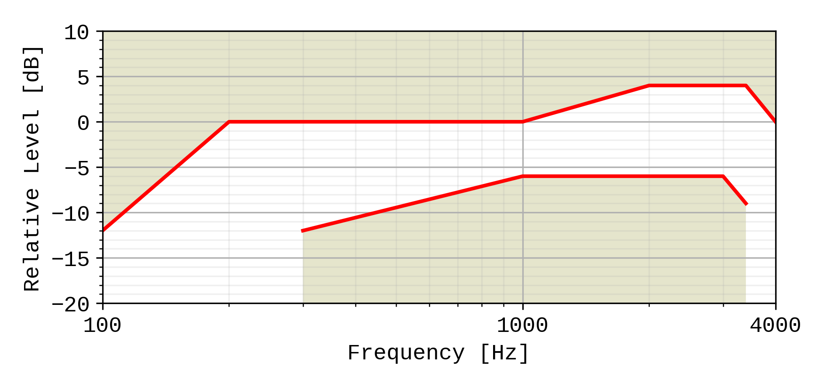

Figure 1: Handset and headset sending sensitivity/frequency mask

Compliance shall be checked by the relevant test described in TS 26.132.

### 5.4.2 Handset and headset UE receiving

The sensitivity/frequency characteristics shall be as follows:

The receiving sensitivity frequency response, measured either from the digital interface to the DRP with diffuse-field correction or from the SS audio input (analogue or digital input of the reference speech encoder of the SS) to the DRP with diffuse-field correction shall be within a mask, which can be drawn with straight lines between the breaking points in table 2 on a logarithmic (frequency) - linear (dB sensitivity) scale.

Table 2: Handset and headset receiving sensitivity/frequency mask for 8N application force

|  |  |  |  |
| --- | --- | --- | --- |
| Frequency (Hz) | | Upper limit (dB)  8 ± 2 N | Lower limit (dB)  8 ± 2 N |
| 100 | | 6 |  |
| 300 | | 6 | -6 |
| 3 400 | | 6 | -6 |
| 4 000 | | 6 |  |
| NOTE 1: All sensitivity values are expressed in dB on an arbitrary scale  NOTE 2: The basis for the target frequency responses in send and receive is the orthotelephonic reference response measured between 2 subjects 1 m apart under free-field conditions and assumes an ideal receive characteristic. Under these conditions the overall frequency response shows a rising slope. The present document no longer uses the ERP as the reference point for receive but the diffuse-field. With the concept of diffuse-field based receive measurements a rising slope for the overall frequency response is achieved by a flat target frequency response in send and a flat diffuse-field based receive frequency response. | | | |

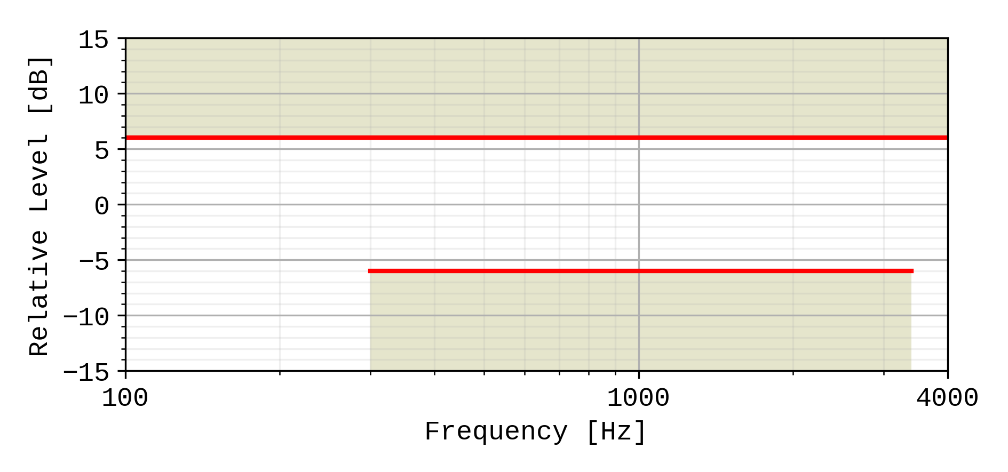

Figure 2: Handset and headset receiving sensitivity/frequency mask for 8N application force

Compliance shall be checked by the relevant test described in TS 26.132.

### 5.4.3 Desktop hands-free UE sending

The sending sensitivity frequency response from the MRP to the SS audio output (digital output of the reference speech decoder of the SS) shall be as follows:

The sending sensitivity frequency response shall be within the mask which can be drawn with straight lines between the breaking points in table 3 on a logarithmic (frequency) - linear (dB sensitivity) scale.

Table 3: Desktop hands-free sending sensitivity/frequency mask

|  |  |  |
| --- | --- | --- |
| Frequency (Hz) | Upper limit (dB) | Lower limit (dB) |
| 100 | ‑12 |  |
| 200 | 0 |  |
| 300 | 0 | ‑12 |
| 1 000 | 0 | ‑6 |
| 2 000 | 4 | ‑6 |
| 3 000 | 4 | ‑6 |
| 3 400 | 4 | ‑9 |
| 4 000 | 0 |  |
| NOTE: All sensitivity values are expressed in dB on an arbitrary scale. | | |



Figure 3: Desktop hands-free sending sensitivity/frequency mask

Compliance shall be checked by the relevant test described in TS 26.132.

### 5.4.4 Desktop hands-free UE receiving

The receiving sensitivity frequency response from the SS audio input (analogue or digital input of the reference speech encoder of the SS) to the free-field shall be as follows:

The receiving sensitivity frequency response shall be within the mask which can be drawn with straight lines between the breaking points in table 4 on a logarithmic (frequency) - linear (dB sensitivity) scale.

Table 4: Desktop hands-free receiving sensitivity/frequency mask

|  |  |  |
| --- | --- | --- |
| Frequency (Hz) | Upper limit (dB) | Lower limit (dB) |
| 200 | 6 |  |
| 315 | 6 | -9 |
| 400 | 6 | -6 |
| 3 100 | 6 | -6 |
| 4 000 | 6 |  |
| NOTE: All sensitivity values are expressed in dB on an arbitrary scale. | | |

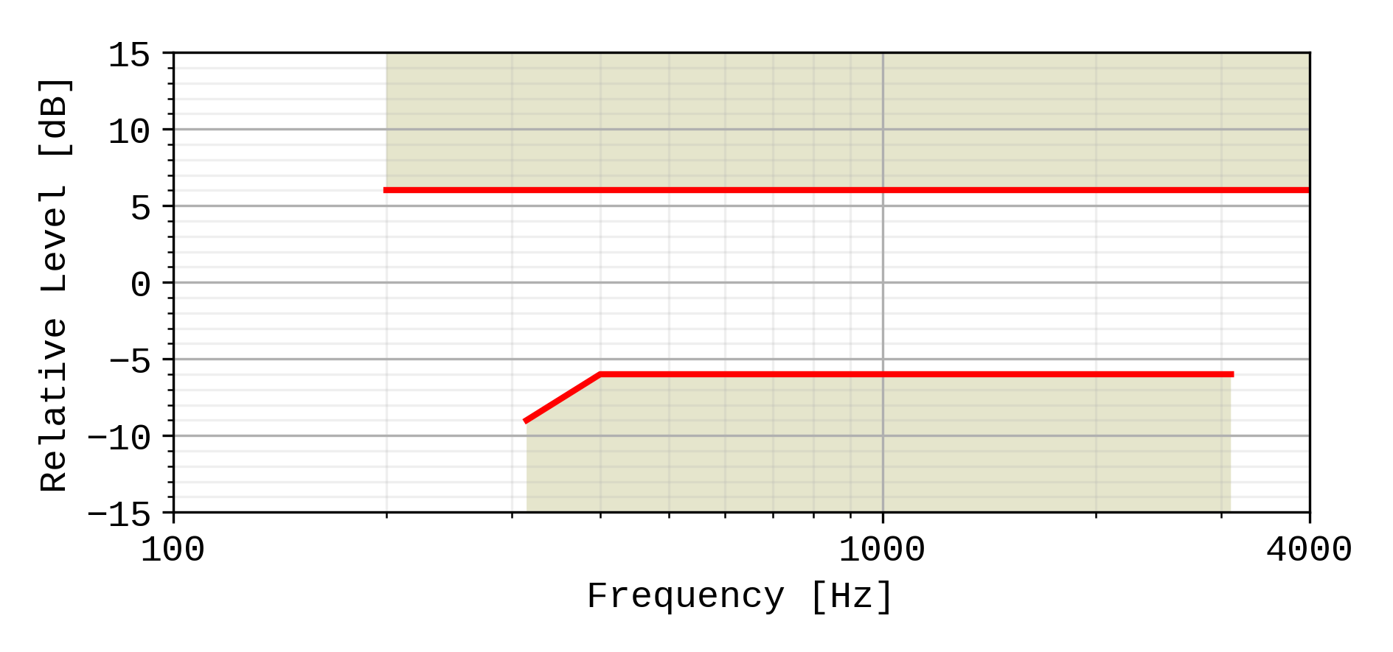

Figure 4: Desktop receiving sensitivity/frequency mask

Compliance shall be checked by the relevant test described in TS 26.132.

### 5.4.5 Hand-held hands-free UE sending

The sending sensitivity frequency response from the MRP to the SS audio output (digital output of the reference speech decoder of the SS) shall be as follows:

The sending sensitivity frequency response shall be within the mask which can be drawn with straight lines between the breaking points in table 5 on a logarithmic (frequency) - linear (dB sensitivity) scale.

Table 5: Hand-held hands-free sending sensitivity/frequency mask

|  |  |  |
| --- | --- | --- |
| Frequency (Hz) | Upper limit (dB) | Lower limit (dB) |
| 100 | ‑12 |  |
| 200 | 0 |  |
| 300 | 0 | ‑12 |
| 1 000 | 0 | ‑6 |
| 2 000 | 4 | ‑6 |
| 3 000 | 4 | ‑6 |
| 3 400 | 4 | ‑9 |
| 4 000 | 0 |  |
| NOTE: All sensitivity values are expressed in dB on an arbitrary scale. | | |



Figure 5: Hand-held hands-free sending sensitivity/frequency mask

Compliance shall be checked by the relevant test described in TS 26.132.

### 5.4.6 Hand-held hands-free UE receiving

The receiving sensitivity frequency response from the SS audio input (analogue or digital input of the reference speech encoder of the SS) to the free-field shall be as follows:

The receiving sensitivity frequency response shall be within the mask which can be drawn with straight lines between the breaking points in table 6 on a logarithmic (frequency) - linear (dB sensitivity) scale.

Table 6: Hand-held hands-free receiving sensitivity/frequency mask

|  |  |  |
| --- | --- | --- |
| Frequency (Hz) | Upper limit (dB) | Lower limit (dB) |
| 200 | 6 |  |
| 500 | 6 | -9 (Note 2) |
| 630 | 6 | -6 (Note 2) |
| 800 | 6 | ‑6 |
| 3 100 | 6 | ‑6 |
| 4 000 | 6 |  |
| NOTE 1: All sensitivity values are expressed in dB on an arbitrary scale.  NOTE 2: The values stated in the Table 6 for 500 and 630 Hz are listed for performance objective purposes. (not mandatory) | | |

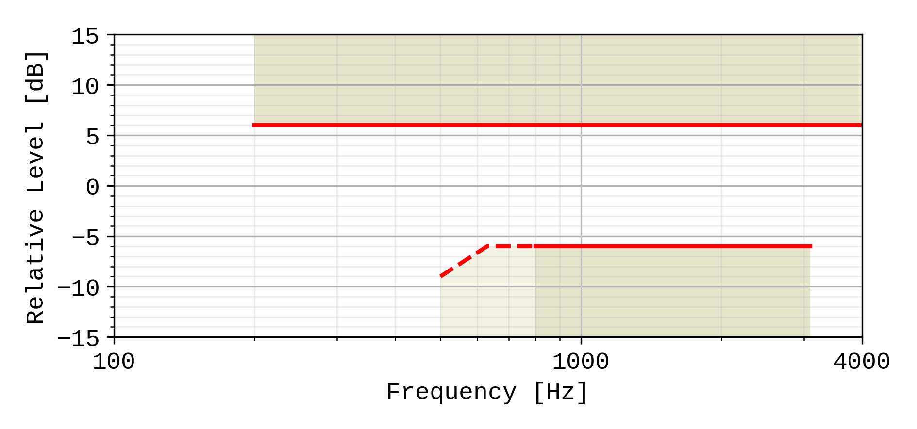

Figure 6: Hand-held hands-free receiving sensitivity/frequency mask

Compliance shall be checked by the relevant test described in TS 26.132.

5.4.7 Electrical interface UE sending

The sensitivity/frequency characteristics shall be as follows:

The sending sensitivity frequency response measured at the electrical reference point shall be within a mask, which can be drawn between the points given in table 6a. The mask is drawn with straight lines between the breaking points in table 6a on a logarithmic (frequency) - linear (dB sensitivity) scale.

NOTE: A tilt above 1 kHz is to compensate for the mouth to microphone acoustic path when the microphone is assumed to be hanging on a headset on the side of the head.

**Table 6a: Electrical interface sending sensitivity/frequency mask**

|  |  |  |
| --- | --- | --- |
| **Frequency (Hz)** | **Upper limit** | **Lower limit** |
| 100 | 3 |  |
| 200 | 3 |  |
| 300 | 3 | -3 |
| 1 000 | 5 | -3 |
| 3 100 |  | 0 |
| 3 400 | 12 | -5 |
| 4 000 | 12 |  |
| NOTE: All sensitivity values are expressed in dB on an arbitrary scale. | | |

**Figure 6a: Electrical interface sending sensitivity/frequency mask**

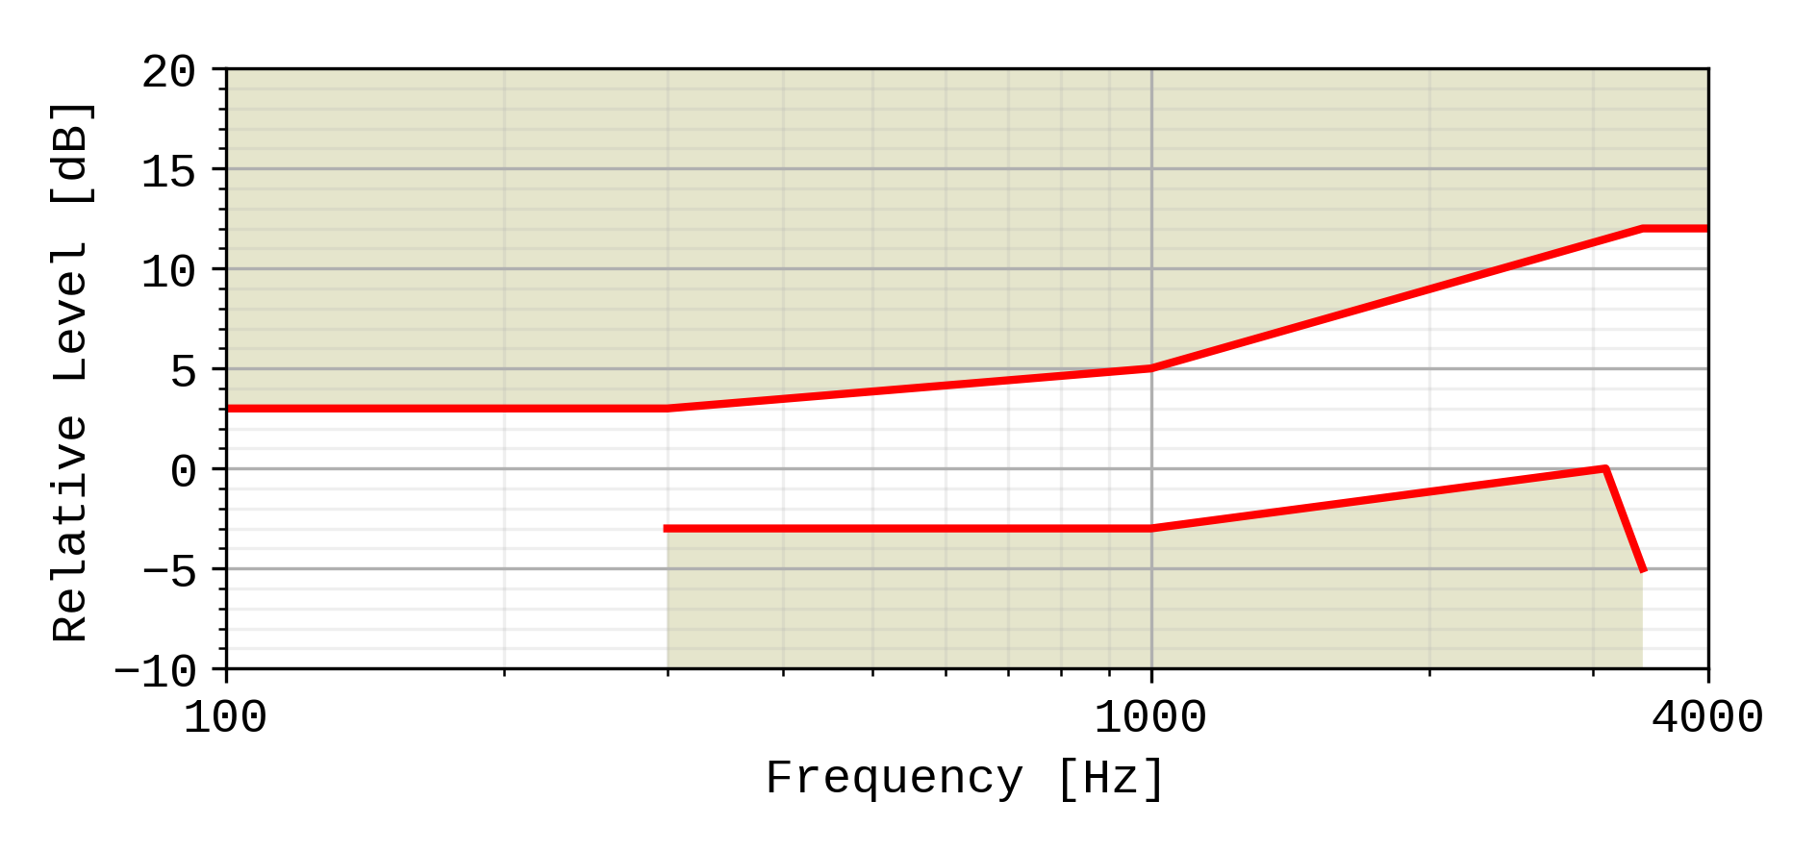

Compliance shall be checked by the relevant test described in TS 26.132.

5.4.8 Electrical interface UE receiving

The sensitivity/frequency characteristics shall be as follows:

The receiving sensitivity frequency response measured at the output of the electrical interface UE shall be within a mask, which can be drawn with straight lines between the breaking points in table 6b on a logarithmic (frequency) - linear (dB sensitivity) scale.

**Table 6b: Electrical interface receiving sensitivity/frequency mask**

|  |  |  |
| --- | --- | --- |
| **Frequency (Hz)** | **Upper limit** | **Lower limit** |
| 100 | 2 |  |
| 200 | 2 |  |
| 300 | 2 | -6 |
| 1 000 | 2 | -2 |
| 2 000 | 6 | -2 |
| 3 400 | 6 | -5 |
| 4 000 | 6 |  |
| NOTE: All sensitivity values are expressed in dB on an arbitrary scale. | | |

**Figure 6b: Handset and headset receiving sensitivity/frequency mask**

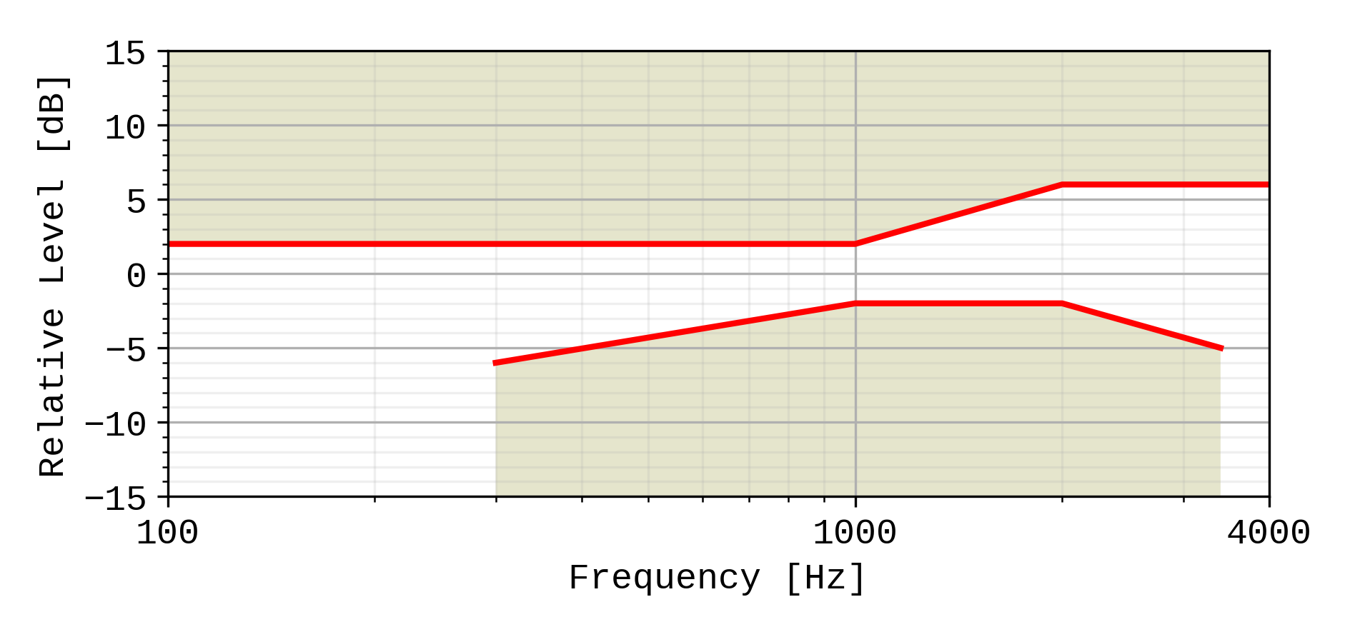

Compliance shall be checked by the relevant test described in TS 26.132.

## 5.5 Sidetone characteristics (handset, headset, and analogue electrical interface UE)

### 5.5.1 Sidetone loss

The talker sidetone masking rating (STMR) shall be ≥ 15 dB and should be ≤ 23 dB for the nominal setting of the volume control. For all other positions of the volume control, the STMR shall be ≥ 10 dB.

In case the STMR is below the lower limit also when the electrical sidetone path has been disabled, the result shall not be regarded as a failure.

Compliance shall be checked by the relevant test described in 3GPP TS 26.132. The bandwidth for the sidetone path provided by the UE may in some terminals not be restricted to the narrowband range. In case the sidetone path operates in a mode other than narrowband (to be declared by the manufacturer), compliance shall be checked using the test described for "Wideband telephony transmission performance".

NOTE 1: Where a user-controlled receiving volume control is provided, it is recommended that the sidetone loss is independent of the volume control setting.

NOTE 2: In general, it is recommended to provide a terminal sidetone path for handset and headset UEs.

NOTE 3: In case the human air-conducted sidetone paths are obstructed (one example being some binaural insert type headset UEs), it is important to provide a terminal sidetone path.

NOTE 4: The STMR calculation algorithm being used was developed for quantifying the audibility of the electrical sidetone path using a sealed coupler. The air-conducted path was not intended to be included in the test setup. A lower STMR limit was specified to avoid annoying effects (e.g. howling, increase of ambient noise level in the ear) of an excessive electrical sidetone. In HATS-based measurements, the air-conducted path cannot be avoided in the test setup. With some UE form factors the air-conducted path can be substantial resulting in low STMR figures also when there are no annoying effects from any excessive electrical sidetone. See ITU-T Recommendation P.76 for definitions of sidetone paths.

### 5.5.2 Sidetone delay

The maximum sidetone delay should be ≤ 5 ms, measured in an echo-free setup.

NOTE: The measured result is only applicable where the level of the electrical sidetone is sufficiently high to be measured. While the STMR value may indicate the presence of sidetone it should be ensured that this is not primarily due to the acoustical or mechanical sidetone path when interpreting sidetone delay results.

Compliance shall be checked by the relevant test described in TS 26.132.

## 5.6 Stability loss

The stability loss presented to the PSTN by the 3G, LTE, NR or WLAN network at the POI should meet the principles of the requirements in clauses 2 and 3 of ITU-T Recommendation G.122 [6]. These requirements will be met if the attenuation between the digital input and digital output at the POI is ≥ 6 dB at all frequencies in the range 200 Hz to 4 kHz under the worst case acoustic conditions at the UE (any acoustic echo control should be enabled). For the normal case of digital connection between the Air Interface and the POI, the stability requirement can be applied at the Air Interface.

The worst case acoustic conditions will be as follows (with volume control set to maximum for each following condition):

**Handset UE:** the handset lying on, and the transducers facing, a hard surface with the ear-piece uncapped;

**Headset UE:** for further study;

**Hands-free UE:** no requirement other than echo loss.

NOTE: The test procedure must take into account the switching effects of echo control and discontinuous transmission (DTX).

## 5.7 Echo Control

### 5.7.1 General

The echo loss (EL) presented by the 3G, LTE, NR or WLAN network at the POI should be sufficient during single-talk. This takes into account the fact that the UE is likely to be used in connections with high transmission delay and in a wide range of noise environments.  
See ITU-T Recommendation G.131 for general guidance.

The use of acoustic echo control is not mandated for 3G, LTE, NR or WLAN networks and the connection between the UE and the POI is zero loss. Therefore the acoustic echo control provided in the UE should provide a sufficient TCLw at the POI over the likely range of acoustic end delays.

If acoustic echo control is provided by voice switching, comfort noise should be injected. This comfort noise shall operate in the same way as that used in DTX.

### 5.7.2 Acoustic echo control in desktop hands-free UE

The TCLw for the desktop hands-free UE shall be ≥ 40 dB for any setting of the volume control.

The TCLw for the desktop hands-free UE shall be ≥ 46 dB when measured under free-field conditions at the nominal setting of the volume control.

NOTE: A TCLw for the desktop hands-free UE of ≥ 55 dB is recommended as a performance objective when measured under free-field conditions at the nominal setting of the volume control. Depending on the UE idle channel noise in the sending direction, it may not always be possible to measure an echo loss ≥ 55 dB.

The echo canceller should be designed to cope with the expected reverberation and dispersion. In the case of the hands-free UE, this reverberation and dispersion may be time variant. Compliance with this requirement shall be checked by the relevant test described in TS 26.132.

### 5.7.3 Acoustic echo control in hand-held hands-free UE

The TCLw for hand-held hands-free UE shall be ≥ 40 dB for any setting of the volume control.

The TCLw for hand-held hands-free UE shall be ≥ 46 dB at the nominal setting of the volume control.

NOTE: A TCLw for the hand-held hands-free UE of ≥ 55 dB is recommended as a performance objective when measured under free-field conditions at the nominal setting of the volume control. Depending on the UE idle channel noise in the sending direction, it may not always be possible to measure an echo loss ≥ 55 dB.

The echo canceller should be designed to cope with the expected reverberation and dispersion. In the case of the hands-free UE, this reverberation and dispersion may be time variant. Compliance with this requirement shall be checked by the relevant test described in TS 26.132.

### 5.7.4 Acoustic echo control in a handset UE

The TCLw for handset UE shall be ≥ 46 dB for any setting of the volume control.

The TCLw for handset UE should be ≥ 55 dB at the nominal setting of the volume control.

NOTE: It is recommended that the volume control should be set back to nominal after each call unless TCLw ≥ 55 dB can also be maintained with the maximum volume setting. Depending on the UE idle channel noise in the sending direction, it may not always be possible to measure an echo loss ≥ 55 dB.

The echo canceller should be capable of dealing with the variations in handset positions when in normal use. The implications of this are under study. Compliance with this requirement shall be checked by the relevant test described in TS 26.132.

### 5.7.5 Acoustic echo control in a headset UE

The TCLw for headset UE shall be ≥ 46 dB for any setting of the volume control.

The TCLw for headset UE should be ≥ 55 dB at the nominal setting of the volume control.

NOTE: It is recommended that the volume control should be set back to nominal after each call unless TCLw ≥ 55 dB can also be maintained with the maximum volume setting. Depending on the UE idle channel noise in the sending direction, it may not always be possible to measure an echo loss ≥ 55 dB.

The echo canceller should be designed to cope with the expected reverberation and dispersion.

Compliance with this requirement shall be checked by the relevant test described in TS 26.132.

### 5.7.6 Echo control in an electrical interface UE

The TCLw for electrical interface UE shall be ≥ 46 dB for any setting of the volume control.

The TCLw for electrical interface UE should be ≥ 55 dB at the nominal setting of the volume control.

NOTE: It is recommended that the volume control should be set back to nominal after each call unless TCLw ≥ 55 dB can also be maintained with the maximum volume setting. Depending on the UE idle channel noise in the sending direction, it may not always be possible to measure an echo loss ≥ 55 dB.

The echo canceller should be designed to cope with the expected reverberation and dispersion.

Compliance with this requirement shall be checked by the relevant test described in TS 26.132.

## 5.8 Distortion

### 5.8.1 Sending distortion (excluding electrical interface UE)

The sending part shall meet the following distortion requirements:

NOTE 1: Digital signal processing other than the transcoder itself is included in this requirement (e.g. echo cancelling).

Distortion shall be measured between the MRP and the SS audio output (output of the reference speech decoder of the SS). The ratio of signal‑to‑total distortion power measured with the proper noise weighting (see table 4 of ITU‑T Recommendation G.223) shall be above the limits given in table 7.

Table 7: Limits for signal‑to‑total distortion ratio

|  |  |
| --- | --- |
| Sending level  (dBPa at the MRP) | Sending Ratio (dB) |
| 5 | 30 |
| 0 | 35 |
| -4,7 | 35 |
| -10 | 33 |
| -15 | 30 |
| -20 | 27 |

Limits for intermediate levels are found by drawing straight lines between the breaking points in table 7 on a linear (dB signal level) ‑ linear (dB ratio) scale.

Compliance of the sending distortion shall be checked by the test described in TS 26.132.

NOTE 2: It should be ensured that the test signal is treated by speech processing algorithms as a speech-like signal, and not a noise-like signal. Test signals with a time-stationary envelope may be treated by certain algorithms, e.g., noise suppression algorithms defined in 3GPP TS 06.77 R99 [16], as a noise-like signal. If speech processing algorithms, including but not limited to noise suppression algorithms, are shown to treat the test signal as a noise-like signal, even where an activation signal has been utilized, then the test should be repeated with said speech processing algorithms disabled. The results of both sets of tests and the state of the processing algorithms should be documented in the test report.

### 5.8.2 Receiving (excluding electrical interface UE)

The receiving part between the SS audio input (input of the reference speech encoder of the SS) and the applicable acoustic measurement point (DRP with diffuse-field correction for handset and headset modes; free field correction for hands-free modes) shall meet the requirements in this clause at the nominal setting of the volume control:

The ratio of signal to total distortion power measured with the proper noise weighting (see table 4 of ITU-T Recommendation G.223) shall be above the limits given in table 8 when the sound pressure at the applicable acoustic measurement point is up to 10 dBPa. For a sound pressure ≥ 10 dBPa at the applicable acoustic measurement point there is no distortion requirement.

Table 8: Limits for signal‑to‑total distortion ratio

| Frequency (Hz) | Receiving level  at the digital interface (dBm0) | Receiving ratio  at nominal volume setting (dB) | Receiving ratio  at maximum volume setting (dB) |
| --- | --- | --- | --- |
| 315 | -16 | 20 |  |
| 408 | -16 | 28 |  |
| 510 | -16 | 28 |  |
| 816 | -16 | 28 |  |
| 1 020 | 0 | 25,5 |  |
| -3 | 31,2 |  |
| -10 | 33,5 |  |
| -16 | 33,5 |  |
| -20 | 33 |  |
| -30 | 30,5 |  |
| -40 (*) | 22,5 (*) |  |
| -45 (*) | 17,5 (*) |  |
| NOTE: (*)For levels -40 and -45 dBm0 a lower signal-to-total distortion ratio may not be possible, and hence would not be regarded as a failing result. However, the obtained results would be reported. | | | |

Limits for intermediate levels are found by drawing straight lines between the breaking points in the table on a linear (dB signal level) ‑ linear (dB ratio) scale.

Compliance of the receiving distortion shall be checked by the appropriate test method in TS 26.132.

NOTE 1: It should be ensured that the test signal is treated by speech processing algorithms as a speech-like signal, and not a noise-like signal. Test signals with a time-stationary envelope may be treated by certain algorithms, e.g. noise suppression algorithms defined in 3GPP TS 06.77 R99 [16], as a noise-like signal. If speech processing algorithms, including but not limited to noise suppression algorithms, are shown to treat the test signal as a noise-like signal, even where an activation signal has been utilized, then the test should be repeated with said speech processing algorithms disabled. The results of both sets of tests and the state of the processing algorithms should be documented in the test report.

NOTE 2: Frequencies from 315 Hz to 816 Hz do not apply to the hands-free UE case, only to handset and headset UE.

### 5.8.3 Sending distortion (electrical interface UE)

The sending part shall meet the following distortion requirements:

NOTE 1: Digital signal processing other than the transcoder itself is included in this requirement (e.g. echo cancelling).

Distortion shall be measured at the output of the electrical reference interface. The ratio of signal‑to‑total distortion power measured with the proper noise weighting (see table 4 of ITU‑T Recommendation G.223) shall be above the limits given in table 8a1 for electrical interface UE with analogue connection and table 8a2 for electrical interface UE with digital connection.

Table 8a1: Limits for signal‑to‑total distortion ratio for analogue connection

|  |  |
| --- | --- |
| Sending level  (dBV at at the output of the electrical reference interface) | Sending Ratio (dB) |
| -50 | 30 |
| -55 | 35 |
| -60 | 35 |
| -65 | 33 |
| -70 | 30 |
| -75 | 27 |

Table 8a2: Limits for signal‑to‑total distortion ratio for digital connection

|  |  |
| --- | --- |
| Sending level  (dBm0 at at the output of the electrical reference interface) | Sending Ratio (dB) |
| -6 | 30 |
| -11 | 35 |
| -16 | 35 |
| -21 | 33 |
| -26 | 30 |
| -31 | 27 |

Limits for intermediate levels are found by drawing straight lines between the breaking points in tables 8a1 and 8a2 on a linear (dB signal level) ‑ linear (dB ratio) scale.

Compliance of the sending distortion shall be checked by the test described in TS 26.132.

NOTE 2: It should be ensured that the test signal is treated by speech processing algorithms as a speech-like signal, and not a noise-like signal. Test signals with a time-stationary envelope may be treated by certain algorithms, e.g., noise suppression algorithms defined in 3GPP TS 06.77 R99 [16], as a noise-like signal. If speech processing algorithms, including but not limited to noise suppression algorithms, are shown to treat the test signal as a noise-like signal, even where an activation signal has been utilized, then the test should be repeated with said speech processing algorithms disabled. The results of both sets of tests and the state of the processing algorithms should be documented in the test report.

### 5.8.4 Receiving distortion (electrical interface UE)

The receiving part between the SS audio input (input of the reference speech encoder of the SS) and applicable electric measurement point (input to the electrical reference interface) shall meet the requirements in this clause at the nominal setting of the volume control:

The ratio of signal to total distortion power measured with the proper noise weighting (see table 4 of ITU-T Recommendation G.223) shall be above the limits given in table 8b.

Table 8b: Limits for signal‑to‑total distortion ratio

| Frequency (Hz) | Receiving level  at the digital interface (dBm0) | Receiving ratio  at nominal volume setting (dB) | Receiving ratio  at maximum volume setting (dB) |
| --- | --- | --- | --- |
| 315 | -16 | 20 |  |
| 408 | -16 | 28 |  |
| 510 | -16 | 28 |  |
| 816 | -16 | 28 |  |
| 1 020 | 0 | 25,5 |  |
| -3 | 31,2 |  |
| -10 | 33,5 |  |
| -16 | 33,5 |  |
| -20 | 33 |  |
| -30 | 30,5 |  |
| -40 (*) | 22,5 (*) |  |
| -45 (*) | 17,5 (*) |  |
| NOTE: (*)For levels -40 and -45 dBm0 a lower signal-to-total distortion ratio may not be possible, and hence would not be regarded as a failing result. However, the obtained results would be reported. | | | |

Limits for intermediate levels are found by drawing straight lines between the breaking points in the table 8b on a linear (dB signal level) ‑ linear (dB ratio) scale.

Compliance of the receiving distortion shall be checked by the appropriate test method in TS 26.132.

NOTE: It should be ensured that the test signal is treated by speech processing algorithms as a speech-like signal, and not a noise-like signal. Test signals with a time-stationary envelope may be treated by certain algorithms, e.g. noise suppression algorithms defined in 3GPP TS 06.77 R99 [16], as a noise-like signal. If speech processing algorithms, including but not limited to noise suppression algorithms, are shown to treat the test signal as a noise-like signal, even where an activation signal has been utilized, then the test should be repeated with said speech processing algorithms disabled. The results of both sets of tests and the state of the processing algorithms should be documented in the test report.

## 5.9 Void

## 5.10 Information on other parameters (not normative)

Information about additional parameters relevant to speech quality, e.g., for terminals where signal processing is used, can be found in ITU-T Recommendations P.340, P.501 and P.502.

## 5.11 Sending performance in the presence of ambient noise

### 5.11.1 General

For sending, in handset mode, the UE shall reduce the ambient noise picked up by the microphone(s) without significantly degrading the quality of the speech signal.

### 5.11.2 Connections with handset UE

The UE shall comply with the following requirements:

S-MOS-LQOn

- The average of S-MOS-LQOn scores across all test conditions shall be ≥ 3.0



- As a performance objective, the average of the S-MOS-LQOn scores across all test conditions should be ≥ 3.5



N-MOS-LQOn

- The average of the N-MOS-LQOn scores across all test conditions shall be ≥ 2.3



- As a performance objective, the average of N-MOS-LQOn scores across all test conditions should be ≥ 3.0



G-MOS-LQOn

- No requirement.

Compliance shall be checked by the relevant tests described in 3GPP TS 26.132.

### 5.11.3 Connections with Handheld hands-free UE

It is recommended that the UE meets the following performance objectives:

S-MOS-LQOn

- The average of S-MOS-LQOn scores across all five test conditions should be ≥ 3.3



N-MOS-LQOn

- The average of N-MOS-LQOn scores across all test conditions should be ≥ 2.2



G-MOS-LQOn

- No performance objective.

Compliance shall be checked by the relevant tests described in 3GPP TS 26.132.

### 5.11.4 Connections with electrical interface UE

The UE shall comply with the following requirements:

S-MOS-LQOn

- The average of S-MOS-LQOn scores across all test conditions shall be ≥ 3.0



- As a performance objective, the average of the S-MOS-LQOn scores across all test conditions should be ≥ 3.5



N-MOS-LQOn

- The average of the N-MOS-LQOn scores across all test conditions shall be ≥ 2.3



- As a performance objective, the average of N-MOS-LQOn scores across all test conditions should be ≥ 3.0



G-MOS-LQOn

- No performance objective.

Compliance shall be checked by the relevant tests described in 3GPP TS 26.132.

## 5.12 Delay

### 5.12.0 UE delay definition

#### 5.12.0.1 Acoustic interfaces

For UMTS circuit-switched operation and MTSI-based speech with LTE, NR or WLAN access, the UE delays in the send and receive directions are defined for acoustic interfaces as:

- The UE delay in the send (uplink) direction is the delay between the first acoustic event at the MRP to the last bit of the corresponding speech frame at the UE antenna

- The UE delay in the receive (downlink) direction is the delay between the first bit of a speech frame at the UE antenna and the first acoustic event at the DRP corresponding to that speech frame

NOTE: In order to harmonize UMTS and LTE delay definitions, the reference points for UMTS UE delay have been changed in Rel-12. Prior to Rel-12, the UE reference points for UMTS were implicitly defined by the compensation factors declared by system simulator vendors, i.e. half of the air interface delay was attributed to the UE, and the last acoustic event at DRP was used for the receive measurement instead of the first.

Considering 10ms for half of the transmission time in each direction of a UMTS call, a speech frame size of 20ms, a codec look-ahead of 5ms, and a difference between the first and the last acoustic event of 20 ms, the previous reference points took into account a UE implementation independent delay of 2x10ms + 25 ms + 20 ms = 65 ms. The same UE delay remains in the new definition above, which attributes the full air interface delay to the UE but uses the first acoustic event at the DRP, instead of the last (2x20ms + 25 ms + 0 ms = 65 ms). Hence, the UMTS requirements with these new reference points remain the same.

#### 5.12.0.2 Electrical interfaces

The UE delays in the send and receive directions are defined for electrical interfaces as:

- The UE delay in the send (uplink) direction is the delay between the first electrical event at the input of the electrical interface (analogue or wired digital connection) or first bit of a speech frame at the UE antenna of the wireless digital interface (wireless digital connection) to the last bit of the corresponding speech frame at the UE antenna

- The UE delay in the receive (downlink) direction is the delay between the first bit of a speech frame at the UE antenna and the first electrical event at the output of the electrical interface (analogue or wired digital connection) or first bit of a speech frame at the UE antenna of the wireless digital interface (wireless digital connection) corresponding to that speech frame.

### 5.12.1 Handset UE

It is in general desirable to minimize UE delays to ensure low enough end-to-end delays and hence a good conversational experience, guidance is found in ITU-T Recommendation G.114.

For UMTS circuit-switched AMR speech codec operation, the sum of the UE delays in sending and receiving directions (TS + TR) shall in any case be ≤ 220ms and should be ≤ 185ms.

NOTE: A delay ≤ 185 ms might not be achievable in some cases due to UE implementation trade-offs between delay and other parameters such as speech quality enhancement, performance of noise reduction or UE power consumption optimization, and UE implementation issues such as rebuffering between components.

For MTSI-based speech-only with LTE, NR or WLAN access in error and jitter free conditions and AMR speech codec operation, the sum of the UE delays in sending and receiving directions (TS + TR) should be ≤ 150ms. If this performance objective cannot be met, the sum of the UE delays in sending and receiving directions (TS + TR) shall in any case be ≤ 190ms.

For MTSI-based speech-only with LTE, NR or WLAN access in conditions with simulated packet arrival time variations and packet loss and AMR speech codec operation, the sum of the UE delays in sending and receiving directions (TS + TR) shall be less than or equal to the delay requirements in Table 8bis, while meeting the speech quality targets defined.

NOTE: The UE delay requirements for MTSI-based speech-only with LTE, NR or WLAN access are derived from:

- A speech frame buffering and codec look-ahead of 25ms.

- An air interface transmission time of 1ms on receive and 1ms on the send direction.

- A budget allowance for a jitter buffer depth of 40ms for error and jitter free conditions and test conditions 0 and 1 of Table 8bis, and 80ms for test condition 2 of Table 8bis.

- A budget allowance for vendor specific implementation of 83ms corresponding to the performance objective and 123ms corresponding to the required maximum UE send and receive delay.

Table 8bis: UE delay and speech quality requirements for LTE, NR and WLAN access

|  |  |  |  |  |
| --- | --- | --- | --- | --- |
| Test Condition | Delay and Loss Profile  (Note 1) | Performance Objectives for Maximum Delay | Requirements for Maximum Delay | Speech Quality  Requirements  (Note 2) |
| 0 | Error and jitter free condition | TS + TR ≤ 150ms | TS + TR ≤ 190ms | No requirement, reference score  MOS-LQOREF |
| 1 | dly_profile_20msDRX_10pct_BLER_e2e | TS + TR ≤ 150ms | TS + TR ≤ 190ms | MOS-LQOTEST ≥  MOS-LQOREF - 0.3 |
| 2 | dly_profile_40msDRX_10pct_BLER_e2e | TS + TR ≤ 190ms | TS + TR ≤ 230ms | MOS-LQOTEST ≥  MOS-LQOREF - 0.3 |
|  | NOTE 1: The delay profiles for test condition 1 and 2 are theoretically constructed to simulate a semi-persistent scheduling transmission scheme with DRX enabled and target BLER in sending and receiving directions of 10%, with +/- 3ms of EPC jitter. Delay profiles are injected at the IP layer of the test system. Delay profiles are attached electronically to document 3GPP TS 26.132 [1]. The delay profiles in test condition 1 and 2 are static delay variation conditions and do not expose the UE to packet delay variations in the full range of the packet delay budget as defined for QCI1 in 3GPP TS 23.203 [18]. A third test condition that exposes the UE to non-stationary packet delay variations experienced in live operation and packet delay variations in the full range of the packet delay budget for QCI1, and accompanied delay and speech quality requirements, is for further study. | | | |
|  | NOTE 2: The purpose of this test is to provide a relative comparison of the objective speech quality between the reference and test conditions. This test is not to be construed as a method to evaluate the absolute objective speech quality of the device. | | | |

Compliance shall be checked by the relevant tests described in 3GPP TS 26.132.

### 5.12.2 Headset UE

#### 5.12.2.1 Wired headset

It is in general desirable to minimize UE delays to ensure low enough end-to-end delays and hence a good conversational experience, guidance is found in ITU-T Recommendation G.114.

For UMTS circuit-switched AMR speech codec operation, the sum of the UE delays in sending and receiving directions (TS + TR) shall in any case be ≤ 220ms and should be ≤ 185ms.

NOTE: A delay ≤ 185 ms might not be achievable in some cases due to UE implementation trade-offs between delay and other parameters such as speech quality enhancement, performance of noise reduction or UE power consumption optimization, and UE implementation issues such as rebuffering between components.

For MTSI-based speech-only with LTE, NR or WLAN access in error and jitter free conditions and AMR speech codec operation, the sum of the UE delays in sending and receiving directions (TS + TR) should be ≤ 150ms. If this performance objective cannot be met, the sum of the UE delays in sending and receiving directions (TS + TR) shall in any case be ≤ 190ms.

For MTSI-based speech-only with LTE, NR or WLAN access in conditions with simulated packet arrival time variations and packet loss and AMR speech codec operation, the sum of the UE delays in sending and receiving directions (TS + TR) shall be less than or equal to the delay requirements in Table 8, while meeting the speech quality targets defined.

NOTE: The UE delay requirements for MTSI-based speech-only with LTE, NR or WLAN access are derived from:

- A speech frame buffering and codec look-ahead of 25ms.

- An air interface transmission time of 1ms on receive and 1ms on the send direction.

- A budget allowance for a jitter buffer depth of 40ms for error and jitter free conditions and test conditions 0 and 1 of Table 8ter, and 80ms for test condition 2 of Table 8ter.

- A budget allowance for vendor specific implementation of 83ms corresponding to the performance objective and 123ms corresponding to the required maximum UE send and receive delay.

Table 8ter: UE delay and speech quality requirements for LTE, NR and WLAN access

|  |  |  |  |  |
| --- | --- | --- | --- | --- |
| Test Condition | Delay and Loss Profile  (Note 1) | Performance Objectives for Maximum Delay | Requirements for Maximum Delay | Speech Quality  Requirements  (Note 2) |
| 0 | Error and jitter free condition | TS + TR ≤ 150ms | TS + TR ≤ 190ms | No requirement, reference score  MOS-LQOREF |
| 1 | dly_profile_20msDRX_10pct_BLER_e2e | TS + TR ≤ 150ms | TS + TR ≤ 190ms | MOS-LQOTEST ≥  MOS-LQOREF - 0.3 |
| 2 | dly_profile_40msDRX_10pct_BLER_e2e | TS + TR ≤ 190ms | TS + TR ≤ 230ms | MOS-LQOTEST ≥  MOS-LQOREF - 0.3 |
|  | NOTE 1: The delay profiles for test condition 1 and 2 are theoretically constructed to simulate a semi-persistent scheduling transmission scheme with DRX enabled and target BLER in sending and receiving directions of 10%, with +/- 3ms of EPC jitter. Delay profiles are injected at the IP layer of the test system. Delay profiles are attached electronically to document 3GPP TS 26.132 [1]. The delay profiles in test condition 1 and 2 are static delay variation conditions and do not expose the UE to packet delay variations in the full range of the packet delay budget as defined for QCI1 in 3GPP TS 23.203 [18]. A third test condition that exposes the UE to non-stationary packet delay variations experienced in live operation and packet delay variations in the full range of the packet delay budget for QCI1, and accompanied delay and speech quality requirements, is for further study. | | | |
|  | NOTE 2: The purpose of this test is to provide a relative comparison of the objective speech quality between the reference and test conditions. This test is not to be construed as a method to evaluate the absolute objective speech quality of the device. | | | |

Compliance shall be checked by the relevant tests described in 3GPP TS 26.132.

#### 5.12.2.2 Wireless headset

For further study.

### 5.12.3 Electrical interface UE

It is in general desirable to minimize UE delays to ensure low enough end-to-end delays and hence a good conversational experience, guidance is found in ITU-T Recommendation G.114.

The delay budget BD to be considered in the performance requirements and objectives depends on the type of electrical interface UE and is given by Table 8quater1.

Table 8quater1: Delay budget for different types of electrical interface UE

|  |  |
| --- | --- |
| Electrical interface type | BD [ms] |
| Analogue | 0 |
| Wireless digital | 20 |
| Wired digital | 20 |
| NOTE: The delay for analogue to digital conversion (and vice versa) in the wired digital connection is considered to be part of the budget allowance for vendor specific implementation in the UE delay requirements. | |

For UMTS circuit-switched AMR speech codec operation, the sum of the UE delays in sending and receiving directions (TS + TR) shall in any case be ≤ 220+BD ms and should be ≤ 185+BD ms.

NOTE1: A delay ≤ 185+BD ms might not be achievable in some cases due to UE implementation trade-offs between delay and other parameters such as speech quality enhancement, performance of noise reduction or UE power consumption optimization, and UE implementation issues such as rebuffering between components.

For MTSI-based speech-only with LTE, NR or WLAN access in error and jitter free conditions and AMR speech codec operation, the sum of the UE delays in sending and receiving directions (TS + TR) should be ≤ 150+BD ms. If this performance objective cannot be met, the sum of the UE delays in sending and receiving directions (TS + TR) shall in any case be ≤ 190+BD ms.

For MTSI-based speech-only with LTE, NR or WLAN access in conditions with simulated packet arrival time variations and packet loss and AMR speech codec operation, the sum of the UE delays in sending and receiving directions (TS + TR) shall be less than or equal to the delay requirements in Table 8quater2, while meeting the speech quality targets defined.

NOTE2: The UE delay requirements for MTSI-based speech-only with LTE, NR or WLAN access are derived from:

- A speech frame buffering and codec look-ahead of 25ms.

- An air interface transmission time of 1ms on receive and 1ms on the send direction.

- A budget allowance for a jitter buffer depth of 40ms for error and jitter free conditions and test conditions 0 and 1 of Table 8quater, and 80ms for test condition 2 of Table 8quater.

- A budget allowance for vendor specific implementation of 83ms corresponding to the performance objective and 123ms corresponding to the required maximum UE send and receive delay.

Table 8quater2: UE delay and speech quality requirements for LTE, NR and WLAN access

|  |  |  |  |  |
| --- | --- | --- | --- | --- |
| Test Condition | Delay and Loss Profile  (Note 1) | Performance Objectives for Maximum Delay | Requirements for Maximum Delay | Speech Quality  Requirements  (Note 2) |
| 0 | Error and jitter free condition | TS + TR ≤ 150+BD ms | TS + TR ≤ 190+BD ms | No requirement, reference score  MOS-LQOREF |
| 1 | dly_profile_20msDRX_10pct_BLER_e2e | TS + TR ≤ 150+BD ms | TS + TR ≤ 190+BD ms | MOS-LQOTEST ≥  MOS-LQOREF -0.3 |
| 2 | dly_profile_40msDRX_10pct_BLER_e2e | TS + TR ≤ 190+BD ms | TS + TR ≤ 230+BD ms | MOS-LQOTEST ≥  MOS-LQOREF -0.3 |
|  | NOTE 1: The delay profiles for test condition 1 and 2 are theoretically constructed to simulate a semi-persistent scheduling transmission scheme with DRX enabled and target BLER in sending and receiving directions of 10%, with +/- 3ms of EPC jitter. Delay profiles are injected at the IP layer of the test system. Delay profiles are attached electronically to document 3GPP TS 26.132 [1]. The delay profiles in test condition 1 and 2 are static delay variation conditions and do not expose the UE to packet delay variations in the full range of the packet delay budget as defined for QCI1 in 3GPP TS 23.203 [18]. A third test condition that exposes the UE to non-stationary packet delay variations experienced in live operation and packet delay variations in the full range of the packet delay budget for QCI1, and accompanied delay and speech quality requirements, is for further study. | | | |
|  | NOTE 2: The purpose of this test is to provide a relative comparison of the objective speech quality between the reference and test conditions. This test is not to be construed as a method to evaluate the absolute objective speech quality of the device. | | | |

Compliance shall be checked by the relevant tests described in 3GPP TS 26.132.

## 5.13 Echo control characteristics

Echo cancellation is commonly deployed in the UE to fulfil the Acoustic echo control requirements. Echo cancellers are complex devices of which the subjective performance is affected by several attributes. The main attribute is its ability to suppress echo. The process of suppressing the echo may introduce impairments to the near-end speech signal, mainly manifested as distortion or clipping of the near-end signal during simultaneous speech from both the far and near-end ("double-talk").

To characterise the echo control performance, the activity (in % of total time) and averaged level difference (in dB) of the duration of any level difference according to Figure 6a and Table 8a between the clean near-end signal and the send-signal shall be reported for "double-talk" as well as the far-end single talk periods adjacent to the "double-talk".

NOTE: The limits for specifying the categories in Figure 6a and Table 8a are provisional pending further analysis and validation.

NOTE: The categories in Figure 6a and Table 8a are labelled in a functional order and the subjective impression of the respective categories is for further study.

All percentage values and averaged level differences described in the relevant test of 3GPP TS 26.132 shall be reported.



Figure 6a: Classification of echo canceller performance

Table 8a: Categories for echo canceller performance classification

|  |  |
| --- | --- |
| Category | Description |
| **A1** | Full-duplex and full transparency |
| **A2** | Full-duplex with level loss in Tx |
| **B** | Very short clipping |
| **C** | Short clipping resulting in loss of syllables |
| **D** | Clipping resulting in loss of words |
| **E** | Very short residual echo |
| **F** | Echo bursts |
| **G** | Continuous echo |

### 5.13.1 Handset

Requirements are for further study.

### 5.13.2 Headset

Requirements are for further study.

### 5.13.3 Handheld hands-free

Requirements are for further study.

### 5.13.4 Desktop hands-free

Requirements are for further study.

### 5.13.5 Electrical interface

Requirements are for further study.

## 5.14 Clock accuracy

For MTSI-based speech-only with LTE, NR or WLAN access, the clock skew in send direction between the device under test and the reference client should be less than 50 PPM (in absolute value) in error-free conditions.

Compliance shall be checked by the relevant test described in TS 26.132.

## 5.15 Jitter buffer management behaviour

For MTSI-based speech-only with LTE, NR or WLAN access, a jitter buffer is used in receiving to handle the variation in packet receiver timing (see clause 8 of TS 26.114 [17]).

If the jitter buffer management (JBM) behaviour is evaluated, the following statistics shall be reported for conditions specified in TS 26.132:

- Delay histogram (on a per sentence basis)

- Quality loss histogram (on a per sentence pair basis)

and all measured delay and quality loss values for these conditions shall be reported as a function of measurement time, together with minimum and maximum values.

The relevant test is described in 3GPP TS 26.132.

# 6 Wideband telephony transmission performance

## 6.1 Applicability

The performance requirements in this clause shall apply when UE is used to provide wideband telephony, either as a stand-alone service, or as part of a multimedia service. The requirements in the clause apply only when the far-end terminal is also providing wideband, and not narrowband telephony. When a wideband-enabled terminal is providing narrowband telephony, the requirements in clause 5, ‘narrowband telephony transmission performance’ shall apply.

## 6.2 Overall loss/loudness ratings

### 6.2.1 General

An international connection involving a 3G, LTE, NR or WLAN network and the PSTN should meet the overall loudness rating (OLR) limits in ITU-T Recommendation G.111 [4]. The national parts of the connection should therefore meet the send and receive loudness rating (SLR, RLR) limits in ITU-T Recommendation G.121 [5].

For the case where digital routings are used to connect the 3G, LTE, NR or WLAN network to the international chain of circuits, the SLR and RLR of the national extension will be largely determined by the SLR and RLR of the 3G, LTE, NR or WLAN network. The limits given below are consistent with the national extension limits and long term objectives in ITU-T Recommendation G.121 [5].

The SLR and RLR values for the 3G, LTE, NR or WLAN network apply up to the POI. However, the main determining factors are the characteristics of the UE, including the analogue to digital conversion (ADC) and digital to analogue conversion (DAC). In practice, it is convenient to specify loudness ratings to the Air Interface. For the normal case, where the 3G, LTE, NR or WLAN network introduces no additional loss between the Air Interface and the POI, the loudness ratings to the PSTN boundary (POI) will be the same as the loudness ratings measured at the Air Interface. However, in some cases loss adjustment may be needed for interworking situations in individual countries.

### 6.2.2 Connections with handset UE

The nominal values of SLR/RLR to the POI shall be:

SLR = 8 ± 3 dB;

RLR = 2 ± 3 dB.

Where a user-controlled receiving volume control is provided, the RLR shall meet the nominal value for at least one setting of the control. When the control is set to maximum, the RLR shall not be ≤ (equal or louder than) -13 dB and shall not be ≥ (equal or quieter than) ‑3 dB.

With the volume control set to the minimum position the RLR shall not be ≥ (equal or quieter than) 24 dB and should not be ≥ (equal or quieter than) 18 dB.

Compliance shall be checked by the relevant tests described in TS 26.132.

### 6.2.2a Connections with handset UE in the presence of background noise

In the presence of background noise, the RLR at maximum volume control shall not be ≤ (equal or louder than) ‑13 dB.

Compliance shall be checked by the relevant tests described in TS 26.132.

### 6.2.3 Connections with desktop hands-free UE

The nominal values of SLR/RLR to/from the POI shall be:

SLR = 13 ± 4 dB;

RLR = 5 ± 4 dB (for desktop hands-free UE).

Where a user-controlled volume control is provided, the RLR shall meet the nominal value for at least one setting of the control. It is recommended that a volume control giving at least 15 dB increase from the nominal RLR (louder) is provided for hands-free units. This is to allow for increased acoustic noise level in the usage environment.

RLR at the maximum volume control setting should ≤ (equal or louder than) 1 dB.

Compliance shall be checked by the relevant tests described in TS 26.132.

NOTE: The target value for nominal RLR, as recommended in ITU-T G.111 Annex B – Table B.1 [4], lies between 1 and 3 dB. The higher RLR requirement of 5 dB for desktop hands-free is appreciative of the limitations in transducer output with current typical form factors.

### 6.2.4 Connections with hand-held hands-free UE

The nominal values of SLR/RLR to/from the POI shall be:

SLR = 13 ± 4 dB;

RLR = 9 +9/-7 dB.

Where a user-controlled volume control is provided, the RLR shall meet the nominal value for at least one setting of the control.

The value of RLR at the maximum volume control shall be ≤ (equal or louder than) 12 dB. As a performance objective it is recommended that the RLR at the maximum volume control setting is ≤ (equal or louder than) 2 dB.

Where a user-controlled volume control is provided, the RLR shall meet the nominal value for at least one setting of the control. It is recommended that a volume control range ≥ 15 dB be provided.

Compliance shall be checked by the relevant tests described in TS 26.132.

### 6.2.5 Connections with headset UE

The SLR and RLR should be measured and computed using methods given in ITU-T Recommendation P.380 [9]. This Recommendation currently gives a measuring technique for supra-aural earphone and insert type receivers. Study is continuing on other types of ear-pieces in ITU-T Study Group 12.

The nominal values of SLR/RLR to/from the POI shall be:

SLR = 8 ± 3 dB;

RLR = 2 ± 3 dB;

RLR (binaural headset) = 8 ± 3 dB for each earphone.

Where a user-controlled receiving volume control is provided, the RLR shall meet the nominal value for at least one setting of the control. When the control is set to maximum, the RLR shall not be ≤ (equal or louder than) -13 dB.

With the volume control set to the minimum position the RLR shall not be ≥ (equal or quieter than) 18 dB and shall not be ≥ (equal or quieter than) 24 dB for a binaural headset.

Compliance shall be checked by the relevant tests described in 3GPP TS 26.132.

### 6.2.5a Connections with headset UE in the presence of background noise

In the presence of background noise, the RLR at maximum volume control shall not be ≤ (equal or louder than) ‑13 dB.

Compliance shall be checked by the relevant tests described in TS 26.132.

### 6.2.6 Connections with electrical interface UE

#### 6.2.6.1 Analogue connection

The nominal values of SJLR/RJLR to/from the POI shall be:

SJLR = 0 ± 3 dB;

RJLR = 0 ± 3 dB;

Where a user-controlled receiving volume control is provided, the RJLR shall meet the nominal value for at least one setting of the control. When the control is set to maximum, the RJLR shall not be ≤ (equal or louder than) -15 dB.

With the volume control set to the minimum position the RJLR shall not be ≥ (equal or quieter than) 16 dB.

Compliance shall be checked by the relevant tests described in 3GPP TS 26.132.

#### 6.2.6.2 Digital connection

The nominal values of SJLR/RJLR to/from the POI shall be:

SJLR = 0 ± 3 dB;

RJLR = 0 ± 3 dB;

Requirements with different volume settings (other than nominal) are not applicable.

Compliance shall be checked by the relevant tests described in 3GPP TS 26.132.

## 6.3 Idle channel noise (handset, headset UE, and electrical interface UE)

### 6.3.1 Sending (handset and headset UE)

The maximum noise level produced by the apparatus at the output of the SS under silent conditions in the sending direction shall not exceed -64 dBm0(A).

NOTE 1: This level includes the eventual noise contribution of an acoustic echo canceller under the condition that no signal is received.

NOTE 2: This figure applies to the total noise level with A-weighting. It is recommended that the level of single frequency disturbances should be ≤ -74 dBm0(A) in the frequency range from 100 Hz to 8 kHz.

Compliance shall be checked by the relevant test described in TS 26.132.

### 6.3.2 Receiving (handset and headset UE)

The maximum (acoustic) noise level at the handset and headset UE when no signal is transmitted to the input of the SS shall be as follows:

- If no user-controlled receiving volume control is provided, or, if it is provided, at the setting of the user-controlled receiving volume control at which the RLR is equal to the nominal value, the noise measured at the DRP with diffuse-field correction contributed by the receiving equipment alone shall not exceed -57 dBPa(A).

- Where a volume control is provided, the measured noise shall be ≤ -54 dBPa(A) at the maximum setting of the volume control.

For the nominal volume control setting, the level of single frequency disturbances shall be ≤ ‑60 dBPa(A) in the frequency range from 100 Hz to 10 kHz. As a performance objective it is recommended that the level should be ≤ ‑64 dBPa(A).

NOTE: In a connection with the PSTN, noise conditions as described in ITU-T Recommendation G.103 [3] can be expected at the input (POI) of the 3G, LTE, NR or WLAN network. The characteristics of this noise may be influenced by the speech transcoding process (for further study).

Compliance shall be checked by the relevant test described in TS 26.132.

### 6.3.3 Sending (electrical interface UE)

The maximum noise level produced by the apparatus at the output of the SS under silent conditions in the sending direction shall be ≤ -64 dBm0(A).

NOTE 1: This level includes the eventual noise contribution of an acoustic echo canceller under the condition that no signal is received.

NOTE 2: This figure applies to the total noise level with psophometric weighting. It is recommended that the level of single frequency disturbances should be ≤ -74 dBm0(A) in the frequency range from 100 Hz to 8 kHz.

Compliance shall be checked by the relevant test described in TS 26.132.

### 6.3.4 Receiving (electrical interface UE)

The maximum A-weighted noise level when no signal is applied to the input of the SS shall be as follows:

If no user-controlled receiving volume control is provided, or, if it is provided, at the setting of the user-controlled receiving volume control at which the RJLR is equal to the nominal value, the noise measured at the receive output of the electrical reference interface contributed by the receiving equipment alone shall be ≤ ‑87 dBV(A) for analogue and ‑64 dBm0(A) for digital connections.

Where a volume control is provided, the measured noise shall be ≤ ‑84 dBV(A) for analogue connection at the maximum setting of the volume control.

For the nominal volume control setting, the level of single frequency disturbances should be ≤ ‑90 dBV(A) for analogue and ‑67 dBm0(A) for digital connections in the frequency range from 100 Hz to 10 kHz. As a performance objective it is recommended that the level should be ≤ ‑94 dBV(A) for analogue and ‑71 dBm0(A) for digital connections.

NOTE: In a connection with the PSTN, noise conditions as described in ITU-T Recommendation G.103 [3] can be expected at the input (POI) of the 3G, LTE, NR or WLAN network. The characteristics of this noise may be influenced by the speech transcoding process (for further study).

Compliance shall be checked by the relevant test described in 3GPP TS 26.132.

## 6.4 Sensitivity/frequency characteristics

In general it is recommended for all configurations to have a flat sending frequency response.

### 6.4.1 Handset and headset UE sending

The sensitivity/frequency characteristics shall be as follows:

The sending sensitivity frequency response, measured either from the mouth reference point (MRP) to the digital interface or from the MRP to the SS audio output (digital output of the reference speech decoder of the SS), shall be within a mask, which can be drawn between the points given in table 9. The mask is drawn with straight lines between the breaking points in table 1 on a logarithmic (frequency) - linear (dB sensitivity) scale.

Table 9: Handset and headset sending sensitivity/frequency mask

|  |  |  |
| --- | --- | --- |
| Send sensitivity/frequency response Frequency (Hz) | Upper limit (dB) | Lower limit (dB) |
| 100 | 0 |  |
| 200 | 5 | -5 |
| 5 000 | 5 | -5 |
| 6 300 | 5 | -10 |
| 8 000 | 5 |  |
| NOTE: All sensitivity values are expressed in dB on an arbitrary scale. | | |

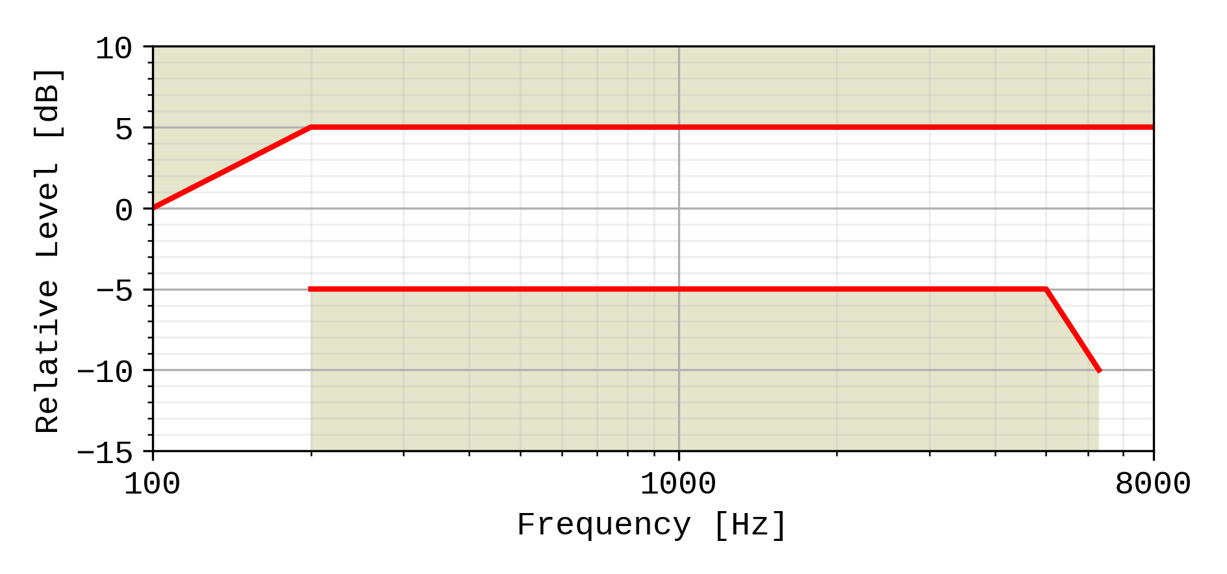

Figure 9: Handset and headset sending sensitivity/frequency mask

Compliance shall be checked by the relevant test described in TS 26.132.

### 6.4.2 Handset and headset UE receiving

The sensitivity/frequency characteristics shall be as follows:

The receiving sensitivity frequency response, measured either from the digital interface to the DRP with diffuse-field correction or from the SS audio input (analogue or digital input of the reference speech encoder of the SS) to the DRP with diffuse-field correction,shall be within a mask, which can be drawn with straight lines between the breaking points in table 10 on a logarithmic (frequency) - linear (dB sensitivity) scale.

Table 10: Handset and headset receiving sensitivity/frequency mask

|  |  |  |
| --- | --- | --- |
| Frequency (Hz) | Upper limit (dB)  8 ± 2 N | Lower limit (dB)  8 ± 2 N |
| 100 | 6 |  |
| 200 | 6 | -10 |
| 300 | 6 | -6 |
| 1 000 | 6 | -6 |
| 2 000 | 8 | -6 |
| 5 000 | 8 | -6 |
| 6 300 | 8 | -12 |
| 8 000 | 8 |  |
| NOTE: All sensitivity values are expressed in dB on an arbitrary scale. | | |

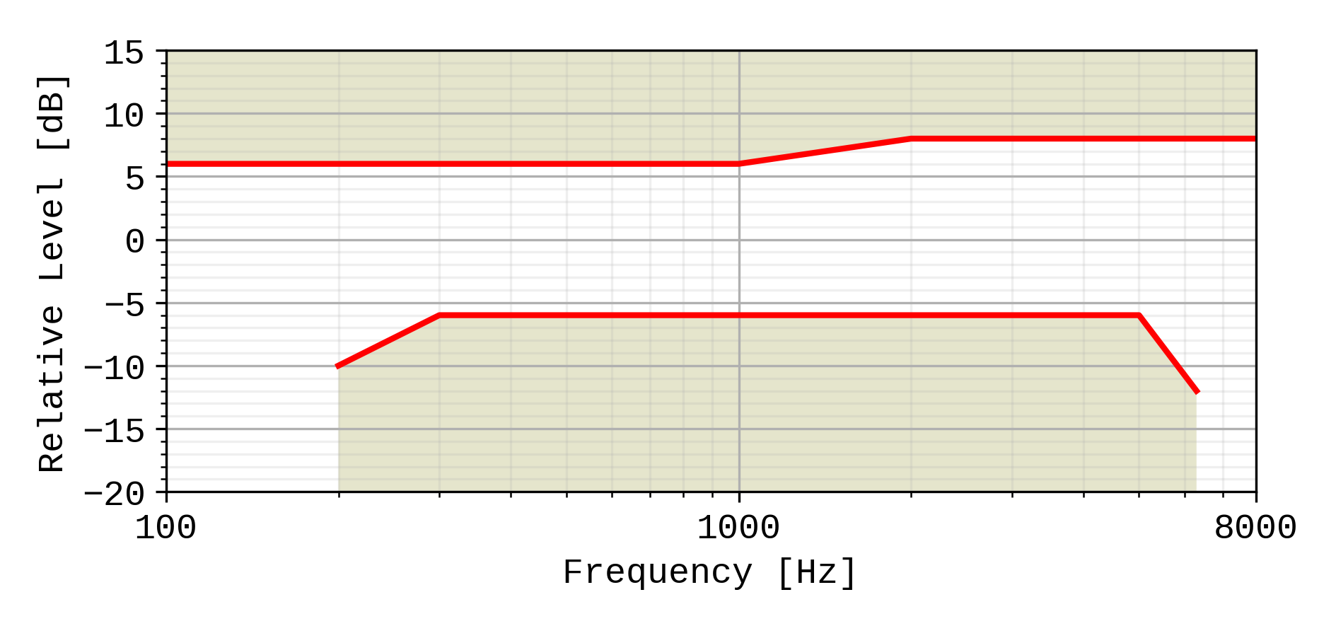

Figure 10: Handset and headset receiving sensitivity/frequency mask

Compliance shall be checked by the relevant test described in TS 26.132.

### 6.4.3 Desktop hands-free UE sending

The sending sensitivity frequency response from the MRP to the SS audio output (digital output of the reference speech decoder of the SS) shall be as follows:

The sending sensitivity frequency response shall be within the mask which can be drawn with straight lines between the breaking points in table 11 on a logarithmic (frequency) - linear (dB sensitivity) scale.

Table 11: Desktop hands-free sending sensitivity/frequency mask

|  |  |  |
| --- | --- | --- |
| Frequency (Hz) | Upper limit (dB) | Lower limit (dB) |
| 100 | 0 |  |
| 200 | 5 | -5 |
| 5 000 | 5 | -5 |
| 6 300 | 5 | -10 |
| 8 000 | 5 |  |
| NOTE: All sensitivity values are expressed in dB on an arbitrary scale. | | |



Figure 11: Desktop hands-free sending sensitivity/frequency mask

Compliance shall be checked by the relevant test described in TS 26.132.

### 6.4.4 Desktop hands-free UE receiving

The receiving sensitivity frequency response from the SS audio input (analogue or digital input of the reference speech encoder of the SS) to the free-field shall be as follows:

The receiving sensitivity frequency response shall be within the mask which can be drawn with straight lines between the breaking points in table 12 on a logarithmic (frequency) - linear (dB sensitivity) scale.

Table 12: Desktop hands-free receiving sensitivity/frequency mask

| Frequency (Hz) | Upper limit (dB) | Lower limit (dB) |
| --- | --- | --- |
| 125 | 8 |  |
| 200 | 8 | -12 |
| 250 | 8 | -9 |
| 315 | 7 | -6 |
| 400 | 6 | -6 |
| 5 000 | 6 | -6 |
| 6 300 Hz | 6 | -9 |
| 8 000 Hz | 6 | - |
| NOTE: The limits for intermediate frequencies lie on a straight line drawn between the given values on a linear (dB) - logarithmic (Hz) scale.  All sensitivity values are expressed in dB on an arbitrary scale. | | |

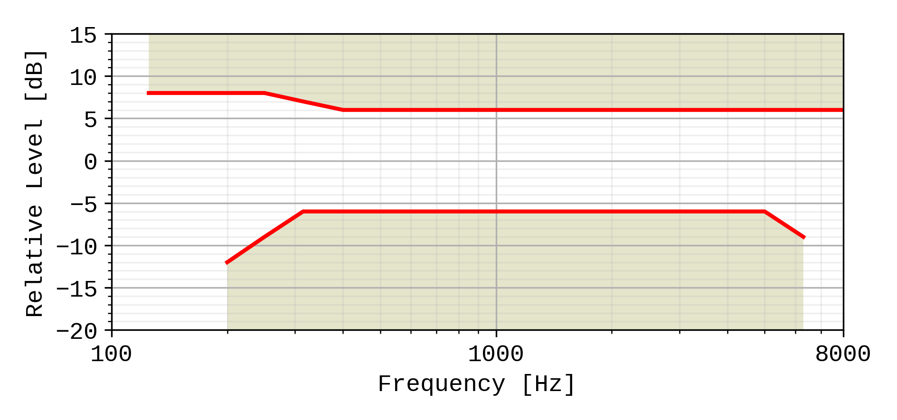

Figure 12: Desktop hands-free receiving sensitivity/frequency mask

It is recommended as a performance objective that the receiving sensitivity frequency response be within the mask which can be drawn with straight lines between the breaking points in table 12.a on a logarithmic (frequency) - linear (dB sensitivity) scale.

Table 12a: Performance objective for desktop hands-free receiving sensitivity/frequency response

|  |  |  |
| --- | --- | --- |
| Frequency (Hz) | Upper limit (dB) | Lower limit (dB) |
| 100 | 0 |  |
| 200 | 0 | -18 |
| 250 | 0 | -15 |
| 315 | 0 | -12 |
| 6 300 | 0 | -12 |
| 8 000 | 0 |  |

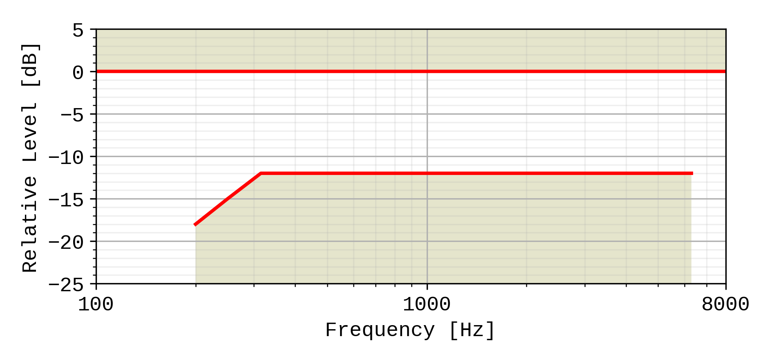

Figure 12a: Performance objective for desktop and vehicle-mounted hands-free receiving sensitivity/frequency response

Compliance shall be checked by the relevant test described in TS 26.132.

### 6.4.5 Hand-held hands-free UE sending

The sending sensitivity frequency response from the MRP to the SS audio output (digital output of the reference speech decoder of the SS) shall be as follows:

The sending sensitivity frequency response shall be within the mask which can be drawn with straight lines between the breaking points in table 13 on a logarithmic (frequency) - linear (dB sensitivity) scale.

Table 13: Hand-held hands-free sending sensitivity/frequency mask

|  |  |  |
| --- | --- | --- |
| Frequency (Hz) | Upper limit (dB) | Lower limit (dB) |
| 100 | 0 |  |
| 200 | 5 | -5 |
| 5 000 | 5 | -5 |
| 6 300 | 5 | -10 |
| 8 000 | 5 |  |
| NOTE: All sensitivity values are expressed in dB on an arbitrary scale. | | |



Figure 13: Hand-held hands-free sending sensitivity/frequency mask

Compliance shall be checked by the relevant test described in TS 26.132.

### 6.4.6 Hand-held hands-free UE receiving

The receiving sensitivity frequency response from the SS audio input (analogue or digital input of the reference speech encoder of the SS) to the free-field shall be as follows:

The receiving sensitivity frequency response shall be within the mask which can be drawn with straight lines between the breaking points in table 14 on a logarithmic (frequency) - linear (dB sensitivity) scale.

Table 14: Hand-held hands-free receiving sensitivity/frequency mask

| Frequency (Hz) | Upper limit (dB) | Lower limit (dB) |
| --- | --- | --- |
| 315 | 6 |  |
| 630 | 6 | -12 |
| 800 | 6 | -6 |
| 4 000 | 6 | -6 |
| 6 300 | 6 | -12 |
| 8 000 | 6 |  |
| NOTE: All sensitivity values are expressed in dB on an arbitrary scale. | | |

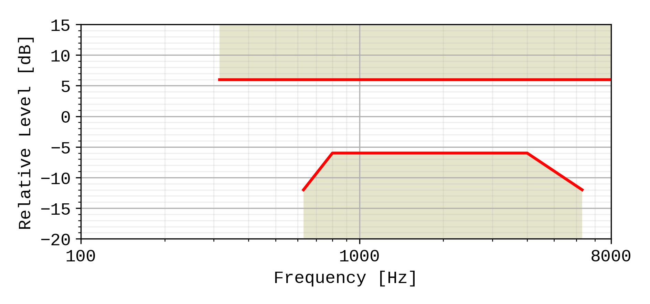

Figure 14: Hand-held hands-free receiving sensitivity/frequency mask

It is recommended as a performance requirement that the receiving sensitivity frequency response be within the mask which can be drawn with straight lines between the breaking points in table 14a on a logarithmic (frequency) - linear (dB sensitivity) scale.

Table 14a: Performance objective for hand-held hands-free receiving sensitivity/frequency mask

|  |  |  |  |
| --- | --- | --- | --- |
| Frequency (Hz) | Upper limit (dB) | Lower limit (dB) | |
| 315 | 6 |  | |
| 400 | 6 | -12 | |
| 500 | 6 | -6 | |
| 4 000 | 6 | -6 | |
| 6 300 | 6 | -12 | |
| 8 000 | 6 |  | |
| NOTE: All sensitivity values are expressed in dB on an arbitrary scale | | | |

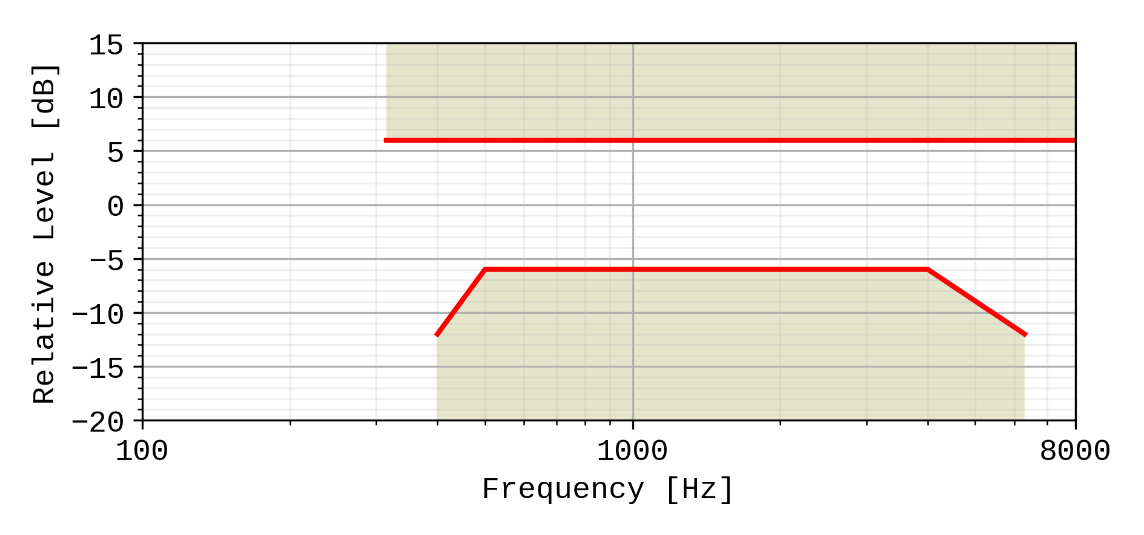

Figure 14.a: Performance objective for hand-held hands-free receiving sensitivity/frequency mask

Compliance shall be checked by the relevant test described in TS 26.132.

6.4.7 Electrical interface UE sending

The sensitivity/frequency characteristics shall be as follows:

The sending sensitivity frequency response measured at the electrical reference point shall be within a mask, which can be drawn between the points given in table 14a1. The mask is drawn with straight lines between the breaking points in table 14a1 on a logarithmic (frequency) - linear (dB sensitivity) scale.

NOTE: A tilt above 1 kHz is to compensate for the mouth to microphone acoustic path when the microphone is assumed to be hanging on a headset on the side of the head.

**Table 14a1: Electrical interface sending sensitivity/frequency mask**

|  |  |  |
| --- | --- | --- |
| **Frequency (Hz)** | **Upper limit** | **Lower limit** |
| 100 | 3 |  |
| 200 | 3 | -3 |
| 1 000 | 3 | -3 |
| 3 000 | 10 | 0 |
| 5 000 | 12 | 0 |
| 6 300 | 12 | 0 |
| 8 000 | 12 |  |
| NOTE: All sensitivity values are expressed in dB on an arbitrary scale. | | |

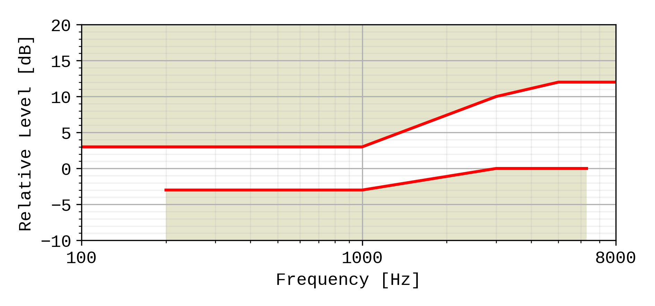

Figure 14a1: Electrical interface sending sensitivity/frequency mask

Compliance shall be checked by the relevant test described in TS 26.132.

6.4.8 Electrical interface UE receiving

The sensitivity/frequency characteristics shall be as follows:

The receiving sensitivity frequency response measured at the output of the electrical interface UE shall be within a mask, which can be drawn with straight lines between the breaking points in table 14a2 on a logarithmic (frequency) - linear (dB sensitivity) scale.

**Table 14a2: Electrical interface receiving sensitivity/frequency mask**

|  |  |  |
| --- | --- | --- |
| **Frequency (Hz)** | **Upper limit** | **Lower limit** |
| 100 | 2 |  |
| 200 | 2 | -7 |
| 300 | 2 | -5.5 |
| 1 000 | 2 | –2 |
| 2 000 | 2 | –2 |
| 5 000 | 2 | –6 |
| 6 300 | 2 | –12 |
| 8 000 | 2 |  |
| NOTE: All sensitivity values are expressed in dB on an arbitrary scale. | | |

Figure 14b2: Electrical interface receiving sensitivity/frequency mask

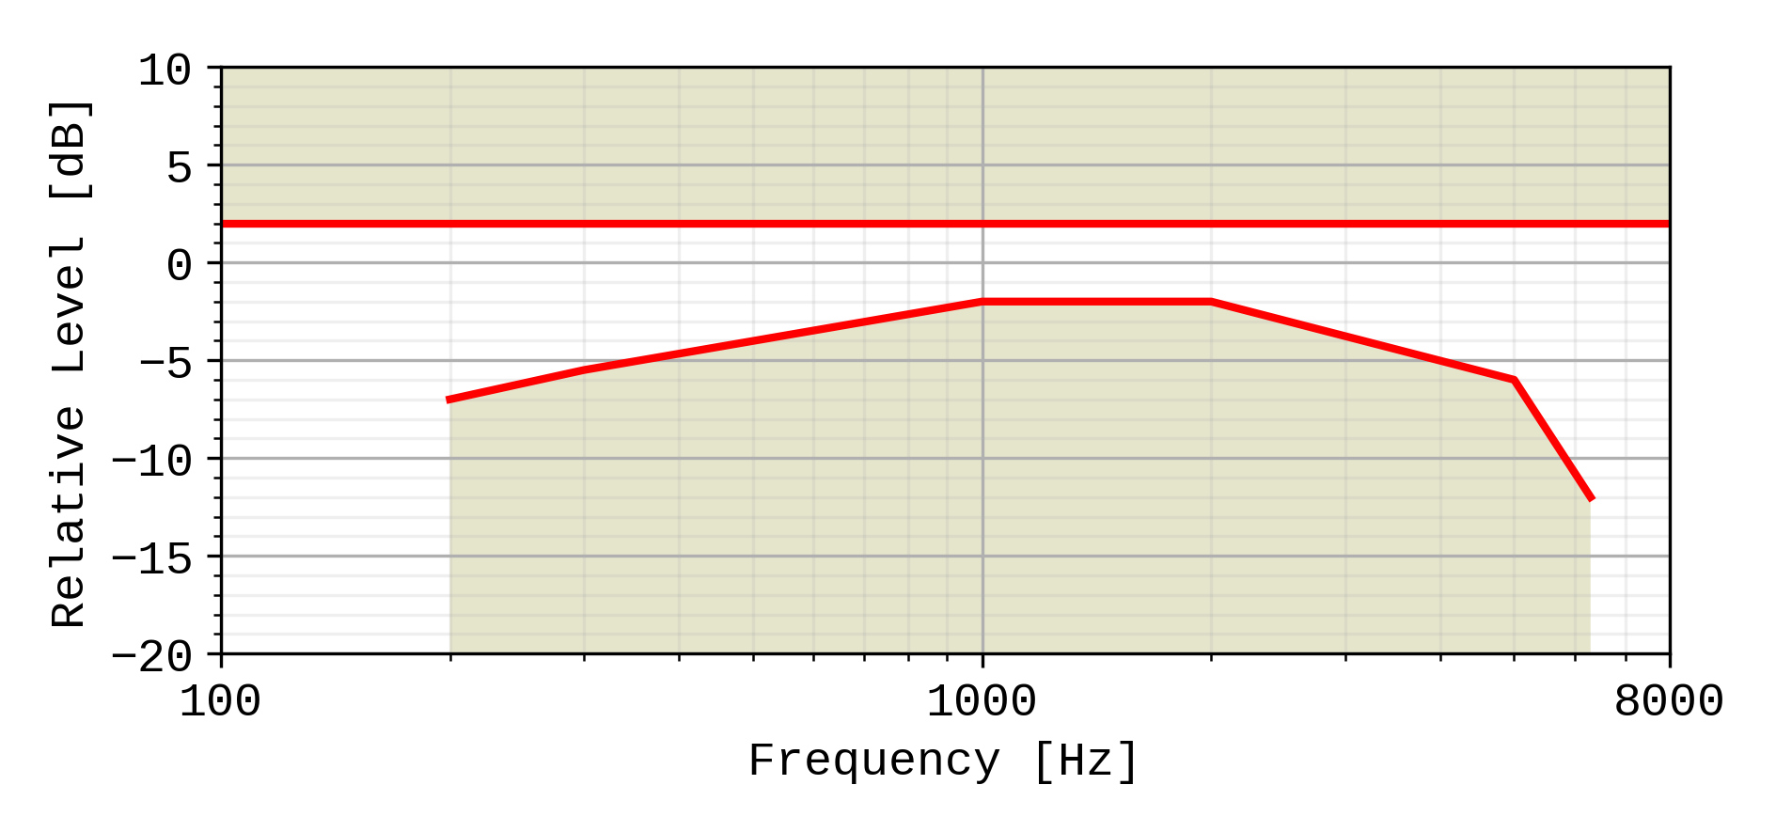

Compliance shall be checked by the relevant test described in TS 26.132.

## 6.5 Sidetone characteristics (handset, headset, and analogue electrical interface UE)

### 6.5.1 Sidetone loss

The talker sidetone masking rating (STMR) shall be ≥ 15 dB and should be ≤ 23 dB for the nominal setting of the volume control. For all other positions of the volume control, the STMR shall be ≥ 10 dB.

In case the STMR is below the lower limit also when the electrical sidetone path has been disabled, the result shall not be regarded as a failure.

Compliance shall be checked by the relevant test described in TS 26.132.

NOTE 1: Where a user-controlled receiving volume control is provided, it is recommended that the sidetone loss is independent of the volume control setting.

NOTE 2: In general, it is recommended to provide a terminal sidetone path for handset and headset UEs.

NOTE 3: In case the human air-conducted sidetone paths are obstructed (one example being some binaural insert type headset UEs), it is important to provide a terminal sidetone path.

NOTE 4: The STMR calculation algorithm being used was developed for quantifying the audibility of the electrical sidetone path using a sealed coupler. The air-conducted path was not intended to be included in the test setup. A lower STMR limit was specified to avoid annoying effects (e.g. howling, increase of ambient noise level in the ear) of an excessive electrical sidetone. In HATS-based measurements, the air-conducted path cannot be avoided in the test setup. With some UE form factors the air-conducted path can be substantial resulting in low STMR figures also when there are no annoying effects from any excessive electrical sidetone. See ITU-T Recommendation P.76 for definitions of sidetone paths.

### 6.5.2 Sidetone delay

The maximum sidetone delay shall be ≤ 5 ms, measured in an echo-free setup.

NOTE: The measured result is only applicable where the level of the electrical sidetone is sufficiently high to be measured. While the STMR value may indicate the presence of sidetone it should be ensured that this is not primarily due to the acoustical or mechanical sidetone path when interpreting sidetone delay results.

Compliance shall be checked by the relevant test described in TS 26.132.

## 6.6 Stability loss

The stability loss presented to the PSTN by the 3G, LTE, NR or WLAN network at the POI should meet the principles of the requirements in clauses 2 and 3 of ITU-T Recommendation G.122 [6]. These requirements will be met if the attenuation between the digital input and digital output at the POI is ≥ 6 dB at all frequencies in the range 100 Hz to 8 kHz under the worst case acoustic conditions at the UE (any acoustic echo control should be enabled). For the normal case of digital connection between the Air Interface and the POI, the stability requirement can be applied at the Air Interface.

The worst case acoustic conditions will be as follows (with volume control set to maximum for each following condition):

**Handset UE:** the handset lying on, and the transducers facing, a hard surface with the ear-piece uncapped;

**Headset UE:** for further study;

**Hands-free UE:** no requirement other than echo loss.

NOTE: The test procedure must take into account the switching effects of echo control and discontinuous transmission (DTX) if applicable.

## 6.7 Echo control

### 6.7.1 General

The echo loss (EL) presented by the 3G, LTE, NR or WLAN network at the POI should be sufficient during single-talk. This takes into account the fact that the UE is likely to be used in connections with high transmission delay and in a wide range of noise environments.

The use of acoustic echo control is not mandated for 3G, LTE, NR or WLAN networks and the connection between the UE and the POI is zero loss. Therefore the acoustic echo control provided in the UE should provide a sufficient TCLw at the POI over the likely range of acoustic end delays.

If acoustic echo control is provided by voice switching, comfort noise should be injected. This comfort noise shall operate in the same way as that used in DTX.

### 6.7.2 Acoustic echo control in desktop and vehicle-mounted hands-free UE

The TCLw for the desktop hands-free UE shall be ≥ 40 dB for any setting of the volume control.

The TCLw for the desktop hands-free UE shall be ≥ 46 dB when measured under free-field conditions at the nominal setting of the volume control.

NOTE: A TCLw for desktop hands-free UE of ≥ 55 dB is recommended as a performance objective when measured under free-field conditions at the nominal setting of the volume control. Depending on the UE idle channel noise in the sending direction, it may not always be possible to measure an echo loss ≥ 55 dB.

The echo canceller should be designed to cope with the expected reverberation and dispersion. In the case of the hands-free UE, this reverberation and dispersion may be time variant. Compliance with this requirement shall be checked by the relevant test described in TS 26.132.

### 6.7.3 Acoustic echo control in hand-held hands-free UE

The TCLw for hand-held hands-free UE shall be ≥ 40 dB for any setting of the volume control.

The TCLw for hand-held hands-free UE shall be ≥ 46 dB at the nominal setting of the volume control.

NOTE: A TCLw for the hand-held hands-free UE of ≥ 55 dB is recommended as a performance objective when measured under free-field conditions at the nominal setting of the volume control. Depending on the UE idle channel noise in the sending direction, it may not always be possible to measure an echo loss ≥ 55 dB.

The echo canceller should be designed to cope with the expected reverberation and dispersion. In the case of the hands-free UE, this reverberation and dispersion may be time variant. Compliance with this requirement shall be checked by the relevant test described in TS 26.132.

### 6.7.4 Acoustic echo control in a handset UE

The TCLw for handset UE shall be ≥ 46 dB for any setting of the volume control.

The TCLw for handset UE should be ≥ 55 dB at the nominal setting of the volume control.

With the volume control set to maximum TCLw should be ≥55 dB.

It is recommended that the volume control should be set back to nominal after each call unless TCLw ≥ 55 dB can also be maintained with the maximum volume setting.

NOTE. Depending on the UE idle channel noise in the sending direction, it may not always be possible to measure an echo loss ≥ 55 dB.

The echo canceller should be capable of dealing with the variations in handset positions when in normal use. The implications of this are under study.

Compliance with this requirement shall be checked by the relevant test described in TS 26.132.

### 6.7.5 Acoustic echo control in a headset UE

The TCLw for headset UE shall be ≥ 46 dB for any setting of the volume control.

The TCLw for headset UE shall be ≥ 55 dB at the nominal setting of the volume control.

The volume control shall be set back to nominal after each call unless a TCLw ≥ 55 dB can also be maintained with the maximum volume setting.

NOTE: Depending on the UE idle channel noise in the sending direction, it may not always be possible to measure an echo loss ≥ 55 dB.

Due to the obstacle effect of the head in this type of terminal, careful design might mean that no active echo control is necessary.

The echo cancellation algorithm should be designed to cope with the expected reverberation and dispersion.

Compliance with this requirement shall be checked by the relevant test described in TS 26.132.

### 6.7.6 Echo control in an electrical interface UE

The TCLw for electrical interface UE shall be ≥ 46 dB for any setting of the volume control.

The TCLw for electrical interface UE shall be ≥ 55 dB at the nominal setting of the volume control.

The volume control shall be set back to nominal after each call unless a TCLw ≥ 55 dB can also be maintained with the maximum volume setting.

NOTE: Depending on the UE idle channel noise in the sending direction, it may not always be possible to measure an echo loss ≥ 55 dB.

The echo cancellation algorithm should be designed to cope with the expected reverberation and dispersion.

Compliance with this requirement shall be checked by the relevant test described in TS 26.132.

## 6.8 Distortion

### 6.8.1 Sending distortion (excluding electrical interface UE)

The sending part shall meet the following distortion requirements:

NOTE 1: Digital signal processing other than the transcoder itself is included in this requirement (e.g., echo cancelling).

Distortion shall be measured between the MRP and the SS audio output (output of the reference speech decoder of the SS). The ratio of signal‑to‑total distortion power measured with the proper noise weighting (see table 4 of ITU‑T Recommendation G.223) shall be above the limits given in table 15.

NOTE 2: Frequencies from 315 Hz to 816 Hz do not apply to the hands-free UE case, but only to handset and headset UE.

Table 15: Limits for signal‑to‑total distortion ratio

| Frequency (Hz) | Sending level  (dBPa at the MRP) | Sending Ratio (dB) |
| --- | --- | --- |
| 315 | -4,7 | 28 |
| 408 | -4,7 | 32 |
| 510 | -4,7 | 32 |
| 816 | -4,7 | 32 |
| 1 020 | 5 | 30 |
| 0 | 35 |
| -4.7 | 35 |
| -10 | 33 |
| -15 | 30 |
| -20 | 27 |

Limits for intermediate levels are found by drawing straight lines between the breaking points in table 15 on a linear (dB signal level) ‑ linear (dB ratio) scale.

Compliance of the sending distortion shall be checked by the test described in TS 26.132.

NOTE 3: It should be ensured that the test signal is treated by speech processing algorithms as a speech-like signal, and not a noise-like signal. Test signals with a time-stationary envelope may be treated by certain algorithms, e.g., noise suppression algorithms defined in 3GPP TS 06.77 R99 [16], as a noise-like signal. If speech processing algorithms, including but not limited to noise suppression algorithms, are shown to treat the test signal as a noise-like signal, even where an activation signal has been utilized, then the test should be repeated with said speech processing algorithms disabled. The results of both sets of tests and the state of the processing algorithms should be documented in the test report.

### 6.8.2 Receiving (excluding electrical interface UE)

The receiving part between the SS audio input (input of the reference speech encoder of the SS) and the applicable acoustic measurement point (DRP with diffuse-field correction for handset and headset modes; free field correction for hands-free modes) shall meet the requirements in this clause at the nominal setting of the volume control (except where another volume setting is specified):

The ratio of signal to total distortion power measured with the proper noise weighting (see table 4 of ITU-T Recommendation G.223) shall be above the limits given in table 16 when the sound pressure at the applicable acoustic measurement point is < 10 dBPa. For a sound pressure ≥ 10 dBPa at the applicable acoustic measurement point there is no distortion requirement.

NOTE 1: Frequencies from 315 Hz to 816 Hz do not apply to the hands-free UE case, only to handset and headset UE.

Table 16: Limits for signal-to-total distortion ratio

| Frequency (Hz) | Receiving level  at the digital interface (dBm0) | Receiving ratio  at nominal volume setting (dB) | Receiving ratio  at maximum volume setting (dB) |
| --- | --- | --- | --- |
| 315 | -16 | 20 |  |
| 408 | -16 | 28 |  |
| 510 | -16 | 28 |  |
| 816 | -16 | 28 |  |
| 1 020 | 0 | 25,5 | tbd |
| -3 | 31,5 | tbd |
| -10 | 33,5 | tbd |
| -16 | 33,5 | tbd |
| -20 | 33 | tbd |
| -30 | 30,5 | tbd |
| -40 | 22,5 (*) | tbd |
| -45 | 17,5 (*) | tbd |
| NOTE: (*)For levels -40 and -45 dBm0 a lower signal-to-total distortion ratio may not be possible, and hence would not be regarded as a failing result. However, the obtained results would be reported. | | | |

Limits for intermediate levels are found by drawing straight lines between the breaking points in the table on a linear (dB signal level) ‑ linear (dB ratio) scale.

Compliance of the receiving distortion shall be checked by the appropriate method in TS 26.132.

NOTE 2: It should be ensured that the test signal is treated by speech processing algorithms as a speech-like signal, and not a noise-like signal. Test signals with a time-stationary envelope may be treated by certain algorithms, e.g., noise suppression algorithms defined in 3GPP TS 06.77 R99 [16], as a noise-like signal.

### 6.8.3 Sending distortion (electrical interface UE)

The sending part shall meet the following distortion requirements:

NOTE 1: Digital signal processing other than the transcoder itself is included in this requirement (e.g., echo cancelling).

Distortion shall be measured at the output of the electrical reference interface. The ratio of signal‑to‑total distortion power measured with the proper noise weighting (see table 4 of ITU‑T Recommendation G.223) shall be above the limits given in table 16a1 for electrical interface UE with analogue connection and table 16a2 for electrical interface UE with digital connection.

Table 16a1: Limits for signal‑to‑total distortion ratio for analogue connection

| Frequency (Hz) | Sending level  (dBV at at the output of the electrical reference interface) | Sending Ratio (dB) |
| --- | --- | --- |
| 315 | -60 | 28 |
| 408 | -60 | 32 |
| 510 | -60 | 32 |
| 816 | -60 | 32 |
| 1 020 | -50 | 30 |
| -55 | 35 |
| -60 | 35 |
| -65 | 33 |
| -70 | 30 |
| -75 | 27 |

Table 16a2: Limits for signal‑to‑total distortion ratio for digital connection

| Frequency (Hz) | Sending level  (dBm0 at at the output of the electrical reference interface) | Sending Ratio (dB) |
| --- | --- | --- |
| 315 | -16 | 28 |
| 408 | -16 | 32 |
| 510 | -16 | 32 |
| 816 | -16 | 32 |
| 1 020 | -6 | 30 |
| -11 | 35 |
| -16 | 35 |
| -21 | 33 |
| -26 | 30 |
| -31 | 27 |

Limits for intermediate levels are found by drawing straight lines between the breaking points in tables 16a1 and 16a2 on a linear (dB signal level) ‑ linear (dB ratio) scale.

Compliance of the sending distortion shall be checked by the test described in TS 26.132.

NOTE 2: It should be ensured that the test signal is treated by speech processing algorithms as a speech-like signal, and not a noise-like signal. Test signals with a time-stationary envelope may be treated by certain algorithms, e.g., noise suppression algorithms defined in 3GPP TS 06.77 R99 [16], as a noise-like signal. If speech processing algorithms, including but not limited to noise suppression algorithms, are shown to treat the test signal as a noise-like signal, even where an activation signal has been utilized, then the test should be repeated with said speech processing algorithms disabled. The results of both sets of tests and the state of the processing algorithms should be documented in the test report.

### 6.8.4 Receiving distortion (electrical interface UE)

The receiving part between the SS audio input (input of the reference speech encoder of the SS) and applicable electric measurement point (input to the electrical reference interface) shall meet the requirements in this clause at the nominal setting of the volume control (except where another volume setting is specified):

The ratio of signal to total distortion power measured with the proper noise weighting (see table 4 of ITU-T Recommendation G.223) shall be above the limits given in table 16b.

NOTE 1: Frequencies from 315 Hz to 816 Hz do not apply to the hands-free UE case, only to handset and headset UE.

Table 16b: Limits for signal‑to‑total distortion ratio

| Frequency (Hz) | Receiving level  at the digital interface (dBm0) | Receiving ratio  at nominal volume setting (dB) | Receiving ratio  at maximum volume setting (dB) |
| --- | --- | --- | --- |
| 315 | -16 | 20 |  |
| 408 | -16 | 28 |  |
| 510 | -16 | 28 |  |
| 816 | -16 | 28 |  |
| 1 020 | 0 | 25,5 | tbd |
| -3 | 31,2 | tbd |
| -10 | 33,5 | tbd |
| -16 | 33,5 | tbd |
| -20 | 33 | tbd |
| -30 | 30,5 | tbd |
| -40 | 22,5 (*) | tbd |
| -45 | 17,5 (*) | tbd |
| NOTE: (*)For levels -40 and -45 dBm0 a lower signal-to-total distortion ratio may not be possible, and hence would not be regarded as a failing result. However, the obtained results would be reported. | | | |

Limits for intermediate levels are found by drawing straight lines between the breaking points in table 16b on a linear (dB signal level) ‑ linear (dB ratio) scale.

Compliance of the receiving distortion shall be checked by the appropriate method in TS 26.132.

NOTE 2: It should be ensured that the test signal is treated by speech processing algorithms as a speech-like signal, and not a noise-like signal. Test signals with a time-stationary envelope may be treated by certain algorithms, e.g., noise suppression algorithms defined in 3GPP TS 06.77 R99 [16], as a noise-like signal.

## 6.9 Void

## 6.10 Sending performance in the presence of ambient noise

### 6.10.1 General

For sending, in handset mode, the UE shall reduce the ambient noise picked up by the microphone(s) without significantly degrading the quality of the speech signal.

### 6.10.2 Connections with handset UE

The UE shall comply with the following requirements:

S-MOS-LQOw

- The average of S-MOS-LQOw scores across all test conditions shall be ≥ 3.0



- As a performance objective, the average of the S-MOS-LQOw scores across all test conditions should be ≥ 3.5



N-MOS-LQOw

- The average of the N-MOS-LQOw scores across all test conditions shall be ≥ 2.3



- As a performance objective, the average of N-MOS-LQOw scores across all test conditions should be ≥ 3.0



G-MOS-LQOw

- No requirement.

Compliance shall be checked by the relevant tests described in 3GPP TS 26.132.

### 6.10.3 Connections with Handheld hands-free UE

It is recommended that the UE meets the following performance objectives:

S-MOS-LQOw

- The average of S-MOS-LQOw scores across all five test conditions should be ≥ 3.4



N-MOS-LQOw

- The average of N-MOS-LQOw scores across all test conditions should be ≥ 2.3



G-MOS-LQOw

- No performance objective.

Compliance shall be checked by the relevant tests described in 3GPP TS 26.132.

### 6.10.4 Connections with electrical interface UE

The UE shall comply with the following requirements:

S-MOS-LQOn

- The average of S-MOS-LQOn scores across all test conditions shall be ≥ 3.0



- As a performance objective, the average of the S-MOS-LQOn scores across all test conditions should be ≥ 3.5



N-MOS-LQOn

- The average of the N-MOS-LQOn scores across all test conditions shall be ≥ 2.3



- As a performance objective, the average of N-MOS-LQOn scores across all test conditions should be ≥ 3.0



G-MOS-LQOn

- No performance objective.

Compliance shall be checked by the relevant tests described in 3GPP TS 26.132.

## 6.11 Delay

### 6.11.0 UE delay definition

#### 6.11.0.1 Acoustic interfaces

For UMTS circuit-switched operation and MTSI-based speech with LTE, NR or WLAN access, the UE delays in the send and receive directions are defined for acoustic interfaces as:

- The UE delay in the send (uplink) direction is the delay between the first acoustic event at the MRP to the last bit of the corresponding speech frame at the UE antenna

- The UE delay in the receive (downlink) direction is the delay between the first bit of a speech frame at the UE antenna and the first acoustic event at the DRP corresponding to that speech frame

NOTE: In order to harmonize UMTS and LTE delay definitions, the reference points for UMTS UE delay have been changed in Rel-12. Prior to Rel-12, the UE reference points for UMTS were implicitly defined by the compensation factors declared by system simulator vendors, i.e. half of the air interface delay was attributed to the UE, and the last acoustic event at DRP was used for the receive measurement instead of the first.

Considering 10ms for half of the transmission time in each direction of a UMTS call, a speech frame size of 20ms, a codec look-ahead of 5ms, and a difference between the first and the last acoustic event of 20 ms, the previous reference points took into account a UE implementation independent delay of 2x10ms + 25 ms + 20 ms = 65 ms. The same UE delay remains in the new definition above, which attributes the full air interface delay to the UE but uses the first acoustic event at the DRP, instead of the last (2x20ms + 25 ms + 0 ms = 65 ms). Hence, the UMTS requirements with these new reference points remain the same.

#### 6.11.0.2 Electrical interfaces

The UE delays in the send and receive directions are defined for electrical interfaces as:

- The UE delay in the send (uplink) direction is the delay between the first electrical event at the input of the electrical interface (analogue or wired digital connection) or first bit of a speech frame at the UE antenna of the wireless digital interface (wireless digital connection) to the last bit of the corresponding speech frame at the UE antenna

- The UE delay in the receive (downlink) direction is the delay between the first bit of a speech frame at the UE antenna and the first electrical event at the output of the electrical interface (analogue or wired digital connection) or first bit of a speech frame at the UE antenna of the wireless digital interface (wireless digital connection) corresponding to that speech frame.

### 6.11.1 Handset UE

It is in general desirable to minimize UE delays to ensure low enough end-to-end delays and hence a good conversational experience, guidance is found in ITU-T Recommendation G.114.

For UMTS circuit-switched AMR-WB speech codec operation, the sum of the UE delays in sending and receiving directions (TS + TR) shall in any case be ≤ 220ms and should be ≤ 185ms.

NOTE: A delay ≤ 185 ms might not be achievable in some cases due to UE implementation trade-offs between delay and other parameters such as speech quality enhancement, performance of noise reduction or UE power consumption optimization, and UE implementation issues such as rebuffering between components.

For MTSI-based speech-only with LTE, NR or WLAN access in error and jitter free conditions and AMR-WB speech codec operation, the sum of the UE delays in sending and receiving directions (TS + TR) should be ≤ 150ms. If this performance objective cannot be met, the sum of the UE delays in sending and receiving directions (TS + TR) shall in any case be ≤ 190ms.

For MTSI-based speech-only with LTE, NR or WLAN access in conditions with simulated packet arrival time variations and packet loss and AMR-WB speech codec operation, the sum of the UE delays in sending and receiving directions (TS + TR) shall be less than or equal to the delay requirements in Table 16a1, while meeting the speech quality targets defined.

NOTE: The UE delay requirements for MTSI-based speech-only with LTE, NR or WLAN access are derived from:

- A speech frame buffering and codec look-ahead of 25ms.

- An air interface transmission time of 1ms on receive and 1ms on the send direction.

- A budget allowance for a jitter buffer depth of 40ms for error and jitter free conditions and test conditions 0 and 1 of Table 16a1, and 80ms for test condition 2 of Table 16a1.

- A budget allowance for vendor specific implementation of 83ms corresponding to the performance objective and 123ms corresponding to the required maximum UE send and receive delay.

Table 16a1: UE delay and speech quality requirements for LTE, NR and WLAN access

|  |  |  |  |  |
| --- | --- | --- | --- | --- |
| Test Condition | Delay and Loss Profile  (Note 1) | Performance Objectives for Maximum Delay | Requirements for Maximum Delay | Speech Quality  Requirements  (Note 2) |
| 0 | Error and jitter free condition | TS + TR ≤ 150ms | TS + TR ≤ 190ms | No requirement, reference score  MOS-LQOREF |
| 1 | dly_profile_20msDRX_10pct_BLER_e2e | TS + TR ≤ 150ms | TS + TR ≤ 190ms | MOS-LQOTEST ≥  MOS-LQOREF - 0.3 |
| 2 | dly_profile_40msDRX_10pct_BLER_e2e | TS + TR ≤ 190ms | TS + TR ≤ 230ms | MOS-LQOTEST ≥  MOS-LQOREF - 0.3 |
|  | NOTE 1: The delay profiles for test condition 1 and 2 are theoretically constructed to simulate a semi-persistent scheduling transmission scheme with DRX enabled and target BLER in sending and receiving directions of 10%, with +/- 3ms of EPC jitter. Delay profiles are injected at the IP layer of the test system. Delay profiles are attached electronically to document 3GPP TS 26.132 [1]. The delay profiles in test condition 1 and 2 are static delay variation conditions and do not expose the UE to packet delay variations in the full range of the packet delay budget as defined for QCI1 in 3GPP TS 23.203 [18]. A third test condition that exposes the UE to non-stationary packet delay variations experienced in live operation and packet delay variations in the full range of the packet delay budget for QCI1, and accompanied delay and speech quality requirements, is for further study. | | | |
|  | NOTE 2: The purpose of this test is to provide a relative comparison of the objective speech quality between the reference and test conditions. This test is not to be construed as a method to evaluate the absolute objective speech quality of the device. | | | |

Compliance shall be checked by the relevant tests described in 3GPP TS 26.132.

### 6.11.2 Headset UE

#### 6.11.2.1 Wired headset

It is in general desirable to minimize UE delays to ensure low enough end-to-end delays and hence a good conversational experience, guidance is found in ITU-T Recommendation G.114.

For UMTS circuit-switched AMR-WB speech codec operation, the sum of the UE delays in sending and receiving directions (TS + TR) shall in any case be ≤ 220ms and should be ≤ 185ms.

NOTE: A delay ≤ 185 ms might not be achievable in some cases due to UE implementation trade-offs between delay and other parameters such as speech quality enhancement, performance of noise reduction or UE power consumption optimization, and UE implementation issues such as rebuffering between components.

For MTSI-based speech-only with LTE, NR or WLAN access in error and jitter free conditions and AMR-WB speech codec operation, the sum of the UE delays in sending and receiving directions (TS + TR) should be ≤ 150ms. If this performance objective cannot be met, the sum of the UE delays in sending and receiving directions (TS + TR) shall in any case be ≤ 190ms.

For MTSI-based speech-only with LTE, NR or WLAN access in conditions with simulated packet arrival time variations and packet loss and AMR-WB speech codec operation, the sum of the UE delays in sending and receiving directions (TS + TR) shall be less than or equal to the delay requirements in Table 16a2, while meeting the speech quality targets defined.

NOTE: The UE delay requirements for MTSI-based speech-only with LTE, NR or WLAN access are derived from:

- A speech frame buffering and codec look-ahead of 25ms.

- An air interface transmission time of 1ms on receive and 1ms on the send direction.

- A budget allowance for a jitter buffer depth of 40ms for error and jitter free conditions and test conditions 0 and 1 of Table 16a2, and 80ms for test condition 2 of Table 16a2.

- A budget allowance for vendor specific implementation of 83ms corresponding to the performance objective and 123ms corresponding to the required maximum UE send and receive delay.

Table 16a2: UE delay and speech quality requirements for LTE, NR and WLAN access

|  |  |  |  |  |
| --- | --- | --- | --- | --- |
| Test Condition | Delay and Loss Profile  (Note 1) | Performance Objectives for Maximum Delay | Requirements for Maximum Delay | Speech Quality  Requirements  (Note 2) |
| 0 | Error and jitter free condition | TS + TR ≤ 150ms | TS + TR ≤ 190ms | No requirement, reference score  MOS-LQOREF |
| 1 | dly_profile_20msDRX_10pct_BLER_e2e | TS + TR ≤ 150ms | TS + TR ≤ 190ms | MOS-LQOTEST ≥  MOS-LQOREF - 0.3 |
| 2 | dly_profile_40msDRX_10pct_BLER_e2e | TS + TR ≤ 190ms | TS + TR ≤ 230ms | MOS-LQOTEST ≥  MOS-LQOREF - 0.3 |
|  | NOTE 1: The delay profiles for test condition 1 and 2 are theoretically constructed to simulate a semi-persistent scheduling transmission scheme with DRX enabled and target BLER in sending and receiving directions of 10%, with +/- 3ms of EPC jitter. Delay profiles are injected at the IP layer of the test system. Delay profiles are attached electronically to document 3GPP TS 26.132 [1]. The delay profiles in test condition 1 and 2 are static delay variation conditions and do not expose the UE to packet delay variations in the full range of the packet delay budget as defined for QCI1 in 3GPP TS 23.203 [18]. A third test condition that exposes the UE to non-stationary packet delay variations experienced in live operation and packet delay variations in the full range of the packet delay budget for QCI1, and accompanied delay and speech quality requirements, is for further study. | | | |
|  | NOTE 2: The purpose of this test is to provide a relative comparison of the objective speech quality between the reference and test conditions. This test is not to be construed as a method to evaluate the absolute objective speech quality of the device. | | | |

Compliance shall be checked by the relevant tests described in 3GPP TS 26.132.

#### 6.11.2.2 Wireless headset

For further study.

### 6.11.3 Electrical interface UE

It is in general desirable to minimize UE delays to ensure low enough end-to-end delays and hence a good conversational experience, guidance is found in ITU-T Recommendation G.114.

The delay budget BD to be considered in the performance requirements and objectives depends on the type of electrical interface UE and is given by Table 16a3.

Table 16a3: Delay budget for different types of electrical interface UE

|  |  |
| --- | --- |
| Electrical interface type | BD [ms] |
| Analogue | 0 |
| Wireless digital | 20 |
| Wired digital | 20 |
| NOTE: The delay for analogue to digital conversion (and vice versa) in the wired digital connection is considered to be part of the budget allowance for vendor specific implementation in the UE delay requirements. | |

For UMTS circuit-switched AMR-WB speech codec operation, the sum of the UE delays in sending and receiving directions (TS + TR) shall in any case be ≤ 220+BD ms and should be ≤ 185+BD ms.

NOTE1: A delay ≤ 185+BD ms might not be achievable in some cases due to UE implementation trade-offs between delay and other parameters such as speech quality enhancement, performance of noise reduction or UE power consumption optimization, and UE implementation issues such as rebuffering between components.

For MTSI-based speech-only with LTE, NR or WLAN access in error and jitter free conditions and AMR-WB speech codec operation, the sum of the UE delays in sending and receiving directions (TS + TR) should be ≤ 150+BD ms. If this performance objective cannot be met, the sum of the UE delays in sending and receiving directions (TS + TR) shall in any case be ≤ 190+BD ms.

For MTSI-based speech-only with LTE, NR or WLAN access in conditions with simulated packet arrival time variations and packet loss and AMR-WB speech codec operation, the sum of the UE delays in sending and receiving directions (TS + TR) shall be less than or equal to the delay requirements in Table 16a4, while meeting the speech quality targets defined.

NOTE2: The UE delay requirements for MTSI-based speech-only with LTE, NR or WLAN access are derived from:

- A speech frame buffering and codec look-ahead of 25ms.

- An air interface transmission time of 1ms on receive and 1ms on the send direction.

- A budget allowance for a jitter buffer depth of 40ms for error and jitter free conditions and test conditions 0 and 1 of Table 16a4, and 80ms for test condition 2 of Table 16a4.

- A budget allowance for vendor specific implementation of 83ms corresponding to the performance objective and 123ms corresponding to the required maximum UE send and receive delay.

Table 16a4: UE delay and speech quality requirements for LTE, NR and WLAN access

|  |  |  |  |  |
| --- | --- | --- | --- | --- |
| Test Condition | Delay and Loss Profile  (Note 1) | Performance Objectives for Maximum Delay | Requirements for Maximum Delay | Speech Quality  Requirements  (Note 2) |
| 0 | Error and jitter free condition | TS + TR ≤ 150+BD ms | TS + TR ≤ 190+BD ms | No requirement, reference score  MOS-LQOREF |
| 1 | dly_profile_20msDRX_10pct_BLER_e2e | TS + TR ≤ 150+BD ms | TS + TR ≤ 190+BD ms | MOS-LQOTEST ≥  MOS-LQOREF – 0.3 |
| 2 | dly_profile_40msDRX_10pct_BLER_e2e | TS + TR ≤ 190+BD ms | TS + TR ≤ 230+BD ms | MOS-LQOTEST ≥  MOS-LQOREF - 0.3 |
|  | NOTE 1: The delay profiles for test condition 1 and 2 are theoretically constructed to simulate a semi-persistent scheduling transmission scheme with DRX enabled and target BLER in sending and receiving directions of 10%, with +/- 3ms of EPC jitter. Delay profiles are injected at the IP layer of the test system. Delay profiles are attached electronically to document 3GPP TS 26.132 [1]. The delay profiles in test condition 1 and 2 are static delay variation conditions and do not expose the UE to packet delay variations in the full range of the packet delay budget as defined for QCI1 in 3GPP TS 23.203 [18]. A third test condition that exposes the UE to non-stationary packet delay variations experienced in live operation and packet delay variations in the full range of the packet delay budget for QCI1, and accompanied delay and speech quality requirements, is for further study. | | | |
|  | NOTE 2: The purpose of this test is to provide a relative comparison of the objective speech quality between the reference and test conditions. This test is not to be construed as a method to evaluate the absolute objective speech quality of the device. | | | |

Compliance shall be checked by the relevant tests described in 3GPP TS 26.132.

## 6.12 Echo control characteristics

Echo cancellation is commonly deployed in the UE to fulfil the Acoustic echo control requirements. Echo cancellers are complex devices of which the subjective performance is affected by several attributes. The main attribute is its ability to suppress echo. The process of suppressing the echo may introduce impairments to the near-end speech signal, mainly manifested as distortion or clipping of the near-end signal during simultaneous speech from both the far and near-end ("double-talk").

To characterise the echo control performance, the activity (in % of total time) and averaged level difference (in dB) of the duration of any level difference according to Figure 14b and Table 16b between the clean near-end signal and the send-signal shall be reported for "double-talk" as well as the far-end single talk periods adjacent to the "double-talk".

NOTE: The limits for specifying the categories in Figure 14b and Table 16b are provisional pending further analysis and validation.

NOTE: The categories in Figure 14b and Table 16b are labelled in a functional order and the subjective impression of the respective categories is for further study.

All percentage values and averaged level differences described in the relevant test of 3GPP TS 26.132 shall be reported.



Figure 14b: Classification of echo canceller performance

Table 16b: Categories for echo canceller performance classification

|  |  |
| --- | --- |
| Category | Description |
| **A1** | Full-duplex and full transparency |
| **A2** | Full-duplex with level loss in Tx |
| **B** | Very short clipping |
| **C** | Short clipping resulting in loss of syllables |
| **D** | Clipping resulting in loss of words |
| **E** | Very short residual echo |
| **F** | Echo bursts |
| **G** | Continuous echo |

### 6.12.1 Handset

Requirements are for further study.

### 6.12.2 Headset

Requirements are for further study.

### 6.12.3 Handheld hands-free

Requirements are for further study.

### 6.12.4 Desktop hands-free

Requirements are for further study.

### 6.12.5 Electrical interface

Requirements are for further study.

## 6.13 Clock accuracy

For MTSI-based speech-only with LTE, NR or WLAN access, the clock skew in send direction between the device under test and the reference client should be less than 50 PPM (in absolute value) in error-free conditions.

Compliance shall be checked by the relevant test described in TS 26.132.

## 6.14 Jitter buffer management behaviour

For MTSI-based speech-only with LTE, NR or WLAN access, a jitter buffer is used in receiving to handle the variation in packet receiver timing (see clause 8 of TS 26.114 [17]).

If the jitter buffer management (JBM) behaviour is evaluated, the following statistics shall be reported for conditions specified in TS 26.132:

- Delay histogram (on a per sentence basis)

- Quality loss histogram (on a per sentence pair basis)

and all measured delay and quality loss values for these conditions shall be reported as a function of measurement time, together with minimum and maximum values.

The relevant test is described in 3GPP TS 26.132.

# 7 Super-wideband telephony transmission performance

## 7.1 Applicability

The performance requirements in this clause shall apply when a UE is used to provide super-wideband telephony, either as a stand-alone service, or as part of a multimedia service. The requirements in the clause apply only when the far-end terminal is also providing super-wideband telephony. When a super-wideband-enabled terminal is providing narrowband telephony, the requirements in clause 5, ‘narrowband telephony transmission performance’ shall apply. When a super-wideband-enabled terminal is providing wideband telephony, the requirements in clause 6, ‘Wideband telephony transmission performance’ shall apply.

## 7.2 Overall loss/loudness ratings

### 7.2.1 General

An international connection involving a 3G, LTE, NR or WLAN network and the PSTN should meet the overall loudness rating (OLR) limits in ITU-T Recommendation G.111 [4]. The national parts of the connection should therefore meet the send and receive loudness rating (SLR, RLR) limits in ITU-T Recommendation G.121 [5].

For the case where digital routings are used to connect the 3G, LTE, NR or WLAN network to the international chain of circuits, the SLR and RLR of the national extension will be largely determined by the SLR and RLR of the 3G, LTE, NR or WLAN network. The limits given below are consistent with the national extension limits and long term objectives in ITU-T Recommendation G.121 [5].

The SLR and RLR values for the 3G, LTE, NR or WLAN network apply up to the POI. However, the main determining factors are the characteristics of the UE, including the analogue to digital conversion (ADC) and digital to analogue conversion (DAC). In practice, it is convenient to specify loudness ratings to the Air Interface. For the normal case, where the 3G, LTE, NR or WLAN network introduces no additional loss between the Air Interface and the POI, the loudness ratings to the PSTN boundary (POI) will be the same as the loudness ratings measured at the Air Interface. However, in some cases loss adjustment may be needed for interworking situations in individual countries.

### 7.2.2 Connections with handset UE

The nominal values of SLR/RLR to the POI shall be:

SLR = 8 ± 3 dB;

RLR = 2 ± 3 dB.

Where a user-controlled receiving volume control is provided, the RLR shall meet the nominal value for at least one setting of the control. When the control is set to maximum, the RLR shall not be ≤ (equal or louder than) -13 dB and shall not be ≥ (equal or quieter than) ‑3 dB.

With the volume control set to the minimum position the RLR shall not be ≥ (equal or quieter than) 24 dB and should not be ≥ (equal or quieter than) 18 dB.

Compliance shall be checked by the relevant tests described in TS 26.132.

### 7.2.2a Connections with handset UE in the presence of background noise

In the presence of background noise, the RLR at maximum volume control shall not be ≤ (equal or louder than) ‑13 dB.

Compliance shall be checked by the relevant tests described in TS 26.132.

### 7.2.3 Connections with desktop hands-free UE

The nominal values of SLR/RLR to/from the POI shall be:

SLR = 13 ± 4 dB;

RLR = 5 ± 4 dB.

Where a user-controlled volume control is provided, the RLR shall meet the nominal value for at least one setting of the control. It is recommended that a volume control giving at least 15 dB increase from the nominal RLR (louder) is provided for hands-free units. This is to allow for increased acoustic noise level in the usage environment.

RLR at the maximum volume control setting should ≤ (equal or louder than) 1 dB.

Compliance shall be checked by the relevant tests described in TS 26.132.

NOTE: The target value for nominal RLR, as recommended in ITU-T G.111 Annex B – Table B.1 [4], lies between 1 and 3 dB. The higher RLR requirement of 5 dB for desktop hands-free is appreciative of the limitations in transducer output with current typical form factors.

### 7.2.4 Connections with hand-held hands-free UE

The nominal values of SLR/RLR to/from the POI shall be:

SLR = 13 ± 4 dB;

RLR = 9 +9/-7 dB.

Where a user-controlled volume control is provided, the RLR shall meet the nominal value for at least one setting of the control.

The value of RLR at the maximum volume control shall be ≤ (equal or louder than) 12 dB. As a performance objective it is recommended that the RLR at the maximum volume control setting is ≤ (equal or louder than) 2 dB.

Where a user-controlled volume control is provided, the RLR shall meet the nominal value for at least one setting of the control. It is recommended that a volume control range ≥ 15 dB be provided.

Compliance shall be checked by the relevant tests described in TS 26.132.

### 7.2.5 Connections with headset UE

The SLR and RLR should be measured and computed using methods given in ITU-T Recommendation P.380 [9]. This Recommendation currently gives a measuring technique for supra-aural earphone and insert type receivers. Study is continuing on other types of ear-pieces in ITU-T Study Group 12.

The nominal values of SLR/RLR to/from the POI shall be:

SLR = 8 ± 3 dB;

RLR = 2 ± 3 dB;

RLR (binaural headset) = 8 ± 3 dB for each earphone.

Where a user-controlled receiving volume control is provided, the RLR shall meet the nominal value for at least one setting of the control. When the control is set to maximum, the RLR shall not be ≤ (equal or louder than) -13 dB.

With the volume control set to the minimum position the RLR shall not be ≥ (equal or quieter than) 18 dB and shall not be ≥ (equal or quieter than) 24 dB for a binaural headset.

Compliance shall be checked by the relevant tests described in 3GPP TS 26.132.

### 7.2.5a Connections with headset UE in the presence of background noise

In the presence of background noise, the RLR at maximum volume control shall not be ≤ (equal or louder than) ‑13 dB.

Compliance shall be checked by the relevant tests described in TS 26.132.

### 7.2.6 Connections with electrical interface UE

#### 7.2.6.1 Analogue connection

The nominal values of SJLR/RJLR to/from the POI shall be:

SJLR = 0 ± 3 dB;

RJLR = 0 ± 3 dB;

Where a user-controlled receiving volume control is provided, the RJLR shall meet the nominal value for at least one setting of the control. When the control is set to maximum, the RJLR shall not be ≤ (equal or louder than) -15 dB.

With the volume control set to the minimum position the RJLR shall not be ≥ (equal or quieter than) 16 dB.

Compliance shall be checked by the relevant tests described in 3GPP TS 26.132.

#### 7.2.6.2 Digital connection

The nominal values of SJLR/RJLR to/from the POI shall be:

SJLR = 0 ± 3 dB;

RJLR = 0 ± 3 dB;

Requirements with different volume settings (other than nominal) are not applicable.

Compliance shall be checked by the relevant tests described in 3GPP TS 26.132.

## 7.3 Idle channel noise (handset, headset UE, and electrical interface UE)

### 7.3.1 Sending (handset and headset UE)

The maximum noise level produced by the apparatus at the output of the SS under silent conditions in the sending direction shall not exceed -64 dBm0(A).

NOTE 1: This level includes the eventual noise contribution of an acoustic echo canceller under the condition that no signal is received.

NOTE 2: This figure applies to the total noise level with A-weighting. It is recommended that the level of single frequency disturbances should be ≤ -74 dBm0(A) in the frequency range from 100 Hz to 16 kHz.

Compliance shall be checked by the relevant test described in TS 26.132.

### 7.3.2 Receiving (handset and headset UE)

The maximum (acoustic) noise level at the handset and headset UE when no signal is transmitted to the input of the SS shall be as follows:

- If no user-controlled receiving volume control is provided, or, if it is provided, at the setting of the user-controlled receiving volume control at which the RLR is equal to the nominal value, the noise measured at the DRP with diffuse-field correction contributed by the receiving equipment alone shall not exceed -57 dBPa(A).

- Where a volume control is provided, the measured noise shall be ≤ -54 dBPa(A) at the maximum setting of the volume control.

For the nominal volume control setting, the level of single frequency disturbances shall be ≤ ‑60 dBPa(A) in the frequency range from 100 Hz to 16 kHz. As a performance objective it is recommended that the level should be ≤ ‑64 dBPa(A).

NOTE: In a connection with the PSTN, noise conditions as described in ITU-T Recommendation G.103 [3] can be expected at the input (POI) of the 3G, LTE, NR or WLAN network. The characteristics of this noise may be influenced by the speech transcoding process (for further study).

Compliance shall be checked by the relevant test described in TS 26.132.

### 7.3.3 Sending (electrical interface UE)

The maximum noise level produced by the apparatus at the output of the SS under silent conditions in the sending direction shall be ≤ -64 dBm0(A).

NOTE 1: This level includes the eventual noise contribution of an acoustic echo canceller under the condition that no signal is received.

NOTE 2: This figure applies to the total noise level with A-weighting. It is recommended that the level of single frequency disturbances should be ≤ -74 dBm0(A) in the frequency range from 100 Hz to 16 kHz.

Compliance shall be checked by the relevant test described in TS 26.132.

### 7.3.4 Receiving (electrical interface UE)

The maximum A-weighted noise level when no signal is applied to the input of the SS shall be as follows:

- If no user-controlled receiving volume control is provided, or, if it is provided, at the setting of the user-controlled receiving volume control at which the RJLR is equal to the nominal value, the noise measured at the receive output of the electrical reference interface contributed by the receiving equipment alone shall not exceed ‑87 dBV(A) for analogue and ‑64 dBm0(A) for digital connections.

- Where a volume control is provided, the measured noise shall be ≤ ‑84 dBV(A) for analogue connection at the maximum setting of the volume control.

For the nominal volume control setting, the level of single frequency disturbances shall be ≤ ‑90 dBV(A) for analogue and ‑67 dBm0(A) for digital connections in the frequency range from 100 Hz to 16 kHz. As a performance objective it is recommended that the level should be ≤ ‑94 dBV(A) for analogue and ‑71 dBm0(A) for digital connections.

NOTE: In a connection with the PSTN, noise conditions as described in ITU-T Recommendation G.103 [3] can be expected at the input (POI) of the 3G, LTE, NR or WLAN network. The characteristics of this noise may be influenced by the speech transcoding process (for further study).

Compliance shall be checked by the relevant test described in TS 26.132.

## 7.4 Sensitivity/frequency characteristics

### 7.4.0 General

It is recommended for all configurations (handset, headset etc) to have a flat sending frequency response in super-wideband mode.

Tolerance masks apply to the center frequencies of the fractional octave bands specified for the respective tests in TS 26.132.

### 7.4.1 Handset and headset UE sending

The sensitivity/frequency characteristics shall be as follows:

The sending sensitivity frequency response, measured either from the mouth reference point (MRP) to the digital interface or from the MRP to the SS audio output (digital output of the reference speech decoder of the SS), shall be within a mask, which can be drawn between the points given in table 17.

The masks are drawn with straight lines between the breaking points in the tables on a logarithmic (frequency) - linear (dB sensitivity) scale.

Table 17: Handset and headset sending sensitivity/frequency requirement mask

|  |  |  |
| --- | --- | --- |
| Frequency (Hz) | Upper limit (dB) | Lower limit (dB) |
| 100 | 4 |  |
| 200 | 4 | -4 |
| 5000 | 4 | -4 |
| 12500 | 4 | -6 |
| 16000 | 4 |  |
| NOTE: All sensitivity values are expressed in dB on an arbitrary scale. | | |

Table 18: Void

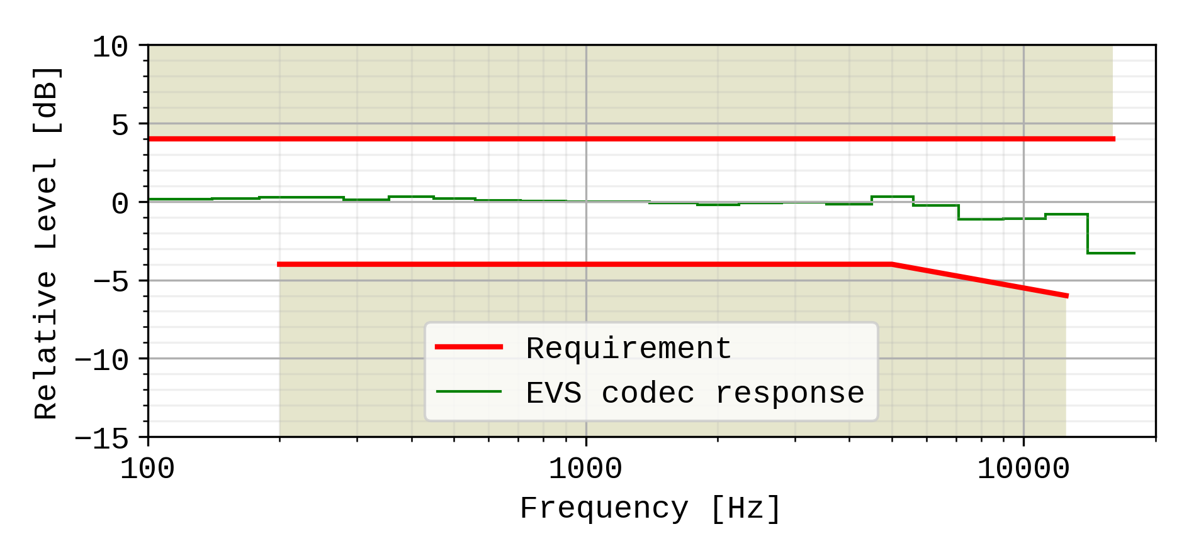

Figure 15: Handset and headset sending sensitivity/frequency masks. The frequency response of the EVS codec operating as specified in TS 26.132 (super-wideband 24,4kbit/s, using the specified P.501 speech test signal), is plotted for reference, normalized to 0dB at 1kHz.

A UE operating in super-wideband mode shall pass the super-wideband requirements (i.e. when measured according to in 1/3rd octaves) as specified in Table 17, and shall also pass the wideband sensitivity/frequency characteristics requirements in the wideband range using the wideband measurement (i.e. measured in 1/12th octaves) as specified in Table 9.

Compliance shall be checked by the relevant test described in TS 26.132.

### 7.4.2 Handset and headset UE receiving

#### 7.4.2.1 Handset UE receiving

The sensitivity/frequency characteristics shall be as follows:

The receiving sensitivity frequency response, measured either from the digital interface to the DRP with diffuse-field correction or from the SS audio input (analogue or digital input of the reference speech encoder of the SS) to the DRP with diffuse-field correction,shall be within a mask, which can be drawn with straight lines between the breaking points in table 19 on a logarithmic (frequency) - linear (dB sensitivity) scale.

Table 19: Handset receiving sensitivity/frequency requirement mask

|  |  |  |
| --- | --- | --- |
| Frequency (Hz) | Upper limit (dB) | Lower limit (dB) |
| 100 | 5 |  |
| 200 | 5 | -8 |
| 250 | 5 | -5 |
| 5000 | 5 | -5 |
| 12500 | 5 | -11 |
| 16000 | 5 |  |
| NOTE: All sensitivity values are expressed in dB on an arbitrary scale. | | |

It is desired as a performance objective that the receiving sensitivity/frequency response be within the mask which can be drawn with straight lines between the breaking points in table 20.

Table 20: Handset receiving sensitivity/frequency performance objective mask

|  |  |  |
| --- | --- | --- |
| Frequency (Hz) | Upper limit (dB) | Lower limit (dB) |
| 100 | 4 |  |
| 200 | 4 | -4 |
| 250 | 4 | -4 |
| 5000 | 4 | -4 |
| 12500 | 4 | -7 |
| 16000 | 4 |  |
| NOTE: All sensitivity values are expressed in dB on an arbitrary scale. | | |

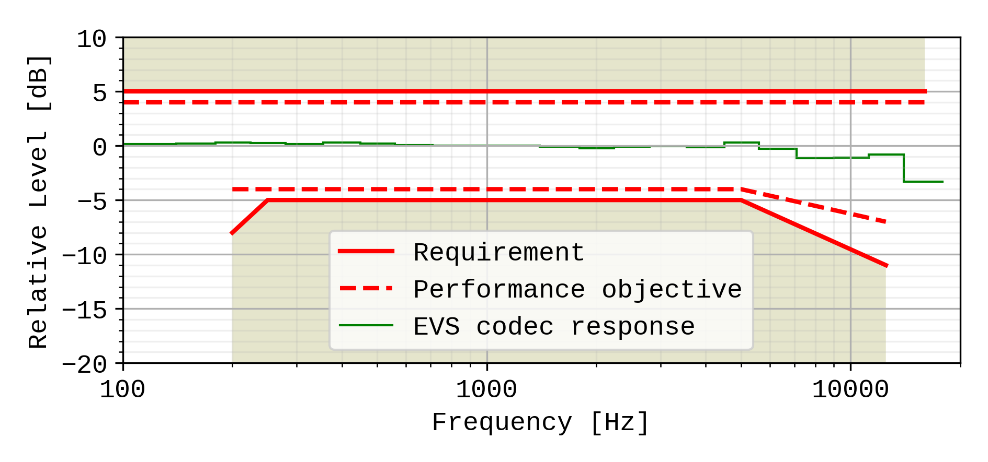

Figure 16: Handset receiving sensitivity/frequency masks. The frequency response of the EVS codec operating as specified in TS 26.132 (super-wideband 24,4kbit/s, using the specified P.501 speech test signal), is plotted for reference, normalized to 0dB at 1kHz.

A UE operating in super-wideband mode shall pass the super-wideband requirements (i.e. when measured according to in 1/3rd octaves) as specified in Table 19, and shall also pass the wideband sensitivity/frequency characteristics requirements in the wideband range using the wideband measurement (i.e. measured in 1/12th octaves) as specified in Table 10.

Compliance shall be checked by the relevant test described in TS 26.132.

#### 7.4.2.2 Headset UE receiving

The sensitivity/frequency characteristics shall be as follows:

The receiving sensitivity frequency response, measured either from the digital interface to the DRP with diffuse-field correction or from the SS audio input (analogue or digital input of the reference speech encoder of the SS) to the DRP with diffuse-field correction,shall be within a mask, which can be drawn with straight lines between the breaking points in table 21 on a logarithmic (frequency) - linear (dB sensitivity) scale.

Table 21: Headset receiving sensitivity/frequency requirement mask

|  |  |  |
| --- | --- | --- |
| Frequency (Hz) | Upper limit (dB) | Lower limit (dB) |
| 100 | [TBD] | [TBD] |
| 200 |  |  |
| 250 |  |  |
| 5000 |  |  |
| 12500 |  |  |
| 16000 |  |  |
| NOTE: All sensitivity values are expressed in dB on an arbitrary scale. | | |

It is recommended as a performance objective that the receiving sensitivity/frequency response be within the mask which can be drawn with straight lines between the breaking points in table 22.

Table 22: Headset receiving sensitivity/frequency performance objective mask

|  |  |  |
| --- | --- | --- |
| Frequency (Hz) | Upper limit (dB) | Lower limit (dB) |
| 100 | [3] |  |
| 200 | [3] | [-6] |
| 250 | [3] | [-3] |
| 5000 | [3] | [-3] |
| 12500 | [3] | [-6] |
| 16000 | [3] |  |
| NOTE 1: All sensitivity values are expressed in dB on an arbitrary scale.  NOTE 2: Values within [] are provisional and expected to be confirmed, revised or removed based on future studies. | | |

TBD

Figure 17: Headset receiving sensitivity/frequency masks

Compliance shall be checked by the relevant test described in TS 26.132.

### 7.4.3 Desktop hands-free UE sending

The sending sensitivity frequency response from the MRP to the SS audio output (digital output of the reference speech decoder of the SS) shall be as follows:

The sending sensitivity frequency response shall be within the mask which can be drawn with straight lines between the breaking points in table 23 on a logarithmic (frequency) - linear (dB sensitivity) scale.

Table 23: Desktop hands-free sending sensitivity/frequency mask

|  |  |  |
| --- | --- | --- |
| Frequency (Hz) | Upper limit (dB) | Lower limit (dB) |
| 100 | [3...5] |  |
| 200 | [3...5] | [-3...-5] |
| 5000 | [3...5] | [-3...-5] |
| 12500 | [3...5] | [-5...-7] |
| 16000 | [3...5] |  |
| NOTE 1: All sensitivity values are expressed in dB on an arbitrary scale.  NOTE 2: Values within [] are provisional and expected to be defined as single values based on future studies. | | |

It is recommended as a performance objective that the sending sensitivity/frequency response be within the mask which can be drawn with straight lines between the breaking points in table 24.

Table 24: Desktop hands-free sending sensitivity/frequency performance objective mask

|  |  |  |
| --- | --- | --- |
| Frequency (Hz) | Upper limit (dB) | Lower limit (dB) |
| 100 | [3] |  |
| 200 | [3] | [-3] |
| 5000 | [3] | [-3] |
| 12500 | [3] | [-5] |
| 16000 | [3] |  |
| NOTE 1: All sensitivity values are expressed in dB on an arbitrary scale.  NOTE 2: Values within [] are provisional and expected to be confirmed, revised or removed based on future studies. | | |

TBD

Figure 18: Desktop hands-free sending sensitivity/frequency masks

Compliance shall be checked by the relevant test described in TS 26.132.

### 7.4.4 Desktop hands-free UE receiving

The receiving sensitivity frequency response from the SS audio input (analogue or digital input of the reference speech encoder of the SS) to the free-field shall be as follows:

The receiving sensitivity frequency response shall be within the mask which can be drawn with straight lines between the breaking points in table 25 on a logarithmic (frequency) - linear (dB sensitivity) scale.

Table 25: Desktop and vehicle-mounted hands-free receiving sensitivity/frequency mask

| Frequency (Hz) | Upper limit (dB) | Lower limit (dB) |
| --- | --- | --- |
| TBD | TBD | TBD |
|  |  |  |
|  |  |  |
|  |  |  |
|  |  |  |
|  |  |  |
|  |  |  |
|  |  |  |
| NOTE: The limits for intermediate frequencies lie on a straight line drawn between the given values on a linear (dB) - logarithmic (Hz) scale.  All sensitivity values are expressed in dB on an arbitrary scale. | | |

It is recommended as a performance objective that the receiving sensitivity frequency response be within the mask which can be drawn with straight lines between the breaking points in table 26 on a logarithmic (frequency) - linear (dB sensitivity) scale.

Table 26: Performance objective for desktop hands-free receiving sensitivity/frequency response

|  |  |  |
| --- | --- | --- |
| Frequency (Hz) | Upper limit (dB) | Lower limit (dB) |
| TBD | TBD | TBD |
|  |  |  |
|  |  |  |
|  |  |  |
|  |  |  |
|  |  |  |

TBD

Figure 19: Desktop hands-free receiving sensitivity/frequency masks

Compliance shall be checked by the relevant test described in TS 26.132.

### 7.4.5 Hand-held hands-free UE sending

The sending sensitivity frequency response from the MRP to the SS audio output (digital output of the reference speech decoder of the SS) shall be as follows:

The sending sensitivity frequency response shall be within the mask which can be drawn with straight lines between the breaking points in table 27 on a logarithmic (frequency) - linear (dB sensitivity) scale.

Table 27: Hand-held hands-free sending sensitivity/frequency mask

|  |  |  |
| --- | --- | --- |
| Frequency (Hz) | Upper limit (dB) | Lower limit (dB) |
| 100 | [3...5] |  |
| 200 | [3...5] | [-3...-5] |
| 5000 | [3...5] | [-3...-5] |
| 12500 | [3...5] | [-5...-7] |
| 16000 | [3...5] |  |
| NOTE 1: All sensitivity values are expressed in dB on an arbitrary scale.  NOTE 2: Values within [] are provisional and expected to be defined as single values based on future studies. | | |

It is recommended as a performance objective that the sending sensitivity/frequency response be within the mask which can be drawn with straight lines between the breaking points in table 28.

Table 28: Hand-held hands-free sending sensitivity/frequency performance objective mask

|  |  |  |
| --- | --- | --- |
| Frequency (Hz) | Upper limit (dB) | Lower limit (dB) |
| 100 | [3] |  |
| 200 | [3] | [-3] |
| 5000 | [3] | [-3] |
| 12500 | [3] | [-5] |
| 16000 | [3] |  |
| NOTE 1: All sensitivity values are expressed in dB on an arbitrary scale.  NOTE 2: Values within [] are provisional and expected to be confirmed, revised, or removed, based on future studies. | | |

TBD

Figure 20: Hand-held hands-free sending sensitivity/frequency masks

Compliance shall be checked by the relevant test described in TS 26.132.

### 7.4.6 Hand-held hands-free UE receiving

The receiving sensitivity frequency response from the SS audio input (analogue or digital input of the reference speech encoder of the SS) to the free-field shall be as follows:

The receiving sensitivity frequency response shall be within the mask which can be drawn with straight lines between the breaking points in table 29 on a logarithmic (frequency) - linear (dB sensitivity) scale.

Table 29: Hand-held hands-free receiving sensitivity/frequency mask

| Frequency (Hz) | Upper limit (dB) | Lower limit (dB) |
| --- | --- | --- |
| TBD | TBD | TBD |
|  |  |  |
|  |  |  |
|  |  |  |
|  |  |  |
|  |  |  |
| NOTE: All sensitivity values are expressed in dB on an arbitrary scale. | | |

TBD

It is recommended as a performance requirement that the receiving sensitivity frequency response be within the mask which can be drawn with straight lines between the breaking points in table 30 on a logarithmic (frequency) - linear (dB sensitivity) scale.

Table 30: Performance objective for hand-held hands-free receiving sensitivity/frequency mask

|  |  |  |  |
| --- | --- | --- | --- |
| Frequency (Hz) | Upper limit (dB) | Lower limit (dB) | |
| TBD | TBD | TBD | |
|  |  |  | |
|  |  |  | |
|  |  |  | |
|  |  |  | |
|  |  |  | |
| NOTE: All sensitivity values are expressed in dB on an arbitrary scale. | | | |

TBD

Figure 21: Hand-held hands-free receiving sensitivity/frequency masks

Compliance shall be checked by the relevant test described in TS 26.132.

### 7.4.7 Electrical interface UE sending

The sensitivity/frequency characteristics shall be as follows:

The sending sensitivity frequency response measured at the electrical reference point shall be within a mask, which can be drawn between the points given in table 30a1.

The masks are drawn with straight lines between the breaking points in the tables on a logarithmic (frequency) - linear (dB sensitivity) scale.

**Table 30a1: Handset and headset sending sensitivity/frequency requirement mask**

|  |  |  |
| --- | --- | --- |
| **Frequency (Hz)** | **Upper limit** | **Lower limit** |
| 100 | 1 | [-8] |
| 200 | 1 | -5 |
| 1000 | 1 | -5 |
| 3000 | 6 | -3 |
| 5000 | 8 | -3 |
| 12500 | 8 | -3 |
| 16000 | 8 |  |
| NOTE 1: All sensitivity values are expressed in dB on an arbitrary scale. | | |
| NOTE 2: The limit in bracket in the table is enforced but is under evaluation. | | |

**Figure 16a: Electrical interface sending sensitivity/frequency masks. The frequency response of the EVS codec operating as specified in TS 26.132 (super-wideband 24,4kbit/s, using the specified P.501 speech test signal), is plotted for reference, normalized to 0dB at 1kHz.**

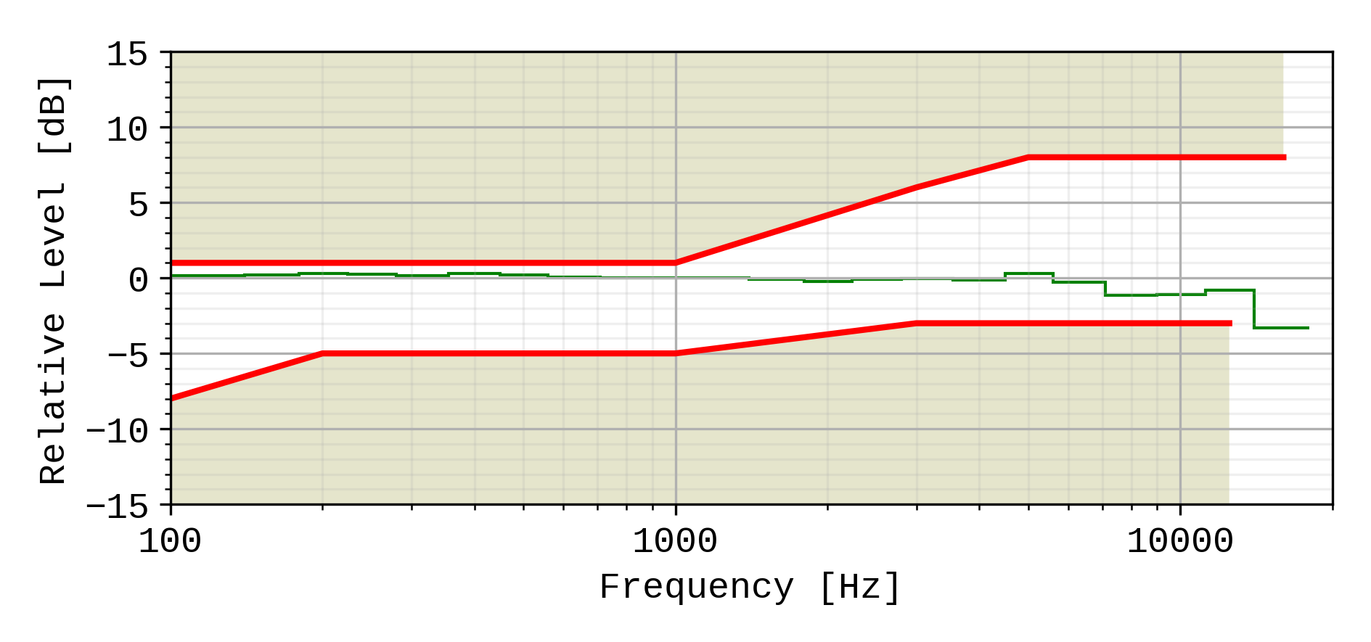

A UE operating in super-wideband mode shall pass the super-wideband requirements (i.e. when measured according to in 1/3rd octaves) as specified in Table 30a1, and shall also pass the wideband sensitivity/frequency characteristics requirements in the wideband range using the wideband measurement (i.e. measured in 1/12th octaves) as specified in Table 14a1.

Compliance shall be checked by the relevant test described in TS 26.132.

### 7.4.8 Electrical interface UE receiving

The sensitivity/frequency characteristics shall be as follows:

The receiving sensitivity frequency response measured at the electrical reference point shall be within a mask, which can be drawn with straight lines between the breaking points in table 30a2 on a logarithmic (frequency) - linear (dB sensitivity) scale.

**Table 30a2: Handset receiving sensitivity/frequency requirement mask**

|  |  |  |
| --- | --- | --- |
| **Frequency (Hz)** | **Upper limit** | **Lower limit** |
| 100 | 2 | -10 |
| 200 | 2 | -7 |
| 1000 | 2 | -2 |
| 3000 | 2 | –2 |
| 5000 | 2 | –2 |
| 8000 | 2 | -3 |
| 12500 | 2 | -6 |
| 16000 | 2 |  |
| NOTE: All sensitivity values are expressed in dB on an arbitrary scale. | | |

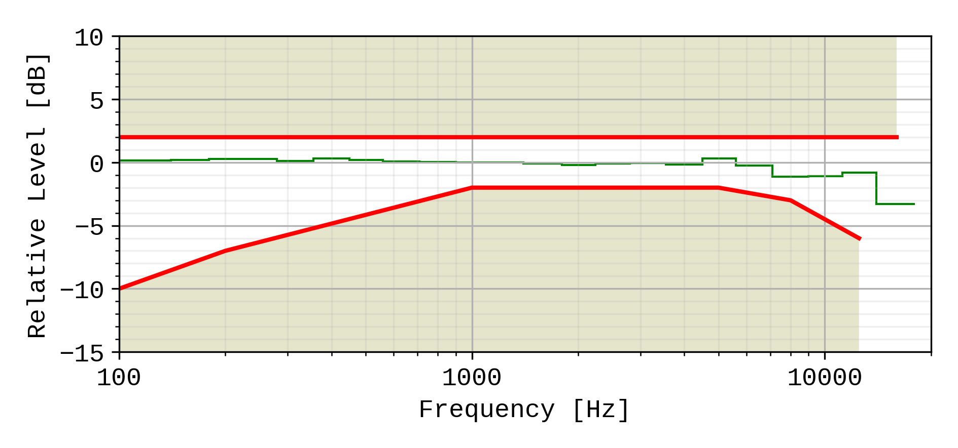

Figure 16b: Electrical interface sensitivity/frequency masks. The frequency response of the EVS codec operating as specified in TS 26.132 (super-wideband 24,4kbit/s, using the specified P.501 speech test signal), is plotted for reference, normalized to 0dB at 1kHz.

A UE operating in super-wideband mode shall pass the super-wideband requirements (i.e. when measured according to in 1/3rd octaves) as specified in Table 30a2, and shall also pass the wideband sensitivity/frequency characteristics requirements in the wideband range using the wideband measurement (i.e. measured in 1/12th octaves) as specified in Table 14a2.

Compliance shall be checked by the relevant test described in TS 26.132.

## 7.5 Sidetone characteristics (handset, headset, and analogue electrical interface UE)

### 7.5.1 Sidetone loss

The talker sidetone masking rating (STMR) shall be ≥ 15 dB and should be ≤ 23 dB for the nominal setting of the volume control. For all other positions of the volume control, the STMR shall be ≥ 10 dB.

In case the STMR is below the lower limit also when the electrical sidetone path has been disabled, the result shall not be regarded as a failure.

Compliance shall be checked by the relevant test described in TS 26.132.

NOTE 1: Where a user-controlled receiving volume control is provided, it is recommended that the sidetone loss is independent of the volume control setting.

NOTE 2: In general, it is recommended to provide a terminal sidetone path for handset and headset UEs.

NOTE 3: In case the human air-conducted sidetone paths are obstructed (one example being some binaural insert type headset UEs), it is important to provide a terminal sidetone path.

NOTE 4: The STMR calculation algorithm being used was developed for quantifying the audibility of the electrical sidetone path using a sealed coupler. The air-conducted path was not intended to be included in the test setup. A lower STMR limit was specified to avoid annoying effects (e.g. howling, increase of ambient noise level in the ear) of an excessive electrical sidetone. In HATS-based measurements, the air-conducted path cannot be avoided in the test setup. With some UE form factors the air-conducted path can be substantial resulting in low STMR figures also when there are no annoying effects from any excessive electrical sidetone. See ITU-T Recommendation P.76 for definitions of sidetone paths.

### 7.5.2 Sidetone delay

The maximum sidetone delay shall be ≤ 5 ms, measured in an echo-free setup.

NOTE: The measured result is only applicable where the level of the electrical sidetone is sufficiently high to be measured. While the STMR value may indicate the presence of sidetone it should be ensured that this is not primarily due to the acoustical or mechanical sidetone path when interpreting sidetone delay results.

Compliance shall be checked by the relevant test described in TS 26.132.

## 7.6 Stability loss

The stability loss presented to the PSTN by the 3G, LTE, NR or WLAN network at the POI should meet the principles of the requirements in clauses 2 and 3 of ITU-T Recommendation G.122 [6]. These requirements will be met if the attenuation between the digital input and digital output at the POI is ≥ 6 dB at all frequencies in the range 100 Hz to 16 kHz under the worst case acoustic conditions at the UE (any acoustic echo control should be enabled). For the normal case of digital connection between the Air Interface and the POI, the stability requirement can be applied at the Air Interface.

The worst case acoustic conditions will be as follows (with volume control set to maximum for each following condition):

**Handset UE:** the handset lying on, and the transducers facing, a hard surface with the ear-piece uncapped;

**Headset UE:** for further study;

**Hands-free UE:** no requirement other than echo loss.

NOTE: The test procedure must take into account the switching effects of echo control and discontinuous transmission (DTX) if applicable.

## 7.7 Echo control

### 7.7.1 General

The echo loss (EL) presented by the 3G, LTE, NR or WLAN network at the POI should be sufficient during single-talk. This takes into account the fact that the UE is likely to be used in connections with high transmission delay and in a wide range of noise environments.

The use of acoustic echo control is not mandated for 3G, LTE, NR or WLAN networks and the connection between the UE and the POI is zero loss. Therefore the acoustic echo control provided in the UE should provide a sufficient TCLw at the POI over the likely range of acoustic end delays.

If acoustic echo control is provided by voice switching, comfort noise should be injected. This comfort noise shall operate in the same way as that used in DTX.

### 7.7.2 Acoustic echo control in desktop hands-free UE

The TCLw for the desktop and vehicle-mounted hands-free UE shall be ≥ 40 dB for any setting of the volume control.

The TCLw for the desktop hands-free and vehicle-mounted hands-free UE shall be ≥ 46 dB when measured under free-field conditions at the nominal setting of the volume control.

NOTE: A TCLw for desktop hands-free and vehicle-mounted hands-free UE of ≥ 55 dB is recommended as a performance objective when measured under free-field conditions at the nominal setting of the volume control. Depending on the UE idle channel noise in the sending direction, it may not always be possible to measure an echo loss ≥ 55 dB.

The echo canceller should be designed to cope with the expected reverberation and dispersion. In the case of the hands-free UE, this reverberation and dispersion may be time variant. Compliance with this requirement shall be checked by the relevant test described in TS 26.132.

### 7.7.3 Acoustic echo control in hand-held hands-free UE

The TCLw for hand-held hands-free UE shall be ≥ 40 dB for any setting of the volume control.

The TCLw for hand-held hands-free UE shall be ≥ 46 dB at the nominal setting of the volume control.

NOTE: A TCLw for the hand-held hands-free UE of ≥ 55 dB is recommended as a performance objective when measured under free-field conditions at the nominal setting of the volume control. Depending on the UE idle channel noise in the sending direction, it may not always be possible to measure an echo loss ≥ 55 dB.

The echo canceller should be designed to cope with the expected reverberation and dispersion. In the case of the hands-free UE, this reverberation and dispersion may be time variant. Compliance with this requirement shall be checked by the relevant test described in TS 26.132.

### 7.7.4 Acoustic echo control in a handset UE

The TCLw for handset UE shall be ≥ 46 dB for any setting of the volume control.

The TCLw for handset UE should be ≥ 55 dB at the nominal setting of the volume control.

With the volume control set to maximum TCLw should be ≥55 dB.

It is recommended that the volume control should be set back to nominal after each call unless TCLw ≥ 55 dB can also be maintained with the maximum volume setting.

NOTE. Depending on the UE idle channel noise in the sending direction, it may not always be possible to measure an echo loss ≥ 55 dB.

The echo canceller should be capable of dealing with the variations in handset positions when in normal use. The implications of this are under study.

Compliance with this requirement shall be checked by the relevant test described in TS 26.132.

### 7.7.5 Acoustic echo control in a headset UE

The TCLw for headset UE shall be ≥ 46 dB for any setting of the volume control.

The TCLw for headset UE shall be ≥ 55 dB at the nominal setting of the volume control.

The volume control shall be set back to nominal after each call unless a TCLw ≥ 55 dB can also be maintained with the maximum volume setting.

NOTE: Depending on the UE idle channel noise in the sending direction, it may not always be possible to measure an echo loss ≥ 55 dB.

Due to the obstacle effect of the head in this type of terminal, careful design might mean that no active echo control is necessary.

The echo cancellation algorithm should be designed to cope with the expected reverberation and dispersion.

Compliance with this requirement shall be checked by the relevant test described in TS 26.132.

### 7.7.6 Echo control in an electrical interface UE

The TCLw for electrical interface UE shall be ≥ 46 dB for any setting of the volume control.

The TCLw for electrical interface UE shall be ≥ 55 dB at the nominal setting of the volume control.

The volume control shall be set back to nominal after each call unless a TCLw ≥ 55 dB can also be maintained with the maximum volume setting.

NOTE: Depending on the UE idle channel noise in the sending direction, it may not always be possible to measure an echo loss ≥ 55 dB.

The echo cancellation algorithm should be designed to cope with the expected reverberation and dispersion.

Compliance with this requirement shall be checked by the relevant test described in TS 26.132.

## 7.8 Distortion

### 7.8.1 Sending distortion (excluding electrical interface UE)

The sending part shall meet the following distortion requirements:

NOTE 1: Digital signal processing other than the transcoder itself is included in this requirement (e.g., echo cancelling).

Distortion shall be measured between the MRP and the SS audio output (output of the reference speech decoder of the SS). The ratio of signal‑to‑total distortion power measured with the proper noise weighting (see table 4 of ITU‑T Recommendation G.223) shall be above the limits given in table 31.

NOTE 2: Frequencies from 315 Hz to 816 Hz do not apply to the hands-free UE case, but only to handset and headset UE.

Table 31: Limits for signal‑to‑total distortion ratio

| Frequency (Hz) | Sending level  (dBPa at the MRP) | Sending Ratio (dB) |
| --- | --- | --- |
| 315 | -4,7 | 28 |
| 408 | -4,7 | 32 |
| 510 | -4,7 | 32 |
| 816 | -4,7 | 32 |
| 1 020 | 5 | 30 |
| 0 | 35 |
| -4.7 | 35 |
| -10 | 33 |
| -15 | 30 |
| -20 | 27 |

Limits for intermediate levels are found by drawing straight lines between the breaking points in table 31 on a linear (dB signal level) ‑ linear (dB ratio) scale.

Compliance of the sending distortion shall be checked by the test described in TS 26.132.

NOTE 3: It should be ensured that the test signal is treated by speech processing algorithms as a speech-like signal, and not a noise-like signal. Test signals with a time-stationary envelope may be treated by certain algorithms, e.g., noise suppression algorithms defined in 3GPP TS 06.77 R99 [16], as a noise-like signal. If speech processing algorithms, including but not limited to noise suppression algorithms, are shown to treat the test signal as a noise-like signal, even where an activation signal has been utilized, then the test should be repeated with said speech processing algorithms disabled. The results of both sets of tests and the state of the processing algorithms should be documented in the test report.

### 7.8.2 Receiving (excluding electrical interface UE)

The receiving part between the SS audio input (input of the reference speech encoder of the SS) and the applicable acoustic measurement point (DRP with diffuse-field correction for handset and headset modes; free field correction for hands-free modes) shall meet the requirements in this sub-clause at the nominal setting of the volume control (except where another volume setting is specified):

The ratio of signal‑to‑total distortion power measured with the proper noise weighting (see table 4 of ITU-T Recommendation G.223) shall be above the limits given in table 32 when the sound pressure at the applicable acoustic measurement point is < 10 dBPa. For a sound pressure ≥ 10 dBPa at the applicable acoustic measurement point there is no distortion requirement.

NOTE 1: Frequencies from 315 Hz to 816 Hz do not apply to the hands-free UE case, only to handset and headset UE.

Table 32: Limits for signal-to-total distortion ratio

| Frequency (Hz) | Receiving level  at the digital interface (dBm0) | Receiving ratio  at nominal volume setting (dB) | Receiving ratio  at maximum volume setting (dB) |
| --- | --- | --- | --- |
| 315 | -16 | 20 |  |
| 408 | -16 | 28 |  |
| 510 | -16 | 28 |  |
| 816 | -16 | 28 |  |
| 1 020 | 0 | 25,5 | tbd |
| -3 | 31,5 | tbd |
| -10 | 33,5 | tbd |
| -16 | 33,5 | tbd |
| -20 | 33 | tbd |
| -30 | 30,5 | tbd |
| -40 | 22,5 (*) | tbd |
| -45 | 17,5 (*) | tbd |
| NOTE: (*)For levels -40 and -45 dBm0 a lower signal-to-total distortion ratio may not be possible, and hence would not be regarded as a failing result. However, the obtained results would be reported. | | | |

Limits for intermediate levels are found by drawing straight lines between the breaking points in the table on a linear (dB signal level) ‑ linear (dB ratio) scale.

Compliance of the receiving distortion shall be checked by the appropriate method in TS 26.132.

NOTE 2: It should be ensured that the test signal is treated by speech processing algorithms as a speech-like signal, and not a noise-like signal. Test signals with a time-stationary envelope may be treated by certain algorithms, e.g., noise suppression algorithms defined in 3GPP TS 06.77 R99 [16], as a noise-like signal.

### 7.8.3 Sending distortion (electrical interface UE)

The sending part shall meet the following distortion requirements:

NOTE 1: Digital signal processing other than the transcoder itself is included in this requirement (e.g., echo cancelling).

Distortion shall be measured between the MRP and the SS audio output (output of the reference speech decoder of the SS). The ratio of signal‑to‑total distortion power measured with the proper noise weighting (see table 4 of ITU‑T Recommendation G.223) shall be above the limits given in table 32a1 for electrical interface UE with analogue connection and table 32a2 for electrical interface UE with digital connection.

Table 32a1: Limits for signal‑to‑total distortion ratio for analogue connection

| Frequency (Hz) | Sending level  (dBV at at the output of the electrical reference interface) | Sending Ratio (dB) |
| --- | --- | --- |
| 315 | -60 | 28 |
| 408 | -60 | 32 |
| 510 | -60 | 32 |
| 816 | -60 | 32 |
| 1 020 | -50 | 30 |
| -55 | 35 |
| -60 | 35 |
| -65 | 33 |
| -70 | 30 |
| -75 | 27 |

Table 32a2: Limits for signal‑to‑total distortion ratio for digital connection

| Frequency (Hz) | Sending level  (dBm0 at at the output of the electrical reference interface) | Sending Ratio (dB) |
| --- | --- | --- |
| 315 | -16 | 28 |
| 408 | -16 | 32 |
| 510 | -16 | 32 |
| 816 | -16 | 32 |
| 1 020 | -6 | 30 |
| -11 | 35 |
| -16 | 35 |
| -21 | 33 |
| -26 | 30 |
| -31 | 27 |

Limits for intermediate levels are found by drawing straight lines between the breaking points in tables 32a1 and 32a2 on a linear (dB signal level) ‑ linear (dB ratio) scale.

Compliance of the sending distortion shall be checked by the test described in TS 26.132.

NOTE 2: It should be ensured that the test signal is treated by speech processing algorithms as a speech-like signal, and not a noise-like signal. Test signals with a time-stationary envelope may be treated by certain algorithms, e.g., noise suppression algorithms defined in 3GPP TS 06.77 R99 [16], as a noise-like signal. If speech processing algorithms, including but not limited to noise suppression algorithms, are shown to treat the test signal as a noise-like signal, even where an activation signal has been utilized, then the test should be repeated with said speech processing algorithms disabled. The results of both sets of tests and the state of the processing algorithms should be documented in the test report.

### 7.8.4 Receiving distortion (electrical interface UE)

The receiving part between the SS audio input (input of the reference speech encoder of the SS) and applicable electric measurement point (input to the electrical reference interface) shall meet the requirements in this clause at the nominal setting of the volume control (except where another volume setting is specified):

The ratio of signal to total distortion power measured with the proper noise weighting (see table 4 of ITU-T Recommendation G.223) shall be above the limits given in table 32b.

NOTE 1: Frequencies from 315 Hz to 816 Hz do not apply to the hands-free UE case, only to handset and headset UE.

Table 32b: Limits for signal‑to‑total distortion ratio

| Frequency (Hz) | Receiving level  at the digital interface (dBm0) | Receiving ratio  at nominal volume setting (dB) | Receiving ratio  at maximum volume setting (dB) |
| --- | --- | --- | --- |
| 315 | -16 | 20 |  |
| 408 | -16 | 28 |  |
| 510 | -16 | 28 |  |
| 816 | -16 | 28 |  |
| 1 020 | 0 | 25,5 | tbd |
| -3 | 31,2 | tbd |
| -10 | 33,5 | tbd |
| -16 | 33,5 | tbd |
| -20 | 33 | tbd |
| -30 | 30,5 | tbd |
| -40 | 22,5 (*) | tbd |
| -45 | 17,5 (*) | tbd |
| NOTE: (*)For levels -40 and -45 dBm0 a lower signal-to-total distortion ratio may not be possible, and hence would not be regarded as a failing result. However, the obtained results would be reported. | | | |

Limits for intermediate levels are found by drawing straight lines between the breaking points in table 32b on a linear (dB signal level) ‑ linear (dB ratio) scale.

Compliance of the receiving distortion shall be checked by the appropriate method in TS 26.132.

NOTE 2: It should be ensured that the test signal is treated by speech processing algorithms as a speech-like signal, and not a noise-like signal. Test signals with a time-stationary envelope may be treated by certain algorithms, e.g., noise suppression algorithms defined in 3GPP TS 06.77 R99 [16], as a noise-like signal.

## 7.9 Void

## 7.10 Sending performance in the presence of ambient noise

### 7.10.1 General

For sending, in handset mode, the UE shall reduce the ambient noise picked up by the microphone(s) without significantly degrading the quality of the speech signal.

### 7.10.2 Connections with handset UE

The UE shall comply with the following requirements:

S-MOS-LQOfb

- The average of S-MOS-LQOfb scores across all test conditions shall be ≥ 3.7



- As a performance objective, the average of the S-MOS-LQOfb scores across all test conditions should be ≥ 3.9



N-MOS-LQOfb

- The average of the N-MOS-LQOfb scores across all test conditions shall be ≥ 2.7



- As a performance objective, the average of N-MOS-LQOfb scores across all test conditions should be ≥ 3.3



G-MOS-LQOfb

- No requirement.

Compliance shall be checked by the relevant tests described in 3GPP TS 26.132.

### 7.10.3 Connections with Handheld hands-free UE

It is recommended that the UE meets the following performance objectives:

S-MOS-LQOfb

- The average of S-MOS-LQOfb scores across all five test conditions should be ≥ 3.4



N-MOS-LQOfb

- The average of N-MOS-LQOfb scores across all test conditions should be ≥ 2.3



G-MOS-LQOfb

- No performance objective.

Compliance shall be checked by the relevant tests described in 3GPP TS 26.132.

### 7.10.4 Connections with electrical interface UE

The UE shall comply with the following requirements:

S-MOS-LQOn

- The average of S-MOS-LQOn scores across all test conditions shall be ≥ 3.0



- As a performance objective, the average of the S-MOS-LQOn scores across all test conditions should be ≥ 3.5



N-MOS-LQOn

- The average of the N-MOS-LQOn scores across all test conditions shall be ≥ 2.3



- As a performance objective, the average of N-MOS-LQOn scores across all test conditions should be ≥ 3.0



G-MOS-LQOn

- No performance objective.

Compliance shall be checked by the relevant tests described in 3GPP TS 26.132.

## 7.11 Delay

### 7.11.0 UE delay definition

#### 7.11.0.1 Acoustic interfaces

For MTSI-based speech with LTE, NR or WLAN access, the UE delays in the send and receive directions are defined for acoustic interfaces as:

- The UE delay in the send (uplink) direction is the delay between the first acoustic event at the MRP to the last bit of the corresponding speech frame at the UE antenna

- The UE delay in the receive (downlink) direction is the delay between the first bit of a speech frame at the UE antenna and the first acoustic event at the DRP corresponding to that speech frame.

NOTE: In order to harmonize UMTS and LTE delay definitions, the reference points for UMTS UE delay have been changed in Rel-12. Prior to Rel-12, the UE reference points for UMTS were implicitly defined by the compensation factors declared by system simulator vendors, i.e. half of the air interface delay was attributed to the UE, and the last acoustic event at DRP was used for the receive measurement instead of the first.

Considering 10ms for half of the transmission time in each direction of a UMTS call, a speech frame size of 20ms, a codec look-ahead of 5ms, and a difference between the first and the last acoustic event of 20 ms, the previous reference points took into account a UE implementation independent delay of 2x10ms + 25 ms + 20 ms = 65 ms. The same UE delay remains in the new definition above, which attributes the full air interface delay to the UE but uses the first acoustic event at the DRP, instead of the last (2x20ms + 25 ms + 0 ms = 65 ms). Hence, the UMTS requirements with these new reference points remain the same.

#### 7.11.0.2 Electrical interfaces

The UE delays in the send and receive directions are defined for electrical interfaces as:

- The UE delay in the send (uplink) direction is the delay between the first electrical event at the input of the electrical interface (analogue or wired digital connection) or first bit of a speech frame at the UE antenna of the wireless digital interface (wireless digital connection) to the last bit of the corresponding speech frame at the UE antenna

- The UE delay in the receive (downlink) direction is the delay between the first bit of a speech frame at the UE antenna and the first electrical event at the output of the electrical interface (analogue or wired digital connection) or first bit of a speech frame at the UE antenna of the wireless digital interface (wireless digital connection) corresponding to that speech frame.

### 7.11.1 Handset UE

It is in general desirable to minimize UE delays to ensure low enough end-to-end delays and hence a good conversational experience, guidance is found in ITU-T Recommendation G.114.

For MTSI-based speech-only with LTE, NR or WLAN access in error and jitter free conditions and EVS speech codec operation, the sum of the UE delays in sending and receiving directions (TS + TR) should be ≤ 157ms. If this performance objective cannot be met, the sum of the UE delays in sending and receiving directions (TS + TR) shall in any case be ≤ 197ms.

For MTSI-based speech-only with LTE, NR or WLAN access in conditions with simulated packet arrival time variations and packet loss and EVS speech codec operation, the sum of the UE delays in sending and receiving directions (TS + TR) shall be less than or equal to the delay requirements in Table 32a1, while meeting the speech quality targets defined.

NOTE: The UE delay requirements for MTSI-based speech-only with LTE, NR or WLAN access are derived from:

- A codec algorithmic delay of 32ms including speech frame buffering and encoder lookahead.

- An air interface transmission time of 1ms on receive and 1ms on the send direction.

- A budget allowance for a jitter buffer depth of 40ms for error and jitter free conditions and test conditions 0 and 1 of Table 32a1, and 80ms for test condition 2 and 3 of Table 32a1. This budget is also applied in Table 32b1 (when testing in EVS 13.2 kbit/s channel-aware mode).

- A budget allowance for vendor specific implementation of 83ms corresponding to the performance objective and 123ms corresponding to the required maximum UE send and receive delay.

Table 32a1: UE delay and speech quality requirements for LTE, NR and WLAN access

|  |  |  |  |  |
| --- | --- | --- | --- | --- |
| Test Condition | Delay and Loss Profile  (Note 1) | Performance Objectives for Maximum Delay | Requirements for Maximum Delay | Speech Quality  Requirements  (Note 2) |
| 0 | Error and jitter free condition | TS + TR ≤ 157ms | TS + TR ≤ 197ms | No requirement, reference score  MOS-LQOREF |
| 1 | dly_profile_20msDRX_10pct_BLER_e2e | TS + TR ≤ 157ms | TS + TR ≤ 197ms | MOS-LQOTEST ≥  MOS-LQOREF - 0.4 |
| 2 | dly_profile_40msDRX_10pct_BLER_e2e | TS + TR ≤ 197ms | TS + TR ≤ 237ms | MOS-LQOTEST ≥  MOS-LQOREF - 0.4 |
| 3 | dly_profile_40msDRX_22pct_BLER_e2e | TS + TR ≤ 197ms | TS + TR ≤ 237ms | MOS-LQOTEST ≥  MOS-LQOREF – 1.0 |
|  | NOTE 1: The delay profiles for test condition 1 and 2 are theoretically constructed to simulate a semi-persistent scheduling transmission scheme with DRX enabled and initial BLER in sending and receiving directions of 10%, with +/- 3ms of EPC jitter. The delay profile for test condition 3 is theoretically constructed to simulate a semi-persistent scheduling transmission scheme with DRX enabled and initial BLER in sending and receiving directions of 22%, with +/- 6ms of EPC jitter. Delay profiles are injected at the IP layer of the test system. Delay profiles are attached electronically to document 3GPP TS 26.132 [1]. | | | |
|  | NOTE 2: The purpose of this test is to provide a relative comparison of the objective speech quality between the reference and test conditions. This test is not to be construed as a method to evaluate the absolute objective speech quality of the device. | | | |

Compliance shall be checked by the relevant tests described in 3GPP TS 26.132. When tested in EVS 13.2kbit/s channel aware mode, the UE shall meet the additional requirements in Table 32b1:

Table 32b1: UE delay and speech quality requirements for LTE, NR and WLAN access when tested in EVS 13.2kbit/s channel aware mode

|  |  |  |  |  |
| --- | --- | --- | --- | --- |
| Test Condition | Delay and Loss Profile  (Note 1) | Performance Objectives for Maximum Delay | Requirements for Maximum Delay | Speech Quality  Requirements  (Note 2) |
| 0 | Error and jitter free condition | TS + TR ≤ 157ms | TS + TR ≤ 197ms | No requirement, reference score  MOS-LQOREF |
| 1 | dly_profile_20msDRX_10pct_BLER_e2e | TS + TR ≤ [157]ms | TS + TR ≤ 197ms | MOS-LQOTEST ≥  MOS-LQOREF - 0.3 |
| 2 | dly_profile_40msDRX_10pct_BLER_e2e | TS + TR ≤ [197]ms | TS + TR ≤ 237ms | MOS-LQOTEST ≥  MOS-LQOREF - 0.3 |
| 3 | dly_profile_40msDRX_22pct_BLER_e2e | TS + TR ≤ [197]ms | TS + TR ≤ 237ms | MOS-LQOTEST ≥  MOS-LQOREF - 0.5 |
|  | NOTE 1: The delay profiles for test condition 1 and 2 are theoretically constructed to simulate a semi-persistent scheduling transmission scheme with DRX enabled and initial BLER in sending and receiving directions of 10%, with +/- 3ms of EPC jitter. The delay profiles for test condition 3 is theoretically constructed to simulate a semi-persistent scheduling transmission scheme with DRX enabled and initial BLER in sending and receiving directions of 22%, with +/- 6ms of EPC jitter. Delay profiles are injected at the IP layer of the test system. Delay profiles are attached electronically to document 3GPP TS 26.132 [1]. | | | |
|  | NOTE 2: The purpose of this test is to provide a relative comparison of the objective speech quality between the reference and test conditions. This test is not to be construed as a method to evaluate the absolute objective speech quality of the device. | | | |

Compliance shall be checked by the relevant tests described in 3GPP TS 26.132.

### 7.11.2 Headset UE

#### 7.11.2.1 Wired headset

It is in general desirable to minimize UE delays to ensure low enough end-to-end delays and hence a good conversational experience, guidance is found in ITU-T Recommendation G.114.

For MTSI-based speech-only with LTE, NR or WLAN access in error and jitter free conditions and EVS speech codec operation, the sum of the UE delays in sending and receiving directions (TS + TR) should be ≤ 157ms. If this performance objective cannot be met, the sum of the UE delays in sending and receiving directions (TS + TR) shall in any case be ≤ 197ms.

For MTSI-based speech-only with LTE, NR or WLAN access in conditions with simulated packet arrival time variations and packet loss and EVS speech codec operation, the sum of the UE delays in sending and receiving directions (TS + TR) shall be less than or equal to the delay requirements in Table 32a2, while meeting the speech quality targets defined.

NOTE: The UE delay requirements for MTSI-based speech-only with LTE, NR or WLAN access are derived from:

- A codec algorithmic delay of 32ms including speech frame buffering and encoder lookahead.

- An air interface transmission time of 1ms on receive and 1ms on the send direction.

- A budget allowance for a jitter buffer depth of 40ms for error and jitter free conditions and test conditions 0 and 1 of Table 32a2, and 80ms for test condition 2 and 3 of Table 32a2. This budget is also applied in Table 32b2 (when testing in EVS 13.2 kbit/s channel-aware mode).

- A budget allowance for vendor specific implementation of 83ms corresponding to the performance objective and 123ms corresponding to the required maximum UE send and receive delay.

Table 32a2: UE delay and speech quality requirements for LTE, NR and WLAN access

|  |  |  |  |  |
| --- | --- | --- | --- | --- |
| Test Condition | Delay and Loss Profile  (Note 1) | Performance Objectives for Maximum Delay | Requirements for Maximum Delay | Speech Quality  Requirements  (Note 2) |
| 0 | Error and jitter free condition | TS + TR ≤ 157ms | TS + TR ≤ 197ms | No requirement, reference score  MOS-LQOREF |
| 1 | dly_profile_20msDRX_10pct_BLER_e2e | TS + TR ≤ 157ms | TS + TR ≤ 197ms | MOS-LQOTEST ≥  MOS-LQOREF - 0.4 |
| 2 | dly_profile_40msDRX_10pct_BLER_e2e | TS + TR ≤ 197ms | TS + TR ≤ 237ms | MOS-LQOTEST ≥  MOS-LQOREF - 0.4 |
| 3 | dly_profile_40msDRX_22pct_BLER_e2e | TS + TR ≤ 197ms | TS + TR ≤ 237ms | MOS-LQOTEST ≥  MOS-LQOREF – 1.0 |
|  | NOTE 1: The delay profiles for test condition 1 and 2 are theoretically constructed to simulate a semi-persistent scheduling transmission scheme with DRX enabled and initial BLER in sending and receiving directions of 10%, with +/- 3ms of EPC jitter. The delay profile for test condition 3 is theoretically constructed to simulate a semi-persistent scheduling transmission scheme with DRX enabled and initial BLER in sending and receiving directions of 22%, with +/- 6ms of EPC jitter. Delay profiles are injected at the IP layer of the test system. Delay profiles are attached electronically to document 3GPP TS 26.132 [1]. | | | |
|  | NOTE 2: The purpose of this test is to provide a relative comparison of the objective speech quality between the reference and test conditions. This test is not to be construed as a method to evaluate the absolute objective speech quality of the device. | | | |

Compliance shall be checked by the relevant tests described in 3GPP TS 26.132. When tested in EVS 13.2kbit/s channel aware mode, the UE shall meet the additional requirements in Table 32b2.

Table 32b2: UE delay and speech quality requirements for LTE, NR and WLAN access when tested in EVS 13.2kbit/s channel aware mode

|  |  |  |  |  |
| --- | --- | --- | --- | --- |
| Test Condition | Delay and Loss Profile  (Note 1) | Performance Objectives for Maximum Delay | Requirements for Maximum Delay | Speech Quality  Requirements  (Note 2) |
| 0 | Error and jitter free condition | TS + TR ≤ 157ms | TS + TR ≤ 197ms | No requirement, reference score  MOS-LQOREF |
| 1 | dly_profile_20msDRX_10pct_BLER_e2e | TS + TR ≤ 157ms | TS + TR ≤ 197ms | MOS-LQOTEST ≥  MOS-LQOREF - 0.3 |
| 2 | dly_profile_40msDRX_10pct_BLER_e2e | TS + TR ≤ 197ms | TS + TR ≤ 237ms | MOS-LQOTEST ≥  MOS-LQOREF - 0.3 |
| 3 | dly_profile_40msDRX_22pct_BLER_e2e | TS + TR ≤ 197ms | TS + TR ≤ 237ms | MOS-LQOTEST ≥  MOS-LQOREF - 0.5 |
|  | NOTE 1: The delay profiles for test condition 1 and 2 are theoretically constructed to simulate a semi-persistent scheduling transmission scheme with DRX enabled and initial BLER in sending and receiving directions of 10%, with +/- 3ms of EPC jitter. The delay profiles for test condition 3 is theoretically constructed to simulate a semi-persistent scheduling transmission scheme with DRX enabled and initial BLER in sending and receiving directions of 22%, with +/- 6ms of EPC jitter. Delay profiles are injected at the IP layer of the test system. Delay profiles are attached electronically to document 3GPP TS 26.132 [1]. | | | |
|  | NOTE 2: The purpose of this test is to provide a relative comparison of the objective speech quality between the reference and test conditions. This test is not to be construed as a method to evaluate the absolute objective speech quality of the device. | | | |

Compliance shall be checked by the relevant tests described in 3GPP TS 26.132.

#### 7.11.2.2 Wireless headset

For further study.

### 7.11.3 Electrical interface UE

It is in general desirable to minimize UE delays to ensure low enough end-to-end delays and hence a good conversational experience, guidance is found in ITU-T Recommendation G.114.

The delay budget BD to be considered in the performance requirements and objectives depends on the type of electrical interface UE and is given by Table 32c1.

Table 32c1: Delay budget for different types of electrical interface UE

|  |  |
| --- | --- |
| Electrical interface type | BD [ms] |
| Analogue | 0 |
| Wireless digital | 20 |
| Wired digital | 20 |
| NOTE: The delay for analogue to digital conversion (and vice versa) in the wired digital connection is considered to be part of the budget allowance for vendor specific implementation in the UE delay requirements. | |

For MTSI-based speech-only with LTE, NR or WLAN access in error and jitter free conditions and EVS speech codec operation, the sum of the UE delays in sending and receiving directions (TS + TR) should be ≤ 157+BD ms. If this performance objective cannot be met, the sum of the UE delays in sending and receiving directions (TS + TR) shall in any case be ≤ 197+BD ms.

For MTSI-based speech-only with LTE, NR or WLAN access in conditions with simulated packet arrival time variations and packet loss and EVS speech codec operation, the sum of the UE delays in sending and receiving directions (TS + TR) shall be less than or equal to the delay requirements in Table 32c2, while meeting the speech quality targets defined.

NOTE1: The UE delay requirements for MTSI-based speech-only with LTE, NR or WLAN access are derived from:

- A codec algorithmic delay of 32ms including speech frame buffering and encoder lookahead.

- An air interface transmission time of 1ms on receive and 1ms on the send direction.

- A budget allowance for a jitter buffer depth of 40ms for error and jitter free conditions and test conditions 0 and 1 of Table 32c2, and 80ms for test condition 2 and 3 of Table 32c2. This budget is also applied in Table 32c3 (when testing in EVS 13.2 kbit/s channel-aware mode).

- A budget allowance for vendor specific implementation of 83ms corresponding to the performance objective and 123ms corresponding to the required maximum UE send and receive delay.

NOTE2: The delay for analogie to digital conversion (and vice versa) in the wired digital connection is considered to be part of the budget allowance for vendor specific implementation in the UE delay requirements.

Table 32c2: UE delay and speech quality requirements for LTE, NR and WLAN access

|  |  |  |  |  |
| --- | --- | --- | --- | --- |
| Test Condition | Delay and Loss Profile  (Note 1) | Performance Objectives for Maximum Delay | Requirements for Maximum Delay | Speech Quality  Requirements  (Note 2) |
| 0 | Error and jitter free condition | TS + TR ≤ 157+BD ms | TS + TR ≤ 197+BD ms | No requirement, reference score  MOS-LQOREF |
| 1 | dly_profile_20msDRX_10pct_BLER_e2e | TS + TR ≤ 157+BD ms | TS + TR ≤ 197+BD ms | MOS-LQOTEST ≥  MOS-LQOREF – 0.4 |
| 2 | dly_profile_40msDRX_10pct_BLER_e2e | TS + TR ≤ 197+BD ms | TS + TR ≤ 237+BD ms | MOS-LQOTEST ≥  MOS-LQOREF – 0.4 |
| 3 | dly_profile_40msDRX_22pct_BLER_e2e | TS + TR ≤ 197+BD ms | TS + TR ≤ 237+BD ms | MOS-LQOTEST ≥  MOS-LQOREF – 1.0 |
|  | NOTE 1: The delay profiles for test condition 1 and 2 are theoretically constructed to simulate a semi-persistent scheduling transmission scheme with DRX enabled and initial BLER in sending and receiving directions of 10%, with +/- 3ms of EPC jitter. The delay profile for test condition 3 is theoretically constructed to simulate a semi-persistent scheduling transmission scheme with DRX enabled and initial BLER in sending and receiving directions of 22%, with +/- 6ms of EPC jitter. Delay profiles are injected at the IP layer of the test system. Delay profiles are attached electronically to document 3GPP TS 26.132 [1]. | | | |
|  | NOTE 2: The purpose of this test is to provide a relative comparison of the objective speech quality between the reference and test conditions. This test is not to be construed as a method to evaluate the absolute objective speech quality of the device. | | | |

Compliance shall be checked by the relevant tests described in 3GPP TS 26.132. When tested in EVS 13.2kbit/s channel aware mode, the UE shall meet the additional requirements in Table 32c3.

Table 32c3: UE delay and speech quality requirements for LTE, NR and WLAN access when tested in EVS 13.2kbit/s channel aware mode

|  |  |  |  |  |
| --- | --- | --- | --- | --- |
| Test Condition | Delay and Loss Profile  (Note 1) | Performance Objectives for Maximum Delay | Requirements for Maximum Delay | Speech Quality  Requirements  (Note 2) |
| 0 | Error and jitter free condition | TS + TR ≤ 157+BD ms | TS + TR ≤ 197+BD ms | No requirement, reference score  MOS-LQOREF |
| 1 | dly_profile_20msDRX_10pct_BLER_e2e | TS + TR ≤ 157+BD ms | TS + TR ≤ 197+BD ms | MOS-LQOTEST ≥  MOS-LQOREF - 0.3 |
| 2 | dly_profile_40msDRX_10pct_BLER_e2e | TS + TR ≤ 197+BD ms | TS + TR ≤ 237+BD ms | MOS-LQOTEST ≥  MOS-LQOREF – 0.3 |
| 3 | dly_profile_40msDRX_22pct_BLER_e2e | TS + TR ≤ 197+BD ms | TS + TR ≤ 237+BD ms | MOS-LQOTEST ≥  MOS-LQOREF - 0.5 |
|  | NOTE 1: The delay profiles for test condition 1 and 2 are theoretically constructed to simulate a semi-persistent scheduling transmission scheme with DRX enabled and initial BLER in sending and receiving directions of 10%, with +/- 3ms of EPC jitter. The delay profiles for test condition 3 is theoretically constructed to simulate a semi-persistent scheduling transmission scheme with DRX enabled and initial BLER in sending and receiving directions of 22%, with +/- 6ms of EPC jitter. Delay profiles are injected at the IP layer of the test system. Delay profiles are attached electronically to document 3GPP TS 26.132 [1]. | | | |
|  | NOTE 2: The purpose of this test is to provide a relative comparison of the objective speech quality between the reference and test conditions. This test is not to be construed as a method to evaluate the absolute objective speech quality of the device. | | | |

Compliance shall be checked by the relevant tests described in 3GPP TS 26.132.

## 7.12 Echo control characteristics

Echo cancellation is commonly deployed in the UE to fulfil the Acoustic echo control requirements. Echo cancellers are complex devices of which the subjective performance is affected by several attributes. The main attribute is its ability to suppress echo. The process of suppressing the echo may introduce impairments to the near-end speech signal, mainly manifested as distortion or clipping of the near-end signal during simultaneous speech from both the far and near-end ("double-talk").

To characterise the echo control performance, the activity (in % of total time) and averaged level difference (in dB) of the duration of any level difference according to Figure 22 and Table 33 between the clean near-end signal and the send-signal shall be reported for "double-talk" as well as the far-end single talk periods adjacent to the "double-talk".

NOTE: The limits for specifying the categories in Figure 22 and Table 33 are provisional pending further analysis and validation.

NOTE: The categories in Figure 22 and Table 33 are labelled in a functional order and the subjective impression of the respective categories is for further study.

All percentage values and averaged level differences described in the relevant test of 3GPP TS 26.132 shall be reported.



Figure 22: Classification of echo canceller performance

Table 33: Categories for echo canceller performance classification

|  |  |
| --- | --- |
| Category | Description |
| **A1** | Full-duplex and full transparency |
| **A2** | Full-duplex with level loss in Tx |
| **B** | Very short clipping |
| **C** | Short clipping resulting in loss of syllables |
| **D** | Clipping resulting in loss of words |
| **E** | Very short residual echo |
| **F** | Echo bursts |
| **G** | Continuous echo |

### 7.12.1 Handset

Requirements are for further study.

### 7.12.2 Headset

Requirements are for further study.

### 7.12.3 Handheld hands-free

Requirements are for further study.

### 7.12.4 Desktop hands-free

Requirements are for further study.

### 7.12.5 Electrical interface

Requirements are for further study.

## 7.13 Clock accuracy

For MTSI-based speech-only with LTE, NR or WLAN access, the clock skew in send direction between the device under test and the reference client should be less than 50 PPM (in absolute value) in error-free conditions.

Compliance shall be checked by the relevant test described in TS 26.132.

## 7.14 Jitter buffer management behaviour

For MTSI-based speech-only with LTE, NR or WLAN access, a jitter buffer is used in receiving to handle the variation in packet receiver timing (see clause 8 of TS 26.114 [17]).

If the jitter buffer management (JBM) behaviour is evaluated, the following statistics shall be reported for conditions specified in TS 26.132:

- Delay histogram (on a per sentence basis)

- Quality loss histogram (on a per sentence pair basis)

and all measured delay and quality loss values for these conditions shall be reported as a function of measurement time, together with minimum and maximum values.

The relevant test is described in 3GPP TS 26.132.

# 8 Fullband telephony transmission performance

## 8.1 Applicability

The performance requirements in this clause shall apply when UE is used to provide fullband telephony, either as a stand-alone service, or as part of a multimedia service. The requirements in the clause apply only when the far-end terminal is also providing fullband telephony. When a fullband-enabled terminal is providing narrowband telephony, the requirements in clause 5, ‘narrowband telephony transmission performance’ shall apply. When a fullband-enabled terminal is providing wideband telephony, the requirements in clause 6, ‘Wideband telephony transmission performance’ shall apply. When a fullband-enabled terminal is providing super-wideband telephony, the requirements in clause 7, ‘Super-wideband telephony transmission performance’ shall apply.

## 8.2 Overall loss/loudness ratings

### 8.2.1 General

See requirements for super-wideband.

### 8.2.2 Connections with handset UE

See requirements for super-wideband.

Compliance shall be checked by the relevant tests described in TS 26.132.

### 8.2.2a Connections with handset UE in the presence of background noise

See requirements for super-wideband.

Compliance shall be checked by the relevant tests described in TS 26.132.

### 8.2.3 Connections with desktop hands-free UE

See requirements for super-wideband.

Compliance shall be checked by the relevant tests described in TS 26.132.

### 8.2.4 Connections with hand-held hands-free UE

See requirements for super-wideband.

Compliance shall be checked by the relevant tests described in TS 26.132.

### 8.2.5 Connections with headset UE

See requirements for super-wideband.

Compliance shall be checked by the relevant tests described in 3GPP TS 26.132.

### 8.2.5a Connections with headset UE in the presence of background noise

See requirements for super-wideband.

Compliance shall be checked by the relevant tests described in TS 26.132.

### 8.2.6 Connections with electrical interface UE

See requirements for super-wideband.

Compliance shall be checked by the relevant tests described in TS 26.132.

## 8.3 Idle channel noise (handset, headset UE, and electrical interface UE)

### 8.3.1 Sending (handset and headset UE)

See requirements for super-wideband.

Compliance shall be checked by the relevant test described in TS 26.132.

### 8.3.2 Receiving (handset and headset UE)

See requirements for super-wideband.

Compliance shall be checked by the relevant test described in TS 26.132.

### 8.3.3 Sending (electrical interface UE)

See requirements for super-wideband.

Compliance shall be checked by the relevant test described in TS 26.132.

### 8.3.4 Receiving (electrical interface UE)

See requirements for super-wideband.

Compliance shall be checked by the relevant test described in TS 26.132.

## 8.4 Sensitivity/frequency characteristics

### 8.4.0 General

It is recommended for all configurations (handset, headset etc) to have a flat sending frequency response in fullband mode.

Tolerance masks apply to the center frequencies of the fractional octave bands specified for the respective tests in TS 26.132.

### 8.4.1 Handset and headset UE sending

See requirements for super-wideband.

Compliance shall be checked by the relevant test described in TS 26.132.

### 8.4.2 Handset and headset UE receiving

#### 8.4.2.1 Handset UE receiving

See requirements for super-wideband.

Compliance shall be checked by the relevant test described in TS 26.132.

#### 8.4.2.2 Headset UE receiving

See requirements for super-wideband.

Compliance shall be checked by the relevant test described in TS 26.132.

### 8.4.3 Desktop hands-free UE sending

See requirements for super-wideband.

Compliance shall be checked by the relevant test described in TS 26.132.

### 8.4.4 Desktop hands-free UE receiving

See requirements for super-wideband.

Compliance shall be checked by the relevant test described in TS 26.132.

### 8.4.5 Hand-held hands-free UE sending

See requirements for super-wideband.

Compliance shall be checked by the relevant test described in TS 26.132.

### 8.4.6 Hand-held hands-free UE receiving

See requirements for super-wideband.

Compliance shall be checked by the relevant test described in TS 26.132.

### 8.4.7 Electrical interface UE sending

See requirements for super-wideband.

Compliance shall be checked by the relevant test described in TS 26.132.

### 8.4.8 Electrical interface UE receiving

See requirements for super-wideband.

Compliance shall be checked by the relevant test described in TS 26.132.

## 8.5 Sidetone characteristics (handset, headset, and analogue electrical interface UE)

### 8.5.1 Sidetone loss

See requirements for super-wideband.

Compliance shall be checked by the relevant test described in TS 26.132.

### 8.5.2 Sidetone delay

See requirements for super-wideband.

Compliance shall be checked by the relevant test described in TS 26.132.

## 8.6 Stability loss

See requirements for super-wideband.

Compliance shall be checked by the relevant test described in TS 26.132.

## 8.7 Echo control

### 8.7.1 General

See requirements for super-wideband.

### 8.7.2 Acoustic echo control in desktop hands-free UE

See requirements for super-wideband.

Compliance with this requirement shall be checked by the relevant test described in TS 26.132.

### 8.7.3 Acoustic echo control in hand-held hands-free UE

See requirements for super-wideband.

Compliance with this requirement shall be checked by the relevant test described in TS 26.132.

### 8.7.4 Acoustic echo control in a handset UE

See requirements for super-wideband.

Compliance with this requirement shall be checked by the relevant test described in TS 26.132.

### 8.7.5 Acoustic echo control in a headset UE

See requirements for super-wideband.

Compliance with this requirement shall be checked by the relevant test described in TS 26.132.

### 8.7.6 Echo control in an electrical interface UE

See requirements for super-wideband.

Compliance with this requirement shall be checked by the relevant test described in TS 26.132.

## 8.8 Distortion

### 8.8.1 Sending distortion (excluding electrical interface UE)

See requirements for super-wideband.

Compliance of the sending distortion shall be checked by the test described in TS 26.132.

### 8.8.2 Receiving (excluding electrical interface UE)

See requirements for super-wideband.

Compliance of the receiving distortion shall be checked by the appropriate method in TS 26.132.

### 8.8.3 Sending distortion (electrical interface UE)

See requirements for super-wideband.

Compliance with this requirement shall be checked by the relevant test described in TS 26.132.

### 8.8.4 Receiving distortion (electrical interface UE)

See requirements for super-wideband.

Compliance with this requirement shall be checked by the relevant test described in TS 26.132.

## 8.9 Void

## 8.10 Sending performance in the presence of ambient noise

### 8.10.1 General

See requirements for super-wideband (see clause 7.10.1)..

### 8.10.2 Connections with handset UE

See requirements for super-wideband (see clause 7.10.2).

### 8.10.3 Connections with Handheld hands-free UE

See requirements for super-wideband (see clause 7.10.3).

### 8.10.4 Connections with electrical interface UE

See requirements for super-wideband (see clause 7.10.4).

## 8.11 Delay

### 8.11.0 UE delay definition

#### 8.11.0.1 Acoustic interfaces

For MTSI-based speech with LTE, NR or WLAN access, the UE delays in the send and receive directions are defined for acoustic interfaces as:

- The UE delay in the send (uplink) direction is the delay between the first acoustic event at the MRP to the last bit of the corresponding speech frame at the UE antenna

- The UE delay in the receive (downlink) direction is the delay between the first bit of a speech frame at the UE antenna and the first acoustic event at the DRP corresponding to that speech frame

NOTE: In order to harmonize UMTS and LTE delay definitions, the reference points for UMTS UE delay have been changed in Rel-12. Prior to Rel-12, the UE reference points for UMTS were implicitly defined by the compensation factors declared by system simulator vendors, i.e. half of the air interface delay was attributed to the UE, and the last acoustic event at DRP was used for the receive measurement instead of the first.

Considering 10ms for half of the transmission time in each direction of a UMTS call, a speech frame size of 20ms, a codec look-ahead of 5ms, and a difference between the first and the last acoustic event of 20 ms, the previous reference points took into account a UE implementation independent delay of 2x10ms + 25 ms + 20 ms = 65 ms. The same UE delay remains in the new definition above, which attributes the full air interface delay to the UE but uses the first acoustic event at the DRP, instead of the last (2x20ms + 25 ms + 0 ms = 65 ms). Hence, the UMTS requirements with these new reference points remain the same.

#### 8.11.0.2 Electrical interfaces

The UE delays in the send and receive directions are defined for electrical interfaces as:

- The UE delay in the send (uplink) direction is the delay between the first electrical event at the input of the electrical interface (analogue or wired digital connection) or first bit of a speech frame at the UE antenna of the wireless digital interface (wireless digital connection) to the last bit of the corresponding speech frame at the UE antenna

- The UE delay in the receive (downlink) direction is the delay between the first bit of a speech frame at the UE antenna and the first electrical event at the output of the electrical interface (analogue or wired digital connection) or first bit of a speech frame at the UE antenna of the wireless digital interface (wireless digital connection) corresponding to that speech frame.

### 8.11.1 Handset UE

It is in general desirable to minimize UE delays to ensure low enough end-to-end delays and hence a good conversational experience, guidance is found in ITU-T Recommendation G.114.

For MTSI-based speech-only with LTE, NR or WLAN access in error and jitter free conditions and EVS speech codec operation, the sum of the UE delays in sending and receiving directions (TS + TR) should be ≤ 157ms. If this performance objective cannot be met, the sum of the UE delays in sending and receiving directions (TS + TR) shall in any case be ≤ 197ms.

For MTSI-based speech-only with LTE, NR or WLAN access in conditions with simulated packet arrival time variations and packet loss and EVS speech codec operation, the sum of the UE delays in sending and receiving directions (TS + TR) shall be less than or equal to the delay requirements in Table 33a1, while meeting the speech quality targets defined.

NOTE: The UE delay requirements for MTSI-based speech-only with LTE, NR or WLAN access are derived from:

- A codec algorithmic delay of 32ms including speech frame buffering and encoder lookahead.

- An air interface transmission time of 1ms on receive and 1ms on the send direction.

- A budget allowance for a jitter buffer depth of 40ms for error and jitter free conditions and test conditions 0 and 1 of Table 33a1, and 80ms for test condition 2 of Table 33a1.

- A budget allowance for vendor specific implementation of 83ms corresponding to the performance objective and 123ms corresponding to the required maximum UE send and receive delay..

Table 33a1: UE delay and speech quality requirements for LTE, NR and WLAN access

|  |  |  |  |  |
| --- | --- | --- | --- | --- |
| Test Condition | Delay and Loss Profile  (Note 1) | Performance Objectives for Maximum Delay | Requirements for Maximum Delay | Speech Quality  Requirements  (Note 2) |
| 0 | Error and jitter free condition | TS + TR ≤ 157ms | TS + TR ≤ 197ms | ffs |
| 1 | dly_profile_20msDRX_10pct_BLER_e2e | TS + TR ≤ 157ms | TS + TR ≤ 197ms | ffs |
| 2 | dly_profile_40msDRX_10pct_BLER_e2e | TS + TR ≤ 197ms | TS + TR ≤ 237ms | ffs |
|  | NOTE 1: The delay profiles for test condition 1 and 2 are theoretically constructed to simulate a semi-persistent scheduling transmission scheme with DRX enabled and target BLER in sending and receiving directions of 10%, with +/- 3ms of EPC jitter. Delay profiles are injected at the IP layer of the test system. Delay profiles are attached electronically to document 3GPP TS 26.132 [1]. The delay profiles in test condition 1 and 2 are static delay variation conditions and do not expose the UE to packet delay variations in the full range of the packet delay budget as defined for QCI1 in 3GPP TS 23.203 [18]. A third test condition that exposes the UE to non-stationary packet delay variations experienced in live operation and packet delay variations in the full range of the packet delay budget for QCI1, and accompanied delay and speech quality requirements, is for further study. | | | |
|  | NOTE 2: P.863 is limited to 14 kHz bandwidth; therefore the speech quality requirements are ffs. | | | |

Compliance shall be checked by the relevant tests described in 3GPP TS 26.132.

### 8.11.2 Headset UE

#### 8.11.2.1 Wired headset

It is in general desirable to minimize UE delays to ensure low enough end-to-end delays and hence a good conversational experience, guidance is found in ITU-T Recommendation G.114.

For MTSI-based speech-only with LTE, NR or WLAN access in error and jitter free conditions and EVS speech codec operation, the sum of the UE delays in sending and receiving directions (TS + TR) should be ≤ 157ms. If this performance objective cannot be met, the sum of the UE delays in sending and receiving directions (TS + TR) shall in any case be ≤ 197ms.

For MTSI-based speech-only with LTE, NR or WLAN access in conditions with simulated packet arrival time variations and packet loss and EVS speech codec operation, the sum of the UE delays in sending and receiving directions (TS + TR) shall be less than or equal to the delay requirements in Table 33a2, while meeting the speech quality targets defined.

NOTE: The UE delay requirements for MTSI-based speech-only with LTE, NR or WLAN access are derived from:

- A codec algorithmic delay of 32ms including speech frame buffering and encoder lookahead.

- An air interface transmission time of 1ms on receive and 1ms on the send direction.

- A budget allowance for a jitter buffer depth of 40ms for error and jitter free conditions and test conditions 0 and 1 of Table 33a2, and 80ms for test condition 2 of Table 33a2.

- A budget allowance for vendor specific implementation of 83ms corresponding to the performance objective and 123ms corresponding to the required maximum UE send and receive delay.

Table 33a2: UE delay and speech quality requirements for LTE, NR and WLAN access

|  |  |  |  |  |
| --- | --- | --- | --- | --- |
| Test Condition | Delay and Loss Profile  (Note 1) | Performance Objectives for Maximum Delay | Requirements for Maximum Delay | Speech Quality  Requirements  (Note 2) |
| 0 | Error and jitter free condition | TS + TR ≤ 157ms | TS + TR ≤ 197ms | ffs |
| 1 | dly_profile_20msDRX_10pct_BLER_e2e | TS + TR ≤ 157ms | TS + TR ≤ 197ms | ffs |
| 2 | dly_profile_40msDRX_10pct_BLER_e2e | TS + TR ≤ 197ms | TS + TR ≤ 237ms | ffs |
|  | NOTE 1: The delay profiles for test condition 1 and 2 are theoretically constructed to simulate a semi-persistent scheduling transmission scheme with DRX enabled and target BLER in sending and receiving directions of 10%, with +/- 3ms of EPC jitter. Delay profiles are injected at the IP layer of the test system. Delay profiles are attached electronically to document 3GPP TS 26.132 [1]. The delay profiles in test condition 1 and 2 are static delay variation conditions and do not expose the UE to packet delay variations in the full range of the packet delay budget as defined for QCI1 in 3GPP TS 23.203 [18]. A third test condition that exposes the UE to non-stationary packet delay variations experienced in live operation and packet delay variations in the full range of the packet delay budget for QCI1, and accompanied delay and speech quality requirements, is for further study. | | | |
|  | NOTE 2: P.863 is limited to 14 kHz bandwidth; therefore, the speech quality requirements are ffs. | | | |

Compliance shall be checked by the relevant tests described in 3GPP TS 26.132.

#### 8.11.2.2 Wireless headset

For further study.

### 8.11.3 Electrical interface UE

It is in general desirable to minimize UE delays to ensure low enough end-to-end delays and hence a good conversational experience, guidance is found in ITU-T Recommendation G.114.

The delay budget BD to be considered in the performance requirements and objectives depends on the type of electrical interface UE and is given by Table 33a3.

Table 33a3: Delay budget for different types of electrical interface UE

|  |  |
| --- | --- |
| Electrical interface type | BD [ms] |
| Analogue | 0 |
| Wireless digital | 20 |
| Wired digital | 20 |
| NOTE: The delay for analogue to digital conversion (and vice versa) in the wired digital connection is considered to be part of the budget allowance for vendor specific implementation in the UE delay requirements. | |

For MTSI-based speech-only with LTE, NR or WLAN access in error and jitter free conditions and EVS speech codec operation, the sum of the UE delays in sending and receiving directions (TS + TR) should be ≤ 157+BD ms. If this performance objective cannot be met, the sum of the UE delays in sending and receiving directions (TS + TR) shall in any case be ≤ 197+BD ms.

For MTSI-based speech-only with LTE, NR or WLAN access in conditions with simulated packet arrival time variations and packet loss and EVS speech codec operation, the sum of the UE delays in sending and receiving directions (TS + TR) shall be less than or equal to the delay requirements in Table 33a3, while meeting the speech quality targets defined.

NOTE: The UE delay requirements for MTSI-based speech-only with LTE, NR or WLAN access are derived from:

- A codec algorithmic delay of 32ms including speech frame buffering and encoder lookahead.

- An air interface transmission time of 1ms on receive and 1ms on the send direction.

- A budget allowance for a jitter buffer depth of 40ms for error and jitter free conditions and test conditions 0 and 1 of Table 33a4, and 80ms for test condition 2 of Table 33a4.

- A budget allowance for vendor specific implementation of 83ms corresponding to the performance objective and 123ms corresponding to the required maximum UE send and receive delay.

Table 33a4: UE delay and speech quality requirements for LTE, NR and WLAN access

|  |  |  |  |  |
| --- | --- | --- | --- | --- |
| Test Condition | Delay and Loss Profile  (Note 1) | Performance Objectives for Maximum Delay | Requirements for Maximum Delay | Speech Quality  Requirements  (Note 2) |
| 0 | Error and jitter free condition | TS + TR ≤ 157+BD ms | TS + TR ≤ 197+BD ms | ffs |
| 1 | dly_profile_20msDRX_10pct_BLER_e2e | TS + TR ≤ 157+BD ms | TS + TR ≤ 197+BD ms | ffs |
| 2 | dly_profile_40msDRX_10pct_BLER_e2e | TS + TR ≤ 197+BD ms | TS + TR ≤ 237+BD ms | ffs |
|  | NOTE 1: The delay profiles for test condition 1 and 2 are theoretically constructed to simulate a semi-persistent scheduling transmission scheme with DRX enabled and target BLER in sending and receiving directions of 10%, with +/- 3ms of EPC jitter. Delay profiles are injected at the IP layer of the test system. Delay profiles are attached electronically to document 3GPP TS 26.132 [1]. The delay profiles in test condition 1 and 2 are static delay variation conditions and do not expose the UE to packet delay variations in the full range of the packet delay budget as defined for QCI1 in 3GPP TS 23.203 [18]. A third test condition that exposes the UE to non-stationary packet delay variations experienced in live operation and packet delay variations in the full range of the packet delay budget for QCI1, and accompanied delay and speech quality requirements, is for further study. | | | |
|  | NOTE 2: P.863 is limited to 14 kHz bandwidth; therefore the speech quality requirements are ffs. | | | |

Compliance shall be checked by the relevant tests described in 3GPP TS 26.132.

## 8.12 Echo control characteristics

See requirements for super-wideband.

### 8.12.1 Handset

Requirements are for further study.

### 8.12.2 Headset

Requirements are for further study.

### 8.12.3 Handheld hands-free

Requirements are for further study.

### 8.12.4 Desktop hands-free

Requirements are for further study.

### 8.12.5 Electrical interface

Requirements are for further study.

## 8.13 Clock accuracy

For MTSI-based speech-only with LTE, NR or WLAN access, the clock skew in send direction between the device under test and the reference client should be less than 50 PPM (in absolute value) in error-free conditions.

Compliance shall be checked by the relevant test described in TS 26.132.

## 8.14 Jitter buffer management behavior

For MTSI-based speech-only with LTE, NR or WLAN access, a jitter buffer is used in receiving to handle the variation in packet receiver timing (see clause 8 of TS 26.114 [17]).

If the jitter buffer management (JBM) behaviour is evaluated, the following statistics shall be reported for conditions specified in TS 26.132:

- Delay histogram (on a per sentence basis)

- Quality loss histogram (on a per sentence pair basis)

and all measured delay and quality loss values for these conditions shall be reported as a function of measurement time, together with minimum and maximum values.

The relevant test is described in 3GPP TS 26.132.

Annex A (informative):  
Change history

| **Change history** | | | | | | | |
| --- | --- | --- | --- | --- | --- | --- | --- |
| **Date** | **TSG #** | **TSG Doc.** | **CR** | **Rev** | **Subject/Comment** | **Old** | **New** |
| 1999-12 |  |  |  |  | Approved at TSG-SA#6 Plenary |  | 3.0.0 |
| 2000-06 | 8 | SP-000264 | 001 | 2 | CR on Addition of a chapter pointing to ITU-T Recommendations for extended parameters | 3.0.0 | 3.1.0 |
| 2000-06 | 8 | SP-000264 | 002 |  | CR on Listener side tone (LSTR) and talker side tone (STMR) requirements | 3.0.0 | 3.1.0 |
| 2000-06 | 8 | SP-000264 | 003 | 1 | CR on Change of Handset and headset UE receiving sensitivity/frequency characteristic mask | 3.0.0 | 3.1.0 |
| 2000-06 | 8 | SP-000264 | 004 | 1 | CR on Acoustic requirements for Handheld-type hands-free user equipment | 3.0.0 | 3.1.0 |
| 2001-03 | 11 | SP-010106 | 005 | 1 | Harmonisation of narrow-band acoustic requirements between 3GPP and GSM | 3.1.0 | 3.2.0 |
| 2001-03 | 11 |  |  |  | Release 4 |  | 4.0.0 |
| 2001-03 | 11 | SP-010106 | 006 | 3 | Wideband acoustic requirements | 4.0.0 | 5.0.0 |
| 2001-09 | 13 | SP-010453 | 009 |  | Introduction of ANR tolerance of 3 dB | 5.0.0 | 5.1.0 |
| 2002-09 | 17 | SP-020435 | 014 |  | Correction on the ANR requirement for hands-free Ues | 5.1.0 | 5.2.0 |
|  |  |  |  |  |  |  |  |
| 2004-09 | 25 | SP-040649 | 022 |  | Change of sending distortion requirement | 5.2.0 | 6.0.0 |
| 2007-03 | 35 | SP-070026 | 0023 | 1 | Minimum echo loss requirements | 6.0.0 | 6.1.0 |
| 2007-03 | 35 | SP-070026 | 0024 | 1 | Correcting wrong reference to ITU-T G.223 | 6.0.0 | 6.1.0 |
| 2007-03 | 35 | SP-070026 | 0025 | 1 | Update of reference [11] to P.79-2001 Annex G | 6.0.0 | 6.1.0 |
| 2007-03 | 35 | SP-070026 | 0027 | 1 | Sending distortion requirements for WB-AMR | 6.0.0 | 6.1.0 |
| 2007-06 | 36 |  |  |  | Version for Release 7 | 6.1.0 | 7.0.0 |
| 2007-12 | 38 | SP-070759 | 0028 | 2 | Creating a sidetone requirement for the case where HATS method is used | 7.0.0 | 7.1.0 |
| 2008-12 | 42 | SP-080682 | 0030 | 1 | Receiving characteristics harmonization | 7.1.0 | 8.0.0 |
| 2008-12 | 42 | SP-080682 | 0031 | 1 | Updated requirements and performance objectives for wideband terminal acoustics | 7.1.0 | 8.0.0 |
| 2009-03 | 43 | SP-090017 | 0029 | 2 | Terminal acoustic characteristics for telephony | 8.0.0 | 9.0.0 |
| 2009-06 | 44 | SP-090257 | 0033 |  | Receiving sensitivity/frequency mask correction | 9.0.0 | 9.1.0 |
| 2009-09 | 45 | SP-090568 | 0035 | 1 | Correction of STMR calculation | 9.1.0 | 9.2.0 |
| 2010-03 | 47 | SP-100021 | 0036 | 1 | Correction of distortion measurements | 9.2.0 | 9.3.0 |
| 2010-09 | 49 | SP-100470 | 0039 | 4 | Enhancement of STMR requirements | 9.3.0 | 10.0.0 |
| 2011-03 | 51 | SP-110042 | 0041 | 3 | Alignment of 3GPP Audio Test Requirements | 10.0.0 | 10.1.0 |
| 2011-03 | 51 | SP-110149 | 0044 | 3 | Correction of WB receive distortion requirements | 10.0.0 | 10.1.0 |
| 2011-06 | 52 | SP-110304 | 0040 | 3 | Remaining modifications to EAAT WI | 10.1.0 | 10.2.0 |
| 2011-09 | 53 | SP-110549 | 0046 | 1 | Note on applicability of WB sidetone delay | 10.2.0 | 10.3.0 |
| 2011-11 | 54 | SP-110793 | 0047 |  | Correction of sending idle channel noise requirement | 10.3.0 | 10.4.0 |
| 2011-11 | 54 | SP-110793 | 0048 |  | Corrections to volume control setting | 10.3.0 | 10.4.0 |
| 2012-09 | 57 | SP-120503 | 0052 | 3 | Addition of UE delay requirement | 10.4.0 | 11.0.0 |
| 2012-09 | 57 | SP-120503 | 0053 | 1 | Extension of Acoustic Test Requirements | 10.4.0 | 11.0.0 |
| 2012-12 | 58 | SP-120760 | 0054 | 2 | Minor clarification of UMTS UE Delay Requirements | 11.0.0 | 11.1.0 |
| 2013-03 | 59 | SP-130017 | 0055 | 1 | Voiding of ambient noise rejection test cases | 11.1.0 | 11.2.0 |
| 2013-06 | 60 | SP-130189 | 0056 |  | Adding receiving distortion tests at frequencies lower than 1020Hz | 11.2.0 | 12.0.0 |
| 2013-06 | 60 | SP-130189 | 0057 | 1 | Update acoustic requirements specification to cover MTSI speech-only services over LTE (narrowband and wideband) | 11.2.0 | 12.0.0 |
| 2013-12 | 62 | SP-130563 | 0061 | 2 | STMR - adaptation to modern form factors | 12.0.0 | 12.1.0 |
| 2014-09 | 65 | SP-140469 | 0062 | 1 | LTE UE delay requirements | 12.1.0 | 12.2.0 |
| 2014-12 | 66 | SP-140731 | 0063 | 2 | Acoustic requirements for super-wideband and fullband telephony | 12.2.0 | 12.3.0 |
| 2015-06 | 68 | SP-150209 | 0065 | 3 | Aligning requirements in TS 26.131 to test conditions in TS 26.132 related to free-field correction for hands-free modes | 12.3.0 | 12.4.0 |
| 2015-09 | 69 | SP-150445 | 0066 | 1 | UE delay requirements for MTSI-based services over LTE with the EVS codec | 12.4.0 | 13.0.0 |
| 2015-12 | 70 | SP-150651 | 0067 | 1 | Additional UE delay test scenarios for MTSI-based services over LTE with the EVS codec | 13.0.0 | 13.1.0 |
| 2016-03 | 71 | SP-160065 | 0069 | 3 | Frequency Response Masks for SWB and FB | 13.1.0 | 13.2.0 |
| 2016-03 | 71 | SP-160067 | 0070 | 3 | Performance objectives for the transmission quality in the sending direction in the presence of ambient noise, for hand-held handsfree | 13.1.0 | 13.2.0 |

|  |  |  |  |  |  |  |  |
| --- | --- | --- | --- | --- | --- | --- | --- |
| **Change history** | | | | | | | |
| **Date** | **Meeting** | **TDoc** | **CR** | **Rev** | **Cat** | **Subject/Comment** | **New version** |
| 2016-06 | 72 | SP-160260 | 0071 | 1 | F | Removal of brackets for channel-aware mode delay requirements | 13.3.0 |
| 2017-03 | 75 |  |  |  |  | Version for Release 14 | 14.0.0 |
| 2017-06 | 76 | SP-170325 | 0073 | 3 | B | Extension of UE Delay Requirements | 14.1.0 |
| 2017-06 | 76 | SP-170321 | 0074 | 1 | B | Addition of SWB and FB noise suppression performance objectives | 14.1.0 |
| 2018-06 | 80 | SP-180274 | 0075 | - | B | Addition of requirements and objectives for SWB and FB terminals | 15.0.0 |
| 2018-06 | 80 | SP-180273 | 0076 | 1 | B | Criteria for RLR in the presence of background noise | 15.0.0 |
| 2018-09 | 81 | SP-180648 | 0077 | - | B | Requirements and objectives for SWB and FB terminals | 15.1.0 |
| 2019-09 | 85 | SP-190648 | 0080 | 1 | A | Clarification of WLAN delay requirements | 15.2.0 |
| 2019-09 | 85 | SP-190650 | 0078 | 2 | B | Support of NR | 16.0.0 |
| 2021-09 | SA#93-e | SP-210823 | 0082 | 3 | F | Correction of missing figure for WB frequency mask in receiving | 17.0.0 |
| 2021-12 | SA#94-e | SP-211350 | 0083 | - | B | Extension for headset interface tests of UE | 17.1.0 |
| 2022-01 | Post SA#94-e |  |  |  |  | Minor Editorial Corrections | 17.1.1 |
| 2022-09 | SA#97-e | SP-220763 | 0084 |  | F | Missing definition of performance requirements for receive frequency response (electrical interface UE) | 17.2.0 |
| 2022-12 | SA#98-e | SP-221051 | 0087 | 1 | F | Corrections for idle noise and sidetone requirements (electrical interface UE) | 17.3.0 |
| 2022-12 | SA#98-e | SP-221048 | 0086 | 1 | C | Performance requirements of vehicle-mounted hands-free UE | 18.0.0 |
| 2022-12 | SA#98-e | SP-221056 | 0085 | 1 | F | Changing RLR requirement at minimum volume in handset mode | 18.0.0 |