|  |  |
| --- | --- |
| 3GPP TR 28.913 V18.0.1 (2023-06) | |
| Technical Report | |
| 3rd Generation Partnership Project;  Technical Specification Group Services and System Aspects;  Study on new aspects of Energy Efficiency (EE)  for 5G phase 2  (Release 18) | |
|  | |
|  | 3GPP-logo_web |
|  | |
| The present document has been developed within the 3rd Generation Partnership Project (3GPP TM) and may be further elaborated for the purposes of 3GPP. The present document has not been subject to any approval process by the 3GPPOrganizational Partners and shall not be implemented. This Specification is provided for future development work within 3GPPonly. The Organizational Partners accept no liability for any use of this Specification. Specifications and Reports for implementation of the 3GPP TM system should be obtained via the 3GPP Organizational Partners' Publications Offices. | |

|  |
| --- |
|  |
| ***3GPP***  Postal address  3GPP support office address  650 Route des Lucioles - Sophia Antipolis  Valbonne - FRANCE  Tel.: +33 4 92 94 42 00 Fax: +33 4 93 65 47 16  Internet  http://www.3gpp.org |
| ***Copyright Notification***  No part may be reproduced except as authorized by written permission. The copyright and the foregoing restriction extend to reproduction in all media.  © 2023, 3GPP Organizational Partners (ARIB, ATIS, CCSA, ETSI, TSDSI, TTA, TTC).  All rights reserved.  UMTS™ is a Trade Mark of ETSI registered for the benefit of its members  3GPP™ is a Trade Mark of ETSI registered for the benefit of its Members and of the 3GPP Organizational Partners LTE™ is a Trade Mark of ETSI registered for the benefit of its Members and of the 3GPP Organizational Partners  GSM® and the GSM logo are registered and owned by the GSM Association |

Contents

Foreword 5

1 Scope 7

2 References 7

3 Definitions of terms, symbols and abbreviations 8

3.1 Terms 8

3.2 Symbols 8

3.3 Abbreviations 8

4 Key Issues and potential solutions 8

4.1 Key Issue #1: Considering additional virtual resources usage to estimate VNF energy consumption 8

4.1.1 Description 8

4.1.2 Potential solutions 9

4.1.2.1 Potential solution #1: Estimated virtual compute resource instance energy consumption based on mean vCPU and vDisk usage 9

4.1.2.1.1 Introduction 9

4.1.2.1.2 Description 9

4.1.2.2 Potential solution #2: Estimated virtual compute resource instance energy consumption based on mean vDisk usage 9

4.1.2.2.1 Introduction 9

4.1.2.2.2 Description 10

4.1.2.3 Potential solution #3: Consideration of four types of metrics provided by NFV MANO 10

4.1.2.3.1 Introduction 10

4.1.2.3.2 Description 10

4.1.3 Conclusion - Recommendation 13

4.2 Key Issue #2: Energy Consumption of containerized VNF/VNFCs 13

4.2.1 Description 13

4.2.2 Conclusion 13

4.3 Key Issue #3: Energy Consumption of RAN nodes 13

4.3.1 Description 13

4.3.2 Potential solutions 13

4.3.2.1 Potential solution #1: Consider that 'one logical node = one Network Function' 13

4.3.2.1.1 Introduction 13

4.3.2.1.2 Description 13

4.3.3 Conclusion 14

4.4 Key Issue #4: EE KPI for V2X network slice 14

4.4.1 Description 14

4.4.2 Potential solutions 14

4.4.2.1 Potential solution #1: Consider V2X as a sub-case of URLLC 14

4.4.2.1.1 Introduction 14

4.4.2.1.2 Description 14

4.4.3 Conclusion 15

4.5 Key Issue #5: Customer accepts QoS degradation to save energy 15

4.5.1 Description 15

4.5.2 Conclusion 16

4.6 Key Issue #6: Energy Efficiency KPI of URLLC Network Slice based on its Reliability 16

4.6.1 Description 16

4.6.1.1 Introduction 16

4.6.1.2 Potential requirements 16

4.6.2 Potential Solutions 16

4.6.2.1 Potential solution #1: Energy Efficiency KPI of URLLC Network Slice based on its Reliability when Reliability is in terms of PSR% 16

4.6.2.1.1 Introduction 16

4.6.2.1.2 Description 16

4.6.2.2 Potential solution #2: Energy Efficiency KPI of URLLC Network Slice based on reliability 19

4.6.2.2.1 Introduction 19

4.6.2.2.2 Description 19

4.6.3 Conclusion 19

4.6.4 Recommendation 20

4.7 Issue #7: Roles involved in EE KPI building 20

4.7.1 Description 20

4.7.2 Potential use cases 20

4.7.2.1 Potential use case #1: 'NOP only, MEs are all PNFs' 20

4.7.2.1.1 Introduction 20

4.7.2.1.2 Description 20

4.7.2.2 Potential use case #2: 'NOP deploys virtualized 5GC NFs on internal virtualization infrastructure and data centre' 21

4.7.2.2.1 Potential sub-use case #2.1 21

4.7.2.2.2 Potential sub-use case #2.2 22

4.7.2.3 Potential use case #3: 'NOP deploys virtualized 5GC NFs on external virtualization infrastructure and data centre' 24

4.7.2.3.1 Potential sub-use case #3.1 24

4.7.2.3.2 Potential sub-use case #3.2 25

4.7.3 Conclusion 27

4.8 Key Issue #8: Energy Saving compensation procedure 27

4.8.1 Description 27

4.8.1.1 Introduction 27

4.8.1.2 Potential requirements 27

4.8.2 Potential solutions 28

4.8.2.1 Potential solution #1: Energy saving compensation activation and deactivation procedures 28

4.8.2.1.1 Introduction 28

4.8.2.1.2 Description 28

4.8.3 Conclusion - Impact on normative work 28

4.9 Key Issue #9: RAN energy saving when using backup batteries 28

4.9.1 Description 28

4.9.1.1 Introduction 28

4.9.1.2 Potential requirements 29

4.9.2 Potential solutions 29

4.9.2.1 Potential solution #1: based on information of backup batteries as per ETSI ES 202 336-11 [18] 29

4.9.2.1.1 Introduction 29

4.9.2.1.2 Description 29

4.9.3 Conclusion 30

4.10 Key Issue #10: Digital sobriety 30

4.10.1 Description 30

4.10.2 Conclusion 31

Annex A (informative): Change history 32

# Foreword

This Technical Specification has been produced by the 3rd Generation Partnership Project (3GPP).

The contents of the present document are subject to continuing work within the TSG and may change following formal TSG approval. Should the TSG modify the contents of the present document, it will be re-released by the TSG with an identifying change of release date and an increase in version number as follows:

Version x.y.z

where:

x the first digit:

1 presented to TSG for information;

2 presented to TSG for approval;

3 or greater indicates TSG approved document under change control.

y the second digit is incremented for all changes of substance, i.e. technical enhancements, corrections, updates, etc.

z the third digit is incremented when editorial only changes have been incorporated in the document.

In the present document, modal verbs have the following meanings:

**shall** indicates a mandatory requirement to do something

**shall not** indicates an interdiction (prohibition) to do something

The constructions "shall" and "shall not" are confined to the context of normative provisions, and do not appear in Technical Reports.

The constructions "must" and "must not" are not used as substitutes for "shall" and "shall not". Their use is avoided insofar as possible, and they are not used in a normative context except in a direct citation from an external, referenced, non-3GPP document, or so as to maintain continuity of style when extending or modifying the provisions of such a referenced document.

**should** indicates a recommendation to do something

**should not** indicates a recommendation not to do something

**may** indicates permission to do something

**need not** indicates permission not to do something

The construction "may not" is ambiguous and is not used in normative elements. The unambiguous constructions "might not" or "shall not" are used instead, depending upon the meaning intended.

**can** indicates that something is possible

**cannot** indicates that something is impossible

The constructions "can" and "cannot" are not substitutes for "may" and "need not".

**will** indicates that something is certain or expected to happen as a result of action taken by an agency the behaviour of which is outside the scope of the present document

**will not** indicates that something is certain or expected not to happen as a result of action taken by an agency the behaviour of which is outside the scope of the present document

**might** indicates a likelihood that something will happen as a result of action taken by some agency the behaviour of which is outside the scope of the present document

**might not** indicates a likelihood that something will not happen as a result of action taken by some agency the behaviour of which is outside the scope of the present document

In addition:

**is** (or any other verb in the indicative mood) indicates a statement of fact

**is not** (or any other negative verb in the indicative mood) indicates a statement of fact

The constructions "is" and "is not" do not indicate requirements.

# 1 Scope

The present document investigates the opportunities for defining new Energy Efficiency (EE) KPIs and new Energy Saving (ES) solutions for 5G. It identifies and documents key issues related to energy efficiency and energy saving, documents and evaluates potential solutions, and provides recommendations for the normative work.

# 2 References

The following documents contain provisions which, through reference in this text, constitute provisions of the present document.

- References are either specific (identified by date of publication, edition number, version number, etc.) or non‑specific.

- For a specific reference, subsequent revisions do not apply.

- For a non-specific reference, the latest version applies. In the case of a reference to a 3GPP document (including a GSM document), a non-specific reference implicitly refers to the latest version of that document *in the same Release as the present document*.

[1] 3GPP TR 21.905: "Vocabulary for 3GPP Specifications".

[2] 3GPP TS 28.554: " Management and orchestration; 5G end to end Key Performance Indicators (KPI)".

[3] ETSI GS NFV-IFA 027 (V4.2.2) (2021-07): "Network Functions Virtualisation (NFV) Release 4; Management and Orchestration; Performance Measurements Specification".

[4] ETSI ES 202 336-12 (V1.2.1) (2019-02): "Environmental Engineering (EE); Monitoring and control interface for infrastructure equipment (power, cooling and building environment systems used in telecommunication networks); Part 12: ICT equipment power, energy and environmental parameters monitoring information model".

[5] ETSI GS NFV-EVE 004 (V1.1.1) (2016-03): "Network Functions Virtualisation (NFV); Virtualisation Technologies; Report on the application of Different Virtualisation Technologies in the NFV Framework".

[6] ETSI GR NFV-IFA 029 (V3.3.1) (2019-11): "Network Functions Virtualisation (NFV) Release 3; Architecture; Report on the Enhancements of the NFV architecture towards "Cloud-native" and "PaaS"".

[7] 3GPP TS 38.300: "NR; NR and NG-RAN Overall Description; Stage 2".

[8] 3GPP TS 38.401: "NG-RAN; Architecture description".

[9] The Greenhouse Gas Protocol - <https://ghgprotocol.org/sites/default/files/standards/ghg-protocol-revised.pdf>

[10] 3GPP TS 28.530: "Management and orchestration; Concepts, use cases and requirements".

[11] 3GPP TS 28.552: " Management and orchestration; 5G performance measurements".

[12] ETSI GS NFV-IFA 008 (V4.3.1) (2022-05): "Management and Orchestration; Ve-Vnfm reference point - Interface and Information Model Specification".

[13] 3GPP TS 28.310: "Management and orchestration; Energy efficiency of 5G".

[14] 3GPP TS 32.551: "Energy Saving Management (ESM); Concepts and requirements".

[15] 3GPP TS 22.261: "Service requirements for the 5G system".

[16] 3GPP TS 22.289: "Mobile Communication System for Railways".

[17] 3GPP TS 22.186: "Enhancement of 3GPP support for V2X scenarios; Stage 1".

[18] ETSI ES 202 336-11: "Environmental Engineering (EE); Monitoring and control interface for infrastructure equipment (Power, Cooling and environment systems used in telecommunication networks); Part 11: Battery system with integrated control and monitoring information model".

# 3 Definitions of terms, symbols and abbreviations

## 3.1 Terms

For the purposes of the present document, the terms given in TR 21.905 [1] and the following apply. A term defined in the present document takes precedence over the definition of the same term, if any, in TR 21.905 [1].

**compensatingForEnergySaving state:** Refer to TS 32.551 [14] for the definition.

**ES compensation:** Refer to TS 32.551 [14] for the definition.

**energySaving state:** Refer to TS 28.310 [13] for the definition.

## 3.2 Symbols

Void.

## 3.3 Abbreviations

For the purposes of the present document, the abbreviations given in TR 21.905 [1] and the following apply. An abbreviation defined in the present document takes precedence over the definition of the same abbreviation, if any, in TR 21.905 [1].

# 4 Key Issues and potential solutions

## 4.1 Key Issue #1: Considering additional virtual resources usage to estimate VNF energy consumption

### 4.1.1 Description

In Release 17 (see [2] clause 6.7.3.1), the Energy Consumption (EC) of VNFs is obtained by summing up the estimated energy consumption of its constituent Virtualized Network Function Components (VNFC), where the estimated energy consumption of a VNFC is obtained by taking the estimated energy consumption of the virtual compute resource instance on which the VNFC runs. The energy consumption of a virtual compute resource instance X is estimated as a proportion of the energy consumption of the NFVI node on which the virtual compute resource instance X runs. This proportion is obtained by dividing the vCPU mean usage of the virtual compute resource instance X, by the sum of the vCPU mean usage of all virtual compute resource instances running on the same NFVI Node as X, during the same observation period.

This key issue investigates how additional performance measurements of virtual compute resources, also provided by NFV MANO, can be considered in the estimation of the energy consumption of VNFCs, and consequently of VNFs.

### 4.1.2 Potential solutions

#### 4.1.2.1 Potential solution #1: Estimated virtual compute resource instance energy consumption based on mean vCPU and vDisk usage

##### 4.1.2.1.1 Introduction

In this potential solution #1, it is proposed to consider the mean virtual disk usage of the virtualised compute resource instance, in addition to the mean vCPU usage, to estimate the energy consumed by the virtual compute resource instance. Thus, the definition of the estimated energy consumption of a virtual compute resource instance combines both virtual CPU mean usage and virtual disk mean usage.

##### 4.1.2.1.2 Description

In this potential solution #1, the energy consumption of a virtual compute resource instance X is estimated as a proportion of the energy consumption of the NFVI node on which the virtual compute resource runs. This proportion is obtained by multiplying relative mean virtual CPU usage and virtual disk usage of the virtual compute resource instance X. The relative mean virtual CPU usage of the virtual compute resource instance X is obtained by dividing the vCPU mean usage of the virtual compute resource instance X, by the sum of the vCPU mean usage of all virtual compute resource instances running on the same NFVI Node as X, The relative mean virtual disk usage of the virtual compute resource instance X is obtained by dividing the vDisk mean usage of the virtual compute resource instance X, by the sum of the vDisk mean usage of all virtual compute resource instances running on the same NFVI Node as X. This is defined by the equation below:



where:

- VCpuUsageMean is the mean virtual CPU usage of the virtual compute resource instance during the observation period, provided by NFV MANO;

-  is the sum of the mean virtual CPU usage of all virtual compute resource instances running on the same NFVI Node during the same observation period, all separately provided by NFV MANO (see clause 7.1.2 of [3];

- VDiskUsageMean is the mean virtual disk usage of the virtual compute resource instance during the observation period, provided by NFV MANO;

- is the sum of the mean virtual disk usage of all virtual compute resource instances running on the same NFVI Node during the same observation period, all separately provided by NFV MANO (see clause 7.1.6 of [3];

- ECNFVINode,measured is the measured energy consumption of the NFVI node on which the virtual compute resource instance runs, during the same observation period, as per ETSI ES 202 336-12 [4];

#### 4.1.2.2 Potential solution #2: Estimated virtual compute resource instance energy consumption based on mean vDisk usage

##### 4.1.2.2.1 Introduction

In this potential solution #2, it is proposed to consider the mean virtual disk usage of the virtualised compute resource instance only.

##### 4.1.2.2.2 Description

In this potential solution, the energy consumption of a virtual compute resource X is estimated as a proportion of the energy consumption of the NFVI node on which the virtual compute resource runs, this proportion being obtained by dividing the vDisk mean usage of the virtual compute resource X, by the sum of the vDisk mean usage of all virtual compute resources running on the same NFVI Node as X, as defined by the equation below:

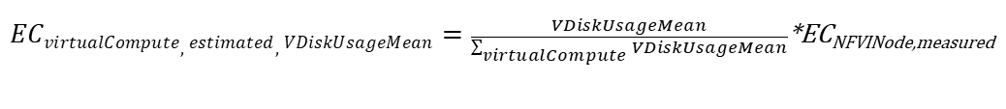

where:

- VDiskUsageMean is the mean vDisk usage of the virtual compute resource during the observation period, provided by NFV MANO;

-  is the sum of the vDisk mean usage of all virtual compute resources running on the same NFVI Node during the same observation period, all separately provided by NFV MANO (see clause 7.1.6 of [3];

- ECNFVINode,measured is the measured energy consumption of the NFVI node on which the virtual compute resource runs, during the same observation period, as per ETSI ES 202 336-12 [4].

#### 4.1.2.3 Potential solution #3: Consideration of four types of metrics provided by NFV MANO

##### 4.1.2.3.1 Introduction

In this potential solution #3, it is proposed to consider four types of metrics related to virtualized compute resources which can be provided by ETSI NFV MANO:

# Mean virtual CPU usage of the virtualized compute resource (see clause 7.1.2 of [3]);

# Mean memory usage of the virtualized compute resource (see clause 7.1.4 of [3]);

# Mean disk usage of the virtualized compute resource (see clause 7.1.6 of [3]);

# I/O traffic of the virtualized compute resource, measured by the sum of the number of incoming bytes on virtual compute (see clause 7.1.8 of [3]) and the number of outgoing bytes on virtual compute (see clause 7.1.9 of [3]).

Thus, four separate definitions of the estimated energy consumption of a virtualized compute resource are proposed, based on the four aforementioned measurements.

Which of these four KPIs is to be used for estimating the energy consumed by different virtualized compute resources is not subject to standardization and is left to operators' decision.

##### 4.1.2.3.2 Description

4.1.2.3.2.0 General

In this potential solution #3, the energy consumption of a virtualized compute resource X is estimated as a proportion of the energy consumption of the NFVI node on which the virtualized compute resource runs.

This proportion is obtained by considering either:

- the relative mean virtual CPU usage, or

- the relative mean virtual memory usage, or

- the relative mean virtual disk usage, or

- the relative incoming/outgoing traffic volume of the virtual compute resource instance X.

The relative mean virtual CPU usage of a virtual compute resource instance X is obtained by dividing the vCPU mean usage of the virtual compute resource instance X, by the sum of the vCPU mean usage of all virtual compute resource instances running on the same NFVI node as X.

The relative mean memory usage of a virtual compute resource instance X is obtained by dividing the mean memory usage of the virtual compute resource instance X, by the sum of the mean memory usage of all virtual compute resource instances running on the same NFVI node as X.

The relative mean disk usage of a virtual compute resource instance X is obtained by dividing the mean disk usage of the virtual compute resource instance X, by the sum of the mean disk usage of all virtual compute resource instances running on the same NFVI node as X.

The relative incoming/outgoing traffic volume of a virtual compute resource instance X is obtained by dividing the incoming/outgoing traffic volume of the virtual compute resource instance X, by the sum of the incoming/outgoing traffic volume of all virtual compute resource instances running on the same NFVI node as X.

4.1.2.3.2.1 Estimated virtual compute resource instance energy consumption based on mean vCPU usage

See TS 28.554 [2] clause 6.7.3.1.4.

4.1.2.3.2.2 Estimated virtual compute resource instance energy consumption based on mean vMemory usage

a) ECvirtualCompute,estimated,VMemoryUsageMean

b) A KPI that gives an estimation of the energy consumption of a virtual compute resource instance. The energy consumption of a virtual compute resource instance X is estimated as a proportion of the energy consumption of the NFVI node on which the virtual compute resource instance X runs. This proportion is obtained by dividing the vMemory mean usage of the virtual compute resource instance X, by the sum of the vMemory mean usage of all virtual compute resource instances running on the same NFVI Node as X. The unit of this KPI is J.

c)

d) ManagedFunction

e)

- VMemoryUsageMean is the mean memory usage of the virtual compute resource instance during the observation period, provided by NFV MANO,

- is the sum of the mean memory usage of all virtual compute resource instances running on the same NFVI node during the same observation period, all separately provided by NFV MANO (see clause 7.1.4 of [3],

- ECNFVINode,measured is the energy consumption of the NFVI node on which the virtual compute resource runs, measured during the same observation period, as per ETSI ES 202 336-12 [10]. Whether the measurement defined in TS 28.552 [1] clause 5.1.1.19.3 can be used to measure ECNFVINode,measured is FFS.

4.1.2.3.2.3 Estimated virtual compute resource instance energy consumption based on mean vDisk usage

a) ECvirtualCompute,estimated,VDiskUsageMean

b) A KPI that gives an estimation of the energy consumption of a virtual compute resource instance. The energy consumption of a virtual compute resource instance X is estimated as a proportion of the energy consumption of the NFVI node on which the virtual compute resource instance X runs. This proportion is obtained by dividing the vDisk mean usage of the virtual compute resource instance X, by the sum of the vDisk mean usage of all virtual compute resource instances running on the same NFVI Node as X. The unit of this KPI is J.

c)



d) ManagedFunction

e)

- VDiskUsageMean is the mean disk usage of the virtual compute resource instance during the observation period, provided by NFV MANO,

- is the sum of the mean disk usage of all virtual compute resource instances running on the same NFVI Node during the same observation period, all separately provided by NFV MANO (see clause 7.1.6 of [3],

- ECNFVINode,measured is the energy consumption of the NFVI node on which the virtual compute resource runs, measured during the same observation period, as per ETSI ES 202 336-12 [10]. Whether the measurement defined in TS 28.552 [1] clause 5.1.1.19.3 can be used to measure ECNFVINode,measured is FFS.

4.1.2.3.2.4 Estimated virtual compute resource instance energy consumption based on I/O traffic volume

a) ECvirtualCompute,estimated,VDiskUsageMean

b) A KPI that gives an estimation of the energy consumption of a virtual compute resource instance. The energy consumption of a virtual compute resource instance X is estimated as a proportion of the energy consumption of the NFVI node on which the virtual compute resource instance X runs. This proportion is obtained by dividing the I/O traffic volume of the virtual compute resource instance X, by the sum of the I/O traffic volume of all virtual compute resource instances running on the same NFVI Node as X. The unit of this KPI is J.

c)



d) ManagedFunction

e)

- IOTrafficVolume is the sum of the incoming and outgoing traffic volumes of the virtual compute resource instance during the observation period, provided by NFV MANO.

# Incoming traffic volume is obtained by measuring the number of incoming bytes on virtual compute (VNetByteIncoming - cf. clause 7.1.8 of [3]) during the observation period.

# Outgoing traffic volume is obtained by measuring the number of outgoing bytes on virtual compute (VNetByteOutgoing - cf. clause 7.1.9 of [3]) during the observation period,



- is the sum of the incoming and outgoing traffic volumes of all virtual compute resource instances running on the same NFVI node during the same observation period, all separately provided by NFV MANO (see clause 7.1.8 and 7.1.9 of [3]),

- ECNFVINode,measured is the energy consumption of the NFVI node on which the virtual compute resource runs, measured during the same observation period, as per ETSI ES 202 336-12 [10]. Whether the measurement defined in TS 28.552 [1] clause 5.1.1.19.3 can be used to measure ECNFVINode,measured is FFS.

### 4.1.3 Conclusion - Recommendation

The potential solution #3 for considering additional virtual resources usage to estimate virtual compute resource instance energy consumption is proposed to be introduced in the normative specification TS 28.554 [2].

## 4.2 Key Issue #2: Energy Consumption of containerized VNF/VNFCs

### 4.2.1 Description

The Rel-17 definition of the Energy Consumption (EC) of VNF/VNFCs (see TS 28.554 [2] – clauses 6.7.3.1.2 and 6.7.3.1.3) is valid for VM-based VNFs, i.e. when VNF/VNFC(s) are implemented on Virtual Machine(s) (VM).

ETSI ISG NFV started considering that VNF/VNFCs can be implemented using OS container technology (see e.g. [5] and [6]).

In the context of this key issue, a VNF (respectively VNFC) running using OS container technology is called a 'containerized VNF' (resp. 'containerized VNFC'), as per ETSI GR NFV-IFA 029 [6] clause 5.3.1.

This key issue aims at investigating on potential definition(s) of EC for containerized VNF/VNFCs.

### 4.2.2 Conclusion

There is no potential solution to key issue #2 in this version of the present document.

## 4.3 Key Issue #3: Energy Consumption of RAN nodes

### 4.3.1 Description

In TS 28.554 [2] clause 6.7.3.4.2, the Energy Consumption (EC) of a gNB is defined as the sum of the Energy Consumption of all the Network Functions (NF) that constitute the gNB, with no definition of what these NFs can be. Therefore, the definition of the EC of a gNB, as specified in TS 28.554 [2] clause 6.7.3.4.2, can lead to different interpretations, especially in case of gNB split architecture.

This key issue investigates how to apply the definition of the EC of a gNB as specified in TS 28.554 [2] clause 6.7.3.4.2 to various gNB split architectures. The case of non-split gNB is already covered by the existing definition in TS 28.554 [2] clause 6.7.3.4.2.

### 4.3.2 Potential solutions

#### 4.3.2.1 Potential solution #1: Consider that 'one logical node = one Network Function'

##### 4.3.2.1.1 Introduction

In this potential solution #1, it is proposed to consider every single 'logical node' (cf. TS 38.401 [8] clause 3.1) within gNBs as a Network Function (NF) and that, therefore, the EC of the gNB is the sum of the EC of all its contained logical nodes / NFs, as per TS 28.554 [2] clause 6.7.3.4.2.

##### 4.3.2.1.2 Description

In TS 38.300 [7] clause 3.2, a gNB is defined as a 'node' providing NR user plane and control plane protocol terminations towards the UE, and connected via the NG interface to the 5GC.

In TS 38.401 [8] clause 3.1, gNB-CU, gNB-DU, gNB-CU-CP and gNB-CU-UP are defined as 'logical nodes' within the gNB.

In this potential solution #1, considering every single 'logical node' (cf. TS 38.401 [8] clause 3.1) within split-gNBs as a Network Function (NF), the EC of a split-gNB is equal to the sum of the EC of all contained gNB-CU(s), gNB-DU(s), gNB-CU-CP(s) (if any), gNB-CU-UP(s) (if any). As any other NFs, gNB-CU(s), gNB-DU(s), gNB-CU-CP(s) and gNB-CU-UP(s) can be composed of PNFs and/or VNFs.

### 4.3.3 Conclusion

In case of split gNBs, the potential solution #1 is not completely described in this version of the present document.

## 4.4 Key Issue #4: EE KPI for V2X network slice

### 4.4.1 Description

TS 28.554 [2] – clause 6.7.2 provides definitions of EE KPIs for networks slices of the following types: eMBB, URLLC and MIoT. There is no EE KPI definition for V2X network slices.

This key issue aims at investigating on potential definition(s) of the EE of V2X network slices.

As stated in TS 28.554 [2] clause 6.7.2.1, the generic network slice EE KPI is defined by the 'Performance of the network slice' (Pns) divided by the 'Energy Consumption of the network slice' (ECns). Potential solutions in the following sub-clause(s) have to concentrate on definition(s) of Pns for V2X network slices.

### 4.4.2 Potential solutions

#### 4.4.2.1 Potential solution #1: Consider V2X as a sub-case of URLLC

##### 4.4.2.1.1 Introduction

TS 22.186 [17] clause 4.1 states that different V2X scenarios require the transport of V2X messages with different performance requirements for the 3GPP system.

TS 22.186 [17] clause 5 specifies service requirements for V2X scenarios in the six following areas:

# General Aspects: interworking, communication-related requirements valid for all V2X scenarios

# Vehicles Platooning

# Advanced Driving

# Extended Sensors

# Remote Driving

# Vehicle quality of service Support.

Though not all V2X scenarios have exactly the same performance requirements, they all have stringent requirements with regard to latency and reliability, similarly to URLLC scenarios. For this reason, in this potential solution #1, it is proposed to consider V2X as a sub-case of URLLC.

##### 4.4.2.1.2 Description

In this potential solution #1, given that:

- V2X scenarios have performance requirements with regard to latency and reliability in the same range as URLLC,

- EE KPIs for URLLC network slices are already defined in TS 28.554 [2] clause 6.7.2.3,

It is proposed to consider that already defined EE KPIs for URLLC network slices (cf. TS 28.554 [2] clause 6.7.2.3) may also apply to V2X network slices.

Therefore, there is no need to define additional EE KPI(s) for V2X network slices.

### 4.4.3 Conclusion

There is one potential solution in this version of the present document, proposing to consider that already defined EE KPIs for URLLC network slices (cf. TS 28.554 [2] clause 6.7.2.3) may also apply to V2X network slices.

## 4.5 Key Issue #5: Customer accepts QoS degradation to save energy

### 4.5.1 Description

Nowadays, most companies are expecting to reduce their Greenhouse Gas (GHG) emissions. GHG emissions are categorized into Scope 1, Scope 2 and Scope 3 emissions (see [9]). In a nutshell:

# Scope 1 - Direct GHG emissions, i.e. direct GHG emissions occurring from sources that are owned or controlled by the company; for example, emissions produced by the company's own facilities and vehicles

# Scope 2 - Electricity indirect GHG emissions, i.e. GHG emissions from the generation of purchased electricity consumed by the company

# Scope 3 - Other indirect GHG emissions, i.e. emissions which are a consequence of the activities of the company, but occur from sources not owned or controlled by the company.

Some companies, like e.g. large IT or consulting companies, have relatively little Scope 1 and Scope 2 emissions. Most of their emissions would come from Scope 3. Part of their Scope 3 emissions could come from the telecommunication services they use.

Sometimes, under the pressure of their stakeholders, these companies (playing, in the context of this key issue, the role of NSC) may be willing to cooperate with their providers (in general) to reduce their Scope 3 emissions. In the context of the network slice(s) they get from their Network Slice Provider(s) (NSP), they could decide to accept some limited QoS degradation from their NSP(s), provided:

a) they can specify which QoS limitation they are ready to accept

b) related energy savings can be measured and reported to them.

Optionally, price reductions may also be negotiated between NSCs and NSPs, corresponding to the commonly agreed limited QoS degradation. This is out of scope of SA5.

In TS 28.541, the ServiceProfile data type contains the attribute 'energyEfficiency', enabling the NSC to express his requirement with respect to the energy efficiency level of the network slice being ordered. However, there is no means for the NSC to mention that he would accept some limited QoS degradation. Limited QoS degradation could be expressed according to various dimensions:

# The 'what': the NSC may be capable and willing to express that he accepts e.g. degraded bandwidth and/or latency and/or number of simultaneously connected UEs, etc.;

# The 'how much': the NSC may be capable and willing to express that he accepts e.g. a 10 % QoS degradation, a 50 % QoS degradation, etc.;

# The 'when': the NSC may be willing to express when he accepts some time-limited QoS degradation, e.g. dates, time slots, punctual (e.g. on identified labour days) / recurrent (e.g. all Saturdays and Sundays of the year), etc.;

# The 'where': the NSC may be willing to express where he accepts some space-limited QoS degradation, e.g. in country X, in city Y, etc.

This key issue aims at investigating how NSCs could express their requirements for acceptable QoS degradation, for sake of reduction of their Scope 3 emissions via network energy savings.

In return, such NSCs should be able to receive, from their NSPs, information about actual Energy Consumption (EC) savings attributable to their decision to accept limited QoS degradation.

### 4.5.2 Conclusion

There is no potential solution to the key issue #5 in this version of the present document.

## 4.6 Key Issue #6: Energy Efficiency KPI of URLLC Network Slice based on its Reliability

### 4.6.1 Description

#### 4.6.1.1 Introduction

Performance of a URLLC network slice can be its latency and reliability. The lower the latency or higher the reliability of a URLLC network slice is, the higher its performance is. However, existing standardised solution (TS 28.554 [2], clause 6.7.2.3), determines Energy Efficiency (EE) for a URLLC slice only based on Latency performance, reliability performance is not considered. Reliability performance is also an integral part of URLLC slice by nature.

A CSP/NOP may want to assess Energy Efficiency (EE) KPI with respect to "reliability" of a URLLC Network Slice (NS) that is being used for communication services requiring very high reliability, such as Cloud/Edge/Split Rendering, Gaming or Interactive Data Exchanging, wireless road-side infrastructure backhaul etc. Reliability is a very important performance metric for such use cases.

A CSP/NOP providing such crucial services, would like to check its URLLC slice's EE with respect to reliability in addition to latency so that a more comprehensive and useful energy efficiency KPI can be determined.

Hence, it is important that a variant of Energy Efficiency KPI should also consider reliability performance of a URLLC slice for comprehensive assessment of EE.

#### 4.6.1.2 Potential requirements

**REQ-EURLC-FUN-y1** The 3GPP management system should have the capability to determine Energy Efficiency KPI of a URLLC Network Slice based on its reliability.

### 4.6.2 Potential Solutions

#### 4.6.2.1 Potential solution #1: Energy Efficiency KPI of URLLC Network Slice based on its Reliability when Reliability is in terms of PSR%

##### 4.6.2.1.1 Introduction

This potential solution focuses on the 'Ultra Reliable' (UR) characteristic of the URLLC network slice. The solution considers reliability of Network Slice as "percentage of successfully delivered packets within a time constraint" as defined in TS 22.261 [15] and TS 22.289 [16]. This enables CSPs/NOPs to have a robust and complete view of its URLLC slice's EE KPI. The solution involves dividing the Reliability Performance of URLLC slice (based on percentage of successfully delivered packets within a time constraint) by the total amount of energy consumption of the URLLC slice in same time period.

##### 4.6.2.1.2 Description

Energy Efficiency KPI of a URLLC network slice based on its reliability performance is represented as EEURLLC,Reliability. Since generic EE KPI formula of a slice is the ratio of Performance of network slice to the Energy Consumption of network slice hence EEURLLC,Reliability is given as below:

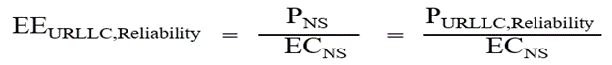

Equation 1

where PNS is the performance of a network slice. For a URLLC slice it can be both latency and reliability. Since the proposed solution is to establish EE KPI with respect to its reliability, thus here, performance of Network Slice is in terms of its reliability and hence PNS is actually denoted as PURLLC,Reliability. ECNS is the Energy Consumption of the whole slice as specified in TS 28.554 [2] clause 6.7.3.3.

Reliability performance of URLLC slice i.e. PURLLC,Reliability can be judged by "Packet Success Rate percentage" (PSR%). The definition of reliability in TS 22.261 [15] says "Reliability is defined in the context of network layer packet transmissions, as percentage value of the packets successfully delivered to a given system entity within the time constraint required by the targeted service out of all the packets transmitted.".

So, in this case, PURLLC,Reliability is denoted by PURLLC,Reliability,PSR and is defined as:



Equation 2

where:

# PSR% is Packet Success Rate percentage and is calculated over different interfaces and direction (UL/DL) as explained below;

# X is the total number of bits of packets sent over an interface in a URLLC slice, within the considered time frame T1.

It can be obtained by the measurements defined in clauses 5.4.1.4 & 5.1.2.1.2.1 of TS 28.552 for DL and UL respectively.

Note: Measurement from clause 5.4.1.4 needs to be multiplied by 8.

If PURLLC,Reliability,PSR is divided by Energy Consumption of network slice (ECNS), then EE KPI i.e. EEURLLC,Reliability is obtained. Ittells that "with an evaluated reliability (PSR%), how many packets can be successfully sent per Joule of energy in a URLLC slice in a given time frame constraint".

So, in this case, EE KPI is given by:



Equation 3

Specifically, EE KPI in DL and UL is given by equations 4 and 5 as below:



Equation 4



Equation 5

PURLLC,Reliability,PSR can be calculated independently for DL and UL directions. With PSR% based approach the EEURLLC,Reliability of a URLLC slice has the unit of bits per Joule. EEURLLC,Reliability can be calculated per interface and per DL and UL direction.

Throughout the slice, the same or different PSR% might exist on different interfaces.

# If it is same, the PSR % (reliability) of a slice can be calculated at any one segment of network i.e. between UE and gNB or between gNB and UPF.

# In case, if it is not same, the implementations may choose to calculate the PSR% of a URLLC slice at any interface deemed appropriate for the operator e.g. N3 or if end to end PSR% reliability is required, then it can consider combined (multiplied) PSR% reliability of all the interfaces together.

Following are the possible options and related calculations:

# **Reliability calculation for uplink over Uu interface** – PURLLC,Reliability,PSR is obtained for Uu interface by using PSR% calculated in equation below:

PSRUL,Uu = ULRelPSR\_Uu.SNSSAI

Equation 6

where PSRUL,Uu is equal to ULRelPSR\_Uu.SNSSAI which is PSR% in UL for Uu interface per SNSSAI as defined in TS 28.554 [2] clause 6.8.1.2.

# **Reliability calculation for downlink over Uu interface**: PURLLC,Reliability,PSR is obtained for Uu interface by using corresponding PSR% as calculated in equation below.

PSRDL,Uu = DLRelPSR\_Uu.SNSSAI

Equation 7

$S\left(T1,drbid\right).SNSSAI$

where PSRDL,Uu is equal to DLRelPSR\_Uu.SNSSAI which is PSR% in DL for Uu interface per SNSSAI as defined in TS 28.554 [2] clause 6.8.1.1.

# **Reliability calculation over N3 interface in uplink**: PURLLC,Reliability,PSR is obtained for N3 interface by using PSR% calculated in equation below. It is based on number of GTP data packets measurement.

PSRUL,N3 = ULRelPSR\_N3.SNSSAI

Equation 8

where PSRUL,N3 is equal to ULRelPSR\_N3.SNSSAI which is PSR% in UL for N3 interface per SNSSAI as defined in TS 28.554 [2] clause 6.8.1.4.

# **Reliability calculation over N3 interface in downlink**: PURLLC,Reliability,PSR is obtained for N3 interface by using PSR% calculated in equation below. It is based on number of GTP data packets measurement.

PSRDL,N3 = DLRelPSR\_N3.SNSSAI

Equation 9

where PSRDL,N3 is equal to DLRelPSR\_N3.SNSSAI which is PSR% in DL for N3 interface per SNSSAI as defined in TS 28.554 [2] clause 6.8.1.3.

So,

# end to end PSR% Reliability in UL = PSRUL,Uu × PSRUL,N3

# end to end PSR% Reliability in DL = PSRDL,Uu × PSRDL,N3

These end to end PSR% values in DL and UL will be fed in equation 2. Accordingly, equations 4 and 5 will provide Energy efficiency value for URLLC network slice in DL and UL respectively.

#### 4.6.2.2 Potential solution #2: Energy Efficiency KPI of URLLC Network Slice based on reliability

##### 4.6.2.2.1 Introduction

In this potential solution #2, it is proposed to define a variant of Energy Efficiency KPI that considers reliability performance of a URLLC slice for comprehensive assessment of EE. Specifically, some of KPI and parameters refer to definitions in TS 28.554 [2].

##### 4.6.2.2.2 Description

a) A KPI that shows the energy efficiency of network slices of type URLLC based on reliability. The Pns for a network slice of type URLLC is the multiplication of downlink packet transmission reliability and uplink packet transmission reliability of the network slice [2]. In this KPI variant, reliability is the factor considered for evaluating the performance of network slice.

b)

$$P_{URLLC, Reliability}=Network slice DL reliability*Network slice UL reliability$$

where

# 'Network slice DL reliability' is defined as the downlink packet transmission reliability of the network slice, and where the downlink packet transmission reliability of the network slice for one S-NSSAI is defined by:

$$Network slice DL reliability=\frac{DLRelPSR_Uu.SNSSAI}{100}*\frac{DLRelPSR_N3.SNSSAI}{100}$$

where $DLRelPSR_Uu.SNSSAI$ and $DLRelPSR_N3.SNSSAI$ are defined according to clause 6.8.1 in TS 28.554 [2].

# 'Network slice UL reliability' is defined as the uplink packet transmission reliability of the network slice, and where the uplink packet transmission reliability of the network slice for one S-NSSAI is defined by:

$$Network slice UL reliability=\frac{ULRelPSR_Uu.SNSSAI}{100}*\frac{ULRelPSR_N3.SNSSAI}{100}$$

where $ULRelPSR_Uu.SNSSAI$ and $ULRelPSR_N3.SNSSAI$ are defined according to clause 6.8.1 in TS 28.554[2].

Besides, URLLC Performance management on reliability in RAN has been discussed in the Study on management aspects of URLLC, and the discussion results would be considered if needed.

The unit of this KPI is percentage per Joule.

c)

$${EE}_{URLLC,Reliability}=\frac{Network slice DL reliability*Network slice UL reliability}{EC_{ns}}$$

d) The KPI object is network slice.

### 4.6.3 Conclusion

The solutions are feasible as they are based on the generic Network Slice Energy Efficiency (EE) KPI formula defined in TS 28.554 [2]. For this, they determine performance of URLLC slice in terms of reliability by using already defined Reliability KPI of TS 28.554 [2] and for Energy consumption of network slice they use already defined formula in TS 28.554 [2]. Solutions provide Energy Efficiency of URLLC network slice based on reliability.

### 4.6.4 Recommendation

Based on the conclusion in clause 4.6.3, it is proposed to introduce one single solution based on the potential solutions #1 and #2 into normative specification TS 28.554 [2].

## 4.7 Issue #7: Roles involved in EE KPI building

### 4.7.1 Description

Building EE KPIs (see TS 28.554 [2] – clause 6.7 requires collecting measurements from various entities. These entities may be or not under the responsibility of various stakeholders.  
TS 28.530 [10] clause 4.8 describes roles, and interactions between them, involved in 5G networks and network slicing management.

This issue aims at investigating, based on different use cases, which roles are involved in the collection of required measurements and in building EE KPIs, and the interactions between them.

In all use cases, the Network Operator (NOP) is involved.

### 4.7.2 Potential use cases

#### 4.7.2.1 Potential use case #1: 'NOP only, MEs are all PNFs'

##### 4.7.2.1.1 Introduction

In this use case:

# the Network Operator (NOP) operates its network;

# all Managed Elements (ME) on which measurements are collected are Physical Network Functions (PNF), i.e. none are virtualized;

# the NOP has all the MEs in its own premises.

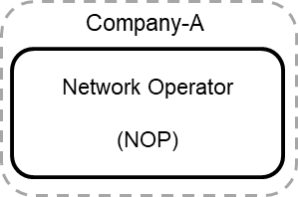

Figure 4.7.2.1.1-1: NOP only, MEs are all PNFs

##### 4.7.2.1.2 Description

In this use case, NOP:

1) collects required performance measurements from MEs. These performance measurements include those used in the upper part of EE KPIs defined in TS 28.554 [2] clause 6.7, e.g. performance measurements related to traffic data volumes, number of registered subscribers, etc.

2) collects PEE (Power, Energy and Environmental) parameters from MEs. Depending on whether Network Elements (NE) are equipped with embedded sensors or external sensors, the NOP may use an OA&M channel (in case of embedded sensor) or a dedicated channel (in case of external sensor) to collect PEE parameters.

3) build EE KPIs using:

a) performance measurements (cf. item 1 above) in the numerator of the KPIs; and

b) PEE parameters (cf. item 2 above) in the denominator of the KPIs;

4) use EE KPIs for its own purpose, i.e. the EE KPIs are not communicated to any other roles.

#### 4.7.2.2 Potential use case #2: 'NOP deploys virtualized 5GC NFs on internal virtualization infrastructure and data centre'

##### 4.7.2.2.1 Potential sub-use case #2.1

4.7.2.2.1.1 Introduction

In this use case:

# the Network Operator (NOP) operates its 5GC network;

# some 5GC NFs are virtualized and deployed on a virtualization infrastructure;

# the virtualization infrastructure is deployed and operated by an internal Virtualization Infrastructure Service Provider (VISP);

# the VISP deploys its virtualization infrastructure on its own data centre;

# the data centre is deployed and operated by an internal Data Centre Service Provider (DCSP);

# interfaces between NOP and VISP (NOP-VISP) and between NOP and DCSP (NOP-DCSP) are internal to Company A.

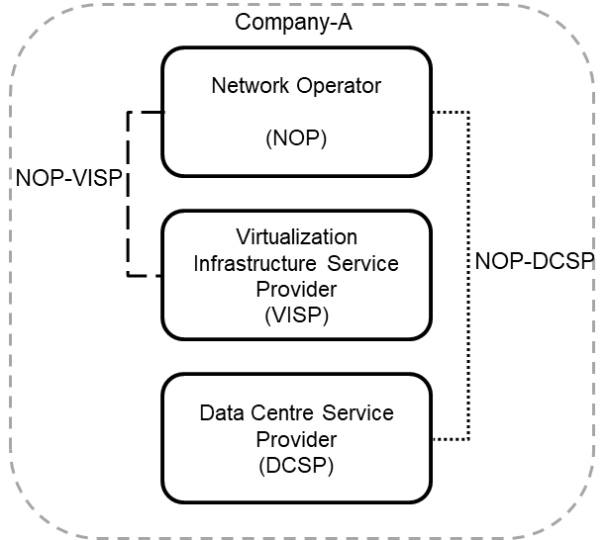

Figure 4.7.2.2.1.1-1: NOP deploys virtualized 5GC NFs on internal virtualization infrastructure and data centre

4.7.2.2.1.2 Description

In this use case, NOP:

1) collects required performance measurements from 5GC NFs via OA&M. These performance measurements include those used in the upper part of EE KPIs defined in TS 28.554 [2] clause 6.7, e.g. performance measurements related to traffic data volumes, number of registered subscribers, etc.

2) gets, from the VISP, performance measurements related to VNF/VNFCs which compose the NOP 5GC NFs. These performance measurements include the vCPU usage and vDisk usage of VNF/VNFCs defined in ETSI GS NFV-IFA 027 [3] clause 7;

3) gets, from the DCSP, PEE (Power, Energy and Environmental) parameters related to NFVI nodes on which the VNF/VNFCs supporting the NOP 5GC NFs run. These PEE parameters are defined in TS 28.552 [11] clause 5.1.1.19 and collected according to the method defined in ETSI ES 202 336-12 [4];

4) builds EE KPIs using:

a) performance measurements (cf. item 1 above) in the numerator of the KPIs; and

b) performance measurements related to VNF/VNFCs which compose the NOP 5GC NFs (cf. item 2 above) and PEE parameters (cf. item 3 above) in the denominator of the KPIs;

5) uses EE KPIs for its own purpose, i.e. the EE KPIs are not communicated to any other roles.

VISP:

1) collects performance measurements related to VNF/VNFCs which compose the NOP 5GC NFs. These performance measurements include the vCPU usage and vDisk usage of VNF/VNFCs defined in ETSI GS NFV‑IFA 027 [3] clause 7;

2) sends them to the NOP via the interface between the VISP ETSI MANO and the NOP OSS (cf. ETSI GS NFV‑IFA 008 [12] clause 7.4).

DCSP:

1) collects PEE (Power, Energy and Environmental) parameters from NFVI nodes on which the VNF/VNFCs supporting the NOP 5GC NFs run. These PEE parameters are defined in TS 28.552 [11] clause 5.1.1.19;

2) sends them to the NOP. Depending on whether NFVI nodes (i.e. servers) are equipped with embedded sensors or external sensors, the interactions between the DCSP and the NOP may use an OA&M channel (in case of embedded sensor) or a dedicated channel (in case of external sensor).

##### 4.7.2.2.2 Potential sub-use case #2.2

4.7.2.2.2.1 Introduction

In this use case:

# the Network Operator (NOP) operates its 5GC network;

# some 5GC NFs are virtualized and deployed on a virtualization infrastructure;

# the virtualization infrastructure is deployed and operated by an internal Virtualization Infrastructure Service Provider (VISP);

# the VISP deploys its virtualization infrastructure on its own data centre;

# the data centre is deployed and operated by an internal Data Centre Service Provider (DCSP);

# interfaces between NOP and VISP (NOP-VISP) and between VISP and DCSP (VISP-DCSP) are internal to Company A.

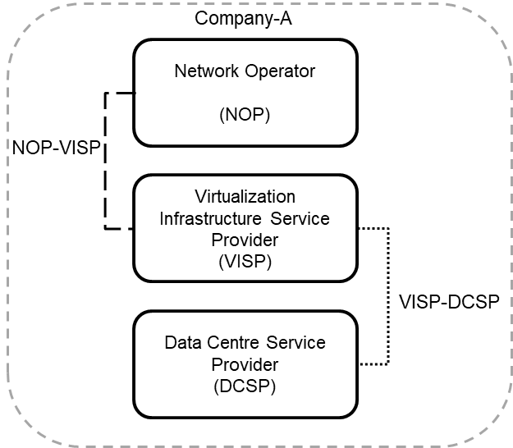

Figure 4.7.2.2.2.1-1: NOP deploys virtualized 5GC NFs on internal virtualization infrastructure and data centre

4.7.2.2.2.2 Description

In this use case, NOP:

1) collects required performance measurements from 5GC NFs via OA&M. These performance measurements include those used in the numerator of EE KPIs defined in TS 28.554 [2] clause 6.7, e.g. performance measurements related to traffic data volumes, number of registered subscribers, etc.

2) gets, from the VISP, performance measurements related to VNF/VNFCs which compose the NOP 5GC NFs. These performance measurements include the vCPU usage and vDisk usage of VNF/VNFCs defined in ETSI GS NFV-IFA 027 [3] clause 7;

3) gets, from the VISP, PEE (Power, Energy and Environmental) parameters related to NFVI nodes on which the VNF/VNFCs supporting the NOP 5GC NFs run. These PEE parameters are defined in TS 28.552 [11] clause 5.1.1.19 and collected according to the method defined in ETSI ES 202 336-12 [4] and are first received by the VISP from the DCSP;

4) builds EE KPIs using:

a) performance measurements (cf. item 1 above) in the numerator of the KPIs; and

b) performance measurements related to VNF/VNFCs which compose the NOP 5GC NFs (cf. item 2 above) and PEE parameters (cf. item 3 above) in the denominator of the KPIs.

5) uses EE KPIs for its own purpose, i.e. the EE KPIs are not communicated to any other roles.

VISP:

1) collects performance measurements related to VNF/VNFCs which compose the NOP 5GC NFs. These performance measurements include the vCPU usage and vDisk usage of VNF/VNFCs defined in ETSI GS NFV‑IFA 027 [3] clause 7;

2) sends them to the NOP via the interface between the VISP ETSI MANO and the NOP OSS (cf. ETSI GS NFV‑IFA 008 [12] clause 7.4);

3) collects, from the DCSP, PEE (Power, Energy and Environmental) parameters related to NFVI nodes on which the VNF/VNFCs supporting the NOP 5GC NFs run;

4) sends them to the NOP via the interface between the VISP and the NOP OSS.

DCSP:

1) collects PEE (Power, Energy and Environmental) parameters from NFVI nodes on which the VNF/VNFCs supporting the NOP 5GC NFs run. These PEE parameters are defined in TS 28.552 [11] clause 5.1.1.19;

2) sends them to the VISP via the interface between the VISP and the DCSP.

#### 4.7.2.3 Potential use case #3: 'NOP deploys virtualized 5GC NFs on external virtualization infrastructure and data centre'

##### 4.7.2.3.1 Potential sub-use case #3.1

4.7.2.3.1.1 Introduction

In this use case:

# the Network Operator (NOP) operates its 5GC network;

# some 5GC NFs are virtualized and deployed on a virtualization infrastructure;

# the virtualization infrastructure is deployed and operated by an external Virtualization Infrastructure Service Provider (VISP);

# the VISP deploys its virtualization infrastructure on a data centre;

# the data centre is deployed and operated by an external Data Centre Service Provider (DCSP).

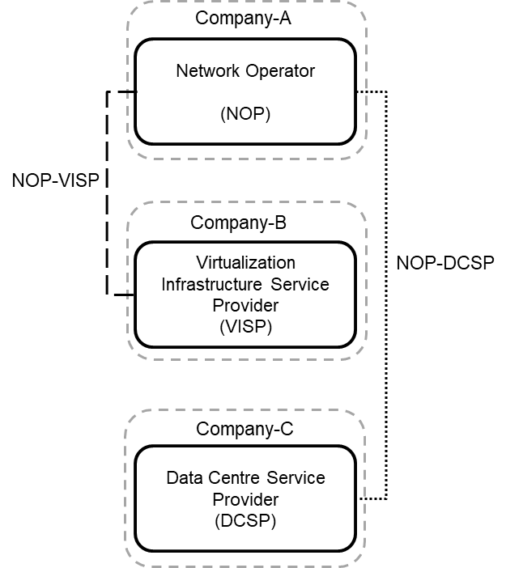

Figure 4.7.2.3.1.1-1: NOP deploys virtualized 5GC NFs on external virtualization infrastructure and data centre

4.7.2.3.1.2 Description

In this use case, NOP:

1) collects required performance measurements from 5GC NFs via OA&M. These performance measurements include those used in the upper part of EE KPIs defined in TS 28.554 [2] clause 6.7, e.g. performance measurements related to traffic data volumes, number of registered subscribers, etc.

2) gets, from the VISP, performance measurements related to VNF/VNFCs which compose the NOP 5GC NFs. These performance measurements include the vCPU usage and vDisk usage of VNF/VNFCs defined in ETSI GS NFV-IFA 027 [3] clause 7;

3) gets, from the DCSP, PEE (Power, Energy and Environmental) parameters related to NFVI nodes on which the VNF/VNFCs supporting the NOP 5GC NFs run. These PEE parameters are defined in TS 28.552 [11] clause 5.1.1.19 and collected according to the method defined in ETSI ES 202 336-12 [4];

4) builds EE KPIs using:

a) performance measurements (cf. item 1 above) in the numerator of the KPIs; and

b) performance measurements related to VNF/VNFCs which compose the NOP 5GC NFs (cf. item 2 above) and PEE parameters (cf. item 3 above) in the denominator of the KPIs.

5) uses EE KPIs for its own purpose, i.e. the EE KPIs are not communicated to any other roles.

VISP:

1) collects performance measurements related to VNF/VNFCs which compose the NOP 5GC NFs. These performance measurements include the vCPU usage and vDisk usage of VNF/VNFCs defined in ETSI GS NFV-IFA 027 [3] clause 7;

2) sends them to the NOP via the interface between the VISP ETSI MANO and the NOP OSS (cf. ETSI GS NFV-IFA 008 [12] clause 7.4).

DCSP:

1) collects PEE (Power, Energy and Environmental) parameters from NFVI nodes on which the VNF/VNFCs supporting the NOP 5GC NFs run. These PEE parameters are defined in TS 28.552 [b] clause 5.1.1.19;

2) sends them to the NOP. Depending on whether NFVI nodes (i.e. servers) are equipped with embedded sensors or external sensors, the interactions between the DCSP and the NOP may use an OA&M channel (in case of embedded sensor) or a dedicated channel (in case of external sensor).

##### 4.7.2.3.2 Potential sub-use case #3.2

4.7.2.3.2.1 Introduction

In this use case:

# the Network Operator (NOP) operates its 5GC network;

# some 5GC NFs are virtualized and deployed on a virtualization infrastructure;

# the virtualization infrastructure is deployed and operated by an external Virtualization Infrastructure Service Provider (VISP);

# the VISP deploys its virtualization infrastructure on a data centre;

# the data centre is deployed and operated by an external Data Centre Service Provider (DCSP).

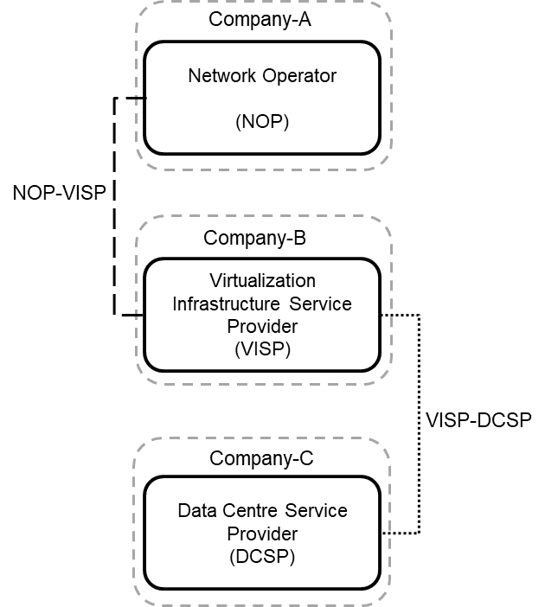

Figure 4.7.2.3.2.1-1: NOP deploys virtualized 5GC NFs on external virtualization infrastructure and data centre

4.7.2.3.2.2 Description

In this use case, NOP:

1) collects required performance measurements from 5GC NFs via OA&M. These performance measurements include those used in the upper part of EE KPIs defined in TS 28.554 [2] clause 6.7, e.g. performance measurements related to traffic data volumes, number of registered subscribers, etc.

2) gets, from the VISP, performance measurements related to VNF/VNFCs which compose the NOP 5GC NFs. These performance measurements include the vCPU usage and vDisk usage of VNF/VNFCs defined in ETSI GS NFV-IFA 027 [3] clause 7;

3) gets, from the VISP, PEE (Power, Energy and Environmental) parameters related to NFVI nodes on which the VNF/VNFCs supporting the NOP 5GC NFs run. These PEE parameters are defined in TS 28.552 [11] clause 5.1.1.19 and collected according to the method defined in ETSI ES 202 336-12 [4] and are first received by the VISP from the DCSP;

4) builds EE KPIs using:

a) performance measurements (cf. item 1 above) in the numerator of the KPIs, and

b) performance measurements related to VNF/VNFCs which compose the NOP 5GC NFs (cf. item 2 above) and PEE parameters (cf. item 3 above) in the denominator of the KPIs;

5) uses EE KPIs for its own purpose, i.e. the EE KPIs are not communicated to any other roles.

VISP:

1) collects performance measurements related to VNF/VNFCs which compose the NOP 5GC NFs. These performance measurements include the vCPU usage and vDisk usage of VNF/VNFCs defined in ETSI GS NFV-IFA 027 [3] clause 7;

2) sends them to the NOP via the interface between the VISP ETSI MANO and the NOP OSS (cf. ETSI GS NFV-IFA 008 [12] clause 7.4);

3) collects, from the DCSP, PEE (Power, Energy and Environmental) parameters related to NFVI nodes on which the VNF/VNFCs supporting the NOP 5GC NFs run;

4) sends them to the NOP via the interface between the VISP and the NOP OSS.

DCSP:

1) collects PEE (Power, Energy and Environmental) parameters from NFVI nodes on which the VNF/VNFCs supporting the NOP 5GC NFs run. These PEE parameters are defined in TS 28.552 [11] clause 5.1.1.19;

2) sends them to the VISP via the interface between the VISP and the DCSP.

### 4.7.3 Conclusion

The above use cases illustrate situations in which different roles, i.e. not only the NOP, are involved in the collection of required measurements and in building EE KPIs, and show the interactions between these roles.

Further investigations on these use cases may be needed.

## 4.8 Key Issue #8: Energy Saving compensation procedure

### 4.8.1 Description

#### 4.8.1.1 Introduction

The energy saving procedures described in TS 28.310 [13] clause 6.2 do not specify the impact on the candidate cell(s) when energy saving is activated in the capacity booster cell in 5G. The concept of ES compensation and compensating for energy saving state are described in TS 32.551 [14] for the legacy technologies. This key issue is to study potential solutions for the concepts of ES compensation for 5G.

#### 4.8.1.2 Potential requirements

**REQ-ESCOL-FUN-y1** The Domain-centralized ES shall support a capability to initiate energy saving compensation activation to one or multiple cells.

**REQ-ESCOL-FUN-y2** The Domain-centralized ES shall support a capability to initiate energy saving compensation deactivation to one or multiple cells.

**REQ-ESCOL-FUN-y3** The distributed ES function shall support a capability to initiate energy saving compensation activation to one or multiple cells.

**REQ-ESCOL-FUN-y4** The distributed ES function shall support a capability to initiate energy saving compensation deactivation to one or multiple cells.

### 4.8.2 Potential solutions

#### 4.8.2.1 Potential solution #1: Energy saving compensation activation and deactivation procedures

##### 4.8.2.1.1 Introduction

The MnS producer for Domain-centralized ES or the distributed ES function, that makes a decision for the NR capacity booster cell to enter or exit energySaving state, should be able to initiate energy saving compensation activation and/or deactivation on one or multiple cells.

##### 4.8.2.1.2 Description

For the energy saving use cases (refer to TS 28.310 [13], clause 5.1.3), when a NR capacity booster cell enters energySaving state, then the candidate cell(s) may transition to the:

- compensatingForEnergySaving.

Correspondingly, the use cases support the following procedures:

- Energy saving compensation activation: the procedure to increase the coverage area for the candidate cell(s).

- Energy saving compensation deactivation: the procedure to decrease a previously increased coverage area.

### 4.8.3 Conclusion - Impact on normative work

The potential requirements and solution proposed by potential solution #1 for Energy saving compensation procedure for the 5G are proposed to be introduced in the normative specification TS 28.310 [13].

## 4.9 Key Issue #9: RAN energy saving when using backup batteries

### 4.9.1 Description

#### 4.9.1.1 Introduction

When RAN faces main power failure, it is supported by backup batteries to prolong the service. However, due to cost and deployment space considerations, batteries may have insufficient lifespan. As a result, the period of service time supported by backup batteries may not meet demand, but may be extended by RAN energy saving actions.

RAN energy saving achieved by executing energy saving actions is especially crucial when using backup batteries, and satisfy the following requirements:

# energy saving requirement: the period of time batteries can provide service needs to be maximized, which needs the help of RAN energy saving;

# QoS requirement: the influence on QoS should also be considered when taking energy saving actions.

Hence, when using backup batteries, it is much important to manage energy saving actions to balance the energy saving requirement and the QoS requirement. For example, 3GPP Management System could manage the energy saving actions sent to gNB according to the backup batteries situation and the QoS requirement.

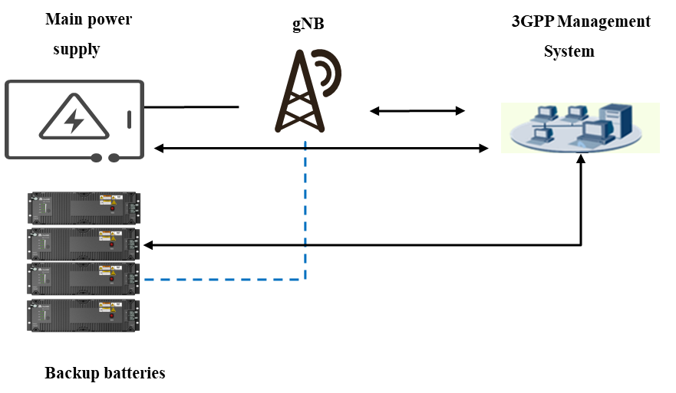

Figure 4.9.1-1: gNB and backup batteries

#### 4.9.1.2 Potential requirements

REQ-ES\_BB-1: The 3GPP management system should be able to monitor the state of charge and discharge of backup batteries of gNBs, i.e. it should be able to know the UPS battery capacity at any time.

REQ-ES\_BB-2: The 3GPP management system should be able to monitor the state of the main power supply of gNBs.

### 4.9.2 Potential solutions

#### 4.9.2.1 Potential solution #1: based on information of backup batteries as per ETSI ES 202 336-11 [18]

##### 4.9.2.1.1 Introduction

This potential solution relies partly on ETSI ES 202 336-11 [18] which defines:

# monitored and controlled battery system architectures;

# the information exchanged between a battery system (in a telecom site) and a remote management application.

##### 4.9.2.1.2 Description

Clause 4 of ETSI ES 202 336-11 [18] lists the information that can be monitored and controlled via the interface between the battery system and the remote management application:

- State of Charge (SoC) for each Integrated Battery System (IBS – see definition in ETSI ES 202 336-11 [18] clause 3.1).

Annex A (respectively annex B) of ETSI ES 202 336-11 [18] provides the list of mandatory (resp. non-mandatory) monitoring / supervision information, amongst which the following two attributes can be extracted:

- Operating mode: it represents the working status of backup batteries. The enumeration value of operating mode could be charge, discharge, float charge, sleep, and safe. The change of operating mode is a monitored event and can be sent out from the on-site battery system to a remote management application.

- Estimated remaining battery autonomy (time): it is an information which may be consulted from a remote management application to know the remaining battery autonomy time.

Clause C.1 of ETSI ES 202 336-11 [18] provides the structure of an XML document which can be used to control and monitor battery systems from a remote management application.

Where (i.e. in which SDO) and when the aforementioned information and data models are specified is FFS.

### 4.9.3 Conclusion

To fulfil the requirement REQ-ES\_BB-1 from clause 4.9.1.2, this potential solution #1 should be complemented with:

# an information model (Stage 2) specifying the backup battery information (based on ETSI ES 202 336-11 [18]) that can be monitored for the NG-RAN in the 3GPP management system;

# data model(s) (Stage 3), in YAML and/or in YANG.

## 4.10 Key Issue #10: Digital sobriety

### 4.10.1 Description

It should be clear that the efforts requested by 3GPP are to be made when specifying new features, by the integration of environmental aspects into the 3GPP Technical Specifications (TS) development process, by balancing ecological and functional, performance, QoS, etc. requirements.

Digital sobriety, in the context of this study, encompasses all design principles enabling to optimize the volume of information to be:

- processed;

- stored;

- transported;

by the 3GPP system.

Optimizing the volume of information processed, stored, carried by 3GPP networks can be addressed at:

# user plane;

# control plane;

# management plane.

When it comes to 'consider EE as a guiding principle when developing new solutions and evolving the 3GPP systems specification', only the management plane (i.e. OA&M) is in the scope of the present document.

Though it is well known that the management plane traffic volumes are far less than e.g. user plane ones, it is 3GPP's responsibility to try to optimize them anyway, from the specification phase to the operation phase.

This key issue focuses on the specification phase in 3GPP, and aims at studying where and when it is possible to minimize OA&M traffic volumes processed and/or transported and/or stored by the managed elements / functions and management functions, so as to render the 3GPP system more digitally sober.

As said above, the energy consumed by managed elements, managed functions and management functions highly depends on the volumes of information that they:

- process; and/or

- store; and/or

- carry.

Based on the above, this key issue aims at studying how 3GPP can consider digital sobriety when specifying OA&M concepts, architectures, interfaces, APIs, Network Resource Models (NRM), etc.

NOTE: This key issue and its potential solution(s) do not aim at deriving any potential requirements for the 3GPP management system. Instead, they aim at proposing recommendations to be considered by 3GPP when developing new, or evolving existing, specifications.

### 4.10.2 Conclusion

There is no potential solution in the present document.

Annex A (informative):  
Change history

|  |  |  |  |  |  |  |  |
| --- | --- | --- | --- | --- | --- | --- | --- |
| **Change history** | | | | | | | |
| **Date** | **Meeting** | **TDoc** | **CR** | **Rev** | **Cat** | **Subject/Comment** | **New version** |
| 2022 04 | SA5#142e | S5-222022  S5-222023  S5-222024  S5-222669  S5-222670 | - | - | - | TR 28.913 Skeleton  Clause titles for Key Issues and Potential Solutions  New Key Issue Considering additional virtual resources usage metrics in EC estimation  New Key Issue Considering Containerized Network Functions  New Key Issue Energy Consumption of RAN nodes | 0.1.0 |
| 2022 07 | SA5#144e | S5-224090  S5-224091  S5-224096 |  |  |  | Add new Key Issue - EE KPI for V2X network slice  Correcting vocabulary for CNF  New Key Issue – Customer accepts QoS degradation to save energy | 0.2.0 |
| 2022 07 | SA5#144e |  |  |  |  | Re-upload due to corrupt file uploaded (MCC) | 0.2.1 |
| 2022 08 | SA5#145e | S5-225862  S5-225861  S5-225863 |  |  |  | Potential solution No.2, conclusion and recommendation for KI #1  New Key Issue for Energy Efficiency of a URLLC network slice based on reliability  New Issue – Roles involved in EE KPI building | 0.3.0 |
| 2022 11 | SA5#146 | S5-226059  S5-227009  S5-226456  S5-226292  S5-227063  S5-226333 |  |  |  | Add key issue for Energy Saving compensation procedure  Solution for Energy Efficiency of a URLLC network slice based on reliability  Potential solution for KI#4 EE KPI for V2X network slice  Add conclusion for the key issue for Energy Saving compensation procedure  New Key Issue-RAN energy saving when using backup batteries  Add new Issue on digital sobriety | 0.4.0 |
| 2023 03 | SA5#147 | S5-232067 |  |  |  | Clean up KI#8 - Energy Saving compensation procedure | 0.5.0 |
| 2023 04 | SA5#148e | S5-233614  S5-233615  S5-233616  S5-233617  S5-233618  S5-233619  S5-233620 |  |  |  | Conclusion for KI#2 Energy Consumption of containerized VNF/VNFCs  Conclusion for KI#3 Energy Consumption of RAN nodes  Conclusion for KI#4 EE KPI for V2X network slice  Conclusion for KI#7 Roles involved in EE KPI building  Conclusion for KI#5 Customer acceptance for QoS degradation to save energy  Conclusion for KI#9 RAN energy saving when using backup batteries  Solution and conclusion for KI#10 Digital sobriety | 0.6.0 |
| 2023-05 | SA5#148e |  |  |  |  | EditHelp review | 0.6.1 |
| 2023-05 | SA5#149 | S5-234560  S5-234561  S5-234562  S5-234563 |  |  |  | KI#1 Consideration of four types of metrics to estimate VNF Energy  Add potential solution for Energy Efficiency KPI of URLLC Network Slice based on both reliability  Updates in Potential solution of clause 4.6.2.1 for EE  Add Conclusion and Recommendation for Key Issue 6 | 0.7.0 |
| 2023-06 | SA#100 | SP-230638 |  |  |  | Presented for information and approval | 1.0.0 |
| 2023-06 | SA#100 |  |  |  |  | Upgrade to change control version | 18.0.0 |
| 2023-06 | SA#100 |  |  |  |  | EditHelp review | 18.0.1 |