3GPP TS 32.130 V18.1.0 (2023-12)

Technical Specification

3rd Generation Partnership Project;

Technical Specification Group Services and System Aspects;

Telecommunication management;

Network sharing;

Concepts and requirements

(Release 18)





The present document has been developed within the 3rd Generation Partnership Project (3GPP TM) and may be further elaborated for the purposes of 3GPP..  
The present document has not been subject to any approval process by the 3GPPOrganizational Partners and shall not be implemented.  
This Specification is provided for future development work within 3GPPonly. The Organizational Partners accept no liability for any use of this Specification.  
Specifications and Reports for implementation of the 3GPP TM system should be obtained via the 3GPP Organizational Partners' Publications Offices.

Keywords

Network sharing, Management, 3GPP

***3GPP***

Postal address

3GPP support office address

650 Route des Lucioles - Sophia Antipolis

Valbonne - FRANCE

Tel.: +33 4 92 94 42 00 Fax: +33 4 93 65 47 16

Internet

http://www.3gpp.org

***Copyright Notification***

No part may be reproduced except as authorized by written permission.  
The copyright and the foregoing restriction extend to reproduction in all media.

© 2023, 3GPP Organizational Partners (ARIB, ATIS, CCSA, ETSI, TSDSI, TTA, TTC).

All rights reserved.

UMTS™ is a Trade Mark of ETSI registered for the benefit of its members

3GPP™ is a Trade Mark of ETSI registered for the benefit of its Members and of the 3GPP Organizational Partners  
LTE™ is a Trade Mark of ETSI registered for the benefit of its Members and of the 3GPP Organizational Partners

GSM® and the GSM logo are registered and owned by the GSM Association

Contents

Foreword 4

Introduction 4

1 Scope 5

2 References 5

3 Definitions and abbreviations 5

3.1 Definitions 5

3.2 Abbreviations 6

4 Concepts and background 7

4.1 RAN sharing scenarios 7

4.2 Management architecture 9

5 Business level requirements 10

5.1 Requirements 10

5.1.1 Requirements for the OAM&P of shared RAN 10

5.1.2 Requirements for the OA&M of shared core network elements 11

5.1.3 Requirements for the management of measurements for cross-operator accounting based on data volume and QoS 11

5.1.4 Requirements for management support for NG-RAN MOCN network sharing scenario with same Cell Identity broadcast 12

5.1.5 Requirements for management support for NG-RAN MOCN network sharing scenario with multiple Cell Identity broadcast 12

5.1.6 Requirements for the OAM&P of shared NG-RAN 12

5.2 Actor roles 13

5.3 Telecommunications resources 13

5.4 High-level use cases 13

5.4.1 Fully pooled radio resources between two POPs 13

5.4.2 Alarm raised on a shared cell (MOCN scenario) 14

5.4.3 Single DM for managing S-RAN and POP own RAN 15

5.4.4 Management of measurements for cross-operator accounting based on data volume and QoS 15

5.4.5 Management support for the mixed deployment scenario of shared NG-RAN network elements and non-shared NG-RAN network elements 15

5.4.6 Radio resources partitioning between two POPs for the shared NG-RAN 16

6 Specification level requirements 17

6.1 Requirements 17

6.2 Actor roles 17

6.3 Telecommunications resources 17

6.4 Use cases 17

6.4.1 Management of measurements for cross-operator accounting based on data volume and QoS 17

7 Management workflows for requirements for the management of the shared NG-RAN NE(s) in MOCN network sharing scenario 18

7.1 Management of the shared NG-RAN NE(s) in MOCN network sharing scenario with the same cell Identity broadcast 18

7.2 Management of the shared NG-RAN NE(s) in MOCN network sharing scenario with the multiple cell Identity broadcast 19

Annex A (informative): Network sharing agreement 21

Annex B (informative): Change history 22

# Foreword

This Technical Specification has been produced by the 3rd Generation Partnership Project (3GPP).

The contents of the present document are subject to continuing work within the TSG and may change following formal TSG approval. Should the TSG modify the contents of the present document, it will be re-released by the TSG with an identifying change of release date and an increase in version number as follows:

Version x.y.z

where:

x the first digit:

1 presented to TSG for information;

2 presented to TSG for approval;

3 or greater indicates TSG approved document under change control.

y the second digit is incremented for all changes of substance, i.e. technical enhancements, corrections, updates, etc.

z the third digit is incremented when editorial only changes have been incorporated in the document.

# Introduction

Network sharing is emerging as a mechanism for operators to substantially and sustainably improve network costs and to efficiently utilize network capacity. The traditional model of single ownership of all network layers and elements is being challenged and more and more operators are adopting network sharing as a means of cutting the heavy costs involved in initial roll-out, capital expenditure (CAPEX) and [operational expenditure](http://en.wikipedia.org/wiki/Operating_expense) (OPEX).

In general, an increasing number of operators are sharing their mobile networks. Main arguments presented are:

- Increased rollout speed.

- Quickly expanding coverage to meet customer demand for wider coverage.

- Sharing low traffic areas.

- Sharing high license burdens.

- Lower CAPEX and OPEX.

Network sharing has some major implications on the operations of the network. Alignment on operational priorities, common network planning/evolution strategy, sharing end user data/subscriber data, sharing performance data, alarms etc. in the shared network need to be considered carefully. Privacy, security and competitive information are also important for the operations of a shared network.

# 1 Scope

The present document describes concepts and high-level requirements for the Operations, Administration, Maintenance and Provisioning (OAM&P) of network sharing.

Network sharing scenarios considered in the present document are Multiple Operator Core Network (MOCN) and Gateway Core Network (GWCN) for GERAN, UTRAN and E-UTRAN, as defined in TS 23.251 [7] , and Multiple Operator Core Network (MOCN) for NG-RAN as defined in TS 23.501[7].

# 2 References

The following documents contain provisions which, through reference in this text, constitute provisions of the present document.

- References are either specific (identified by date of publication, edition number, version number, etc.) or non‑specific.

- For a specific reference, subsequent revisions do not apply.

- For a non-specific reference, the latest version applies. In the case of a reference to a 3GPP document (including a GSM document), a non-specific reference implicitly refers to the latest version of that document *in the same Release as the present document*.

[1] 3GPP TR 21.905: "Vocabulary for 3GPP Specifications".

[2] 3GPP TS 32.101: "Telecommunication management; Principles and high level requirements".

[3] 3GPP TS 32.102: "Telecommunication management; Architecture".

[4] 3GPP TS 36.300: "Evolved Universal Terrestrial Radio Access (E-UTRA) and Evolved Universal Terrestrial Radio Access Network (E-UTRAN); Overall description; Stage 2".

[5] 3GPP TS 23.251: "Network sharing; Architecture and functional description".

[6] 3GPP TS 36.314: "Evolved Universal Terrestrial Radio Access (E-UTRA); Layer 2 – Measurements"

[7] 3GPP TS 23.501: "System architecture for the 5G System (5GS); Stage2".

[8] 3GPP TS 28.541: "Management and orchestration; 5G Network Resource Model (NRM); Stage 2 and stage 3".

[9] 3GPP TS 28.552: "Management and orchestration; 5G performance measurements".

# 3 Definitions and abbreviations

## 3.1 Definitions

For the purposes of the present document, the terms and definitions given in TS 32.101 [2], TS 32.102 [3] and TR 21.905 [1] and the following apply. A term defined in the present document takes precedence over the definition of the same term, if any, in TS 32.101 [2], TS 32.102 [3] and TR 21.905 [1], in that order.

Organizational roles:

**Master Operator (MOP):** In Radio Access Network (RAN) and/or Core Network (CN) sharing scenarios, deployment and daily operation of shared network elements are entrusted to a single Actor, called the Master Operator. The Master Operator provides network and OAM&P services to other Operators, called Participating Operators (POPs). The Master Operator is the only one to have a direct OAM&P connection from its Domain Manager (DM) to the shared network elements.

**Participating Operator (POP):** Participating Operators are service providers who share, alongside other Participating Operators, the network (RAN and/or CN) facilities provided by the Master Operator. According to TS 36.300 [4] up to 6 operators can share a RAN.

Note: In a RAN/CN sharing scenario where Company A and Company B are POPs, MOP represents a role which can be played by either:

- Company A or Company B: in that case, Company A or Company B plays both roles, i.e. is the MOP and one of the POPs simultaneously, or

- A joint-venture between Company A and Company B, or

- A third-party entity: in this context, third party is referring to a wholesale mobile connectivity provider.

In the two latter cases, companies A and B rely on another company to play the role of MOP. This company cannot play the role of POP.

Management systems:

**Master Operator Network Manager (MOP-NM):** Network Manager enabling the Master Operator to manage the shared RAN and/or shared CN.

**Master Operator Shared CN dm (MOP–SC-DM):** Domain Manager enabling the Master Operator to manage the Shared CN.

**Master Operator Shared RAN dm (MOP–SR-DM):** Domain Manager enabling the MOP to manage the Shared RAN.

**Participating Operator CN DM (POP-CORE-DM):** Domain Manager enabling a Participating Operator to manage its own (not shared) Core Network.

**Participating Operator Network Manager (POP-NM):** Network Manager enabling a Participating Operator to manage its own (not shared) network and its portion of the shared network.

**Participating Operator RAN DM (POP-RAN-DM):** Domain Manager enabling a Participating Operator to manage its own (not shared) RAN.

Managed resources in a shared Radio Access Network (RAN) environment:

**Shared RAN (S-RAN):** A set of Radio Access Network elements shared among Participating Operators.

Managed resources in a shared Core Network (CN) environment:

**Shared CN (S-CORE):** A set of Core Network elements shared among Participating Operators. It may or may not include all core network elements. For example, the Participating Operators may share only the MMEs while having independent S/P GWs.

## 3.2 Abbreviations

For the purposes of the present document, the abbreviations given in TR 21.905 [1] and the following apply.   
An abbreviation defined in the present document takes precedence over the definition of the same abbreviation, if any, in TR 21.905 [1].

ARP Allocation and Retention Priority

DL Downlink

DM Domain Manager

GBR Guaranteed Bit Rate

GWCN Gateway Core Network

MDT Minimization of Drive Tests

MOCN Multiple Operator Core Network

MOP Master Operator

MOP-NM Master Operator Network Manager

MOP–SC-DM Master Operator Shared CN DM

MOP–SR-DM Master Operator Shared RAN DM

NGCOR Next Generation Converged Operations Requirements

OAM&P Operations, Administration, Maintenance and Provisioning

POP Participating Operator

POP-CORE-DM Participating Operator CN DM

POP-NM Participating Operator Network Manager

POP-RAN-DM Participating Operator RAN DM

QCI Quality of Service Class Indicator

QoS Quality of Service

SON Self-Organizing Networks

S-CORE Shared CN

S-RAN Shared RAN

UL Uplink

# 4 Concepts and background

## 4.1 RAN sharing scenarios

Various network sharing scenarios exist, amongst which one category is RAN sharing which can be divided into the following (non exhaustive) list of sub-categories:

- Passive RAN sharing, also known as infrastructure sharing (including site sharing).

- Active RAN sharing, where active network elements of the RAN are shared:

- RAN-only sharing (MOCN; see TS 23.251 [5] and TS 23.501 [7]), i.e. BTSs / BSCs (respectively NodeBs / RNCs and eNodeBs) in a 2G Radio Access Network (respectively a 3G Radio Access Network and an E-UTRA network) , and gNBs in a 5G NR network;

- Gateway Core Network (GWCN; see TS 23.251 [5]), in which not only the Radio Access Network elements are shared but also part or all of the Core Network elements (there is no passive core network sharing).

The following figures depict the MOCN scenarios:



Figure 4.1-1: E-UTRAN MOCN network sharing scenario



Figure 4.1-2: NG-RAN MOCN Network Sharing with same cell identity broadcast scenario



Figure 4.1-3 NG-RAN MOCN Network Sharing with multiple cell identity broadcast scenario

In GWCN, besides sharing Radio Access Network nodes, the POPs also share Core Network nodes (see TS 23.251 [5] – clause 4.1).

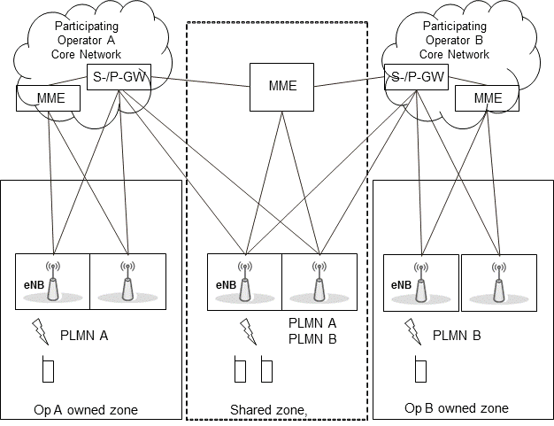

Figure 4.1-4: GateWay Core Network (GWCN)

## 4.2 Management architecture

The management architecture for MOCN is depicted in figure 4.2-1. It is compliant with 3GPP management reference model (TS 32.101 [2]).

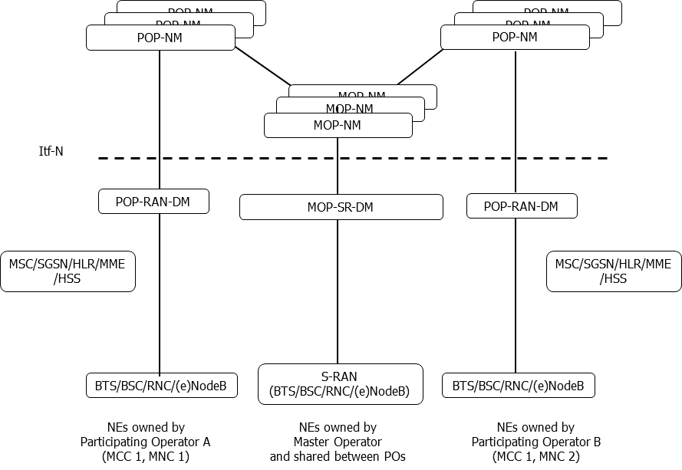

Figure 4.2-1: Management architecture for MOCN

In the MOCN scenario, all cells of the S-RAN are shared between POPs.

The management architecture for GWCN is depicted in figure 4.2-2. It is compliant with 3GPP management reference model (TS 32.101 [2]).

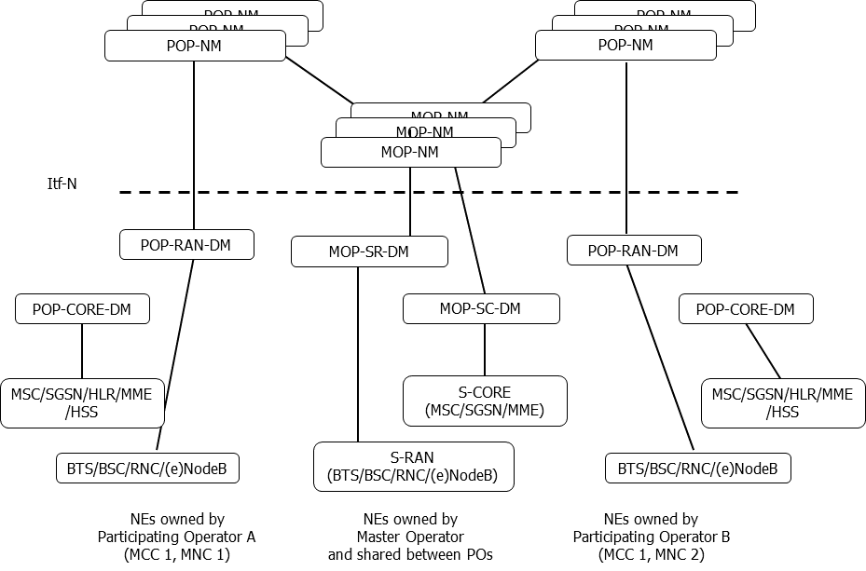

Figure 4.2-2: Management architecture for GWCN

# 5 Business level requirements

## 5.1 Requirements

### 5.1.1 Requirements for the OAM&P of shared RAN

**REQ-NS_GEN-CON-1** The **3GPP management system** of the MOP shall support a capability allowing its authorized consumer to manage S-RAN of any of the following radio access technologies:

i/ GERAN;

ii/ UTRAN;

iii/ E-UTRAN;

iV/ NG-RAN.

**REQ-NS_GEN-CON-2** The 3GPP management system of the MOP shall support a capability allowing its authorized consumer to manage S-RAN according to any of the following scenarios:

i/ Multi-Operator Core Network

ii/ Gateway Core Network.

**REQ-NS_GEN-CON-3** The 3GPP management system of the MOP shall support a capability allowing its authorized consumer to know which POPs the shared resources belong to.

**REQ-NS_GEN-CON-4** The 3GPP management system of the MOP shall support a capability allowing its authorized consumer to configure which POPs share each cell.

**REQ-NS_GEN-CON-5**  Any POP shall be able to activate a signaling-based trace / MDT session on its subscribers, whether they are attached to the POP own RAN or to the S-RAN, provided:

a/ this is compliant with the RAN sharing contract; and

b/ user consent for participation in MDT is respected.

**REQ-NS_GEN-CON-6** The MOP shall be able, on behalf of any POP, to activate an area-based trace / MDT session, on the portion of the S-RAN that the POP shares and on the POP subscribers only, from the 3GPP management system of MOP, provided

a/ only the POP related subscriber data are collected;

b/ this is compliant with the RAN sharing contract; and

c/ user consent for participation in MDT is respected.

**REQ-NS_GEN-CON-7**  The MOP shall be able, on behalf of multiple POPs, to activate an area-based trace / MDT session, on the portion of the S-RAN that each POP shares and on each POP subscribers only, from the 3GPP management system of MOP, provided:

a/ each POP has access only to its subscriber data (i.e. not to other POPs' subscriber data);

b/ this is compliant with the RAN sharing contract; and

c/ user consent for participation in MDT is respected.

### 5.1.2 Requirements for the OA&M of shared core network elements

**REQ-NS_GEN-CON-8** In theGWCNscenario, the MOP shall be able to manage **S-CORE**.

**REQ-NS_GEN-CON-9** The MOP shall be able to know which POPs the shared core network elements belong to.

**REQ-NS_GEN-CON-10** The MOP shall be able to configure which POPs share each core network element.

### 5.1.3 Requirements for the management of measurements for cross-operator accounting based on data volume and QoS

**REQ-NS_PM-CON-1** The MOP shall be able to charge the POPs for the data volume used by POP’s users per selected QoS profile criteria via measurements defined for shared networks.

- The QoS profile criteria may include QCI Indicator, GBR Indicator, ARP Indicator.

- It shall be possible to differentiate between DL and UL.

**REQ-NS_PM-CON-2** The MOP shall be able to set the reliability for the selected measurements defined for cross operator accounting purpose in shared networks.

**REQ-NS_PM-CON-3** A maximum number of 200 counter instances (for measurements defined for cross operator accounting purpose in shared networks) can be recorded per granularity period.

### 5.1.4 Requirements for management support for NG-RAN MOCN network sharing scenario with same Cell Identity broadcast

**Req-MOCN_SameCellId_Cfg-CON-1** The 3GPP management system of the MOP shall have the capability to configure NgC and NgU individually for each POP.

**Req- MOCN_SameCellId_Cfg-CON-2** The 3GPP management system of the MOP shall have the capability to configure PLMNId individually for each POP.

**Req- MOCN_SameCellId_Per-CON-3** The 3GPP management system of the MOP shall have the capability to collect and report some measurements (e.g. active UEs measurements, packet delay measurements) in PLMN granularity for each POP.

**Req-MOCN-SameCellId-Cfg-CON-4** The 3GPP management system of the MOP shall have the capability to support operator-specific configurations.

**Req-MOCN-SameCellId-Cfg-CON-5** The 3GPP management system of the MOP shall have the capability to support operator-specific performance measurement jobs.

### 5.1.5 Requirements for management support for NG-RAN MOCN network sharing scenario with multiple Cell Identity broadcast

**Req-MOCN-MultiCellId-Cfg-CON-1** The 3GPP management system of the MOP shall have the capability to configure NgC and NgU individually for each POP.

**Req-MOCN-MultiCellId-Cfg-CON-2** The 3GPP management system of the MOP shall have the capability to configure PLMN-IdentityInfo (including PLMNId, NR Cell Identity, TAC) individually for each POP.

**Req-MOCN-MultiCellId-Perf-CON-3** The 3GPP management system shall have the capability to collect and report some measurements (e.g. active UEs measurements, packet delay measurements) in PLMN granularity for each POP.

**Req-MOCN-MultiCellId-Cfg-CON-4** The 3GPP management system of the MOP shall have the capability to configure the common F1 interface for all POPs.

**Req-MOCN-MultiCellId-Cfg-CON-5** The 3GPP management system of the MOP shall have the capability to configure the individual F1 interface for each POP.

**Req-MOCN-MultiCellId-Cfg-CON-6** The 3GPP management system of the MOP shall have the capability to configure the individual NR cell relation individually for each POP.

**Req-MOCN-MultiCellId-Cfg-CON-7** The 3GPP management system of the MOP shall have the capability to support operator-specific configurations.

**Req-MOCN-MultiCellId-Cfg-CON-8** The 3GPP management system of the MOP shall have the capability to support operator-specific performance measurement jobs.

### 5.1.6 Requirements for the OAM&P of shared NG-RAN

**REQ-NS_NG-CON-1** The 3GPP management system of the MOP shall support a capability to manage both the non-shared network elements and shared network elements in a NG-RAN network at the same time.

**REQ-NS_NG-CON-2** The 3GPP management system of the MOP shall support a capability to configure the NG-RAN network element to start the sharing of one currently non-shared NG-RAN network element or stop the sharing of one currently shared NG-RAN network element.

**REQ-NS_NG-CON-3** The 3GPP management system of the MOP shall support a capability to configure the POP-specific attributes of the shared NG-RAN individually based on the POPs’ requirements.

**REQ-NS_NG-CON-4** The 3GPP management system of the MOP shall have the capability to configure the radio resources partitioning policies for the POPs based on the agreement between POPs.

**Req-MOCN-MultiCellId-Cfg-CON-5** The 3GPP management system of the MOP shall have the capability to configure the administrative state of the operator specific NR Cell DU.

## 5.2 Actor roles

For GERAN, UTRAN, and E-UTRAN:

MOP-SR-DM: An entity performing an IRPAgent role in MOCN and in GWCN.

MOP-SC-DM: An entity performing an IRPAgent role in GWCN.

MOP-NM: An entity performing the IRPManager role in MOCN and in GWCN.

For NG-RAN:

MOP-SR-DM: An entity performing the Management Service Producer role for the management of shared NG-RAN MOCN.

MOP-NM: An entity performing the Management Service Consumer role for the management of shared NG-RAN in MOCN.

## 5.3 Telecommunications resources

For MOCN and GWCN, the managed GERAN, UTRAN, E-UTRAN, NG-RAN network elements are viewed as relevant telecommunications resources in the present document.

For GWCN, MSC, SGSN and MME are viewed as relevant telecommunications resources in the present document.

## 5.4 High-level use cases

### 5.4.1 Fully pooled radio resources between two POPs

In this use case, cells are shared between POP A and POP B. As agreed by MOP and POPs in their RAN sharing agreement:

- Radio resources of the **S-RAN** are fully pooled between POP A and POP B; UEs from POP A and POP B are served in the **S-RAN** in a first come first served mode;

- MOP is responsible for configuring the **S-RAN** accordingly.

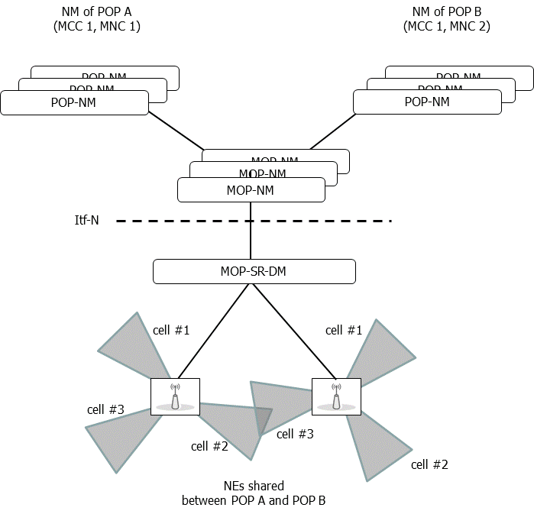

Figure 5.4.1-1: Fully pooled radio resources between two POPs

### 5.4.2 Alarm raised on a shared cell (MOCN scenario)

In this use case, an alarm is raised on cell #1 of a shared (e)NodeB. According to the RAN sharing agreement, the two POPs A and B are informed by the MOP of the occurrence of this new alarm, as well as of the alarm clearance by the MOP.

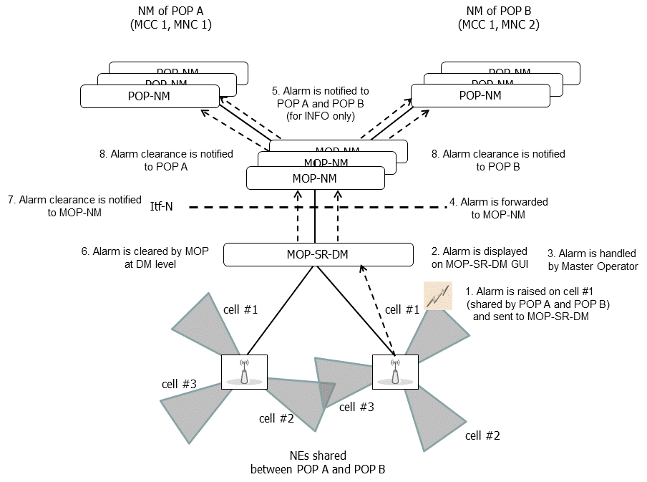

Figure 5.4.2-1. Handling of an alarm raised on a shared cell (MOCN)

### 5.4.3 Single DM for managing S-RAN and POP own RAN

In this use case, Operator A is a POP and manages its own (non-shared) NEs from its POP-RAN-DM while Operator B is both MOP and POP and manages **S-RAN** and its own (non-shared) NEs from a single DM.

Operator B has several possibilities:

Example #1: configure, NE per NE, which POPs share the cells that it manages; or

Example #2: define two separate groups of BTSs / (e)NodeBs:

- one for the **S-RAN** NEs – it shall then configure which POPs share the cells of this group of BTSs / (e)NodeBs; and

- one for its own (non-shared) RAN NEs.

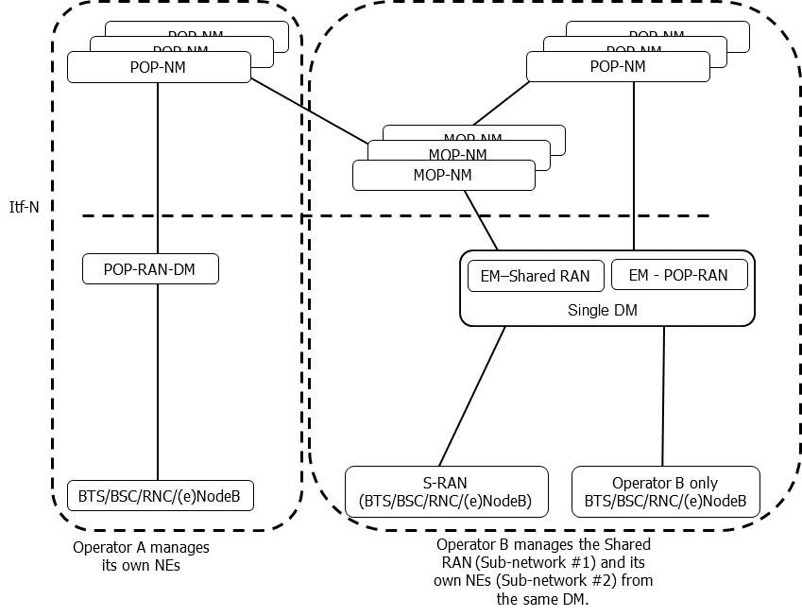

Figure 5.4.3-1: Single DM for managing both S-RAN and own RAN

### 5.4.4 Management of measurements for cross-operator accounting based on data volume and QoS

The operator has made an agreement to act as a Master Operator, MOP, for another operator (Participating Operator, POP) for RAN sharing. The agreement is regulated in an SLA, which states the following: The QoS profile criteria ARP-1 – 10 and GBR-5 for QCI-4 and QCI-8 is supported. The DL QCI-4, GBR-5, and ARP-1 – 10 is charged by x Euro per Mbit, while UL QCI-4, GBR-5, and ARP-1 – 10 is charged by y Euro per Mbit. QCI-8 is charged z Euro per Mbit regardless of QoS. For cross operator accounting purpose, the network needs to provide data volume measurements with high reliability for the used QoS profile criteria to the MOP.

### 5.4.5 Management support for the mixed deployment scenario of shared NG-RAN network elements and non-shared NG-RAN network elements

In this use case, Operator A owns and manages a NG-RAN network. Operator A and Operator B get a NG-RAN sharing agreement that Operator A will share some of the NG-RAN network elements in its NG-RAN network with Operator B. Operator A may need to configure the NG-RAN network to start the sharing of one currently non-shared NG-RAN network element or stop the sharing of one currently shared NG-RAN network element according to the requests from Operator B in the future.

### 5.4.6 Radio resources partitioning between two POPs for the shared NG-RAN

In this use case, radio access network (i.e. one of multiple shared NG-RAN network elements) are shared between two POPs (POP A identified by PLMN A, POP B identified by PLMN B).

As agreed by POP A and POP B in their RAN sharing agreement:

- Radio resources (e.g. PRB, RRC connection, DRB) of the shared radio access network are partitioned for POP A and POP B, which means the radio resource partitioning policies (e.g. RRMPolicyRatio) of the radio access network is agreed for POP A and POP B. The detailed RRMPolicy definition for NG-RAN see the clause 4.3.36 of TS 28.541 [8]. Following is one example of RRMPolicy for corresponding POP A and POP B. In this example,

- POP A has 20% dedicated radio resources, 30% prioritized resources and 50% shared resources. In this case, there are 20% radio resources are dedicated for the POP A, 30% radio resources are guaranteed for POPA when it needs to use them, and 50% resources are shared with POP B.

- POP B has 30% prioritized resources and 20% shared resources. In this case, there are 30% radio resources are guaranteed for POP B when it needs to use them, and 20% resources are shared with POP A.

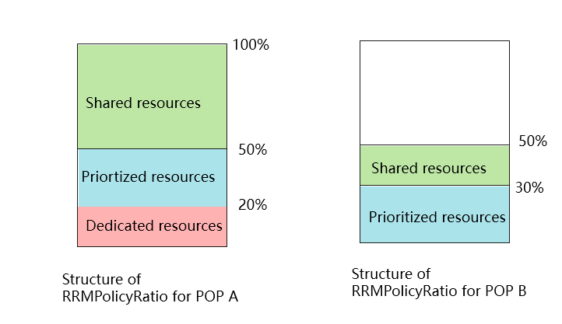

Figure 5.4.6-1 Example of structure RRMPolicy for radio access network resource partitioning for POP A and POP B

Note: If the network slicing feature is supported, the RRMPolicy is defined for each RRMPolicyMemberList which contains both PLMNId and S-NSSAI. In this case, the RRMPolicy is defined in RRMPolicyMember (combination of PLMNId and S-NSSAI) granularity.

MOP-NM (play the role of MnS consumer) obtains the radio resource partitioning policies the shared radio access network based on above agreement, and sends the radio resource partitioning policies to MOP-SR-DM (play the role of MnS prodcuer) to configure the shared NG-RAN NEs. MOP-SR-DM derives the radio resource partitioning policies for corresponding cells of each shared NG-RAN NE and configures the corresponding shared NG-RAN NE with corresponding radio resource partitioning policies for corresponding cells (see RRMPolicy defined in TS 28.541[8] which is contained by RRMPolicyManagedEntity).

MOP-SR-DM monitors the radio usage resources measurement (e.g. UL/DL PRB used for data traffic, RRC connections) for POP A and POP B, and send such radio usage resources measurements to MnS consumer. Based on the radio resources usage measurements and other information (e.g. service traffic requirements changes) for POP A and POP B, the radio resources partitioning policies may be updated based on the agreement between POP A and POP B. The MOP-NM requests the MOP-SR-DM to reconfigure the updated radio resources partitioning policies of the shared radio access network for corresponding POP A and POP B.

# 6 Specification level requirements

## 6.1 Requirements

**REQ-NS_GEN-FUN-1** The IRPAgent shall support a capability allowing the IRPManager to configure which POPs share each cell.

**REQ-NS_GEN-FUN-2** The IRPAgent shall support a capability allowing the IRPManager to know which POPs share each cell.

**REQ-NS_GEN-FUN-3** In GWCN, the IRPAgent shall support a capability allowing the IRPManager to configure which POPs share each core network element.

**REQ-NS_GEN-FUN-4** In GWCN, the IRPAgent shall support a capability allowing the IRPManager to know which POPs share each core network element.

**REQ-NS_PM-FUN-1** TheIRPAgent shall have the capability to support subscription of UL and DL data volume measurements per QoS profile criteria for cross operator accounting purpose from the IRPManager.  
The QoS profile criteria may include one or more of the following criteria: one QCI indicator, one GBR Indicator, one ARP Indicator, where:

- a QCI Indicator identifies one specific QCI value. If the indicator is not set then all QCI values should be taken into account.

- a GBR Indicator identifies one GBR range value defined by the management system. If the indicator is not set then all GBR ranges should be taken into account.

- an ARP Indicator identifies one ARP priority value. If the indicator is not set then all ARP priority values should be taken into account.

**REQ-NS_PM-FUN-2** The IRPAgent shall support the IRPManager setting the reliability for the counter instances in a measurement job. The detailed definition of reliability is vendor specific.

**REQ-NS_PM-FUN-3** The IRPAgent shall support up to a maximum number of 200 recorded counter instances per granularity period of data volume measurements for cross operator accounting purpose.

**REQ-NS_PM-FUN-4** The IRPAgent shall support the IRPManager to access a file containing data volume measurements for cross operator accounting purposes every granularity period.

## 6.2 Actor roles

See clause 5.2.

## 6.3 Telecommunications resources

See clause 5.3.

## 6.4 Use cases

### 6.4.1 Management of measurements for cross-operator accounting based on data volume and QoS

The network manager requests a measurement job for data volume measurements for shared network for charging purposes with high reliability, for a subset of data volume counters per shared PLMN, per UL/DL traffic direction and per QoS profile criteria. The QoS profile criteria may include one or more of the following criteria: one QCI Indicator, one GBR Indicator, one ARP Indicator, where:

- a QCI Indicator identifies one specific QCI value. QCI values range from 0 to 255. If the indicator is not set then all QCI values should be taken into account.

- a GBR Indicator identifies one GBR range value defined by the management system. GBR range values can range from 1 to N, where N is bigger than 1 (e.g. N=5). If the indicator is not set then all GBR ranges should be taken into account.

- an ARP Indicator identifies one ARP priority value. ARP priority values range from 1 to 15. If the indicator is not set then all ARP priority values should be taken into account.

An overall maximum number of 200 counter instances (measurement instances) can be recorded per granularity period.

The measurement type is specified by sub-clause 4.1.9 in TS 36.314 [6].  
All the counters instances in the measurement job should be subject to high reliability as it is for cross operator accounting purpose. The detailed definition of reliability is vendor specific.

The network provides the counters each granularity period.

# 7 Management workflows for requirements for the management of the shared NG-RAN NE(s) in MOCN network sharing scenario

## 7.1 Management of the shared NG-RAN NE(s) in MOCN network sharing scenario with the same cell Identity broadcast

The NG-RAN MOCN Network Sharing with same cell identity broadcast scenario is illustrated in Figure 4.1-2 and corresponding requirements is defined in clause 5.1.4. This clause describes the workflows for the management of the shared NG-RAN NE(s) in MOCN network sharing scenario with the same cell identity broadcast.

In this workflow, the radio access network (i.e. one or multiple shared NG-RAN NE(s)) is shared between two POPs (POP A identified by PLMN#1and POP B identified by PLMN#2). Both MnS consumer and MnS producer for the management of shared NG-RAN NE(s) belong to MOP.For the **Req-MOCN_SameCellId_Cfg-CON-1:**

MnS consumer determines the individual EP_NgC MOI and EP_NgU MOI (see the attributes of NgC and NgU in TS 28.541[X]) for each POP (POP A and POP B), and requests MnS producer to create and configure EP_NgC MOI and EP_NgU MOI for each POP.

MnS producer creates and configures the EP_NgC MOI and EP_NgU MOI for each POP based on the requests from MnS consumer. The EP_NgC MOI and EP_NgU MOI are name containe by same GNBCUCPFunction MOI and GNBCUUPFunction MOI which is shared for different POPs.

For the **Req- MOCN_SameCellId_Cfg-CON-2**:

MnS consumer determines the attribute "PLMNInfoList" in NRCellDU MOI and NRCellCU MOI (see the attribute definition in TS 28.541[X]), which includes the PLMN#1 and PLMN#2, and requests MnS producer to configure NRCellDU MOI and NRCellCU MOI with attribute "PLMNInfoList".

MnS producer configures the NG-RAN NE(s) (i.e. subtree of ManagedElement MOI) based on the requests from MnS consumer, including configuring the NRCellDU MOI and NRCellCU MOIwith attribute "PLMNInfoList" to include PLMN#1 and PLMN#2.

For the **Req- MOCN_SameCellId_Per-CON-3:**

MnS producer collects the individual measurements for POP A and POP B in PLMN granularity by utilizing PLMN granularity subcounter. For the concrete PLMN granularity measurements, see TS 28.552[9].

MnS producer sends the individual measurements for POP A and POP B in PLMN granularity to MnS consumer.

## 7.2 Management of the shared NG-RAN NE(s) in MOCN network sharing scenario with the multiple cell Identity broadcast

The NG-RAN MOCN Network Sharing with multiple cell identity broadcast scenario is illustrated in Figure 4.1-3 and corresponding requirements is defined in clause 5.1.5. This clause describes the workflows for the management of the shared NG-RAN NE(s) in MOCN network sharing scenario with the muliple cell identity broadcast.

In this workflow, the radio access network (i.e. one or multiple shared NG-RAN NE(s)) is shared between two POPs (POP A identified by PLMN#1and POP B identified by PLMN#2). Both MnS consumer and MnS producer for the management of shared NG-RAN NE(s) belong to MOP.

For the **Req-MOCN-MultiCellId-Cfg-CON-1:**

MnS consumer determines the individual EP_NgC MOI and EP_NgU MOI (see the attributes of NgC and NgU in TS 28.541[8]) for each POP (POP A and POP B), and requests MnS producer to create and configure EP_NgC MOI and EP_NgU MOI for each POP.

MnS producer creates and configures the EP_NgC MOI and EP_NgU MOI for each POP based on the requests from MnS consumer. The EP_NgC MOI and EP_NgU MOI are name containe by corresponding POP's GNBCUCPFunction MOI and GNBCUUPFunction MOI.

For the **Req-MOCN-MultiCellId-Cfg-CON-2**

MnS consumer determines the individual OperatorDU MOI and NROperatorCellDU MOI (see the attributes of OperatorDU and NROperatorCellDU in TS 28.541[8]) for each POP (POP A and POP B), and requests MnS producer to create and configure OperatorDU MOI and NROperatorCellDU MOI for each POP.

MnS producer configures the NG-RAN NE(s) (i.e. subtree of ManagedElement) based on the requests from MnS consumer, including creates and configures OperatorDU and NROperatorCellDU MOI for each POP.

MnS consumer determines the individual NRCellCU MOI (see the attributes of NRCellCU in TS 28.541[8]) for each POP (POP A and POP B), and requests MnS producer to create and configure NRCellCU MOI for each POP.

MnS producer configures the NG-RAN NE(s) (i.e. subtree of ManagedElement) based on the requests from MnS consumer, including creates and configures NRCellCU MOI for each POP.

For the **Req-MOCN-MultiCellId-Cfg-CON-3**

MnS producer collects the individual measurements for POP A and POP B in PLMN granularity by utilizing PLMN granularity subcounter or associated with OperatorDU and NROperatorCellDU. For the concrete PLMN granularity measurements, see TS 28.552[9].

MnS producer sends the individual measurements for POP A and POP B in PLMN granularity to MnS consumer.

For the **Req-MOCN-MultiCellId-Cfg-CON-4** and **Req-MOCN-MultiCellId-Cfg-CON-5**

MnS consumer determines the individual EP_F1C MOI and EP_F1U MOI (see corresponding attributes in TS 28.541[8]) for each POP (POP A and POP B), and requests MnS producer to create and configure these MOIs for each POP. In case of common F1 intertface configuration, the values of the EP_F1C MOI and EP_F1U MOI attributes (including localAddress and remoteAddress) contained by different POP's OperatorDU MOI of the same GNBDUFunction MOI should be same.

MnS producer creates and configures the individual EP_F1C MOI and EP_F1U MOI for each POP based on the requests from MnS consumer. The EP_F1C MOI and EP_F1U MOI are name contained by corresponding POP's OperatorDU and associated to it's own GNBCUCPFunction MOI and GNBCUUPFunction MOI.

For the **Req-MOCN-MultiCellId-Cfg-CON-6**

MnS consumer determines the NRCellRelation MOI(s) (see corresponding attributes in TS 28.541[8]) for each POP (POP A and POP B), and requests MnS producer to create and configure NRCellRelation MOI(s) for each POP.

MnS producer configures the NG-RAN NE(s) (i.e. subtree of ManagedElement) based on the requests from MnS consumer, including creates and configures the individual NRCellRelation MOI for each POP.

Annex A (informative):  
Network sharing agreement

Prior to any network sharing deployment, the MOP and the POPs have to agree on legal, financial, technical and operational aspects. Among operational aspects, the network sharing agreement captures the following (non-exhaustive list):

- Organizations involved (i.e. Operators) and their roles in the network sharing deployment.

- Exhaustive list of shared and unshared resources in the shared network.

- Rights attached to each role (e.g. rights to configure network resources, rights to receive alarms, etc.).

- Duties attached to each role (e.g. obligation for the MOP to provide POPs with monthly KPIs, etc.).

- Delegations (if any) given by any organization to another organization.

- Service Level Agreements (SLAs).

Annex B (informative):  
Change history

|  |  |  |  |  |  |  |  |
| --- | --- | --- | --- | --- | --- | --- | --- |
| **Change history** | | | | | | | |
| **Date** | **TSG #** | **TSG Doc.** | **CR** | **Rev** | **Subject/Comment** | **Old** | **New** |
| 2014-12 | SA#66 | SP-140795 |  |  | Presented for approval | 1.2.0 | 2.0.0 |
| 2014-12 |  |  |  |  | Version after approval | 2.0.0 | 12.0.0 |
| 2016-01 | - | - | - | - | Update to Rel-13 version (MCC) | 12.0.0 | **13.0.0** |

|  |  |  |  |  |  |  |  |
| --- | --- | --- | --- | --- | --- | --- | --- |
| **Change history** | | | | | | | |
| **Date** | **Meeting** | **TDoc** | **CR** | **Rev** | **Cat** | **Subject/Comment** | **New version** |
| 2016-12 | SA#74 | SP-160856 | 0001 | 2 | B | Add use cases and requirements for Management of measurements for cross-operator accounting based on data volume and QoS | 14.0.0 |
| 2018-01 | SA#78 | SP-170964 | 0002 | - | F | Correcting requirements tags | 14.1.0 |
| 2018-06 | - | - | - | - | - | Update to Rel-15 version (MCC) | 15.0.0 |
| 2020-07 | - | - | - | - | - | Update to Rel-16 version (MCC) | 16.0.0 |
| 2021-03 | SA#91e | SP-210141 | 0003 | 1 | B | Update the scope and background of network sharing scenarios | 17.0.0 |
| 2021-03 | SA#91e | SP-210141 | 0006 | 1 | B | Update the business requirements to support NG-RAN sharing | 17.0.0 |
| 2021-03 | SA#91e | SP-210141 | 0009 | 1 | B | Update business requirements to applicable for SBMA | 17.0.0 |
| 2021-06 | SA#92e | SP-210415 | 0011 | - | B | Add requirememts for management support for 5G MOCN network sharing scenario with same Cell Identity | 17.1.0 |
| 2021-06 | SA#92e | SP-210415 | 0012 | 1 | B | Add requirememts for management support for 5G MOCN network sharing scenario with multiple Cell Identity | 17.1.0 |
| 2021-06 | SA#92e | SP-210415 | 0013 | 1 | B | Add mixed NG-RAN sharing use case and requirements | 17.1.0 |
| 2021-09 | SA#93e | SP-210877 | 0014 | 2 | B | Add NG-RAN sharing individual management use case and requirements | 17.2.0 |
| 2021-12 | SA#94e | SP-211471 | 0015 | - | B | Update RAN sharing scenarios to cover 5G RAN sharing | 17.3.0 |
| 2021-12 | SA#94e | SP-211471 | 0016 | - | B | Update RAN sharing scenarios to cover 5G RAN sharing | 17.3.0 |
| 2022-03 | SA#95e | SP-220184 | 0017 | - | F | Clean up on concept and business level requirements | 17.4.0 |
| 2022-03 | SA#95e | SP-220184 | 0018 | - | B | Add missing use case and requirements for radio resources partitioning between POPs | 17.4.0 |
| 2022-03 | SA#95e | SP-220184 | 0019 | 1 | B | Solution description for the requirements for the management of the shared NG-RAN NE(s) in MOCN network sharing scenario | 17.4.0 |
| 2022-03 | SA#95e | SP-220184 | 0020 | - | B | Add requirement about administrative management capability for operator specific cell | 17.4.0 |
| 2022-12 | SA#98e | SP-221168 | 0022 | - | F | delete redundant figure | 17.5.0 |
| 2023-03 | SA#99 | SP-230196 | 0023 | - | F | correct the wrong figure number | 17.6.0 |
| 2023-09 | SA#101 | SP-230966 | 0024 | 1 | B | Add new requirements for management support for NG-RAN MOCN network sharing scenario | 18.0.0 |
| 2023-12 | SA#102 | SP-231494 | 0026 | - | B | Rel-18 CR TS 32.130 Add requirements for NG-RAN MOCN network sharing scenario with multiple Cell Identity broadcast | 18.1.0 |