|  |  |
| --- | --- |
| 3GPP TR 33.896 V18.0.1 (2023-06) | |
| Technical Report | |
| 3rd Generation Partnership Project;  Technical Specification Group Services and System Aspects;  Study of security aspects on user consent for 3GPP services phase 2  (Release 18) | |
|  | |
|  |  |
|  | |
| The present document has been developed within the 3rd Generation Partnership Project (3GPP TM) and may be further elaborated for the purposes of 3GPP. The present document has not been subject to any approval process by the 3GPPOrganizational Partners and shall not be implemented. This Specification is provided for future development work within 3GPPonly. The Organizational Partners accept no liability for any use of this Specification. Specifications and Reports for implementation of the 3GPP TM system should be obtained via the 3GPP Organizational Partners' Publications Offices. | |

|  |
| --- |
|  |
| ***3GPP***  Postal address  3GPP support office address  650 Route des Lucioles - Sophia Antipolis  Valbonne - FRANCE  Tel.: +33 4 92 94 42 00 Fax: +33 4 93 65 47 16  Internet  http://www.3gpp.org |
| ***Copyright Notification***  No part may be reproduced except as authorized by written permission. The copyright and the foregoing restriction extend to reproduction in all media.  © 2023, 3GPP Organizational Partners (ARIB, ATIS, CCSA, ETSI, TSDSI, TTA, TTC).  All rights reserved.  UMTS™ is a Trade Mark of ETSI registered for the benefit of its members  3GPP™ is a Trade Mark of ETSI registered for the benefit of its Members and of the 3GPP Organizational Partners LTE™ is a Trade Mark of ETSI registered for the benefit of its Members and of the 3GPP Organizational Partners  GSM® and the GSM logo are registered and owned by the GSM Association |

Contents

Foreword 4

1 Scope 6

2 References 6

3 Definitions of terms, symbols and abbreviations 6

3.1 Terms 6

3.2 Symbols 7

3.3 Abbreviations 7

4 Overview 7

5 Key issues 7

5.1 Key Issue #1: User consent for roaming case in eNA 7

5.1.1 Key issue details 7

5.1.2 Security threats 7

5.1.3 Potential security requirements 7

5.2 Key Issue #2: User consent for NTN 8

5.2.1 Key issue details 8

5.2.2 Security threats 8

5.2.3 Potential security requirements 8

5.3 Key Issue #3: Unified framework for user consent related data retrieval, notification, and revocation 8

5.3.1 Key issue details 8

5.3.2 Security threats 8

5.3.3 Potential security requirements 8

5.4 Key Issue #4: Guidance for Enforcing User Consent 9

5.4.1 Key issue details 9

5.4.2 Security threats 9

5.4.3 Potential security requirements 9

6 Solutions 9

6.1 Mapping of solutions to key issues 9

6.1 Solution #1: User consent obtained by the NTN-RAN in non-mobility use case 9

6.1.1 Introduction 9

6.1.2 Solution details 10

6.2 Solution #2: User consent revocation obtained by the NTN-RAN 11

6.2.1 Introduction 11

6.2.2 Solution details 11

6.3 Solution #3: User Consent for UE Data Exposure to HPLMN in the Roaming case 13

6.3.1 Introduction 13

6.3.2 Solution details 13

6.3.3 Evaluation 14

6.4 Solution #4: User Consent for UE Data Exposure to VPLMN in the Roaming case 15

6.4.1 Introduction 15

6.4.2 Solution details 15

6.4.3 Evaluation 16

6.5 Solution #5: Central authorization for user consent handling 16

6.5.1 Introduction 16

6.5.2 Solution details 16

6.5.3 Evaluation 16

7 Conclusions 16

7.1 Conclusion for Key Issue #1 16

7.2 Conclusion for Key Issue #2 17

7.3 Conclusion for Key Issue #3 17

Annex A: Change history 18

# Foreword

This Technical Report has been produced by the 3rd Generation Partnership Project (3GPP).

The contents of the present document are subject to continuing work within the TSG and may change following formal TSG approval. Should the TSG modify the contents of the present document, it will be re-released by the TSG with an identifying change of release date and an increase in version number as follows:

Version x.y.z

where:

x the first digit:

1 presented to TSG for information;

2 presented to TSG for approval;

3 or greater indicates TSG approved document under change control.

y the second digit is incremented for all changes of substance, i.e. technical enhancements, corrections, updates, etc.

z the third digit is incremented when editorial only changes have been incorporated in the document.

In the present document, modal verbs have the following meanings:

**shall** indicates a mandatory requirement to do something

**shall not** indicates an interdiction (prohibition) to do something

The constructions "shall" and "shall not" are confined to the context of normative provisions, and do not appear in Technical Reports.

The constructions "must" and "must not" are not used as substitutes for "shall" and "shall not". Their use is avoided insofar as possible, and they are not used in a normative context except in a direct citation from an external, referenced, non-3GPP document, or so as to maintain continuity of style when extending or modifying the provisions of such a referenced document.

**should** indicates a recommendation to do something

**should not** indicates a recommendation not to do something

**may** indicates permission to do something

**need not** indicates permission not to do something

The construction "may not" is ambiguous and is not used in normative elements. The unambiguous constructions "might not" or "shall not" are used instead, depending upon the meaning intended.

**can** indicates that something is possible

**cannot** indicates that something is impossible

The constructions "can" and "cannot" are not substitutes for "may" and "need not".

**will** indicates that something is certain or expected to happen as a result of action taken by an agency the behaviour of which is outside the scope of the present document

**will not** indicates that something is certain or expected not to happen as a result of action taken by an agency the behaviour of which is outside the scope of the present document

**might** indicates a likelihood that something will happen as a result of action taken by some agency the behaviour of which is outside the scope of the present document

**might not** indicates a likelihood that something will not happen as a result of action taken by some agency the behaviour of which is outside the scope of the present document

In addition:

**is** (or any other verb in the indicative mood) indicates a statement of fact

**is not** (or any other negative verb in the indicative mood) indicates a statement of fact

The constructions "is" and "is not" do not indicate requirements.

# 1 Scope

The present document is to investigate potential enhancements of 5GS that would enable broader use cases in relation with user consent.

The following aspects are in the scope of the study:

1. Investigating the potential issues and solutions with user consent for:

- eNA in case of roaming.

- MEC in case of roaming.

- NTN.

- AI/ML for NG-RAN.

2. Investigating the potential generic security requirements, services and guidance for user consent derived from objective 1.

NOTE 1: Principles, regulations, and definitions related to privacy, which are recognized differently in each different country or area, are taken into account when deriving the concept of user consent for 3GPP users.

Even where solutions exist to obtain user consent, collection and exposure of user sensitive data should be minimized and identification of the users should only be allowed where critical to the operation of the related feature.

# 2 References

The following documents contain provisions which, through reference in this text, constitute provisions of the present document.

- References are either specific (identified by date of publication, edition number, version number, etc.) or non‑specific.

- For a specific reference, subsequent revisions do not apply.

- For a non-specific reference, the latest version applies. In the case of a reference to a 3GPP document (including a GSM document), a non-specific reference implicitly refers to the latest version of that document *in the same Release as the present document*.

[1] 3GPP TR 21.905: "Vocabulary for 3GPP Specifications".

[2] 3GPP TR 23.700-81: "Study of Enablers for Network Automation for 5G System (5GS); Phase 3".

[3] 3GPP TS 33.501: "Security architecture and procedures for 5G system".

[4] 3GPP TS 23.501: "System architecture for the 5G System (5GS)".

[5] 3GPP TS 38.300: "NR; NR and NG-RAN Overall Description".

[6] 3GPP TR 33.867: "Study on User Consent for 3GPP services".

# 3 Definitions of terms, symbols and abbreviations

## 3.1 Terms

For the purposes of the present document, the terms given in TR 21.905 [1] and the following apply. A term defined in the present document takes precedence over the definition of the same term, if any, in TR 21.905 [1].

## 3.2 Symbols

Void.

## 3.3 Abbreviations

For the purposes of the present document, the abbreviations given in TR 21.905 [1] and the following apply. An abbreviation defined in the present document takes precedence over the definition of the same abbreviation, if any, in TR 21.905 [1].

# 4 Overview

Concept of user consent and some of background information are depicted in clause 4 in TR 33.867 [6].

In TS 33.501 [3]. The framework includes storage requirements for the UDM as well as generic services for user consent check and revocation. For any such feature, the framework requires the identification, in the standards, of a special NF called the user consent enforcement entity.

However, the case that the enforcement entity and UDM belong to different legal domains, i.e. subject to different regulations, has not been considered so far.

All the user consent work performed in Rel-17 pertains to CN and CN related features.

# 5 Key issues

## 5.1 Key Issue #1: User consent for roaming case in eNA

### 5.1.1 Key issue details

As depicted in key issue #3 in TR 23.700-81 [2], "In roaming scenario, the HPLMN/VPLMN may need to collect data or consume analytics from the VPLMN/HPLMN." In this case, the user data may be exchanged between different entity, i.e. VPLMN and HPLMN, that may be subject to different regulations with respect to user consent.

When it comes to the actions performed on the user data, the following cases need to be considered:

- HPLMN collects user data and exposes the data to VPLMN, VPLMN performs analytics and ML training.

- VPLMN collects user data and exposes the data to HPLMN, HPLMN performs analytics and ML training.

In order to cover these scenarios, it is important to assess the current user consent framework in Annex V in TS 33.501 [3], and decides who will perform the role of enforcement point.

### 5.1.2 Security threats

If the HPLMN/VPLMN is not aware to check user consent for roaming case for eNA, e.g. data analysis or ML training, the HPLMN/VPLMN may expose user privacy information to VPLMN/HPLMN which could lead to a compromise of the user privacy.

If the HPLMN/VPLMN is not aware to revoke user consent for roaming case for eNA, the HPLMN/VPLMN may continue to process user privacy information which could lead to a compromise of user privacy.

### 5.1.3 Potential security requirements

The 5GS shall provide the means for a HPLMN/VPLMN to check of user consent for the roaming scenario in eNA.

The 5GS shall provide the means for HPLMN/VPLMN to revoke of user consent for the roaming scenario in eNA.

NOTE: Cross-PLMN data sharing among different countries is not addressed in the present document.

## 5.2 Key Issue #2: User consent for NTN

### 5.2.1 Key issue details

NTN scenario is specified in clause 5.4.11 of TS 23.501 [4] and clause 16.14 of TS 38.300 [5]. For this scenario, the NG-RAN in NTN may require UE's location information for selecting the AMF.

The way it works now is that after AS security is activated, the NG-RAN in NTN can request the UE to report its accurate location or coarse location. However, for both types of location reports obtaining, user consent aspect is missing.

This key issue is intended to study whether there is any need to enhance the current user consent framework specified in Annex V in TS 33.501 [3] in order to support the NTN feature.

### 5.2.2 Security threats

If the NG-RAN in NTN is not aware of user consent status, then the NG-RAN in NTN may collect user's location information without consent which could lead to a compromise of the user privacy.

If the NG-RAN in NTN is not aware that user consent for NTN use case has been revoked, then the NG-RAN in NTN may continue to collect user's location information which could lead to a compromise of user privacy.

### 5.2.3 Potential security requirements

The network should take into account the user consent for NTN usage when user subscribes to NTN services considering NTN regulatory requirements.

NOTE: Proposed solutions should consider current solutions with the actual communication flow.

## 5.3 Key Issue #3: Unified framework for user consent related data retrieval, notification, and revocation

### 5.3.1 Key issue details

User consent is stored in the UDM/UDR. All NFs/AFs need to retrieve the consent flag from the UDM and accordingly collect the data from a UE or UE related data from other NFs. However, not all NFs/AFs do contact UDM before collecting data.

For example, AF does not interact with UDM before collecting the data related to a UE. Even if AF interacts with UDM for the user consent, then AF collects data via AMF, therefore AMF also needs to coordinate with UDM before collecting data from a UE or UE related data from other NFs. This means, that the same consent checking is necessary at multiple places/NFs. Furthermore, keeping track of revocation and which NF has received which UE-related user consent details seems to become tedious. TS 33.501 [3] clause V.2 states that user consent revocation service is not provided by UDM.

This key issue looks into the benefits of a unified framework such as a central function or a service for coordinating and keeping track of user consent retrieval, notification, and revocation.

### 5.3.2 Security threats

When user consent needs to get revoked, all NFs/AFs that have asked for user data beforehand need to revoke them. Otherwise, there is the danger that some NFs/AFs are not tracked and thus not informed about the revocation demand. This can result in accessing user-related data by NFs/AFs even after revocation by the user.

### 5.3.3 Potential security requirements

In addition to the requirements listed in TS 33.501 [3] clauses V.1 and V.4:

The 5GS shall ensure that all NFs/AFs that collected user consent related data are notified.

## 5.4 Key Issue #4: Guidance for Enforcing User Consent

### 5.4.1 Key issue details

As depicted in Annex V.1.1 in TS 33.501 [3], "user consent can be required for 3GPP features depending on local regulations." It means that user consent check and revocation procedure for different 3GPP features is conditional and configurable based on operator's local policy which considers local regulation.

However, there is no guidance to determine for what information user consent is required and for what information user consent is not required, or how to enforce user consent, it may be helpful to provide some general principles for these purposes.

### 5.4.2 Security threats

Not applicable.

### 5.4.3 Potential security requirements

Not applicable.

# 6 Solutions

## 6.1 Mapping of solutions to key issues

Table 6.1-1: Mapping of solutions to key issues

|  |  |  |  |  |
| --- | --- | --- | --- | --- |
| Solutions | KI#1 | KI#2 | KI#3 | KI#4 |
| **Solution#1: User consent obtained by the NTN-RAN in non-mobility use case** |  | X |  |  |
| **Solution #2: User consent revocation obtained by the NTN-RAN** |  | X |  |  |
| **Solution #3: User Consent for UE Data Exposure to HPLMN in the Roaming case** | X |  |  |  |
| **Solution #4: User Consent for UE Data Exposure to VPLMN in the Roaming case** | X |  |  |  |
| **Solution #5: Central authorization for user consent handling** |  |  | X |  |

## 6.1 Solution #1: User consent obtained by the NTN-RAN in non-mobility use case

### 6.1.1 Introduction

This solution addresses the Key Issue #2 on NTN specific user consent. Specifically, it addresses the first requirement in KI#2.

In NTN use case, the network function requiring user consent is the NTN-RAN, which needs to obtain user consent for configuring the UE to report its GNSS-based information and processing the UE location information. By referring to TS 33.501 [3] Annex V, the NTN-RAN is the enforcement point for user consent which does not perform the related operation unless user consent is granted.

According to TS 33.501 [3] Annex V.2, the parameters indicating user consent preference are stored in the UDM as subscription data, which can be retrieved via UDM service for network function to check whether user consent is granted for the requested operation or not. Specifically for NTN use case, it is proposed that user consent preference for a UE can be stored in a UE NTN privacy profile as part of UE subscription data in the UDM/UDR. The user consent preference within the UE NTN privacy profile can be used to indicate whether the configuration on the UE performed by the NTN-RAN is allowed or disallowed.

### 6.1.2 Solution details

Given that the use of user consent information at the NTN-RAN in NTN could allow its enforcement at the earliest RAN convenience, it is proposed that the user consent information is provisioned by the UDM at the earliest possibility to the AMF, i.e. during Registration procedure, which could be "initial registration", "periodic registration update" or "mobility registration update" procedure, etc. The AMF can store the received user consent preference in the UE context, which further provisions the user consent preference to the NTN-RAN.



Figure 6.1.2-1: NTN Specific User Consent in Non-mobility Case

1. The UE sends the Registration Request to the NTN-RAN (gNB or NTN-GW) including its SUCI or 5G-GUTI.

2. The NTN-RAN selects an AMF for the UE and sends to the AMF a N2 message (e.g. Initial UE Message) containing N2 parameters in addition to the Registration Request. The N2 message also includes a UE Context Request indicating that the user consent preference on UE location information for NTN access is needed or to be updated.

3. Based on the N2 message from the NTN-RAN, the AMF determines that the RAT type is NTN access. If the received N2 message contains a UE Context Request requesting the user consent preference, the AMF checks whether its stored UE context already contains the user consent preference of the UE for NTN access by checking against the SUCI or 5G-GUTI. If the user consent preference of the UE is not available in the UE context or the validity timer for user consent preference has expired, the AMF proceeds to step 4. Otherwise, the AMF proceeds to step 8.

4. The AMF sends a Nudm_SDM_Get request to the UDM for retrieving the user consent preference on UE location information for NTN access from the UE's subscription data.

5. After receiving the Nudm_SDM_Get request, the UDM checks with the UDR for the user consent preference on location information for NTN access, probably within the NTN privacy profile of the UE's subscription data, against the SUPI of the UE.

6. The UDM sends a Nudm_SDM_Get response to the AMF containing the user consent preference on UE location information for NTN access.

7. After receiving the Nudm_SDM_Get response, the AMF stores the user consent preference in the UE context, or replaces its stored user consent preference with the one received from the UDM. The AMF forwards the user consent preference to the NTN-RAN.

8. The AMF sends a N2 message (e.g. Initial Context Setup Request) to the NTN-RAN, which includes user consent result or user consent preference for NTN access in addition to the Registration Accept.

9. After receiving the N2 message, the NTN-RAN stores the user consent result or user consent preference in its UE context. Based on the received user consent result/preference, the NTN-RAN determines how to enforce the user consent, either using *RRCReconfiguration* message in (in step #10) or using *UEInformationRequest* message (in step #14).

10. The NTN-RAN sends the RRCReconfiguration message () to the UE. If the user consent is granted for location reporting and the NTN-RAN decides to request UE location using *RRCReconfiguration* message, the RRCReconfiguration message also contains location configuration info (e.g. via *includeCommonLocationInfo* in the *reportConfig*); if the use consent is not granted for location reporting, the NTN-RAN does not send such configuration.

11. The UE sends the RRCReconfigurationComplete message to the NTN-RAN.

12. The NTN-RAN sends a N2 message (e.g. Initial Context Setup Response) to the AMF.

13. The UE sends the Registration Complete message to the NTN-RAN.

14. If the user consent is granted for location reporting and the NTN-RAN decides to request UE location using *UEInformationRequest* message, the NTN-RAN contains *coarseLocationRequest* in the *UEInformationRequest* message sent to the UE.

15. The UE returns *coarseLocationInfo* in the *UEInformationResponse* message sent to the NTN-RAN.

NOTE: The granularity of user consent preference could be detailed in the UE privacy profile for NTN in the UE subscription.

## 6.2 Solution #2: User consent revocation obtained by the NTN-RAN

### 6.2.1 Introduction

This solution addresses the Key Issue #2 on NTN specific user consent. Specifically, it addresses the second requirement in KI#2.

As per TS 33.501 [3] Annex V, besides the retrieval of user consent parameters, the notification of user consent parameters change or user consent revocation shall also be supported for user consent mechanism. Any 5GC consumer NFs (processing the data pertaining to user consent) shall subscribe to the UDM for user consent parameter change notification, except if the consent enforcement NF that is deemed an enforcement point is tracking of those NFs and is actively informing those consumer NFs in case of user consent revocation.

The solution is introduced for NTN-RAN to obtain user consent parameters change or user consent revocation in NTN use case, so as to protect the user privacy while user consent is updated or revoked.

### 6.2.2 Solution details

In NTN use case, the enforcement point of user consent is not a 5GC NF but the NTN-RAN, which is informed of the user consent status by the 5GC NF, i.e. the AMF in this case. As the AMF is able to track multiple NTN-RANs within the tracking area it covers, this solution proposes that the AMF subscribes to the UDM for user consent parameter change notification or revocation notification, which then informs the NTN-RAN at which the UE is camped.



Figure 6.2.2-1: NTN Specific User Consent Revocation Procedure

1. The AMF subscribes to the UDM for the service of user consent update and/or revocation notification via Nudm_SDM_Subscribe service operation. The service could be subscribed for a specific UE or it could be a generic service subscription for all UEs.

2. The user consent parameters are updated or revoked in the subscription data during the related procedure between a specific UE and the UDM.

3. The UDM retrieves the AMF ID serving the UE and notifies the AMF about the user consent parameter change via Nudm_SDM_Notification service operation. The user consent parameter change is associated with the UE by indicating the UE ID, i.e. SUPI. The user consent parameter change may also contain the NTN-RAN ID which is affected by the change, e.g. the NTN-RAN which was allowed to obtain UE location before it is no longer allowed.

4. Upon receiving the notification from the UDM, the AMF updates the user consent parameters in its locally stored UE context associated with the SUPI.

5. The AMF sends a N2 message to the NTN-RAN including, e.g. UE Context Modification Request, which contains the user consent parameter change. The AMF associates the user consent parameter change with a temporary UE ID, e.g. 5G GUTI.

6. Upon receiving the N2 message from the AMF, the NTN-RAN updates the user consent parameters in its locally stored UE context associated with a temporary UE ID, e.g. I-RNTI. The NTN-RAN then determines how to enforce the updated/revoked user consent. If the NTN-RAN has previously sent *UEInformationRequest* message to request UE location, the NTN-RAN stores the updated user consent parameters to stop including *coarseLoactionRequest* in the next *UEInformationRequest* message and proceeds to step #10. If the NTN-RAN has previously configured the UE to periodically report its location using *RRCReconfiguration* message, the NTN-RAN proceeds to step #7.

7. Based on the updated user consent parameters, the NG-RAN determines the configuration and sends the RRCReconfiguration message to the UE. If the user consent is revoked, the NG-RAN does NOT send the configuration (e.g. includeCommonLocationInfo in the reportConfig) so as to prevent the UE from reporting its location.

8. Upon receiving the RRCReconfiguration message without the configuration for location reporting, the UE stops reporting its location.

9. The UE sends the RRCReconfigurationComplete message to the NTN-RAN.

10. The NTN-RAN sends a N2 message to the AMF including e.g. UE Context Modification Response.2. The NTN-RAN selects an AMF for the UE and sends to the AMF a N2 message (e.g. Initial UE Message) containing N2 parameters in addition to the Registration Request. The N2 message also includes a UE Context Request indicating that the user consent preference on UE location information for NTN access is needed or to be updated.

## 6.3 Solution #3: User Consent for UE Data Exposure to HPLMN in the Roaming case

### 6.3.1 Introduction

The solution addresses Key Issue #1: User consent for roaming case in eNA. It aims to meet two potential requirements in Key issue #1 regarding checking of user consent and revocation of user consent for the roaming scenario in eNA.

As per TR 23.700-81 [2], both PLMNs (VPLMN, HPLMN) need the ability to control the amount of UE data exposed based on user consent, operator policy, regulatory policy and/or roaming agreements. If the Consumer NF in the HPLMN requests the data collection or data analytics from the VPLMN, the V-Central NF will perform the role of enforcement point and determine whether the requested collected data and analytics information can be exposed to HPLMN.

As the enforcement point, the V-Central NF will send the notification message to the Consumer NF and Data Provider NF once the user consent is modified or revoked. After receiving the notification message, the Consumer NF deletes the data or stops the data processing for which prior user consent was given, the Data Provider NF stops to collect data or generate analytics information.

### 6.3.2 Solution details

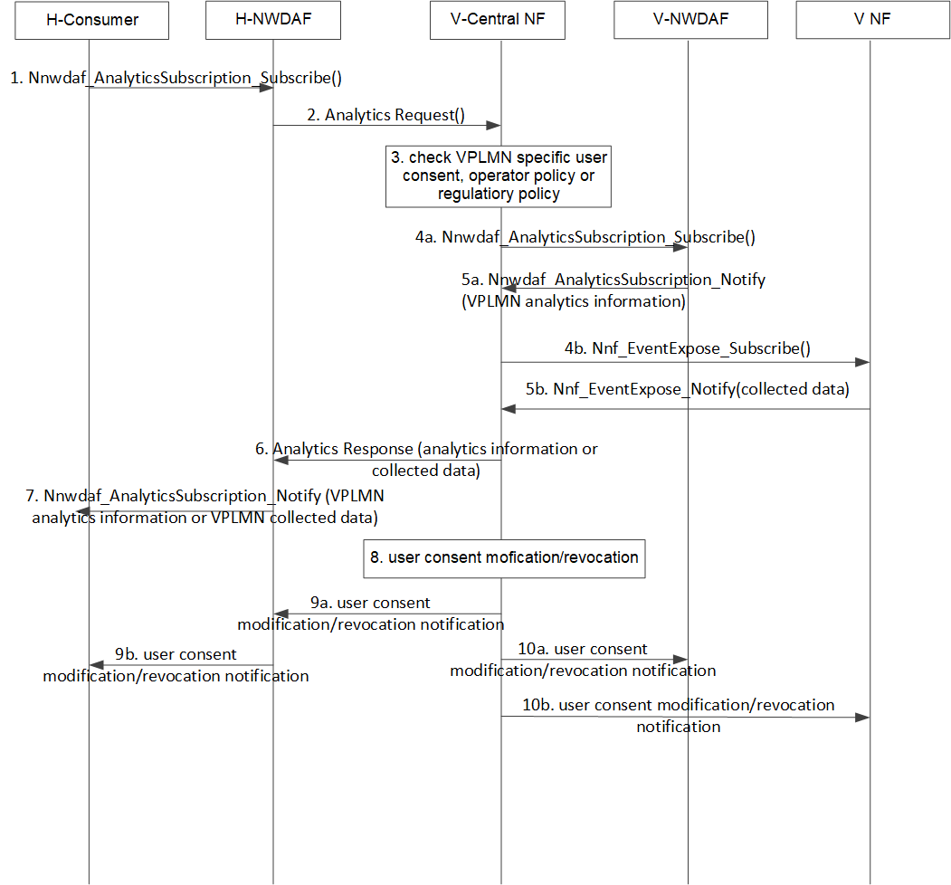

Figure 6.2.3-1: User Consent for UE Data Exposure to HPLMN in the Roaming case

1. The H-Consumer NF requests/subscribes analytics to the H-NWDAF. The message may include UE ID and Data Processor ID.

2. Once receiving the request message, the H-NWDAF checks local operator policy and/or regulatory policy to determine whether it is allowed to obtain analytics information in the VPLMN. If the analytics information in the VPLMN is allowed to be used in the HPLMN, the H-NWDAF sends the Analytics Request to the V-Central NF.

Note 1: The selection of V-Central NF (i.e. NWDAF, DCCF, NEF or new NF, e.g. GEF) is based on the SA2's conclusion.

3. Once receiving the request message, the V-Central NF checks the user consent. Based on the user consent, local operator policy and/or local regulatory policy, V-Central NF determines whether it is allowed to expose analytics information/collected data to the HPLMN.

Note 2: If the HPLMN and the VPLMN belong to the same legal domain, the VPLMN specific user consent is stored in the UDM/UDR as subscription data. The V Central NF can obtain the VPLMN specific user consent by using the Nudm_SDM_Get service operation. If the HPLMN and the VPLMN belong to different legal domains, the procedure to collect and/or revoke the user consent could be left to the local operator to decide.

If the VPLMN analytics information is requested, steps 4a-5a are performed.

4a. The V-Central NF sends Nnwdaf_AnalyticsSubscription_Subscribe message to the V-NWDAF.

5a. The V-NWDAF sends the Nnwdaf_AnalyticsSubscription_Notify message to V-Central NF, which contains VPLMN analytics information.

If the collected data is requested, steps 4b-5b are performed.

4b. The V-Central NF sends Nnf_EventExpose_Subscribe message to the V-NF.

5b. The V-NF sends the Nnf_EventExpose_Notify message to V-Central NF, which contains collected data in the VPLMN.

6. The V-Central NF sends the Analytics response to the H-NWDAF, which contains analytics information or collected data.

7. The H-NWDAF obtains the analytics information and sends the Nnwdaf_AnalyticsSubscription_Notify message to H-Consumer NF.

Steps 8-10 are performed after the user consent is modified or revoked.

8. If VPLMN specific user consent parameter is changed, e.g. user consent is revoked, the V-central NF decides to send the notification messages.

9a. The V-Central NF sends the user consent modification/revocation notification message to the H-NWDAF.

9b. The H-NWDAF sends the user consent modification/revocation notification message to the H-Consumer NF. Once receiving the notification message, H-Consumer NF stops to process the collected data and deletes the related analytics information.

10a. The V-Central NF sends the user consent modification/revocation notification message to the V-NWDAF. The V-NWDAF stops to generate the analytics information.

10b. The V-Central NF sends the user consent modification/revocation notification message to the V-NF. The V-NF stops to collect user information.

Note 3: The sequence of steps 9 and 10 can be changed.

### 6.3.3 Evaluation

This solution addresses KI#1: User consent for roaming case in eNA.

This solution provides a method to check/revoke user consent for UE Data Exposure to HPLMN in the Roaming case.

The V Central NF (i.e. NWDAF) acts as the enforcement point for checking and revoking user consent and determines whether the requested collected data and analytics information can be exposed to HPLMN based on the user consent, operator policy, regulatory policy and/or roaming agreements.

## 6.4 Solution #4: User Consent for UE Data Exposure to VPLMN in the Roaming case

### 6.4.1 Introduction

The solution addresses Key Issue #1: User consent for roaming case in eNA. It aims to meet two potential requirements in Key issue #1 regarding checking of user consent and revocation of user consent for the roaming scenario in eNA.

As per TR 23.700-81 [2], both PLMNs (VPLMN, HPLMN) need the ability to control the amount of UE data exposed based on user consent, operator policy, regulatory policy and/or roaming agreements. If the Consumer NF in the VPLMN requests the analytics information from the HPLMN, the H-NWDAF will perform the role of enforcement point and determine whether the requested collected data and analytics information can be exposed to VPLMN.

As the enforcement point, the H-NWDAF will send the notification message to the Consumer NF once the user consent is modified or revoked. After receiving the notification message, the Consumer NF deletes the analytics information and stops to use the obtained analytics information for which prior user consent was given.

### 6.4.2 Solution details

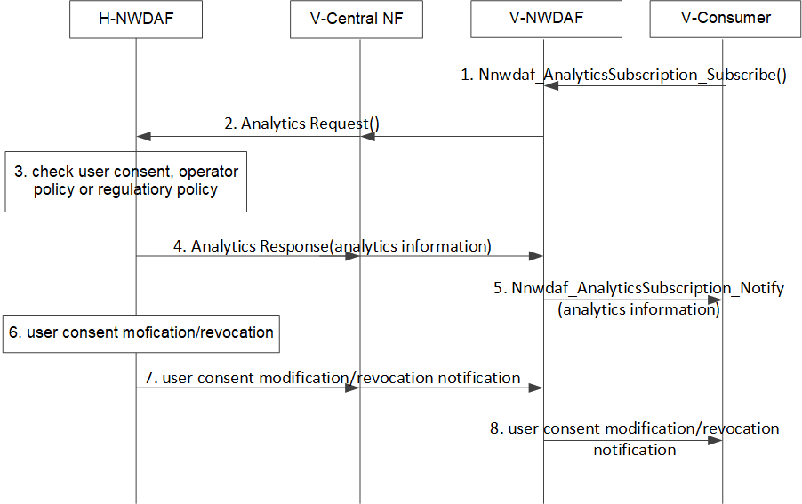

Figure 6.4.2-1: User Consent for UE Data Exposure toVPLMN in the Roaming case

1. A V-Consumer NF requests/subscribes analytics to the V-NWDAF. The message may include UE ID and Data Processor ID.

2. Once receiving the request message, the V-NWDAF checks local operator policy and/or regulatory policy to determine whether it is allowed to obtain analytics information in the HPLMN. If the analytics information in the HPLMN is allowed to be used in the VPLMN, the V-NWDAF sends the Analytics request.

If the V-Central NF is V-NWDAF, the V-NWDAF sends Analytics Request to the H-NWDAF. If the V-Central NF is DCCF, NEF or new NF, e.g. GEF, the V-NWDAF sends Analytics Request to the H-NWDAF via V-Central NF.

Note 1: The selection of V-Central NF (i.e. NWDAF, DCCF, NEF or new NF, e.g. GEF) is based on the conclusion in TR 23.700-81 [2].

3. Once receiving the request message, the H-NWDAF checks the user consent. Based on the user consent, operator policy and/or regulatory policy, H-NWDAF determines whether it is allowed to expose analytics information to the VPLMN.

NOTE 2: This solution does not describe how the H-NWDAF obtains the VPLMN specific user consent.

4. If the user consent parameters, operator policy and/or regulatory policy indicate that the analytics information is allowed to be exposed to the VPLMN, the H-NWDAF sends analytics response to V-NWDAF, which contains analytics information.

5. The V-NWDAF obtains the analytics information and sends the Nnwdaf_AnalyticsSubscription_Notify message to V-Consumer NF.

Steps 6-8 are performed after the user consent is modified or revoked.

6. If the user consent parameter is changed, e.g. user consent is revoked, H-NWDAF updates the H-NWDAF's UE context.

7. The H-NWDAF sends the user consent modification/revocation notification message to the V-NWDAF via V-Central NF.

8. The V-NWDAF sends the user consent modification/revocation notification message to the V-Consumer NF. Once receiving the notification message, the V-Consumer NF stops to use the obtained analytics information and deletes the obtained analytics information.

### 6.4.3 Evaluation

Evaluation is not provided.

## 6.5 Solution #5: Central authorization for user consent handling

### 6.5.1 Introduction

This solution is addressing key issue #3.

This solution provides one solution for introducing a central NF or a service to allow for dedicated authorization related to user consent data retrieval and revocation, which allows to provide a unified authentication framework.

### 6.5.2 Solution details

Whenever NF/AF wants to retrieve data related to one or several UEs, it provides in an authorization request to a user consent authorization function (UCA NF) a list of UEs, for which the user consent is wanted. The UCA NF contacts the UDM/UDR to gain information about which UEs give their user consent, and which do not. This information can then also be re-used by UCA NF for other requests.

The UCA NF creates a user consent authorization token including the list of allowed UE identities. This token is created in addition to the OAuth2.0 token that the NF needs to request from NRF.

The UCA NF sends in a signed response the user consent related authorization token which includes the list of UEs, for which data collection was authorized. With this token (and the OAuth2.0 token for authorizing for the service), the NF/AF requests another NF to provide data about the UE.

NFp validates both tokens before providing any data.

The UCA NF has the history of NFs/AFs that collected UE consent. This allows for sending centrally notifications of updates or revocations to those NFs that requested UE consent before. To keep an up-to-date list, the UCA needs to either subscribe for notifications from UDM once user consent was collected about a UE, or regularly check the UDM.

### 6.5.3 Evaluation

This solution ensures that all NF(s)/AF(s) receiving/having received UE data are tracked centrally. It does not require multiple NFs to check the user consent. Whenever user consent is revoked, the 5GS is able to find the NF(s)/AF(s) that have been storing the data by requesting the central entity, which can trigger/request NF(s)/AF(s) to revoke the data.

# 7 Conclusions

## 7.1 Conclusion for Key Issue #1

For KI#1 on analytics, the following is agreed for user consent handling:

For scenarios where local regulations permit, for example vPLMN and hPLMN subject to the same regulatory requirements, the NWDAF is deemed to be the enforcement point and is subject to the requirement specified in Annex V of TS 33.501 [3]. Depending on the use case and the data source, it could be the vNWDAF or the hNWDAF. This is however left to the involved PLMNs to determine.

## 7.2 Conclusion for Key Issue #2

For KI #2 on the NTN feature, it is concluded that no normative work is required.

## 7.3 Conclusion for Key Issue #3

It is concluded that no normative work is required. There is only one use case, i.e. user consent for eNA roaming, and in this case, UDM is the NF to notify the revocation.

Annex A:  
Change history

|  |  |  |  |  |  |  |  |
| --- | --- | --- | --- | --- | --- | --- | --- |
| **Change history** | | | | | | | |
| **Date** | **Meeting** | **TDoc** | **CR** | **Rev** | **Cat** | **Subject/Comment** | **New version** |
| 2022-06 | SA3#107Adhoc-e | S3-221680 |  |  |  | S3-221400, S3-221401, S3-221668, S3-221669 | 0.1.0 |
| 2022-08 | SA3#108-e | S3- 222342 |  |  |  | S3-222350, S3-222351 | 0.2.0 |
| 2022-10 | SA3#108Adhoc-e | S3-223130 |  |  |  | S3-223039, S3-223132 | 0.3.0 |
| 2022-11 | SA3#109 | S3-224181 |  |  |  | S3-224090, S3-224091, S3-223635, S3-223757, S3-223758, S3-223770, S3-223771 | 0.4.0 |
| 2022-11 | SA3#109 |  |  |  |  | implementing the original content of approved document S3-223635 | 0.4.1 |
| 2023-01 | SA3#109Adhoc-e | S3-230530 |  |  |  | S3-230406, S3-230473, S3-230474 | 0.5.0 |
| 2023-02 | SA3#110 | S3-231531 |  |  |  | S3-230959, S3-231530, S3-230961, S3-230765 | 0.6.0 |
| 2023-05 | SA3#111 | S3-233318 |  |  |  | S3-232701 | 0.7.0 |
| 2023-06 | SA#100 | SP-230579 |  |  |  | Presented for information and approval | 1.0.0 |
| 2023-06 | SA#100 |  |  |  |  | Upgrade to change control | 18.0.0 |
| 2023-06 | SA#100 |  |  |  |  | EditHelp review | 18.0.1 |