|  |  |
| --- | --- |
| 3GPP TR 36.764 V18.0.0 (2023-12) | |
| Technical Report | |
| 3rd Generation Partnership Project;  Technical Specification Group Radio Access Network;  LTE IoT NTN operating bands  (Release 18) | |
|  | |
|  |  |
|  | |
| The present document has been developed within the 3rd Generation Partnership Project (3GPP TM) and may be further elaborated for the purposes of 3GPP. The present document has not been subject to any approval process by the 3GPPOrganizational Partners and shall not be implemented. This Specification is provided for future development work within 3GPPonly. The Organizational Partners accept no liability for any use of this Specification. Specifications and Reports for implementation of the 3GPP TM system should be obtained via the 3GPP Organizational Partners' Publications Offices. | |

|  |
| --- |
|  |
| ***3GPP***  Postal address  3GPP support office address  650 Route des Lucioles - Sophia Antipolis  Valbonne - FRANCE  Tel.: +33 4 92 94 42 00 Fax: +33 4 93 65 47 16  Internet  http://www.3gpp.org |
| ***Copyright Notification***  No part may be reproduced except as authorized by written permission. The copyright and the foregoing restriction extend to reproduction in all media.  © 2023, 3GPP Organizational Partners (ARIB, ATIS, CCSA, ETSI, TSDSI, TTA, TTC).  All rights reserved.  UMTS™ is a Trade Mark of ETSI registered for the benefit of its members  3GPP™ is a Trade Mark of ETSI registered for the benefit of its Members and of the 3GPP Organizational Partners LTE™ is a Trade Mark of ETSI registered for the benefit of its Members and of the 3GPP Organizational Partners  GSM® and the GSM logo are registered and owned by the GSM Association |

Contents

Foreword 4

1 Scope 6

2 References 6

3 Definitions of terms, symbols and abbreviations 6

3.1 Terms 6

3.2 Symbols 6

3.3 Abbreviations 6

4 Background 6

5 Common band agnostic aspects 7

5.1 System parameters 7

5.1.1 Operating bands 7

5.1.2 Channel arrangements 7

5.1.2.1 Channel arrangement for category M1 7

6 FDD band B254 (L+S band) 7

6.1 Regulation 7

6.2 UE requirements 8

6.2.1 UE transmitter characteristics 8

6.2.1.1 Maximum output power for category M1 and NB1/NB2 8

6.2.1.2 Emission requirements and NS values 8

6.2.1.2.1 Spurious emission for category M1 8

6.2.1.3 Configured TX power 8

6.2.1.4 Power control 8

6.2.1.5 Frequency error 8

6.2.1.6 Transmit modulation quality 9

6.2.2 UE receiver characteristics 9

6.2.2.1 Reference sensitivity for category M1 and NB1/NB2 9

6.2.2.2 Blocking requirements 9

6.2.3 Evaluation and simulation 10

6.2.3.1 Evaluation and simulation on Cat. M1 10

6.2.3.2 Evaluation and simulation on Cat. NB1/NB2 11

6.3 BS requirements 16

Annex A (informative): Change history 17

# Foreword

This Technical Specification|Report has been produced by the 3rd Generation Partnership Project (3GPP).

The contents of the present document are subject to continuing work within the TSG and may change following formal TSG approval. Should the TSG modify the contents of the present document, it will be re-released by the TSG with an identifying change of release date and an increase in version number as follows:

Version x.y.z

where:

x the first digit:

1 presented to TSG for information;

2 presented to TSG for approval;

3 or greater indicates TSG approved document under change control.

y the second digit is incremented for all changes of substance, i.e. technical enhancements, corrections, updates, etc.

z the third digit is incremented when editorial only changes have been incorporated in the document.

In the present document, modal verbs have the following meanings:

**shall** indicates a mandatory requirement to do something

**shall not** indicates an interdiction (prohibition) to do something

The constructions "shall" and "shall not" are confined to the context of normative provisions, and do not appear in Technical Reports.

The constructions "must" and "must not" are not used as substitutes for "shall" and "shall not". Their use is avoided insofar as possible, and they are not used in a normative context except in a direct citation from an external, referenced, non-3GPP document, or so as to maintain continuity of style when extending or modifying the provisions of such a referenced document.

**should** indicates a recommendation to do something

**should not** indicates a recommendation not to do something

**may** indicates permission to do something

**need not** indicates permission not to do something

The construction "may not" is ambiguous and is not used in normative elements. The unambiguous constructions "might not" or "shall not" are used instead, depending upon the meaning intended.

**can** indicates that something is possible

**cannot** indicates that something is impossible

The constructions "can" and "cannot" are not substitutes for "may" and "need not".

**will** indicates that something is certain or expected to happen as a result of action taken by an agency the behaviour of which is outside the scope of the present document

**will not** indicates that something is certain or expected not to happen as a result of action taken by an agency the behaviour of which is outside the scope of the present document

**might** indicates a likelihood that something will happen as a result of action taken by some agency the behaviour of which is outside the scope of the present document

**might not** indicates a likelihood that something will not happen as a result of action taken by some agency the behaviour of which is outside the scope of the present document

In addition:

**is** (or any other verb in the indicative mood) indicates a statement of fact

**is not** (or any other negative verb in the indicative mood) indicates a statement of fact

The constructions "is" and "is not" do not indicate requirements.

# 1 Scope

The present document is a technical report for LTE IoT NTN operating bands.

# 2 References

The following documents contain provisions which, through reference in this text, constitute provisions of the present document.

- References are either specific (identified by date of publication, edition number, version number, etc.) or non‑specific.

- For a specific reference, subsequent revisions do not apply.

- For a non-specific reference, the latest version applies. In the case of a reference to a 3GPP document (including a GSM document), a non-specific reference implicitly refers to the latest version of that document *in the same Release as the present document*.

[1] 3GPP TR 21.905: "Vocabulary for 3GPP Specifications".

[2] 3GPP TR 38.741: “Non-Terrestrial Networks (NTN) L-/S-band for NR”.

# 3 Definitions of terms, symbols and abbreviations

## 3.1 Terms

For the purposes of the present document, the terms given in TR 21.905 [1] and the following apply. A term defined in the present document takes precedence over the definition of the same term, if any, in TR 21.905 [1].

## 3.2 Symbols

For the purposes of the present document, the following symbols apply:

## 3.3 Abbreviations

For the purposes of the present document, the abbreviations given in TR 21.905 [1] and the following apply. An abbreviation defined in the present document takes precedence over the definition of the same abbreviation, if any, in TR 21.905 [1].

# 4 Background

In 3GPP RAN#99 meeting, for fulfilling market demand, the new spectrum WI to add support for a new IoT NTN band with the DL part on the S-band (2500MHz) and the UL part on the L-band (1600MHz) was agreed. Secondly, another new IoT NTN spectrum WI for the extend- L band was agreed as well. Introduction and specifying requirements of more NTN IoT bands is expected and can be requested if necessary.

# 5 Common band agnostic aspects

## 5.1 System parameters

### 5.1.1 Operating bands

IoT NTN operation is designed in the operating bands defined in Table 5.1.1-1.

Table 5.1.1-1 E-UTRA operating bands for IoT NTN operation

|  |  |  |  |  |  |  |  |
| --- | --- | --- | --- | --- | --- | --- | --- |
| E‑UTRA Operating Band | Uplink (UL) operating band BS receive UE transmit | | | Downlink (DL) operating band BS transmit  UE receive | | | Duplex Mode |
| FUL_low – FUL_high | | | FDL_low – FDL_high | | |
| 254 | 1610 MHz | - | 1626.5 MHz | 2483.5 MHz | - | 2500 MHz | FDD |
| NOTE: Satellite bands are numbered in descending order from 256 | | | | | | | |

### 5.1.2 Channel arrangements

#### 5.1.2.1 Channel arrangement for category M1

Table 5.1.2.1-1: E-UTRA channel numbers

|  |  |  |  |  |  |  |  |
| --- | --- | --- | --- | --- | --- | --- | --- |
| E-UTRA Operating  Band | ΔFRaster (kHz) | Downlink | | | Uplink | | |
| FDL_low (MHz) | NOffs-DL | Range of NDL  (First – <Step size> – Last) | FUL_low (MHz) | NOffs-UL | Range of NUL  (First – <Step size> – Last) |
| 254 | 100 | 2483.5 | 228571 | 228571 –<1>- 228735 | 1610 | 261339 | 261339 –<1>- 261503 |

Table 5.1.2.1-2: Default UE TX-RX frequency separation

| E-UTRA Operating Band | TX – RX  carrier centre frequency separation |
| --- | --- |
| 254 | 873.5 MHz |

# 6 FDD band B254 (L+S band)

## 6.1 Regulation

Existing regulatory information concerning regulatory rules applicable to this NTN L-/S-band can be found in Clause 5 in [2].

## 6.2 UE requirements

### 6.2.1 UE transmitter characteristics

#### 6.2.1.1 Maximum output power for category M1 and NB1/NB2

Table 6.2.1.1-1: UE Power Class for category M1

|  |  |  |  |  |  |  |
| --- | --- | --- | --- | --- | --- | --- |
| EUTRA band | Class 2  (dBm) | Tolerance  (dB) | Class 3 (dBm) | Tolerance (dB) | Class 5 (dBm) | Tolerance (dB) |
| 254 |  |  | 23 | +/-2 | 20 | +/-2 |
| NOTE 1: PPowerClass is the maximum UE power specified without taking into account the tolerance. | | | | | | |

Table 6.2.1.1-2: UE Power Class for category NB1/NB2

|  |  |  |  |  |
| --- | --- | --- | --- | --- |
| EUTRA band | Class 3 (dBm) | Tolerance (dB) | Class 5 (dBm) | Tolerance (dB) |
| 254 | 23 | +/-2 | 20 | +/-2 |

#### 6.2.1.2 Emission requirements and NS values

##### 6.2.1.2.1 Spurious emission for category M1

Table 6.2.1.2.1-1: Requirements for spurious emissions for UE co-existence

|  |  |  |  |  |  |  |  |
| --- | --- | --- | --- | --- | --- | --- | --- |
| E-UTRA Band | Spurious emission | | | | | | |
| Protected band | Frequency range (MHz) | | | Maximum Level (dBm) | MBW (MHz) | NOTE |
| 254 | E-UTRA Band 2, 4, 5, 12, 13, 14, 17, 24, 25, 26, 29, 30, 31, 41, 48, 54, 66, 70, 71, 72, 85, 87, 88, 103  NR Band n1, n3, n7, n8, n18, n20, n28, n34, n38, n39, n40, n50, n51, n53, n54, n65, n67, n74, n75, n76, n77, n78, n90, n91, n92, n93, n94, n105 | FDL_low | - | FDL_high | -50 | 1 |  |
| NR Band n79 | FDL_low | - | FDL_high | -50 | 1 | 2 |
| NOTE 1: FDL_low and FDL_high refer to each E-UTRA frequency band specified in Table 5.1.1-1  NOTE 2: As exceptions, measurements with a level up to the applicable requirements defined in Table 6.5A.4.2-2 are permitted for each assigned E-UTRA carrier used in the measurement due to 2nd, 3rd, 4th [or 5th] harmonic spurious emissions. Due to spreading of the harmonic emission the exception is also allowed for the first 1 MHz frequency range immediately outside the harmonic emission on both sides of the harmonic emission. This results in an overall exception interval centred at the harmonic emission of (2MHz + N x LCRB x 180kHz), where N is 2, 3, 4, [5] for the 2nd, 3rd, 4th [or 5th] harmonic respectively. The exception is allowed if the measurement bandwidth (MBW) totally or partially overlaps the overall exception interval. | | | | | | | |

##### 6.2.1.3 Configured TX power

It is agreed the current TS 36.102 requirements can be re-used for band n254.

##### 6.2.1.4 Power control

It is agreed the current TS 36.102 requirements can be re-used for band n254.

##### 6.2.1.5 Frequency error

It is agreed the current TS 36.102 requirements can be re-used for band n254.

##### 6.2.1.6 Transmit modulation quality

It is agreed the current TS 36.102 requirements can be re-used for band n254.

### 6.2.2 UE receiver characteristics

#### 6.2.2.1 Reference sensitivity for category M1 and NB1/NB2

Table 6.2.2.1-1: Reference sensitivity for FDD UE category M1 QPSK PREFSENS

|  |  |  |
| --- | --- | --- |
| NTN Band | REFSENS (dBm) | Duplex Mode |
| 254 | -102.2 | FDD |
| 255 | -102.7 | FDD |
| 256 | -102.2 | FDD |
| NOTE 1: The transmitter shall be set to PUMAX as defined in subclause 6.2.5- in TS 36.101 [7]. | | |

Table 6.2.2.1-2: Reference sensitivity for HD-FDD UE category M1 QPSK PREFSENS

|  |  |  |
| --- | --- | --- |
| NTN Band | REFSENS (dBm) | Duplex Mode |
| 254 | -103.1 | HD-FDD |
| 255 | -103.5 | HD-FDD |
| 256 | -103 | HD-FDD |
| NOTE 1: The transmitter shall be set to PUMAX as defined in subclause 6.2.5 in TS 36.101 [7]. | | |

Table 6.2.2.1-3: FDD UE category M1 Uplink configuration for reference sensitivity

|  |  |  |
| --- | --- | --- |
| E-UTRA Band | NRB | Duplex Mode |
| 254 | 61 | FDD and HD-FDD |
| 255 | 61 | FDD and HD-FDD |
| 256 | 61 | FDD and HD-FDD |
| NOTE 1: 1 refers to the UL resource blocks shall be located as close as possible to the downlink operating band but confined within the transmission bandwidth configuration for the channel bandwidth (Table 5.3A-1). | | |

Table 6.2.2.1-4: Reference sensitivity for UE category NB1 and NB2

|  |  |
| --- | --- |
| Operating band | REFSENS [dBm] |
| According to subclause 5.2B | - 108.2 |

#### 6.2.2.2 Blocking requirements

For Out-of-Band Blocking requirement, it is agreed to reuse the general requirements for NR bands with FDL_high < 2700 MHz and FUL_high < 2700 MHz, for band b254 category M1 and NB1/NB2.

### 6.2.3 Evaluation and simulation

#### 6.2.3.1 Evaluation and simulation on Cat. M1

The 3GPP emission mask for the 1.4MHz channel is generally either the same or stricter comparing to the ETSI or FCC requirements, and there is one case for the ETSI in-band emission mask for the 1618.25-1626.5MHz range where the ETSI mask is stricter. To check whether existing MPR requirements still apply, we conduct a set of simulation cases with the 1.4MHz LTE channel placed in different locations. The common simulation parameters are as follows:

- Tx power: PC3 +23dBm

- Modulation: DFT-s-OFDM QPSK

- LO placement: always in the centre of the carrier

- Regulations: ETSI and FCC

As for the actual channel configurations, Figure 6.2.3-1 below shows three 1.4MHz channel with centre frequencies of 1610.7MHz, 1618.95MHz and 1625.8MHz.



Figure 6.2.3.1-1: Considered channels for power back-off simulations.

Figure 6.2.3.1-2 below captures summary of the power back-off needed for the LTE MTC 1.4MHz channel placed right at the lower edge of the NTN L-/S-band:

- For most cases no power back-off is needed at all. Even when a single RB is scheduled at the lower-most edge of the channel resulting in the highest PSD, still no power back-off is required.

- There are only two cases when power back-off is applied, when 5 and 6 RBs are scheduled. Still power back-off values are quite marginal, 0.2dB, and are within the existing MPR allowances (see Appendix A).

Figure 6.2.3.1-2: Power back-off values for the 1.4MHz channel at Fc=1610.7MHz.

Figure 6.2.3.1-3 below captures summary of the power back-off needed for the LTE MTC 1.4MHz channel placed in the second ETSI sub-range of 1618.25-1626.5MHz:

- The main conclusion is that while a UE might need some power back-off to meet emission requirements, it is needed only for 5-6 RBs and the maximum value does not exceed 0.3dB, which is still within existing MPR requirements (see Appendix A).

- It does not matter much whether the 1.4MHz channel is at the lower or the upper edge of the second ETSI sub-range. While there are out-of-band emission requirements for frequencies above 1628.5MHz, they do not have any discernible impact on the power back-off values.

Figure 6.2.3.1-3: Power back-off values for the 1.4MHz channel at Fc=1618.95 and Fc=1625.8MHz.

Based on these observations our preliminary view is that no additional maximum power reduction requirements are needed to meet existing FCC and ETSI requirements.

#### 6.2.3.2 Evaluation and simulation on Cat. NB1/NB2

For A-MPR for category NB1/NB2, simulations where a QPSK signal with different allocations including 3 tones, 6 tones and 12 tones is generated and passed to a typical PC3 power amplifier. And LO is set to the center of the carrier. The simulation results are shown in the following figures from R4-2317572 and R4-2318708.

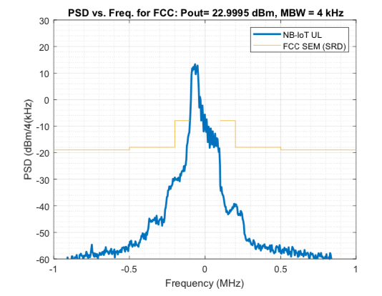

a. 3-tone [0-2] allocation, FCC 🡪 No A-MPR is required

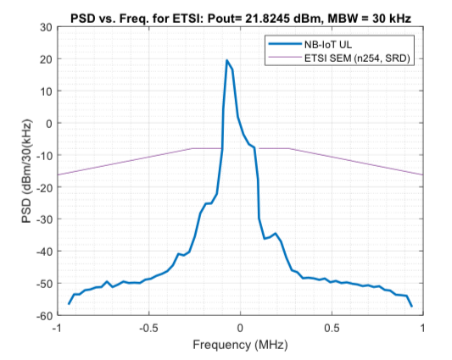

b. 3-tone [0-2] allocation, ETSI, Fc = 1610 – 1618.25 MHz 🡪 A-MPR = 0.7dB

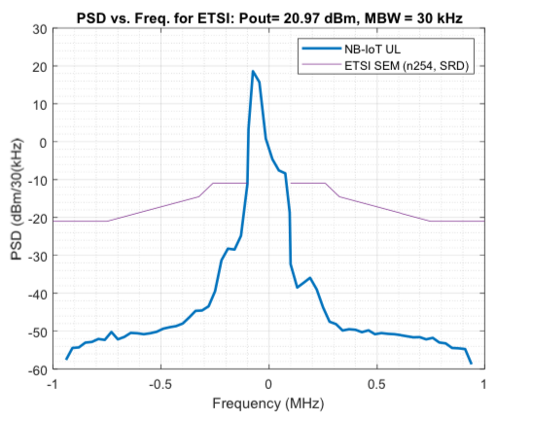

c. 3-tone [0-2] allocation, ETSI, Fc = 1618.25 – 1626.5 MHz 🡪 A-MPR = 1.5 dB

Fig. 6.2.3.2-1, MPR simulation results wth 3-tone allocation for FCC and ETSI requirements.

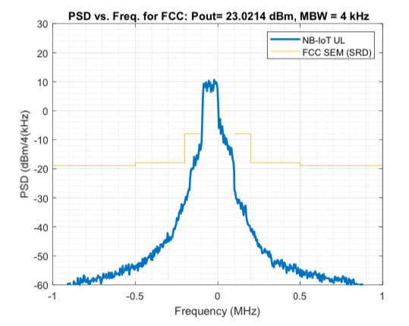

d. 6-tone [0-6] allocation, FCC 🡪 No A-MPR is required

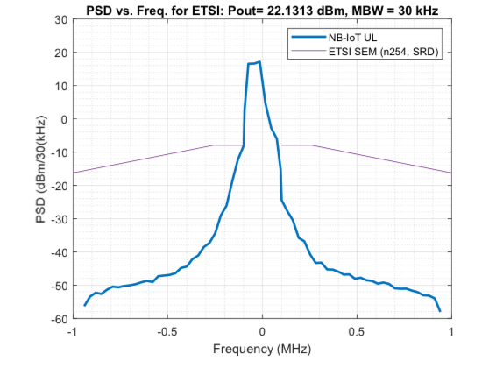

e. 6-tone [0-5] allocation, ETSI, Fc = 1610 – 1618.25 MHz 🡪 A-MPR = 0

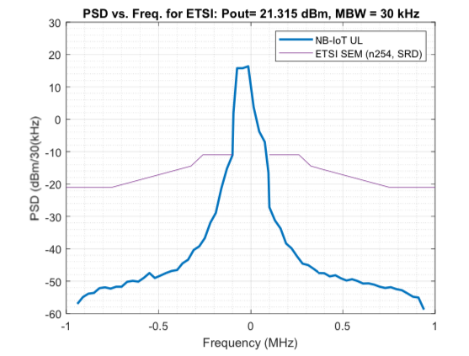

f. 6-tone [0-5] allocation, ETSI, Fc = 1618.25 – 1626.5 MHz 🡪 A-MPR = 0.7dB

Fig. 6.2.3.2-2, MPR simulation results wth 6-tone allocation for FCC and ETSI requirements.

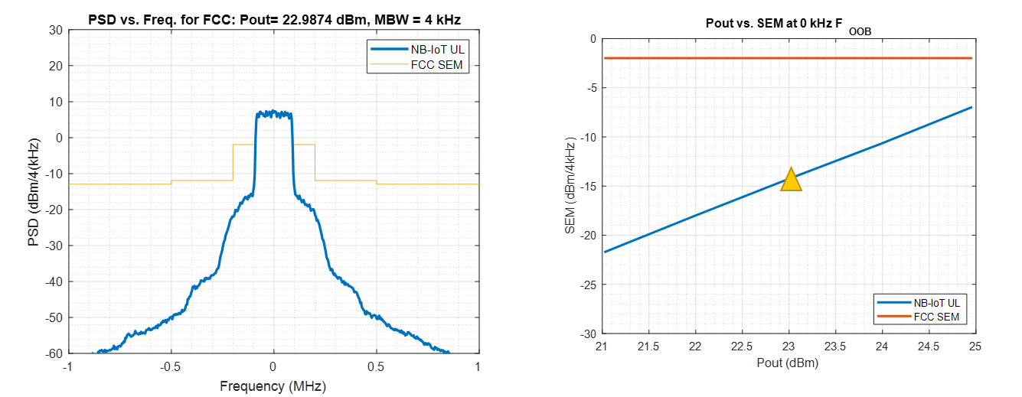

g. FCC

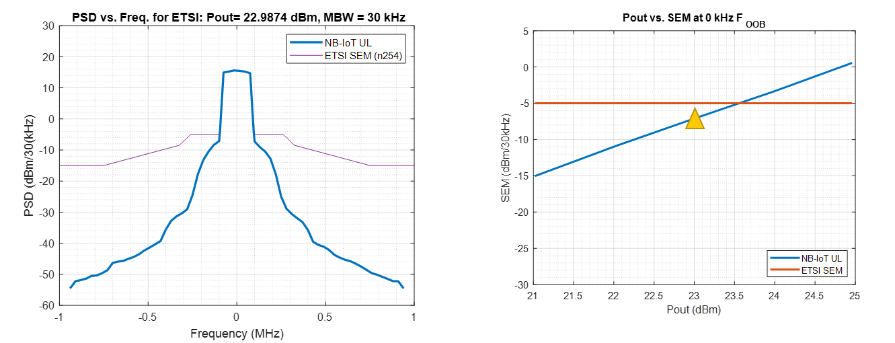

h. ETSI, Fc = 1618.25 MHz – 1626.5 MHz

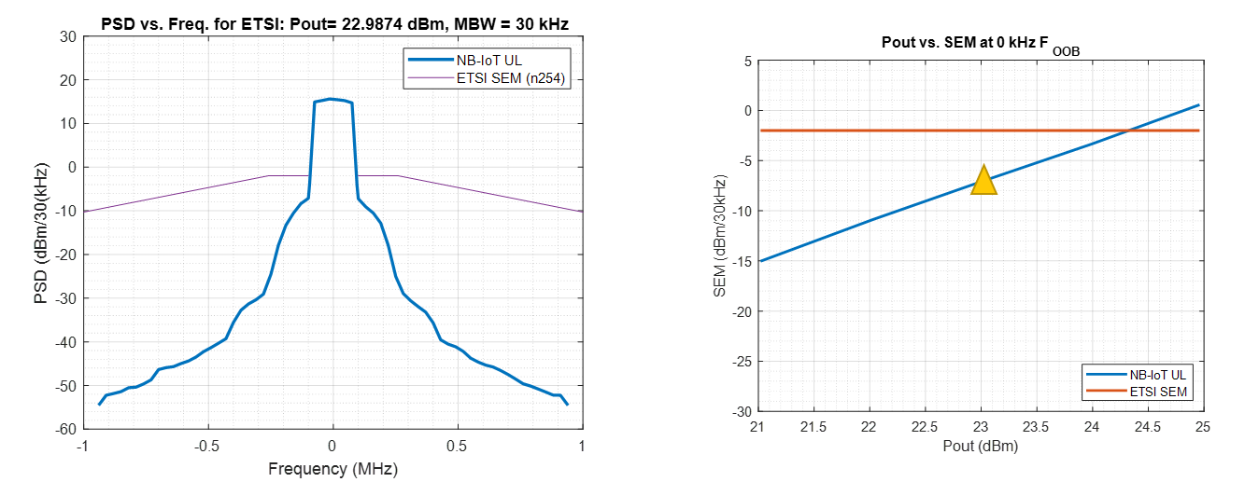

i. ETSI, Fc = 1610 MHz – 1618.25 MHz

Fig. 6.2.3.2-3, MPR simulation results wth 12-tone allocation for FCC and ETSI requirements.

The additional MPR is not required for FCC regulations.

The additional MPR are summarized in the tables below for ETSI regulations.

Table 6.2.3.2-1: A-MPR for NS_04N

|  |  |  |  |  |
| --- | --- | --- | --- | --- |
| Modulation | QPSK | | | |
| Tone positions for 3 Tones allocation | 0-2 | 3-5 and 6-8 | | 9-11 |
| A-MPR | ≤ 0.7 dB | 0.2 dB | | ≤ 0.7 dB |
| Tone positions for 6 Tones allocation | 0-5 and 6-11 | | | |
| A-MPR | 0 dB | | 0 dB | |
| Tone positions for 12 Tones allocation | 0-11 | | | |
| A-MPR | 0 dB | | | |

Table 6.2.3.2-2: A-MPR for NS_05N

|  |  |  |  |  |
| --- | --- | --- | --- | --- |
| Modulation | QPSK | | | |
| Tone positions for 3 Tones allocation | 0-2 | 3-5 and 6-8 | | 9-11 |
| A-MPR | ≤ 1.5 dB | 0.5 dB | | ≤ 1.5 dB |
| Tone positions for 6 Tones allocation | 0-5 and 6-11 | | | |
| A-MPR | ≤ 0.7 dB | | ≤ 0.7 dB | |
| Tone positions for 12 Tones allocation | 0-11 | | | |
| A-MPR | 0 dB | | | |

For 12-tone allocation, the below results are based on the measurements from R4-2321798.

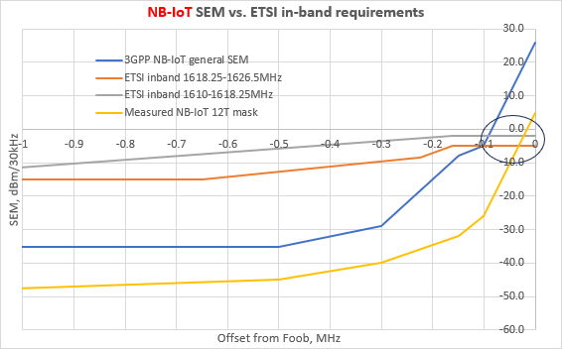

## 6.3 BS requirements

Annex A (informative):  
Change history

|  |  |  |  |  |  |  |  |
| --- | --- | --- | --- | --- | --- | --- | --- |
| Change history | | | | | | | |
| Date | Meeting | TDoc | CR | Rev | Cat | Subject/Comment | New version |
| 2023-04 | RAN4#106bis-e | R4-2304497 |  |  |  | TR skeleton | 0.0.1 |
| 2023-08 | RAN4#108 | R4-2314712 |  |  |  | System parameters/MOP/Spurious emission/REFSENS and some simulation results are added | 0.0.2 |
| 2023-10 | RAN4#108-bis | R4-2316133 |  |  |  | TP to Draft TR for IoT NTN bands | 0.0.4 |
| 2023-11 | RAN4#109 | R4-2321815 |  |  |  | TP to draft TR for B254 | 0.0.5 |
| 2023-12 | RAN#102 | RP-233282 |  |  |  | Provide endorsed TR to RAN plenary for one step approval | 1.0.0 |

|  |  |  |  |  |  |  |  |
| --- | --- | --- | --- | --- | --- | --- | --- |
| **Change history** | | | | | | | |
| **Date** | **Meeting** | **TDoc** | **CR** | **Rev** | **Cat** | **Subject/Comment** | **New version** |
| 2023-12 | RAN#102 |  |  |  |  | Approved by plenary – Rel-18 spec under change control | 18.0.0 |