|  |  |
| --- | --- |
| 3GPP TR 36.792 V18.1.0 (2023-12) | |
| Technical Report | |
| 3rd Generation Partnership Project;  Technical Specification Group Radio Access Network;  Summary of regulatory requirements on unwanted emissions for transmission over broadcast bands in UHF spectrum;  (Release 18) | |
|  | |
|  |  |
|  | |
| The present document has been developed within the 3rd Generation Partnership Project (3GPP TM) and may be further elaborated for the purposes of 3GPP. The present document has not been subject to any approval process by the 3GPPOrganizational Partners and shall not be implemented. This Specification is provided for future development work within 3GPPonly. The Organizational Partners accept no liability for any use of this Specification. Specifications and Reports for implementation of the 3GPP TM system should be obtained via the 3GPP Organizational Partners' Publications Offices. | |

|  |
| --- |
|  |
| ***3GPP***  Postal address  3GPP support office address  650 Route des Lucioles - Sophia Antipolis  Valbonne - FRANCE  Tel.: +33 4 92 94 42 00 Fax: +33 4 93 65 47 16  Internet  http://www.3gpp.org |
| ***Copyright Notification***  No part may be reproduced except as authorized by written permission. The copyright and the foregoing restriction extend to reproduction in all media.  © 2023, 3GPP Organizational Partners (ARIB, ATIS, CCSA, ETSI, TSDSI, TTA, TTC).  All rights reserved.  UMTS™ is a Trade Mark of ETSI registered for the benefit of its members  3GPP™ is a Trade Mark of ETSI registered for the benefit of its Members and of the 3GPP Organizational Partners LTE™ is a Trade Mark of ETSI registered for the benefit of its Members and of the 3GPP Organizational Partners  GSM® and the GSM logo are registered and owned by the GSM Association |

Contents

Foreword 4

Introduction 6

1 Scope 7

2 References 7

3 Definitions of terms, symbols and abbreviations 7

3.1 Terms 7

3.2 Symbols 7

3.3 Abbreviations 8

4 Spectrum limit masks for digital terrestrial television broadcasting 8

4.1 General 8

4.2 Scope 8

4.3 Specific spectrum limit masks for digital terrestrial television system A (ATSC) 9

4.3.1 General 9

4.3.2 Sampling the transmitter output 9

4.3.3 Spectrum limit masks for 6 MHz DTTB systems using 8-VSB modulation 9

4.3.3.1 General 9

4.3.3.2 High power DTTB spectrum limit mask 9

4.3.3.3 Low power DTTB spectrum limit mask for LPTV transmitters and translators 10

4.3.3.4 Simple DTTB spectrum limit mask for LPTV transmitters and translators 11

4.4 Specific spectrum limit masks for digital terrestrial television system B (DVB-T) 12

4.4.1 Specific spectrum limit masks for 6 MHz channelling system B (DVB-T) 12

4.4.2 Specific spectrum limit masks for 7 MHz channelling system B (DVB-T) 13

4.4.3 Specific spectrum limit masks for 8 MHz channelling system B (DVB-T) 14

4.5 Specific spectrum limit masks for digital terrestrial television system C (ISDB-T) 16

4.5.1 Specific spectrum limit masks for 6 MHz channelling system C (ISDB-T) 16

4.5.2 Specific spectrum limit masks for 7 MHz channelling system C (ISDB-T) 17

4.5.3 Specific spectrum limit masks for 8 MHz channelling system C (ISDB-T) 19

4.6 Specific spectrum limit masks for digital terrestrial television system D (DTMB) 20

4.6.1 Specific spectrum limit masks for 6 MHz channelling system D (DTMB) 20

4.6.2 Specific spectrum limit masks for 7 MHz channelling system D (DTMB) 21

4.6.3 Specific spectrum limit masks for 8 MHz channelling system D (DTMB) 22

Annex A: Regulatory requirements for ITU Region 1 according to GE06 [5] 25

A.1 Scope 26

A.2 Conformance requirements 26

A.2.1 Introduction 26

A.2.2 Operating band unwanted emissions and ACLR 27

A.2.2.1 Definition 27

A.2.2.2 Classification of transmitters 27

A.2.2.3 Limits 27

A.2.3 Transmitter spurious emissions 32

A.2.3.1 Definition 32

A.2.3.2 Limits 32

Annex B (informative): Change history 34

# Foreword

This Technical Report has been produced by the 3rd Generation Partnership Project (3GPP).

The contents of the present document are subject to continuing work within the TSG and may change following formal TSG approval. Should the TSG modify the contents of the present document, it will be re-released by the TSG with an identifying change of release date and an increase in version number as follows:

Version x.y.z

where:

x the first digit:

1 presented to TSG for information;

2 presented to TSG for approval;

3 or greater indicates TSG approved document under change control.

y the second digit is incremented for all changes of substance, i.e. technical enhancements, corrections, updates, etc.

z the third digit is incremented when editorial only changes have been incorporated in the document.

In the present document, modal verbs have the following meanings:

**shall** indicates a mandatory requirement to do something

**shall not** indicates an interdiction (prohibition) to do something

The constructions "shall" and "shall not" are confined to the context of normative provisions, and do not appear in Technical Reports.

The constructions "must" and "must not" are not used as substitutes for "shall" and "shall not". Their use is avoided insofar as possible, and they are not used in a normative context except in a direct citation from an external, referenced, non-3GPP document, or so as to maintain continuity of style when extending or modifying the provisions of such a referenced document.

**should** indicates a recommendation to do something

**should not** indicates a recommendation not to do something

**may** indicates permission to do something

**need not** indicates permission not to do something

The construction "may not" is ambiguous and is not used in normative elements. The unambiguous constructions "might not" or "shall not" are used instead, depending upon the meaning intended.

**can** indicates that something is possible

**cannot** indicates that something is impossible

The constructions "can" and "cannot" are not substitutes for "may" and "need not".

**will** indicates that something is certain or expected to happen as a result of action taken by an agency the behaviour of which is outside the scope of the present document

**will not** indicates that something is certain or expected not to happen as a result of action taken by an agency the behaviour of which is outside the scope of the present document

**might** indicates a likelihood that something will happen as a result of action taken by some agency the behaviour of which is outside the scope of the present document

**might not** indicates a likelihood that something will not happen as a result of action taken by some agency the behaviour of which is outside the scope of the present document

In addition:

**is** (or any other verb in the indicative mood) indicates a statement of fact

**is not** (or any other negative verb in the indicative mood) indicates a statement of fact

The constructions "is" and "is not" do not indicate requirements.

# Introduction

In Rel-14 and Rel-16, RAN introduced a set of features under the umbrella of “LTE based 5G terrestrial broadcast” that, together with the corresponding enhancements in the core network, enable the deployment of a downlink-only dedicated broadcast network using 3GPP technologies.

A clear target spectrum for this technology is the portion of UHF spectrum allocated to broadcast systems (~470 - ~694/698MHz, depending on the region). The objective of this work item was to introduce the necessary features for LTE based 5G terrestrial broadcast to operate in the portion of UHF spectrum allocated to broadcast systems in different regions of the globe. For instance:

- For ITU region 1, a channelization of 8 MHz is used.

- For ITU region 2, a channelization of 6 MHz is used.

- In some countries (e.g. North America), frequencies above 614 MHz are used by FDD (B71).

- For ITU region 3, different channelizations (6/7/8 MHz) are used in different countries, for instance China and India are using 8 MHz.

- In China broadcast systems are using the spectrum ranges 470 – 702 MHz.

- In India broadcast systems are using the spectrum ranges 470 – 610 MHz and 614 – 698 MHz.

In this work, at least the following specifications are to be taken into account, and requirements reused when available:

- For ITU region 1, requirements defined in ETSI EN 302 296 [3] and GE06 Agreement [5].

- For ITU region 2:

- In United States, FCC Title 47 CFR 73.622 [6].

- In Brazil, ABNT NBR 15601 [7].

- For ITU region 3: in China, GB20600-2006 [8].

# 1 Scope

The present document provides a summary of regulatory requirements on unwanted emissions for transmission over broadcast bands in UHF spectrum. This document is not exhaustive and is intended to be used only informatively; in all cases whether included in this document or not, the official requirements issued by the regulator should be consulted for the most accurate and up-to-date information.

# 2 References

The following documents contain provisions which, through reference in this text, constitute provisions of the present document.

- References are either specific (identified by date of publication, edition number, version number, etc.) or non‑specific.

- For a specific reference, subsequent revisions do not apply.

- For a non-specific reference, the latest version applies. In the case of a reference to a 3GPP document (including a GSM document), a non-specific reference implicitly refers to the latest version of that document *in the same Release as the present document*.

[1] 3GPP TR 21.905: "Vocabulary for 3GPP Specifications".

[2] ITU-R Recommendation BT.1206: "Spectrum limit masks for digital terrestrial television broadcasting".

[3] ETSI EN 302 296: "Digital Terrestrial TV Transmitters; Harmonised Standard for access to radio spectrum".

[4] Radio Equipment Directive 2014/53/EU, European Parliament.

[5] ITU GE06 Agreement: "Primary Terrestrial Services Other Than Broadcasting In The Planning Area And Bands Governed By The Regional Agreement GE06", <https://www.itu.int/en/ITU-R/terrestrial/fmd/Documents/fxm-GE06-report.pdf>

[6] FCC Title 47 CFR 73.622, Digital television table of allotments, FCC, United States.

[7] ABNT NBR 15601, Digital terrestrial television – Transmission system, Brazilian Association of Technical Standards, Anatel, Brazil.

[8] GB20600-2006: "Framing structure, Channel coding and modulation for digital television terrestrial broadcasting system", National Standard, China.

[9] ITU-R Recommendation SM.1541: "Unwanted emissions in the out-of-band domain".

# 3 Definitions of terms, symbols and abbreviations

## 3.1 Terms

For the purposes of the present document, the terms given in TR 21.905 [1] and the following apply. A term defined in the present document takes precedence over the definition of the same term, if any, in TR 21.905 [1].

## 3.2 Symbols

For the purposes of the present document, the following symbols apply:

## 3.3 Abbreviations

For the purposes of the present document, the abbreviations given in TR 21.905 [1] and the following apply. An abbreviation defined in the present document takes precedence over the definition of the same abbreviation, if any, in TR 21.905 [1].

8-VSB 8-level Vestigial-SideBand

ATSC Advanced Television Systems

DTMB Digital Terrestrial Multimedia Broadcast

DTT Digital Terrestrial Television

DTTB Digital Terrestrial Television Broadcasting

DVB-T Digital Video Broadcasting

ISDB-T Integrated Services Digital Broadcasting

LPTV Low Power TeleVision

OOB Out Of Band

UHF Ultra High Frequency

# 4 Spectrum limit masks for digital terrestrial television broadcasting

## 4.1 General

In order to avoid referring to national regulations since they vary from country to country, instead this TR refers to the Recommendation ITU-R BT.1206 [2] Spectrum limit masks for digital terrestrial television broadcasting. The spectrum masks defined in the recommendation are not based on the ITU-R Region but on the DTT system.

Currently there are 4 different DTT systems in operation worldwide:

- Advanced Television Systems Committee (ATSC)

- Digital Video Broadcasting (DVB-T)

- Integrated Services Digital Broadcasting (ISDB-T)

- Digital Terrestrial Multimedia Broadcast (DTMB)

Besides, different TV channel raster are currently in use (6, 7, and 8 MHz).

ATSC1.0 spectrum masks are also considered for ATSC3.0. Furthermore, DVB-T2 uses the same spectrum masks as DVB-T, and DTMB-A uses the same spectrum masks as DTMB.

Each of these DTT systems can be used in different ITU-R Regions. Although the majority of Region 1 countries use DVB-T (or DVB-T2), there are some countries in Region 1 using ISDB-T or DTMB. Likewise, although in Region 2 ATSC (or ATSC 3.0) is used in North America and ISDB-T is used in most of Central America, South America, and the Caribbean, there are some countries in Region 2 using DVB-T/T2 or DTMB. Finally, in Region 3, all four DTT systems (or their corresponding second-generation systems) are used in different countries.

Regarding the UHF TV channel raster, only ITU-R Region 1 is fully harmonized using 8 MHz channels.

In Regions 2 and 3, there are different countries using all three UHF TV channel raster (6, 7, and 8 MHz).

Therefore, it is advisable to refer to the spectrum masks defined in Recommendation ITU-R BT.1206 [2] to enhance the compatibility of LTE-based 5G terrestrial broadcast with existing DTT systems, not based on ITU-R Region, but based on the DTT system and UHF TV channel raster adopted in each country.

In addition to the ITU-R BT.1206 [2], GE06 [5] shall be considered as a regulatory reference for ITU Region 1 in respect to OOB emissions. Existing 3GPP specifications with relation to Out-of-Band emissions shall be considered as well.

## 4.2 Scope

This Technical Report provides specific spectrum limit masks for digital terrestrial television broadcasting systems specified in Recommendation ITU-R BT.1206 [2]. While Recommendation ITU-R SM.1541 [9] provides out-of-band domain emission limits that should be regarded as generic spectrum limit masks, specific spectrum limit masks might be required for specific environments to enhance compatibility with other radiocommunication services.

## 4.3 Specific spectrum limit masks for digital terrestrial television system A (ATSC)

### 4.3.1 General

The spectrum limit masks described in this section are applicable to the ITU-R digital terrestrial television broadcasting (DTTB) System A (ATSC) employing the 6 MHz single carrier modulation scheme, eight-level Vestigial-SideBand (8-VSB) modulation.

This section applied only to Countries/regions where ATSC1.0 may co-exist with LTE-based 5G Broadcast.

### 4.3.2 Sampling the transmitter output

To examine the spectrum, the output port of the transmitter (including any RF channel-defining filters) is connected to a spectrum analyser via a coupler or sampling device inserted in the transmission line (coaxial cable or waveguide) between the transmitter and its load or antenna. During the measurement, the transmitter may be operated into either an antenna or a dummy load. The dummy load is preferred, as it minimizes possible problems with off-air signal ingress. The spectrum shaping limits are based upon a measurement (or resolution) bandwidth of 500 kHz. Other measurement bandwidths may be used as long as appropriate correction factors are applied. Measurements need not be made any closer to the channel edge than one-half of the resolution bandwidth of the measuring instrument.

### 4.3.3 Spectrum limit masks for 6 MHz DTTB systems using 8-VSB modulation

#### 4.3.3.1 General

The following 6 MHz DTTB spectrum limit masks required outside of the 6 MHz channel are stated relative to a reference amplitude. The reference amplitude for the spectrum shaping limit is the total transmitter output power, including the pilot signal, contained within the 6 MHz channel. Three cases are considered below. The “high power” spectrum limit mask is intended for high-power transmitters which service large populated areas. These transmitters may be co-located with similar transmitters on adjacent channels avoiding interference. The “low power” spectrum limit mask is intended for low power television (LPTV) transmitters and translators. An LPTV transmitter provides a locally- oriented television service in small communities both rural and within larger urban areas. TV translator stations are stations in the broadcast service operated for the purpose of retransmitting the programmes and signals of a TV broadcast station in areas of poor reception. The “simple” spectrum limit mask is also intended for LPTV transmitters and translators in locations where such transmitters and translators will not cause interference.

#### 4.3.3.2 High power DTTB spectrum limit mask

The spectrum shaping limit in the range between one-half of the width of the resolution bandwidth filter used and 500 kHz from the channel edge relative to the total transmitter output power shall be:

Spectrum shaping limit  –47 (dBDTV)

The spectrum shaping limit at any frequency between 500 kHz and 6 MHz from the channel edge should be:

Spectrum shaping limit  -(11.5 (|ΔF| – 0.5) + 47) (dBDTV)

where:

ΔF is the frequency difference, in MHz, from the channel edge.

The spectrum shaping limit at any frequency more than 6 MHz from the channel edge should be:

Spectrum shaping limit  –110 dBDTV

The spectrum limit mask for a high power DTTB transmitter is illustrated graphically in Figure 4.3.3.2-1.

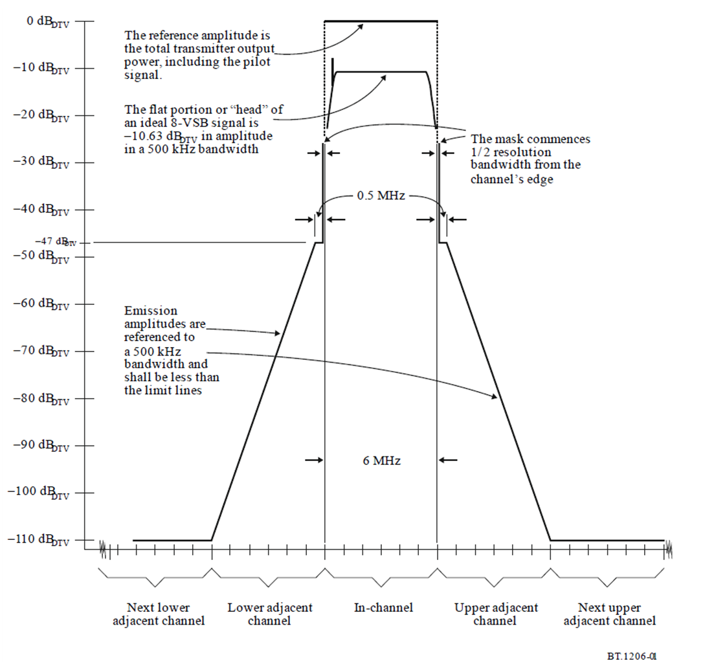

Figure 4.3.3.2-1: Spectrum limit mask for 6 MHz high power 8-VSB digital terrestrial television systems

#### 4.3.3.3 Low power DTTB spectrum limit mask for LPTV transmitters and translators

The spectrum shaping limit in the range between one-half of the width of the resolution bandwidth filter used and 500 kHz from the channel edge relative to the total transmitter output power shall be:

Spectrum shaping limit  –47 (dBDTV)

The spectrum shaping limit at any frequency between 500 kHz and 3 MHz from the channel edge should be:

Spectrum shaping limit  -(11.5 (|ΔF| – 0.5) + 47) (dBDTV)

where:

ΔF is the frequency difference, in MHz, from the channel edge.

The spectrum shaping limit at any frequency more than 3 MHz from the channel edge should be:

Spectrum shaping limit  –76 dBDTV

The DTTB low power spectrum limit mask for LPTV transmitters and translators is illustrated graphically in Figure 4.3.3.3-1.

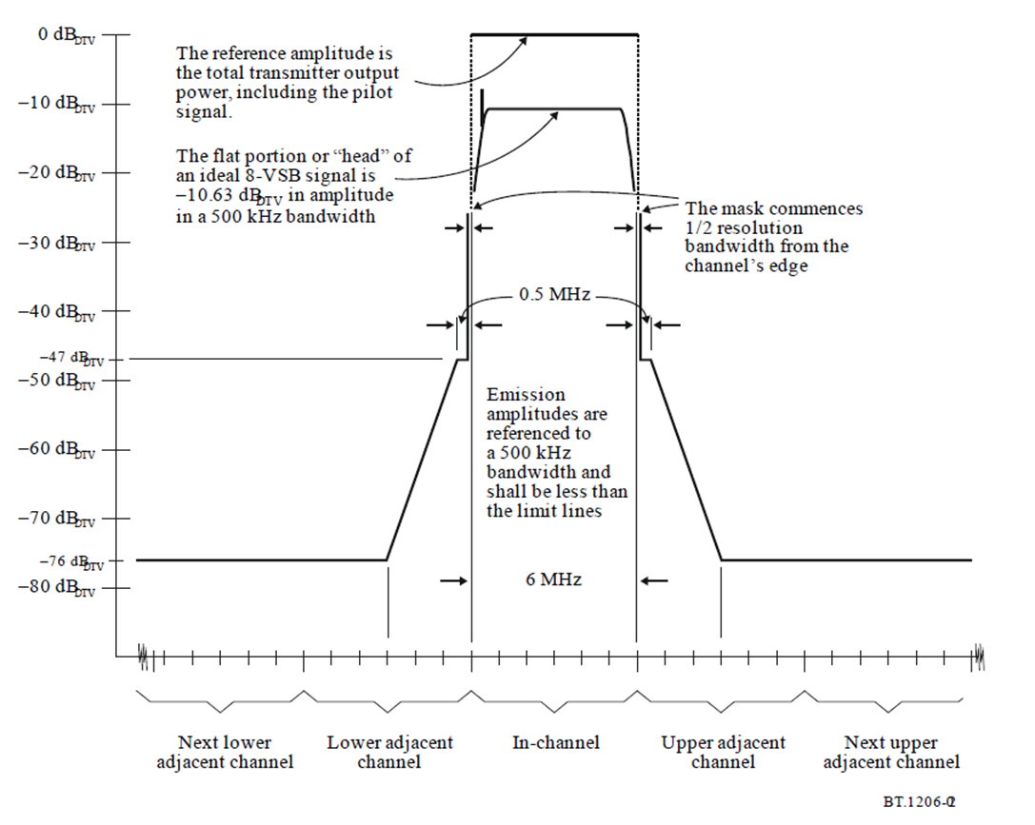

Figure 4.3.3.3-1: Low power spectrum limit mask for 6 MHz 8-VSB LPTV transmitters and translators

#### 4.3.3.4 Simple DTTB spectrum limit mask for LPTV transmitters and translators

The spectrum shaping limit in the range between one-half of the width of the resolution bandwidth filter used and 6 MHz from the channel edge relative to the total transmitter output power shall be:

Spectrum shaping limit  -((ΔF2/1.44) + 46) (dBDTV)

where:

ΔF is the frequency difference, in MHz, from the channel edge.

The spectrum shaping limit at any frequency more than 6 MHz from the channel edge should be:

Spectrum shaping limit  –77 dBDTV

The DTTB simple spectrum limit mask for LPTV transmitters and translators is illustrated graphically in Figure 4.3.3.4-1.

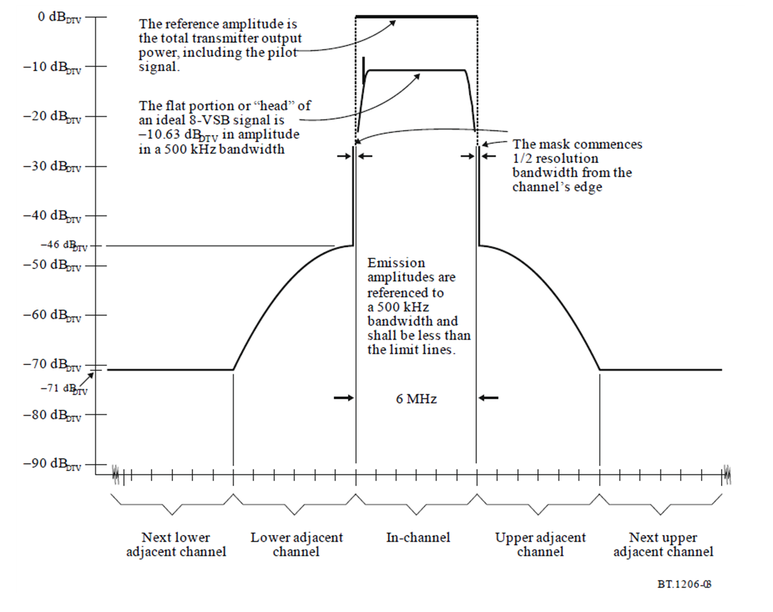

Figure 4.3.3.4-1: Simple spectrum limit mask for 6 MHz 8-VSB LPTV transmitters and translators

## 4.4 Specific spectrum limit masks for digital terrestrial television system B (DVB-T)

### 4.4.1 Specific spectrum limit masks for 6 MHz channelling system B (DVB-T)

For 6 MHz digital television, the OoB domain extends from ±3.0 MHz (i.e. ±0.5 × 6 MHz) to ±15.0 MHz (i.e. ±2.5 × 6 MHz) relative to channel centre.

Two spectrum masks are specified in Figure 4.4.1-1 and the associated Table 4.4.1-1. The upper curve defines the spectrum mask for the non-critical cases and the lower curve defines the spectrum mask for the sensitive cases.

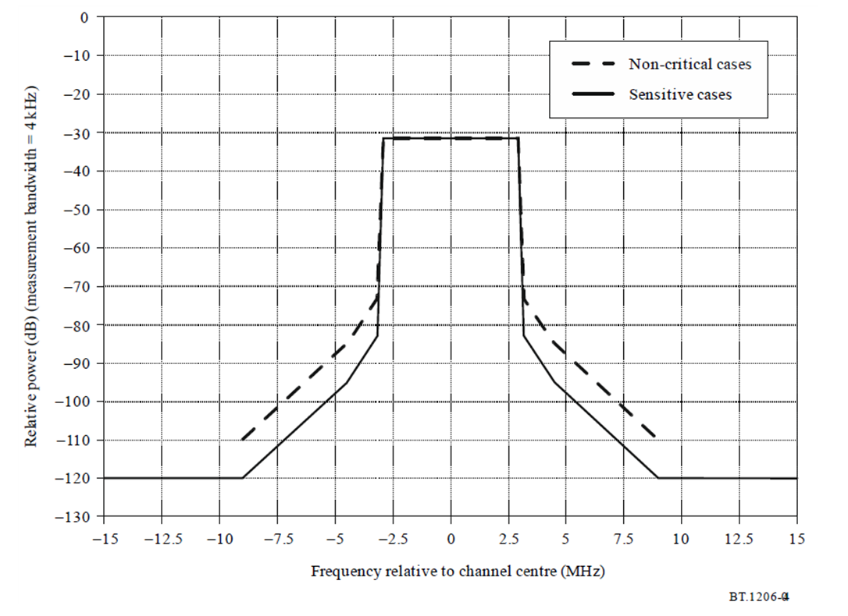

Figure 4.4.1-1: Spectrum limit masks for 6 MHz channelling system B (DVB-T)

Table 4.4.1-1: Table of break points corresponding to Figure 4.4.1-1 for 6 MHz channeling system B (DVB-T)

|  |  |  |
| --- | --- | --- |
| Frequency relative to the centre of the 6 MHz channel (MHz) | Relative level in a 4 kHz measurement bandwidth (dB) | |
| Non-critical emission mask | Sensitive cases |
| –15.0 | –110 | –120 |
| –9.0 | –110 | –120 |
| –4.5 | –85 | –95 |
| –3.15 | –73 | –83 |
| –2.92 | –31.6 | –31.6 |
| +2.92 | –31.6 | –31.6 |
| +3.15 | –73 | –83 |
| +4.5 | –85 | –95 |
| +9.0 | –110 | –120 |
| +15.0 | –110 | –120 |

### 4.4.2 Specific spectrum limit masks for 7 MHz channelling system B (DVB-T)

For 7 MHz digital television, the OoB domain extends from ±3.5 MHz (i.e. ±0.5 × 7 MHz) to ±17.5 MHz (i.e. ±2.5 × 7 MHz) relative to channel centre.

Two spectrum masks are specified in Figure 4.4.2-1 and the associated Table 4.4.2-1. The upper curve defines the spectrum mask for the non-critical cases and the lower curve defines the spectrum mask for the sensitive cases.

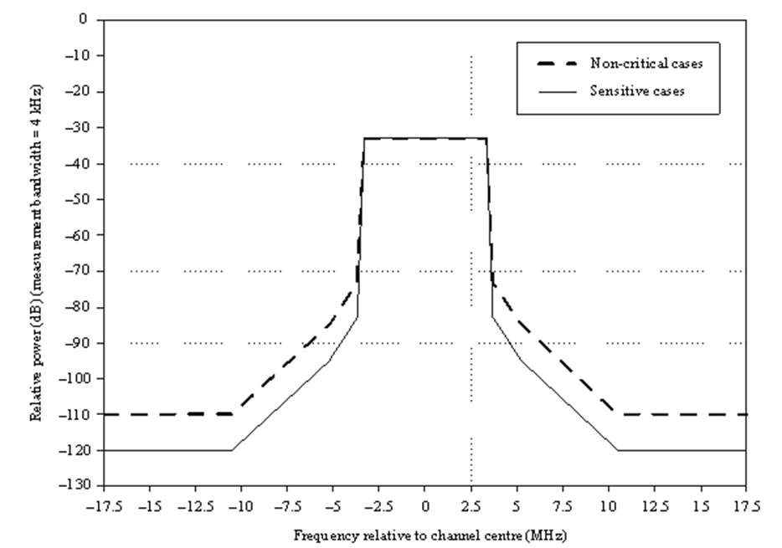

Figure 4.4.2-1: Spectrum limit masks for 7 MHz channelling system B (DVB-T)

Table 4.4.2-1: Table of break points corresponding to Figure 4.4.2-1 for 7 MHz channelling system B (DVB-T)

|  |  |  |
| --- | --- | --- |
| Frequency relative to the centre of the 7 MHz channel (MHz) | Relative level in a 4 kHz measurement bandwidth (dB) | |
| Non-critical emission mask | Sensitive cases |
| –17.5 | –110 | –120 |
| –10.5 | –110 | –120 |
| –5.25 | –85 | –95 |
| –3.7 | –73 | –83 |
| –3.35 | –32.8 | –32.8 |
| +3.35 | –32.8 | –32.8 |
| +3.7 | –73 | –83 |
| +5.25 | –85 | –95 |
| +10.5 | –110 | –120 |
| +17.5 | –110 | –120 |

### 4.4.3 Specific spectrum limit masks for 8 MHz channelling system B (DVB-T)

For 8 MHz digital television, the OoB domain extends from ±4 MHz (i.e. ±0.5 × 8 MHz) to ±20 MHz (i.e. ±2.5 × 8 MHz) relative to channel centre.

Two spectrum masks are specified in Figure 4.4.3-1 and the associated Table 4.4.3-1. The upper curve defines the spectrum mask for the non-critical cases and the lower curve defines the spectrum mask for the sensitive cases.

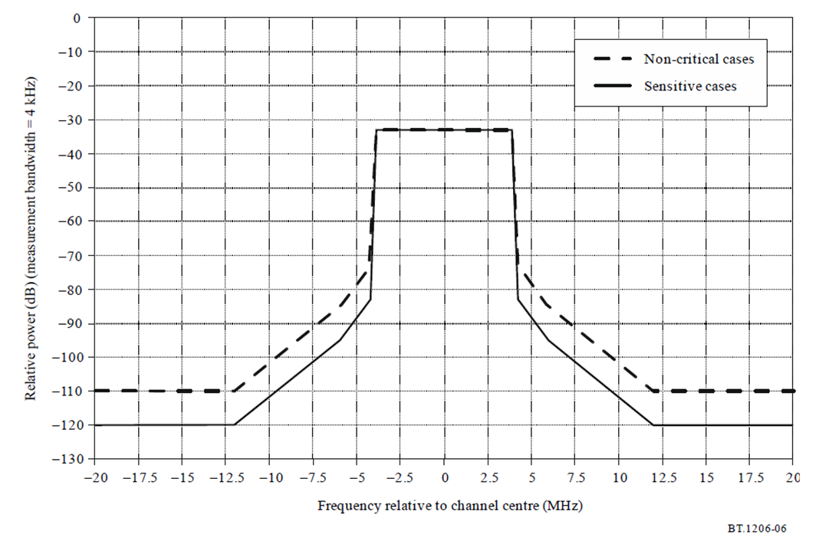

Figure 4.4.3-1: Spectrum limit masks for 8 MHz channelling system B (DVB-T)

Table 4.4.3-1: Table of break points corresponding to Figure 4.4.3-1 for 8 MHz channelling system B (DVB-T)

|  |  |  |
| --- | --- | --- |
| Frequency relative to the centre of the 8 MHz channel (MHz) | Relative level in a 4 kHz measurement bandwidth (dB) | |
| Non-critical emission mask | Sensitive cases |
| –20 | –110 | –120 |
| –12 | –110 | –120 |
| –6 | –85 | –95 |
| –4.2 | –73 | –83 |
| –3.9 | –32.8 | –32.8 |
| +3.9 | –32.8 | –32.8 |
| +4.2 | –73 | –83 |
| +6 | –85 | –95 |
| +12 | –110 | –120 |
| +20 | –110 | –120 |

# 4.5 Specific spectrum limit masks for digital terrestrial television system C (ISDB-T)

### 4.5.1 Specific spectrum limit masks for 6 MHz channelling system C (ISDB-T)

For 6 MHz digital television, the OoB domain extends from ±3 MHz (i.e. ±0.5 × 6 MHz) to ±15 MHz (i.e. ±2.5 × 6 MHz) relative to channel centre.

Spectrum limit masks for 6 MHz channeling system C (ISDB-T) are shown in Figure 4.5.1-1. The related break points are given in Table 4.5.1-1.

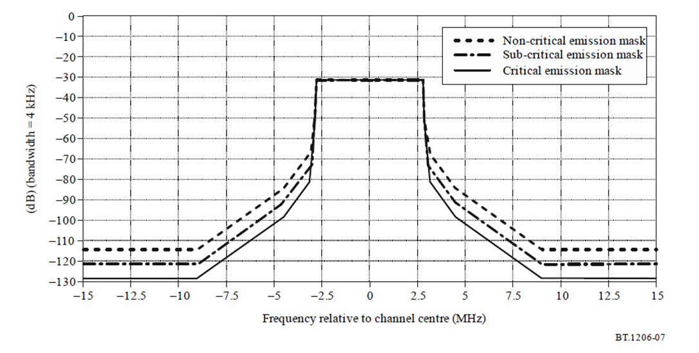

Figure 4.5.1-1: Spectrum limit masks for 6 MHz channeling system C (ISDB-T)

Table 4.5.1-1: Table of break points corresponding to Figure 4.5.1-1 for 6 MHz channelling system C (ISDB-T)

|  |  |  |  |
| --- | --- | --- | --- |
| Frequency relative to the centre of  the 6 MHz channel (MHz) | Relative level in a 4 kHz measurement bandwidth (dB) | | |
| Non-critical emission mask | Sub-critical emission mask | Critical emission mask |
| –15 | –114.4 | –121.4 | –128.4 |
| –9 | –114.4 | –121.4 | –128.4 |
| –4.5 | –84.4 | –91.4 | –98.4 |
| –3.15 | –67.4 | –74.4 | –81.4 |
| –3 | –58.4 | –65.4 | –65.4 |
| –2.86 | –51.4 | –51.4 | –51.4 |
| –2.79 | –31.4 | –31.4 | –31.4 |
| 2.79 | –31.4 | –31.4 | –31.4 |
| 2.86 | –51.4 | –51.4 | –51.4 |
| 3 | –58.4 | –65.4 | –65.4 |
| 3.15 | –67.4 | –74.4 | –81.4 |
| 4.5 | –84.4 | –91.4 | –98.4 |
| 9 | –114.4 | –121.4 | –128.4 |
| 15 | –114.4 | –121.4 | –128.4 |

### 4.5.2 Specific spectrum limit masks for 7 MHz channelling system C (ISDB-T)

For 7 MHz digital television, the OoB domain extends from ±3.5 MHz (i.e. ±0.5 × 7 MHz) to ±17.5 MHz (i.e. ±2.5 × 7 MHz) relative to channel centre.

Two spectrum masks are specified in Figure 4.5.2-1 and the associated Table 4.5.2-1. The upper curve defines the spectrum mask for the non-critical cases and the lower curve defines the spectrum mask for the sensitive cases.

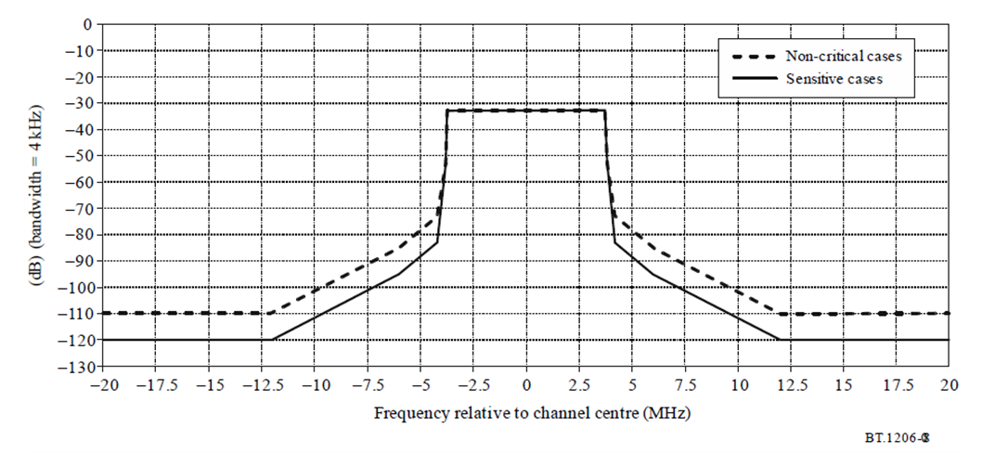

Figure 4.5.2-1: Spectrum limit masks for 7 MHz channeling system C (ISDB-T)

Table 4.5.2-1: Table of break points corresponding to Figure 4.5.2-1 for 7 MHz channeling system C (ISDB-T)

|  |  |  |
| --- | --- | --- |
| Frequency relative to the centre of the 7 MHz channel (MHz) | Relative level in a 4 kHz measurement bandwidth (dB) | |
| Non-critical emission mask | Sensitive cases |
| –17.5 | –110 | –120 |
| –10.5 | –110 | –120 |
| –5.25 | –85 | –95 |
| –3.7 | –73 | –83 |
| –3.34 | –52.1 | –52.1 |
| –3.26 | –32.1 | –32.1 |
| +3.26 | –32.1 | –32.1 |
| +3.34 | –52.1 | –52.1 |
| +3.7 | –73 | –83 |
| +5.25 | –85 | –95 |
| +10.5 | –110 | –120 |
| +17.5 | –110 | –120 |

### 4.5.3 Specific spectrum limit masks for 8 MHz channelling system C (ISDB-T)

For 8 MHz digital television, the OoB domain extends from ±4 MHz (i.e. ±0.5 × 8 MHz) to ±20 MHz (i.e. ±2.5 × 8 MHz) relative to channel centre.

Two spectrum masks are specified in Figure 4.5.3-1 and the associated Table 4.5.3-1. The upper curve defines the spectrum mask for the non-critical cases and the lower curve defines the spectrum mask for the sensitive cases.

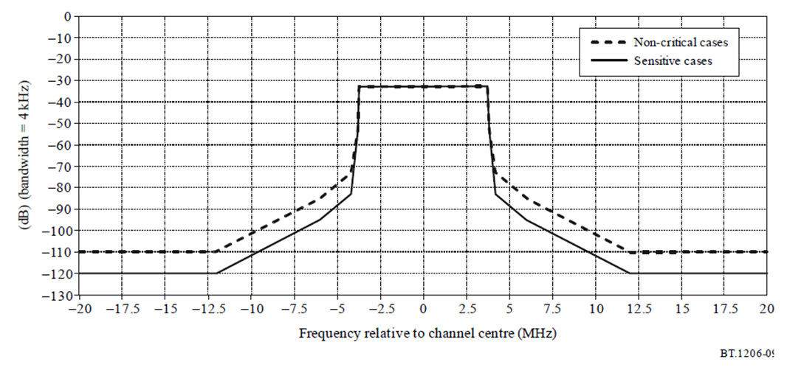

Figure 4.5.3-1: Spectrum limit masks for 8 MHz channeling system C (ISDB-T)

Table 4.5.3-1: Table of break points corresponding to Figure 4.5.3-1 for 8 MHz channelling system C (ISDB-T)

|  |  |  |
| --- | --- | --- |
| Frequency relative to the centre of the 8 MHz channel (MHz) | Relative level in a 4 kHz measurement bandwidth (dB) | |
| Non-critical emission mask | Sensitive cases |
| –20 | –110 | –120 |
| –12 | –110 | –120 |
| –6 | –85 | –95 |
| –4.2 | –73 | –83 |
| –3.81 | –52.7 | –52.7 |
| –3.72 | –32.7 | –32.7 |
| +3.72 | –32.7 | –32.7 |
| +3.81 | –52.7 | –52.7 |
| +4.2 | –73 | –83 |
| +6 | –85 | –95 |
| +12 | –110 | –120 |
| +20 | –110 | –120 |

## 4.6 Specific spectrum limit masks for digital terrestrial television system D (DTMB)

### 4.6.1 Specific spectrum limit masks for 6 MHz channelling system D (DTMB)

For 6 MHz digital television, the OoB domain extends from ±3 MHz (i.e. ±0.5 × 6 MHz) to ±15 MHz (i.e. ±2.5 × 6 MHz) relative to channel centre.

Two spectrum masks are specified in Figure 4.6.1-1 and the associated Table 4.6.1-1. The upper curve defines the spectrum mask for the non-sensitive cases and the lower curve defines the spectrum mask for the sensitive cases.

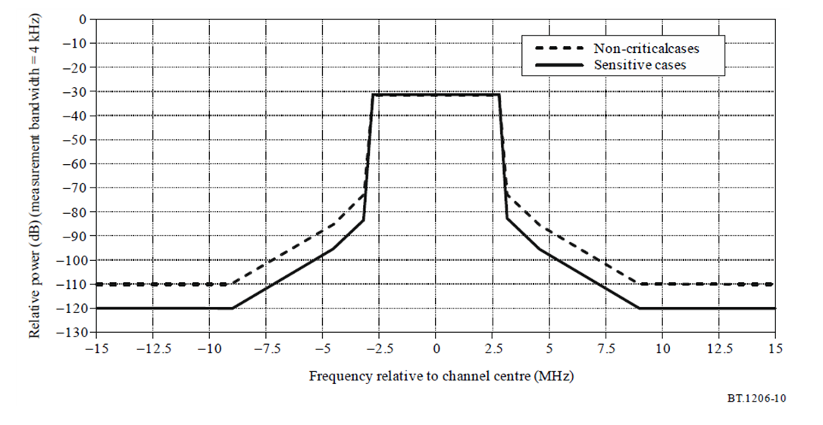

Figure 4.6.1-1: Spectrum limit masks for 6 MHz channeling system D (DTMB)

Table 4.6.1-1: Table of break points corresponding to Figure 4.6.1-1 for 6 MHz channelling system D (DTMB)

|  |  |  |
| --- | --- | --- |
| Frequency relative to the centre of the 8 MHz channel (MHz) | Relative level in a 4 kHz measurement bandwidth (dB) | |
| Non-critical emission mask | Sensitive cases |
| –15 | –110 | –120 |
| –9 | –110 | –120 |
| –4.5 | –85 | –95 |
| –3.15 | –73 | –83 |
| –2.85 | –31.4 | –31.4 |
| 2.85 | –31.4 | –31.4 |
| 3.15 | –73 | –83 |
| 4.5 | –85 | –95 |
| 9 | –110 | –120 |
| 15 | –110 | –120 |

### 4.6.2 Specific spectrum limit masks for 7 MHz channelling system D (DTMB)

For 7 MHz digital television, the OoB domain extends from ±3.5 MHz (i.e. ±0.5 × 7 MHz) to ±17.5 MHz (i.e. ±2.5 × 7 MHz) relative to channel centre.

Two spectrum masks are specified in Figure 4.6.2-1 and the associated Table 4.6.2-1. The upper curve defines the spectrum mask for the non-sensitive cases and the lower curve defines the spectrum mask for the sensitive cases.

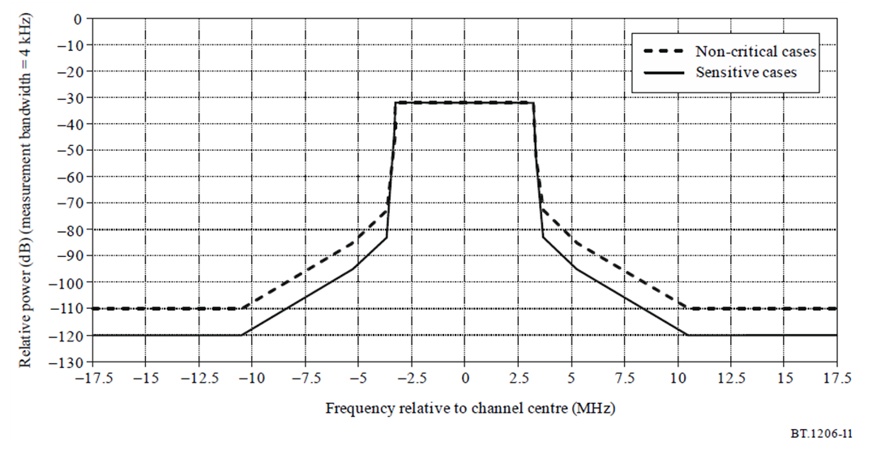

Figure 4.6.2-1: Spectrum limit masks for 7 MHz channeling system D (DTMB)

Table 4.6.2-1: Table of break points corresponding to Figure 4.6.2-1 for 7 MHz channelling system D (DTMB)

|  |  |  |
| --- | --- | --- |
| Frequency relative to the centre of the 7 MHz channel (MHz) | Relative level in a 4 kHz measurement bandwidth (dB) | |
| Non-critical emission mask | Sensitive cases |
| –17.5 | –110 | –120 |
| –10.5 | –110 | –120 |
| –5.25 | –85 | –95 |
| –3.7 | –73 | –83 |
| –3.33 | –32.1 | –32.1 |
| +3.33 | –32.1 | –32.1 |
| +3.7 | –73 | –83 |
| +5.25 | –85 | –95 |
| +10.5 | –110 | –120 |
| +17.5 | –110 | –120 |

### 4.6.3 Specific spectrum limit masks for 8 MHz channelling system D (DTMB)

When the digital system operates on a lower or higher adjacent channel to a co-sited transmitter, the spectrum limit mask of system D with 8 MHz channel spacing for different application scenarios are given by Figures 4.6.3-1 and 4.6.3-2. Detailed data of Figures 4.6.3-1 and 4.6.3-2. were presented by Tables 4.6.3-1 and 4.6.3-2., respectively.

The masks shown in Figure 4.6.3-1 show the minimum protection needed for analogue television where the analogue and the digital television transmitters are co-sited and are applicable for cases where:

- no polarization discrimination between digital and analogue television is used; and

- the radiated power from both transmitters is the same (analogue sync-peak power equal to total power from the digital television transmitter). If the radiated powers from the two transmitters are not identical, proportional correction can be applied as follows:

- correction = minimum analogue erp − maximum digital erp.

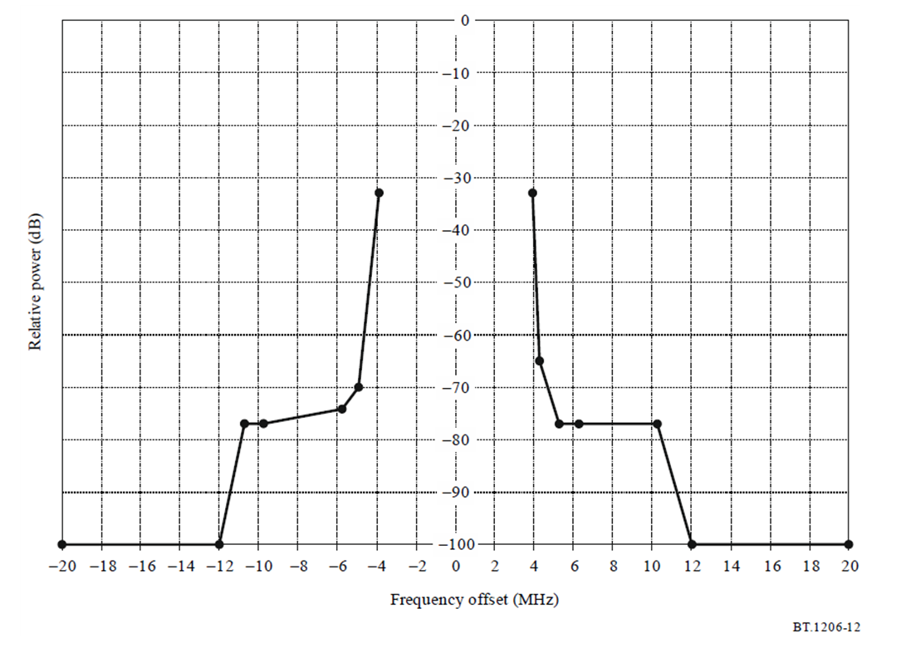

Figure 4.6.3-1: Spectrum limit mask when DTMB transmitter with 8 MHz channel spacing operates on a lower or higher adjacent channel to a co-sited analogue television transmitter (measured with 4 kHz bandwidth)

Table 4.6.3-1: Breakpoints of the spectrum limit mask when DTMB transmitter with 8 MHz channel spacing operates on a lower or higher adjacent channel to a co-sited analogue television transmitter (measured with 4 kHz bandwidth)

|  |  |
| --- | --- |
| Frequency offset to the central frequency (MHz) | Relative level (dB) |
| −20 | −100 |
| −12 | −100 |
| −10.75 | −76.9 |
| −9.75 | −76.9 |
| −5.75 | −74.2 |
| −4.94 | −69.9 |
| −3.9 | −32.8 |
| +3.9 | −32.8 |
| +4.25 | −64.9 |
| +5.25 | −76.9 |
| +6.25 | −76.9 |
| +10.25 | −76.9 |
| +12 | −100 |
| +20 | –100 |

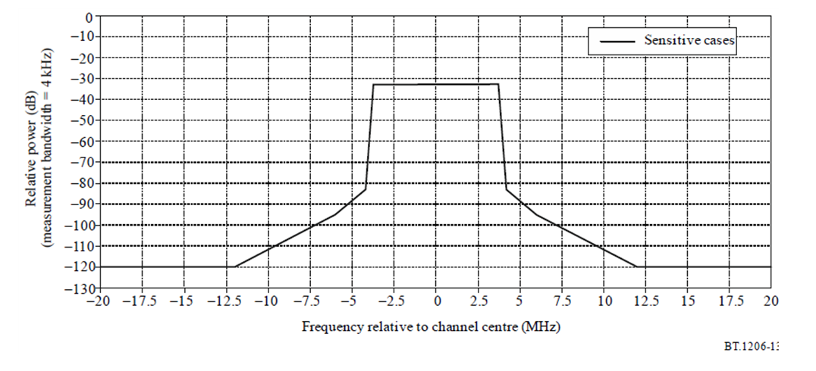

Figure 4.6.3-2: Spectrum limit mask for sensitive cases when DTMB transmitter with 8 MHz channel spacing operates on a lower or higher adjacent channel to other services (e.g. with low power) (measured with 4 kHz bandwidth)

Table 4.6.3-2: Breakpoints of the spectrum limit mask for sensitive cases when DTMB transmitter with 8 MHz channel spacing operates on a lower or higher adjacent channel to other services (e.g. with low power) (measured with 4 kHz bandwidth)

|  |  |
| --- | --- |
| Frequency offset related to the central frequency (MHz) | Relative level (dB) |
| −20 | −120 |
| −12 | −120 |
| −6 | −95 |
| −4.2 | −83 |
| −3.8 | −32.8 |
| +3.8 | −32.8 |
| +4.2 | −83 |
| +6 | −95 |
| +12 | −120 |
| +20 | −120 |

Annex A:  
Regulatory requirements for ITU Region 1 according to GE06 [5]

The regulatory requirements for ITU Region 1 are extracted from ETSI EN 302 296 [3].

# A.1 Scope

The present document specifies technical characteristics and methods of measurements for digital terrestrial television transmitters as defined in Table A.1-1 and A.1-2. The power classification (Table A.1-1) and emission classification (Table A.1-2) are combined to define a transmitter category. For example, power classification H and emission classification 0 denote a high-power transmitter (category H0) whose OOB emissions comply with a non-critical mask.

Table A.1-1: Transmitter power classification

|  |  |  |
| --- | --- | --- |
| Power Class | Description | Notes |
| H | High power transmitter | Transmitter with an output power ≥ 25 W operating in the VHF band (174 MHz to 230 MHz) or UHF band (470 MHz to  694 MHz). |
| L | Low power transmitter | Transmitter with an output power < 25 W operating in the VHF band (174 MHz to 230 MHz) or UHF band (470 MHz to 694 MHz). |

Table A.1-2: Transmitter emission classification

|  |  |  |
| --- | --- | --- |
| Emission  Classification | Conformance approach | Notes |
| 0 | Non-critical mask | For high power transmitters, the mask defines the level of the OOB emissions relative to the channel power (dBc). For low power transmitters the mask defines the absolute power limit of the OOB emissions (dBm). The former approach is mandated by RRC-06 (non-critical case) [i.4] for transmitters  subject to coordination. |
| 1 | Critical mask | A similar but more stringent approach based on ITU RRC-06 (sensitive case) [i.4]. |
| 2 | Non-critical ACLR | A set of ACLR limits defining permitted relative emission levels into adjacent channels. |
| 3 | Critical ACLR | A set of more stringent ACLR limits defining permitted  relative emission levels into adjacent channels. |

# A.2 Conformance requirements

## A.2.1 Introduction

The essential parameters and corresponding technical requirements aiming to meet the requirements of article 3.2 of Directive 2014/53/EU [4] are shown in Table A.2.1-1. To fulfil this essential parameter the compliance with all the corresponding technical requirements in Table A.2.1-1 shall be verified.

Table A.2.1-1: Cross references

|  |  |
| --- | --- |
| Essential parameter | Corresponding technical requirements |
| Conducted emissions at the antenna port | 4.2.2 Spurious emissions |
| 4.2.3 Out-of-band emissions |

Both spurious emission limits and OOB limits are defined in terms of output power at the antenna port. The boundary between spurious domain emissions and out-of-band emissions is shown in Figure A.2.1-1.

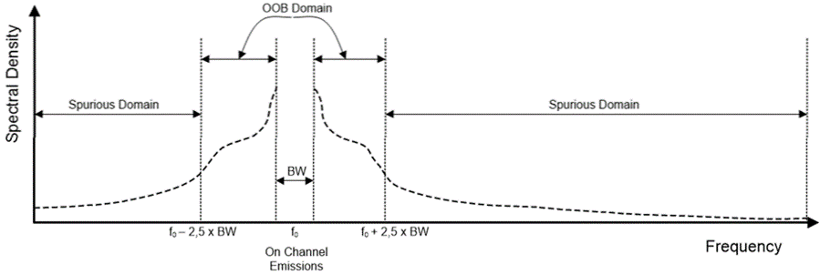

Figure A.2.1-1 Definition of out-of-band and Spurious Domains

## A.2.2 Operating band unwanted emissions and ACLR

### A.2.2.1 Definition

Out-of-band emissions are unwanted emissions which fall at frequencies separated from the centre frequency of the wanted emission by less than or equal to 250 % of the channel bandwidth. For the purposes of the present document out-of-band emissions are emissions at frequencies outside the necessary bandwidth and within the frequency ranges f0 ± 17.5 MHz for 7 MHz channels, f0 ± 20 MHz for 8 MHz channels where f0 is the centre frequency of the channel, irrespective of the number of carriers employed.

For mask-based approaches, the out-of-band emissions limits are given as mean power level measured at the antenna port in a 3 kHz bandwidth.

### A.2.2.2 Classification of transmitters

Transmitters will be classified according to power and emissions according to Table A.1-1 and A.1-2.

With regard to the declaration of conformity, the manufacturer shall declare which classification the equipment complies with. For example, a transmitter conforming to classification H0 is a high-power transmitter conforming to the non-critical mask.

### A.2.2.3 Limits

Out-of-band emissions shall not exceed the values set out in Table A.2.2.3-1 to A.2.2.3-6, subject to the specific transmitter category (see Table A.1-1 and A.1-2).

Table A.2.2.3-1 sets out the limits for transmitter classification L0. Table A.2.2.3-2 sets out the limits for transmitter classification L1. Table A.2.2.3-3 sets out the limits for transmitter classifications L2 and L3.

Table A.2.2.3-4 sets out the limits for transmitter classification H0 additionally shown in Figure A.2.2.3-1 and A.2.2.3-2 for 7 MHz channels and 8 MHz channels respectively. Table A.2.2.3-5 sets out the limits for transmitter classification H1 additionally shown in Figure A.2.2.3-3 and A.2.2.3-4 for 7 MHz channels and 8 MHz channels respectively. Table A.2.2.3-6 sets out the limits for transmitter classification H3.

Table A.2.2.3-1: OOB emission limits for classification L0

|  |  |  |  |
| --- | --- | --- | --- |
| Transmitter Classification | Frequency offset for 7 MHz systems  (MHz) | Frequency offset for 8 MHz systems  (MHz) | Absolute power level (dBm/3 kHz) |
| L0  (Low power, non-critical mask) | ±3.41 | ±3.9 | ≤ 10 |
| ±3.7 | ±4.2 | ≤ -30 |
| ±5.25 | ±6 | ≤ -42 |
| ±10.5 | ±12 | ≤ -67 |
| ±17.5 | ±20 | ≤ -67 |

Table A.2.2.3-2: OOB emission limits for classification L1

|  |  |  |  |
| --- | --- | --- | --- |
| Transmitter Classification | Frequency offset for 7 MHz systems  (MHz) | Frequency offset for 8 MHz systems  (MHz) | Absolute power level (dBm/3 kHz) |
| L1  (Low power, critical mask) | ±3.41 | ±3.9 | ≤ 10 |
| ±3.7 | ±4.2 | ≤ -40 |
| ±5.25 | ±6 | ≤ -52 |
| ±10.5 | ±12 | ≤ -77 |
| ±17.5 | ±20 | ≤ -77 |

Table A.2.2.3-3: OOB limits for transmitter classification L2 and L3

|  |  |  |
| --- | --- | --- |
| Transmitter  Classification | First adjacent channel ACLR  (dB) | Second adjacent channel ACLR  (dB) |
| L2 | ≥ 42 | ≥ 64 |
| L3 | ≥ 55 | ≥ 77 |
| NOTE 1: The first and second adjacent channel frequency offsets are defined as 8 MHz and 16 MHz respectively for UHF transmitters and 7 MHz and 14 MHz respectively for VHF transmitters.  NOTE 2: The integration bandwidth for the victim channel is defined as 7 MHz for VHF transmitters and 8 MHz for UHF transmitters. | | |

Table A.2.2.3-4: OOB emission limits for classification H0

|  |  |  |  |
| --- | --- | --- | --- |
| **Transmitter Classification** | **Frequency offset for**  **7 MHz systems (MHz)** | **Frequency offset for**  **8 MHz systems (MHz)** | **Relative power level (dBc/3 kHz)** |
| H0  (High power, non- critical mask) | ±3.41 | ±3.9 | ≤ -34 |
| ±3.7 | ±4.2 | ≤ -74 |
| ±5.25 | ±6 | ≤ -86 |
| ±10.5 | ±12 | ≤ -111 |
| ±17.5 | ±20 | ≤ -111 |
| NOTE: The limits for UHF transmitters using 8 MHz channels are plotted in Figure A.2.2.3-2. The limits for VHF transmitters using 7 MHz channels are plotted in Figure A.2.2.3-1. | | | |

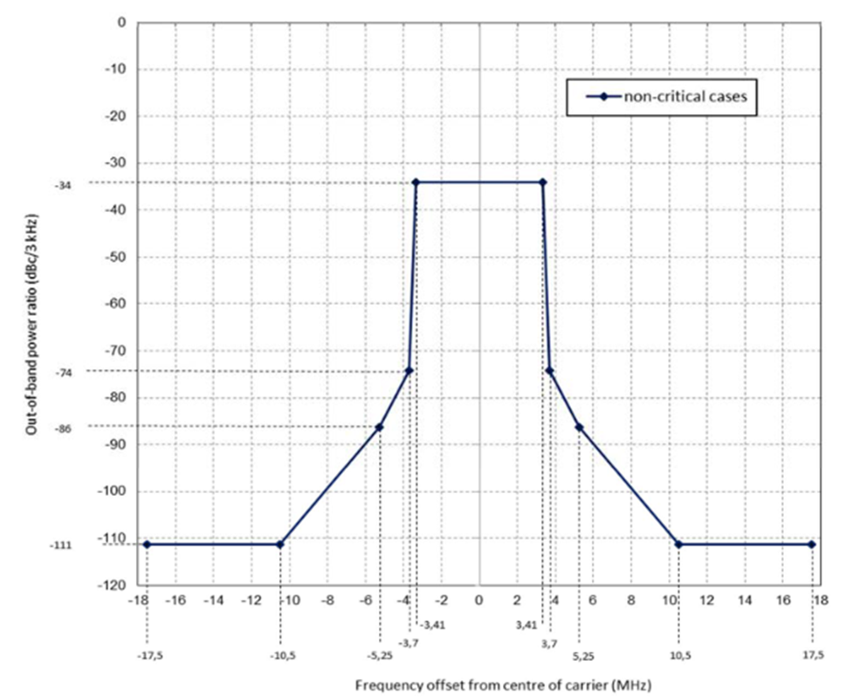

Figure A.2.2.3-1: Out-of-band limits for transmitter classification H0 using 7 MHz channels

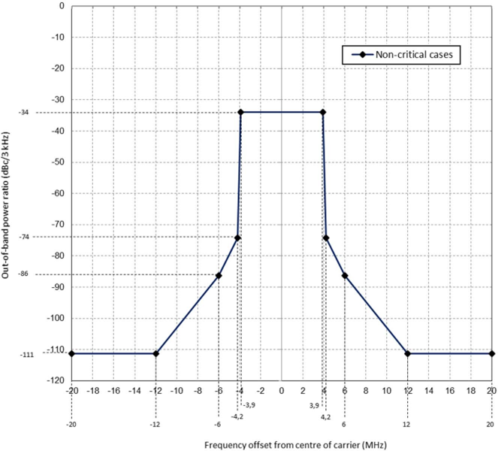

Figure A.2.2.3-2: Out-of-band limits for transmitter classification H0 using 8 MHz channels

Table A.2.2.3-5: OOB emission limits for classification H1

|  |  |  |  |
| --- | --- | --- | --- |
| Transmitter Classification | 7 MHz Channel, frequency difference from the centre frequency (MHz) | 8 MHz Channel, frequency difference from the centre frequency (MHz) | Relative level (dBc/3 kHz) |
| H1  (High power, critical mask) | ±3.41 | ±3.9 | ≤ -34 |
| ±3.7 | ±4.2 | ≤ -84 |
| ±5.25 | ±6 | ≤ -96 |
| ±10.5 | ±12 | ≤ -121 |
| ±17.5 | ±20 | ≤ -121 |
| NOTE: The limits for UHF transmitters using 8 MHz channels are plotted in Figure A.2.2.3-4 and the limits for VHF transmitters using 7 MHz channels are plotted in Figure A.2.2.3-3. | | | |

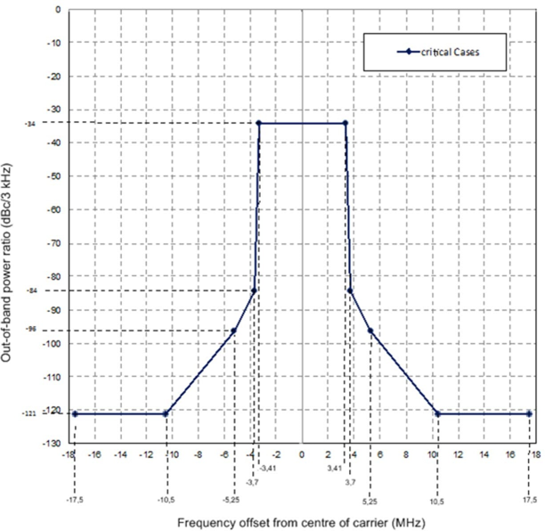

Figure A.2.2.3-3: Out-of-band limits for transmitter classification H1 using 7 MHz channels

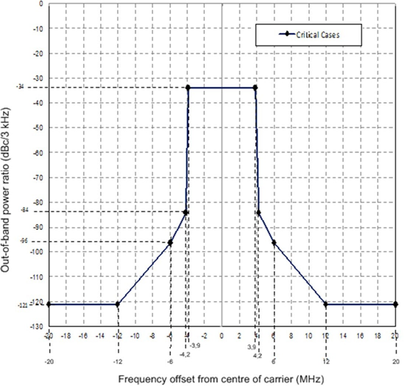

Figure A.2.2.3-4: Out-of-band limits for transmitter classification H1 using 8 MHz channels

Table A.2.2.3-6: OOB emission limits for classification H3

|  |  |  |  |  |  |  |  |  |
| --- | --- | --- | --- | --- | --- | --- | --- | --- |
| Transmitter Classification | UHF DVB-T/T2  ACLR limits (see note 1) | | VHF DVB-T/T2  ACLR limits (see note 2) | | LTE-800 ACLR limits (see note 3) | | LTE-700 ACLR limits (see note 3) | |
| Offset  (MHz) | ACLR  (dB) | Offset  (MHz) | ACLR  (dB) | Offset  (MHz) | ACLR  (dB) | Offset  (MHz) | ACLR  (dB) |
| H3  (critical ACLR) | ±8 | ≥ 61 | ±7 | ≥ 61 | +10 | ≥ 68 | +18 | ≥ 86 |
| ±16 | ≥ 87 | ±14 | ≥ 87 | +20 | ≥ 86 | N/A | N/A |
| NOTE 1: The ACLR limits are derived by integration of the critical mask defined in Table A.2.2.3-5 over the victim DVB-T/T2 bandwidth of 8 MHz.  NOTE 2: For VHF DVB-T2 systems (7 MHz channels) the victim DVB-T/T2 service integration bandwidth is 7 MHz.  NOTE 3: These values apply only for UHF transmitters. The victim service integration bandwidth is 10 MHz. | | | | | | | | |

## A.2.3 Transmitter spurious emissions

### A.2.3.1 Definition

Spurious emissions are unwanted emissions at frequencies separated by more than 250 % of the channel bandwidth from the centre of the occupied spectrum. These include harmonic emissions, parasitic emissions, intermodulation products and frequency conversion products but exclude out-of-band emissions.

For the purposes of the present document spurious emissions are emissions at frequencies outside the frequency range f0 ± 17.5 MHz for 7 MHz channels, f0 ± 20 MHz for 8 MHz channels, where f0 is the centre frequency of the channel, irrespective of the number of carriers employed.

### A.2.3.2 Limits

Spurious emissions shall not exceed the values set out in Table A.2.3.2-1 additionally shown in Figure A.2.3.2-1, for the frequency range 9 kHz to 3 GHz.

Table A.2.3.2-1: Spurious emission limits for DVB-T/T2 transmitters

|  |  |  |
| --- | --- | --- |
| Frequency range of the  spurious emission | Limits of the spurious emission | Reference  bandwidth |
| 9 kHz to 470 MHz | ≤ -36 dBm (250 nW) for P  69 dBm  ≥ 105 dBc for 69 dBm < P | 100 kHz |
| > 470 MHz to 694 MHz | ≤ -36 dBm for P  39 dBm  ≥ 75 dBc for 39 dBm < P  50 dBm  ≤ -25 dBm (3 µW) for 50 dBm < P | 100 kHz |
| > 694 MHz | ≤ -36 dBm (250 nW) for P  69 dBm  ≥ 105 dBc for 69 dBm < P | 100 kHz |
| NOTE: P = mean power of the transmitter measured at the antenna port. | | |

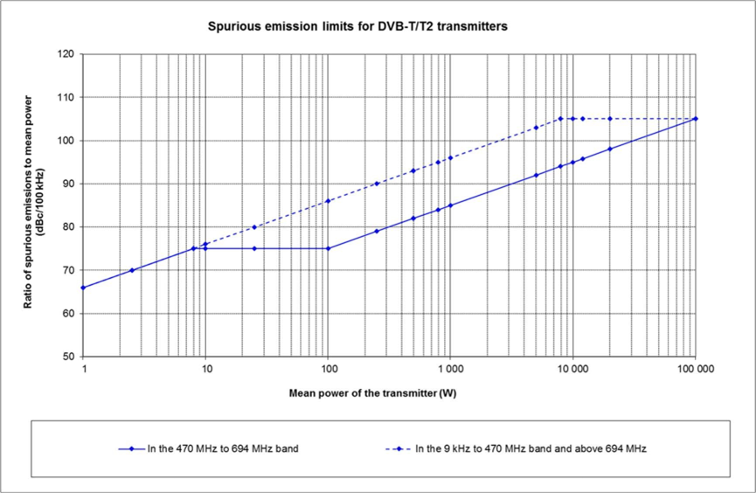

Figure A.2.3.2-1: Spurious emission limits measured at the antenna port (100 kHz reference bandwidth)

Annex B (informative):  
Change history

|  |  |  |  |  |  |  |  |
| --- | --- | --- | --- | --- | --- | --- | --- |
| Change history | | | | | | | |
| Date | Meeting | TDoc | CR | Rev | Cat | Subject/Comment | New version |
| 2023-02 | RAN4 #106 | R4-2302702 |  |  |  | Skeleton TR | 0.0.1 |
| 2023-09 | RAN #101 | RP-232589 |  |  |  | The changes come from a RAN4 TP in R4-2313084 agreed during RAN4 #108. | 1.0.0 |

|  |  |  |  |  |  |  |  |
| --- | --- | --- | --- | --- | --- | --- | --- |
| Change history | | | | | | | |
| Date | Meeting | TDoc | CR | Rev | Cat | Subject/Comment | New version |
| 2023-09 | RAN #101 |  |  |  |  | Put under change control | 18.0.0 |
| 2023-12 | RAN#102 | RP-233359 | 0001 |  | F | [LTE_terr_bcast_bands_part2-Core] CR to TR 36.792: adding missing figures, general cleanup, Rel-18 | 18.1.0 |