|  |  |
| --- | --- |
| 3GPP TR 38.761 V18.0.0 (2023-12) | |
| Technical Report | |
| 3rd Generation Partnership Project;  Technical Specification Group Radio Access Network;  Measurements of Multiple Input Multiple Output (MIMO) Over-the-Air (OTA) performance of User Equipment (UE);  (Release 18) | |
|  | |
|  |  |
|  | |
| The present document has been developed within the 3rd Generation Partnership Project (3GPP TM) and may be further elaborated for the purposes of 3GPP. The present document has not been subject to any approval process by the 3GPPOrganizational Partners and shall not be implemented. This Specification is provided for future development work within 3GPPonly. The Organizational Partners accept no liability for any use of this Specification. Specifications and Reports for implementation of the 3GPP TM system should be obtained via the 3GPP Organizational Partners' Publications Offices. | |

|  |
| --- |
|  |
| ***3GPP***  Postal address  3GPP support office address  650 Route des Lucioles - Sophia Antipolis  Valbonne - FRANCE  Tel.: +33 4 92 94 42 00 Fax: +33 4 93 65 47 16  Internet  https://www.3gpp.org |
| ***Copyright Notification***  No part may be reproduced except as authorized by written permission. The copyright and the foregoing restriction extend to reproduction in all media.  © 2023, 3GPP Organizational Partners (ARIB, ATIS, CCSA, ETSI, TSDSI, TTA, TTC).  All rights reserved.  UMTS™ is a Trade Mark of ETSI registered for the benefit of its members  3GPP™ is a Trade Mark of ETSI registered for the benefit of its Members and of the 3GPP Organizational Partners LTE™ is a Trade Mark of ETSI registered for the benefit of its Members and of the 3GPP Organizational Partners  GSM® and the GSM logo are registered and owned by the GSM Association |

Contents

Foreword 6

1 Scope 8

2 References 8

3 Definitions of terms, symbols and abbreviations 8

3.1 Terms 8

3.2 Symbols 9

3.3 Abbreviations 9

4 General 10

4.1 Device types 10

4.2 Testing configuration 10

4.3 Testing Bands 10

5 Measurement setup 10

5.1 General 10

5.2 Measurement setup for FR1 MIMO OTA 10

5.3 Measurement setup for FR2 MIMO OTA 10

6 Channel Model Validation 10

6.1 General 10

6.2 Verification of Channel Model implementation of FR1 11

6.2.1 Framework 11

6.2.2 Channel Model Validation Results 11

6.2.2.1 Power Delay Profile (PDP) 11

6.2.2.2 Doppler/Temporal correlation 17

6.2.2.3 Spatial correlation 27

6.2.2.4 Cross-polarization 34

6.2.2.5 Power validation 37

6.3 Verification of Channel Model implementation of FR2 39

6.3.1 Framework 39

6.3.2 Channel Model Validation Results 40

6.3.2.1 Power Delay Profile (PDP) 40

6.3.2.2 Doppler/Temporal correlation 42

6.3.2.3 PAS similarity percentage (PSP) 44

6.3.2.4 Cross-polarization 47

6.3.2.5 Power validation 48

7 Lab alignment of FR1 MIMO OTA 48

7.1 General 48

7.2 Noise impact in MPAC on MIMO performance 49

7.3 Lab alignment campaign for frequency bands > 1GHz 51

7.3.1 Framework 51

7.3.2 Measurement results 51

7.3.3 Pass/fail limits 53

7.3.4 Conclusion 53

7.4 Lab alignment campaign for frequency bands < 1GHz 53

7.4.1 Framework 53

7.4.2 Measurement results 54

7.4.3 Pass/fail limits 54

7.4.4 Conclusion 54

8 Lab alignment of FR2 MIMO OTA 54

8.1 Framework 54

8.2 Measurement results 55

8.3 Pass/fail limits 55

8.4 Conclusion 55

Annex A: Change history 56

# Foreword

This Technical Report has been produced by the 3rd Generation Partnership Project (3GPP).

The contents of the present document are subject to continuing work within the TSG and may change following formal TSG approval. Should the TSG modify the contents of the present document, it will be re-released by the TSG with an identifying change of release date and an increase in version number as follows:

Version x.y.z

where:

x the first digit:

1 presented to TSG for information;

2 presented to TSG for approval;

3 or greater indicates TSG approved document under change control.

y the second digit is incremented for all changes of substance, i.e. technical enhancements, corrections, updates, etc.

z the third digit is incremented when editorial only changes have been incorporated in the document.

In the present document, modal verbs have the following meanings:

**shall** indicates a mandatory requirement to do something

**shall not** indicates an interdiction (prohibition) to do something

The constructions "shall" and "shall not" are confined to the context of normative provisions, and do not appear in Technical Reports.

The constructions "must" and "must not" are not used as substitutes for "shall" and "shall not". Their use is avoided insofar as possible, and they are not used in a normative context except in a direct citation from an external, referenced, non-3GPP document, or so as to maintain continuity of style when extending or modifying the provisions of such a referenced document.

**should** indicates a recommendation to do something

**should not** indicates a recommendation not to do something

**may** indicates permission to do something

**need not** indicates permission not to do something

The construction "may not" is ambiguous and is not used in normative elements. The unambiguous constructions "might not" or "shall not" are used instead, depending upon the meaning intended.

**can** indicates that something is possible

**cannot** indicates that something is impossible

The constructions "can" and "cannot" are not substitutes for "may" and "need not".

**will** indicates that something is certain or expected to happen as a result of action taken by an agency the behaviour of which is outside the scope of the present document

**will not** indicates that something is certain or expected not to happen as a result of action taken by an agency the behaviour of which is outside the scope of the present document

**might** indicates a likelihood that something will happen as a result of action taken by some agency the behaviour of which is outside the scope of the present document

**might not** indicates a likelihood that something will not happen as a result of action taken by some agency the behaviour of which is outside the scope of the present document

In addition:

**is** (or any other verb in the indicative mood) indicates a statement of fact

**is not** (or any other negative verb in the indicative mood) indicates a statement of fact

The constructions "is" and "is not" do not indicate requirements.

# 1 Scope

The present document is a Technique Report for Measurements of Multiple Input Multiple Output (MIMO) Over-the-Air (OTA) performance of User Equipment (UE). It includes analysis and measurement results of MIMO OTA in Frequency Range 1 and Frequency Range 2, such as verification of channel models, lab alignment activities, etc..

# 2 References

The following documents contain provisions which, through reference in this text, constitute provisions of the present document.

- References are either specific (identified by date of publication, edition number, version number, etc.) or non‑specific.

- For a specific reference, subsequent revisions do not apply.

- For a non-specific reference, the latest version applies. In the case of a reference to a 3GPP document (including a GSM document), a non-specific reference implicitly refers to the latest version of that document *in the same Release as the present document*.

[1] 3GPP TR 21.905: "Vocabulary for 3GPP Specifications".

[2] 3GPP TR 38.151: “NR; Multiple Input Multiple Output (MIMO) Over-the-Air (OTA) performance requirements for NR UEs”.

[3] 3GPP TR 38.827: “Study on radiated metrics and test methodology for the verification of multi-antenna reception performance of NR User Equipment (UE)”.

[4] 3GPP TS 38.101-1: "NR; User Equipment (UE) radio transmission and reception; Part 1: Range 1 Standalone"

[5] 3GPP TS 38.101-2: "NR; User Equipment (UE) radio transmission and reception; Part 2: Range 2 Standalone"

[6] 3GPP TS 38.101-3: "NR; User Equipment (UE) radio transmission and reception; Part 3: Range 1 and Range 2 Interworking operation with other radios"

[7] 3GPP TS 38.101-4: "NR; User Equipment (UE) radio transmission and reception; Part 4: Performance requirements"

[8] 3GPP TS 36.101: "Evolved Universal Terrestrial Radio Access (E-UTRA); User Equipment (UE) radio transmission and reception"

[9] 3GPP TS 38.508-1: "5GS; User Equipment (UE) conformance specification; Part 1: Common test environment"

[10] 3GPP TR 38.901: "Study on channel model for frequencies from 0.5 to 100 GHz"

[11] F. Zhang, L. Hentilä, P. Kyösti and W. Fan, "Millimeter-wave New Radio Test Zone Validation for MIMO Over-the-air Testing," in IEEE Transactions on Antennas and Propagation, doi: 10.1109/TAP.2021.3111326.

# 3 Definitions of terms, symbols and abbreviations

## 3.1 Terms

For the purposes of the present document, the terms given in TR 21.905 [1] and the following apply. A term defined in the present document takes precedence over the definition of the same term, if any, in TR 21.905 [1].

**FS:** UE used in a free space configuration.

**Handheld UE:** A UE intended to be used in hand held scenario.

**MIMO Average Spherical Coverage:** An averaged sensitivity of best 18 FR2 MIMO OTA sensitivity values within the 3D sphere with constant-density points for PC3 device.

**Primary mechanical mode:** The mode that is most often used for a specific user scenario. Every terminal has at least one primary mechanical mode, if multiple modes are supported, different primary mechanical modes may be applicable for different user scenarios, e.g., different primary mechanical modes for Free Space and Hand phantom usage for the same UE.

**PSP (PAS Similarity Percentage):** The similarity of the PAS produced by the OTA system and the reference PAS, which is presented by the Total Variation Distance (TVD) of power angular spectrum (PAS). PSP is defined as (1-TVD)*100%. PSP=100% denotes full similarity and PSP=0% denotes full dissimilarity..

## 3.2 Symbols

For the purposes of the present document, the following symbols apply:

## 3.3 Abbreviations

For the purposes of the present document, the abbreviations given in TR 21.905 [1] and the following apply. An abbreviation defined in the present document takes precedence over the definition of the same abbreviation, if any, in TR 21.905 [1].

AOA Azimuth angle Of Arrival

AOD Azimuth angle Of Departure

BS Base Station

CDL Clustered Delay Line

CW Continuous Wave

DML Data Mode Landscape

DMP Data Mode Portrait

DMSU Data Mode Screen Up

DUT Device Under Test

EUT Equipment Under Test

FR1 Frequency Range 1

FR2 Frequency Range 2

FS Free Space

MASC MIMO Average Spherical Coverage

MIMO Multiple Input Multiple Output

MPAC Multi-Probe Anechoic Chamber

NR New Radio

NSA Non-Standalone, a mode of operation where operation of an other radio is assisted with an other radio

OTA Over The Air

PAS Power Angular Spectrum

PDP Power Delay Profile

PSP PAS Similarity Percentage

RS-EPRE Reference Signal-Energy Per Resource Element

SS System Simulator

SSS Secondary Synchronization Signal

TRMS Total Radiated Multi-antenna Sensitivity

UE User Equipment

UMa Urban Macro

UMi Urban Micro

XPR Cross-Polarization Ratio

ZOA Zenith angle Of Arrival

ZOD Zenith angle Of Departure

ZSA Zenith angle Spread of Arrival

ZSD Zenith angle Spread of Departure

# 4 General

## 4.1 Device types

The present technical report covers the smartphone device type.

## 4.2 Testing configuration

The present technical report covers the free space (FS) testing configuration.

## 4.3 Testing Bands

The present technical report covers both FR1 and FR2 operating bands. FR1 operating bands are defined in TS 38.101-1 [4] and FR2 operating bands are defined in TS 38.101-2 [5]. NSA band combinations are defined in TS 38.101-3 [6]. E-UTRA is designed to operate in operating bands defined in TS 36.101 [8].

# 5 Measurement setup

## 5.1 General

The measurements in the present technical report are based on the test methodology defined in 3GPP TS 38.151 [2] and 3GPP TR 38.827 [3].

## 5.2 Measurement setup for FR1 MIMO OTA

The multi-probe anechoic chamber (MPAC) test method is the reference methodology for FR NR MIMO OTA testing, the measurement setup and test procedure are defined in TS 38.151 [2].

## 5.3 Measurement setup for FR2 MIMO OTA

The 3D MPAC test method is the reference methodology for FR2 NR MIMO OTA testing, the measurement setup and test procedure are defined in TS 38.151 [2].

# 6 Channel Model Validation

## 6.1 General

This clause describes the FR1 and FR2 MIMO OTA channel model validation measurements. The purpose of channel model validation is to ensure that the channel models are correctly implemented and hence capable of generating the propagation environment, as described by the model, within the test zone.

## 6.2 Verification of Channel Model implementation of FR1

### 6.2.1 Framework

This clause describes how to proceed Channel Model Validation for FR1 MIMO OTA with MPAC system.

- The channel model validation measurements shall be performed according to the procedures in Annex C.3 of TS 38.151, including:

- Power Delay Profile (PDP)

- Doppler/Temporal correlation

- Spatial correlation

- Cross-polarization

- Power validation

- Channel model: FR1 UMa CDL-C and UMi CDL-C, as specified in Annex C.1 of TS 38.151

- Test frequency: as specified in Tables C.3.1-1 and C.3.1-2 of TS 38.151

- Pass/fail limits: as defined in Annex C.4 of TS 38.151

### 6.2.2 Channel Model Validation Results

This clause presents channel model validation results from different labs with different types of equipment and setup vendors. All the validation results are included for comparison. Table 6.2.2-1 lists equipment and setup vendors of different labs.

Table 6.2.2-1: Equipment and setup vendors of different labs

|  |  |  |  |
| --- | --- | --- | --- |
| Labs | Channel Emulator | BS Emulator | System |
| Lab 1 | Vendor A | Vendor I | Vendor 1 |
| Lab 2 | Vendor B (for bands n41, n78)  Vendor A (for band n28) | Vendor II | Vendor 4 |
| Lab 3 | Vendor B | Vendor II | Vendor 1 |
| Lab 4 | Vendor A | Vendor II | Vendor 3 |
| Lab 5 | Vendor A | Vendor III | Vendor 3 |
| Lab 6 | Vendor B | Vendor I | Vendor 2 |
| Lab 7 | Vendor B | Vendor I | Vendor 1 |

#### 6.2.2.1 Power Delay Profile (PDP)

The PDP should be validated in a Beam-Specific manner. It is assumed that the beams are mapped to the inputs of the channel emulator as follows:

- Beam 1: Input 1 and Input 2

- Beam 2: Input 3 and Input 4 (CDL-C UMa only)

The PDP measurement results of UMa CDL-C for bands n41 and n78 are presented in Figures 6.2.2.1-1~5.



(a) Band n41



(b) Band n78

Figure 6.2.2.1-1: Lab 1: PDP measurement results for CDL-C UMa, (a) Band n41, beam 1 and beam 2; (b) Band n78, beam 1 and beam 2. CE bandwidth: 100MHz



(a) Band n41



(b) Band n78

Figure 6.2.2.1-2: Lab 2: PDP measurement results for CDL-C UMa, (a) Band n41, beam 1 and beam 2; (b) Band n78, beam 1 and beam 2



(a) Band n41



(b) Band n78

Figure 6.2.2.1-3: Lab 3: PDP measurement results for CDL-C UMa, (a) Band n41, beam 1 and beam 2; (b) Band n78, beam 1 and beam 2. CE bandwidth: 40MHz

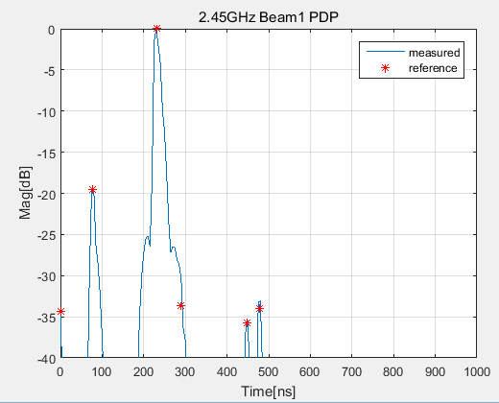 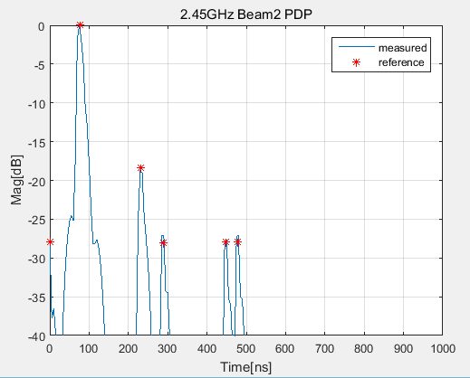

(a) Band n41

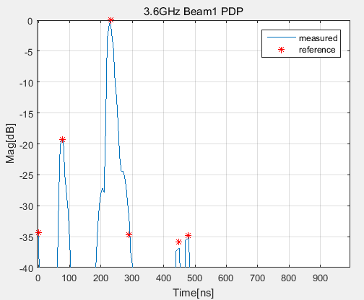 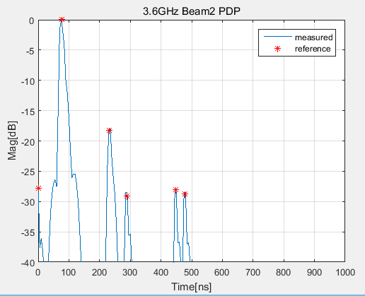

(b) Band n78

Figure 6.2.2.1-4: Lab 4: PDP measurement results for CDL-C UMa, (a) Band n41, beam 1 and beam 2; (b) Band n78, beam 1 and beam 2.

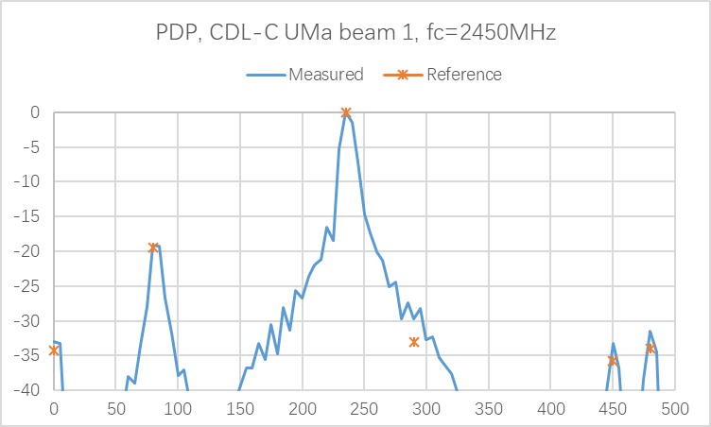 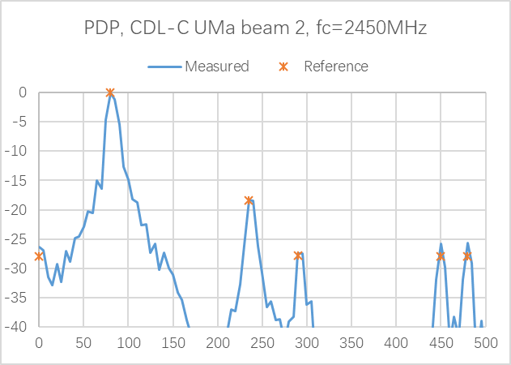

a. Band 41

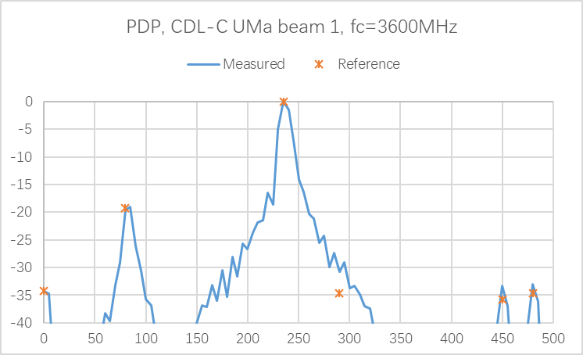 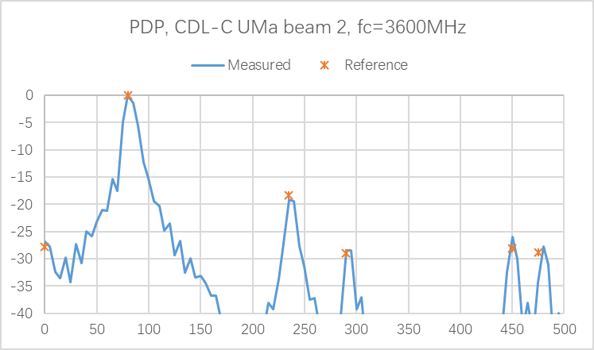

b. Band n78

Figure 6.2.2.1-5: Lab 5: PDP measurement results for CDL-C UMa, (a) Band n41, beam 1 and beam 2; (c) Band n78, beam 1 and beam 2.

(a) Band n41

(b) Band n78

Figure 6.2.2.1-6: Lab 6: PDP measurement results for CDL-C UMa, (a) Band n41, beam 1 and beam 2; (b) Band n78, beam 1 and beam 2.

The PDP measurement results of UMi CDL-C for band n28 are presented in Figures 6.2.2.1-7~12.



Figure 6.2.2.1-7: Lab 1: PDP measurement results for CDL-C UMi at Band n28, beam 1



Figure 6.2.2.1-8: Lab 2: PDP measurement results for CDL-C UMi at Band n28, beam 1

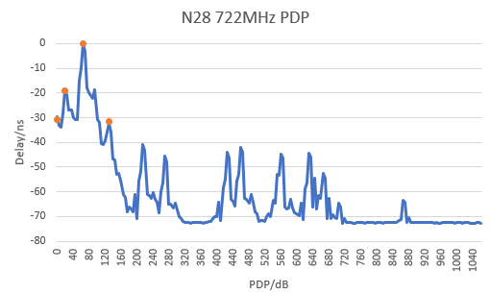

Figure 6.2.2.1-9: Lab 4: PDP measurement results for CDL-C UMi at Band n28, beam 1

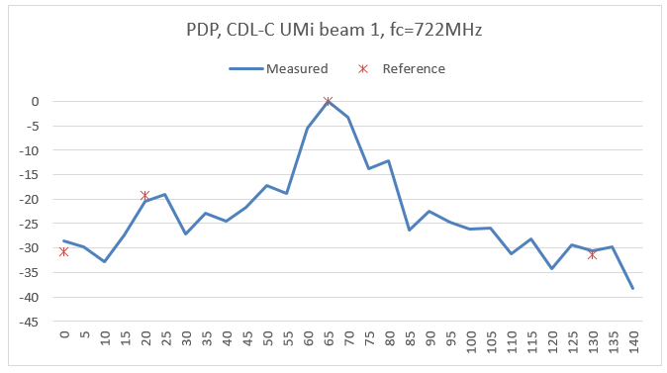

Figure 6.2.2.1-10: Lab 5: PDP measurement results for CDL-C UMi at Band n28, beam 1

Figure 6.2.2.1-11: Lab 6: PDP measurement results for CDL-C UMi at Band n28, beam 1

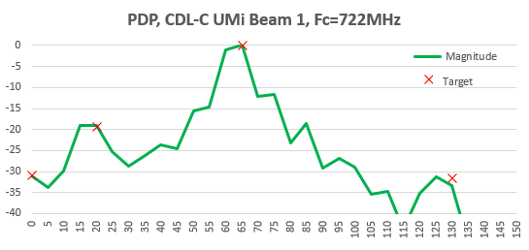

Figure 6.2.2.1-12: Lab 7: PDP measurement results for CDL-C UMi at Band n28, beam 1

#### 6.2.2.2 Doppler/Temporal correlation

The Doppler should be validated in a Beam-Specific manner. It is assumed that the beams are mapped to the inputs of the channel emulator as follows:

- Beam 1: Input 1 and Input 2

- Beam 2: Input 3 and Input 4 (CDL-C UMa only)

The Doppler measurement results of UMa CDL-C for bands n41 and n78 are presented in Figures 6.2.2.2-1~6.



(a-1) Beam 1, H11 (a-2) Beam 2, H11



(a-3) Beam 1, H12 (a-4) Beam 2, H12

 

(a-5) Beam 1, H12 (a-6) Beam 2, H12

 

(a-7) Beam 1, X2V (a-8) Beam 2, X2V

(a) Band n41



(b-1) Beam 1, H11 (b-2) Beam 2, H11

 

(b-3) Beam 1, X2V (b-4) Beam 2, X2V

(b) Band n78

Figure 6.2.2.2-1: Lab 1: Doppler measurement results for CDL-C UMa, (a) Band n41 with different beams and different polarizations; (b) Band n78 with different beams and different polarizations



(a) Band n41



(b) Band n78

Figure 6.2.2.2-2: Lab 2: Doppler measurement results for CDL-C UMa, (a) Band n41, beam 1 and beam 2; (b) Band n78, beam 1 and beam 2





(a) Band n41

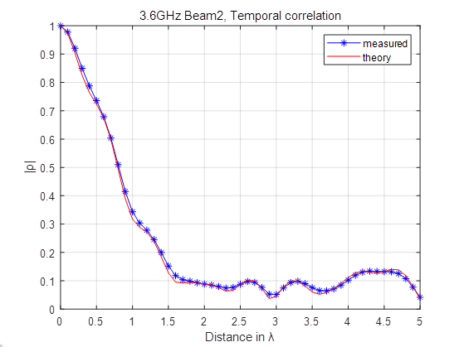

(b) Band n78



(c) Band n79

Figure 6.2.2.2-3: Lab 3: Doppler measurement results for CDL-C UMa, (a) Band n41, beam 1, beam 2, and combined beams; (b) Band n78, beam 1 and beam 2; (c) Band n79, beam 1 and beam 2

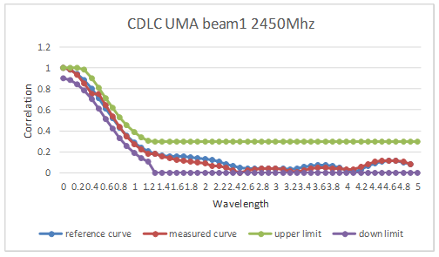 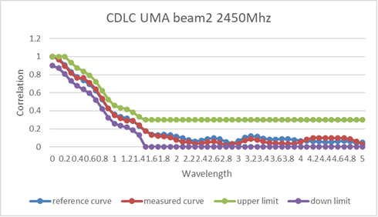

(a) Band n41

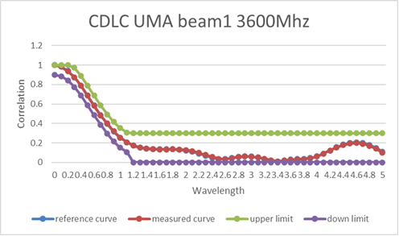 

(b) Band n78

Figure 6.2.2.2-4: Lab 4: Doppler measurement results for CDL-C UMa, (a) Band n41, beam 1 and beam 2; (b) Band n78, beam 1 and beam 2

(a) Band n41

(b) Band n78

Figure 6.2.2.2-5: Lab 5: Doppler measurement results for CDL-C UMa, (a) Band n41, beam 1 and beam 2; (b) Band n78, beam 1 and beam 2

(a) Band n41

(b) Band n78

Figure 6.2.2.2-6: Lab 6: Doppler measurement results for CDL-C UMa, (a) Band n41, beam 1 and beam 2; (b) Band n78, beam 1 and beam 2

The Doppler measurement results of UMi CDL-C for band n28 are presented in Figures 6.2.2.2-7~12.



Figure 6.2.2.2-7: Lab 1: Doppler measurement results for CDL-C UMi at Band n28, beam 1



Figure 6.2.2.2-8: Lab 2: Doppler measurement results for CDL-C UMi at Band n28, beam 1

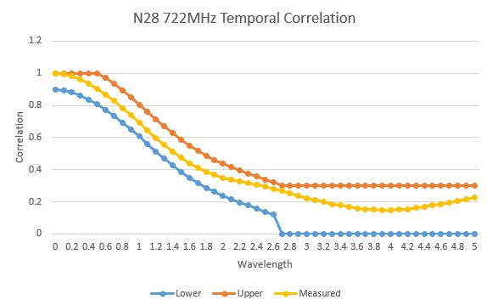

Figure 6.2.2.2-9: Lab 4: Doppler measurement results for CDL-C UMi at Band n28, beam 1

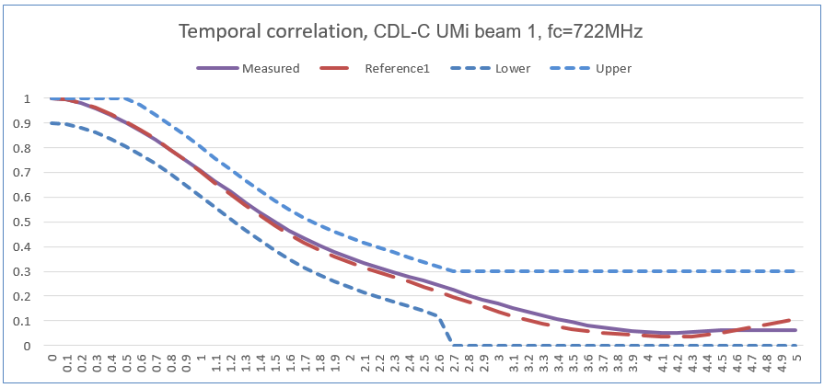

Figure 6.2.2.2-10: Lab 5: Doppler measurement results for CDL-C UMi at Band n28, beam 1

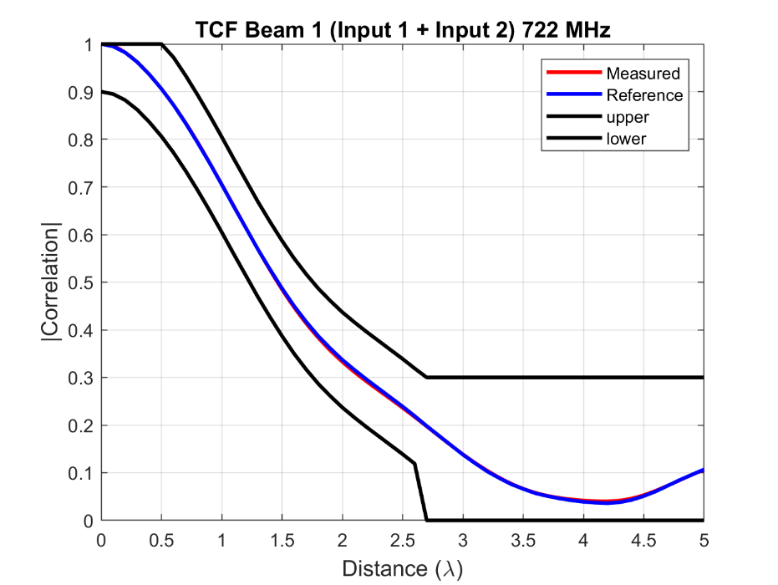

Figure 6.2.2.2-11: Lab 6: Doppler measurement results for CDL-C UMi at Band n28, beam 1

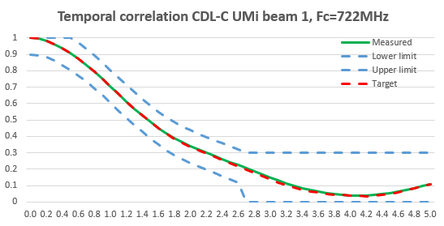

Figure 6.2.2.2-12: Lab 7: Doppler measurement results for CDL-C UMi at Band n28, beam 1

#### 6.2.2.3 Spatial correlation

The Spatial correlation should be validated in a Beam-Combined manner. It is assumed that the beams are mapped to the inputs of the channel emulator as follows:

- Beam 1: Input 1 and Input 2

- Beam 2: Input 3 and Input 4 (CDL-C UMa only)

- Combined beam for CDL-C UMa: Input 1 + Input 2 + Input 3 + Input 4

- Combined beam for CDL-C UMi: Input 1 + Input 2

The Spatial correlation measurement results of UMa CDL-C for bands n41 and n78 are presented in Figures 6.2.2.3-1~6.

 



(a) Band n41



(b) Band n78

Figure 6.2.2.3-1: Lab 1: Spatial correlation measurement results for CDL-C UMa, (a) Band n41, beam 1, beam 2, and combined beams; (b) Band n78, combined beams



(a) Band n41 (b) Band n78

Figure 6.2.2.3-2: Lab 2: Spatial correlation measurement results for CDL-C UMa, (a) Band n41 with combined beams; (b) Band n78 with combined beams



(a) Band n41



(b) Band n78

Figure 6.2.2.3-3: Lab 3: Spatial correlation measurement results for CDL-C UMa, (a) Band n41, beam 1, beam 2, and combined beams; (b) Band n78, combined beams

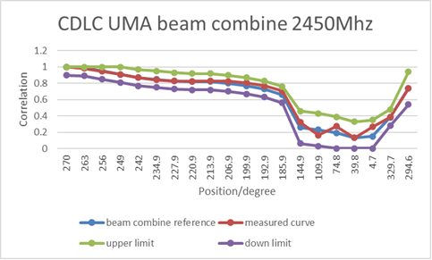

(a) Band n41

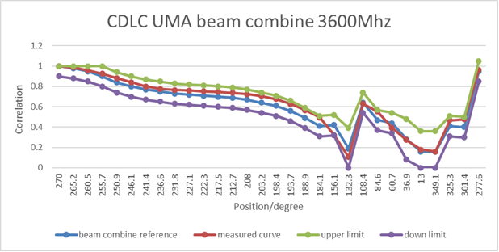

(b) Band n78

Figure 6.2.2.3-4: Lab 4: Spatial correlation measurement results for CDL-C UMa, (a) Band n41, combined beams; (b) Band n78, combined beams

(a) Band n41

(b) Band n78

Figure 6.2.2.3-5: Lab 5: Spatial correlation measurement results for CDL-C UMa, (a) Band n41, combined beams; (b) Band n78, combined beams

(a) Band n41

(b) Band n78

Figure 6.2.2.3-6: Lab 6: Spatial correlation measurement results for CDL-C UMa, (a) Band n41, combined beams; (b) Band n78, combined beams

The Spatial correlation measurement results of UMi CDL-C for band n28 are presented in Figures 6.2.2.3-7~12.



Figure 6.2.2.3-7: Lab 1: Spatial correlation measurement results for CDL-C UMi at Band n28, beam 1



Figure 6.2.2.3-8: Lab 2: Spatial correlation measurement results for CDL-C UMi at Band n28, beam 1

Figure 6.2.2.3-9: Lab 4: Spatial correlation measurement results for CDL-C UMi at Band n28, beam 1

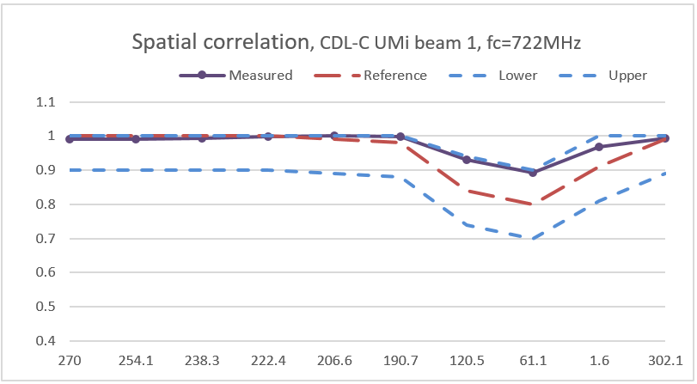

Figure 6.2.2.3-10: Lab 5: Spatial correlation measurement results for CDL-C UMi at Band n28, beam 1

Figure 6.2.2.3-11: Lab 6: Spatial correlation measurement results for CDL-C UMi at Band n28, beam 1

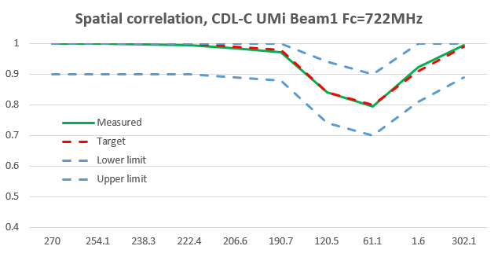

Figure 6.2.2.3-12: Lab 7: Spatial correlation measurement results for CDL-C UMi at Band n28, beam 1

#### 6.2.2.4 Cross-polarization

The Cross-polarization should be validated in a Beam-Specific manner. It is assumed that the beams are mapped to the inputs of the channel emulator as follows:

- Beam 1: Input 1 and Input 2

- Beam 2: Input 3 and Input 4 (CDL-C UMa only)

The Cross-polarization measurement results of UMa CDL-C for bands n41 and n78 are presented in Table 6.2.2.4-1~6.

Table 6.2.2.4-1: Lab 1: Cross-polarization verification results for CDL-C UMa, bands n41 and n78

|  |  |  |  |
| --- | --- | --- | --- |
| Frequency | Beam | Reference | Measurement result |
| fc ≤ 2.5 GHz (n41) | Beam 1 | Input 1+2:  V/H = 0 dB | 0.44 dB |
| Beam 2 | Input 3+4:  V/H = 0 dB | 0.55 dB |
| fc > 2.5 GHz (n78) | Beam 1 | Input 1+2:  V/H = 0 dB | 0.49 dB |
| Beam 2 | Input 3+4:  V/H = 0 dB | 0.58 dB |

Table 6.2.2.4-2: Lab 2: Cross-polarization verification results for CDL-C UMa, bands n41 and n78

|  |  |  |  |
| --- | --- | --- | --- |
| Frequency | Beam | Reference | Measurement result |
| fc ≤ 2.5 GHz (n41) | Beam 1 | Input 1:  V/H = -0.5 dB  Input 2:  V/H = 0.6 dB | Input 1:  V/H = -0.96 dB  Input 2:  V/H = 0.94 dB |
| Beam 2 | Input 3:  V/H = -0.6 dB  Input 4:  V/H = 0.7 dB | Input 3:  V/H = -0.11 dB  Input 4:  V/H = 0.71 dB |
| fc > 2.5 GHz (n78) | Beam 1 | Input 1:  V/H = -0.6 dB  Input 2:  V/H = 0.7 dB | Input 1:  V/H = -0.51 dB  Input 2:  V/H = 1.19 dB |
| Beam 2 | Input 3:  V/H = -0.7 dB  Input 4:  V/H = 0.8 dB | Input 3:  V/H = -0.41 dB  Input 4:  V/H = 0.47 dB |

Table 6.2.2.4-3: Lab 3: Cross-polarization verification results for CDL-C UMa, bands n41 and n78

|  |  |  |  |
| --- | --- | --- | --- |
| Frequency | Beam | Reference | Measurement result |
| fc ≤ 2.5 GHz (n41) | Beam 1 | Input 1:  V/H = -0.5 dB  Input 2:  V/H = 0.6 dB  Input 1+ 2:  V/H = 0 dB | Input 1:  V/H = -0.98 dB  Input 2:  V/H = 0.63 dB  Input 1+ 2:  V/H = -0.21 dB |
| Beam 2 | Input 3:  V/H = -0.6 dB  Input 4:  V/H = 0.7 dB  Input 3+4:  V/H = 0 dB | Input 3:  V/H = -1.1dB  Input 4:  V/H = -0.07 dB  Input 3+4:  V/H = -0.60 dB |
| fc > 2.5 GHz (n78) | Beam 1 | Input 1:  V/H = -0.6 dB  Input 2:  V/H = 0.7 dB  Input 1+ 2:  V/H = 0 dB | Input 1:  V/H = -0.45  Input 2:  V/H = 1.32 dB  Input 1+ 2:  V/H = 0.39 dB |
| Beam 2 | Input 3:  V/H = -0.7 dB  Input 4:  V/H = 0.8 dB  Input 3+4:  V/H = 0 dB | Input 3:  V/H = 0.25  Input 4:  V/H = 1.61  Input 3+4:  V/H = 0.91 dB |

Table 6.2.2.4-4: Lab 4: Cross-polarization verification results for CDL-C UMa, bands n41 and n78

|  |  |  |  |
| --- | --- | --- | --- |
| Frequency | Beam | Reference | Measurement result |
| fc ≤ 2.5 GHz (n41) | Beam 1 | Input 1: V/H = -0.5 dB | -0.48 dB |
| Input 2: V/H = 0.6 dB | 0.57 dB |
| Beam 2 | Input 3: V/H = -0.6 dB | -0.69 dB |
| Input 4: V/H = 0.7 dB | 0.71 dB |
| fc > 2.5 GHz (n78) | Beam 1 | Input 1: V/H = -0.6 dB | -0.48 |
| Input 2: V/H = 0.7 dB | 0.99 |
| Beam 2 | Input 3: V/H = -0.7 dB | -0.34 |
| Input 4: V/H = 0.8 dB | 1.13 |

Table 6.2.2.4-5: Lab 5: Cross-polarization verification results for CDL-C UMa, band n41

|  |  |  |  |
| --- | --- | --- | --- |
| Frequency | Beam | Reference | Measurement result |
| fc ≤ 2.5 GHz (n41) | Beam 1 | Input 1: V/H = -0.5 dB | -0.48 dB |
| Input 2: V/H = 0.6 dB | 0.61 dB |
| Beam 2 | Input 3: V/H = -0.6 dB | -0.64 dB |
| Input 4: V/H = 0.7 dB | 0.68 dB |

Table 6.2.2.4-6: Lab 6: Cross-polarization verification results for CDL-C UMa, bands n41 and n78

|  |  |  |  |
| --- | --- | --- | --- |
| Frequency | Beam | Reference | Measurement result |
| fc ≤ 2.5 GHz (n41) | Beam 1 | Input 1+2:  V/H = 0 dB | -0.6555 dB |
| Beam 2 | Input 3+4:  V/H = 0 dB | -0.0676 dB |
| fc > 2.5 GHz (n78) | Beam 1 | Input 1+2:  V/H = 0 dB | 0.5064 dB |
| Beam 2 | Input 3+4:  V/H = 0 dB | 0.6414 dB |

The Cross-polarization measurement results of UMi CDL-C for band n428 are presented in Table 6.2.2.4-7~12.

Table 6.2.2.4-7: Lab 1: Cross-polarization verification results for CDL-C UMi, Band n28

|  |  |  |  |  |
| --- | --- | --- | --- | --- |
| Frequency | Beam | Reference | Measurement result | Pass/fail limit |
| fc = 722 MHz | Beam 1 | Input 1+2: V/H = 0 dB | V/H = -0.08 dB | ±1 dB |

Table 6.2.2.4-8: Lab 2: Cross-polarization verification results for CDL-C UMi, Band n28

|  |  |  |  |  |
| --- | --- | --- | --- | --- |
| Frequency | Beam | Reference | Measurement result | Pass/fail limit |
| fc = 722 MHz | Beam 1 | Input 1+2: V/H = 0 dB | V/H = 0.15 dB | ±1 dB |

Table 6.2.2.4-9: Lab 4: Cross-polarization verification results for CDL-C UMi, Band n28

|  |  |  |  |  |
| --- | --- | --- | --- | --- |
| Frequency | Beam | Reference | Measurement result | Pass/fail limit |
| fc = 722 MHz | Beam 1 | Input 1+2: V/H = 0 dB | V/H = -0.14 dB | ±1 dB |

Table 6.2.2.4-10: Lab 5: Cross-polarization verification results for CDL-C UMi, Band n28

|  |  |  |  |  |
| --- | --- | --- | --- | --- |
| Frequency | Beam | Reference | Measurement result | Pass/fail limit |
| fc = 722 MHz | Beam 1 | Input 1+2: V/H = 0 dB | V/H = -0.09 dB | ±1 dB |

Table 6.2.2.4-11: Lab 6: Cross-polarization verification results for CDL-C UMi, Band n28

|  |  |  |  |  |
| --- | --- | --- | --- | --- |
| Frequency | Beam | Reference | Measurement result | Pass/fail limit |
| fc = 722 MHz | Beam 1 | Input 1+2: V/H = 0 dB | V/H = 0.59 dB | ±1 dB |

Table 6.2.2.4-12: Lab 7: Cross-polarization verification results for CDL-C UMi, Band n28

|  |  |  |  |  |
| --- | --- | --- | --- | --- |
| Frequency | Beam | Reference | Measurement result | Pass/fail limit |
| fc = 722 MHz | Beam 1 | Input 1+2: V/H = 0 dB | V/H = -0.71 dB | ±1 dB |

#### 6.2.2.5 Power validation

The Power validation results of UMa CDL-C for bands n41 and n78 are presented in Table 6.2.2.5-1~3.

Table 6.2.2.5-1: Lab 1: Power validation results for CDL-C UMa, bands n41 and n78 (Unit: dBm/30kHz)

|  |  |  |  |  |
| --- | --- | --- | --- | --- |
| CDL-C UMa, n41, 2592.99 MHz | | | | |
| Measured V power | Measured H power | Measured total power | Expected | Delta |
| -79.6244 | -79.5959 | -76.5999 | -77 | 0.4001 |
| CDL-C UMa, n78, 3549.99 MHz | | | | |
| Measured V power | Measured H power | Measured total power | Expected | Delta |
| -79.9988 | -79.6618 | -76.8168 | -77 | 0.1832 |

Table 6.2.2.5-2: Lab 4: Power validation results for CDL-C UMa, bands n41 and n78 (Unit: dBm/30kHz)

|  |  |  |
| --- | --- | --- |
| UMa CDL-C  2450 MHz | Dipole | S=-50.6dBm |
| Loop | S=-50.4dBm |
| UMa CDL-C  3600 MHz | Dipole | S=-45.6dBm | |
| Loop | S=-46.68dBm | |

Table 6.2.2.5-3 (a): Lab 6: Power validation results for CDL-C UMa, band n41 (Unit: dBm/30kHz)

Table 6.2.2.5-3 (b): Lab 6: Power validation results for CDL-C UMa, band n78 (Unit: dBm/30kHz)

The Power validation results of UMi CDL-C for band n28 are presented in Table 6.2.2.5-4~8.

Table 6.2.2.5-4: Lab 1: Power validation results for CDL-C UMi, Band n28 (Unit: dBm/15kHz)

|  |  |  |  |  |  |  |
| --- | --- | --- | --- | --- | --- | --- |
| Frequency | Measured V power | Measured H power | Measured total power | Target power | Delta | Pass/fail limit |
| 780.5 MHz | -83.1288 | -82.9819 | -80.0444 | -80 | -0.0444 | ±1.5 dB |

Table 6.2.2.5-5: Lab 4: Power validation results for CDL-C UMi, Band n28 (Unit: dBm/15kHz)

|  |  |  |  |  |
| --- | --- | --- | --- | --- |
| Frequency | Measured power | Target power | Delta | Pass/fail limit |
| 780.5 MHz | -70.6609811 | -70.6 | -0.06098109 | ±1.5 dB |
| -80.5325084 | -80.6 | 0.067491565 |
| -90.116428 | -90.6 | 0.483572032 |

Table 6.2.2.5-6: Lab 5: Power validation results for CDL-C UMi, Band n28 (Unit: dBm/15kHz)

|  |  |  |  |  |
| --- | --- | --- | --- | --- |
| Frequency | Measured power | Target power | Delta | Pass/fail limit |
| 780.5 MHz | NA | NA | 1.3 | ±1.5 dB |

Table 6.2.2.5-7: Lab 6: Power validation results for CDL-C UMi, Band n28 (Unit: dBm/15kHz)

|  |  |  |  |  |
| --- | --- | --- | --- | --- |
| Frequency | Measured power | Target power | Delta | Pass/fail limit |
| 780.5 MHz | -49.64 | -50.00 | 0.36 | ±1.5 dB |

Table 6.2.2.5-8: Lab 7: Power validation results for CDL-C UMi, Band n28 (Unit: dBm/15kHz)

|  |  |  |  |  |
| --- | --- | --- | --- | --- |
| Frequency | Measured power | Target power | Delta | Pass/fail limit |
| 780.5 MHz | NA | NA | 0.0002 | ±1.5 dB |

## 6.3 Verification of Channel Model implementation of FR2

### 6.3.1 Framework

This clause describes how to proceed Channel Model Validation for FR2 MIMO OTA with 3D-MPAC system.

1. The channel model validation measurements shall be performed as described in Annex D.3 of TS 38.151, including:

- Power delay profile (PDP)

- Doppler/Temporal correlation

- PAS similarity percentage (PSP)

- Cross-polarization

- Power validation

2. Channel model: FR2 UMi CDL-C, as specified in Annex D.1 of TS 38.151

3. Test frequency: as specified in Tables D.3.1-1 of TS 38.151

4. Pass/fail limits: as defined in Annex D.2 of TS 38.151

### 6.3.2 Channel Model Validation Results

This clause presents channel model validation results from different labs with different types of equipment and setup vendors. All the validation results are included for comparison. Table 6.3.2-1 lists equipment and setup vendors of different labs.

Table 6.3.2-1: Equipment and setup vendors of different labs (FR2)

|  |  |  |  |
| --- | --- | --- | --- |
| Labs | Channel Emulator | BS Simulator | System |
| Lab A | Vendor 1 | Vendor A | Vendor I |
| Lab B | Vendor 2 | TBA | Vendor II |
| Lab C | Vendor 1 | TBA | Vendor III |
| Lab D | Vendor 2 | TBA | Vendor II |
| Lab E | Vendor 1 | TBA | Vendor III |
| Lab F | Vendor 1 | TBA | Vendor IV |

#### 6.3.2.1 Power Delay Profile (PDP)

The PDP measurement results of UMi CDL-C for bands n261/28GHz are presented in Figures 6.3.2.1-1~6.

Figure 6.3.2.1-1: Lab A: PDP measurement results for CDL-C UMi at 28GHz



Figure 6.3.2.1-2: Lab B: PDP measurement results for CDL-C UMi at band n261

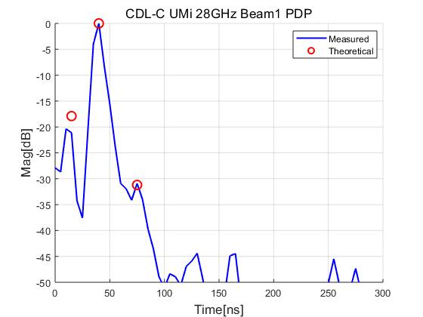

Figure 6.3.2.1-3: Lab C: PDP measurement results for CDL-C UMi at band n261

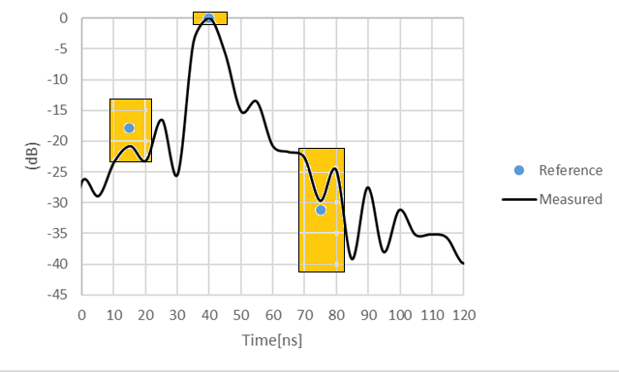

Figure 6.3.2.1-4: Lab D: PDP measurement results for CDL-C UMi at band n261

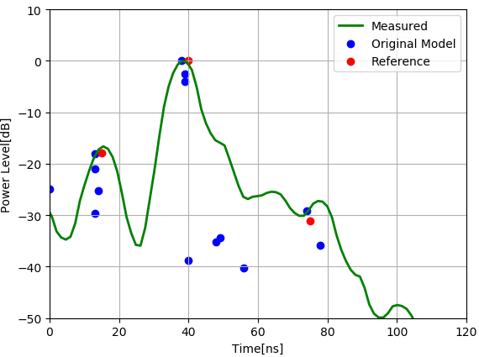

Figure 6.3.2.1-5 Lab E: PDP measurement results for CDL-C UMi at band n261

Figure 6.3.2.1-6 Lab F: PDP measurement results for CDL-C UMi at 28GHz

#### 6.3.2.2 Doppler/Temporal correlation

The Doppler measurement results of UMi CDL-C for bands n261/28GHz are presented in Figures 6.3.2.2-1~6.

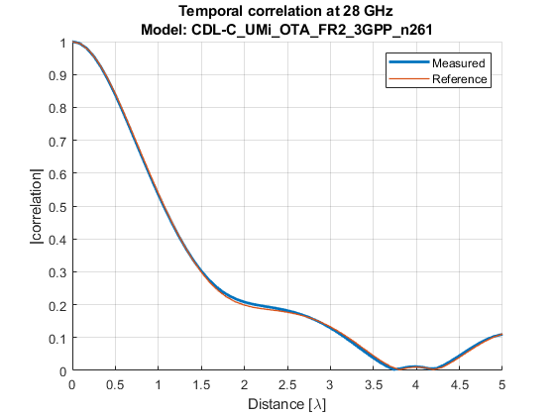

Figure 6.3.2.2-1: Lab A: Doppler measurement results for CDL-C UMi at band n261



Figure 6.3.2.2-2: Lab B: Doppler measurement results for CDL-C UMi at band n261

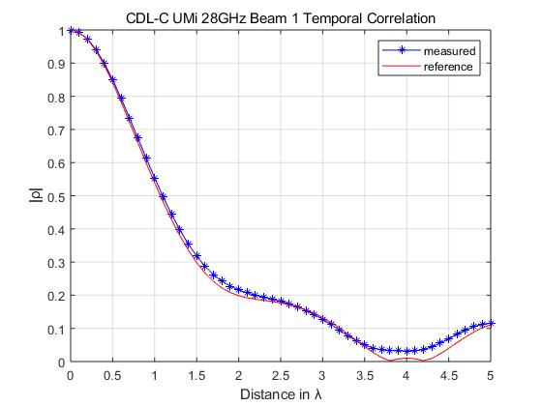

Figure 6.3.2.2-3: Lab C: Doppler measurement results for CDL-C UMi at 28GHz

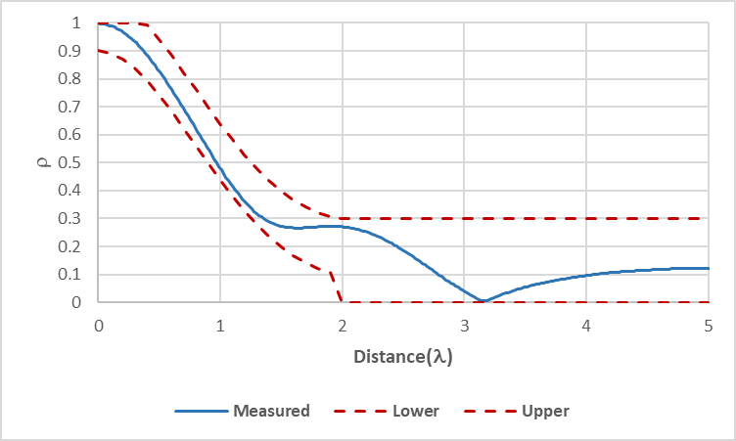

Figure 6.3.2.2-4: Lab D: Doppler measurement results for CDL-C UMi at band n261

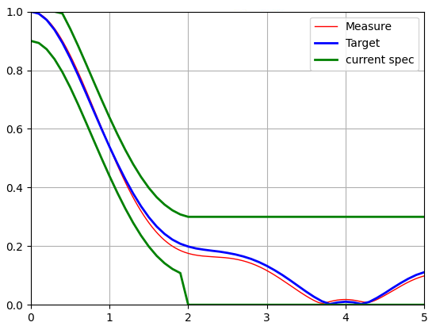

Figure 6.3.2.2-5: Lab E: Doppler measurement results for CDL-C UMi at band n261

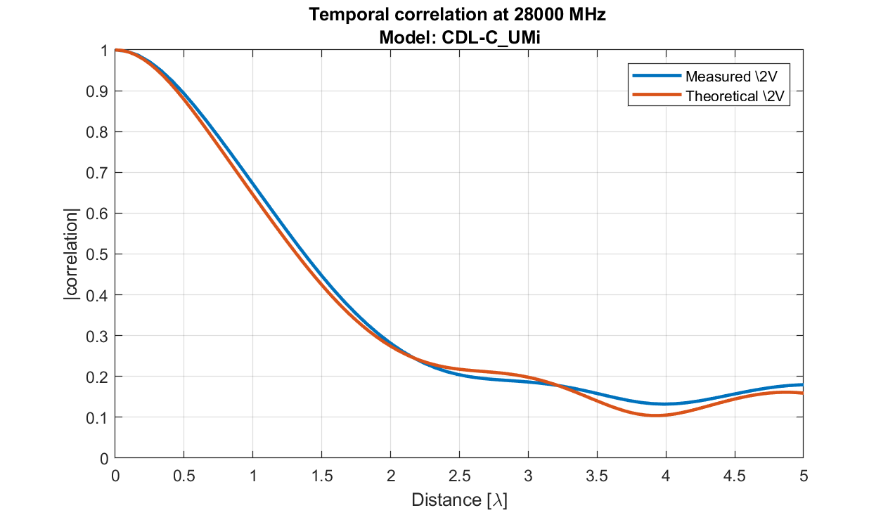

Figure 6.3.2.2-6: Lab F: Doppler measurement results for CDL-C UMi at 28GHz

#### 6.3.2.3 PAS similarity percentage (PSP)

The PAS measurement results of UMi CDL-C for band n261/28GHz are presented in Figures 6.3.2.3-1~6. The corresponding PSP values are summarized in Table 6.3.2.3-1.

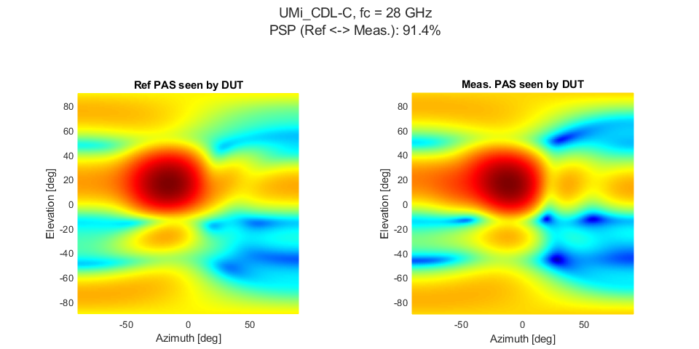

Figure 6.3.2.3-1: Lab A: PAS measurement results for CDL-C UMi at band n261

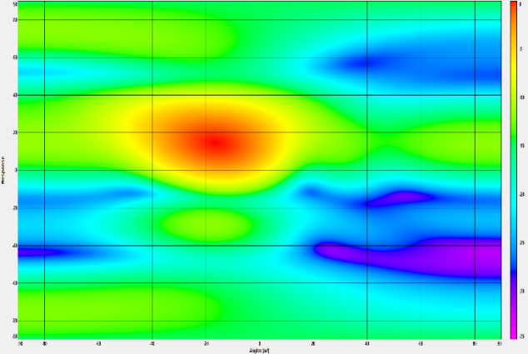

(a) Ref. PAS Seen by DUT (b) Measured PAS Seen by DUT

Figure 6.3.2.3-2: Lab B: PAS measurement results for CDL-C UMi at band n261

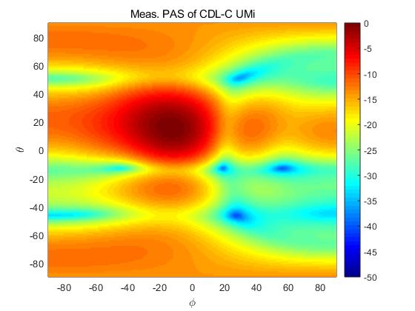

Figure 6.3.2.3-3: Lab C: PAS measurement results for CDL-C UMi at band n261

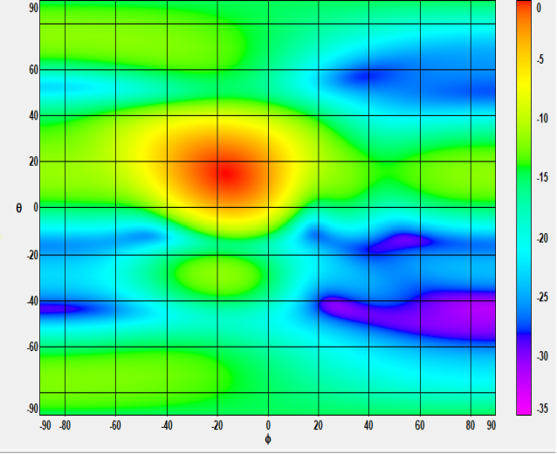 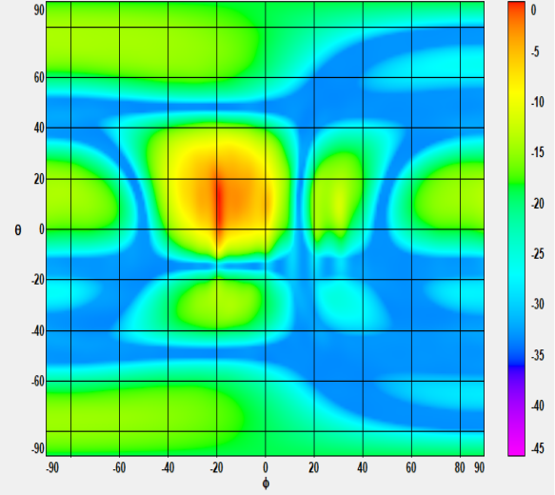

(a) Ref. PAS Seen by DUT (b) Measured PAS Seen by DUT

Figure 6.3.2.3-4: Lab D: PAS measurement results for CDL-C UMi at band n261

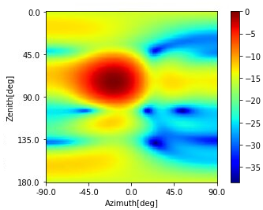

Figure 6.3.2.3-5: Lab E: PAS measurement results for CDL-C UMi at band n261

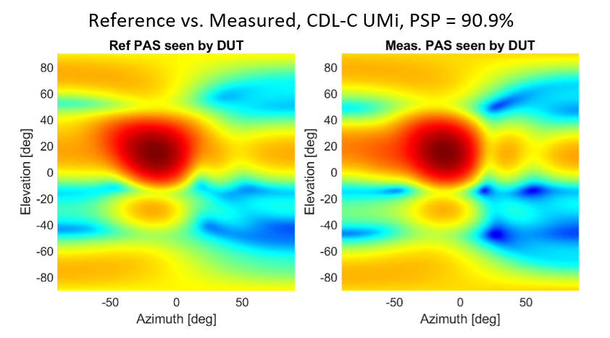

Figure 6.3.2.3-6: Lab F: PAS measurement results for CDL-C UMi at band n261

Table 6.3.2.3-1: PSP verification results for CDL-C UMi, band n261

|  |  |  |
| --- | --- | --- |
| Lab | PSP value | Pass/fail limit |
| Lab A | 91.4% | 84% |
| Lab B | 89.7% |
| Lab C | 94% |
| Lab D | 86.2% |
| Lab E | 91.3% |
| Lab F | 90.9% |

#### 6.3.2.4 Cross-polarization

The Cross-polarization measurement results of UMi CDL-C for bands n261/28GHz are presented in Table 6.3.2.4-1~5.

Table 6.3.2.4-1: Lab A: Cross-polarization verification results for CDL-C UMi, band n261

|  |  |  |  |  |
| --- | --- | --- | --- | --- |
| Beam | Reference | Measurement result | Delta | Pass/fail limit |
| Beam 1 | Input 1: V/H = -0.45 dB | V/H = -0.38 dB | 0.07 dB | ±1.5 dB |
| Input 2: V/H = 0.49 dB | V/H = 0.76 dB | 0.27 dB |
| Input 1+2: V/H = 0 dB | V/H =0.44dB | 0.44 dB |

Table 6.3.2.4-2: Lab B: Cross-polarization verification results for CDL-C UMi, band n261

|  |  |  |  |  |
| --- | --- | --- | --- | --- |
| Beam | Reference | Measurement result | Delta | Pass/fail limit |
| Beam 1 | Input 1: V/H = -0.45 dB | V/H = -0.70 dB | -0.25 dB | ±1.5 dB |
| Input 2: V/H = 0.49 dB | V/H = 1.27 dB | 0.78 dB |
| Input 1+2: V/H = 0 dB | V/H = -0.23dB | -0.23 dB |

Table 6.3.2.4-3: Lab C: Cross-polarization verification results for CDL-C UMi, band n261

|  |  |  |  |  |
| --- | --- | --- | --- | --- |
| Beam | Reference | Measurement result | Delta | Pass/fail limit |
| Beam 1 | Input 1: V/H = -0.45 dB | V/H = 1.01 dB | 1.46 dB | ±1.5 dB |
| Input 2: V/H = 0.49 dB | V/H = -0.51 dB | -1.00 dB |

Table 6.3.2.4-4: Lab D: Cross-polarization verification results for CDL-C UMi, band n261

|  |  |  |  |  |
| --- | --- | --- | --- | --- |
| Beam | Reference | Measurement result | Delta | Pass/fail limit |
| Beam 1 | Input 1+2: V/H = 0 dB | V/H = -0.28dB | -0.28 dB | ±1.5 dB |

Table 6.3.2.4-5: Lab E: Cross-polarization verification results for CDL-C UMi, band n261

|  |  |  |  |  |
| --- | --- | --- | --- | --- |
| Beam | Reference | Measurement result | Delta | Pass/fail limit |
| Beam 1 | Input 1: V/H = -0.45 dB | V/H = -0.80 dB | -0.35 dB | ±1.5 dB |
| Input 2: V/H = 0.49 dB | V/H = 1.01 dB | 0.52 dB |
| Input 1+2: V/H = 0 dB | V/H = 0.76 dB | 0.76 dB |

#### 6.3.2.5 Power validation

The Power validation results of UMi CDL-C for bands n261 are presented in Table 6.3.2.5-1~4.

Table 6.3.2.5-1: Lab A: Power validation results for CDL-C UMi, band n261 (Unit: dBm/120kHz)

|  |  |  |  |  |
| --- | --- | --- | --- | --- |
| Band | Measured EPRE | Target EPRE | Delta | Pass/fail limit |
| n261 | -74.3 | -74 | -0.3 | ±1.5 dB |

Table 6.3.2.5-2: Lab B: Power validation results for CDL-C UMi, band n261 (Unit: dBm/120kHz)

|  |  |  |  |  |  |  |
| --- | --- | --- | --- | --- | --- | --- |
| Band | Measured V power | Measured H power | Measured total power | Target power | Delta | Pass/fail limit |
| n261 | -110.314 | -110.807 | -107.543 | -107 | -0.543 | ±1.5 dB |

Table 6.3.2.5-3: Lab C: Power validation results for CDL-C UMi, band n261 (Unit: dBm/120kHz)

|  |  |  |  |  |
| --- | --- | --- | --- | --- |
| Band | Measured power | Target power | Delta | Pass/fail limit |
| n261 | -43.96 | -43.18 | -0.78 | ±1.5 dB |

Table 6.3.2.5-4: Lab E: Power validation results for CDL-C UMi, band n261 (Unit: dBm/120kHz)

|  |  |  |  |  |
| --- | --- | --- | --- | --- |
| Band | Measured power | Target power | Delta | Pass/fail limit |
| n261 | -42.16 | -42.84 | 0.68 | ±1.5 dB |

# 7 Lab alignment of FR1 MIMO OTA

## 7.1 General

To establish valid and trustable measurement data pools for defining FR1 MIMO OTA requirements, lab alignment campaigns are required before measurement campaign for ensuring there is no unexpected deviations among labs. 3GPP RAN4 performed a lab alignment campaign for bands > 1GHz during Rel-17, and a lab alignment campaign for bands < 1GHz during Rel-18.

## 7.2 Noise impact in MPAC on MIMO performance

This clause includes analysis and experimental measurement results of the impact of noise in MPAC on FR1 MIMO OTA performance.

During Rel-18, several companies studied the impact of noise in MPAC on FR1 MIMO OTA performance, conducted experiments, and obtained similar observations. It was found that by adding suitable attenuators after the amplifiers in MPAC system, the impact of noise can be eliminated and the MIMO OTA measurement results can be corrected, as shown in Figure 7.2-1.



Figure 7.2-1: Measurement setup for correcting FR1 MIMO OTA test results with MPAC

The measurement results (12 orientations average in FS DMP mode) at bands n28 (780.5MHz) and n41 (2593MHz) obtained by Lab 1 are show in Figure 7.2-2. The same DUT were measured with different attenuation values. It can be observed that, as the attenuation value increases, the measurement results first get better and then become stable. At the lower frequency, the effect of the attenuation value is more obvious, and it requires a lager attenuation to make the measurement results stable. The reason is that at lower frequency, the path loss from the amplifier output to the chamber centre is smaller, and when the amplifier noise arrives at the chamber centre, it has higher power than that at higher frequency.

Adding attenuators after the amplifiers can reduce the noise and make it neglectable for FR1 MIMO OTA testing. A suitable attenuation value can be selected, e.g., for band n28, the measurement results with 20dB-attenuation and 30dB-attenuation are almost the same, but the measurement result with 10dB-attenuation is worse, which means 20dB-attenuation is enough for band n28 in Lab 1’s MPAC system.

 

(a) Band n28 (780.5MHz) (b) Band n41 (2593MHz)

Figure 7.2-2: Measured MIMO OTA performance with different attenuation values (in Lab 1)

Figures 7.2-3 and 7.2-4 present the measurement results at band n28 (780.5MHz) from Lab 2 and Lab 4. Similar phenomenon can be observed.



Figure 7.2-3: Measured MIMO OTA performance at band n28 (780.5MHz) with different attenuation values (in Lab 2)

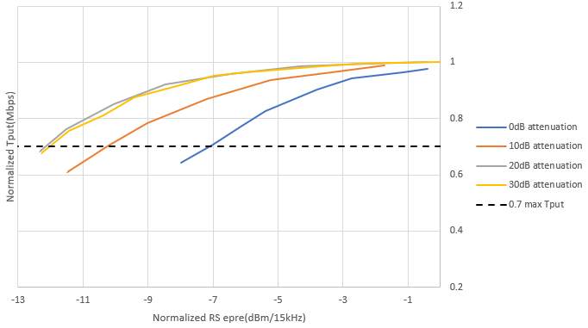

Figure 7.2-4: Measured MIMO OTA performance at band n28 (780.5MHz) with different attenuation values (in Lab 4)

Table 7.2-1 presents the measurement results at band n28 (780.5MHz) from Lab 6, RS EPRE difference between FR1 MIMO OTA system with and without 10dB attenuators are listed.

Table 7.2-1: Measured RS EPRE difference between FR1 MIMO OTA system with and without 10dB attenuators at band n28 (780.5MHz) in Lab 6

|  |  |
| --- | --- |
| Percentile of max TP | RS EPRE Δ between FR1 MIMO OTA system with and without 10dB attenuators |
| @ 50% throughput | 0.59 dB |
| @ 70% throughput | 0.66 dB |
| @ 90% throughput | 0.67 dB |

Based on the observations, RAN4 reached the following agreements:

- Labs should first exclude the impact of noise before performing MIMO OTA measurements, especially for frequency bands <1GHz.

- Perform a low-band lab alignment activity at Band n28, to cross-validate the measurement results from different labs and ensure the validity of the data pool for requirements definition.

## 7.3 Lab alignment campaign for frequency bands > 1GHz

### 7.3.1 Framework

This clause defines the working procedure on how to proceed the lab alignment campaign for frequency bands > 1GHz.

Labs/companies volunteer to participate in the performance requirement part shall complete the lab alignment measurements and system validation measurements, results should be submitted to RAN4 for review.

Using the testing conditions as defined in TS38.151.

The test bands for lab alignment are n41 and n78. Three performance alignment devices (PADs) for each band should be tested to ensure the alignment of measurement results.

TRMS value in SA mode will be used for alignment comparison.

The reference value of each PAD should be the average of the PAD measurement results submitted on or before 12:00 UTC 30th April 2022, based on the condition at least 3 labs’ results collected. Submission with measurement data after 12:00 UTC 30th April can be considered for lab alignment, but will not change the reference TRMS value.

The acceptance criteria for declaring alignment should be defined based on the preliminary MU value of MPAC system. The detailed criteria for accepting the outcome of the lab alignment activity are listed in Table 7.3.3-1.

Table 7.3.3-1: Requirements for lab alignment results (FR1 MIMO OTA)

|  |  |  |
| --- | --- | --- |
| **Band** | **Case** | **Acceptance criteria** |
| n41 | PAD_1 | The deviation between the measurement result and the reference value of each PAD shall be less than the pass/fail limit, i.e.,  ≦pass/fail limit |
| PAD_2 |
| PAD_3 |
| n78 | PAD_1 | The deviation between the measurement result and the reference value of each PAD shall be less than the pass/fail limit, i.e.,  ≦pass/fail limit |
| PAD_2 |
| PAD_3 |

Note:

- The PAD measurement results shall NOT be shared to anyone before submitting to RAN4 meetings or sharing in the NR MIMO OTA reflector. Comparison and alignment analyses should only be done in RAN4 meetings.

- Three PADs for each band are selected. Labs should submit PAD measurements results in an anonymous approach, i.e., the PADs for each band should be marked as PAD_1, PAD_2, and PAD_3, respectively. The mapping between the codename PAD_n and the actual PAD shall only be known among the labs participated in the alignment activity, and shall NOT be disclosed to any other companies.

### 7.3.2 Measurement results

RAN4 carried out the lab alignment campaign for frequency bands > 1GHz during Rel-17. Considering the test burden and urgent timeline, RAN4 decided to select three smartphones (named as PADs, Performance Alignment Devices) as reference DUTs, and select two bands, n41 and n78, to perform FR1 MIMO OTA lab alignment activity for frequencies bands > 1GHz.

There are 6 test labs participated in the lab alignment campaign, the reference value of each PAD at each band is derived based on linear average (with dBm) of PAD measurement results submitted by all labs. The summary of the lab alignment results is shown in Table 7.3.2-1 and Figure 7.3.2-1. The TRMS offset between each measurement result and reference value of FR1 MIMO OTA lab alignment is shown in Table 7.3.2-2 and Figure 7.3.2-1.

Table 7.3.2-1: Summary of FR1 MIMO OTA lab alignment results for bands > 1GHz

|  |  |  |  |  |  |  |  |  |  |  |
| --- | --- | --- | --- | --- | --- | --- | --- | --- | --- | --- |
| Device | Band | TRMS measurement result [dBm/30kHz] | | | | | | Average approach | Reference value | Max-Min deviation |
| **Lab 1** | **Lab 2** | **Lab 3** | **Lab 4** | **Lab 5** | **Lab 6** |
| PAD_n41_1 | n41 | -96.43 | -97.61 | -98.20 | -97.45 | -96.88 | -99.10 | Linear average | -97.61 | 2.67 |
| PAD_n41_2 | n41 | -99.30 | -97.80 | -100.02 | -99.96 | -99.62 | -101.43 | -99.69 | 3.63 |
| PAD_n41_3 | n41 | -96.31 | -97.39 | -97.81 | -96.53 | -96.74 | -98.59 | -97.23 | 2.28 |
| PAD_n78_1 | n78 | -96.02 | -96.54 | -96.44 | -96.10 | -96.53 | -98.38 | -96.67 | 2.36 |
| PAD_n78_2 | n78 | -95.42 | -95.95 | -96.11 | -96.48 | -96.66 | -98.97 | -96.60 | 3.55 |
| PAD_n78_3 | n78 | -99.06 | -97.42 | -99.53 | -99.08 | -99.54 | NA | -98.93 | 2.12 |

Table 7.3.2-2: FR1 MIMO OTA lab alignment outcome - TRMS offset (for bands > 1GHz)

|  |  |  |  |  |  |  |  |  |
| --- | --- | --- | --- | --- | --- | --- | --- | --- |
| Device | Band | TRMS offset from reference [dBm/30kHz] | | | | | | Pass/fail limit |
| Lab 1 | Lab 2 | Lab 3 | Lab 4 | Lab 5 | Lab 6 |
| PAD_n41_1 | n41 | 1.18 | 0.00 | -0.59 | 0.16 | 0.73 | -1.49 | +/- 0.75 MU, i.e., +/- 2.25 dB |
| PAD_n41_2 | n41 | 0.39 | 1.89 | -0.33 | -0.27 | 0.07 | -1.74 |
| PAD_n41_3 | n41 | 0.92 | -0.16 | -0.58 | 0.70 | 0.49 | -1.36 |
| PAD_n78_1 | n78 | 0.65 | 0.13 | 0.22 | 0.57 | 0.14 | -1.71 | +/- 0.75 MU, i.e., +/- 2.55 dB |
| PAD_n78_2 | n78 | 1.18 | 0.65 | 0.48 | 0.12 | -0.06 | -2.37 |
| PAD_n78_3 | n78 | -0.13 | 1.51 | -0.60 | -0.15 | -0.61 | NA |
| Lab alignment conclusion | | Pass | Pass | Pass | Pass | Pass | Pass |  |

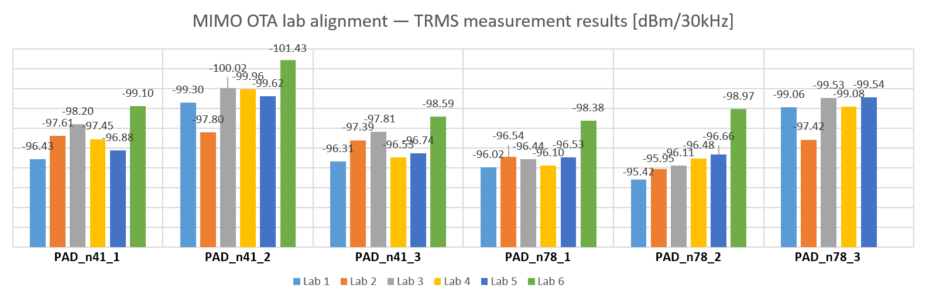

Figure 7.3.2-1: Measurement results of FR1 MIMO OTA lab alignment for bands > 1GHz

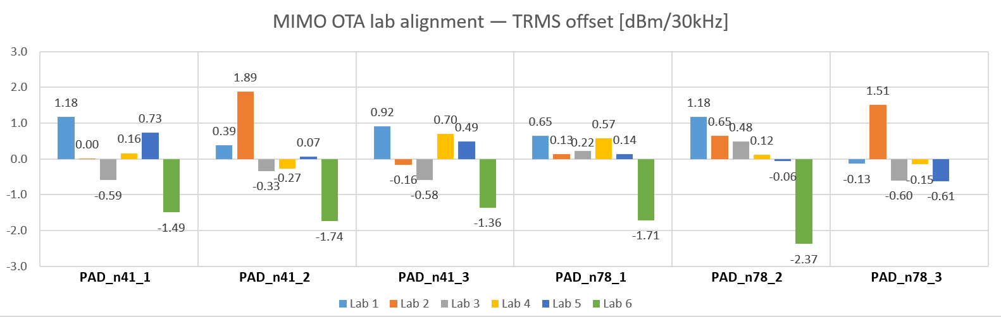

Figure 7.3.2-2: Deviation between each measurement result and reference value of FR1 MIMO OTA lab alignment for bands > 1GHz

### 7.3.3 Pass/fail limits

Based on the preliminary MU assessment of FR1 MPAC system in Annex A.2.5 of TS 38.151, and lab alignment measurement results in Clause 7.3.2, RAN4 decided the final pass/fail limits for FR1 MIMO OTA lab alignment activity for bands > 1GHz as 0.75* preliminary MU, i.e.,

- < 3GHz: 2.25 dB

- > 3GHz: 2.55 dB

### 7.3.4 Conclusion

RAN4 concluded the successful FR1 MIMO OTA lab alignment activity for bands > 1GHz, all the 6 test labs are aligned. FR1 MIMO OTA performance requirements for bands > 1GHz are specified based on the measurement results submitted by the above aligned test labs.

## 7.4 Lab alignment campaign for frequency bands < 1GHz

### 7.4.1 Framework

This clause defines the working procedure on how to proceed the lab alignment campaign for frequency bands < 1GHz.

1. Test labs are invited to participate in the lab alignment activity, the following conditions should be fulfilled:

- At least 3 participating labs are required.

- Participating labs shall complete channel model validation.

- Participating labs should have sufficient test resource to provide on-time measurement results without delay.

- Participating labs should first examine and exclude the impact of noise before submitting PAD measurement results.

2. Test methodology:

- Test plan: 3GPP TS 38.151

- Test system: MPAC

3. Test cases for Lab Alignment Activity:

- Test band: n28

- Number of test cases: 3 PADs

- Operation mode: NR Standalone (SA)

- Use scenario: Free space

4. Test results submission:

- Use the same worksheet template in R4-2316308 to submit the measurement results

- The measurement results should be submitted to RAN4 by anonymous approach (the UE model shall not be disclosed publicly)

- Results shall not be shared between labs before submitting to RAN4 meetings or sharing in the RAN4 reflector. Comparison and lab alignment analysis should only be done in RAN4 meetings/discussions

5. Lab alignment criteria:

- The pass/fail criteria are defined as the maximum deviation between the measurement result and the reference value

- The reference value will be derived based on the averaging approach (linear average in dBm) of lab alignment data pool from ≥ 3 labs

- Apparent outliers (if identified) will not be considered in the average process for reference value. The PAD measurement result deviates over 1.5*preliminary MU (i.e., 4.55dB) from all the other labs’ results should be identified as apparent outlier.

- Pass/fail limit for lab alignment should be defined as X*preliminary MU (X is TBD) as baseline.

6. Volunteer lab procedures:

- PAD delivery scheme: Decide PAD delivery scheme after all the volunteer labs and PADs information being confirmed.

- PAD measurement time in each volunteer lab: finalize PAD measurement within [7] workdays, and deliver to the next lab ASAP with PAD delivery In/Out information shared in email-reflector.

### 7.4.2 Measurement results

<Editor’s note: This clause includes the measurement results of the reference DUTs in the selected frequency bands (<1 GHz). This clause will be added when lab alignment campaign for frequency bands < 1GHz is completed.>

### 7.4.3 Pass/fail limits

<Editor’s note: This clause defines the pass/fail limits of lab alignment campaign for frequency bands < 1GHz. This clause will be added when lab alignment campaign for frequency bands < 1GHz is completed.>

### 7.4.4 Conclusion

<Editor’s note: This clause describes the conclusion of lab alignment campaign for frequency bands < 1GHz. This clause will be added when lab alignment campaign for frequency bands < 1GHz is completed.>

# 8 Lab alignment of FR2 MIMO OTA

## 8.1 Framework

This clause defines the working procedure on how to proceed the FR2 MIMO OTA lab alignment campaign. The purpose of lab alignment activity is to ensure there is no unexpected lab deviation and establish full trust and confidence on the measurement data pool for specifying FR2 MIMO OTA performance requirements.

1. Test labs are invited to participate in the lab alignment activity, the following conditions should be fulfilled:

- At least 3 participating labs are required.

- Participating labs shall complete channel model validation.

- Participating labs should have sufficient test resource to provide on-time measurement results without delay.

- Each lab should finalize PAD measurement within 10 workdays, and deliver to the next lab in the same country ASAP with PAD In/Out information shared via email-reflector; otherwise, labs in the same country should equally share the period for testing the PADs.

2. Test methodology:

- Test plan: 3GPP TS 38.151

3. Test cases for Lab Alignment Activity:

- Test band: n261 (for PADs that support n261), n257 (for the PAD that does not support n261)

- Number of test cases: 2~4 PADs per-band

- Operation mode: NR Non-Standalone (NSA) is preferred and SA is not precluded, and should be mapped with the measurement results submission.

- Power class: PC3

4. Test results submission:

- Use the same worksheet template in R4-2308740 to submit the measurement results

- The measurement results should be submitted to RAN4 by anonymous approach (the UE model shall not be disclosed publicly)

- Results shall not be shared between labs before submitting to RAN4 meetings or sharing in the RAN4 reflector. Comparison and lab alignment analysis should only be done in RAN4 meetings/discussions

5. Lab alignment criteria:

- The pass/fail criteria are defined as the maximum deviation between the MASC measurement result and the reference value

- The reference value is derived based on the per-band averaging approach of lab alignment data pool from ≥ 3 labs, whether apparent outliers will be considered in averaging process, or not, is FFS

- Pass/fail limit for lab alignment should be derived from the preliminary MU value. Adopt [0.5-1]*preliminary MU as starting point and further check after the FR2 MU is decided and some PAD measurement results are available.

## 8.2 Measurement results

<Editor’s note: This clause includes the measurement results of the reference DUTs in the selected frequency band (FR2). This clause will be added when lab alignment campaign for FR2 MIMO OTA is completed.>

## 8.3 Pass/fail limits

<Editor’s note: This clause defines the pass/fail limits of lab alignment campaign for FR2 MIMO OTA. This clause will be added when lab alignment campaign for FR2 MIMO OTA is completed.>

## 8.4 Conclusion

<Editor’s note: This clause describes the conclusion of lab alignment campaign for FR2 MIMO OTA.This clause will be added when lab alignment campaign for FR2 MIMO OTA is completed.>

Annex A:  
Change history

|  |  |  |  |  |  |  |  |
| --- | --- | --- | --- | --- | --- | --- | --- |
| **Change history** | | | | | | | |
| **Date** | **Meeting** | **TDoc** | **CR** | **Rev** | **Cat** | **Subject/Comment** | **New version** |
| 2023-10 | R4#108bis | R4-2316704 |  |  |  | Skeleton of TR38.761 on Measurement of NR MIMO OTA performance | 0.0.1 |
| 2023-11 | R4#109 | R4-2319164 |  |  |  | R4-2316946 TP to TR 38.761 on channel model validation for n41 n78  R4-2316968 TP to TR 38.761 on lab alignment for bands > 1GHz | 0.1.0 |
| 2023-11 | R4#109 | R4-2320179 |  |  |  | R4-2321107 TP to TR 38.761 on Lab 6 Power Validation  R4-2320060 TP to TR 38.761 on General Aspects and Measurement Setup  R4-2320062 TP to TR 38.761 on FR2 channel model validation  R4-2318895 TP for TR 38.761 on channel model validation for n78 and n41  R4-2320061 TP to TR 38.761 on channel model validation for n28  R4-2321108 TP to TR 38.761 on FR1 noise impact  R4-2320064 TP to TR 38.761 on Rel-18 lab alignment framework | 0.2.0 |
| 2023-12 | RAN#102 | RP-23xxxxx |  |  |  | Presented to RAN for approval | 1.0.0 |

|  |  |  |  |  |  |  |  |
| --- | --- | --- | --- | --- | --- | --- | --- |
| **Change history** | | | | | | | |
| **Date** | **Meeting** | **TDoc** | **CR** | **Rev** | **Cat** | **Subject/Comment** | **New version** |
| 2023-12 | RAN#102 |  |  |  |  | Approved by plenary – Rel-18 spec under change control | 18.0.0 |