|  |  |
| --- | --- |
| 3GPP TR 38.877 V18.1.0 (2023-09) | |
| Technical Report | |
| 3rd Generation Partnership Project;  Technical Specification Group Radio Access Network;  Study on NR mmWave MB-BS  (Release 18) | |
|  | |
|  |  |
|  | |
| The present document has been developed within the 3rd Generation Partnership Project (3GPP TM) and may be further elaborated for the purposes of 3GPP. The present document has not been subject to any approval process by the 3GPPOrganizational Partners and shall not be implemented. This Specification is provided for future development work within 3GPPonly. The Organizational Partners accept no liability for any use of this Specification. Specifications and Reports for implementation of the 3GPP TM system should be obtained via the 3GPP Organizational Partners' Publications Offices. | |

|  |
| --- |
|  |
| ***3GPP***  Postal address  3GPP support office address  650 Route des Lucioles - Sophia Antipolis  Valbonne - FRANCE  Tel.: +33 4 92 94 42 00 Fax: +33 4 93 65 47 16  Internet  http://www.3gpp.org |
| ***Copyright Notification***  No part may be reproduced except as authorized by written permission. The copyright and the foregoing restriction extend to reproduction in all media.  © 2023, 3GPP Organizational Partners (ARIB, ATIS, CCSA, ETSI, TSDSI, TTA, TTC).  All rights reserved.  UMTS™ is a Trade Mark of ETSI registered for the benefit of its members  3GPP™ is a Trade Mark of ETSI registered for the benefit of its Members and of the 3GPP Organizational Partners LTE™ is a Trade Mark of ETSI registered for the benefit of its Members and of the 3GPP Organizational Partners  GSM® and the GSM logo are registered and owned by the GSM Association |

Contents

Foreword 4

1 Scope 6

2 References 6

3 Definitions of terms, symbols and abbreviations 8

3.1 Terms 8

3.2 Symbols 9

3.3 Abbreviations 10

4 General 11

4.1 Study item objective 11

4.2 Deployment scenarios 11

4.2.1 Architecture options 12

5 Feasibility study 13

5.1 General 13

5.2 Wideband RF architectures 14

5.2.1 RF Front end 14

5.2.1.1 General 14

5.2.1.2 Beam former and PA 14

5.2.1.3 Receiver front end 16

5.2.1.4 Summary 17

5.2.2 Digital Pre-distortion 17

5.2.2.1 DPD for FR2 single-band BS 17

5.2.2.2 DPD for FR2 multiband BS 19

5.2.3 Phase shifter 20

5.3 Wideband antenna architectures 22

5.3.1 General 22

5.3.2 Single array bandwidth 23

5.3.3 Interleaved array structures 25

5.3.4 MIMO EM simulation results 27

5.3.5 Diplexer technology 29

5.4 Other 30

6 Study on RF requirements 31

6.1 Definition of FR2 multi-band BS 31

6.2 Re-using FR1 multi-band methods 32

6.3 Re-using FR1 exceptions 32

6.4 FR2-1 specific multi-band requirements 33

7 Summary and further work 33

Annex A (informative): Change history 34

# Foreword

This Technical Report has been produced by the 3rd Generation Partnership Project (3GPP).

The contents of the present document are subject to continuing work within the TSG and may change following formal TSG approval. Should the TSG modify the contents of the present document, it will be re-released by the TSG with an identifying change of release date and an increase in version number as follows:

Version x.y.z

where:

x the first digit:

1 presented to TSG for information;

2 presented to TSG for approval;

3 or greater indicates TSG approved document under change control.

y the second digit is incremented for all changes of substance, i.e. technical enhancements, corrections, updates, etc.

z the third digit is incremented when editorial only changes have been incorporated in the document.

In the present document, modal verbs have the following meanings:

**shall** indicates a mandatory requirement to do something

**shall not** indicates an interdiction (prohibition) to do something

The constructions "shall" and "shall not" are confined to the context of normative provisions, and do not appear in Technical Reports.

The constructions "must" and "must not" are not used as substitutes for "shall" and "shall not". Their use is avoided insofar as possible, and they are not used in a normative context except in a direct citation from an external, referenced, non-3GPP document, or so as to maintain continuity of style when extending or modifying the provisions of such a referenced document.

**should** indicates a recommendation to do something

**should not** indicates a recommendation not to do something

**may** indicates permission to do something

**need not** indicates permission not to do something

The construction "may not" is ambiguous and is not used in normative elements. The unambiguous constructions "might not" or "shall not" are used instead, depending upon the meaning intended.

**can** indicates that something is possible

**cannot** indicates that something is impossible

The constructions "can" and "cannot" are not substitutes for "may" and "need not".

**will** indicates that something is certain or expected to happen as a result of action taken by an agency the behaviour of which is outside the scope of the present document

**will not** indicates that something is certain or expected not to happen as a result of action taken by an agency the behaviour of which is outside the scope of the present document

**might** indicates a likelihood that something will happen as a result of action taken by some agency the behaviour of which is outside the scope of the present document

**might not** indicates a likelihood that something will not happen as a result of action taken by some agency the behaviour of which is outside the scope of the present document

In addition:

**is** (or any other verb in the indicative mood) indicates a statement of fact

**is not** (or any other negative verb in the indicative mood) indicates a statement of fact

The constructions "is" and "is not" do not indicate requirements.

# 1 Scope

The present document is the Technical Report for the Study Item on BS RF requirement evolutiondealing with FR2 multi-band BS deployments.

# 2 References

The following documents contain provisions which, through reference in this text, constitute provisions of the present document.

- References are either specific (identified by date of publication, edition number, version number, etc.) or non‑specific.

- For a specific reference, subsequent revisions do not apply.

- For a non-specific reference, the latest version applies. In the case of a reference to a 3GPP document (including a GSM document), a non-specific reference implicitly refers to the latest version of that document *in the same Release as the present document*.

[1] 3GPP TR 21.905: "Vocabulary for 3GPP Specifications".

[2] 3GPP TS 38.104: "NR; Base Station (BS) radio transmission and reception".

[3] 3GPP TR 37.840: “Study of Radio Frequency (RF) and Electromagnetic Compatibility (EMC) requirements for Active Antenna Array System (AAS) base station”

[4] Rusek, Fredrik, et al. "Scaling up MIMO: Opportunities and challenges with very large arrays." IEEE signal processing magazine 30.1 (2012): 40-60.

[5] Fager, Christian, et al. "Linearity and efficiency in 5G transmitters: New techniques for analyzing efficiency, linearity, and linearization in a 5G active antenna transmitter context." IEEE Microwave Magazine 20.5 (2019): 35-49.

[6] Tervo, Nuutti, et al. "Analyzing the effects of PA variations on the performance of phased array digital predistortion." 2018 IEEE 29th Annual International Symposium on Personal, Indoor and Mobile Radio Communications (PIMRC). IEEE, 2018.

[7] Jalili, Feridoon, et al. "Linearization trade-offs in a 5G mmWave active phased array OTA setup." Ieee Access 8 (2020): 110669-110677.

[8] Khan, Bilal, et al. "Statistical Digital Predistortion of 5G Millimeter-Wave RF Beamforming Transmitter Under Random Amplitude Variations." IEEE Transactions on Microwave Theory and Techniques 70.9 (2022): 4284-4296.

[9] Ng, Eric, et al. "Digital predistortion of millimeter-wave RF beamforming arrays using low number of steering angle-dependent coefficient sets." IEEE Transactions on Microwave Theory and Techniques 67.11 (2019): 4479-4492.

[10] Larsson, Erik G., and Liesbet Van der Perre. "Out-of-band radiation from antenna arrays clarified." IEEE Wireless Communications Letters 7.4 (2018): 610-613.

[11] Haider, Muhammad Furqan, et al. "Predistortion-Based Linearization for 5G and Beyond Millimeter-Wave Transceiver Systems: A Comprehensive Survey." IEEE Communications Surveys & Tutorials (2022).

[12] ADI, Technical article, “Why Millimeter Wave Requires a Different Approach to DPD and How to Quantify Its Value”

[13] Abdelaziz, Mahmoud, et al. "Digital predistortion for hybrid MIMO transmitters." IEEE Journal of Selected Topics in Signal Processing 12.3 (2018): 445-454.

[14] Design and linearization of concurrent dual-band Doherty PA with frequency-dependent power ranges, Chen W H, Bassam S A, Li X, et al. IEEE Trans Microw Theory Tech, 2011, 59:2537–2546

[15] Wu, Qian, et al. "Digital Predistortion for Concurrent Dual-Band Millimeter Wave Analog Multibeam Transmitters." IEEE Transactions on Circuits and Systems II: Express Briefs 69.3 (2021): 1747-1751.

[16] Li, Yue, Xiaoyu Wang, and Anding Zhu. "Sampling rate reduction for digital predistortion of broadband RF power amplifiers." IEEE Transactions on Microwave Theory and Techniques 68.3 (2019): 1054-1064.

[17] Yu, Chao, et al. "Linear-decomposition digital predistortion of power amplifiers for 5G ultrabroadband applications." IEEE Transactions on Microwave Theory and Techniques 68.7 (2020): 2833-2844.

[18] 3GPP R4-2219154: “Further discussion on phase shifters”, Huawei, HiSilicon.

[19] 28/38 GHz Dual-band Dual-polarized Highly Isolated Antenna for 5G Phased Array Applications, Chenhao Chu et.al, University College Dublin, IEEE IWS 2019: Sixth IEEE MTT-S International Wireless Symposium, Guangzhou, China, 19-22 May 2019 https://researchrepository.ucd.ie/bitstream/10197/11051/2/Antenna%20for%205G%20Phased%20Array_IWS2019_CChu.pdf

[20] A Compact Dual-Band and Dual-Polarized Millimeter-Wave Beam Scanning Antenna Array for 5G Mobile Terminals，Yuqi He et.al，Xidian University, https://ieeexplore.ieee.org/stamp/stamp.jsp?arnumber=9500212

[21] Dual-Band Dual-Polarized Microstrip Antenna Array Using Double-Layer Gridded Patches for 5G Millimeter-Wave Applications, Wangyu Sun et.al, IEEE Transactions On Antennas And Propagation, Vol. 69, No. 10, October 2021

[22] A 32-Element 28/39 GHz Dual-Band Dual-Beam 5G Phased-Array with 40 dBm EIRP and Simultaneous 64 QAM Operation, Shufan Wang et al., University of California San Diego, USA, 2022 IEEE/MTT-S International Microwave Symposium, <https://ieeexplore.ieee.org/stamp/stamp.jsp?arnumber=9865316>

[23] Antenna diversity in mobile communications, R. G. Vaughan et al., IEEE Transactions on Vehicular Technology, Vol. 36, No. 4, November 1987, https://ieeexplore.ieee.org/document/1623508

[24] R4-2215413: "General consideration on mmWave multi-band BS".

[25] An Instantaneously Broadband Ultra-Compact Highly Linear PA with Compensated Distributed-Balun Output Network Achieving >17.8dBm P1dB and >36.6% PAEP1dB over 24 to 40GHz and Continuously Supporting 64-/256-QAM 5G NR Signals over 24 to 42GHz, Fei Wang, Hua Wang, ISSCC 2020 / session 24 / RF & mm-Wave power amplifiers / 24.6, https://ieeexplore.ieee.org/stamp/stamp.jsp?arnumber=9063157

[26] A 26-to-39GHz Broadband Ultra-Compact High-Linearity Switchless Hybrid N/PMOS Bi-Directional PA/LNA Front-End for Multi-Band 5G Large-Scaled MIMO System，ISSCC 2022 / Session 19 / power amplifiers and building blocks / 19.4, Jeongsoo Park1,

[27] A Mm-Wave Wideband MIMO RX With Instinctual Array-Based Blocker/Signal Management for Ultralow-Latency Communication, Min-Yu Huang, et al., IEEE Journal Of Solid-State Circuits, Vol. 54, No. 12, December 2019

[28] A Power-Efficient 24-to-71GHz CMOS Phased-Array Receiver Utilizing Harmonic-Selection Technique Supporting 36dB Inter-Band Blocker Rejection for 5G NR, Jian Pang et al., ISSCC 2022 / Session 27 / mm-Wave & Sub-6GHz receivers and transceivers for 5g radios / 27.2, https://ieeexplore.ieee.org/stamp/stamp.jsp?tp=&arnumber=9731619

[29] A 22–44-GHz Phased-Array Receive Beamformer in 45-nm CMOS SOI for 5G Applications With 3–3.6-dB NF, Li Gao et al., IEEE Transactions on Microwave Theory and Techniques, Vol. 68, No. 11, November 2020

[30] 3GPP TS 38.141-2: "NR; Base Station (BS) conformance testing, Part 2: Radiated conformance testing".

[31] 3GPP TR 38.901: “Study on channel model for frequencies from 0.5 to 100 GHz”

# 3 Definitions of terms, symbols and abbreviations

## 3.1 Terms

For the purposes of the present document, the terms given in TR 21.905 [1] and the following apply. A term defined in the present document takes precedence over the definition of the same term, if any, in TR 21.905 [1].

**array element:** subdivision of a passive *antenna array*, consisting of a single radiating element or a group of radiating elements, with a fixed radiation pattern

**antenna array:** group of radiating elements characterized by the geometry and the properties of the *array elements*

**Base Station RF Bandwidth**: RF bandwidth in which a base station transmits and/or receives single or multiple carrier(s) within a supported *operating band*

NOTE: In single carrier operation, the *Base Station RF Bandwidth* is equal to the *BS channel bandwidth*.

**beam:** beam (of the antenna) is the main lobe of the radiation pattern of an *antenna array*

NOTE: For certain AAS BS *antenna array*, there may be more than one beam.

**BS channel bandwidth**: RF bandwidth supporting a single NR RF carrier with the *transmission bandwidth* configured in the uplink or downlink

NOTE 1: The *BS channel bandwidth* is measured in MHz and is used as a reference for transmitter and receiver RF requirements.

NOTE 2: It is possible for the BS to transmit to and/or receive from one or more UE bandwidth parts that are smaller than or equal to the *BS transmission bandwidth configuration*, in any part of the *BS transmission bandwidth configuration*.

**BS transmission bandwidth configuration**: set of resource blocks located within the *BS channel bandwidth* which may be used for transmitting or receiving by the BS

**BS type 1-O:** NR base station operating at FR1 with a requirement set consisting only of OTA requirements defined at the RIB

**BS type 2-O:** NR base station operating at FR2 with a requirement set consisting only of OTA requirements defined at the RIB

**directivity:** ratio of the radiation intensity in a given direction from the antenna to the radiation intensity averaged over all directions

NOTE: If the direction is not specified, the direction of maximum radiation intensity is implied.

**equivalent isotropic radiated power:** in a given direction, the relative *antenna gain* of a transmitting antenna with respect to the *antenna gain* of an isotropic radiating element multiplied by the net power accepted by the antenna from the connected transmitter

NOTE: For an AAS BS the EIRP can be seen as the equivalent power radiated from an isotropic radiating element, producing the same field intensity as the field intensity radiated in the declared beam pointing direction of the active antenna system being considered.

**equivalent isotropic sensitivity:** power level relative to an isotropic antenna that is required to be incident on the AAS BS array from a specified azimuth/elevation direction in order to meet a specified receiver sensitivity requirement

NOTE: EIS is directly related to field-strength via free-space impedance and effective aperture antenna area. EIS is expressed as the receiver power that would be collected by an isotropic antenna if it were subject to a uniform field around the whole sphere as the AAS BS array experiences in the specified azimuth/elevation direction.

**Inter RF Bandwidth gap:** frequency gap between two consecutive *Base Station RF Bandwidths* that are placed within two supported *operating bands*

**multi-band RIB:** *operating band* specific RIB associated with a transmitter or receiver that is characterized by the ability to process two or more carriers in common active RF components simultaneously, where at least one carrier is configured at a different *operating band* than the other carrier(s) and where this different *operating band* is not a *sub-band* or *superseding-band* of another supported *operating band*

**operating band:** frequency range in which NR operates (paired or unpaired), that is defined with a specific set of technical requirements**.**

**radiated interface boundary**: *operating band* specific radiated requirements reference where the radiated requirements apply

NOTE: For requirements based on EIRP/EIS, the *radiated interface boundary* is associated to the far-field region

**radiating element:** basic building block of an *array element* characterized by its radiation properties

**radiation pattern:** angular distribution of the radiated electromagnetic field or power level in the far field region

**radio distribution network:** passive network which distributes radio signals generated by the active *transceiver unit array* to the *antenna array*, and/or distributes the radio signals collected by the *antenna array* to the active *transceiver unit array*.

NOTE: The number of transmission outputs from the RDN should be greater than or equal to the number of transmission inputs for a single frequency.

NOTE: In the case when the active *transceiver units* are physically integrated with the *array elements* of the *antenna array*, the radio distribution network is a one-to-one mapping.

**single-band RIB:** *operating band* specific RIB supporting operation either in a single *operating band* only, or in multiple *operating bands* but does not meet the conditions for a *multi-band RIB*.

**sub-band**: A *sub-band* of an operating band contains a part of the uplink and downlink frequency range of the operating band.

**superseding-band**: A *superseding-band* of an operating band includes the whole of the uplink and downlink frequency range of the operating band.

**total radiated power:** is the total power radiated by the antenna

NOTE: The *total radiated power* is the power radiating in all direction for two orthogonal polarizations. *Total radiated power* is defined in both the near-field region and the far-field region

**transmission bandwidth:** RF Bandwidth of an instantaneous transmission from a UE or BS, measured in resource block units

## 3.2 Symbols

For the purposes of the present document, the following symbols apply:

FFBWhigh Highest supported frequency within supported *operating band*, for which *fractional bandwidth* support was declared

FFBWlow Lowest supported frequency within supported *operating band*, for which *fractional bandwidth* support was declared

FPBWhigh Highest supported frequency, for which *percentage bandwidth* support was declared

FPBWlow Lowest supported frequency, for which *percentage bandwidth* support was declared

## 3.3 Abbreviations

For the purposes of the present document, the abbreviations given in TR 21.905 [1] and the following apply. An abbreviation defined in the present document takes precedence over the definition of the same abbreviation, if any, in TR 21.905 [1].

AA Antenna Array

AAS Antenna Array System

ACLR Adjacent Channel Leakage Ratio

ACS Adjacent Channel Selectivity

ADC Analog-to-Digital Converter

BB Base Band

BS Base Station

BW Bandwidth

CFR Crest Factor Reduction

CMOS Complementary Metal-Oxide-Semiconductor

DAC Digital-to-Analog Converter

DPD Digital Pre-Distortion

EIRP Effective Isotropic Radiated Power

EIS Equivalent Isotropic Sensitivity

EVM Error Vector Magnitude

FBW Fractional Bandwidth

FR Frequency Range

IC Integrated Circuit

IM Inter-Modulation

IMD Inter-Modulation Distortion

LNA Low Noise Amplifier

LTCC Low Temperature Co-fired Ceramic

MCS Modulation and Coding Scheme

MIMO Multiple-Input Multiple-Output

NF Noise Figure

N/PMOS N/P-channel Metal-Oxide Semiconductor

NR New Radio

OBUE Operating Band Unwanted Emissions

OOB Out-of-band

OTA Over-The-Air

PA Power Amplifier

PAE Power Added Efficiency

PBW Percentage Bandwidth

PSD Power Spectral Density

RB Resource Block

RDN Radio Distribution Network

RF Radio Frequency

RIB Radiated Interface Boundary

RMS Root Mean Square (value)

RX Receiver

SCS Sub-Carrier Spacing

SOI Silicon On Insulator

TX Transmitter

TRP Total Radiated Power

TRX Transceiver

UE User Equipment

VGA Variable Gain Amplifier

VSWR Voltage Standing Wave Ratio

ZF Zero Forcing

# 4 General

## 4.1 Study item objective

Study the following aspects for FR2 multi-band BS:

Example bands:

- 26+28 GHz: n258 + n261

- 28+39 GHz: n257/n261 + n260

- 26+40 GHz: n258 + n259/n262

- 28+40 GHz: n257/n261 + n259/n262

- Investigate the feasibility and performance of wideband RF and antenna architectures covering multiple FR2 bands

- Investigate if FR1 multi-band methods are re-usable for FR2, and (if so) agree on the appropriate inter-RF BW gaps

- Investigate if FR1 exceptions are acceptable for FR2

- Investigate whether a generic solution for all combinations within FR2-1 is possible and/or a solution for all or a part of the frequency range should be targeted

- Frequency range 24-29 GHz which includes n257/n258/n261

- Frequency range 37-48 GHz which includes n260/n259/n262

- Study the definition of FR2 multi-band BS

## 4.2 Deployment scenarios

The scope of this study encompasses FR2 multi-band BS can support multiple FR2-1 mmWave bands transmission and/or reception through common active RF components. BS that supports multiple bands by means of separate antenna arrays and active components within the same enclosure are not in the scope of this study as they can already be supported by Rel-15 single band requirements and do not need further study.

FR2 BS capable of multi-band operation (whether those in the scope of this study, or BS supporting multiple bands by means of separate antenna arrays and active components within the same enclosure) should support evolution from single FR2-1 band to two FR2-1 bands application. Operators can configure for single band operation at one band initially and upgrade it to two bands sharing a common radio without further hardware investment.

Since common active RF components are used for FR2 multi-band BS, the receiver and transmitter operate simultaneously would require very large isolation, which make it less possible for unsynchronized operation between bands. Hence inter-band synchronized operation is required for multi-band operation.

Possible FR2 multi-band BS structures and configurations based on combining different receiver/transmitter implementations (multi-band or single band), as well as mapping receive and transmit signals on a shared antenna or separate antennas should be considered in the study.

Scenarios 1), 4), 5) and 6) below should be considered as the target scenarios to be studied in this study while no study needed on the scenario 2) and 3) below:

1) Multi-band transmitter and/or receiver with common active RF components

2) Single-band transmitter and receiver

3) Configurable BS for different bands with the same hardware, i.e. only one band can be configured to operate at any time.

4) BS covers full-band or sub-band of band A and band B

5) BS covers consecutive spectrums with different band number, for example, n258+n261

6) BS covers two bands which have overlapping spectrums, for example, n258+n257, and BS support no overlapping frequency range in the two bands.

The upcoming section illustrates high-level architecture options for multi-band support and further identifies which of those options are within the scope of this study.

### 4.2.1 Architecture options

Figure 4.2.1-1 depicts potential architectures based on the implementation options available for multi-band support in FR2-1 BS. The main components included are the PA, antenna array, and diplexers (wherever needed). Note that there are no active RF components before the RF input in any of the options in the figure.

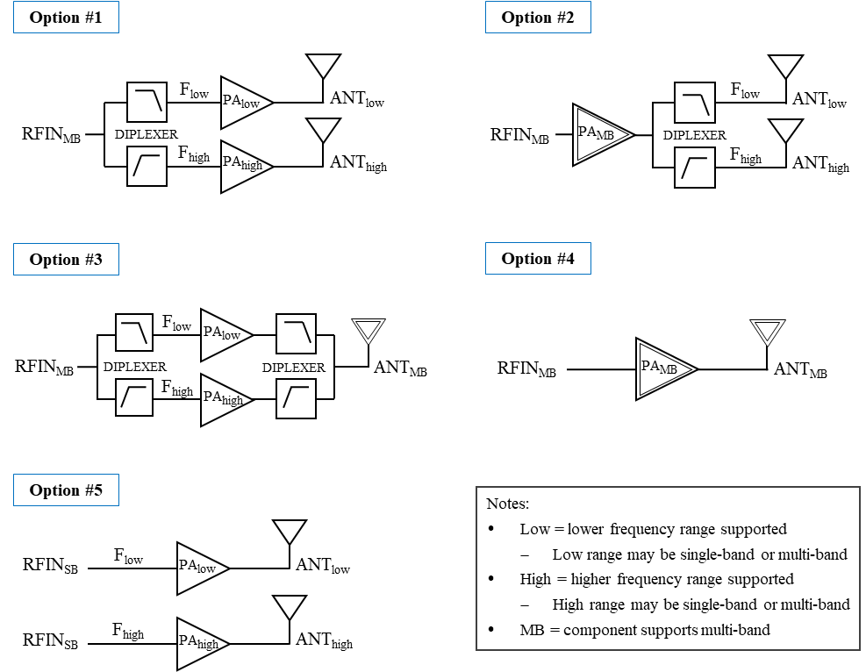

Figure 4.2.1-1: High-level architecture options to support multi-band operation in FR2-1

From the options captured in the figure, Option #2 and Option #4 are the target scenarios of this study item, while no study is needed for Option #5. For Option #1 and Option #3, if the PA is capable of being operated in multiple bands at the same time, then it supports multi-band operation. However, if the PA can only be configured and operated in a single-band, then it is considered a single-band RIB.

Option #1 and Option #3 are feasible with current technology if the ranges covered by each path have a percentage bandwidth up to 19.5%. Per agreements in sub-Clause 5.2.1.4, Option #2 and Option #4 should also be feasible for a percentage bandwidth up to 19.5%. Note that even within the same frequency group, the performance attained would yield a lower Tx power compared to a single-band design. However, given that this requirement is a manufacturer declaration, it would not impact the requirement applicability.

# 5 Feasibility study

## 5.1 General

According to the definition in section 6.1, a multi-band FR2-1 RIB is a RIB that transmits in two or more FR2-1 bands using common active components. In this section, the feasibility of an FR2-1 multi-band solution is considered. The feasibility is examined taking into account technology challenges and emerging solutions. It is possible that not all parts of the BS are multi-band but that some advantage can be gained by implementing some parts as multi-band. For example one potential advantage of a multiband PA might be that power can be distributed between the supported bands offering more flexibility to optimize the power available for each, this requires only a multi-band PA.

The evaluation considers whether the proposed set of FR2-1 requirements is likely to be achievable with present or future implementation possibilities. The study does not aim to conclude on whether a multi-band FR2 solution is more optimal or effective (considering complexity, power, weight etc.) than other possibilities, for example mounting individual radio panels for each band within a BS enclosure.

When discussing the feasibility of wideband components/systems the multi-band bandwidth as a percentage of the carrier frequency should be considered.

Note that this is generally called fractional BW but in [2] the term fractional BW is already defined to mean something specific so is best avoided to prevent confusion.

Fractional bandwidth (FBW) is defined for a single operating band as shown below:

- Fractional bandwidth (FBW) is defined in [2] as ,

- where FFBWhigh is highest supported frequency within supported operating band, for which fractional bandwidth support was declared, and FFBWlow is lowest supported frequency within supported operating band, for which fractional bandwidth support was declared.

Multiple operating bands are discussed in this study so the existing definition of fractional bandwidth is not suitable, the term percentage bandwidth is therefore used and defined as follows:

- Percentage bandwidth (PBW) is defined in this study as ,

- where FPBWhigh is highest supported frequency, for which percentage bandwidth support was declared, and FPBWlow is lowest supported frequency, for which percentage bandwidth support was declared.

Table 5.1-1 shows the percentage bandwidth for the FR2-1 bands and various potential multi-band groups.

Table 5.1-1:Percentage band width of FR2-1 operating band (s)

|  |  |  |
| --- | --- | --- |
| Frequency group, NR *operating band* pairing (lowest, highest) | Frequency range | Percentage bandwidth |
| 26 GHz (n258) | 24250 MHz – 27500 MHz | 12.6% |
| 28 GHz (n257) | 26500 MHz – 29500 MHz | 10.7% |
| 28 GHz (n261) | 27500 MHz – 28350 MHz | 3% |
| 39 GHz (n260) | 37000 MHz – 40000 MHz | 7.8% |
| 40 GHz (n259) | 39500 MHz – 43500 MHz | 9.6% |
| 48 GHz (n262) | 47200 MHz – 48200 MHz | 2.1% |
| 24-29 GHz (n257/n258/n261) | 24250 MHz – 29500 MHz | 19.5% |
| 37-48 GHz (n260/n259/n262) | 37000 MHz – 48200 MHz | 26.3% |
| 26+28 GHz (n258, n261) | 24250 MHz – 28350 MHz | 15.6% |
| 28+39 GHz (n257/n261, n260) | 26500 MHz – 40000 MHz | 40.6% |
| 26+40 GHz (n258, n259/n262) | 24250 MHz – 48200 MHz | 66.1% |
| 28+40 GHz (n257/n261, n259/n262) | 26500 MHz – 48200 MHz | 58.1% |

## 5.2 Wideband RF architectures

### 5.2.1 RF Front end

#### 5.2.1.1 General

Feasibility for RF front ends can be considered by looking at existing component capabilities which could be used for multi-band FR2 products now but also by studying literature for the direction of future capabilities.

#### 5.2.1.2 Beam former and PA

There are a number of components available today which offer sufficient band widths to cover at least some of the FR2 multi-band options. In [24] a wide band beamformer and PA was presented which covered 24 to 29.5 GHz (bands n257/n258/n261). The performance of which can be seen in table 5.2.1.2-1 and figure 5.2.1.2-1.

Table 5.2.1.2-1: beamformer IC in 24-29.5GHz

|  |  |
| --- | --- |
| Parameter | Beamformer |
| Frequency Range | 24-29.5 GHz |
| Tx OP1dB/OIP3 | 21 / 25 dBm |
| Tx Pdiss/Ch @ 12dBm Pout | 300 mW |
| Pout @3% EVM w/ 64QAM | 12 dBm |
| Rx Single Channel NF | 4 dB |
| Rx Pdiss | 130 mW |
| Instantaneous Bandwidth | 1600 MHz |

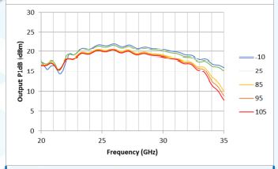 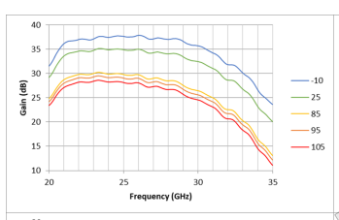

Figure 5.2.1.2-1: PA bias optimized for P1dB for 24GHz (left), and 28GHz (right)

It is considered feasible that multi-band beamformer IC covering 24-29.5GHz and associated bands can be achieved.

Looking further ahead the results of academic studies in [25] a 24-42 GHZ wideband PA was presented which exhibited flat P1dB of 17.8 to 19.6dBm, within 1.6dB from Psat, and flat PAEP1dB of 36.6 to 44.3% over 24 to 40GHz, verifying the truly wideband large-signal matching.

In [26] the hybrid N/PMOS allowed the 26-39GHz PA deep Class-AB biasing and device cascade, substantially increasing PA Pout and efficiency.

These PAs across different frequency groups are summarized in the following Table 5.2.1.2-2. It can be seen that some recent study shows PA covering 26-39GHz, 24-42GHz with average output power around 10dBm,PAEP1dB larger than 30%.

Table 5.2.1.2-2: PAs performance from literatures

|  |  |  |
| --- | --- | --- |
| Frequency | [25] 24 -42GHz PA | [26] 26 -39GHz PA |
| Authors and year of publication | Fei Wang,2020 | J Park,2022 |
| Technology | 45nm SOI CMOS | 45nm SOI CMOS |
| Gain (dB) | 20.5 | 18.9 |
| S21BW-3dB（GHz） | 25.8-43.4 | 25.3-42.0 |
| P1dBBW-1dB（GHz） | 22.0-37.0 | 25.0-37.0 |
| PAEp1dB BW-1dB（GHz） | 24.0-41.2 | 29.9-33.6 |
| P1dB（dBm） | 17.8-19.6 | 16.3-18.4 |
| Pavg（dBm） | 8.4-11.3 | 10.8-12.3 |
| PAEP1dB（%） | 36.6-44.3 | 29.9-34.9 |

These papers indicate that PAs covering frequency ranges from 26 to 40GHz or more are at least technically feasible in the research environment and may become available in the longer term.

It should be noted PAs with wide percentage bandwidths may not be capable of operating with signals that broad. For instance, while the PA may cover 50% bandwidth, its instantaneous bandwidth, i.e. maximum signal bandwidth, is usually restricted to a few hundred MHz due to limitations with bias networks and memory effects.

#### 5.2.1.3 Receiver front end

In [27] a 27-41GHz RX was designed and a proof-of-concept mm-Wave four-input–four-output MIMO RX array was implemented in a 45-nm CMOS SOI process with a total chip size of 3.6 mm×6.5 mm.

In [28] a 24.25-to-71GHz phased-array receiver ~~is~~ was introduced, which covering the whole FR2 frequency band 3GPP have defined by now. A harmonic-selection technique ~~is~~ was proposed to extend the operating bandwidth with low power consumption. The LNA can be configured into either operating Mode 1 covering 24 to 44GHz or operating Mode 2 covering 44 to 71GHz.

Paper [29] presented a 22–44 GHz 2×2 phased-array receive beamformer. The RX channel includes a LNA, a 5-bit vector modulator (VM) phase shifter, an attenuator, and a variable gain amplifier (VGA). The phased-array channel results in a peak gain of 26.3 dB and a 3-dB bandwidth of 20.5–44 GHz. The measured NF is 3–3.6 dB at 22–44 GHz with an IP1dB of −27.5 to −24.5 dBm.

For phase-array receive beamformer, these good performance receivers across different frequency groups are summarized in the following Table 5.2.1.3-3. They achieved low NF in a wide bandwidth.

Table 5.2.1.3-3: Phased-array receiver chips performance

|  |  |  |  |
| --- | --- | --- | --- |
| Frequency | [29]22–44 GHz | [27]27-41GHz | [28]24-71GHz |
| Authors and year of publication | Li Gao,2020 | Min-Yu Huang,2019 | Jian Pang,2022 |
| Tech. | 45nm CMOS SOI | 45nm CMOS SOI | 65nm CMOS Bulk |
| BW(GHz) | 22-44 | 27-41 | 24.25-71 |
| Gain(dB) | 26.2 | 36/element | / |
| NF(dB) | 3-3.6 | 4.3-6.3 | 3.6-8.0 (at 24.25-35GHz)  4.0-7.6(at 35-44GHz) |
| Gain Tuning(dB) | 16 | 15 | / |
| Phase Shift Res(º) | 11.25 | / | / |
| Phase/Gain RMS Error(º /dB) | 6/1.9 | / | / |
| IP1dB(dBm) | -25.4 | -34/-27.3 | -17.6 (at 28GHz)  -20.9(at 39GHz) |
| IIP3(dBm) | -18 | / | / |
| Pdc(mW) | 112 | / | / |

#### 5.2.1.4 Summary

It has been shown that:

- Multi-band beamformer IC with common active RF components with 19.5% percentage bandwidth in frequency range 24-29 GHz which includes n257/n258/n261 is technically feasible.

- For RF front-end, TRX chips covering 24-29.5GHz. 27-41GHz RX are shown. A harmonic-selection technique is proposed to extend the receiver’s operating bandwidth up to 24.25-71GHz.

Key components of a multi-band FR2 RF front end are hence available today for certain frequency ranges and band numbers (n257/n258/n261) and it can be envisioned that wider frequency range products could be feasible in the future.

### 5.2.2 Digital Pre-distortion

#### 5.2.2.1 DPD for FR2 single-band BS

For single-band FR2 radios, the application of DPD may not be critical compared to that of the FR1 counterpart. On one hand, the contribution of PAs to the total DC power consumption in a FR2 BS is much reduced. This is due to the fact that more antenna elements are added to increase the directivity of the antenna array to combat against the high path loss occurred at FR2, which in turn requires smaller power to feed each antenna element, and thus small-power PA per Tx is sufficient. On the other hand, the requirement on ACLR for FR2 BSs is not as large, i.e. 24 - 28dBc (by means of OTA measurement), compared to that applied to FR1 BSs, i.e. 45dBc [2] due to the beamforming and propagation environment. This somewhat alleviates the essential need of high-linearity PAs on meeting required ACLR. Therefore, the DPD in single-band FR2 BSs is expected to provide a little gain in terms of improving power efficiency and meeting the ACLR requirement. Furthermore, the analog and hybrid beamforming, which are predominantly used in FR2 radios, also pose challenges for DPD implementation. With hundreds to thousands of PAs and higher operating bandwidths for FR2 radio, simply utilizing a similar DPD architecture as in FR1 would cost extra for RF hardware design and power consumption, while it may be infeasible to deploy single DPD for every PA in the analog/hybrid beamforming phased array since several or all analog chains essentially share one digital path. The DPD algorithms would also have more demands on the bandwidth of feedback receiver/ADC and BB signal processing resources, which are scaled with the size of bandwidth to be linearized. These limited-gain and implementation-challenge factors make the similar DPD implementations as in FR1 less attractive to the FR2 single-band BS.

Nevertheless, DPD may still bring benefit for FR2 BSs in terms boosting the overall system performance (e.g. throughput due to improved EVM, or very possibly energy efficiency). It is worth highlighting that common FR2 transmitter architecture requires to have tight integration between RF components to reduce hardware costs, sizes, and power loss in which isolator between an antenna element and a PA is preferably avoided [5], e.g. as illustrated in Figure 5.2.2.1-1. In such architecture, PAs directly interact with the antenna array due to low path isolation between them. As a result, mutual coupling and antenna mismatch between antenna paths have strong impact to the PAs’ output matching impedance which changes the PA’s efficiency and nonlinearity behaviours [5]. The array steering angle, which also alters the antenna matching impedance, shows strong dependence on the nonlinearity to the PAs too. In addition, input of PAs in different branches may be driven with different power as a result of the beamforming techniques applied (i.e. tapering, ZF, etc.), or gain error of the phase shifters and gain imbalance of power division network [6]. These mentioned factors have the detrimental effect to efficiency and linearity behaviours of PAs which may degrade the ACLR while increasing the OOB emission and beam distortions [5]. For example, several studies have demonstrated the impact of steering angle to ACLR and OOB emission and how DPD can help to improve the beamforming performance [5, 6, 7, 8, 9].



Figure 5.2.2.1-1: A typical single-band FR2 antenna array architecture

Obviously, any individual variation in PA would affect the performance of the linearization so the peak linearization performance is likely to be lower than that of a one-DPD-per-PA system. Whilst the design of PA’s is likely to be identical there are a number of factors which could change their performance:

- Temperature – the location of each PA in the array (and the silicon) may mean different transistors are at different temperature (depending on the number of neighbouring devices for example) so the temperature of each junction may be different.

- Unit to unit variation – whilst some transistors may all be on a single piece of silicon and variation on a single bit of silicon may be small if multiple devices are used (8 or 16 per device may be more usual) so there will be unit to unit variation across the potential 128 paths

- Output match variation – PA performance is very dependent on the load it is working into, again all output match circuits are likely to be designed identically but will vary based on a number of factors:

- Unit to unit of components

- Antenna unit to unit

- Antenna isolation and load pulling from nearby antenna (and signals)

Despite these issues useful linearization of an FR2 systems can be achieved and may become more common as technology improves.

#### 5.2.2.2 DPD for FR2 multiband BS

Antenna array and TRXs in FR2 radios are desired to be tightly integrated in which RF filter is preferably omitted after the PA. Since a *multi-band RIB* essentially needs to transmit multiple-band signals concurrently, the nonlinearity of PAs will likely cause intermodulation (IM) distortion. It would be highly challenging to manage the PAs in multiband RIB not to operate in the nonlinearity power region. Particularly, the varying nonlinearity behaviours of the PAs, which causes by the nonlinear interaction between antenna array and the PAs as discussed above, also inherit to the FR2 *multi-band RIB*. Such issues would be expected to be more complicated in the multiband use cases than in single-band ones due to higher requirements on matching load impedance of PAs covering multiband/wideband. Therefore, unwanted emissions due to IM distortions likely exist and may possibly fall into the operating bands or inter-RF bandwidth. Note that the latter case occurs if there is multicarrier transmission in one band. Figures 5.2.2.2-1 and 5.2.2.2-2 illustrate some examples. Assume that frequency ranges that the BS can operate in Band A and B are 24.25-26.5GHz (n258) and 27-29.5 GHz (n257), and there is transmission taking place at 26GHz in Band A and 27.5GHz in band B. Then IM3 components occur at 24.5GHz and 29GHz, which obviously fall into operating bandwidth of both bands as seen in Figure 5.2.2.2-1. Now assume that band A transmits two carrier frequencies at 24.75 and 25.75GHz. Then one IM3 component occurs at 26.75GHz which falls into the inter-RF bandwidth of the multiband BS as seen in Figure 5.5.2-3.



Figure 5.2.2.2-1: Example for possible unwanted emission due to concurrent multiband transmission

Figure 5.2.2.2-2: Example for possible unwanted emission due to multi-carrier transmission in one band

Note that Figure 5.2.2.2-1 and Figure 5.2.2.2-2 demonstrate the location of IMD products with CW signals, in reality the transmitted signals are wide band and the IMD products even more so, as such they may not be separable from the noise floor. As such IMD products are a potential issue but possibly not a serious one in some case, for example:

- 128 PA’s at 20mW each is only 2.56W (34dBm)

- With 28dBc ACLR this gives an adjacent channel power of 6dBm

For a 100MHz channel this gives a PSD of -14dBm/MHz which is below the spurious emissions requirements for FR2. It is unlikely that any in-band non-linearities will be greater than the ACLR level (as these are 3rd order products) so the out of band emissions requirements are unlikely to be a problem.

The IM distortion is also beamformed [10], however if the beams in the different bands are steered in different directions the IM product is in a different direction again [3]. If the beams are close to each other however, e.g. when UEs are nearby each other, the IM distortion beam may still be close enough to point at the intended UE. Thus, it needs to be managed to ensure that RF requirements are still be met for the FR2 multiband RIB.

Apart from other UEs within the network, IM products in the *inter RF bandwidth gap* need to be suppressed sufficiently to ensure that spurious emissions requirements towards other systems are met. This would in particular need attention if band combinations between frequency groups would be considered.

RF filter/diplexer after every PAs could be used to handle IM distortions. However, such solution would be very expensive since beamforming phased array in FR2 could have thousands of antenna paths. Filter per path may also generate significantly phase error between antenna paths and increase power loss. Thus, this may not be feasible in terms of cost, size, and performance of FR2 radios. Alternatively, DPD may be a cheaper solution for RF hardware architectures to this issue. For FR2 multi-band DPD, it essentially inherits the abovementioned advantages as well as challenges for single-band FR2 BS with a few additional issues. For instance, the very large percentage BW may cause potential issues when applying DPD for multi-band FR2, these are:

- The large percentage BW of the PA and the wider the BW the more difficult it will be to maintain a consistent impedance match of PAs over the entire band and hence memory effects may be greater making the DPD algorithm tougher to achieve good linearization.

- Larger BW means variation of the potential sources (as listed for single band) are greater, once gain reducing the potential linearity saving.

Potentially split or stacked element arrays mean each band signal may be fed to a different antenna, meaning the output load for the PA is more complex and more open to variation.

Investigating practically feasible DPD solutions for beamforming phased array in FR2 has been an active research topic [11]. To address the concerns on the DPD implementation in FR2, DPD architectures and efficient DPD training model/algorithms have been intensively studies. Note that since one digital path will be shared between some or all analog chains in the analog/hybrid beamforming phased array, an architecture in which DPD linearization is applied for a set of PAs has been proposed and then demonstrated to be able to improve ACLR and EVM, e.g. [12, 13].

For multi-band DPD, as the beam steering for a multi-band FR2 system is likely to be applied to each band separately before the signals are combined and fed to a single PA, one example architecture could be that the signals will be generated separately in different converters. Such architectures have been investigated in FR1 bands [14] where separate signals were used to linearize a dual-band signals in a dual-band PA.

In general, one can either deploy a common DPD for all bands or a dedicated DPD for each band [15]. The former may have less demand on DPD architecture but requires much higher bandwidth for DPD hardware as the captured, training and correcting samples are wideband; since the correction is wide-band, band-specific linearization may not be achievable as such. The latter has lower demand on DPD hardware bandwidth and can achieve per-band linearization but may require more complex DPD architectures and algorithms, i.e. to decompose the captured multiband signals to single-band one and vice versa for the corrections, as well as jointly optimize linearized coefficients for all bands. In both architectures, a wider bandwidth feedback path is required to deal with large signal bandwidth of FR2 band; traditionally the feedback channel needs 3 to 5 times the signal bandwidth to collect nonlinear information of PA. This can be a big burden for high-speed and high-precision ADCs. Nevertheless, DPD training algorithms which minimize the demand on DPD hardware bandwidth and BB resources have also been proposed, e.g. in [16, 17]. It should be highlighted that the implementation of phase shifters will not significantly impact the DPD solutions as linearization are applied to signals seen at the output of the PA, as mentioned in [18].

### 5.2.3 Phase shifter

Analog phase shifters in mmWave BS are used to control the phase of signals in order to steer the beam. In some architectures, attenuators or variable-gain amplifiers are also placed along with the phase shifter to control the gain of beamformed signals to achieve desirable beamforming performance.

Considering phase shifter designs which are wideband it would prove difficult to apply different phase shifts to different bands. Hence it is not possible to independently steer beams to different directions in the different bands, and it may even not be feasible to steer the beams in the same directions for to 2 separate bands if the bands are sufficiently far apart in frequency that the beamforming weights would need to be different for each band.

If variable true time delay based phase shifters, which add delay to time-domain signals to create phase shift such as tapped delay line phase shifter, are used, then it may be possible to steer the beams toward the same direction for two different bands. This is because the frequency-dependent linear phase response of the true time delay phase shifter can create different phase shifts at different frequencies. However, true time delay phase shifts are challenging to implement due to the required size to delivered acceptable phase shift performance (e.g, phase shift resolution), while incurring high insertion loss.

Phase shifters with a frequency-flat phase response, such as vector modulated phase shifters may have cheaper implementational cost and be more feasible to integrated into commercial BFICs. However, since only one phase shift value can be controlled at a time instant, it may not be feasible to steer the beams in the same direction for two different bands if the bands are sufficiently far apart in frequency that the beamforming weights need to be different for each band.

Examples of beam steering results when wide-band frequency-flat phase response phase shifters and wideband phased array are used in a multiband transmitter are shown below. The phase shifters only control the beam weights of the lower frequency band. Two steering angles are considered, i.e. 0 and 20 degrees. Figure 5.2.3-1 illustrates the beam patterns when the element separation for lower band and upper band is 0.5λ and 0.6λ, respectively, which corresponds to the case of, for example, the combination n258+n261. Figure 5.2.3-2 presents the case when the operating bands are further apart, i.e. the element separation for lower band and upper band is 0.35λ and 0.65λ, respectively, which can be the case of combinations across different frequency groups. As can be seen, except when UEs of different bands are at the boresight of the array, otherwise the transmitter cannot steer the beam to multiple UEs independently. Even if different-band UEs are located at same direction (but not boresight), the beam for upper-band UEs is not pointed to its desired direction and a larger frequency separation of the bands results in bigger error of the steering angle.



Figure 5.2.3-1. Beam pattern of different band signals when using wideband phase shifter and antenna array. Phase shifters apply beam weights for the lower band. Array separation for lower band 0.5λ, and upper band 0.6 λ: (Left) 0-degree steering angle; (Right) 20-degree steering angle



Figure 5.2.3-2. Beam pattern of different band signals when using wideband phase shifter and antenna array. Phase shifters apply beam weights for the lower band. Array separation for lower band 0.35λ, and upper band 0.65λ: (Left) 0-degree steering angle; (Right) 20-degree steering angle.

Thus, it is not clear such a wide band phase shifter as shown in Figure 5.2.3-3 would be of use. Within the time frame of this SI it seems commercially available multi-band frequency selective phase shifters that can apply a different phase shift per band are unlikely to be available. However, any specification should not preclude a potential future architecture based on frequency dependent phase shifters. If and when frequency dependent phase shifters become viable, it is possible that RAN4 requirements created in Rel-18 would need re-visiting.

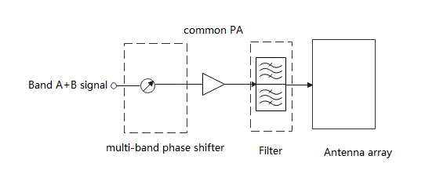

Figure 5.2.3-3. Example of multi-band phase shifter prior to a multi-band PA

In order to apply independent phase shift and hence independent steering to each band, phase shifters need to be applied differently to each band. Using technology available today it may be possible to use multiple single band phase shifters to provide the beam steering to each band independently whilst feeding into a multi-band PA shown in Figure 5.2.3-4, although this may have some performance penalty.

Note that Figures 5.2.3-3 and 5.2.3-4 show example architectures for a multi-band BS. Depending on the implementation, filter may or may not be placed after the multi-band PAs.

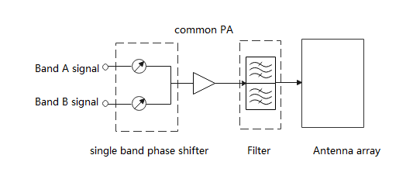

Figure 5.2.3-4. Example of single band phase shifter prior to a multi-band PA to steer each band separately

## 5.3 Wideband antenna architectures

### 5.3.1 General

Antenna arrays are resonant structures. The optimum radiating element size (a dipole is nominally λ/2) and the array element separation are both dependent on frequency. If an antenna is required to operate over a broad range of frequencies it is difficult to maintain optimum element size and element spacing over the whole range. The required percentage bandwidth of the multi-band signal in Table 5.1-1 is therefore important when looking at the feasibility of a broadband antenna.

From antenna design perspective, solutions covering multiple bands can be achieved in three main ways: a single broadband design covering the entire range of the bands (trades certain performance parameters), designing an antenna with multiple resonances in the desired bands, or having separate antenna designs each covering a band (lower percentage bandwidth

### 5.3.2 Single array bandwidth

It can be noted for comparison that there are FR1 multi-band fixed antenna arrays covering 1710MHz to 2690MHz, with a percentage bandwidth of 44.5% (VSWR of < 1.5:1). Fixed antenna arrays (with no or limited beam steering) however have more flexibility on element separation with values of up to 0.9λ being acceptable as the grating lobe is also fixed and can be attenuated with the element pattern. Whilst FR1 antennas build practices are different, the limitations on element size and spacing between elements are similar to those for FR2.

The radiating element can trade bandwidth against radiation performance. Short dipoles still radiate but the performance degrades the farther from the ideal frequency they are operated at. Defining an exact “acceptable” level of radiation efficiency for a broadband product is not straightforward as other aspects have to be considered (some radiation efficiency may be traded to achieve a broadband system). Also, as the element becomes smaller, its radiation pattern becomes broader these negating its ability to act as a spatial filter for array grating lobes.

The size of the radiating element and the element separation are also dependent, e.g. the elements cannot touch each other. The separation of the elements in terms of wavelength occurs at the highest frequency, as the maximum separation is limited by the grating lobe performance there is an upper limit to how large this separation may be. Therefore, this sets the maximum size of the element (which will be electrically shortest at the lowest frequency).



Figure 5.3.2-1: Example of physical limitations of element size and separation

The maximum separation is also a parameter which is difficult to agree as it depends on a number of things, a fixed antenna array may have a separation of up to 0.9λ (at its maximum operational frequency). In previous studies [xx] it has been assumed for BS antenna simulations that a fully steerable antenna array has a separation of 0.5-0.7λ to avoid grating lobes.

For example, taking 0.5λ as a lower limit (this could be smaller if short dipoles were used), it then needs to be decided what an acceptable level of side lobe / grating lobe suppression is and also what range of steering is required.

Three examples with similar grating lobe levels and different element spacing and steering can be seen:

- 0.7λ element separation with 30° steering

- 0.8λ element separation with 20° steering

- 0.9λ element separation with 10° steering





Figure 5.3.2-1 Array pattern: 0.7λ element separation with 30° steering, 0.8λ element separation with 20° steering, 0.9λ element separation with 10° steering

Each of these maximum separations equates to a percentage BW of 33%, 46% and 57%, respectively, and it is clear that grating lobe level and steering range can be traded against percentage bandwidth. Once again, selecting an exact set of conditions to estimate a maximum percentage bandwidth is difficult as it depends on the product definition.

Using another approach and taking antenna element separation 0.5λ at a higher limit, the scanning angle reaches ±60º at 26 GHz and ±45º at 38 GHz with acceptable side lobe/grating lobe levels, as shown in Figure 5.3.2-2. The corresponding spacing will be 0.34λ at a lower limit. The isolation among the antenna elements at a lower limit can be ensured with the use of decoupling structures.

 

(a) (b)

Figure 5.3.2-2. Beam scanning performance in azimuth plane when antenna element separation is 0.5*λ* at higher limit (a) 26 GHz, and (b) 38 GHz.

In addition to the physical limitations and grating lobe performance discussed, it should also be noted that the array is electrically shorter at lower frequencies than higher frequencies and this also affects the antenna directivity and gain. For example, there is approximately 3dB gain difference between low band (26GHz) and high band (38GHz) that can be seen in Figure 5.3.2-2. This factor may also be a consideration when planning an antenna design.

Taking another example, Figure 5.3.2-3 shows the directivity of an 8x8 uniform rectangular phased array with respect to different element separations. The antenna elements described in [31] are used in the simulation. It is seen that lower element separation will result in low array directivity. This means if the separations seen by lower frequency band is low, it likely consumes more energy to deliver acceptable array performance and cause power imbalance with higher bands, while the EIS receiver sensitive is low. The directivity difference between operating frequency bands may also be a consideration when planning an antenna design.



Figure 5.3.2-3. Directivity of uniform rectangular array (URA) with respect to array element separations.

The coupling effect may also pose challenges in wideband antenna array designs. It should be further noticed that the lower and higher band will see different impact of the mutual coupling effect among radiators due to different element spacing, i.e. the narrower element spacing suffers stronger mutual coupling. This effect could change the array pattern and input impedance matching of the antenna elements while being difficult to analytically predict.

However, based on existing technology it has been agreed that multi-band AA with common radiated element with 19.5% percentage bandwidth in frequency range 24-29 GHz which includes n257/n258/n261, or with 26.3% percentage bandwidth in frequency range 37-48 GHz which includes n260/n259/n262 is feasible, at least from antenna array perspective.

### 5.3.3 Interleaved array structures

If the required multi-band antenna bandwidth is too great to be handled by a single antenna array (for the required steering range) it is also possible to use interleaved array structures such as stacked patches. Using stacked patches allows the different bands to feed different elements which are tuned for the specific band. This resolves some of the physical restrictions on the element size. However, if the arrays are stacked then restrictions still exist on the element separation in the array.

Stacked patches can be designed with either a single dual band input or with separate input ports. As the bands are separated (for example 26GHz and 40GHz), it is possible to implement a diplexer to separate the bands for each of the antenna arrays, if necessary.



Figure 5.3.3-1: Multi-band PA with stacked single band arrays (single and dual input ports)

A number of papers have been identified [19], [20], [21], and [22] which have demonstrated the feasibility of operational stacked patch antennas in the range 26 to 40 GHz

Dual band performance can be achieved by using multiple patches stacked on top of each other. For example, in [20] a simple stack with a high band patch and a low band patch with a single input port was shown. Using these patches, a 2x2 array was demonstrated with acceptable levels of input match, boresight gain isolation and scanning angle. Although of course such small arrays are more suitable for a handset than a BS.

In [22] a larger 8x4 array was demonstrated along with separate single band beamformers. While this is still small for BS purposes, it demonstrates the scalability of such structures and that larger BS-size arrays may be technically feasible to implement.

In the above configuration, there are two types of feed line such as single input and dual input. The following analysis shows the difference between their performance. The 28+39 GHz (n257/n261, n260) combination was analysed, and figure 5.3.3-2 shows their structures. Both type support dual polarization. Upper patch is for Hi-band (n260) and lower patch is for Lo-band (n257/n261).

|  |  |
| --- | --- |
| Single input type | Dual input type |

Figure 5.3.3-2: Dual polarized stacked patch antenna element for 28+39GHz combination.

The following simulation result shows antenna gain of both stacked patch antenna elements.

|  |  |  |
| --- | --- | --- |
| (a) Single input type | (b) Dual input type(28GHz) | (c) Dual input type(39GHz) |

Figure 5.3.3-3: Performance of multi-band stacked patch antenna element for 28+39GHz combination.

Table 5.3.3-1: Performance of multi-band stacked patch antenna element for 28+39GHz combination.

|  |  |  |  |  |
| --- | --- | --- | --- | --- |
|  | Antenna element gain [dBi] | | | |
| 26.5GHz | 29.5GHz | 37.0GHz | 40.0GHz |
| Single input type | 4.99 | 5.65 | 5.07 | 4.67 |
| Dual input type | 4.47 | 5.37 | 4.42 | 4.26 |

From antenna performance perspective, the difference between single input and dual input of stacked patch multi-band antenna is small, and both types could achieve 4 to 5dBi element gain including frequency roll-off. Considering that 4 to 5dBi is generally set as the antenna element gain in a link budget for mmWave communication equipment, performance impact of both stacked patch multi-band antennas is small. In addition, it is possible to expand the support frequency range by increasing thickness of the antenna as needed.

From the above discussions for different antenna array structures, either a multi-band antenna array (broadband or with multi-resonances) or separate antenna arrays with lower percentage bandwidth can be used in FR2 multiband RIB/BS. In comparison to separate antenna arrays, a consolidated multi-band design is more compact and reduces costs, but trades performance aspects that can be optimized for in separate designs. On the other hand, having separate designs enables dedicated optimizations, yielding better performance. However, this comes at the cost of a significantly larger circuit area being used for two designs and additional integration losses from lines and transitions.

### 5.3.4 MIMO EM simulation results

To enhance the capacity and reliability of data transmission the BSs utilize MIMO of antenna arrays. Therefore, the antenna array designs need to ensure key metrics (such as isolation between antenna elements and diversity performance parameters) achievable in order to deliver expected MIMO performances. The following simulation results demonstrate the capability of a dual-band antenna array design to achieve acceptable performance metrics required for the MIMO.

Uniform phased antenna arrays in multiple panels spanning beams in two dimensions (2D) are employed at BSs, to serve multiple users within the same time-frequency resource via spatial beamforming across the azimuth and elevation domains. Figure 5.3.4-1 shows the example of 2D multibeam scanning of an 8-panel massive MIMO antenna array system of in 3D view at 26 GHz and 38 GHz, which has been designed by considering antenna element separation of 0.5λ at higher limit. When various phased antenna arrays are employed in multiple panels in a small physical size, the mutual coupling between them can greatly affect the performance. The isolation between panels’ adjacent antenna elements and correlation between the radiated beams needs to be ensured. The performance metrics are isolation (between antenna elements) and diversity performance parameters e.g. envelope correlation coefficient (ECC). The ECC is commonly used to measure amount of radiated beams correlation. The ECC values are calculated using radiated far-field equation in [23]. For good diversity action the ECC should be low.

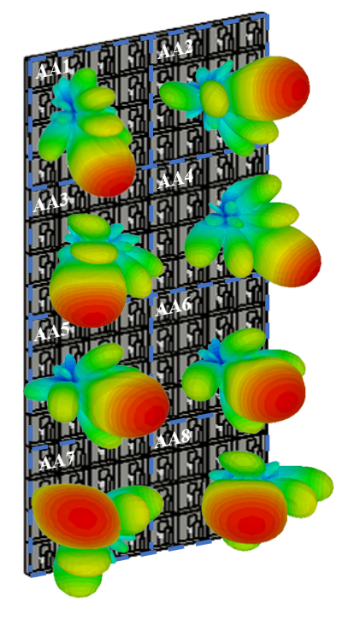 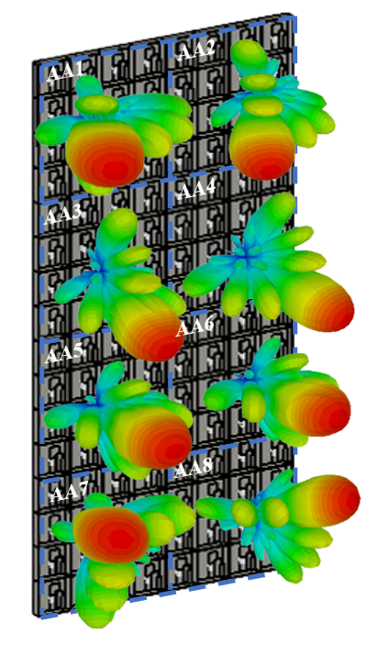

Figure 5.3.4-1. Example of 2D multibeam scanning of an 8-panel MIMO antenna array system in 3D view: 26 GHz (left), 38 GHz (right)

MIMO diversity performance of massive MIMO antenna system has been evaluated for three different cases by considering one panel steering the beam at different angles with respect to the other panels’ main beam in a fixed direction.

**Case 1:** When Panel 1 (AA1) radiates the field in the azimuth plane at (40º,0º) and Panel 2 (AA2) steers the beam at different angles i.e. -40º, -20º, 0º, 20º, and 40º in the azimuth plane.

**Case 2:** When Panel 1 (AA1) radiates the field in the elevation plane at (0º, 20º) and Panel 3 (AA3) steers the beam at different angles i.e. -40º, -20º, 0º, 20º, and 40º in the elevation plane.

**Case 3:** When Panel 1 (AA1) radiates field at (20º, 20º) and Panel 4 (AA4) steers beam at different angles i.e. (-40º, -40º), (-20º, -20º), (0º, 0º), (20º, 20º), and (40º, 40º).

 



Figure 5.3.4-2. Diversity performance: when beam steered in azimuth plane, when beam steered in elevation plane, when beam steered diagonally

BSs implemented with MIMO antenna systems can serve multiple users via spatial beamforming across the azimuth and elevation domains with good diversity performance over multiple frequency bands.

### 5.3.5 Diplexer technology

The following discusses a use case of diplexer in FR2 multiband RIB architecture.

To support across the different frequency group with dual input stacked patch multi-band antenna and multi-band PA, a diplexer is useful to divide each frequency group’s signals as figure 5.3.5-1. To implement a diplexer between multi-band antenna and PA, diplexer should be smaller than antenna elements interval of phased array.

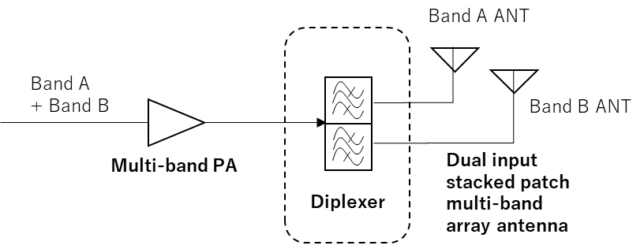

Figure 5.3.5-1 Diplexer between multi-band PA and stacked patch multi-band array antenna.

The following simulation result shows the feasibility of a diplexer and its performance impact based on the above condition. Figure 5.3.5-2 is for a diplexer for 28+39GHz (n257/n261, n260) band combination. 1dB insertion loss and >50dB attenuation are achieved.

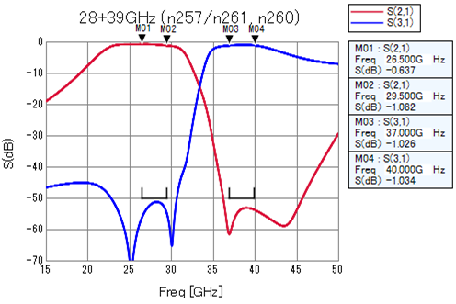

Figure 5.3.5-2. Diplexer performance for 28+39GHz combination

The dimension of this diplexer is 4.0 mm x 1.8 mm or less in LTCC substrate, and dielectric constant of this substrate is 6.4, Q value is 200. Most of the current base station supports dual polarization, so the required area to implement a diplexer should be doubled and it becomes 4.0mm x 3.6mm. In case of 28+39GHz combination, 0.5λ at the centre frequency is 4.51mm. So if antenna element interval is 0.5λ or larger, it is possible to implement diplexer below each antenna elements.

For other multi-band combinations such as 26+40GHz (n258, n259/n260) and 28+40GHz (n257/n261, n259/n262), the following examples are provided. Over 50dB attenuation is achieved for the all band combinations and their performance impact is around 1dB.

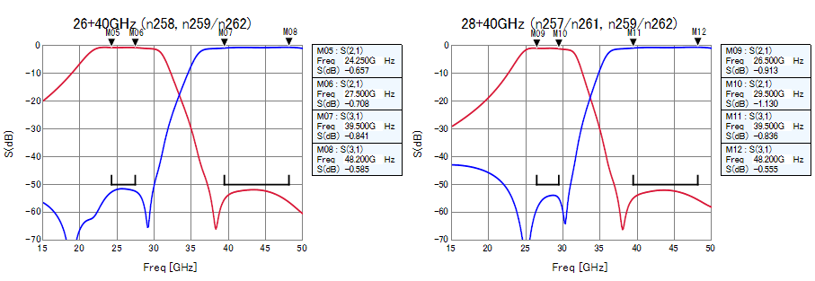

Figure 5.3.5-3. Diplexer performance for 26+40GHz, 28+40GHz combinations

## 5.4 Other

In this section, a number of other considerations for FR2-1 wideband BS from the feasibility point of view that are not considered in the preceding sections are mentioned.

Digital considerations

To support a large bandwidth, it is necessary to provide a high sampling rate for ADC and DAC. For individual Frequency Band Groups (e.g. 24.5-29.5GHz, n257+n258), the bandwidth to be supported may be more than 5GHz, and to cover the full FR2-1 the bandwidth might be up to 24GHz. If linearization would be seen later to be feasible for multiband BS, then DAC/ADC would need to support for the feedback and correction, which poses another challenge to DAC/ADC.

Potentially only the in band spectrum could be generated by separate converters which would reduce the requirements on individual converters.

In an implementation, the architecture, RF performance and power consumption of the analogue/digital interface would be key considerations. The ADC and DAC complexity and power consumption could be reduced by reducing the sampling resolution, but this would impact TX factors such as EVM and emissions and RX factors such as dynamic range and RX EVM. For this reason, care would need to be taken that requirements on e.g. EVM, receiver dynamic range and demodulation performance would be achievable.

In addition to the DAC and ADC, the large bandwidth and sampling rates would lead to very high volumes of data to be moved within the radio architecture. Data transport and interface architectures would need to support the very high data volume. Reducing the data volume (e.g. by reducing the sampling resolution) would lead to similar considerations as for ADC and DAC on meeting requirements such as EVM, emissions, RX dynamic range and demodulation.

In addition to the interface bandwidth, the digital transport latency may also impact radio near algorithms (such as DPD, CFR) and could impact the performance of the transmitter and receiver. It is not clear whether the need to support a much larger interface bandwidth could impact the interface latency.

Digital filtering may be needed for meeting selectivity and blocking requirements depending on the sensitivity and architecture. The large sampling rates and bandwidth would increase the amount of computational power needed for digital filtering, and potentially the achievable steepness of the filters. This could impact the feasibility of meeting TX EVM and RX selectivity, blocking and demodulation requirements.

Analogue considerations

The possibilities for analogue filtering within an FR2-1 AAS array are extremely limited. The filter in a typical single-band FR2 BS may not be placed before the antenna. However, it could be the case of multi-band, due to the multi-frequency signal going through the PA if the PA is highly nonlinearity, or due to the architecture splitting multi-band signals. And thus filter before the antenna may be needed.

Choosing where to place filter components is an important part of a multi-band solution as it impacts the overall performance. For instance, if a filter would need to be placed before the antenna, then there are other issues in practice with insertion loss and power unbalancing due to non-identical filter for each branch.

The regulatory requirements in the *inter RF gap* and the linearity of the transmitter will set the boundary for the analogue filtering. The feasibility of analogue filtering may impact the ability to meet some regulatory emissions requirements and out of band blocking, and if the filter has ripple also the EVM may be impacted.

Depending on the array architecture, it may be necessary to split different frequency components of the multi-band signal and route them to different antenna elements, e.g. in architectures using diplexer. The splitting and additional routing can have implications for TX power loss and RX sensitivity, and the placement of components needs to be carefully considered. For instance, placing the diplexer before the PA is preferred from a design loss and power dissipation perspective. This is because the insertion loss of the diplexer occurs at a lower power level and can be accommodated by a simple increase in driver gain. Conversely, if the diplexer is placed after the PA, the insertion loss of the diplexer directly reduces the power available to the antenna array and leads to more thermal dissipation.

On the other hand, it is worth noting that if the power loss is significantly different/uneven between antenna branches, then beamforming may be degraded, and calibration may be required which may bring complexity to the architecture. This may impact the feasibility of the multi-band solution, although since TX power and RX sensitivity are subject to declarations it may not impact the requirements definition. As shown in Clause 4.2.1 Option #4, splitting and additional routing can be avoided by using a multi-band antenna, such as a single input stacked patch design.

Dedicated PAs for the desired frequency ranges may be adopted from a design loss and power dissipation perspective, as the narrower band designs will have better efficiency and the thermal dissipation will be spread out over a larger area.

# 6 Study on RF requirements

## 6.1 Definition of FR2 multi-band BS

The existing definitions of single-band RIB and *multi-band RIB* for FR1 defined in TS 38.104 are shown as below:

**multi-band RIB:** *operating band* specific RIB associated with a transmitter or receiver that is characterized by the ability to process two or more carriers in common active RF components simultaneously, where at least one carrier is configured at a different *operating band* than the other carrier(s) and where this different *operating band* is not a *sub-band* or *superseding-band* of another supported *operating band.*

**single-band RIB:** *operating band* specific RIB supporting operation either in a single *operating band* only, or in multiple *operating bands* but does not meet the conditions for a *multi-band RIB*.

From definition of *multi-band RIB* for FR1, the transmitter or receiver of *multi-band RIB* dependent BS have the capability to process two or more carriers from the different bands in common active RF components simultaneously. For FR2-1, the existing *multi-band RIB* definition for FR1 can be reused.

As the same with FR1, the existing explanations on BS capable of supporting operation in multiple operating bands in 38.104 [2] for FR1 are sufficient. The same descriptions can be applied to FR2-1, i.e.

*- BS type 2-O* may be capable of supporting operation in multiple *operating bands* with one of the following implementations at the *radiated interface boundary*:

- All RIBs are single-band RIBs.

- All RIBs are multi-band RIBs.

- A combination of single-band RIBs and multi-band RIBs provides support of the BS type 2-O capability of operation in multiple operating bands.

## 6.2 Re-using FR1 multi-band methods

On requirements of FR2-1 multi-band BS, the followings are agreed:

- Existing definitions of *Inter RF Bandwidth gap* and Base Station RF Bandwidth for FR1 multi-band operation can be reused for FR2-1 multi-band operation.

- The existing method for requirement for FR1 multi-band operation can be reused for that for FR2-1 multi-band operation.

The impacts on requirements of FR2-1 multi-band BS in TS 38.104 [2] are summarized in Table 6.2-1.

Table 6.2-1: Impacts on requirements of FR2-1 multi-band BS in TS 38.104

|  |  |  |
| --- | --- | --- |
| OTA Clause | Requirement | Impacts |
| 9.5.2 | Transmitter OFF power | Existing *BS type 2-O* requirements can be applied. |
| 9.7.3.3 | ACLR | Specify ACLR and CACLR requirements inside the *Inter RF Bandwidth* gap for a *BS type 2-O* *multi-band RIB*. |
| 9.7.4.3 | OBUE | Specify cumulative OBUE limits the *Inter RF Bandwidth* gap for a *BS type 2-O* *multi-band RIB*. |
| 9.7.5.3 | Transmitter spurious emissions | Apply *BS type 2-O* requirements with the same *BS type 1-O* *multi-band RIB* exceptions to *BS type 2-O* *multi-band RIB*. |
| 9.8.2 | Transmitter intermodulation | No transmitter intermodulation requirement for *BS type 2-O*. |
| 10.5.1.3 | ACS | Specify ACS requirements the *Inter RF Bandwidth* gap for a *BS type 2-O* *multi-band RIB*. |
| 10.5.2.3 | In-band blocking | Specify in-band blocking requirements the *Inter RF Bandwidth* gap for a *BS type 2-O* *multi-band RIB*. |
| 10.6.3 | Out-of-band blocking | Apply *BS type 2-O* requirements with the same *BS type 1-O* *multi-band RIB* exceptions to *BS type 2-O* *multi-band RIB*. |
| 10.7.3 | Receiver spurious emissions | Apply *BS type 2-O* requirements with the same *BS type 1-O* *multi-band RIB* exceptions to *BS type 2-O* *multi-band RIB*. |
| 10.8.3 | Receiver Intermodulation | Specify receiver intermodulation requirements the *Inter RF Bandwidth* gap for a *BS type 2-O* *multi-band RIB*. |

## 6.3 Re-using FR1 exceptions

On requirement exceptions of FR2-1 multi-band BS, the followings are agreed:

- The FR1 exceptions for spurious emissions, RX spurious emissions and out of band blocking could be applied in FR2-1, as well as all other multi-band considerations made for FR1 for transmit ON/OFF power, operating band unwanted emissions, transmitter/receiver intermodulation, in-band selectivity and blocking.

Table 6.3-1: Impacts on requirement exceptions of FR2-1 multi-band BS in TS 38.104

|  |  |  |
| --- | --- | --- |
| OTA Clause | Requirement | Impacts |
| 9.7.5.3 | Transmitter spurious emissions | Apply the same *BS type 1-O* *multi-band RIB* exceptions to *BS type 2-O* *multi-band RIB*. |
| 10.6.3 | Out-of-band blocking | Apply the same *BS type 1-O* *multi-band RIB* exceptions to *BS type 2-O* *multi-band RIB*. |
| 10.7.3 | Receiver spurious emissions | Apply the same *BS type 1-O* *multi-band RIB* exceptions to *BS type 2-O* *multi-band RIB*. |

## 6.4 FR2-1 specific multi-band requirements

FR2-1 specific multi-band requirements refer to requirements specific to FR2-1 compared to those currently applied to FR1. It was agreed that this study focuses on the *multi-band RIB* within the same frequency group meanwhile the study on *multi-band RIB* across different frequency groups not precluded. With this agreement, together with the agreements on re-using FR1 multi-band methods and exceptions, there is currently no need for new FR2-1 specific multi-band requirements as the current FR1 multi-band methods and exceptions can be applied to FR2-1 and are sufficient for FR2-1 *multi-band RIB* for all band combinations within the same frequency group. For *multi-band RIB* for band combinations across different frequency groups, the current FR1 multi-band methods and exceptions can also be applied, while FR2-1 specific multi-band requirements may be considered in the future taking into account the implementation challenges.

# 7 Summary and further work

The feasibility study for the essential RF components and sub-systems for an FR2-1 multi-band system were carried out and found that:

- Multi-band implementations with percentage BW of up to 19.5% are feasible.

- Multi-band implementations with greater percentage BW’s may be feasible in the future.

Within these percentage BWs some design blocks such as the PA, and RF front end components are capable of true multi-band performance, other blocks and specifically the phase shifters used for beam forming the different bands need to be applied to separate band specific solutions. There are currently no proposed solutions to enable a wide band beam former to steer beams for different bands in different directions.

Antennas and antenna arrays are limited to certain maximum percentage BW’s however MB solutions using multiple antenna arrays have been investigated and solutions within the agreed percentage BW’s above have been identified.

Other considerations, i.e. on a need of DPD and complications of digital and analogue designs for a wideband / multiband BS are also analysed.

Considering the wide range of FR2-1 operating bands and potential combinations FR2-1 operating bands have been considered within frequency groups with limited percentage BW’s as shown in table 5.1-1 and feasibility analysed within these groups. However, whilst practical limits exist which may limit multi-band solutions to be within these groups no restrictions need to be used in the technical specification and as such frequency groups do not need to be defined with the updates of the technical specifications. On the other hand, as highlighted in clause 6.2 study of solutions across frequency groups may be further studied and the use of additional multi-band requirements may be considered in the future for percentage BW’s greater than 19.5%.

For updating the technical specifications, FR2-1 multi-band requirements are to be added to the existing NR 3GPP TS 38.104 [2]and 3GPP TS 38.141-2 [30] technical specifications, using the same approach as FR1 multi-band as described in clause 6. The existing MB RIB definition as well as the explanations on BS capable of supporting operation in multiple operating bands with different implementations at the RIB in 38.104 [2] for FR1 can also apply to FR2-1.

Annex A (informative):  
Change history

|  |  |  |  |  |  |  |  |
| --- | --- | --- | --- | --- | --- | --- | --- |
| Change history | | | | | | | |
| Date | Meeting | TDoc | CR | Rev | Cat | Subject/Comment | New version |
| 2022-08 | RAN4#104-e | R4-2214779 |  |  |  | TR skeleton | 0.0.1 |
| 2022-11 | RAN4#105 | R4-2219148 |  |  |  | The following TP approved at RAN4#104-bis-e was implemented:  R4-2217502 TP for deployment scenarios | 0.1.0 |
| 2023-03 | RAN4#106 | R4-2301419 |  |  |  | The following TPs approved at RAN4#105 were implemented:  R4-2220295 TP for TR 38.877: On definition of FR2-1 multi-band BS in clause 6.1  R4-2220294 TP to TR 38.877: Requirements of FR2-1 multi-band BS | 0.2.0 |
| 2023-04 | RAN4#106-bis-e | R4-2305882 |  |  |  | The following TPs approved at RAN4#106 were implemented:  R4-2302894 TP to TR 38.877: FR2-1 specific multi-band requirements  R4-2302895 TP to TR 38.877: General paragraph for feasibility aspects  R4-2302896 TP to TR 38.877: DPD in FR2 multiband BS  R4-2302897 TP on Antenna array capability  R4-2302898 TP on RF front end capability  R4-2302899 TP to TR 38.877: phase shifter in FR2 multiband BS  R4-2302900 TP to TR 38.877: Other feasibility aspects | 0.3.0 |
| 2023-05 | RAN4#107 | R4-2307753 |  |  |  | The following TPs approved at RAN4#106-bis-e were implemented:  R4-2304118 TP to TR 38.877: Phase shifter and antenna  R4-2304712 TP to TR 38.877: Corrections in DPD sections  R4-2305880 TP to TR 38.877: Antenna array  R4-2305881 TP to TR 38.877: Fractional bandwidth and percentage bandwidth  R4-2305883 TP for Clause 3: abbreviations  R4-2305884 TP on SI summary  R4-2305885 TP for TR 38.877: Additional feasibility aspects | 0.4.0 |
| 2023-05 | RAN4#107 | R4-2309759 |  |  |  | The following TPs approved at RAN4#107 were implemented:  R4-2307230 TP to TR 38.877: Clause 4.2 and Clause 5  R4-2309756 TP to TR 38.877: Terms and Symbols  R4-2309757 Clean up and correction to TR 38.877  R4-2309758 TP to TR 38.877: Antenna array | 0.5.0 |
| 2023-06 | RAN#100 | RP-231057 |  |  |  | Presented to RAN for approval. | 1.0.0 |
| 2023-06 | RAN#100 |  |  |  |  | First version of Release 18 | 18.0.0 |
| 2023-09 | RAN#101 | RP-232506 | 0001 | 1 | F | [FS_NR_BS_RF_evo] CR to TR 38.877 on correction and additional clarification on phase shifters for MB BS | 18.1.0 |